Moracchini
CSD420-308A(2265-DD)
May 10, 2026

MySQL Java Test
Module 9.2 Assignment
Pr. Payne

Starting MySQL 5.7 and NetBeans installation
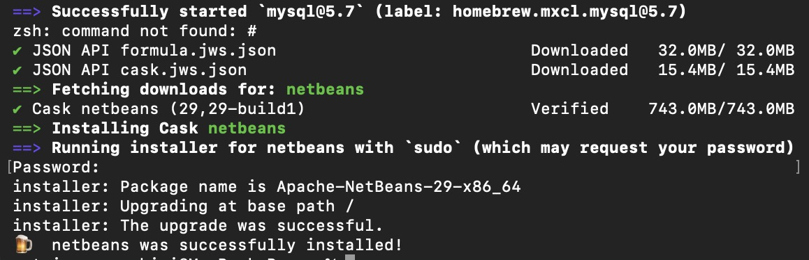

Log in and connection to MySQL 5.7

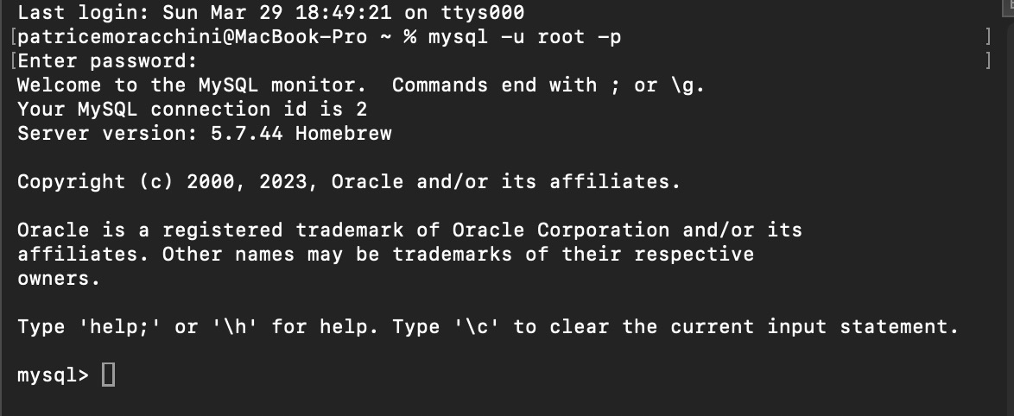

Select User

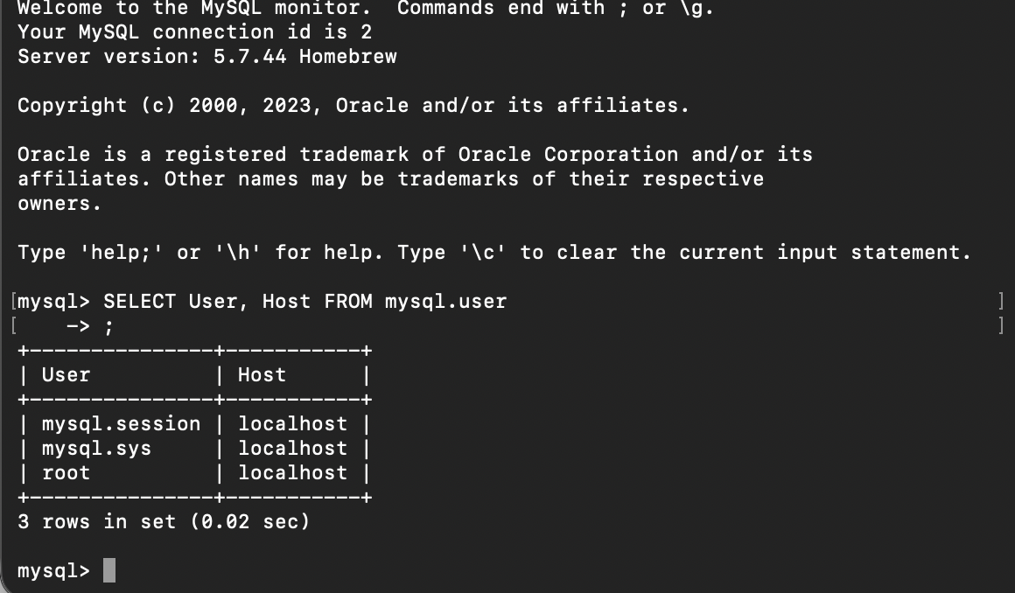

Create User student1

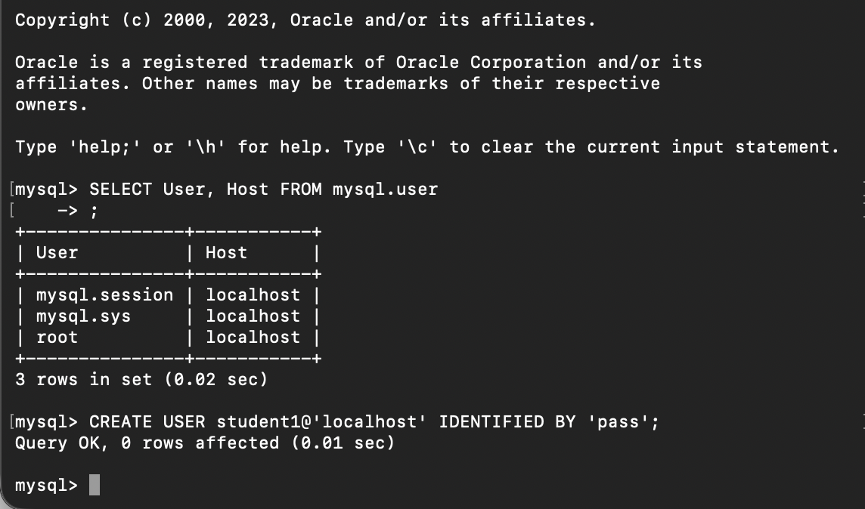

Grant All Privileges to student1

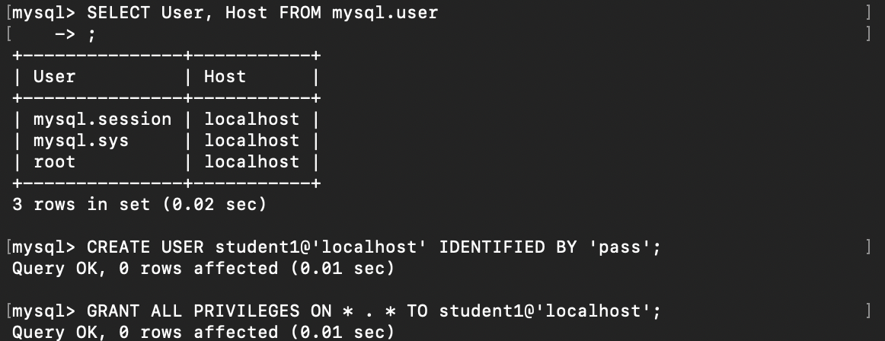

Exit

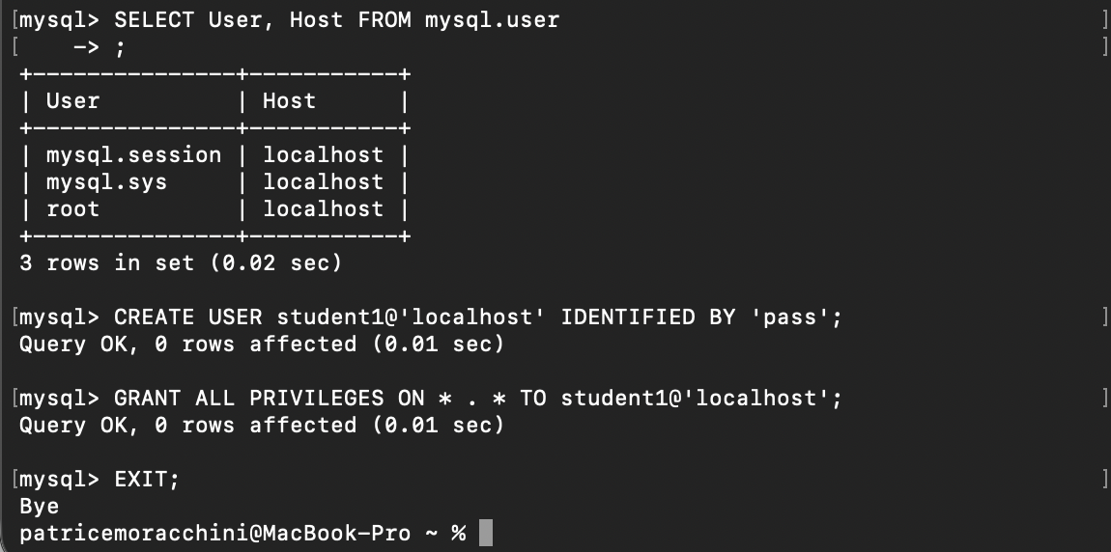

Select current user

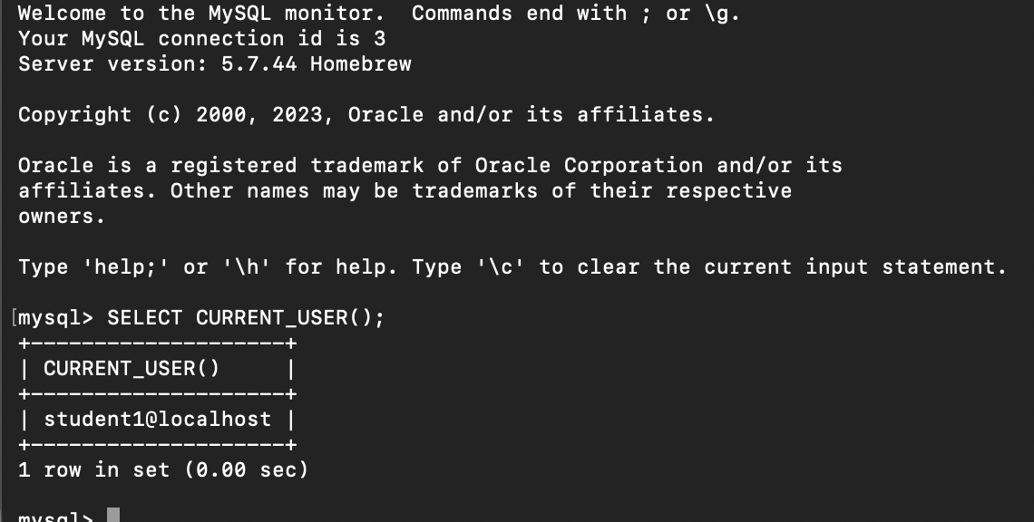

Show database, create database databasedb, use databasedb, show tables.

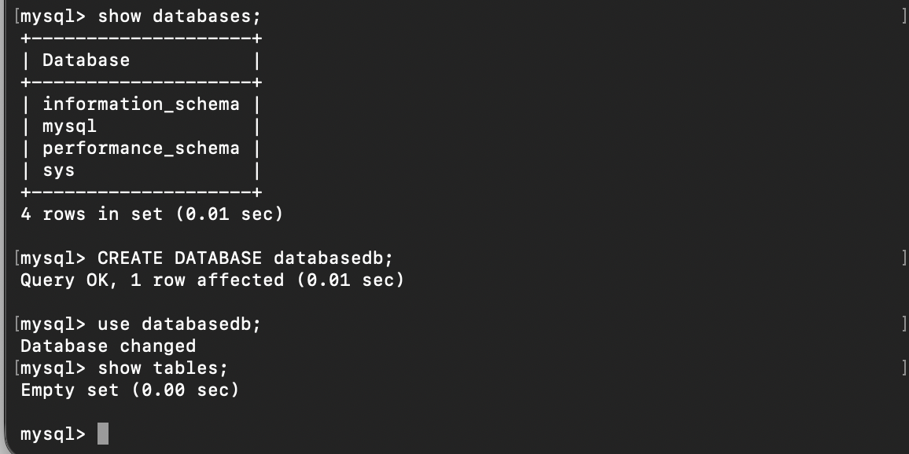

I downloaded MySQLConnector/J and added it to NetBeans.

Tables creation with the CreateTable.java file in NetBeans.

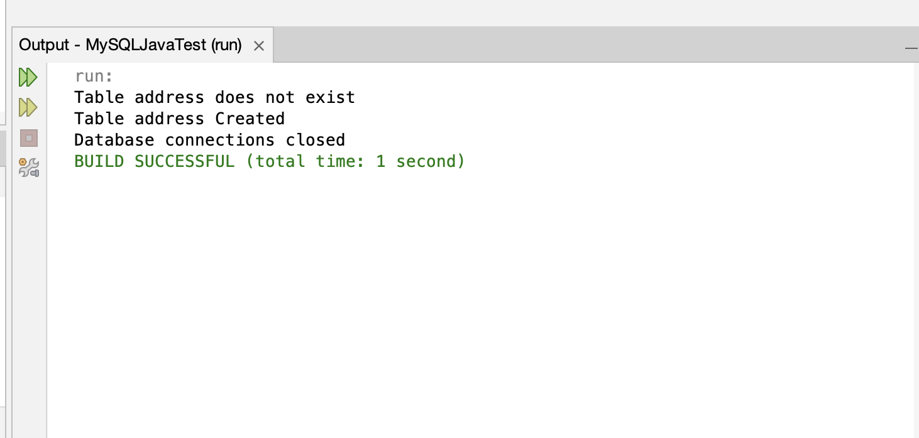

Data added with the InsertData.java file in NetBeans.

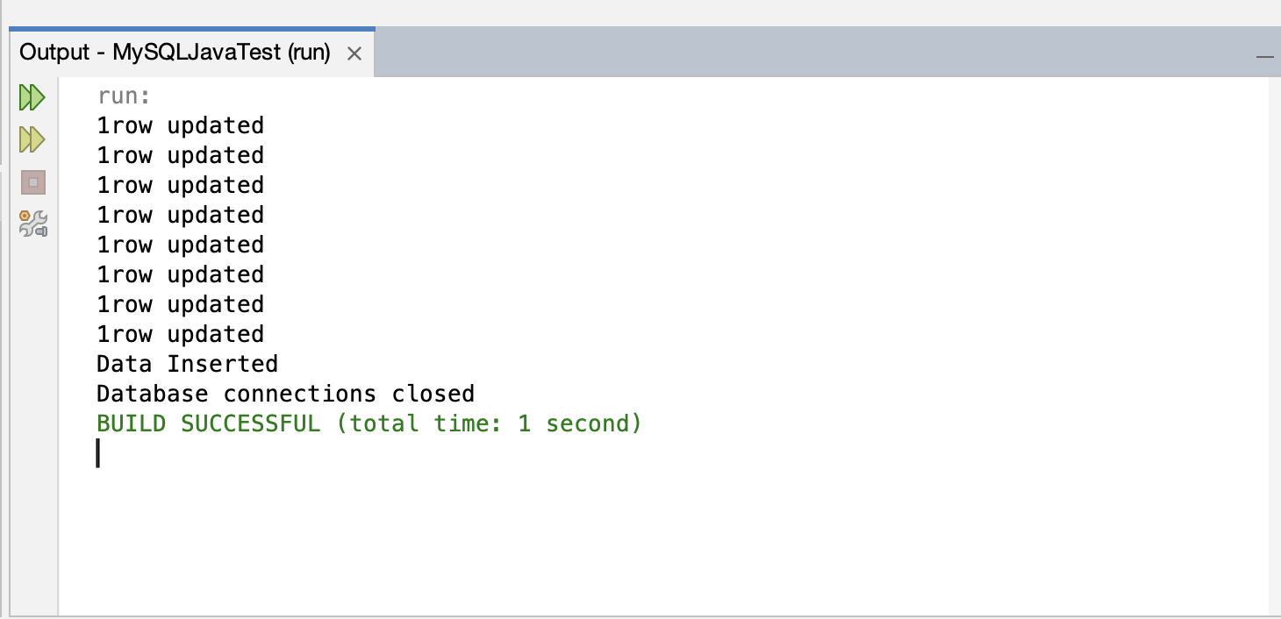

Query to display data with the Select5.java file.

