Moracchini
CSD420-308A(2265-DD)
Mar 29, 2026

Java and JavaFX installation
Module 1.3 Assignment
Pr. Payne

Screenshot 1: Java runtime installation

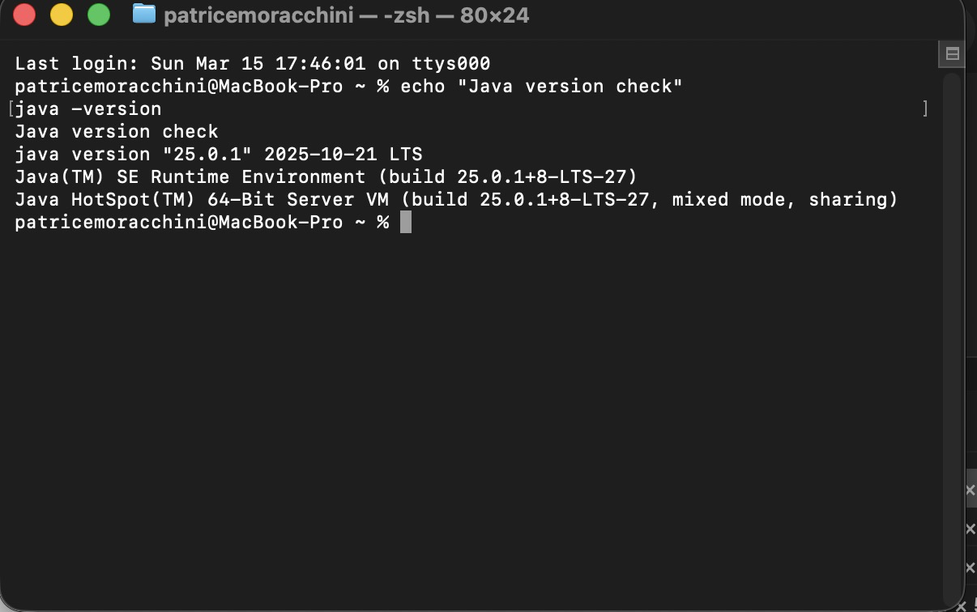

Screenshot 2: Java compiler installation

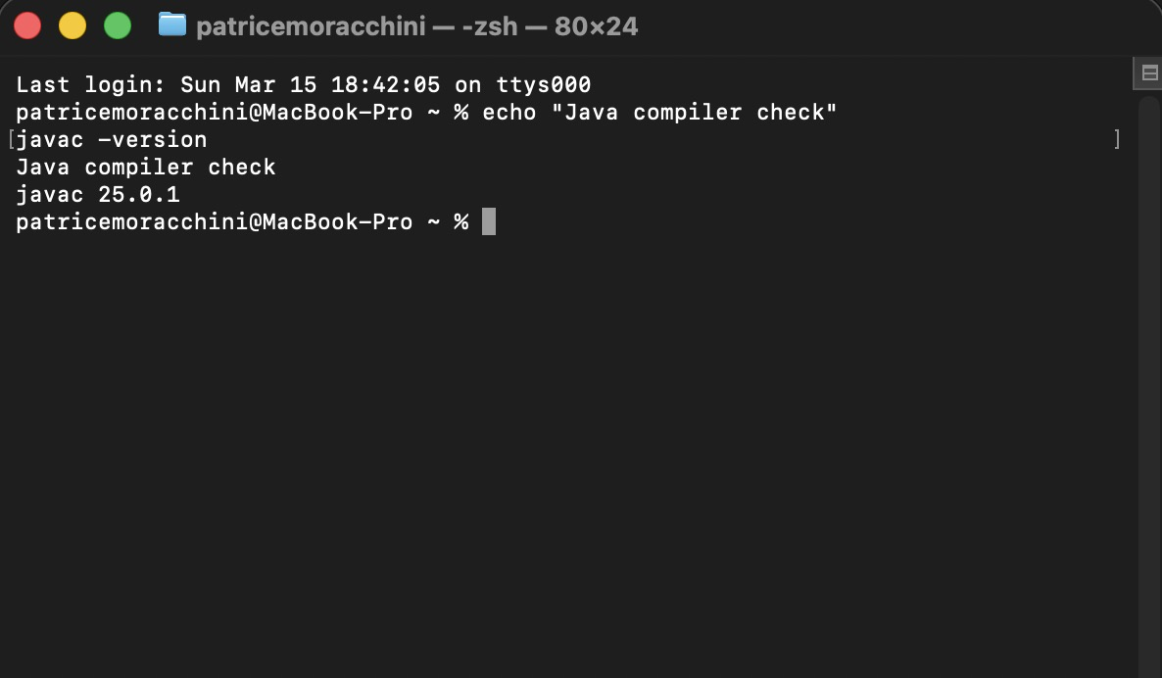

Screenshot 3: Java path configuration

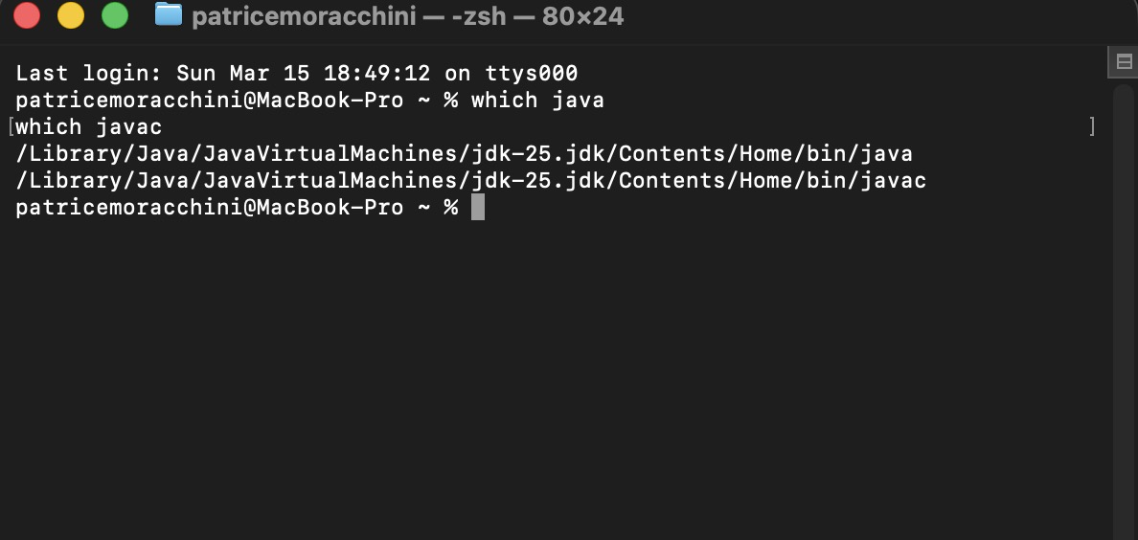

Screenshot 4: JavaFX SDK library files

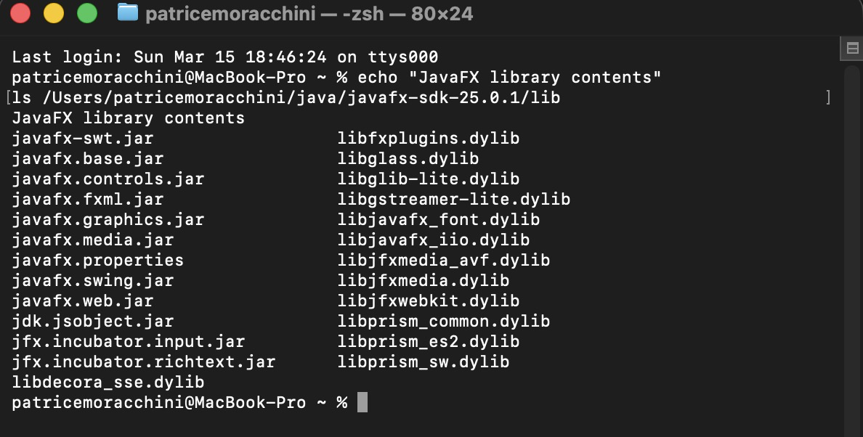

Screenshot 5: JavaFX compilation

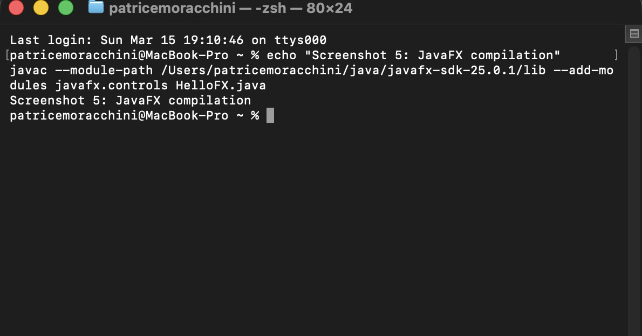

Screenshot 6: JavaFX application running

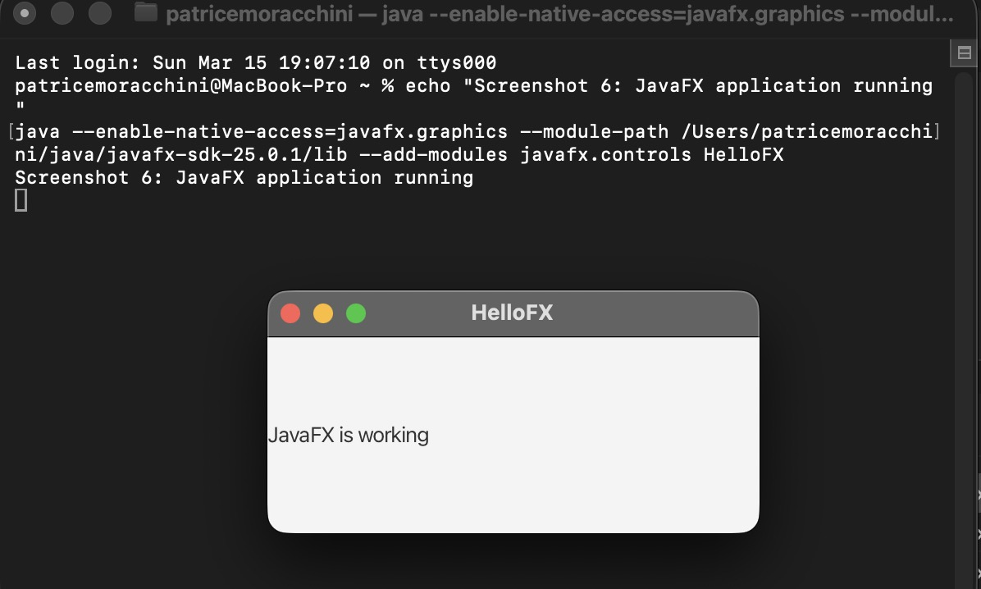

Screenshot 7: RandomCards program executed

