Patrice Moracchini
CSD430-308A(2267-DD)
Jun 28th, 2026

JavaBean Movie Database Display
Screenshots
Module 4.2 Assignment
Pr. Payne

MySQL Database is ready for JSP run.

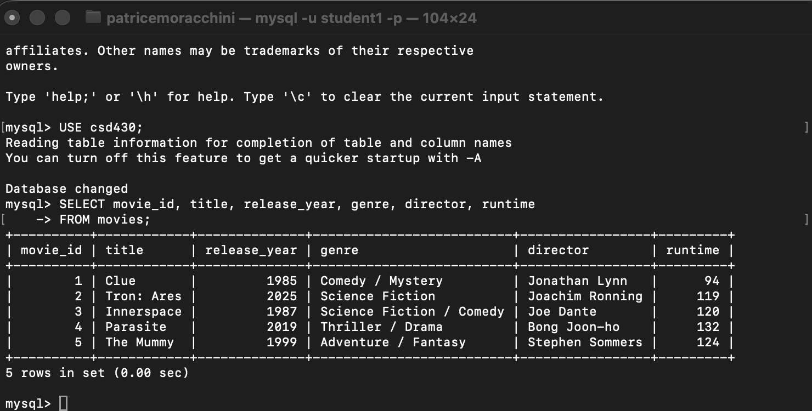

Tomcat Server is running on Eclipse, and mysql-connector-j-9.7.0.jar is in the Tomcat Lib folder.
I entered the address http://localhost:8080/module4-2/movieBeanDisplay.jsp in Safari.

The page displays the data taken from the database in a table:

