Patrice Moracchini
CSD430-308A(2267-DD)
June 7th, 2026

Java Tomcat and IDE installation
Module 1.3 Assignment
Pr. Payne

Java installation and configuration
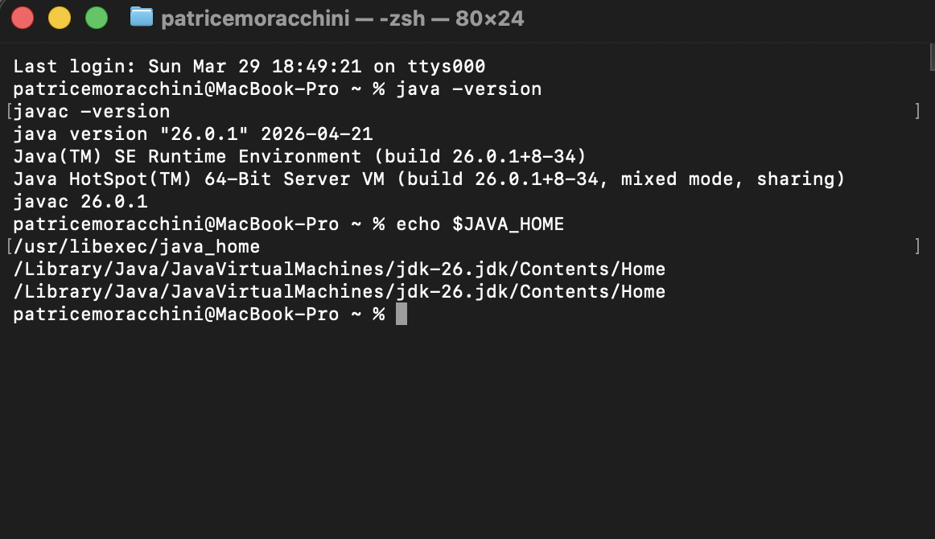

Tomcat

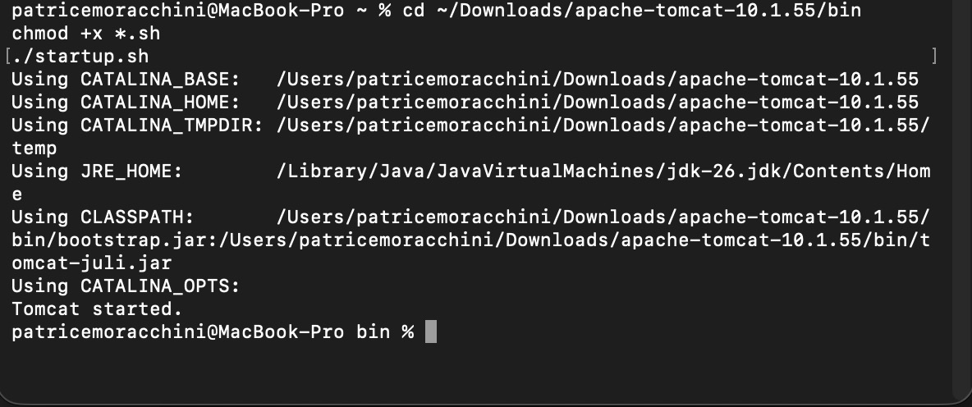
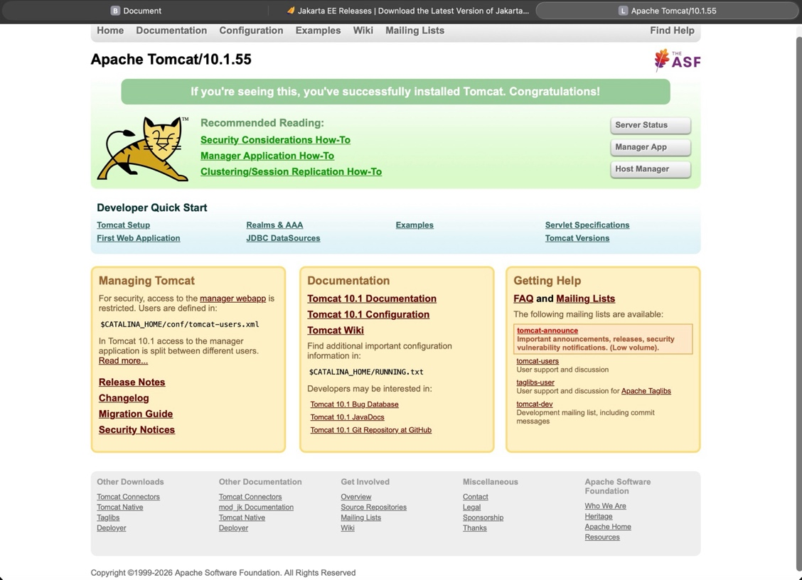
Tomcat is installed, started, and synchronized with Eclipse. I left it on port 8080 because ports below 1024 on macOS are considered privileged and may require elevated permissions.
ECLIPSE

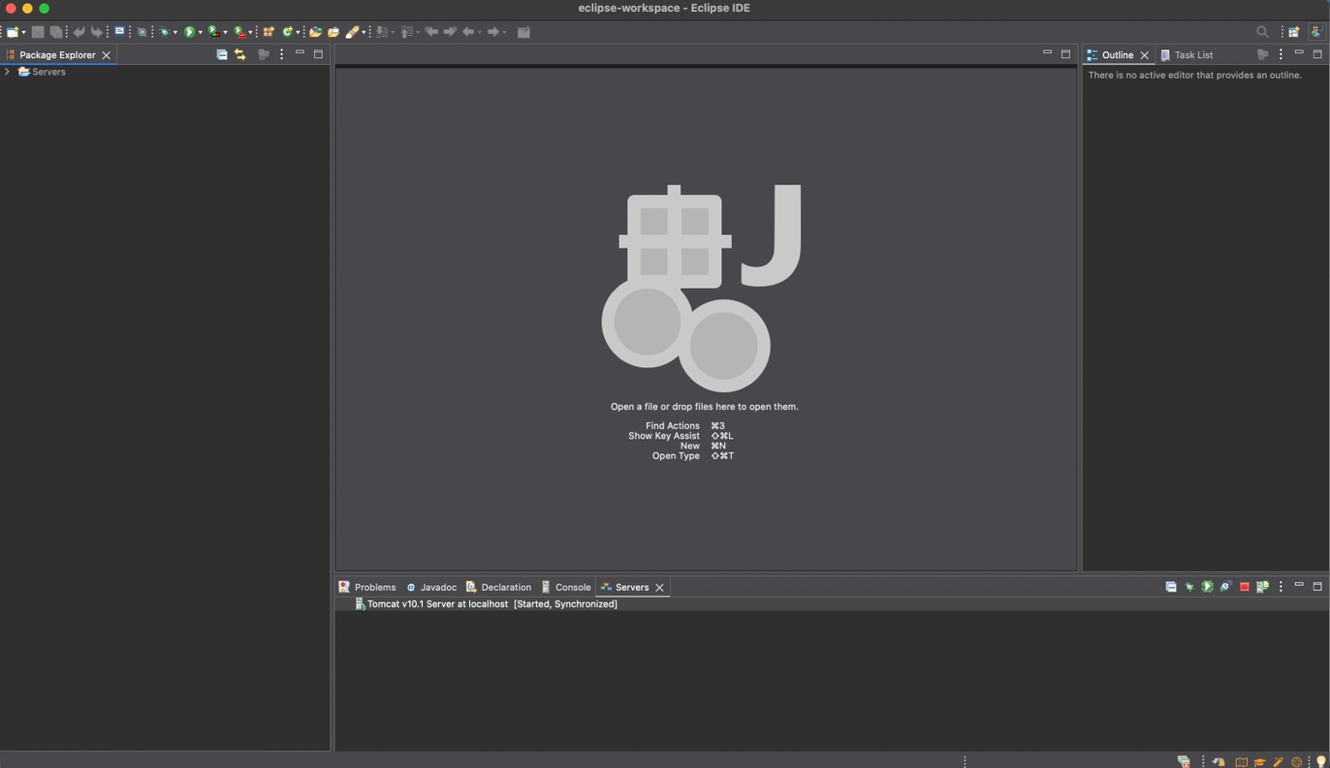

I also installed Spring Tools 5.11 from the Eclipse marketplace.

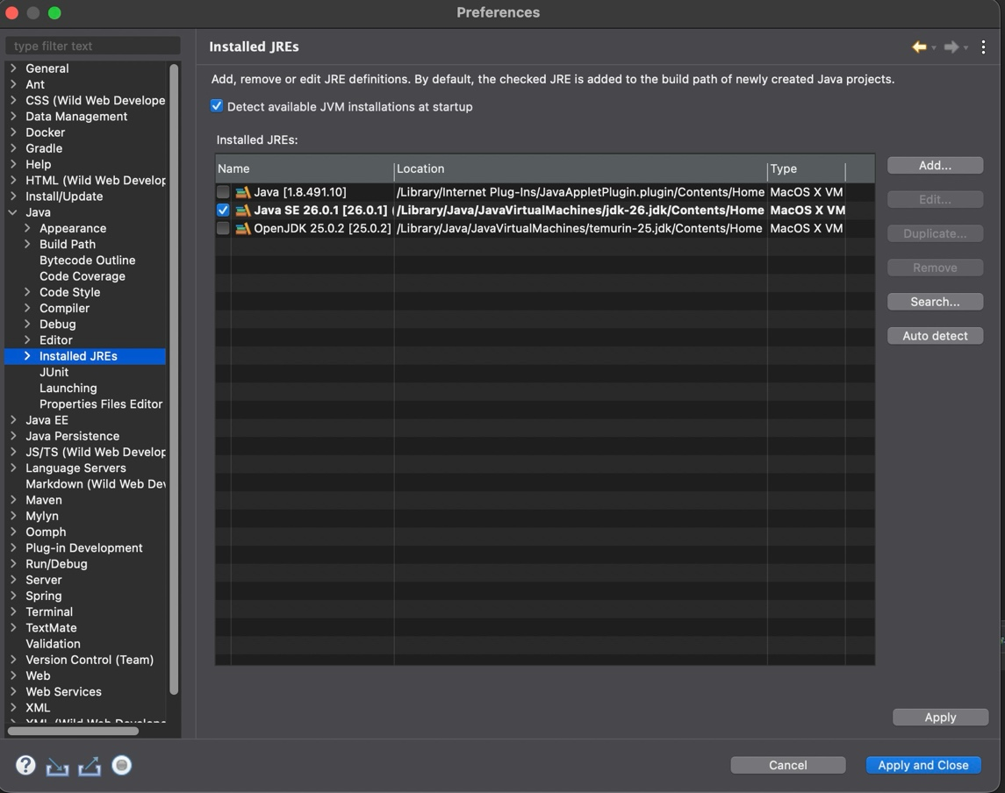

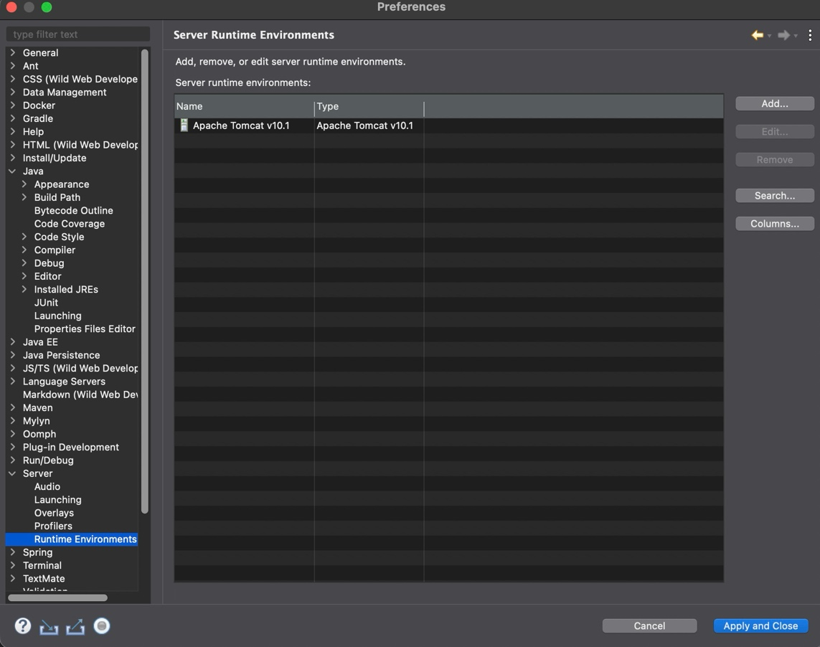
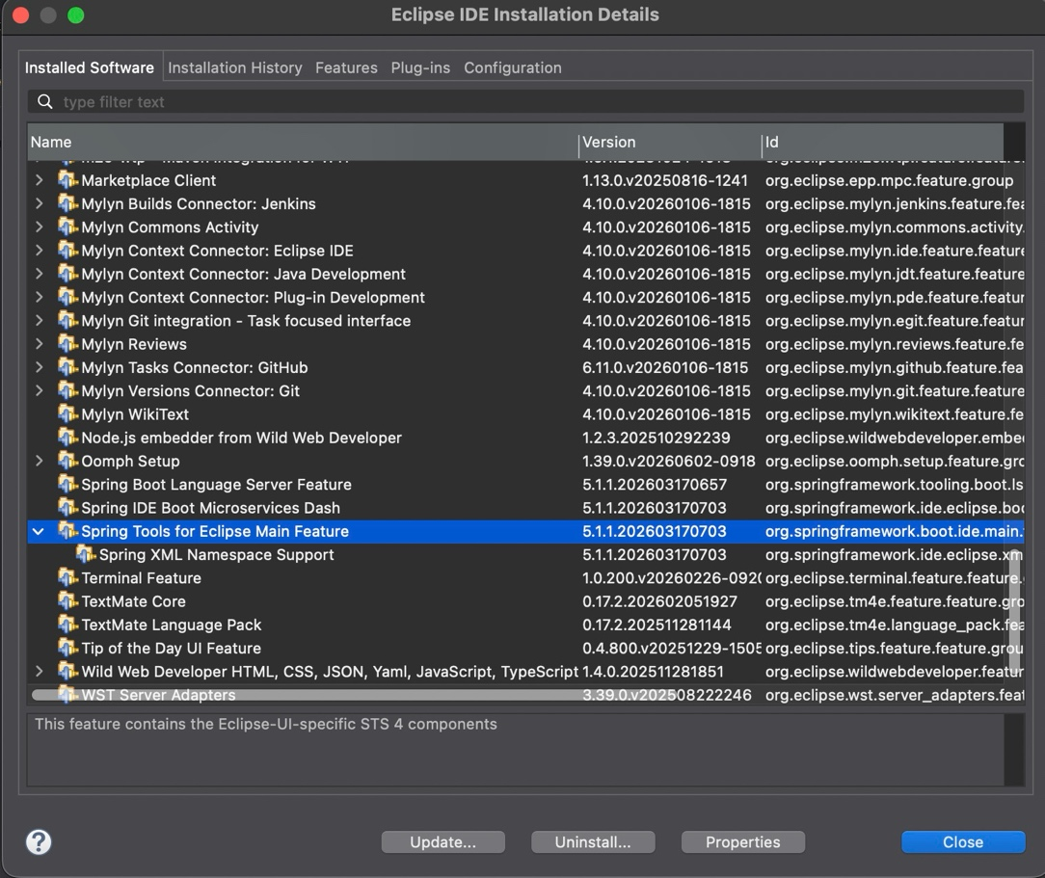

Execution MovieTable.jsp

