Patrice Moracchini
CSD430-308A(2267-DD)
July 12th, 2026

Working with CRUD-CREATE & JavaBeans – Project Part 2
Module 7.2 Assignment
Pr. Payne

Project Screenshot
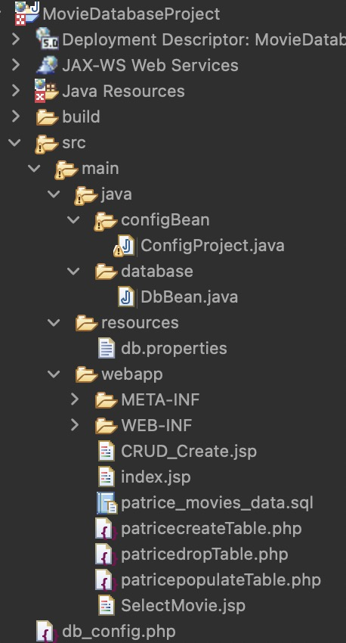

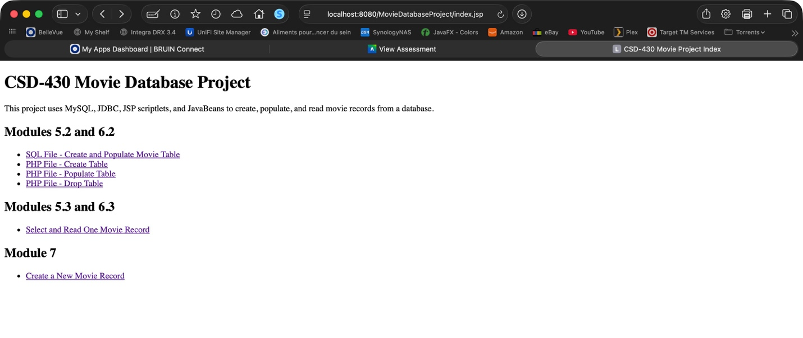
Index Page screenshot
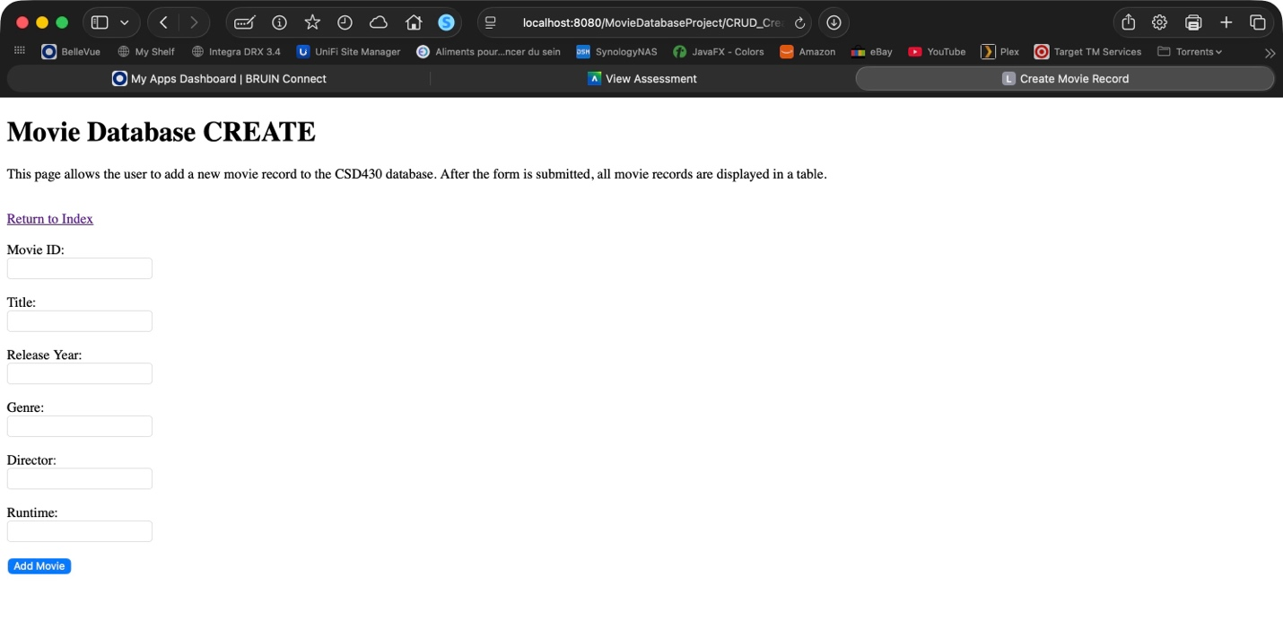
Create Page screenshot
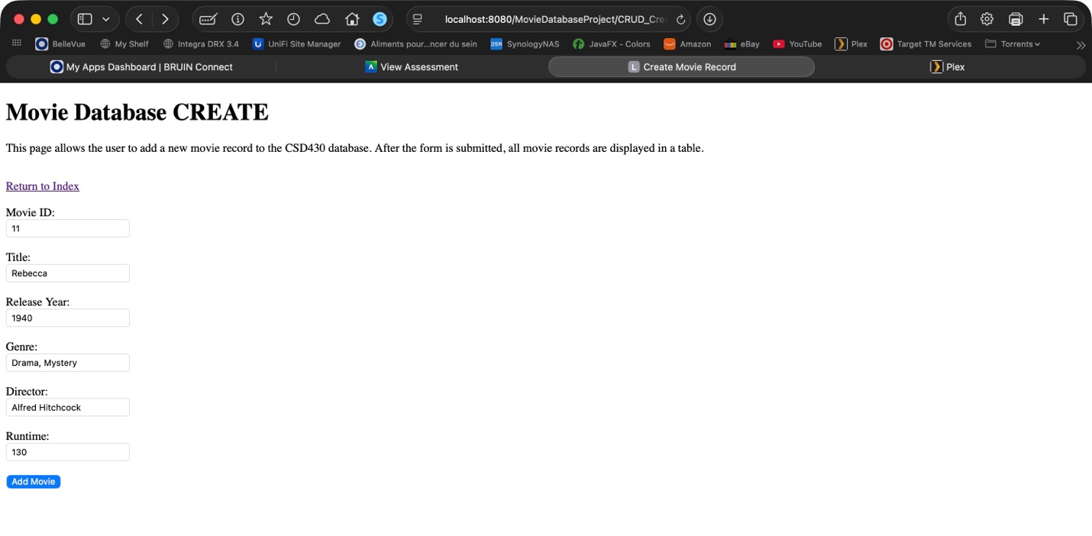
Adding a movie

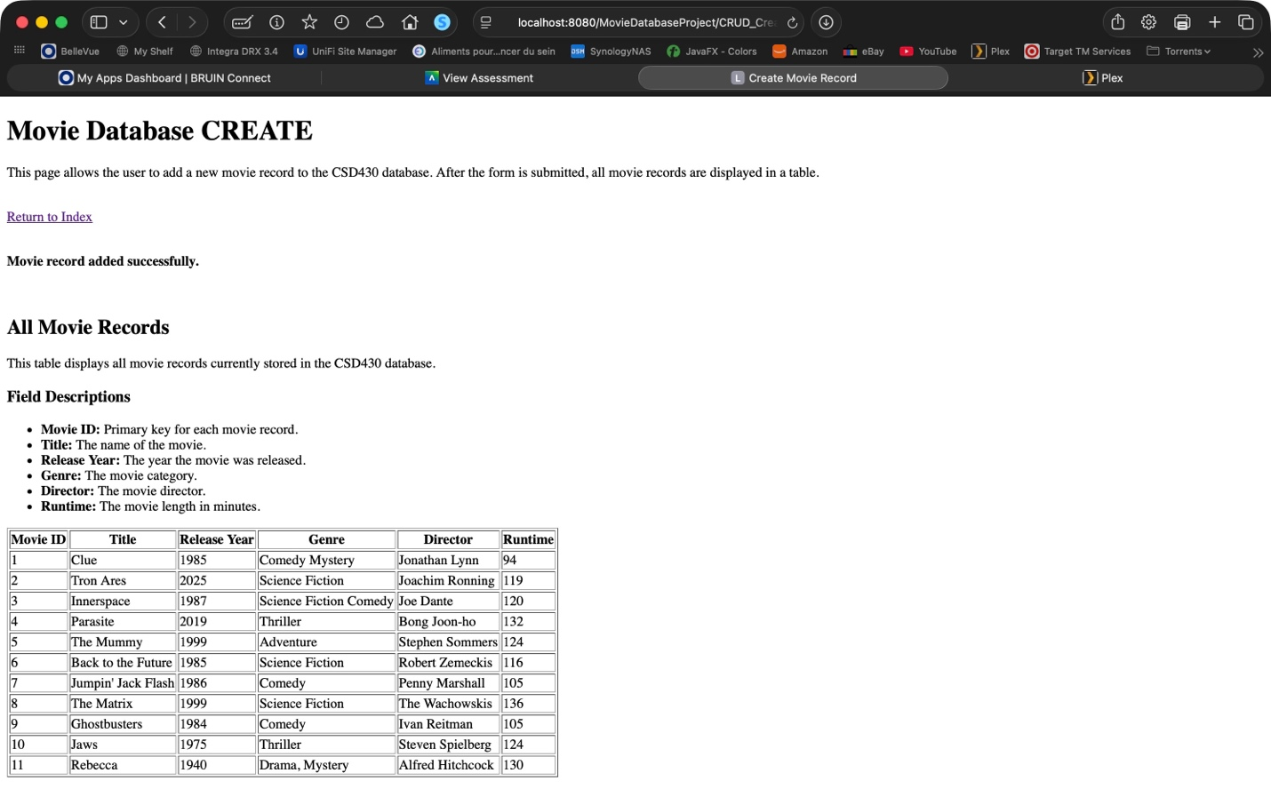
Result Screenshot

