Patrice Moracchini
CSD430-308A(2267-DD)
June 7th, 2026

GitHub Repository Setup
Module 1.2 Assignment
Pr. Payne

Link to GitHub Repository:
https://github.com/Bellevuestudent/csd-430.git
Screenshot 1: GitHub repository

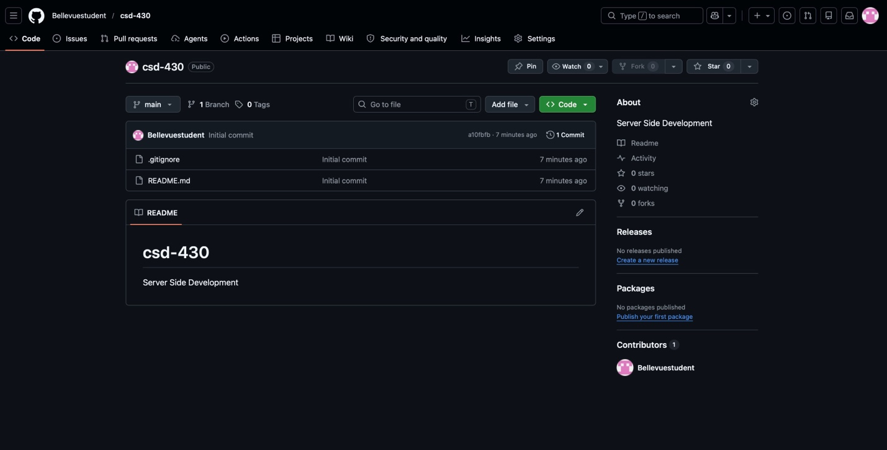

Screenshot 2: Local directory structure

