Patrice Moracchini
CSD430-308A(2267-DD)
August 16th, 2026

First PHP program
Module 1.3 Assignment
Pr. Payne

Screenshot
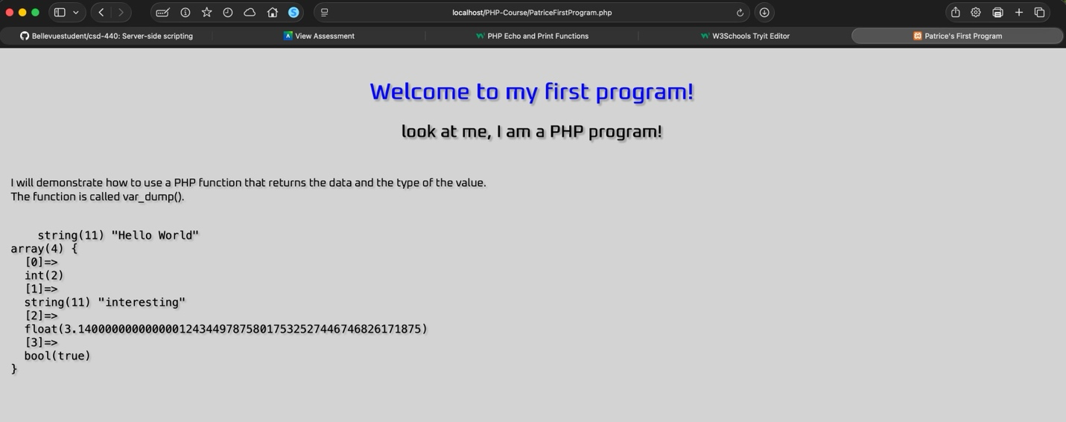

Reference:
This program has been written with help from the W3Schools PHP tutorial.
https://www.w3schools.com/php/default.asp

