Patrice Moracchini
CSD430-308A(2267-DD)
August 16th, 2026

GitHub Repository Setup
Module 1.2 Assignment
Pr. Payne

Link to GitHub Repository:
https://github.com/Bellevuestudent/csd-440.git
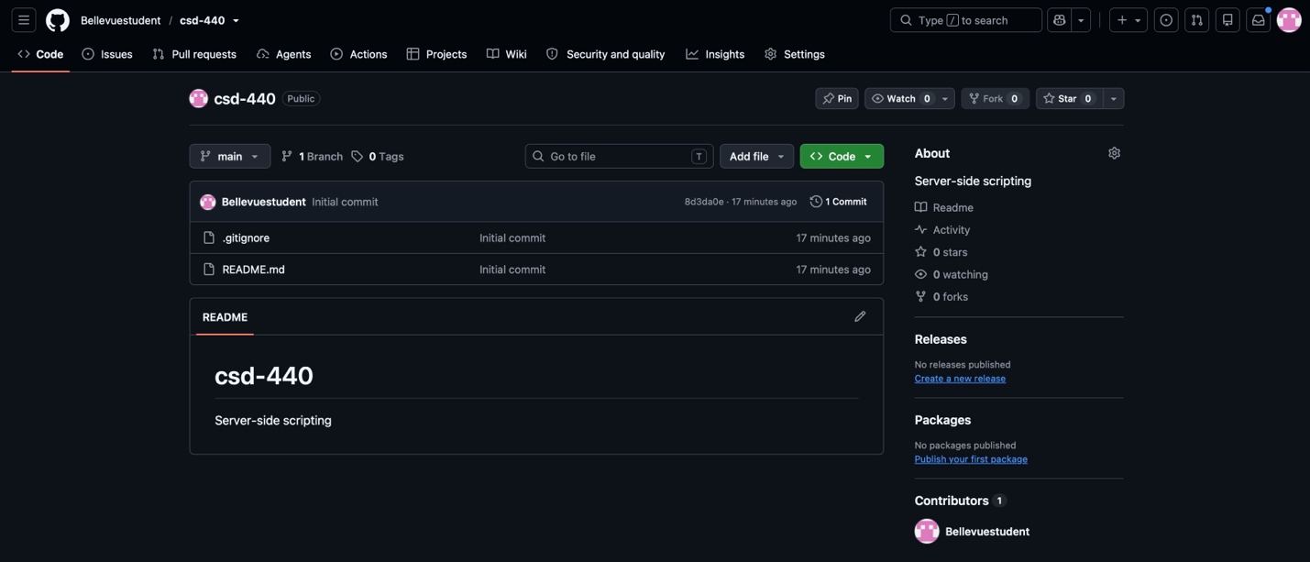
Screenshot 1: GitHub repository

Screenshot 2: Local directory structure

