BRADLEY BENTOW

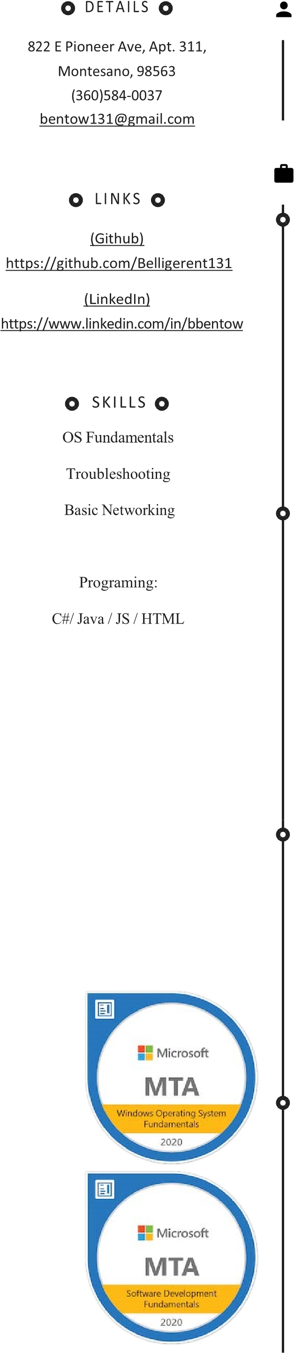Student Software Engineer  MONTESANO, 98563 | (360)584-0037

PROFILE

A passionate Software Engineer student with several years of personal experience. I have experience in several languages and modern technologies, Including Oracle Cloud Services, Amazon Web Services, Microsoft Azure. Also, full-Stack applications using React with Redux, GraphQL, and much more. On top of that, my general experience with Information Tech fundamentals constantly grow; involving networking and technology troubleshooting.

EMPLOYMENT HISTORY

# Software Architect at Lanfest National, Olympia, WA

# June 2020 - Current

* Volunteer Service directed towards Gamers for charitable causes
* Organize and direct the team for website development
* Assist with implementing new content mainly using PHP, JS, and HTML
* Liaison for events as a National Representative, and assist with technical aspects

# Field Service Technician at Capital Business Machines, Inc., Olympia, WA

# October 2019 - Current

* Reassemble machines after making repairs or replacing parts.
* Travel to customers' stores or offices to service machines or to provide emergency repair service.
* Install and configure new equipment, including operating software or peripheral equipment.
* Reinstall software programs or adjust settings on existing software to fix machine malfunctions.

# Corrections Officer at Washington State Dept. of Corrections, Aberdeen, WA

## July 2013 — September 2019

* Assisted with recruitment and training of new employees, while also monitoring the safety of current employees.
* Use weapons, handcuffs, and physical force to maintain discipline and order among prisoners.
* Conduct fire, safety, and sanitation inspections.
* Monitor conduct of prisoners in housing unit, or during work or recreational activities, according to established policies, regulations, and procedures, to prevent escape or violence.
* Settle disputes between inmates.

# Watercraft Operator at Army Reserves, Tacoma, WA

## February 2008— February 2016

* Assisted with recruitment and training of new employees, while also monitoring the safety of current employees.
* Maintain government-issued certifications, as required.
* Steer ships under the direction of commanders or navigating officers or direct helmsmen to steer, following designated courses.
* Progressed to the rank of Specialist (E-4)
* Attended training events in courses pertaining to leadership
* Handle lines to moor vessels to wharfs, to tie up vessels to other vessels, or to rig towing lines.

# Audio Video Installer at Westport Shipyard LLC, Westport, WA

## March 2012 — May 2013

* Install equipment and accessories such as stereos, navigation equipment, communication equipment, and security systems.
* Installed in-wall and ceiling speakers for a great surround-sound experience.
* Maintained systems and provided trouble-shooting services when needed.
* Tested systems post-set up to ensure they worked and to make certain customers were comfortable and understood how to operate them.
* Maintained systems and provided trouble-shooting services when needed.

EDUCATION



# B.S. Information Technology, Liberty University, Lynchburg, VA

## September 2018 — June 2022

* Advance concepts of Object-Oriented Programming
* Adapt and use sever languages such as C#, C++, Python, Javascript, Html, Css.
* Courses oriented towards business organization and leadership.
* SQL and NoSQL databases heavily emphasized towards Oracle systems

COURSES

# Warrior Leadership Course, Army Reserves July

2015 — August 2015

# Basic Essential Skills for Instructors, Washington State Dept. of Corrections

## February 2017 — February 2017