**Міністерство освіти і науки України**

**Національний технічний університет України**

**“Київський політехнічний інститут”**

**Факультет прикладної математики**

**Кафедра спеціалізованих комп’ютерних систем**

**Лабораторна робота № 1**

з дисципліни «WEB-дизайн»

«**Розробка статичного інтерфейсу Web-додатка**»



Виконав:

студент групи КВ-84

**Мулярчук Микола**

Київ 2021

**Зміст**

**Мета**: ознайомитись із засобами мов HTML5 та CSS3 та навчитись застосовувати бібліотеки Twitter Bootstrap/Material UI щодо швидкої побудови Web-інтерфейсу користувача.

**Загальне завдання**: розробити статичні Web-сторінки додатку та перевірити коректне їх відображення на екранах різного розміру.

Інструменти розробки: мови HTML5, CSS3, фреймворки [Twitter Bootstrap](https://getbootstrap.com/) або [Material UI](https://material.io/develop/web)

**Зміст**

**Github:** https://github.com/Bellis-lab/web_lab**на drive**  
**Telegram:** @origin9

**Опис лабораторної:**Мною був створений “Блог” додаток з використанням HTML, CSS та фреймворку Bootstrap.

**HTML сторінки додатку**

* **index.html -** головна сторінка. На цій сторінці знаходяться всі останні опубліковані пости.   
  Desktop  
  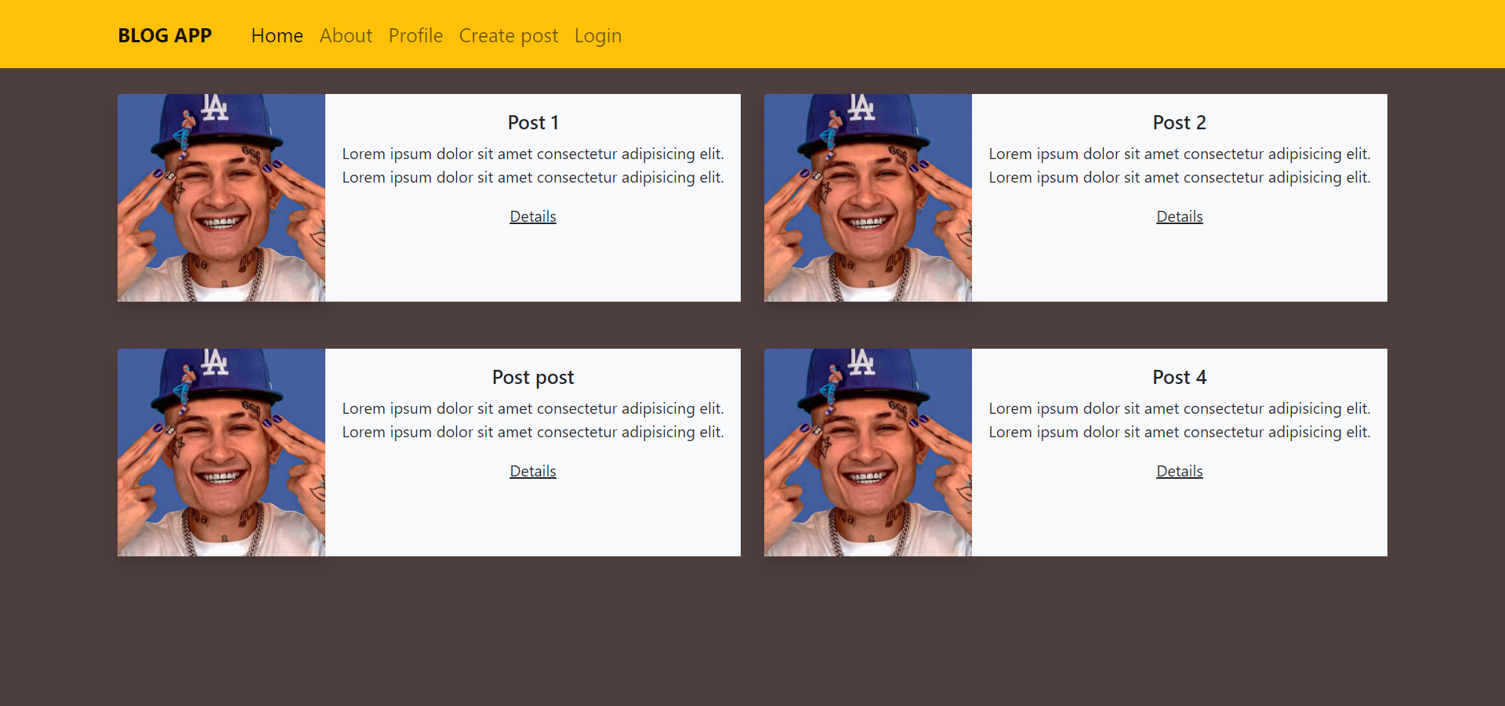  
  Tablet  
  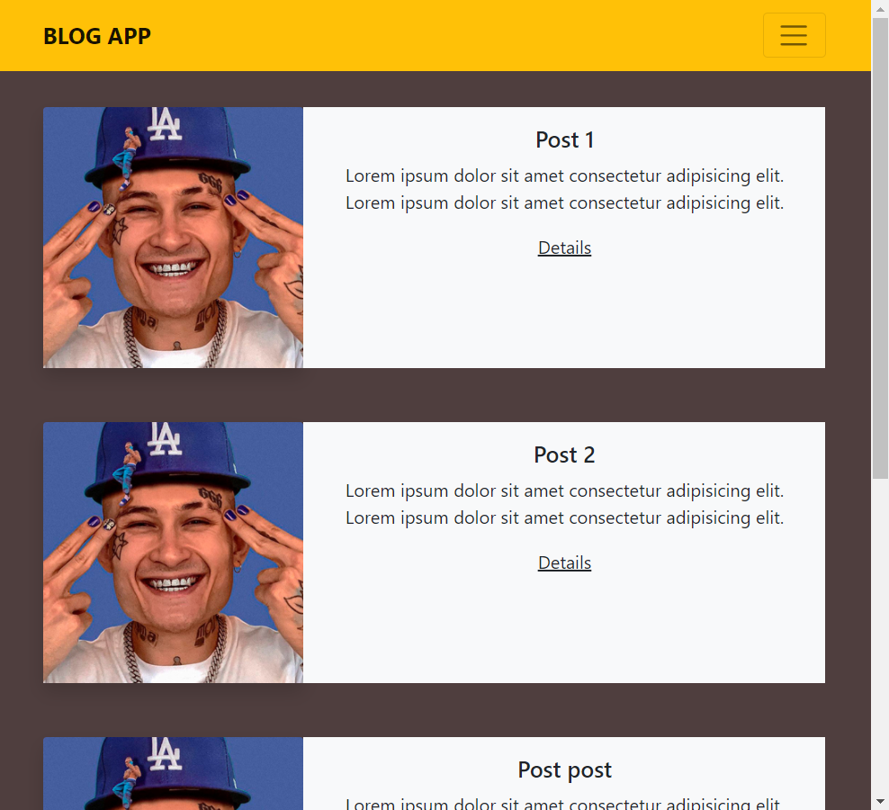  
  Mobile  
  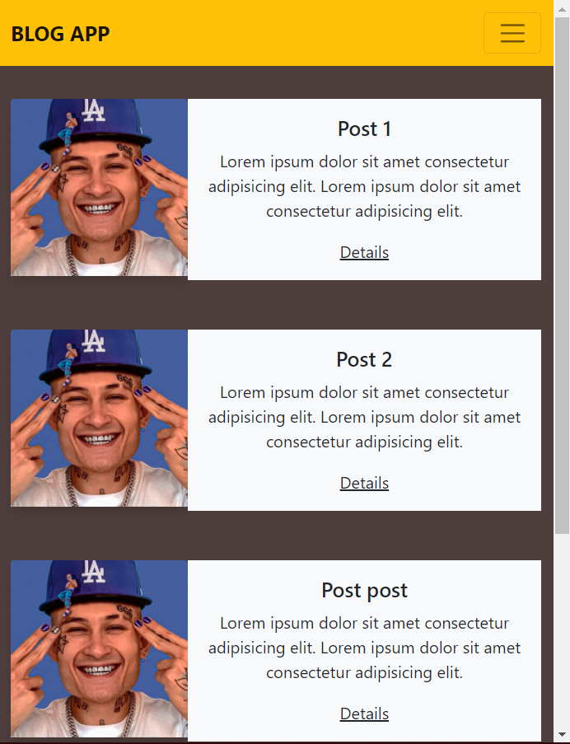
* **post.html** - сторінка посту. Відображається назва, текст та зображення прикріплене до посту. Також під постом відображаються коментарі.  
    
  Desktop   
  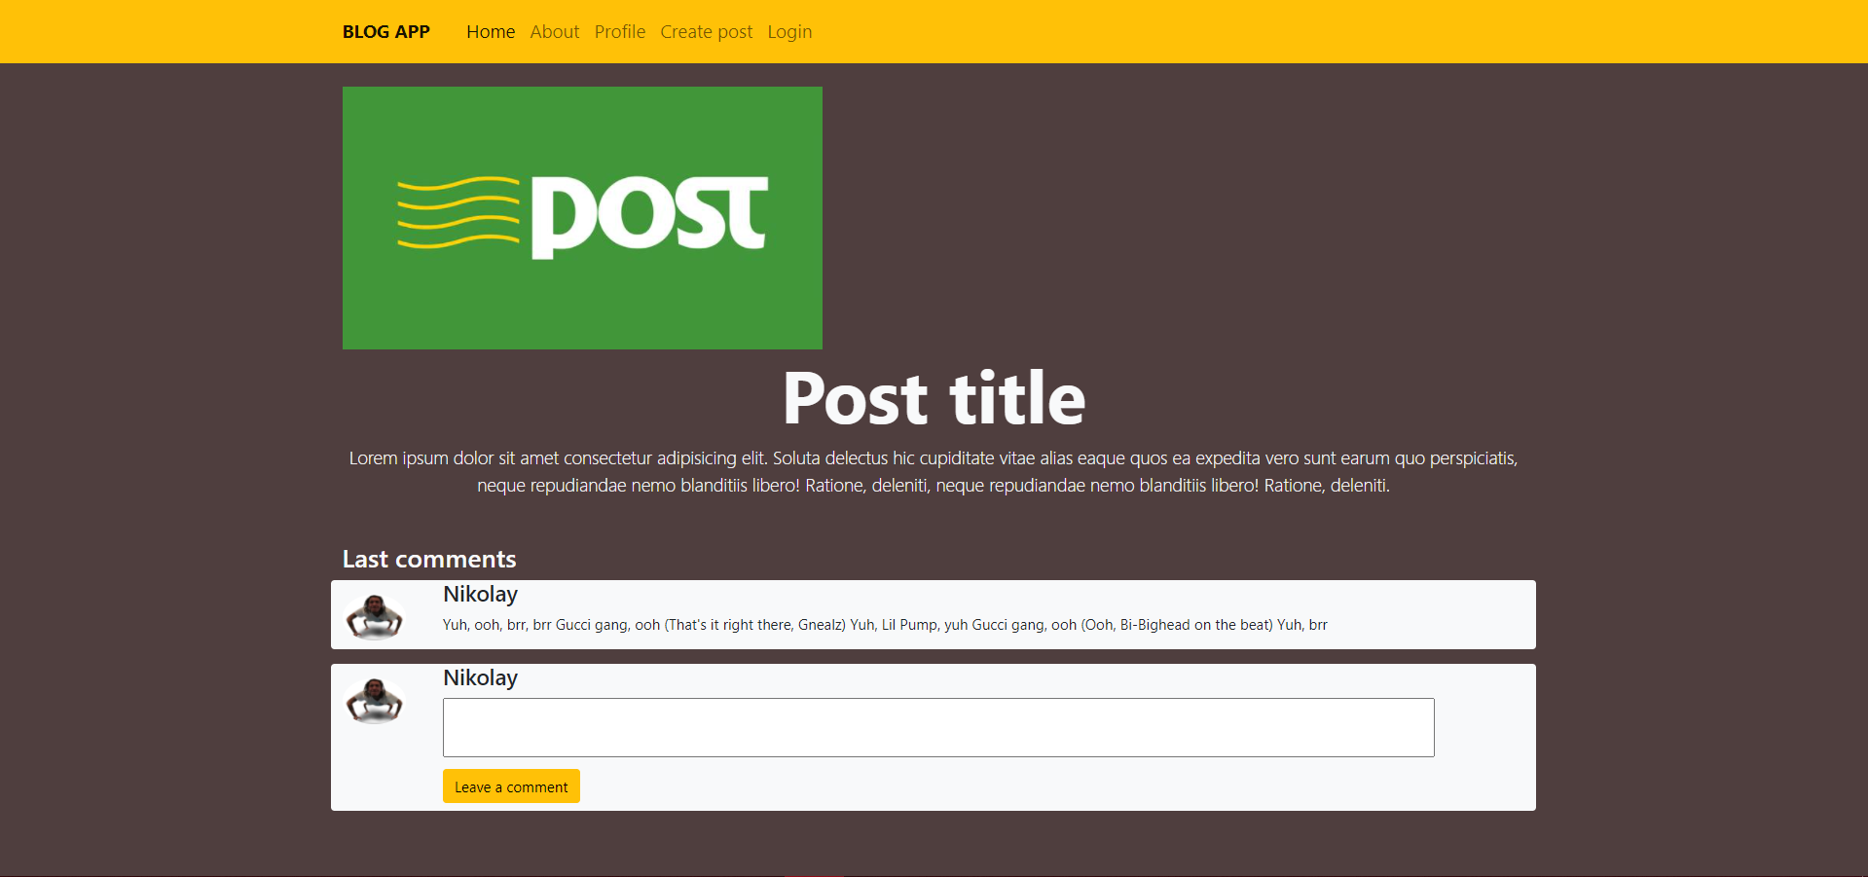  
  Tablet  
  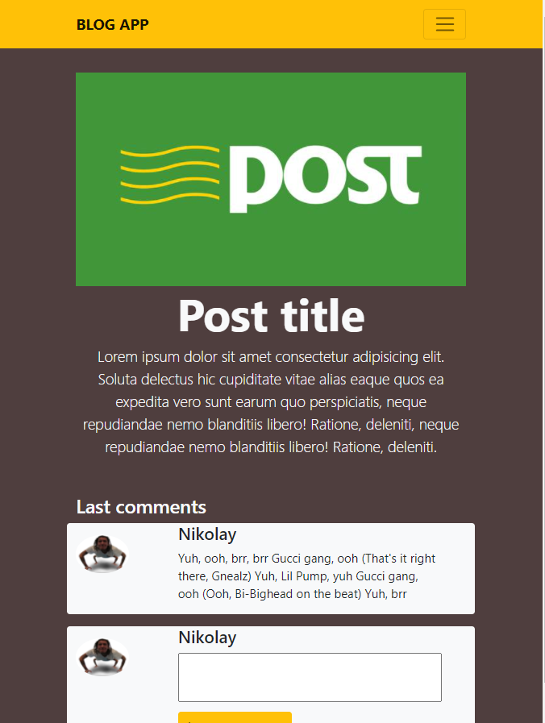  
  Mobile  
  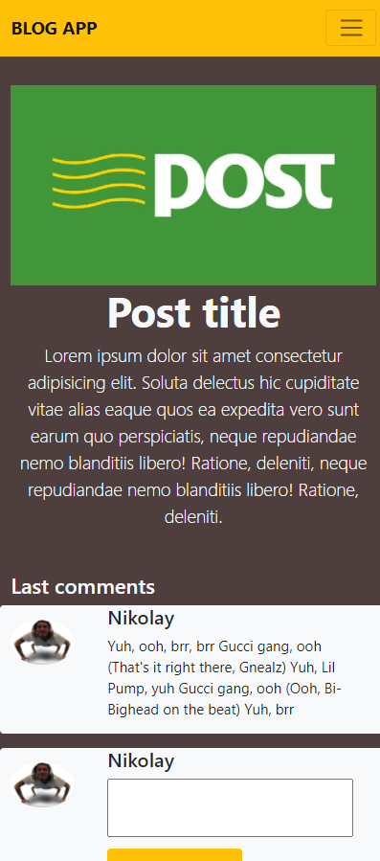

* **about.html -** сторінка з описом додатку.  
  Desktop  
   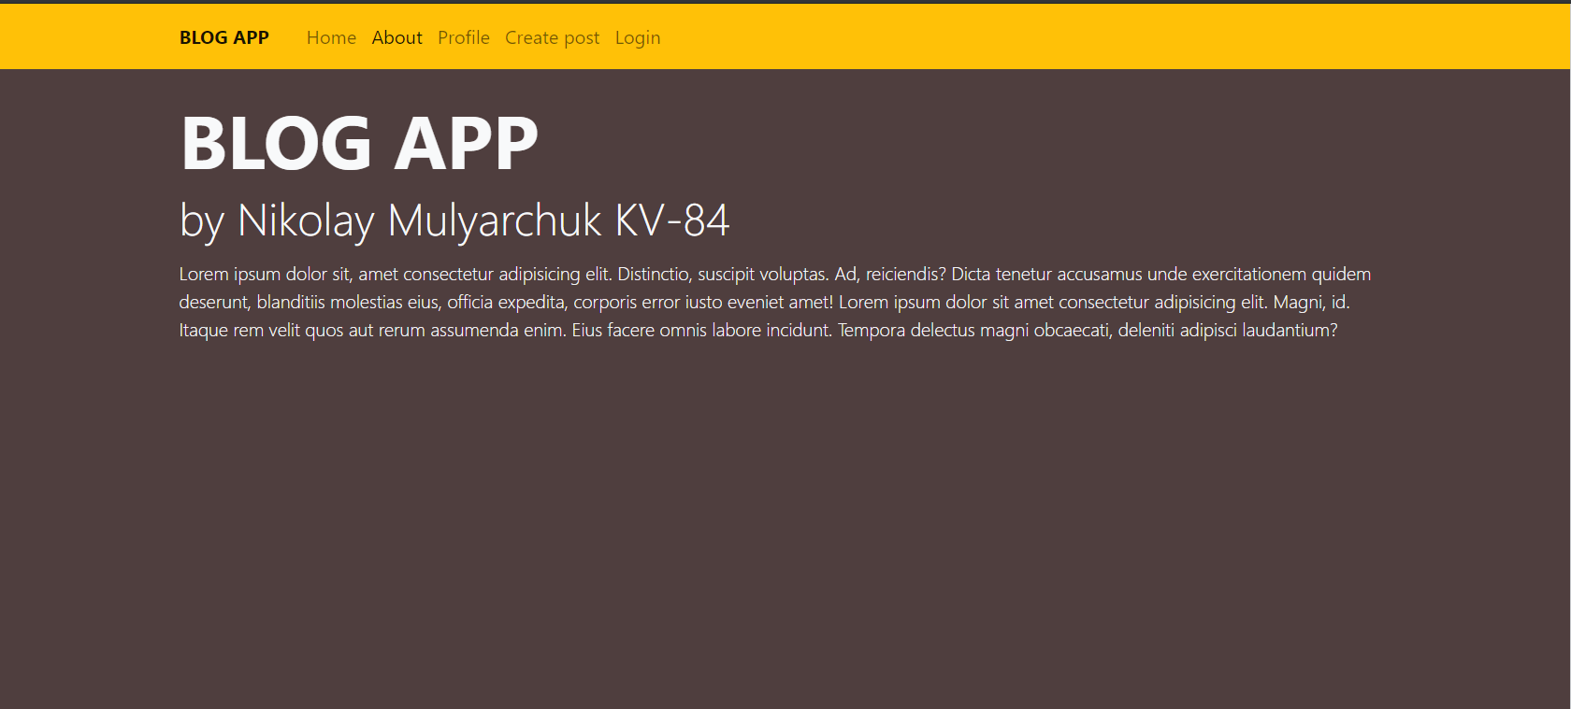  
  Tablet  
  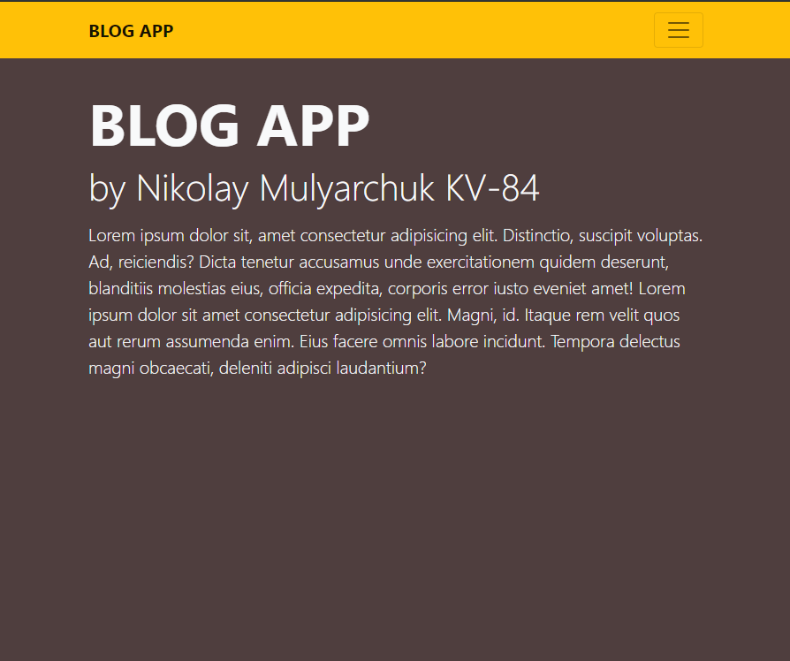  
  Mobile  
  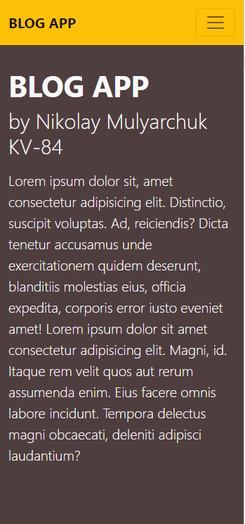
* **new_post.html**  - сторінка для створення нового поста.  
  Desktop  
  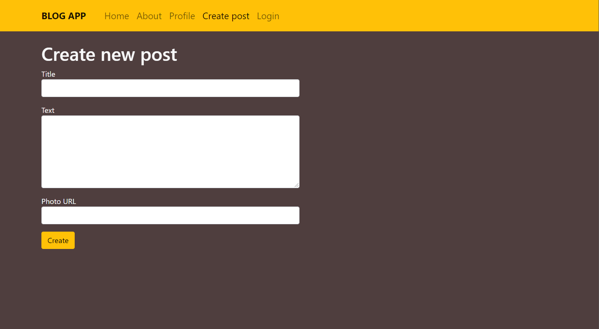  
  Tablet  
  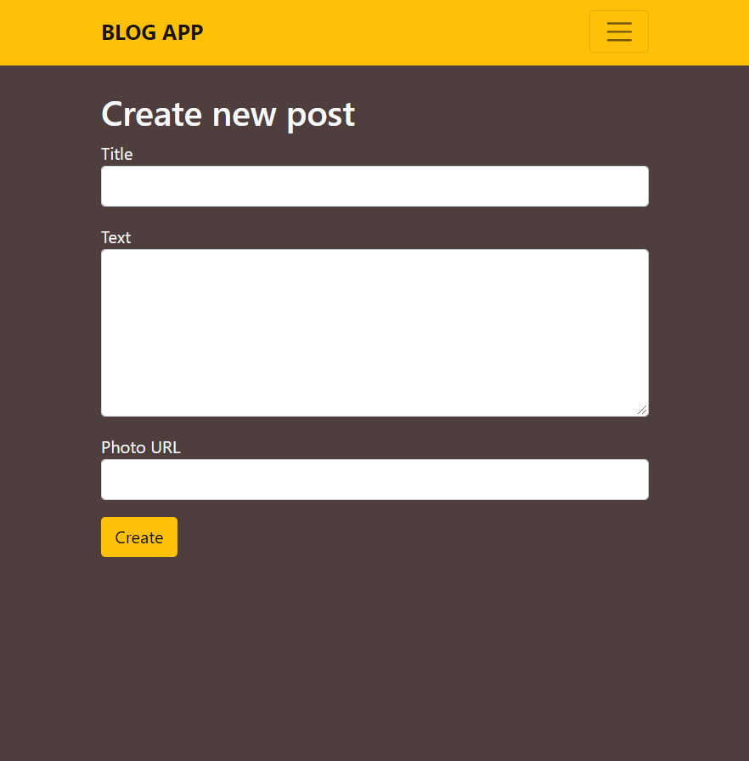  
  Mobile

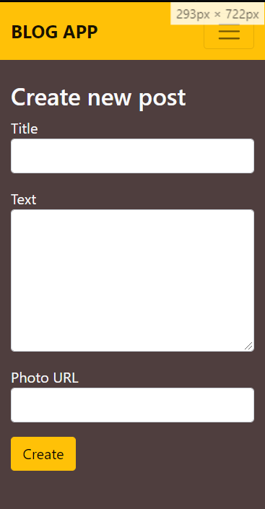

* **profile.html -** cторінка профілю. Взята з інтернету.   
    
  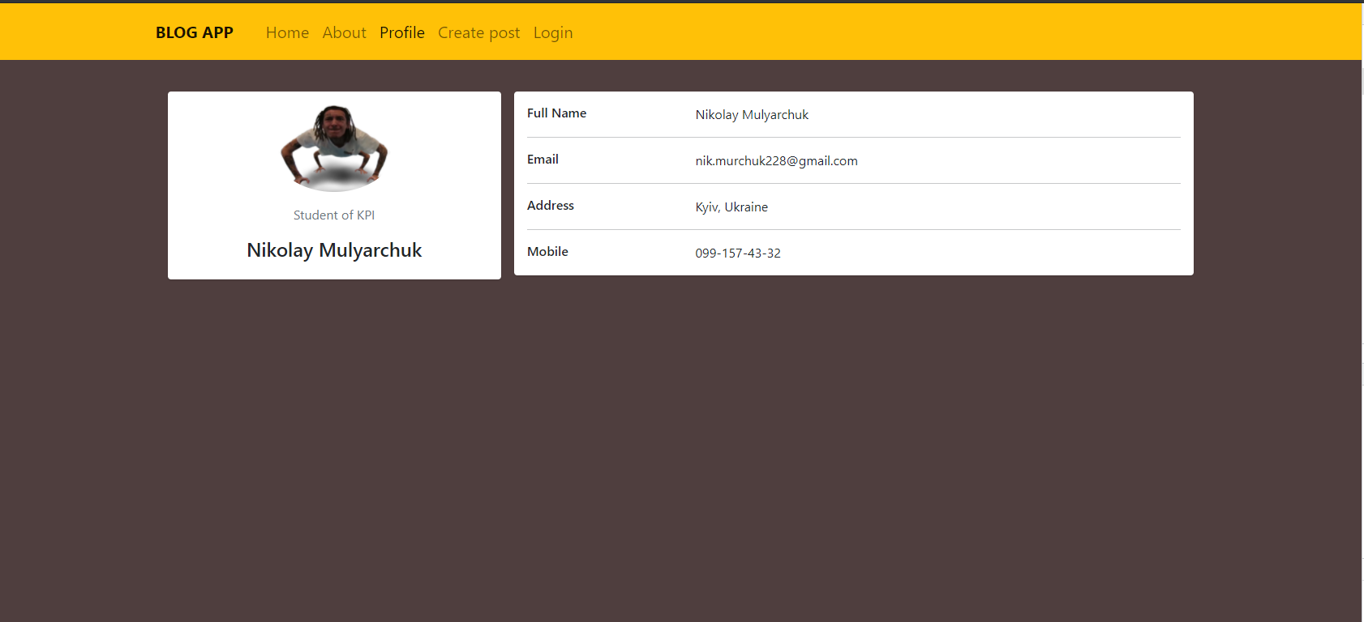  
  Tablet  
  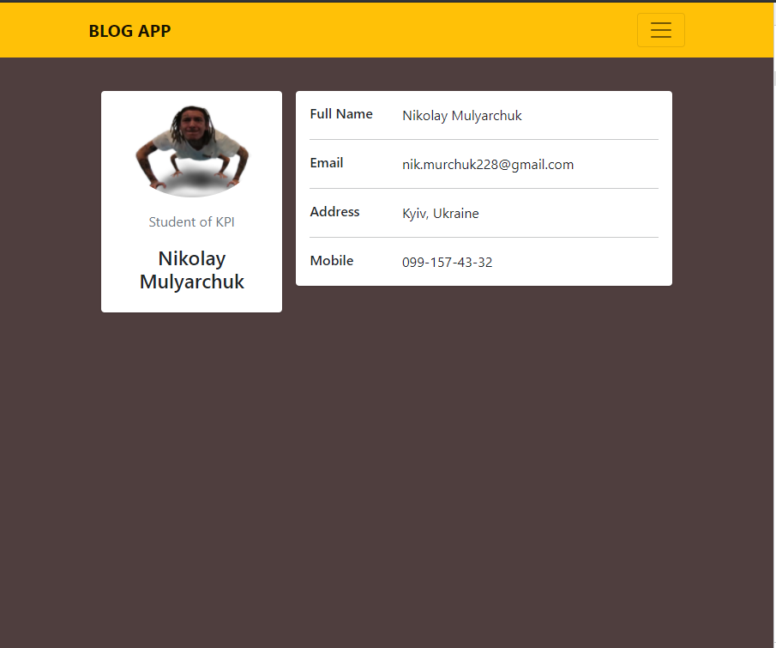  
  Mobile  
  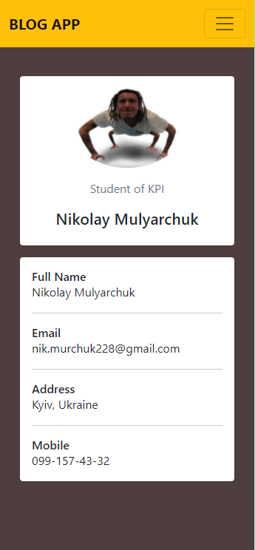
* **login.html -** cторінка логіну.

Desktop  
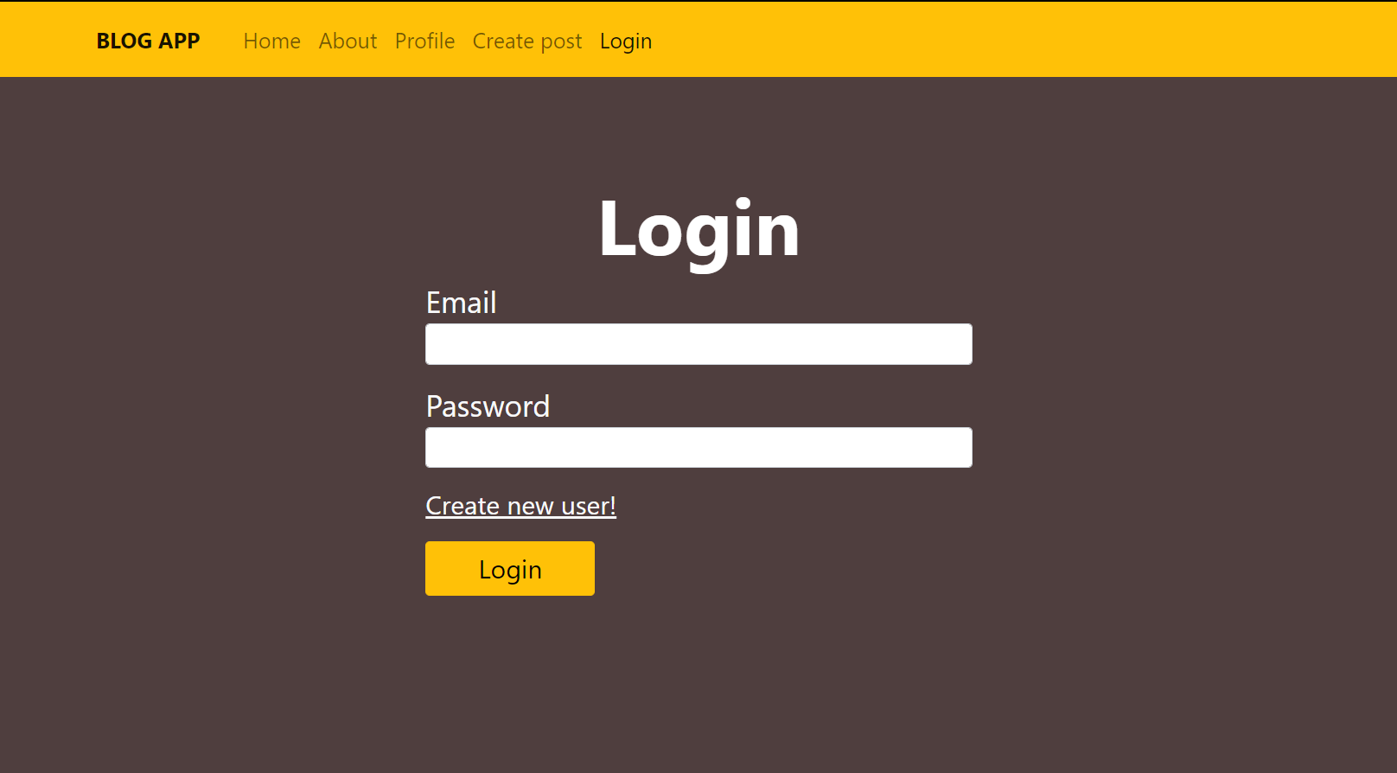  
Tablet  
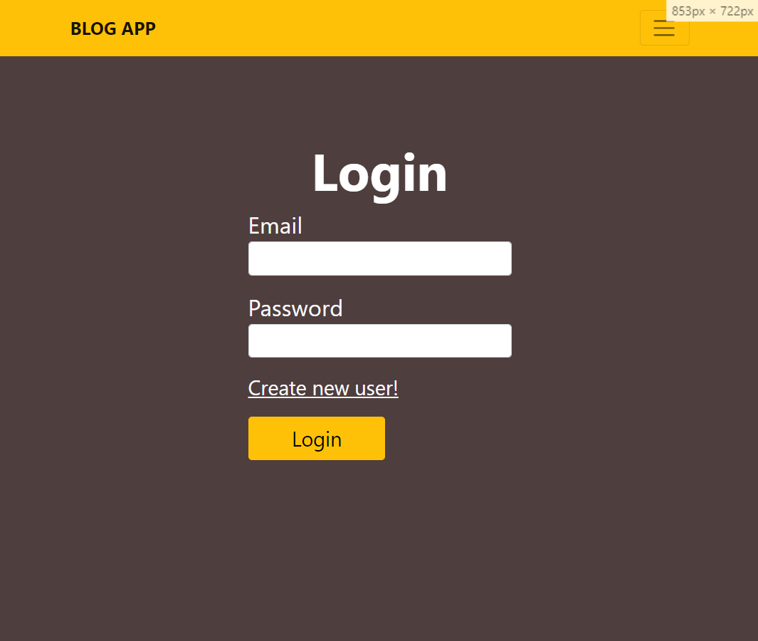  
Mobile  
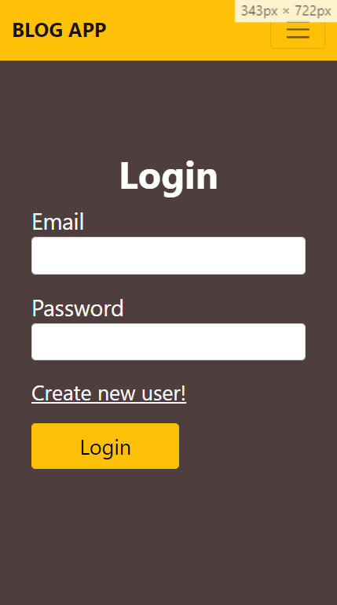

* **registration.html -** сторінка регістрації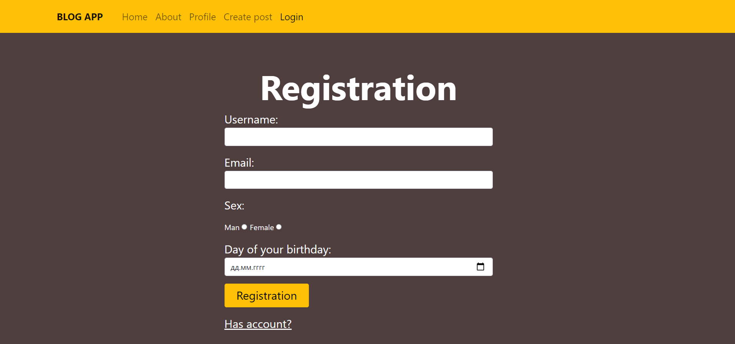  
    
  Tablet   
  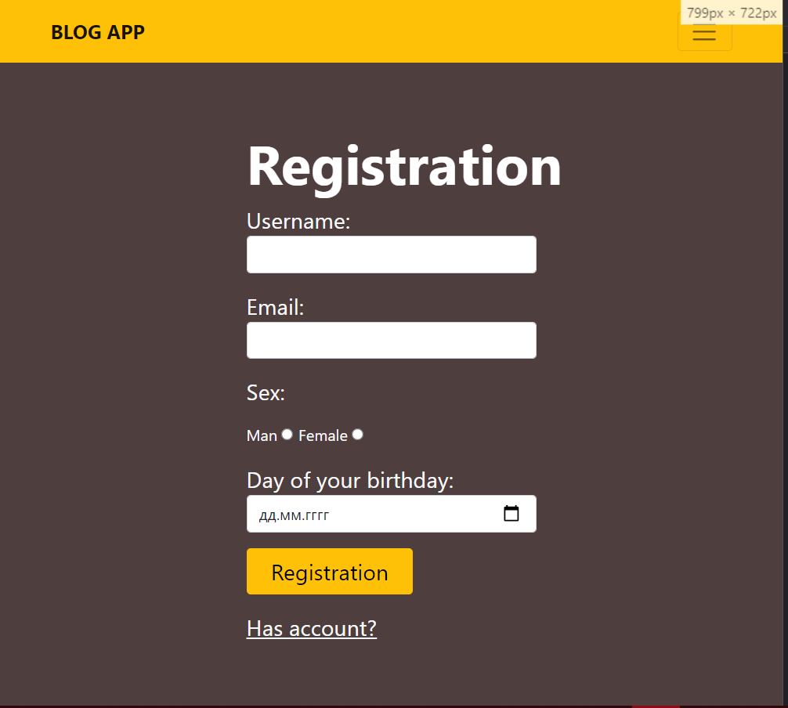Mobile  
  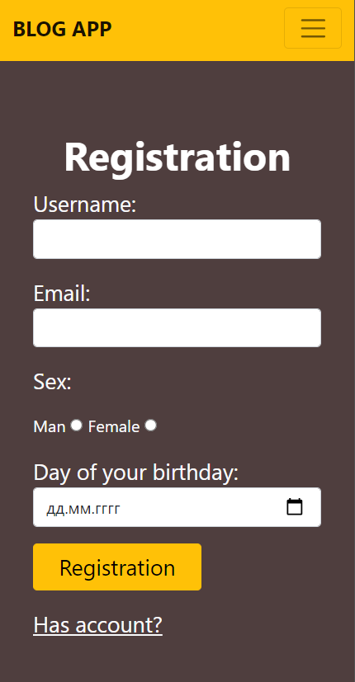

# Index.html <!DOCTYPE *html*>

# <html *lang*="en">

# <head>

# <meta *charset*="UTF-8" />

# <meta *http-equiv*="X-UA-Compatible" *content*="IE=edge" />

# <meta *name*="viewport" *content*="width=device-width, initial-scale=1.0" />

# <link

# *href*="https://cdn.jsdelivr.net/npm/bootstrap@5.0.0-beta1/dist/css/bootstrap.min.css"

# *rel*="stylesheet"

# *integrity*="shapost86-giJF6kkoqNQ00vy+HxlP7azOuL0xtbfIcaT9wjKHr8RbDVddVHyTfAAsrekwKmP1"

# *crossorigin*="anonymous" />

# <link *rel*="stylesheet" *href*="./css/style.css" />

# <title>WEB</title>

# </head>

# <body *style*="background: #4f3e3e;">

# <header *class*="header py-1 fixed-top bg-warning">

# <nav *class*="container navbar navbar-expand-xl navbar-light">

# <a *class*="navbar-brand" *href*="./index.html">

# <span *class*="navbar-brand fw-bold">BLOG APP</span>

# </a>

# <button *class*="navbar-toggler" *type*="button" *data-toggle*="collapse"

# *data-target*="./post.htmlnavbarSupportedContent"

# *aria-controls*="navbarSupportedContent" *aria-expanded*="false"

# *aria-label*="Toggle navigation">

# <span *class*="navbar-toggler-icon"></span>

# </button>

# <div *class*=" collapse navbar-collapse" *id*="navbarSupportedContent">

# <ul *class*="navbar-nav mr-auto fs-5">

# <li *class*="nav-item active">

# <a *class*="nav-link active" *href*="./index.html">Home</a>

# </li>

# <li *class*="nav-item">

# <a *class*="nav-link" *href*="./about.html">About</a>

# </li>

# <li *class*="nav-item">

# <a *class*="nav-link" *href*="./profile.html">Profile</a>

# </li>

# <li *class*="nav-item">

# <a *class*="nav-link" *href*="./new_post.html">Create post</a>

# </li>

# <li *class*="nav-item">

# <a *class*="nav-link" *href*="./login.html">Login</a>

# </li>

# </ul>

# </div>

# </nav>

# </header>

# <main *class*="pt-5 text-center">

# <div *class*="mt-5 container">

# <div *class*="row">

# <div *class*="col-12 col-xl-6 mb-5">

# <div *class*="row g-0">

# <div *class*="col-4">

# <img *class*="card-img-top shadow"

# *src*="./images/post2.jpg" *alt*="Card image cap" />

# </div>

# <div *class*="col-8 bg-light">

# <div *class*="card-body">

# <h5 *class*="card-title">Post 1</h5>

# <p *class*="card-text">

# Lorem ipsum dolor sit amet consectetur

# adipisicing elit. Lorem ipsum dolor sit amet

# consectetur adipisicing elit.

# </p>

# <a *href*="./post.html" *class*="text-dark py-2">Details</a>

# </div>

# </div>

# </div>

# </div>

# <div *class*="col-12 col-xl-6 mb-5">

# <div *class*="row g-0">

# <div *class*="col-4">

# <img *class*="card-img-top shadow"

# *src*="./images/post2.jpg" *alt*="Card image cap" />

# </div>

# <div *class*="col-8 bg-light">

# <div *class*="card-body">

# <h5 *class*="card-title">Post 2</h5>

# <p *class*="card-text">

# Lorem ipsum dolor sit amet consectetur

# adipisicing elit. Lorem ipsum dolor sit amet

# consectetur adipisicing elit.

# </p>

# <a *href*="./post.html" *class*="text-dark py-2">Details</a>

# </div>

# </div>

# </div>

# </div>

# <div *class*="col-12 col-xl-6 mb-5">

# <div *class*="row g-0">

# <div *class*="col-4">

# <img *class*="card-img-top shadow"

# *src*="./images/post2.jpg" *alt*="Card image cap" />

# </div>

# <div *class*="col-8 bg-light">

# <div *class*="card-body">

# <h5 *class*="card-title">Post post</h5>

# <p *class*="card-text">

# Lorem ipsum dolor sit amet consectetur

# adipisicing elit. Lorem ipsum dolor sit amet

# consectetur adipisicing elit.

# </p>

# <a *href*="./post.html" *class*="text-dark py-2">Details</a>

# </div>

# </div>

# </div>

# </div>

# <div *class*="col-12 col-xl-6 mb-5">

# <div *class*="row g-0">

# <div *class*="col-4">

# <img *class*="card-img-top shadow"

# *src*="./images/post2.jpg" *alt*="Card image cap" />

# </div>

# <div *class*="col-8 bg-light">

# <div *class*="card-body">

# <h5 *class*="card-title">Post 4</h5>

# <p *class*="card-text">

# Lorem ipsum dolor sit amet consectetur

# adipisicing elit. Lorem ipsum dolor sit amet

# consectetur adipisicing elit.

# </p>

# <a *href*="./post.html" *class*="text-dark py-2">Details</a>

# </div>

# </div>

# </div>

# </div>

# </div>

# </div>

# </main>

# </body>

# </html>

**post.html  
<!DOCTYPE *html*>**

**<html *lang*="en">**

**<head>**

**<meta *charset*="UTF-8" />**

**<meta *http-equiv*="X-UA-Compatible" *content*="IE=edge" />**

**<meta *name*="viewport" *content*="width=device-width, initial-scale=1.0" />**

**<link**

***href*="https://cdn.jsdelivr.net/npm/bootstrap@5.0.0-beta1/dist/css/bootstrap.min.css"**

***rel*="stylesheet"**

***integrity*="sha384-giJF6kkoqNQ00vy+HMDP7azOuL0xtbfIcaT9wjKHr8RbDVddVHyTfAAsrekwKmP1"**

***crossorigin*="anonymous" />**

**<link *rel*="stylesheet" *href*="./css/style.css" />**

**<title>WEB</title>**

**</head>**

**<body *style*="background: #4f3e3e;">**

**<header *class*="header py-1 bg-warning fixed-top">**

**<nav *class*="container navbar navbar-expand-lg navbar-light">**

**<a *class*="navbar-brand" *href*="./index.html">**

**<span *class*="navbar-brand fw-bold">BLOG APP</span>**

**</a>**

**<button *class*="navbar-toggler" *type*="button" *data-toggle*="collapse"**

***data-target*="./post.hmtlnavbarSupportedContent"**

***aria-controls*="navbarSupportedContent" *aria-expanded*="false"**

***aria-label*="Toggle navigation">**

**<span *class*="navbar-toggler-icon"></span>**

**</button>**

**<div *class*=" collapse navbar-collapse" *id*="navbarSupportedContent">**

**<ul *class*="navbar-nav mr-auto fs-5">**

**<li *class*="nav-item active">**

**<a *class*="nav-link active" *href*="./index.html">Home</a>**

**</li>**

**<li *class*="nav-item">**

**<a *class*="nav-link" *href*="./about.html">About</a>**

**</li>**

**<li *class*="nav-item">**

**<a *class*="nav-link" *href*="./profile.html">Profile</a>**

**</li>**

**<li *class*="nav-item">**

**<a *class*="nav-link" *href*="./new_post.html">Create post</a>**

**</li>**

**<li *class*="nav-item">**

**<a *class*="nav-link" *href*="./login.html">Login</a>**

**</li>**

**</ul>**

**</div>**

**</nav>**

**</header>**

**<main *class*="pt-5 text-light text-center">**

**<div *class*="mt-5 container">**

**<div *class*="row flex-column flex-lg-row">**

**<img *src*="./images/post1.jpg"**

***class*="col-12 col-lg-5 img-fluid order-1" *alt*="Responsive image" />**

**</div>**

**<div *class*="col-12 ">**

**<h1 *class*="display-1 fw-bold">Post title</h1>**

**<p *class*="lead">**

**Lorem ipsum dolor sit amet consectetur adipisicing**

**elit. Soluta delectus hic cupiditate vitae alias**

**eaque quos ea expedita vero sunt earum quo**

**perspiciatis, neque repudiandae nemo blanditiis**

**libero! Ratione, deleniti, neque repudiandae nemo**

**blanditiis libero! Ratione, deleniti.**

**</p>**

**</div>**

**<div *class*="mt-5 text-start">**

**<h3>Last comments</h3>**

**<div**

***class*="rounded row justify-content-md-center bg-light text-dark mb-3">**

**<div *class*="col-md-1 col-3">**

**<img *src*="./images/kizaru-pauk-shablon.png" *alt*="avatar"**

***class*="mt-3 rounded-circle" *width*="70" />**

**</div>**

**<div *class*="col-md-11 col-9 text-start">**

**<div *class*="row">**

**<div *class*="col">**

**<h4>Nikolay</h4>**

**</div>**

**</div>**

**<div *class*="row">**

**<div *class*="col">**

**<p *class*="col-11">**

**Yuh, ooh, brr, brr**

**Gucci gang, ooh**

**(That's it right there, Gnealz)**

**Yuh, Lil Pump, yuh**

**Gucci gang, ooh**

**(Ooh, Bi-Bighead on the beat)**

**Yuh, brr**

**</p>**

**</div>**

**</div>**

**</div>**

**</div>**

**<form**

***class*="rounded row justify-content-md-center bg-light text-dark mb-3 col-">**

**<div *class*="col-md-1 col-3">**

**<img *src*="./images/kizaru-pauk-shablon.png" *alt*="avatar"**

***class*="mt-3 rounded-circle" *width*="70" />**

**</div>**

**<div *class*="col-md-11 col-9 text-start">**

**<div *class*="row">**

**<div *class*="col">**

**<h4>Nikolay</h4>**

**</div>**

**</div>**

**<div *class*="row">**

**<div *class*="col">**

**<textarea *class*="col-11 p-2"**

***style*="resize: none;"></textarea>**

**</div>**

**</div>**

**<div *class*="row">**

**<div *class*="col">**

**<button *class*="btn btn-warning my-2 ">Leave a**

**comment</button>**

**</div>**

**</div>**

**</div>**

**</ащкь>**

**</div>**

**</div>**

**</main>**

**</body>**

**</html>**

**about.html  
<!DOCTYPE *html*>**

**<html *lang*="en">**

**<head>**

**<meta *charset*="UTF-8" />**

**<meta *http-equiv*="X-UA-Compatible" *content*="IE=edge" />**

**<meta *name*="viewport" *content*="width=device-width, initial-scale=1.0" />**

**<link**

***href*="https://cdn.jsdelivr.net/npm/bootstrap@5.0.0-beta1/dist/css/bootstrap.min.css"**

***rel*="stylesheet"**

***integrity*="sha384-giJF6kkoqNQ00vy+HMDP7azOuL0xtbfIcaT9wjKHr8RbDVddVHyTfAAsrekwKmP1"**

***crossorigin*="anonymous" />**

**<link *rel*="stylesheet" *href*="./css/style.css" />**

**<title>WEB</title>**

**</head>**

**<body *style*="background: #4f3e3e;">**

**<header *class*="header py-1 bg-warning fixed-top">**

**<nav *class*="container navbar navbar-expand-lg navbar-light sticky-top">**

**<a *class*="navbar-brand" *href*="./index.html">**

**<span *class*="navbar-brand fw-bold">BLOG APP</span>**

**</a>**

**<button *class*="navbar-toggler" *type*="button" *data-toggle*="collapse"**

***data-target*="#navbarSupportedContent"**

***aria-controls*="navbarSupportedContent" *aria-expanded*="false"**

***aria-label*="Toggle navigation">**

**<span *class*="navbar-toggler-icon"></span>**

**</button>**

**<div *class*=" collapse navbar-collapse" *id*="navbarSupportedContent">**

**<ul *class*="navbar-nav mr-auto fs-5">**

**<li *class*="nav-item">**

**<a *class*="nav-link" *href*="./index.html">Home</a>**

**</li>**

**<li *class*="nav-item">**

**<a *class*="nav-link active" *href*="./about.html">About</a>**

**</li>**

**<li *class*="nav-item">**

**<a *class*="nav-link" *href*="./profile.html">Profile</a>**

**</li>**

**<li *class*="nav-item">**

**<a *class*="nav-link" *href*="./new_post.html">Create post</a>**

**</li>**

**<li *class*="nav-item">**

**<a *class*="nav-link" *href*="./login.html">Login</a>**

**</li>**

**</ul>**

**</div>**

**</nav>**

**</header>**

**<main *class*="pt-5 text-light">**

**<div *class*="mt-5 container">**

**<div *class*="row flex-column flex-lg-row">**

**<div *class*="col-12 jumbotron order-2 order-lg-1">**

**<h1 *class*="display-1 fw-bold">BLOG APP</h1>**

**<p *class*="display-5">by Nikolay Mulyarchuk KV-84</p>**

**<p *class*="lead">**

**Lorem ipsum dolor sit, amet consectetur adipisicing elit.**

**Distinctio, suscipit voluptas. Ad, reiciendis? Dicta tenetur**

**accusamus unde exercitationem quidem deserunt, blanditiis**

**molestias eius, officia expedita, corporis error iusto eveniet**

**amet! Lorem ipsum dolor sit amet consectetur adipisicing elit.**

**Magni, id. Itaque rem velit quos aut rerum assumenda enim. Eius**

**facere omnis labore incidunt. Tempora delectus magni obcaecati,**

**deleniti adipisci laudantium?**

**</p>**

**</div>**

**</div>**

**</div>**

**</main>**

**</body>**

**</html>**

**new_post.html  
<!DOCTYPE *html*>**

**<html *lang*="en">**

**<head>**

**<meta *charset*="UTF-8" />**

**<meta *http-equiv*="X-UA-Compatible" *content*="IE=edge" />**

**<meta *name*="viewport" *content*="width=device-width, initial-scale=1.0" />**

**<link**

***href*="https://cdn.jsdelivr.net/npm/bootstrap@5.0.0-beta1/dist/css/bootstrap.min.css"**

***rel*="stylesheet"**

***integrity*="sha384-giJF6kkoqNQ00vy+HMDP7azOuL0xtbfIcaT9wjKHr8RbDVddVHyTfAAsrekwKmP1"**

***crossorigin*="anonymous" />**

**<link *rel*="stylesheet" *href*="./css/style.css" />**

**<title>WEB</title>**

**</head>**

**<body *style*="background: #4f3e3e;">**

**<header *class*="header py-1 bg-warning">**

**<nav *class*="container navbar navbar-expand-lg navbar-light sticky-top">**

**<a *class*="navbar-brand" *href*="./index.html">**

**<span *class*="navbar-brand fw-bold">BLOG APP</span>**

**</a>**

**<button *class*="navbar-toggler" *type*="button" *data-toggle*="collapse"**

***data-target*="#navbarSupportedContent"**

***aria-controls*="navbarSupportedContent" *aria-expanded*="false"**

***aria-label*="Toggle navigation">**

**<span *class*="navbar-toggler-icon"></span>**

**</button>**

**<div *class*=" collapse navbar-collapse" *id*="navbarSupportedContent">**

**<ul *class*="navbar-nav mr-auto fs-5">**

**<li *class*="nav-item">**

**<a *class*="nav-link" *href*="./index.html">Home </a>**

**</li>**

**<li *class*="nav-item">**

**<a *class*="nav-link" *href*="./about.html">About</a>**

**</li>**

**<li *class*="nav-item">**

**<a *class*="nav-link" *href*="./profile.html">Profile</a>**

**</li>**

**<li *class*="nav-item">**

**<a *class*="nav-link active" *href*="./new_post.html">Create**

**post</a>**

**</li>**

**<li *class*="nav-item">**

**<a *class*="nav-link" *href*="./login.html">Login</a>**

**</li>**

**</ul>**

**</div>**

**</nav>**

**</header>**

**<main *class*="pt-4 text-light">**

**<div *class*="container">**

**<div *class*="col-md-6 col-md-offset-2">**

**<h1>Create new post</h1>**

**<form *action*="./index.html">**

**<div *class*="form-group">**

**<label *for*="title">Title</label>**

**<input *type*="text" *class*="form-control" *name*="title" />**

**</div>**

**<div *class*="form-group mt-3">**

**<label *for*="description">Text</label>**

**<textarea *rows*="6" *class*="form-control"**

***name*="description"></textarea>**

**</div>**

**<div *class*="form-group mt-3 ">**

**<label *for*="photo">Photo URL</label>**

**<input *type*="text" *class*="form-control" *name*="photo" />**

**</div>**

**<div *class*="form-group mt-3">**

**<button *type*="submit" *class*="btn btn-warning">**

**Create**

**</button>**

**</div>**

**</form>**

**</div>**

**</div>**

**</main>**

**</body>**

**</html>**

**profile.html  
<!DOCTYPE *html*>**

**<html *lang*="en">**

**<head>**

**<meta *charset*="UTF-8" />**

**<meta *http-equiv*="X-UA-Compatible" *content*="IE=edge" />**

**<meta *name*="viewport" *content*="width=device-width, initial-scale=1.0" />**

**<link**

***href*="https://cdn.jsdelivr.net/npm/bootstrap@5.0.0-beta1/dist/css/bootstrap.min.css"**

***rel*="stylesheet"**

***integrity*="sha384-giJF6kkoqNQ00vy+HMDP7azOuL0xtbfIcaT9wjKHr8RbDVddVHyTfAAsrekwKmP1"**

***crossorigin*="anonymous" />**

**<link *rel*="stylesheet" *href*="./css/style.css" />**

**<title>WEB</title>**

**</head>**

**<body *style*="background: #4f3e3e;">**

**<header *class*="header py-1 bg-warning">**

**<nav *class*="container navbar navbar-expand-lg navbar-light sticky-top">**

**<a *class*="navbar-brand" *href*="./index.html">**

**<span *class*="navbar-brand fw-bold">BLOG APP</span>**

**</a>**

**<button *class*="navbar-toggler" *type*="button" *data-toggle*="collapse"**

***data-target*="#navbarSupportedContent"**

***aria-controls*="navbarSupportedContent" *aria-expanded*="false"**

***aria-label*="Toggle navigation">**

**<span *class*="navbar-toggler-icon"></span>**

**</button>**

**<div *class*=" collapse navbar-collapse" *id*="navbarSupportedContent">**

**<ul *class*="navbar-nav mr-auto fs-5">**

**<li *class*="nav-item">**

**<a *class*="nav-link" *href*="./index.html">Home </a>**

**</li>**

**<li *class*="nav-item">**

**<a *class*="nav-link" *href*="./about.html">About</a>**

**</li>**

**<li *class*="nav-item">**

**<a *class*="nav-link active" *href*="./profile.html">Profile</a>**

**</li>**

**<li *class*="nav-item">**

**<a *class*="nav-link" *href*="./new_post.html">Create post</a>**

**</li>**

**<li *class*="nav-item">**

**<a *class*="nav-link" *href*="./login.html">Login</a>**

**</li>**

**</ul>**

**</div>**

**</nav>**

**</header>**

**<main *class*="pt-4">**

**<div *class*="container">**

**<div *class*="main-body">**

**<div *class*="row gutters-sm">**

**<div *class*="col-md-4 mb-3">**

**<div *class*="card">**

**<div *class*="card-body">**

**<div**

***class*="d-flex flex-column align-items-center text-center">**

**<img *src*="./images/kizaru-pauk-shablon.png"**

***alt*="avatar" *class*="rounded-circle" *width*="150" />**

**<div *class*="mt-3">**

**<p *class*="text-muted font-size-sm">**

**Student of KPI**

**</p>**

**<h4>Nikolay Mulyarchuk</h4>**

**</div>**

**</div>**

**</div>**

**</div>**

**</div>**

**<div *class*="col-md-8">**

**<div *class*="card mb-3">**

**<div *class*="card-body">**

**<div *class*="row">**

**<div *class*="col-sm-3">**

**<h6 *class*="mb-0">Full Name</h6>**

**</div>**

**<div *class*="col-sm-9">**

**Nikolay Mulyarchuk**

**</div>**

**</div>**

**<hr />**

**<div *class*="row">**

**<div *class*="col-sm-3">**

**<h6 *class*="mb-0">Email</h6>**

**</div>**

**<div *class*="col-sm-9">**

**nik.murchuk228@gmail.com**

**</div>**

**</div>**

**<hr />**

**<div *class*="row">**

**<div *class*="col-sm-3">**

**<h6 *class*="mb-0">Address</h6>**

**</div>**

**<div *class*="col-sm-9">**

**Kyiv, Ukraine**

**</div>**

**</div>**

**<hr />**

**<div *class*="row">**

**<div *class*="col-sm-3">**

**<h6 *class*="mb-0">Mobile</h6>**

**</div>**

**<div *class*="col-sm-9">**

**099-157-43-32**

**</div>**

**</div>**

**</div>**

**</div>**

**</div>**

**</div>**

**</div>**

**</div>**

**</main>**

**</body>**

**</html>**

**login.html  
<!DOCTYPE *html*>**

**<html *lang*="en">**

**<head>**

**<meta *charset*="UTF-8" />**

**<meta *http-equiv*="X-UA-Compatible" *content*="IE=edge" />**

**<meta *name*="viewport" *content*="width=device-width, initial-scale=1.0" />**

**<link**

***href*="https://cdn.jsdelivr.net/npm/bootstrap@5.0.0-beta1/dist/css/bootstrap.min.css"**

***rel*="stylesheet"**

***integrity*="sha384-giJF6kkoqNQ00vy+HMDP7azOuL0xtbfIcaT9wjKHr8RbDVddVHyTfAAsrekwKmP1"**

***crossorigin*="anonymous" />**

**<link *rel*="stylesheet" *href*="./css/style.css" />**

**<title>WEB</title>**

**</head>**

**<body *style*="background: #4f3e3e;">**

**<header *class*="header py-1 bg-warning">**

**<nav *class*="container navbar navbar-expand-lg navbar-light sticky-top">**

**<a *class*="navbar-brand" *href*="./index.html">**

**<span *class*="navbar-brand fw-bold">BLOG APP</span>**

**</a>**

**<button *class*="navbar-toggler" *type*="button" *data-toggle*="collapse"**

***data-target*="#navbarSupportedContent"**

***aria-controls*="navbarSupportedContent" *aria-expanded*="false"**

***aria-label*="Toggle navigation">**

**<span *class*="navbar-toggler-icon"></span>**

**</button>**

**<div *class*=" collapse navbar-collapse" *id*="navbarSupportedContent">**

**<ul *class*="navbar-nav mr-auto fs-5">**

**<li *class*="nav-item">**

**<a *class*="nav-link" *href*="./index.html">Home </a>**

**</li>**

**<li *class*="nav-item">**

**<a *class*="nav-link" *href*="./about.html">About</a>**

**</li>**

**<li *class*="nav-item">**

**<a *class*="nav-link" *href*="./profile.html">Profile</a>**

**</li>**

**<li *class*="nav-item">**

**<a *class*="nav-link" *href*="./new_post.html">Create post</a>**

**</li>**

**<li *class*="nav-item">**

**<a *class*="nav-link active" *href*="./login.html">Login</a>**

**</li>**

**</ul>**

**</div>**

**</nav>**

**</header>**

**<main *class*="pt-4 text-light">**

**<div *id*="login">**

**<div *class*="container">**

**<div *id*="login-row" *class*="row justify-content-center align-items-center">**

**<div *id*="login-column" *class*="col-md-6">**

**<div *id*="login-box" *class*="col-md-12">**

**<form *id*="login-form" *class*="form" *action*="./index.html">**

**<h3 *class*="text-center text-white pt-5 fw-bold display-2">**

**Login**

**</h3>**

**<div *class*="form-group mb-3">**

**<label *for*="email" *class*="fs-3">Email</label><br />**

**<input *type*="text" *name*="email" *id*="email"**

***class*="form-control" />**

**</div>**

**<div *class*="form-group mb-3">**

**<label *for*="password"**

***class*="fs-3">Password</label><br />**

**<input *type*="text" *name*="password" *id*="password"**

***class*="form-control" />**

**</div>**

**<div *id*="register-link" *class*="text-right">**

**<a *href*="./registration.html"**

***class*="fs-4 text-light">Create new user!</a>**

**</div>**

**<div *class*="form-group mt-3">**

**<button *class*="btn btn-warning fs-4 px-5">**

**Login**

**</button>**

**</div>**

**</form>**

**</div>**

**</div>**

**</div>**

**</div>**

**</div>**

**</main>**

**</body>**

**</html>**

**registration.html  
<!DOCTYPE *html*>**

**<html *lang*="en">**

**<head>**

**<meta *charset*="UTF-8" />**

**<meta *http-equiv*="X-UA-Compatible" *content*="IE=edge" />**

**<meta *name*="viewport" *content*="width=device-width, initial-scale=1.0" />**

**<link**

***href*="https://cdn.jsdelivr.net/npm/bootstrap@5.0.0-beta1/dist/css/bootstrap.min.css"**

***rel*="stylesheet"**

***integrity*="sha384-giJF6kkoqNQ00vy+HMDP7azOuL0xtbfIcaT9wjKHr8RbDVddVHyTfAAsrekwKmP1"**

***crossorigin*="anonymous" />**

**<link *rel*="stylesheet" *href*="./css/style.css" />**

**<title>WEB</title>**

**</head>**

**<body *style*="background: #4f3e3e;">**

**<header *class*="header py-1 bg-warning">**

**<nav *class*="container navbar navbar-expand-lg navbar-light sticky-top">**

**<a *class*="navbar-brand" *href*="./index.html">**

**<span *class*="navbar-brand fw-bold">BLOG APP</span>**

**</a>**

**<button *class*="navbar-toggler" *type*="button" *data-toggle*="collapse"**

***data-target*="#navbarSupportedContent"**

***aria-controls*="navbarSupportedContent" *aria-expanded*="false"**

***aria-label*="Toggle navigation">**

**<span *class*="navbar-toggler-icon"></span>**

**</button>**

**<div *class*=" collapse navbar-collapse" *id*="navbarSupportedContent">**

**<ul *class*="navbar-nav mr-auto fs-5">**

**<li *class*="nav-item">**

**<a *class*="nav-link" *href*="./index.html">Home </a>**

**</li>**

**<li *class*="nav-item">**

**<a *class*="nav-link" *href*="./about.html">About</a>**

**</li>**

**<li *class*="nav-item">**

**<a *class*="nav-link" *href*="./profile.html">Profile</a>**

**</li>**

**<li *class*="nav-item">**

**<a *class*="nav-link" *href*="./new_post.html">Create post</a>**

**</li>**

**<li *class*="nav-item">**

**<a *class*="nav-link active" *href*="./login.html">Login</a>**

**</li>**

**</ul>**

**</div>**

**</nav>**

**</header>**

**<main *class*="text-light">**

**<div *id*="login">**

**<div *class*="container">**

**<div *id*="login-row" *class*="row justify-content-center align-items-center">**

**<div *id*="login-column" *class*="col-md-6">**

**<div *id*="login-box" *class*="col-md-12">**

**<form *id*="login-form" *class*="form" *action*="./index.html">**

**<h3 *class*="text-center text-white pt-5 fw-bold display-2">**

**Registration**

**</h3>**

**<div *class*="form-group mb-3">**

**<label *for*="username"**

***class*="fs-4">Username:</label><br />**

**<input *type*="text" *name*="username" *id*="username"**

***class*="form-control" />**

**</div>**

**<div *class*="form-group mb-3">**

**<label *for*="email" *class*="fs-4">Email:</label><br />**

**<input *type*="text" *name*="email" *id*="email"**

***class*="form-control" />**

**</div>**

**<div *class*="form-group mb-3">**

**<p *class*="fs-4">Sex:</p>**

**<div *class*="mr-2"></div>**

**<label *for*="man" *class*="">Man</label>**

**<input *name*="sex" *type*="radio" *id*="man" *value*="man" />**

**<label *for*="female" *class*="">Female</label>**

**<input *name*="sex" *type*="radio" *id*="female"**

***value*="female" />**

**</div>**

**<div *class*="form-group mb-3">**

**<label *for*="birthday" *class*="fs-4">Day of your**

**birthday:</label><br />**

**<input *type*="date" *name*="birthday" *id*="birthday"**

***class*="form-control" />**

**</div>**

**<div *class*="form-group my-3">**

**<button *class*="btn btn-warning fs-4 px-4">**

**Registration**

**</button>**

**</div>**

**<div *id*="register-link" *class*="text-right">**

**<a *href*="./login.html" *class*="fs-4 text-light">Has**

**account?</a>**

**</div>**

**</form>**

**</div>**

**</div>**

**</div>**

**</div>**

**</div>**

**</main>**

**</body>**

**</html>**