Letsema Distributed Database Architecture Overview
This document provides a comprehensive architecture overview for the Letsema microfinance credit sharing platform. The system uses a hybrid database approach with PostgreSQL for transactional data and MongoDB for distributed credit history. Both databases are hosted on Supabase and designed for high availability, fault tolerance, and scalability.

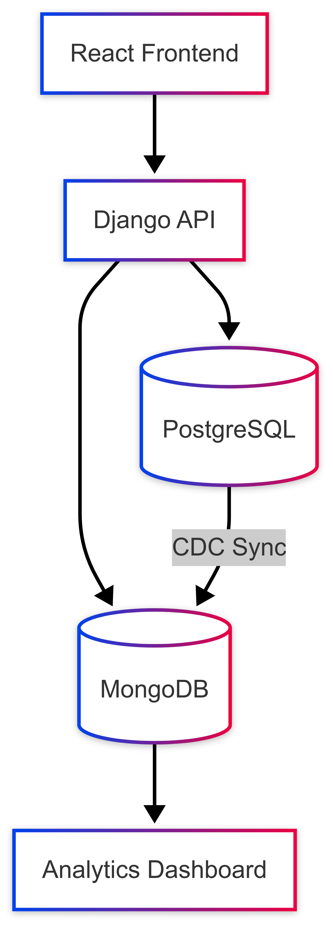

1. Database Schema

1.1 PostgreSQL (Transactional Data)
- Core Tables & Relationships
Table | Primary Key | Description | Key Fields
users_user | id (UUID) | Django auth model with extended fields | username, role, mfi_id
users_mfi | mfi_id (UUID) | Microfinance institutions | name, registration_number
users_borrower | borrower_id (UUID) | Borrower profiles | national_id, phone, address (JSONB)
loans_loan | loan_id (UUID) | Loan transactions | amount, status, term, due_date
- Relationships:
  - One-to-one: users_user ↔ users_borrower
  - One-to-many: users_mfi → loans_loan
  - One-to-many: users_user → loans_documents, loans_guarantors

1.2 MongoDB (Distributed Credit History)
- Collections & Sharding:
  - borrower_profiles: Core credit profiles indexed by national ID (hashed).
  - credit_events: Stores time-series credit history, indexed by national_id and timestamp.
  - mfi_metadata: Caches MFI data indexed by mfi_id.
- MongoEngine Models:
  - LoanHistory, CreditInquiry, BorrowerProfile, CreditEvent are modeled to store structured documents about loan history and credit events.

2. Replication Strategy

2.1 PostgreSQL (Supabase Implementation)
- Key Objectives:
  - High Availability: Automated failover and point-in-time recovery.
  - Data Redundancy: Multiple synchronized copies of data.
  - Scalability: Supports future expansion.
  - Read Performance: Offloads read traffic to replicas.
- Failover Mechanism:
  - Supabase handles automatic failover.
  - In the event of a primary failure, a replica is automatically promoted.
  - Retry logic is supported for temporary connection issues.
- Replication Configuration (PostgreSQL):
  - WAL Level: logical
  - Replication Slots: 10
  - Failover Configuration: pg_auto_failover for seamless transition to replicas.

2.2 MongoDB (High Availability)
- Replica Set Configuration:
  - MongoDB is set up with a replica set for high availability.
  - The set includes three nodes (primary, secondary, and tertiary), with failover priorities configured.
- Sharding Strategy:
  - Data is partitioned by national_id for borrower profiles and by timestamp for credit events, using hashed and range-based sharding.
- Read/Write Configurations:
  - Write Concern: majority for durability.
  - Read Preference: primaryPreferred for failover compatibility.
  - Journal: Enabled to ensure write persistence.

3. Data Synchronization
- PostgreSQL → MongoDB Pipeline:
  - Uses Django signals and Kafka for change data capture (CDC), ensuring synchronization between the transactional database (PostgreSQL) and the distributed credit history database (MongoDB).

4. Performance Optimization

4.1 PostgreSQL Optimization
- Query Optimization:
  - Optimized queries and views for loan listings and related data.
  - Indexing on key fields such as borrower_id and mfi_id to support faster querying.
- Connection Pooling:
  - Connection reuse configured via CONN_MAX_AGE=600 to optimize database connection usage.

4.2 MongoDB Optimization
- Index Strategy:
  - Indexing critical fields like national_id, timestamp, and event_type to enhance query performance.
  - Implementing TTL (Time-to-Live) indexes for credit inquiries to maintain efficient data management.
- Batch Updates:
  - Example batch update for credit score calculations based on loan history, optimizing write operations.

5. Disaster Recovery

5.1 PostgreSQL Recovery
- Backup Strategy:
  - Daily full backups and continuous WAL (Write-Ahead Log) archiving.
  - Weekly logical backups for additional safety.
- Recovery Procedure:
  - Restore from backups and perform point-in-time recovery (PITR) using WAL archives.

5.2 MongoDB Recovery
- Backup Strategy:
  - Daily full backups and incremental oplog backups for fast recovery.
- Recovery Steps:
  - Restore from full backup and replay oplog to bring data up-to-date.
  - Add new nodes to the replica set for recovery after a failure.

6. System Integration

6.1 Django ORM Integration
- Multiple Database Configuration:
  - Django is configured to interact with both PostgreSQL and MongoDB using custom database routers to separate read/write operations based on the model type.

6.2 Credit Score API Integration
- API View:
  - Provides a RESTful API endpoint for credit checks, integrating data from both PostgreSQL and MongoDB.

