NGINX Server Deployment Assessment

Target: NGINX Server (v1.15.5)
Assessment Type: Internal Security Assessment
Date: (Insert your date)

Executive Summary
This assessment focused on deploying an outdated NGINX server and evaluating its security risks. The setup revealed insecure practices such as HTTP downloads and manual compilation without validation.
Risk Level: Critical
1. Environment Preparation
Command: sudo wget https://archive.kali.org/archive-keyring.gpg -O /usr/share/keyrings/kali-archive-keyring.gpg
Ensures trusted package installation.
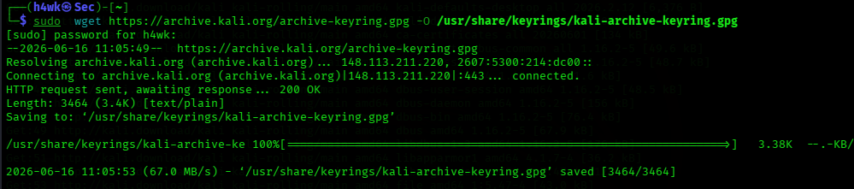
2. SSH Installation and Setup
Commands: apt install openssh-server, systemctl start ssh, systemctl status ssh
Enables remote access.
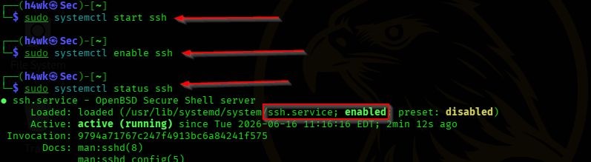
3. Downloading NGINX
Command: wget http://nginx.org/download/nginx-1.15.5.tar.gz
Downloads outdated version.
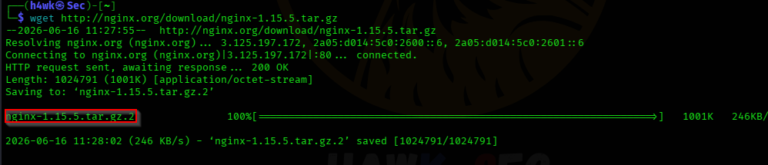

4. Installing Dependencies
Command: apt install build-essential libpcre3 libssl-dev
Installs required libraries.
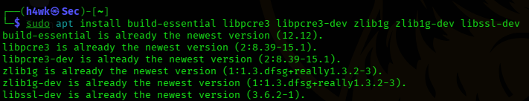
5. Extracting Source Code
Command: tar -zxvf nginx-1.15.5.tar.gz
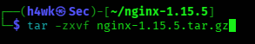
Objective: Extracts the compressed source package
6. Compilation and Installation
Commands: ./configure, make, make install
Objective: Compiles and installs NGINX from source

7. Starting NGINX
Command: /usr/local/nginx/sbin/nginx
Objective: Launches the NGINX web server.
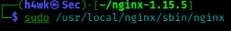
8. Configuration Validation
Command: sudo /usr/local/nginx/sbin/nginx -t
Objective: Verifies that the Nginx configuration files and syntax are accurate and valid
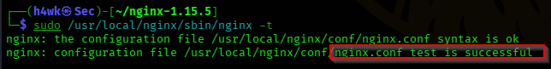
9. Version Verification
Command: sudo /usr/local/nginx/sbin/nginx nginx -v


Vulnerability Assessment
S/N | Vulnerability | Risk Level | Description | Remediation
1 | Outdated NGINX Version | Critical | Unsupported version vulnerable to known exploits | Upgrade to the latest stable NGINX release
2 | Multiple NGINX Vulnerabilities (1.9.5 < 1.16.1 / 1.17.x < 1.17.3) | High | Susceptible to Denial-of-Service attacks | Upgrade to the latest stable NGINX release
3 | HTTP Download | High | Risk of man-in-the-middle attacks during package retrieval | Use HTTPS for all package downloads
4 | Missing Integrity Verification | High | No checksum or signature verification performed | Verify GPG signatures before installation
5 | SSH Exposure | Medium | Remote access increases attack surface | Restrict SSH access using firewall rules
6 | Manual Compilation | Medium | Security patches are not automatically applied | Use package manager installations for updates
7 | Weak TLS Defaults | Medium | Potential insecure SSL/TLS configuration | Use strong cipher suites and disable weak ones

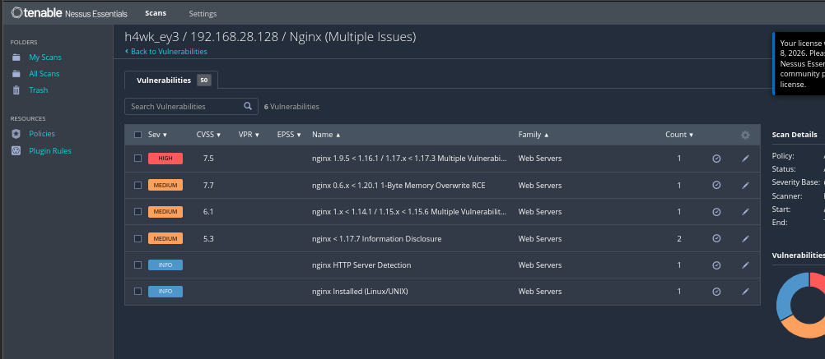

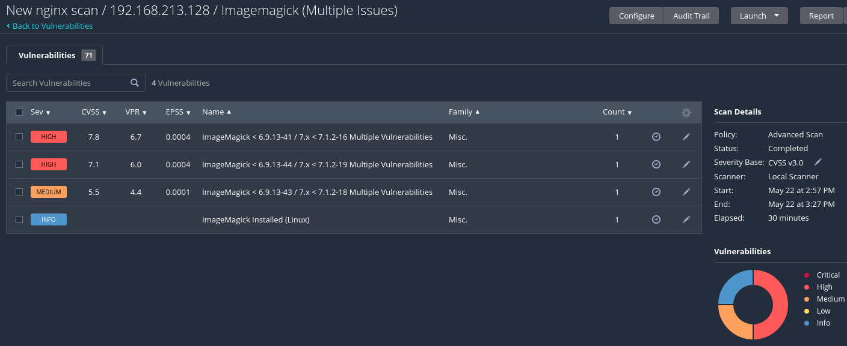

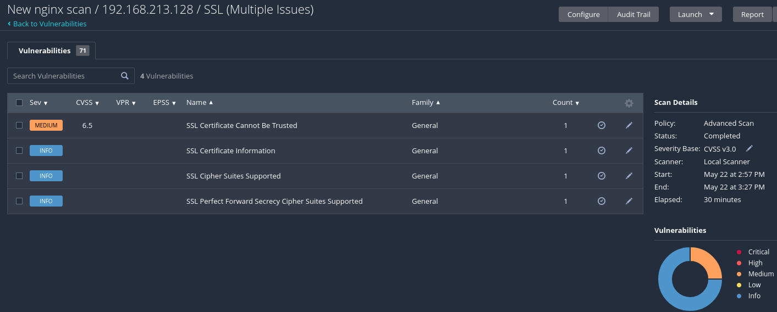
PATCHING NGINX WITH ANSIBLE
This section documents the process of installing Ansible, creating a playbook, and using it to manage and verify the NGINX installation on the target system.
Step1: Install Ansible

Command: sudo apt install ansible -y

Objective: Installs Ansible on the system using the package manager, with the -y flag automatically approving all prompts to ensure a smooth, non-interactive installation.

Step 2: Verify the installation and version
Command: ansible –version
Objective: To confirm that Ansible has been installed correctly and to check the installed version.
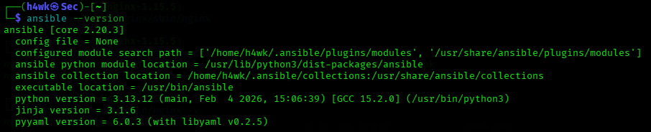

Step 3: Creating a yml file for the playbook
Command: nano update_nginx.yml
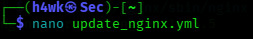
Objective: To create and open a YAML file that will contain the automation script (playbook) for updating NGINX.

Step 4: Configure Playbook
Action: Write the required Ansible configuration inside the update_nginx.yml file.
Objective: To define tasks that will update or patch the NGINX service automatically.
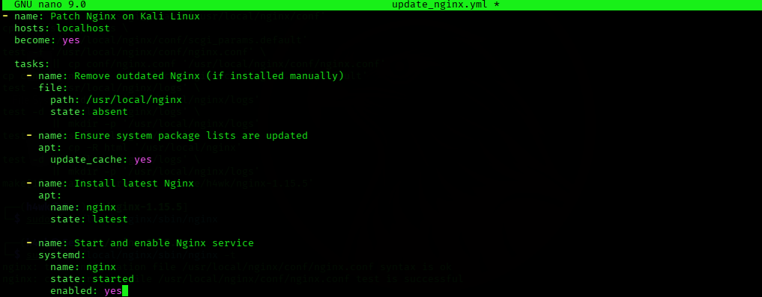
Step 5: Execute Playbook
Command: ansible-playbook update_nginx.yml --ask-become-pass
Objective: To run the playbook with elevated privileges, allowing Ansible to perform system-level updates securely.
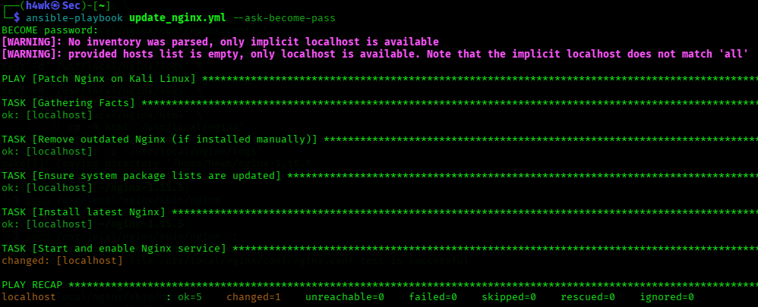
Step 6: Verify NGINX Version
Command: nginx -version
Objective: To confirm that NGINX has been successfully updated to the latest or intended version after running the playbook.


Summary
The process demonstrates how Ansible can be used to automate NGINX updates efficiently. By using a playbook, repetitive administrative tasks are simplified, reducing the risk of human error and ensuring consistency across deployments.

