The USRP B210 Current Hardware Revision: 5

The schematics of the board can be visited here <http://files.ettus.com/schematics/b200/b210.pdf>

As characterized the most important components of the SDR are listed below

|  |  |  |  |  |  |  |  |
| --- | --- | --- | --- | --- | --- | --- | --- |
| **Part Number** | **Description** | **fabrication** | **thermal characterisation** | **radiation characterisation** | **TID** | **SEE** | **TID comment** |
| [Mini-Circuits TCM1-63AX+](https://www.minicircuits.com/pdfs/TCM1-63AX+.pdf) | Transformer |  | -40°C to 85°C |  |  |  |  |
| [Analog Devices AD9361](http://www.analog.com/en/products/rf-microwave/integrated-transceivers-transmitters-receivers/wideband-transceivers-ic/ad9361.html#product-overview) | RF Transceiver |  | -40°C to 85°C |  |  |  |  |
| [Xilinx Spartan-6](http://www.xilinx.com/products/silicon-devices/fpga/spartan-6.html) [XC6SLX150](http://www.xilinx.com/support/documentation/data_sheets/ds160.pdf) | FPGA | 45 nm low-power copper process technology | **  -40°C to 100°C | up to 100krad |  |  | Ref 3 paragr. |
| [ADF4001](http://www.analog.com/media/en/technical-documentation/data-sheets/ADF4001.pdf) | Frequency Synthesizer |  | -40°C to 85°C |  |  |  |  |
| [CYUSB3014](http://www.cypress.com/file/140296/download) | FX3: SuperSpeed USB Controller |  | -40°C to 85°C |  |  |  |  |
| [EZ-USB FX3™ Product Page](http://www.cypress.com/applications/ez-usb-fx3-superspeed-usb-30-peripheral-controller-collateral-guide) |
| [SKY13317](http://www.skyworksinc.com/uploads/documents/SKY13317_373LF_200914K.pdf) | Antenna Switch | a GaAs pHEMT single-pole | -40°C to 100°C |  |  |  |  |
| [BD3150L50100A00](http://www.anaren.com/sites/default/files/BD3150L50100A00%20Data%20sheet%20Rev%20C.pdf) | Balun | not even a contact point |  |  |  |  |  |
| [PGA−102+](https://www.minicircuits.com/pdfs/PGA-102+.pdf) | Amplifier | E-PHEMT technology | -40°C to 85°C |  |  |  |  |
| [525L20DA40M0000](https://www.ctscorp.com/wp-content/uploads/2015/11/008-0334-0.pdf) | VCTCXO (B200/B210 only) | Fundamental Crystal Design | -40°C to 85°C |  |  |  |  |
| [Jackson Labs LC_XO](http://www.jackson-labs.com/index.php/products/lc_xo) [Spec Sheet](http://www.jackson-labs.com/assets/uploads/main/LC_XO_specsheet.pdf) [Manual](http://www.jackson-labs.com/assets/uploads/main/LC_XO_Manual.pdf) | Optional GPSDO (B200/B210 only) | probably 3.3V cmos | -45°C to +85°C |  |  |  |  |
| resistors |  |  | most -40°C to 85°C | resistant enough in compare with other components on the board (critical components for the functionality, should be checked again) |  |  | according to REF 1 page 66(59)  & Ref2 page 20 |
| capacitors |  |  | most -55°C to 125°C | resistant enough in compare with other components on the board (critical components for the functionality, should be checked again) |  |  | according to REF 1 page 66(59)  & Ref2 page 20 |
| pcb |  |  |  |  |  |  |  |

**

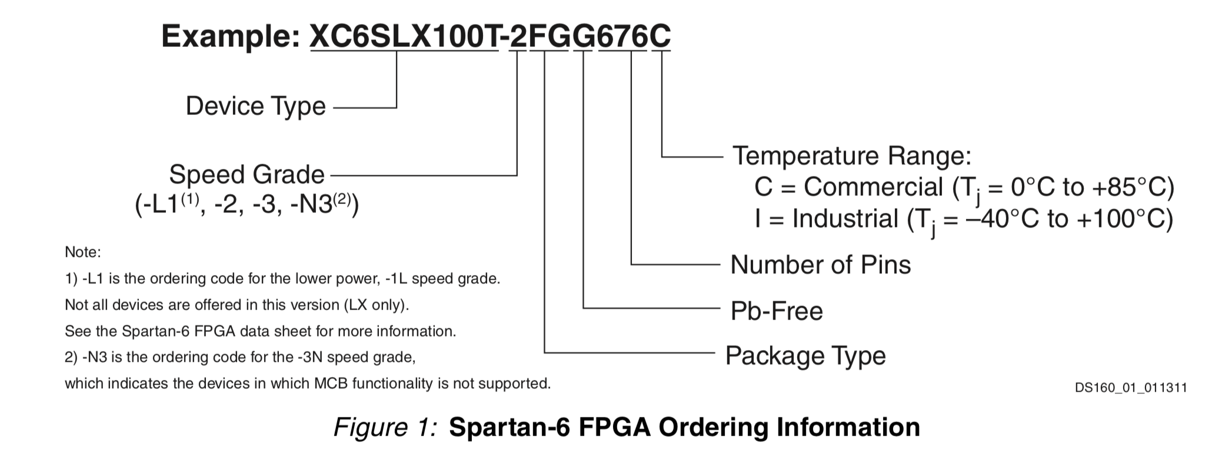

Ref 1 Nuclear radiation hardening for electronic components (LOCKHEED MISSILES & SPACE COMPANY August 1969)

Ref 2 Report on the Effect of Radiation on Resistors and Capacitors for the HV filter circuit of the Endcap VPT (By Ignacio Yaselli, 04/08/2004)

Ref 3 A Commercial 65 nm CMOS Technology for Space Applications: Heavy Ion, Proton and Gamma Test Results and Modeling