The USRP B210 Current Hardware Revision: 5
The schematics of the board can be visited here http://files.ettus.com/schematics/b200/b210.pdf

As characterized the most important components of the SDR are listed below
Part Number | Description | fabrication | thermal characterisation | radiation characterisation | TID | SEE | TID comment
Mini-Circuits TCM1-63AX+ | Transformer |  | -40°C to 85°C
Analog Devices AD9361 | RF Transceiver |  | -40°C to 85°C
Xilinx Spartan-6 XC6SLX150 | FPGA | 45 nm low-power copper process technology | **  -40°C to 100°C | up to 100krad |  |  | Ref 3 paragr.
ADF4001 | Frequency Synthesizer |  | -40°C to 85°C
CYUSB3014 | FX3: SuperSpeed USB Controller |  | -40°C to 85°C
EZ-USB FX3™ Product Page
SKY13317 | Antenna Switch | a GaAs pHEMT single-pole | -40°C to 100°C
BD3150L50100A00 | Balun | not even a contact point
PGA−102+ | Amplifier | E-PHEMT technology | -40°C to 85°C
525L20DA40M0000 | VCTCXO (B200/B210 only) | Fundamental Crystal Design | -40°C to 85°C
Jackson Labs LC_XO Spec Sheet Manual | Optional GPSDO (B200/B210 only) | probably 3.3V cmos | -45°C to +85°C
resistors |  |  | most -40°C to 85°C | resistant enough in compare with other components on the board (critical components for the functionality, should be checked again) |  |  | according to REF 1 page 66(59)  & Ref2 page 20
capacitors |  |  | most -55°C to 125°C | resistant enough in compare with other components on the board (critical components for the functionality, should be checked again) |  |  | according to REF 1 page 66(59)  & Ref2 page 20
pcb

**
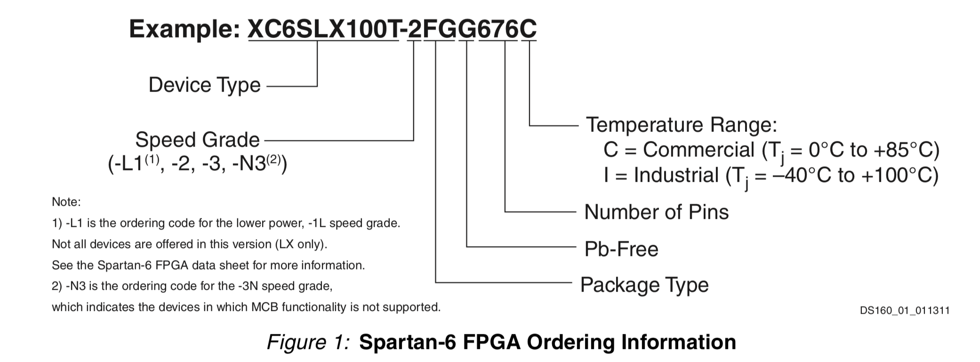

Ref 1 Nuclear radiation hardening for electronic components (LOCKHEED MISSILES & SPACE COMPANY August 1969)
Ref 2 Report on the Effect of Radiation on Resistors and Capacitors for the HV filter circuit of the Endcap VPT (By Ignacio Yaselli, 04/08/2004)
Ref 3 A Commercial 65 nm CMOS Technology for Space Applications: Heavy Ion, Proton and Gamma Test Results and Modeling

