Technical Report

Evaluation of SDR Boards and Toolchains
– Evaluation of the Technical Specifications –

Authors: | Alexandru Csete
 | Sheila Christiansen
Date: | YYYY-MM-DD
Version: | 1.0
Status: | Draft

Table of Contents
1 Introduction 1
1.1 Purpose and Scope 1
1.2 Selected SDR devices 1
1.3 Evaluation Criteria 2
1.4 Evaluation Methods 3
2 Test Setup and Procedures 4
2.1 Receiver Noise Figure 4
2.1.1 Background 4
2.1.2 Test Procedure 5
2.2 Receiver Dynamic Range 7
2.2.1 Background 7
2.2.2 Test Procedure 9
2.3 Receiver Spectral Purity 10
2.4 Transmitter Spectral Purity 10
2.5 Transmitter Output Power 11
2.6 Transmitter Modulation Error Ratio 11
2.7 Test Software 12
3 Test Results 15
3.1 RTL-SDR Blog V3 15
3.1.1 Receiver Noise Figure 16
3.1.2 Receiver Blocking Dynamic Range 17
3.1.3 Receiver Spectral Purity 18
3.2 Airspy Mini 21
3.2.1 Receiver Noise Figure 23
3.2.2 Receiver Blocking Dynamic Range 24
3.2.3 Receiver Spectral Purity 25
3.3 SDRplay RSPduo 27
3.3.1 Receiver Noise Figure 29
3.3.2 Receiver Blocking Dynamic Range 30
3.3.3 Receiver Spectral Purity 31
3.4 LimeSDR Mini 33
3.4.1 Receiver Noise Figure 35
3.4.2 Receiver Blocking Dynamic Range 36
3.4.3 Receiver Spectral Purity 37
3.4.4 Transmitter Spectral Purity 42
3.4.5 Transmitter Output Power 47
3.4.6 Transmitter MER 47
3.5 BladeRF 2.0 Micro 47
3.5.1 Receiver Noise Figure 49
3.5.2 Receiver Blocking Dynamic Range 50
3.5.3 Receiver Spectral Purity 51
3.5.4 Transmitter Spectral Purity 57
3.5.5 Transmitter Output Power 64
3.5.6 Transmitter MER 64
3.6 Ettus USRP B210 64
3.6.1 Receiver Noise Figure 66
3.6.2 Receiver Blocking Dynamic Range 67
3.6.3 Receiver Spectral Purity 67
3.6.4 Transmitter Spectral Purity 73
3.6.5 Transmitter Output Power 80
3.6.6 Transmitter MER 80
3.7 PlutoSDR 80
3.7.1 Receiver Noise Figure 82
3.7.2 Receiver Blocking Dynamic Range 83
3.7.3 Receiver Spectral Purity 83
3.7.4 Transmitter Spectral Purity 90
3.7.5 Transmitter Output Power 90
3.7.6 Transmitter MER 90
3.8 Device Comparions 90
3.8.1 Best Noise Figure 90
3.8.2 Dynamic Range 90
3.8.3 Transmitter Power 90
4 Test Setup Verification 91
4.1 Signal Generator Output Power Comparison 91
5 On-Air Tests 94
5.1 Test Setup 94
5.2 Test Results 95
6 Software Support 97
7 Conclusion 98
8 Appendices I

List of Figures
Figure 2.1: Test setup for noise figure measurements using the MDS method. 6
Figure 2.2: Test setup for noise figure measurements using the Y-factor method. 6
Figure 2.3: Disturbing signal causing increase in the noise level at 100 kHz away. 8
Figure 2.4: Disturbing signal causing spurs as far as 1 MHz away. 8
Figure 2.5: Test setup for dynamic range measurements. 9
Figure 2.6: Test setup for receiver spectral purity measurements. 10
Figure 2.7: Test setup for transmitter power and spectral purity measurements. 10
Figure 2.8: Constellation with error [8]. 11
Figure 2.9: Test setup for transmitter MER measurements. 12
Figure 2.10: Functional diagram for the test software used for receiver tests. 13
Figure 2.11: GNU Radio application used for output power measurements. 13
Figure 2.12: GNU Radio application used for MER measurements. 14
Figure 3.1: The RTL-SDR blog V3 receiver. 15
Figure 3.2: RTL-SDR Blog V3 dongle block diagram. 15
Figure 3.3: RTL-SDR V3 noise figure measurements. 17
Figure 3.4: RT-SDR V3 blocking dynamic range measurements. 18
Figure 3.5: RTL-SDR receiver spectrum between 145 – 146 MHz. 19
Figure 3.6: RTL-SDR receiver spectrum between 434 – 436 MHz. 19
Figure 3.7: RTL-SDR receiver spectrum between 436 – 438 MHz. 19
Figure 3.8: RTL-SDR receiver spectrum between 1260 – 1262 MHz. 20
Figure 3.6: RTL-SDR receiver spectrum between 1264 – 1266 MHz. 20
Figure 3.9: RTL-SDR spectrum between 1262 – 1264 MHz. 20
Figure 3.10: RTL-SDR receiver spectrum between 1266 – 1268 MHz. 21
Figure 3.11: RTL-SDR receiver spectrum between 1268 – 1270 MHz. 21
Figure 3.12: The Airspy Mini receiver. 22
Figure 3.13: Airspy Mini block diagram. 22
Figure 3.14: Airspy Mini noise figure measurements. 23
Figure 3.15: Airspy Mini blocking dynamic range measurements. 24
Figure 3.16: Airspy Mini receiver spectrum between 145 – 146 MHz. 25
Figure 3.17: Airspy Mini receiver spectrum between 435 – 438 MHz. 25
Figure 3.18: Airspy Mini receiver spectrum between1260 – 1264 MHz. 26
Figure 3.19: Airspy Mini receiver spectrum between 1264 – 1268 MHz. 26
Figure 3.20: Airspy Mini receiver spectrum between 1267 – 1271 MHz. 26
Figure 3.21: The SDRplay RSPduo receiver. 27
Figure 3.22: The SDRplay RSPduo block diagram. 28
Figure 3.23: SDRplay RSPduo noise figure measurements. 30
Figure 3.24: SDRplay RSPduo blocking dynamic range measurements. 31
Figure 3.25: SDRplay RSPduo receiver spectrum between 145 – 146 MHz. 32
Figure 3.26: SDRplay RSPduo receiver spectrum between 435 – 438 MHz. 32
Figure 3.27: SDRplay RSPduo receiver spectrum between 1260 – 1265 MHz. 32
Figure 3.28: SDRplay RSPduo receiver spectrum between 1265 – 1270 MHz. 33
Figure 3.29: LimeSDR Mini transceiver. 34
Figure 3.30: LimeSDR Mini block diagram. 34
Figure 3.31: LimeSDR Mini noise figure measurements. 36
Figure 3.32: LimeSDR Mini blocking dynamic range measurements. 37
Figure 3.33: LimeSDR Mini receiver spectrum between 145 – 146 MHz. 38
Figure 3.34: LimeSDR Mini receiver spectrum between 435 – 438 MHz. 38
Figure 3.35: LimeSDR Mini receiver spectrum between 1260 – 1270 MHz. 39
Figure 3.36: LimeSDR Mini receiver spectrum between 2200 – 2225 MHz. 39
Figure 3.37: LimeSDR Mini receiver spectrum between 2225 – 2250 MHz. 40
Figure 3.38: LimeSDR Mini receiver spectrum between 2250 – 2275 MHz. 40
Figure 3.39: LimeSDR Mini receiver spectrum between 2275 – 2300 MHz. 41
Figure 3.40: LimeSDR Mini receiver spectrum between 2400 – 2425 MHz. 41
Figure 3.41: LimeSDR Mini receiver spectrum between 2425 – 2450 MHz. 42
Figure 3.42: LimeSDR Mini transmitter spectrum at 145.6 MHz, gain 0. 42
Figure 3.43: LimeSDR Mini transmitter spectrum at 145.6 MHz, gain 30. 43
Figure 3.44: LimeSDR Mini transmitter spectrum at 437.6 MHz, gain 0. 43
Figure 3.45: LimeSDR Mini transmitter spectrum at 437.6 MHz, gain 30. 44
Figure 3.46: LimeSDR Mini transmitter spectrum at 1280 MHz, gain 0. 44
Figure 3.47: LimeSDR Mini transmitter spectrum at 1280 MHz, gain 10. 45
Figure 3.48: LimeSDR Mini transmitter spectrum at 2425 MHz, gain 0. 46
Figure 3.49: LimeSDR Mini transmitter spectrum at 2425 MHz, gain 10. 46
Figure 3.50: LimeSDR Mini CW transmitter output power as function of gain. 47
Figure 3.51: The BladeRF 2.0 micro transceiver. 48
Figure 3.52: BladeRF 2.0 micro block diagram. 48
Figure 3.53: BladeRF 2.0 micro noise figure measurements. 50
Figure 3.54: BladeRF 2.0 micro blocking dynamic range measurements. 51
Figure 3.55: BladeRF 2.0 micro receiver spectrum between 145 – 146 MHz. 52
Figure 3.56: BladeRF 2.0 micro receiver spectrum between 435 – 438 MHz. 52
Figure 3.57: BladeRF 2.0 micro receiver spectrum between 1260 – 1270 MHz. 53
Figure 3.58: BladeRF 2.0 micro receiver spectrum between 2200 – 2225 MHz. 53
Figure 3.59: BladeRF 2.0 micro receiver spectrum between 2225 – 2250 MHz. 54
Figure 3.60: BladeRF 2.0 micro receiver spectrum between 2250 – 2275 MHz. 54
Figure 3.61: BladeRF 2.0 micro receiver spectrum between 2275 – 2300 MHz. 55
Figure 3.62: BladeRF 2.0 micro receiver spectrum between 2400 – 2425 MHz. 55
Figure 3.63: BladeRF 2.0 micro receiver spectrum between 2425 – 2450 MHz. 56
Figure 3.64: BladeRF 2.0 micro receiver spectrum between 5790 – 5820 MHz. 56
Figure 3.65: BladeRF 2.0 micro receiver spectrum between 5820 – 5850 MHz. 57
Figure 3.66: BladeRF 2.0 micro transmitter spectrum at 145.5 MHz, gain 0. 57
Figure 3.67: BladeRF 2.0 micro transmitter spectrum at 145.5 MHz, gain 30. 58
Figure 3.68: BladeRF 2.0 micro transmitter spectrum at 437.5 MHz, gain 0. 59
Figure 3.69: BladeRF 2.0 micro transmitter spectrum at 437.5 MHz, gain 30. 59
Figure 3.70: BladeRF 2.0 micro transmitter spectrum at 1280 MHz, gain 0. 60
Figure 3.71: BladeRF 2.0 micro transmitter spectrum at 1280 MHz, gain 25. 60
Figure 3.72: BladeRF 2.0 micro transmitter spectrum at 2250 MHz, gain 5. 61
Figure 3.73: BladeRF 2.0 micro transmitter spectrum at 2250 MHz, gain 30. 61
Figure 3.74: BladeRF 2.0 micro transmitter spectrum at 2425 MHz, gain 5. 62
Figure 3.75: BladeRF 2.0 micro transmitter spectrum at 2425 MHz, gain 30. 62
Figure 3.76: BladeRF 2.0 micro transmitter spectrum at 5830 MHz, gain 5. 63
Figure 3.77: BladeRF 2.0 micro transmitter spectrum at 5830 MHz, gain 30. 63
Figure 3.78: BladeRF 2.0 micro CW transmitter output power as function of gain. 64
Figure 3.79: The Ettus USRP B210 transceiver. 65
Figure 3.80: USRP B210 block diagram. 65
Figure 3.81: USRP B210 noise figure measurements. 67
Figure 3.82: Ettus USRP B210 receiver spectrum between 145 – 146 MHz. 68
Figure 3.83: Ettus USRP B210 receiver spectrum between 435 – 438 MHz. 68
Figure 3.84: Ettus USRP B210 receiver spectrum between 1260 – 1270 MHz. 69
Figure 3.85: Ettus USRP B210 receiver spectrum between 2200 – 2225 MHz. 69
Figure 3.86: Ettus USRP B210 receiver spectrum between 2225 – 2250 MHz. 70
Figure 3.87: Ettus USRP B210 receiver spectrum between 2250 – 2275 MHz. 70
Figure 3.88: Ettus USRP B210 receiver spectrum between 2275 – 2300 MHz. 71
Figure 3.89: Ettus USRP B210 spectrum between 2400 – 2425 MHz. 71
Figure 3.90: Ettus USRP B210 receiver spectrum between 2425 – 2450 MHz. 72
Figure 3.91: Ettus USRP B210 receiver spectrum between 5790 – 5820 MHz. 72
Figure 3.92: Ettus USRP B210 receiver spectrum between 5820 – 5850 MHz. 73
Figure 3.93: Ettus USRP B210 transmitter spectrum at 145.5 MHz, gain 35. 73
Figure 3.94: Ettus USRP B210 transmitter spectrum at 145.5 MHz, gain 53. 74
Figure 3.95: Ettus USRP B210 transmitter spectrum at 437.5 MHz, gain 35. 74
Figure 3.96: Ettus USRP B210 transmitter spectrum at 437.5 MHz, gain 50. 75
Figure 3.97: Ettus USRP B210 transmitter spectrum at 1280 MHz, gain 35. 75
Figure 3.98: Ettus USRP B210 transmitter spectrum at 1280 MHz, gain 50. 76
Figure 3.99: Ettus USRP B210 transmitter spectrum at 2250 MHz, gain 43. 77
Figure 3.100: Ettus USRP B210 transmitter spectrum at 2250 MHz, gain 65. 77
Figure 3.101: Ettus USRP B210 transmitter spectrum at 2425 MHz, gain 43. 78
Figure 3.102: Ettus USRP B210 transmitter spectrum at 2425 MHz, gain 65. 78
Figure 3.103: Ettus USRP B210 transmitter spectrum at 5830 MHz, gain 43. 79
Figure 3.104: Ettus USRP B210 transmitter spectrum at 5830 MHz, gain 60. 79
Figure 3.105: Ettus USRP B210 CW transmitter output power as function of gain. 80
Figure 3.106: The Analog Devices PlutoSDR transceiver. 81
Figure 3.107: PlutoSDR block diagram. 81
Figure 3.108: PlutoSDR noise figure measurements. 83
Figure 3.109: PlutoSDR receiver spectrum between 145 – 146 MHz. 84
Figure 3.110: PlutoSDR receiver spectrum between 435 – 438 MHz. 84
Figure 3.111: PlutoSDR receiver spectrum between 1260 – 1265 MHz. 85
Figure 3.112: PlutoSDR receiver spectrum between 1265 – 1270 MHz. 85
Figure 3.113: PlutoSDR receiver spectrum between 2200 – 2225 MHz. 86
Figure 3.114: PlutoSDR receiver spectrum between 2225 – 2250 MHz. 86
Figure 3.115: PlutoSDR receiver spectrum between 2250 – 2275 MHz. 87
Figure 3.116: PlutoSDR receiver spectrum between 2275 – 2300 MHz. 87
Figure 3.117: PlutoSDR receiver spectrum between 2400 – 2425 MHz. 88
Figure 3.118: PlutoSDR receiver spectrum between 2425 – 2450 MHz. 88
Figure 3.119: PlutoSDR receiver spectrum between 5790 – 5820 MHz. 89
Figure 3.120: PlutoSDR receiver spectrum between 5820 – 5850 MHz. 89
Figure 5.1: On-air test setup. 95

List of Tables
Table 1.1: Selected SDR devices under test. 2
Table 3.1: RTL-SDR Blog V3 technical specifications. 16
Table 3.2: RTL-SDR settings used during noise figure measurements. 16
Table 3.3: RTL-SDR V3 settings used during BDR measurements. 17
Table 3.4: Airspy Mini technical specifications. 23
Table 3.5: Airspy Mini settings used during noise figure measurements. 23
Table 3.6: Airspy Mini settings used during BDR measurements. 24
Table 3.7: SDRplay RSPduo technical specifications. 29
Table 3.8: SDRplay RSPduo settings used during noise figure measurements. 29
Table 3.9: SDRplay RSPduo settings used for BDR measurements. 30
Table 3.10: LimeSDR Mini technical specifications. 35
Table 3.11: LimeSDR Mini settings used during noise figure measurements. 35
Table 3.12: LimeSDR Mini settings used for BDR measurements. 36
Table 3.13: BladeRF 2.0 micro technical specifications. 49
Table 3.14: BladeRF 2.0 micro settings used during noise figure measurements. 49
Table 3.15: BladeRF2.0 micro settings used for BDR measurements. 50
Table 3.16: Ettus USRP B210 technical specifications. 66
Table 3.17: USRP B210 settings used during noise figure measurements. 66
Table 3.18: PlutoSDR technical specifications. 82
Table 3.19: PlutoSDR settings used during noise figure measurements. 82
Table 4.1: Coaxial cable insertion loss. 91
Table 4.2: Signal generator output power comparison at 145.5 MHz. 92
Table 4.3: Signal generator output power comparison at 437.5 MHz. 92
Table 4.4: Signal generator output power comparison at 1280 MHz. 92
Table 4.5: Signal generator output power comparison at 2250 MHz. 93
Table 4.6: Signal generator output power comparison at 2425 MHz. 93
Table 5.1: SDR device settings used during the on-air tests. 94
Table 5.2: Number of packets decoded during the on-air test campaign. 96

Appendices
Appendix I: Insertion Losses I

List of Abbreviations and Symbols
ADC | Analog-to-Digital Converter
CW | Carrier Wave or Continous Wave
DDC | Digital Down Converter
DR | Dynamic Range
FFT | Fast Fourier Transform
MDS | Minimum Detectable Signal
MER | Modulation Error Ratio
NF | Noise Figure
RF | Radio Frequency
RFIC | Radio Frequency Integrated Circuit
SDR | Software Defined Radio

References
[1] | SDRplay RSPduo datasheet:  https://www.sdrplay.com/wp-content/uploads/2018/05/RSPduoDatasheetV0.6.pdf
[2] | Keysight Technologies, Noise Figure Measurement Accuracy: The Y-Factor Method, (application note, local copy in Git):  https://www.keysight.com/dk/en/assets/7018-06829/application-notes/5952-3706.pdf
[3] | Wikipedia article on Minimum Detectable Signal:  https://en.wikipedia.org/wiki/Minimum_detectable_signal
[4] | Wikipedia article on Johnson-Nyquist noise:  https://en.wikipedia.org/wiki/Johnson%E2%80%93Nyquist_noise
[5] | Wikipedia article on Boltzmann Constant:  https://en.wikipedia.org/wiki/Boltzmann_constant
[6] | Rohde & Schwarz, The Y Factor Technique for Noise Figure Measurements (application note, local copy in Git):  https://www.rohde-schwarz.com/pl/applications/the-y-factor-technique-for-noise-figure-measurements-application-note_56280-15484.html
[7] | Walt Kester, Taking the Mystery out of the Infamous Formula, "SNR = 6.02N + 1.76dB," and Why You Should Care, Analog Devices MT-001:  https://www.analog.com/media/en/training-seminars/tutorials/MT-001.pdf
[8] | Error vector magnitude on Wikipedia: https://en.wikipedia.org/wiki/Error_vector_magnitude
[9] | ETSI EN 302 307-1 V1.4.1
[10] | Softrig Git repository: https://gitlab.com/csete/softrig
[11] | GNU Radio: https://gnuradio.org
[12] | GrSoapy SDR device wrapper module for GNU Radio:  https://gitlab.com/librespacefoundation/gr-soapy
[13] | Git repository for this sub-activity:  https://gitlab.com/librespacefoundation/sdrmakerspace/sdreval
[14] | RTL-SDR wiki page at Osmocom: https://osmocom.org/projects/rtl-sdr/wiki/Rtl-sdr
[15] | Airspy Mini product page: https://airspy.com/airspy-mini/
[16] | SDRplay RSPduo Technical Information:  https://www.sdrplay.com/wp-content/uploads/2018/06/RSPDuo-Technical-Information-R1P1.pdf
[17] | LimeSDR Mini product page: https://www.crowdsupply.com/lime-micro/limesdr-mini
[18] | LMS7002M data sheet v3.1:  https://limemicro.com/app/uploads/2017/07/LMS7002M-Data-Sheet-v3.1r00.pdf
[19] | Lime Microsystems projects on GitHub: https://github.com/myriadrf
[20] | BladeRF 2.0 micro product page: https://www.nuand.com/bladerf-2-0-micro/
[21] | Nuand BladeRF project on GitHub: https://github.com/Nuand/bladeRF
[22] | BladeRF 2.0 micro schematics: https://www.nuand.com/bladeRF-micro.pdf
[23] | Ettus USRP B210 product page: https://www.ettus.com/all-products/ub210-kit/
[24] | Ettus Research on GitHub: https://github.com/EttusResearch
[25] | USRP B210 schematics: https://files.ettus.com/schematics/b200/b210.pdf
[26] | USRP B2xx Environmental Specifications:  https://kb.ettus.com/B200/B210/B200mini/B205mini#Environmental_Specifications
[27] | PlutoSDR Wiki page: https://wiki.analog.com/university/tools/pluto
[28] | PlutoSDR System Issues:  https://wiki.analog.com/university/tools/pluto/users/name#system_issues
[29] | ADALM-PLUTO Hardware:  https://wiki.analog.com/university/tools/pluto/hacking/hardware

Introduction

Purpose and Scope
During recent years, we have seen tremendous development in the availability of low cost, consumer-grade SDR hardware. Unfortunately, the low cost and the fast pace at which SDR hardware is developed does not leave much room for delivering complete turnkey solutions to the users. Hardware is often delivered as “evaluation boards” and software support is often left to third parties.
The purpose of this activity is to evaluate a selection of currently available SDR hardware and software from a satellite communications point of view, in order to provide prospective users with independent data that is often not available from the manufacturers. The evaluation includes both analytical assessments of the hardware and software capabilities, as well as lab tests supplemented by over the air usage of the systems.
The work was executed in three parts:
- Evaluation of the technical specifications of SDR hardware
- Over the air evaluation
- SDR software evaluation

This report covers part 1, Evaluation of the technical specifications of selceted SDR devices.

Selected SDR devices
The SDR devices under test were selected according to the following criteria:
- Relevant for satellite communications, most notably for CubeSat projects
- Affordable and easily available
- Variety in architecture and expected performance
The list of devices that were tested is shown in Table 1.1 below.

Device | Type | Frequency range | Bandwidth | Bits
RTL-SDR Blog V3 | RX | 0.1 – 1700 MHz | 3.2 MHz | 8
Airspy Mini | RX | 24 – 1700 MHz | 6 MHz | 12
SDRplay RSPduo | RX | 1 kHz – 2 GHz | 10 MHz | 8-14
LimeSDR Mini | RX/TX | 10 MHz – 3.5 GHz | 30 MHz | 12
BladeRF 2.0 Micro | RX/TX | 70 MHz – 6 GHz | 56 MHz | 12
Ettus USRP B210 | RX/TX | 70 MHz – 6 GHz | 56 MHz | 12
PlutoSDR | RX/TX | 70 MHz – 6 GHz | 20 MHz | 12
Table 1.1: Selected SDR devices under test.
Notes:
- In practice, RTL-SDR devices are limited to 2.4 MSPS continuous transfer to the host computer [14].
- SDRPlay RSPduo has 14-bits resolution up to 6.048 MSPS, 12-bits up to 8.064 MSPS, 10-bits up to 9.216 MSPS, and 8-bits above 9.216 MSPS [1].

Evaluation Criteria
Given the scope of the activity, the evaluation of the devices was limited to the frequency bands used for satellite communications:
- VHF: 145-146 MHz
- UHF: 435-438 MHz
- L-band: 1.26-1.30 GHz
- S-band: 2.0-2.1 GHz TX and 2.2-2.3 GHz RX
- S-band: 2.40-2.45 GHz
- C-band: 5.8 GHz

The evaluation criteria according to which the devices are evaluated are grouped in three groups:
- Generic parameters (extracted from datasheets):
  - Frequency range, stability, and phase noise
  - Maximum bandwidth
  - Operating temperature range
  - Const and availability
  - Size and weight
- Receiver-specific parameters (tested):
  - Noise figure (NF) and minimum detectable signal (MDS)
  - Receiver dynamic range
  - Spectral purity
- Transmitter-specific parameters (tested):
  - Maximum output power
  - Spectral purity
  - Achievable MER

Evaluation Methods
One of our objectives with this activity was to provide useful and reproducible results. To that end, we have defined our test procedures according to the following criteria:
- Use simple methods that do not require a lot of expensive laboratory equipment.
- Carry out the tests under realistic conditions that are representative for a setup under which the SDR devices are normally used.
Such methods can not provide results with the same accuracy as measurements carried out in a professional RF laboratory. However, in order to increase confidence in our results, we cross-check the measurements using different test methods and tools. These cross-checks are described in section 4.
Furthermore, since we use the same methods to test all devices, the results can always be used for a relative comparison between the devices, even if the measurements are not accurate on an absolute scale.

Test Setup and Procedures

Receiver Noise Figure

Background
The receiver sensitivity determines the smallest signal that a receiver can reliably detect [2]. Therefore, it is also called the minimum detectable signal [3], MDS, and specifies the strength of the smallest signal at the input of the receiver that causes the output signal power to be M times the output noise power.
We will use M = 1 and measure the MDS as the input signal that leads to a 3 dB increase in output power.
The receiver noise figure and noise factor are measures of degradation in signal-to-noise ratio in the receiver caused by internal thermal noise in the receiver [4]. The noise figure (NF) is the noise factor (F) expressed in dB:

The noise factor is closely related to the MDS of the receiver [2]:

where k_{B} is the Boltzmann constant in units of J/K [5], T₀ is the temperature of the device, B is the detection bandwidth in Hz, and M is the power ratio used in the MDS measurement.
Using T0 = 290 K and expressing the MDS in dBm:

Using M = 1, we can calculate the noise figure from the MDS:

Another common way to measure the noise figure is the Y-factor method. The Y-factor method uses a calibrated noise source with well known excess noise ratio (ENR). The noise source is connected to the device under test (DUT) and the noise power output density from the DUT is then measured with the noise source ON and OFF. The noise figure of the DUT is then given by [6]:

where ENR is the noise figure of the noise source and Y is the difference between output power density from the device under test when the noise source is ON and OFF.
When the noise figure of the device becomes larger than the ENR of the noise source, the difference between noise source ON and OFF becomes difficult to measure. Therefore, we will be using both the MDS-method and the Y-factor method to measure the noise figure. Moreover, the MDS method is simpler because it does not require a calibrated ENR source and is therefore interesting to compare it to the more accurate Y-factor method.

Test Procedure
The device under test is connected to a calibrated signal generator or ENR source, and the output power from the receiver is measured using the test SDR software described in section 2.7.
Settings:
- Sample rate and analog bandwidth are set to what is considered optimal for the device
- The DDC is tuned as to avoid DC and other spurious signals in the passband
- All automatic gain control in hardware and software is turned OFF
- The measurement bandwidth is set to 500 Hz
The measurement is carried out according to the following steps listed below.

MDS method:
- With the signal generator OFF, measure the output power in 500 Hz bandwidth
- With the signal generator ON, find the input power in dBm that gives a 3 dB increase in output power; this is our MDS
- Calculate the noise figure using the formula NF = MDS + 147
- Repeat steps 1-3 for different gain settings in each frequency band of interest listed in section 1.3

The MDS value obtained using the method described above has to be corrected for the insertion losses introduced by the DC block and the coaxial cable, as well as the deviation of the attenuator from the nominal 20 dB attenuation. The correction is performed by subtracting the insertion losses to the MDS obtained from the signal generator:
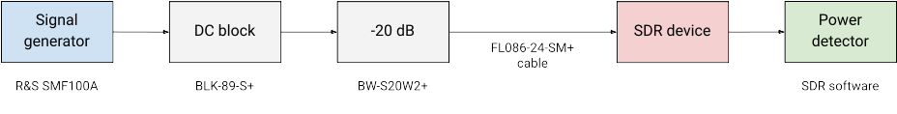Figure 2.1: Test setup for noise figure measurements using the MDS method.

The insertion losses of the individual parts in the setup are listed in Appendix I.

Y-factor method:
- With the noise source OFF, measure the output power in 500 Hz bandwidth
- With the noise source ON, measure the output power in 500 Hz bandwidth
- Calculate the Y-factor using the formula Y = P_{ON} − P_{OFF}
- Calculate the noise figure using the formula NF = ENR − 10 log⁡₁₀(10^{Y/10} − 1)
- Calculate the MDS using the formula MDS = NF − 147
- Repeat steps 1-5 for different gain settings in each frequency band of interest listed in section 1.3

To avoid unnecessary losses, the SDR device is connected directly to the DC block. Therefore, only the insertion loss of the DC block has to be taken into account and this has the effect of increasing the measured noise figure.
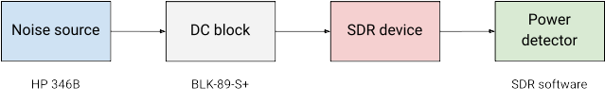Figure 2.2: Test setup for noise figure measurements using the Y-factor method.

Receiver Dynamic Range

Background
The dynamic range of a receiver tells us the largest signal-to-noise ratio (SNR) that we can achieve in the receiver. In other words, it expresses the difference between the strongest and the weakest signal a receiver can receive at the same time and is therefore of great importance when receiving weak signals from satellites in the presence of strong local interference.
A theoretical estimate for the dynamic range of an SDR receiver can be obtained from the bit resolution and the quantization noise of the analog to digital converter (ADC) in the receiver [7]:

where Q is the bit resolution of the ADC. However, analog circuitry in front of the ADC as well as digital signal processing after the ADC can enhance or degrade the dynamic range of the complete system.
There are different metrics that can be used to characterize the dynamic range of a receiver system. We will limit our measurements to finding the blocking dynamic range, BDR, and the 1 dB compression point P_{1dB}.
Blocking occurs when the receiver performance is degraded by a strong input signal. This often happens because of:
- Reciprocal mixing, i.e. when a strong signal outside of the received passband mixes with the phase noise of the receiver's local oscillator or another strong signal, generating extra spurs or noise in the receiver, or
- A strong input signal overloads an analog component (amplifier, mixer, ADC) making it behave in a non-linear fashion
In both cases, the degradation can be measured either as a change in noise level, see Figure 2.3, or as a clearly noticeable "receiver breakdown" in the form of spurs in the receiver spectrum, see Figure 2.4.

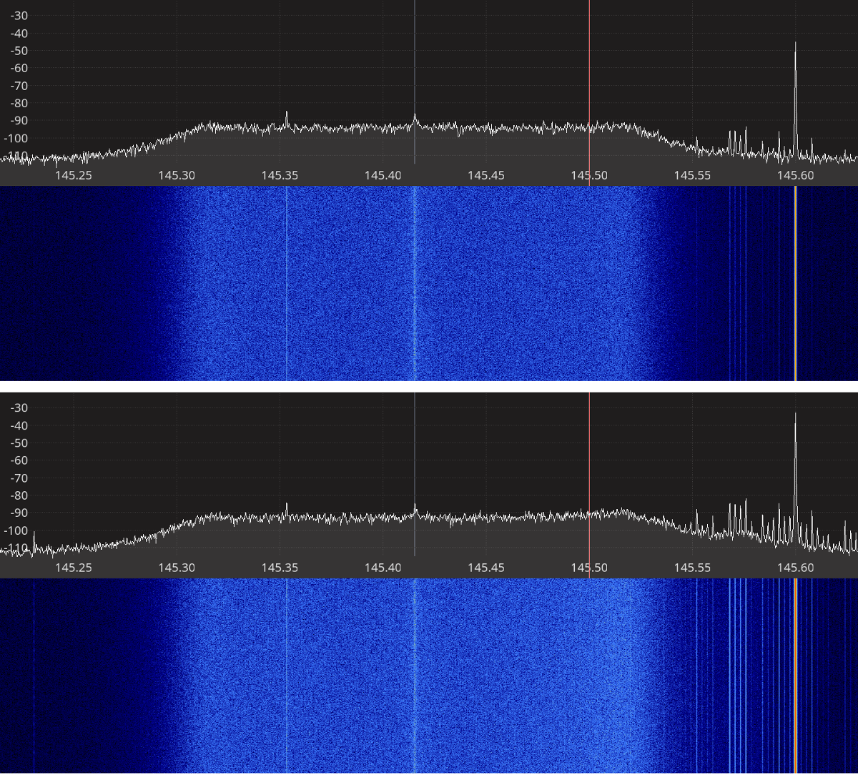Figure 2.3: Disturbing signal causing increase in the noise level at 100 kHz away.
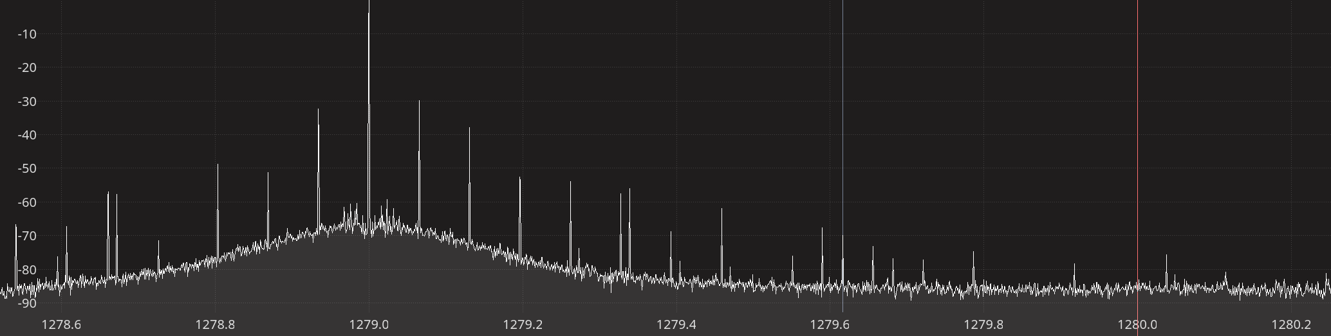Figure 2.4: Disturbing signal causing spurs as far as 1 MHz away.

The power level just before the reciprocal mixing or overload, P_{in}, is the maximum power the receiver can handle. The blocking dynamic range is then found as the difference between the power of this input signal, P_{in}, and the minimum detectable signal, MDS, found during the noise figure measurements:

The 1 dB compression point, P_{1dB}, is the input power level at which an increase in input power by X dB leads to an increase in output power by X-1 dB, hence the 1 dB compression. When this occurs, the dynamic range of the receiver is calculated as the difference between the P_{1dB} and the MDS found during noise figure measurements:

Test Procedure
The dynamic range is measured in a similar setup that was used for noise figure measurements, however, we use both a power detector and spectrum plot at the same time.

The blocking dynamic range is measured as follows:
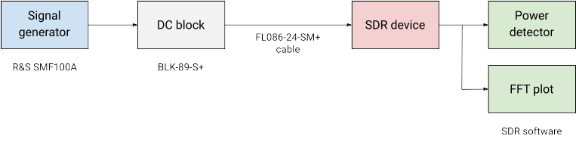Figure 2.5: Test setup for dynamic range measurements.
- Tune the receiver to the desired frequency f₀ (closed to what was used during the noise figure)
- Tune the signal generator (unwanted signal) to a frequency 5 kHz away from f₀
- With the signal generator OFF, measure the output power in 500 Hz bandwidth
- With the signal generator ON, find the input power P_{in} that gives a 3 dB increase in output noise power, or until spurs appear in the vicinity of f₀ and the strongest spur is 3 dB above the noise floor, c.f. figures 2.3 and 2.4
- Calculate the dynamic range using the formula BDR = P_{in} − MDS
- Repeat steps 2-5 with a signal 100 kHz and 1 MHz away

Since this setup also uses a DC block and coaxial cable, P_{in} has to be corrected for the insertion losses of these components:

The receiver gain compression, P_{1dB}, is measured as follows:
- Tune the receiver and the signal generator to the desired frequency f₀ (closed to what was used during the noise figure)
- With the signal generator OFF, measure the output power in 500 Hz bandwidth
- With the signal generator ON, increase the input power P_{in} by 2-3 dB at a time until 1 dB compression is observed in the output power
- Calculate the dynamic range using the formula DR = P_{1dB} − MDS

Note:
Receiver gain compression could not be measured on any of the devices under test because the ADC got saturated before any gain compression could be observed. Therefore, there are no P_{1dB} measurements.

Receiver Spectral Purity
The spectral purity of the receiver is tested through visual observation of the spectrum using an FFT in the SDR software. The tests are carried out in the frequency bands listed in section 1.3:
- Connect a 50-ohm terminator to the receiver input
- Adjust the receiver frequency, sample rate, and decimation to cover as much of the band of interest as possible
- Set the receiver to maximum gain
- Take a screenshot

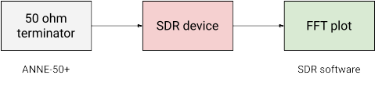Figure 2.6: Test setup for receiver spectral purity measurements.

Transmitter Spectral Purity
The transmitter spectral purity is tested by transmitting a CW test signal in the frequency bands of interest listed in section 1.3. The output is checked using a spectrum analyzer.

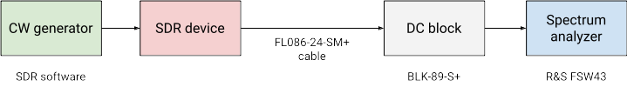Figure 2.7: Test setup for transmitter power and spectral purity measurements.

Transmitter Output Power
The transmitter output power is measured by transmitting a CW test signal at various gain settings and measuring the output power using a spectrum analyzer. The setup used for this is the same as the setup used for transmitter spectral purity measurements shown in Figure 2.9. Since this setup also uses a DC block and a coaxial cable, the measured CW power is corrected for the insertion losses from these components:

where PFSW is the power measured by the spectrum analyzer.

Transmitter Modulation Error Ratio
The transmitter modulation error ratio (MER) is a measure used to quantify how much the transmitted symbols deviate from their ideal value as illustrated on the constellation diagram in Figure 2.8 and given by the formula:

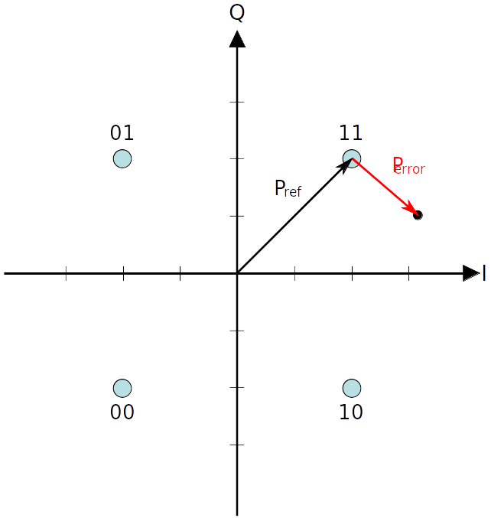Figure 2.8: Constellation with error [8].

Transmitter MER is measured by transmitting a DVB-S2 signal and measuring the SNR and MER using a DVB-S/S2 signal analyzer and using the following settings:
- 6.25 Msymbols / sec
- Modulation: 8-PSK
- FEC rate: 9/10
- FEC frame: Normal
- Roll-off factor: 0.20
- Pilots: ON

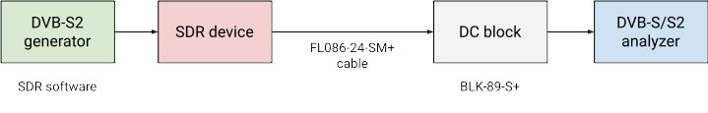Figure 2.9: Test setup for transmitter MER measurements.
The anlyzer used in our setup was a Rover HD Flash DVB-S/S2 signal analyzer. It measures the signal power, MER, and noise margin in dB, the latter being presumably a margin above the E_{S}/N₀ that is required for error free reception, which is 11 dB for the modulation and FEC-rate used in our setup, c.f. Table 13 in ETSI-EN-302-307-1 [9].

Photos of ROVER screen

Test Software
INTRO
For the receiver tests (noise figure, dynamic range, spectral purity), a dedicated Qt-based application [10] with the following components has been devloped:
- Device interface to configure, control and read samples from the SDR device under test.
- Spectrum plot using FFT and Qt graphics.
- Digital downconverter to select a channel with adjustable bandwidth.
- RMS power detector with adjustable averaging time.
- Basic AM, FM, CW, and SSB demodulators.

A functional diagram for the test software used for receiver tests is shown on Figure 2.10 below. In order to ensure sufficient support for the SDR devices, the test software does not use any SDR device wrappers but interfaces directly to the SDR device driver libraries.

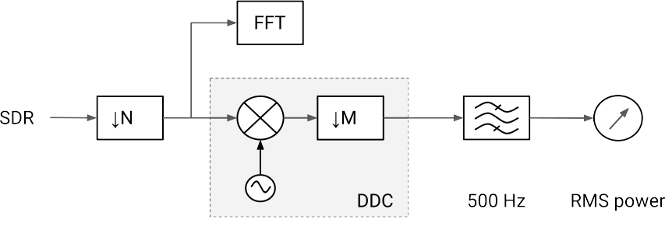Figure 2.10: Functional diagram for the test software used for receiver tests.
For transmitter tests (output power, MER, spectral purity), simple applications based on GNU Radio 3.8 [11] and the gr-soapy [12] device interface module were created. These applications are available in the project repository [13] and two examples using the BladeRF 2.0 micro are shown on Figure 2.11 and Figure 2.12 below.

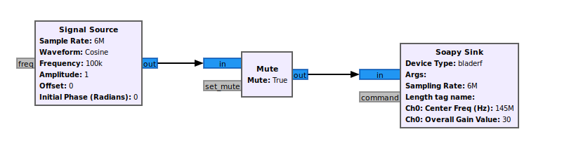Figure 2.11: GNU Radio application used for output power measurements.

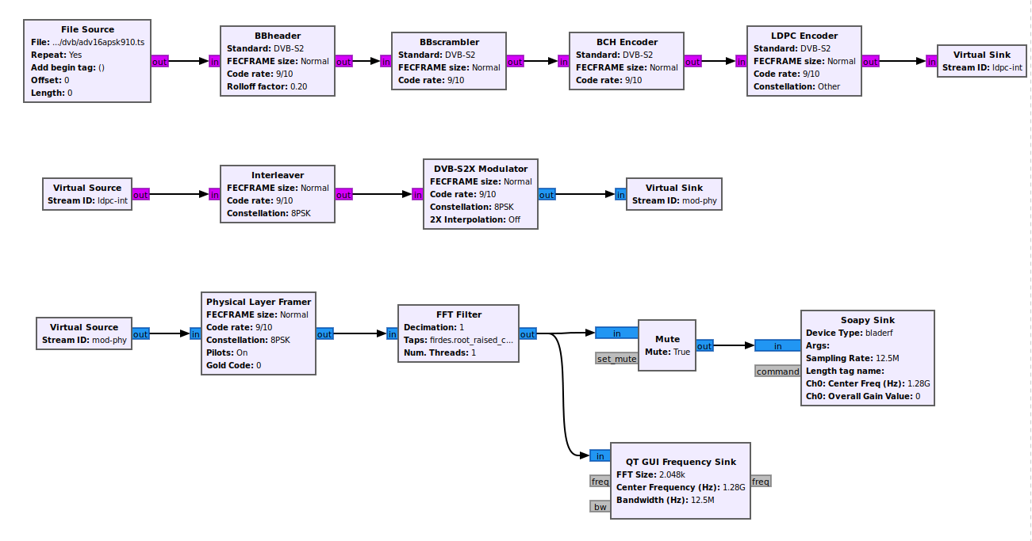Figure 2.12: GNU Radio application used for MER measurements.

Test Results

RTL-SDR Blog V3
RTL-SDR dongles are based on the Realtek RTL2832U DVB-T demodulator chip that was found to be capable of transferring raw I/Q samples to the host computer. This characteristic was discovered already in 2012 and has made the RTL2832U-based dongles the most popular SDR receivers to date. Compared to generic RTL-SDR devices, the RTL-SDR Blog V3 dongle has been redesigned with SDR users in mind providing significantly better performance than the generic RTL-SDR dongles.

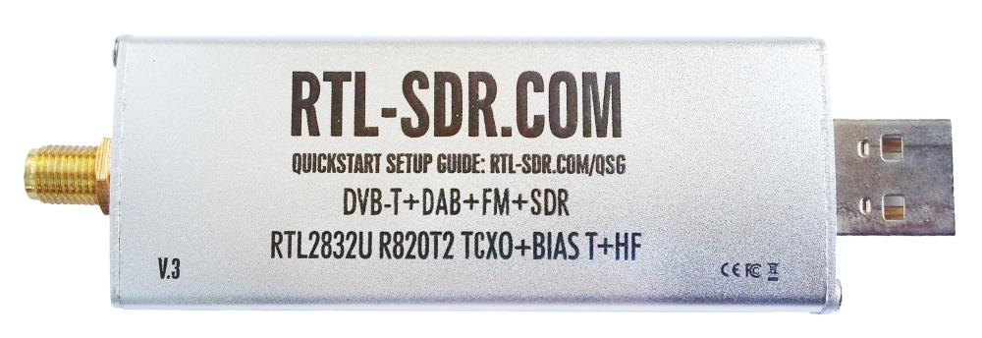
Figure 3.1: The RTL-SDR blog V3 receiver.
The RTL-SDR Blog V3 dongle uses a Rafael R820T2 24-1700 MHz RF tuner, which delivers analog I/Q samples to the RTL2832U demodulator chip. The RTL2832U chip acts as 8-bit analog to digital converter and USB interface to the host computer and can also function as a direct sampling shortwave receiver, see figure 3.2 below.

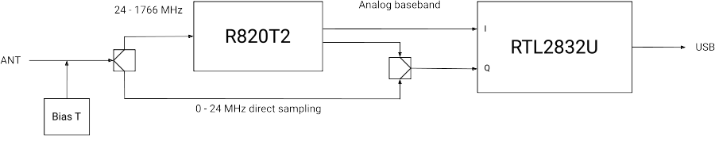Figure 3.2: RTL-SDR Blog V3 dongle block diagram.
** Software API **
A summary of the technical specifications for the RTL-SDR Blog V3 dongle is listed in Table 3.1 below.

Frequency Range | 500 kHz – 1766 MHz
Sample rate | 2.4 MSPS
RF bandwidth | 350 kHz – 8 MHz
Frontend filters | Tracking RF filters in the R820T2 tuner
RX paths | 1
RX inputs | 1
ADC resolution | 8-bit
Claimed noise figure | -
Clained dynamic range | -
Reference clock | 1 PPM TCXO
Other features | Bias T  Direct sampling  Expansion ports
Temperature range | -
Size | 10 cm × 2.5 cm × 1.4 cm
Weight | 30 g
Approximate price | 22 USD
Product page | https://www.rtl-sdr.com/buy-rtl-sdr-dvb-t-dongles/
Table 3.1: RTL-SDR Blog V3 technical specifications.

Receiver Noise Figure
Input rate | Decimation | Sample rate
2.4 MHz | 8 | 300 kHz
Table 3.2: RTL-SDR settings used during noise figure measurements.

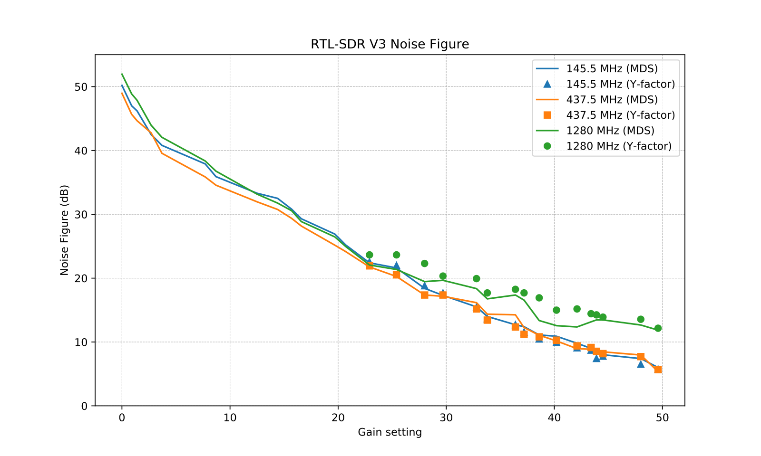Figure 3.3: RTL-SDR V3 noise figure measurements.

Receiver Blocking Dynamic Range

Input rate | Decimation | Sample rate
2.4 MHz | 1 | 2.4 MHz
Table 3.3: RTL-SDR V3 settings used during BDR measurements.
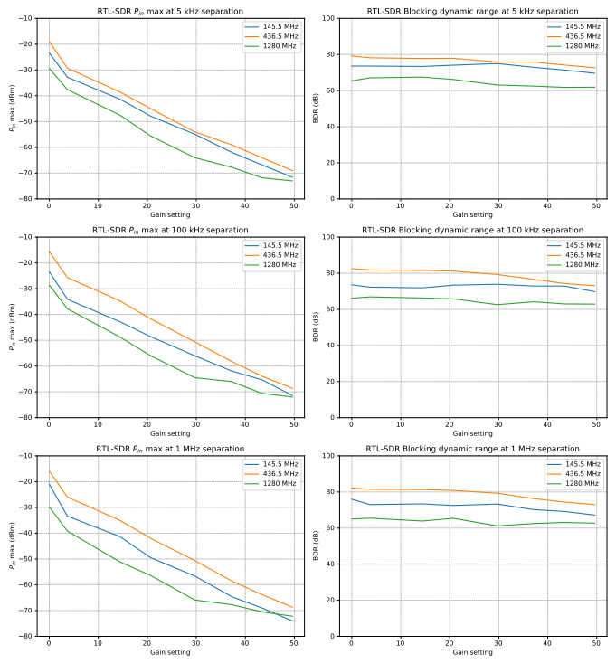Figure 3.4: RT-SDR V3 blocking dynamic range measurements.

Receiver Spectral Purity

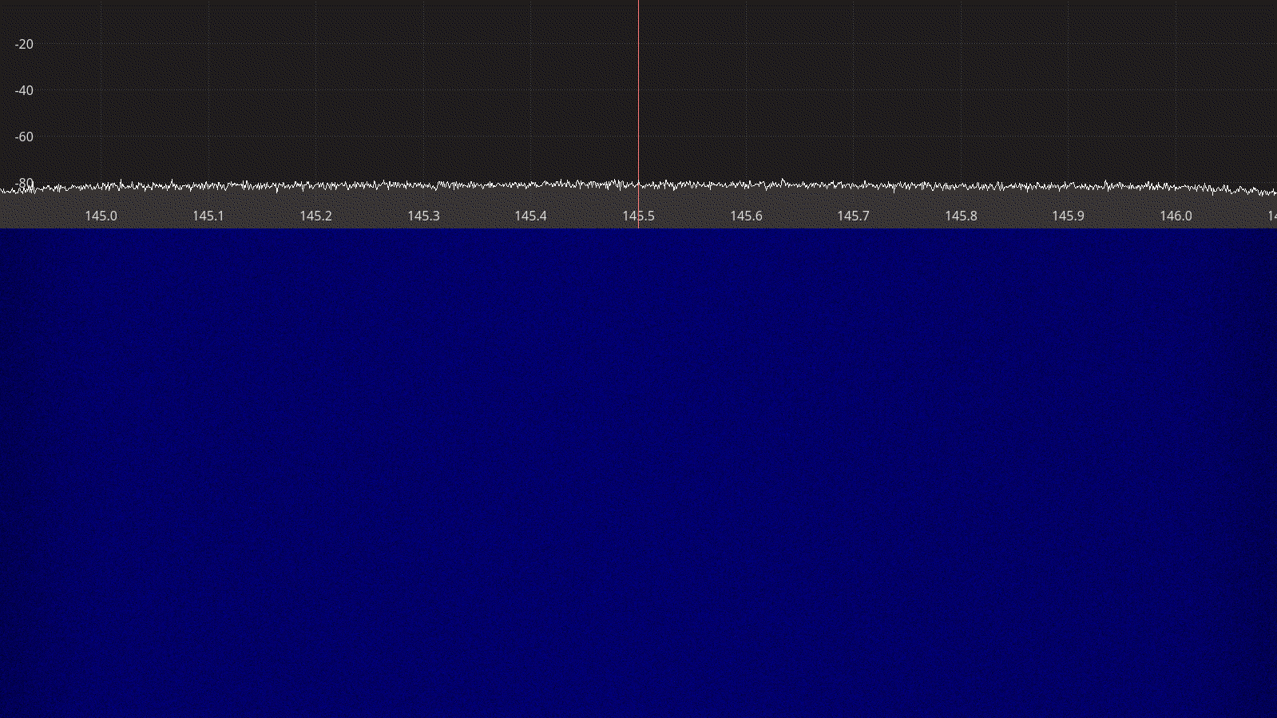Figure 3.5: RTL-SDR receiver spectrum between 145 – 146 MHz.
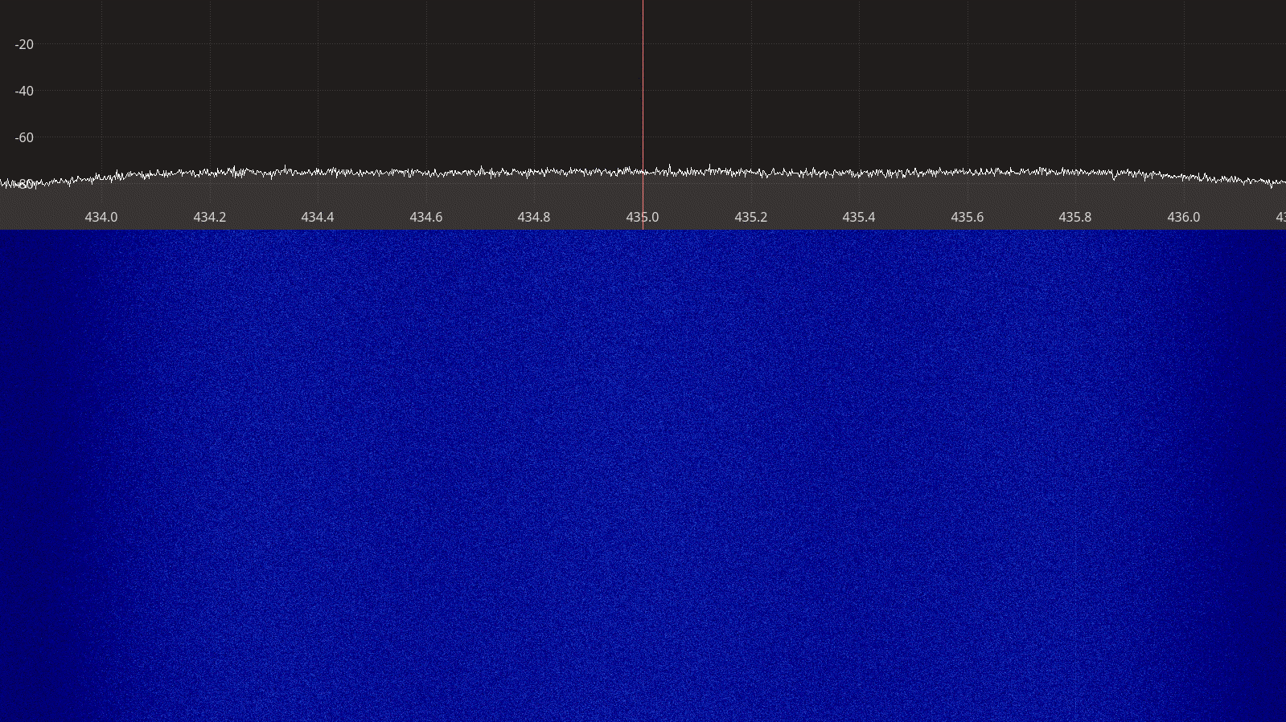Figure 3.6: RTL-SDR receiver spectrum between 434 – 436 MHz.
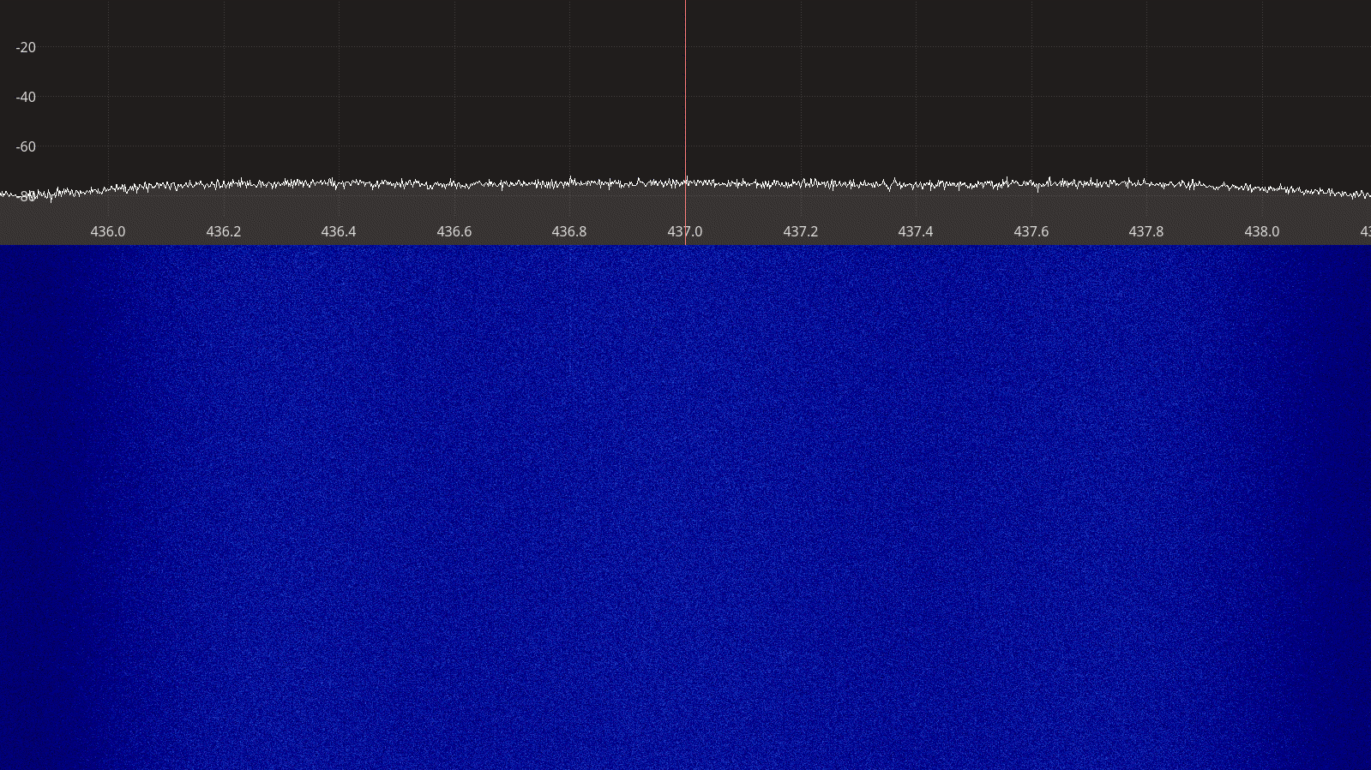Figure 3.7: RTL-SDR receiver spectrum between 436 – 438 MHz.
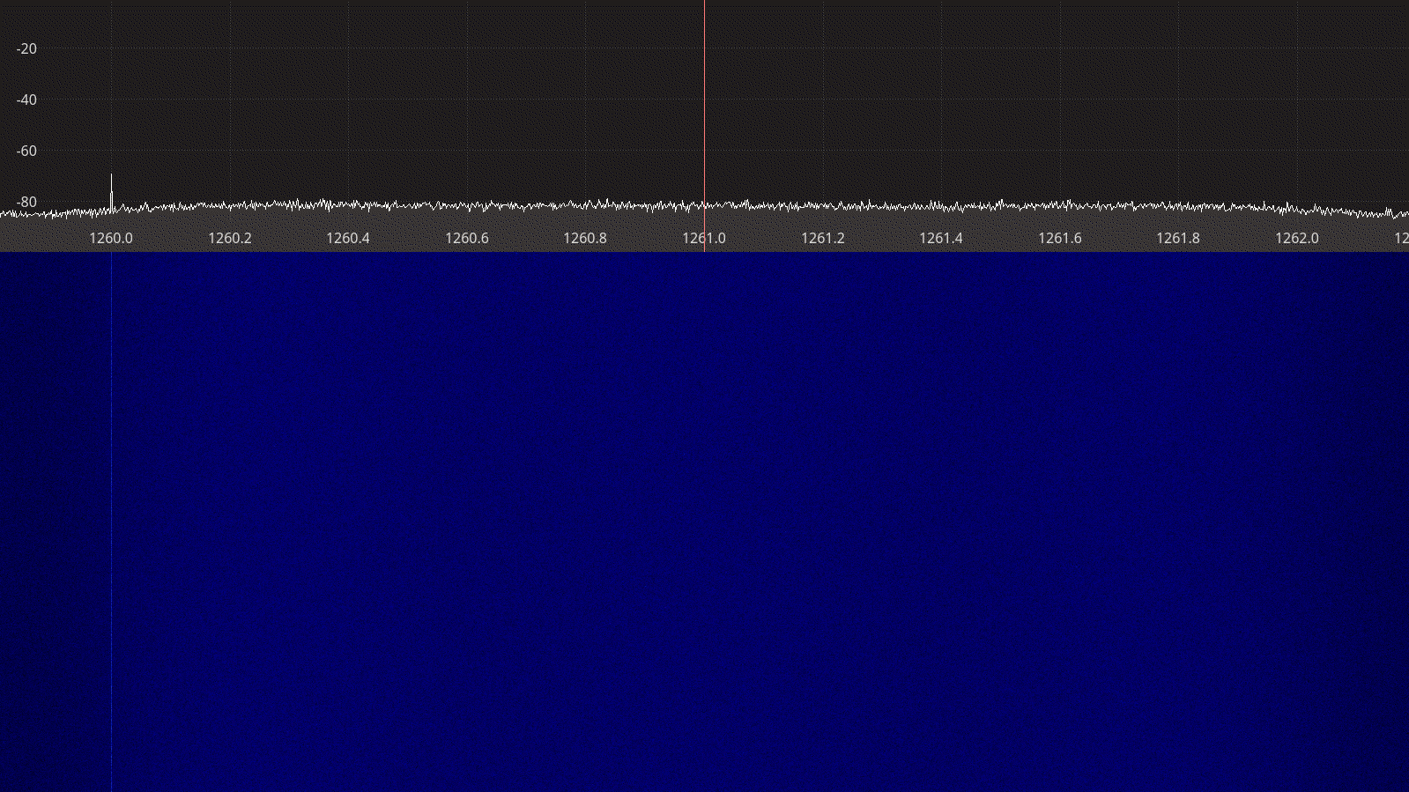Figure 3.8: RTL-SDR receiver spectrum between 1260 – 1262 MHz.

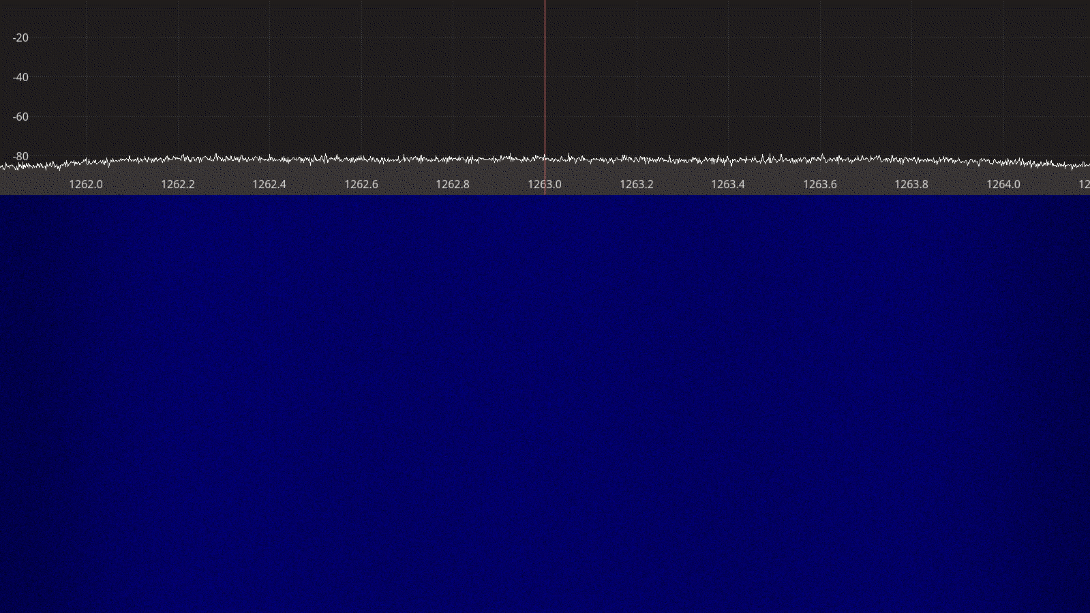Figure 3.9: RTL-SDR spectrum between 1262 – 1264 MHz.
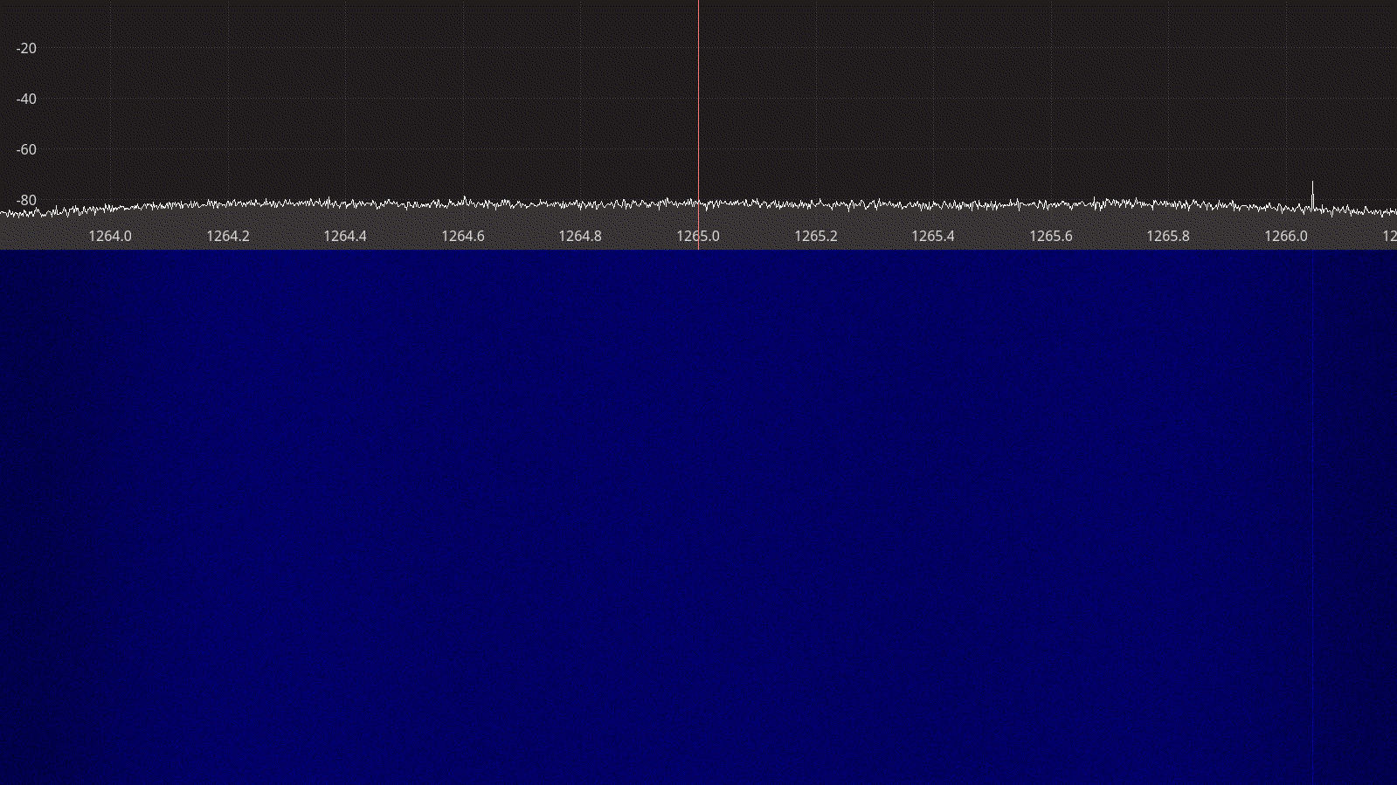Figure 3.6: RTL-SDR receiver spectrum between 1264 – 1266 MHz.

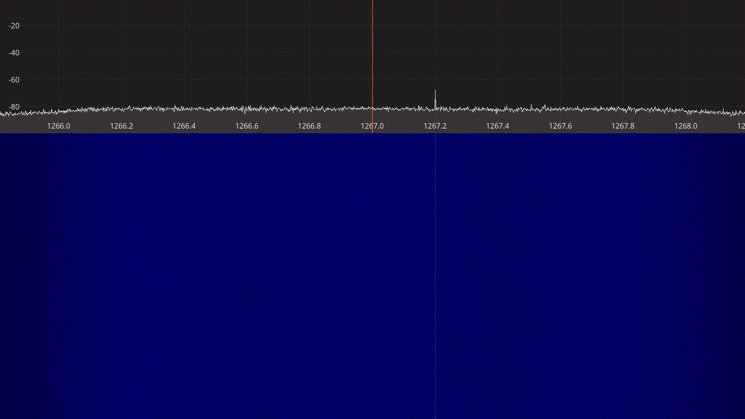Figure 3.10: RTL-SDR receiver spectrum between 1266 – 1268 MHz.
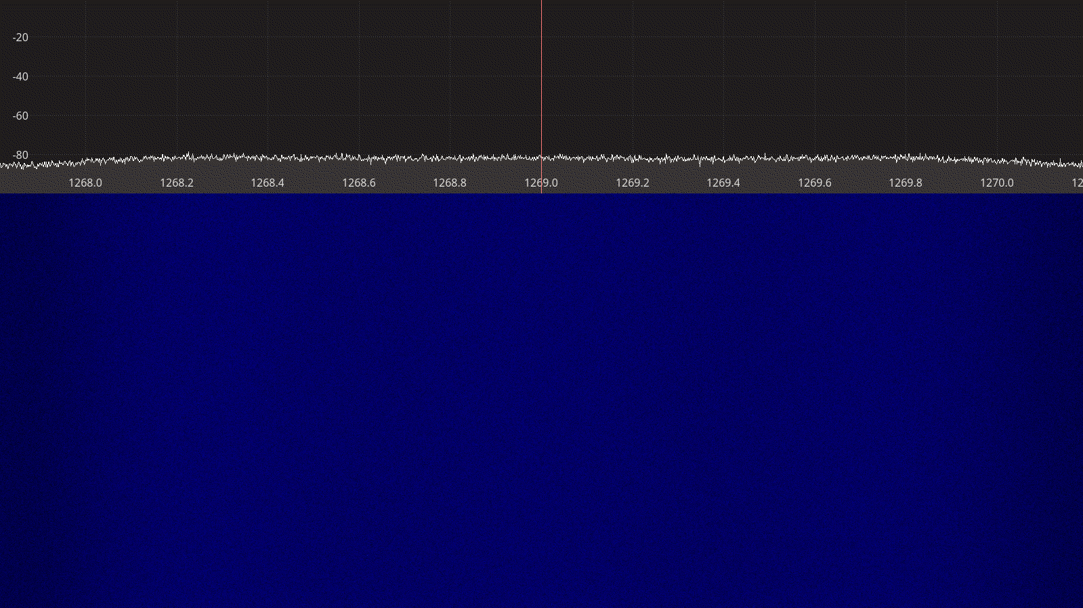Figure 3.11: RTL-SDR receiver spectrum between 1268 – 1270 MHz.

Airspy Mini
The Airspy Mini has similar architecture as the RTL-SDR, except that the RTL2832U DVB-T demodulator chip is replaced with an LPC4370 microcontroller with integrated 12-bit, 20 MSps analog to digital converter, providing both higher sample rates and potentially better dynamic range.

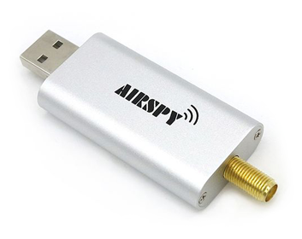
Figure 3.12: The Airspy Mini receiver.

The Airpsy Mini uses IF sampling to capure the bandwidth of interest. Conversion to quadrature samples is done by the driver running on the host PC. Thus, the Airspy Mini does not suffer from the I/Q imbalance, DC offset, and 1/F noise often seen in SDR receivers that use direct conversion [15].
** Software API **

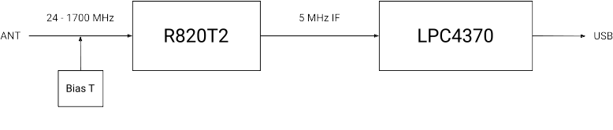Figure 3.13: Airspy Mini block diagram.
A summary of the technical specifications for the Airspy Mini is listed in Table 3.4 below.

Frequency Range | 24 – 1700 MHz
Sample rate | 3, 6, 10 MSPS
RF bandwidth | 2.4 – 6 MHz
Frontend filters | Tracking RF filters
RX paths | 1
RX inputs | 1
ADC resolution | 12-bit (10.4 ENOB)
Claimed noise figure | 3.5 dB between 42 – 1002 MHz
Clained dynamic range | 70 dB SNR, 95 dB SFDR for the ADC
Reference clock | 0.5 PPM
Other features | Bias T
Temperature range | -10 to 40 °C
Size | 8 cm × 2.7 cm × 1 cm
Weight | 20 g
Approximate price | 99 USD
Product page | https://airspy.com/airspy-mini/
Table 3.4: Airspy Mini technical specifications.

Receiver Noise Figure
Input rate | Decimation | Sample rate | Gain mode
6 MHz | 16 | 375 kHz | Linearity
Table 3.5: Airspy Mini settings used during noise figure measurements.

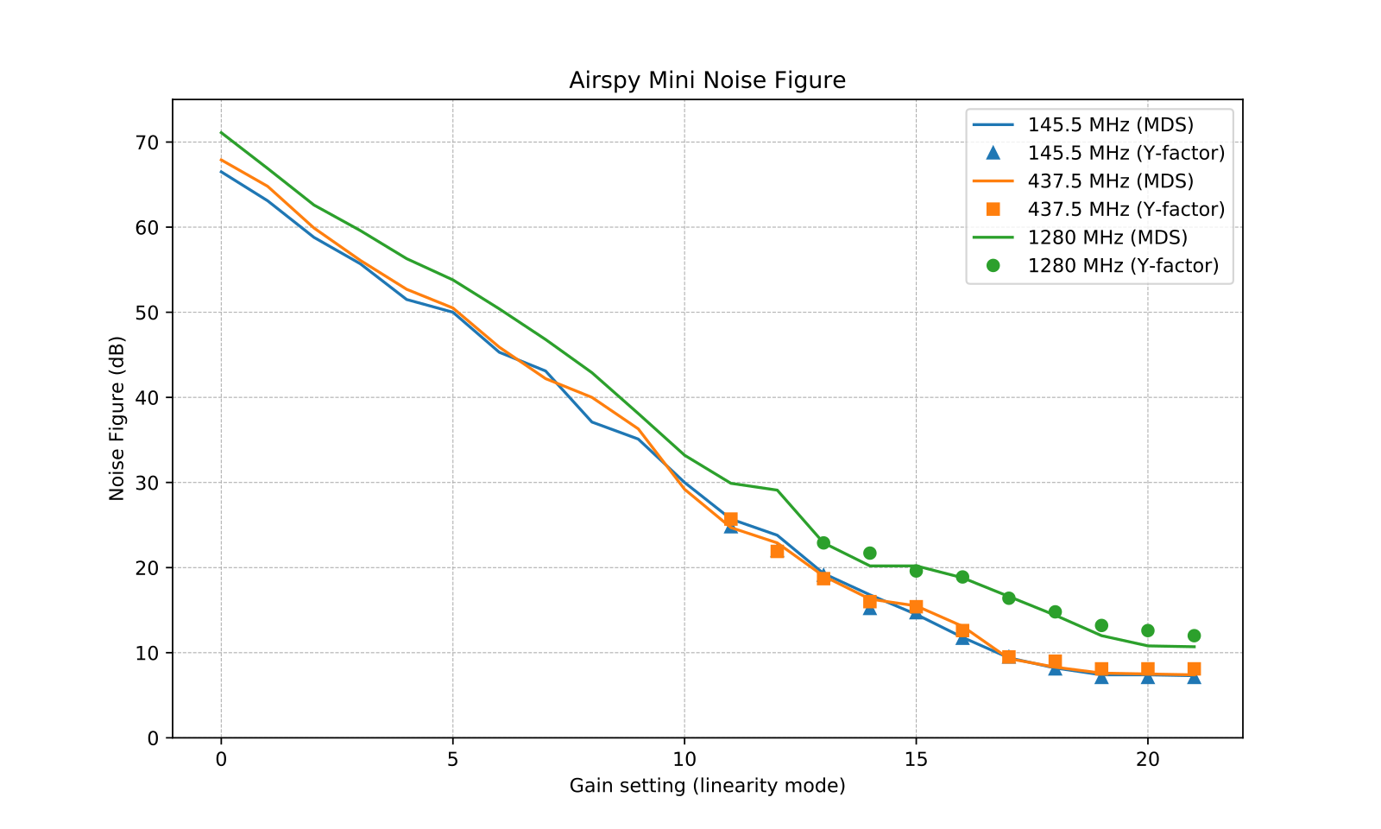Figure 3.14: Airspy Mini noise figure measurements.

Receiver Blocking Dynamic Range

Input rate | Decimation | Sample rate | Gain mode
6 MHz | 2 | 3 MHz | Linearity
Table 3.6: Airspy Mini settings used during BDR measurements.

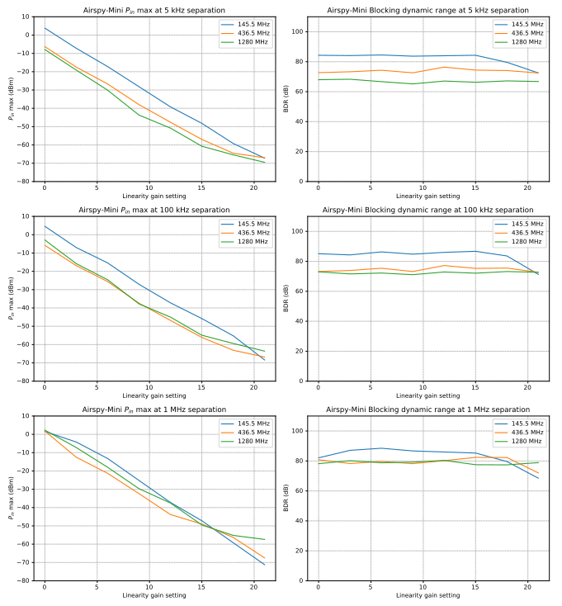Figure 3.15: Airspy Mini blocking dynamic range measurements.

Receiver Spectral Purity

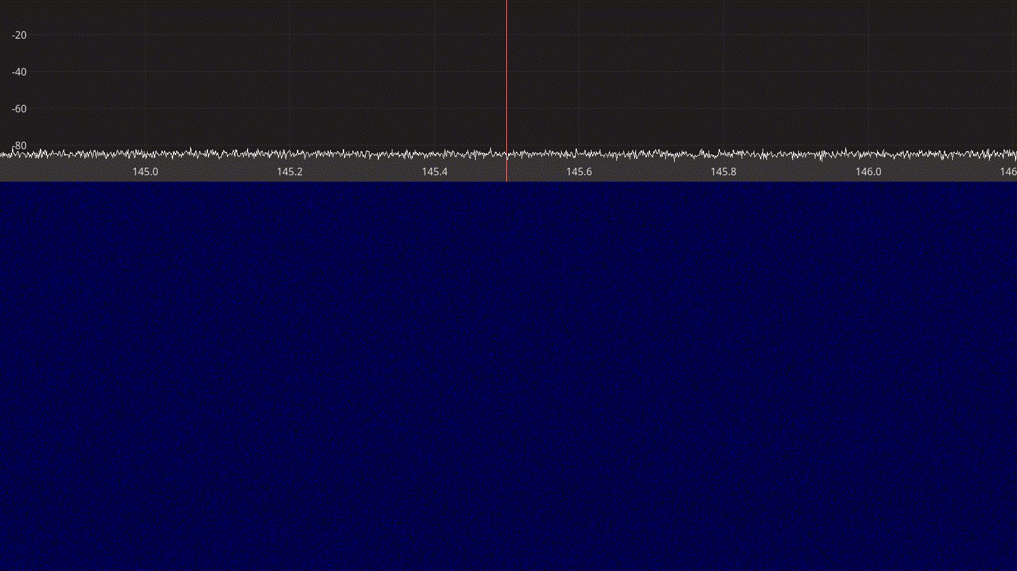Figure 3.16: Airspy Mini receiver spectrum between 145 – 146 MHz.
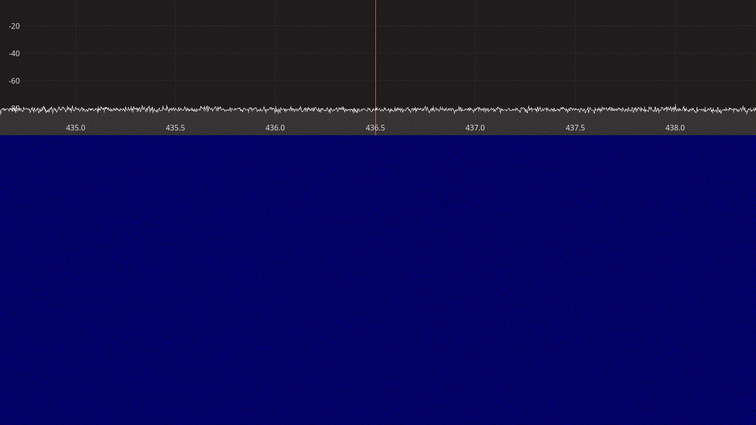Figure 3.17: Airspy Mini receiver spectrum between 435 – 438 MHz.

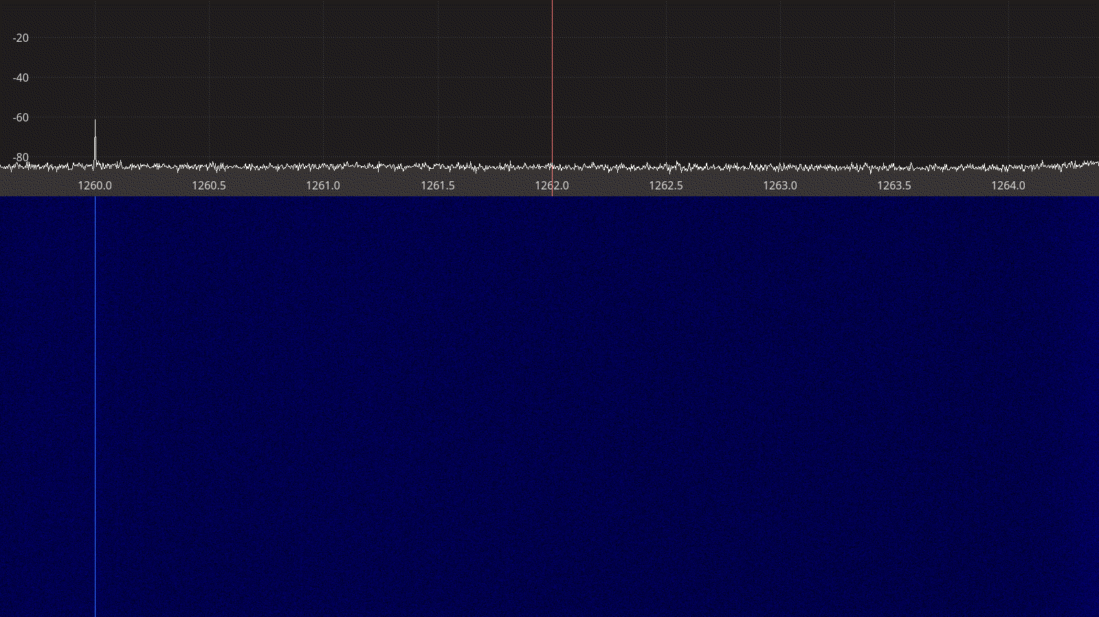Figure 3.18: Airspy Mini receiver spectrum between1260 – 1264 MHz.
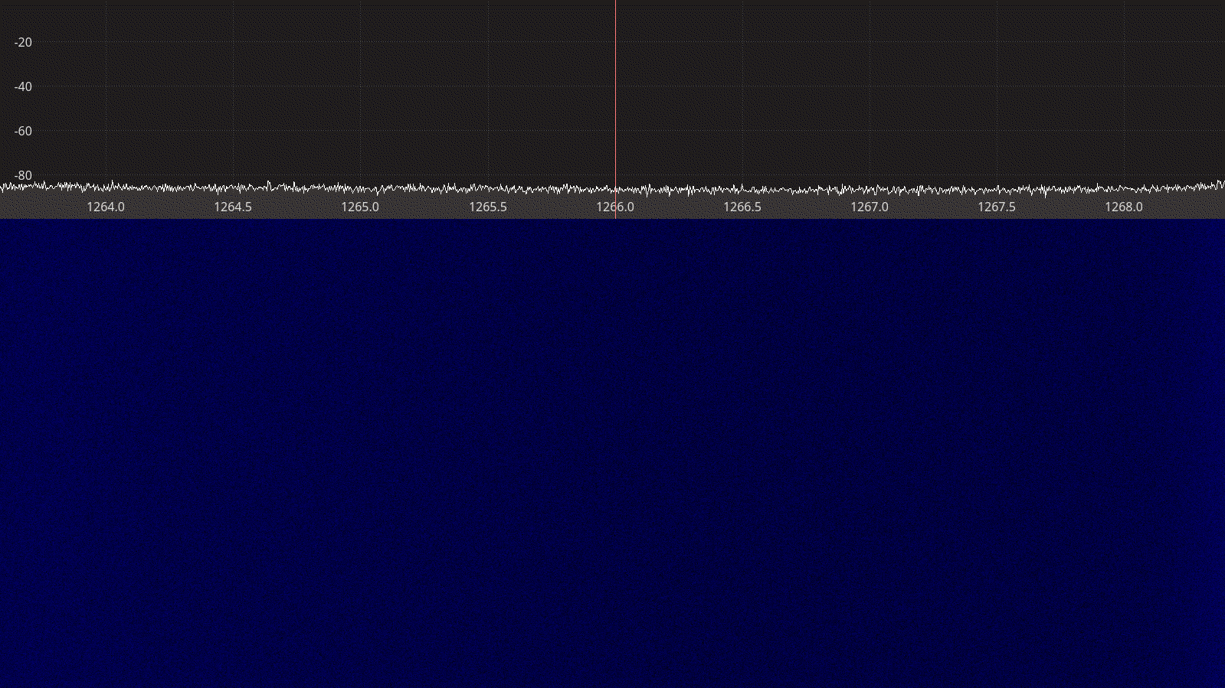Figure 3.19: Airspy Mini receiver spectrum between 1264 – 1268 MHz.

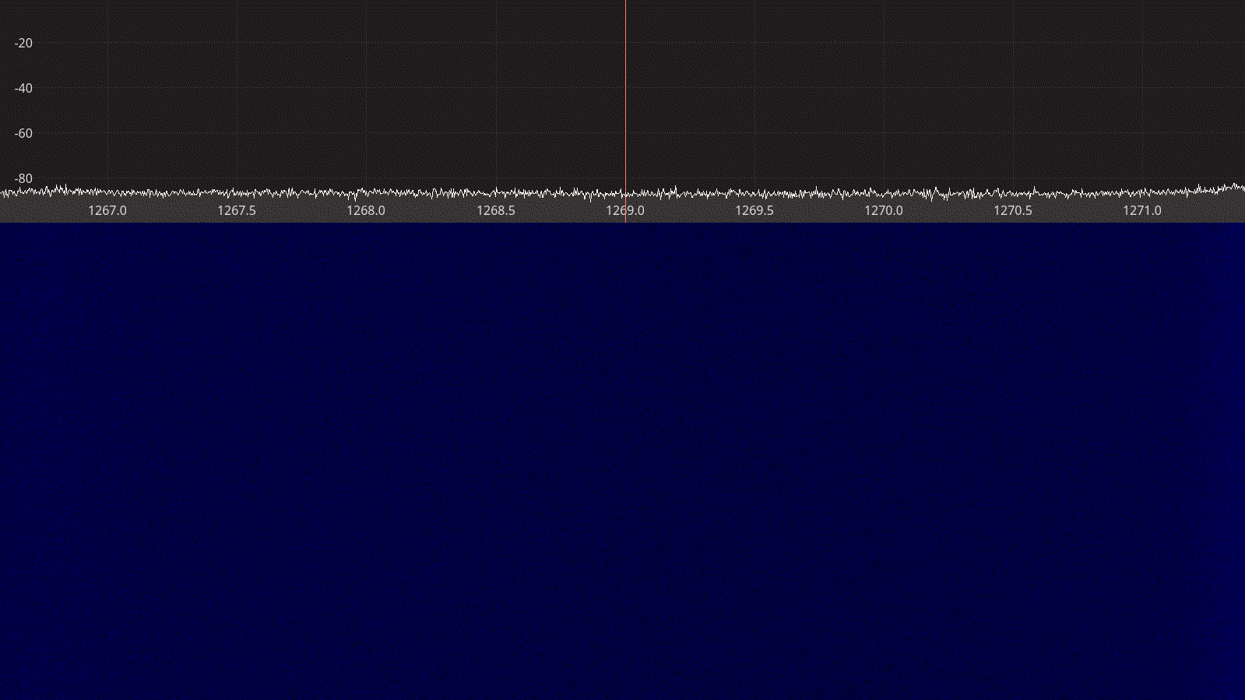Figure 3.20: Airspy Mini receiver spectrum between 1267 – 1271 MHz.

SDRplay RSPduo
The SDRplay RSPduo is a dual-tuner 14-bit receiver based on a tuner and USB chipset from Mirics, covering the entire spectrum from 1 kHz to 2 GHz with up to 10 MHz maximum bandwidth [1].
Unlike the other devices with multiple receive paths, the two tuners in the SDRplay RSP duo function independently of each other and can receive different frequency bands at the same time. This makes them aprticulary interesting for applications such as a SatNOGS ground station, where VHF and UHF could be reecieved simultaneously using just one device.
Other noteworthy features of SDRplay devices include the extensive set of band-pass and notch filters as well as the extensive documentation of receiver performance measurmenets available on the website [16].
On the other hand, we need to mention that the SDRplay device driver library is only avaialble as a closed-source binary, potentially limiting the number of supported host architectures and operating systems. The software API is not as intuitive as the ones provided by RTL-SDR and Airspy.

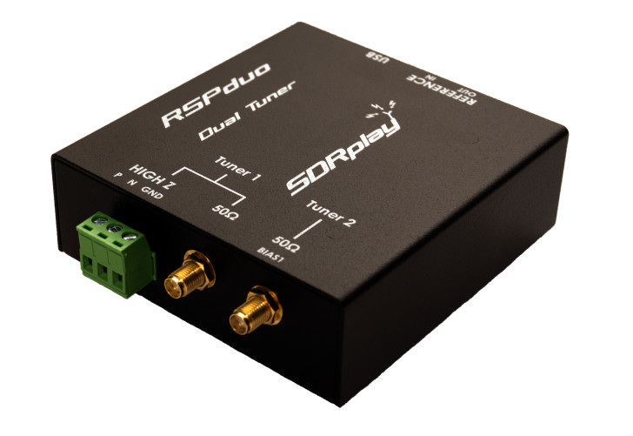
Figure 3.21: The SDRplay RSPduo receiver.

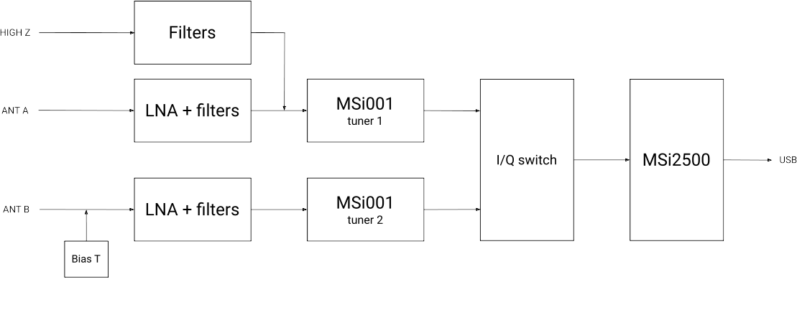Figure 3.22: The SDRplay RSPduo block diagram.
A summary of the technical specifications for the SDRplay RSPduo is listed in Table 3.7 below.

Frequency Range | 1 kHz – 2 GHz
Sample rate | 2 – 10.66 MSPS
RF bandwidth | 200 – 8000 kHz
Frontend filters | 2 MHz low-pass  2-12 MHz  30-60 MHz  60-120 MHz  120-250 MHz  250-300 MHz  300-380 MHz  380-420 MHz  420-1000 MHz  1000 MHz high-pass
RX paths | 2
RX inputs | 3
ADC resolution | 14-bit up to 6.048 MSPS  12-bit between 6.048-8.064 MSPS  10-bit between 8.064-9.216 MSPS  8-bit above 9.216 MSPS
Claimed noise figure | ~ 2.5 dB below 500 MHz  ~ 4.5 dB below 1.3 GHz
Clained dynamic range | -
Reference clock | 0.5 PPM TCXO
Other features | Independent tuners  Bias T  External clock
Temperature range | -
Size | 9.5 cm × 8.0 cm × 3 cm
Weight | 315 g
Approximate price | 240 €
Product page | https://www.sdrplay.com/rspduo/
Table 3.7: SDRplay RSPduo technical specifications.

Receiver Noise Figure
Input rate | Decimation | Sample rate | IF Bandwidth | IF gain
4 MHz | 8 | 500 kHz | 600 kHz | -20 dB
Table 3.8: SDRplay RSPduo settings used during noise figure measurements.

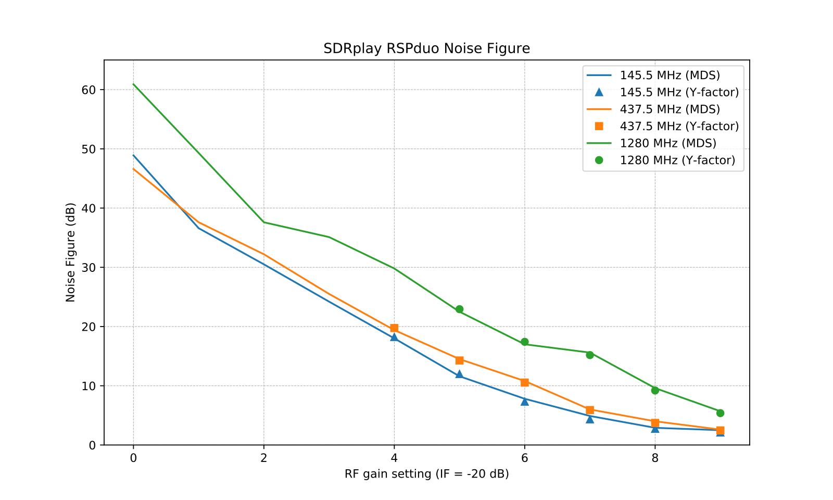Figure 3.23: SDRplay RSPduo noise figure measurements.
Notes:
- strange gain API, no diff in MDS between IF -40 and -20
- Compare to data from SDRplay / claimed NF.

Receiver Blocking Dynamic Range

Input rate | Decimation | Sample rate | IF Bandwidth | IF gain
4 MHz | 2 | 2 MHz | 200 kHz | -40 dB
Table 3.9: SDRplay RSPduo settings used for BDR measurements.

Notes:
- We have verified that using IF gain -40 does not change the MDS.
- We can clearly see higher dependency on the separation (IF filters help!)

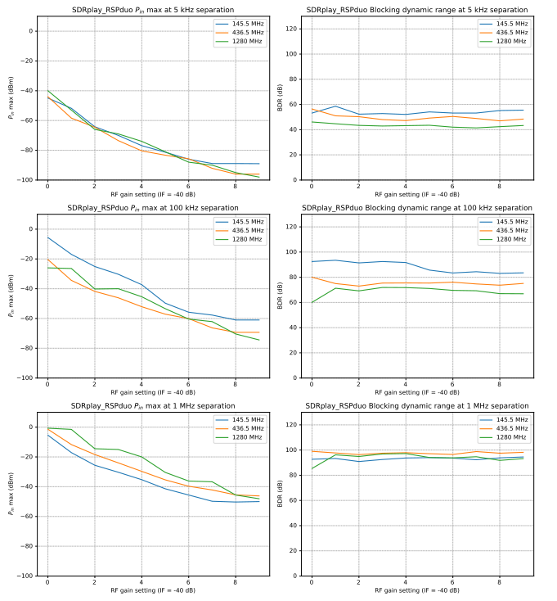Figure 3.24: SDRplay RSPduo blocking dynamic range measurements.

Receiver Spectral Purity

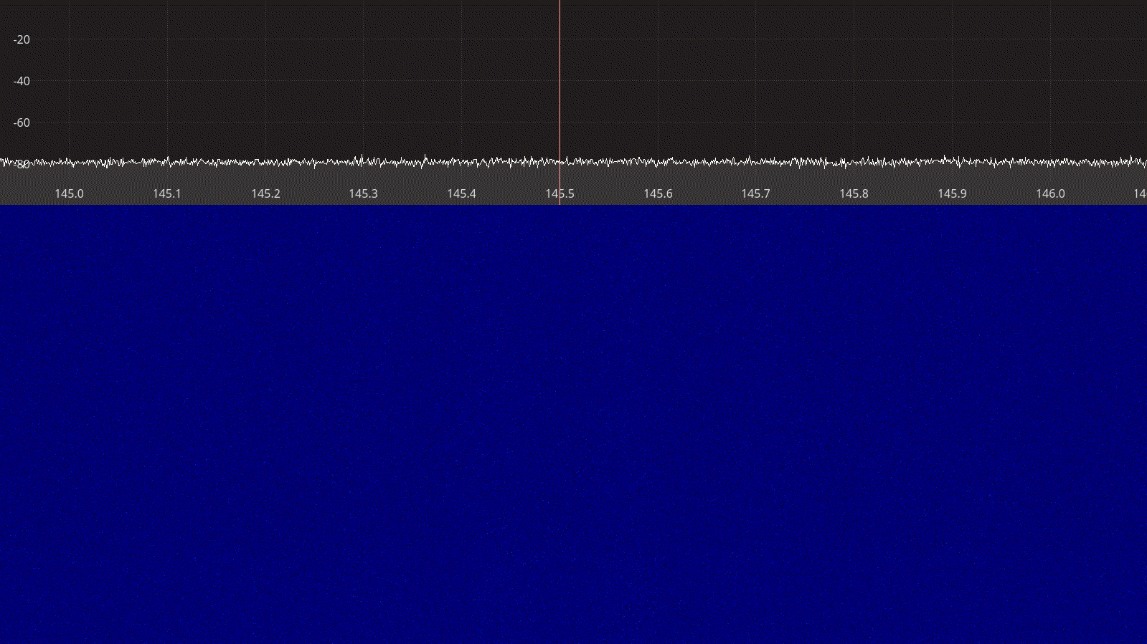Figure 3.25: SDRplay RSPduo receiver spectrum between 145 – 146 MHz.
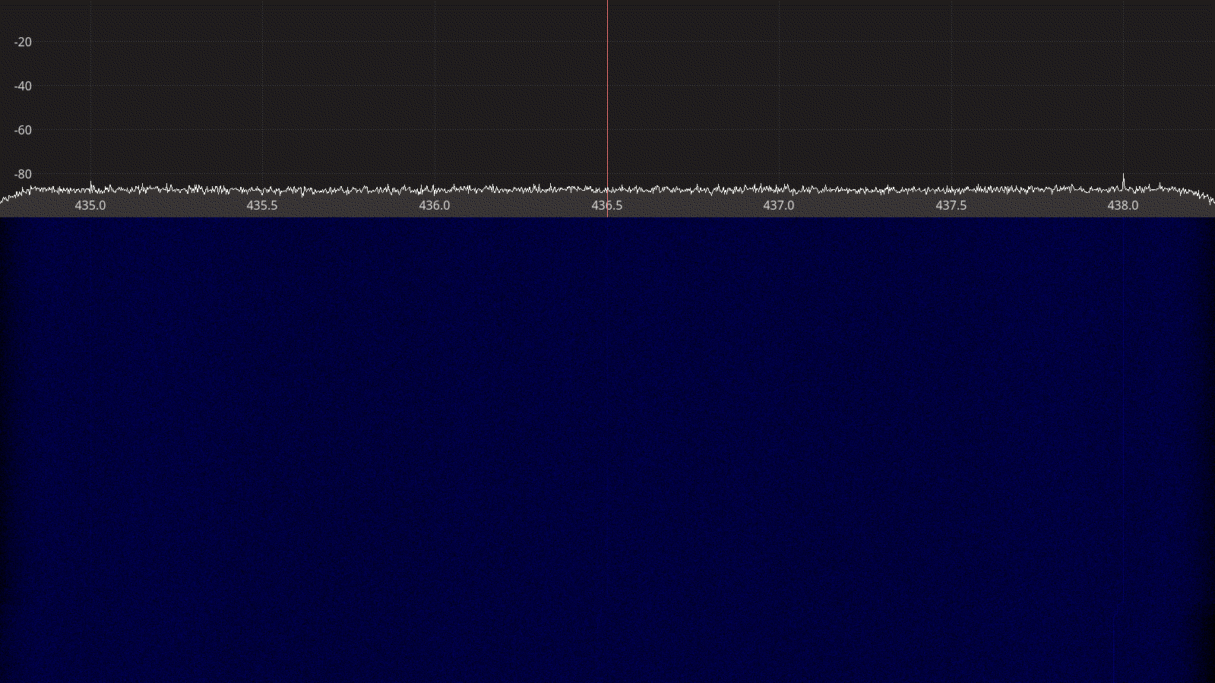Figure 3.26: SDRplay RSPduo receiver spectrum between 435 – 438 MHz.

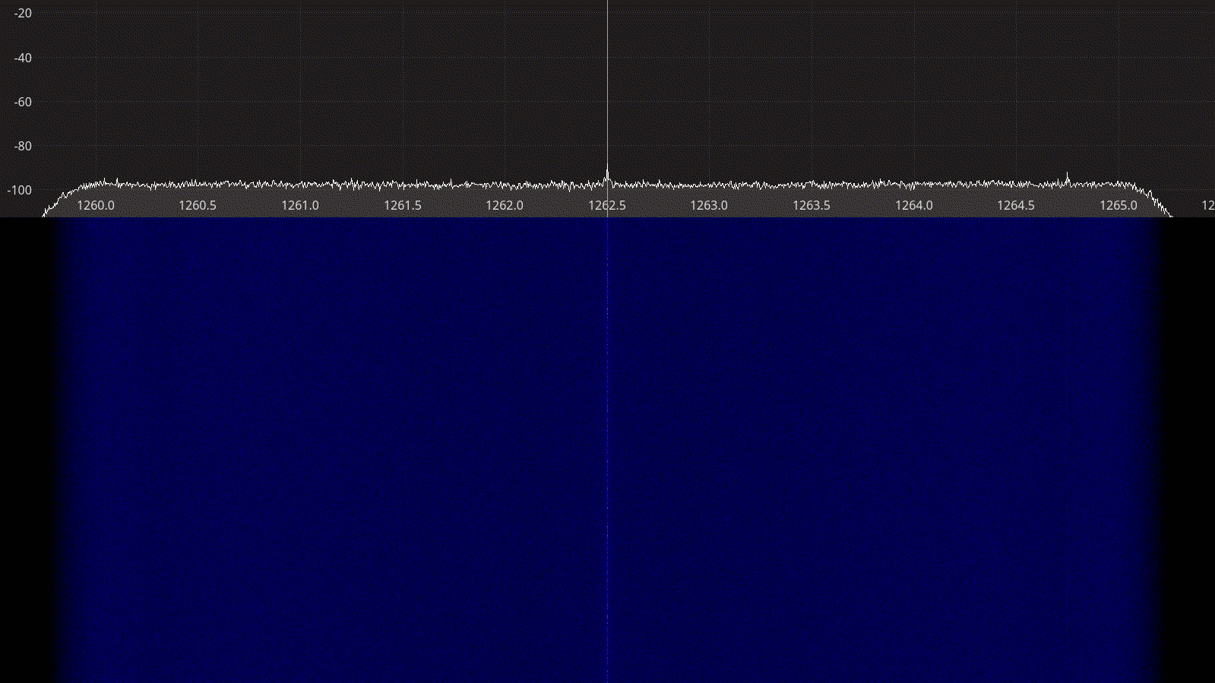Figure 3.27: SDRplay RSPduo receiver spectrum between 1260 – 1265 MHz.
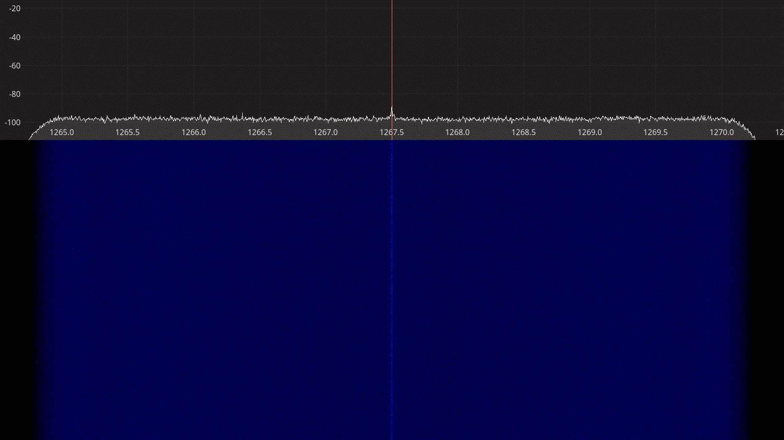Figure 3.28: SDRplay RSPduo receiver spectrum between 1265 – 1270 MHz.

LimeSDR Mini
The LimeSDR Mini is a small 10 MHz – 3.5 GHz full-duplex transceiver based on the LMS7002M integrated transceiver from Lime Microsystems [17]. Its small size and low cost makes it a popular choice amongst hobbyists looking for entry-level SDR transceiver hardware. Although the LMS7002M is capable of delivering bandwidths up to 96 MHz [18], the components used in the LimeSDR Mini limit its capabilities to 30.72 MHz.
Both the LimeSDR Mini hardware and accompanying software come as open-source with design files and source code available on GitHub [19]. All LimeSDR devices are controlled through a LimeSuite library, which provides a simple API to user applications.

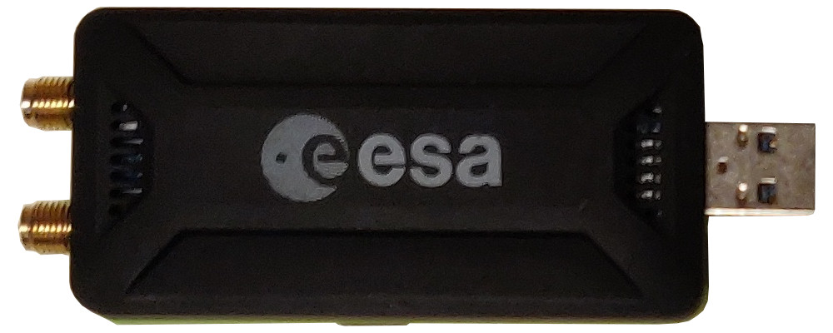
Figure 3.29: LimeSDR Mini transceiver.

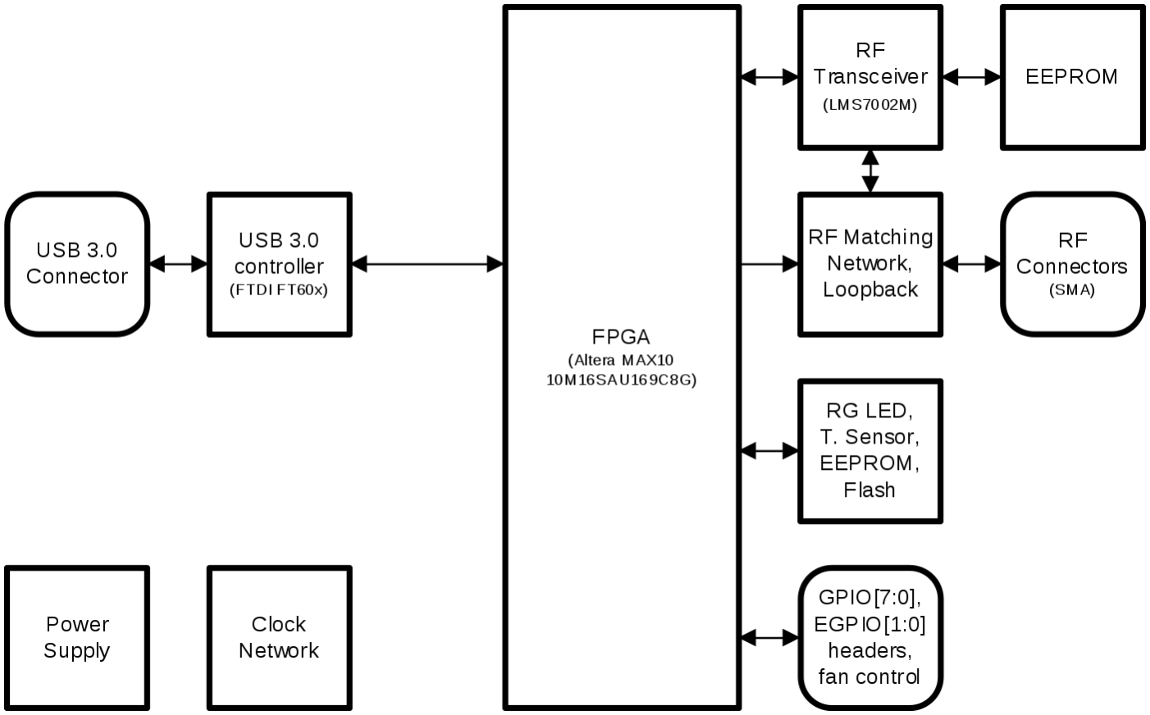Figure 3.30: LimeSDR Mini block diagram.

A summary of the technical specifications for the LimeSDr Mini is listed in Table 3.10 below.

Frequency Range | 10 – 3800 MHz
Sample rate | 30.72 MSPS
RF bandwidth | 30.72 MHz
Frontend filters | Variable bandwidth low-pass filter before ADC
RX paths | RX1_W for 10 MHz – 2 GHz  RX1_H for 2 – 3.5 GHz
RX inputs | 1
TX paths | TX1_1 for 2 – 3.5 GHz  TX1_2 for 10 MHz – 2 GHz
TX outputs | 1
ADC resolution | 12
DAC resolution | 12
Claimed noise figure | -
Clained dynamic range | -
Claimed transmit power | -
Reference clock | VCTCXO (±1 ppm initial, ±4 ppm stable)
Other features | On-board EEPROM and flash for firmware and FPGA image  GPIO through header  External clock through uFL connectors  Open source design
Temperature range | -
Size | 9.5 cm × 3.6 cm × 1.3 cm (with enclosure)
Weight | 42 g
Approximate price | 159 USD (board only)  299 USD (with aluminum enclosure)
Product page | https://limemicro.com/products/boards/limesdr-mini/
Table 3.10: LimeSDR Mini technical specifications.

Receiver Noise Figure
Input rate | Decimation | Sample rate | RF Path | Bandwidth | LPF
4 MHz | 8 | 500 kHz | Auto | Auto | ON
Table 3.11: LimeSDR Mini settings used during noise figure measurements.

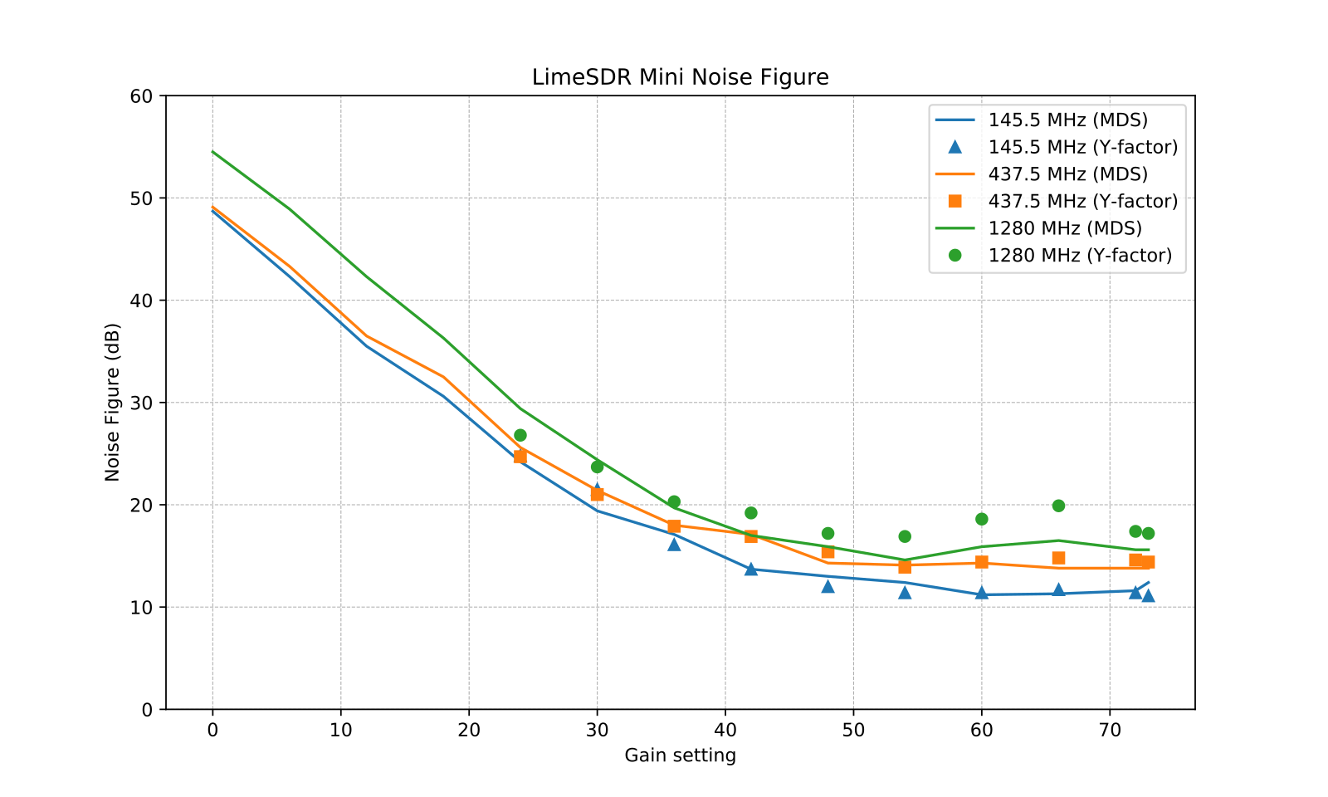Figure 3.31: LimeSDR Mini noise figure measurements.

Notes:
- The LimeSDR Mini was in general sufferring from excessive noise
- Above 2 GHz the noise was so high and sensitive to toucing the enclosure that we didn’t find it meaningful to include the results.
- Perhaps the RF matching network or LMS7002M is damaged (try other units)
- We have verified that Analog LFP ON/OFF doe not impact the NF (within 1 dB, which is our accuracy)

Receiver Blocking Dynamic Range

Input rate | Decimation | Sample rate | RF path | Bandwidth | LPF
2 MHz | 1 | 3 MHz | Auto | 1401 kHz | ON
Table 3.12: LimeSDR Mini settings used for BDR measurements.

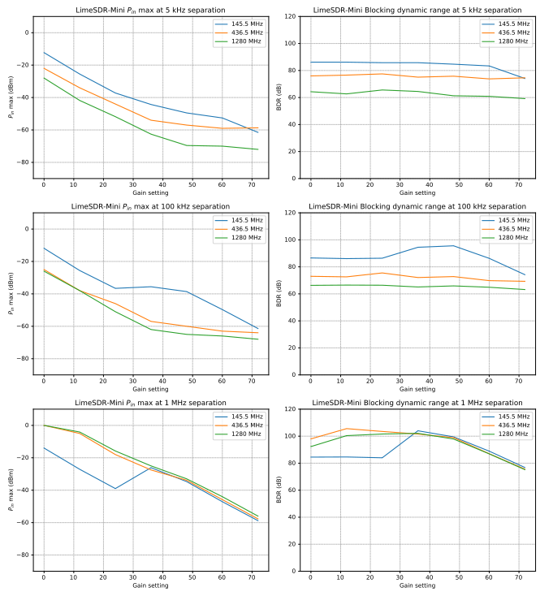Figure 3.32: LimeSDR Mini blocking dynamic range measurements.

Receiver Spectral Purity

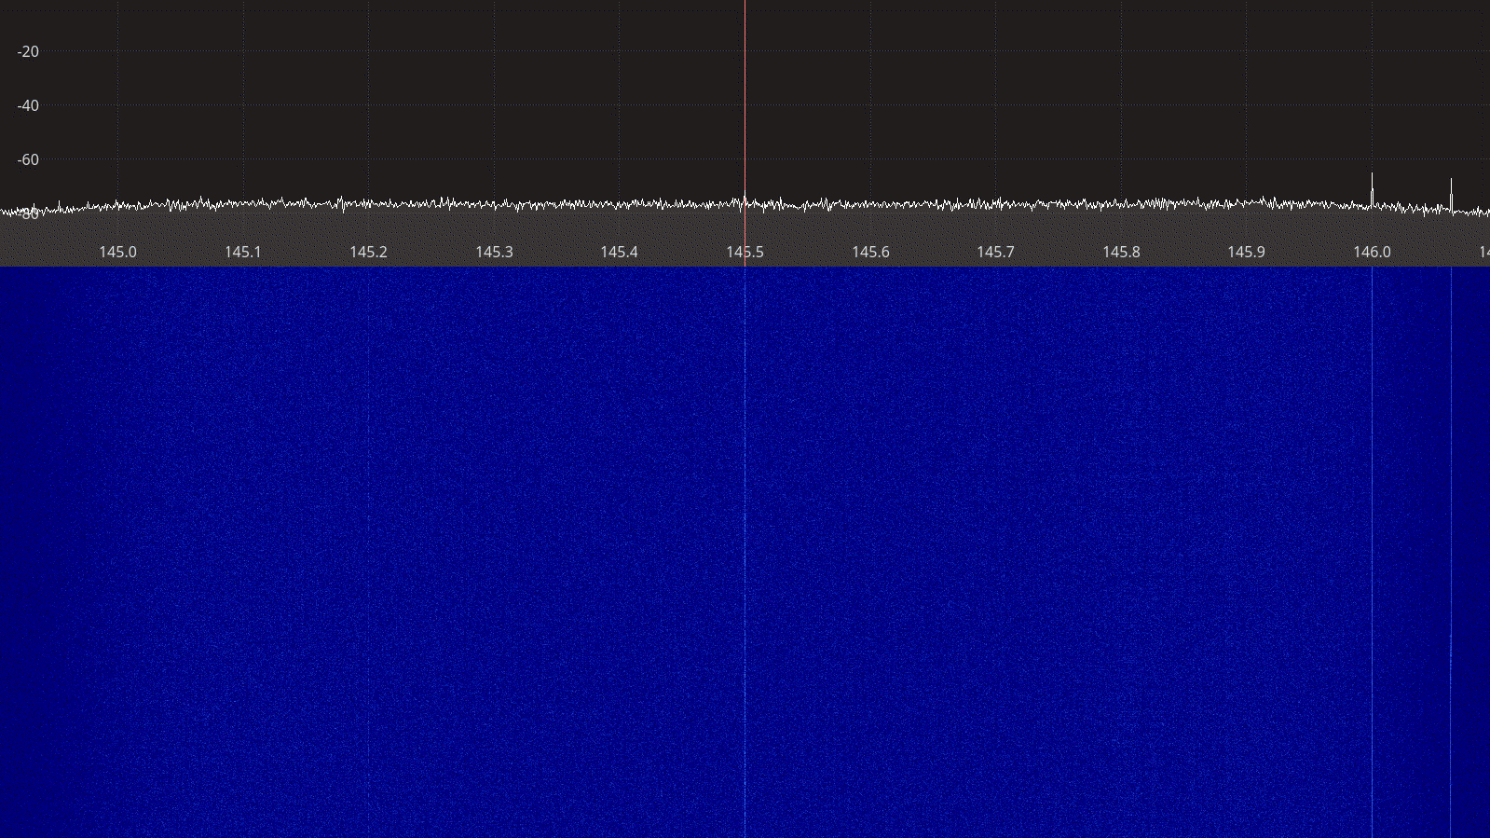Figure 3.33: LimeSDR Mini receiver spectrum between 145 – 146 MHz.

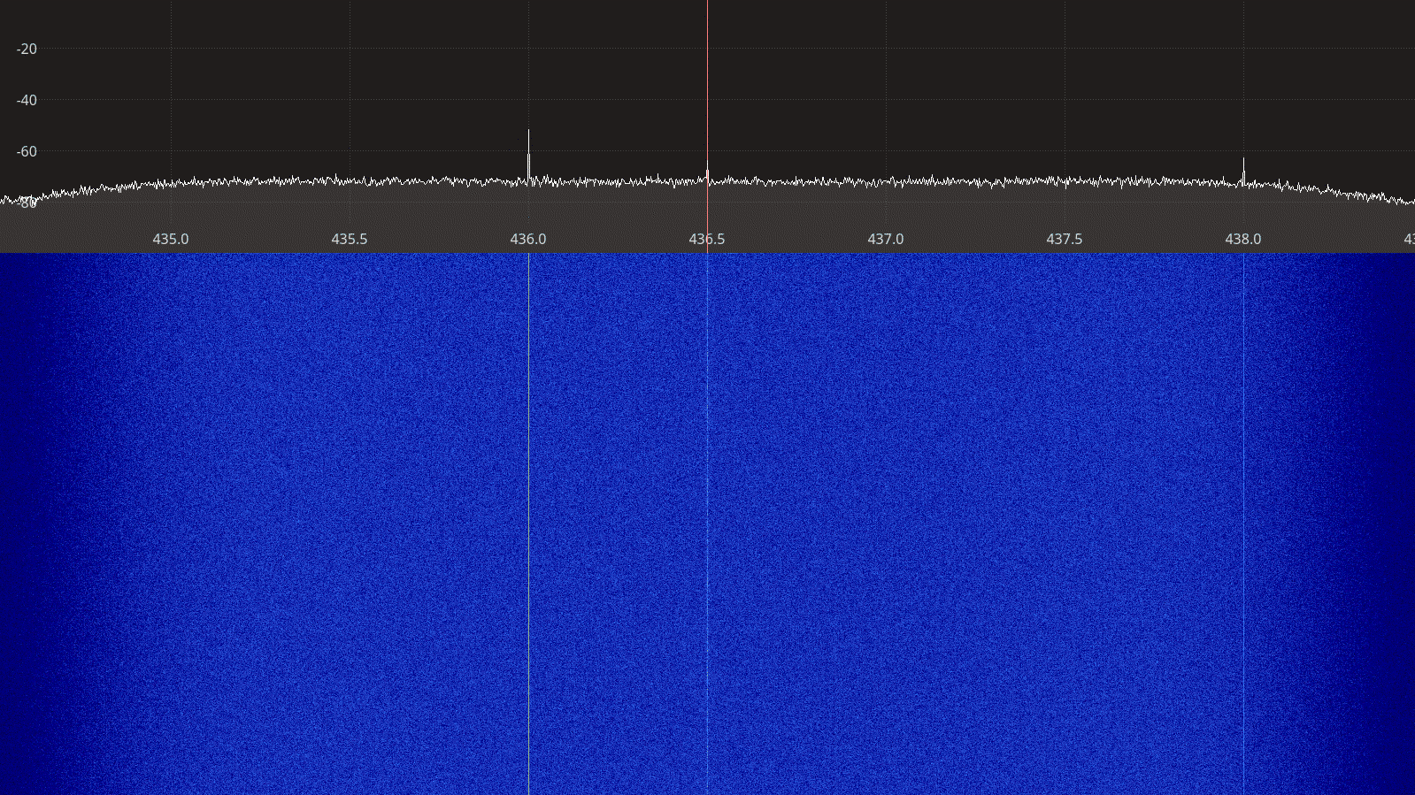Figure 3.34: LimeSDR Mini receiver spectrum between 435 – 438 MHz.
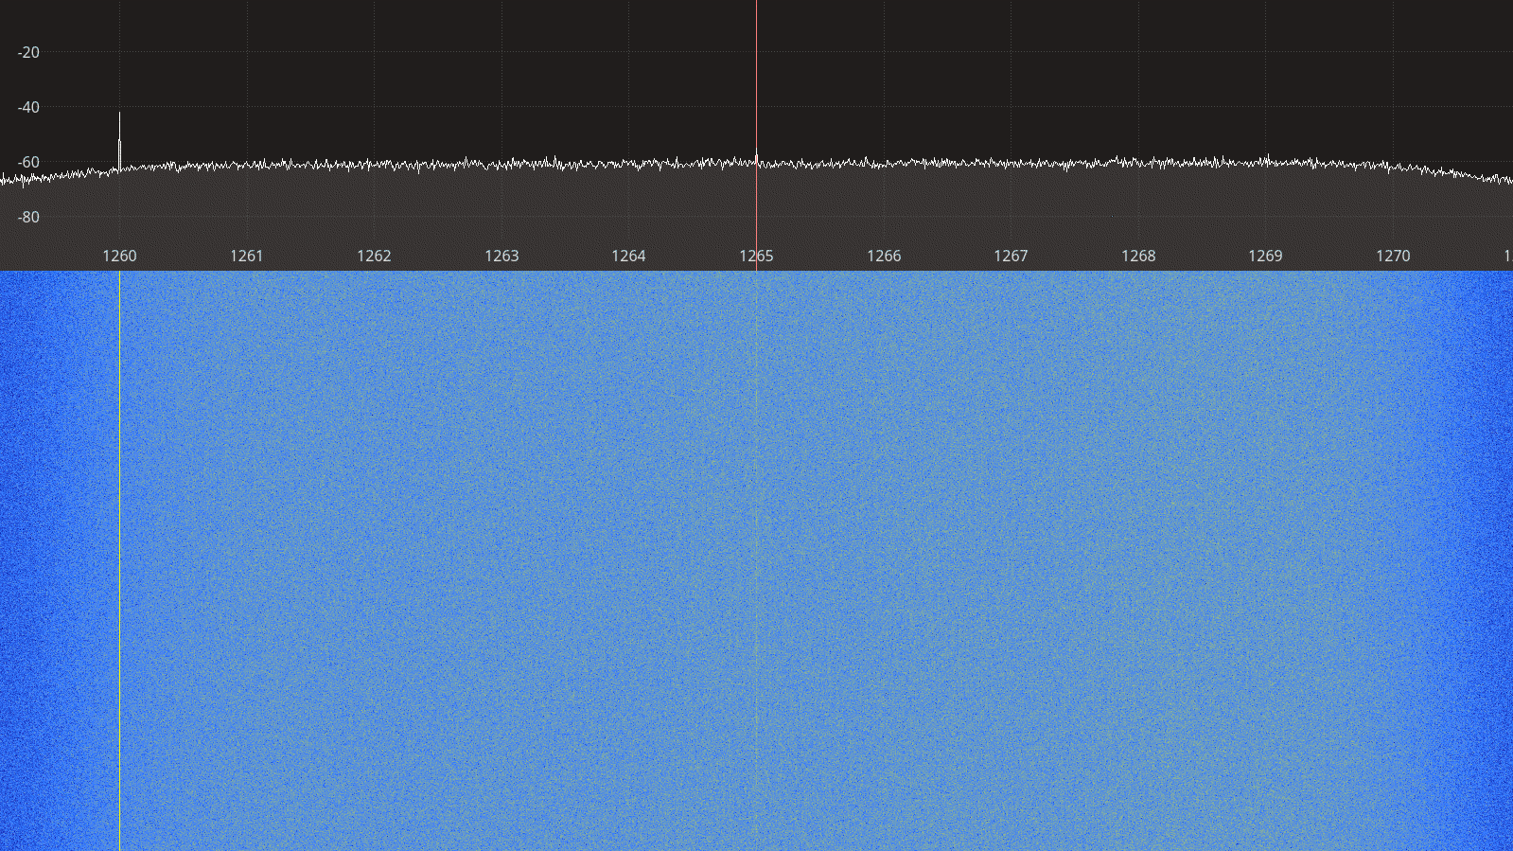Figure 3.35: LimeSDR Mini receiver spectrum between 1260 – 1270 MHz.

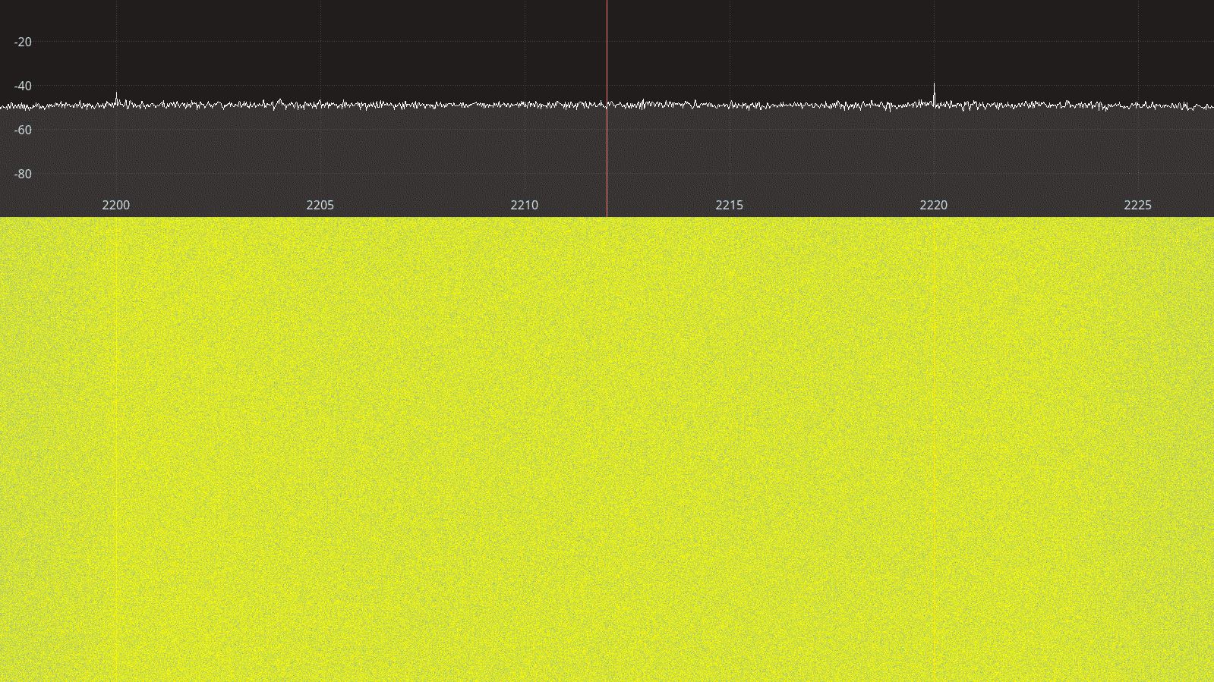Figure 3.36: LimeSDR Mini receiver spectrum between 2200 – 2225 MHz.
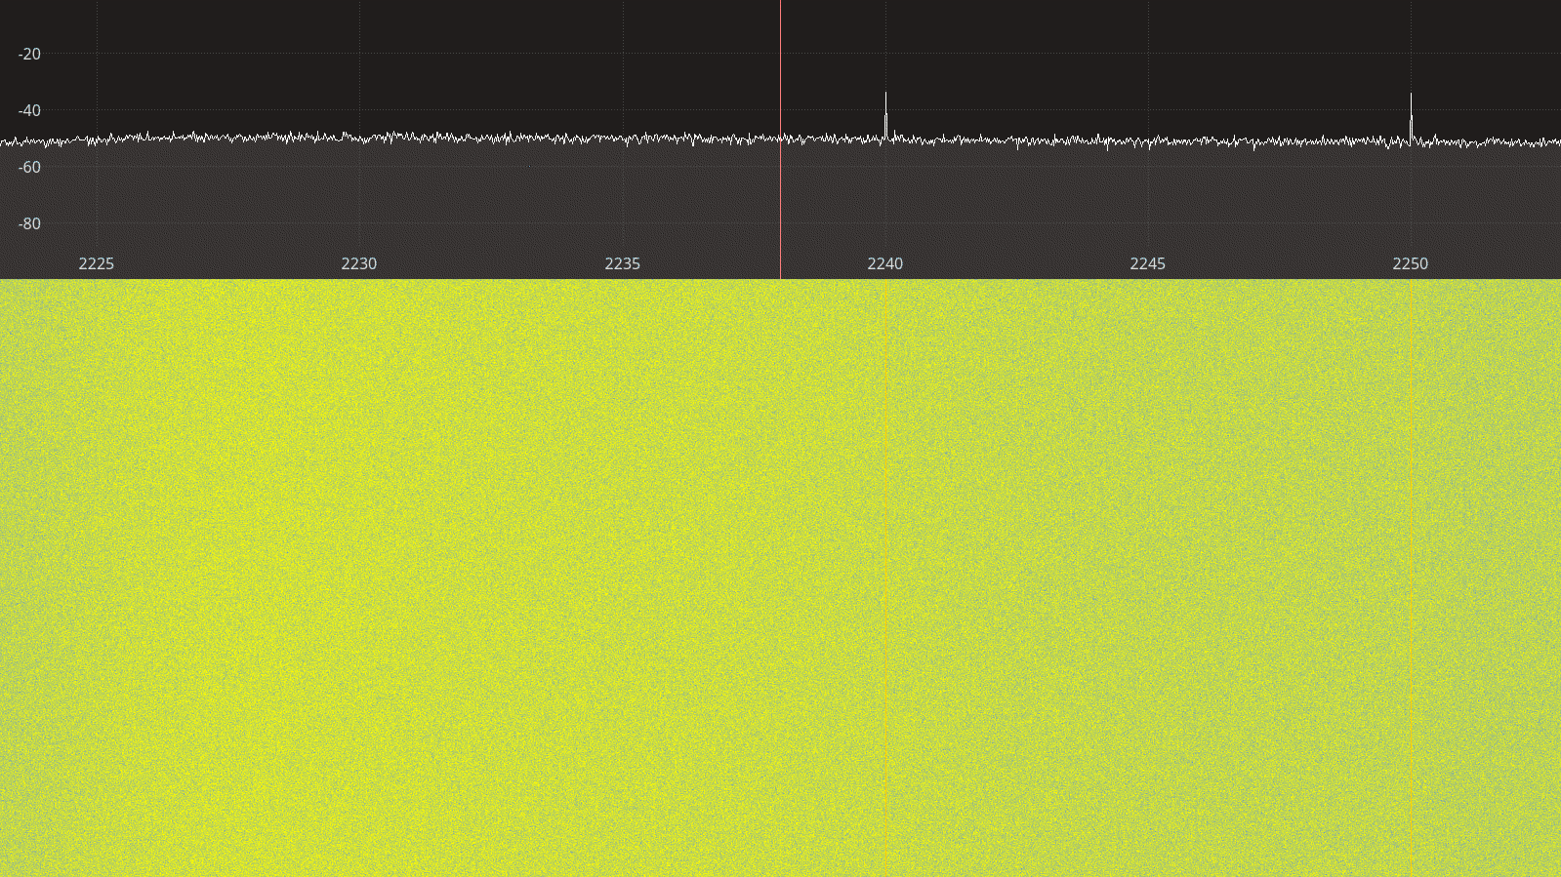Figure 3.37: LimeSDR Mini receiver spectrum between 2225 – 2250 MHz.

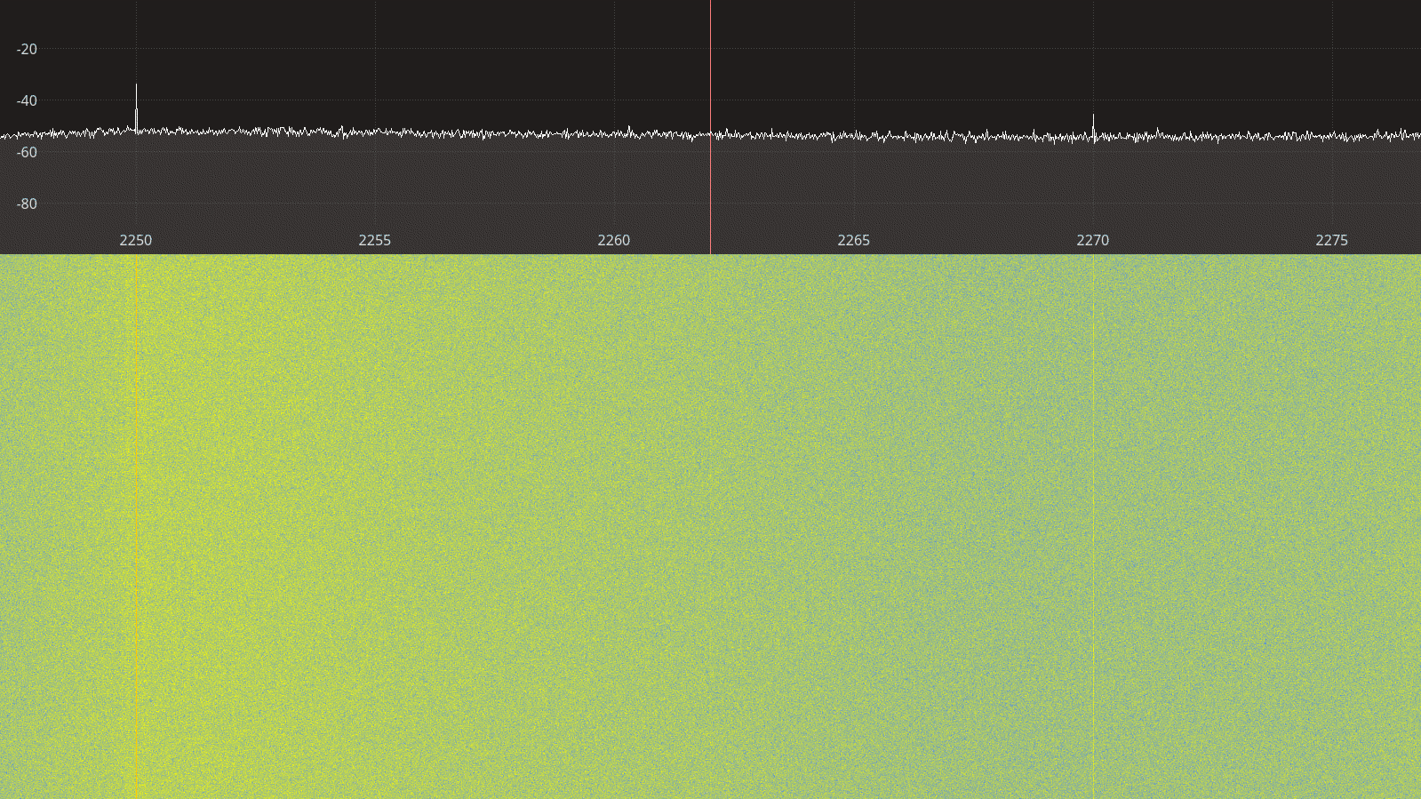Figure 3.38: LimeSDR Mini receiver spectrum between 2250 – 2275 MHz.
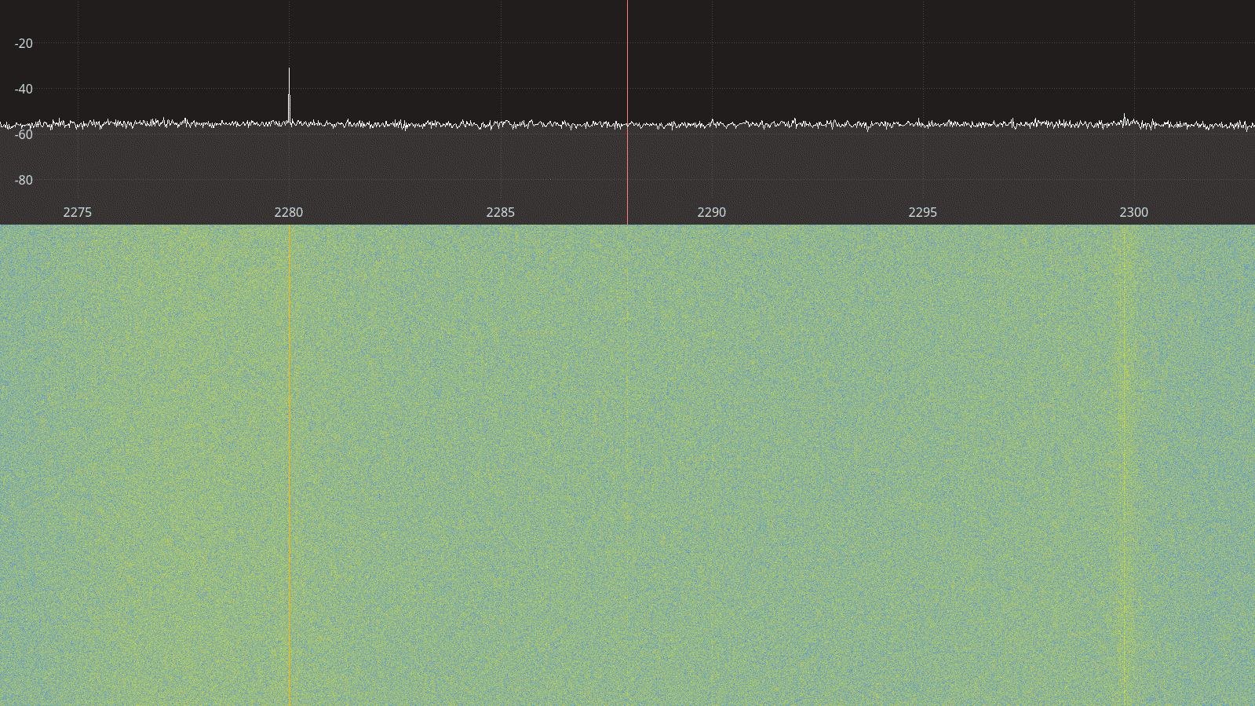Figure 3.39: LimeSDR Mini receiver spectrum between 2275 – 2300 MHz.

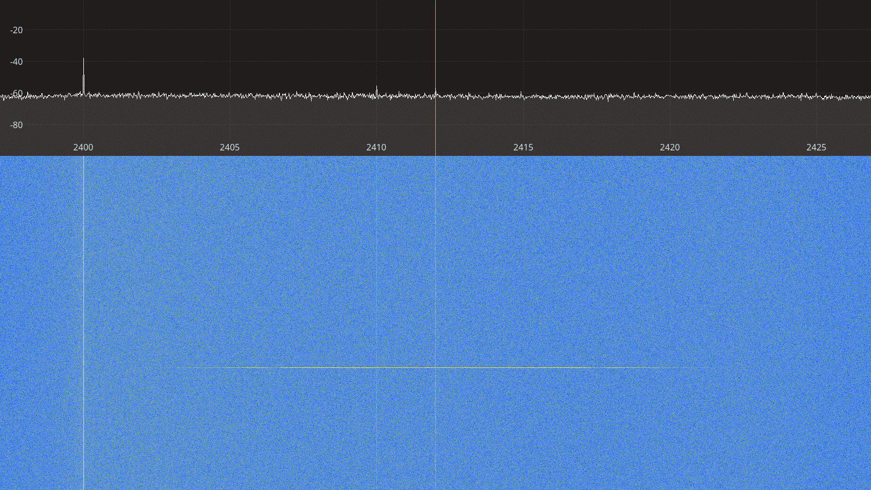Figure 3.40: LimeSDR Mini receiver spectrum between 2400 – 2425 MHz.
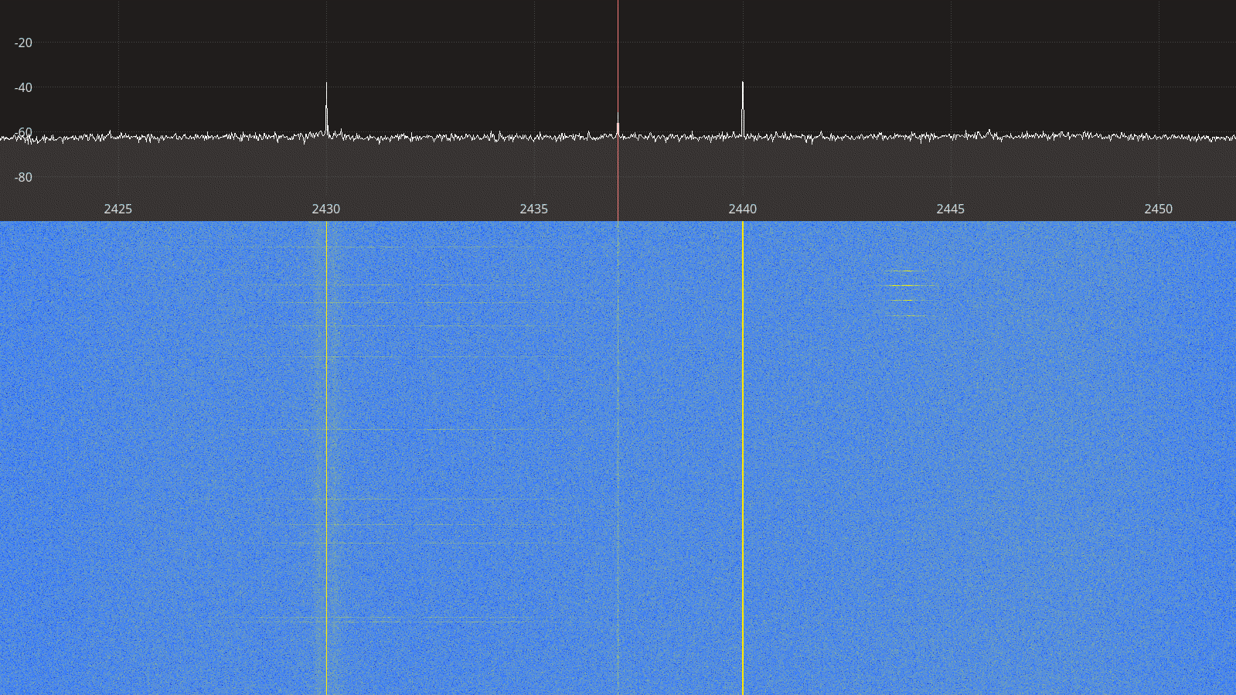Figure 3.41: LimeSDR Mini receiver spectrum between 2425 – 2450 MHz.

Transmitter Spectral Purity

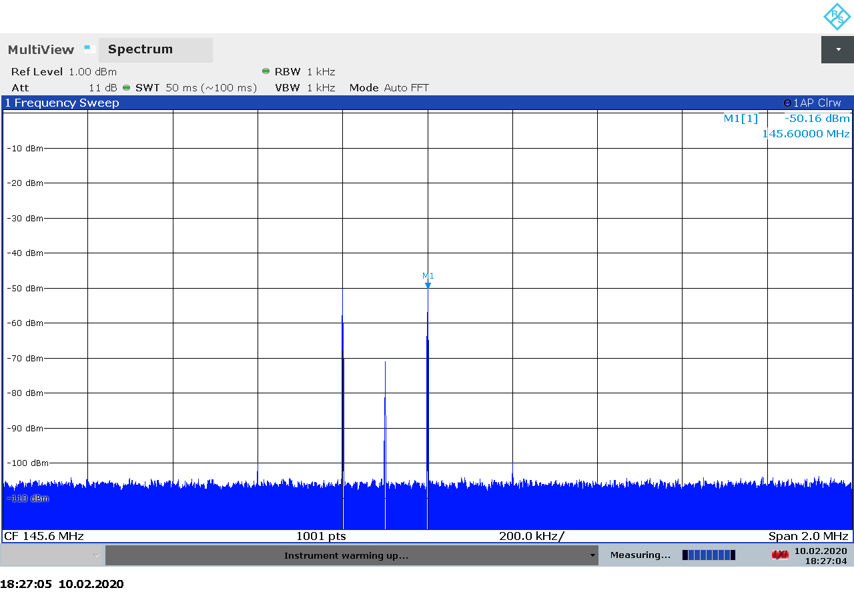Figure 3.42: LimeSDR Mini transmitter spectrum at 145.6 MHz, gain 0.
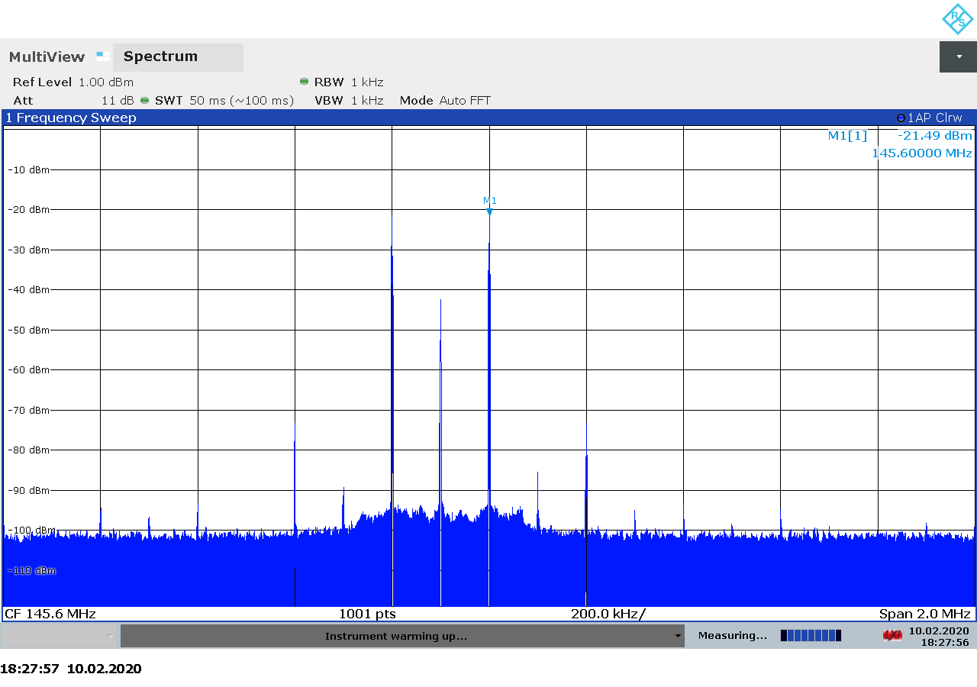Figure 3.43: LimeSDR Mini transmitter spectrum at 145.6 MHz, gain 30.
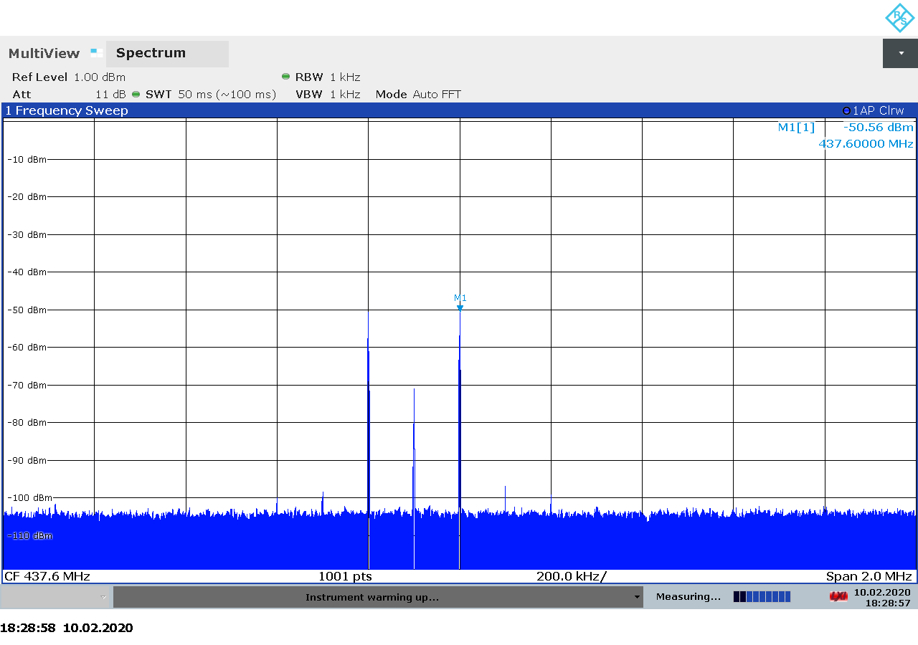Figure 3.44: LimeSDR Mini transmitter spectrum at 437.6 MHz, gain 0.

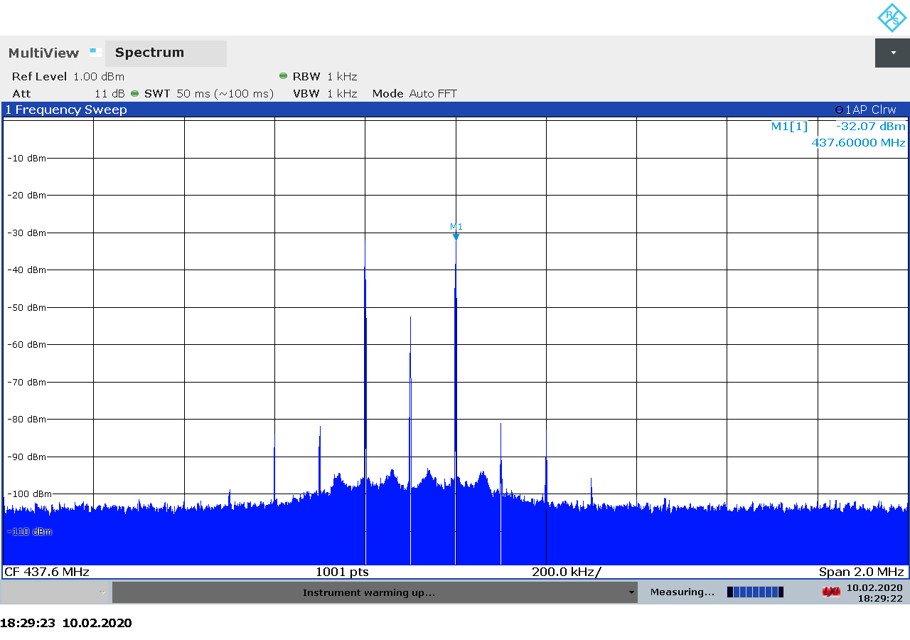Figure 3.45: LimeSDR Mini transmitter spectrum at 437.6 MHz, gain 30.
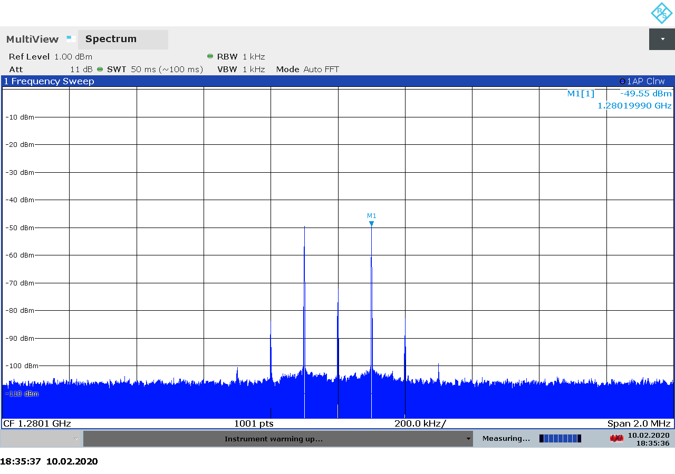Figure 3.46: LimeSDR Mini transmitter spectrum at 1280 MHz, gain 0.

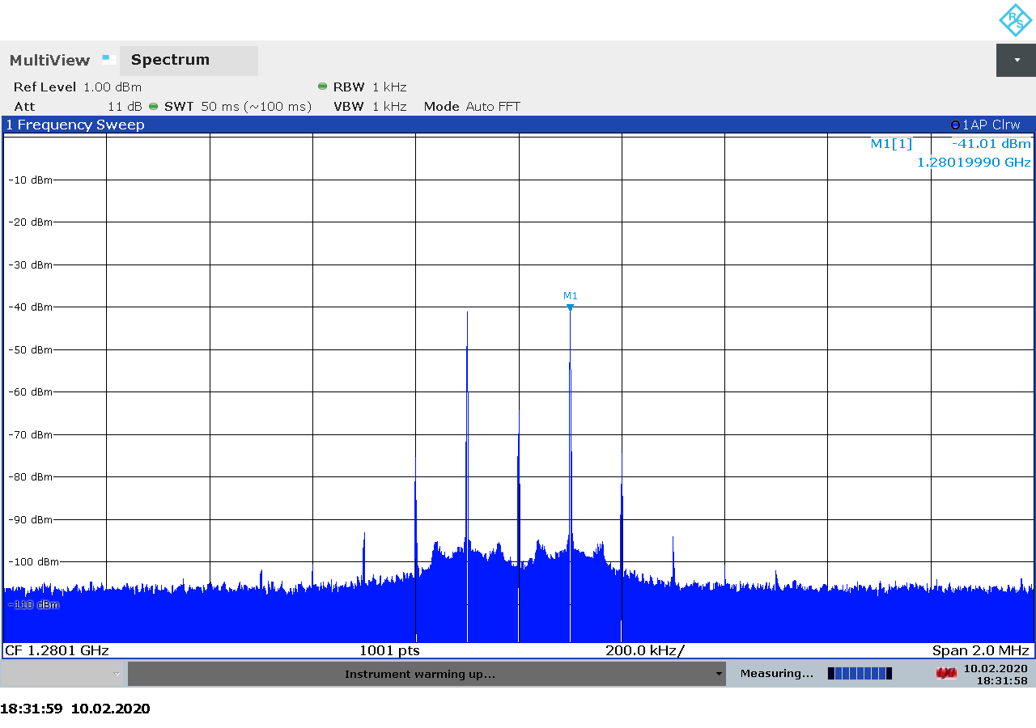Figure 3.47: LimeSDR Mini transmitter spectrum at 1280 MHz, gain 10.

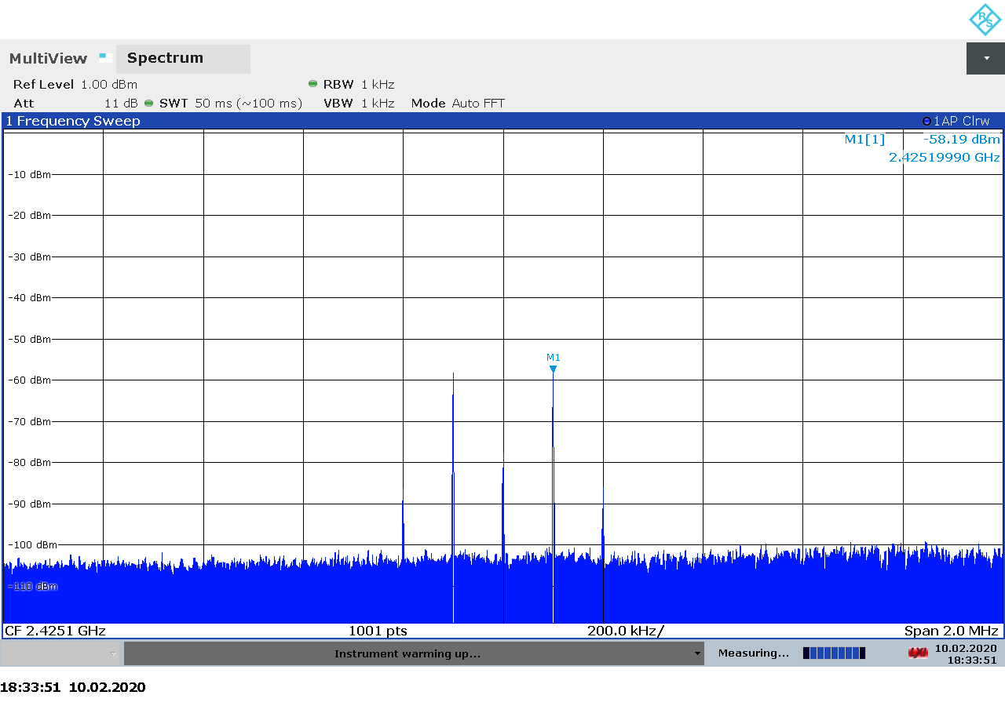Figure 3.48: LimeSDR Mini transmitter spectrum at 2425 MHz, gain 0.

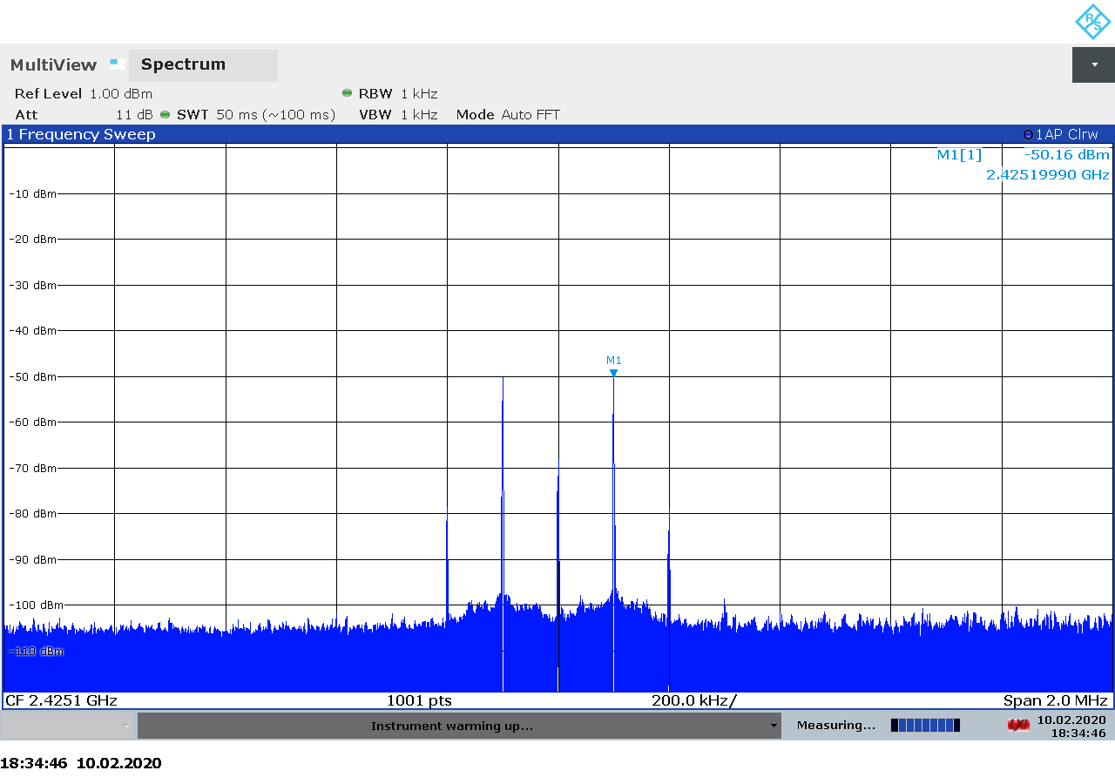Figure 3.49: LimeSDR Mini transmitter spectrum at 2425 MHz, gain 10.

Transmitter Output Power

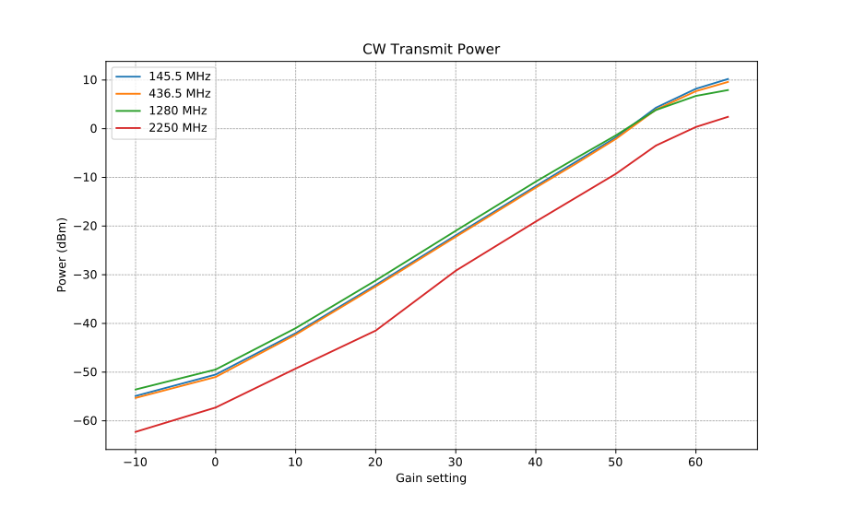Figure 3.50: LimeSDR Mini CW transmitter output power as function of gain.

Transmitter MER

BladeRF 2.0 Micro
The BladeRF 2.0 micro is a 2×2 MIMO transceiver based on the AD9361 intergated RFIC from Analog Devices. It covers 70 MHz – 6 GHz with up to 61 MHz sample rate and 56 MHz analog bandwidth [20].
The wide bandwidth and frequency range make the BladeRF 2.0 micro an interesting choice for satellite communications, both as a receiver and as a transmitter.
BladeRF products are supported through an open-source driver library, which provides a simple and intuitive programming interface to the hardware. Firmware and FPGA sources are avaialble as well [21].
On the hardware side, the schecmatics are available in PDF format on the website [22].

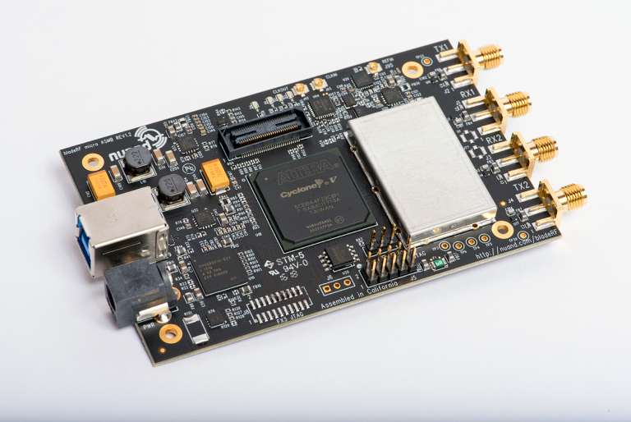Figure 3.51: The BladeRF 2.0 micro transceiver.

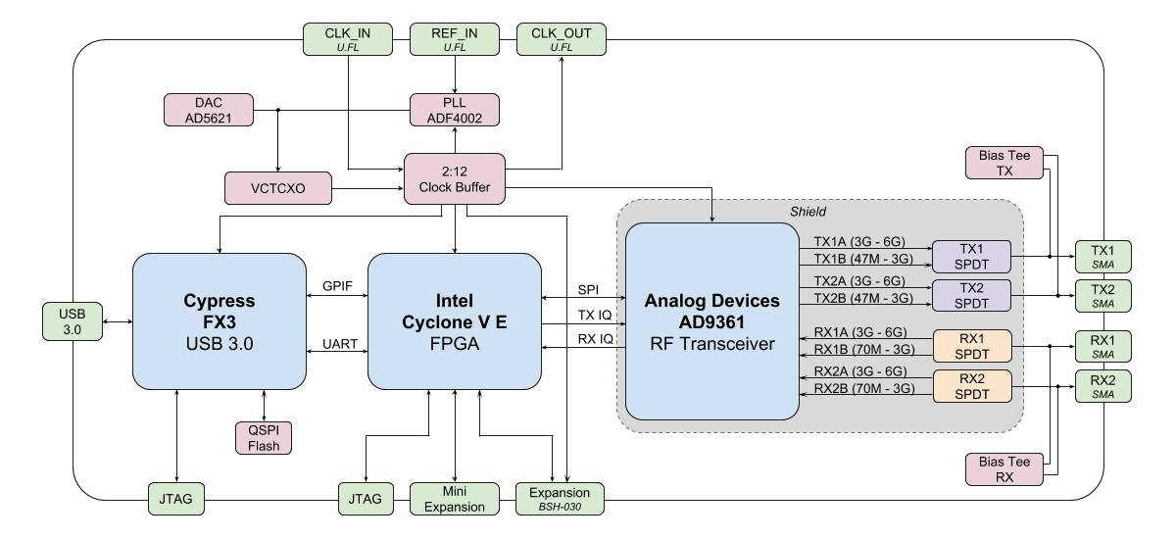Figure 3.52: BladeRF 2.0 micro block diagram.

A summary of the technical specifications for the BladeRF 2.0 micro is listed in Table 3.13 below.

Frequency Range | 70 MHz – 6 GHz
Sample rate | 61.44 MSPS
RF bandwidth | 200 kHz – 56 MHz
Frontend filters | None
RX paths | 2
RX inputs | 2
TX paths | 2
TX outputs | 2
ADC resolution | 12
DAC resolution | 12
Claimed noise figure | -
Clained dynamic range | -
Claimed transmit power | 8 dBm (CW)
Reference clock | Factory calibrated VCTCXO
Other features | Automatic IQ and DC offset correction  2×2 MIMO  Bias-T on both TX and RX ports  External clock through uFL connectors on the board
Temperature range | 0-70 °C
Size | 10.2 cm × 6.3 cm × 1.8 cm (board only)  11.1 cm × 7.3 cm × 2.4 cm (in acrylic case)
Weight | 90 g (board only)  125 g (in acrylic case covered with copper tape)
Approximate price | 480 USD (xA4)  720 USD (xA9)
Product page | https://www.nuand.com/bladerf-2-0-micro/
Table 3.13: BladeRF 2.0 micro technical specifications.

Receiver Noise Figure
Input rate | Decimation | Sample rate | Bandwidth
2 MHz | 4 | 500 kHz | Auto
Table 3.14: BladeRF 2.0 micro settings used during noise figure measurements.

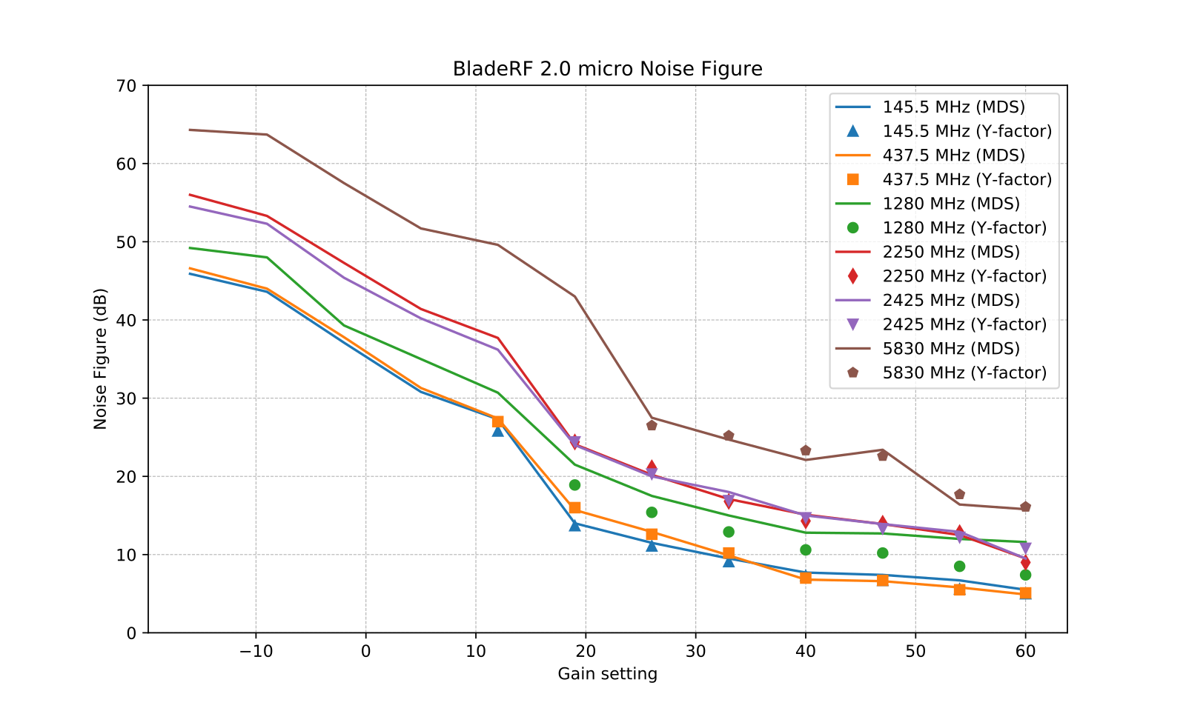Figure 3.53: BladeRF 2.0 micro noise figure measurements.

Notes:
- MDS measurements at 1.28 GHz unreliable because device was picking up much noise.
- Noise level at 5.8 GHz is very sensitive to USB connection (grounding?)

Receiver Blocking Dynamic Range

Input rate | Decimation | Sample rate | Bandwidth
3 MHz | 1 | 3 MHz | Auto
Table 3.15: BladeRF2.0 micro settings used for BDR measurements.

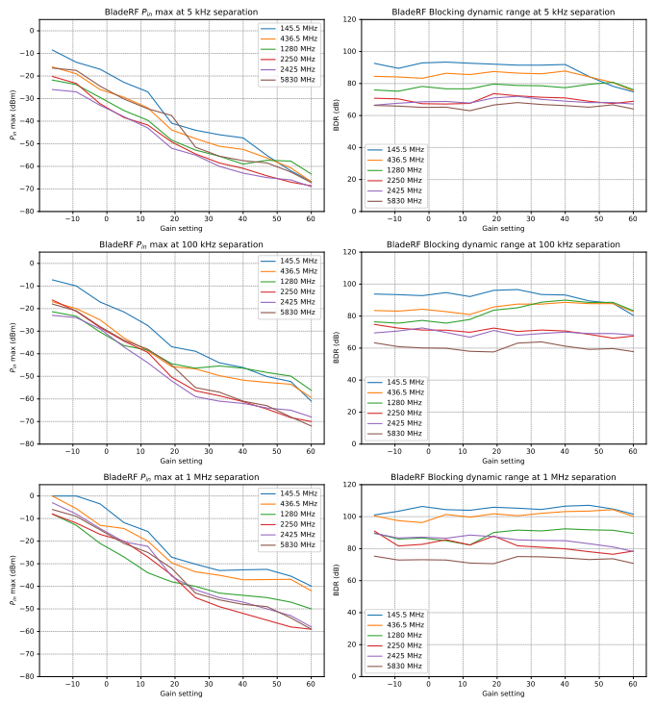Figure 3.54: BladeRF 2.0 micro blocking dynamic range measurements.

Receiver Spectral Purity

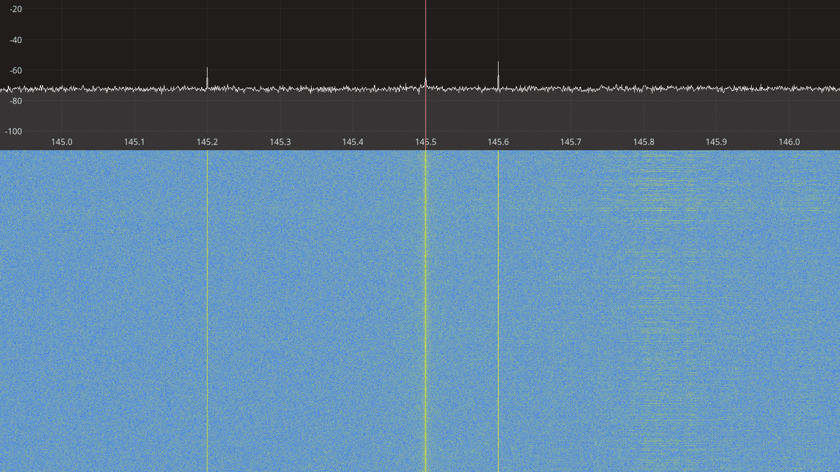Figure 3.55: BladeRF 2.0 micro receiver spectrum between 145 – 146 MHz.

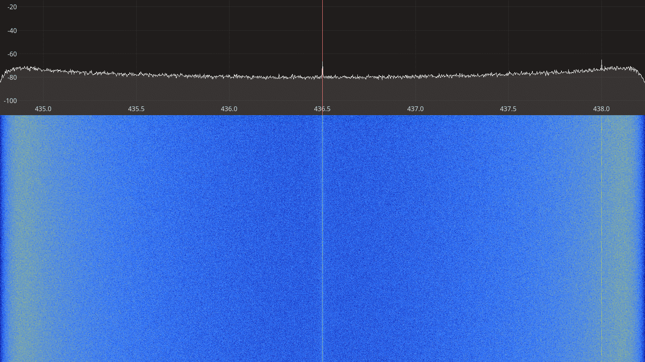Figure 3.56: BladeRF 2.0 micro receiver spectrum between 435 – 438 MHz.
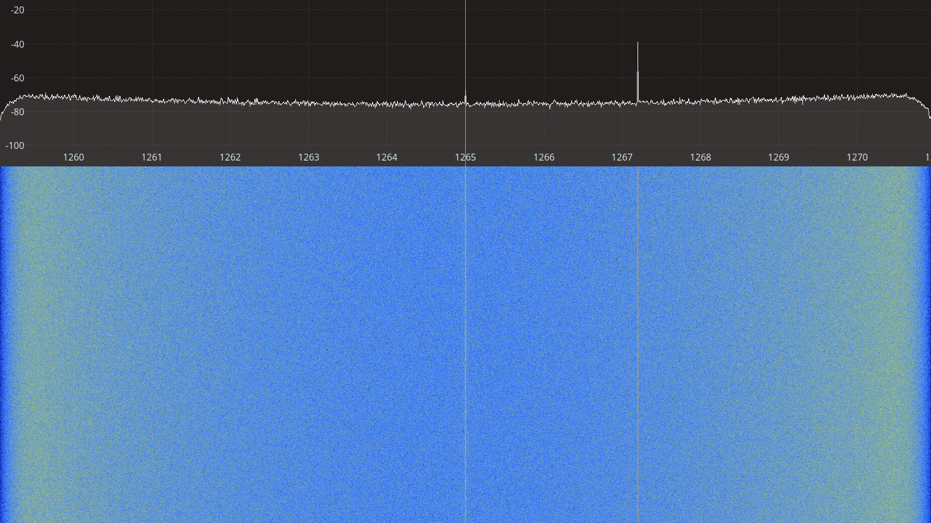Figure 3.57: BladeRF 2.0 micro receiver spectrum between 1260 – 1270 MHz.

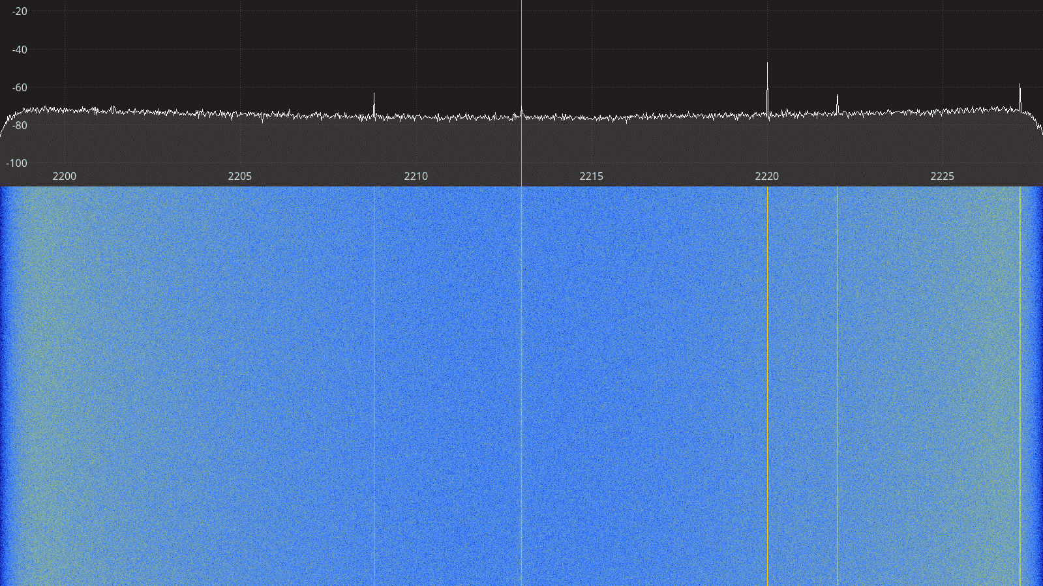Figure 3.58: BladeRF 2.0 micro receiver spectrum between 2200 – 2225 MHz.
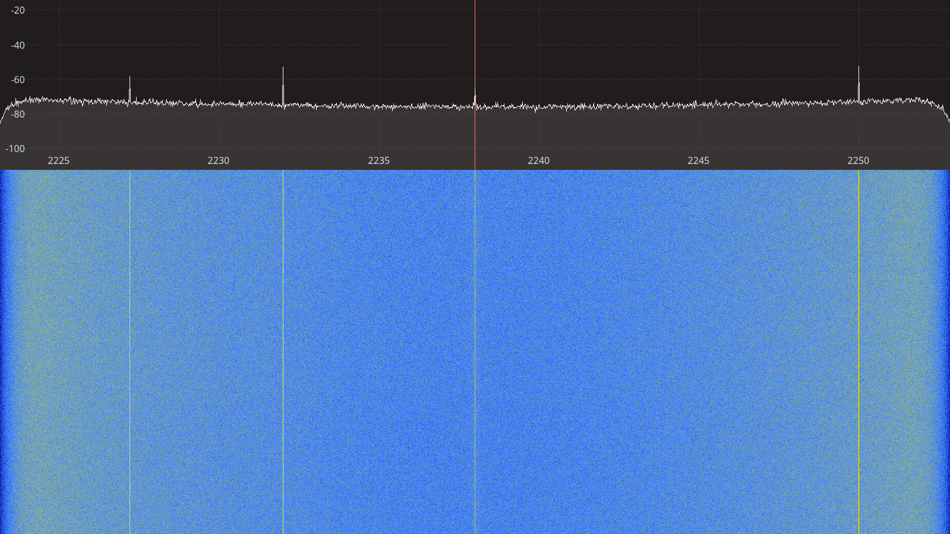Figure 3.59: BladeRF 2.0 micro receiver spectrum between 2225 – 2250 MHz.

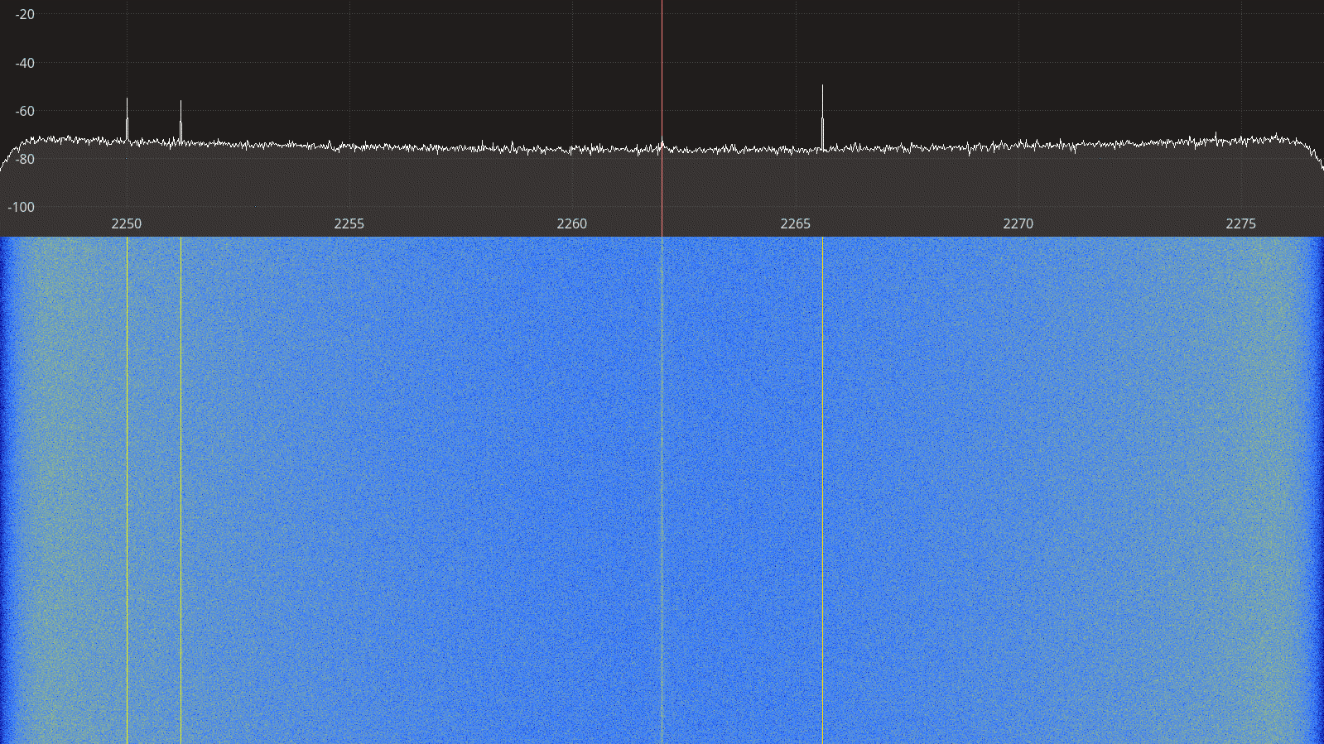Figure 3.60: BladeRF 2.0 micro receiver spectrum between 2250 – 2275 MHz.
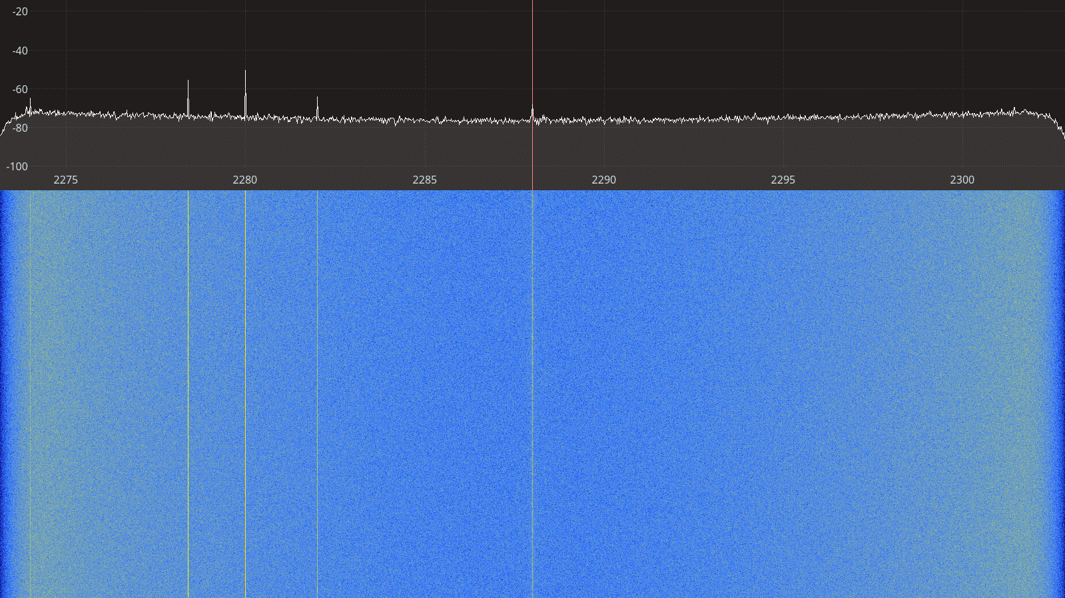Figure 3.61: BladeRF 2.0 micro receiver spectrum between 2275 – 2300 MHz.

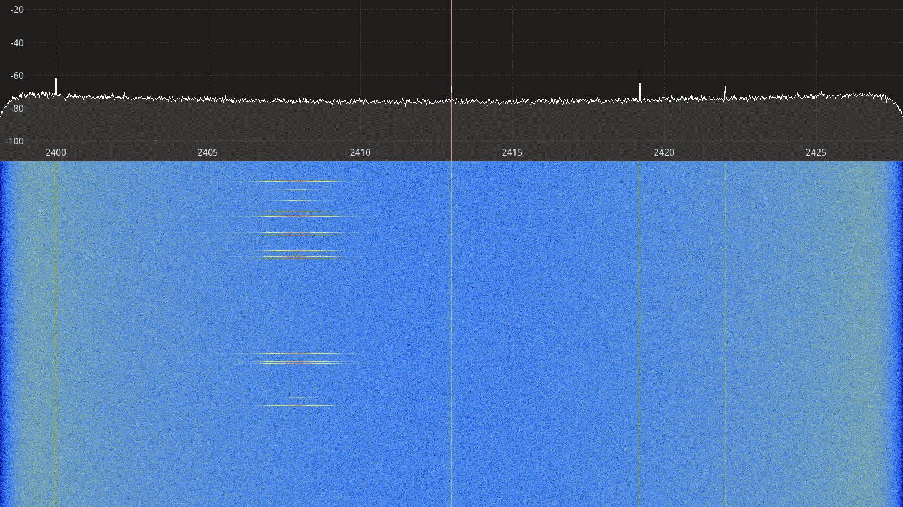Figure 3.62: BladeRF 2.0 micro receiver spectrum between 2400 – 2425 MHz.
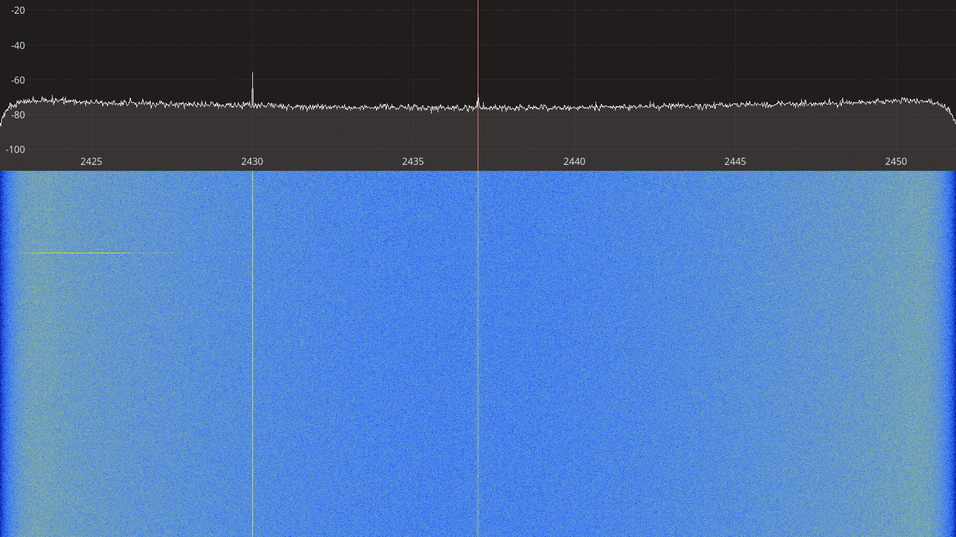Figure 3.63: BladeRF 2.0 micro receiver spectrum between 2425 – 2450 MHz.

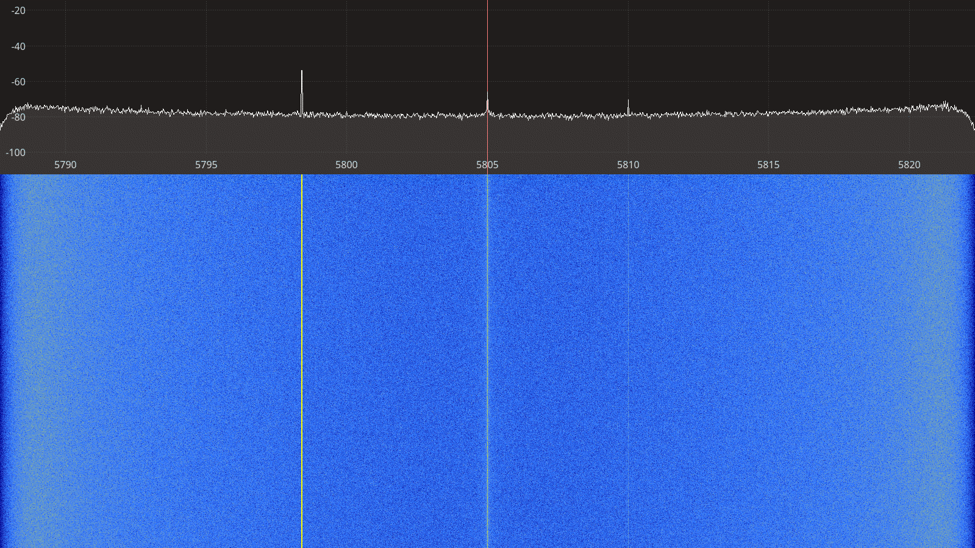Figure 3.64: BladeRF 2.0 micro receiver spectrum between 5790 – 5820 MHz.
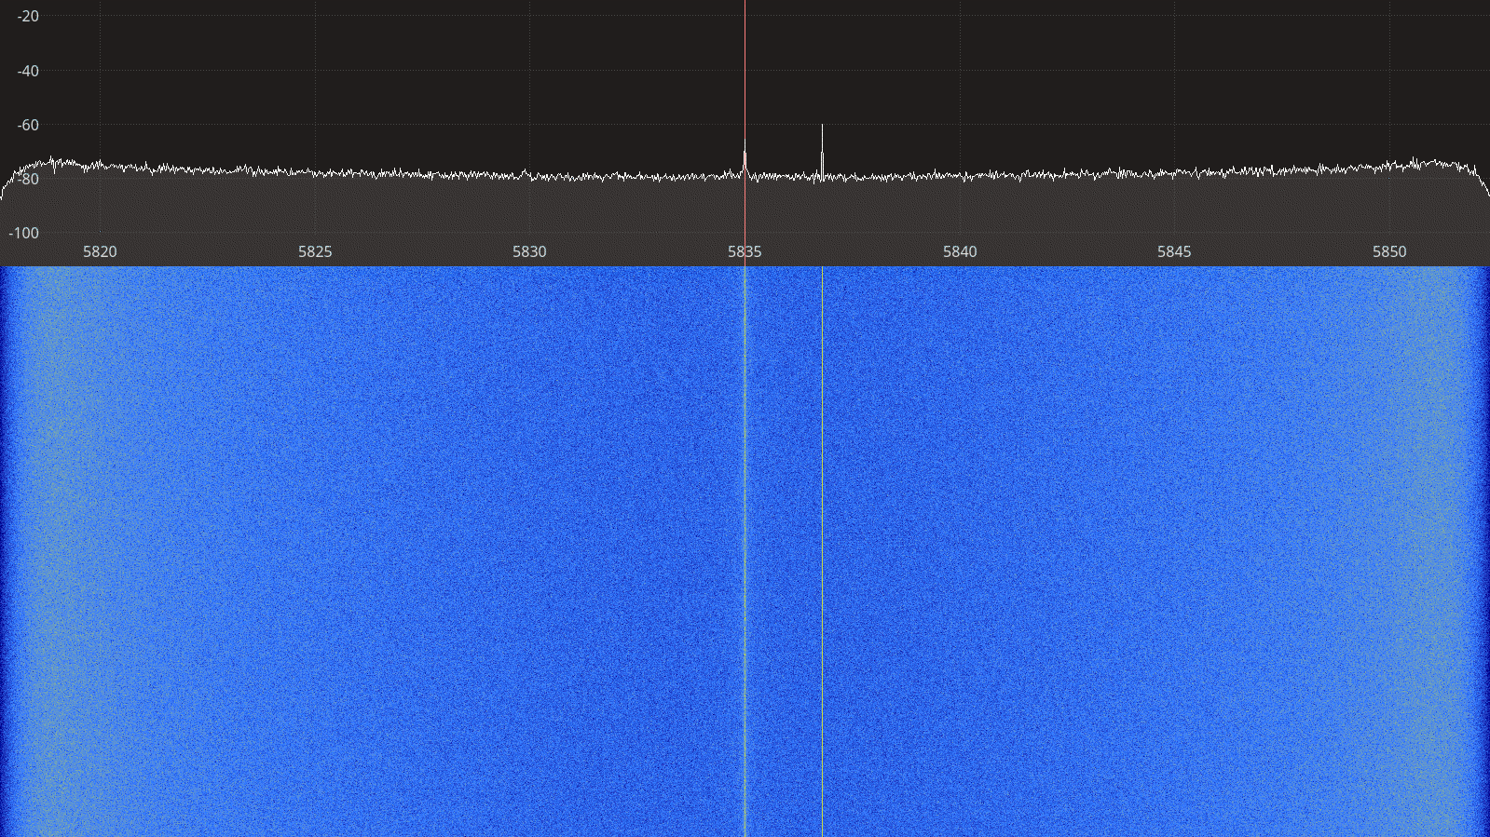Figure 3.65: BladeRF 2.0 micro receiver spectrum between 5820 – 5850 MHz.

Transmitter Spectral Purity

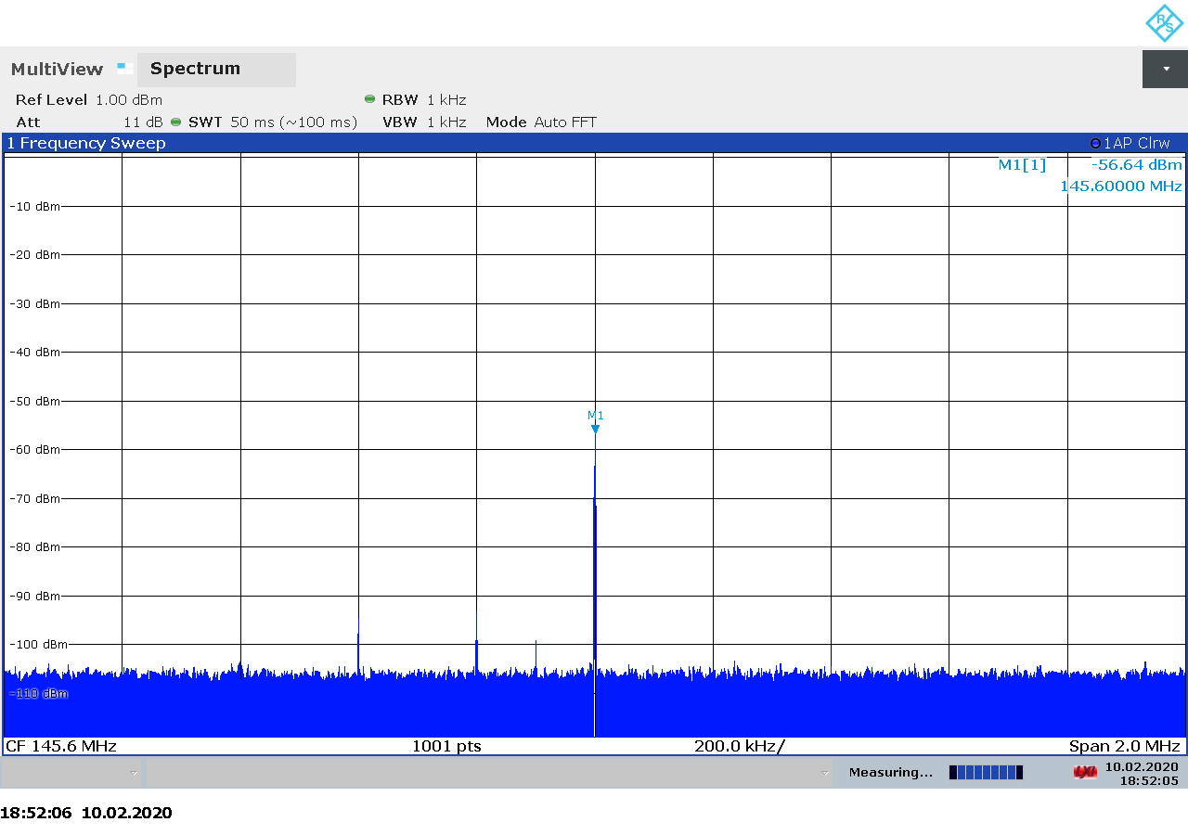Figure 3.66: BladeRF 2.0 micro transmitter spectrum at 145.5 MHz, gain 0.

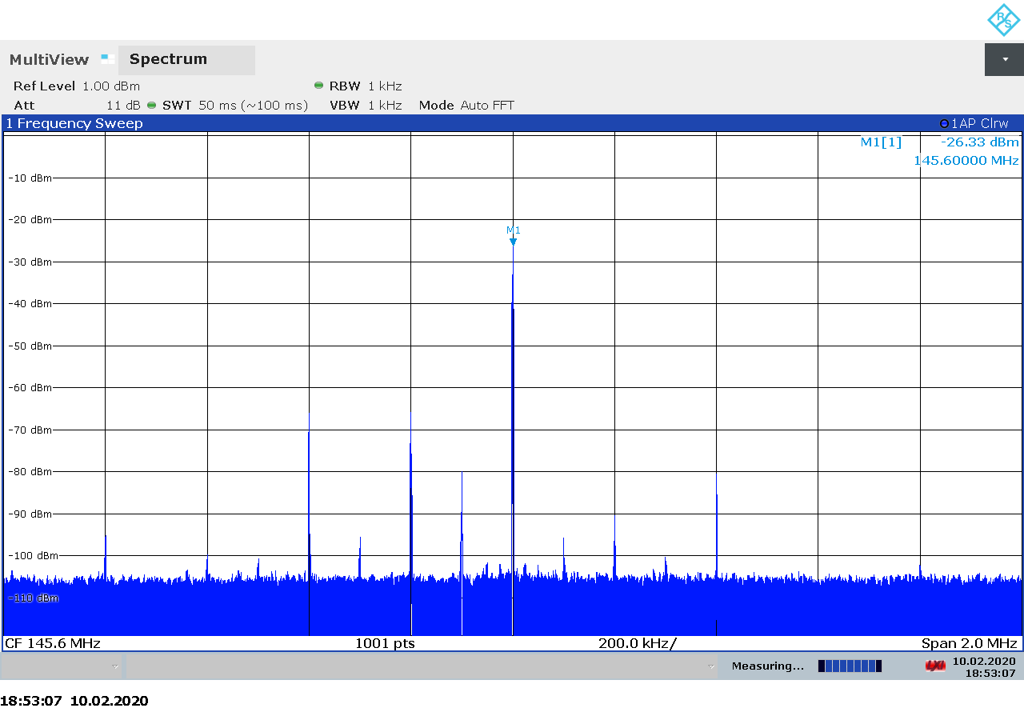Figure 3.67: BladeRF 2.0 micro transmitter spectrum at 145.5 MHz, gain 30.
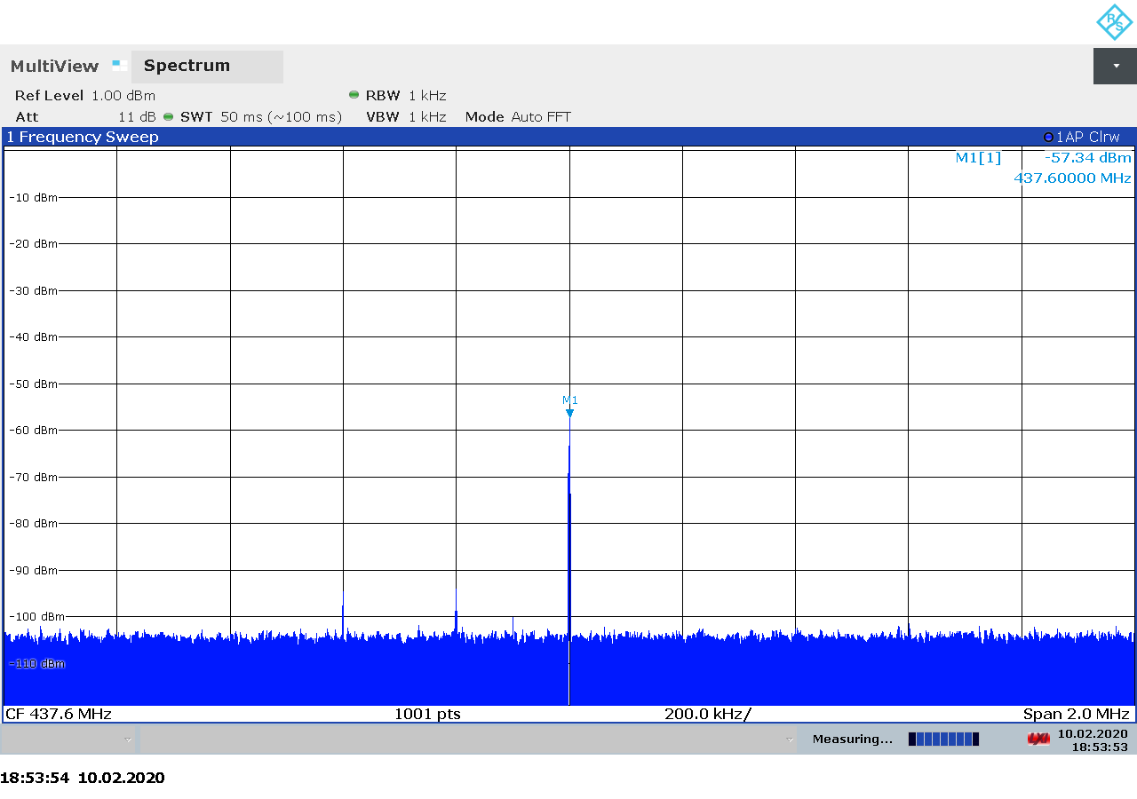Figure 3.68: BladeRF 2.0 micro transmitter spectrum at 437.5 MHz, gain 0.

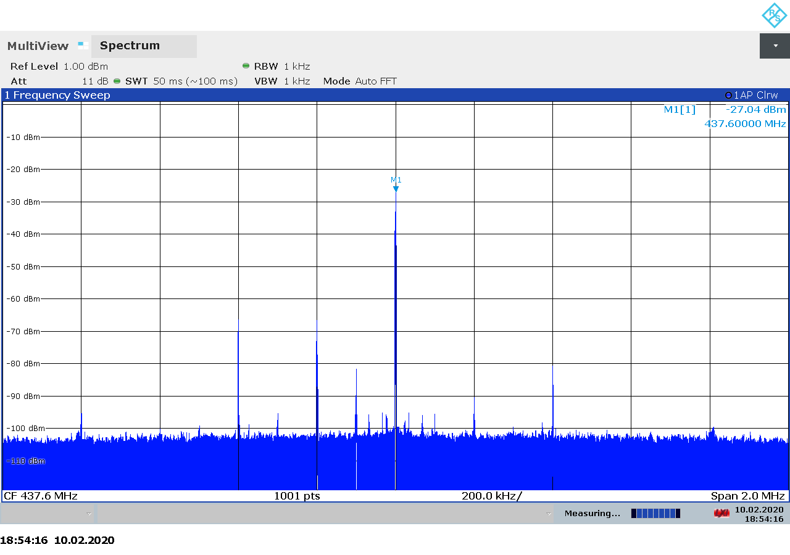Figure 3.69: BladeRF 2.0 micro transmitter spectrum at 437.5 MHz, gain 30.

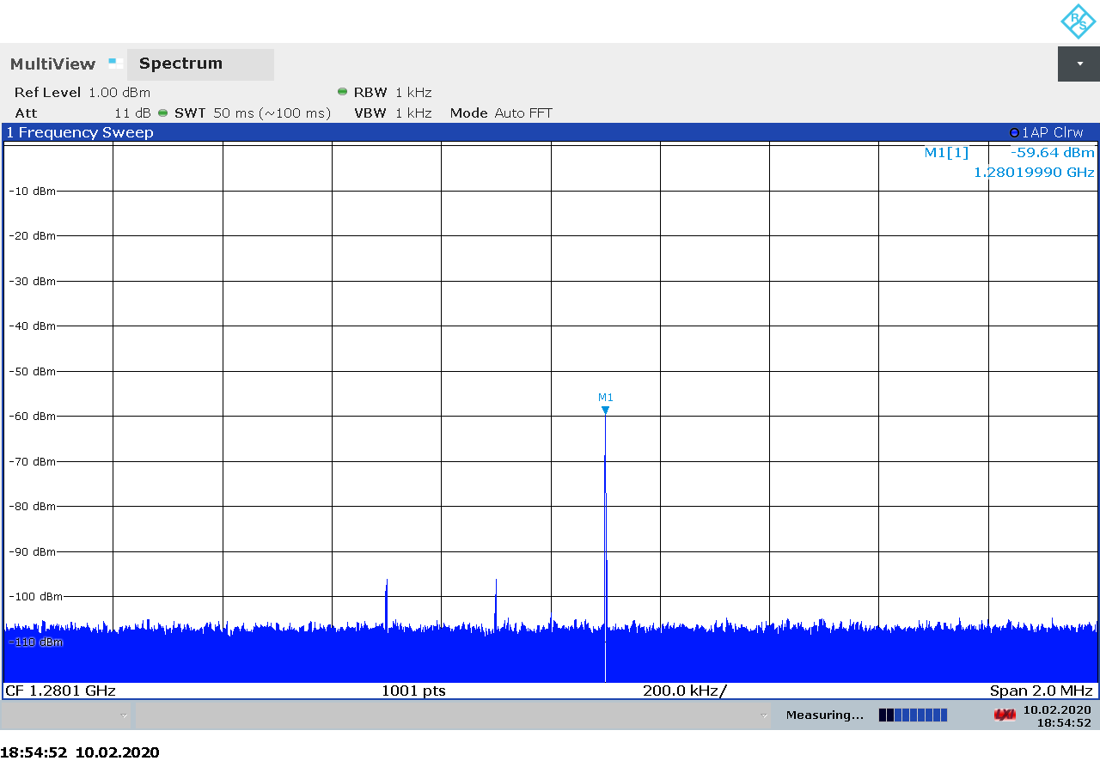Figure 3.70: BladeRF 2.0 micro transmitter spectrum at 1280 MHz, gain 0.
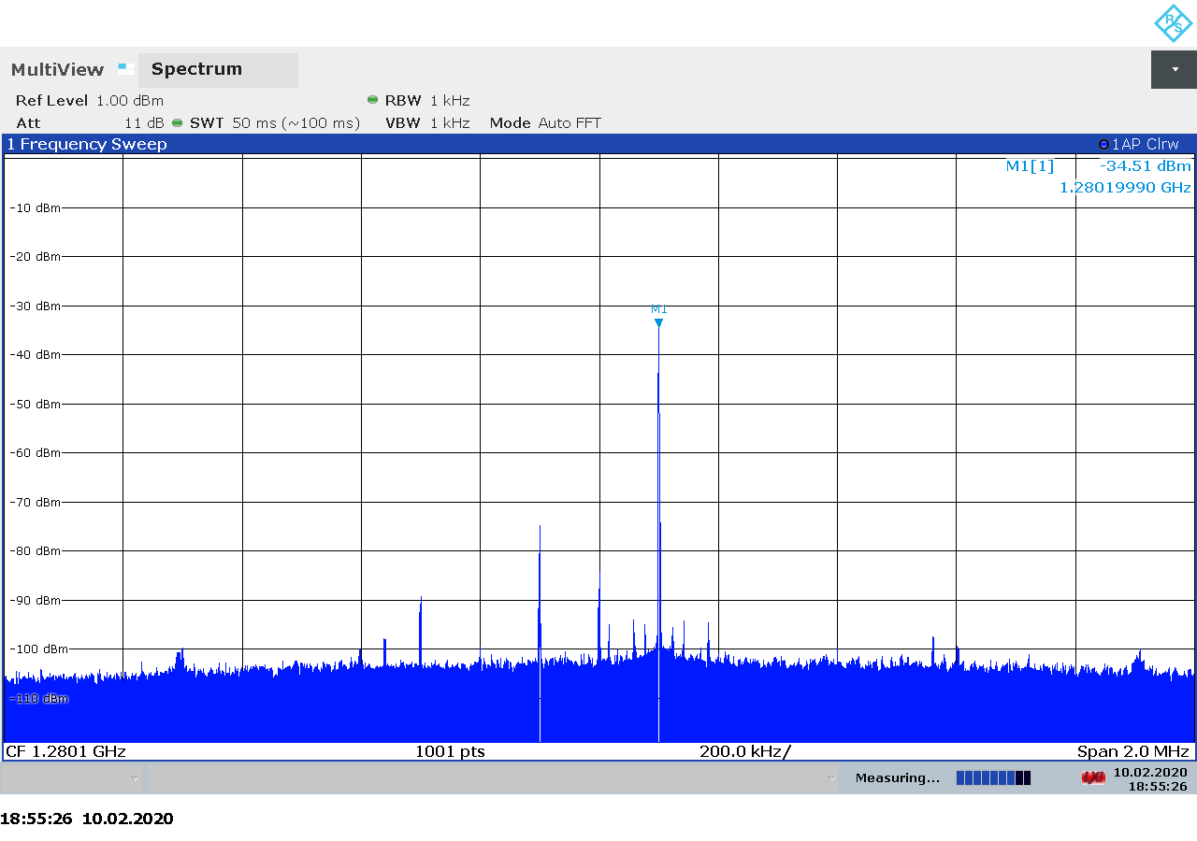Figure 3.71: BladeRF 2.0 micro transmitter spectrum at 1280 MHz, gain 25.

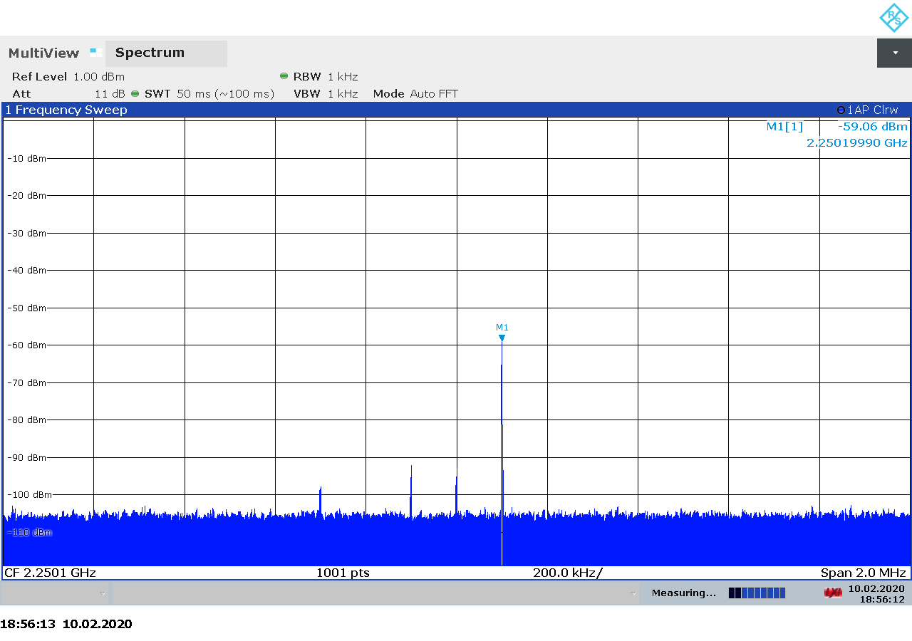Figure 3.72: BladeRF 2.0 micro transmitter spectrum at 2250 MHz, gain 5.
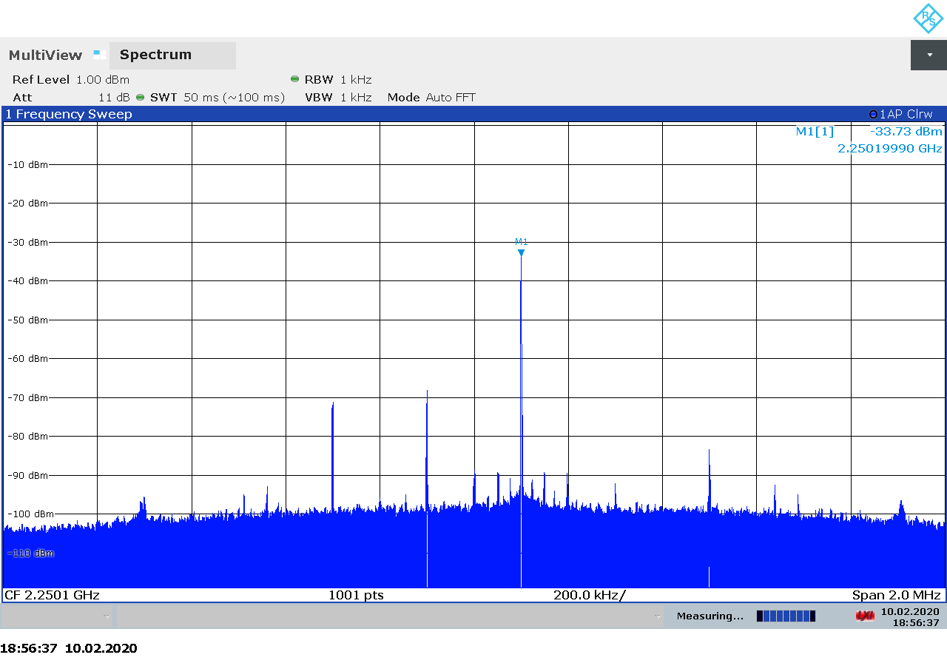Figure 3.73: BladeRF 2.0 micro transmitter spectrum at 2250 MHz, gain 30.

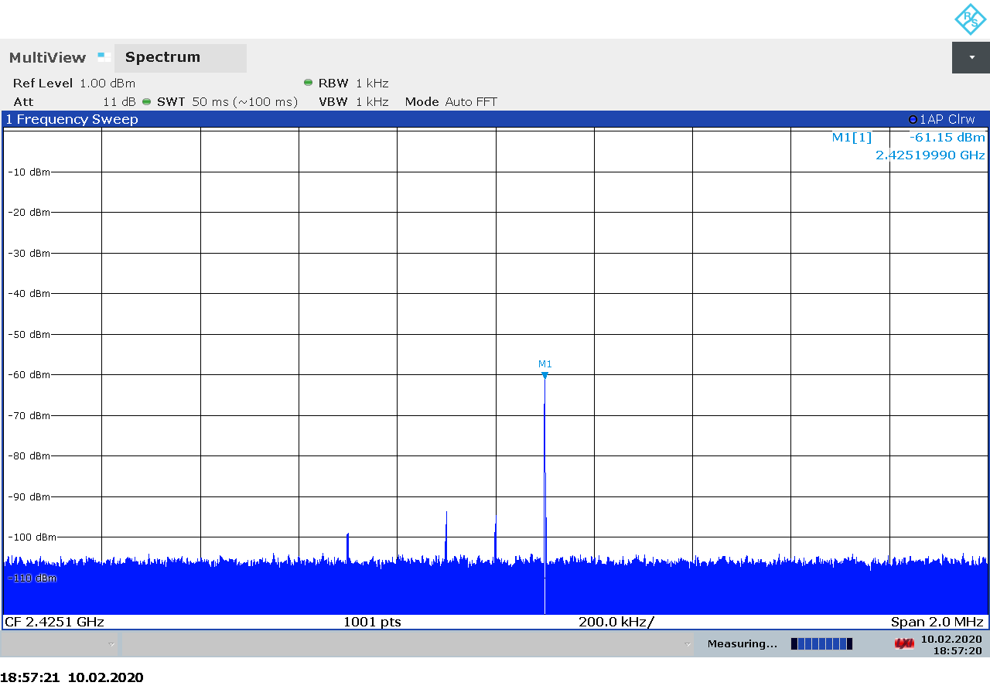Figure 3.74: BladeRF 2.0 micro transmitter spectrum at 2425 MHz, gain 5.
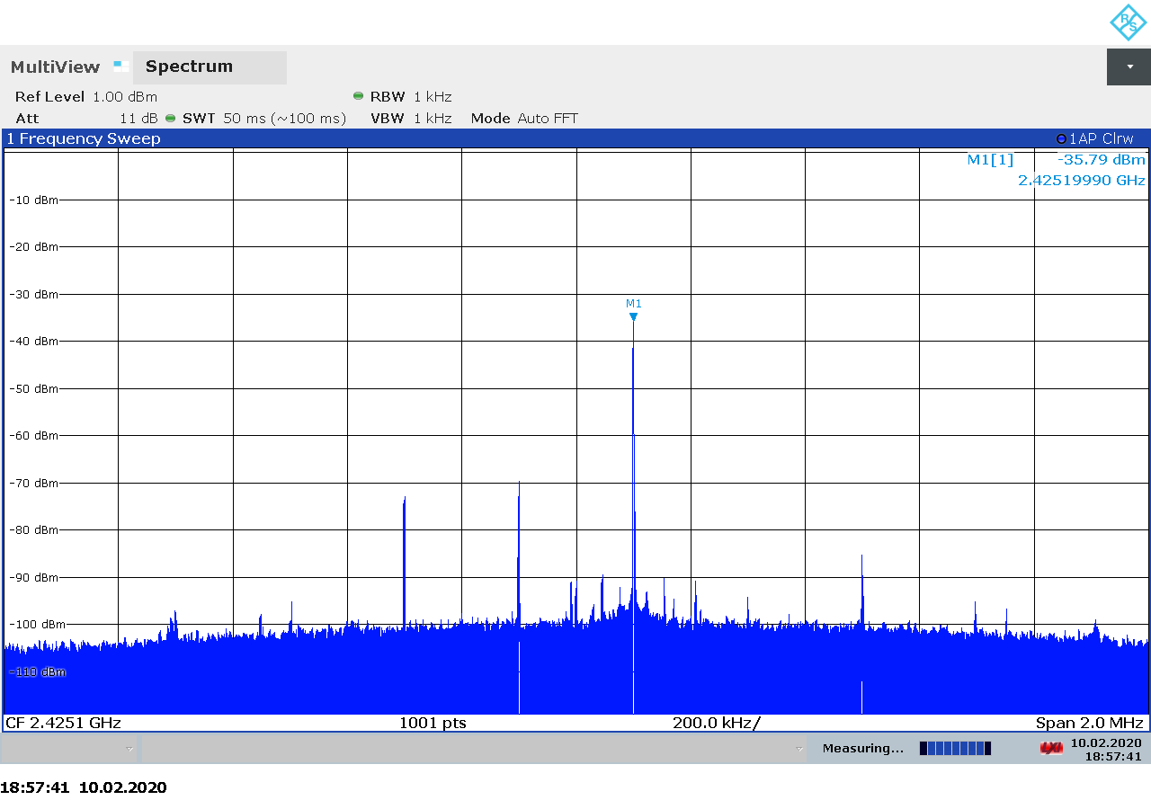Figure 3.75: BladeRF 2.0 micro transmitter spectrum at 2425 MHz, gain 30.

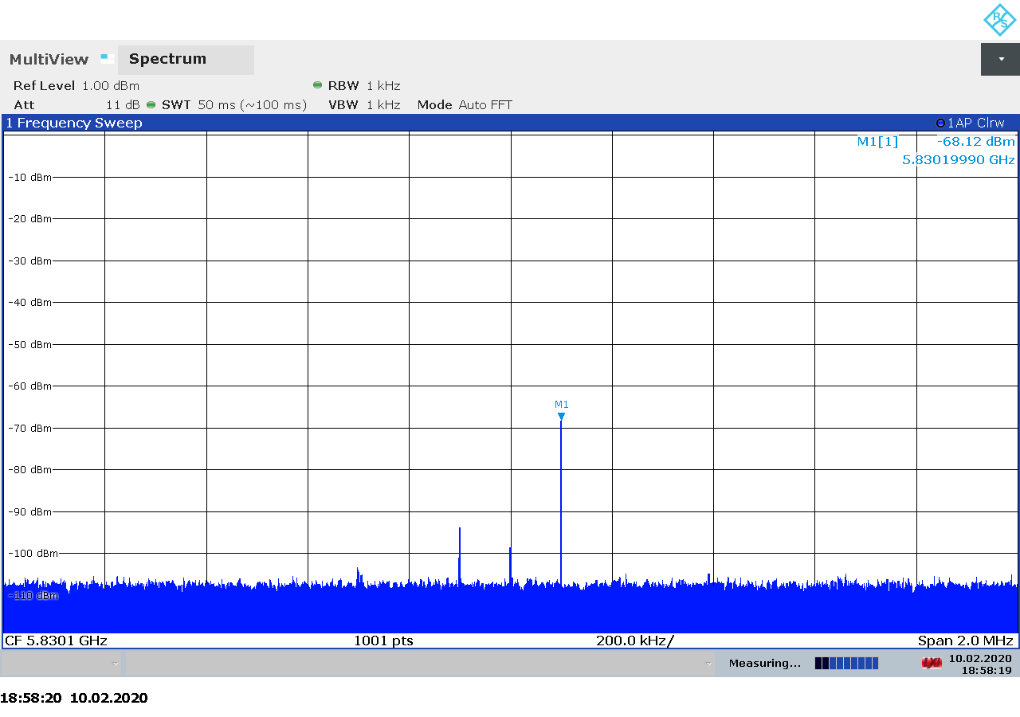Figure 3.76: BladeRF 2.0 micro transmitter spectrum at 5830 MHz, gain 5.
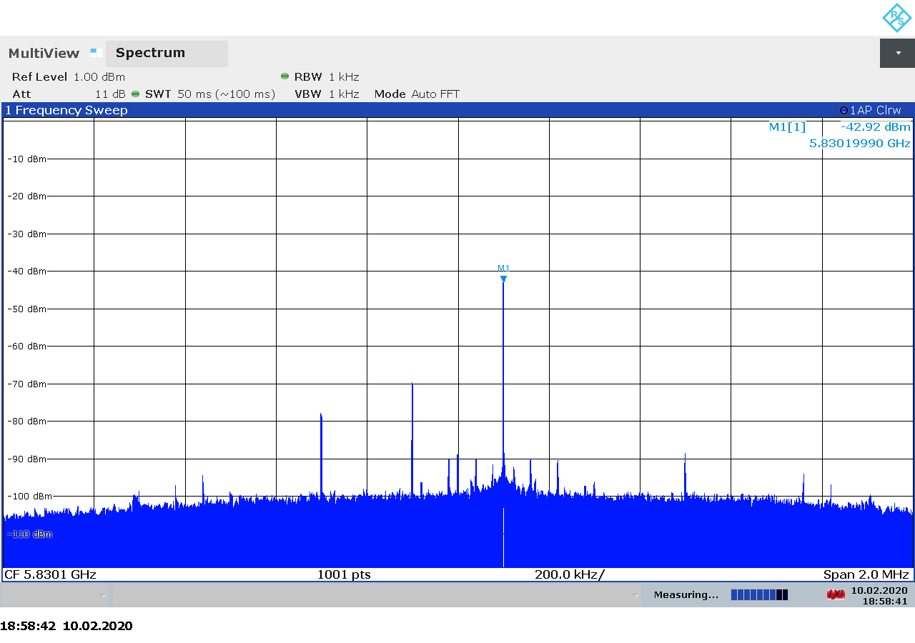Figure 3.77: BladeRF 2.0 micro transmitter spectrum at 5830 MHz, gain 30.

Transmitter Output Power

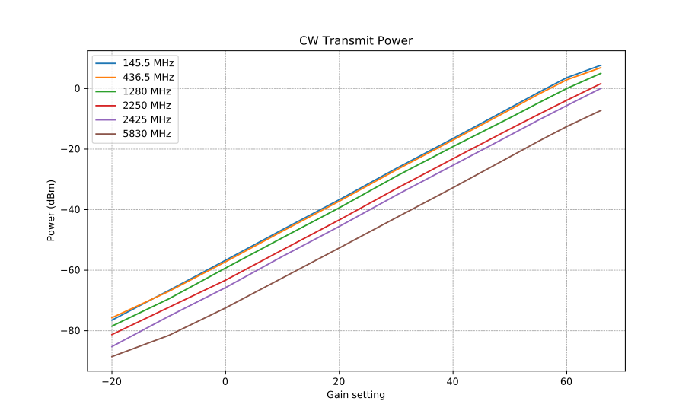Figure 3.78: BladeRF 2.0 micro CW transmitter output power as function of gain.

Transmitter MER

Ettus USRP B210
The The USRP B210 from Ettus Research is a 2×2 MIMO transceiver based on the AD9361 intergated RFIC from Analog Devices. It covers 70 MHz – 6 GHz with up to 61 MHz sample rate and 56 MHz analog bandwidth [23].
The wide bandwidth and frequency range make the BladeRF 2.0 micro an interesting choice for satellite communications, both as a receiver and as a transmitter.
USRP products are supported through an open-source Universal Hardware Driver (UHD) library, which provides a relatively simple and intuitive programming interface to the hardware. Firmware and FPGA sources are avaialble as well [24].
On the hardware side, the schecmatics are available in PDF format on the website [25].

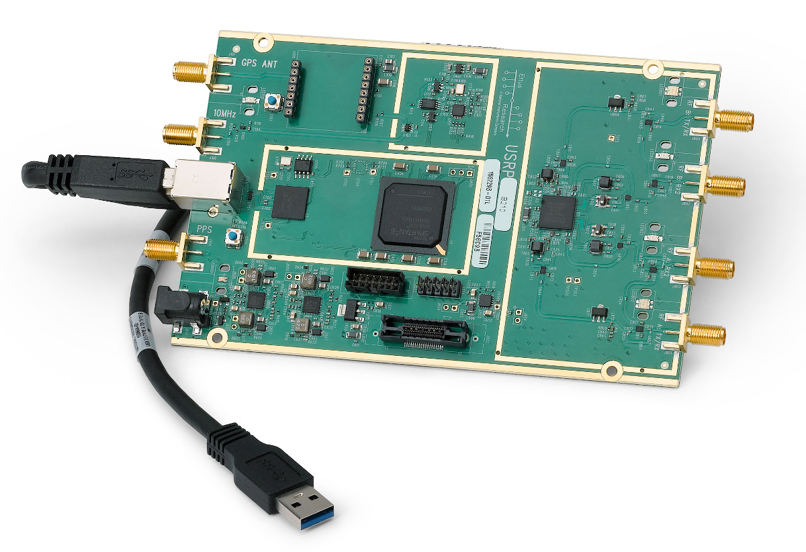Figure 3.79: The Ettus USRP B210 transceiver.

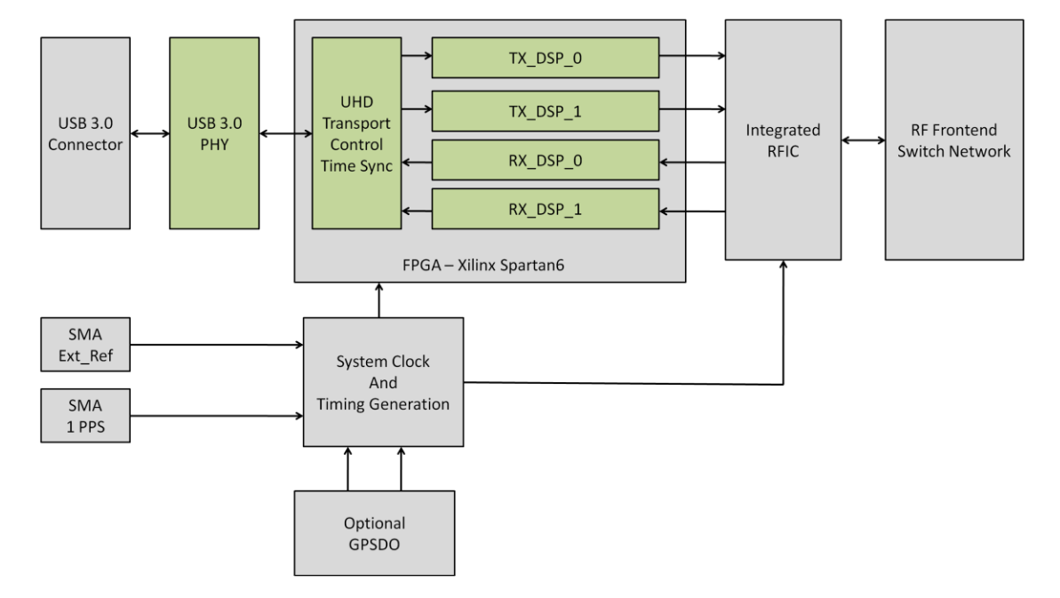Figure 3.80: USRP B210 block diagram.

A summary of the technical specifications for the Ettus USRP B210 is listed in Table 3.16 below.

Frequency Range | 70 MHz – 6 GHz
Sample rate | 61.44 MSPS
RF bandwidth | 200 kHz – 56 MHz
Frontend filters | None
RX paths | 2
RX inputs | 2
TX paths | 2
TX outputs | 2
ADC resolution | 12
DAC resolution | 12
Claimed noise figure | 8 dB
Clained dynamic range | -
Claimed transmit power | 10 dBm
Reference clock | 2 ppm
Other features | Automatic IQ and DC offset correction  2×2 MIMO  External clock  Optional GPSDO
Temperature range | 25 °C [26]
Size | 15.5 cm × 9.7 cm × 1.5 cm
Weight | 350 g (board only)
Approximate price | 1200 € (board only)
Product page | https://www.ettus.com/all-products/ub210-kit/
Table 3.16: Ettus USRP B210 technical specifications.

Receiver Noise Figure
Input rate | Decimation | Sample rate | Bandwidth
3 MHz | 4 | 750 kHz | Auto
Table 3.17: USRP B210 settings used during noise figure measurements.

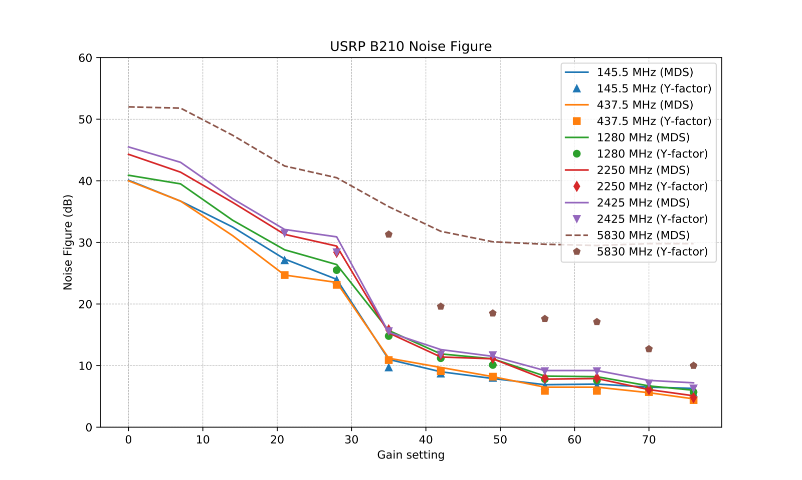Figure 3.81: USRP B210 noise figure measurements.

Notes:
- On 5.83 GHz, the USRP was picking up leaked signal from the signal generator making MDS measurements on this frequency impossible at high gains.
- Compare to data from Ettus.

Receiver Blocking Dynamic Range

Input rate | Decimation | Sample rate | Bandwidth
3 MHz | 1 | 3 MHz | Auto
Table 3.18: USRP B210 settings used for BDR measurements.

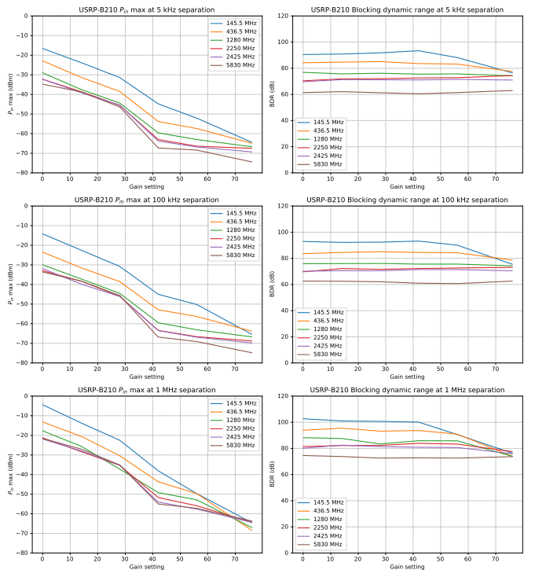Figure 3.82: USRP B210 blocking dynamic range measurements.

Receiver Spectral Purity

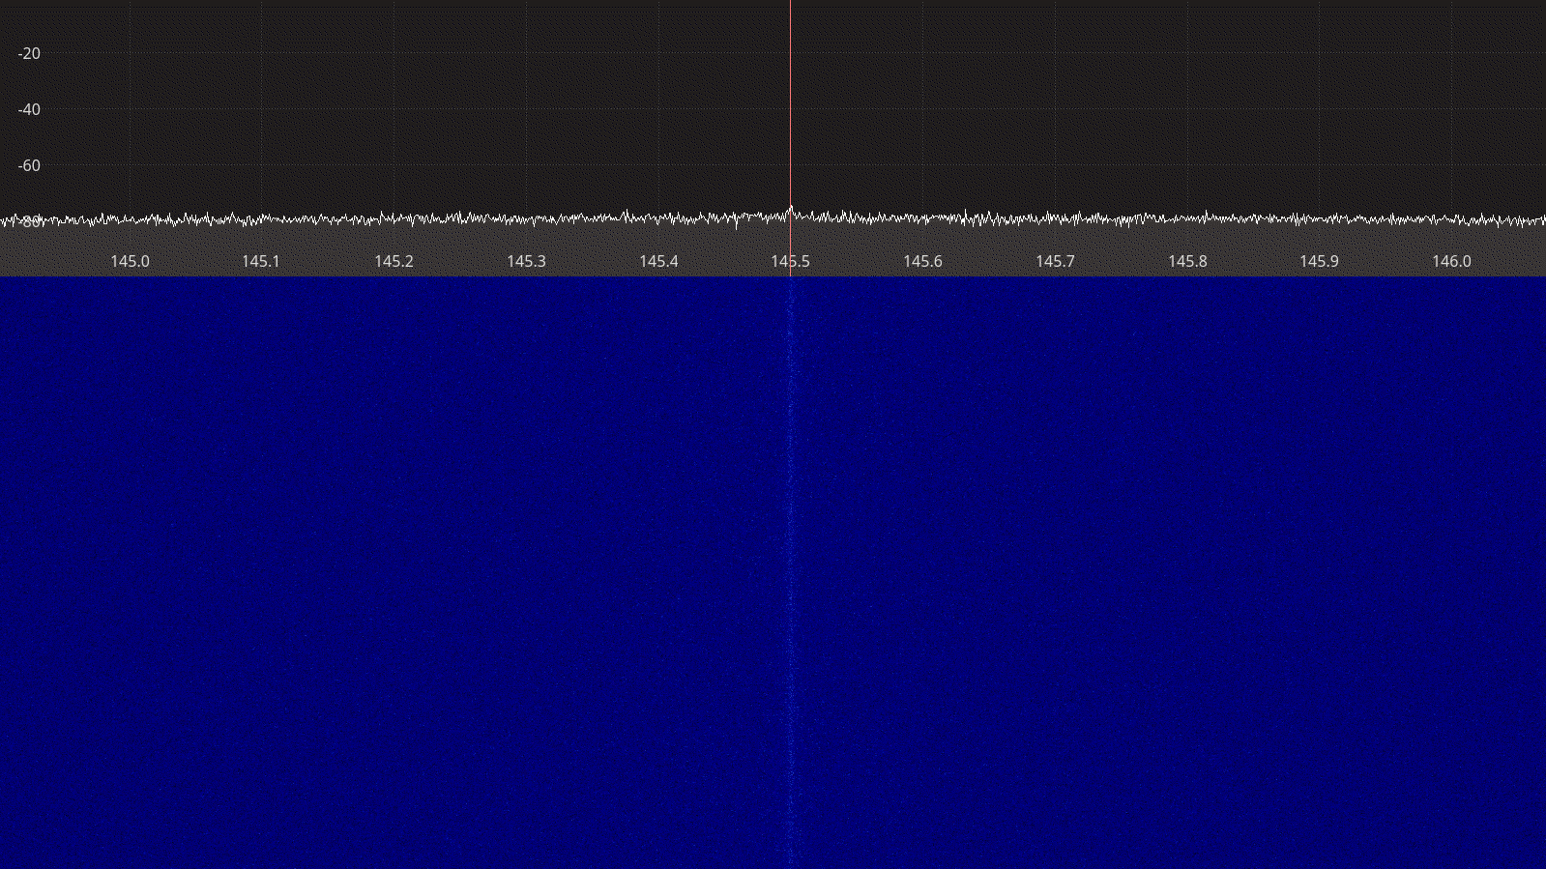Figure 3.83: Ettus USRP B210 receiver spectrum between 145 – 146 MHz.

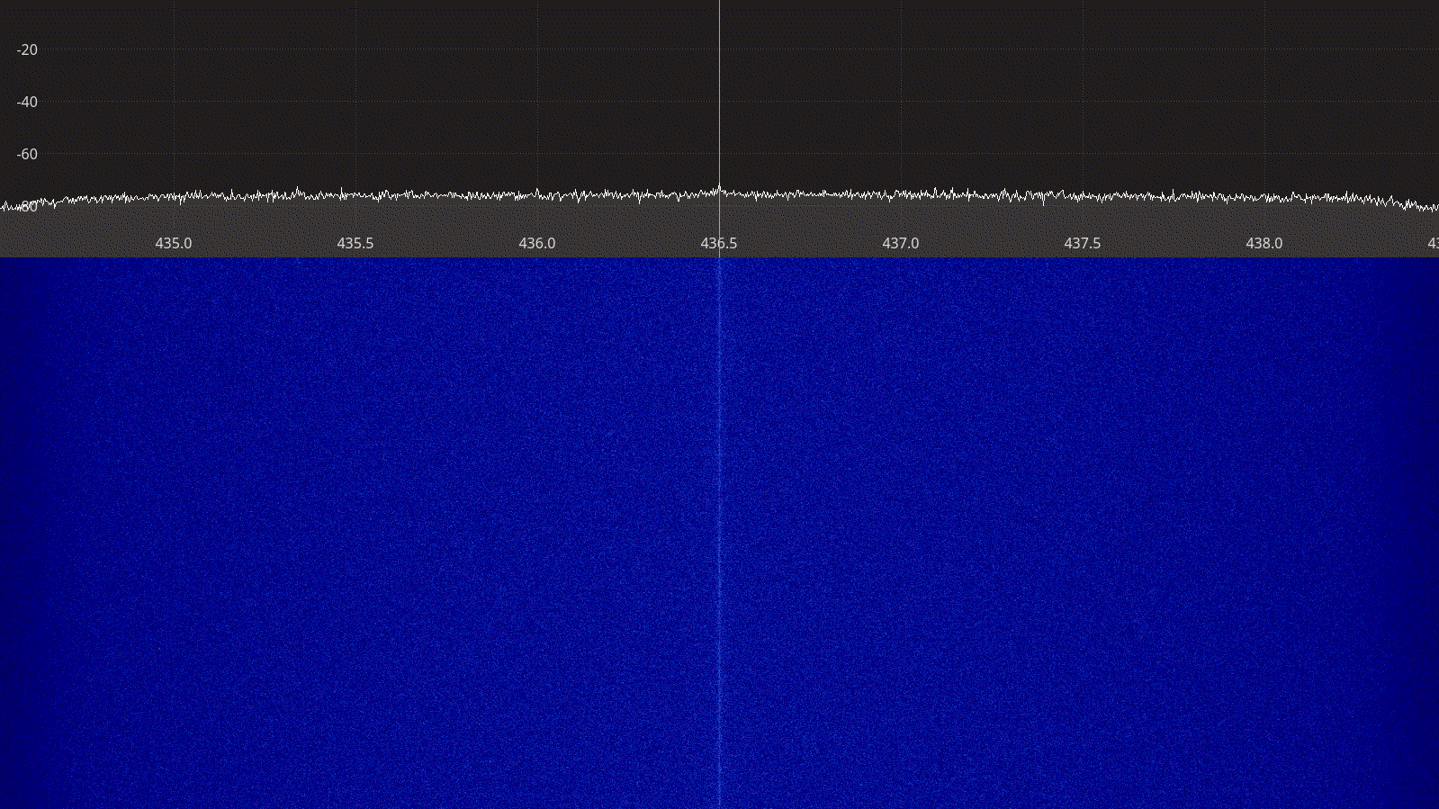Figure 3.84: Ettus USRP B210 receiver spectrum between 435 – 438 MHz.
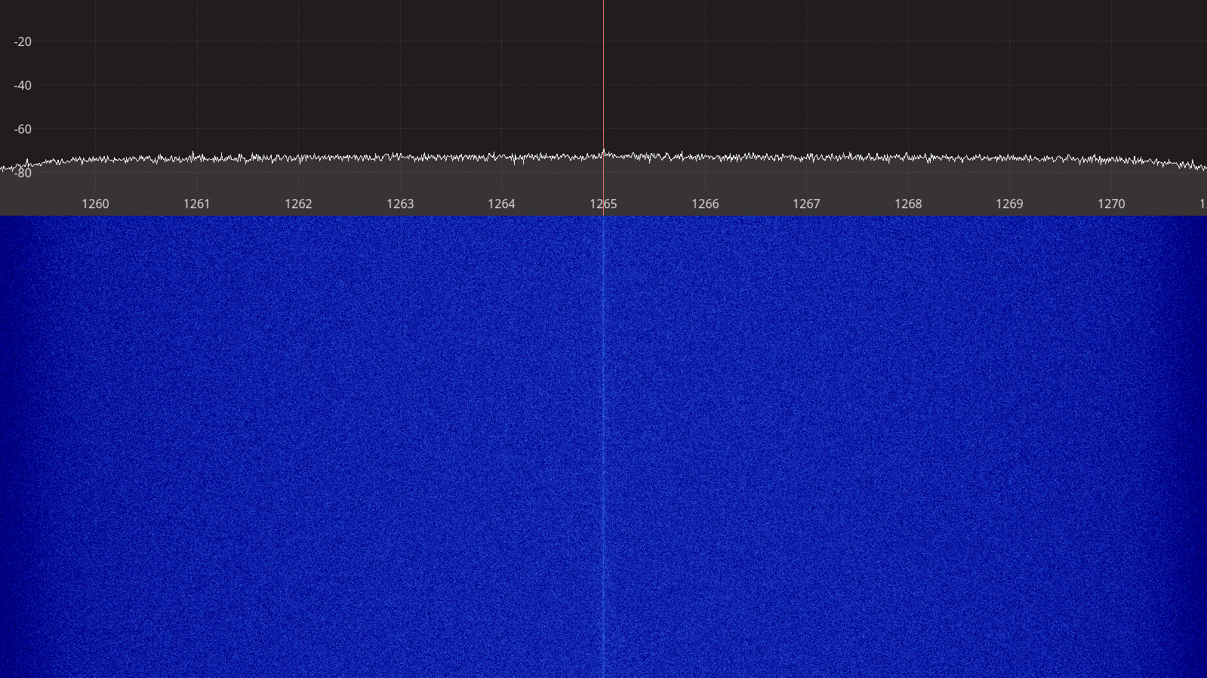Figure 3.85: Ettus USRP B210 receiver spectrum between 1260 – 1270 MHz.

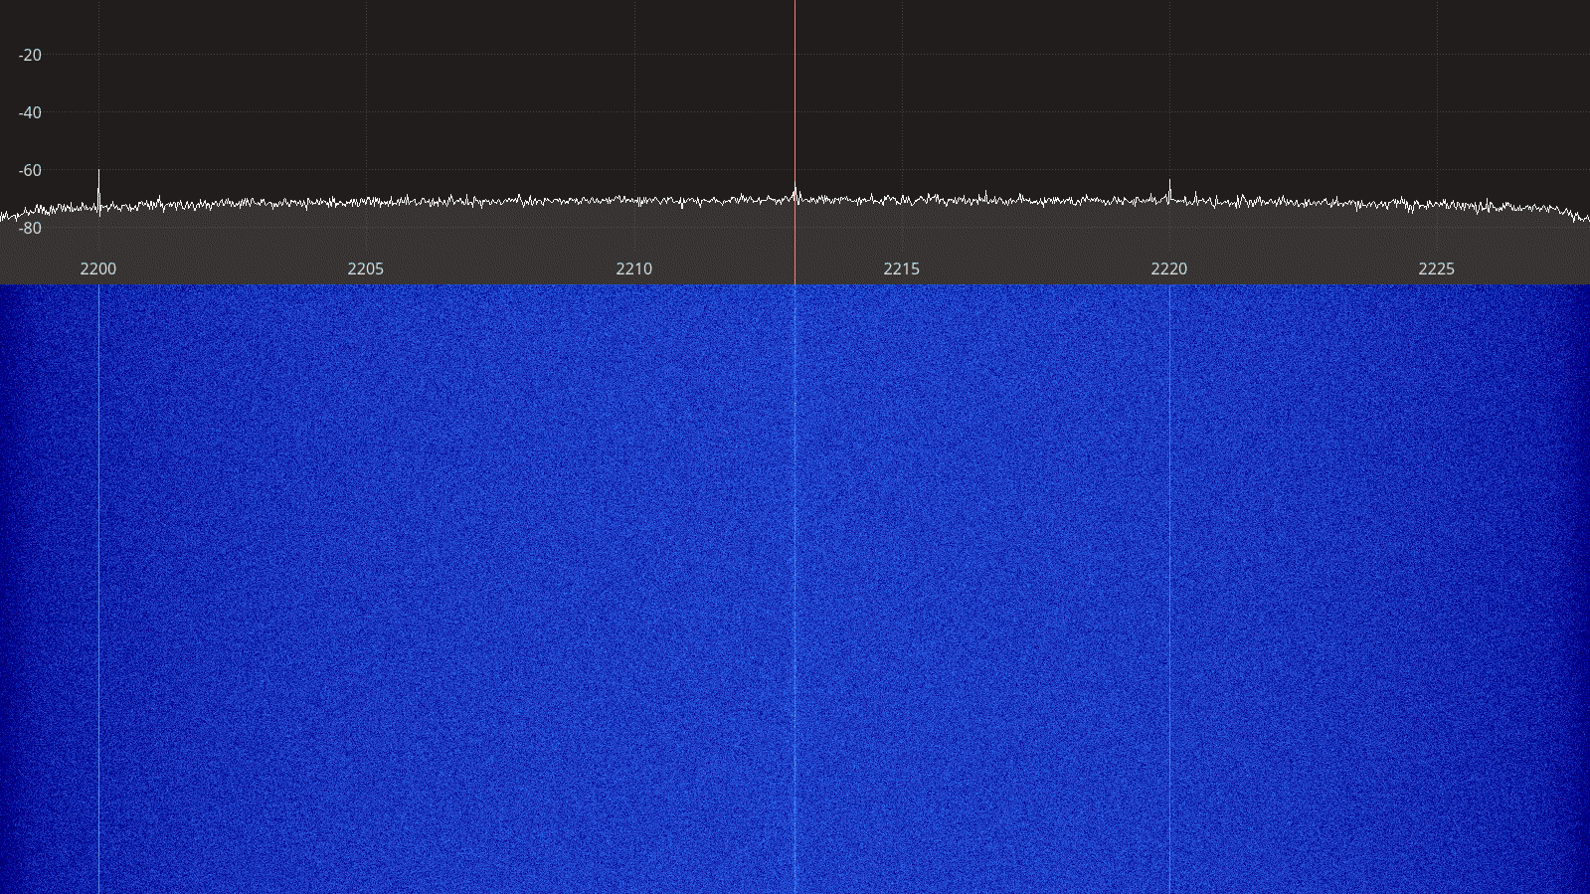Figure 3.86: Ettus USRP B210 receiver spectrum between 2200 – 2225 MHz.
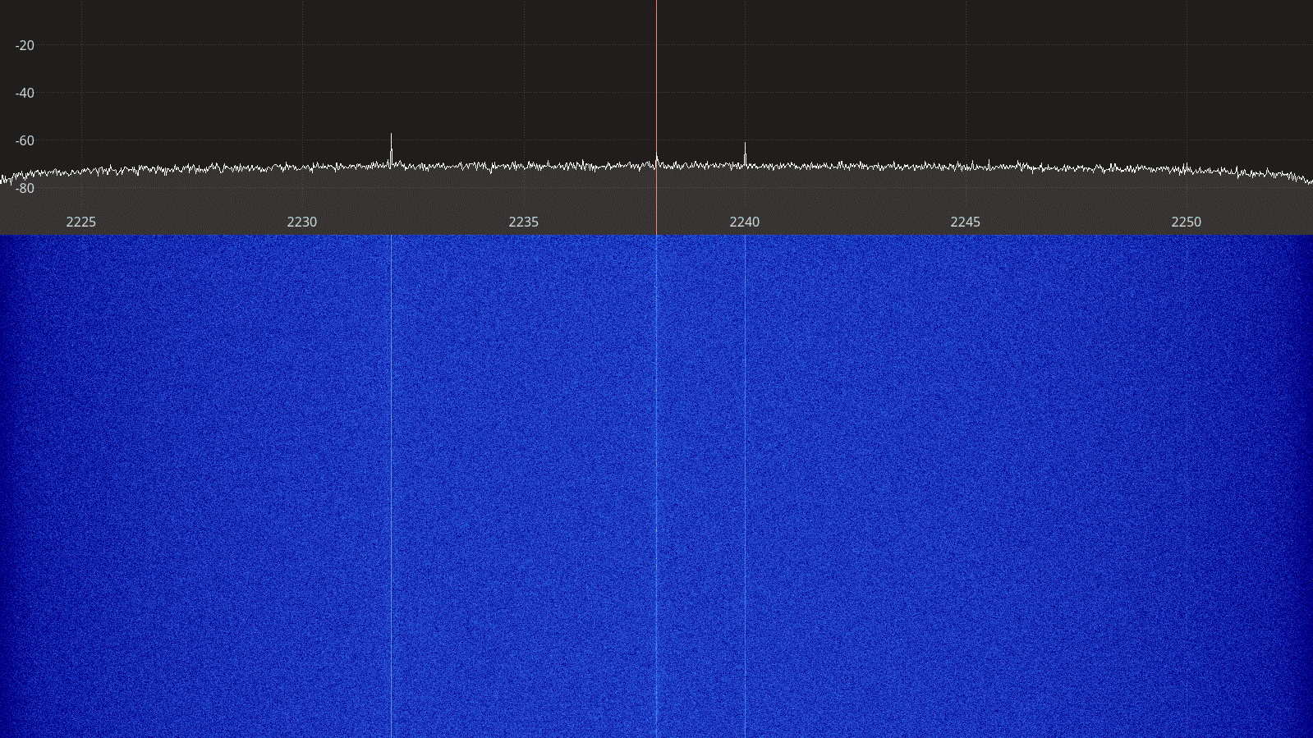Figure 3.87: Ettus USRP B210 receiver spectrum between 2225 – 2250 MHz.

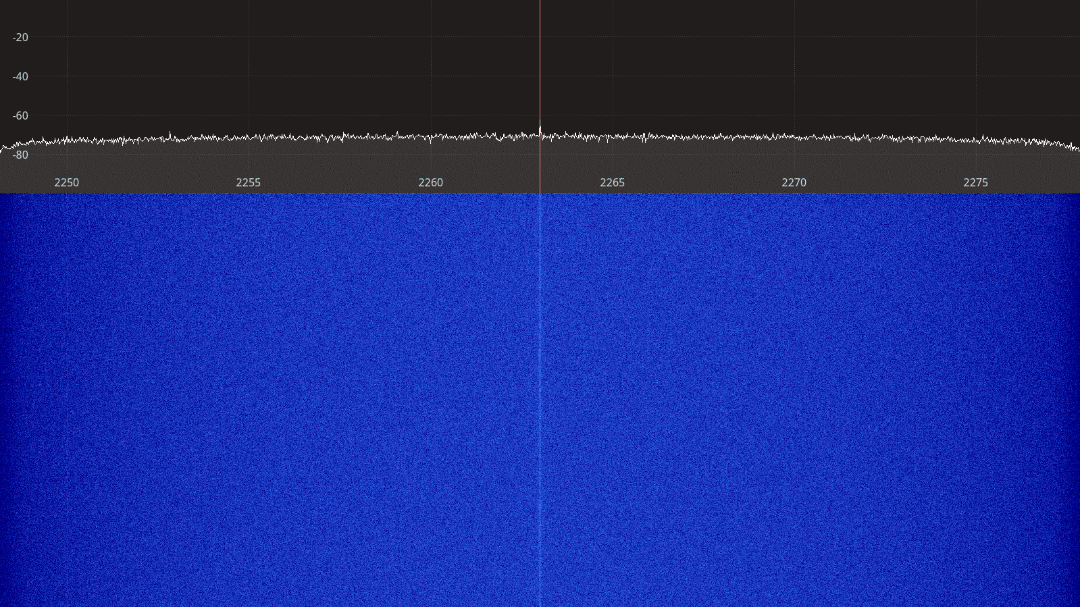Figure 3.88: Ettus USRP B210 receiver spectrum between 2250 – 2275 MHz.
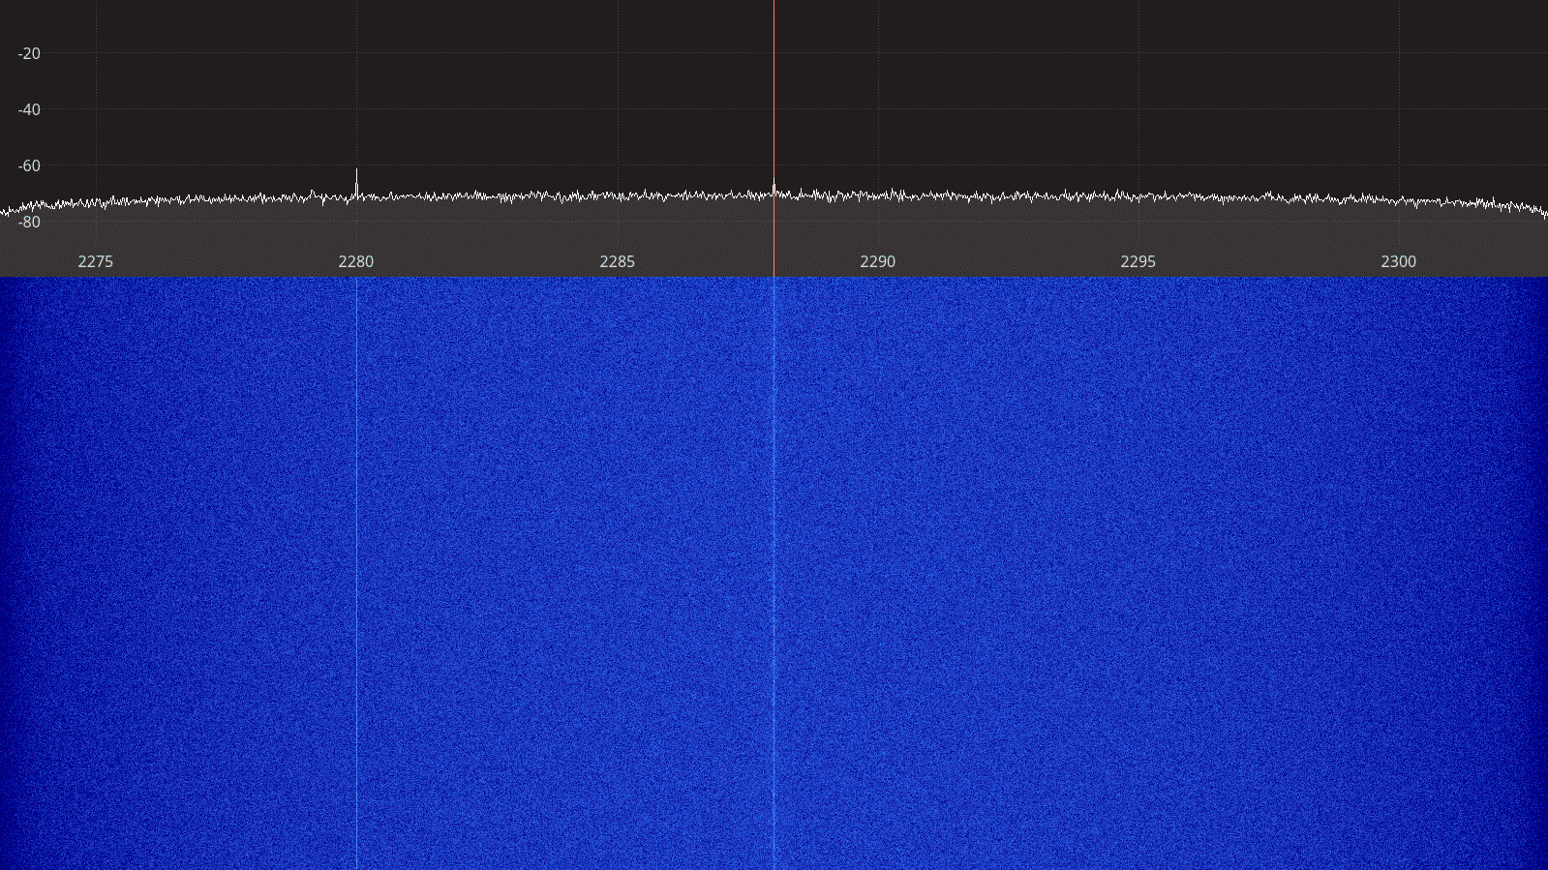Figure 3.89: Ettus USRP B210 receiver spectrum between 2275 – 2300 MHz.

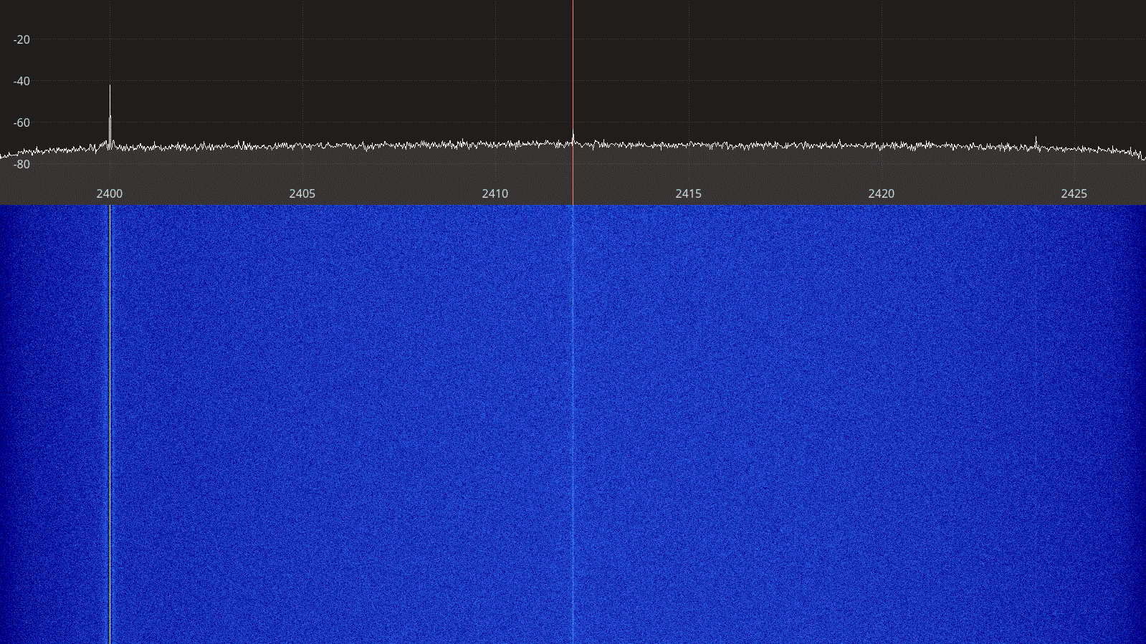Figure 3.90: Ettus USRP B210 spectrum between 2400 – 2425 MHz.
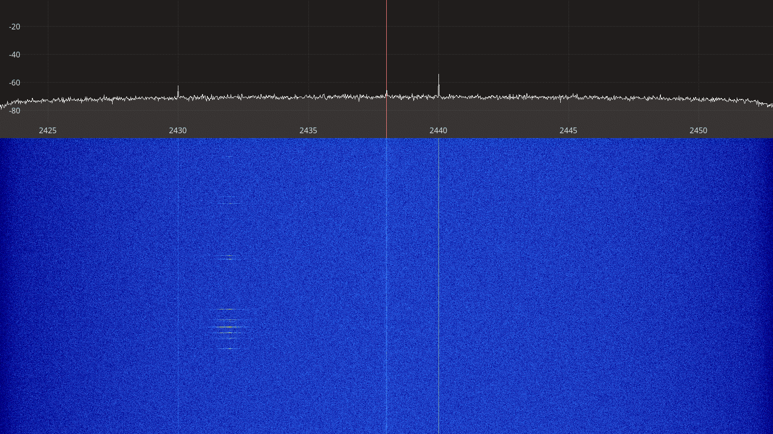Figure 3.91: Ettus USRP B210 receiver spectrum between 2425 – 2450 MHz.

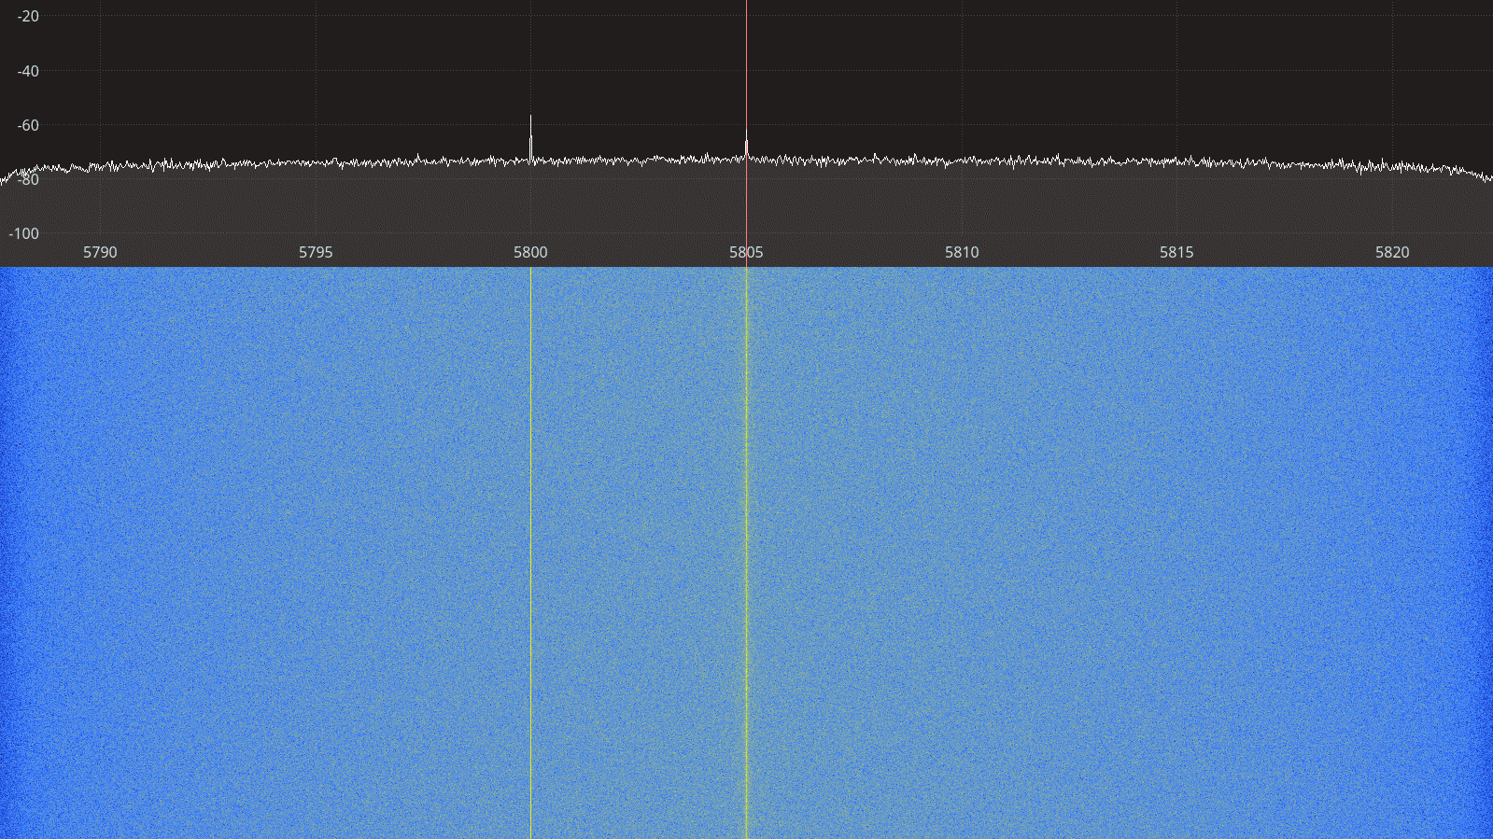Figure 3.92: Ettus USRP B210 receiver spectrum between 5790 – 5820 MHz.
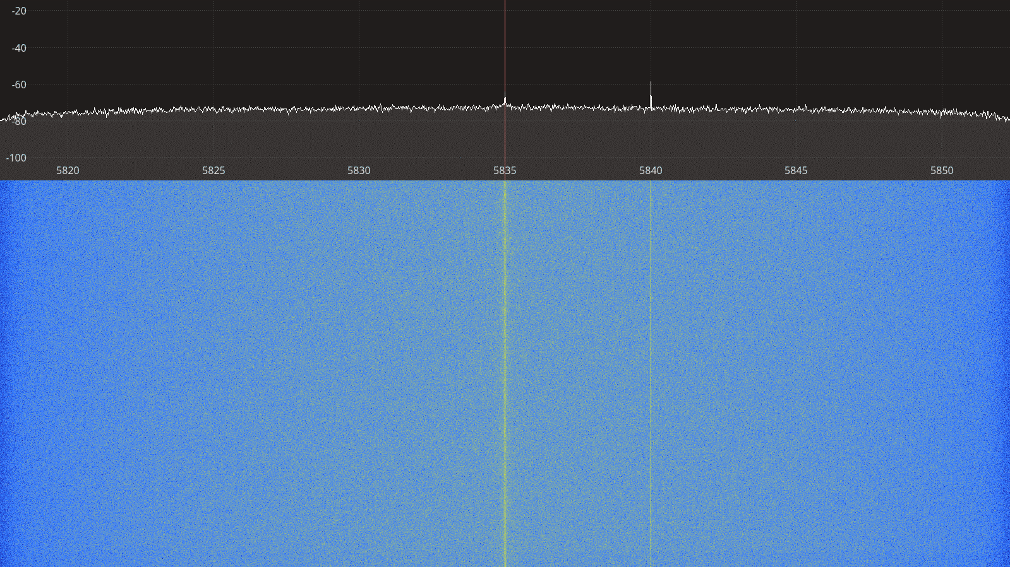Figure 3.93: Ettus USRP B210 receiver spectrum between 5820 – 5850 MHz.

Transmitter Spectral Purity

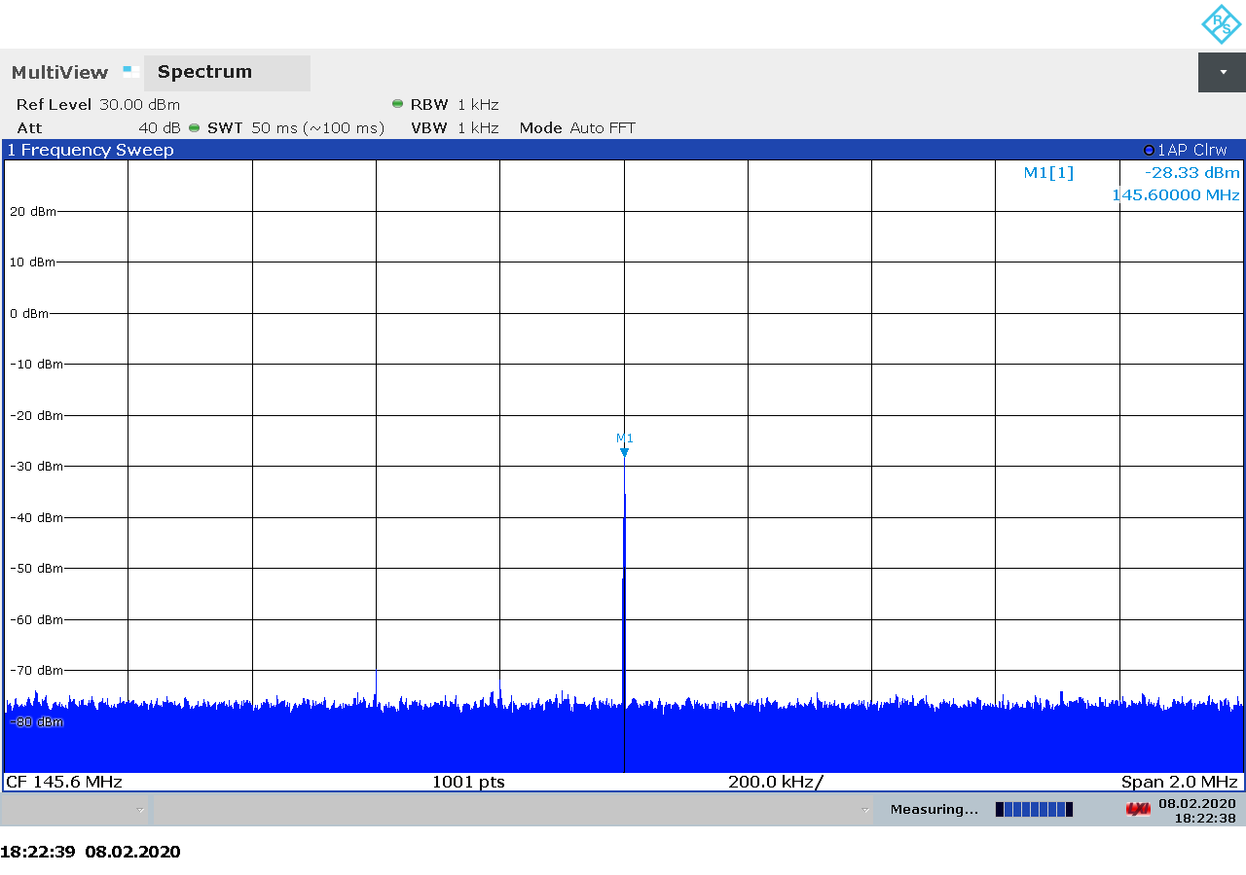Figure 3.94: Ettus USRP B210 transmitter spectrum at 145.5 MHz, gain 35.

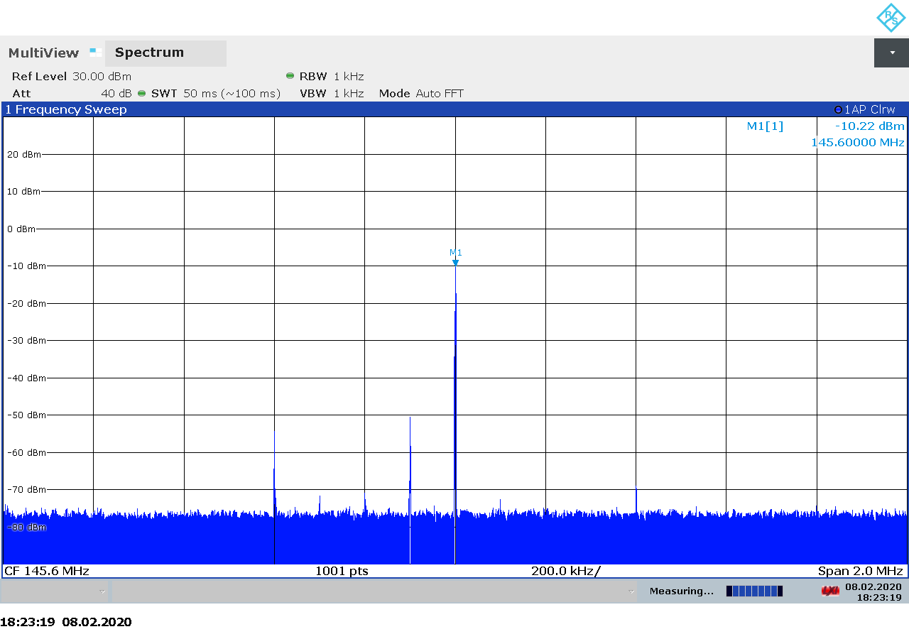Figure 3.95: Ettus USRP B210 transmitter spectrum at 145.5 MHz, gain 53.
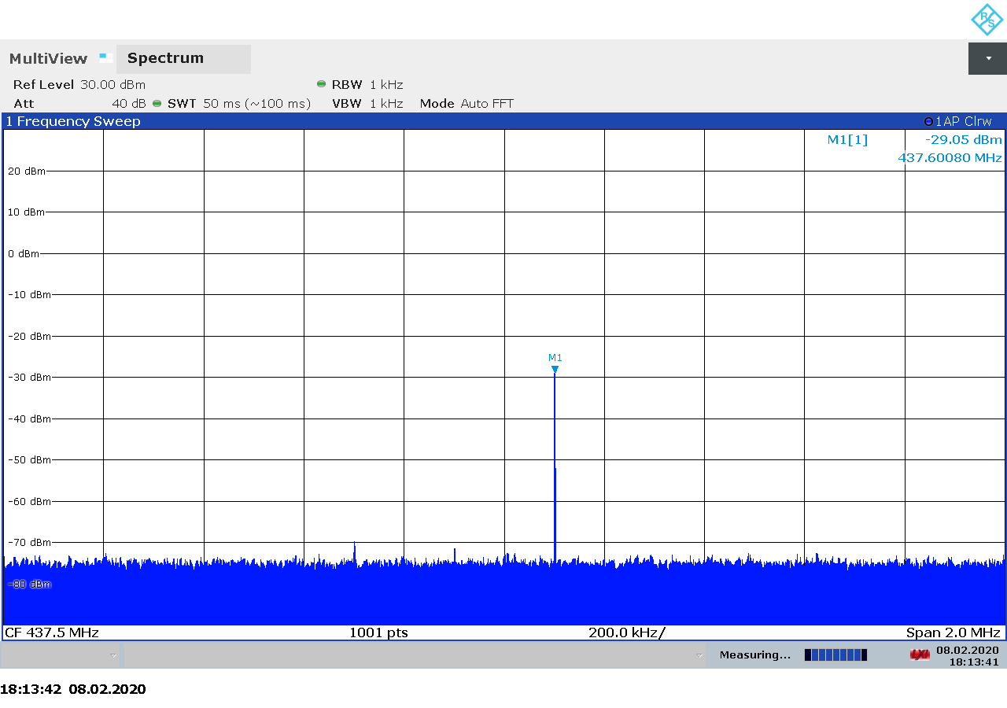Figure 3.96: Ettus USRP B210 transmitter spectrum at 437.5 MHz, gain 35.

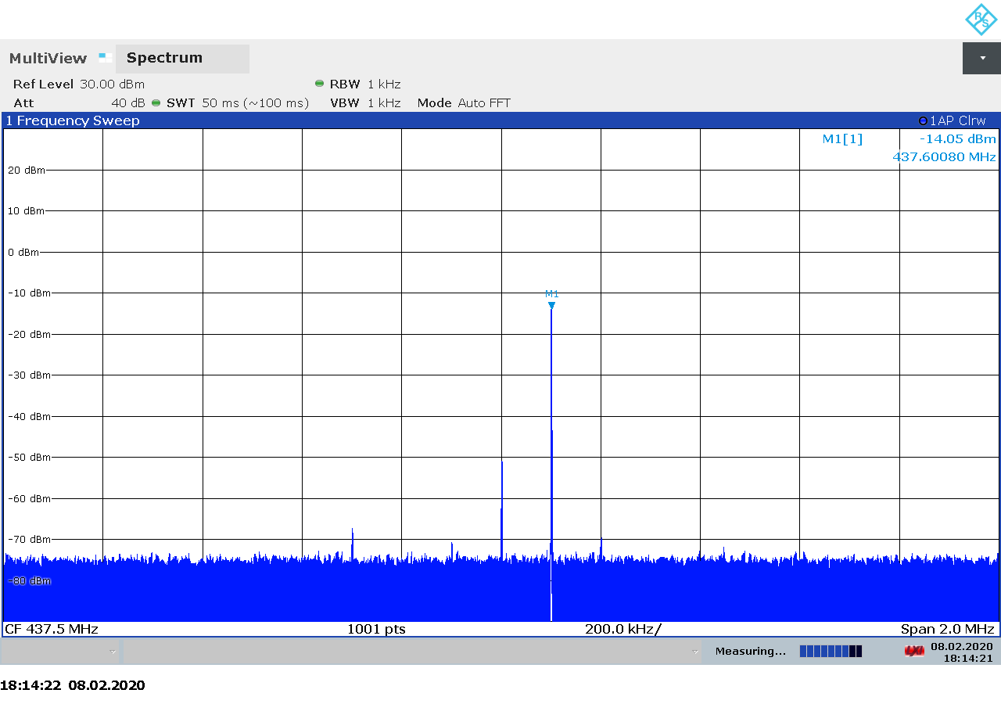Figure 3.97: Ettus USRP B210 transmitter spectrum at 437.5 MHz, gain 50.
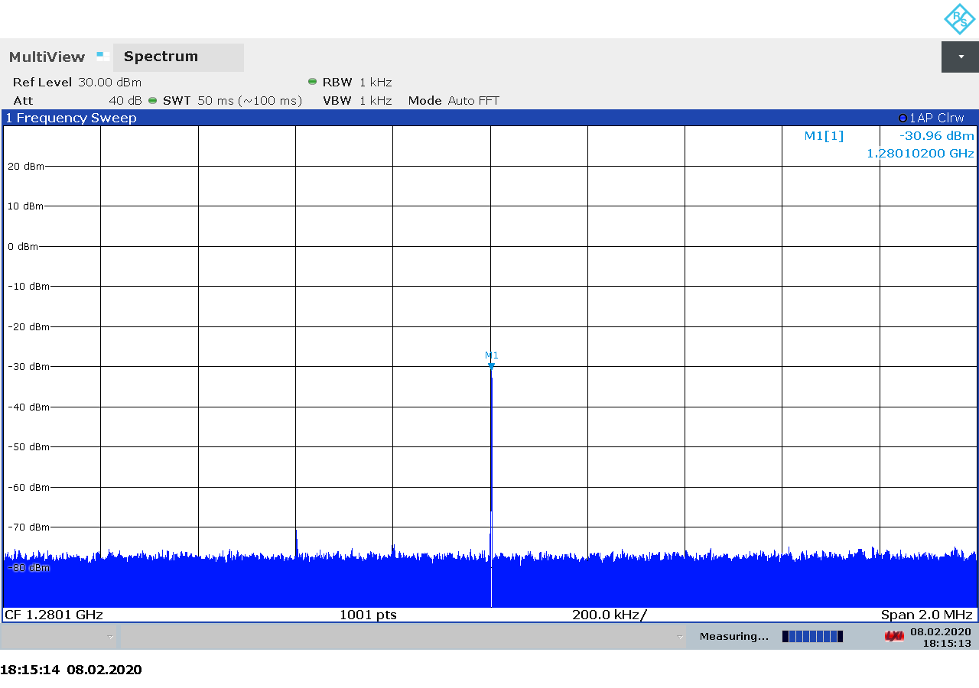Figure 3.98: Ettus USRP B210 transmitter spectrum at 1280 MHz, gain 35.

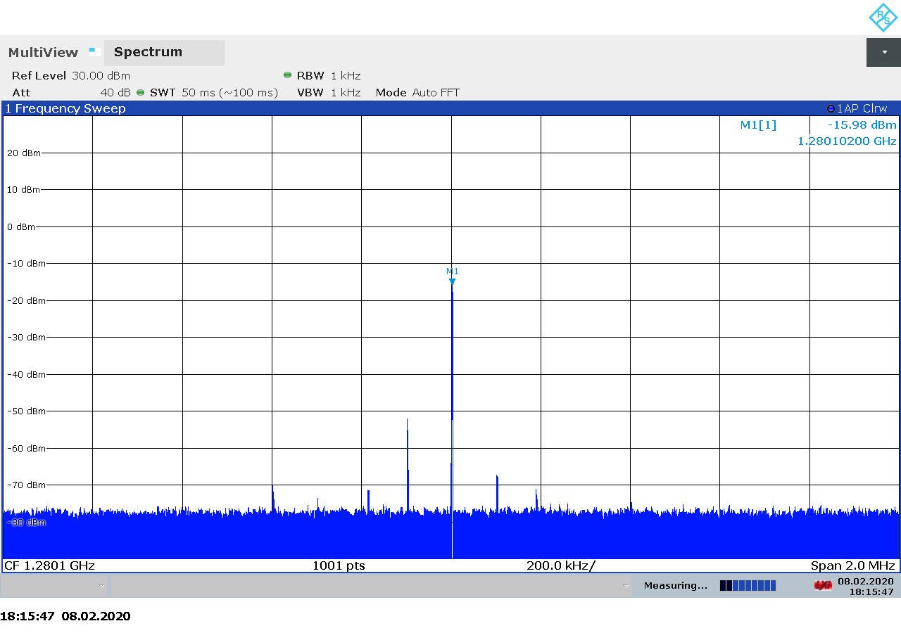Figure 3.99: Ettus USRP B210 transmitter spectrum at 1280 MHz, gain 50.
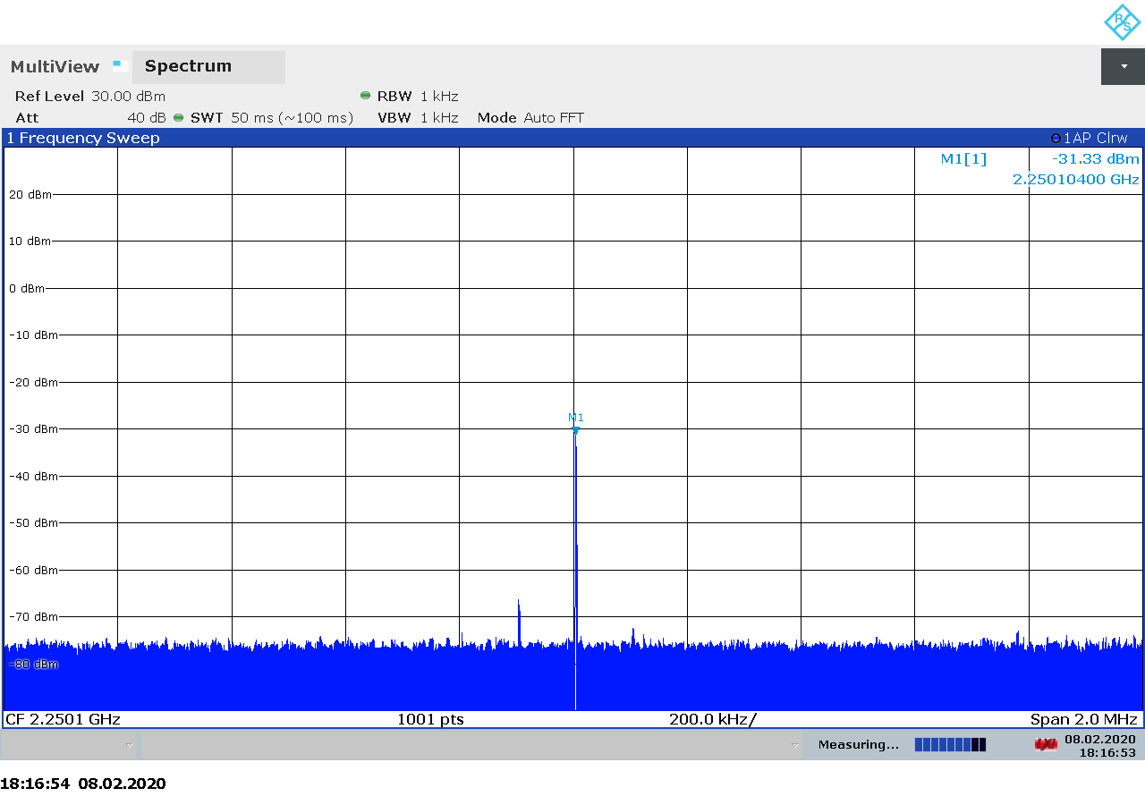Figure 3.100: Ettus USRP B210 transmitter spectrum at 2250 MHz, gain 43.

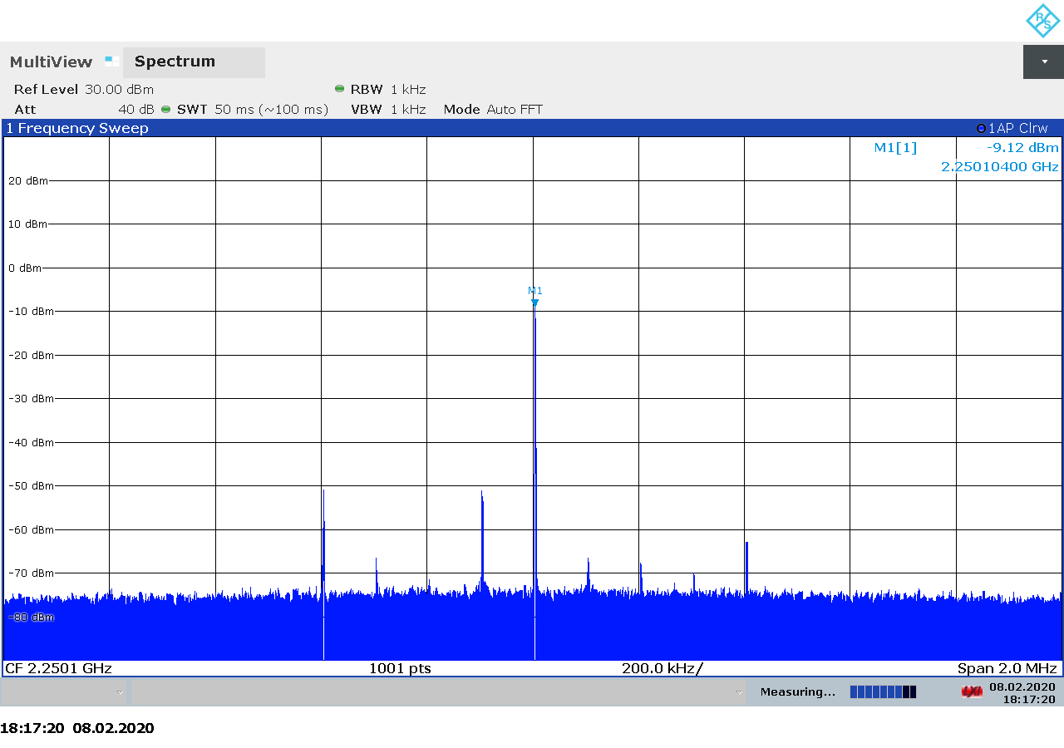Figure 3.101: Ettus USRP B210 transmitter spectrum at 2250 MHz, gain 65.

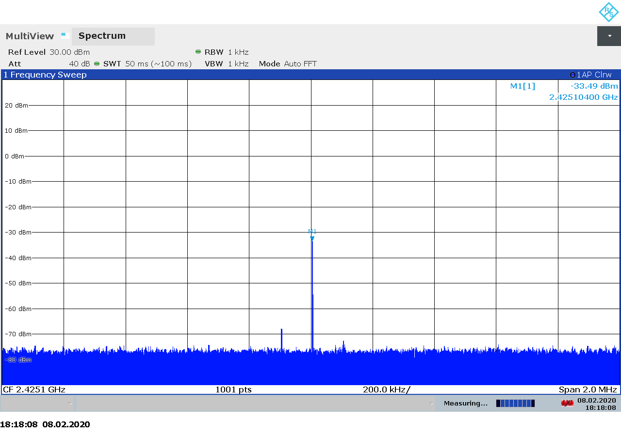Figure 3.102: Ettus USRP B210 transmitter spectrum at 2425 MHz, gain 43.
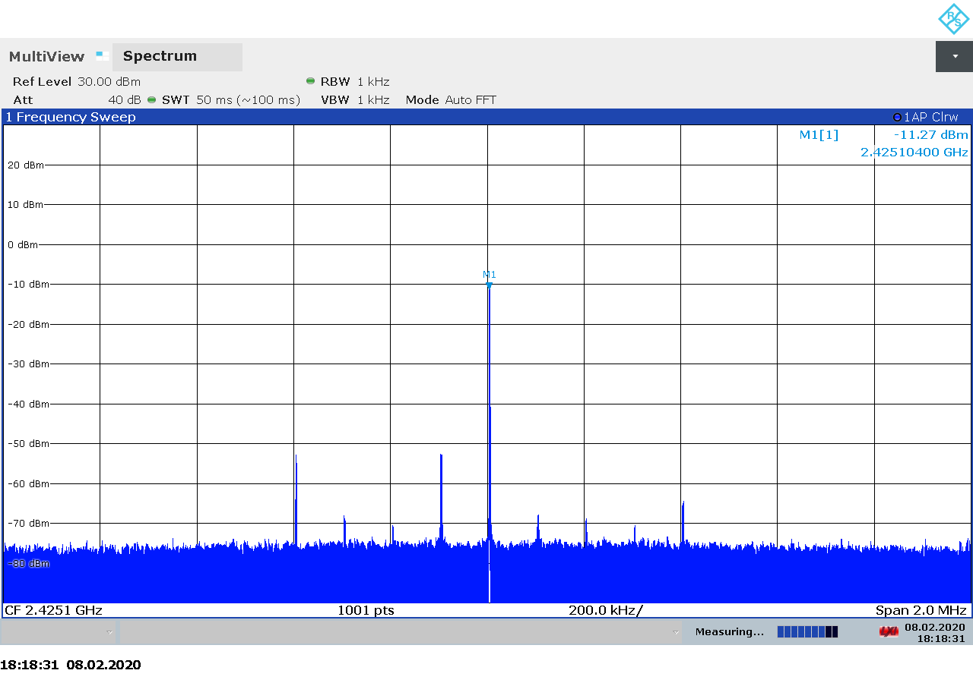Figure 3.103: Ettus USRP B210 transmitter spectrum at 2425 MHz, gain 65.

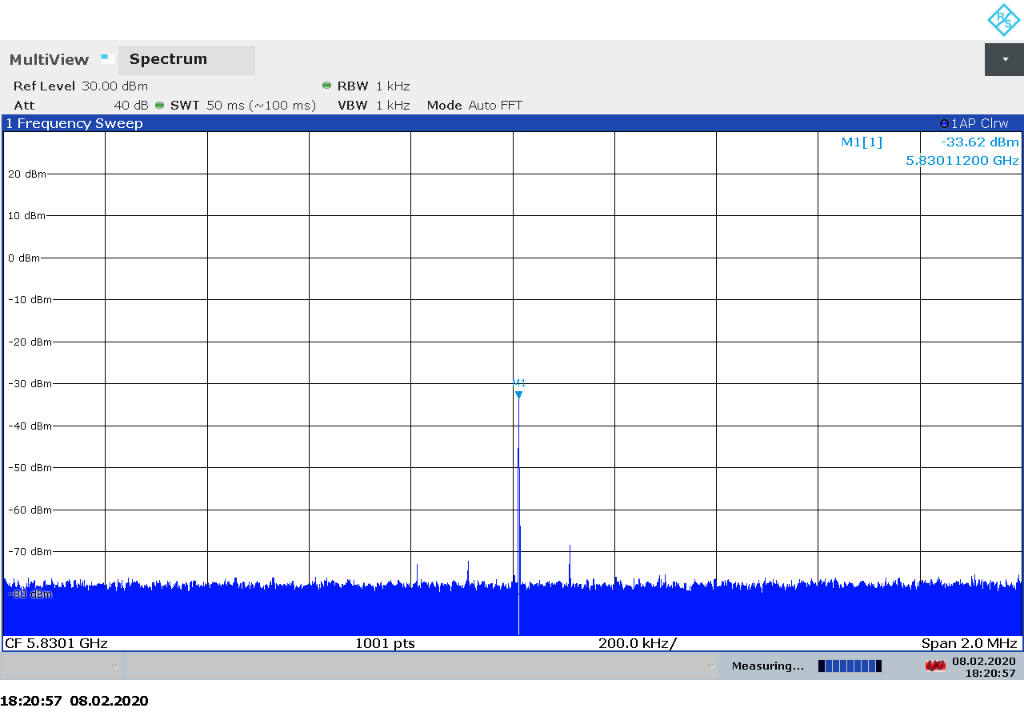Figure 3.104: Ettus USRP B210 transmitter spectrum at 5830 MHz, gain 43.
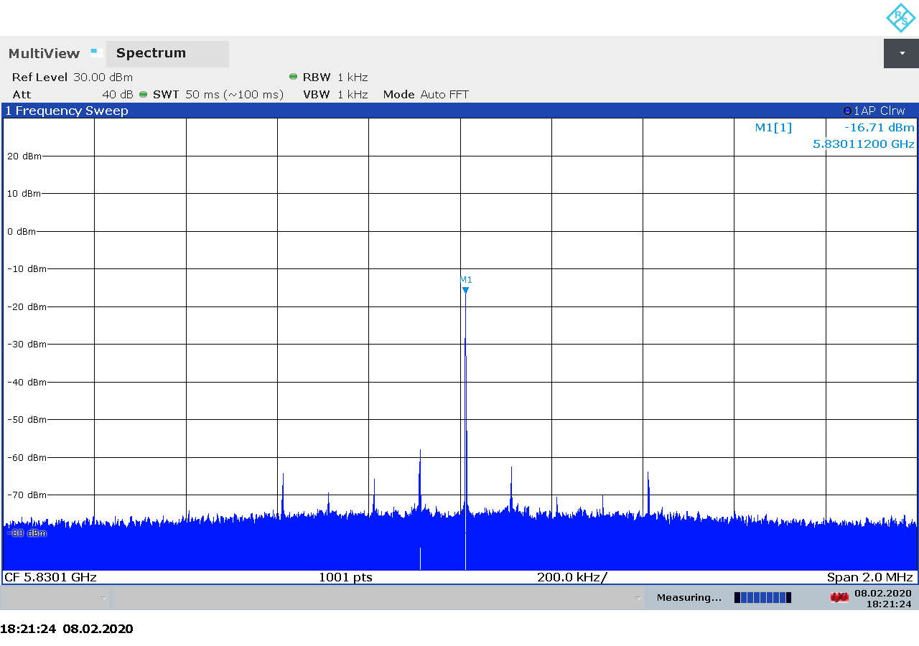Figure 3.105: Ettus USRP B210 transmitter spectrum at 5830 MHz, gain 60.

Transmitter Output Power

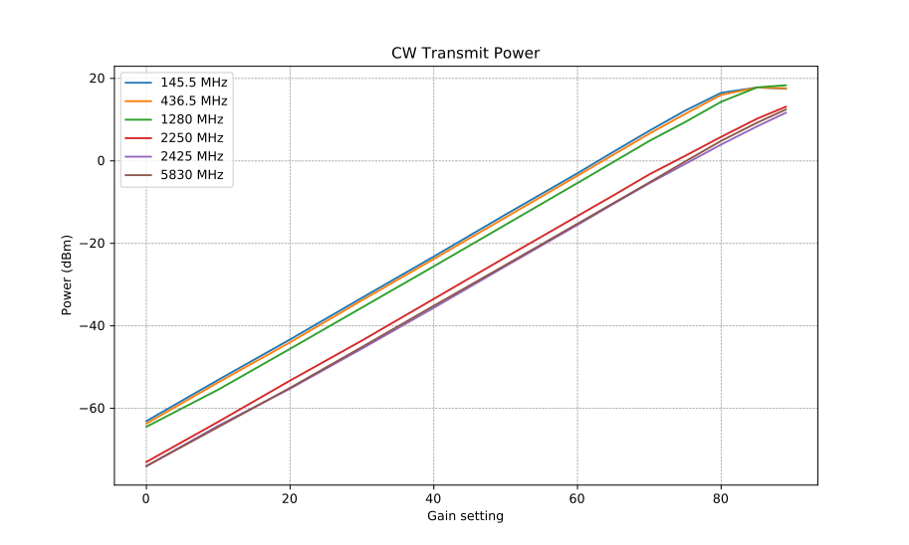Figure 3.106: Ettus USRP B210 CW transmitter output power as function of gain.

Transmitter MER

PlutoSDR
The PlutoSDR (officially called ADALM-PLUTO Active Learning Module) is a low-cost software defined radio transceiver from Analog Devices Inc., created to be used as a tool for teaching RF and radio communications at all levels [27]. It is based on the Analog Devices AD9363 integrated RFIC and can be used as a full-duplex transceiver between 325 – 3800 MHz.
By default, the PlutoSDR is set up to stream raw I/Q samples to/from a host computer through a USB2 connection. However, the devices contains a ZYNQ processor running embedded linux, allowing advanced users and developer to run SDR applications on the device. The PlutoSDR comes as an open-source hardware and software with schematics and PCB layout files avaialble through the Analog Devices website [29].

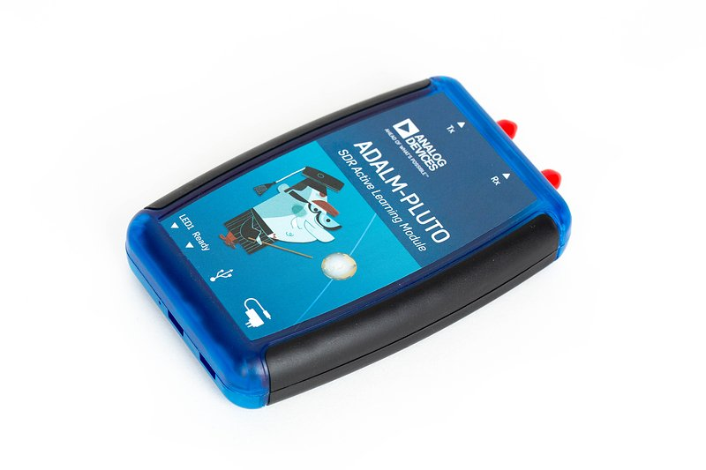Figure 3.107: The Analog Devices PlutoSDR transceiver.
PlutoSDR devices are controlled via the Linux Industrial I/O Subsytem (IIO). Compared to simple SDR-specific APIs, IIO provides a somehow obscure and unintuitive interface for controlling SDRs and streaming samples. Clear and concise programming documentation is hard to find. Mastering Google and reading the source code of existing applications are must-have skills if one wants to write an application that interfaces to the PlutoSDR.
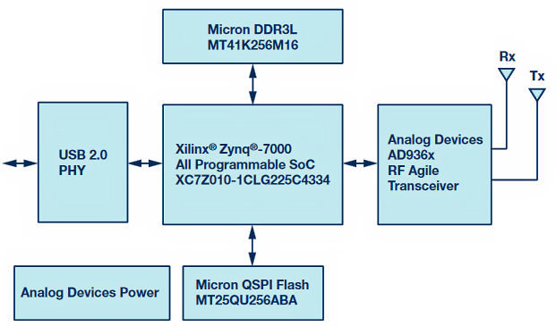
Figure 3.108: PlutoSDR block diagram.

A summary of the technical specifications for the PlutoSDR is listed in Table 3.19 below.
Frequency Range | 325 – 3800 MHz (70 MHz – 6 GHz through bootloader config)
Sample rate | 7.5 – 12 MSPS (depending on USB2 host [28])
RF bandwidth | 20 MHz
Frontend filters | None
RX paths | 1
RX inputs | 1
TX paths | 1
TX outputs | 1
ADC resolution | 12
DAC resolution | 12
Claimed noise figure | -
Clained dynamic range | -
Claimed transmit power | -
Reference clock | 25 ppm
Other features | ZYNQ processor running embedded linux  Onboard flash  Open source design
Temperature range | 10 – 40 °C
Size
Weight | 127 g (in original case covered with copper tape)
Approximate price | 140 €
Product page | https://www.analog.com/en/design-center/evaluation-hardware-and-software/evaluation-boards-kits/adalm-pluto.html
Table 3.19: PlutoSDR technical specifications.

Receiver Noise Figure
Input rate | Decimation | Sample rate | Bandwidth
3 MHz | 8 | 375 kHz | Auto
Table 3.20: PlutoSDR settings used during noise figure measurements.

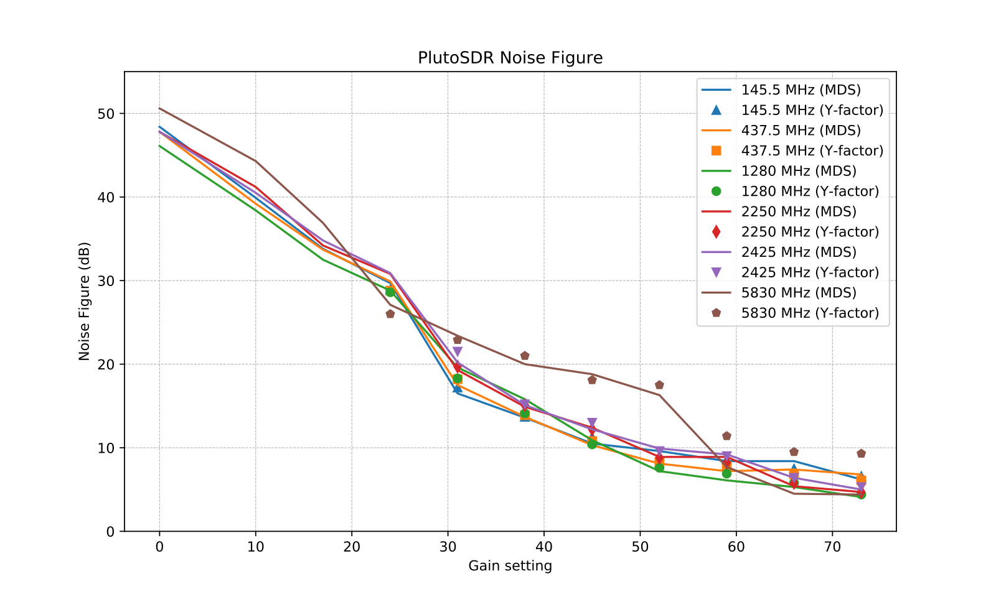Figure 3.109: PlutoSDR noise figure measurements.

Notes:
- Can’t explain the large difference between MDS and Y-factor on 5.8 GHz… We trust the Y-factor more as it is more consistent with the expectation of higher NF at higher frequencies.

Receiver Blocking Dynamic Range

Input rate | Decimation | Sample rate | Bandwidth
3 MHz | 1 | 3 MHz | Auto
Table 3.21: PlutoSDR settings used for BDR measurements.

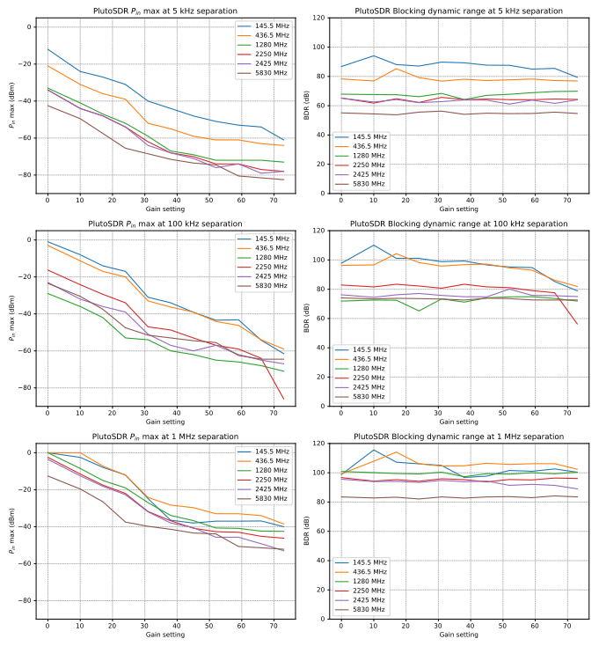Figure 3.110: PlutoSDR blocking dynamic range measurements.
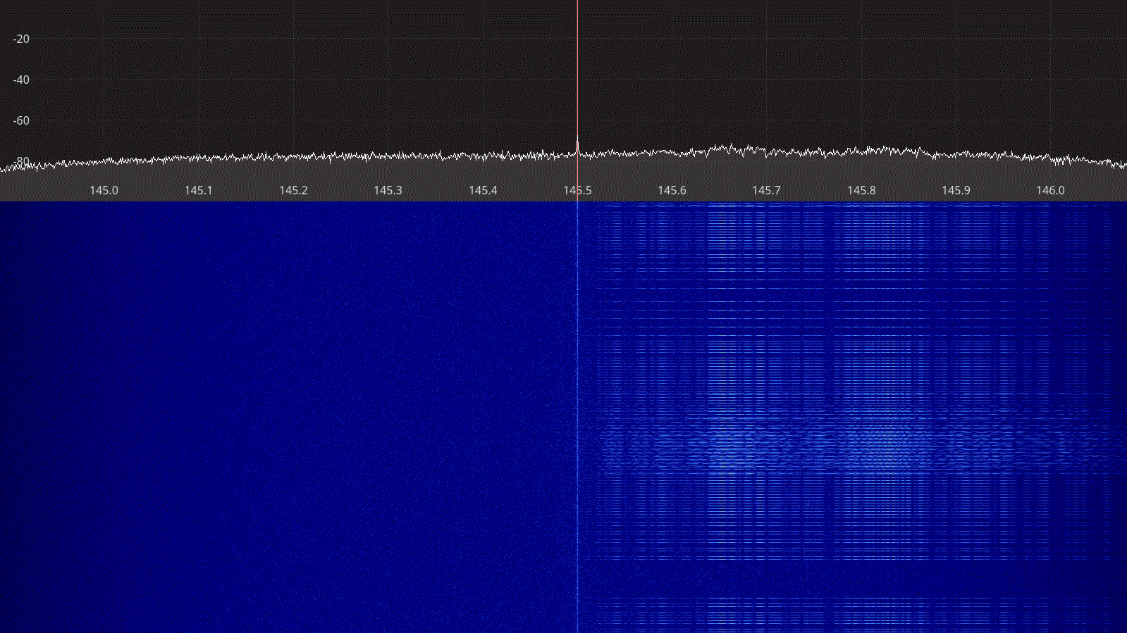Figure 3.111: PlutoSDR receiver spectrum between 145 – 146 MHz.

Receiver Spectral Purity

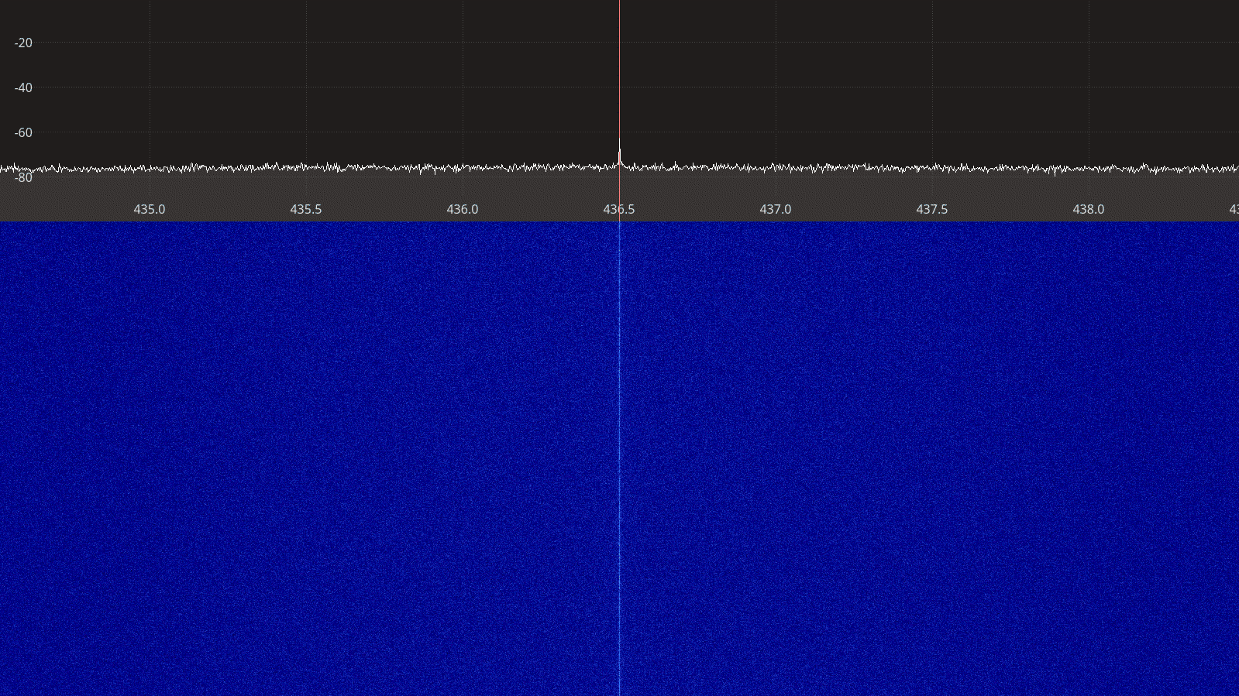Figure 3.112: PlutoSDR receiver spectrum between 435 – 438 MHz.
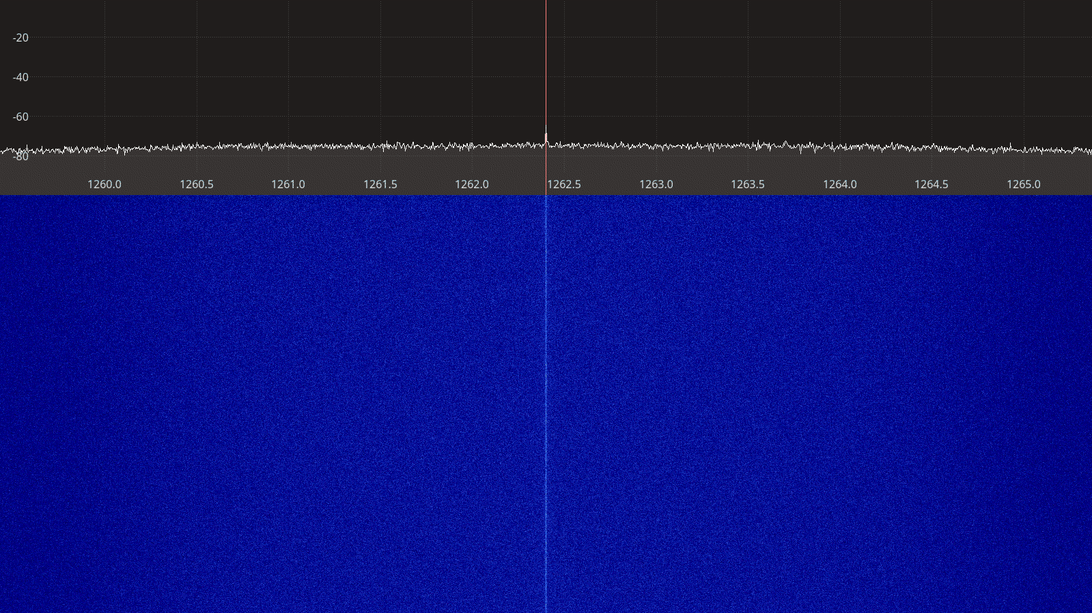Figure 3.113: PlutoSDR receiver spectrum between 1260 – 1265 MHz.

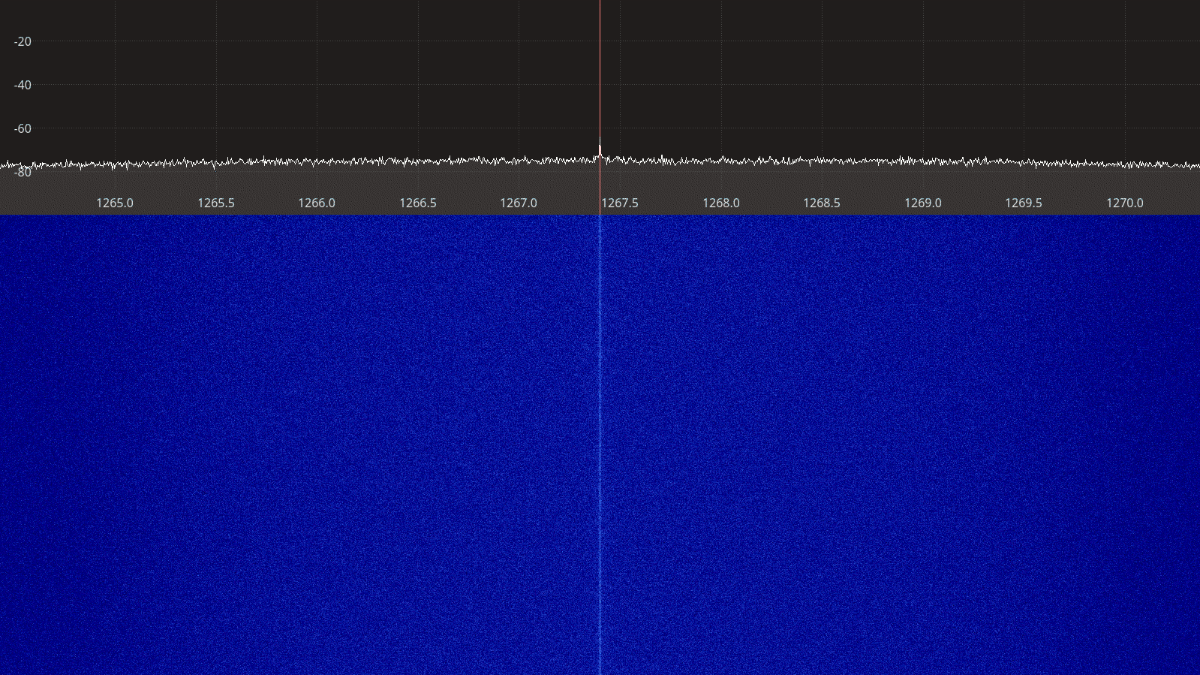Figure 3.114: PlutoSDR receiver spectrum between 1265 – 1270 MHz.
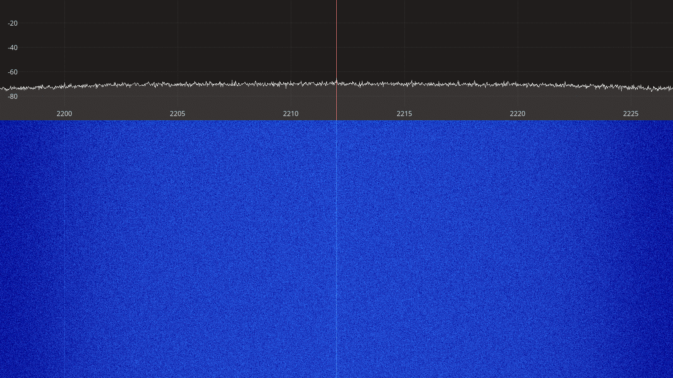Figure 3.115: PlutoSDR receiver spectrum between 2200 – 2225 MHz.

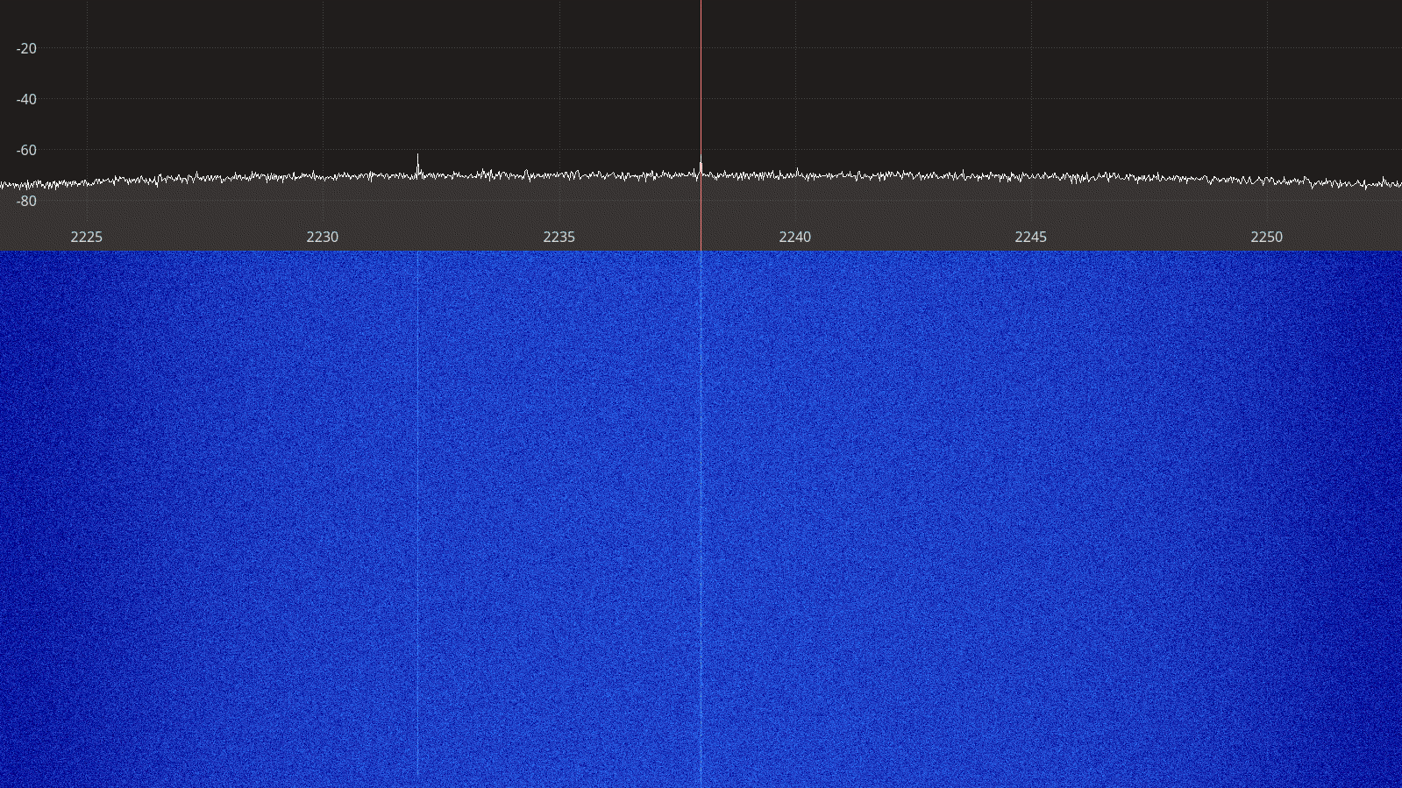Figure 3.116: PlutoSDR receiver spectrum between 2225 – 2250 MHz.
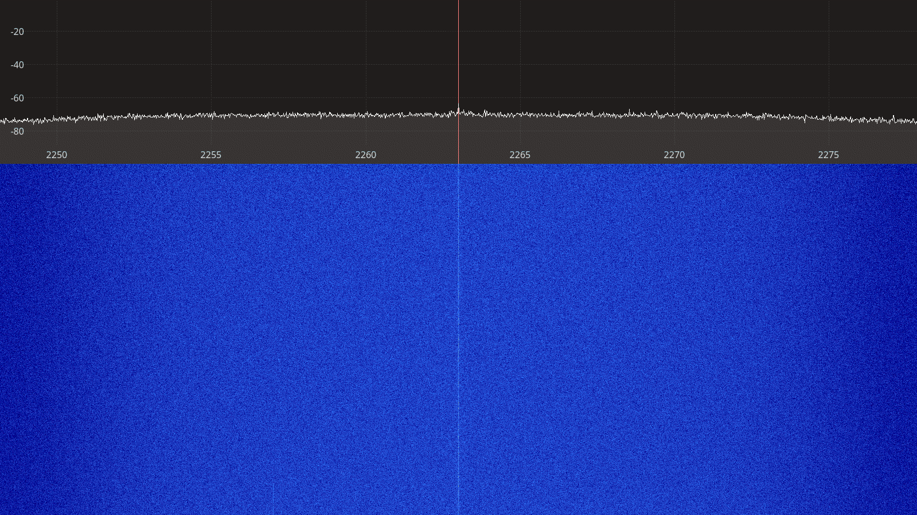Figure 3.117: PlutoSDR receiver spectrum between 2250 – 2275 MHz.

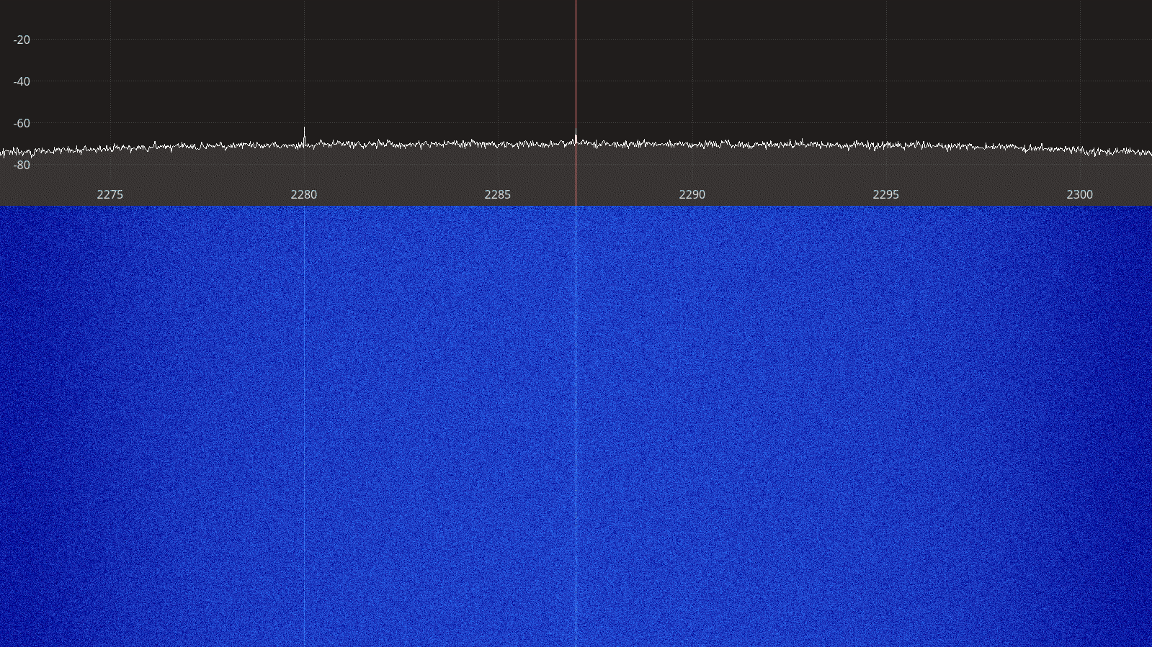Figure 3.118: PlutoSDR receiver spectrum between 2275 – 2300 MHz.
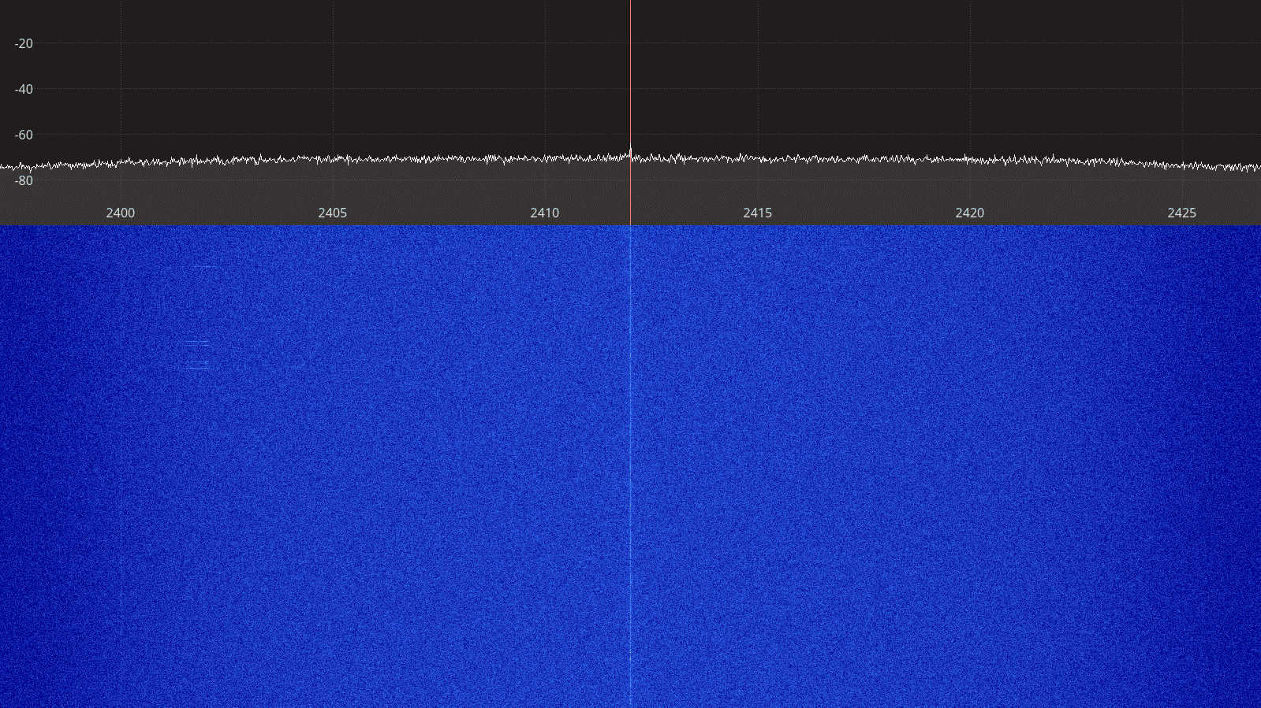Figure 3.119: PlutoSDR receiver spectrum between 2400 – 2425 MHz.

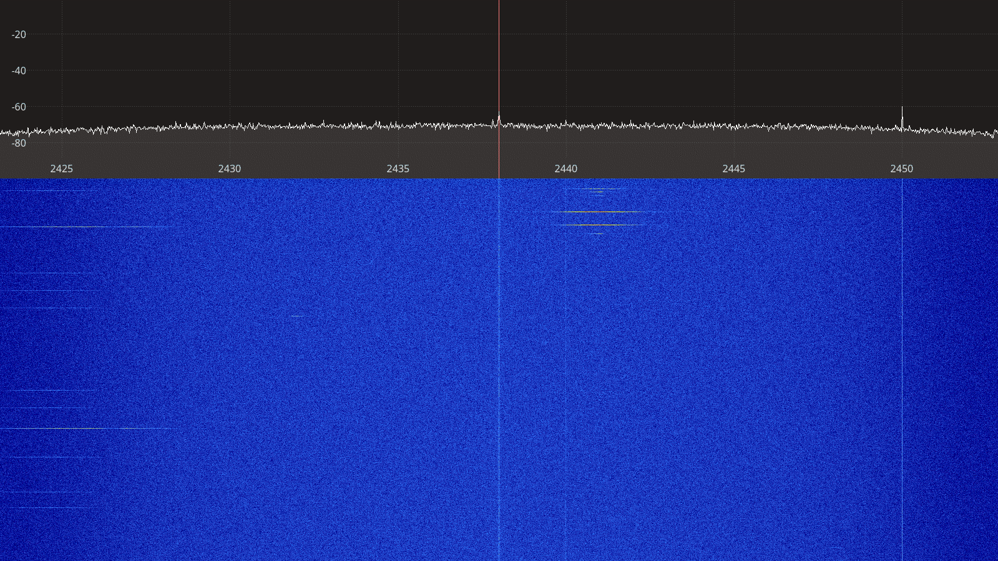Figure 3.120: PlutoSDR receiver spectrum between 2425 – 2450 MHz.
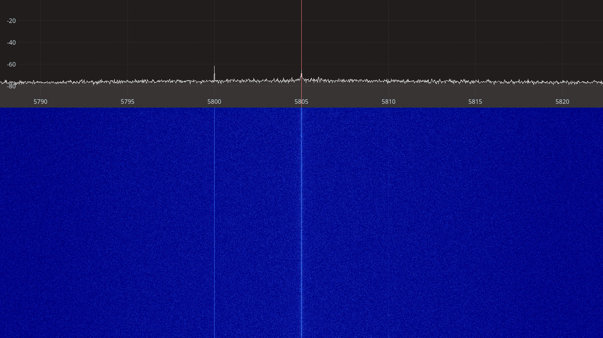Figure 3.121: PlutoSDR receiver spectrum between 5790 – 5820 MHz.

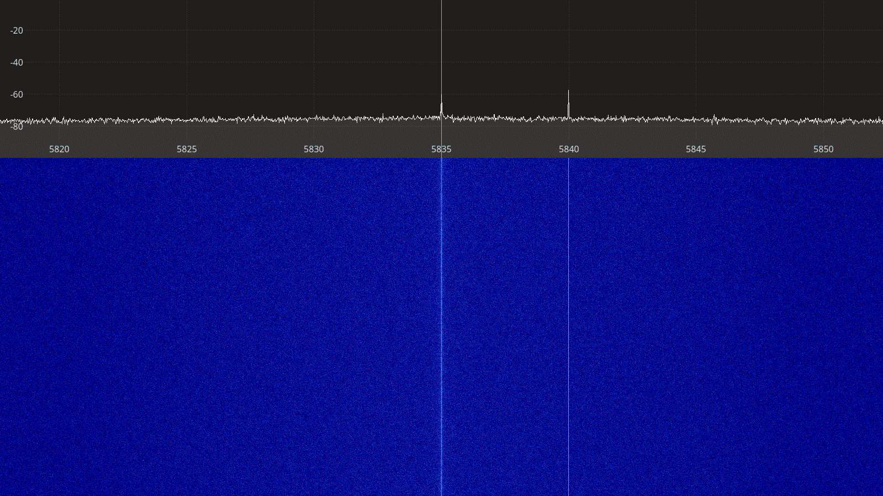Figure 3.122: PlutoSDR receiver spectrum between 5820 – 5850 MHz.

Transmitter Spectral Purity

Transmitter Output Power

Transmitter MER

Device Comparisons

Best Noise Figure

Dynamic Range
Dynamic range at 2 or 3 noise figures.

Transmitter Power

Test Setup Verification
Since our test setups and methods were relatively simple, we carried out the following cross-checks to ensure that our measurements are reliable:
- We used two different methods to measure the noise figure: MDS and Y-factor
- We used two different signal generators and verified that they provide the same output power
- We cross-checked the noise figure measurements at 2.4 GHz in a wifi-quiet area
- We cross-checked the MDS measurements using another SDR software (SDR Radio V3)

Signal Generator Output Power Comparison
We used two different signal generators during the MDS measurement:
- Marconi Instruments 2031 that could support measurements up to 2.7 GHz
- Rohde & Schwartz SMF 100A generator that covered all frequency bands of interest
The measurements were carried out by conneting the output of the signal generator to a Rohde & Schwartz FSP3 specturm analyzer with the following settings:
- Span: 10 kHz
- Resolution bandwidth: 1 kHz
- Video bandwidth: 10 kHz (auto)

The generators were connected to the spectrum analyzer using a 141-24SMNM+ coaxial cable from Mini Circuits with the following insertion losses:

Frequency | Insertion Loss
145.5 MHz | 0.09 dB
437.5 MHz | 0.12 dB
1280 MHz | 0.23 dB
2250 MHz | 0.33 dB
2450 MHz | 0.35 dB
Table 4.1: Coaxial cable insertion loss.

These losses are taken into account in the measurements shown in the tables below. The measurements done at -100 dBm signal power are more uncertain than the others since this power level is rather close to the noise floor of the spectrum analyzer.

Generator setting  (dBm) | Measured Power (dBm) |  | Difference  (dBm)
Generator setting  (dBm) | R&S SMF 100A | Marconi 2031 | Difference  (dBm)
-100 | -100.2 | -100.1 | 0.10
-80 | -80.29 | -80.39 | 0.10
-60 | -60.27 | -60.41 | 0.14
-40 | -40.27 | -40.38 | 0.11
-20 | -20.28 | -20.39 | 0.11
Table 4.2: Signal generator output power comparison at 145.5 MHz.

Generator setting  (dBm) | Measured Power (dBm) |  | Difference  (dBm)
Generator setting  (dBm) | R&S SMF 100A | Marconi 2031 | Difference  (dBm)
-100 | -100.3 | -100.1 | 0.20
-80 | -80.52 | -80.62 | 0.10
-60 | -60.55 | -60.67 | 0.12
-40 | -40.56 | -40.68 | 0.12
-20 | -20.56 | -20.70 | 0.14
Table 4.3: Signal generator output power comparison at 437.5 MHz.

Generator setting  (dBm) | Measured Power (dBm) |  | Difference  (dBm)
Generator setting  (dBm) | R&S SMF 100A | Marconi 2031 | Difference  (dBm)
-100 | -100.5 | -101.2 | 0.70
-80 | -80.83 | -80.93 | 0.10
-60 | -60.83 | -61.04 | 0.21
-40 | -40.82 | -40.97 | 0.15
-20 | -20.82 | -20.97 | 0.15
Table 4.4: Signal generator output power comparison at 1280 MHz.

Generator setting  (dBm) | Measured Power (dBm) |  | Difference  (dBm)
Generator setting  (dBm) | R&S SMF 100A | Marconi 2031 | Difference  (dBm)
-100 | -100.8 | -101.3 | 0.50
-80 | -81.03 | -81.05 | 0.02
-60 | -61.03 | -61.11 | 0.08
-40 | -41.07 | -41.10 | 0.03
-20 | -21.05 | -21.08 | 0.03
Table 4.5: Signal generator output power comparison at 2250 MHz.

Generator setting  (dBm) | Measured Power (dBm) |  | Difference  (dBm)
Generator setting  (dBm) | R&S SMF 100A | Marconi 2031 | Difference  (dBm)
-100 | -100.8 | -101.3 | 0.50
-80 | -81.13 | -81.15 | 0.02
-60 | -61.12 | -61.23 | 0.11
-40 | -41.12 | -41.21 | 0.09
-20 | -21.13 | -21.18 | 0.05
Table 4.6: Signal generator output power comparison at 2425 MHz.

On-Air Tests
Based on the technical specifications and the results obtained from the lab measurements, two SDR devices were selcted for further side-by-side perfomance testing over the air:
- SDRplay RSPduo
- Ettus USRP B210

Test Setup
The two devices were installed in a SatNOGS setup REF at the AMSAT OZ premises. The devices were configured to run as separate SatNOGS ground stations, namely station 1353 (USRP) REF and station 1354 (SDRplay) REF, sharing the same antenna and receiving the same satellite passes. This way the perfomance of the two SDR devices can be compared based on the number of packets received and decoded during the test campaign.
Figure 5.1 shows a diagram of the on-air test setup. After installation, the stations were running for 24 hours during which the device settings were adjusted for best performance. Once the optimal settings were found, the stations were left running unattended for a few days, just like they would run in a regular SatNOGS ground station setup. The final settings that were used during the the on-air tests are listed in Table 5.1 below.

 | Station 1353  USRP B210 | Station 1354  SDRplay RSPduo
SATNOGS_RX_SAMP_RATE | 2 MHz | 2 MHz
SATNOGS_RX_BANDWIDTH | 600 kHz | 600 kHz
SATNOGS_RF_GAIN | 50 | 34
SATNOGS_ANTENNA | RX2 | Tuner 1 50 ohm
Table 5.1: SDR device settings used during the on-air tests.

The ground stations were running the latest SatNOGS client software available at the time of testing:
- satnogs-client git revision d9ff0e8509df12889d25bf4c1d8403c798d3ce04
- gr-satnogs git revision 0ba9e0e601f1fe561ba4d74f349bb45530fa58c7
- gr-soapy git revision a7399c5e7b586c90f971b47280ac92eb64349bc8
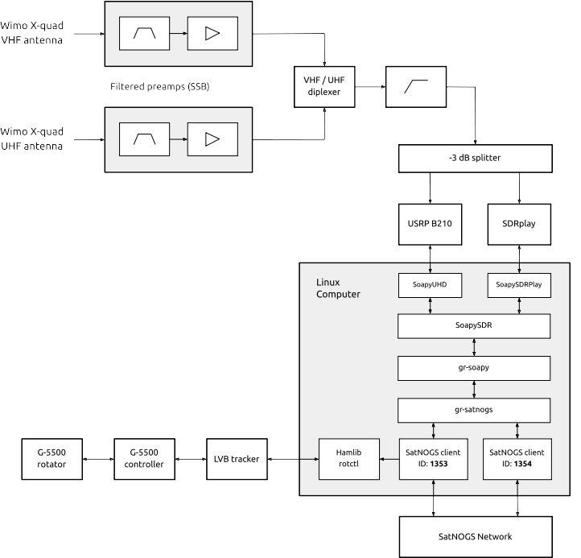Figure 5.1: On-air test setup.

Test Results

Satellite | Frequency  MHz | Modulation | Packets  (USRP B210) | Packets  (SDRplay RSPduo)
OPS-SAT | 437.200 | GMSK 9600 | 1483 | 1537
UNISAT-6 | 437.421 | FSK 9600 | 2180 | 2271
TIGRISAT | 435.001 | FSK 9600 | 1010 | 999
CubeBel-1 | 436.990 | FSK 9600 | 209 | 218
MCUBED-2 | 437.480 | FSK 9600 | 134 | 139
BUGSAT-1 | 437.445 | FSK 9600 | 187 | 191
FOX-1B | 145.960 | DUV 200 | 246 | 220
FOX-1D | 145.880 | DUV 200 | 192 | 181
Total |  |  | 5641 | 5756
Table 5.2: Number of packets decoded during the on-air test campaign.

Software Support

Conclusion

Appendices
Appendix I: Insertion Losses

