**Whispers of the Moon**

**<html></html> \\\**

**Ççççççç**

**In the quiet night, $*ù the moon unveils,**

**A silver orb, a tale it tells.**

**It whispers softly to the sea,**

**A ( cosmic dance, a mystery.**

**ààààààààààààààààààààààààààààààààààààààààààààààààààààààà**

**Stars adorn the velvet sky,**

**In constellations, dreams do fly.**

**<n><n> é((-&é Night's embrace, a soothing balm,**

**A lullaby, a tranquil psalm. \\\\\\\\\**

**Mystic += * shadows, secrets keep, ----------------------------------------**

**As the world below does sleep.**

**&&&&&===++$*ù**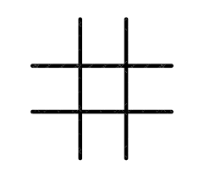

**Nature's canvas, a masterpiece,**



**In the realm where dreams find peace.**