1. On click on read more button or post title post will been opened all post
2. Сlicking on this button will return you to the first page 
3. Selection of the number of displayed posts on the page 
4. Buttons to go to registration or login forms 
5. To add news – sign in or sign up
6. Button to go to add news form 
7. Button to logout 
8. To create a post, enter a title, text, select a photo and click the button Add news. Add news form - 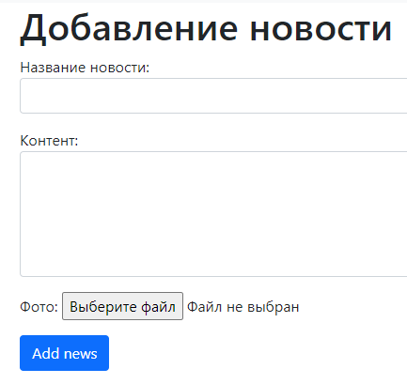
9. To sign in enter a username and password and click the button Sign in. Sign in form - 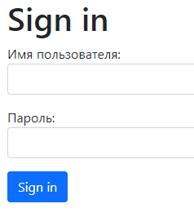
10. To sign up enter a username, email, password and repeat password and click the Sign up button. Sign up form - 