User interface

When the program runs, the first that is appeared is the suggestion to type help for detailed instructions.

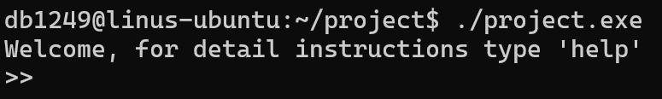

Here is what the “help” command does:

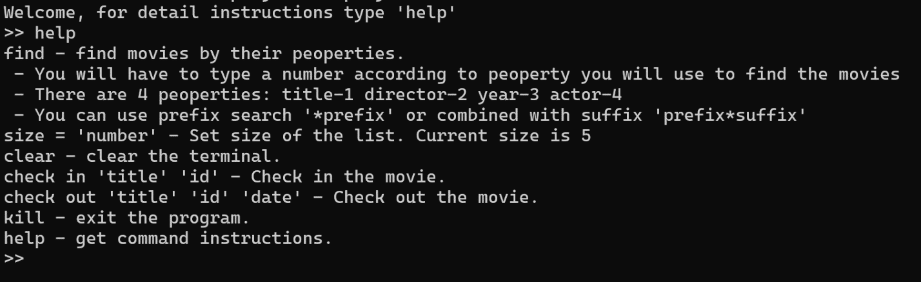

The “find” command allows searching for the movies. You choose the category, type the whole searched word, or use prefix/suffix. (it is case-sensitive).

The "check out" sets the "out" status for the movie. You have to write the title, index, and date. It checks if the index is free. Movies with the same title have a unique index, but it is possible to have the same one for different titles.

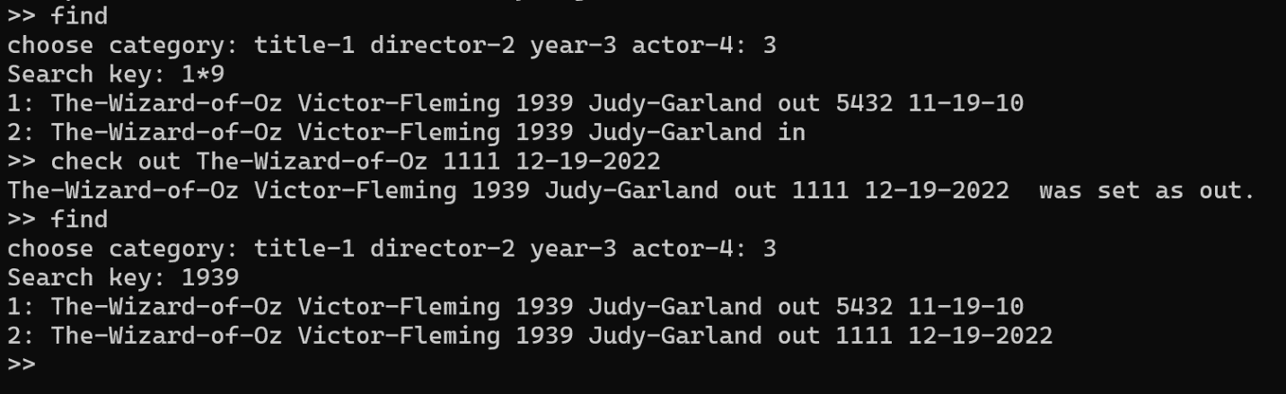

The "check in" on other hand, sets the "in" status. You have to specify the title and index of the movie.

As we know the list can be long for the display, but there is a way to control the amount of content shown on screen. You can set the "size" variable to get the proper list length. Here is an example with a "size" equal to 5.

Here is how to change the "size" to another value.

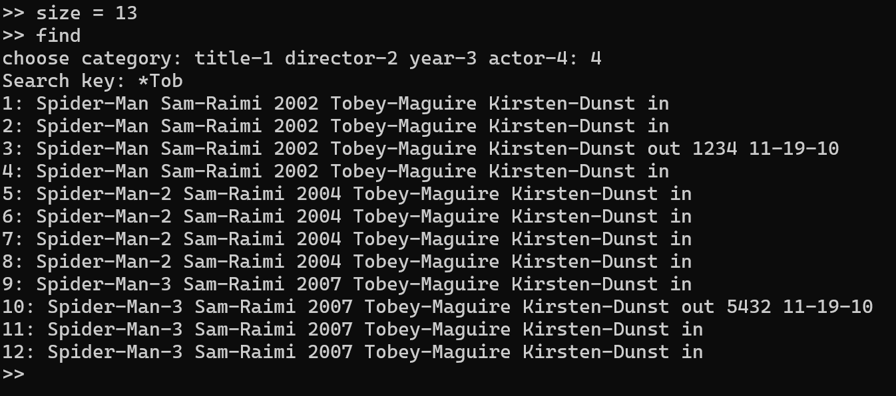

General diagram

