Министерство цифрового развития, связи и массовых коммуникаций

Российской Федерации

Ордена Трудового Красного Знамени федеральное государственное бюджетное образовательное учреждение высшего образования

«Московский Технический Университет Связи и Информатики»

Лабораторная работа №7

По дисциплине

Введение в ИТ

**На тему: “UI-бот”**

Выполнил: Белов Д.Б БИН2003

Москва 2021

Цель работы: познакомиться с созданием UI-бота

Исходный код

import psycopg2

import sys

from datetime import date

from PyQt5.QtWidgets import (QApplication, QWidget,

                             QTabWidget, QAbstractScrollArea,

                             QVBoxLayout, QHBoxLayout,

                             QTableWidget, QGroupBox,

                         QTableWidgetItem, QPushButton, QMessageBox)

from config import DATABASE, USER, PASSWORD

time = ['9:30', '11:20', '13:10', '15:25', '17:15', '19:00', '20:40', '22:10']

days = ['monday', 'tuesday', 'wednesday', 'thursday', 'friday', 'saturday']

class MainWindow(QWidget):

    def __init__(self):

        super(MainWindow, self).__init__()

        self.week_type = 'чет' if get_week_num() % 2 == 0 else 'неч'

        self._connect_to_db()

        self.setWindowTitle("Schedule")

        self.vbox = QVBoxLayout(self)

        self.tabs = QTabWidget(self)

        self.vbox.addWidget(self.tabs)

        self._create_shedule_tab()

        self._create_teachers_tab()

    def _connect_to_db(self):

        self.conn = psycopg2.connect(database=DATABASE,

                                        user=USER,

                                        password=PASSWORD,

                                        host="localhost",

                                        port="5432")

        self.cursor = self.conn.cursor()

        self.timetable_table_name = 'qtimetable'

        self.teachers_table_name = 'teachers'

        self.teachers_names, self.teachers_places = self._fetch_teachers()

        # self.teachers_names = []

        self.class_names = self._fetch_classes()

    def _fetch_teachers(self):

        select_teachers = f"SELECT id, name FROM {self.teachers_table_name}"

        self.cursor.execute(select_teachers)

        names = dict(self.cursor.fetchall())

        select_teachers = f"SELECT id, place FROM {self.teachers_table_name}"

        self.cursor.execute(select_teachers)

        places = dict(self.cursor.fetchall())

        return [names, places]

    def _fetch_classes(self):

        select_classes = f"SELECT * FROM {self.timetable_table_name}"

        self.cursor.execute(select_classes)

        return [class_name[1] for class_name in (self.cursor.fetchall())]

    def _create_teachers_table(self, gbox):

        table = QTableWidget()

        table.setSizeAdjustPolicy(QAbstractScrollArea.AdjustToContents)

        table.setColumnCount(5)

        table.setHorizontalHeaderLabels(["ID", "Name", "Place", "Update", "Delete"])

        table.setRowCount(len(self.teachers_names) + 1)

        for i in range(len(self.teachers_names)):

            joinButton = QPushButton("Update")

            joinButton.clicked.connect(lambda ch, tbl=table, id=(i + 1):self._change_teacher_from_table(tbl, id))

            deleteButton = QPushButton("Delete")

            deleteButton.clicked.connect(lambda ch, t_id=(i + 1):self._delete_teacher(t_id))

            table.setItem(i, 0, QTableWidgetItem(str(i + 1)))

            try:

                table.setItem(i, 1, QTableWidgetItem(str(self.teachers_names[i + 1])))

                table.setItem(i, 2, QTableWidgetItem(str(self.teachers_places[i + 1])))

            except KeyError:

                table.setItem(i, 1, QTableWidgetItem())

                table.setItem(i, 2, QTableWidgetItem())

            table.setCellWidget(i, 3, joinButton)

            table.setCellWidget(i, 4, deleteButton)

        joinButton = QPushButton("Update")

        joinButton.clicked.connect(lambda ch, tbl=table:self._insert_teacher(tbl.item(i + 1, 1).text(), tbl.item(i + 1, 2).text()))

        table.setItem(i + 1, 0, QTableWidgetItem(''))

        table.setItem(i + 1, 1, QTableWidgetItem(''))

        table.setItem(i + 1, 2, QTableWidgetItem(''))

        table.setCellWidget(i + 1, 3, joinButton)

        table.resizeRowsToContents()

        mvbox = QVBoxLayout()

        mvbox.addWidget(table)

        gbox.setLayout(mvbox)

    def _create_teachers_tab(self):

        self.teachers_tab = QWidget()

        self.tabs.addTab(self.teachers_tab, "Teachers")

        gbox = QGroupBox('Teachers')

        svbox = QVBoxLayout()

        shboxes = [QHBoxLayout() for _ in range(2)]

        [svbox.addLayout(shbox) for shbox in shboxes]

        shboxes[0].addWidget(gbox)

        self._create_teachers_table(gbox)

        self.teachers_tab.setLayout(svbox)

        update_shedule_button = QPushButton("Update")

        shboxes[1].addWidget(update_shedule_button)

        update_shedule_button.clicked.connect(lambda : self._update_shedule())

        self.teachers_tab.setLayout(svbox)

    def _create_table(self, table, gbox, weekday):

        table = QTableWidget()

        table.setSizeAdjustPolicy(QAbstractScrollArea.AdjustToContents)

        table.setColumnCount(6)

        table.setHorizontalHeaderLabels(["Subject", "Time", "Teacher", "Where", "Add", "Delete"])

        self._update_table(table, weekday)

        mvbox = QVBoxLayout()

        mvbox.addWidget(table)

        gbox.setLayout(mvbox)

    def _create_shedule_tab(self):

        self.shedule_tab = QWidget()

        self.tabs.addTab(self.shedule_tab, "Schedule")

        self.gboxes = [QGroupBox(day) for day in days]

        self.svbox = QVBoxLayout()

        self.shboxes = [QHBoxLayout() for _ in range(2)]

        [self.svbox.addLayout(shbox) for shbox in self.shboxes]

        [self.shboxes[0].addWidget(day_box) for day_box in self.gboxes]

        self.tables = [QTableWidget() for _ in range(6)]

        for i, table in enumerate(self.tables):

            self._create_table(table, self.gboxes[i], i)

        self.update_shedule_button = QPushButton("Update")

        self.shboxes[1].addWidget(self.update_shedule_button)

        self.update_shedule_button.clicked.connect(lambda : self._update_shedule())

        self.shedule_tab.setLayout(self.svbox)

    def _update_table(self, table, weekday):

        global time

        what_we_need = f"WHERE weekday = {weekday} AND week = '{self.week_type}';"

        select_day = f"SELECT * FROM {self.timetable_table_name} {what_we_need}"

        self.cursor.execute(select_day)

        records = sorted(list(self.cursor.fetchall()), key=lambda elem: elem[4])

        table.setRowCount(len(records) + 1)

        empty = ['None', 'удалена', '', 'тут могла быть ваша пара']

        for i, r in enumerate(records):

            if str(r[1]) not in empty:

                joinButton = QPushButton("Join")

                deleteButton = QPushButton("Delete")

                joinButton.clicked.connect(lambda ch, wd=weekday, tbl=table, class_num=i:self._change_day_from_table(tbl, wd, class_num))

                deleteButton.clicked.connect(lambda ch, tbl=table, wd=weekday, num = r[4]:self._delete_class(wd, num))

                table.setItem(i, 0, QTableWidgetItem(str(r[1])))

                table.setItem(i, 1, QTableWidgetItem(str(time[i])))

                try:

                    table.setItem(i, 2, QTableWidgetItem(str(self.teachers_names[r[5]])))

                    table.setItem(i, 3, QTableWidgetItem(str(self.teachers_places[r[5]])))

                except KeyError:

                    table.setItem(i, 2, QTableWidgetItem(str(self.teachers_names[10])))

                    table.setItem(i, 3, QTableWidgetItem((self.teachers_places[10])))

                table.setCellWidget(i, 4, joinButton)

                table.setCellWidget(i, 5, deleteButton)

            else:

                table.setItem(i, 0, QTableWidgetItem(''))

                table.setItem(i, 1, QTableWidgetItem(str(time[i])))

                insert_button = QPushButton("Insert")

                insert_button.clicked.connect(lambda ch, tbl=table, wd=weekday, num=i:self._change_day_from_table(tbl, wd, num))

                table.setCellWidget(i, 4, insert_button)

        insert_button = QPushButton("Insert")

        insert_button.clicked.connect(lambda ch, tbl=table:self._insert_class(tbl.item(i + 1, 0).text(), weekday, i + 1, tbl.item(i + 1, 0).text()))

        table.setItem(i + 1, 0, QTableWidgetItem(''))

        table.setItem(i + 1, 1, QTableWidgetItem(str(time[i + 1])))

        table.setCellWidget(i + 1, 4, insert_button)

        table.resizeRowsToContents()

    def _change_day_from_table(self, table, weekday, class_num):

        try:

            text = table.item(class_num, 0).text()

            try:

                pr_id = int(table.item(class_num, 2).text())

                if pr_id > len(self.teachers_names):

                    return QMessageBox.about(self, "Error", "Такого id не существует")

            except:

               return QMessageBox.about(self, "Error", "Введите ID цифрами")

            update_day = f"UPDATE {self.timetable_table_name} SET class_name = %s, pr_id = %s WHERE weekday = %s AND class_num = %s AND week = '{self.week_type}'"

            self.cursor.execute(update_day, (text, pr_id, weekday, class_num))

            self.conn.commit()

        except:

            QMessageBox.about(self, "Error", "sql error")

    def _change_teacher_from_table(self, table, id):

        try:

            update_teacher = f"UPDATE {self.teachers_table_name} SET name = %s WHERE id = %s"

            self.cursor.execute(update_teacher, (str(table.item(id - 1, 1).text()), str(id), ))

            update_teacher = f"UPDATE {self.teachers_table_name} SET place = %s WHERE id = %s"

            self.cursor.execute(update_teacher, (str(table.item(id - 1, 2).text()), str(id), ))

            self.conn.commit()

        except:

            QMessageBox.about(self, "Error", "Enter all fields")

    def _insert_class(self, class_name, weekday, class_num, pr_id):

        try:

            insert_data = f"""

            INSERT INTO {self.timetable_table_name} (class_name, week, weekday, class_num, pr_id)

            VALUES (%s, %s, %s, %s, %s);

            """

            self.cursor.execute(insert_data, (class_name, self.week_type, str(weekday), str(class_num), str(pr_id), ))

            self.conn.commit()

            self._update_shedule()

        except:

            QMessageBox.about(self, "Error", "Ошибка")

    def _insert_teacher(self, name, place):

        insert_data = f"""

        INSERT INTO {self.teachers_table_name} (name, place)

        VALUES (%s, %s);

        """

        self.cursor.execute(insert_data, (name, place, ))

        self.conn.commit()

        self._update_shedule()

    def _delete_class(self, weekday, class_num):

        update_day = f"UPDATE {self.timetable_table_name} SET class_name = %s WHERE weekday = %s AND class_num = %s AND week = '{self.week_type}'"

        self.cursor.execute(update_day, ('', weekday, class_num))

        self.conn.commit()

        self._update_shedule()

    def _delete_teacher(self, teacher_id):

        delete_day = f"DELETE FROM {self.teachers_table_name} WHERE id = %s;"

        self.cursor.execute(delete_day, (str(teacher_id), ))

        self.conn.commit()

        self._update_shedule()

    def _update_shedule(self):

        self.teachers_names, self.teachers_places = self._fetch_teachers()

        self.class_names = self._fetch_classes()

        self.tabs.removeTab(1)

        self.tabs.removeTab(0)

        self._create_shedule_tab()

        self._create_teachers_tab()

def get_week_num():

    first_day = date(2021, 8, 30)

    today = date.today()

    delta = (today - first_day).days

    week_number = (delta // 7) + 1

    return week_number

app = QApplication(sys.argv)

win = MainWindow()

win.show()

sys.exit(app.exec_())

Результат:

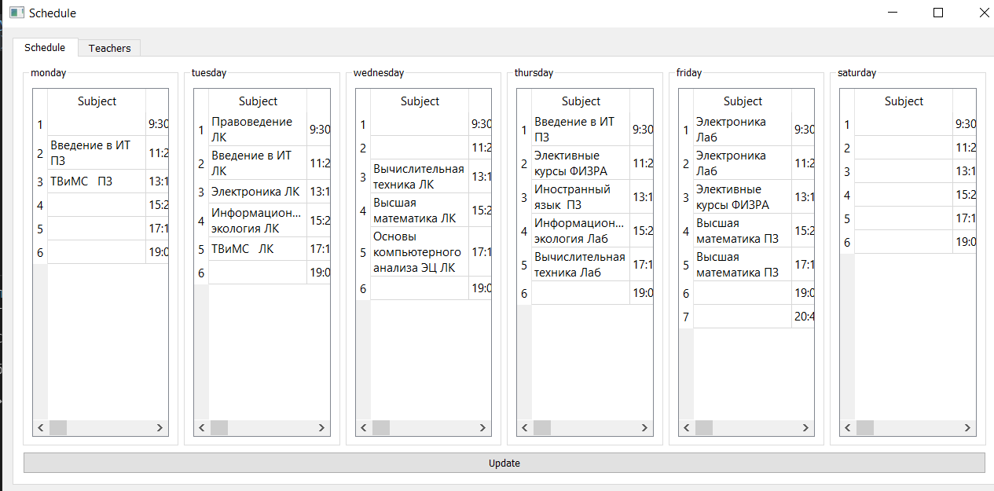

Вывод: познакомился с созданием UI-бота