Project 2

ISCG6420 Internet & Website

Development

Documentation

October 2017



Authors:

Denis Eltcov ID 1481961

Roman Belovolov ID 1484314

Table of Contents

XML Schema Definition 3

Booking system design 4

Test Cases for the Cinema Booking 5

Storyboard for the Canvas Game 6

Test Cases for the Canvas Game 7

# **XML Schema Definition**

The following is the XML **Schema Definition** for booking system (Task 1):

<?xml version="1.0" encoding="UTF-8"?>

<xs:schema xmlns:xs="http://www.w3.org/2001/XMLSchema">

<xs:element name="cinema">

<xs:complexType>

<xs:sequence>

<xs:element name="florence">

<xs:complexType>

<xs:sequence>

<xs:element name="row" maxOccurs="unbounded" type="rowType"/>

</xs:sequence>

</xs:complexType>

</xs:element>

<xs:element name="ronald">

<xs:complexType>

<xs:sequence>

<xs:element name="row" maxOccurs="unbounded" type="rowType"/>

</xs:sequence>

</xs:complexType>

</xs:element>

</xs:sequence>

</xs:complexType>

</xs:element>

<xs:complexType name="rowType">

<xs:sequence>

<xs:element name="cost">

<xs:simpleType>

<xs:restriction base="xs:decimal">

<xs:minInclusive value="0"/>

</xs:restriction>

</xs:simpleType>

</xs:element>

<xs:element name="seat" maxOccurs="unbounded">

<xs:simpleType>

<xs:restriction base="xs:string">

<xs:enumeration value="Vacant"/>

<xs:enumeration value="Empty"/>

<xs:enumeration value="Booked"/>

</xs:restriction>

</xs:simpleType>

</xs:element>

</xs:sequence>

</xs:complexType>

</xs:schema>

# **Booking system design**

The initial sketch of the design for booking system is represented on Figure 1. Circles represent seats.

*Figure 1 – Initial sketch of booking*

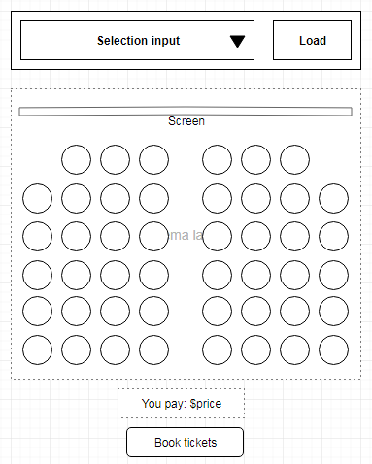

The design also assumed such visual techniques like hover effect for seats, click effect for buttons and tooltips. Figure 2 roughly shows the colour scheme and the workflow of booking system:

*Figure 2 – Colour scheme and workflow*

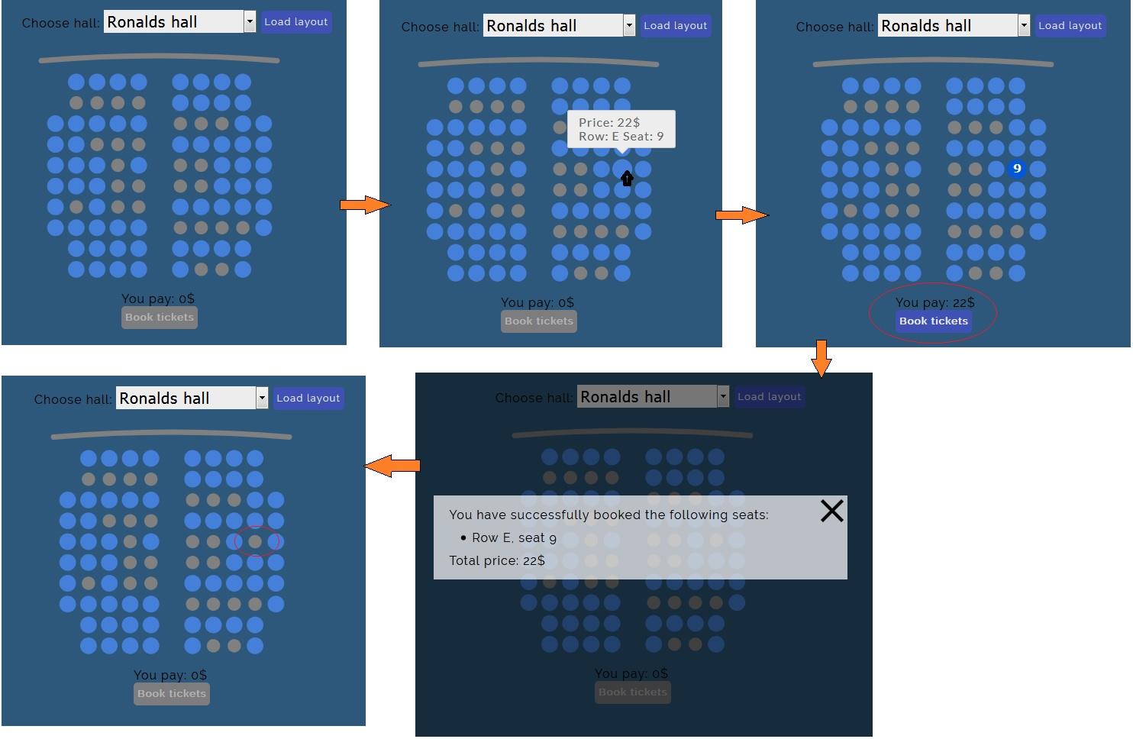

# **Test Cases for the Cinema Booking**

|  |  |  |  |
| --- | --- | --- | --- |
| **Requirement to test** | **Test Data Input** | **Expected Outcomes** | **Actual Outcomes** |
| Display desired room, requested by user. | Select “Florence hall” and click ‘Load layout’ | Florence hall layout appears on the screen | As expected |
| Select “Ronald hall” and click ‘Load layout’ | Ronald hall layout appears on the screen | As expected |
| Booked seats cannot be taken | Select “Florence Hall”. Hover over the third circle from the right side in the first row indicated by grey colour.  Then click on the circle | Tooltip says “BOOKED’  No reaction after click | As expected |
| Price for seats in first two rows is $20 | Select “Florence Hall”. Hover over the leftmost circle in the first row.  Then click on the circle | Tooltip says: “Price: 20$ Row: A Seat: 1”  Click results to seat style change and price being added to total price. | As expected |
| Price for seats in rows from 3rd to 5th is $22 | Select “Florence Hall”. Hover over the leftmost circle in the third row.  Then click on the circle | Tooltip says: “Price: 22$ Row: C Seat: 1”  Click results to seat style change and price being added to total price. | As expected |
| Price for seats in rows from 6th to the last one is $25 | Select “Florence Hall”. Hover over the leftmost circle in the last row.  Then click on the circle | Tooltip says: “Price: 25$ Row: H Seat: 1”  Click results to seat style change and price being added to total price. | As expected |
| Program calculates price for the booked seats. | Select “Florence Hall”. Click on the rightmost circle in the third row  Click on the rightmost circle in the last row. | The text “You pay: 45$” appears in the bottom | As expected |
| Program should indicate that recently booked seats are not available any more | Select “Florence Hall”. Hover over the leftmost circle in the first row.  Then click on the circle.  Then click the button “Book tickets” in the bottom. | Modal window with message “You have successfully booked the following seats:   * Row A, seat 1   Total price: 20$” | As expected |

# **Storyboard for the Canvas Game**

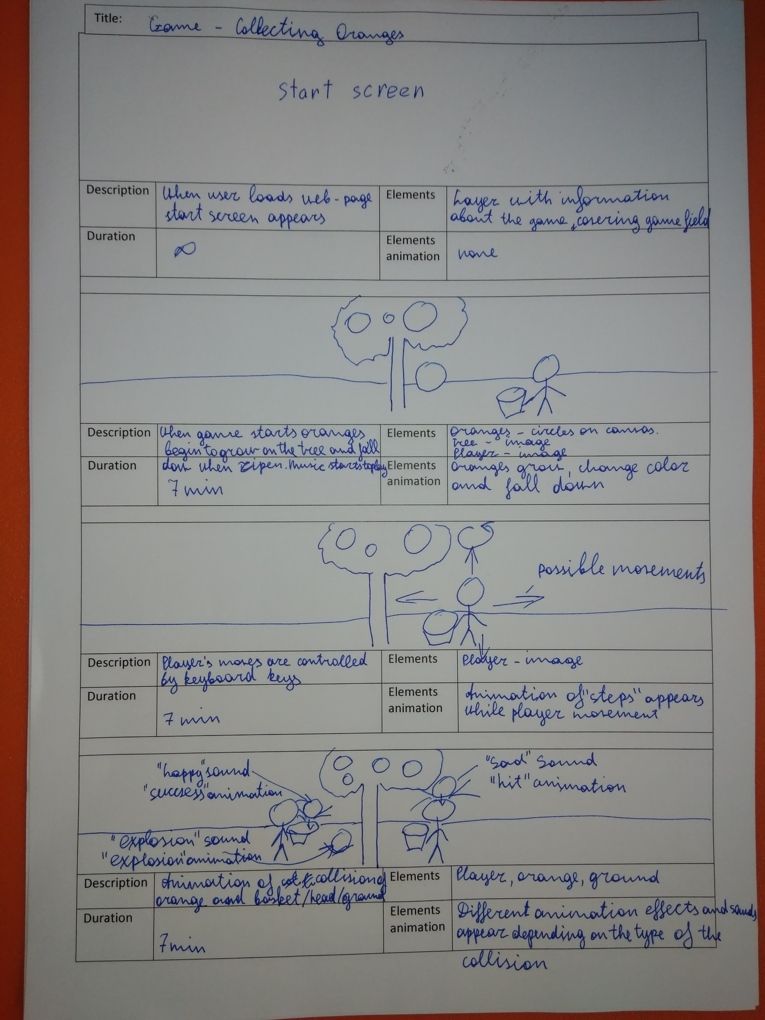

# **Test Cases for the Canvas Game**

|  |  |  |  |
| --- | --- | --- | --- |
| **Requirement to test** | **Test Data Input** | **Expected Outcomes** | **Actual Outcomes** |
| Overall design and complexity of scenery (background) and overall design and complexity of play character - Mr X | Making game run by mouse left-click in the game field. | Background represented by “sky”, “ground” and “tree” appears. Player represented by “wolf” appears | As expected |
| Use 4 keyboard arrow keys (up, down, left, right) for user interaction | Trying to move player by pressing arrow keys | Player moves after pressing the arrow keys and by pressing WASD keys as well. Player turns off after space key pressing. | As expected |
| The play’s character - Mr X animation (turnoff basket, eye movements) | Trying to move player by pressing arrow and space keys | Sprite of player has animation for movement. After pressing space key whole player’s sprite with basket turns off. | As expected |
| Growing oranges animation (changing size animation) Changing oranges’ colours (radiant) animation, Oranges move down animation | Making game run by mouse left-click in the game field. | Growing oranges animation, changing oranges’ colours animation, oranges move down animation appear over time | As expected |
| Collision detection. Sound in the game collision beep – “happy sound” and “unhappy sound”. Scores displayed correctly. | Trying to collect oranges by moving player on the game field. | After collision of an orange and player’s head “unhappy sound” is played, score is reduced by 1, animation of “bad” collision appeared. After collision of an orange and basket “happy sound” is played, score is increased by 1, animation of “good” collision appeared. After collision of an orange and “earth” “explosion sound” is played, animation of explosion appears. | As expected |
| The game should have time restriction of 7 minutes | Making game run by mouse left-click in the game field and waiting for 7 minutes. | Game stopped, final score and start screen appeared | As expected |
| Other Sounds at the beginning of the game and at the end of the game.  User can control volume | Making game run by mouse left-click in the game field and waiting for 7 minutes. Controlling volume by slider in left-bottom corner. | After the beginning music started to play and was playing during all game session. In the end of the game music stopped and “end” sound was played. Volume changed when we were trying to move slider. | As expected |