Network robustness assessment via edge criticality evaluation: improvement of bridgness and topological overlap methods by the iterative metrics re-estimation
Hamza Ejjbiri¹ and Vasily Lubashevskiy²[0000-0002-2399-5050]
¹ Tokyo International University, 4-42-31 Higashi-Ikebukuro, Toshima City, Tokyo, Japan. ejjbirihamza@gmail.com
² Tokyo International University, 4-42-31 Higashi-Ikebukuro, Toshima City, Tokyo, Japan. vlubashe@tiu.ac.jp
Abstract.
Detection of significant edges maintaining the connectivity in complex networks is essential in many applications such as attack vulnerability analysis, the spread of epidemic diseases, and information spreading patterns discovery. There are many existing methods enabling us to evaluate the criticality ranking of links in networks, which are based on straightforward algorithms and topological features of analyzed graphs. In this paper, we propose an improvement of well-known algorithms for the edge criticality ranking in complex networks, bridgeness, and topological overlap. The two resulting methods, iterative bridgeness and iterative topological overlap, are both funded on the principle of iterative metrics re-estimation. To compare methods, we conducted a numerical simulation and decomposition of three real-world benchmark networks. The resulting algorithms are compared with the original methods and demonstrated an increase of efficiency of up to 40% for the iterative bridgeness and up to 11% for the iterative topological overlap.
Keywords: Network Robustness, Edge Criticality, Topological Overlap, Bridgeness.
- Introduction
The advent and evolution of complex networks have marked a crucial step forward in our understanding of various natural and social systems. Whether it’s the biological networks [1] that drive life processes within organisms, the social networks [2] that shape human interactions and the dissemination of ideas, or the technological networks [3] that support our critical infrastructures and information exchanges, network science provides an essential lens through which we can understand the dynamics that govern these complex systems. As our dependence on these networks increases, whether for the maintenance of social, economic, or ecological functions, the need to understand their functioning [4], robustness, and vulnerability [5] to internal or external disruption becomes a compelling priority.

Network science, as a multidisciplinary field, covers a wide range of theories, models, and analytical approaches designed to unlock the structure and dynamics of networks. By examining networks from a variety of perspectives – be it the topology of their structure, the strength and meaning of their links, or their behavior in the face of change [6] researchers can identify patterns and principles that transcend the specificities of each system. This holistic approach is crucial for developing strategies to improve the resilience and efficiency of networks [7], with the aim of building more robust and adaptative systems capable of withstanding and recovering from challenges and crises of the modern world.

To understand the significance of links within networks, several metrics have been explored in the scientific literature [8], including Edge betweenness centrality[9], degree product [10], diffusion importance [11], bridgeness [12, 13], topological overlap [14] and k-path centrality [15]. These methods offer diverse perspectives on the importance of edges within networks, ranging from their role in information communication to their contribution to community structure. Our study, while recognizing the value of these metrics, focuses specifically on two of them: “Bridgeness” and “Topological Overlap,” which represent typical methods focusing on the topology of networks. By focusing on these aspects, we aim to unveil the underlying mechanisms that contribute to the stability and flexibility of networks, thus offering new insights into how to manage these complex systems to optimize their resilience.

At the heart of the networks that structure our interactions and exchanges are linked “ edges” whose value stretches beyond their mere connection. Among them, the notion of “Bridgeness” emerges as a measure of their ability to unite different sections of a network. These links serve as crucial channels that not only facilitate the flow of information but also ensure continuity in communication, even in the event of disruptions. Bridgeness is based on the idea that an edge that effectively connects cliques of fully interconnected nodes is vital to the integrity of the network. When an edge has a high level of “Bridgeness,” it often indicates a strategic point whose reinforcement or preservation can considerably increase the overall robustness of the network[12].

In addition, the concept of “Topological Overlap” represents a metric that helps us understand how links between nodes in a network are resilient in the face of disturbances. Based on the number of neighbors shared between two nodes, this metric gives an idea of the multiplicity of possible communication paths. The higher the value, the more likely it is that the network will continue to function efficiently, even if certain links disappear. This notion is fundamental in assessing the reliability of a network and its aptitude to maintain itself despite any issues that may arise[14].

This research builds on these two concepts to reveal the key structural elements that contribute to network stability. By examining how “Bridgeness” and “Topological Overlap“ influence the cohesion and flexibility of networks, we can better understand how these systems adapt and evolve in response to change. By adopting a rigorous analytical approach inspired by advanced methodologies such as “Deep Link Entropy” [16] and “Improved Link Entropy” [17], which uses the principle of iteration to re-evaluate metrics after each edge removal, our study aims to offer a dynamic perspective on how networks respond to disturbances.
In addition to this iterative perspective, applied to the concept of “Bridgeness” and “ Topological Overlap”, we impliment $R_{gc}$ “the largest component” [20] measurement to assess the impact of selective edge removal on network stability. This allow us to target links vital for connectivity and to evaluate the effectiveness of our methods. $R_{gc}$ reduction guides us in understanding network robustness and improving our strategies for enhancing system resilience in the face of change and disruption.

This paper is structured to progressively illustrate our approach; after explaining our pioneering method, we present its application on a variety of reference networks, such as the Dolphins [18], Football [9], and Jazz [19] networks. Details of the method used to test the effectiveness of our approach will be given, followed by the presentation of experimental results, which reveal a substantial improvement in the approach. The final discussion will place our findings in a wider context and conclude with the implications and prospects of our work.

This research enriches the field of network science by providing valuable insights into the mechanisms underlying the robustness and adaptability of networks. By identifying the key elements that contribute to network stability and exploring ways in which they can be optimized, our work paves the way for significant advances in network design and management, offering innovative solutions to enhance their sustainability and face the challenges of the modern world.
- Methods
  - Bridgeness

Bridgeness is an index that quantifies the central role an edge plays in maintaining the connectivity of a network. This index is particulary relevant in contexts where the assessment of links strength is limited by the lack of access to personal or historical data, as is often the case in social networks.

The structure of a network is often characterized by cliques, groups of interconnected nodes forming a complete sub-graph. A clique is determined by its number of nodes (k), and an edge is considered all the more central as it connects larger cliques. This, an edge that links two distinct cliques performs an essential function as a bridge between thes two substructures, facilitating interactions within the network.

To explain this mathematically, the “Bridgeness” $B_{e}$ of an edge e is calculated using the following formula :
$$B_{e}= \frac{\sqrt{S_{x}S_{y}}}{S_{e}}$$
Where $S_{x}$ represents the size of the largest clique, including node x at one end of the edge, excluding cliques that include node y at the other end, and $S_{y}$ is similarly defined for node y, excluding those containing x, and $S_{e}$ is the size of the largest clique to which the edge itself belongs.

To illustrate this concept, let’s take this example: assume an edge connects a six-member clique to a three-member clique, and the same edge belongs to a clique of length 2. Applying the “Bridgeness” Formula, we would obtain the following :
$$B_{e}= \frac{\sqrt{6*3}}{2}$$
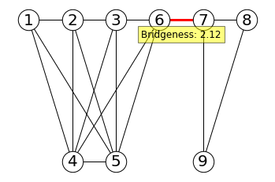
Fig. 1 An example for Calculating Bridgeness
This calculation shown above in Figure 1 would indicate that the edge in point has a “Bridgeness” of 2.12, underlining its role as a major axis of passage between the two sets of nodes, which has a direct impact on the structure of the network and its ability to maintain connectivity between its different segments. Edges with significant “Bridgeness” are strategic: their removal would result in significant network fragmentation, demonstrating their importance in the stability and robustness of the overall system.

  - Topological Overlap

Topological Overlap is a relevant index used to measure the similarity between the social environments of two nodes within a network. It is used to quantify, in topological terms, the proximity of relationships based on the number of shared friends. This index, first introduced to analyze the strength of links in mobile telecommunications networks, is proving to be a reflection of the strength of social links.

Formally, the topological overlap between two nodes i and j, denoted $O_{ij}$, is given by the following formula :
$$O_{ij}= \frac{n_{ij}}{(\left(k_{i}-1\right)+\left(k_{j}-1\right)-n_{ij})}$$
Where $n_{ij}$ is the number of common neighbors between node i and j, and $k_{i}$ and $k_{j}$ represent the respective degrees of nodes i and j, meaning the number of connections they possess. This measure is based on the probability that neighbors at both ends of an edge are identical, thus reflecting repetitive local structures within the network, whether at the core or the margin.

Where there are no common neighbors between two nodes, the topological overlap is zero, indicating that the edge between them could represent a bridge between two distinct communities. Conversely, a topological overlap of one means that all friends of i are also friends of j, implying a very strong connection, usually within the same clique or community.

Therefore, the topological overlap is a measure based on the probability that the neighbors of two connected nodes are interrelated, which can provide information about the local structures of the network regardless of its overall shape.

  - Iterative Approach
In order to analyze the robustness of networks by applying “ Bridgeness” and “Topological Overlap,” we adopt a systematic process that progressively alters the structure of the network. This procedure begins with the calculation of these metrics for all edges, followed by the identification and removal of the most important edge according to the specified metric. With each removal, the size of the largest connected component $R_{gc}$ is recalculated to reflect the new topological conditions.

The effectiveness of this iterative process is evaluated by comparing the size of $R_{gc}$ relative to the proportional number of edges removed. A more pronounced decrease in $R_{gc}$ suggest more impactful edge removal, and therefore a more efficient quantification method. Furthermore, for more accurate numerical comparisons, the area under the curve representing this decrease in $R_{gc}$ is calculated, providing a performance metric where a smaller area indicates a more effective method.

To ensure consistent evaluation across different networks, two normalizations are commonly applied: the $R_{gc}$ is scaled relative to the number of nodes, and the number of removed edges is normalized relative to the total number of edges in the original network. This approach provides a clear visual and quantitative means of comparing the effectiveness of methods in terms of overall connectivity across the network.

The use of $R_{gc}$ as a criterion owes its success to its clarity: the faster the value of $R_{gc}$ decreases with increasing of ρ -the percentage of the edges removed relative to the total number of edges in the network- the more significant the edges removed are considered to be. This criterion makes it possible to rank methods clearly according to their efficiency with a curve $R_{gc:1}$(ρ) less than $R_{gc:2}$(ρ) for any ρ>0, meaning that the former method is more efficient than the latter. This methodical approach focuses on the general characteristics of the network topology rather than the details of the network structure at the microscopic level.
- Data And Numerical Experiments
To examine how the introduction of an iterative approach improves the effectiveness of “Bridgeness” and “Topological Overlap,” we set up an in-depth numerical analysis. We selected three representative networks [18] [9] [19], varied in terms of size and link density. These networks, regularly used in benchmark studies, serve as a test case to evaluate the progress made by our iterative method compared with traditional static measures of “Bridgeness” and “Topological Overlap.”

  - Dolphins Network
The dolphins network, a social system comprising 159 interactions between 62 dolphins living near Doubtful Sound in New Zealand, provides an ideal study ground for examining the effects of measures on network connectivity. The graph shows a significant fluctuation in the size of the largest connected component $R_{gc}$ when sequentially removing edges from the network. This allows us to examine the effect of various methods used. These include Figure 2, representing the circular display of the Dolphins network, and Figure 3, detailing the percolation process within the same network, respectively.
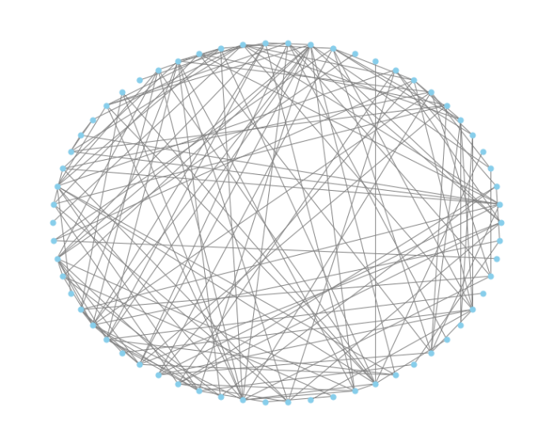
Fig. 2 Circular display of the Dolphins network graph
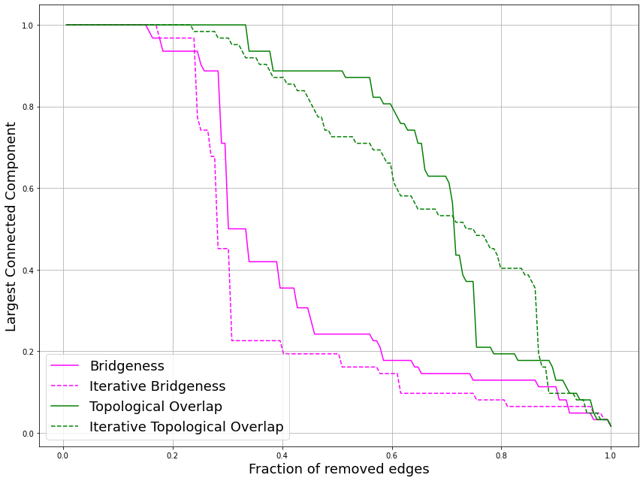
Fig. 3 Display of classic and iterative edge percolation in the Dolphins network: Drop of the $R_{gc}$ as a function of deleted edges

The illustration shows significantly that the iterative approach to Bridgeness and Topological Overlap leads to an accelerated decrease in $R_{gc}$, much faster than the classical approaches. This indicates that the iterative methods, which adapt their calculation after each removal, offer a more reactive and accurate perspective on the relative importance of connections within the network. The rate at which $R_{gc}$ decreases in iterative versions underlines their potential for assessing network robustness and predicting the effects of possible disturbance.

  - American College Football Network
The American football network, capturing the contests between Division IA teams during the autumn 2000 regular season, stands out as a large-scale case study for our study. With its 115 nodes connected by 613 edges, the network lends itself to a detailed breakdown of the structural robustness via measures of Bridgeness and Topological overlap. These are supported by Figure 4, which shows the circular display of the network, and Figure 5, which details the percolation process within the network.
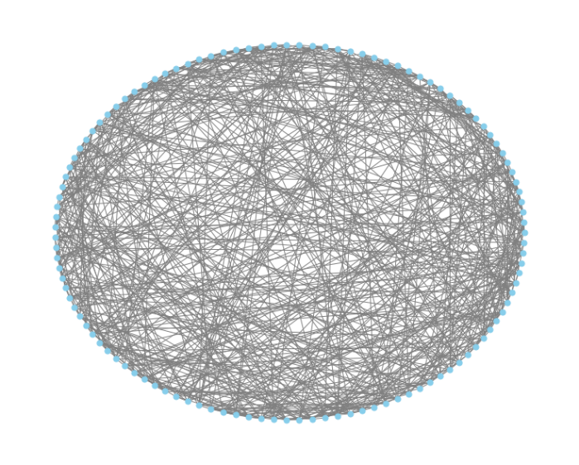
Fig. 4 Circular display of the Football network graph
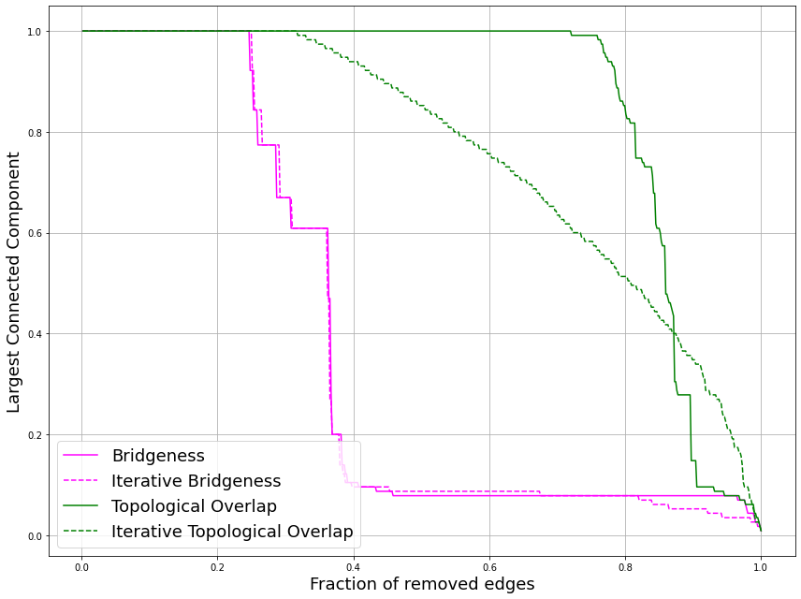
Fig. 5 Display of classic and iterative edge percolation in the Football network: Drop of the $R_{gc}$ as a function of deleted edges
The illustration shows that, although the results of the classical and iterative Bridgeness are broadly similar for the majority of edge deletions, a notable distinction emerges in the last 20% of deletions. At this point, the curve corresponding to the iterative method shows a steeper fall than that of the classical method. Regarding the iterative Topological Overlap, it shows a more gradual decrease in $R_{gc}$, suggesting that this method subtly captures structural variations as the network evolves. These insights underline the relevance of iterative approaches to understanding and maintaining the structural robustness of a complex network.

  - Jazz Network
The Jazz Network, reflecting collaborations between members of the Jazz world, with its 198 nodes woven together by 2742 edges, offers an enriching perspective for examining connectivity mechanisms. This complex structure allows us to apprehend the network’s resilience through measures of bridgeness and topological overlap, which can be viewed from both static and dynamic angles. Figure 6 shows the circular display of the network, and Figure 7 details the percolation process within the network, respectively.
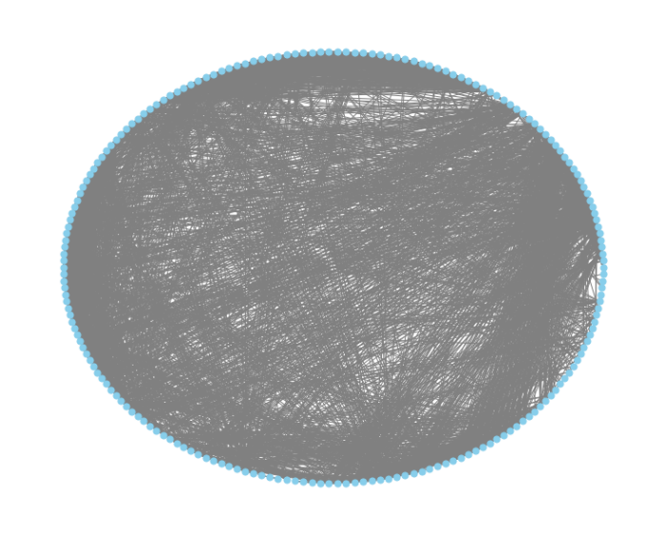
Fig. 6 Circular display of the Jazz network graph
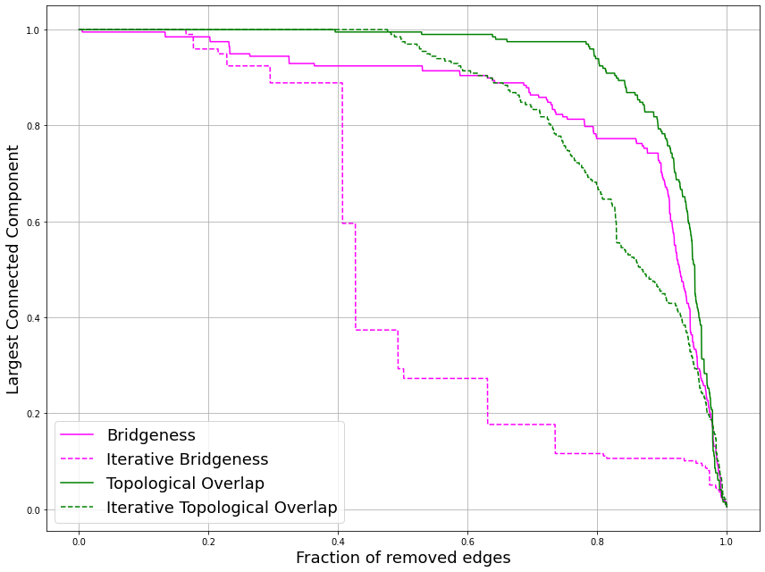
Fig. 7 Display of classic and iterative edge percolation in the Jazz network: Drop of the $R_{gc}$ as a function of deleted edges

The illustration shows that the iterative “Bridgeness” method causes a steeper reduction in $R_{gc}$ compared to the classic approach, highlighting a sharper skill in identifying key edges that support the network. At the same time, iterative Topological overlap induces a more moderate but sustained drop in $R_{gc}$, suggesting an ability to finely distinguish evolutions in network structure. This distinction highlights the significant advantage of iterative methods in understanding and preserving the structural integrity of complex social networks.
- Discussion
Our study highlights the comparative strengths of iterative and classic methods through the analysis of distinct networks, as shown in the following table. Focusing on the bridgeness and topological overlap indicators, we have integrated $R_{gc}$ dimension to assess the impact of targeted edge elimination on network stability. The table shows the performance of the methods according to the area under the curve, revealing the effectiveness of the iterative and classic approaches in relation to the proportional number of edges removed. A smaller era under the curve suggests a more impactful edge removal method, reinforcing the efficiency of the iterative process.

Table 1. $R_{gc}$ integral area: Comparison of 'Bridgeness' and 'Topological Overlap' measurements in static and dynamic contexts for Dolphins, Football, and Jazz networks
Network | Bridgeness | Iterative Bridgeness | Topological Overlap | Iterative Topological Overlap
Dolphins | 0.4260 | 0.3636 | 0.6941 | 0.6796
Football | 0.3794 | 0.3775 | 0.8594 | 0.7577
Jazz | 0.8538 | 0.5062 | 0.9250 | 0.8413

A closer look at the numbers in Table 1 shows that the iterative method demonstrates its superiority in evaluating edge criticality. The improvement of brightness by the iterative approach decreases the space under the curve by up to 40%, with an average improvement of 18%, considering the noted benchmark networks. The iteration of topological overlap enhanced the ranking of link criticality up to 11%, with an average improvement of 7%. This finding is of crucial importance, underlining the ability of the iterative approach to identify and neutralize the edges whose absence is most determined to network integrity.

Adopting this iterative approach opens up innovative perspectives for optimizing network resilience. By incorporating progressive edge removal measures, this methodology reveals points of vulnerability that classic approaches might otherwise overlook. The approach adopted proves to be a valuable tool for practitioners seeking to design networks that are resilient to disturbance while retaining optimal functionality.

This detailed analysis centered around the above results represents only an initial step in a comprehensive assessment of network robustness. It is conceivable that the trends observed could guide the development of targeted intervention strategies, where critical edges could be strengthened or reorganized to improve overall resilience. However, the scope and the applicability of the findings require further investigations based on a wider range of networks and outage scenarios.
- Conclusion
The quest to identify critical edges within complex networks is a fundamental line of research in network science. Our study has taken an innovative route, adopting an iterative method to examine these key components. This iterative approach, in application to the concepts of Bridgeness and Topological overlap, enabled us to assess the reaction of networks to specific edge deletions, reflecting their capacity for adaptation and resilience.

The present work and numerical experiments demonstrated that the proposed iterative approach excels and outperforms traditional static methods, revealing its hat of potential in accurately assessing link criticality. Analysis revealed that our method makes the conventional algorithms more efficient, notably by demonstrating a significantly faster decrease in the largest connected component. The numerical experiment of this approach on the Dolphins, Football, and Jazz networks highlighted its ability to identify links whose removal would have a significant impact on the overall network structure.

However, it is important to note that this statement does not aim to minimize the effectiveness of existing methods but rather emphasizes that the application of our iterative method offers more potential advantages when applied to certain network contexts. This recognition opens the way to a constructive discussion of the various factors that can influence the outcome of network analysis methods, enabling further exploration of solutions suitable for different types of networks.

This research lays a foundation stone for network science, going beyond conventional measurements and offering a deep understanding of network topology. In conclusion, the current study not only provides a framework for the assessment of network robustness but also opens a dialogue on the practical application of this knowledge for the design of resilient systems capable of sustaining and operating effectively in the face of future challenges.

Acknowledgments. This study was partially funded by the Personal Research Fund of Tokyo International University and by (Hamza’s scholarship).
Disclosure of Interests. The authors have no competing interests to declare that are relevant to the content of this article.

References
- Newman, M. E. J.: Spread of Epidemic Disease on Networks. Phys. Rev. E, Stat. Phys. Plasmas Fluids Relat. Interdiscip. Top., vol. 66, no. 1, Jul. 2002, Art. no. 016128.
- Pei, S., Muchnik, L., Tang, S., Zheng, Z., and Makse, H. A.: Exploring the Complex Pattern of Information Spreading in Online Blog Communities. PLoS ONE, vol. 10, no. 5. (2015)
- Wan, R., Xiong, N., The Loc, N.: An Energy-Efficient Sleep Scheduling Mechanism with Similarity Measure for Wireless Sensor NetworksHum.-Centric Comput. Inf. Sci. 8, 18. (2018)
- Newman, M. E. J.: The Structure and Function of Complex Networks. SIAM Review, vol. 45, no. 2, pp. 167–256, (2003)
- Xia, Y., Hill, D. J.: Attack Vulnerability of Complex Communication Networks. IEEE Transactions on Circuits and Systems II: Express Briefs, vol. 55, no. 1, pp. 65–69, 2008
- Albert, R., and Barabási, A.-L.: Statistical Mechanics of Complex Networks. Rev. Mod. Phys., vol. 74, no. 1, pp. 47–97, (2002)
- Louzada, V. H. P., Daolio, F., Herrmann, H. J., and Tomassini, M.: Generating Robust and Efficient Networks Under Targeted Attacks. In: Propagation Phenomena in Real World Networks (Intelligent Systems Reference Library), vol. 85, D. Król, D. Fay, and B. Gabryś (Eds.), Cham, Switzerland: Springer, pp. 215–224, (2015)
- Qian, Y., Li, Y., Zhang, M., Ma, G., and Lu, F.: Quantifying Edge Significance on Maintaining Global Connectivity. Sci. Rep., vol. 7, no. 1, (2017)
- Girvan, M., & Newman, M. E.: Community Structure in Social and Biological Networks. Proceedings of the National Academy of Sciences, 99(12), 7821–7826 (2002)
- Wang, W. X., & Chen, G. R.: Universal Robustness Characteristic of Weighted Networks Against Cascading FailurePhysical Review E, 77(2), 026101 (2008)
- Liu, Y., Tang, M., Zhou, T., & Do, Y.: Improving the Accuracy of the k-Shell Method by Removing Redundant Links: From a Perspective of Spreading DynamicsScientific Reports, 5, 45380 (2015)
- Cheng, X. Q., Ren, F. X., Shen, H. W., Zhang, Z. K., & Zhou, T.: Bridgeness: A Local Index on Edge Significance in Maintaining Global Connectivity. Journal of Statistical Mechanics: Theory and Experiment, 2010(10), P10011 (2010)
- Wu, A. K., Tian, L., & Liu, Y. Y.: Bridges in Complex NetworksPhys. Rev. E, 97, 012307 (2018)
- Onnela, J.-P., Saramäki, J., Hyvönen, J., Szabó, G., Lazer, D., Kaski, K., Kertész, J., and Barabási, A.-L.: Structure and Tie Strengths in Mobile Communication Networks. Proc. Natl. Acad. Sci. USA, vol. 104, no. 18, pp. 7332–7336. (2007)
- De Meo, P., Ferrara, E., Fiumara, G., & Ricciardello, A.: A Novel Measure of Edge Centrality in Social Networks. Knowledge-Based Systems, 30, 136–150 (2012)
- Ozaydin, S. Y., and Ozaydin, F.: Deep Link Entropy for Quantifying Edge Significance in Social Networks. Appl. Sci., vol. 11, no. 23. (2021)
- Lubashevskiy, V., Ozaydin, S. Y., and Ozaydin, F.: Improved Link Entropy with Dynamic Community Number Detection for Quantifying Significance of Edges in Complex Social Networks. Entropy, vol. 25, no. 2, p. 365, (2023)
- Lusseau, D., Schneider, K., Boisseau, O. J., Haase, P., Slooten, E., & Dawson, S. M.: The Bottlenose Dolphin Community of Doubtful Sound Features a Large Proportion of Long-Lasting AssociationsBehav. Ecol. Sociobiol., 54, 396–405 (2003)
- Gleiser, P. M., & Danon, L.: Community Structure in Jazz. Adv. Complex Syst., 6, 565–573 (2003).
- Lubashevskiy, V., and Lubashevsky, I.: Evolutionary Approach for Detecting Significant Edges in Social and Communication Networks. IEEE Access, Volume 11. (2023)

