BASIC PRESENTATION   
THE POWER OF COMMUNICATION   
involvement



engagement and making sure the audience feel involved SELECTING VISUAL AIDS Enhancing your presentation EFFECTIVE DELIVERY TECHNIQUES   
NAVIGATING Q&A SESSIONS   
DYNAMIC DELIVERY

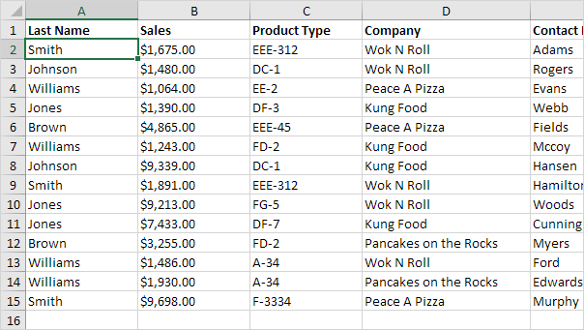

FINAL TIPS AND TAKEAWAYS   
Practice audience   
SPEAKING ENGAGEMENT METRICS   
THANK YOU   
Brita Tamm 502-555-0152 brita@firstupconsultants.com www.firstupconsultants.com