Introduction to Problem

In this project, I intend to program the board game Go, as a playable program.

Go is akin to chess, draughts, and other strategy board games in that it is played by two players, black vs white, in a turn-by-turn fashion. The board is a grid, where pieces are placed on the intersections of lines – the standard size in professional tournaments is 19x19. Both players aim to surround the other’s pieces with their own and ‘capture’ them from the board. Stones cannot be moved once placed, and the empty points that a player surrounds become part of their ‘territory’. When the game has ended, their score is calculated as their total territory minus the number of their stones that their opponent captured, and the highest score determines the winner.

It is my intention that my implementation allows two people to play each-other either locally (on the same machine), or over the network.

Research / Consumer

To gain an understanding of the problem, I first had to understand the game itself – its rules, the interactions they create, and how these might be modelled in a computer program. For this, I turned to an excellent website, “Senseis Library”:

https://senseis.xmp.net/

Through it, I was able to get a good understanding of the terminology used by Go players, various common formations and situations, as well as look at some example games playing out for myself. This gave me a good feel for how a game of Go evolves as moves are made, and some idea of how my program might be able to best accommodate this. I also read through the Wikipedia entry on the rules of Go, particularly the section on scoring systems. This helped me start to think about what rules my implementation would use, and if any could be chosen by the user.

I also needed to get to grips with computer networking, an area I only knew about in theory. To understand how I could get communication between two computers running my version of the game working, I went to the documentation for my project’s language of choice, Python 3:

https://docs.python.org/3/howto/sockets.html

Another option would be to have made my application a website, and use AWS or similar to host it. While this would have avoided me having to handle networking between computers, I decided that I would prefer to have control over the this myself, to avoid complications from external sources.

Current Systems

Online, you can find many free Go sites, with varying degrees of quality and differing features. Almost all of these choose to use a GUI, with moves made with the mouse rather than the keyboard. They also usually have accounts, lobbies, chat systems – all useful for people interested in joining an online community or getting on a leader-board, but quite distracting for anyone who wants to simply play the game. Indeed, the focus many of them place on either ranked tournaments or AI opponents means playing against a specific friend on another computer can be unnecessarily complicated, or not even a feature to begin with.
Outside of the Web, there are stand-alone applications, such as ‘gnugo’, a popular open-source version. It has an excellent, simple interface that runs in the terminal, as well as extensive options for different rules and board-sizes. However, without using it with a front-end, it does not enable remote play over the network.

Identification of End Users

I have chosen my brother, Elijah Mullan, as my end-user. He likes board-games, and him and I have often played Go together on a physical board. However, I’m going away for Uni next year, and since he wants to continue our games so we stay in touch, he needs a remote solution.

Client Interview

In order to understand my brother’s needs more precisely, I conducted an interview with him.

Why do you need my program?

I like playing Go on a physical board with my brother and my friends, but a lot of the time that isn’t possible. It would be nice to have a simple way to play a game with them when we’re in different places, especially so that we I can keep in practice and don’t forget the rules.

What device would you be running it on?

Since I don’t own a smartphone, my laptop would probably be the best choice. I’d want it to be easy to install and run, so that if I want to play it on a different computer sometime I can do so without any trouble.

Are there no existing programs that let you do this?

There are lots that I’ve look at on the Internet, but they always want you to sign up and make an account, and a lot of them try to get you to pay for premium features that I don’t really need. I don’t want to play with strangers, so the tournaments they put on aren’t of any interest to me. Plus, my laptop’s a hand-me-down and starts to struggle when a lot’s happening on the screen at once, and most of these webpages do that.

What features would you want this program to have?

To let me play Go with someone in a different house. I’d like it to have different board sizes, so I can choose one depending on how much time I have to play, and also the handicap system since I reckon that soon I’ll be better than my brother. Also, I’d like the option to play on the same computer, in case a physical board isn’t around.

How would you like the program to look and behave?

Nothing fancy. I’m pretty good with computers, so I’d be comfortable with it running in the terminal, but in case my friends who aren’t as good with computers want to play, I want it to be clearly laid out. I’d like moves to be entered with board coordinates so that it’s easy to use. Also, when the game is over, I want the winner to be displayed, as well as the actual score, so I can see how close it was.

User Needs

- A program that allows the user to play Go with another person either locally or remotely.
- A working handicap/”komi” system to ensure the game stays competitive.
- Support for 13x13 and 19x19 board sizes, to accommodate how much time the users have.

Acceptable Limitations

- While the program needs to clearly show the state of the board, GUI elements like buttons, scrollbars etc. are not necessary
- It does not need an extensive range of optional rules – it can choose to implement the most common ones

The Rules of Go

As I’ve found when researching the game, its rules are quite simple for a human to understand, but may be quite complex for a computer to accurately simulate.

The game is played on a 9x9, 13x13 or 19x19 grid, with the last being the most popular. It is played by two people, one with black stones and the other with white, with the only action being to place one of their own stones onto an intersection (point) of the grid, or to pass their turn. Indeed, the game ends when both players pass consecutively. The goal is to have the most territory on the board at the end – I’ll explain that later.

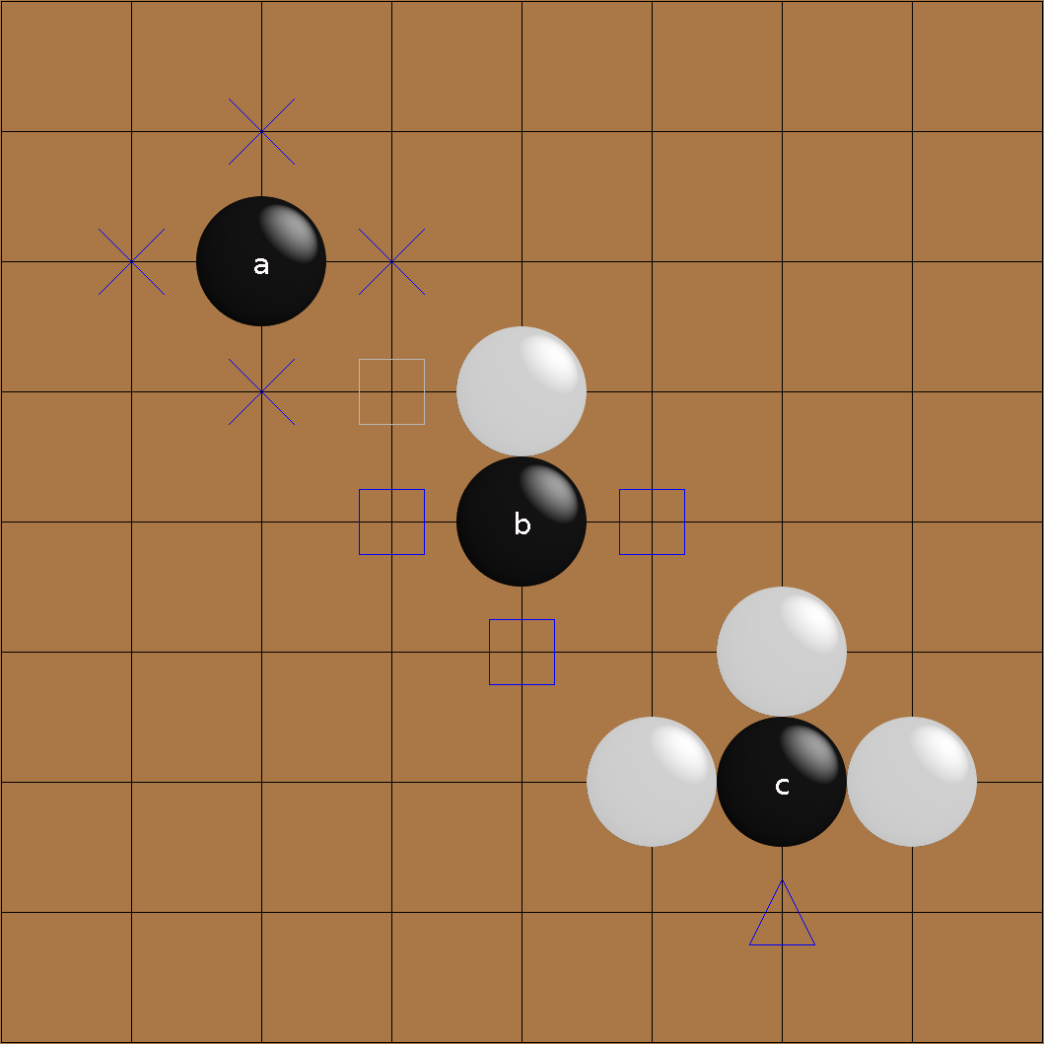
At any given time, every stone on the board has a certain amount of liberties, equal to the number of empty points neighbouring it in the cardinal directions. For example, the black stone A has four liberties; B has a white stone beside it so it has three. C has just one liberty, and so if white chooses to play in the last empty point on her turn…

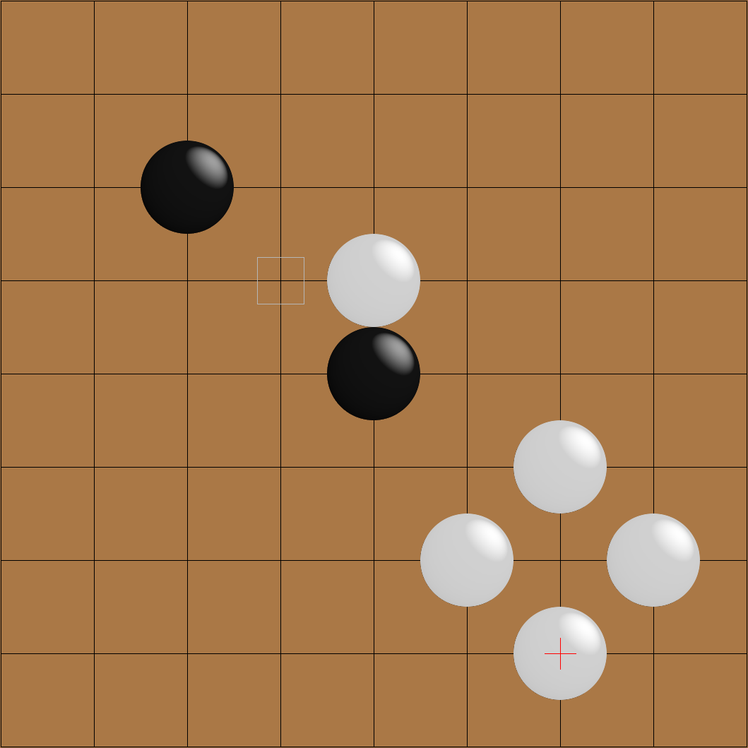
C gets captured by white, and is removed from the board.

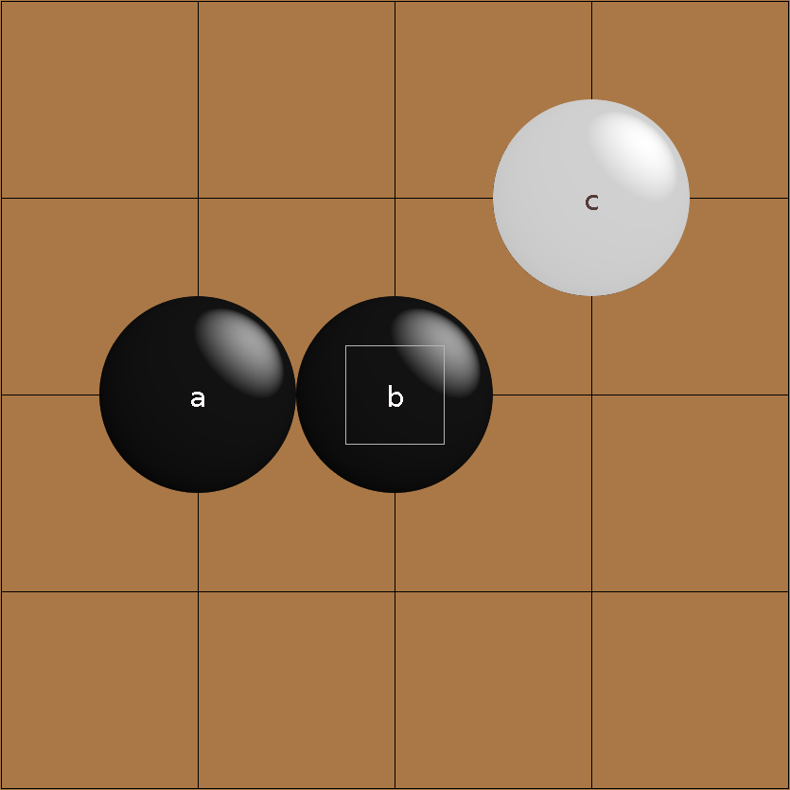
This rule is by itself quite simple. Where it becomes more complicated is that neighbouring stones of the same colour share liberties. Here, A and B have a total of six liberties. Note that C does not share liberties with them (it has four), as it is diagonally adjacent – however there is no problem with two of its liberties being on the same points as two of A/B’s.

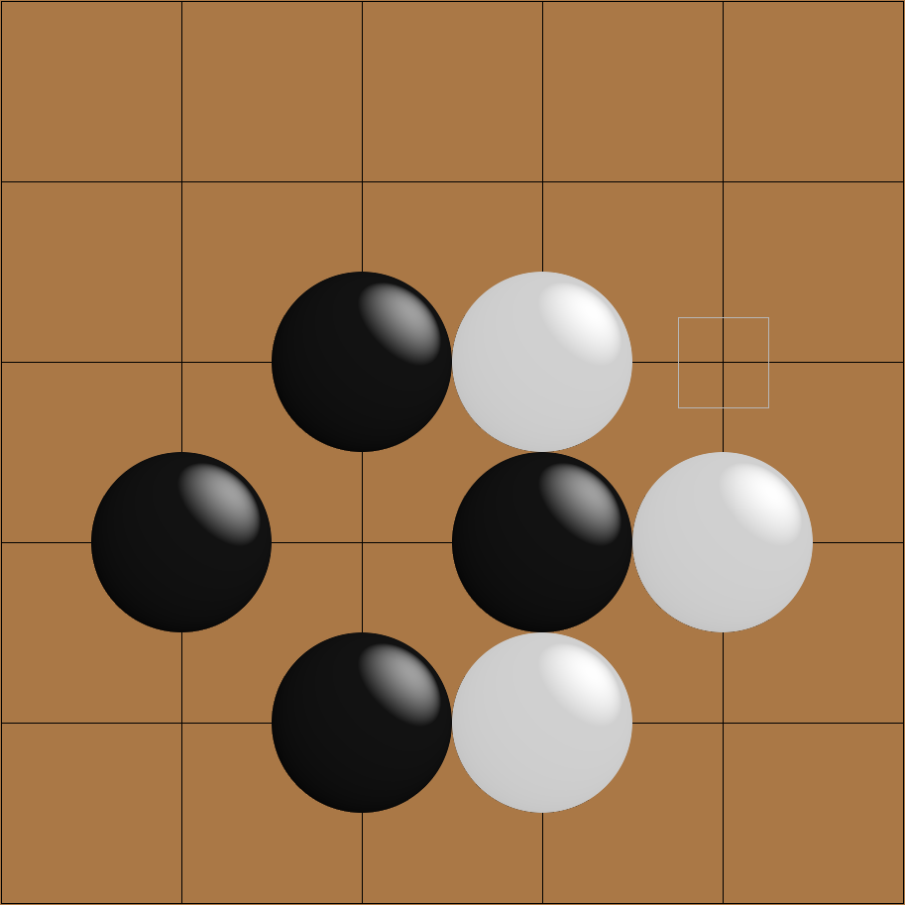
Then there is the rule of ko, in which infinite loops of moves by preventing a player from playing a move that would repeat a previous board state. It typically arises in a formation like this one:
If white plays to capture black’s stone:
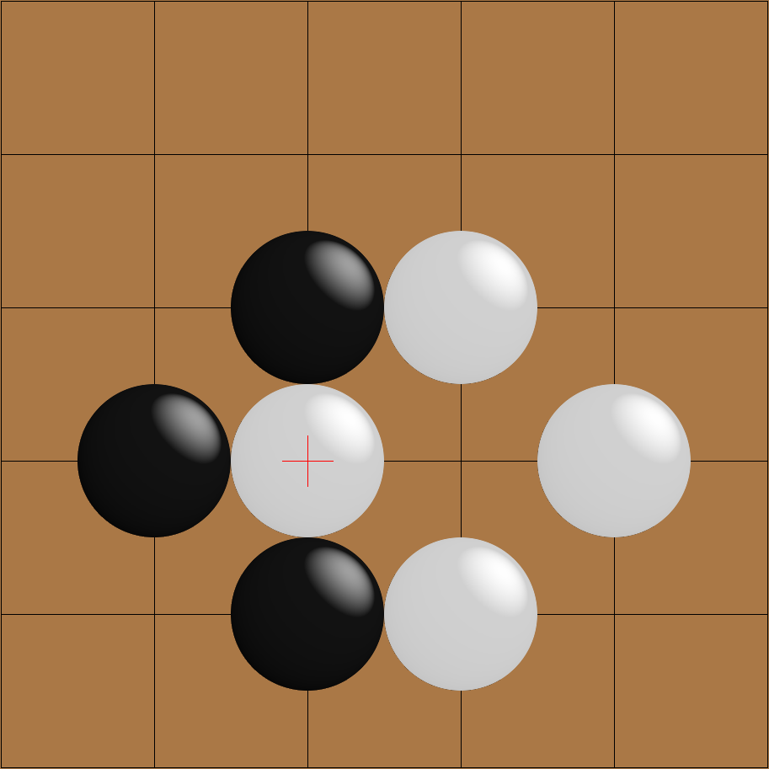
Then black cannot capture white’s, as this would repeat the position from two turns previously. Therefore, he must play elsewhere on the board first.

At the end of the game, territory is counted. An empty intersection is said to belong to a player’s territory if all stones adjacent to it or to an empty intersection connected to it are of that player’s colour. Take this example:

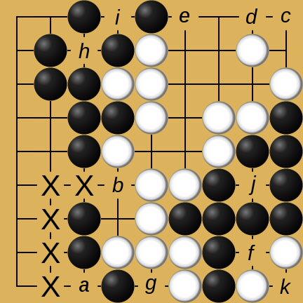
a is adjacent to black stones, so it cannot belong to white’s territory. However, it is connected to b, through the path in the diagram, and b is adjacent to a white stone. So, a is neutral territory. The same logic applies to c: it’s connected to d, which is adjacent to a white stone, but also e, adjacent to a black. Ergo, c is neutral, as are f and g. h is only adjacent to black stones, so it is black territory. So are i and j, and k is white territory for the same reason.

Both players final score is equal to their territory minus the number of stones their opponent captured, and the highest score wins.

Networking

In my research I learned that computer networking (according to the TCP/IP model) is split into different layers, namely: link, internet, transport and application. A program running on a computer is at that top layer, application. To send data between computers, from the application layer, the most popular method is to use sockets. Modern programming languages tend to provide libraries that enable programmers to implement these themselves, and Python is no different, and has sockets as part of its standard library. As such, I only have to worry about how I use and maintain these connections after I’ve established them.

System Objectives
- On opening the program, the user should be greeted with a menu allowing them to choose between a local or remote game.
- In a game, the user should be able to enter coordinates through the terminal to specify where they want to place a stone, or to pass their turn.
- Stones should have their liberties kept track of, and those with no liberties should be captured and removed from the board.
- Adjacent stones of the same colour should share liberties, and be captured at the same time.
- Players should be unable to make a move that:
- The game should end when both players pass.
- The score should be calculated based on territory and captured stones.
- The user should be available to assign a player handicaps before a game has been started.
- The user should also be able to select between (at least) 13x13 and 19x19 board sizes.
- If a remote game is selected, they should be able to enter the IP address of the computer of the person they wish to play with, and send a play request.
- If a play request is sent to a computer, and it has the program open and is not engaged in a game already, the user should be able to accept or reject the request.
- A remote game should have the same user experience as a local one, with the exception of having a “Waiting for Player B” message while the other player’s has yet to finish their turn.
- At the end of any game, there should be the option to rematch or quit (closing the connection, in the remote play case).

Optional Objectives

- Enable “Go-by-Email”, whereby the user can have long-term “correspondence” games with multiple people, where moves are sent via email and parsed by the program.
- Allow the user to enter variable board sizes before a game, between 5x5 and 99x99.
- Add timers for when the players are selecting a move.
- Add additional, non-canonical game types, like Four Player Go or Reverse Go.

