Table of Contents
ANALYSIS 1
Introduction to Problem 1
Research / Consumer 2
Current Systems 3
Identification of End Users 4
Client Interview 4
User Needs 5
Acceptable Limitations 6
The Rules of Go 6
The Smart Game Format 9
System Objectives 10
Optional Objectives 11
DESIGN 11
Modelling 11

ANALYSIS

Introduction to Problem

In this project, I intend to implement the board game Go, as a playable program.

Go is akin to chess, draughts, and other strategy board games in that it is played by two players, black vs white, in a turn-by-turn fashion. The board is a grid, where pieces are placed on the intersections of lines – the standard size in professional tournaments is 19x19. Both players aim to surround the other’s pieces with their own and ‘capture’ them from the board. Stones cannot be moved once placed, and the empty points that a player surrounds become part of their ‘territory’. When the game has ended, their score is calculated as their total territory minus the number of their stones that their opponent captured, and the highest score determines the winner. Players who want to improve at the game often do so through through short “Go Problems”, puzzles where the goal is to find the optimal sequence of moves.

It is my intention that my implementation allows local play between two human players, and also allow users to select and play through Go problems.

Research / Consumer

To gain an understanding of the problem, I first had to understand the game itself – its rules, the interactions they create, and how these might be modelled in a computer program. For this, I turned to an excellent website, “Senseis Library”:

https://senseis.xmp.net/

Through it, I was able to get a good understanding of the terminology used by Go players, various common formations and situations, as well as look at some example games playing out for myself. This gave me a good feel for how a game of Go evolves as moves are made, and some idea of how my program might be able to best accommodate this. I also read through the Wikipedia entry on the rules of Go, particularly the section on scoring systems. This helped me start to think about what rules my implementation would use, and if any could be chosen by the user.

The site also introduced me to the “Smart Game Format”, used by many existing Go solutions; a description of its purpose and function can be found on its official site. Files using the format (with “.sgf” extensions) can actually describe numerous other games, such as backgammon. The format consists of a tree made up of nodes, allowing it to keep a record of a game (by having each node contain a move) and variations in the lines of play. That latter quality is very useful for describing Go problems, and this turns out to be a very common use-case in practice. I soon found a large repository of problems in the form of .sgf files, a far simpler method of providing them to a user than generating them. That would require some form of AI and machine learning, but as this is an area of ongoing research from organisations like DeepMind, I decided it was beyond the scope of this project.

Current Systems

Online, you can find many free Go sites, with varying degrees of quality and differing features. Almost all of these choose to use a GUI, with moves made with the mouse rather than the keyboard. They also usually have accounts, lobbies, chat systems – all useful for people interested in joining an online community or getting on a leader-board, but quite the opposite for anyone who wants to simply play the game. Indeed, the focus many of them place on ranked tournaments and chat rooms means they can be incredibly distracting to use. Those that offer Go problems, such as ‘goproblems.com’, have very mixed collections in terms of quality and difficulty – coupled with their distracting interfaces, someone wishing to simply play them would be better buying a published collection and doing them on a physical board.

Outside of the Web, there are stand-alone applications, such as ‘gnugo’, a popular open-source version. It has an excellent, simple interface that runs in the terminal, as well as extensive options for different rules and board-sizes. However, while it does support loading from .sgf files, it can only do so to load a game that has been played. When I presented it with Go problem files, it simply chose the first variation and played the game from there; it fundamentally isn’t designed with problems in mind, focusing instead on an AI opponent.

Identification of End Users

I have chosen my brother, Elijah Mullan, as my end-user. He likes board-games, and him and I have often played Go together on a physical board. I am going away for Uni next year, so he wants to stay practiced, but doesn’t like playing against the computer. Additionally, he’s intent on getting better, and has heard that many masters of the game like to practice using problems.

Client Interview

In order to understand my brother’s needs more precisely, I conducted an interview with him.

Why do you need my program?

I like playing Go on a physical board with my brother, but a lot of the time that isn’t possible. I want to be able to keep practising playing so that I can keep improving, and problems have lots of the tricky situations that I find really hard when I’m playing a real game. I’ve tried playing them from a book, but it’s hard to not accidentally spoil them while you’re reading!

What device would you be running it on?

Since I don’t own a smartphone, my laptop would probably be the best choice. I’d want it to be easy to install and run, so that if I want to play it on a different computer sometime I can do so without any trouble.

Are there no existing programs that let you do this?

There are lots that I’ve look at on the Internet, but they always want you to sign up and make an account, and a lot of them try to get you to pay for premium stuff that I don’t really need. I don’t want to play with strangers, so the tournaments they put on aren’t of any interest to me, and I’ve never enjoyed playing the computer. Plus, my laptop’s a hand-me-down and starts to struggle when a lot’s happening on the screen at once, and most of these websites do that.

What features would you want this program to have?

To let me through Go problems. I want to be able to select them from a list, and for it to tell me when I’ve made a wrong move. I’d also like the option to play against another person on the same computer, in case I want to play a friend and a physical board isn’t around.

How would you like the program to look and behave?

Nothing fancy. I’m pretty good with computers, so I’d be comfortable with it running in the terminal, but in case my friends who aren’t as good with computers want to play, I want it to be clearly laid out. I’d like moves to be entered with board coordinates so that it’s easy to use. Also, when a human game is over, I want the winner to be displayed, as well as the actual score, so I can see how close it was.

User Needs

- A program that allows the user to play Go, against a human or within a pre-made “Go problem”.
- It must provide a selection of such problems, and have the capability for more to be added.
- A working handicap/”komi” system to ensure games stay competitive.
- Support for 13x13 and 19x19 board sizes, to accommodate how much time the users have.

Acceptable Limitations

- It does not need an extensive range of optional rules for games– it can choose to implement the most common ones.
- The number of problems included does not need to be huge, and they don’t have to be of a especially high difficulty.
- It can use a simple console-based display, without GUI elements like scroll bars or button prompts.

The Rules of Go

As I’ve found when researching the game, its rules are quite simple for a human to understand, but may be quite complex for a computer to accurately simulate.

The game is played on a 9x9, 13x13 or 19x19 grid, with the last being the most popular. It is played by two people, one with black stones and the other with white, with the only action being to place one of their own stones onto an intersection (point) of the grid, or to pass their turn. Indeed, the game ends when both players pass consecutively. The goal is to have the most territory on the board at the end – I’ll explain that later.

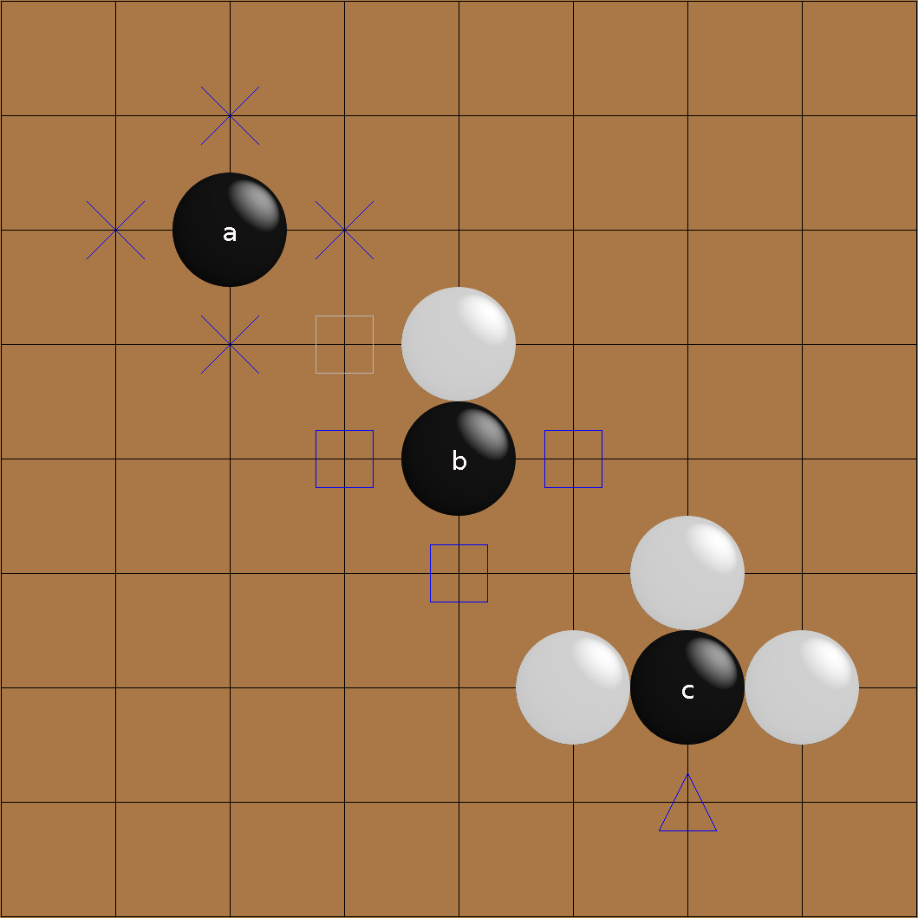
At any given time, every stone on the board has a certain amount of liberties, equal to the number of empty points neighbouring it in the cardinal directions. For example, the black stone A has four liberties; B has a white stone beside it so it has three. C has just one liberty, and so if white chooses to play in the last empty point on her turn…

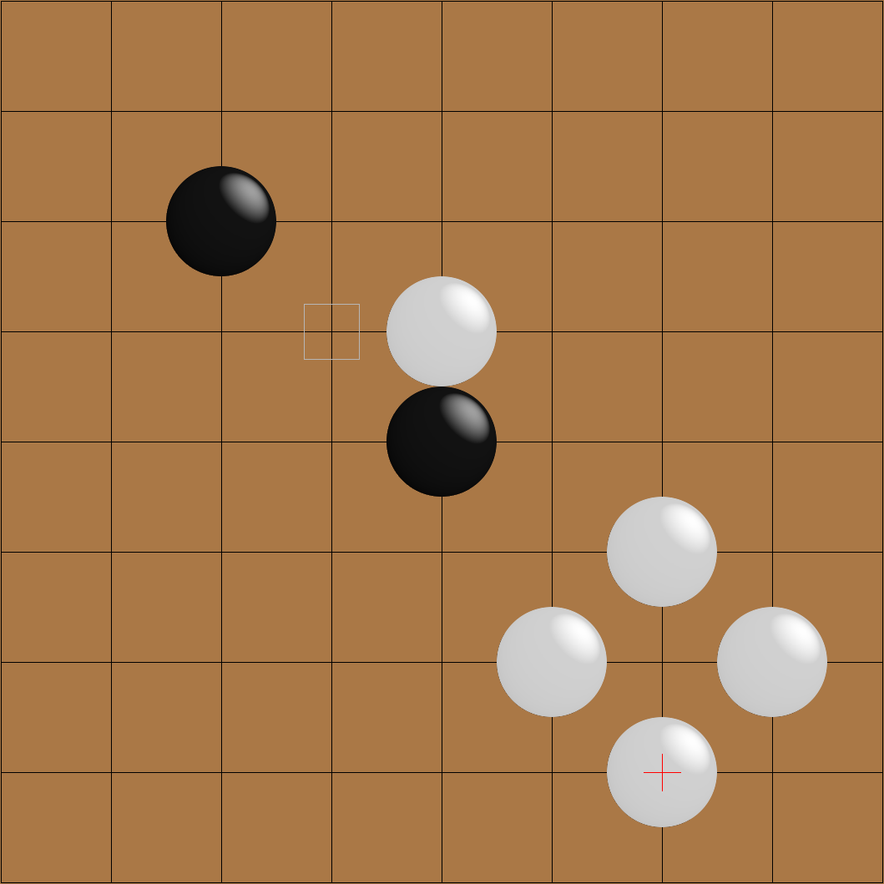
C gets captured by white, and is removed from the board.

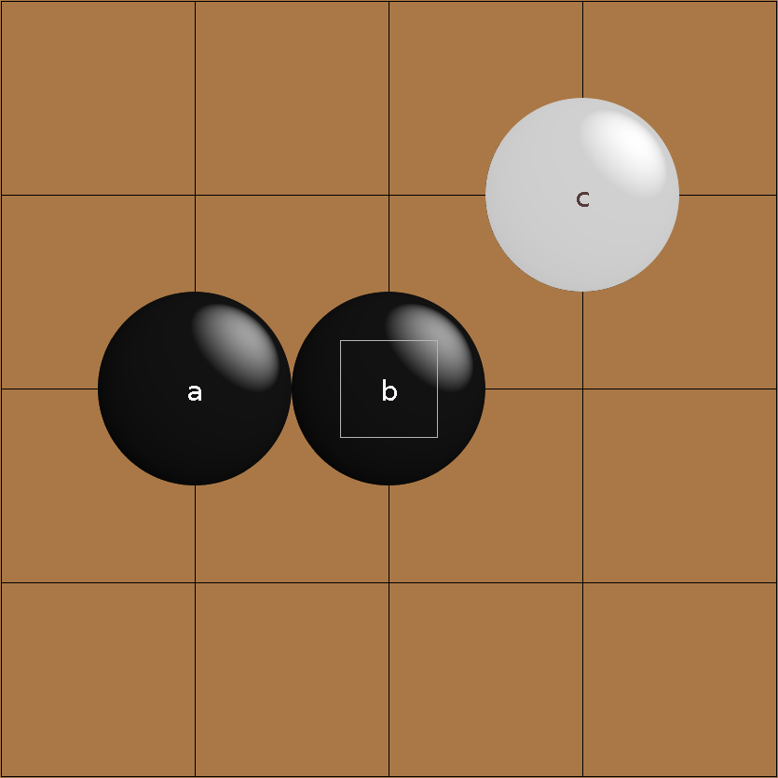
This rule is by itself quite simple. Where it becomes more complicated is that neighbouring stones of the same colour share liberties. Here, A and B have a total of six liberties. Note that C does not share liberties with them (it has four), as it is diagonally adjacent – however there is no problem with two of its liberties being on the same points as two of A/B’s.

Then there is the rule of ko, in which infinite loops of moves by preventing a player from playing a move that would repeat a previous board state. It typically arises in a formation like this one:
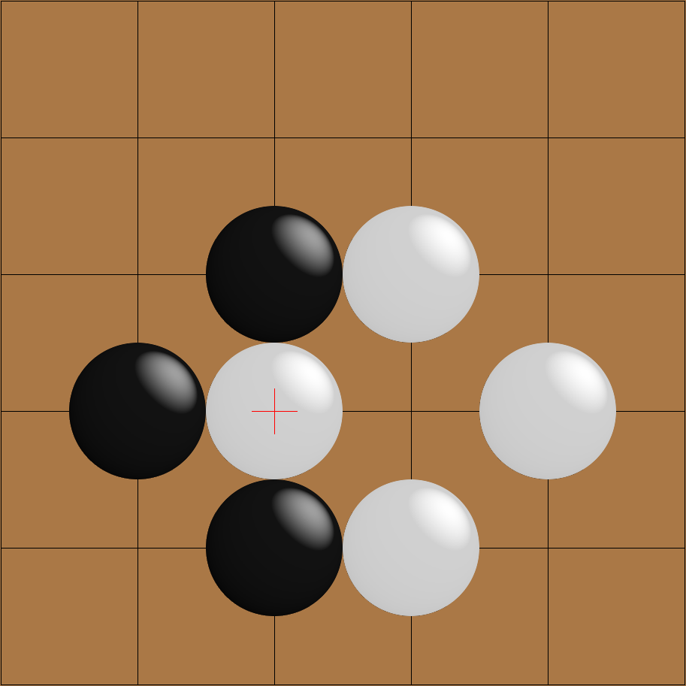
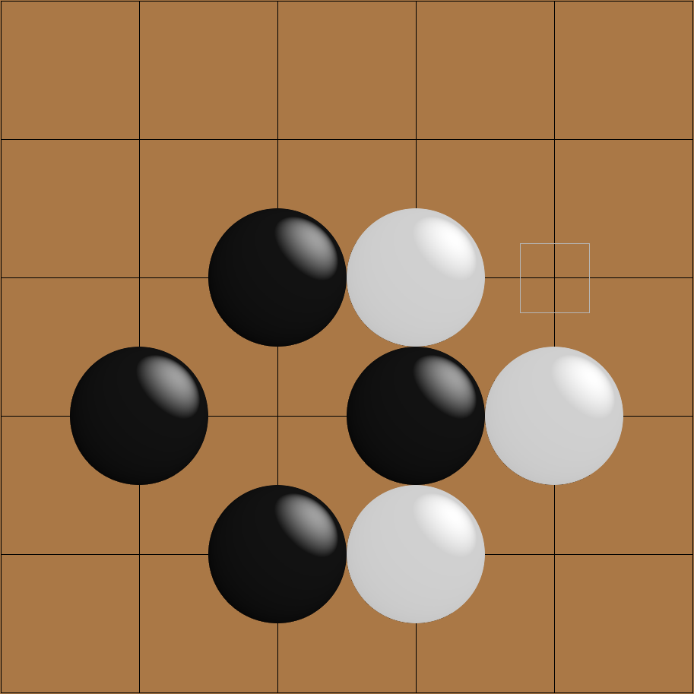
If white plays to capture black’s stone:
Then black cannot capture white’s, as this would repeat the position from two turns previously. Therefore, he must play elsewhere on the board first.

At the end of the game, territory is counted. An empty intersection is said to belong to a player’s territory if all stones adjacent to it or to an empty intersection connected to it are of that player’s colour. Take this example:
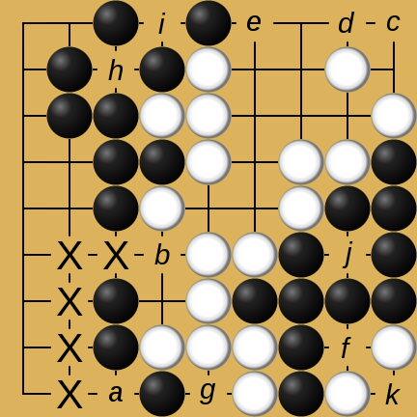
a is adjacent to black stones, so it cannot belong to white’s territory. However, it is connected to b, through the path in the diagram, and b is adjacent to a white stone. So, a is neutral territory. The same logic applies to c: it’s connected to d, which is adjacent to a white stone, but also e, adjacent to a black. Ergo, c is neutral, as are f and g. h is only adjacent to black stones, so it is black territory. So are i and j, and k is white territory for the same reason.

Both players final score is equal to their territory minus the number of stones their opponent captured, and the highest score wins.

The Smart Game Format

A .sgf file contains text that describes a game tree. That tree consists of nodes, and those nodes can have certain properties.

The root node contains info pertaining to the entire file, such as: the version of the format being used, in the FF property; the game being played, in GM, which is set to 1 for Go; the size of the board, in SZ; and the initial board state for a problem can be expressed through lists of coordinates in the AW and AB properties, which place down white and black stones respectively (critically, this is different from making a move).

Subsequent nodes can have annotations (using various properties), comments (using C), and black and white moves (with B and C).
The general syntax is very helpfully summarized on the official website with an EBNF definition:
Collection = GameTree { GameTree }
GameTree = "(" Sequence { GameTree } ")"
Sequence = Node { Node }
Node = ";" { Property }
Property = PropIdent PropValue { PropValue }
PropIdent = UcLetter { UcLetter }
PropValue = "[" CValueType "]"
CValueType = (ValueType | Compose)
ValueType = (None | Number | Real | Double | Color | SimpleText | Text | Point | Move
| Stone)

System Objectives
- On opening the program, the user should be greeted with a menu allowing them to choose between playing a human or the computer.
- In a game, the user should be able to enter coordinates through the terminal to specify where they want to place a stone, or to pass their turn.
- Stones should have their liberties kept track of, and those with no liberties should be captured and removed from the board.
- Adjacent stones of the same colour should share liberties, and be captured at the same time.
- Players should be unable to make a move that:
- Attempts to place a stone on an occupied point.
- Is suicidal (results in the players own stones being captured).
- Violates ko (repeats a previous board position).
- The game should end when both players pass.
- The score should be calculated based on territory and captured stones.
- The user should be available to give the black player an arbitrary handicap before a game has been started.
- The user should also be able to select between (at least) 13x13 and 19x19 board sizes.
- A game against the computer should have the same user experience as a local one, with the exception of having a message describing the AI opponents move in the stead of a prompt when playing the computer.
- At the end of any game, there should be the option to rematch or quit.

Optional Objectives

- Enable “Go-by-Email”, whereby the user can have long-term “correspondence” games with multiple people, where moves are sent via email and parsed by the program.
- Allow the user to enter variable board sizes before a game, between 5x5 and 99x99.
- Add timers for when the players are selecting a move.
- Allow the AI opponents difficulty to be set between multiple options.

DESIGN

Modelling

My first major design decision was to decouple the three major parts of my project: the logic of the game itself, the implementation of problems, and the interface the user interacts with. This way, each part could be developed independently, and issues could be more easily isolated to being caused by a particular part.

As such, I chose to begin with the game logic itself, the core of which I put in a class called Board. It was clear from my research that this class would need the following to properly enforce Go’s mechanics:

Variable/Method Name | Variable/Return Value type | Purpose
grid | 2D array (list of lists) | The intersections of the game board need to have their contents kept track of – with a 2D array, this can be represented in a format that suits the shape of the board.
turn | String | This is needed so that the current player can be kept track of and displayed on the screen.
white_score, black_score | Integer, integer | This determines the winner, and can be displayed at the end of a game.
g_over, winner | Boolean, string | The former will allow a program using the game logic to know when the game is over; the latter allows it to display a winner.
is_legal_move | Boolean | This is needed for a program dealing with human players to see if their inputted moves are actually legal.
make_move | N/A | Once a move is confirmed as legal, this allows it to be performed on the game board.
SIZE | Integer | The size of the length of the game board (such that its dimensions are SIZE x SIZE)
KOMI | Float | The handicap value to be added to black’s score when the game ends.

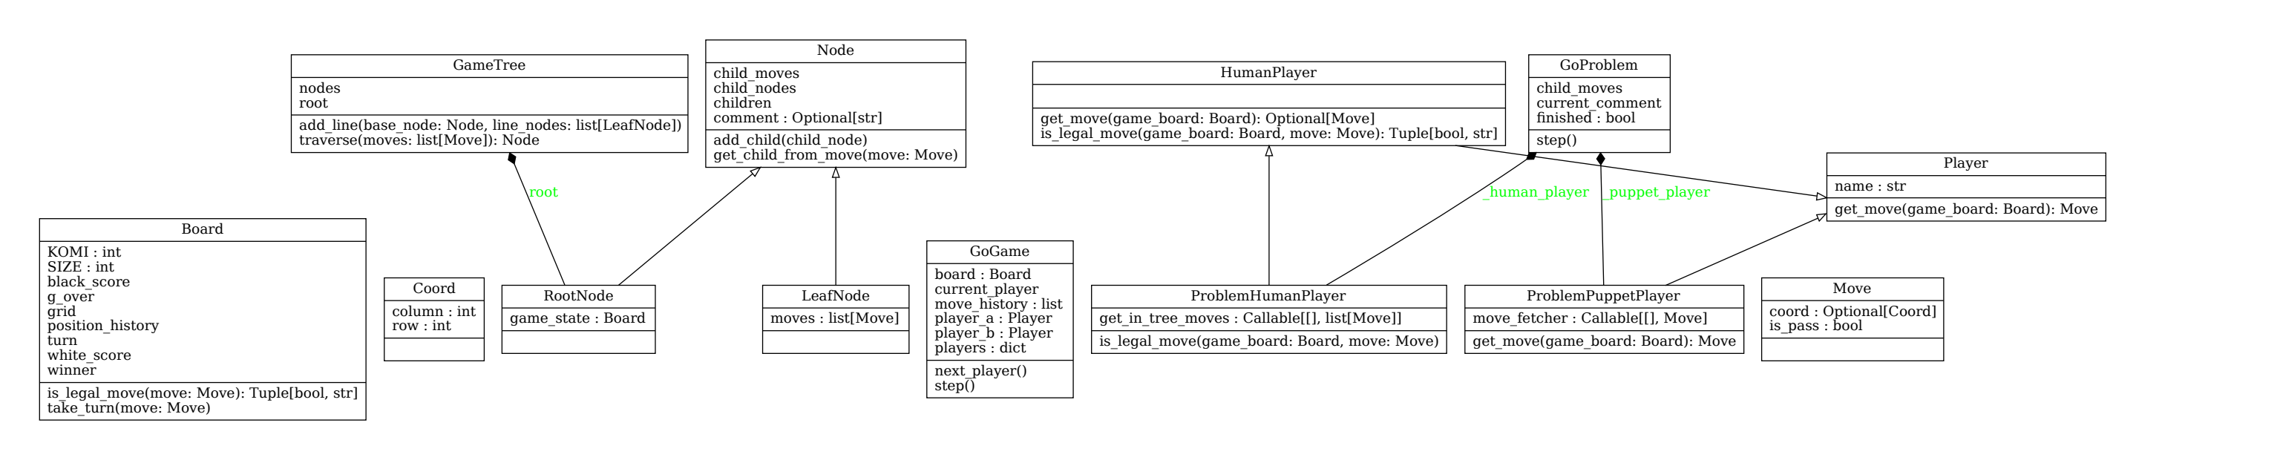
To simplify describing positions on this board, I created Coord, which has the row and column of a particular element in Board’s internal 2D array. Move represents the actions players can take, containing either a Coord or a boolean value to reflect a passed turn.

A ‘layer’ of logic above this is the GoGame class. The former has a Board object, and two Player objects. Every time the step method is called, it 1) passes the current board to the current player, 2) receives a move back, 3) gets the board to execute this move, and 4) changes the current player.

Player itself is only an abstract class. This means adding new kinds of players, such as AI opponents or users connected over the network, should be relatively painless. All you’d need to do is create a new class that inherits from Player with the desired behaviour.

