Lab-1.R

23847

2024-02-20

GenAI has not been used. Instead I visited websites such as <https://www.w3schools.com/r/>, <https://www.geeksforgeeks.org/> and https://www.stackoverflow.com/

# Problem 1  
# a)  
plot(c(0:100)[21:71], dbinom(0:100, size = 100, prob = 1/6)[21:71], pch = 20,  
 xlab = "Successes", ylab = "Probability")

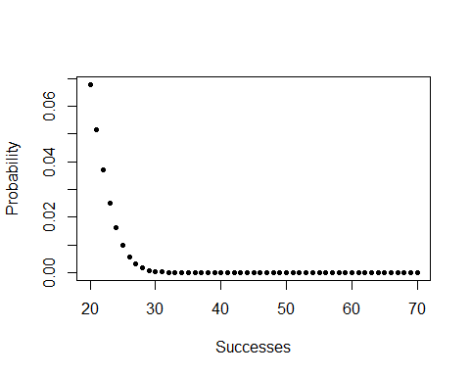

# b)  
 # Fair coins  
E1 <- pbinom(40, 100, 1/2)   
E2 <- 1 - pbinom(71, 100, 1/2)  
  
 # Biased coins  
E1 <- pbinom(40, 100, 2/3)   
E2 <- 1 - pbinom(71, 100, 2/3)  
  
  
# c)  
dbinom(40, 100, 1/2)

## [1] 0.01084387

dbinom(40, 100, 2/3)

## [1] 2.932636e-08

dbinom(70, 100, 1/2)

## [1] 2.317069e-05

dbinom(70, 100, 1/2)

## [1] 2.317069e-05

# it can be seen that it is more likely for the coin that landed 40 heads   
 # to be the fair coin as the value for dbinom is greater. Consequently   
 # the coin that lands 70 heads should be the biased coin with P(Heads) = 2/3  
  
# d)  
# i)  
sum(dbinom(seq(from = 0,to = 10, by = 2), 10, 1/2))

## [1] 0.5

# ii)  
sum(dbinom(seq(from = 0,to = 10, by = 2), 10, 2/3))

## [1] 0.5000085

# Problem 2  
# a)  
a <- c(1:6)  
b <- c(10^a[])  
c <- c((1 - 1/b[])^b[])  
  
# b) Yes, it is 1/e   
  
# c)  
 # P({"Rolls a 6"}) = 1/6 -> P({"No 6"}) = 1-1/6  
 # P({"Ace of spades}) = 1/52 -> P({"Not Ace of spades"}) = 1-1/52  
 # Assuming independence P({"No 6"}) and P({"Not Ace of spades"}) = (1-1/6)(1-1/52)  
 # = 85/104   
 # Now observe, we have 255/312 = 1 - 57/312  
 # Repeating this 312 times gives (1 - 57/312)^312 which is similar to the form   
 # seen in part b) so our answer is 4.6x10^-28 or roughly exp(-57)  
  
# d)   
# i) (255/312)^1560, roughly 2x10^-137   
# ii) distributed with an exponential distribution   
r <- rbinom(20, 1560, 1/6*1/52)  
plot(c(1:20), r, pch = 20,  
 xlab = "Number of eggs", ylab = "Probability", main = "Realisations")

