23847-Lab-5

23847

2024-05-02

Gen AI has not been used within the creation of this document

# Problem 1

## a)

We have

$$F_{X}\left(x\right)=∫\frac{π}{20}cos\left(\frac{\left(x−10\right)}{20}π\right)dx = sin\left(\frac{\left(x−10\right)}{20}π\right)$$

Setting

$$u=sin\left(\frac{\left(x−10\right)}{20}π\right) ⇒ x=\frac{20}{π}arcsin\left(u\right)+10$$

we may then generate Unif(0, 1) realizations.

pr1 = function(n){  
 return(20 / pi * asin(runif(n, 0, 1)) + 10)  
}

## b)

We plot a histogram of the realizations generated from the pr1 function. Then the graph of the PDF is overlaid, to which we can see the sample matches the PDF.

pr1_check = function(n){  
 x = pr1(n)  
 hist(x , prob = TRUE, xlab = "X values", ylab = "Probability density", xlim = c(10, 20), ylim = c(0, 1))  
 curve((pi / 20 * cos((x-10) / 20 * pi)), add = TRUE, col = "red")  
}  
  
pr1_check(5000)

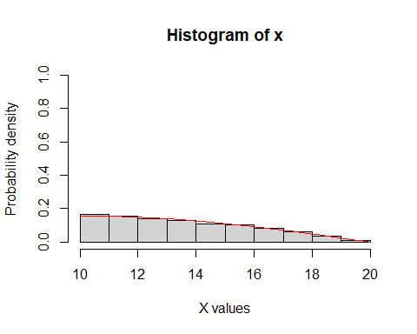

## c)

To have a standard deviation below 0.002 we must first repeat the **pr1_prob** function to find a standard deviation. To calculate it we may use the **sd** function, where the number of repetitions is chosen to be 1000. Then we use a while loop to increment the number of repetitions **pr1_prob** takes until the desired deviation, here approximately 52000, is reached.

pr1_prob = function(n){  
 x1 = pr1(n)  
 x2 = pr1(n)  
 count = sum((x1 + x2) > 25)  
 return (count / n)  
}  
  
# Checking sdev   
nreps = 10000  
std_dev = 1  
while(std_dev > 0.002){  
 std_dev = sd(replicate(1000, pr1_prob(nreps)))  
 nreps = nreps + 1000  
}  
print(nreps)

## [1] 48000

pr1_prob(52000) # Estimate

## [1] 0.7212692

# Problem 2

## a)

We calculate the times

$$X_{i}$$

by comparing the values of

$$\sum_{1}^{i}{T_{i}}\overset{?}{≥}15i$$

, if it is greater then the appointment overran and the following appointments will be delayed. Then we iterate over the values in Y := X + T, subtracting their arrival times to calculate W, which is then directly inputted into the array. To check the function was working as intended a test with T = (16, 15, 30) was inputted, resulting in W = (16, 16, 32) to be returned, as desired.

gentimes = function(n){   
 z = array(0, c(n, 3))  
 for(i in 1:n){  
 T = runif(3, 5, 30)   
 X = c(0, max(T[1], 15), max(T[1] + T[2], 30) )  
 z[i, ] = (X + T)[1:3] - 15 * (0:2)   
 }  
 return (z)  
}

## b)

The plot has a linear correlation, which can be seen by adding a line of best fit. This implies the variables are not independent.

times = gentimes(2000)  
plot(times[1:2000, 1], times[1:2000, 3], xlab = "W1", ylab = "W3")  
abline(lm(times[1:2000, 3] ~ times[1:2000, 1]), col = "red")

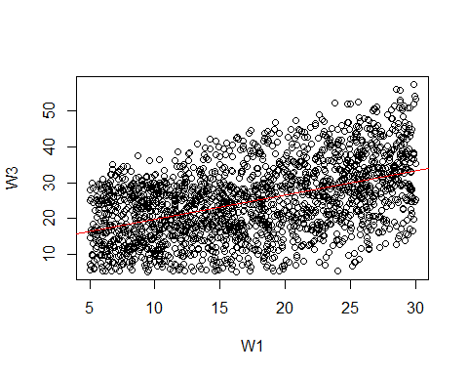

## c)

Firstly we calculate the expectaions as given in the problem sheet. Then we calculate the variance using

$$Var\left(W_{i}\right)=E\left[W_{i}^{2}\right]−E{\left[W_{i}\right]}^{2}$$

and then the covariance,

$$Cov\left(W_{1},W_{3}\right)=E\left[W_{1}W_{3}\right]−E\left[W_{1}\right]E\left[W_{3}\right]$$

. Using these two values we may then calculate the correlation coefficient,

$$Corr\left(W_{1},W_{3}\right)=\frac{Cov\left(W_{1},W_{3}\right)}{\sqrt{Var\left(W_{1}\right)Var\left(W_{3}\right)}}$$

This gives us a correlation coefficient of approximately 0.48.

n = 20000  
wPairs = gentimes(n)[, -2]  
E_W1 = 1/n * sum(wPairs[ , 1])  
E_W1_2 = 1/n * sum(wPairs[ , 1]^2)  
  
E_W3 = 1/n * sum(wPairs[ , 2])  
E_W3_2 = 1/n * sum(wPairs[ , 2]^2)  
  
E_W1_W3 = 1/n * sum(wPairs[ , 1] * wPairs[ , 2])  
  
var_W1 = E_W1_2 - E_W1^2  
var_W3 = E_W3_2 - E_W3^2  
covar_W1_W3 = E_W1_W3 - (E_W1 * E_W3)  
  
corr = covar_W1_W3 / sqrt(var_W1 * var_W3)  
print(corr)

## [1] 0.4802548