Synthetic Augmentation to Bridge the Data Gap in Chest X-Ray Classification

Benjamin Bergenstein
Colorado State University Global
MIS581: Capstone - Business Intelligence and Data Analytics
Dr. Orenthio Goodwin
10/30/2026

Abstract
Small healthcare organizations often cannot build reliable diagnostic imaging models, because access to labeled patient data is restricted by privacy regulation and cost. This study tested whether synthetic chest X-rays can substitute for, or augment, a dataset of only 11 labeled real images. The public Chest X-Ray Images (Pneumonia) dataset was re-partitioned at the patient level to remove data leakage found in the original split, and a 1,222-image hold-out test set was created first. For each of 10 random draws of 11 real images, a Stable Diffusion model was fine-tuned with Low-Rank Adaptation (LoRA) to generate 2,000 synthetic X-rays, and a ResNet-18 classifier was trained under four conditions: real-only on the full training partition, real-only on the 11 images, synthetic-only, and bridged transfer learning (BTL), which pretrains on synthetic images and then fine-tunes on the 11 real images. The Matthews Correlation Coefficient (MCC) was the primary metric, and paired comparisons used two-level bootstrap confidence intervals with Holm correction. The synthetic-only model scored significantly lower than the full real-data model, with an MCC difference of -0.277, p = .024, so the first null hypothesis was rejected. BTL did not significantly improve MCC at the default threshold over either small-data baseline, but significantly improved the area under the receiver operating characteristic curve (ROC-AUC) by 0.087, and calibrated MCC by 0.160, over the 11-image model. BTL remained 0.083 below the full real-data model in ROC-AUC, and missed more pneumonia cases, so the gap was only partially closed. These results held under a patient-level bootstrap. Synthetic pretraining is a feasible, low-cost way to improve models built from very limited data, but does not replace real data, and requires local calibration and validation before clinical use.
Keywords: synthetic data, bridged transfer learning, chest X-ray, diffusion models, data scarcity, healthcare machine learning

Synthetic Augmentation to Bridge the Data Gap in Chest X-Ray Classification

Introduction
Access to real identifiable data is often the limiting factor between organizations that can build reliable machine learning models, and organizations that cannot. The healthcare industry is one of the most impacted examples of this limitation. Diagnostic imaging models depend on thousands of labeled patient scans, yet the same patient scans needed to train these models are protected under HIPAA (Health Insurance Portability and Accountability Act) and comparable privacy regulations. Using patient data in a development environment typically requires IRB (Institutional Review Board) approval, formal de-identification, and a data use agreement, which is a slow and costly process for smaller organizations. From previous experience as a data scientist supporting healthcare systems on government contracts, development environments were not allowed to use production data, so models had to be built using mock data, or very small approved samples.
Synthetic data has emerged as a response to this restriction, and published work has shown that synthetic images can help improve medical imaging classifiers (Dushenev et al., 2026; Waheed et al., 2020).
The specific problem this research addresses is that small healthcare providers, independent researchers, and health-technology startups are frequently unable to build reliable diagnostic imaging models, because these organizations cannot access enough labeled real patient data. The purpose of this study is to determine whether synthetic chest X-ray images can substitute for, or meaningfully augment, a very small real dataset of 11 images. The study tests BTL (Bridged Transfer Learning), which pretrains a classifier on synthetic images, and then fine-tunes the classifier on a small set of real images (Li et al., 2024).

Objectives
The first objective is to measure the performance gap between a classifier trained only on synthetic chest X-rays, and a classifier trained on the full set of real images. The second objective is to determine whether BTL significantly improves on training with the same 11 real images alone, or with synthetic images alone. The third objective is to evaluate the practical limitations of synthetic medical images, including generator quality and privacy risks, so the findings become concrete guidance for smaller organizations.

Overview of Study
The study is a controlled experiment built around a small organization that holds only 11 labeled chest X-rays (five normal, and six pneumonia). For each of 10 random seeds, a different set of 11 real images is drawn, and a pretrained Stable Diffusion model is fine-tuned on those 11 images to generate 2,000 synthetic X-rays. A classifier is then trained under four conditions: real-only on the full training partition, real-only on the 11 images, synthetic-only, and BTL. Every condition is scored on the same hold-out real test set, which was created before any other step. Each seed represents a different small organization.

Research Questions and Hypotheses
The research questions are:
Question 1: How large is the performance gap between a classification model trained only on synthetic chest X-rays, and a classification model trained only on the full set of real chest X-rays, when both are evaluated on the same hold-out real test set?
Question 2: Does BTL, which pretrains a model on synthetic images and then fine-tunes the model on the same 11 real images, produce a statistically significant improvement over training on the 11 real images alone, or over training on synthetic images alone?
Question 3: Can BTL close the gap to the full real-dataset benchmark within a practical margin defined before any results were produced?
Question 1 establishes the baseline gap between synthetic and real data. Question 2 is the main premise, testing whether synthetic pretraining improves on the options a small organization faces. Question 3 asks whether the improvement is large enough to matter in practice. The primary metric is MCC (Matthews Correlation Coefficient), and the significance level is set in advance at alpha = .05. The hypotheses are:
Hypothesis 1 (Question 1)
Ho1: There is no statistically significant difference in MCC between the synthetic-only model and the real-only model trained on the full training partition.
Ha1: There is a statistically significant difference in MCC between the synthetic-only model and the real-only model trained on the full training partition.
Hypothesis 2 (Question 2)
Ho2a: There is no statistically significant difference in MCC between the BTL model and the real-only model trained on the same 11 images.
Ha2a: There is a statistically significant difference in MCC between the BTL model and the real-only model trained on the same 11 images.
Ho2b: There is no statistically significant difference in MCC between the BTL model and the synthetic-only model.
Ha2b: There is a statistically significant difference in MCC between the BTL model and the synthetic-only model.
Hypothesis 3 (Question 3)
Ho3: The BTL model’s ROC-AUC (Receiver Operating Characteristic Area Under the Curve) is more than 0.05 below the full real-data benchmark, meaning the gap is not closed.
Ha3: The BTL model’s ROC-AUC is within 0.05 of the full real-data benchmark, meaning the gap is closed.

Literature Review
This literature review discusses four areas of research that support the study, which are the data access problem in healthcare, synthetic medical images and the synthetic data gap, bridged transfer learning, and the evaluation and privacy risks that shaped the research method.

The Data Access Problem in Healthcare
Kermany, Goldbaum, et al. (2018) used transfer learning to train a diagnostic model on more than 100,000 retinal images, and then applied the same approach to the pediatric chest X-ray dataset used in this study, showing that strong medical imaging models are possible when enough labeled data exists, which is a volume most smaller organizations do not have. Real patient data is protected under HIPAA, and even de-identified data can still carry residual re-identification risk (U.S. Department of Health and Human Services, 2012). Chen et al. (2021) described synthetic data as a response to both data scarcity and privacy restrictions in medicine, while cautioning that synthetic data raises its own questions about fidelity, bias, and regulation. The FDA (U.S. Food and Drug Administration) is also researching the limitations of supplementing patient datasets with synthetic data, citing the cost and privacy constraints of collecting medical data (U.S. Food and Drug Administration, 2024). These sources agree that access to labeled data, rather than the availability of medical cases, is the primary blocker for smaller organizations.

Synthetic Medical Images and the Synthetic Data Gap
Published research consistently shows that synthetic images can improve medical image classifiers when the synthetic images are added to real data. Frid-Adar et al. (2018) used GAN (Generative Adversarial Network) generated liver lesion images to raise classification sensitivity from 78.6% to 85.7%, Waheed et al. (2020) raised chest X-ray classification accuracy from 85% to 95%, and Dushenev et al. (2026) fine-tuned a pretrained diffusion model on a small number of real images using LoRA (Low-Rank Adaptation), raising a chest X-ray classifier’s F1 score from 0.19 to 0.69. However, the broader medical imaging literature questions how much of the gains survive outside the original dataset in a practical setting. Roberts et al. (2021) screened 2,212 COVID-19 imaging studies, and found that none of the 62 studies passing quality review produced models of potential clinical use, because of dataset bias, inappropriate validation, and limited external testing. Each of these synthetic data studies also adds synthetic images to real data rather than replacing real data. Bay et al. (2025) found that object detection models trained only on synthetic images performed at roughly the same level of a model trained on 10% of the real data, which is the synthetic data gap that Question 1 measures. An open question remains, since few studies test synthetic data when an organization holds only around 10 – 11 labeled real images, which is the case this study is built around.

Bridged Transfer Learning
How the synthetic data is used during training matters as much as the quality of the synthetic data. Li et al. (2024) found that pretraining a model on synthetic images first, and then fine-tuning the model on real images, outperformed simply mixing synthetic and real images in the same training run. Bay et al. (2025) reported a similar benefit in warehouse object detection. Because neither study tested medical image classification, this study transfers the BTL principle to chest X-rays and tests whether the principle holds true, which forms the basis of Questions 2 and 3.

Evaluation and Privacy Risks
Zech et al. (2018) showed that pneumonia models often performed worse on X-rays from hospitals outside the training data, indicating the models had learned hospital-specific features rather than specific disease features. That finding supports the patient-level partitioning used in this study, and a hold-out test set that is scored only after every decision is frozen. Because roughly 74% of the test images are pneumonia, a model that predicts pneumonia for every image still produces a high F1 score, so MCC is used as the primary metric, since MCC accounts for all four cells of the confusion matrix (Chicco & Jurman, 2020). Lastly, the literature agrees that synthetic data is not automatically private. Membership inference attacks can reveal whether a specific record was used to train a model (Shokri et al., 2017), and Duan et al. (2023) showed that diffusion models are vulnerable to membership inference attacks.

Research Design
The research design describes the type of research, the data, and the procedures used to answer the research questions.

Methodology
This study uses a quantitative methodology with an experimental design. The study manipulates one independent variable, the training condition, while holding other factors constant, and measures the effect on numeric outcomes. The approach is deductive, since the hypotheses were stated before the experiment, and the analysis either rejects or fails to reject each null hypothesis (Polonsky & Waller, 2019). A qualitative or mixed methods design would not fit, because the research questions ask whether performance differences are statistically significant.
The data is secondary data combined with generated data. The real images were collected and labeled by others (Kermany, Goldbaum, et al., 2018). Although reading a chest X-ray is traditionally a qualitative judgment, each image is treated as a record of numeric pixel intensities on a 0 – 255 scale, the diagnosis is a binary variable, where 0 = normal, and 1 = pneumonia, and the outcomes, such as MCC and ROC-AUC, are continuous ratio-level measures. The design is a paired, repeated-measures comparison, since every model is scored on the same test images, and each of the 10 seeds acts as a block. Table 1 summarizes the variables carried by each record.
Table 1
Data Dictionary for Real and Synthetic Chest X-Ray Records
Variable | Description | Type | Values / Range | Role in Analysis
patient_id | Patient identifier parsed from the filename | Nominal | 3,117 unique patients | Grouping key for partitioning
label | Diagnosis | Binary | 0 = normal (1,579); 1 = pneumonia (4,245) | Dependent variable
subtype | Pneumonia type | Nominal | none, bacterial (2,760), viral (1,485) | Descriptive; stratification
pixel_intensity | Grayscale brightness of each pixel | Interval | 0–255 | Model input features
color_mode | Stored color format | Nominal | grayscale (5,541), RGB (283) | Preprocessing (convert)
partition | Partition assignment | Nominal | test_holdout, train, validation, fewshot_seed_k | Leakage control
source | Real or synthetic origin | Binary | 0 = real, 1 = synthetic | Condition assignment
seed | Random seed for each draw and generation run | Nominal | 0–9 | Reproducibility
condition | Training condition | Nominal | real full, real 11, synthetic-only, BTL | Independent variable
MCC, ROC-AUC, F1, sensitivity, specificity, precision | Model performance on the hold-out test set | Ratio (continuous) | MCC −1 to 1; others 0–1 | Outcome measures
Note. Values come from profiling the 5,824 unique real images. The source, seed, and condition variables apply once synthetic images are generated, and outcome measures are recorded for each model and condition.

Methods

Data Preparation and Partitioning
After removing a duplicate folder in the Kaggle download, and 32 exact duplicate images identified by a file hash, the working dataset contains 5,824 unique images from 3,117 patients. Profiling also showed the original Kaggle split is unusable, as 170 patients appear in both the original training and test folders, and 317 of the 618 original test images come from those patients. Evaluating on that split would reward recognizing patients already seen, which is data leakage (Kaufman et al., 2012).
To prevent data leakage, the patient ID was extracted from each filename, and the images were re-partitioned at the patient level using class-stratified group sampling, as shown in Figure 1. The hold-out test set of 1,222 images from 624 patients was created first, before any other step. A patient-level validation partition of 706 images was then held out for model selection, leaving a training partition of 3,896 images. For each of the 10 seeds, 11 images (five normal, and six pneumonia, with only one image per patient) were drawn from the training partition only. Each draw is random within these rules, and is seeded so every draw can be reproduced exactly. The same 11 images are used to fine-tune the generator, and to fine-tune the real-only, and BTL classifiers so no condition gains hidden access to additional real data.
Figure 1
Data Flow and Patient-Level Partitioning
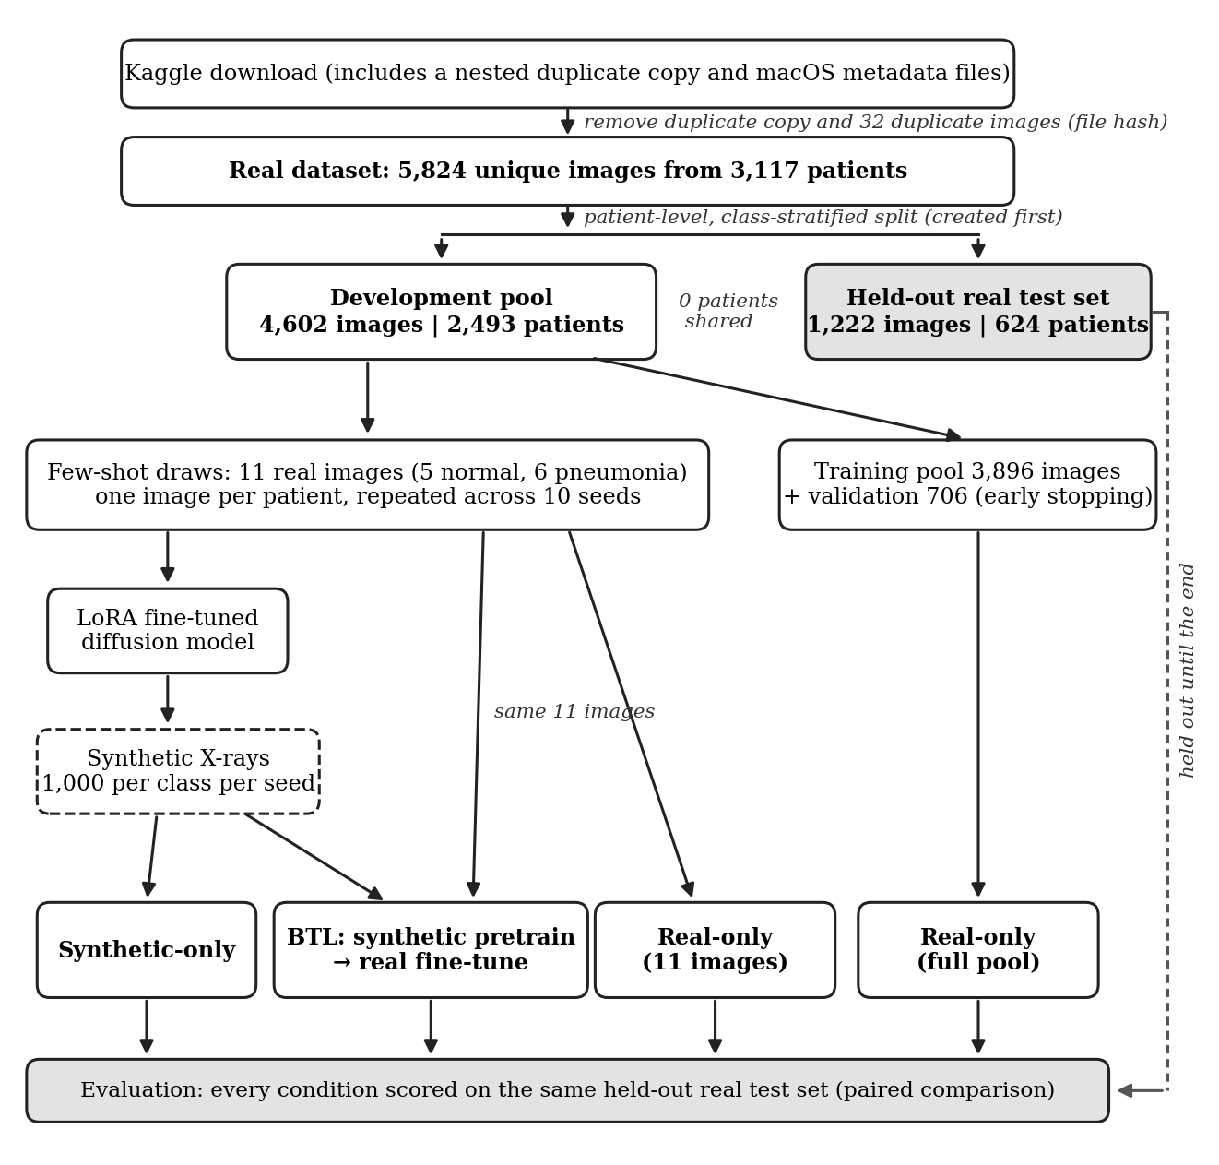
Note. Counts reflect the profiled dataset after duplicate removal. The hold-out test set was created before any other step and is used only for final evaluation. Every image was processed with the same fixed CLAHE transformation before training and evaluation.

Preprocessing
Every image was converted to grayscale, padded to a square, and resized to 224 × 224 pixels. Grayscale conversion matters, because all 283 color images belong to the pneumonia class, and a model could otherwise learn color as a shortcut for the diagnosis. Every image was then processed with CLAHE (Contrast-Limited Adaptive Histogram Equalization) using fixed parameters, a clip limit of 3.0, and 8 × 8 tiles (Zuiderveld, 1994). No CLAHE parameters are estimated from the data, and the same transformation is applied to every real and synthetic image without using labels. CLAHE was chosen because the synthetic images showed a brightness shift, where real normal images resembled synthetic pneumonia images. CLAHE was used to reduce that real-to-synthetic mismatch, and reduced brightness variability is not assumed to improve generalization on its own.

Synthetic Data Generation
For each seed, a pretrained Stable Diffusion 1.5 model was fine-tuned with LoRA on that seed’s 11 real images (Hu et al., 2021; Rombach et al., 2022). LoRA trains only a small number of added weights, which made fine-tuning feasible on a local NVIDIA RTX 3060 GPU (Graphics Processing Unit). The checkpoint rule of 500 training steps was fixed using seed 0 only, and then applied unchanged to every seed. Each fine-tuned model generates 1,000 synthetic normal X-rays, and 1,000 synthetic pneumonia X-rays, for a total of 20,000 synthetic images across the 10 seeds.

Classification Models
The classifier is a ResNet-18 convolutional neural network pretrained on ImageNet (He et al., 2016), trained under four conditions. The full-pool model trains on all 3,896 training images, with early stopping on the validation partition. The real-only small model trains on the seed’s 11 images, the synthetic-only model trains on the seed’s 2,000 synthetic images, and the BTL model starts from the synthetic-only weights, and then fine-tunes on the same 11 real images. The real-only small model and the BTL model use an identical training recipe, and differ only in the starting weights. The few-shot training recipe was selected from a fixed grid of candidates using the validation partition only, and the primary analysis uses a decision threshold of 0.5.

Evaluation Measures
Realism, predictive performance, and privacy are reported as three separate measures. Realism is measured with KID (Kernel Inception Distance) using a pretrained Inception-v3 network. Predictive performance is measured on the hold-out test set using MCC as the primary metric, with ROC-AUC, F1 score, sensitivity, specificity, precision, and a confusion matrix reported for every condition. Pneumonia is designated as the positive class. With roughly 74% of the test images labeled pneumonia, a model that predicts pneumonia for every image has a precision of about 0.74, and a recall of 1.0, which produces an F1 score of approximately 0.85, while the same model scores an MCC of 0. Any condition must exceed that F1 score of 0.85 to be considered better than the trivial classifier. Privacy is checked by rejecting any synthetic image with a cosine similarity above 0.95 to one of the 11 training images.

Statistical Tests
The statistical tests were chosen to match the structure of the experiment. Every condition is scored on the same 1,222 hold-out images, and each seed produces one result for every condition, so the observations are paired rather than independent. A Friedman test, which is the nonparametric test for comparing more than two related conditions, is reported for each metric with the 10 seeds treated as blocks (Polonsky & Waller, 2019). The pre-specified comparisons for Hypotheses 1, 2a, and 2b are then tested in three ways. First, a two-level paired bootstrap with 1,000 resamples draws seeds with replacement, and then draws test images with replacement within each seed, so the 95% confidence interval reflects variation from both the 11 images drawn and the test images used for scoring. Second, a paired t-test and a Wilcoxon signed-rank test compare the 10 per-seed differences, where the Wilcoxon test does not assume the differences are normally distributed. Third, McNemar’s test compares the predictions of two models on the same test images within each seed.
The decision rule for each null hypothesis is the Holm-adjusted bootstrap p value at alpha = .05, where the Holm correction controls the chance of a false positive across the three primary comparisons. The paired t-test and Wilcoxon test are reported as supporting evidence. Because some patients contributed more than one test image, the bootstrap was also repeated with patients rather than images as the resampling unit, as a sensitivity analysis. Hypothesis 3 is tested as a non-inferiority test rather than a difference test, so Ho3 is rejected only if the lower bound of the 95% confidence interval for the BTL minus benchmark ROC-AUC difference is at or above -0.05. A recall guard also flags the BTL model if BTL sensitivity falls more than 0.05 below the full real-data benchmark. As a secondary analysis, each model’s decision threshold was also tuned to maximize MCC on the validation partition, and then applied once to the hold-out test set.

Tools
Python is the primary platform used for this research. Table 2 lists each tool, the purpose of each tool, and the URL for each tool and dataset.
Table 2
Tools, Resources, and URLs Used in This Study
Tool or Resource | Purpose in This Study | URL
Python | Primary programming platform | https://www.python.org/
pandas | Data profiling and preparation | https://pandas.pydata.org/
scikit-learn | Patient-level partitioning (StratifiedGroupKFold) and evaluation metrics | https://scikit-learn.org/
SciPy | Statistical tests | https://scipy.org/
OpenCV | CLAHE preprocessing | https://opencv.org/
PyTorch and torchvision | ResNet-18 classifier training | https://pytorch.org/
Hugging Face Diffusers | Synthetic image generation | https://huggingface.co/docs/diffusers
Hugging Face PEFT | LoRA fine-tuning | https://huggingface.co/docs/peft
Stable Diffusion 1.5 | Pretrained image generator | https://huggingface.co/stable-diffusion-v1-5/stable-diffusion-v1-5
Matplotlib | Figures | https://matplotlib.org/
Chest X-Ray Images (Pneumonia) | Real dataset (Kaggle distribution) | https://www.kaggle.com/datasets/paultimothymooney/chest-xray-pneumonia
Mendeley Data | Original dataset release | https://doi.org/10.17632/rscbjbr9sj.2
Note. All tools are open source and run on a local Windows machine with an NVIDIA RTX 3060 GPU. The dataset is cited as Kermany, Zhang, and Goldbaum (2018) and Mooney (2018).

Limitations
The first limitation is the source of the data. All real images come from one pediatric medical center, with patients aged one to five (Kermany, Goldbaum, et al., 2018). Although the hold-out test set is partitioned at the patient level, the hold-out test set comes from the same source as the training data, so the results do not show how the models would perform on adults, on other imaging equipment, or at other institutions (Zech et al., 2018). The dataset also contains no demographic information, so performance cannot be compared across patient groups.
The second limitation is the small real sample. Synthetic images may reproduce the narrow characteristics of the 11 images rather than the broader patient population, and because each seed changes both the image sample and the training randomness, the study cannot separate the two sources of variation. The full real-data benchmark also trains on patients who contributed many images.
The third limitation is the generator. Stable Diffusion 1.5 is a general-purpose image model rather than a generator built for chest X-rays, and the KID measure and near-copy screen rely on a network pretrained on everyday photographs. The near-copy screen is also not a formal membership inference test (Shokri et al., 2017), so the study cannot claim the synthetic images carry no privacy risk.
The final limitation concerns the hold-out evaluation. First, the hold-out test set was scored twice. The training recipe was revised after the first run using the validation partition only, and the revised protocol was recorded before the test set was scored a second time. The failure of the first run was diagnosed using the validation partition, but the knowledge that the first run had failed on the test set motivated the revision, so the second run is not fully independent of the hold-out test set. The final results should therefore be read as confirmatory with this caveat, and only an untouched external test set would fully remove the concern. Second, the 1,222 test images come from 624 patients, so some test images share a patient. A patient-level bootstrap produced nearly identical confidence intervals, but the McNemar tests still treat images as independent. Third, 74% of the test images are pneumonia, which reflects the source dataset rather than a typical clinic, and threshold-based metrics such as MCC, F1 score, and precision would change at a different prevalence. Lastly, the validation partition used for the secondary threshold calibration contains 706 labeled images, which is more labeled data than the small organizations this study represents would hold.

Ethical Considerations
The chest X-rays used in this study were released in de-identified form for research use under an open license, so this study does not access protected health information or interact with patients (Kermany, Zhang, & Goldbaum, 2018). If this data had been collected directly, several obligations would apply. The study would first require IRB approval, and because the patients are children, consent would be needed from a parent or guardian, unless the IRB granted a waiver for retrospective use of existing records. Before leaving the clinical system, the images would need to be de-identified under the HIPAA Safe Harbor or Expert Determination standard, including identifiers burned into the image itself (U.S. Department of Health and Human Services, 2012). A data use agreement would define who can access the data, and for what purpose.
Data security would also be required throughout the project. In this study, all data and models are stored and processed on a single local machine, and no images are uploaded to cloud services. With collected patient data, the same approach would add encrypted storage, restricted access, and an audit trail. Synthetic data would not remove these obligations, since diffusion models can memorize training images (Duan et al., 2023). Synthetic data is therefore treated as privacy-enhancing rather than privacy-guaranteeing.
The final ethical consideration is clinical harm and research integrity. A missed pneumonia case is more harmful than a false alarm, so sensitivity is reported for every condition, and the models are research models not intended for clinical use. To keep the results unbiased, the decision rules were recorded before the test set was used, and every training run, including runs that did not perform as intended, is reported. The dataset is used under the CC BY 4.0 license, and the Stable Diffusion model is used under the CreativeML OpenRAIL-M license, which restricts harmful uses of the model.

Findings
This section presents the descriptive statistics, synthetic image quality, the first training run, model performance, and the result of each hypothesis test. Unless the first run is named, all results come from the final run, in which the test set was scored once after the training was frozen.

Descriptive Statistics
Table 3 below summarizes the real dataset. Pneumonia patients contributed an average of 2.54 images each, compared with 1.09 images for normal patients, which explains much of the 2.7 to 1 class imbalance. The two classes also differ in ways unrelated to pneumonia. All 283 color images are pneumonia images, and normal images are larger on average, at 1,686 × 1,378 pixels compared with 1,194 × 818 pixels for pneumonia images. These differences are the reason every image was converted to grayscale and resized before modeling, and CLAHE reduced the spread of chest brightness by roughly half in both classes. The hold-out test set contains 316 normal images, and 906 pneumonia images, so 74.1% of the test images are pneumonia.
Table 3
Descriptive Statistics for the Real Chest X-Ray Dataset
Measure | Normal | Pneumonia | Total
Unique images | 1,579 | 4,245 | 5,824
Patients | 1,443 | 1,674 | 3,117
Images per patient, M (maximum) | 1.09 (4) | 2.54 (31) | 1.87 (31)
Color (RGB) images | 0 | 283 | 283
Mean image size (pixels) | 1,686 × 1,378 | 1,194 × 818 | 1,327 × 970
Chest brightness, M (SD), original | 137.4 (14.6) | 146.7 (21.1) | 144.2 (19.9)
Chest brightness, M (SD), after CLAHE | 137.0 (6.9) | 149.2 (11.8) | 145.9 (12.0)
Synthetic chest brightness, M (sample of 160 per class) | 124.0 | 133.1 | -
Hold-out test images | 316 | 906 | 1,222
Note. Chest brightness is the mean pixel intensity (0–255) of the central chest region. CLAHE = Contrast-Limited Adaptive Histogram Equalization. The synthetic sample contains 40 images per class from each of four seeds.

Synthetic Image Realism and Privacy
Realism and privacy were measured separately from predictive performance. Across the 10 seeds, KID values multiplied by 1,000 ranged from 142 to 415, with an average of about 256 for both classes, which means the synthetic images remained clearly distinguishable from real X-rays at every seed. As shown in Figure 2, the synthetic images were darker and higher in contrast than the real images. The average chest brightness of synthetic normal images was 124.0, compared with 137.4 for real normal images, so real normal images more closely resembled synthetic pneumonia images, at 133.1. The KID measure did not detect this brightness shift. For privacy, none of the 20,000 synthetic images were rejected by the near-copy screen, with a highest cosine similarity to a training image of 0.919.
Figure 2
Example Real and Synthetic Chest X-Rays Before and After CLAHE
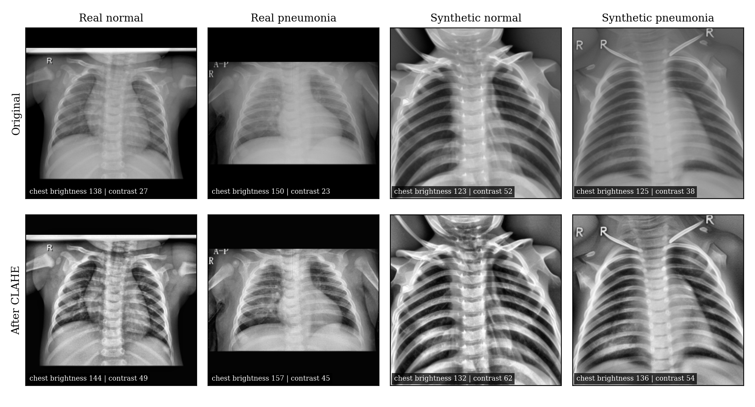
Note. The top row shows original images, and the bottom row shows the same images after CLAHE. Values show the chest-region brightness and contrast of each image. The synthetic images are darker and higher in contrast than the real images, and CLAHE narrows the difference.

First Training Run
In the first training run, the few-shot models fine-tuned the full network for 150 steps on the 11 real images, and the models memorized the 11 images. At the 0.5 threshold, the real-only small, synthetic-only, and BTL models predicted pneumonia for nearly every test image, with average specificity between 0.08 and 0.14. The average F1 scores of these models, between 0.82 and 0.86, were close to the 0.85 produced by labeling every image as pneumonia, so MCC became the primary metric. Two causes were identified using the validation partition. The first cause was overfitting to the 11 images, and the second cause was the brightness shift between real and synthetic images, which led models pretrained on synthetic images to label real normal images as pneumonia. The revised recipe trains only the final block and classifier head for 25 steps, with dropout, label smoothing, weight decay, augmentation, and CLAHE. On the validation partition, these changes raised the average MCC of the few-shot models from 0.180 to 0.326, and raised the BTL model’s specificity from 0.04 to 0.44, which justified freezing the revised recipe before the test set was scored again.

Model Performance by Condition
Table 4 below shows the average performance of each condition across the 10 seeds, and Figure 3 shows the result of every seed. The full real-data benchmark performed best on every metric, with an MCC of 0.502, and a ROC-AUC of 0.953. Among the conditions available to a small organization, the BTL model had the highest MCC (0.328), the highest ROC-AUC (0.870), and the highest specificity (0.441), followed by the real-only small model and the synthetic-only model. However, results varied widely between seeds. The BTL model’s MCC ranged from 0 to 0.655, and two BTL seeds still predicted pneumonia for every test image at the 0.5 threshold. The synthetic-only model had high sensitivity (0.931) but the lowest specificity (0.254), labeling most normal images as pneumonia. Lastly, only five of the 10 BTL seeds exceeded the always-pneumonia F1 score of 0.85, compared with nine of 10 for the full real-data benchmark.
Table 4
Mean Hold-Out Test Performance by Training Condition Across 10 Seeds
Measure | Real-only, full partition | Real-only, 11 images | Synthetic-only | BTL
MCC (primary) | 0.502 (0.282) | 0.272 (0.168) | 0.224 (0.230) | 0.328 (0.236)
ROC-AUC | 0.953 (0.030) | 0.784 (0.088) | 0.810 (0.117) | 0.870 (0.034)
F1 score | 0.899 (0.039) | 0.811 (0.085) | 0.849 (0.029) | 0.839 (0.047)
Sensitivity | 0.967 (0.055) | 0.838 (0.189) | 0.931 (0.090) | 0.871 (0.156)
Specificity | 0.454 (0.362) | 0.416 (0.326) | 0.254 (0.320) | 0.441 (0.416)
Precision | 0.847 (0.088) | 0.822 (0.071) | 0.791 (0.075) | 0.841 (0.098)
MCC at calibrated threshold | 0.746 (0.080) | 0.383 (0.160) | 0.457 (0.179) | 0.543 (0.081)
True negatives | 143.6 | 131.6 | 80.3 | 139.5
False positives | 172.4 | 184.4 | 235.7 | 176.5
False negatives | 29.5 | 147.2 | 62.9 | 116.9
True positives | 876.5 | 758.8 | 843.1 | 789.1
Note. Values are M (SD) across the 10 seeds at the default 0.5 threshold, except the calibrated MCC, which uses each model’s validation-tuned threshold. The last four rows are mean confusion matrix counts per seed for 316 normal and 906 pneumonia test images, with pneumonia as the positive class. MCC = Matthews Correlation Coefficient; ROC-AUC = Receiver Operating Characteristic Area Under the Curve; BTL = Bridged Transfer Learning.
Figure 3
Per-Seed Test Performance by Training Condition
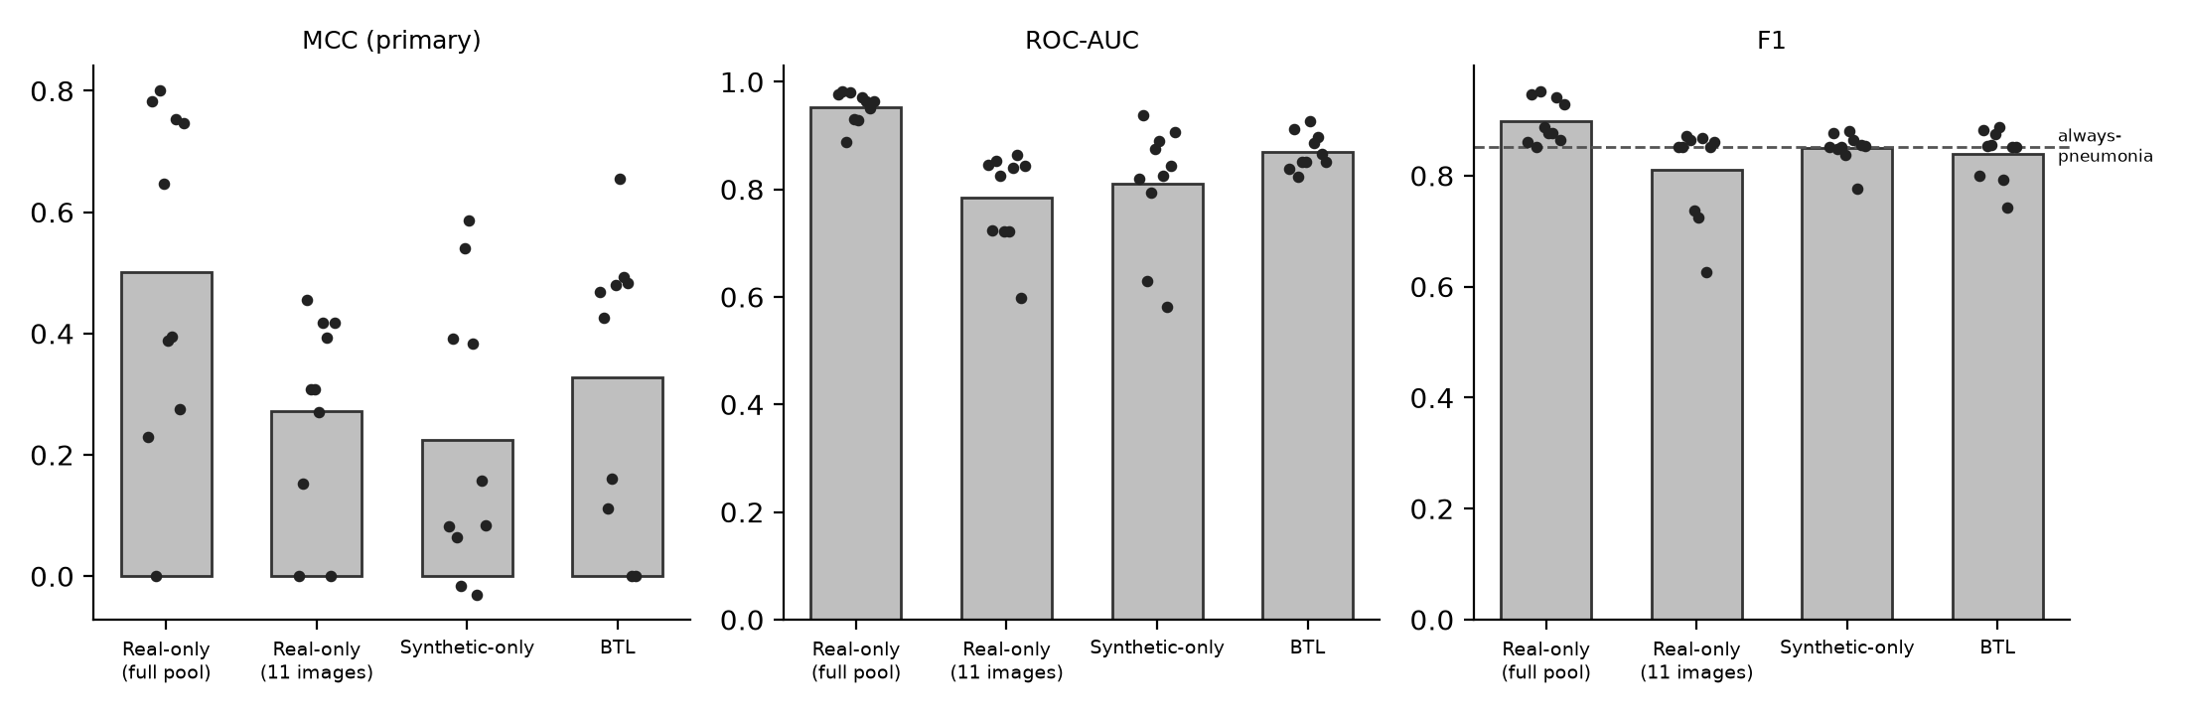
Note. Bars show the mean of the 10 seeds, and each point is one seed. The dashed line in the F1 panel marks the F1 score of 0.85 produced by labeling every image as pneumonia.

Hypothesis Testing
Table 5 reports the result of each pre-specified comparison. The Friedman test, run separately on each metric, showed significant differences across the four conditions for ROC-AUC, χ²(3) = 20.28, p < .001, and for MCC at the calibrated threshold, χ²(3) = 18.60, p < .001, but not for MCC at the default threshold, χ²(3) = 6.09, p = .107. Because the pairwise comparisons were planned in advance, the pairwise comparisons are still reported, but the MCC comparisons should be interpreted with caution.
Table 5
Pre-Specified Paired Comparisons and Hypothesis Decisions
Hypothesis and comparison | Metric | M diff. | 95% CI | Holm p | t-test p | Wilcoxon p | Seeds better | Decision
Primary
H1: Synthetic-only vs. full real | MCC | -0.277 | [-0.509, -0.060] | .024 | .039 | .049 | 2/10 | Reject
H2a: BTL vs. real-only (11) | MCC | 0.055 | [-0.109, 0.218] | .520 | .563 | .570 | 6/10 | Fail to reject
H2b: BTL vs. synthetic-only | MCC | 0.104 | [-0.014, 0.223] | .188 | .151 | .232 | 7/10 | Fail to reject
H3: BTL vs. full real (non-inferiority) | ROC-AUC | −0.083 | [-0.107, -0.058] | - | < .001 | .002 | 0/10 | Fail to reject
Secondary
Synthetic-only vs. full real | ROC-AUC | -0.143 | [-0.221, -0.087] | < .002 | .003 | .002 | 0/10 | -
BTL vs. real-only (11) | ROC-AUC | 0.087 | [0.031, 0.150] | < .002 | .026 | .027 | 8/10 | -
BTL vs. synthetic-only | ROC-AUC | 0.060 | [-0.001, 0.137] | .054 | .127 | .131 | 7/10 | -
BTL vs. real-only (11) | MCC (cal.) | 0.160 | [0.053, 0.289] | < .002 | .027 | .020 | 8/10 | -
BTL vs. synthetic-only | MCC (cal.) | 0.085 | [-0.014, 0.200] | .108 | .164 | .232 | 7/10 | -
Note. M diff. = mean per-seed difference (first condition minus second). 95% CI from a two-level paired bootstrap with 1,000 resamples. Holm p = Holm-adjusted bootstrap p across the three primary comparisons for each metric; with 1,000 resamples the smallest resolvable value is .002. Hypothesis 3 is decided by the confidence interval: Ho3 is rejected only if the lower bound is at or above -0.05. Seeds better = seeds in which the first condition scored higher. MCC (cal.) = MCC at each model’s validation-calibrated threshold.
For Hypothesis 1, the synthetic-only model scored an average MCC 0.277 lower than the full real-data benchmark, 95% CI [-0.509, -0.060], Holm-adjusted p = .024, with the paired t-test (p = .039) and Wilcoxon test (p = .049) in agreement. Ho1 is therefore rejected. The difference was even clearer for ROC-AUC, where the synthetic-only model scored lower than the benchmark in all 10 seeds.
For Hypothesis 2a, the BTL model scored an average MCC 0.055 higher than the real-only small model, 95% CI [-0.109, 0.218], Holm-adjusted p = .520, so the study fails to reject Ho2a. For Hypothesis 2b, the BTL model scored an average MCC 0.104 higher than the synthetic-only model, 95% CI [-0.014, 0.223], Holm-adjusted p = .188, so the study also fails to reject Ho2b. Although the primary MCC comparison was not significant, the BTL model significantly outperformed the real-only small model on ROC-AUC, with a difference of 0.087, 95% CI [0.031, 0.150], in eight of the 10 seeds, and on MCC at the calibrated threshold, with a difference of 0.160, 95% CI [0.053, 0.289]. These secondary results indicate that synthetic pretraining improved how well the model ranks pneumonia cases, while the default threshold limited how much of that improvement reached the model’s decisions.
For Hypothesis 3, the BTL model’s ROC-AUC was 0.083 below the full real-data benchmark, 95% CI [-0.107, -0.058], and the BTL model scored lower than the benchmark in all 10 seeds. Because the lower bound of the confidence interval falls below -0.05, the study fails to reject Ho3, and the gap is not closed. Under the pre-registered tiers, the result is partially closed, since the average difference falls between -0.05 and -0.10, and synthetic pretraining recovered about 31% of the ROC-AUC gap between the real-only small model and the benchmark.

Patient-Level Sensitivity Analysis
Because the 1,222 test images came from 624 patients, and 245 patients contributed more than one image, the bootstrap was repeated with patients rather than images as the resampling unit, so that all images from one patient were resampled together. As shown in Table 6, the patient-level confidence intervals were nearly identical to the image-level intervals, and no hypothesis decision changed. For example, the Hypothesis 3 difference in ROC-AUC was -0.083, 95% CI [-0.105, -0.058], compared with [-0.107, -0.058] at the image level. The similarity indicates that most of the uncertainty in the results comes from which 11 images are drawn, rather than from repeated images of the same patient. One secondary comparison, BTL versus synthetic-only on ROC-AUC, moved from p = .054 to p = .018. Repeating that comparison with different random resamples produced p values between .024 and .05 under both methods, so the comparison is treated as borderline rather than significant.
Table 6
Image-Level and Patient-Level Bootstrap Confidence Intervals
Comparison | Metric | Image-level 95% CI | Patient-level 95% CI | Patient-level Holm p | Decision changed
Primary
H1: Synthetic-only vs. full real | MCC | [-0.509, -0.060] | [-0.484, -0.084] | .036 | No
H2a: BTL vs. real-only (11) | MCC | [-0.109, 0.218] | [-0.117, 0.211] | .536 | No
H2b: BTL vs. synthetic-only | MCC | [-0.014, 0.223] | [-0.010, 0.241] | .184 | No
H3: BTL vs. full real | ROC-AUC | [-0.107, -0.058] | [-0.105, -0.058] | - | No
Secondary
Synthetic-only vs. full real | ROC-AUC | [-0.221, -0.087] | [-0.212, -0.084] | < .002 | -
BTL vs. real-only (11) | ROC-AUC | [0.031, 0.150] | [0.028, 0.147] | .008 | -
BTL vs. synthetic-only | ROC-AUC | [-0.001, 0.137] | [0.005, 0.133] | .018 | Borderline
BTL vs. real-only (11) | MCC (cal.) | [0.053, 0.289] | [0.052, 0.282] | .004 | -
BTL vs. synthetic-only | MCC (cal.) | [-0.014, 0.200] | [-0.015, 0.186] | .098 | -
Sensitivity guard: BTL vs. full real | Sensitivity | - | [-0.201, 0.001] | - | -
Note. Both analyses use 1,000 two-level bootstrap resamples with seeds resampled at the first level. The image-level analysis resamples the 1,222 test images, and the patient-level analysis resamples the 624 test patients, keeping all images from a patient together. The BTL versus synthetic-only ROC-AUC comparison produced p values between .024 and .05 across repeated resampling runs and is treated as borderline. MCC (cal.) = MCC at the validation-calibrated threshold.

Sensitivity Guard and Calibrated Threshold
The pre-registered recall guard was triggered. The BTL model’s average sensitivity was 0.871, compared with 0.967 for the full real-data benchmark, a difference of 0.096, which is larger than the 0.05 margin, and the BTL model fell more than 0.05 below the benchmark in four of the 10 seeds. Compared with the real-only small model, which is the realistic alternative for a small organization, the BTL model had higher average sensitivity, at 0.871 compared with 0.838, although this difference was not tested for significance. When each model’s threshold was calibrated on the validation partition, the BTL model’s MCC rose from 0.328 to 0.543, and the BTL model’s specificity rose from 0.441 to 0.693, while sensitivity remained similar at 0.862. However, the calibrated thresholds were not stable. The BTL model’s validation-tuned threshold ranged from 0.31 to 0.95 across the 10 seeds, so the improvement depends on having a labeled calibration set, and a threshold chosen at one site may not transfer to another. The calibration used only the validation partition and was applied once to the test set, which keeps calibration separate from final testing, as reporting guidance for clinical prediction models recommends (Collins et al., 2024).

Practical Meaning of Sensitivity and Specificity
In patient terms, the differences in sensitivity matter more than the differences in overall scores. Out of every 100 pneumonia cases in the test set, the full real-data benchmark missed about three, the BTL model missed about 13, and the real-only small model missed about 16. The models were much closer on false alarms, which occurred for about 55 of every 100 normal images with both the benchmark and the BTL model. The BTL model’s gap to the benchmark is therefore almost entirely in missed pneumonia, which is the more dangerous error, since a missed case can delay treatment while a false alarm leads to an additional review. The high false alarm rate of every model at the default threshold also means that none of the models would be usable as an unsupervised screening tool. At the calibrated threshold, false alarms fell to about 31 of every 100 normal images for the BTL model, and about 16 for the benchmark.

Interpretation and Other Factors
Rejecting Ho1 shows that, in this dataset, synthetic images generated from 11 real images do not carry enough diagnostic information to replace real training data. Failing to reject Ho2a, Ho2b, and Ho3 means the study found insufficient evidence that synthetic pretraining improves decisions at the default threshold, or matches a full real dataset. Failing to reject a null hypothesis is not evidence that no effect exists, and with 10 seeds and wide variation between seeds, the study had limited power to detect moderate MCC differences.
The brightness shift between real and synthetic images likely influenced what the models learned. Because synthetic pneumonia images were brighter than synthetic normal images, a model pretrained on synthetic images could learn brightness itself as a sign of pneumonia, and real normal images, which are brighter than synthetic normal images, would then be labeled as pneumonia. In the first run, the BTL model assigned real normal test images an average pneumonia probability of 0.87, compared with 0.41 for the full real-data benchmark, which is consistent with that explanation. On a sample of training and synthetic images, CLAHE reduced the brightness gap between real and synthetic normal images from 17.5 to 6.5, while the brightness difference between real normal and real pneumonia images increased from 10.7 to 14.1. The full real-data benchmark also reached nearly the same ROC-AUC with CLAHE (0.953) as without CLAHE (0.957), which suggests CLAHE did not remove diagnostically relevant information for real images, although subtler losses cannot be ruled out. This finding also shows that general-purpose realism measures such as KID, which rely on features learned from everyday photographs, can miss differences that matter for medical images.
Several other factors may have influenced the results. The first factor is the decision threshold, since most of the BTL model’s advantage appeared in ranking and at the calibrated threshold rather than at the default threshold. The second factor is generator quality, which varied substantially with the 11 images drawn. In an exploratory analysis performed after the results, seeds with more realistic synthetic images, measured by lower KID, tended to produce higher BTL ROC-AUC (Spearman rho = -0.77). The third factor is the benchmark itself. The benchmark selected training epochs using validation F1 score, which rewards predicting pneumonia, and one benchmark seed scored an MCC of 0. The fourth factor is the mix of bacterial and viral cases in each draw.

Conclusion
It has been shown in this paper that synthetic data can help, but cannot replace, real patient data for a small healthcare organization building a chest X-ray classifier. A classifier trained only on synthetic images performed significantly worse than a classifier trained on the full real dataset, so Ho1 was rejected. Bridged transfer learning produced the best results among the options available to a small organization, and significantly improved ROC-AUC and calibrated MCC over training on the 11 real images alone. However, the MCC improvement at the default threshold was not significant, so Ho2a and Ho2b were not rejected, and the BTL model did not reach the full real-data benchmark, so Ho3 was not rejected. The BTL model also missed more pneumonia cases than the benchmark, which triggered the pre-registered sensitivity guard. These conclusions held true when the analysis was repeated at the patient level.
Because the study used only 11 real images per draw, and all data came from one pediatric medical center, the results should be read as preliminary evidence that synthetic pretraining is technically feasible, rather than evidence that the approach is ready for clinical use. The World Health Organization (2021) emphasizes that artificial intelligence used in healthcare requires transparency, human oversight, and ongoing evaluation, and the sensitivity results in this study show why. For smaller healthcare organizations, synthetic pretraining is a low-cost way to improve a model built from very limited data, but a small labeled real set is still needed for calibration, and any model must be validated on the organization’s own real data before use.

Recommendations
Each recommendation below is tied to a specific finding of this study. First, synthetic data should be used to supplement a small real dataset through bridged transfer learning, rather than to replace real data, since the synthetic-only model had the lowest MCC and specificity, and Ho1 was rejected. Second, organizations should reserve a small labeled set of real images to calibrate the decision threshold, since calibration produced the largest improvement in the BTL model’s decisions, although the unstable thresholds across seeds show the calibration set should come from the organization’s own data. Third, synthetic images should be checked with simple image statistics, such as brightness and contrast, before training, since the brightness shift in this study caused the first training run to fail, and KID did not detect the shift. Fourth, because the BTL model missed noticeably more pneumonia cases than the benchmark, any model built this way should only be used as a screening aid, with a clinician reviewing every result.
Before recommending even a limited clinical pilot, the following minimum requirements should be set in advance. The model should be validated on independent real X-rays from the pilot site, partitioned at the patient level, and taken from the site’s own imaging equipment. The model’s sensitivity should be non-inferior to a model trained on real data or to radiologist reads, with the lower bound of the confidence interval within a pre-set margin, which the BTL model in this study did not meet. The decision threshold should be fixed on a separate local calibration set before testing, the synthetic images should pass a formal membership inference test, and the pilot should begin in a silent mode, where predictions are recorded but not used for patient care, with every false negative audited, and performance monitored over time.
For future research, the study should be repeated with several generators and classifiers trained on the same 11 images, which would separate the effect of the image sample from training randomness. Future work should also test a generator built for medical images, reject generators with poor realism, evaluate the models on X-rays from other institutions and adult patients, and use more seeds to increase the power to detect moderate differences in MCC.

References
Bay, M., von Marcard, T., & Fazlija, D. (2025). The impact of synthetic data on object detection model performance: A comparative analysis with real-world data. arXiv. https://doi.org/10.48550/arXiv.2510.12208
Chen, R. J., Lu, M. Y., Chen, T. Y., Williamson, D. F. K., & Mahmood, F. (2021). Synthetic data in machine learning for medicine and healthcare. Nature Biomedical Engineering, 5(6), 493–497. https://doi.org/10.1038/s41551-021-00751-8
Chicco, D., & Jurman, G. (2020). The advantages of the Matthews correlation coefficient (MCC) over F1 score and accuracy in binary classification evaluation. BMC Genomics, 21, Article 6. https://doi.org/10.1186/s12864-019-6413-7
Collins, G. S., Moons, K. G. M., Dhiman, P., Riley, R. D., Beam, A. L., Van Calster, B., Ghassemi, M., Liu, X., Reitsma, J. B., van Smeden, M., Boulesteix, A.-L., Camaradou, J. C., Celi, L. A., Denaxas, S., Denniston, A. K., Glocker, B., Golub, R. M., Harvey, H., Heinze, G., . . . Logullo, P. (2024). TRIPOD+AI statement: Updated guidance for reporting clinical prediction models that use regression or machine learning methods. BMJ, 385, Article e078378. https://doi.org/10.1136/bmj-2023-078378
Duan, J., Kong, F., Wang, S., Shi, X., & Xu, K. (2023). Are diffusion models vulnerable to membership inference attacks? Proceedings of the 40th International Conference on Machine Learning, 202, 8717–8730.
Dushenev, D., Karpov, N., Zinovjev, D., Gorin, A., & Kulikov, K. (2026). Few-shot synthetic data generation with diffusion models for downstream vision tasks. arXiv. https://doi.org/10.48550/arXiv.2605.11898
Frid-Adar, M., Diamant, I., Klang, E., Amitai, M., Goldberger, J., & Greenspan, H. (2018). GAN-based synthetic medical image augmentation for increased CNN performance in liver lesion classification. Neurocomputing, 321, 321–331. https://doi.org/10.1016/j.neucom.2018.09.013
He, K., Zhang, X., Ren, S., & Sun, J. (2016). Deep residual learning for image recognition. In Proceedings of the IEEE Conference on Computer Vision and Pattern Recognition (pp. 770–778). https://doi.org/10.1109/CVPR.2016.90
Hu, E. J., Shen, Y., Wallis, P., Allen-Zhu, Z., Li, Y., Wang, S., Wang, L., & Chen, W. (2021). LoRA: Low-rank adaptation of large language models. arXiv. https://doi.org/10.48550/arXiv.2106.09685
Kaufman, S., Rosset, S., Perlich, C., & Stitelman, O. (2012). Leakage in data mining: Formulation, detection, and avoidance. ACM Transactions on Knowledge Discovery from Data, 6(4), Article 15. https://doi.org/10.1145/2382577.2382579
Kermany, D. S., Goldbaum, M., Cai, W., Valentim, C. C. S., Liang, H., Baxter, S. L., McKeown, A., Yang, G., Wu, X., Yan, F., Dong, J., Prasadha, M. K., Pei, J., Ting, M. Y. L., Zhu, J., Li, C., Hewett, S., Dong, J., Ziyar, I., . . . Zhang, K. (2018). Identifying medical diagnoses and treatable diseases by image-based deep learning. Cell, 172(5), 1122–1131.e9. https://doi.org/10.1016/j.cell.2018.02.010
Kermany, D., Zhang, K., & Goldbaum, M. (2018). Labeled optical coherence tomography (OCT) and chest X-ray images for classification (Version 2) [Data set]. Mendeley Data. https://doi.org/10.17632/rscbjbr9sj.2
Li, Y., Dong, X., Chen, C., Li, J., Wen, Y., Spranger, M., & Lyu, L. (2024). Is synthetic image useful for transfer learning? An investigation into data generation, volume, and utilization. arXiv. https://doi.org/10.48550/arXiv.2403.19866
Mooney, P. (2018). Chest X-ray images (pneumonia) [Data set]. Kaggle. https://www.kaggle.com/datasets/paultimothymooney/chest-xray-pneumonia
Polonsky, M. J., & Waller, D. S. (2019). Designing and managing a research project: A business student’s guide (4th ed.). SAGE Publications.
Roberts, M., Driggs, D., Thorpe, M., Gilbey, J., Yeung, M., Ursprung, S., Aviles-Rivero, A. I., Etmann, C., McCague, C., Beer, L., Weir-McCall, J. R., Teng, Z., Gkrania-Klotsas, E., AIX-COVNET, Ruggiero, A., Korhonen, A., Jefferson, E., Ako, E., Langs, G., . . . Schönlieb, C.-B. (2021). Common pitfalls and recommendations for using machine learning to detect and prognosticate for COVID-19 using chest radiographs and CT scans. Nature Machine Intelligence, 3(3), 199–217. https://doi.org/10.1038/s42256-021-00307-0
Rombach, R., Blattmann, A., Lorenz, D., Esser, P., & Ommer, B. (2022). High-resolution image synthesis with latent diffusion models. In Proceedings of the IEEE/CVF Conference on Computer Vision and Pattern Recognition (pp. 10684–10695). https://doi.org/10.1109/CVPR52688.2022.01042
Shokri, R., Stronati, M., Song, C., & Shmatikov, V. (2017). Membership inference attacks against machine learning models. In 2017 IEEE Symposium on Security and Privacy (pp. 3–18). https://doi.org/10.1109/SP.2017.41
U.S. Department of Health and Human Services. (2012). Guidance regarding methods for de-identification of protected health information in accordance with the Health Insurance Portability and Accountability Act (HIPAA) Privacy Rule. https://www.hhs.gov/hipaa/for-professionals/special-topics/de-identification/index.html
U.S. Food and Drug Administration. (2024, June 10). Addressing the limitations of medical data in AI. https://www.fda.gov/medical-devices/medical-device-regulatory-science-research-programs-conducted-osel/addressing-limitations-medical-data-ai
Waheed, A., Goyal, M., Gupta, D., Khanna, A., Al-Turjman, F., & Pinheiro, P. R. (2020). CovidGAN: Data augmentation using auxiliary classifier GAN for improved Covid-19 detection. IEEE Access, 8, 91916–91923. https://doi.org/10.1109/ACCESS.2020.2994762
World Health Organization. (2021). Ethics and governance of artificial intelligence for health: WHO guidance. https://www.who.int/publications/i/item/9789240029200
Zech, J. R., Badgeley, M. A., Liu, M., Costa, A. B., Titano, J. J., & Oermann, E. K. (2018). Variable generalization performance of a deep learning model to detect pneumonia in chest radiographs: A cross-sectional study. PLOS Medicine, 15(11), Article e1002683. https://doi.org/10.1371/journal.pmed.1002683
Zuiderveld, K. (1994). Contrast limited adaptive histogram equalization. In P. S. Heckbert (Ed.), Graphics gems IV (pp. 474–485). Academic Press. https://doi.org/10.1016/B978-0-12-336156-1.50061-6

