Automation Technical Document Layout
Project Name | Vendor Invoice Processing Automation
Flow Diagrams Location | [TBD - populate manually]
Jira Project # | [TBD - populate manually]

Automation Toolset
Automation Tools | [TBD - missing]
BTP Services | [TBD - missing]
Document Processing | PDF invoice extraction — either AI/ML-based extraction model or template-based reading (to be decided; flagged as open design question)
New SDKs/Objects | [TBD - missing]
Artificial Intelligence | Potential AI extraction model for PDF invoice field extraction (vendor name, invoice number, amount, line items) — vs. template-based approach; decision pending
Credential Management | [TBD - missing]

Automation Tool Selection Criteria:
No automation tooling has been selected yet — the automation_tools and btp_services lists are empty, and the document processing and artificial intelligence fields record only an open design question rather than a committed approach. Based on what the process actually requires, a practical starting set would include three components. First, a Microsoft Graph API client to handle all mailbox operations against ap-invoices@: reading unread messages (step 1), downloading PDF attachments (step 2), sending vendor rejection replies and marking emails read (steps 4 and 11), moving emails to the vendor-not-found subfolder (step 6), sending procurement and cost center owner notifications (steps 6 and 9), and dispatching the weekly summary to Sarah Chen (step 12). Second, an SAP ECC integration layer — either UI automation scripting against the FB60 screen or programmatic RFC/BAPI calls — to perform vendor master lookups (step 5, exact transaction code is partial per the coverage report and must be confirmed), park documents in FB60 (step 8, field-entry sequence and parking mechanism are flagged as missing in coverage), and post or retrieve parked documents (step 10, the re-open-versus-fresh-entry distinction is also missing). Third, a PDF extraction component for step 3; because invoices arrive from many different suppliers in free-form layouts with no guaranteed field positions, a template-based approach is likely to be fragile at 70–90 documents per day, making an AI/ML extraction model worth evaluating — however, the confidence threshold that separates a usable extraction from an unreadable-PDF exception has not been defined, and that decision must be resolved before committing to either approach. Authentication to both the Graph API and SAP ECC is entirely unspecified (coverage score 0.0 for access_authentication), so the credential model — service account credentials, OAuth client-credentials flow for Graph, and any SAP-side authorisation required for automated FB60 postings — is a prerequisite that must be addressed before build can begin.

Business Criticality (low, medium, high, critical) | high
Development Complexity Score (simple, medium, high) | high

2.0 Applications Used
Application Name | Version | Application Language | Environment/ Access method | Comments
Shared Mailbox — ap-invoices@ | [TBD - app.version] | [TBD - app.language] | API | Source of ~80% of vendor invoices; receives 70–90 emails per day, mostly PDFs attached to plain emails. Contains subfolder 'vendor-not-found'.
SAP ECC | 6.0 | [TBD - app.language] | [TBD - app.environment] | Transaction FB60 used for invoice posting. Vendor master lookup required. Invoices over $5,000 are parked pending approval.

2.1 Known Application Errors and Exceptions
Error/Exception Name | Action | Parameters | Action to be taken
Vendor not found in SAP | Move invoice email to 'vendor-not-found' subfolder in the ap-invoices@ mailbox and notify procurement to set up the vendor | Vendor name as extracted from PDF | Move email to subfolder via Graph API PATCH; send notification email to procurement via Graph API POST /sendMail
Invoice amount exceeds $5,000 — approval required | Park invoice in SAP FB60 as 'parked' status; send approval request email to cost center owner | Invoice amount > $5,000; cost center owner identified from PO if attached | Enter invoice in SAP FB60 with parked status; send email to cost center owner requesting approval; await reply; upon approval reply, return to SAP and post the invoice
Unreadable PDF — bad scan or unrecognisable format | Return the email/PDF to the originating vendor | [TBD - err.parameters] | Send reply or new email to vendor via Graph API POST /sendMail indicating the invoice could not be processed and requesting a legible resubmission

Accepted failure threshold | [TBD - missing]
Rerun on failure steps | [TBD - missing]

3.0 Scheduling and Triggers
Schedule / Frequency | Continuous / throughout the day — no fixed schedule; aims to clear inbox by end of day
Expected bot utilization | [TBD - missing]%
Triggers | New unread email with PDF attachment arriving in shared mailbox ap-invoices@

4.0 Reporting
Report Type | Update frequency | Details | Monitoring Tool to visualize the data
Weekly summary email to AP Lead | Weekly | Count of invoices posted automatically, count escalated/kicked to AP team, and reason breakdown for exceptions (vendor not found, approval required, unreadable PDF, other) | [TBD - report.monitoring_tool]

General Service and Application Architecture
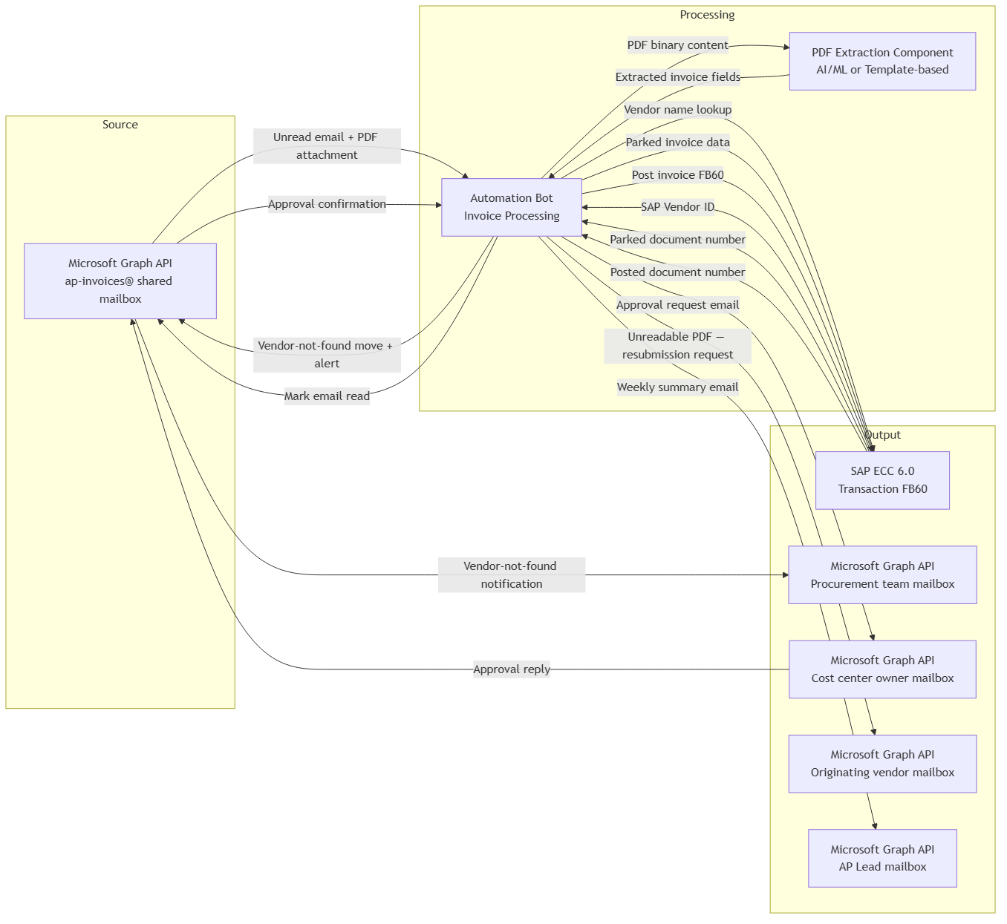

AUTOMATION SBS FLOW:
Step 1: Read unread emails from shared mailbox ap-invoices@
Call GET /users/ap-invoices@{tenant}/messages?$filter=isRead eq false&$expand=attachments to retrieve all unread messages with their attachments.
Done when: Unread emails with attachments are retrieved successfully

Step 2: Download PDF attachment from email
For each message retrieved in step 1 that has an attachment with contentType 'application/pdf', call GET /users/ap-invoices@{tenant}/messages/{messageId}/attachments/{attachmentId} to download the PDF content.
Decision rule: If no PDF attachment is present on the email, skip to exception handling (flag for manual review or ignore — clarification needed).
Done when: PDF file downloaded successfully

Step 3: Extract invoice fields from PDF
[TBD - exact click-by-click / API sequence missing — ask the business]
Decision rule: If extraction fails or confidence is below acceptable threshold (threshold TBD), treat as unreadable PDF and proceed to step 4 exception path. Otherwise proceed to step 5.
Exception handling: If PDF is unreadable or extraction fails: proceed to step 4
Done when: All required fields (vendor name, invoice number, invoice amount) extracted with sufficient confidence

Step 4: Return unreadable PDF to vendor
Call POST /users/ap-invoices@{tenant}/sendMail with a message body addressed to the original sender's email address, informing them that the invoice PDF could not be processed and requesting a legible resubmission. Mark the original email as read via PATCH /users/ap-invoices@{tenant}/messages/{messageId} with body {"isRead": true}.
Done when: Vendor notified and original email marked as read; no further processing of this invoice

Step 5: Look up vendor in SAP ECC vendor master
[TBD - exact click-by-click / API sequence missing — ask the business]
Decision rule: If vendor is found (unique match), proceed to step 7. If vendor cannot be found or match is ambiguous due to duplicates in vendor master, proceed to step 6.
Exception handling: If vendor not found or ambiguous: proceed to step 6
Done when: Unique SAP vendor ID resolved from vendor name

Step 6: Handle vendor-not-found exception
Call PATCH /users/ap-invoices@{tenant}/messages/{messageId}/move with body {"destinationId": "<folder-id-of-vendor-not-found-subfolder>"} to move the original email to the 'vendor-not-found' subfolder. Then call POST /users/ap-invoices@{tenant}/sendMail to send a notification email to the procurement team, including the vendor name as extracted from the PDF and the original email details.
Done when: Email moved to vendor-not-found subfolder and procurement notified; no further automated processing of this invoice

Step 7: Determine approval requirement based on invoice amount
[TBD - exact click-by-click / API sequence missing — ask the business]
Decision rule: If invoice amount > $5,000, proceed to step 8 (park and route for approval). If invoice amount <= $5,000, proceed to step 10 (post directly).
Done when: Correct routing determined based on invoice amount threshold

Step 8: Enter invoice in SAP FB60 as parked
[TBD - exact click-by-click / API sequence missing — ask the business]
Done when: Invoice saved in SAP with parked status and document number returned

Step 9: Send approval request email to cost center owner
Identify cost center owner from PO attached to invoice if available; otherwise owner identification method is unclear (clarification needed from business). Call POST /users/ap-invoices@{tenant}/sendMail addressed to the cost center owner's email, including invoice details (vendor name, invoice number, amount, SAP parked document number) and requesting approval reply.
Decision rule: If manager replies with approval, proceed to step 10. Handling of non-reply or rejection not defined — clarification needed.
Exception handling: If cost center owner cannot be determined from PO: clarification needed on fallback (currently done manually by Jamie)
Done when: Approval request email sent to cost center owner; awaiting reply

Step 10: Post invoice in SAP FB60
[TBD - exact click-by-click / API sequence missing — ask the business]
Done when: Invoice posted in SAP ECC with a confirmed posted document number

Step 11: Mark source email as read / processed
Call PATCH /users/ap-invoices@{tenant}/messages/{messageId} with body {"isRead": true} to mark the processed email as read.
Done when: Email marked as read in shared mailbox

Step 12: Send weekly summary email to AP Lead
On a weekly schedule, compile processing statistics (count posted automatically, count escalated to AP team, breakdown of exception reasons: vendor not found, approval required, unreadable PDF) and call POST /users/ap-invoices@{tenant}/sendMail addressed to Sarah Chen's email address with the summary in the message body.
Done when: Weekly summary email delivered to AP Lead

