|  |
| --- |
|  |
| AQA A LEVEL Computer Science NEA |
| Assessment Checklist & Criteria |
|  |
|  |
| **Student Name: Ben Bromley** |

|  |
| --- |
| **Please return to Mrs Nemaura in C1.1 if found.** |

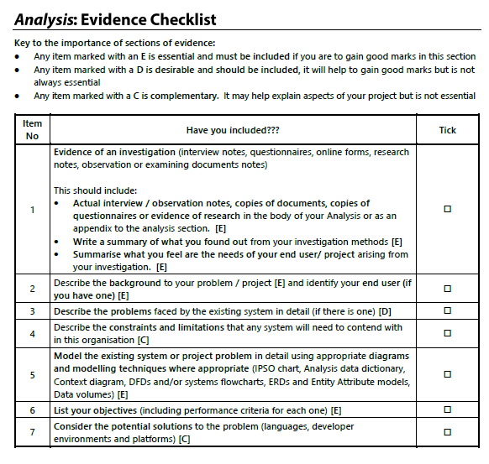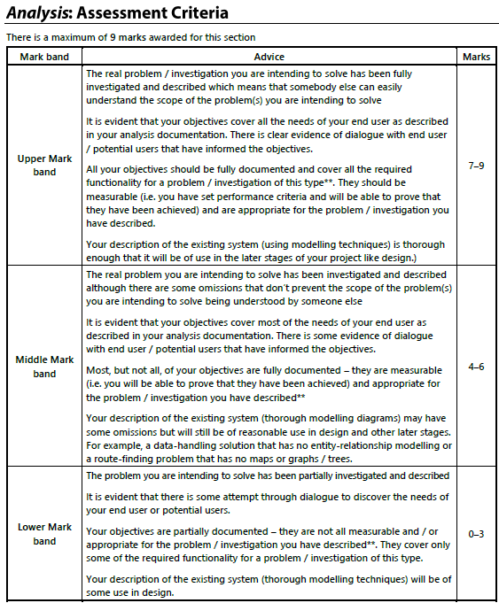

|  |
| --- |
| **Teacher Feedback (FAR)** |
| **Feedback:**  **You are currently in the middle mark band as your work have some ommissions. You have evidence of an interview. However, you cannot be the end user, you need a peer/family member/ teacher to be your end user, so the interview script should be based on someone else. You need to clearly describe your end user i.e. peer/family member/ teacher. Description of problems/constraints of existing system should be clearer and more detailed. Data flow diagram should be based on the existing system. The objectives needs to be SMART – review so that it can be easily translated to program.**  **You have described why the programming language that you are using platforms and IDE are suitable in solving your problem. Be clear and focus on python advantages to solving your problem.**  **Action:**  **To improve your draft analysis, you need to consider the following actions:**   * **List the problems faced by the existing system in details.** * **Outline and describe the constraints and limitations that the system will encounter.** * **Create a DFD that is level 0/1. Model the existing system using modelling techniques for at least one of the models. This will be based on the spreadsheet system.**   **Response:** |

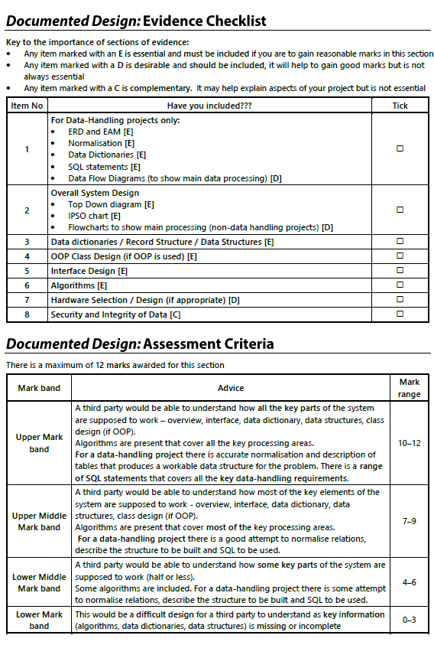

|  |
| --- |
| **Teacher Feedback (FAR)** |
| **Feedback:**  **Your design is in Lower Middle Mark Band.**  **Action:**   * **Include class design for OOP design** * **Include algorithm of the main proposed program**   **Response:** |

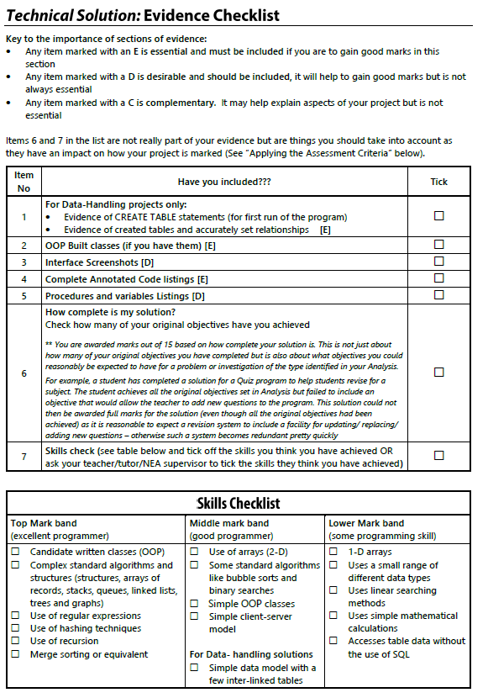

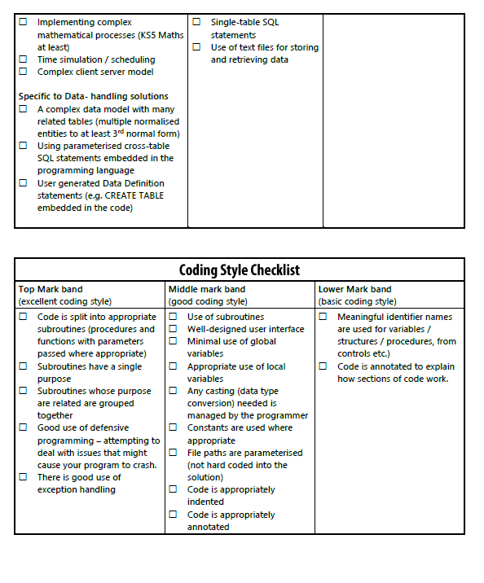

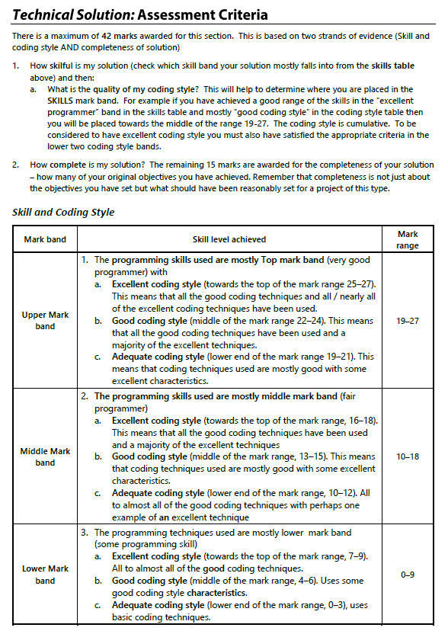

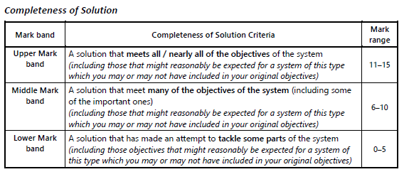

|  |
| --- |
| **Teacher Feedback (FAR)** |
| **Feedback:**  **Action:**  **Response:** |

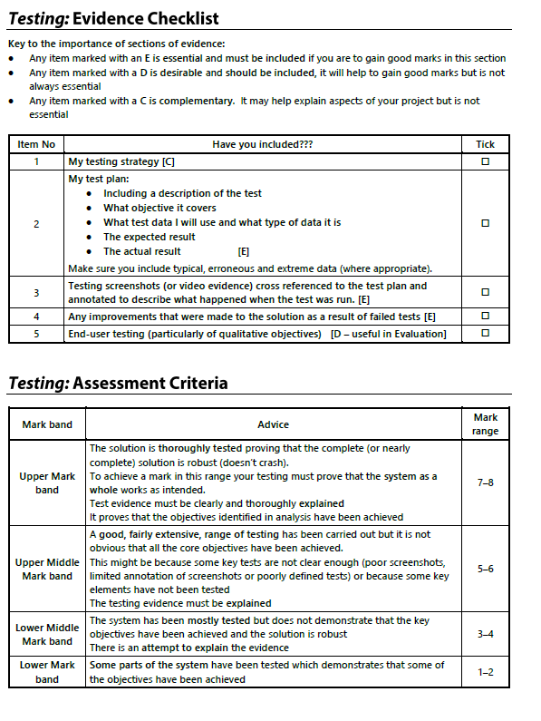

|  |
| --- |
| **Teacher Feedback (FAR)** |
| **Feedback:**  **You are currently working at a Skill Level that is within the middle mark band and completeness of the solution is within the lower mark band as the objectives have not been identified.**  **Action:**   * **Include evidence of 2D Arrays** * **Include evidence of bubble sort and binary search algorithms** * **Include evidence of simple client server model.** * **Most of the program code when ran issues an error**   **Response:** |

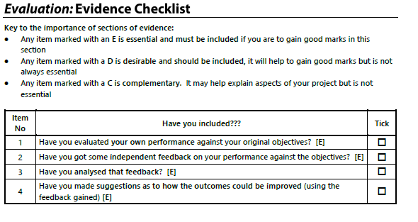

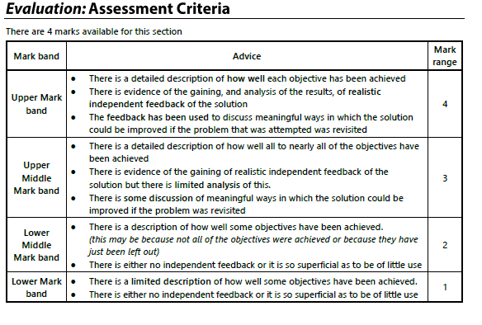

|  |
| --- |
| **Teacher Feedback (FAR)** |
| **Feedback:**  **No evidence shown for this assessment criteria.**  **Action:**  **Response:** |