Benjamin Hillen

CS 362

4 February 2021

In-class Activity 3

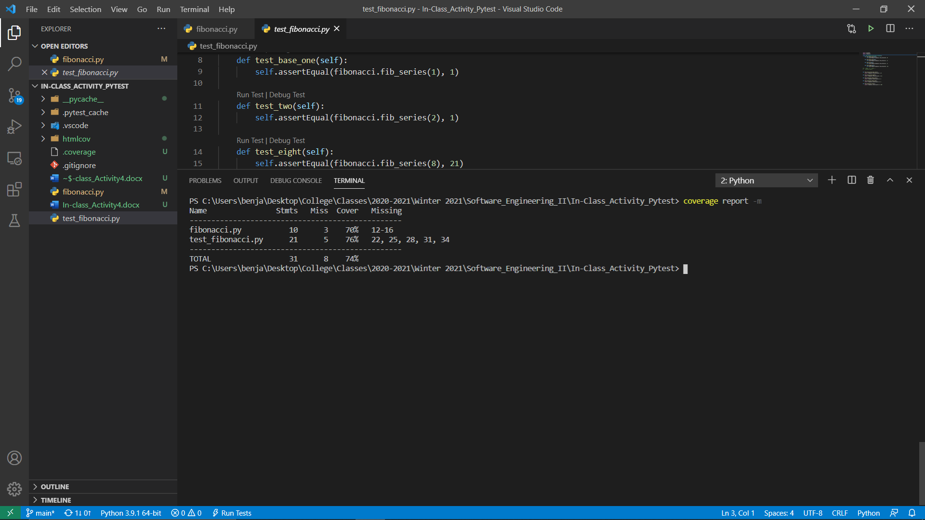

Figure 1: Running ‘coverage report -m’

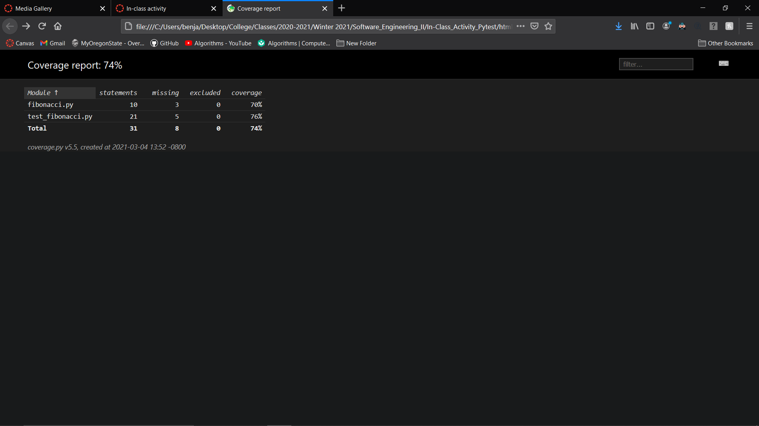

Figure 2: Index.html of htmlcov Folder

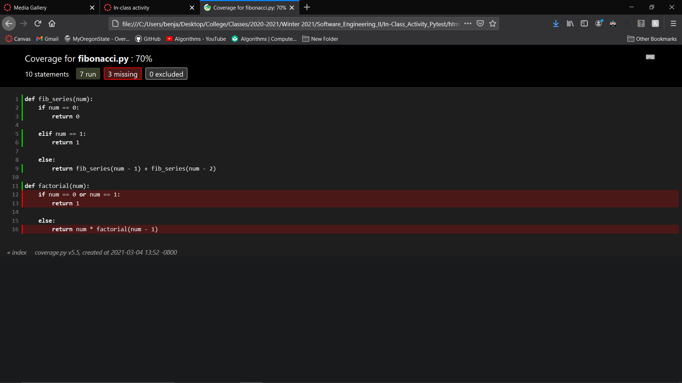

Figure 3: Visualized Coverage for Fibonacci.py

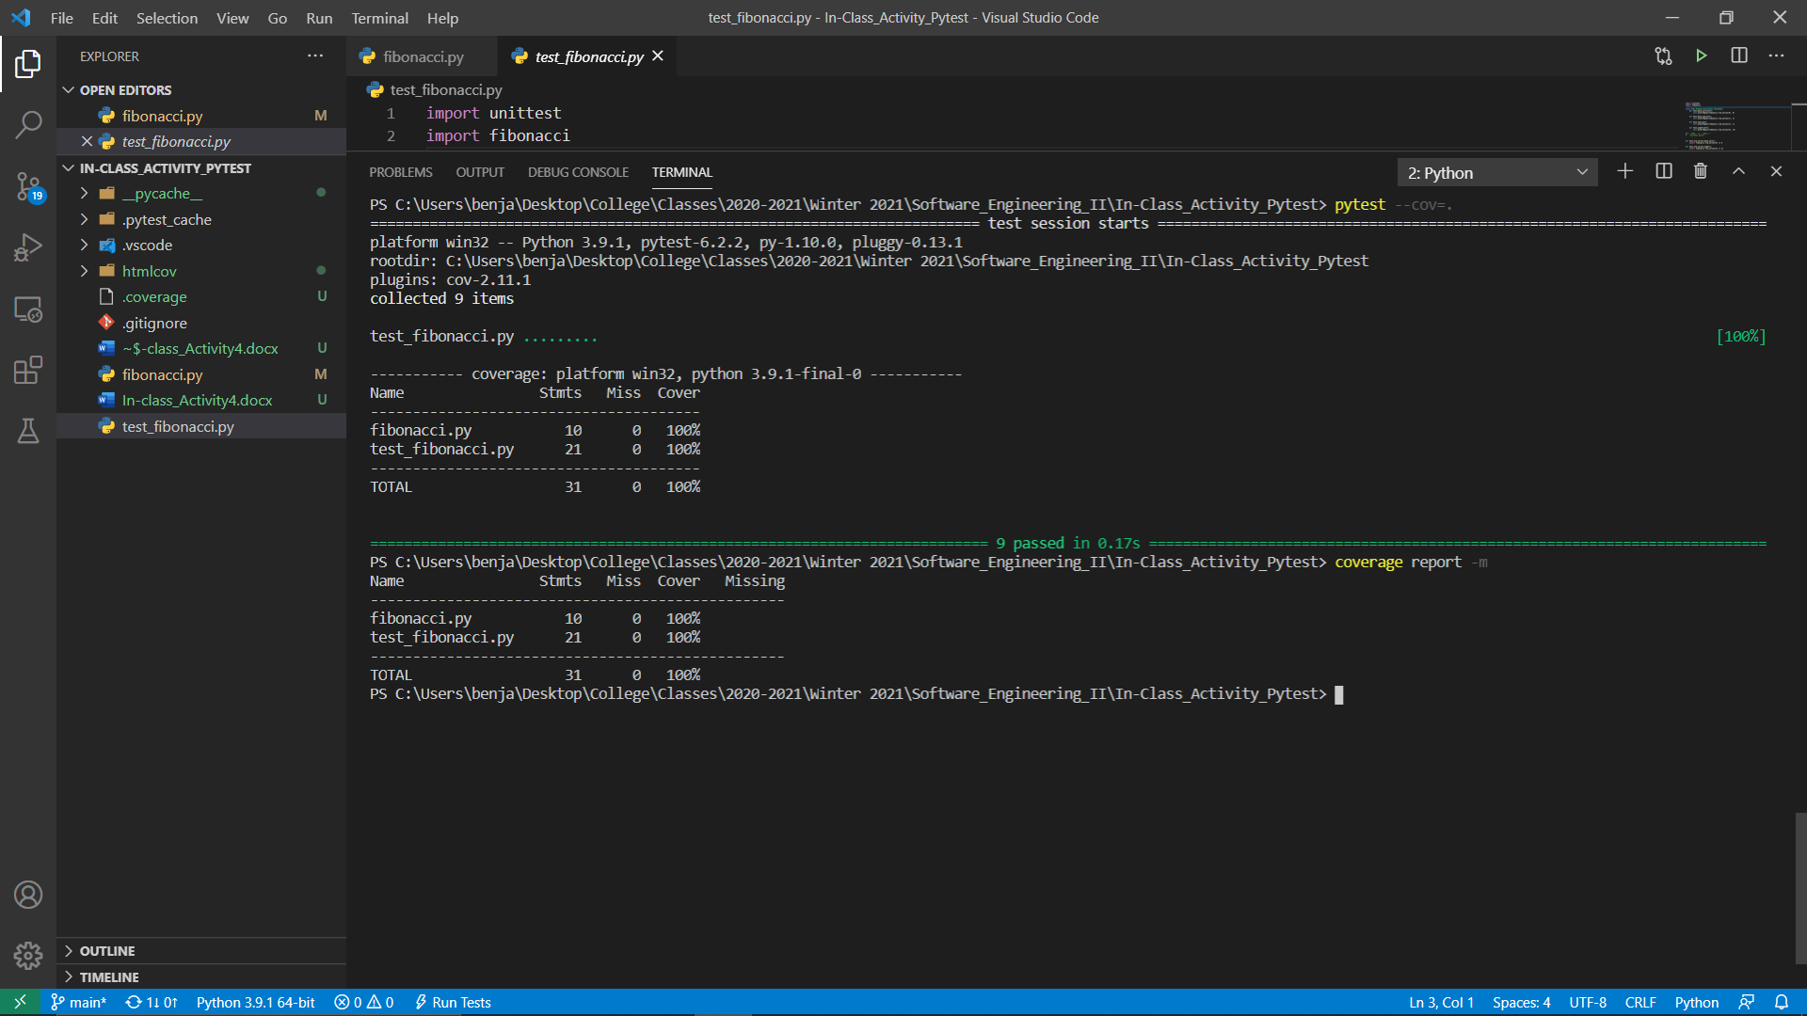

Figure 4: Pytest-cov Test Coverage

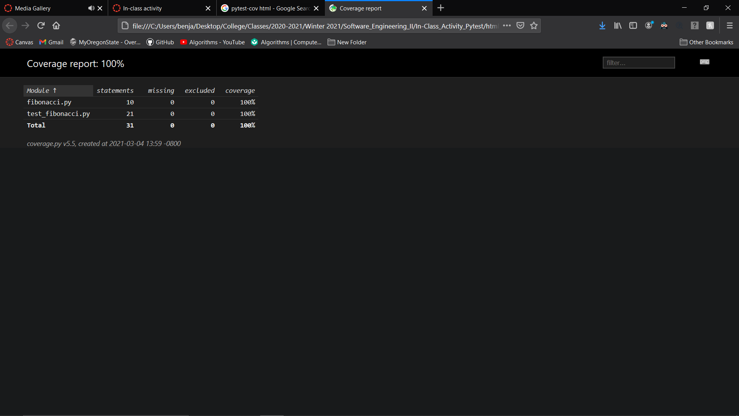

Figure 5: Pytest-cov Index.html from covhtml Folder