A global latitudinal gradient in the proportion of terrestrial vertebrate forest species

# Abstract

## Aim

Global patterns in species distributions such as the latitudinal biodiversity gradient are of great interest to ecologists and have been thoroughly studied. Whether such a gradient holds true for the proportion of species associated with key ecotypes such as forests is however unknown. Identifying a gradient and ascertaining the factors causing it could further our understanding of community sensitivity to deforestation and uncover drivers of habitat specialisation. The null hypothesis is that proportions of forest species remain globally consistent, though we hypothesise that proportions will change with differences in ecotype amount, spatial structure, and environmental stability. Here we study whether the proportion of forest species follows a latitudinal gradient, and test hypotheses for why this may occur.

## Location

Worldwide

## Time Period

Present

## Major Taxa Studied

Terrestrial vertebrates

## Methods

We combined range maps and habitat use data for all terrestrial vertebrates to calculate the proportion of forest species in an area. We then used data on the global distribution of current, recent historical, and long-term historical forest cover, as well as maps of global disturbances and plant diversity to test our hypotheses using generalised linear models.

## Results

We identified a latitudinal gradient in the proportion of forest species whereby the highest proportions occurred at the equator and decreased polewards. We additionally found that the proportion of forest species increased with current forest cover, historical deforestation, plant structural complexity, and habitat stability. Despite the inclusion of these variables, the strong latitudinal gradient remained, suggesting additional causes of the gradient.

## Main Conclusions

Our findings suggest that the global distribution of the proportion of forest species are a result of recent ecological, as well as long-term evolutionary factors. Interestingly, high proportions of forest species were found in areas that experienced historical deforestation, suggesting a lagged response to such perturbations and potential extinction debt.

# Keywords

Amphibians, birds, deforestation, drivers of diversity patterns, forests, habitat disturbance, latitudinal biodiversity gradient, mammals, reptiles, species distributions

# Introduction

Global biodiversity is under threat from anthropogenic-driven habitat loss [(Giam, 2017; IPBES, 2019)](https://www.zotero.org/google-docs/?ODxGlE), and conservation action is required to minimise the negative effects of this [(Cullen, 2012; Dinerstein *et al.*, 2017)](https://www.zotero.org/google-docs/?5em0BC). Identifying patterns in the distribution and diversity of species is a key step to prioritising areas to protect to achieve conservation goals [(Gaston, 2007)](https://www.zotero.org/google-docs/?DOlbPf). The global distribution and diversity of species have generally been well studied, and the latitudinal biodiversity gradient (LBG) is one of the most pervasive and longest-studied phenomena in ecology dating back to Humboldt [(Humboldt, 1849)](https://www.zotero.org/google-docs/?t18hFV), Darwin [(Darwin, 1859)](https://www.zotero.org/google-docs/?7KFK3s), and Wallace [(Wallace, 1878)](https://www.zotero.org/google-docs/?FeKYR3). Current research on this pattern continues to emphasise its generality across nearly all terrestrial and marine taxa [(Willig *et al.*, 2003; Hillebrand, 2004; Smith *et al.*, 2017; Menegotto & Rangel, 2018)](https://www.zotero.org/google-docs/?8LVHxe) and different measures of diversity [(Smith *et al.*, 2017; Schumm *et al.*, 2019)](https://www.zotero.org/google-docs/?AxXfMH). Such measures of diversity may however be inefficient when designating protected areas, as they fail to incorporate the expected response of communities to habitat loss – high-diversity communities will not necessarily be more negatively affected by habitat loss than low-diversity communities. Therefore, identification of whether a latitudinal gradient exists in the proportion of species associated with key ecotypes, and understanding the mechanisms which cause this, is not only critical to furthering our understanding of biodiversity distributions but could also inform conservation.

Forests are perhaps the world's most important terrestrial ecotype, covering 30% of the earth's land surface, yet providing habitat for approximately 80%, 75% and 70% of terrestrial amphibian, bird, and mammal species respectively [(FAO, 2020)](https://www.zotero.org/google-docs/?88MfOB). Despite this, forests are the habitat type experiencing the fastest loss, with a third of global forest cover already lost [(Ritchie & Roser, 2023)](https://www.zotero.org/google-docs/?eoN6Ls). It is, therefore, no surprise that the protection of forests, and the ecological communities within them, is a vital part of global plans to mitigate biodiversity loss [(Dinerstein *et al.*, 2017; Arroyo-Rodríguez *et al.*, 2020; Waldron *et al.*, 2020)](https://www.zotero.org/google-docs/?S3XwUC). Species however vary in their sensitivity to forest loss [(Henle *et al.*, 2004; Betts *et al.*, 2014; Keinath *et al.*, 2017)](https://www.zotero.org/google-docs/?r4PuNu), with species that specifically rely on resources and conditions provided by forests (forest species) expected to be the most sensitive [(Henle *et al.*, 2004; Keinath *et al.*, 2017)](https://www.zotero.org/google-docs/?qIsYvr). Communities with particularly high proportions of forest species would be expected to be most strongly affected by deforestation, and it could therefore be proposed that areas with high proportions of sensitive species should be protected above areas that simply have the most species. Due to their global biodiversity and continued anthropogenic threat, we focus on identifying global patterns in the proportion of forest species, as well as the potential drivers of this pattern, particularly focusing on whether the proportion of forest species follows a latitudinal gradient.

For a latitudinal gradient in the proportion of forest species to occur, the richness of forest species must decrease disproportionately towards the poles compared to generalist species associated with no particular ecotypes, or species associated with other ecotypes (e.g. grasslands, deserts). A number of factors would be expected to create such a pattern, including the global distribution of forests, latitudinal variation in the structural complexity of forests [(Ehbrecht *et al.*, 2021)](https://www.zotero.org/google-docs/?BZYRlP), more disturbances towards the poles [(Betts *et al.*, 2019)](https://www.zotero.org/google-docs/?Vv4Vo2), higher stability at the equator [(Wiens & Graham, 2005; Brown, 2014; Pontarp *et al.*, 2019)](https://www.zotero.org/google-docs/?Y1xA4Q), more species creating a ‘niche packing’ effect [(Macarthur, 1965; Sánchez González *et al.*, 2023)](https://www.zotero.org/google-docs/?h5z79U), and presence of extreme environments [(Rivas-Salvador *et al.*, 2019)](https://www.zotero.org/google-docs/?emdkIY). An overview of each hypothesis, its rationale, and our expectations are outlined in Table 1.

In summary, we predict that the proportion of forest species will increase with the amount of current and historical forest cover in an area, as well as the stability and complexity of the forests, where we expect higher proportions of forest species in areas which have had few disturbances and have remained the same forest type. We additionally expect factors which increase specialisation and speciation to increase the proportion of forest species towards the equator, specifically total species richness and altitude. A combination of these factors is predicted to create a latitudinal gradient in the proportion of forest species, likely to be most heavily driven by the disproportionately high amounts of forest at the equator. To test these expectations we use range and habitat use data from IUCN [(The IUCN Red List of Threatened Species)](https://www.zotero.org/google-docs/?RcMjIC) and Birdlife International [(BirdLife Data Zone)](https://www.zotero.org/google-docs/?wFBBfq) to map the global distribution of the proportion of forest species (described as those only occurring in forest habitats). We then use generalised additive mixed models to test the aforementioned hypotheses that could cause such a pattern using data on current forest cover, recent deforestation, geological forest cover, natural disturbances, plant diversity, altitude, and species richness. We find a clear latitudinal gradient in the proportion of forest species, which is associated with, but not solely explained by current global forest cover, recent deforestation, total species richness, and geological forest stability.

# Methods

### Map Projections

All map data in this study were projected to Behrmann Equal Area projection at the native resolution of 96x96km pixels, including conversion to raster format if the data were not already of this type. For brevity, any mention of projecting maps in the methods refers to Behrmann Equal Area projection at 96x96km pixel size. We chose to use an equal area projection to ensure that the proportion of species per area is comparable across the globe.

Proportion of Forest Species

We obtained distribution range maps and habitat data for four taxa: amphibians, birds, mammals, and reptiles from IUCN [(The IUCN Red List of Threatened Species)](https://www.zotero.org/google-docs/?0fxN8Z) and BirdLife International [(BirdLife Data Zone)](https://www.zotero.org/google-docs/?wiuR1W). For a small number of species habitat data were not available (0.07%), these were removed from further analysis. We also removed areas of the distribution range classified as presence uncertain; non-native origin and seasonality descriptors other than “Resident” or “Breeding”, which removed a further 1.3% of the initial species. Lastly, we removed all marine species which left a final total species count of 6,963 amphibian, 10,041 bird, 5,619 mammal, and 9,477 reptile species.

We then designated species as forest or non-forest based on the habitats that were defined as suitable for them by the IUCN. Forest species only had forest habitats (category 1 in the IUCN Habitats Classification Scheme) described as suitable, whilst non-forest species either had a mixture of forest and non-forest habitat types, or only non-forest habitat types defined as suitable. We then projected the ranges of all species and used these to create maps of the total species richness and the total forest species richness of each taxon in each 96x96km pixel. From these rasters we then calculated the proportion of forest species in each pixel by dividing the forest species richness by the total species richness.

### Current Forest Cover (Proportion of Current Forested Land Area)

We used the Hansen tree cover dataset [(Hansen *et al.*, 2013)](https://www.zotero.org/google-docs/?CN4mnN), which describes the approximate percentage of tree cover in a 30x30m pixel for the year 2000. While these data are now over 20 years old, they still represent the best estimate of global tree cover and are unlikely to affect our results as the IUCN and BirdLife range maps were created over a similarly coarse temporal and spatial scale. We reclassified pixels into forest or non-forest categories using a 70% cut-off value (i.e. pixels with at least 70% tree cover were classified as forest). A cut-off of 70% was chosen as a conservative categorisation of forest as the definition of a forest varies nationally between datasets (e.g 60% of tree cover is determined as forest in Brazil’s mapBiomas, 20% in the United States USGS National Land Cover Database, and 70% in the Copernicus Global Land Cover Dataset) [(Yang *et al.*, 2018; Buchhorn *et al.*, 2020; Souza *et al.*, 2020)](https://www.zotero.org/google-docs/?0cLLXK). The Hansen dataset also contained a land mask that classifies pixels as land or not land (i.e. oceans). We projected both the forest and land data to our larger 96x96km pixel size, summing their total area to calculate a total forest area and total land area per 96x96km pixel. We then divided the total forest area by the total land area to calculate the proportion of current forest cover per pixel, and the total land area by the total area of our larger pixels to calculate the proportion of land area per pixel.

Historical Deforestation (Historical Proportion of Deforested Land Area)

The historical proportion of deforested land area was calculated using a map of predicted forest cover prior to human activities, which had had the areas of current forest cover removed, this map was also already categorised as forest or non-forest , available from [Betts *et al.* (2017)](https://www.zotero.org/google-docs/?sZvf1i) at 0.009° pixel resolution. This map was generated using a random forest regression model which predicted the distribution of historical forest as a function of 19 bioclimatic variables from the WorldClim database [(WorldClim, 2024)](https://www.zotero.org/google-docs/?xGZtQj), and the coordinates of forest loss from the Hansen tree cover dataset [(Hansen *et al.*, 2013)](https://www.zotero.org/google-docs/?uksY0e). The maps were projected and the total deforested area was calculated by summing the area of the forested pixels. The historical proportion of deforested land area was calculated by dividing the total deforested area by the total land area. Note that due to the different initial pixel sizes of the land area raster and the deforested raster some pixels contained values greater than one. Most of these were removed during the ‘Data Preparation’ process described below, but 85 of 5,434 pixels for amphibians (1.6%, mean value > 1 (sd) = 1.13 ±0.317), 125 out of 9,571 pixels for birds (1.3%, mean value > 1 (sd) = 1.13 ±0.305), 125 out of 9,435 pixels for mammals (1.3%, mean value > 1 (sd) = 1.13 ±0.305), and 101 out of 6,125 pixels for reptiles (1.6%, mean value > 1 (sd) = 1.05 ±0.087) remained with values above one, and as such these were all set to a value of one since the proportion of land area deforested cannot by greater than the total land area present.

### Natural Disturbances

Maps of historical naturally-occurring disturbance areas caused by fire [(Lavorel *et al.*, 2007)](https://www.zotero.org/google-docs/?vOqUQs), glaciation [(University of Geneva, Switzerland *et al.*, 2001)](https://www.zotero.org/google-docs/?hihbzH), and storms [(Location of tropical cyclones, 2024)](https://www.zotero.org/google-docs/?AnCvJT) were extracted from relevant sources where they were generated by expert opinion [(University of Geneva, Switzerland *et al.*, 2001; Lavorel *et al.*, 2007)](https://www.zotero.org/google-docs/?GGn9Yd) and satellite observation [(Location of tropical cyclones, 2024)](https://www.zotero.org/google-docs/?HHQcVb). These layers were projected and then combined by summing the occurrence of disturbances to create a single raster including all three disturbance types, with pixel values between 0 - 3 depending on the number of disturbances in the pixel.

### Maximum Geological Forest Time and Geological Forest Stability

Maps of predicted forest type (tropical, temperate, or boreal) from five geological epochs (Holocene, Pliocene, Miocene, Oligocene, and Eocene) were hand digitised from [Fine & Ree (2006)](https://www.zotero.org/google-docs/?vXQyeZ) into five vector layers. These layers were projected and pixels were then given values based on two measures of temporal stability of the forest type present. Firstly, we calculated the ‘maximum geological forest time’, which we define as the approximate amount of time the pixel could have remained the same forest type since the Holocene (0 mya). The period assigned to each of the epochs is as follows, Holocene = 0mya, Pliocene = 5mya, Miocene = 23mya, Oligocene = 33mya, and Eocene = 55mya. For example, a pixel not classified as tropical forest in the Eocene but then classified as tropical forest throughout the Oligocene, Miocene, Pliocene and Holocene would have a value of 33 (the Oligocene started roughly 33 million years ago), which represents how long the area could have been continuously covered by tropical forest. Secondly, we calculated the ‘geological forest stability’, which we define as the number of layers the pixel was classified as the same forest type as it is currently (Holocene, 0mya). For example, if a pixel was categorised as tropical forest in the Eocene and Oligocene, temperate in the Miocene, and tropical forest in the Pliocene and Holocene the pixel would be given a value of 4.

Plant Alpha Diversity

Raster maps of the global alpha diversity of flora were obtained from [Sabatini *et al.* (2022)](https://www.zotero.org/google-docs/?NetD98) at 0.04° pixel resolution and projected by averaging the plant alpha diversity across the larger 96x96km pixels.

### Altitude

We obtained a raster map of global altitude from ETOPO 3 [(NOAA National Centers for Environmental Information, 2022)](https://www.zotero.org/google-docs/?XFwj57) at 60-arc second resolution. This was projected by averaging the altitude of pixels within the larger 96x96km pixel.

### Latitude (Distance from Equator 1000km)

To define latitude, we calculated the distance from each pixel to the equator (described in 1000kms for ease of interpretation).

Forest Ecoregions

Lastly, we cropped all of our maps to only include data for ecoregions which contain forest biomes based on the RESOLVE 2017 dataset [(Dinerstein *et al.*, 2017)](https://www.zotero.org/google-docs/?qHKJAN). This was done to ensure we were comparing areas in which forest species would be expected to occur and to aid with the interpretation of results. For example, differences in plant diversity between two forest ecoregions suggest changes in structural complexity and the number of niches available to forest species. On the other hand, comparing differences in plant, and therefore structural, diversity between a forest and grassland ecoregion has far less ecological meaning in the context of the proportion of forest species. We also assigned each pixel to the forest ecoregion it occurred in which was later used as a random effect in our models.

## Quantification and Statistical Analysis

## All data quantification, spatial analysis, statistical analysis, and visualisation were conducted in R version 4.2.2 [(R Core Team, 2023)](https://www.zotero.org/google-docs/?g2U0RK) using the mgcv package version 1.9.0 [(Wood, 2011)](https://www.zotero.org/google-docs/?hkgHKI) and the ‘bam’ function for generalised additive mixed effect models, the DHARMa package version 0.4.6 [(Hartig, 2022)](https://www.zotero.org/google-docs/?q69TaC) was used for model evaluation of overdispersion and model fit, the performance package version 0.10.8 [(Lüdecke *et al.*, 2021)](https://www.zotero.org/google-docs/?U52lVw) was used to assess multicollinearity, and the ncf package version 1.3.2 [(Bjornstad, 2022)](https://www.zotero.org/google-docs/?3OlE77) was used to assess spatial autocorrelation using correlograms.

### Data Preparation

Before analysing the proportion of forest species in each pixel, we removed pixels which had a small amount of land within them (<10% land area).

### Modelling the Proportion of Forest Species

We modelled the proportion of forest species for each taxon individually, as well as for all taxa combined, using two sets of explanatory variables. All models used binomial errors and the logit link function, since our response variable, the proportion of forest species, is a set of trials (total number of species in a pixel), and successes (the number of forest specialist species in a pixel). We first used a simple model which predicted the proportion of forest species in a pixel using only latitude (distance of the pixel from the equator) as an explanatory variable. Secondly, we used a more complex model which used all of the previously described variables (Current Forest Cover, Historical Deforestation, Naturally Disturbed Areas, Maximum Geological Forest Time, Geological Forest Stability, Plant Alpha Diversity, Altitude, Total Species Richness, and Latitude) to predict the proportion of forest species in a pixel. In both cases, we ran generalised additive mixed models, with explanatory variables scaled and centred to allow for comparison of effect sizes. Though we used generalised additive mixed models, the fixed effects were included as linear predictors and outputs from them can be interpreted as if from a generalised linear mixed effect model. Models including all taxa combined included random intercept terms for taxa. The structure of all models can be seen in the ‘model structure‘ section of the supplementary, and model variables were chosen based on our prior hypotheses and were not included or excluded based on model comparisons such as AIC.

For both sets of models we accounted for spatial autocorrelation since preliminary models which did not account for it showed spatial clustering of residuals and therefore lacked independence between sampling points [(Legendre, 1993)](https://www.zotero.org/google-docs/?LwFJg9). We used two methods to account for spatial autocorrelation. Firstly, we included a Gaussian process which fits a smooth spatial trend by modelling the way the correlation between pairs of observations (proportion of forest species in a pixel) varies as a function of the distance in space between them [(Simpson, 2018)](https://www.zotero.org/google-docs/?Pc7lUI). Several functions can be used to model the correlation between observations and we chose to use the Matern family since it is the most commonly used, though all family choices appeared to perform similarly well in observational comparisons of correlograms. Secondly, we included a random intercept term for ecoregion which improved model fit and slightly further reduced spatial autocorrelation. Diagnostics for all models including comparisons of spatial autocorrelations between models with and without the Gaussian process can be seen in S1.

Proportion of Forest Species vs Total Species Richness

To highlight the differences between total species richness and our measure of the proportion of forest species we plotted the proportion of forest species and total species richness against absolute latitude, as well as plotting the proportion of forest species against total species richness to visualise the relationship.

# Results

Mammals had the highest proportion of forest species (N = 2,166, 39%), followed by reptiles (N = 3,086, 33%), birds (N = 3,011, 30%), and amphibians (N = 1,735, 25%). The highest proportion of forest species for all taxa occurs in the equatorial tropical forests, with particularly high proportions in South America and Southeast Asia (Figs. 1, 2A). All taxa followed a similar latitudinal pattern, whereby the proportion of forest species decreased with latitude (effect size of latitude, all taxa = -0.96, amphibians = -0.72, birds = –0.97, mammals = –0.94, reptiles = –1.01) (Figs. 1, 3). For example, our models predict that 33.5% of species at the equator are forest species, which decreases to 9.3% at 30° latitude (tropics) and to 4.1% at 50° latitude (temperate). The proportion of forest species generally follows the same trend as total species richness (Figs. 2A, 2B) which similarly decreases from the equator to the poles.

As expected, for all taxa the proportion of forest species increased with current forest cover, historical deforestation, geological forest stability, and total species richness (Fig. 4). Additionally, the proportion of forest species generally increased with altitude, though this was not significant for mammals. We found no consistent relationships between natural disturbances or plant alpha diversity and the proportion of forest species, and a generally negative, albeit weak, relationship between the maximum amount of time an area had remained the same type of forest (maximum geological forest time) and the proportion of forest species. Even with these explanatory variables, the proportion of forest species of all taxa, apart from amphibians, still showed a strong negative relationship with increasing latitude, though the effect was slightly dampened (change in effect size of latitude compared to latitude-only models, all taxa = 0.37, amphibians = 0.54, birds = 0.28, mammals = 0.45, reptiles = 0.50) (Fig. 4), and the variation explained by the models only increased marginally (Table 2).

# Discussion

We found a strong negative relationship between latitude and the proportion of forest species of all terrestrial vertebrates. Surprisingly, the strong effect of latitude on the proportion of forest species remained for all taxa except amphibians once we accounted for key variables expected to influence the global distribution of forest species. Other than latitude, the total species richness of the community, as well as the amount of forest cover, and historical deforestation in the area most strongly affected the proportion of forest species. Interestingly, the effect of historical deforestation was almost as strong as that of current forest cover; regions with higher amounts of forest historically tend to still have greater proportions of forest species – even long after that forest has been removed. This suggests a lagged response of forest species to the removal of habitat. In contrast to our expectations, we found a generally negative effect of maximum geological forest time, as well as non-significant and mixed effects of plant diversity and the presence of natural disturbances on the proportion of forest species, though the positive influence of geological forest stability suggests that long-term stability of a habitat type increases specialisation towards that habitat to some extent.

As expected, we found that the proportion of forest species in an area increased with the amount of forest cover. The species-area relationship is a well-studied phenomenon in ecology [(Pimm & Askins, 1995; Matthews *et al.*, 2014)](https://www.zotero.org/google-docs/?guqmzl), and the higher proportion of forest species in areas with more forest cover is likely a direct result; more area of a habitat type at the regional scale increases the pool of species associated with that habitat [(Leibold *et al.*, 2004; Halstead *et al.*, 2019)](https://www.zotero.org/google-docs/?QPsudH), and decreases the number associated with other habitat types. We similarly found that the proportion of forest species increased with the amount of deforestation that had historically occurred in the area. This suggests that forest species which occurred in the area before deforestation still at least partially remain; likely in smaller forest remnants. Whether the high proportions of forest species in such areas will remain long-term is unknown, however, previous studies have found lagged responses of species to habitat loss [(Tilman *et al.*, 1994; Chen & Peng, 2017; Liao *et al.*, 2022)](https://www.zotero.org/google-docs/?ucUR0r), which only increase as the size of the area increases [(Haddad *et al.*, 2015)](https://www.zotero.org/google-docs/?UuZrOo), meaning that this may be a case of extinction debts that are yet to be paid, and could take centuries to do so [(Chen & Peng, 2017)](https://www.zotero.org/google-docs/?WTaCIW).

Factors that were expected to increase the specialisation of species were similarly found to generally increase the proportion of forest species in an area. Total species richness had consistently strong effects on the proportion of forest species, supporting the ‘niche packing’ hypothesis that species are required to specialise in more specific niches to maintain a stable community with high species richness [(Macarthur, 1965; Sánchez González *et al.*, 2023)](https://www.zotero.org/google-docs/?HTTigK). This is further corroborated by the weak effect of total species richness in our model including all taxa, indicating that niche-packing is working at an intra-taxa level, in which species are more likely to be competing for shared resources. For example, the total number of amphibian species does not affect the proportion of forest bird species in an area. Contrastingly, altitude had a relatively weak but generally positive effect on the proportion of forest species, potentially stemming from increased speciation due to dispersal limitations [(Janzen, 1967)](https://www.zotero.org/google-docs/?JLKQPy) and increased specialisation to survive in relatively extreme environments [(Rivas-Salvador *et al.*, 2019)](https://www.zotero.org/google-docs/?NVgM4w).

On the other hand, we found that hypotheses that most closely match those in the traditional latitudinal biodiversity gradient literature, such as more stable environments increasing speciation [(Allen & Gillooly, 2006; Mittelbach *et al.*, 2007; Brown, 2014)](https://www.zotero.org/google-docs/?fSgHnX), tended to be less supported. Neither the presence of natural disturbances nor the amount of time an area had continuously been the same forest type consistently affected the proportion of forest species. The lack of relationship between the proportion of forest species and these variables may be due to the ability of species to move, find refugia, and then repopulate the disturbed or altered area when it returns to a habitable state; similar to species repopulating areas after modern disturbances [(Kotliar *et al.*, 2007; Haney *et al.*, 2008)](https://www.zotero.org/google-docs/?IMPldy). This is further supported by the positive relationship between geological forest stability and the proportion of forest species, whereby a higher proportion of forest species were found in areas which had generally contained the same habitat type, even if it was not temporally continuous. This suggests that forest species can persist in areas when the type of forest present changes, either by moving to nearby refugia and repopulating when the forest type changes again to become favourable [(Sommer & Nadachowski, 2006; Waltari *et al.*, 2007)](https://www.zotero.org/google-docs/?MYgPNF), or simply adapting to the new conditions.

Perhaps the most obvious differences between forests across latitudes are their plant diversity and structural complexity; with diversity and structural complexity increasing towards the equator. Higher plant diversity, and therefore structural complexity [(Sabatini *et al.*, 2022)](https://www.zotero.org/google-docs/?WTJrzE), should create more niches for forest species [(Brown, 2014; Bracewell *et al.*, 2018; Cao *et al.*, 2021)](https://www.zotero.org/google-docs/?uDpkla) and therefore increase the proportion of forest species found in an area. However, while we found that the proportion of forest species did generally increase with plant diversity, the effect was extremely weak and variable between taxa, and did not account for the observed latitudinal gradient. In fact, latitude had one of the strongest effects on the proportion of forest species (only total species richness had a larger effect for some taxa) after all other variables had been included, which indicates that the gradient is additionally being driven by unmeasured factors.

We focused our analysis on the effects of habitat type and environmental perturbations on the proportion of forest species in an area, however, traits of the species themselves may explain the observed latitudinal gradient. A plausible hypothesis borrowed from the latitudinal biodiversity gradient literature is the “Out of the Tropics” hypothesis. This hypothesis postulates that species richness decreases with latitude because species require greater dispersal ability to move from the equatorial refugia of the last glacial maxima to the relatively new habitat of the high latitudes [(Jablonski *et al.*, 2006; Brown, 2014)](https://www.zotero.org/google-docs/?wXM5Lu). This hypothesis is supported for the LBG in birds by the latitudinal gradient in hand wing index; a widely used proxy for dispersal ability [(Sheard *et al.*, 2019, 2020; Weeks *et al.*, 2023)](https://www.zotero.org/google-docs/?eDGE0b), and could explain our observed latitudinal pattern in the proportion of forest species, if forest species are generally poorer dispersers than generalist or open area species. Whilst a recent analysis found no significant differences in the hand wing index of closed versus open-area species [(Sheard *et al.*, 2019)](https://www.zotero.org/google-docs/?P15Ivc), analysis of our categorisation of species into forest or non-forest suggests that forest species are indeed poorer dispersers (Fig. S1), and that this therefore may be a viable alternative hypothesis as to why the proportion of forest species varies with latitude.

Our findings were generally consistent across birds, mammals, reptiles, and in models which included all taxa, however, results for amphibians varied considerably. The most interesting of these was the lack of support for a relationship between latitude and the proportion of forest amphibian species. This in large part appeared to be caused by an increased effect of total species richness, current forest cover, historical deforestation, and altitude on the proportion of amphibian species compared to that of the other studied taxa, explaining much of the observed latitudinal variation. This discrepancy was likely due to the smaller latitudinal range over which amphibians occur compared to the other studied taxa (Fig. 1), with very few data points at high latitudes, as well as the smaller range sizes of amphibian species which could be entirely encompassed in a single pixel. Despite this, the direction and relative strength of effect of variables were quite consistent between taxa. Similarly, we believe such a pattern is likely to hold across proportions of species associated with other ecotypes, since total species richness and latitude had by far the strongest effect, though differences in the distributions of other ecotypes could dampen or exacerbate the latitudinal gradient [(Dinerstein *et al.*, 2017)](https://www.zotero.org/google-docs/?3F7hIg), as could their respective stability over evolutionary timeframes [(Jetz & Fine, 2012)](https://www.zotero.org/google-docs/?oWB5Ho).

The observed pattern of increasing proportions of forest species towards the equator may explain the common finding that ecological communities in forests near the equator are less resilient to habitat loss than those nearer the poles [(Melo *et al.*, 2018; Betts *et al.*, 2019)](https://www.zotero.org/google-docs/?flJwBq). Since forest species are less likely to be able to persist after deforestation and land-use change than generalist species [(Hansen & Urban, 1992; Swift & Hannon, 2010)](https://www.zotero.org/google-docs/?LYRtPs). This finding would suggest that protected areas should be prioritised close to the equator, as should efforts to minimise deforestation which will have a strong negative effect on forest species [(Sverdrup-Thygeson *et al.*, 2017; Anjos *et al.*, 2019; Vargas-Cárdenas *et al.*, 2022)](https://www.zotero.org/google-docs/?2YRhdE). Additionally, our results suggest that reforesting historically deforested areas is a conservation priority since they contain disproportionately high proportions of forest species, which may be declining towards local extinction [(Tilman *et al.*, 1994; Liao *et al.*, 2022)](https://www.zotero.org/google-docs/?wEBqfl). Ultimately, we report a striking relationship between the proportion of forest species and latitude, which can only partially be explained by key factors such as current and historical forest cover. It is likely that this pattern, similarly to the latitudinal biodiversity gradient, is driven by a plethora of factors, and uncovering these may shed light on drivers of species distributions.

# Figures and Legends

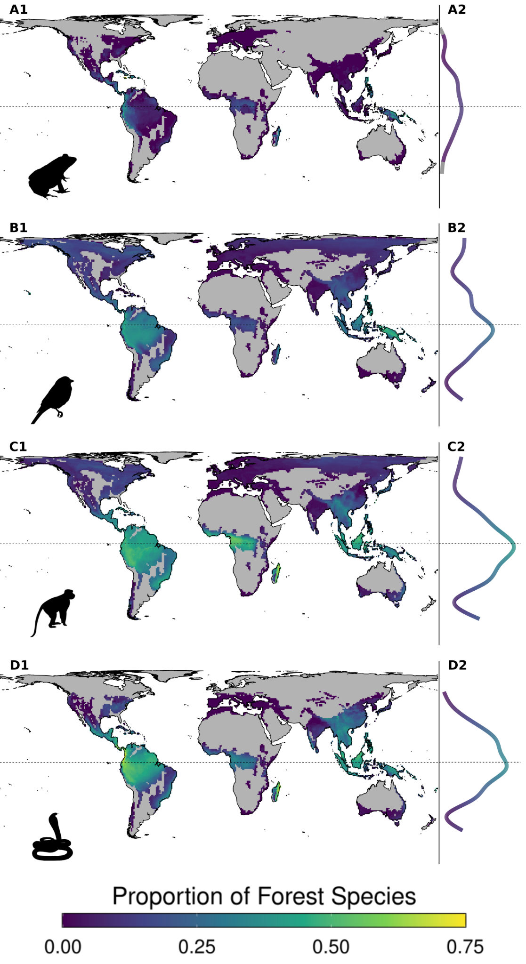

Figure 1. Global distribution of the proportion of forest species of amphibians (A1), birds (B1), mammals (C1), and reptiles (D1) in forest ecoregions. All taxa show a peak in the proportion of forest species at the equator, and a gradual decrease towards the poles. Figures A2:D2 represent the relationship between the proportion of forest species and latitude generated by a GAM fit, with the proportion of forest species shown on the x-axis and by the colour scheme; grey represents erroneously predicted values below 0%. We calculated the proportion of forest species for pixels with at least 10 species of a taxa and that contained at least 10% land cover.

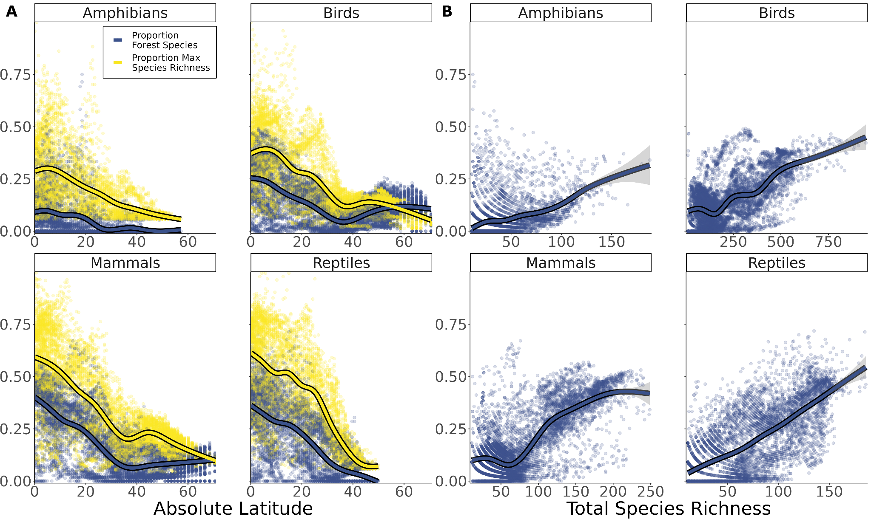

Figure 2. Both the proportion of forest species and total species richness decreased with absolute latitude (**A**), and the proportion of forest species generally increased with total species richness (**B**). (**A**) and (**B**) are both generalised additive model fits. Proportion of maximum species richness is used in (**A**) to bound values between 0 - 1 and allow for plotting on the same scale as the proportion of forest species. This was calculated per taxa as the total species richness of a pixel divided by the maximum total species richness of any pixel.

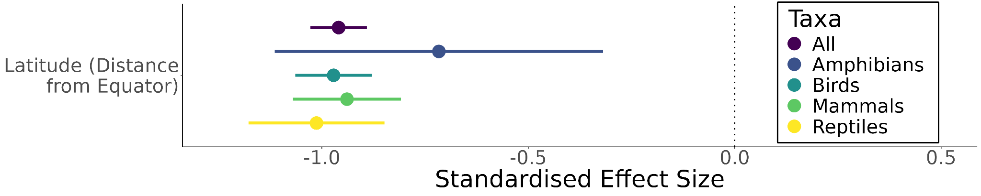

Figure 3. Proportion of forest species significantly decreases with latitude for amphibians, birds, mammals and reptiles. Results of generalised additive mixed models using latitude as the only explanatory variable, and accounting for spatial autocorrelation. Latitude has been scaled and centered to standardise the effect size and allow for comparison between models, Predictors can be interpreted as significant if the 95% confidence intervals do not cross 0.

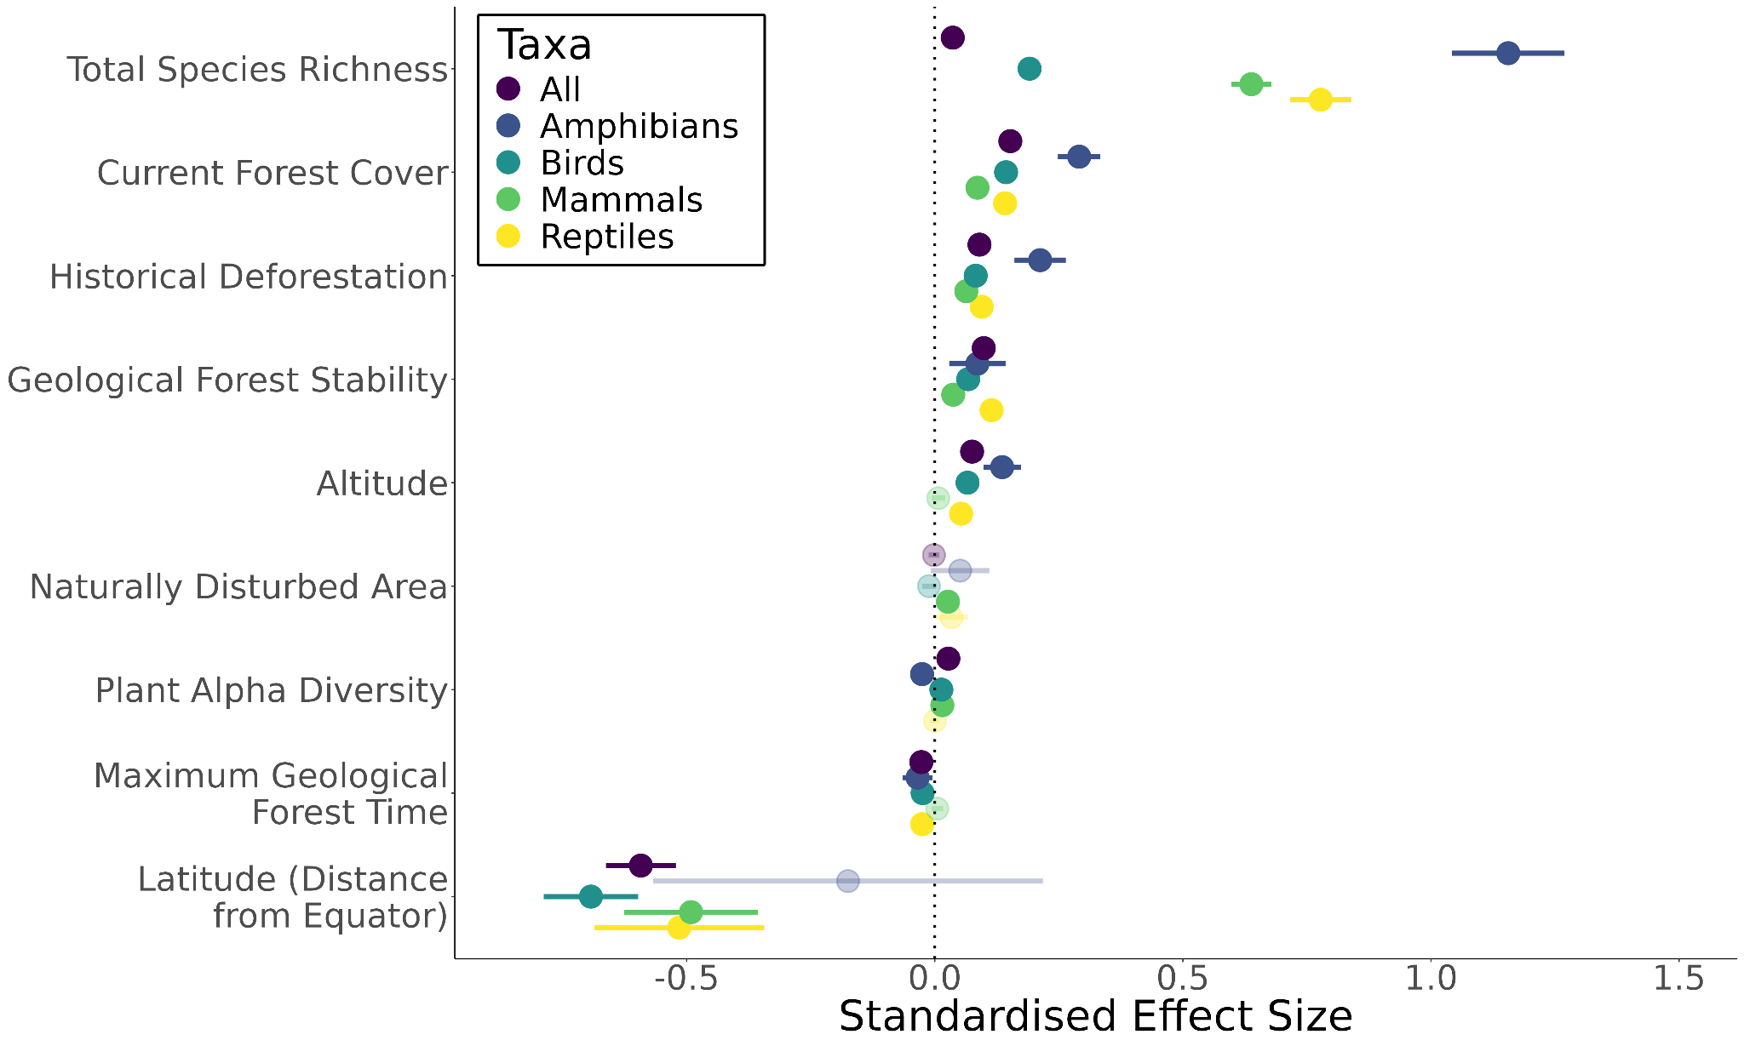

Figure 4. Proportions of forest species ubiquitously increases with current forest cover, historical deforestation, geological forest stability, and total species richness, whilst generally increasing with altitude. On the other hand proportions of forest species generally decreased with latitude and maximum geological forest time, whilst results were mixed for naturally disturbed areas and plant alpha diversity Results of generalised additive mixed models using all explanatory variables, while accounting for spatial autocorrelation. All variables have been scaled and centered to standardise effect sizes and allow for comparison between variables and models. Predictors can be interpreted as significant if the 95% confidence intervals do not cross 0. Non-significant predictors are denoted by transparent points and intervals.

# Tables and Legends

Table 1. Outline of hypothesis expected to affect the global distribution of the proportion of forest species, giving rationale as to how and why it is expected to create a latitudinal gradient, and linking to similar hypotheses within the LBG literature as defined in [Fine (2015)](https://www.zotero.org/google-docs/?bOLE6c).

| **Hypothesis Name** | **Rationale** | **Latitudinal Expectation** | **LBG Analogue** |
| --- | --- | --- | --- |
| Current Forest Cover | Increased proportion of total area available to forest species, and decreased area available for species associated with other ecotypes [(Pimm & Askins, 1995; Matthews *et al.*, 2014)](https://www.zotero.org/google-docs/?SueSQR). | **Increase the proportion of forest species as latitude decreases** sincecontemporary forest cover is skewed towards the equator [(Willig *et al.*, 2003; Hillebrand, 2004; Saupe, 2023)](https://www.zotero.org/google-docs/?AKmYcq). | Geographic area |
| Historial Deforestation | Areas with historically high proportions of forest cover are expected to have higher proportions of forest species due to the increased forested area previously available to them and known lagged responses of species to environmental changes [(Tilman *et al.*, 1994; Chen & Peng, 2017; Liao *et al.*, 2022)](https://www.zotero.org/google-docs/?isSZ5F). | **No effect on the latitudinal distribution of the proportion of forest species** as historical forest cover was relatively uniformly spread globally [(Betts *et al.*, 2017)](https://www.zotero.org/google-docs/?KLwMXs). | Geographic area |
| Forest Stability | Long-term persistence of environmental conditions is known to increase speciation rates and is a central hypothesis of the traditional LBG [(Wiens & Graham, 2005; Brown, 2014; Pontarp *et al.*, 2019)](https://www.zotero.org/google-docs/?n6Qbql). Increased speciation rates in forested environments would be expected to increase the number of forest species, and thus increase the proportion of forest species in the area. | **Increase the proportion of forest species as latitude decreases** since the tropical forests of the equator have generally been stable over the last 55 million years [(Fine & Ree, 2006)](https://www.zotero.org/google-docs/?oSMa6W), whilst forests at higher latitudes have changed between tropical, temperate, and boreal conditions [(Fine & Ree, 2006)](https://www.zotero.org/google-docs/?M6sTzM). | Climatic stability, Time |
| Forest Complexity | More species occur in areas with more structurally complex forests, due to the greater number of available niches. More species in forested environments means more forest species, which increases the proportion of forest species in the area. | **Increase the proportion of forest species as latitude decreases** since alpha diversity of plants in forests, and therefore structural complexity, increases towards the equator [(Sabatini *et al.*, 2022)](https://www.zotero.org/google-docs/?d8rg60). | Spatial Heterogeneity |
| Natural Disturbances | Higher numbers of generalist species have been found in disturbed regions [(Betts *et al.*, 2019)](https://www.zotero.org/google-docs/?P9Jklx), likely due to the lack of stable habitat types, which increases extinction rates of specialist species. Hence the proportion of forest species is expected to decrease in areas which have experienced natural disturbances. | **Increase the proportion of forest species as latitude decreases** since natural disturbances are skewed towards higher latitudinal regions [(Betts *et al.*, 2019)](https://www.zotero.org/google-docs/?vaYSo2) | Climatic stability |
| Altitude | Extreme environments such as mountains increase the specialisation of species [(Rivas-Salvador *et al.*, 2019)](https://www.zotero.org/google-docs/?qxWuUi), as well as creating physiological barriers to dispersal which further increase speciation and niche partitioning [(Janzen, 1967)](https://www.zotero.org/google-docs/?BCRBUx). Both of these factors could increase the number of forest species in an area, and thus the proportion of forest species. | **Increase the proportion of forest species as latitude decreases** as extreme altitudes are skewed towards low latitude regions. | Narrow physiological tolerance |
| Niche Packing | As species richness increases, niches must be further partitioned and therefore the proportion of specialist species increases [(Macarthur, 1965; Sánchez González *et al.*, 2023)](https://www.zotero.org/google-docs/?7rEBz6). If these species inhabit forested areas, then we would expect a higher proportion of forest specialist species in areas with higher species richness. | **Increase the proportion of forest species as latitude decreases** since species richness is known to follow a latitudinal gradient whereby the number of species increases from the poles to the equator [(Willig *et al.*, 2003; Allen & Gillooly, 2006)](https://www.zotero.org/google-docs/?cuR46p) | Niche Width |

Table 2. R2 of generalised additive mixed models using latitude as the only explanatory variable, and models including all explanatory variables. Note that the R2 value is artificially high due to the explanatory power of terms accounting for spatial autocorrelation and random effects.

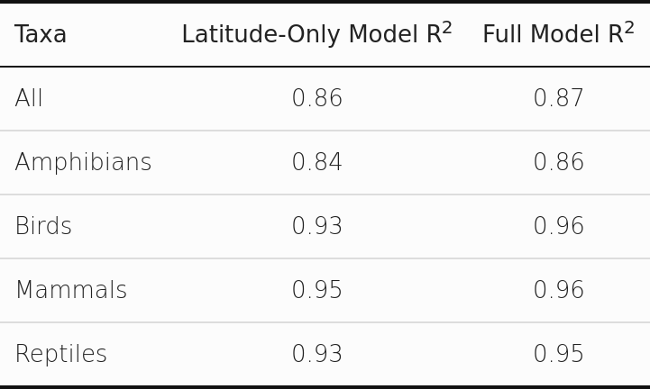

# References

[Allen, A.P. & Gillooly, J.F. (2006) Assessing latitudinal gradients in speciation rates and biodiversity at the global scale. *Ecology Letters*, **9**, 947–954.](https://www.zotero.org/google-docs/?lT8tRl)

[Anjos, L. dos, Bochio, G.M., Medeiros, H.R., Almeida, B. de A., Lindsey, B.R.A., Calsavara, L.C., Ribeiro, M.C. & Torezan, J.M.D. (2019) Insights on the functional composition of specialist and generalist birds throughout continuous and fragmented forests. *Ecology and Evolution*, **9**, 6318–6328.](https://www.zotero.org/google-docs/?lT8tRl)

[Arroyo-Rodríguez, V., Fahrig, L., Tabarelli, M., Watling, J.I., Tischendorf, L., Benchimol, M., Cazetta, E., Faria, D., Leal, I.R., Melo, F.P.L., Morante-Filho, J.C., Santos, B.A., Arasa-Gisbert, R., Arce-Peña, N., Cervantes-López, M.J., Cudney-Valenzuela, S., Galán-Acedo, C., San-José, M., Vieira, I.C.G., Slik, J.W.F., Nowakowski, A.J. & Tscharntke, T. (2020) Designing optimal human-modified landscapes for forest biodiversity conservation. *Ecology Letters*, **23**, 1404–1420.](https://www.zotero.org/google-docs/?lT8tRl)

[Betts, M.G., Fahrig, L., Hadley, A.S., Halstead, K.E., Bowman, J., Robinson, W.D., Wiens, J.A. & Lindenmayer, D.B. (2014) A species-centered approach for uncovering generalities in organism responses to habitat loss and fragmentation. *Ecography*, **37**, 517–527.](https://www.zotero.org/google-docs/?lT8tRl)

[Betts, M.G., Wolf, C., Pfeifer, M., Banks-Leite, C., Arroyo-Rodríguez, V., Ribeiro, D.B., Barlow, J., Eigenbrod, F., Faria, D., Fletcher, R.J., Hadley, A.S., Hawes, J.E., Holt, R.D., Klingbeil, B., Kormann, U., Lens, L., Levi, T., Medina-Rangel, G.F., Melles, S.L., Mezger, D., Morante-Filho, J.C., Orme, C.D.L., Peres, C.A., Phalan, B.T., Pidgeon, A., Possingham, H., Ripple, W.J., Slade, E.M., Somarriba, E., Tobias, J.A., Tylianakis, J.M., Urbina-Cardona, J.N., Valente, J.J., Watling, J.I., Wells, K., Wearn, O.R., Wood, E., Young, R. & Ewers, R.M. (2019) Extinction filters mediate the global effects of habitat fragmentation on animals. *Science*, **366**, 1236–1239.](https://www.zotero.org/google-docs/?lT8tRl)

[Betts, M.G., Wolf, C., Ripple, W.J., Phalan, B., Millers, K.A., Duarte, A., Butchart, S.H.M. & Levi, T. (2017) Global forest loss disproportionately erodes biodiversity in intact landscapes. *Nature*, **547**, 441–444.](https://www.zotero.org/google-docs/?lT8tRl)

[BirdLife Data Zone.](https://www.zotero.org/google-docs/?lT8tRl)

[Bjornstad, O.N. (2022) *ncf: Spatial Covariance Functions*,.](https://www.zotero.org/google-docs/?lT8tRl)

[Bracewell, S.A., Clark, G.F. & Johnston, E.L. (2018) Habitat complexity effects on diversity and abundance differ with latitude: an experimental study over 20 degrees. *Ecology*, **99**, 1964–1974.](https://www.zotero.org/google-docs/?lT8tRl)

[Brown, J.H. (2014) Why are there so many species in the tropics? *Journal of Biogeography*, **41**, 8–22.](https://www.zotero.org/google-docs/?lT8tRl)

[Buchhorn, M., Lesiv, M., Tsendbazar, N.-E., Herold, M., Bertels, L. & Smets, B. (2020) Copernicus Global Land Cover Layers—Collection 2. *Remote Sensing*, **12**, 1044.](https://www.zotero.org/google-docs/?lT8tRl)

[Cao, K., Condit, R., Mi, X., Chen, L., Ren, H., Xu, W., Burslem, D.F.R.P., Cai, C., Cao, M., Chang, L.-W., Chu, C., Cui, F., Du, H., Ediriweera, S., Gunatilleke, C.S.V., Gunatilleke, I.U. a. N., Hao, Z., Jin, G., Li, J., Li, B., Li, Y., Liu, Y., Ni, H., O’Brien, M.J., Qiao, X., Shen, G., Tian, S., Wang, X., Xu, H., Xu, Y., Yang, L., Yap, S.L., Lian, J., Ye, W., Yu, M., Su, S.-H., Chang-Yang, C.-H., Guo, Y., Li, X., Zeng, F., Zhu, D., Zhu, L., Sun, I.-F., Ma, K. & Svenning, J.-C. (2021) Species packing and the latitudinal gradient in beta-diversity. *Proceedings of the Royal Society B: Biological Sciences*, **288**, 20203045.](https://www.zotero.org/google-docs/?lT8tRl)

[Chen, Y. & Peng, S. (2017) Evidence and mapping of extinction debts for global forest-dwelling reptiles, amphibians and mammals. *Scientific Reports*, **7**, 44305.](https://www.zotero.org/google-docs/?lT8tRl)

[Cullen, R. (2012) Biodiversity protection prioritisation: a 25-year review. *Wildlife Research*, **40**, 108–116.](https://www.zotero.org/google-docs/?lT8tRl)

[Darwin, C. (1859) *The Origin of Species: By Means of Natural Selection, or the Preservation of Favoured Races in the Struggle for Life*, 6th edn. Cambridge University Press.](https://www.zotero.org/google-docs/?lT8tRl)

[Dinerstein, E., Olson, D., Joshi, A., Vynne, C., Burgess, N.D., Wikramanayake, E., Hahn, N., Palminteri, S., Hedao, P., Noss, R., Hansen, M., Locke, H., Ellis, E.C., Jones, B., Barber, C.V., Hayes, R., Kormos, C., Martin, V., Crist, E., Sechrest, W., Price, L., Baillie, J.E.M., Weeden, D., Suckling, K., Davis, C., Sizer, N., Moore, R., Thau, D., Birch, T., Potapov, P., Turubanova, S., Tyukavina, A., de Souza, N., Pintea, L., Brito, J.C., Llewellyn, O.A., Miller, A.G., Patzelt, A., Ghazanfar, S.A., Timberlake, J., Klöser, H., Shennan-Farpón, Y., Kindt, R., Lillesø, J.-P.B., van Breugel, P., Graudal, L., Voge, M., Al-Shammari, K.F. & Saleem, M. (2017) An Ecoregion-Based Approach to Protecting Half the Terrestrial Realm. *BioScience*, **67**, 534–545.](https://www.zotero.org/google-docs/?lT8tRl)

[Ehbrecht, M., Seidel, D., Annighöfer, P., Kreft, H., Köhler, M., Zemp, D.C., Puettmann, K., Nilus, R., Babweteera, F., Willim, K., Stiers, M., Soto, D., Boehmer, H.J., Fisichelli, N., Burnett, M., Juday, G., Stephens, S.L. & Ammer, C. (2021) Global patterns and climatic controls of forest structural complexity. *Nature Communications*, **12**, 519.](https://www.zotero.org/google-docs/?lT8tRl)

[FAO ed. (2020) *Forest, biodiversity and people*, FAO, Rome.](https://www.zotero.org/google-docs/?lT8tRl)

[Fine, P.V.A. (2015) Ecological and Evolutionary Drivers of Geographic Variation in Species Diversity. *Annual Review of Ecology, Evolution, and Systematics*, **46**, 369–392.](https://www.zotero.org/google-docs/?lT8tRl)

[Fine, P.V.A. & Ree, R.H. (2006) Evidence for a time-integrated species-area effect on the latitudinal gradient in tree diversity. *The American Naturalist*, **168**, 796–804.](https://www.zotero.org/google-docs/?lT8tRl)

[Gaston, K.J. (2007) Latitudinal gradient in species richness. *Current Biology*, **17**, R574.](https://www.zotero.org/google-docs/?lT8tRl)

[Giam, X. (2017) Global biodiversity loss from tropical deforestation. *Proceedings of the National Academy of Sciences*, **114**, 5775–5777.](https://www.zotero.org/google-docs/?lT8tRl)

[Haddad, N.M., Brudvig, L.A., Clobert, J., Davies, K.F., Gonzalez, A., Holt, R.D., Lovejoy, T.E., Sexton, J.O., Austin, M.P., Collins, C.D., Cook, W.M., Damschen, E.I., Ewers, R.M., Foster, B.L., Jenkins, C.N., King, A.J., Laurance, W.F., Levey, D.J., Margules, C.R., Melbourne, B.A., Nicholls, A.O., Orrock, J.L., Song, D.-X. & Townshend, J.R. (2015) Habitat fragmentation and its lasting impact on Earth’s ecosystems. *Science Advances*, **1**, e1500052.](https://www.zotero.org/google-docs/?lT8tRl)

[Halstead, K.E., Alexander, J.D., Hadley, A.S., Stephens, J.L., Yang, Z. & Betts, M.G. (2019) Using a species-centered approach to predict bird community responses to habitat fragmentation. *Landscape Ecology*, **34**, 1919–1935.](https://www.zotero.org/google-docs/?lT8tRl)

[Haney, A., Apfelbaum, S. & Burris, J.M. (2008) Thirty Years of Post-fire Succession in a Southern Boreal Forest Bird Community. *The American Midland Naturalist*, **159**, 421–433.](https://www.zotero.org/google-docs/?lT8tRl)

[Hansen, A.J. & Urban, D.L. (1992) Avian response to landscape pattern: The role of species’ life histories. *Landscape Ecology*, **7**, 163–180.](https://www.zotero.org/google-docs/?lT8tRl)

[Hansen, M.C., Potapov, P.V., Moore, R., Hancher, M., Turubanova, S.A., Tyukavina, A., Thau, D., Stehman, S.V., Goetz, S.J., Loveland, T.R., Kommareddy, A., Egorov, A., Chini, L., Justice, C.O. & Townshend, J.R.G. (2013) High-Resolution Global Maps of 21st-Century Forest Cover Change. *Science*, **342**, 850–853.](https://www.zotero.org/google-docs/?lT8tRl)

[Hartig, F. (2022) *DHARMa: Residual Diagnostics for Hierarchical (Multi-Level / Mixed) Regression Models*,.](https://www.zotero.org/google-docs/?lT8tRl)

[Henle, K., Davies, K.F., Kleyer, M., Margules, C. & Settele, J. (2004) Predictors of Species Sensitivity to Fragmentation. *Biodiversity & Conservation*, **13**, 207–251.](https://www.zotero.org/google-docs/?lT8tRl)

[Hillebrand, H. (2004) On the Generality of the Latitudinal Diversity Gradient. *The American Naturalist*, **163**, 192–211.](https://www.zotero.org/google-docs/?lT8tRl)

[Humboldt, A.V. (1849) *Ansichten der Natur : mit wissenschaftlichen Erläuterungen /*, J.G. Cotta, Stuttgart :](https://www.zotero.org/google-docs/?lT8tRl)

[IPBES, I. (2019) *Summary for policymakers of the global assessment report on biodiversity and ecosystem services*,.](https://www.zotero.org/google-docs/?lT8tRl)

[Jablonski, D., Roy, K. & Valentine, J.W. (2006) Out of the Tropics: Evolutionary Dynamics of the Latitudinal Diversity Gradient. *Science*, **314**, 102–106.](https://www.zotero.org/google-docs/?lT8tRl)

[Janzen, D.H. (1967) Why Mountain Passes are Higher in the Tropics. *The American Naturalist*, **101**, 233–249.](https://www.zotero.org/google-docs/?lT8tRl)

[Jetz, W. & Fine, P.V.A. (2012) Global Gradients in Vertebrate Diversity Predicted by Historical Area-Productivity Dynamics and Contemporary Environment. *PLOS Biology*, **10**, e1001292.](https://www.zotero.org/google-docs/?lT8tRl)

[Keinath, D.A., Doak, D.F., Hodges, K.E., Prugh, L.R., Fagan, W., Sekercioglu, C.H., Buchart, S.H.M. & Kauffman, M. (2017) A global analysis of traits predicting species sensitivity to habitat fragmentation: Species sensitivity. *Global Ecology and Biogeography*, **26**, 115–127.](https://www.zotero.org/google-docs/?lT8tRl)

[Kotliar, N.B., Kennedy, P.L. & Ferree, K. (2007) Avifaunal Responses to Fire in Southwestern Montane Forests Along a Burn Severity Gradient. *Ecological Applications*, **17**, 491–507.](https://www.zotero.org/google-docs/?lT8tRl)

[Lavorel, S., Flannigan, M.D., Lambin, E.F. & Scholes, M.C. (2007) Vulnerability of land systems to fire: Interactions among humans, climate, the atmosphere, and ecosystems. *Mitigation and Adaptation Strategies for Global Change*, **12**, 33–53.](https://www.zotero.org/google-docs/?lT8tRl)

[Legendre, P. (1993) Spatial Autocorrelation: Trouble or New Paradigm? *Ecology*, **74**, 1659–1673.](https://www.zotero.org/google-docs/?lT8tRl)

[Leibold, M.A., Holyoak, M., Mouquet, N., Amarasekare, P., Chase, J.M., Hoopes, M.F., Holt, R.D., Shurin, J.B., Law, R., Tilman, D., Loreau, M. & Gonzalez, A. (2004) The metacommunity concept: a framework for multi-scale community ecology. *Ecology Letters*, **7**, 601–613.](https://www.zotero.org/google-docs/?lT8tRl)

[Liao, Z., Peng, S. & Chen, Y. (2022) Half-millennium evidence suggests that extinction debts of global vertebrates started in the Second Industrial Revolution. *Communications Biology*, **5**, 1–8.](https://www.zotero.org/google-docs/?lT8tRl)

[Location of tropical cyclones (2024) *Met Office*.](https://www.zotero.org/google-docs/?lT8tRl)

[Lüdecke, D., Ben-Shachar, M.S., Patil, I., Waggoner, P. & Makowski, D. (2021) performance: An R Package for Assessment, Comparison and Testing of Statistical Models. *Journal of Open Source Software*, **6**, 3139.](https://www.zotero.org/google-docs/?lT8tRl)

[Macarthur, R.H. (1965) Patterns of Species Diversity. *Biological Reviews*, **40**, 510–533.](https://www.zotero.org/google-docs/?lT8tRl)

[Matthews, T.J., Cottee-Jones, H.E. & Whittaker, R.J. (2014) Habitat fragmentation and the species-area relationship: a focus on total species richness obscures the impact of habitat loss on habitat specialists. *Diversity and Distributions*, **20**, 1136–1146.](https://www.zotero.org/google-docs/?lT8tRl)

[Melo, I., Ochoa‐Quintero, J.M., Roque, F. de O. & Dalsgaard, B. (2018) A review of threshold responses of birds to landscape changes across the world. *Journal of Field Ornithology*, **89**, 303–314.](https://www.zotero.org/google-docs/?lT8tRl)

[Menegotto, A. & Rangel, T.F. (2018) Mapping knowledge gaps in marine diversity reveals a latitudinal gradient of missing species richness. *Nature Communications*, **9**, 4713.](https://www.zotero.org/google-docs/?lT8tRl)

[Mittelbach, G.G., Schemske, D.W., Cornell, H.V., Allen, A.P., Brown, J.M., Bush, M.B., Harrison, S.P., Hurlbert, A.H., Knowlton, N., Lessios, H.A., McCain, C.M., McCune, A.R., McDade, L.A., McPeek, M.A., Near, T.J., Price, T.D., Ricklefs, R.E., Roy, K., Sax, D.F., Schluter, D., Sobel, J.M. & Turelli, M. (2007) Evolution and the latitudinal diversity gradient: speciation, extinction and biogeography. *Ecology Letters*, **10**, 315–331.](https://www.zotero.org/google-docs/?lT8tRl)

[NOAA National Centers for Environmental Information (2022) ETOPO 2022 15 Arc-Second Global Relief Model.](https://www.zotero.org/google-docs/?lT8tRl)

[Pimm, S.L. & Askins, R.A. (1995) Forest losses predict bird extinctions in eastern North America. *Proceedings of the National Academy of Sciences*, **92**, 9343–9347.](https://www.zotero.org/google-docs/?lT8tRl)

[Pontarp, M., Bunnefeld, L., Cabral, J.S., Etienne, R.S., Fritz, S.A., Gillespie, R., Graham, C.H., Hagen, O., Hartig, F., Huang, S., Jansson, R., Maliet, O., Münkemüller, T., Pellissier, L., Rangel, T.F., Storch, D., Wiegand, T. & Hurlbert, A.H. (2019) The Latitudinal Diversity Gradient: Novel Understanding through Mechanistic Eco-evolutionary Models. *Trends in Ecology & Evolution*, **34**, 211–223.](https://www.zotero.org/google-docs/?lT8tRl)

[R Core Team (2023) *R: A Language and Environment for Statistical Computing*, R Foundation for Statistical Computing, Vienna, Austria.](https://www.zotero.org/google-docs/?lT8tRl)

[Ritchie, H. & Roser, M. (2023) The world has lost one-third of its forest, but an end of deforestation is possible. *Our World in Data*.](https://www.zotero.org/google-docs/?lT8tRl)

[Rivas-Salvador, J., Hořák, D. & Reif, J. (2019) Spatial patterns in habitat specialization of European bird communities. *Ecological Indicators*, **105**, 57–69.](https://www.zotero.org/google-docs/?lT8tRl)

[Sabatini, F.M., Jiménez-Alfaro, B., Jandt, U., Chytrý, M., Field, R., Kessler, M., Lenoir, J., Schrodt, F., Wiser, S.K., Arfin Khan, M.A.S., Attorre, F., Cayuela, L., De Sanctis, M., Dengler, J., Haider, S., Hatim, M.Z., Indreica, A., Jansen, F., Pauchard, A., Peet, R.K., Petřík, P., Pillar, V.D., Sandel, B., Schmidt, M., Tang, Z., van Bodegom, P., Vassilev, K., Violle, C., Alvarez-Davila, E., Davidar, P., Dolezal, J., Hérault, B., Galán-de-Mera, A., Jiménez, J., Kambach, S., Kepfer-Rojas, S., Kreft, H., Lezama, F., Linares-Palomino, R., Monteagudo Mendoza, A., N’Dja, J.K., Phillips, O.L., Rivas-Torres, G., Sklenář, P., Speziale, K., Strohbach, B.J., Vásquez Martínez, R., Wang, H.-F., Wesche, K. & Bruelheide, H. (2022) Global patterns of vascular plant alpha diversity. *Nature Communications*, **13**, 4683.](https://www.zotero.org/google-docs/?lT8tRl)

[Sánchez González, I., Hopper, G.W., Bucholz, J.R., Kubala, M.E., Lozier, J.D. & Atkinson, C.L. (2023) Niche specialization and community niche space increase with species richness in filter-feeder assemblages. *Ecosphere*, **14**, e4495.](https://www.zotero.org/google-docs/?lT8tRl)

[Saupe, E.E. (2023) Explanations for latitudinal diversity gradients must invoke rate variation. *Proceedings of the National Academy of Sciences*, **120**, e2306220120.](https://www.zotero.org/google-docs/?lT8tRl)

[Schumm, M., Edie, S.M., Collins, K.S., Gómez-Bahamón, V., Supriya, K., White, A.E., Price, T.D. & Jablonski, D. (2019) Common latitudinal gradients in functional richness and functional evenness across marine and terrestrial systems. *Proceedings of the Royal Society B: Biological Sciences*, **286**, 20190745.](https://www.zotero.org/google-docs/?lT8tRl)

[Sheard, C., Neate-Clegg, M.H.C., Alioravainen, N., Jones, S.E.I., Vincent, C., MacGregor, H.E.A., Bregman, T.P., Claramunt, S. & Tobias, J.A. (2020) Ecological drivers of global gradients in avian dispersal inferred from wing morphology. *Nature Communications*, **11**, 2463.](https://www.zotero.org/google-docs/?lT8tRl)

[Sheard, C., Neate-Clegg, M.H.C., Alioravainen, N., Jones, S.E.I., Vincent, C., MacGregor, H.E.A., Bregman, T.P., Claramunt, S. & Tobias, J.A. (2019) The latitudinal gradient in hand-wing-index: global patterns and predictors of wing morphology in birds. 816603.](https://www.zotero.org/google-docs/?lT8tRl)

[Simpson, G.L. (2018) Modelling Palaeoecological Time Series Using Generalised Additive Models. *Frontiers in Ecology and Evolution*, **6**.](https://www.zotero.org/google-docs/?lT8tRl)

[Smith, B.T., Seeholzer, G.F., Harvey, M.G., Cuervo, A.M. & Brumfield, R.T. (2017) A latitudinal phylogeographic diversity gradient in birds. *PLOS Biology*, **15**, e2001073.](https://www.zotero.org/google-docs/?lT8tRl)

[Sommer, R.S. & Nadachowski, A. (2006) Glacial refugia of mammals in Europe: evidence from fossil records. *Mammal Review*, **36**, 251–265.](https://www.zotero.org/google-docs/?lT8tRl)

[Souza, C.M., Z. Shimbo, J., Rosa, M.R., Parente, L.L., A. Alencar, A., Rudorff, B.F.T., Hasenack, H., Matsumoto, M., G. Ferreira, L., Souza-Filho, P.W.M., de Oliveira, S.W., Rocha, W.F., Fonseca, A.V., Marques, C.B., Diniz, C.G., Costa, D., Monteiro, D., Rosa, E.R., Vélez-Martin, E., Weber, E.J., Lenti, F.E.B., Paternost, F.F., Pareyn, F.G.C., Siqueira, J.V., Viera, J.L., Neto, L.C.F., Saraiva, M.M., Sales, M.H., Salgado, M.P.G., Vasconcelos, R., Galano, S., Mesquita, V.V. & Azevedo, T. (2020) Reconstructing Three Decades of Land Use and Land Cover Changes in Brazilian Biomes with Landsat Archive and Earth Engine. *Remote Sensing*, **12**, 2735.](https://www.zotero.org/google-docs/?lT8tRl)

[Sverdrup-Thygeson, A., Skarpaas, O., Blumentrath, S., Birkemoe, T. & Evju, M. (2017) Habitat connectivity affects specialist species richness more than generalists in veteran trees. *Forest Ecology and Management*, **403**, 96–102.](https://www.zotero.org/google-docs/?lT8tRl)

[Swift, T.L. & Hannon, S.J. (2010) Critical thresholds associated with habitat loss: a review of the concepts, evidence, and applications. *Biological Reviews*, **85**, 35–53.](https://www.zotero.org/google-docs/?lT8tRl)

[The IUCN Red List of Threatened Species *IUCN Red List of Threatened Species*.](https://www.zotero.org/google-docs/?lT8tRl)

[Tilman, D., May, R.M., Lehman, C.L. & Nowak, M.A. (1994) Habitat destruction and the extinction debt. *Nature*, **371**, 65–66.](https://www.zotero.org/google-docs/?lT8tRl)

[University of Geneva, Switzerland, Ray, N. & Adams, J.M. (2001) A GIS-based Vegetation Map of the World at the Last Glacial Maximum (25,000-15,000 BP). *Internet Archaeology*.](https://www.zotero.org/google-docs/?lT8tRl)

[Vargas-Cárdenas, F., Arroyo-Rodríguez, V., Morante-Filho, J.C., Schondube, J.E., Auliz-Ortiz, D.M. & Ceccon, E. (2022) Landscape forest loss decreases bird diversity with strong negative impacts on forest species in a mountain region. *Perspectives in Ecology and Conservation*, **20**, 386–393.](https://www.zotero.org/google-docs/?lT8tRl)

[Waldron, A., Adams, V., Allan, J., Arnell, A., Asner, G., Atkinson, S., Baccini, A., Baillie, E., Balmford, A., Beau, J.A., Brander, L., Brondizio, E., Bruner, A., Burgess, N., Burkart, K., Butchart, S., Button, R., Carrasco, R., Cheung, W., Christensen, V., Clements, A., Coll, M., di Marco, Deguignet, M., Dinerstein, E., Ellis, E., Eppink, F., Ervin, J., Escobedo, A., Fa, J., Fernandes-Llamazares, A., Fernando, S., Fujimori, S., Fulton, B., Garnett, S., Gerber, J., Gill, D., Gopalakrishna, T., Hahn, N., Halpern, B., Hasegawa, T., Havlik, P., Heikinheimo, V., Heneghan, R., Henry, E., Humpenoder, F., Jonas, H., Jones, K., Joppa, L., Joshi, A.R., Kingston, N., Klein, C., Krisztin, T., Lam, V., Leclere, D., Lindsey, P., Locke, H., Lovejoy, T., Madgwick, P., Malhi, Y., Malmer, P., Maron, M., Mayorga, J., van Meijl, H., Miller, D., Molnar, Z., Mueller, N., Mukherjee, N., Naidoo, R., Nakamura, K., Nepal, P., Noss, R., O’Leary, B., Olson, D., Abrantes, J.P., Paxton, M., Popp, A., Possingham, H., Prestemon, J., Steenbeck, J., Stehfest, E., Strassborg, B., Sumaila, R., Swinnerton, K., Sze, J., Tittensor, D., Toivonen, T., Toledo, A., Torres, P.N., Vilela, T., Visconti, P., Vynne, C., Watson, R., Watson, J., Wikramanayake, E., Williams, B., Wintle, B., Woodley, S., Wu, W., Zander, K., Zhang, Y. & Zhang, Y. (2020) Protecting 30% of the planet for nature: costs, benefits and economic implications.](https://www.zotero.org/google-docs/?lT8tRl)

[Wallace, A.R. (1878) *Tropical Nature, and Other Essays*, Macmillan and Company.](https://www.zotero.org/google-docs/?lT8tRl)

[Waltari, E., Hijmans, R.J., Peterson, A.T., Nyári, Á.S., Perkins, S.L. & Guralnick, R.P. (2007) Locating Pleistocene Refugia: Comparing Phylogeographic and Ecological Niche Model Predictions. *PLOS ONE*, **2**, e563.](https://www.zotero.org/google-docs/?lT8tRl)

[Weeks, T.L., Betts, M.G., Pfeifer, M., Wolf, C., Banks-Leite, C., Barbaro, L., Barlow, J., Cerezo, A., Kennedy, C.M., Kormann, U.G., Marsh, C.J., Olivier, P.I., Phalan, B.T., Possingham, H.P., Wood, E.M. & Tobias, J.A. (2023) Climate-driven variation in dispersal ability predicts responses to forest fragmentation in birds. *Nature Ecology & Evolution*, **7**, 1079–1091.](https://www.zotero.org/google-docs/?lT8tRl)

[Wiens, J.J. & Graham, C.H. (2005) Niche Conservatism: Integrating Evolution, Ecology, and Conservation Biology. *Annual Review of Ecology, Evolution, and Systematics*, **36**, 519–539.](https://www.zotero.org/google-docs/?lT8tRl)

[Willig, M.R., Kaufman, D.M. & Stevens, R.D. (2003) Latitudinal Gradients of Biodiversity: Pattern, Process, Scale, and Synthesis. *Annual Review of Ecology, Evolution, and Systematics*, **34**, 273–309.](https://www.zotero.org/google-docs/?lT8tRl)

[Wood, S.N. (2011) Fast stable restricted maximum likelihood and marginal likelihood estimation of semiparametric generalized linear models. *Journal of the Royal Statistical Society (B)*, **73**, 3–36.](https://www.zotero.org/google-docs/?lT8tRl)

[WorldClim (2024).](https://www.zotero.org/google-docs/?lT8tRl)

[Yang, L., Jin, S., Danielson, P., Homer, C., Gass, L., Bender, S.M., Case, A., Costello, C., Dewitz, J., Fry, J., Funk, M., Granneman, B., Liknes, G.C., Rigge, M. & Xian, G. (2018) A new generation of the United States National Land Cover Database: Requirements, research priorities, design, and implementation strategies. *ISPRS Journal of Photogrammetry and Remote Sensing*, **146**, 108–123.](https://www.zotero.org/google-docs/?lT8tRl)