Supplementary: A global latitudinal gradient in the proportion of terrestrial vertebrate forest species

## Model Structure

All predictors in models were scaled and centered to allow for direct comparison of effect sizes.

### Latitude Model Per Taxa

*bam(proportion_of_forest_species ~ latitude + s(x, y, bs = “gaussian process”) + s(ecoregion, bs = “random”), weights = total_species, family = binomial)*

### Latitude Model All Taxa

*bam(proportion_of_forest_species ~ latitude + s(x, y, bs = “gaussian process”) + s(ecoregion, bs = “random”) + s(taxa, bs = “random”), weights = total_species, family = binomial)*

### Full Model Per Taxa

*bam(proportion_of_forest_species ~ current_forest_cover + historical_deforestation + natural_disturbances + geological_forest_time + geologica_forest_stability + plant_alpha_diversity + latitude + s(x, y, bs = “gaussian process”) + s(ecoregion, bs = “random”), weights = total_species, family = binomial)*

### Full Model All Taxa

*bam(proportion_of_forest_species ~ current_forest_cover + historical_deforestation + natural_disturbances + geological_forest_time + geologica_forest_stability + plant_alpha_diversity + latitude + s(x, y, bs = “gaussian process”) + s(ecoregion, bs = “random”) + s(taxa, bs = “random”), weights = total_species, family = binomial)*

## Hand Wing Index

Hand wing index data was obtained from Avonet [(Tobias *et al.*, 2022)](https://www.zotero.org/google-docs/?blhr8Z) and paired with our categorisation of bird species using IUCN habitat classification into forest and non-forest. Hand wing index is a well-studied proxy for dispersal ability [(Sheard *et al.*, 2020; Tobias *et al.*, 2022; Weeks *et al.*, 2023)](https://www.zotero.org/google-docs/?QHpXFz), and is calculated as the ratio of the Kipp's distance (the distance between the tip of the first secondary feather and the tip of the longest primary feather) to the total wing chord [(Sheard *et al.*, 2019)](https://www.zotero.org/google-docs/?xf3JYV). A linear regression was run using habitat classification (forest or non-forest) as a categorical explanatory variable, and hand wing index as the response. Forest species were found to have significantly lower hand wing indexes than non-forest species (Non-forest = 24.94, 95% CI (24.62, 25.26), Forest = 21.32 95% CI (20.84, 21.81)) suggesting forest species are generally poorer dispersers than non-forest species, at least in birds.

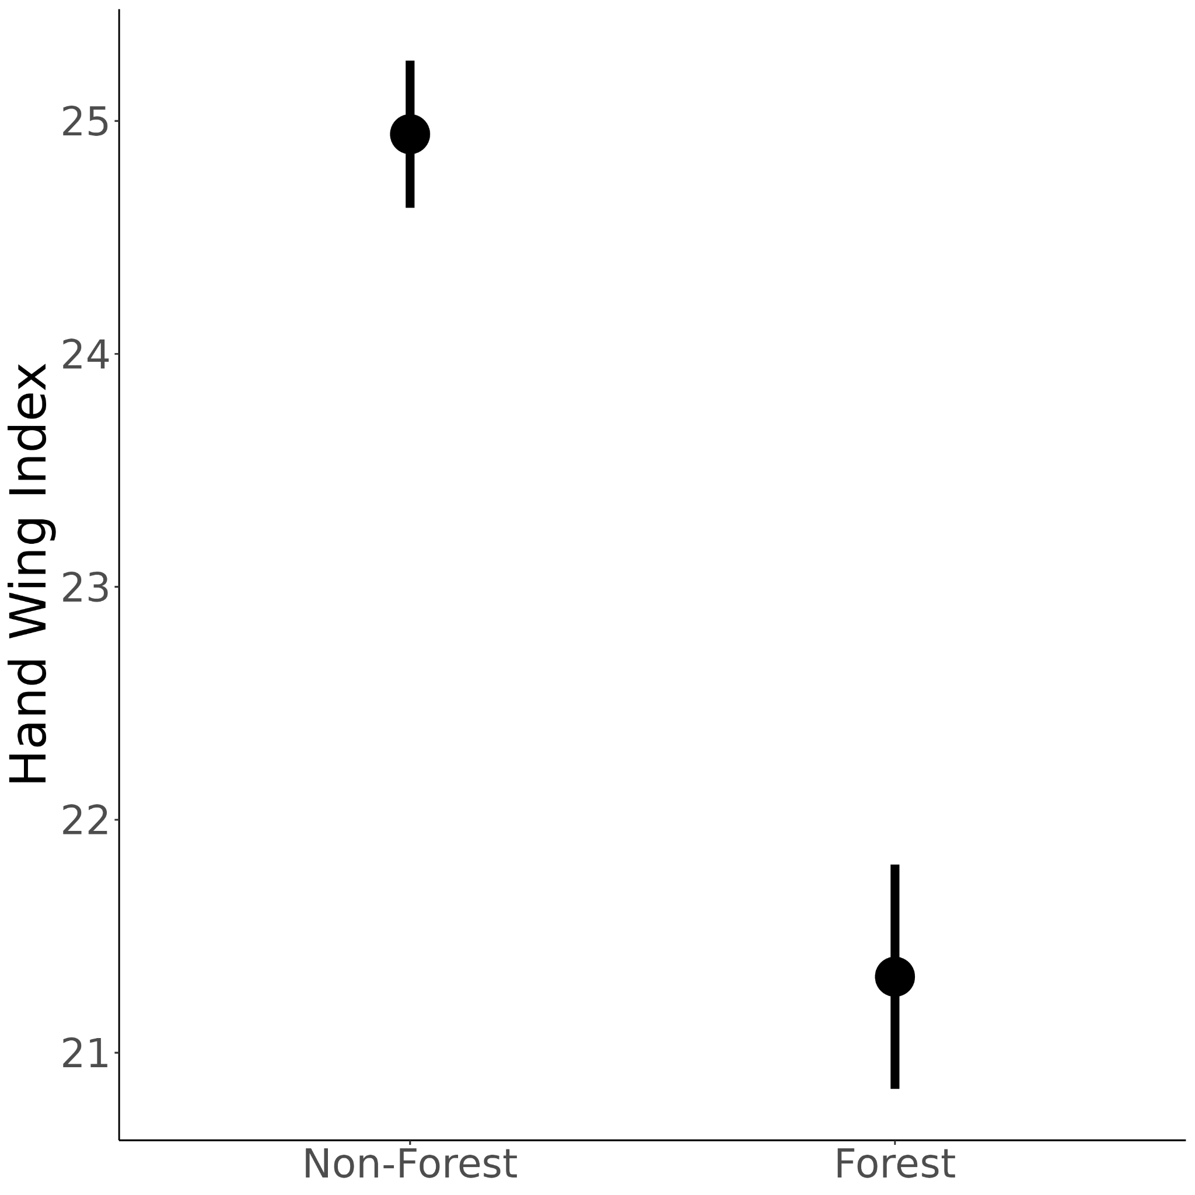

Figure S1. Forest species have on average a significantly smaller hand wing index than non-forest species, indicating that they are generally poorer dispersers. Estimates and 95% confidence intervals of a linear model where habitat classification (forest or non-forest) was used as a predictor variable, and hand wing index as the response.

# References

[Sheard, C., Neate-Clegg, M.H.C., Alioravainen, N., Jones, S.E.I., Vincent, C., MacGregor, H.E.A., Bregman, T.P., Claramunt, S. & Tobias, J.A. (2020) Ecological drivers of global gradients in avian dispersal inferred from wing morphology. *Nature Communications*, **11**, 2463.](https://www.zotero.org/google-docs/?DCdZrc)

[Sheard, C., Neate-Clegg, M.H.C., Alioravainen, N., Jones, S.E.I., Vincent, C., MacGregor, H.E.A., Bregman, T.P., Claramunt, S. & Tobias, J.A. (2019) The latitudinal gradient in hand-wing-index: global patterns and predictors of wing morphology in birds. 816603.](https://www.zotero.org/google-docs/?DCdZrc)

[Tobias, J.A., Sheard, C., Pigot, A.L., Devenish, A.J.M., Yang, J., Sayol, F., Neate-Clegg, M.H.C., Alioravainen, N., Weeks, T.L., Barber, R.A., Walkden, P.A., MacGregor, H.E.A., Jones, S.E.I., Vincent, C., Phillips, A.G., Marples, N.M., Montaño-Centellas, F.A., Leandro-Silva, V., Claramunt, S., Darski, B., Freeman, B.G., Bregman, T.P., Cooney, C.R., Hughes, E.C., Capp, E.J.R., Varley, Z.K., Friedman, N.R., Korntheuer, H., Corrales-Vargas, A., Trisos, C.H., Weeks, B.C., Hanz, D.M., Töpfer, T., Bravo, G.A., Remeš, V., Nowak, L., Carneiro, L.S., Moncada R., A.J., Matysioková, B., Baldassarre, D.T., Martínez-Salinas, A., Wolfe, J.D., Chapman, P.M., Daly, B.G., Sorensen, M.C., Neu, A., Ford, M.A., Mayhew, R.J., Fabio Silveira, L., Kelly, D.J., Annorbah, N.N.D., Pollock, H.S., Grabowska-Zhang, A.M., McEntee, J.P., Carlos T. Gonzalez, J., Meneses, C.G., Muñoz, M.C., Powell, L.L., Jamie, G.A., Matthews, T.J., Johnson, O., Brito, G.R.R., Zyskowski, K., Crates, R., Harvey, M.G., Jurado Zevallos, M., Hosner, P.A., Bradfer-Lawrence, T., Maley, J.M., Stiles, F.G., Lima, H.S., Provost, K.L., Chibesa, M., Mashao, M., Howard, J.T., Mlamba, E., Chua, M.A.H., Li, B., Gómez, M.I., García, N.C., Päckert, M., Fuchs, J., Ali, J.R., Derryberry, E.P., Carlson, M.L., Urriza, R.C., Brzeski, K.E., Prawiradilaga, D.M., Rayner, M.J., Miller, E.T., Bowie, R.C.K., Lafontaine, R.-M., Scofield, R.P., Lou, Y., Somarathna, L., Lepage, D., Illif, M., Neuschulz, E.L., Templin, M., Dehling, D.M., Cooper, J.C., Pauwels, O.S.G., Analuddin, K., Fjeldså, J., Seddon, N., Sweet, P.R., DeClerck, F.A.J., Naka, L.N., Brawn, J.D., Aleixo, A., Böhning-Gaese, K., Rahbek, C., Fritz, S.A., Thomas, G.H. & Schleuning, M. (2022) AVONET: morphological, ecological and geographical data for all birds. *Ecology Letters*, **25**, 581–597.](https://www.zotero.org/google-docs/?DCdZrc)

[Weeks, T.L., Betts, M.G., Pfeifer, M., Wolf, C., Banks-Leite, C., Barbaro, L., Barlow, J., Cerezo, A., Kennedy, C.M., Kormann, U.G., Marsh, C.J., Olivier, P.I., Phalan, B.T., Possingham, H.P., Wood, E.M. & Tobias, J.A. (2023) Climate-driven variation in dispersal ability predicts responses to forest fragmentation in birds. *Nature Ecology & Evolution*, **7**, 1079–1091.](https://www.zotero.org/google-docs/?DCdZrc)