Tài liệu hướng dẫn tạo dịch vụ với Oracle Service Bus 12c,

Các link tài liệu tham khảo:

Developing Oracle Service Bus 12c in JDeveloper tool

<https://docs.oracle.com/middleware/1221/osb/develop/GUID-669A9F6F-EE55-499A-AF33-D2FF7DB651B4.htm#OSBDV2815>

Learning about oracle Service bus developer:

<https://docs.oracle.com/middleware/1221/osb/develop/OSBDV.pdf>

<https://docs.oracle.com/en/middleware/soa-suite/soa/12.2.1.3/concepts/understanding-oracle-soa-suite.pdf>

<https://docs.oracle.com/middleware/1221/osb/develop/GUID-DBC25F49-2379-432B-BC29-7CB619FB4EEA.htm#OSBDV1430>

Dynamic routing:

<https://www.youtube.com/watch?v=imKCwRWSGfQ>

<https://www.youtube.com/watch?v=R6bOXfiS-KQ>

<https://svgonugu.com/2011/07/31/using-dynamic-routing-in-osb/>

<http://soa-bpel-esb.blogspot.com/2010/08/dynamic-routing-in-oracle-service-bus.html>

<https://docs.oracle.com/middleware/1213/osb/develop/GUID-FE2CAC5B-E4DF-49DE-AD3C-36EEAF750BFE.htm#OSBDV2409>

# **Configuring Business Services for Message Throttling**

<https://docs.oracle.com/middleware/1221/osb/administer/GUID-24DF76EC-BB77-4AAA-8A6B-EF91518CFD1F.htm#OSBAG614>

<https://docs.oracle.com/middleware/1221/osb/administer/GUID-24DF76EC-BB77-4AAA-8A6B-EF91518CFD1F.htm#OSBAG2103>

Learning develop:

<https://www.techsupper.com/2017/02/what-is-difference-between-oracle-soa.html>

caching in OSB:

<https://www.youtube.com/watch?v=peIuwf8YGck>

<https://www.youtube.com/watch?v=w9LT1BHtiBQ>

Create business service and Proxy service for OSB;

<https://docs.oracle.com/middleware/1213/osb/develop/GUID-B932E48E-8DDA-4C3D-B600-CBE2C510CED6.htm#OSBDV2168>

Sử dụng tool Jdeveloper để phát triển:

1. Tổng quan về Oracle Service Bus
2. Sử dụng tool Jdeveloper để tạo OSB Service

***Giao diện phát triển 1 ứng dụng Oracle Service bus:***

***Gồm 4 phần chính:***

*+* ***Proxy services****: Tạo ra các Service cho phép client gọi đến OSB (Inbound Services).*

*+ Pipelines: data transformation, routing, validate…sử dụng javacall out hoặc xpath query để xử lý if else dữ liệu…*

*+ External services (Business Services): hay còn gọi là business services: Là các dịch vụ bên trong mà có thể OSB cần gọi đến. Như các dịch vụ service được tích hợp trên SOA suite, hoặc các webservice nào đó OSB cần gọi đến… (OUT bound services).*

*+ Các Services bus conponents: Các thành phần, các adapter, các chuẩn được tính hợp sẵn để sử dụng cho phát triển 1 ứng dụng OSB hoàn chỉnh.*

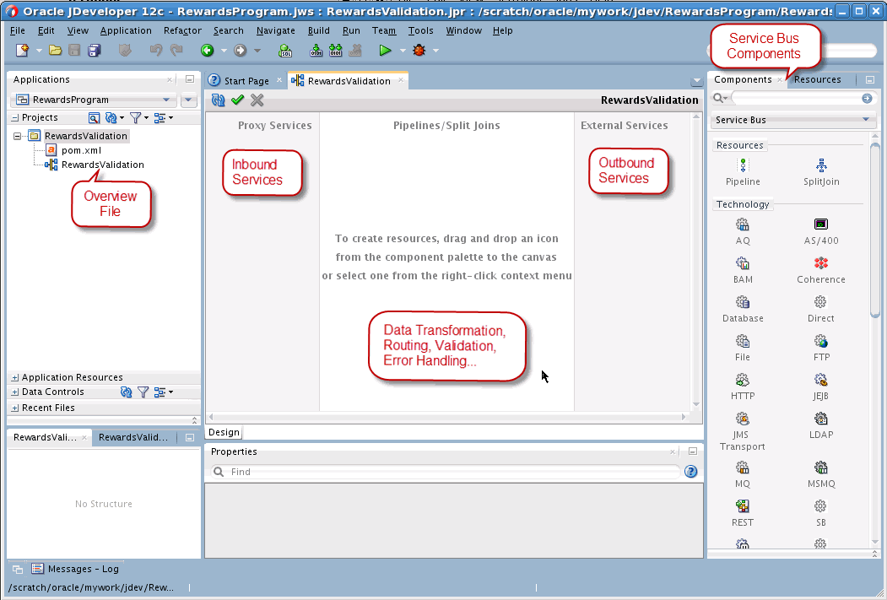

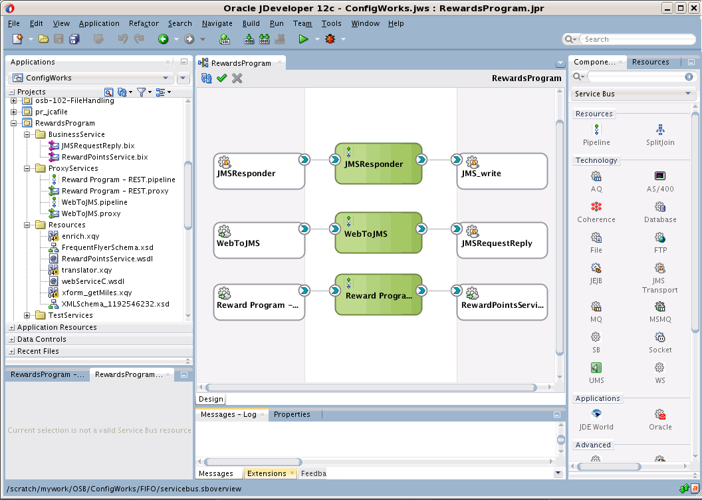

### Tìm hiểu về Flow data message với OSB

Messages can contain data or status information about application processes, as well as instructions for the recipient. Service Bus lets you route messages based on their contents and perform transformations on that content. The processing happens through the transport and binding layers of Service Bus.

The processing of messages through Service Bus occurs in the following sequence of events:

1. A client sends a message to Service Bus using a specific transport protocol.
2. A transport provider processes the inbound message, handling communication with the service client endpoint and acting as the entry point for messages into Service Bus.
3. The binding layer packs and unpacks messages, handles message security, and hands messages off to the pipeline.
4. The pipeline performs any transformation, validation, logging, and reporting, and then routes the message to an endpoint (either a business service or another proxy service).
5. Service Bus processes the response message in a similar manner as the above steps.

The following figure illustrates the flow of data through Service Bus, from inbound endpoint (proxy service) to outbound endpoint (in this case, a business service). The transports listed are a subset of those available through Service Bus.

***Figure 1-3 Oracle Service Bus Message Processing***

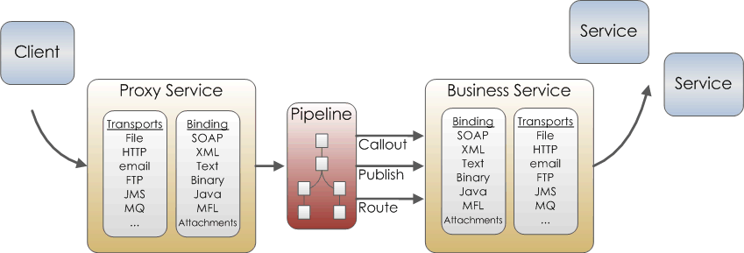  
[Description of "Figure 1-3 Oracle Service Bus Message Processing"](https://docs.oracle.com/middleware/1221/osb/develop/img_text/GUID-0D2C3E6A-A726-4AB3-B1D4-8918BC85C515-default.htm)

The following sections describe each layer involved in this message processing.

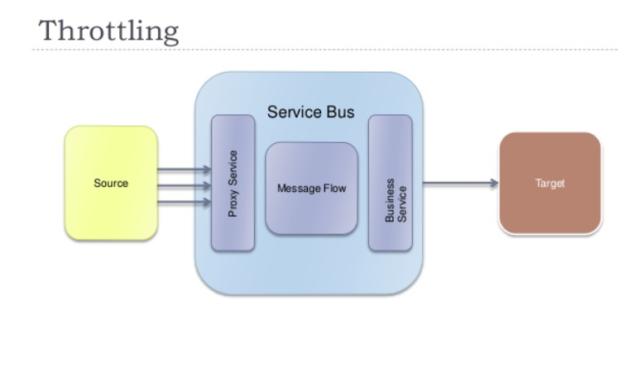

***Proxy Service Definition Editor in JDeveloper***

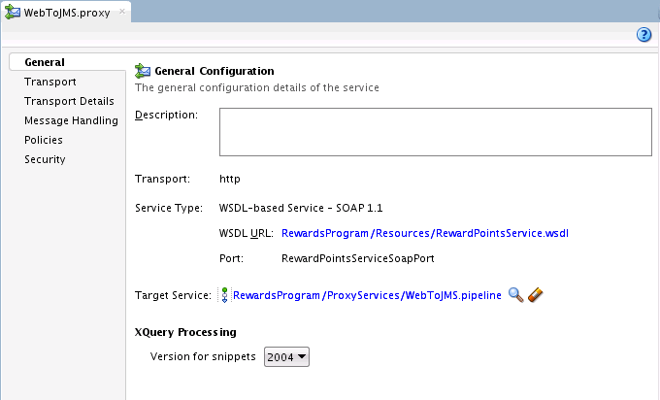

Components Window

The Components window appears when the Service Bus Overview Editor, the Pipeline Editor, or the Split-Join Editor is open. The Components window lists the various components that you can use in a Service Bus application, pipeline, or split-join, depending on which editor is visible. For the overview editor, the Components window displays the components you can add to the application, including resources, adapters, and transports. For pipelines and split-joins, the Components window displays routing, transformation, and error handling actions that you can use to define the flow of data between services.

The elements listed in the Components window can be dragged and dropped from the Components window to the visible editor. If the Components window is not visible, select **Components** from the Window main menu. The following figure shows the Components window for the Service Bus Overview Editor.

***Figure 3-4 Service Bus Components Window***

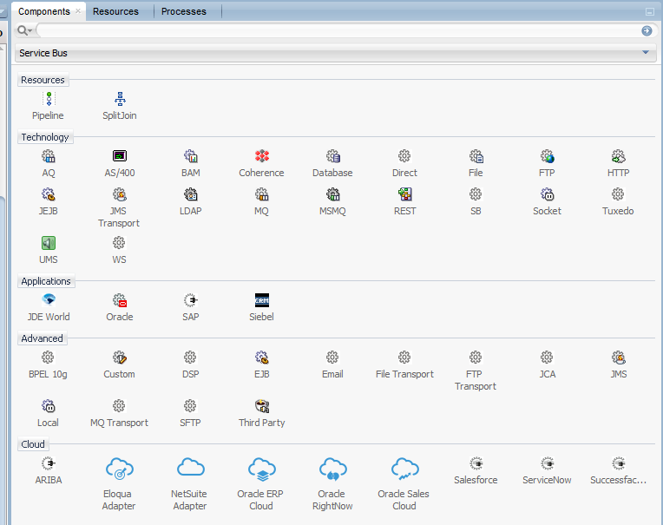

***Table 5-2 Technology Components***

| **Component** | **Description** |
| --- | --- |
| AQ | Drag an AQ adapter to either the Proxy Services or External Services swimlane to create and configure an Oracle AQ Adapter, and to create its associated service. The AQ Adapter lets Service Bus interact with a single consumer or a multi-consumer queue.  This action launches the AQ Adapter Configuration wizard. |
| AS/400 | Drag an AS/400 adapter to either the Proxy Services or External Services swimlane to create and configure an Oracle Database Adapter for AS/400, and to create its associated service.  This action launches the Database Adapter Configuration wizard. |
| BAM | Drag a BAM adapter to either the Proxy Services or External Services swimlane to create and configure an Oracle BAM Adapter, and to create its associated service. The BAM Adapter lets Service Bus interact with Oracle Business Activity Monitoring.  This action launches the BAM Adapter Configuration wizard. |
| Coherence | Drag a Coherence adapter to either the Proxy Services or External Services swimlane to create and configure an Oracle Coherence Resource Adapter, and to create its associated service. Use the Coherence Resource Adapter to perform cache operations in a transaction.  This action launches the Coherence Adapter Configuration wizard. |
| Database | Drag a Database adapter to either the Proxy Services or External Services swimlane to create and configure a Database JCA Adapter, and to create its associated service. The Database Adapter lets Service Bus communicate with Oracle and other databases through JDBC.  This action launches the Database Adapter Configuration wizard. |
| Direct | Drag a Direct transport to the External Services swimlane to create a business service using the SOA-DIRECT transport. Use the SOA DIRECT transport to exchange messages over a remote method invocation (RMI).  This action launches the Create Business Service wizard. The Direct transport can only be used with business services. |
| File | Drag a File adapter to either the Proxy Services or External Services swimlane to create and configure an Oracle File Adapter, and to create its associated service. The File Adapter lets Service Bus applications read and write messages from files on a local file system.  This action launches the File Adapter Configuration wizard. |
| FTP | Drag an FTP adapter to either the Proxy Services or External Services swimlane to create and configure an Oracle FTP Adapter, and to create its associated service. The FTP Adapter lets Service Bus applications read and write messages from remote service files.  This action launches the FTP Adapter Configuration wizard. |
| HTTP | Drag an HTTP transport to the Proxy Services swimlane to create an HTTP proxy service, or to the External Services swimlane to create an HTTP business service. The HTTP transport lets you invoke applications through HTTP POST and GET operations.  This action launches either the Create Proxy Service wizard or the Create Business Service wizard. |
| JEJB | Drag a JEJB transport to the Proxy Services swimlane to create a JEJB proxy service, or to the External Services swimlane to create a JEJB business service. The JEJB transport lets you pass Plain Old Java Objects (POJOs) through Service Bus.  This action launches either the Create Proxy Service wizard or the Create Business Service wizard. |
| JMS | Drag a JMS Transport to the Proxy Services swimlane to create a JMS proxy service, or to the External Services swimlane to create a JMS business service. The JMS transport configures services that interact with Java Messaging Service.  This action launches either the Create Proxy Service wizard or the Create Business Service wizard. |
| LDAP | Drag an LDAP adapter to either the Proxy Services or External Services swimlane to create and configure an Oracle LDAP Adapter, and to create its associated service. The LDAP Adapter lets Service Bus interact with an LDAP directory.  This action launches the LDAP Adapter Configuration wizard. |
| MQ | Drag an MQ adapter to either the Proxy Services or External Services swimlane to create and configure an Oracle MQ Series Adapter, and to create its associated service. The MQ Series Adapter lets Service Bus connect to MQ Series queue managers and to add and remove messages in queues.  This action launches the MQ Series Adapter Configuration wizard. |
| MSMQ | Drag an MSMQ adapter to either the Proxy Services or External Services swimlane to create and configure an Oracle MSMQ Adapter, and to create its associated service.  This action launches the MSMQ Adapter Configuration wizard. |
| REST | Drag REST binding to either the Proxy Services or External Services swimlane to create and configure a REST binding component, and to create its associated service.  This action launches the Create REST Binding dialog. |
| SB | Drag an SB transport to the Proxy Services swimlane to create an SB proxy service, or to the External Services swimlane to create an SB business service. Use the SB transport to allow Oracle products to synchronously invoke a proxy service using RMI.  This action launches either the Create Proxy Service wizard or the Create Business Service wizard. |
| Socket | Drag a Socket adapter to either the Proxy Services or External Services swimlane to create and configure an Oracle Socket Adapter, and to create its associated service. The Oracle Socket Adapter lets Service Bus create a client or server socket, and establish a connection.  This action launches the SOCKET Adapter Configuration wizard. |
| Tuxedo | Drag a Tuxedo transport to the Proxy Services swimlane to create a Tuxedo proxy service, or to the External Services swimlane to create a Tuxedo business service. The Tuxedo transport to access a Tuxedo domain from Service Bus.  This action launches either the Create Proxy Service wizard or the Create Business Service wizard. |
| UMS | Drag a UMS adapter to either the Proxy Services or External Services swimlane to create and configure an Oracle UMS Adapter, and to create its associated service. The Oracle UMS Adapter lets Service Bus send and receive notifications using email, SMS, or instant messaging.  This action launches the UMS Adapter Configuration wizard. |
| WS | Drag a WS transport to the Proxy Services swimlane to create a WS proxy service, or to the External Services swimlane to create a WS business service. The WS transport implements requests for services derived from based on SOAP 1.1- or SOAP 1.2-based WSDL documents with WSRM policy.  This action launches either the Create Proxy Service wizard or the Create Business Service wizard. |

***Table 5-3 Application Components***

| **Component** | **Description** |
| --- | --- |
| JDE World | Drag a JDE World adapter to either the Proxy Services or External Services swimlane to create and configure an Oracle JDE World Adapter, and to create its associated service. This action launches the JDE World Adapter Configuration wizard. |
| Oracle | Drag an Oracle adapter to either the Proxy Services or External Services swimlane to create and configure an Oracle Applications Adapter, and to create its associated service. This action launches the Oracle Applications Adapter Configuration wizard. |
| SAP | Drag a SAP adapter to either the Proxy Services or External Services swimlane to create and configure an Oracle SAP Adapter, and to create its associated service. This action launches the Oracle SAP Adapter Configuration wizard. |

***Table 5-4 Advanced Components***

| **Component** | **Description** |
| --- | --- |
| BPEL 10g | Drag a BPEL 10*g* transport to the External Services swimlane to create a BPEL Process Manager business service. Use the BPEL Processing Manager (BPEL-10*g*) to define messaging with Oracle SOA Suite 10*g* BPEL processes.  This action launches the Create Business Service wizard. The BPEL 10*g* transport can only be used with business services.  **Note:** For messaging with Oracle SOA Suite 11*g* BPEL processes, use the SOA_DIRECT transport. |
| Custom | Drag a Custom adapter to either the Proxy Services or External Services swimlane to create and configure an Oracle Custom Adapter, and to create its associated service. The Oracle Custom Adapter lets you create a customized adapter to connect to external systems.  This action launches the Custom Adapter Configuration wizard. |
| DSP | Drag a DSP transport to the External Services swimlane to create a DSP business service. Use the DSP transport to communicate with Oracle Data Service Integrator.  This action launches the Create Business Service wizard. The DSP transport can only be used with business services. |
| EJB | Drag an EJB transport to the External Services swimlane to create an EJB business service. Use the EJB transport to create an Enterprise JavaBeans service for using SDO parameters or Java interfaces with Enterprise JavaBeans.  This action launches the Create Business Service wizard. The EJB transport can only be used with business services. |
| Email | Drag an Email transport to the Proxy Services swimlane to create an email proxy service, or to the External Services swimlane to create an email business service. The Email transport lets Service Bus communicate with email servers.  This action launches either the Create Proxy Service wizard or the Create Business Service wizard. |
| File Transport | Drag a File Transport to the Proxy Services swimlane to create a file proxy service, or to the External Services swimlane to create a file business service. The File transport configures services that read and write messages from files on a local file system.  This action launches either the Create Proxy Service wizard or the Create Business Service wizard. |
| FTP Transport | Drag an FTP Transport to the Proxy Services swimlane to create an FTP proxy service, or to the External Services swimlane to create an FTP business service. The FTP transport configures services that read and write messages from remote service files.  This action launches either the Create Proxy Service wizard or the Create Business Service wizard. |
| JCA | Drag a JCA transport to the Proxy Services swimlane to create a proxy service based on an existing JCA adapter, or to the External Services swimlane to create a business service based on an existing JCA adapter.  This action launches either the Create Proxy Service wizard or the Create Business Service wizard. |
| JMS | Drag a JMS adapter to either the Proxy Services or External Services swimlane to create and configure an Oracle JMS Adapter, and to create its associated service. The JMS Adapter lets Service Bus interact with Java Messaging Service.  This action launches the JMS Adapter Configuration wizard. |
| Local | Drag a Local transport to the Proxy Services swimlane to create a Local proxy service. Local proxy services can only be invoked by other proxy services, not by external clients.  This action launches the Create Proxy Service wizard. The Local transport can only be used with proxy services. |
| MQ Transport | Drag an MQ Transport to the Proxy Services swimlane to create an MQ proxy service, or to the External Services swimlane to create an MQ business service. The MQ transport provides access to IBM WebSphere MQ.  This action launches either the Create Proxy Service wizard or the Create Business Service wizard. |
| SFTP | Drag an SFTP Transport to the Proxy Services swimlane to create an SFTP proxy service, or to the External Services swimlane to create an SFTP business service. The SFTP transport lets you transfer files securely over the SSH File Transfer Protocol (SFTP).  This action launches either the Create Proxy Service wizard or the Create Business Service wizard. |
| Third Party | Drag a Third Party adapter to either the Proxy Services or External Services swimlane to create and configure an Oracle Third Party Adapter, and to create its associated service. The Third Party Adapter lets Service Bus interact with third-party services as long as a WSDL document is already defined.  This action launches the Create Third Party Adapter Service dialog. |

#### **1.3.5.2 JAR Files (Archives)**

A JAR (Java Archive) is a zipped file that contains a set of Java classes. It is used to store compiled Java classes and associated metadata that can constitute a program. A JAR acts like a callable program library for Java code elements, so a single compilation link provides access to multiple elements rather than requiring bindings for each element individually.

In JDeveloper, you can add JAR files to a project or component directly from the file system, but in the Oracle Service Bus Console, you need to upload each JAR file to add to a project into an *archive* resource. In Service Bus, JAR files are used the following components:

* Java callout actions (in pipelines) that provide a Java exit mechanism
* EJB-based business services
* JEJB-based business and proxy services
* Tuxedo-based proxy and business services

For more information, see [Working with JAR Files](https://docs.oracle.com/middleware/1221/osb/develop/GUID-1E8A7575-61F6-48A7-9760-A0673D2CA767.htm#GUID-303C4A98-7589-4AFB-A42D-05F6838F4793).

***Table 1-1 Service Bus Development Roadmap - Top-Down Approach***

| **Step** | **Description** | **More Information** |
| --- | --- | --- |
| 1 | Create the necessary supporting resources, such as service accounts, WSDL files, or XQuery maps. | Links for each type of resource are provided in [Oracle Service Bus Overview](https://docs.oracle.com/middleware/1221/osb/develop/GUID-2CFA406F-66DF-44F1-894B-CFD7EC66CEB1.htm#GUID-7367E101-1A24-4FC0-87E4-DA2DD868B146). |
| 2 | Create any proxy services, pipelines, business services, and optionally split-joins. | [Adding Service Bus Components](https://docs.oracle.com/middleware/1221/osb/develop/GUID-5C999412-7BC7-4021-882C-5CCACD60A30E.htm#GUID-DE47FFC7-D8E7-426E-AE48-DE94A295B973) |
| 3 | Wire the components together. | [Wiring Service Bus Components](https://docs.oracle.com/middleware/1221/osb/develop/GUID-5C999412-7BC7-4021-882C-5CCACD60A30E.htm#GUID-CDC45088-9E9F-44C2-9202-18993C3E543A) |
| 4 | Configure the proxy services and their transports. | [Configuring Proxy Services](https://docs.oracle.com/middleware/1221/osb/develop/GUID-C7FA8DAD-E235-437F-87D8-3FE28BE98A6D.htm#GUID-21253D8F-D0C4-48DF-9DE9-ACD2AC693EDC)  [Working with JCA Adapters, Transports, and Bindings](https://docs.oracle.com/middleware/1221/osb/develop/GUID-ABAFDA2E-2194-4970-BCA0-9C642AE8613F.htm) |
| 5 | Configure the pipelines and split-joins. | [Working with Oracle Service Bus Pipelines](https://docs.oracle.com/middleware/1221/osb/develop/GUID-039D0931-049A-4F0B-87AA-0C8EE4DFB6E5.htm)  [Improving Service Performance with Split-Join](https://docs.oracle.com/middleware/1221/osb/develop/GUID-6910F50F-A681-4A80-809B-4115B2548A0E.htm#GUID-6910F50F-A681-4A80-809B-4115B2548A0E) |
| 6 | Configure the business services and their transports. | [Configuring Business Services](https://docs.oracle.com/middleware/1221/osb/develop/GUID-B932E48E-8DDA-4C3D-B600-CBE2C510CED6.htm#GUID-10223AAB-5755-4F1E-80C1-6EF677FD36A4)  [Working with JCA Adapters, Transports, and Bindings](https://docs.oracle.com/middleware/1221/osb/develop/GUID-ABAFDA2E-2194-4970-BCA0-9C642AE8613F.htm) |
| 7 | Configure security for the business and proxy services. | [Securing Business and Proxy Services](https://docs.oracle.com/middleware/1221/osb/develop/GUID-EBE2E5A7-973A-439E-888A-F592B77A02FA.htm#GUID-EBE2E5A7-973A-439E-888A-F592B77A02FA) |
| 8 | Test and debug the services and resources. | [Debugging Oracle Service Bus Applications](https://docs.oracle.com/middleware/1221/osb/develop/GUID-3BB56D8B-F692-4791-A004-9345C2857056.htm#GUID-3BB56D8B-F692-4791-A004-9345C2857056)  [Using the Test Console](https://docs.oracle.com/middleware/1221/osb/develop/GUID-69FFAD84-BEFE-4348-8C8C-D76962616561.htm#GUID-69FFAD84-BEFE-4348-8C8C-D76962616561) |
| 9 | Deploy the service. | [Deploying Oracle Service Bus Services](https://docs.oracle.com/middleware/1221/osb/develop/GUID-B7C64F39-EF51-4123-BCA1-6372D9E32F87.htm#GUID-B7C64F39-EF51-4123-BCA1-6372D9E32F87) |
| 10 | Monitor and administer the runtime. | [Oracle Service Bus Runtime Monitoring](https://docs.oracle.com/middleware/1221/osb/administer/GUID-F42965DF-5AA2-4F8C-903D-A8C72101CD6C.htm#OSBAG-GUID-86338659-8AC5-49F2-AC10-3D29CE1F3FEE) |

WSDL Documents

URL to display a WSDL document:

http://host:port/sbresource?WSDL/project_path/wsdlname

URL to display the WSDL document for WSDL-based HTTP proxy services:

http://host:port/proxy_service_endpoint_URI?WSDL

URL to display the WSDL document for WSDL-based proxy services:

http://host:port/sbresource?PROXY/project_path/proxyname

URL to display the WSDL document for proxy services with Oracle Web Services Manager policies attached:

http://host:port/sbresource?ORAPROXY/project_path/proxyname

URL to display the WSDL document for WSDL-based business services:

http://host:port/sbresource?BIZ/project_path/bizname

URL to display the WSDL document for WSDL-based business services with Oracle Web Services Manager policies attached:

http://host:port/sbresource?ORABIZ/project_path/bizname

1. Tạo một OSB service đơn giản?

## Ví dụ tạo 1 OSB xml đơn giản như sau:

Mô tả yêu cầu: OSB tiếp nhận nội dung xml 🡪 Gửi đến 1 link http để xử lý 🡪 Nhận lại kết quả

Các bước thực hiện như sau:

* Bước 1: Tạo mới 1 Application dạng service bus application

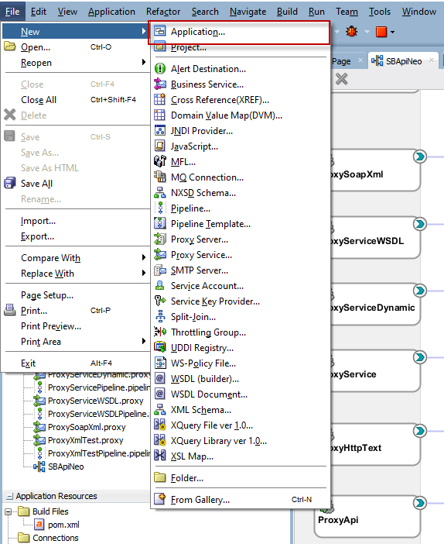

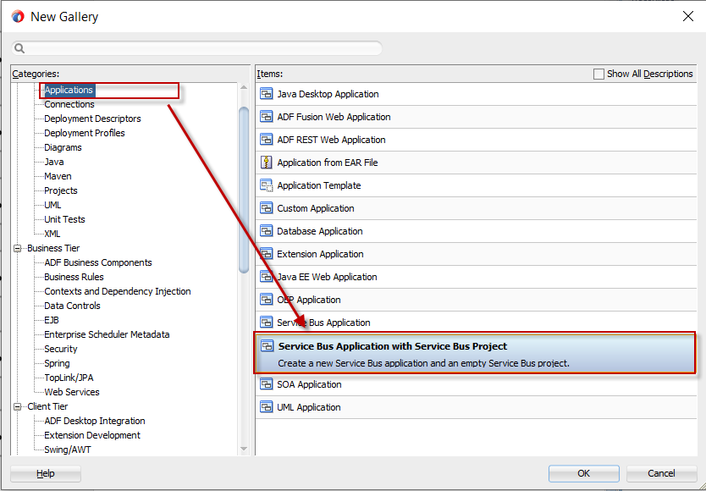

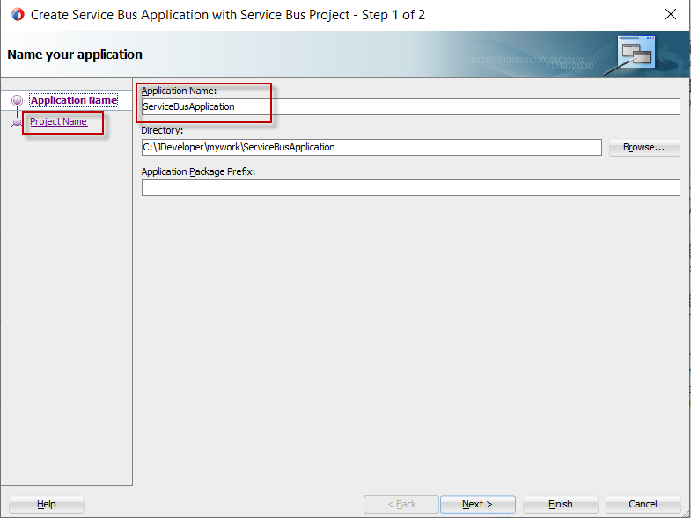

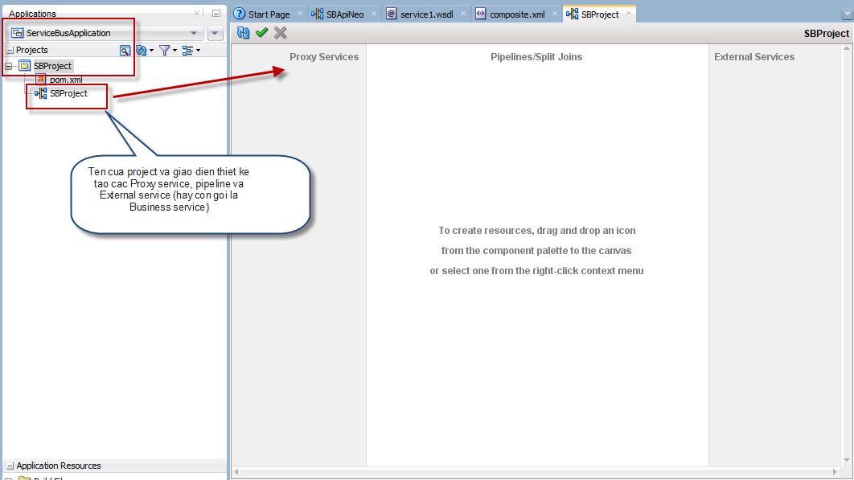

* Bước 2: Tạo 1 Proxy service dạng http protocol

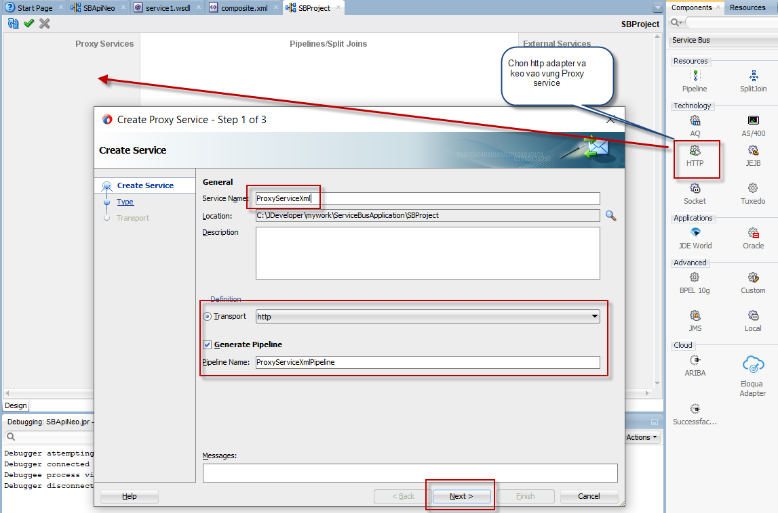

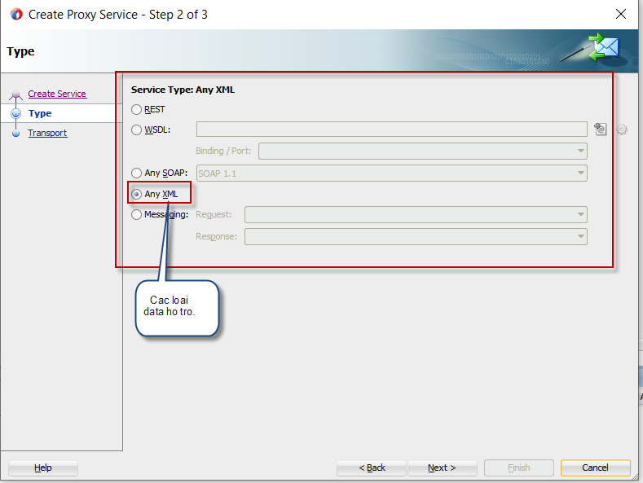

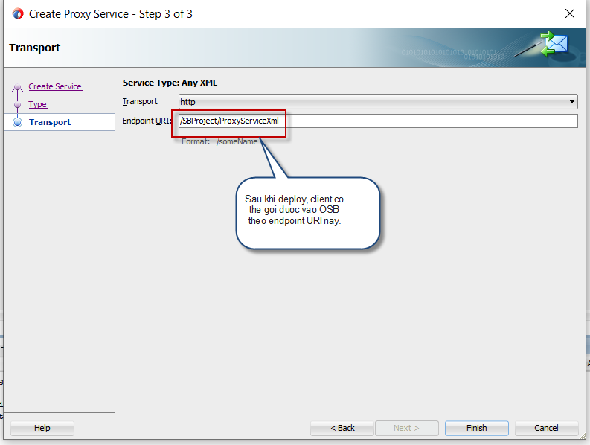

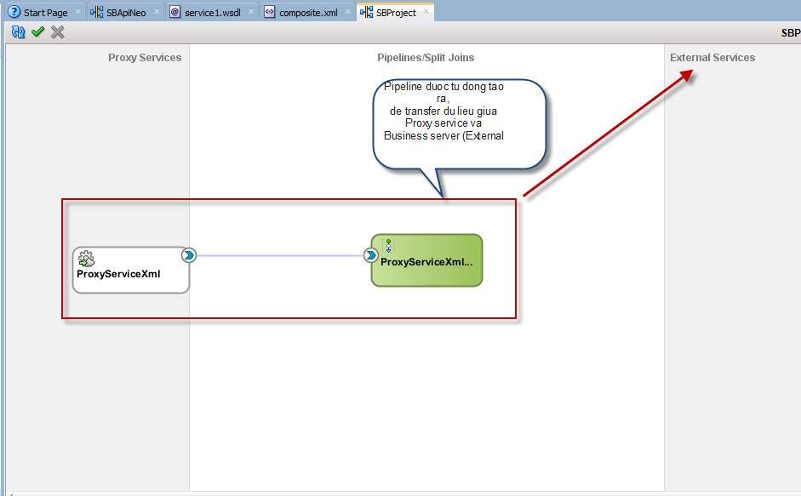

Lưu ý: Ta có thể tạo pipeline thủ công bằng cách kéo thả giống như tạo Proxy service.

Bước 3: Tạo External service (Business service 🡪 Gọi đến link http xử lý cụ thể dữ liệu xml)

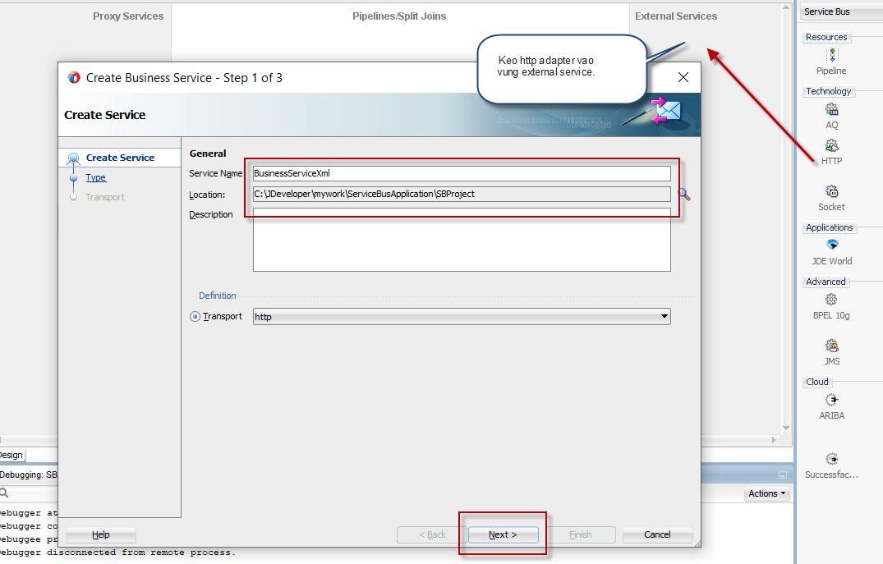

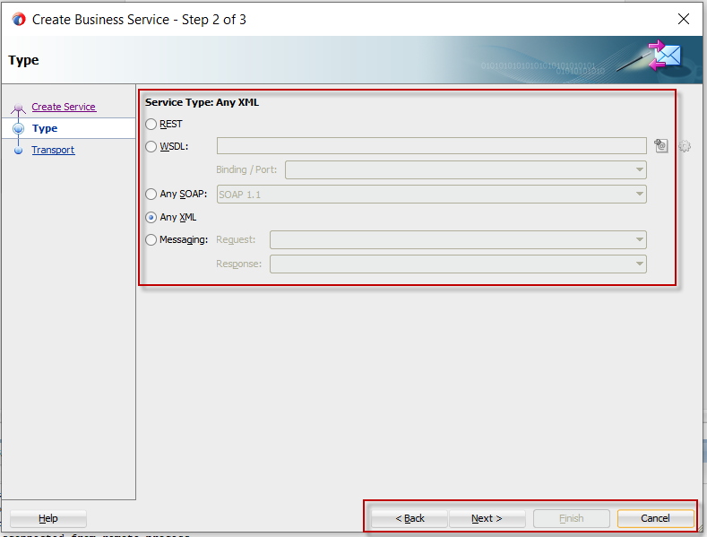

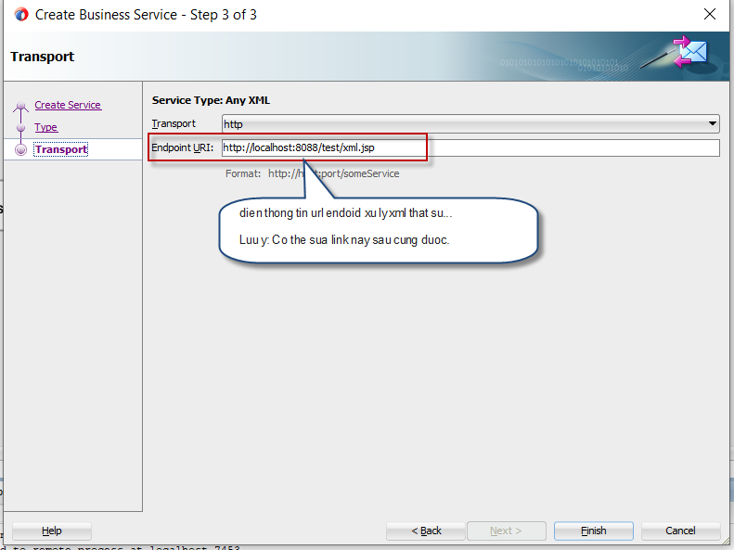

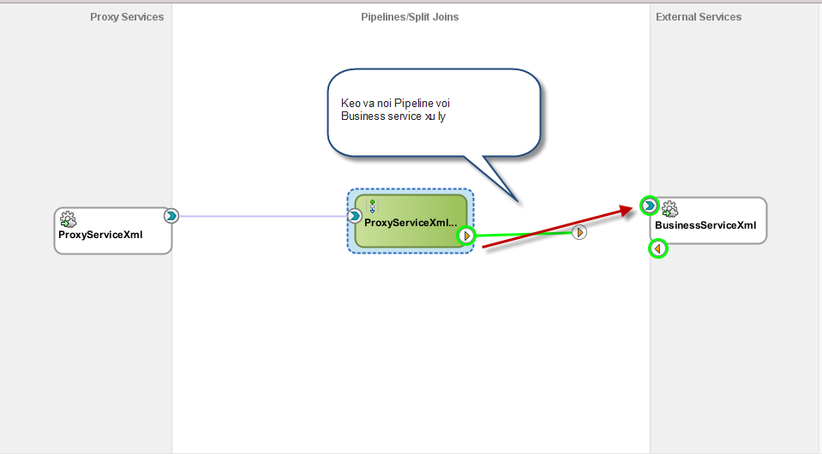

Bước 4: Edit Business service để gọi đến link http xử lý xml:

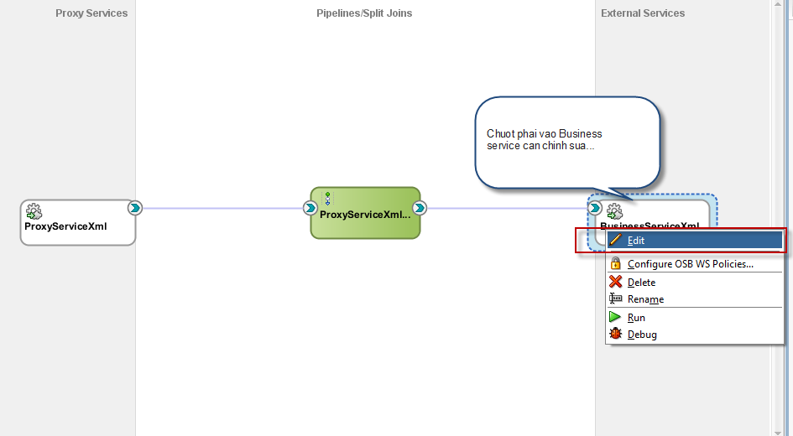

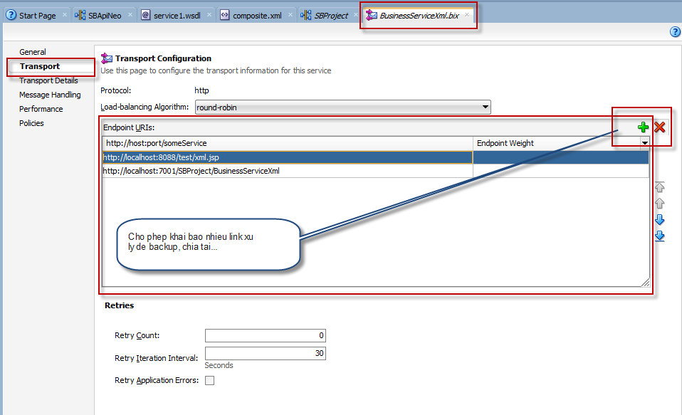

Bước 5: Test kiểm tra Proxy service đã tạo:

Ví dụ gửi xml sau vào OSB service:

|  |  |  |  |  |  |  |  |  |  |  |  |  |  |
| --- | --- | --- | --- | --- | --- | --- | --- | --- | --- | --- | --- | --- | --- |
| |  |  |  |  |  |  |  |  |  |  |  |  |  | | --- | --- | --- | --- | --- | --- | --- | --- | --- | --- | --- | --- | --- | | |  |  | | --- | --- | |  | <root> |  |  |  | | --- | --- | |  | <msisdn>904508766</msisdn> |  |  |  | | --- | --- | |  | <data>test</data> |  |  |  | | --- | --- | |  | <pkg>MCA</pkg> |  |  |  | | --- | --- | |  | <bsname>BusinessServiceXmlOK</bsname> |  |  |  | | --- | --- | |  | </root> | | |

Giao diện debug trên jdevelop như sau:

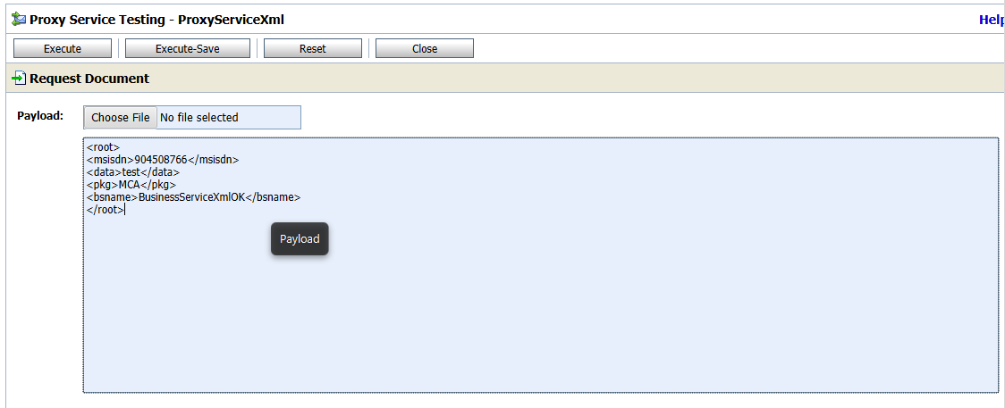

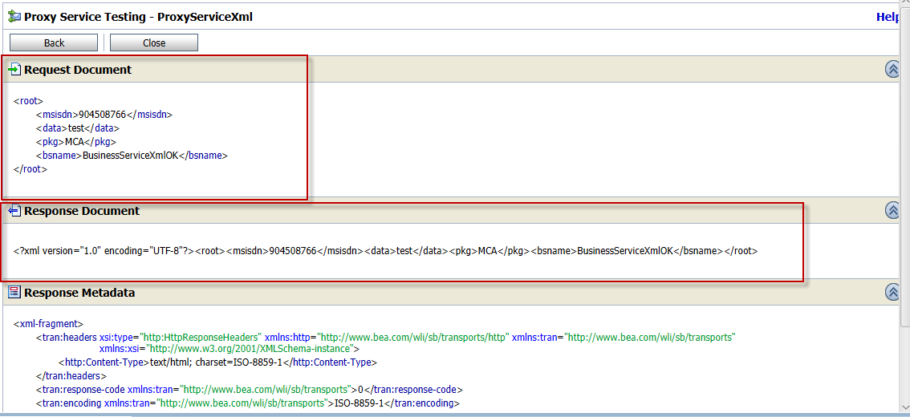

Check log tomcat …

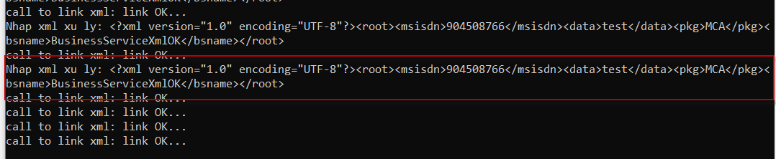

**Test link OSB với tool Soap UI:**

Lưu ý phải deploy Project lên server test của jdeveplop trước mới có thể vào được trực tiếp link deploy:

Ví dụ log deploy như sau:

[04:36:00 AM] ---- Deployment finished. ----

[05:36:28 AM] ---- Deployment started. ----

[05:36:28 AM] Target platform is Standard Java EE.

[05:36:40 AM] Deployed: SBProject/BusinessServiceXml (type: BusinessService)

[05:36:40 AM] Deployed: SBProject/ProxyServiceXml (type: ProxyService)

[05:36:40 AM] Deployed: SBProject/ProxyServiceXmlPipeline (type: Pipeline)

[05:36:40 AM] Elapsed time for deployment: 12 seconds

[05:36:40 AM] ---- Deployment finished. ----

Sau khi deploy, link OSB được public theo địa chỉ:

<http://localhost:7101/SBProject/ProxyServiceXml>

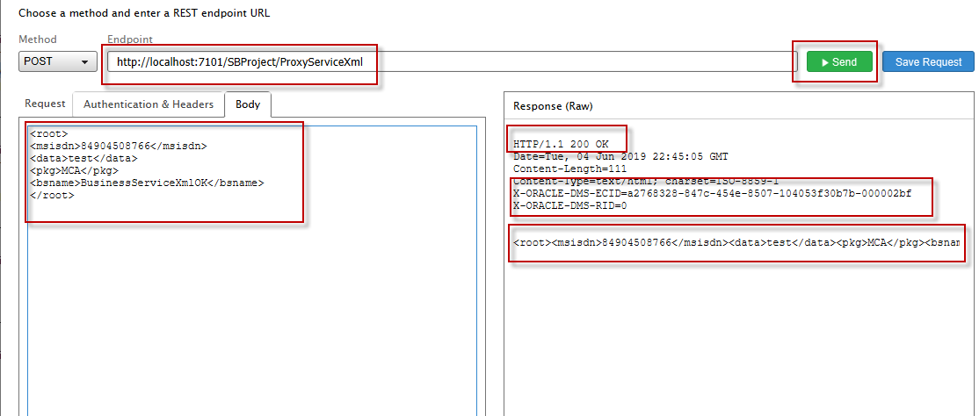

1. Tạo 1 OSB với 1 SOAP service có sẵn?

Giả sử có 1 Webservice có sẵn, giờ muốn tích hợn vào OSB để các client có thể gọi qua OSB service?

Ví dụ có 1 webservice sẵn theo link: <http://localhost:8088/wsapi/services/MlineApi?wsdl>

Các bước thực hiện cụ thể như sau:

Bước 1: tạo file WSDL cho Project:

Đầu tiên tạo 1 thư mục WSDL để lưu trữ file wsdl

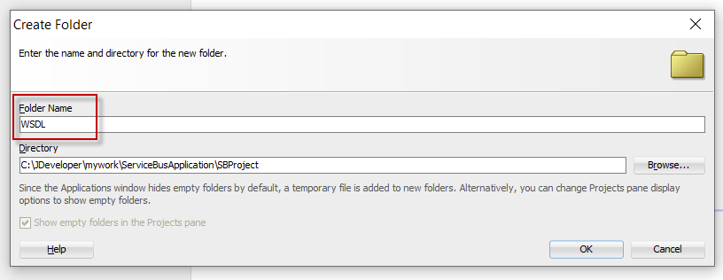

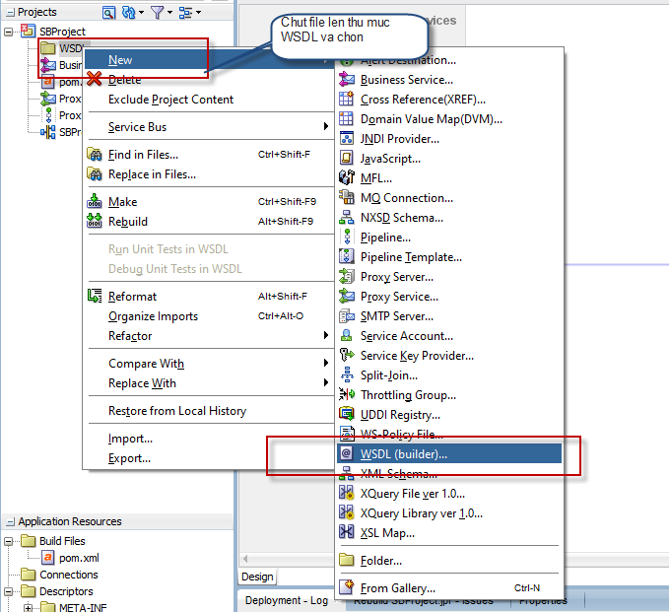

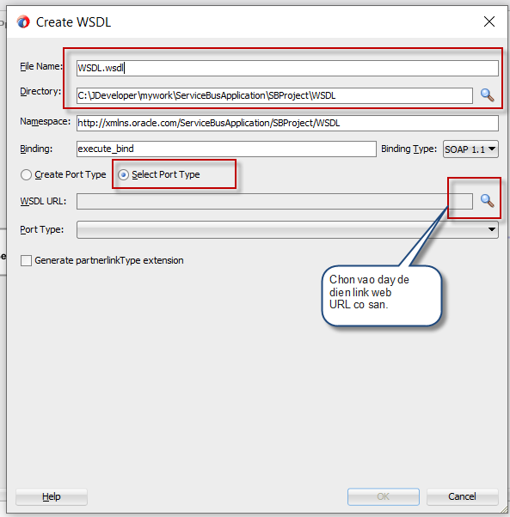

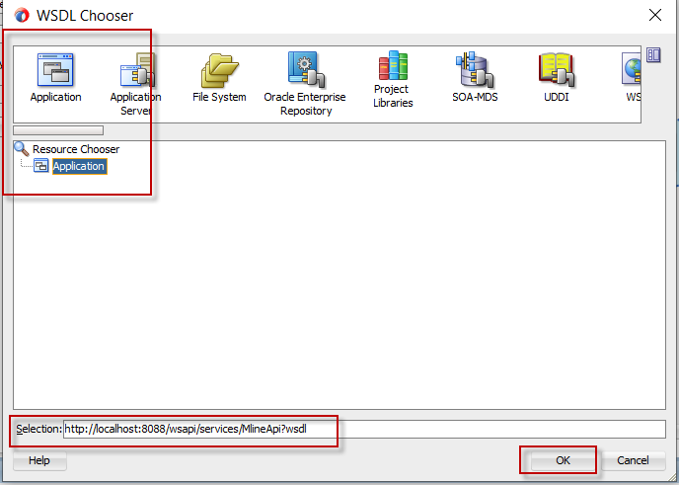

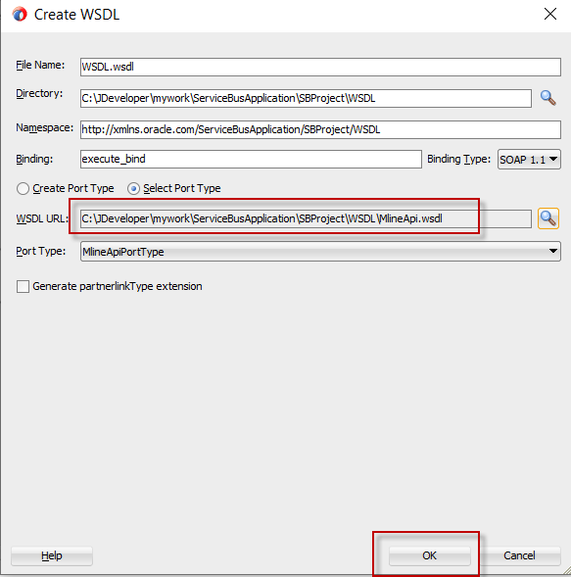

Kết quả cuối cùng khi nhập và tạo file wsdl ok.

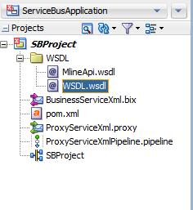

Bước 2: Tạo Proxy Service với file WSDL vừa tạo?

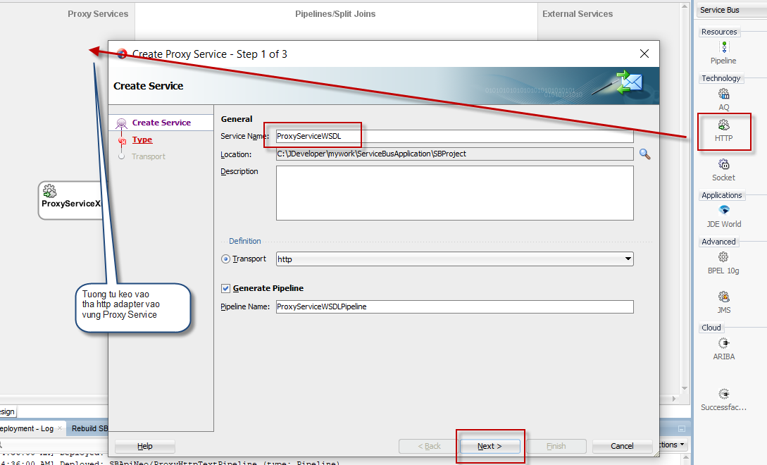

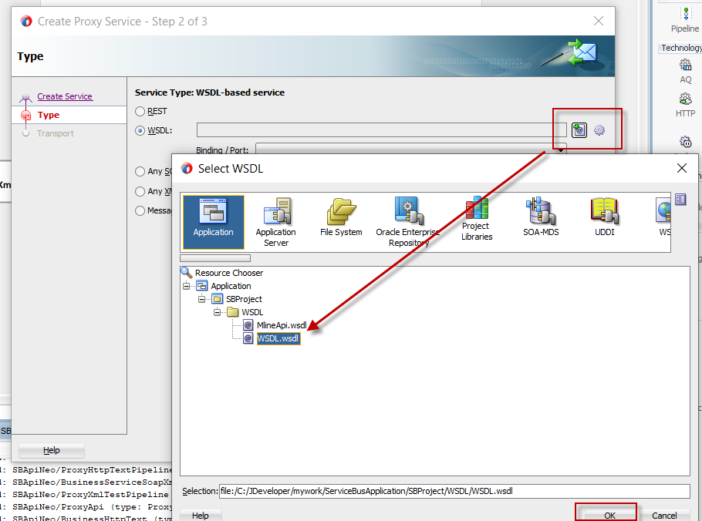

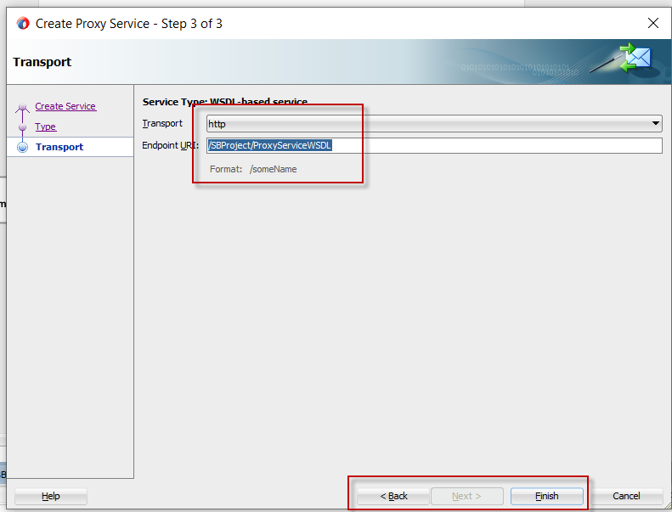

Bước 3: Tạo 1 Business service theo WSDL đã tạo:

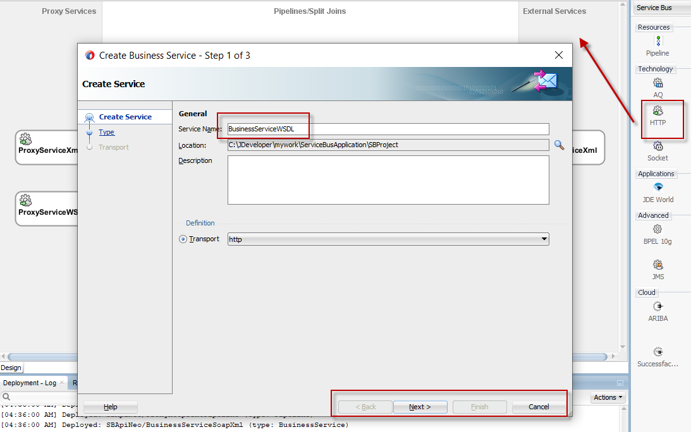

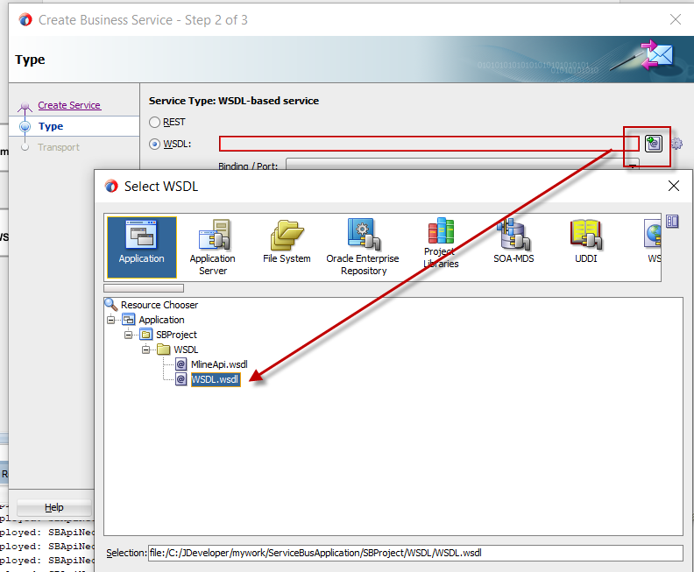

Sauk hi tạo xong, sửa lại link endpoint của Business service trỏ đến đúng link của Soap service:

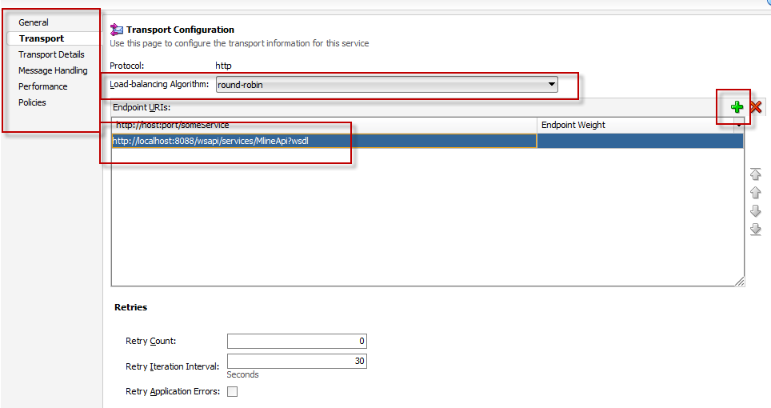

Bước 4: Test các hàm của webservice:

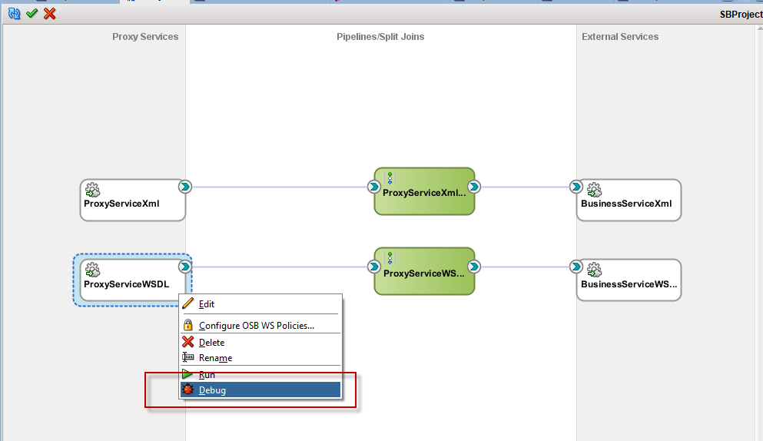

Hoặc deploy OSB sau đó sử dụng SOAPUI để test link OSB:

Link có dạng: [http://localhost:7101//SBProject/ProxyServiceWSDL?wsdl](http://localhost:7101/SBProject/ProxyServiceWSDL?wsdl)

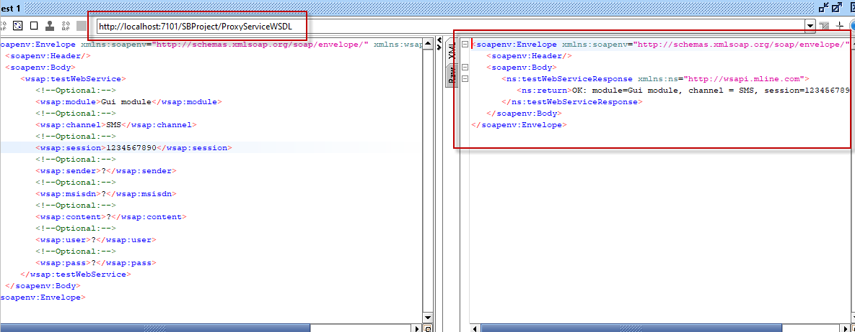

1. Sử dụng dynamic routing

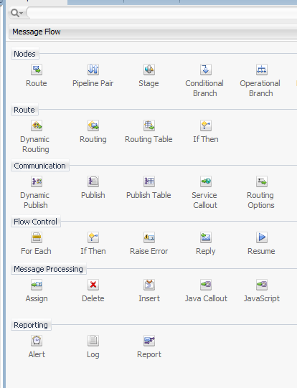

Có 2 loại routing hay sử dụng: dynamic routing hoặc routing table, Sử dụng riêng cho từng OSB hoặc kết hợp với nhau cũng được.

Với: **routing table** 🡪 Sử dụng cho Routing Request đến các business service cụ thể đã được ấn định trước theo cấu hình. Việc gọi đến business service nào cũng phụ thuộc vào dữ liệu đầu vào. (cấu hình nhánh đến list các business service cụ thể)

Ví dụ hình:

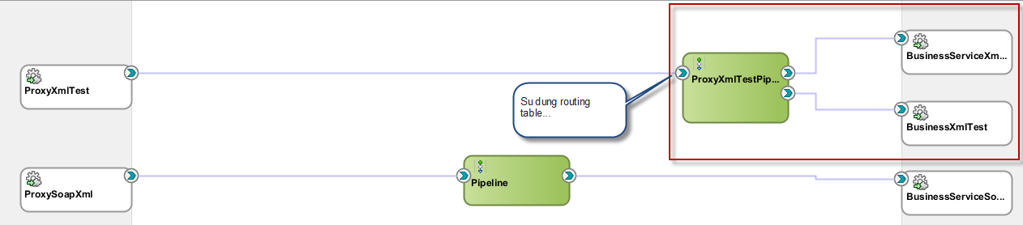

Với **Dynamic routing 🡪 Sử dụng cho: routing request động đến 1 Business bất kỳ theo tham số truyền vào.**

**(Nghĩa là ta không thể cấu hình trước được các business service cần gọi).**

**Ví dụ:**

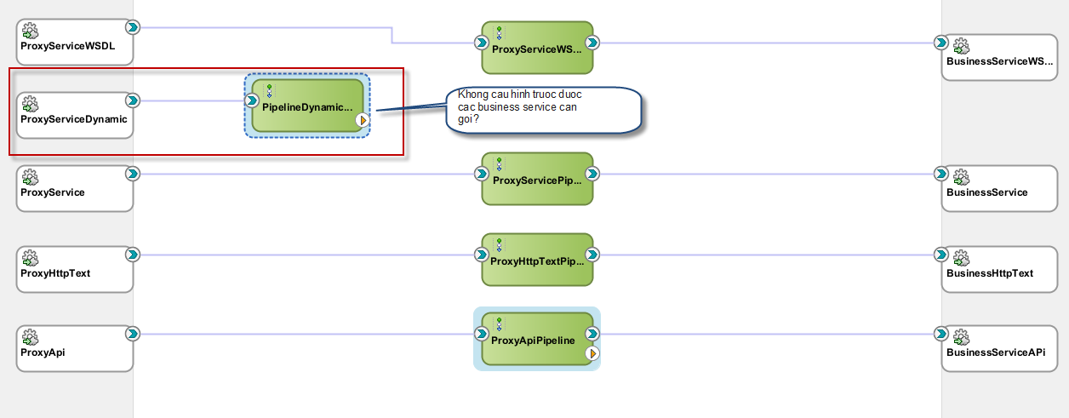

* **Sử dụng routing table**

Mô tả tình huống: Giả sử ta có 2 link http xử lý nghiệp vụ khác nhau như sau:

<http://localhost:8088/test/xml.jsp>

và <http://localhost:8088/test/index.jsp>

Trong đó: xml.jsp 🡪 xử lý với case dữ liệu đầy đủ,

còn <http://localhost:8088/test/index.jsp> xử lý các case còn lại.

Cụ thể:

Giả sử client gửi lên dữ liệu có dạn như sau:

<root>

<msisdn></msisdn>

<data></data>

<pkg>MCA</pkg>

</root>

Tạo 1 OSB kiểm tra dữ liệu đầu vào, Nếu:

Có đầy đủ thông tin số thuê bao, mã gói, thì gửi đến link: <http://localhost:8088/test/xml.jsp>

Các trường hợp còn lại gửi đến link: <http://localhost:8088/test/index.jsp>

Lưu ý: để kiểm tra thông tin, OSB có sử dụng đến java call out để gọi 1 hàm Java xử lý check thông tin:

Cần tạo 1 file jar trước có chứa class xử lý validate dữ liệu đơn giản như sau:

package com.neo.pkg;

public class MyFunc {

public static void main(String arr[]) {

System.out.println("Hello Java in Jdeveloper 12c");

String data = MyFunc.changeText("Hello OSB 12c");

System.out.println(data);

boolean is = MyFunc.haveData(data);

System.out.println("to check data:" + is);

}

public static String changeText(String value) {

String data = value;

try{

if (data!=null) {

data = "do change value: " + value;

}

}catch(Exception e) {

e.printStackTrace();

}

return data;

}

public static boolean haveData(String value) {

boolean is = false;

try{

if (value!=null){

is = true;

}

}catch(Exception e) {

e.printStackTrace();

}

return is;

}

}

Export thành file jar để sẵn sàng sử dụng vào OSB.

Ví dụ:

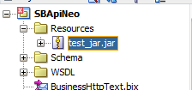

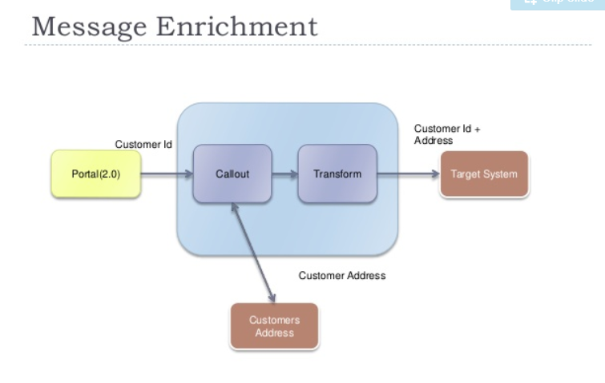

Các bước tạo OSB sử dụng routing table như sau:

Bước 1: Tạo 1 Proxy service name: ProxyXmlTest, protocol http như đã hướng dẫn ở trên. (lưu ý không auto tạo pipeline). Datatype là any xml.

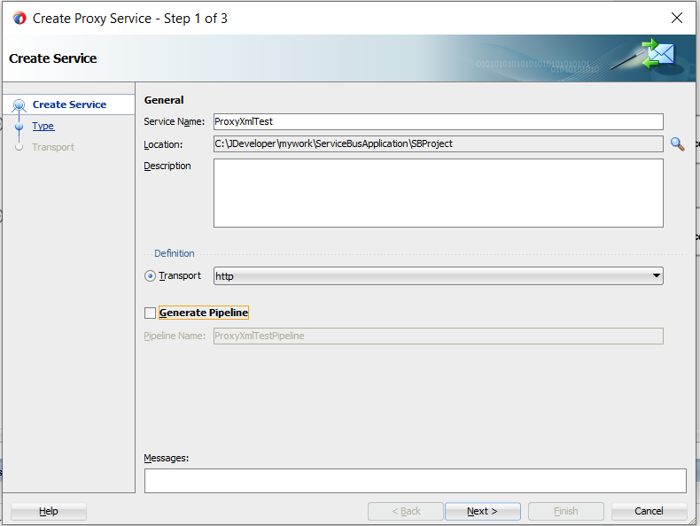

Bước 2: Tạo pipeline:

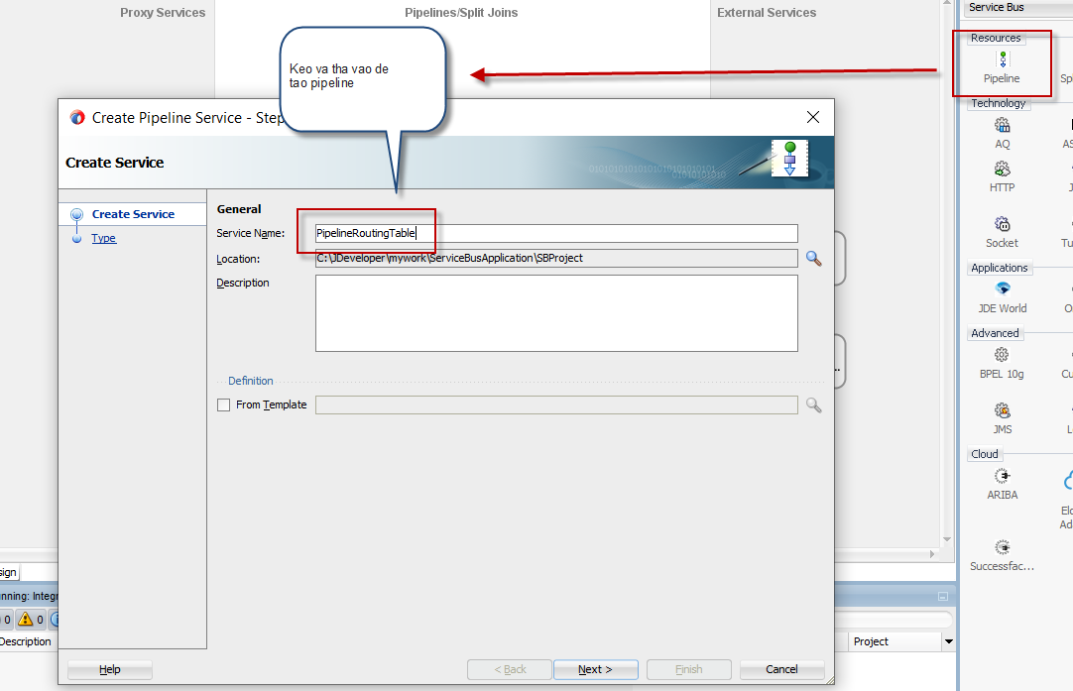

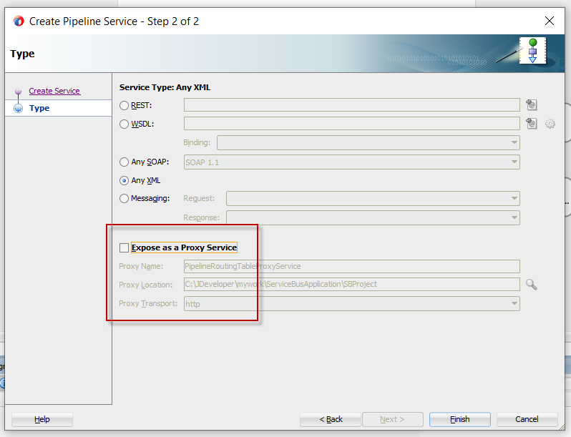

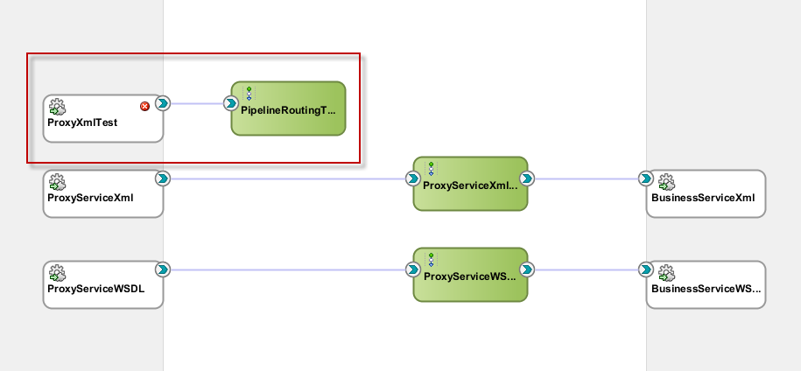

Sau đó nối ProxyXmlTest với pipeline vừa tạo.

Bước 3: Sửa và cấu hình pipeline:

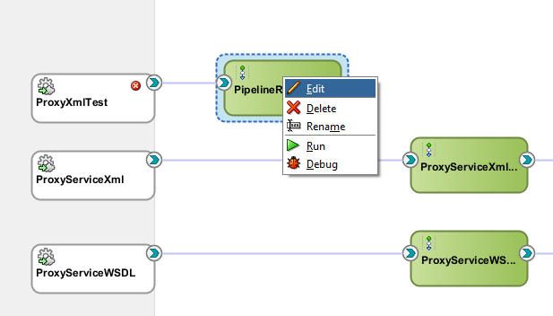

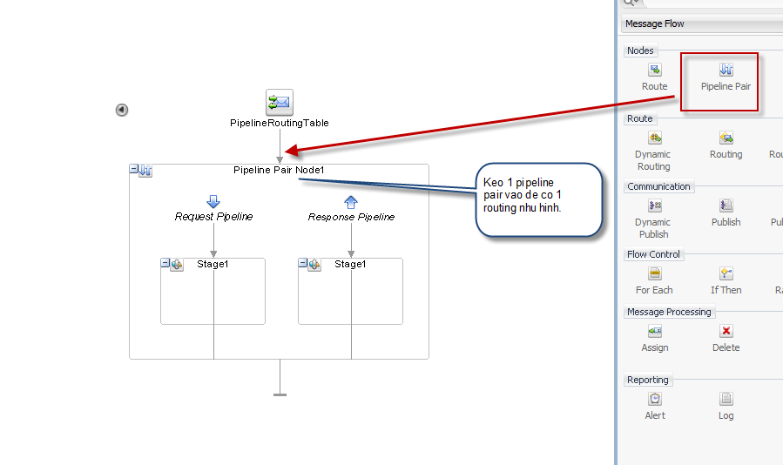

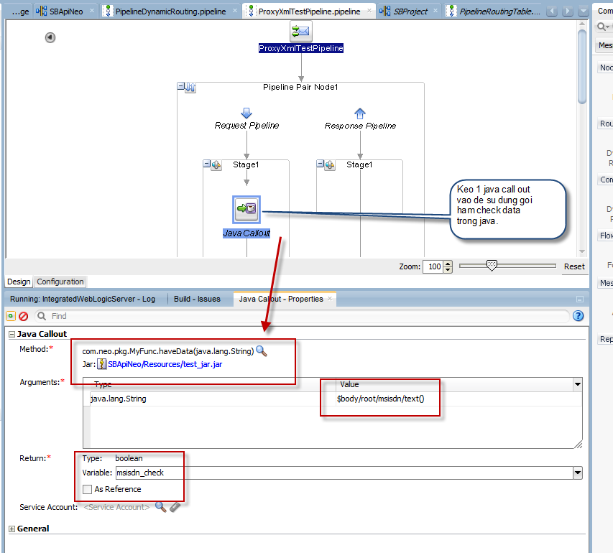

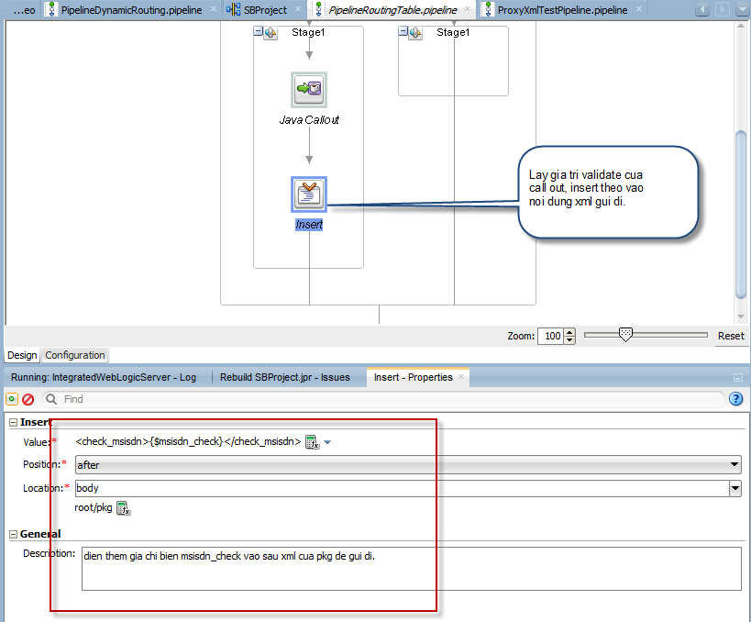

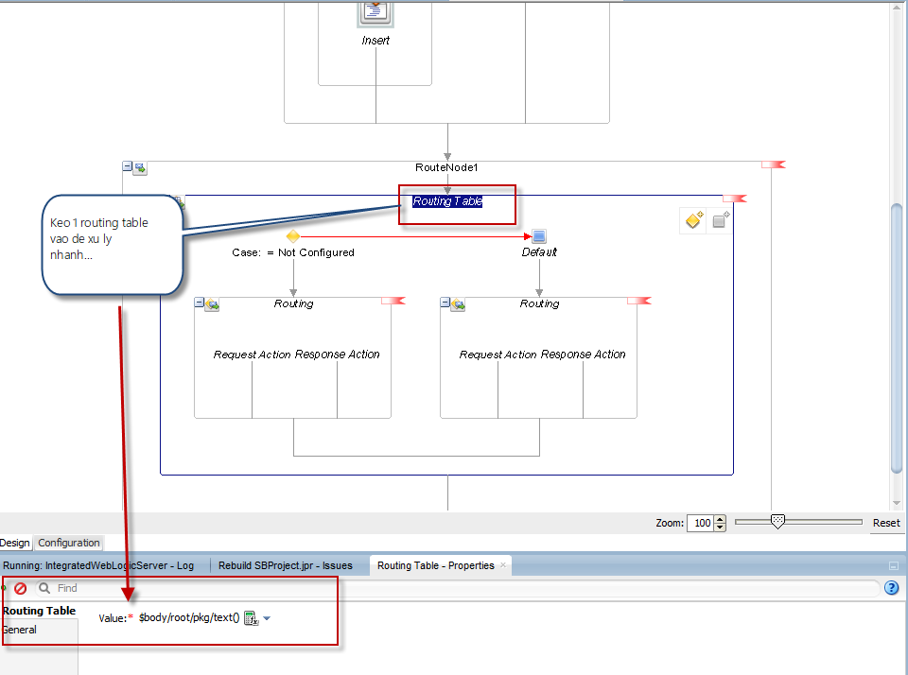

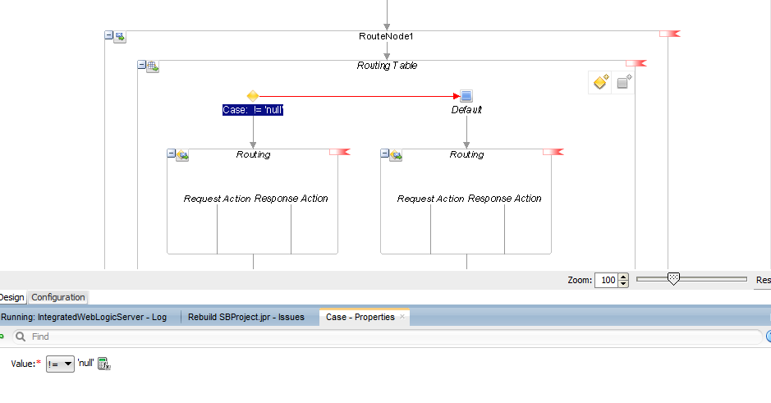

Nếu pkg !=null 🡪 Thì gọi đến business service nào?

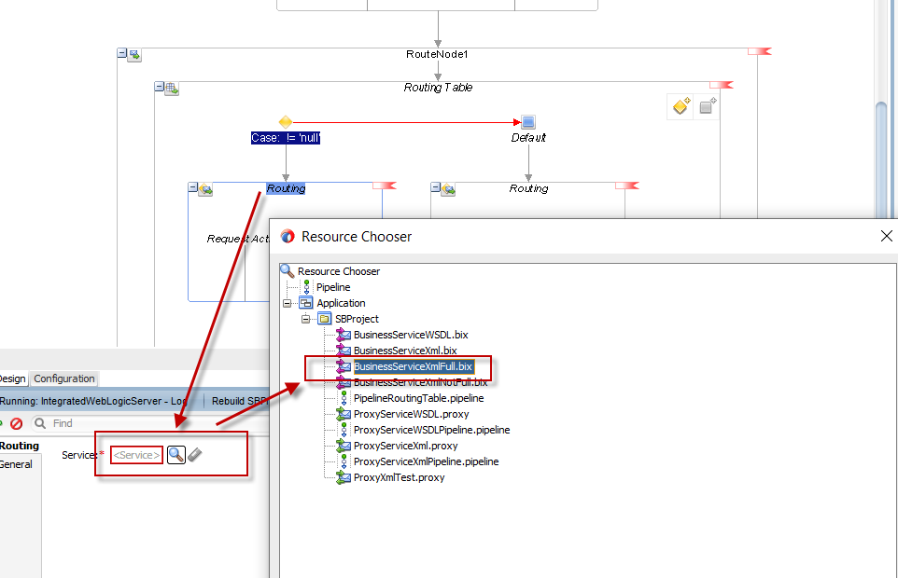

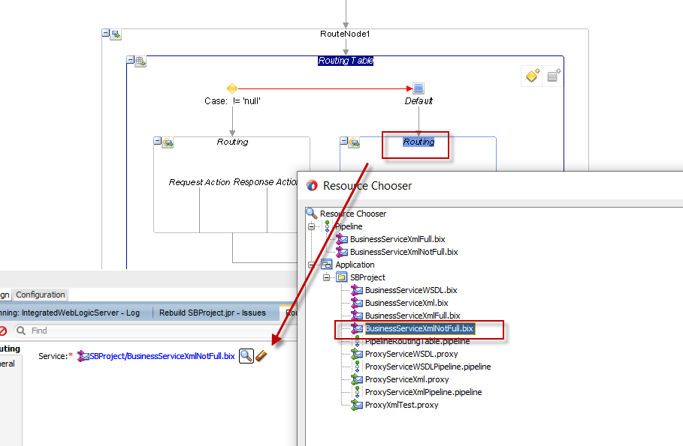

Kết quả cuối cùng (Lưu ý: Ở đây đã bỏ qua bước tạo 02 business service trỏ đến 2 link như mô tả ở trên ☺).

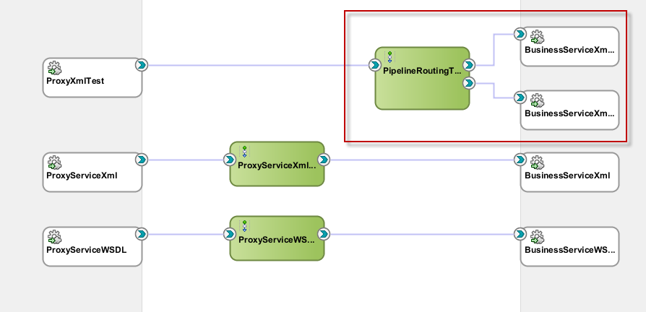

Bước 4: Test proxy vừa tạo?

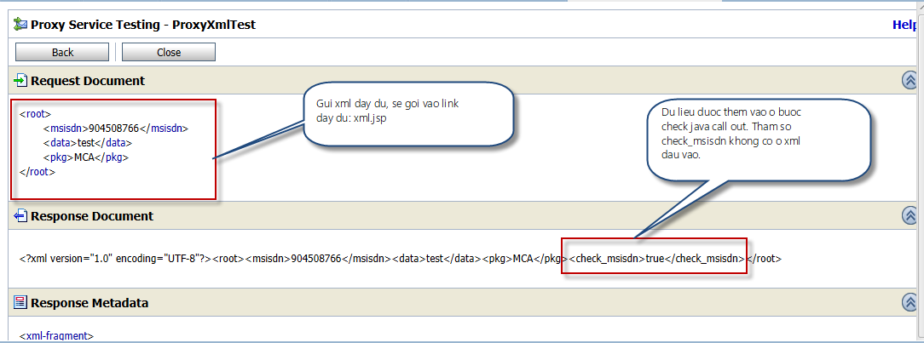

Gửi thiếu dữ liệu?

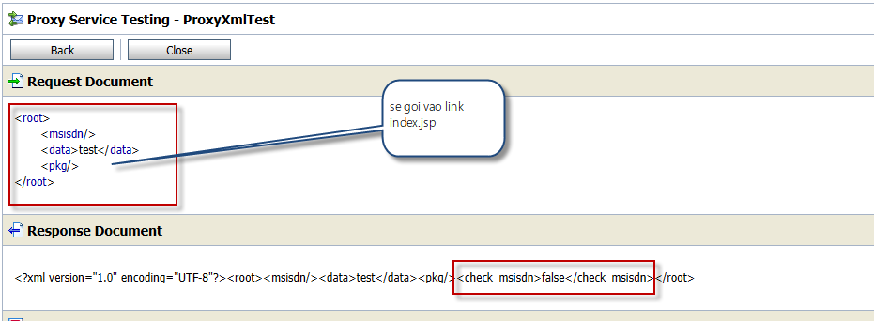

* **Sử dụng dynamic routing**

Phân tích yêu cầu:

Business service cụ thể sẽ được Client truyền vào khi gọi OSB?

Ví vụ:

Gửi xml như sau:

<root>

<msisdn>904508766</msisdn>

<data>test</data>

<pkg>MCA</pkg>

<bsname>BusinessServiceXmlOK</bsname>

</root>

🡪 Thì sẽ gọi đến dịch vụ: **BusinessServiceXmlOK**

Hoặc:

<root>

<msisdn>904508766</msisdn>

<data>test</data>

<pkg>MCA</pkg>

<bsname>BusinessHttpText</bsname>

</root>

Thì gọi đến: **BusinessHttpText**

Vậy ta chỉ cần tạo tạo OSB như hình:

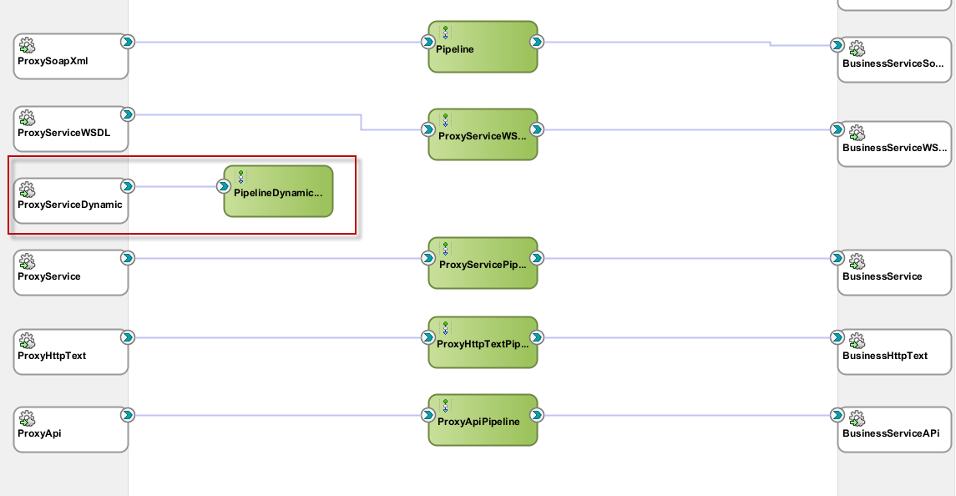

Pipeline không nối đến Business service cụ thể nào.

Cấp hình pipeline thể hiện như sau: Kéo thả các thành phần để tạo ra 1 pipeline như hình:

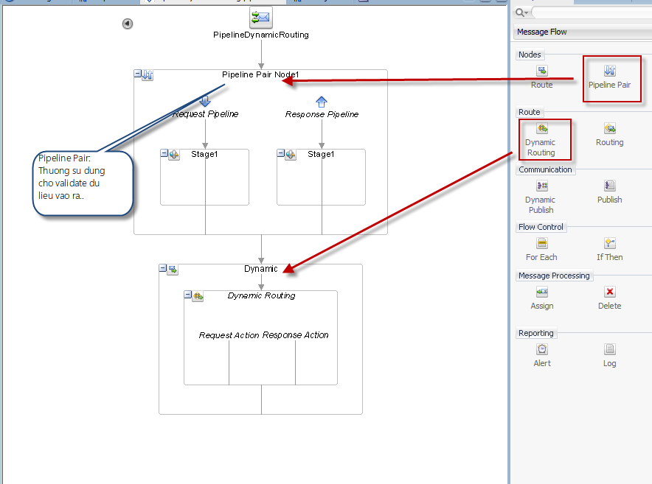

Sau đó cấu hình Dynamic routing như sau:

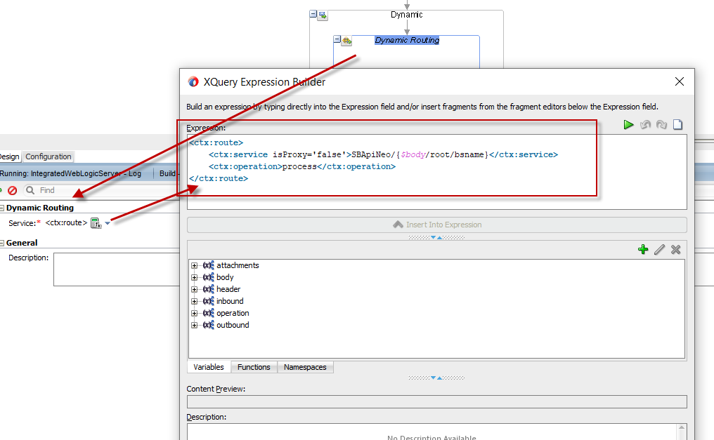

Phân tích biểu thức:

<ctx:route>

<ctx:service isProxy='false'>SBApiNeo/{$body/root/bsname}</ctx:service>

<ctx:operation>process</ctx:operation>

</ctx:route>

Nếu cần gọi đến 1 Business service (Không phải là proxy: isProxy = false)

* Thì Request sẽ được gửi đến Business có luật như sau:
* Có dạng: http://ip:port/SBApiNeo/ + Tên được truyền vào (biến bsname trong xml). Deploy trên cùng domain với proxy dynamic vừa tạo.

Test /SBApiNeo/ProxyServiceDynamic bằng tool SOAP UI như sau:

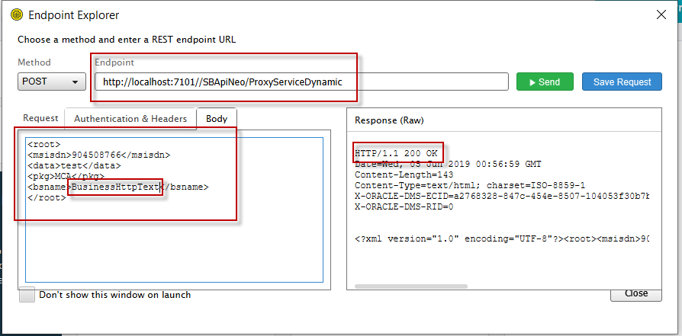

Hoặc:

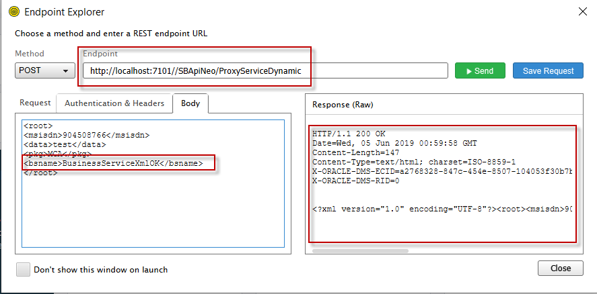

Nếu không tồn tại business service, gặp lỗi:

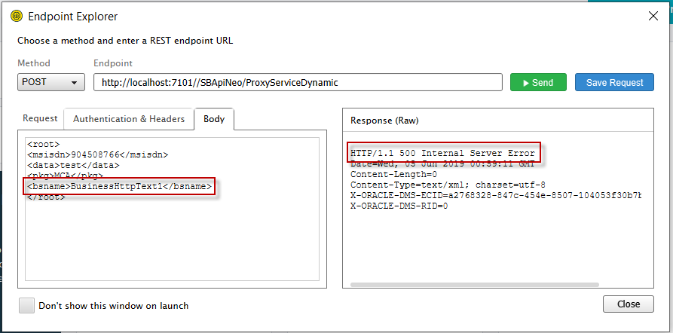

1. Sử dụng OSB Message buffer (Set Throttling)

Đang cập nhật