|  |
| --- |
| https://i.gyazo.com/0af3abf7f193a30ef795f91c92357432.png |
| Techstra-One |
| Assessment 2: Team Project |
|  |
|  |
| **Timothy Hall S3851553**  **Benjamin McDonald S3851983**  **Andrew Wendt S3858515**  **Rebecca Barnett S3856827**  **Adrian Foti S3857888**  **Adrian Ferrara S3856304** |

|  |
| --- |
| TechstraOne is a group of like-minded students from RMIT coming together with the goal of producing a project with real world purpose and to demonstrate our commitment to developing the necessary skills required for the Information Technology industry in the 2020’s. |

**10-Apr-20**

Table of Contents

1. Introduction 2

2. Team Profile 3

2.1 Team Introduction 3

2.1.1 Timothy Hall S3851553 3

2.1.2 Benjamin McDonald S3851983 3

2.1.3 Andrew Wendt S3858515 3

2.1.4 Rebecca Barnett S3856827 4

2.1.5 Adrian Foti S3857888 4

2.1.6 Adrian Ferrara S3856304 4

2.2 Team Personality Test Results 5

2.2.1 Myers Briggs 5

2.2.2 Learning Style 9

2.2.3 Creativity 10

2.3 Team Career Goals 12

2.3.1 Ideal Jobs 12

2.3.2 Industry Data Review 16

2.3.3 Interview with an IT Professional. 18

3. Project Tools 21

4. IT Technologies 22

4.1 Cyber Security 22

4.2 Machine Learning 24

4.3 Robots (Tim) 27

4.4 The Cloud 28

5. Team Project 31

6. Summary 33

7. Reflection 34

Individual 34

Group Reflection 34

References 35

# 1. Introduction

The Techstra-One team was formed by students from RMIT who shared an interest in creating a project that would allow us to develop and demonstrate skills relevant to our interests in Information Technology. The students met during the Introduction to Information Technology course as part of the Bachelor of Information Technology offered by RMIT.

In the following report, you will learn more about the Techstra-One team members, what their interest in Information Technology is and how their personality’s and learning styles will impact the team. We will also discuss what each team member’s ideal job is and the required skill set that they would like to develop and how that relates to industry demand.

We will also discuss IT Technologies that are of interest to the team and what influence this may have on the future of Information Technology.

Finally, we will reveal our project idea in detail and discuss our approach to its development and implementation in the future.

# 2. Team Profile

## 2.1 Team Introduction

### 2.1.1 Timothy Hall S3851553

Tim has always had an interest in IT from a very young age and continued to follow this interest by pursuing a role in IT in the Navy.

Completing 15 years of service following this interest he has found his passion for IT revolves around networking. Tim has continued to follow his passion by completing his CISCO CCNA qualification and continues to educate himself. With his 15 years of experience in the Navy, Tim brings project and team management skills as well as a raft of IT knowledge to Techstra-One to help see the goals of the company come to life.

During his spare time Tim is an amateur home chef and loves to go to the gym and rock climbing with his partner Tiffany.

### 2.1.2 Benjamin McDonald S3851983

Ben is a student at RMIT studying a Bachelor of Information Technology. Prior to beginning his degree, Ben had pursued a career as an audio visual technician working for companies in Canada and Australia.

Working in the AV industry for seven years helped Ben develop his knowledge of networking as well as hardware and software. This led to an interest in IT and AI (Artificial Intelligence) and the possibilities of what AI could hold not only for the AV industry but for every industry.

Ben strives to work as an AI developer, working with the top teams on creating sentient AI, as well as working on smaller AI inclined projects. Ben is semi-fluent in HTML, CSS, and is currently learning java script and python which will all be of benefit to the Techstra-One team.

### 2.1.3 Andrew Wendt S3858515

Andrew’s career started out at a data centre, where he administrated the facilities access control and building management systems.

He successfully completed a certificate 4 in IT networking and a certificate 3 in electronics, he applied the knowledge he learnt by becoming a technical specialist for an electronic security company. He has worked in the field for 5 years, with his responsibilities and experience including fitting off field devices, running cables to programming advance access control systems, IP CCTV, biometrics and intercom systems.

One of Andrew’s goals is to further his knowledge with cyber security - a career in cyber security is very interesting to him. Andrew brings an array of technical knowledge to Techstra-One, including IT networking, electronics and hardware, Linux based operating systems, SQL database management and cisco routing and switching.

### 2.1.4 Rebecca Barnett S3856827

Rebecca has been interested in Software & Website Development for many years, teaching herself how to code HTML in high school before choosing to commence a Bachelor of Technology degree after graduating.

Although her life took a different career path early on - working as a retail manager for fifteen years, Rebecca has always had a passion for technology and is excited to pursue new opportunities in Information Technology, hoping to work as part of a Software Development team in the future.

Rebecca enjoys the problem solving aspects of Information Technology and loves pursuing the “ah-ha!” moment of getting something difficult to work. Rebecca loves to break down problems into manageable parts and can spend endless time perfecting her work whether it is when coding or writing documentation.

Rebecca brings some project management and Java development experience to Techstra-One, which she acquired whilst studying for her Diploma of Information Technology and from a six month industry based scheduling software project. She considers herself excellent at documentation and enjoys producing reports and experimenting with data to create graphs and charts.

In her spare time Rebecca enjoys strategy games, reading and going for long drives with her husband David.

### 2.1.5 Adrian Foti S3857888

Adrian is an enthusiastic, hardworking individual recently obtaining his VCE certificate after completing year 12. Adrian was previously an apprentice Cabinet Maker where he acquired a Cert II in Furniture Making and is now a Building Construction worker looking to further his career.

Adrian’s interest in IT began at a young age, experimenting with and tweaking Windows XP machines. Adrian developed a curiosity in how machines worked and how their output could be manipulated.

Adrian intends to learn the skills required to be part of a business ICT team and also programming skills that he can utilise in passion projects and as part of the Techstra-One team.

### 2.1.6 Adrian Ferrara S3856304

Adrian's interest in IT stems from a young age when his father brought home the first family PC in 1997. He found himself a natural at navigation and immediately was drawn to the world of video games. In his teenage years he spent a lot of time in music production using programs like FL Studio and Cubase as well as the introduction of the internet where he dabbled in HTML coding unknowingly thanks to MySpace.

He is currently enrolled in a Bachelor of Information Technology at RMIT University through OUA. He hopes to find his place in the world of IT by pursuing all aspects and finding a true passion. Adrian is driven to learn as much as possible about all things he takes interest in and has vast experience in retail sales as well as holding a 2nd degree black belt in taekwondo.

## 2.2 Team Personality Test Results

### 2.2.1 Myers Briggs

The Techstra-One team each took a Myers-Briggs Type Indicator test from the 16 Personalities website.

The Myers-Briggs Type Indicator tool was developed in the 1940’s by Isabel Briggs Myers and was based off of C. G. Jung’s psychological theories from the 1920’s and attempts to make insights into peoples behaviours and personality traits.

Isabel Briggs Myers described sixteen types of personalities that every person could be categorized by. This Information is useful to a team as it can highlight areas of strengths and weaknesses and may provide insight into how the team will perform together.

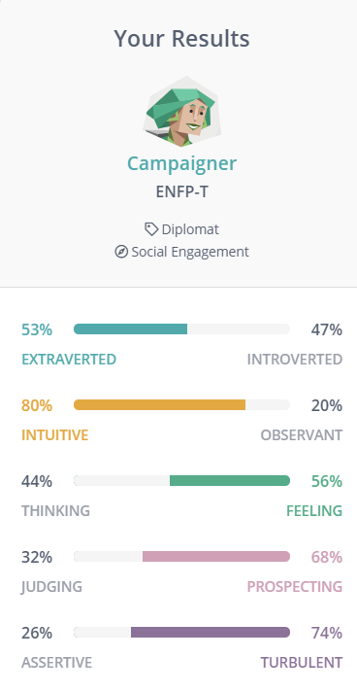

#### Benjamin McDonald ENFP - T

Ben is a Turbulent Campaigner (Figure 2.2.1.2) according to the Myers-Briggs test and means once he has his sight set on a goal nothing can stop him from achieving it.

Campaigners possess curiosity and energy that allow them to read between the lines and seek deeper meaning in what they encounter.

A weakness of a Campaigner may be that they may have poor practical skills relevant to what it is they wish to achieve.

Ben will be an asset to the team, possessing the drive to see the project’s completion as well as helping the team to better understand what is required of them.

*Figure 2.2.1.1: Timothy Hall: Defender*

*Figure 2.2.1.2: Benjamin McDonald: Campaigner*

#### Timothy Hall ISFJ-A

Tim is an Assertive Defender (Figure 2.2.1.1) which is a character who is supportive, reliable and patient.

Defenders in general are often in the background of a team and get the jobs done that are allocated to them as well as often taking on extra work which is often a detriment to themselves but are happy to do it.

A weakness of a Defender may be that they take things too personally and may take criticism more harshly than it is intended.

Tim will be a solid foundation for the Techstra-One team to rely on, supporting the team with his strong work ethic and reliability.

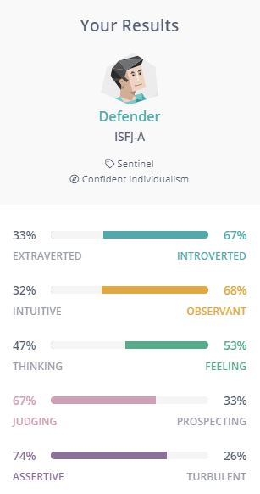

#### Andrew Wendt ENFJ - A

Andrew is labelled as a Protagonist (Figure 2.2.1.3) meaning he has a strong sense of feeling and judgement and is intuitive and altruistic. He is a believer of a strong team effort and prides himself in being reliable, tolerant and charismatic.

A weakness of a Protagonist may be that they can be perceived as being naïve.

Andrew will help to support the team in working better together and provide vision and guidance to seeing the team succeed.

#### Rebecca Barnett – INFJ - T

Rebecca is an Advocate type (figure 2.2.1.4), forming strong opinions about what she feels is the best way to proceed and also excelling at helping others to reach their potential.

A weakness of an Advocate may be that they can be sensitive when challenged or criticized.

In a group situation, Rebecca will bring out the best in her peers and approach tasks with a strong understanding of the requirements and possible solutions.

*Figure 2.2.1.4: Rebecca Barnett: Advocate*

*Figure 2.2.1.3: Andrew Wendt: Protagonist*

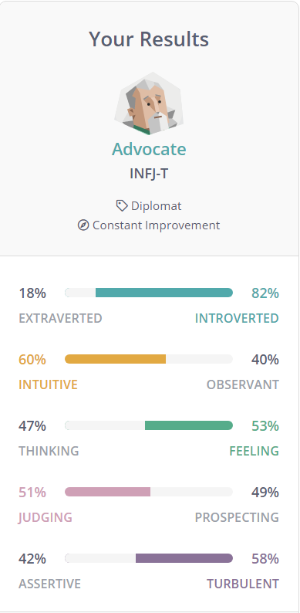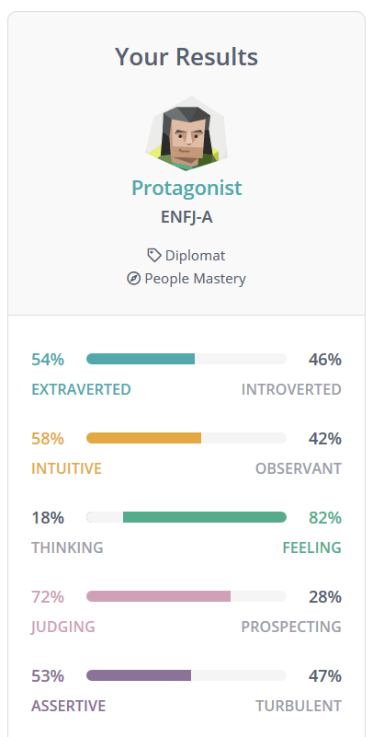

#### Adrian Foti INFJ - T

Adrian is a Mediator (Figure 2.2.1.5) and possesses the introverted, intuitive, feeling and prospecting personality traits. Mediators are open-minded, caring and creative in their approach.

A weakness of a Mediator personality type may be that they can be too idealistic and too altruistic.

Adrian will bring creativity to the project team as well as an open-minded approach to completing tasks.

*Figure 2.2.1.6: Adrian Ferrara: Campaigner*

*Figure 2.2.1.5: Adrian Foti: Mediator*

#### Adrian Ferrara ENFP - T

Adrian is a Campaigner (Figure 2.2.1.6), identified as being approachable, enthusiastic and observant, not missing details that others may. Campaigners also possess the drive to see their ideas succeed.

Campaigners may lack the practical skills required for achieving what it is they set their sights on.

Campaigners are fantastic at motivating others and Adrian will be a good addition to any team as he can adapt easily and work well with anyone in the right circumstances.

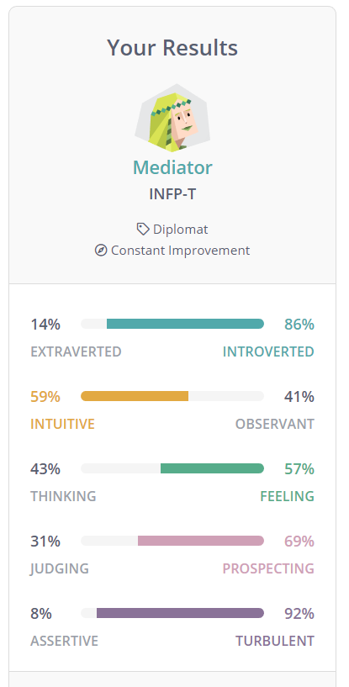

### 2.2.2 Learning Style

The team also each took a Learning Style test from EducationPlanner.org which reveals what style of learning each team member prefers and how they handle information and problem solve.

The three different learning styles include Visual, Auditory and Tactile and it is possible to have more than one preference.

Visual Learners prefer to see pictures or read in order to understand information and concepts.

Auditory style learners learn by listening and hearing and excel at remembering information that they have heard.

Tactile learners are “hands-on” and learn by touching and attempting what it is they are trying to learn.

Timothy Hall and Adrian Ferrara both identify as Auditory learners. Benjamin McDonald, Andrew Wendt, and Rebecca Barnett all identify as Visual/Tactile learners. Adrian Foti Identifies as a Visual learner. The results can be seen on the below chart: (Figure 2.2.2.1)

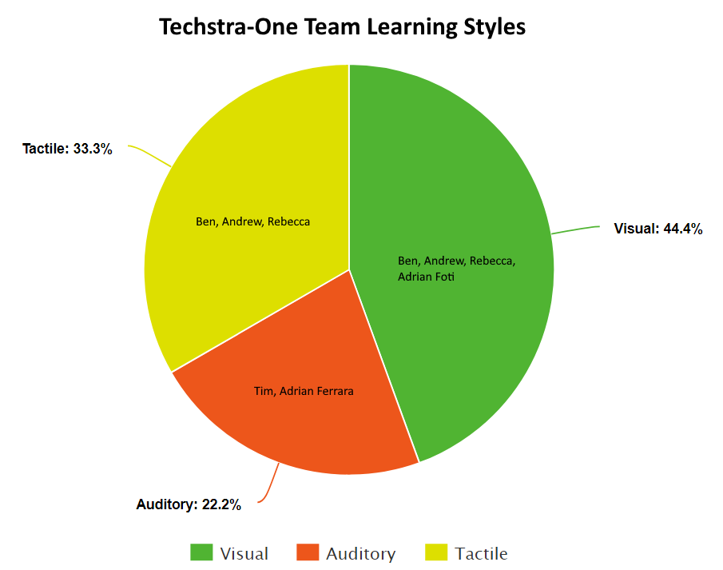

*Figure 2.2.2.1: Techstra-One Learning Styles*

Knowing what each team member prefers, it is apparent the most popular learning style is Visual and the team may benefit from sharing pictures and videos when discussing information.

Ideally, videos demonstrating concepts and discussing how it is done would be the best format as it would appeal to auditory style learners like Tim & Adrian Ferrara too. Ben, Andrew & Rebecca will also benefit from attempting tasks and getting “hands-on” with their project work.

### 2.2.3 Creativity

The last personality test the team did was a creativity test from Test My Creativity.

The metrics used to measure a person’s creativity by this test include:

* **Abstraction**: Ability to abstract concepts from ideas.
* **Connection**: Ability to make connections between things with no apparent connections.
* **Perspective**: Ability to change ones perspective of a situation.
* **Curiosity**: Desire to improve and change things that are accepted as the norm.
* **Boldness**: Confidence to push boundaries beyond accepted conventions.
* **Paradox**: Ability to simultaneously accept and work with statements that are contradictory.
* **Complexity**: Ability to carry large quantities of information and manage it.
* **Persistence**: Ability to force oneself to keep trying.

Timothy’s results show him as well rounded, possessing a creativity score of 58.08, and it is evident that Tim is not afraid of large quantities of information and is able to manipulate that information to his advantage. Not only is he able to work with this large amount of data he can simultaneous work with things that are contradictory to the norm to his advantage.

Benjamin has a creativity score of 64.9, with him having a high score in Boldness, Connection and Persistence. This means that Ben has the self-assurance to challenge perceived boundaries, find similarities in data sets and the persistence to see things through.

Andrew has the teams highest creativity score at 73.89 showing a strong result for Complexity, suggesting he has the ability to deal with lots of data and making it work for him.

Rebecca has a creativity score of 58.57, also showing fairly well rounded results although lacking slightly in Boldness. A weak score in Boldness might suggest Rebecca is against pushing boundaries and would likely stick to the norm.

Adrian Foti scores the lowest for Creativity with a result of 49.79. The areas in which he is lacking most is Persistence and Boldness. Like Rebecca, he might also stick to normal conventions and may be discouraged easily.

Adrian Ferrara also scores high in this test, with a result of 72.01. His stand out areas include Complexity, Paradox and Abstraction. This means Adrian is likely capable of simultaneously working with contradictory information and take away new concepts.

The results of the team’s tests are displayed in Figure 2.2.3.1.

**Tim**

*Figure 2.2.3.1: Team Creativity Results*

1. **Ferrara**
2. **Foti**

**Rebecca**

**Andrew**

**Ben**

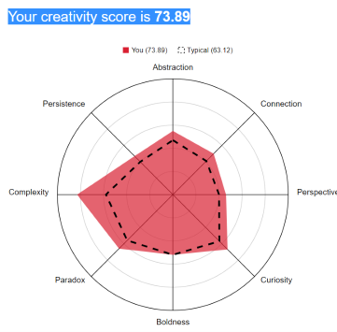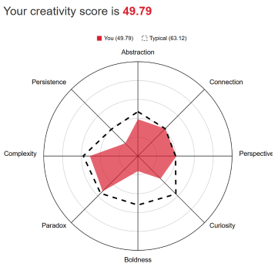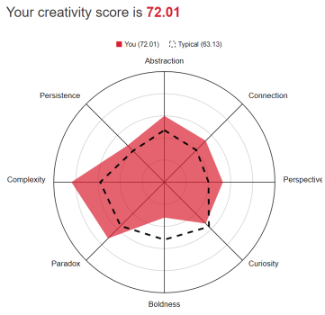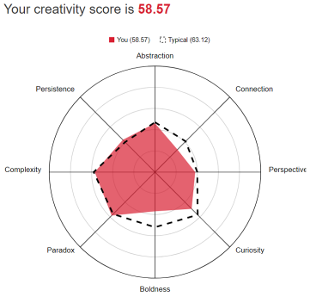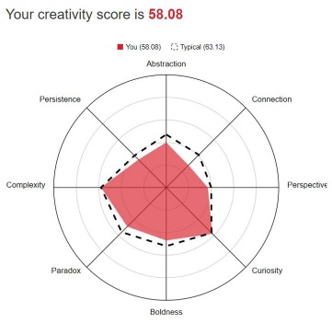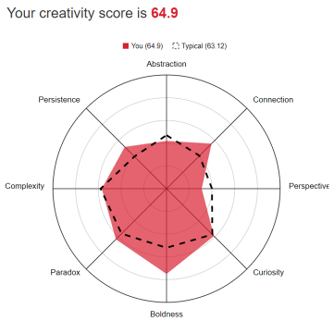

## 2.3 Team Career Goals

### 2.3.1 Ideal Jobs

The team’s ideal jobs are as follows:

#### Timothy Hall – Senior Network Engineer

Tim’s ideal job would be as the manager of a group of network engineers, where he would have the required skills and knowledge to design, develop and implement various network designs and technologies to meet his employer’s needs. While working in a team, he would pass on valuable knowledge to the team in the form of teaching and mentoring, and provide them with opportunities for professional development. A Senior Network Engineer position that Timothy is interested in requires the following skills:

* Level 3 incident resolution
* CISCO CCNP Enterprise/Security
* CISCO CCDE
* CISCO VOIP services
  + Call Manager
  + Call Manager Express
* BGP
* OSPF
* ITIL practices certification
* Cellular and Satellite Technologies
* CISCO Wireless products
* PKI

#### Benjamin McDonald – Artificial Intelligence Architect

Since Ben was a teenager, he’s had an interest in Artificial Intelligence, but of course when he was a teenager, he never really understood what AI could do. In more recent years he’s come to understand that AI could be more than just an android butler or killer robot hive mind. AI can be used for so many things, everything from Siri organising your music library and setting alarms to programs that control prosthetics as if they were a real limb through tracking electric impulses sent from the brain. The possibilities are endless. That is why Ben’s chosen to study IT and later study a masters in artificial intelligence.

Ben’s ideal job would be as an Artificial Intelligence Architect. He would ideally like to work in designing and building the latest big AI technologies and exploring the vast possibilities that AI has to offer.

An AI architect requires the following skills:

* Software programing
* Algorithms
* Logic
* Mathematics (Algebra, Statistics, Calculus)
* Science (Physics, Cognitive learning theory)
* Software testing
* System architecture
* Prototyping
* Data analysis
* Big data
* Python
* PHP
* Java
* Prolog
* Lisp
* C++
* Data structures

#### Andrew Wendt – Network Security Engineer

Andrew’s ideal job would be a Network Security Engineer, working on the design of large networks with security as the priority. Andrew already possess some Networking and Cisco qualifications and has some exposure to small and large infrastructure. A Network security position that Andrew is interested lists the following required skill set:

* Network Security
* Palo Alto Certification
* Linux Based Operating Systems
* Python for networks
* Virtualisation
* SQL Database Administration
* Azure applications
* Cloud based technologies

#### Rebecca Barnett – Software Developer

Rebecca’s ideal job would be as a Software Developer, creating solutions for complex problems in a challenging yet rewarding environment. Rebecca has previously completed work on development projects in Java and would love to make it her career. A Software Developer position Rebecca is interested in requires the following skills:

* MEAN stack
  + Node.js
  + Angular.js
  + Express.js
  + MongoDB
* Native iOS (Objective C)
* Native Android

#### Adrian Foti – IT Manager

Adrian’s ideal job would be as an IT Manager, excelling at creating business critical project and ensuring data security for his clients. An IT Management position Adrian is interested lists the following requirements:

* Cyber Security
* High availability, virtualised servers
* Data analytics
* Business Intelligence

#### Adrian Ferrara – PHP Web Developer

Adrian is interested in Website Development and desires to produce efficient and attractive websites.

A PHP Developer position that Adrian is interested requires the following skill:

* PHP based CMS ‘s
* HTML5
* CSS3
* JavaScript
* Templating Languages (Twig, Mustache, Handlebars)
* Search Engine Optimisation

#### Overview of required skills

There are many related skills that each team member desires to develop for each of their ideal career paths. Categorising these in a broad collection of technologies, the following general areas were identified:

**Networking :** Timothy and Andrew both require Networking certifications and knowledge.

**Information Security:** Timothy, Andrew and Adrian Foti all desire skills and knowledge in Information Security.

**Server Administration:** Timothy and Adrian Foti will both require Server Administration knowledge and experience.

**Data Analytics:** Adrian Foti, Adrian Ferrara and Ben all desire to learn data analytics.

**Web Development:** Adrian Ferrara, Ben and Rebecca will all require web development skills in their chosen professions.

**Programming & Software Development:** Ben, Rebecca and Andrew will all be required to learn programming languages and develop coding skills.

In the following diagram, it is possible to see the overlapping skills each team member is interested in. (Figure 2.3.1.1)

*Figure 2.3.1.1: Overlapping required skills*

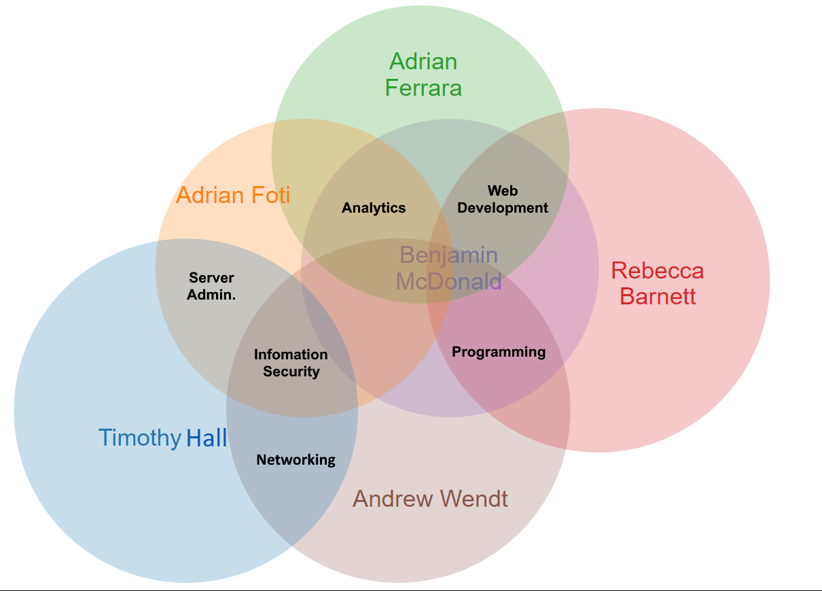

The ideal job of each team member spans multiple fields of interest in information technology. Where Andrew and Timothy will require specialised certifications and qualifications in Networking such as CISCO recognition and Palo Alto certification for networking hardware and telecommunications equipment, Rebecca, Benjamin and Adrian Ferrara will need to focus on Software Development technologies and programming languages such as learning Java, Python as well as database languages such as SQL.

#### Career Plans

Many members of Techstra-One plan to learn the required skills for their ideal jobs during the course of the Bachelor of Information Technology degree studies.

Tim already has a lot of experience in many of his fields of interest, and is now seeking formal qualifications to solidify his knowledge and develop new skills.

Ben plans on perusing a Master’s degree in Artificial Intelligence after completing his Bachelors.

Andrew intends to do work experience or an internship in Cyber Security after completing his Bachelor’s in order to gain relevant experience.

Rebecca plans on continuing the build her project portfolio whilst completing her Bachelors and may look for relevant work experience when confident in her abilities.

Adrian Foti plans on applying for internships while completing his degree.

Adrian Ferrara plans on choosing relevant electives during the course of his Bachelors in order to develop website developing skills.

All team members hope to learn something relevant to their ideal careers during their project work with Techstra-One.

### 2.3.2 Industry Data Review

#### Timothy Hall

After looking at the data in the Burning Glass reports Tim’s opinion of his ideal job hasn’t changed. While there was not a lot of Senior Network Engineer positions compared to the total jobs offered it is similar to other senior positions. The one thing the data did not provide is how many people applied for those positions. Tim, according to his experience in working in IT for the last 15 years believes there isn’t many Senior Network Engineers required in general. It is only medium to large business that require someone with that level of experience as they either have a large enough business or, the service that the business provides has a large network presence like a ISP for example.

#### Benjamin McDonald - AI Architect

The required IT specific skills for an artificial intelligence architect rank rather high in the desired skills on the burning glass report, the highest of which being Software engineering with 5852 job postings requiring this skill. JAVA, Python, and C++ also ranked high in the desired IT specific skills chart. This works out well for Ben plan as these skills will allow him to work in other and related IT fields while he completes his master’s degree latter on. Working in other IT fields will give him the opportunity to learn and gain the experience needed to attain a career as an AI architect.

The general skills needed for an artificial intelligence architect rank a lot lower in the general skills report. The highest of which being big data which is around the mid-range of the graph with 1939 jobs requiring experience in this field. That being said, there is still lot of opportunity in this field. The rest of the general skills rank from mid-range to the lower end of the scale of desirability, though the lowest number of job postings for one of these skills was still relatively high with 954 jobs requiring skills in client-based relations.

The three highest ranked skills in both IT specific skills and general skills on the Burning glass report that are not part of Ben’s required skills are SQL with 3570 job postings, JavaScript with 2946 and Microsoft Windows with 2699. The fact that these skills are at the top of the list for both reports indicates that they are of great importance in the IT industry. Thankfully these are all skills ben will be learning in his degree of Information Technology. Ben believes these skills will help toward his career goal in many ways, such as helping him attain a job once he finishes his degree.

Andrew Wendt

According to the burning glass data, some of the desired skills Andrew would like to possess are currently in high demand, his idea job as network security engineer requires knowledge in multiple fields in Information Technology. He believes that cyber security is quite broad and for his success he is highly interested in obtaining a broad knowledge base.

Andrew is also highly motivated to learn SQL Database Management, as this required skill continues to grow demand and is listed as the highest desired skill. Expanding his knowledge base will allow for flexibility and desirability for future employees. Andrew aims to continue his studies in all areas of Information technology that he has interests in. Some of these interests are Linux based operating systems, programming languages such as Python, C++, SQL, networking and virtualisation.

Rebecca Barnett **<insert data review here>**

Adrian Foti **<insert data review here>**

Adrian Ferrara **<insert data review here>**

### 2.3.3 Interview with an IT Professional.

#### 2.3.3.1 Introduction

As an additional tool for analysing the relevance of our desired career goals, we were tasked with conducting an interview with an IT Professional.

It interests the team to learn about the ups and downs of what a career in IT might entail and speaking with industry professionals may influence each team member’s decisions on what their ideal job may be.

Benjamin McDonald conducted the following interview with David Herod, a Software Development Manager who works for Aware 3, a company which provides IT services for Churches and Schools in the US. The company developed an application that organises group gatherings and events for the institutions that use it. David has worked in the IT industry for thirty years in many rolls - from data analyst to now managing a team of programmers. When asked, David was more than happy to answer any questions we had.

#### 2.3.3.2 Interview with David Herod

**Q. What company do you work for?**

A. Aware 3, manage groups and connectivity in the church market. Fun fact, they started with restaurants and bands and then they just found a niche in the church market. They provide group activities through a mobile application that’s available on both Android and IOS. The company I work for gains a 5% kick back on every dollar that’s donated through the application.

**Q. How long have you worked there?**

A. I’ve been with aware 3 for 1 year and the parent company Nelnet for 2 years.

**Q. What was your first IT job?**

A. Fritolay research and development for 30 years.

**Q. How did you get into the industry?**

A. My boss needed some marketing analysis and I learned I could go into the mainframe and pull data down, and then I was just organizing that data into a spread sheet. That was really mundane and boring. Then I found out I could automate it through something called Macro’s on an old program called Lotus 123. Then I extended that to my next thing when we moved to Colorado which was doing spread sheet analysis for an engineering firm. I took a recording of my spread sheet actions in Microsoft XL and I learned that the language that it was writing, how it interpreted my machine selections, followed a simple rule that was easy to read. It was in English, Visual Basic was the language. Then I learned I could manipulate it, replace it with more generic variables so that I could make it do more analysis for me, then that kind of kicked me off and launched me in to a career in IT.

**Q. What made you want to get into IT?**

A. I’m smart but lazy and I wanted a way to exploit a mundane process to achieve my goals. I found that I could use a language to automate and do repetitive tasks pretty efficiently, and that’s how it started.

**Q. what kind of work do you do? What is your job title?**

A. My technical expertise is as a full stack software developer, but in my thirty years in IT I’ve been a software developer for twenty-five years, and I’ve owned my own company where I did everything start to finish, analysing business requirements, designing the software, develop it then see it through to a production environment where it’s used fully. That’s how I spent half of my career. The other half of my career I’ve spent focused on one or more of those disciplines.

My current roll is I’m acting as a software development manager. I organise teams that do all of the various stages of software development

**Q. What kind of people do you interact with? Are there other IT professionals, clients, investors, general public**

A. In my case we have business analysts that work as an interface between us and the actual public. Also the product owners (clients) who define what we do to deliver a software product, which is great because that keeps us from having to talk to the public.

**Q. Where do you spend most of your time?**

A. I’m 100% remote from home. My corporate office is in Kansas City and what’s really neat is that about half of us are located in Kansas and the rest of us are all over the country so we’re coast to coast all over the US.

**Q. What aspect of your position is the most challenging?**

A. For me the greatest challenge is that I had to learn a completely new language. I was trying to find everything that resembled a pattern in languages I already know and it turned out there were a lot of aspects in this new language PHP that I knew really well. What’s always fun and interesting is learning the business nuance of the different companies.

**Q. How did you get in to this position?**

A. So I’m with the company Aware 3. That company was acquired by my company, which is a larger, multi-billion dollar company called Nelnet. Nelnet made their money through providing student loans. I’ve been with them two years and I jumped over with this company a year ago. So I brought with me another vertical for them to acquire which was schools. I brought a program that would bring one thousand churches and schools as clients over to this new platform Aware 3. Each school has an average of about ten thousand people. Every donator donates an average of three hundred dollars each year. We get 5% of each donation, so it’s a very large segment of business we’re providing. There were a new set of requirements that managing a school organization brought and I happened to know all of those. So I brought this inherit business knowledge across with me and translated it in to this new company.

**Q. How does your job measure progression/up scaling?**

A. We have a simple spread sheet of what the rolls are and the different levels of software developer. It is really based on people who have the right skills for the job based on the project. The person in the management roll, in this case me decides when a person is ready to move up based on their work.

**Q. Is there any in house training offered to employees so that they can progress in the company?**

A. We promote external training but leave it to the individual to create improvement plans, whether through continuing education or online learning. We have online accounts for Plurinsight.com and safari, I use these resources myself. The company does have a fund for reimbursement of continuing education but it is not yet at the level I’d like to see.

**Q. How do you find working remotely, is it easy enough to collaborate with your team to ensure work is getting done? Do you use a platform like Github to track progress and changes to the program?**

A. Working remotely is successful due to the tools we use to collaborate. Slack, Zoom, Webex for face to face meetings, screen sharing, remote control, pair coding, all embraced by Aware 3. We use Jira (Atlassian) for project management, ticketing and tracking our efforts, through a novel mixture of agile practices (Scrum and Kanban). We use Git hub as our source code repository for our half a dozen code bases.

#### 2.3.3.3 Conclusions

This interview was very informative to the team. It is interesting to hear about the ins and outs of the programming field. It sounds like David got his start as a programmer doing what many of us enjoy, automating processes to make life easier. It also sounds very lucrative being able to charge a commission for each client brought to the platform.

The biggest challenge of his work according to David is constantly having to update his skills and learn new technologies in order to stay relevant and on top of trends. This means it is important as an IT professional to be constantly learning and adapting to the requirements of industry.

There are many tools used by David that allow him to work remotely not unlike the tools the team is using to collaborate on Techstra-One. David collaborates regularly with his team and clients using those tools including Git hub for their code repository – this allows David’s team the freedom to work effectively together while never actually being in the same building.

# 3. Project Tools

Having set up an individual website in Assignment 1, you should now set up a group website, using the same approach. You should then include links to each individual website on the group website.

You also need to set up a GitHub or similar repository for your group on which you can use Git. This is to facilitate the production and maintenance of group artefacts, which will include the assignment submission, but may also include other reports or information, code, examples, formatted data, images and videos, links, and similar information.

You will also need to set up your group on Canvas.

In your report you should include a brief description of what you have done, and include the following: • The link to your group’s website • The link to your group’s Git repository (GitHub, BitBucket, etc) • Your comments on how well the audit trail on the Git repository reflects your group’s work. You will presumably only be able to do this close to the time of submission.

# 4. IT Technologies

## 4.1 Cyber Security

With the IoT (Internet of Things) becoming more prominent in everyday life, it is becoming more and more important to secure these types of devices which are generally left vulnerable and easy to hack. These devices may be running on unpatched software, are misconfigured or use unsecured communication protocols.

Check Point Software Technologies has recently released IoT Security offering a cyber-security solution for different IoT environments using components provided by Check Point, including Check Point Security Management, Checkpoint Security Gateways, IoT Discovery Engine (using third party partners) and IoT Nano agent.

The solution has three capabilities, the first being IoT Risk Analysis.

IoT Risk Analysis continuously performs risk analysis of the IoT environment and can provide details of devices on the network based on their risk level but can also be utilised for risk analysis on a certain device. It integrates with third party IoT discovery platforms and auto-identifies devices, tags them and analyses their behaviour in real time to detect anomalies. It can also perform Firmware Risk Assessments to expose security flaws of every connected device such as; weak credentials, known vulnerabilities, suspicious listed domains and hardcoded security flaws like OS misconfiguration. It can also identify IoT specific threat trends and malicious patterns via Check Point’s ThreatCloud which collates threat indicators from 100 Million gateways, endpoints and IoT devices worldwide.

The second capability is Auto-Segmentation.

Auto-Segmentation uses data from the IoT risk analysis to automatically generate and enforce a policy for each connected device which saves time from manually configuring policies and ensures the devices are protected as soon as they connect to the network. The auto-generated policies minimise IoT attack surfaces by allowing only authorized access to and from IoT devices and ensures devices only use protocols they were designed to use. These policies are adaptive to changes in devices’ attributes, risk level and behaviour but can also be manually modified within the Check Point Security Management console in a separate policy management layer to avoid confusion and conflicts with the auto-generated policies. The third capability is Threat Prevention.

Threat Prevention uses data from the IoT risk analysis to automatically activate security protections against known and Zero-day IoT related attacks at both a network and device level. It uses on-device runtime protection to monitor behaviour of devices and blocks known and unknown attacks before the device is compromised. It can also protect unpatched devices from known exploits by utilising virtual patching by installing appropriate IPS signatures on the gateways. This allows protection against unpatched devices or devices using old operating systems and software without disturbing critical processes and operations.

This software is based on previous network monitoring tools such as Wireshank and Splunk as well as Metasploit Framework to find exploits to protect against.

Some of the future applications of this technology could include native security policies installed on the IoT hardware making the software even more accessible. The risk analysis protocols could be installed on the IoT hardware from manufacturing to give users more peace of mind when buying a device without concern that it is easily exploited. It also has the potential to be used for government and military applications. Especially as 5G networks are rolling out making data transfer quicker, this software can be used in conjunction with cyber security experts to decrease workload on producing new security policies for connected devices.

This type of technology is helping to keep a secure connection to devices and maintaining those devices to act and behave in the way they do. This technology could allow more things to be automated as IoTs become more prominent in daily life. Coupled with developments in A.I and machine learning the technology has the potential to save time and money by reading and learning unstructured data and protecting devices that would need to be manually protected by a human or a team of cyber security specialists. This outcome would result in making fewer jobs available in the cyber security field when AI becomes more cognitive and can make better and more human decisions. Companies would benefit greatly by having effective protections on their devices and ensuring that the devices connected are doing the job they are supposed to as well as effectively analysing if a certain device is at risk. If new devices are purchased by the company they can be added to the network immediately with no need to add security policies and will be constantly monitored and analysed from the start. If the company owns devices that are no longer being patched by the manufacturer then the technology will create its own patches for it ensuring that it remains protected from potential attacks.

In daily life this technology may change the outlook of automated living and create risk free environments to make life more efficient and easier. People would no longer have to worry about their devices becoming compromised as they are constantly being analysed to find potential flaws and security risks. If this technology was more available on a consumer level, people would be more willing to add IoT devices to their network, most people are generally concerned with vulnerabilities in the device themselves, data leakage, access control and asset management. If these issues are addressed from the moment the devices are packaged, people would understand that the device is completely secure and will be continually analysed to remain secure throughout the entire time it is connected to their network. IoT devices collect data such as location, status and automation. This makes people reluctant to purchase IoT devices as the data is stored in a potentially insecure way. This would provide peace of mind that one’s personal privacy is protected and attacks on that data would be stopped. Ultimately it would create a safer more secure device with no stress about keeping personal information and data on that device. It would decrease the amount of potential attacks that can be made to compromise that data. It would ensure that the device is up to date with the latest ways attackers can penetrate and stop the attacks in its tracks.

## 4.2 Machine Learning

#### Introduction

Artificial intelligence has become a big part of everyday life. Siri sorts out our calendar and reminds us about appointments, Alexa orders online purchases and plays our favourite party mix, businesses send out personalised catalogues based off your previous purchases and search history. All of these technologies are the result of advances in artificial intelligence. Of course none of these technologies would be possible without three key components, Data mining, Deep learning and machine learning. In this report we will be exploring Machine learning, the latest technologies based around machine learning and the future impact that machine learning could have on our society.

#### What is Machine learning?

What is machine learning? Machine learning is a method of data analysis. This method of analysis allows systems to learn and improve from experience without having to be constantly reprogrammed by a human. But how does machine learning work? Machine learning uses an algorithm to look for and learn from patterns in data. The aim is to allow computers to learn automatically without human intervention. There are four main categories of algorithm that are used in machine learning. They include the following;

**Supervised algorithms:** Uses labelled examples to learn (e.g. an input with a known output). This data is then used to predict what future output values will be. After enough training the algorithm will be able to determine the target for inputs by comparing with the previous inputs with known outputs that it has gathered. Supervised algorithms are commonly used where past data predicts future events such as consumer patterns, or fraudulent behaviour with banking.

**Unsupervised algorithms:** Uses unlabelled data to train the algorithm. As the algorithm only uses unlabelled data, it has no examples to compare with new data. The reason for this is not to solve the problem but to find some structure inside the data.

**Semi-supervised algorithms:** Uses both labelled and unlabelled data to train the algorithm. This algorithm usually uses a small amount of labelled data and a large amount of unlabelled data. Semi-supervised algorithms can be used as an alternative to supervised algorithms. As semi-supervised algorithms use a large amount of unlabelled data and only a small amount of labelled data, this method works out cheaper than supervised algorithms in most cases.

**Reinforced algorithms:** Uses more of a trial and error method to find the best way to learn and improve. There are three main components involved in reinforced algorithms, the agent (the decision maker), the environment (everything the agent interacts with), and actions (what the agent can do). The idea is to have the agent choose the actions that achieve the greatest reward. Reinforced algorithms are commonly used in navigation, robotics and games.

#### The latest machine learning technology

As mentioned earlier, machine learning has become a part of everyday life. Some examples of this include household chat bots such as Amazon’s Alexa or Apple’s Siri are virtual assistants. They can help you by setting reminders, adding items to lists, playing your favourite music or video, searching the internet for any information you may need, and many more helpful tasks. Not only can chat bots perform tasks but they can also find patterns in your request and customize settings as a result. One of the great things about chat bots is they’re voice activated and can easily understand anything you ask them.

Google’s self-driving car is an amazing example of machine learning. This car is equipped with an arsenal of sensors such as sonar, radar, GPS, and lasers to help it determine distance from pedestrians and other vehicles, read road signs and traffic lights, and just keep everyone safe in general. Of course none of these features would be useful if it wasn’t for the autonomous cars ability to put this information to use. Through machine learning and AI technology, this car has been taught to identify potential hazards and read signs to abide by road rules. Not only that but this car can follow the navigation settings to get you where you need to go.

With the leaps and bounds in technology that have involved machine learning and artificial intelligence, the future is looking like something out of a science fiction movie. There are labs around the world working on robot’s that can mimic human behaviour such as Sophia, who is one of the world’s most sophisticated humanoid robots to date. Created by Hong Kong company Hanson Robotics, Sophia has an advanced neural network that lets her discern someone’s emotions from their tone of voice and facial expression as well as react to it. Sophia is still a long way from being completely mistaken for human; however she is definitely a sign of the exciting breakthroughs to come.

#### The impact of Machine learning

As discussed, future breakthroughs in machine learning could lead to some exciting advances in current and future technology. However, it could also lead to some serious issues as well. Let’s look at some of the good and bad possibilities of machine learning in regards to Future advancements.

**Good:** Self-diving and semi-self-driving cars once perfected could lower the road death toll substantially. Drunk and under the influence driving could be almost eliminated as the car won’t be operated by a human. That being said, I’m sure there will still be some form of limitation on the consumption of alcohol as the driver may need to take control if something goes wrong. There will also be fewer accidents as a result of speeding and not paying attention to the road.

AI in the workplace will be able to further increase the security and productivity of companies around the world. Over the past decade we have seen the growth of artificial intelligence in big firms around the globe. The AI is mainly used for sorting through data and improving the way a company operates based on the results. AI is also a big part of security, helping to keep hackers from attaining important or harmful information. In future years we could see artificial intelligence play a much bigger role in the workplace - from helping a customer in a more understanding way to performing surgery with a more effective and precise method that only an AI could do.

**Bad:** Redundant jobs and retraining staff will undoubtedly be more of a problem as artificial intelligence takes on a bigger role in the workplace. This has already been seen in China with fully automated factories becoming cheaper to run than a factory full of paid workers. A McKinsey Global institute study of eight hundred occupations in nearly fifty countries showed that nearly eight hundred million jobs or twenty percent of the global workforce could be replaced by AI and robotics by 2030. This could be one of the biggest issues regarding machine learning in the future.

#### How will this affect you?

We believe this will improve a lot of things for a lot of people in the long run. There will initially be some loss of jobs as well as some other problems that will need to be ironed out. However the evolution of machine learning, AI and robotics will undoubtedly create more jobs and education opportunities. The end result could be a highly advanced society, with improved living conditions and more time to live and be with family. Of course there is the other opinion that we could destroy our self with this technology that still loom’s in the shadows. However we have had the power to do so for almost a century and yet we still exist. There is no doubt that it could happen, but when you think about the possibilities how could we not pursue this future. Machine learning is a huge technological advancement any way you look at it, and the lives it could improve and even save are countless.

## 4.3 Robots (Tim)

## 4.4 The Cloud

#### Introduction

Cloud computing dates as far back as 1960s, back then the technology was called ‘cloud networking’ recently the technology has skyrocketed with popularity and demand, this is due to many major technological advancements that have progressed in the last two decades and more so in the last decade. In the modern era of cloud computing the technology made its mark in the early 2000s, with amazon and Google services setting the precedent for many others.

#### What is Cloud Based Technology?

Cloud technology is a network of remote servers connected by the internet, to provide end users and businesses the ability to manage data remotely from anywhere in the world. The data that can be stored on the cloud is limitless, some well-known examples are social media applications, such as Facebook, Instagram, Twitter and YouTube, some other well-known examples are Dropbox, OneDrive and streaming services such as Netflix and Stan. These businesses heavily rely on cloud-based technology for their global reach, and success.

It is not just social media or streaming services that heavily rely on cloud-based technologies, small to large businesses are starting to use cloud-based technology for a magnitude of reasons. An average office space could use a pool of virtual resources to replace the need for bulky power draining desktops. A typical office worker could conduct their work by using a ‘thin client session’ to establish a remote connection to an offsite data centre.

Data centres can provide a virtual pool of remote shared resources, such as database systems, virtual machines and storage and networking systems. Cloud technology opens the doors for easily centralised IT infrastructure, scalability for business growth, savings in IT infrastructure and the ability to minimise on-going costs such as sustainment of hardware and building costs such as electricity and cooling.

#### What can be done now?

The growth of cloud bases services in 2020 according to Forbes is expected to net approximately $411 billion US dollars, that sum is larger than the GDP’s of some countries around the world.

In some form or another all the world’s continents (including Antarctica) have some connection to cloud-based technology. If someone created a network diagram of how cloud-based technology is connected all around the world it would look like a messy cloud, hence the name.

With cloud technologies in every continent around world the demand and growth has dramatically increased. Now everyone can connect something to the cloud, whether it is a smartphone in your pocket or a tracking station in Antarctica. Everyone is now connected. In recent years small to medium businesses have started to utilise cloud-based tech for business efficiency and productivity, this is due to increased availability and affordability, also practicality due to cost saving measures.

Below are some dot points of what is achievable now, with a basic description outlining each point.

* Cost effective
* Constant innovation
* Scalability
* Backup & Disaster Recovery
* Reduction in onsite IT staff
* Shared responsibility

Businesses are reaping the rewards when it comes to moving to the cloud and with affordability and practicality it makes sense that in the future the majority of businesses infrastructure will be located on the cloud.

#### What will be done in the future?

It is very clear that everyone who has a smart phone, laptop, tablet etc. is connected to the cloud in some instance or another, even if they are aware of it or not. Mobile devices and cloud technology seamlessly go hand in hand, reinforcing each other as time goes on.

While most end users are connected to the cloud, many businesses are still operating IT infrastructure on premises. It is estimated somewhere in the future that almost all small to large businesses will be operating some type of cloud-based service.

Implementing systems such as ‘Desktop as a Service’ (DaaS) as mentioned earlier businesses would save money installing ‘thin clients’ that establish connections to a cluster of shared resources. The applications, computing power and desktop appearances can be handled internally or externally depending on the type of service the business requires.

The success of cloud-based technology for the future is dependent on physical infrastructure and technological advancements. These further advancements will include updated virtualisation technologies, higher speeds of internet access, data compression, increasing the volume of memory that can be stored on hard drives and further investment in research and development. The success of cloud computing also relies on the physical construction of data centres.

#### What is the impact?

With the increased trend of cloud computing in the IT industry, companies all around the world are moving to the cloud. When these companies make the move, there may potential risks that each company must be aware of before moving. With cloud technology continuously expanding and a market that is clearly dominating the information technology sector, the move for some is inevitable.

While there is an abundance of reasons as to why a company should move to the cloud there is also quite a few risks and potential disadvantages. These risks and disadvantages range from security and privacy to loss of jobs and dependency.

**Network connection dependency** – the backbone of cloud computing is the networks they travel on, and this is always going to be a variable as to how cloud technology preforms. While internet speeds and networking technology is gaining traction, it can also be highly unreliable at times.

**Loss of control** – moving to the cloud will mean that some aspects of their IT infrastructure may not be handled internally; this can result in the loss of some employees due to their jobs being made redundant. Entrusting a third-party cloud vendor is a risk for some, due to the potential management of sensitive data.

**Security –** Cloud technologies greatest flaw is security; cybercrime is prevalent in cloud-based computing. Compromised data and leaks are of course large risks, cloud-based computing can travel on public and private internets providing opportunities for hackers.

**Cloud Service Providers –** trust, reliability and security are all issues that can vary from service providers. It is important for a business to conduct research into a service provider before moving to the cloud.

Cloud computing can be a powerful and cost productive tool for many businesses in this technological era, although these risks may seem intimidating for some, risk mitigation and planning can see some issues potentially minimised or eliminated. Unavoidable issues such as network connection dependencies, the unfortunate loss of employment and some security issues are all impacts that cloud technologies can have for a business.

#### How will this affect you?

In your daily life, how will this affect you? What will be different for you? How might this affect members of your family or your friends?

For the average user cloud computing is nothing more than their smart phone uploading a daily backup to the cloud, some end users are completely unaware that some of their personal information is transported virtually to the cloud, located on a hard drive in an undisclosed location. For other end users, cloud technologies such as OneDrive and Dropbox may increase productivity with the ability to work on a document in the palm of your hands while travelling to work or the peace of mind that your data is stored somewhere other than the device that you are using.

Personally, speaking I use a variety of cloud-based technologies including OneDrive and iCloud, this document was edited on multiple computers including my laptop and work pc. According to Bankcell in 2020, approximately 45.04% of the world’s population had some type of access to a smartphone, which percentage wise equates to roughly 3.5 Billion people. Out of those 3.5 Billion people many of them have access to the internet, unknowingly using services and applications that use cloud-based technology.

Many cloud users have increased accessibility to whatever information they store on the cloud, a personal example of cloud accessibility was when I was travelling Europe, I stored all travel itineraries on OneDrive, so if I was to ever lose my bag, my phone or laptop, I could easily go to an internet café and grab whatever information I needed.

As cloud technology rapidly expands and continues to dominate the Information Technology sector, cloud usage will continue to be a part of daily life in the years to come. Cloud technology already has some impact on anyone that owns a smartphone or has an internet connection. Whether you own a business or a smartphone the future is the cloud.

# 5. Team Project

A mobile app that creates and collates a database of collector items (e.g.: trading cards, pop vinyl’s ect.) with the ability to add friends and view their collections. If, for example, you are searching for a particular collector’s item you can search your friends collections to see if they own it, if they do you can request a trade, rather than having to rely on them to see if they own it.

The service would provide an intuitive and user friendly display with different types of collections, for example Pokémon cards, magic the gathering cards, pop vinyl’s etc. The databases for these types of collections already exist so finding the information would not be difficult to do, but users would need to manually input their collections. This would be a potential drawback as these types of collections can be rather large scale and may put users off from inputting the data to catalogue. A way around this could be to utilise a “levelling” system (because everyone loves levelling up). Adding the ability to add friends and view their collections would be beneficial in all respects when it comes to providing and retrieving information from peers. It would be easy to track your collection and track your friends collections by utilising a search option for ease of access to information, for example if you are searching for a particular item for your own collection and you search for it across your friends list you will be able to see who owns it, who owns multiples and would be open to a trade. In addition to this you will be able to form a list of items you will be willing to trade as well as viewing what your friends are willing to trade. Images of the items on the database is crucial to adding aesthetic value to the mobile app. With the images being readily available an image recognition service can be utilised to easily add the physical items to your digital collection by using the inbuilt camera to scan the physical image and match it to the digital image. In the case of pop vinyl’s, the same ideas can be applied but can also work in conjunction with funko to provide QR Codes enclosed with each pop vinyl to be easily added to the digital collection. The basic idea is to connect and share your physical collections digitally with friends and peers.

Using .NET frameworks and SQL servers to create the databases

Angular in conjunction with JavaScript for front end

Data server to store user information and cloud services to store user’s collection information for ease of access

Highly feasible to acquire the skills, hardware and software to develop almost immediately

The success of the project would make collectors more enthusiastic about their collections and provide a sense of value to their collections as friends and peers can connect with each other and open more dialogue in regards to recent acquisitions of items. In future this could be extended to convention settings where collectors will be around each other and form new friendships.

* GUI (Java)
* Website/App (PHP)
* Database (SQL)
* connection to database (API)
  + pokemon, magic, yugio, comic books, ebay, warhammer, (expansion to games later)
    - pokemon database
* Search functionality (SQL)
* Filters (SQL)
* Accessibility –
  + worldwide
  + Different languages

Phone camera access/scanning ability – image recognition (figure out how google images works)

Chat/messaging

User accounts / rating

Integration with tournaments/conventions

Calendar

# 6. Summary

# 7. Reflection

## Individual

#### Timothy Hall

#### Benjamin McDonald

#### Andrew Wendt

#### Rebecca Barnett

#### Adrian Foti

#### Adrian Ferrara

## Group Reflection

400 words group reflection

# References

16personalities.com. 2020. Anonymouscampaigner - Turbulent Campaigner (ENFP-T) | 16Personalities. [online] Available at: [https://www.16personalities.com/profiles/225d3c05a9ef7](https://www.16personalities.com/profiles/225d3c05a9ef7%20) [Accessed 1 April 2020].

16personalities.com. 2020. Advocate (INFJ) Personality | 16Personalities. [online] 16Personalities. Available at: <https://www.16personalities.com/infj-personality> [Accessed 1 April 2020].

16personalities.com. 2020. Protagonist (ENFJ-A/ENFJ-T) Personality | 16Personalities. [online] 16Personalities. Available at: [https://www.16personalities.com/enfj-strengths-and-weaknesses](https://www.16personalities.com/enfj-strengths-and-weaknesses%20) [Accessed 2 April 2020].

16personalities.com. 2020. Tim Hall - Assertive Defender (ISFJ-A) | 16Personalities. [online] Available at: [https://www.16personalities.com/profiles/14e285c2779d0](https://www.16personalities.com/profiles/14e285c2779d0%20) [Accessed 2 April 2020].

Anadiotis, G., 2020. The State Of AI In 2019: Breakthroughs In Machine Learning, Natural Language Processing, Games, And Knowledge Graphs | Zdnet. [online] ZDNet. Available at: <https://www.zdnet.com/article/the-state-of-ai-in-2019-breakthroughs-in-machine-learning-natural-language-processing-games-and-knowledge-graphs/> [Accessed 12 April 2020].

AtoS. (2020). What is cloud based technology? [Online] Available at: https://apprenda.com/library/cloud/uses-of-cloud-computing/ [Accessed 10/04/2020]

Bankmycell. (2020). How many phones are in the world? [Online] Available at: https://www.bankmycell.com/blog/how-many-phones-are-in-the-world [Accessed 10/04/2020]

Educationplanner.org. (2019). What's Your Learning Style? 20 Questions. [online] Available at: [http://www.educationplanner.org/students/self-assessments/learning-styles-quiz.shtml?event=results&A=6&V=7&T=7](http://www.educationplanner.org/students/self-assessments/learning-styles-quiz.shtml?event=results&A=6&V=7&T=7%20) [Accessed 4 Mar. 2020].

Check Point (2020). Cyber Security Built for IoT. [online] Available at: https://www.checkpoint.com/downloads/products/cp-iot-security-solution-brief.pdf [Accessed 12 April 2020]

Columbus, L. (2018) Roundup Of Cloud Computing Forecasts And Market Estimates, 2018.[Online] Available at: https://www.forbes.com/sites/louiscolumbus/2018/09/23/roundup-of-cloud-computing-forecasts-and-market-estimates-2018/#3997b1fa507b [Accessed 12/04/20]

Expert System. 2020. What Is Machine Learning? A Definition - Expert System. [online] Available at: <https://expertsystem.com/machine-learning-definition/> [Accessed 12 April 2020].

Google Cloud. (2020). The future of cloud computing. [Online] Available at:<https://cloud.google.com/blog/topics/research/future-of-cloud-computing-5-insights-from-new-global-research> [Accessed 12/04/2020]

Innovative Architects. (2020). 8 Common Risks of Cloud Computing. [Online] Available at: https://www.innovativearchitects.com/KnowledgeCenter/cloud-computing/cloud-computing-risks.aspx [Accessed 12/04/2020]

Insights, S., 2020. Machine Learning: What It Is And Why It Matters. [online] Sas.com. Available at: <https://www.sas.com/en_au/insights/analytics/machine-learning.html> [Accessed 12 April 2020].

McKinsey & Company. 2020. Automation, Robotics, And The Factory Of The Future. [online] Available at: <https://www.mckinsey.com/business-functions/operations/our-insights/automation-robotics-and-the-factory-of-the-future> [Accessed 12 April 2020].

Medium. 2020. The Good, The Bad And The Ugly Of Artificial Intelligence And Machine Learning. [online] Available at: <https://medium.com/applied-innovation-exchange/the-good-the-bad-and-the-ugly-of-artificial-intelligence-and-machine-learning-3f7e663c317a> [Accessed 12 April 2020].

Medium. 2020. The State Of AI In 2020. [online] Available at: <https://towardsdatascience.com/the-state-of-ai-in-2020-1f95df336eb0> [Accessed 12 April 2020].

MIT Technology Review. (2020). Who thought of cloud computing? [Online] Available at: https://www.technologyreview.com/s/425970/who-coined-cloud-computing/ [Accessed 04/04/2020]

Nationalgeographic.com. 2020. Meet Sophia, The Robot That Looks Almost Human. [online] Available at: <https://www.nationalgeographic.com/photography/proof/2018/05/sophia-robot-artificial-intelligence-science/> [Accessed 12 April 2020].

Opentextbc.ca. 2020. Robotics, Artificial Intelligence, And The Workplace Of The Future. [online] Available at: <https://opentextbc.ca/businessethicsopenstax/chapter/robotics-artificial-intelligence-and-the-workplace-of-the-future/> [Accessed 12 April 2020].

Peerbits. (2020). 10 IoT security concerns to keep in mind before developing apps [online] Available at: <https://www.peerbits.com/blog/10-iot-security-concerns-to-keep-in-mind-before-developing-apps.html> [Accessed 12 April 2020]

Splunk. (2020). About Splunk MINT Management Console [online] Available at: <https://docs.splunk.com/index.php?title=Documentation:MINTMgmtConsole:UserGuide:Networkmonitoring:1.0&action=pdfbook&version=1.0&product=MINTMgmtConsole> [Accessed 12 April 2020]

Testmycreativity.com. 2020. Test My Creativity [online] Available at: [http://www.testmycreativity.com/](http://www.testmycreativity.com/%20) [Accessed 2 April 2020].

The Myers & Briggs Foundation (2020). MBTI Basics. [online] Available at: <https://www.myersbriggs.org/my-mbti-personality-type/mbti-basics/home.htm?bhcp=1> [Acessed 10 April 2020]

Wikipedia. (2020). Wireshark. [online] Available at: <https://en.wikipedia.org/wiki/Wireshark> [Accessed 12 April 2020]

Wikipedia. (2020). Metasploit Project [online] Available at: <https://en.wikipedia.org/wiki/Metasploit_Project> [Accessed 12 April 2020]

WIRED, A., 2020. AI And The Future Of Work. [online] WIRED. Available at: <https://www.wired.com/wiredinsider/2018/04/ai-future-work/> [Accessed 12 April 2020].