Summary of the Constrained NewWave Feature
The constrained wave method with the NewWave model summarized here should work exactly for superposition of linear wave components. No restriction is placed on the directionality and spreading of the wave components. This method should also work with second-order wave kinematics with the following process and allowing for the second-order wave elevation to exceed the specified constrained wave height (which is how we treat second-order wave elevations now relative to the specified WaveHs):
1) Compute the combined linear + constrained waves
2) Compute the second order waves from those combined first-order waves
The NewWave Model
The NewWave model of Tromans, Anaturk, and Hagemeijer (1991) gives the most probable profile of a large wave crest of a specified elevation based on the underlying wave spectrum. Consider a random wave with wave elevation $ζ(t)$ at the origin given by
 | $$ζ\left(t\right)=\sum_{n=1}^{N}{A_{n}\cos\left(ω_{n}t\right)+B_{n}sin⁡(ω_{n}t)}.$$ | (1)
The amplitudes $A_{n}$ and $B_{n}$ are independent Normal random variables with zero means and equal variance:
 | $$var\left(A_{n}\right)=E\left[A_{n}^{2}\right]=σ_{n}^{2}=S\left(ω_{n}\right)Δω,$$ | (2)
 | $$var\left(B_{n}\right)=E\left[B_{n}^{2}\right]=σ_{n}^{2}=S\left(ω_{n}\right)Δω,$$ | (3)
where $S\left(ω_{n}\right)$ is the wave power spectral density. The expectation of the wave amplitude squared at frequency $ω_{n}$, $A_{n}^{2}+B_{n}^{2}$ is given by
 | $$E\left[A_{n}^{2}+B_{n}^{2}\right]=E\left[A_{n}^{2}\right]+E\left[B_{n}^{2}\right]=2σ_{n}^{2}=2S\left(ω_{n}\right)Δω.$$ | (4)
The total variance of $ζ\left(t\right)$ is given by the zeroth wave spectral moment, $m_{0}$:
 | $$σ^{2}=\sum_{n=1}^{N}{σ_{n}^{2}}=\sum_{n=1}^{N}{S\left(ω_{n}\right)Δω}=m_{0}.$$ | (5)
The NewWave model is derived based on the assumption that $A_{n}$ and $B_{n}$ are independent normal random variables. Strictly speaking, this requirement is only met with the WaveNDAmp = True option in SeaState, which randomizes both the wave amplitudes and phases based on the Box-Muller method. However, this approach will still provide the correct constrained wave crest elevation if only the wave phases are randomized, WaveNDAmp = False.
For a wave crest occurring at time $t_{1}$ with wave elevation $η\left(t_{1}\right)=α$ and $\dot{η}\left(t_{1}\right)=0$ (to qualify as a crest), the temporal profile of the wave crest for large $α$, $α>2σ$ for realistic ocean wave spectra (Taylor et al. 1997), is given by
 | $$ζ\left(τ\right)=αρ\left(τ\right)+g(τ)$$ | (6)
where $τ=t-t_{1}$ so that the crest occurs at $τ=0$ and $g\left(τ\right)$ is a non-stationary, Gaussian random variable with zero mean. The standard deviation of $g(τ$) is zero at $τ=0$ and increases to $σ$ as $\left|τ\right|$ increases. $ρ(τ)$ is the autocorrelation function of $ζ$ given by
 | $$ρ\left(τ\right)=σ^{-2}\sum_{n=1}^{N}{σ_{n}^{2}\cos{(ω_{n}τ)}}.$$ | (7)
The standard deviation of $g\left(τ\right)$ is independent of $α$; therefore, for large crests, the deterministic part of the crest profile, $ζ_{d}\left(τ\right)=αρ\left(τ\right)$, dominates the random part, $g(τ)$, and the crest profile becomes more deterministic.
As an example, the most probable profile, $ζ_{d}\left(τ\right)$, of a crest with wave elevation $α=12$ m for a JONSWAP wave spectrum is shown in the Figure 1. The two-sigma interval is also demarked using dashed lines based on the variance of $g(τ)$:
 | $$var\left(g(τ)\right)=var\left(ζ\left(τ\right)\right)=σ^{2}\left(1-{ρ(τ)}^{2}-\frac{{\dot{ρ}(τ)}^{2}}{λ^{2}}\right)=σ_{cond}^{2}$$ | (8)
where $λ$ is given by the second spectral moment, $m_{2}$, of the wave spectrum
 | $$λ^{2}σ^{2}=m_{2}=\sum_{n=1}^{N}{ω_{n}^{2}S\left(ω_{n}\right)Δω}.$$ | (9)
The NewWave model is still based on linear superposition; therefore, the spatial profile of the waves and the wave kinematics can be derived from linear theory.
Figure 1. Most probable temporal profile, $ζ_{d}^{*}$, of a wave crest with a wave elevation of 12 m for a JONSWAP wave spectrum and the conditional two-sigma interval ($±2σ_{cond}$). Near the crest at $τ=0$, the wave profile is mostly deterministic.
The Constrained-Wave Method with the NewWave Model
The constrained NewWave approach entails modifying a wave time series generated with the conventional random-wave method locally by inserting a New Wave, i.e., the most probable wave crest profile discussed above of specified elevation and time based on the underlying wave spectrum. The argument is that, since the inserted New Wave has the correct statistical properties of the underlying random wave, the inserted wave crest would be statistically indistinguishable from one generated “naturally” using many wave realizations. The procedure is documented by Taylor, Jonathan, and Harland (1997) and summarized below.
A constrained wave history, $\tilde{ζ}(τ)$, with crest of elevation $α$ at time $τ=0$ can be constructed from the random wave $ζ(τ)$ as
 | $$\tilde{ζ}\left(τ\right)=ζ\left(τ\right)+Qe\left(τ\right)+Rf\left(τ\right).$$ | (10)
The deterministic time signals $e(τ)$ and $f(τ)$ have zero wave slope and zero wave elevation at $τ=0$, respectively, and are of the forms
 | $$e\left(τ\right)=\sum_{n=1}^{N}{c_{n}\cos\left(ω_{n}τ\right)},$$ | (11)
 | $$f\left(τ\right)=\sum_{n=1}^{N}{d_{n}\sin\left(ω_{n}τ\right)}.$$ | (12)
The coefficients $Q$ and $R$ are considered random because of the dependence on the random wave amplitudes $A_{n}$ and $B_{n}$. To have $\tilde{ζ}\left(0\right)=α$ and $\dot{\tilde{ζ}}\left(0\right)=g=0$, we can choose
 | $Q=\frac{α-\sum_{n=1}^{N}{A_{n}}}{c}$, $R=\frac{g-\sum_{n=1}^{N}{ω_{n}B_{n}}}{d}$ | (13)
where $c=\sum_{n=1}^{N}{c_{n}}$ and $d=\sum_{n=1}^{N}{ω_{n}d_{n}}$.
The expectation of $\tilde{ζ}\left(t\right)$ is given by
 | $$E\left[\tilde{ζ}\left(τ\right)\right]=E\left[ζ\left(τ\right)\right]+e\left(τ\right)E\left[Q\right]+f\left(τ\right)E\left(R\right)=\frac{α}{c}e\left(τ\right)+\frac{g}{d}f\left(τ\right)$$ | (14)
because $E\left[A_{n}\right]=E\left[B_{n}\right]=0$. The variance of $\tilde{ζ}(τ)$ is also given by Taylor et al. (1997):
 | $$var\left(\tilde{ζ}\left(τ\right)\right)=σ^{2}\left(1+\frac{e\left(τ\right)}{c}\left(\frac{e\left(τ\right)}{c}-2ρ\left(τ\right)\right)+\frac{f\left(τ\right)}{d}\left(\frac{λ^{2}f\left(τ\right)}{d}+2\dot{ρ}\left(τ\right)\right)\right)$$ | (15)
To match the expected constrained wave elevation of Eq. (14) with the most probable crest profile of the NewWave model in Eq. (6), we can set $g=0$ and choose
 | $$e\left(τ\right)=cρ\left(τ\right).$$ | (16)
To match the variance of the constrained wave, Eq. (15), to the NewWave model in Eq. (8), we can choose
 | $$f\left(τ\right)=-\frac{d}{λ^{2}}\dot{ρ}\left(τ\right).$$ | (17)
With the above choice of $Q$, $R$, $e(τ)$, and $f(τ)$, Eq. (10) gives the final constrained wave consistent with the NewWave model.
Final Set of Equations
The constrained wave is given by
 | $$\tilde{ζ}\left(τ\right)=ζ\left(τ\right)+Qe\left(τ\right)+Rf(τ)$$ | (18)
where $ζ(t)$ is the original wave generated using the random-wave method based on the wave spectrum:
 | $$ζ\left(τ\right)=\sum_{n=1}^{N}{A_{n}\cos\left(ω_{n}τ\right)+B_{n}sin⁡(ω_{n}τ)}$$ | (19)
The deterministic time signals $e\left(τ\right)$ and $f\left(τ\right)$ and the coefficients $Q$ and $R$ are all functions of the wave spectrum and the specified crest elevation $α$:
 | $$e\left(τ\right)=\sum_{n=1}^{N}{S\left(ω_{n}\right)Δω\cos\left(ω_{n}τ\right)}$$ | (20)
 | $$f\left(τ\right)=\sum_{n=1}^{N}{ω_{n}S\left(ω_{n}\right)Δω\sin\left(ω_{n}τ\right)}$$ | (21)
 | $$Q=\frac{α-\sum_{n=1}^{N}{A_{n}}}{\sum_{n=1}^{N}{S\left(ω_{n}\right)Δω}}$$ | (22)
 | $$R=-\frac{\sum_{n=1}^{N}{ω_{n}B_{n}}}{\sum_{n=1}^{N}{ω_{n}^{2}S\left(ω_{n}\right)Δω}}$$ | (23)
Example applications of the above equations are shown in Figure 2 and Figure 3. In Figure 2, a random wave (solid line) is modified/constrained to have a crest of 12 m at $τ=0$. In Figure 3, multiple realizations of the constrained waves are shown, and the resulting distribution of wave elevation is consistent with the NewWave model. Figure 3 is generated with Constrained_New_Wave.m (attached).

Figure 2. The original random irregular wave, $ζ(τ)$, is constrained to have a crest of elevation $α=12$ m at $τ=0$, resulting in the constrained wave $\tilde{ζ}(τ)$.
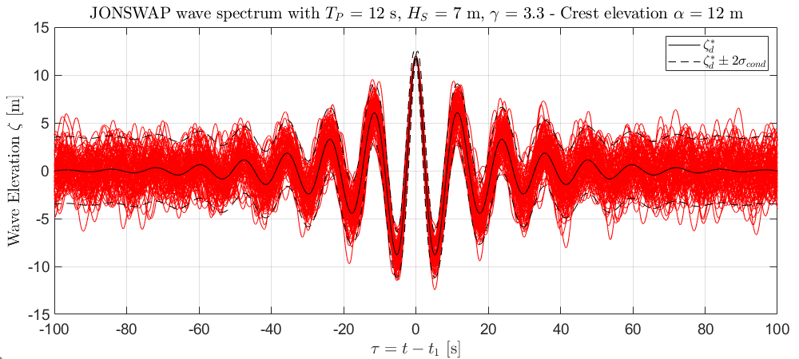
Figure 3. Multiple constrained wave realizations with a crest elevation of 12 m at $τ=0$. The wave elevations from the multiple realizations are consistent with the NewWave model.
Implementation in OpenFAST
For implementation, the constrained wave with arbitrary wave directions can be rewritten in complex form as
 | $$\tilde{ζ}\left(τ,χ\right)=R\left\{\sum_{n=1}^{N}{\left({\tilde{A}}_{n}-i{\tilde{B}}_{n}\right)e^{i\left(ω_{n}τ-k_{n}⋅χ\right)}}\right\}$$ | (24)
where $τ=t-t_{1}$, $χ=x-x_{1}=\left(x-x_{1},y-y_{1}\right)$, and $k_{n}=(k_{n}\cos{β_{n}},k_{n}\sin{β_{n}})$ is the vector wave number based on the direction of the wave component, $β_{n}$. The user specified time and location of the crest are given by $t_{1}$ and $x_{1}$ and
 | $${\tilde{A}}_{n}=A_{n}+QS\left(ω_{n}\right)Δω,$$ | (25)
 | $${\tilde{B}}_{n}=B_{n}+Rω_{n}S\left(ω_{n}\right)Δω.$$ | (26)
Wave spreading can be accommodated with $β_{n}≠\overline{β}$, where $\overline{β}$ is the mean wave direction. The exact crest elevation, $α$, can still be recovered at $t_{1}$ and $χ_{1}$ irrespective of $β_{n}$. After some manipulation, the constrained wave is given by
 | $$\tilde{ζ}\left(t,x\right)=R\left\{\sum_{n=1}^{N}{{\tilde{\tilde{A}}}_{n}\left(x\right)}e^{iω_{n}t}\right\}$$ | (27)
where the complex amplitude ${\tilde{\tilde{A}}}_{n}$ is given by
 | ${\tilde{\tilde{A}}}_{n}\left(x\right)=\left({\tilde{A}}_{n}-i{\tilde{B}}_{n}\right)e^{-i\left(ω_{n}t_{1}+k_{n}⋅\left(x-x_{1}\right)\right)}$. | (28)
Converting to a 2-sided even-length spectrum amenable to inverse fast Fourier transform (IFFT), the expression can be rewritten as
 | $$\tilde{ζ}\left(t,x\right)=\frac{1}{N^{'}}\sum_{n=-\frac{N^{'}}{2}+1}^{\frac{N^{'}}{2}}{\frac{N^{'}}{2}{\tilde{\tilde{A}}}_{n}\left(x\right)e^{iω_{n}t}}$$ | (29)
where ${\tilde{\tilde{A}}}_{k}$ is given by Eq. (28) when $n>0$ and ${\tilde{\tilde{A}}}_{-k}={\tilde{\tilde{A}}}_{k}^{*}$. The angular frequency $ω_{n}=nΔω$. $N^{'}=2(N+1)$ is the total (even) number of 2-sided DFT frequency components including the DC and Nyquist components (both zero).
In SeaState, the time-domain wave signal is computed using IFFT as:
 | $$ζ\left(t,x\right)=\frac{1}{N^{'}}\sum_{n=-\frac{N^{'}}{2}+1}^{\frac{N^{'}}{2}}{X_{n}e^{-ik_{n}⋅x}e^{iω_{n}t}}$$ | (30)
where $X_{n}=\sqrt{\frac{N^{'}}{2}}\sqrt{-2\ln{(U_{1,n})}}e^{2πiU_{2,n}}\sqrt{\frac{2π}{Δt}S_{2s}(ω_{n})}$ for $n>0$ (Evaluated on line 1573 of Waves.f90 as the variable tmpComplex). $U_{1,n}$ and $U_{2,n}$ are both uniform random variables between 0 and 1. The two-sided wave spectrum $S_{2s}$ can be computed from the one-sided spectrum $S_{2s}=\frac{1}{2}S$ (Line 1568 of Waves.f90). It can be shown that
 | $$X_{n}=\frac{N^{'}}{2}\sqrt{ΔωS(ω_{n})}\sqrt{-2\ln{U_{1,n}}}e^{2πiU_{2,n}}=\frac{N^{'}}{2}(A_{n}-iB_{n})$$ | (31)
where $A_{n}$ and $B_{n}$ are independent random normal variables of variance $S\left(ω_{n}\right)Δω$ (Box-Muller transform), consistent with the definition in Eq. (1). When only the wave phases are randomized with WaveNDAmp = False, the term $\sqrt{-2\ln{U_{1,n}}}$ is replaced with $\sqrt{2}$. For implementation, it is convenient to express everything in terms of $X_{n}$. i.e., tmpComplex. In other words, we want an expression of ${\tilde{\tilde{X}}}_{n}$ based on $X_{n}$ such that the final constrained wave is given by
 | $$\tilde{ζ}\left(t,x\right)=\frac{1}{N^{'}}\sum_{n=-\frac{N^{'}}{2}+1}^{\frac{N^{'}}{2}}{ {\tilde{\tilde{X}}}_{n}e^{-ik_{n}⋅x}e^{iω_{n}t}}.$$ | (32)
Comparing Eq. (32) and Eq. (29) and making use of Eq. (31), we have
 | $${\tilde{\tilde{X}}}_{n}={\tilde{X}}_{n}e^{-i(ω_{n}t_{1}-k_{n}⋅x_{1})},$$ | (33)
 | $${\tilde{X}}_{n}=X_{n}+\frac{\frac{N^{'}α}{2}-\sum_{k=1}^{N}{R\left\{X_{k}\right\}}}{\sum_{k=1}^{N}{S\left(ω_{k}\right)Δω} }S\left(ω_{n}\right)Δω-i\frac{\sum_{k=1}^{N}{ω_{k}I\left\{X_{k}\right\}}}{\sum_{k=1}^{N}{ω_{k}^{2}S\left(ω_{k}\right)Δω}}ω_{n}S\left(ω_{n}\right)Δω.$$ | (34)
In Eq. (34), all summations are done over the positive frequencies only, $k=1,…,N$, and the wave spectrum $S(ω_{k})$ can be either all one-sided or all two-sided as the factors of 2 will cancel out. If cut-off frequencies are specified for the first-order wave spectrum, the wave spectrum $S(ω)$ should be the truncated one for consistency. With $ω_{-n}=-ω_{n}$ and $k_{-n}=-k_{n}$, we also have ${\tilde{\tilde{X}}}_{-n}={\tilde{\tilde{X}}}_{n}^{*}$. The modified DFT amplitude, ${\tilde{\tilde{X}}}_{n}$, can be evaluated between line 1573 and line 1574 of Wave.f90 to modify InitOut%WaveElevC0. No other modification is needed after that point. The formulation should allow arbitrary crest time, $t_{1}$, and position, $x_{1}=(x_{1},y_{1})$, and any wave spreading given by $β_{n}$.
Specifying Crest Height instead of Elevation
With the above method, the wave-elevation of the crest is constrained to the specified value. In Bladed, it appears the crest height, defined as the difference in elevation between the crest and the lowest point up to one period ($T_{p}$) before or after the crest at $x_{1}$, is instead specified by the user. This requires some additional iteration on the crest elevation $α$. It is not clear how exactly Bladed achieves this, but a simple Newton-Raphson method can achieve rapid convergence to the target crest height with an initial guess of crest elevation being half of the specified crest height. An example implementation in MATLAB is attached: Directional_Constrained_Wave.m. The results shown in Figure 4 are generated using this script. The general iterative procedure for achieving the specified crest height is outlined below:
- Evaluate ${\tilde{X}}_{n}$ using Eq. (34) with an initial guess for crest elevation, $α_{0}$, equal to half of the specified crest height $H_{crest}^{*}$.
- Perform IFFT directly using ${\tilde{X}}_{n}$ (${\tilde{X}}_{-n}={\tilde{X}}_{n}^{*}$). This is equivalent to Eq. (33) with $t_{1}=0$ and $x_{1}=0$; therefore, the resulting wave-elevation time series will have the specified crest occurring at the first time step.
- Find the trough elevation, i.e., the minimum wave elevation during $t∈[0,T_{p}]$ and $t∈[t_{max}-T_{p},t_{max}=N'Δt]$, and compute the crest height, $H_{crest}$, as the difference between the crest and trough elevations.
- If the difference between $H_{crest}$ and $H_{crest}^{*}$ exceeds the tolerance, $ϵ_{H}$, numerically compute $\frac{dH_{crest}}{dα}≈\frac{H_{crest}\left(α+ϵ_{H}\right)-H_{crest}\left(α\right)}{ϵ_{H}}$. Update $α$ using the Newton-Raphson method, $α_{n+1}=α_{n}-(H_{crest}-H_{crest}^{*})/(dH_{crest}/dα)$.
- Update ${\tilde{X}}_{n}$ based on the new $α_{n+1}$ and compute the wave-elevation time series with IFFT. Repeat Steps 3 to 5 until $\left|H_{crest}-H_{crest}^{*}\right|<ϵ_{H}$.
During the iteration, ${\tilde{X}}_{n}$ can be split into a part that depends on $α$ and a part that does not, which does not need to be updated between iterations. The former only contains the term highlighted in red in Eq. (34).
As an example, a constrained wave with directional spreading and a target 35-m crest height at $t_{1}=300$ sec and $x_{1}=(120 m,-50 m)$ is shown in Figure 4. The wave-elevation time history at $x_{1}$ is shown in Figure 4a. The crest at $t=300$ s has an elevation of 19.18 m, which, together with the immediately preceding trough of elevation -15.82 m, results in a crest height of exactly 35 m. The wave field at $t=300$ s is shown in Figure 4b, in which the crest of elevation 19.18 m at $x_{1}$ is labeled. A short animation of the wave field, wave.avi, is also attached.
(a)
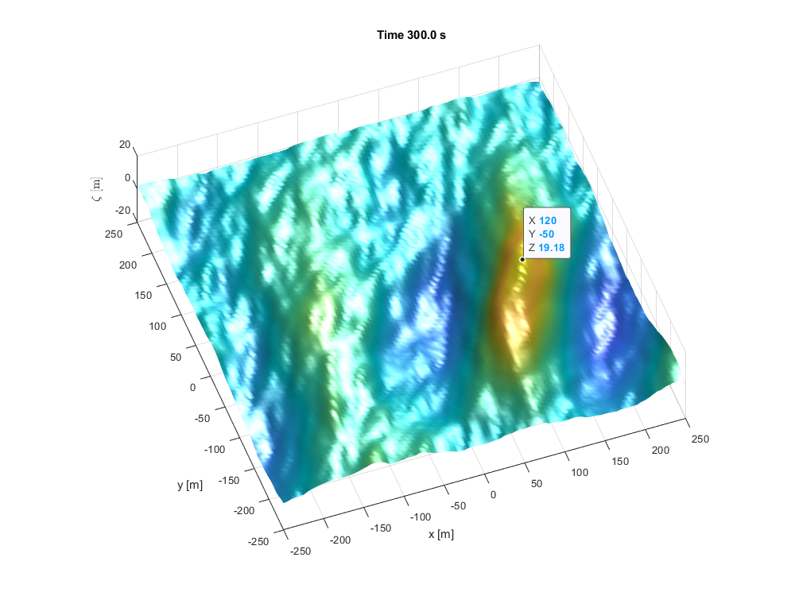
(b)
Figure 4. Example constrained wave with a target 35-m crest height with wave spreading. (a) Wave time series at the crest location $x_{1}$. Wave field at the crest time $t_{1}$ with the crest point at $x_{1}$ labeled.
Modification to SeaState Inputs
The SeaState input file should include four additional inputs for the constrained-wave function. These are listed in Table 1 and can be organized into a new “CONSTRAINED WAVE” section in the SeaState input file, between “2ND-ORDER WAVES” and “CURRENT.” A relative tolerance of 10⁻³ is hardcoded into SeaState for the crest-height iteration when ConstWaveMod = 2. Note the the constrained wave feature only works with WaveMod = 2 (JONSWAP wave spectrum).
Table 1. Additional SeaState Inputs Needed for the Constrained Wave Function.
Input | Description
ConstWaveMod | 0 – No constrained wave.  1 – Constrained wave with specified crest elevation $α$.  2 – Constrained wave with guaranteed peak-to-trough crest height, $H_{crest}^{*}$.
CrestHmax | $2α$ or $H_{crest}^{*}$ depending on the value of ConstWaveMod. (CrestHmax > WaveHs; unused when ConstWaveMod=0)
CrestTime | Time at which the crest appears, $t_{1}$. (unused when ConstWaveMod=0)
CrestXi | $x$-position of the crest. (unused when ConstWaveMod=0)
CrestYi | $y$-position of the crest. (unused when ConstWaveMod=0)
Nonlinear Constrained Wave Method
The nonlinear constrained wave capability (Rainey and Camp, 2007) builds on the constrained NewWave method discussed above. The wave kinematics near the generated large crest (within one period) is replaced with a suitable nonlinear stream-function solution of a regular wave. The velocity field is blended in time between the stream-function solution and the background linear wave field with a blending function. This is likely not needed because the original constrained NewWave method with a suitable wave-stretching formulation should provide adequate results.
References
Tromans, P., Anaturk, A.R., Hagemeijer, P. (1991) A new model for the kinematics of large ocean waves-application as design wave. In Proceedings of the First International Offshore and Polar Engineering Conference, Edinburgh, UK.
Taylor, P.H., Jonathan, P., Harland, L.A. (1997) Time domain simulation of jack-up dynamics with the extremes of a Gaussian process, J. Vib. Acoust. 119:624-628. https://doi.org/10.1115/1.2889772.
Rainey, P.J., Camp, T.R. (2007) Constrained non-linear waves for offshore wind turbine design. J. Phys.: Conf. Ser. 75:012067. https://doi.org/10.1088/1742-6596/75/1/012067.

