

Earn to Fire: STEMfest Newcastle info pack
InfoSec Battle Bots · 3 October 2026

What it is
Earn to Fire is a new kids' STEM mode for the IBB arena, for ages 12 to 14. Teams answer robot-themed science, maths and coding questions on an iPad, and every right answer fires a real arena hazard.
It launches at STEMfest Newcastle, 6 to 8 October 2026, for around 1,500 students in groups of about 10, roughly 50 groups a day in 7-minute slots.

How it plays
It's Red vs Blue. Each team of about five has one iPad and two bots in the arena.
- Two drivers per team drive the bots, keeping their own out of the pit and pushing the other team's in.
- The brains (the rest of the team) tap a weapon on the iPad and answer its question.
- Right answer: that weapon fires for real in the arena, and the team scores its points.
- Wrong answer: the iPad shows the right answer and explains why. That team waits 15 seconds before trying that weapon again.
- Recharge times are shared, so firing a weapon also blocks the other team from it.
- A round lasts 2 minutes. It ends early if both of one team's bots are pitted, which is a knockout.

Scoring
A team's score is STEM points plus bot points, so the brains and the drivers both win it.
Weapon | Question topic | STEM points | What fires
Flipper | Forces & levers | 10 | Flipper (solenoid)
The Pit | Circuits & electricity | 15 | Pit opens, closes after 10 s
Spinner 1 | Gears & motion | 20 | Spinner, 8 s, random direction
Spinner 2 | Code & logic | 20 | Spinner, 8 s, random direction
Spinner 3 | Sensors & robot brains | 20 | Spinner, 8 s, random direction
MEGA SPIN | Boss challenge | 50 | All three spinners, 10 s
Bot points: +1 every second for each of your bots still in the arena, and +50 for every enemy bot pitted. When the clock runs out, the team with more bots still in wins the fight.

What kids learn
There are 72 KS3-level questions, 12 per weapon, all robot-themed. Examples: Ohm's law, gear ratios, binary, ultrasonic ranging, kinetic energy, and how this arena's own solenoid flipper works.
Every answer, right or wrong, comes with a one-line explanation. Teachers get a take-away sheet listing the topics, with five follow-up questions for class.

Referee tablet and safety
One tablet runs the whole game. The arena always starts SAFE: answers score, but nothing moves until the referee arms it.
- Round clock: start, stop and reset. Default 2:00, with presets from 1 to 5 minutes.
- Bot fight: a PITTED button for each of the four bots, with undo. The kids can name their bots.
- Standings: STEM points, bot time, pit bonus and total for each team, updated live.
- ALL STOP: disarms, stops the clock, pauses the questions and switches every spinner off, at any time.
- Auto-stops: spinners switch off after 8 seconds (MEGA SPIN 10), and the pit closes itself after 10.
Rule for every volunteer: disarm before any hand goes near the arena.

Screenshots
These were taken from a demo game, so the team and bot names are made up.
The team iPad: both scores, the round clock, and the six weapons with their points.
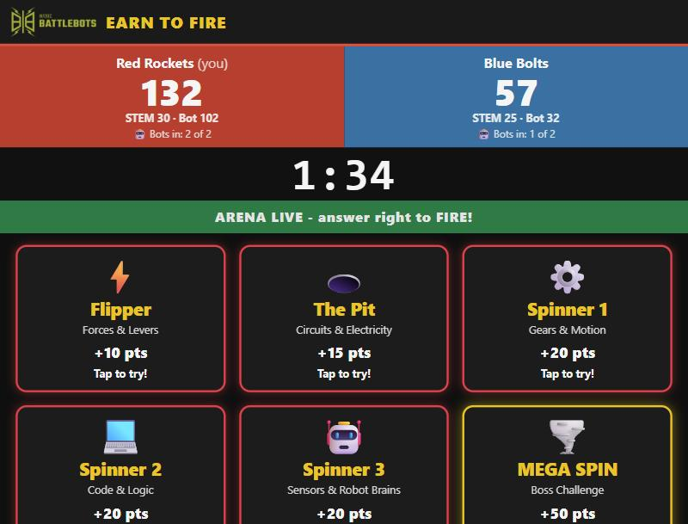
A question: each weapon asks one on its own topic.
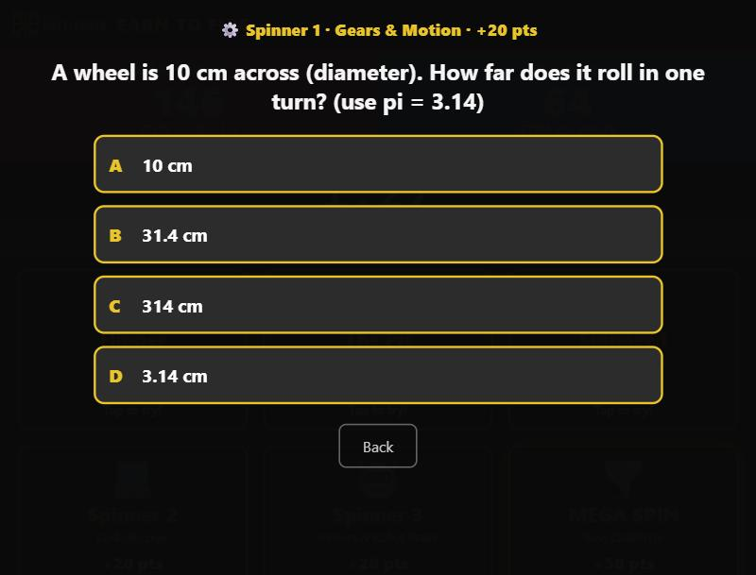
A right answer fires the weapon.
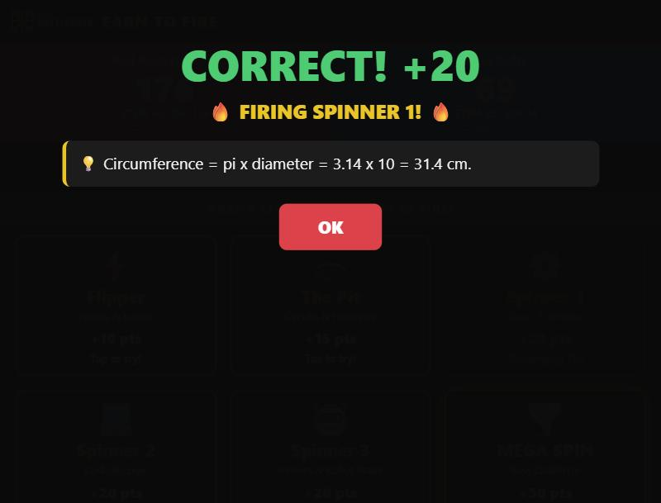
A wrong answer explains why.
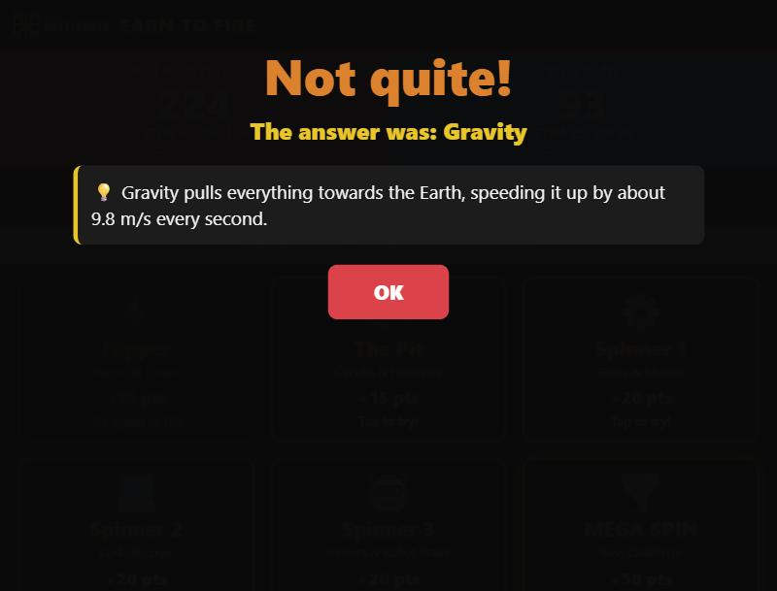
The referee tablet: ALL STOP, arming and the round clock.
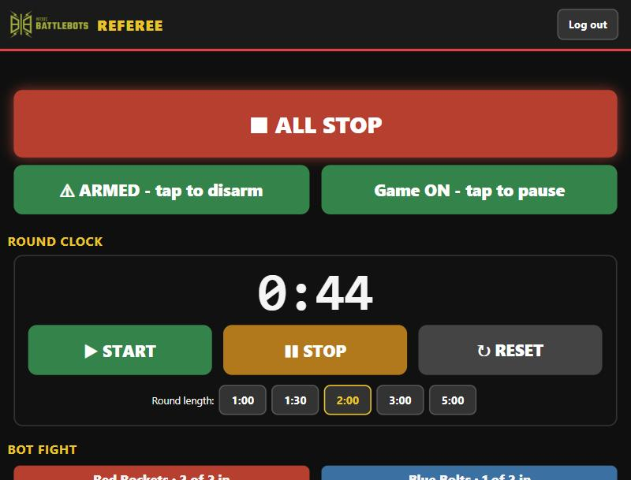
Bot fight and standings: a PITTED button for each bot, and live totals.
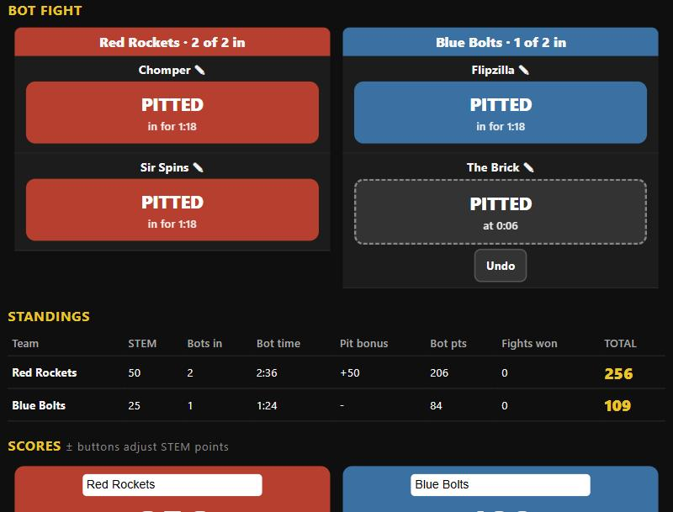

Status and links
- Done: hardware tested on 2 October: every weapon, the auto-stops and ALL STOP.
- Next: test the team pages in Safari on the kids' iPads.
- Next: print and laminate the pack: poster, briefing script, weapon cards, referee sheet, leaderboard, teacher handout.
More about the schools programme: www.infosecbattlebots.com/schools
The game is open source: github.com/Ben-PyroGuy-Doch/IBB-Arena-STEM-Challenge
Helping at STEMfest? Ask Ben for a walkthrough before Tuesday.

