1.TMB去除了Driver突变，都哪些是Driver，怎么定义的？

这是报告中“驱动突变”的定义（与肿瘤治疗、诊断、预后密切相关的突变，包括热点突变、药物靶点突变、癌基因功能激活突变和抑癌基因功能失活突变）。这个定义的文章参考来源是什么？

参考文献如下：

Pon JR, Marra MA. Driver and passenger mutations in cancer. Annu Rev Pathol. 2015;10:25–50. doi: 10.1146/annurev-pathol-012414-040312

另外，值得说明的是：对于我们为什么选择去掉driver突变，也是有根据的依据如下：

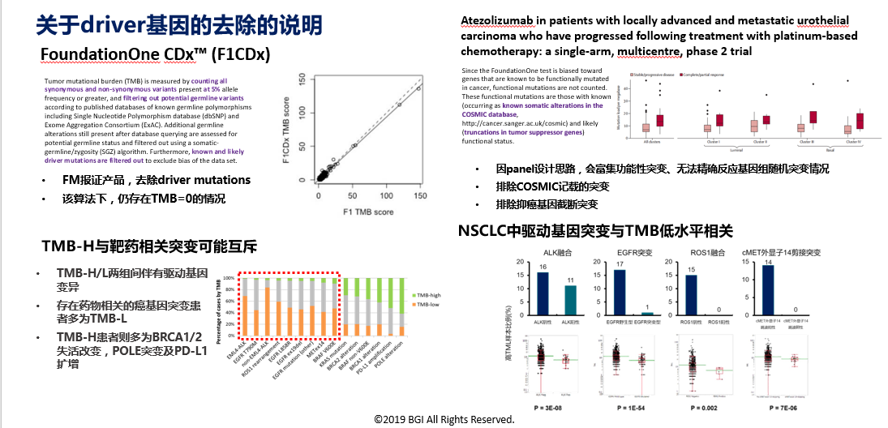

2.我们TMB的算法是什么参考依据？FMI？或某些权威文献？

我们的报告中对TMB算法描述如下：

“本产品靶向测序区域每百万碱基（Mb）中所发生的体细胞突变数目，单位Muts / Mb。本产品的靶向测序区域大小为2.79Mb， TMB计算的体细胞突变包括点突变和插入/缺失突变（包含同义突变），去除驱动突变（与肿瘤治疗、诊断、预后密切相关的突变，包括热点突变、药物靶点突变、癌基因功能激活突变和抑癌基因功能失活突变）。  ”

这种算法逻辑，是参考的哪几篇文献？

调研情况如下：

|  |  |  |  |  |  |
| --- | --- | --- | --- | --- | --- |
| **癌种** | **样本类型** | **检测方法** | **芯片** | **检测突变** | **排除** |
| **CRC** | **FFPE** | **目标序列捕获测序** | **MSK-IMPAC** | **所有非沉默突变** | **germline alterations（BC）、**  **CNV、SV** |
| **NSCLC** | **TISSUE** | **全外显子** | **无** | **所有体细胞**  **非同义突变** | **无** |
| **Urothelial carcinoma** | **FFPE** | **目标序列捕获测序** | **Foundation**  **ONE** | **所有可编码的、短的、可变的改变个数，**  **包括碱基替换、indel 、同义突变** | **germline alterations**  **&功能性突变** |
| **LC** | **FFPE** | **目标序列捕获测序** | **未知** | **体细胞的编码碱基替换和indel** | **无** |
| **Ⅳ期实体瘤** | **TISSUE** | **目标序列捕获测序** | **FoundationONE**  ***&Guardant360***  ***&Caris***  ***Life Sciences*** | **总基因组变化、（预测或非预测的）恶性\良性突变、VUS、其他** | **同义突变** |
| **Melanoma** | **TISSUE** | **全外显子** | **无** | **所有体细胞**  **非同义突变** | **Gernline alternations (BC)** |

最终纳入同义突变，主要的参考文献1：

Chalmers ZR, et al. Analysis of 100,000 human cancer genomes reveals the landscape of tumor mutational burden. Genome Med. 2017;9:34. doi: 10.1186/s13073-017-0424-2.

相关描述如下：Synonymous mutations are counted in order to reduce sampling noise. While synonymous mutations are not likely to be directly involved in creating immunogenicity, their presence is a signal of mutational processes that will also have resulted in nonsynonymous mutations and neoantigens elsewhere in the genome. Non-coding alterations were not counted

最终纳入同义突变，主要依据2（FM）：

TMB by F1CDx is defined based on counting the total number of all synonymous and non-synonymous variants present at 5% allele frequency or greater (after filtering) and reported as mutations per megabase (mut/Mb) unit. The clinical validity of TMB defined by this panel has not been established.

最终纳入同义突变，主要依据3（FM）

Rosenberg JE, et al. Atezolizumab in patients with locally advanced and metastatic urothelial carcinoma who have progressed following treatment with platinum-based chemotherapy: a single-arm, multicentre, phase 2 trial. Lancet. 2016;387(10031):1909–1920

相关描述如下：

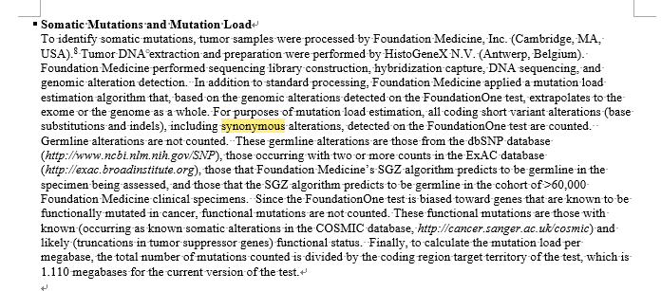

最终纳入同义突变，主要的参考文献4（FM）：

Han Chang, Ariella Sasson, Sujaya Srinivasan, Ryan Golhar, Danielle M. Greenawalt, William J. Geese, George Green, Kim Zerba, Stefan Kirov, Joseph Szustakowski

bioRxiv 626143; doi: https://doi.org/10.1101/626143

相关描述如下：TMB scores comprisingsynonymous, indel, frameshift, and nonsense mutations (all mutations) were 3.1-fold higher than data includingmissense mutations only, but values were highly correlated (Spearman’s r=0.99). Scoresfrom CheckMate 026 samples including missense mutations onlywere similar to those generated from datain The Cancer Genome Atlas, but those including all mutations were generallyhigher. Using databases for germline subtraction (instead of matched controls) showed a trend for race-dependent increases in TMB scores.WES and FoundationOne CDx outputs were highly correlated (Spearman’s r = 0.90).