ADMINPC01 — Workstation Deployment & Domain Integration
Task 1 ─ preparation section for Module 4, before the actual administrative tasks begin.

1. Windows 11 workstation deployment
I created the new workstation:
Computer: ADMINPC01
Operating System: Windows 11
Initial local account: LabAdmin
Initial membership: WORKGROUP
The important concept here is that ADMINPC01 initially had no relationship with Active Directory.
LabAdmin was a local account. It existed only inside ADMINPC01.

2. Network configuration validation
ADMINPC01 received its network configuration through DHCP:
IPv4 Address: 10.20.20.146
Subnet Mask: 255.255.255.0
Default Gateway: 10.20.20.254
DHCP Server: 10.20.20.254
That showed that ADMINPC01 was correctly connected to the 10.20.20.0/24 lab network.
I also tested:
ping 10.20.20.10
and received replies from DC01.
Learning point: Before attempting a domain join, verify basic IP connectivity between the workstation and the Domain Controller.

3. DNS configuration — one of the most important steps
Initially ADMINPC01 was using external Comcast DNS servers.
That allowed Internet name resolution, but:
nslookup dc01.benlab.local
failed.
Why?
Because Comcast DNS knows nothing about the private Active Directory DNS namespace:
benlab.local
I corrected the DNS configuration so ADMINPC01 used:
DNS Server: 10.20.20.10
which is DC01.
Then:
nslookup dc01.benlab.local
successfully returned DC01.

Key learning point
A domain client should use the Active Directory DNS server, not a public/ISP DNS server, for AD name resolution.
Internet DNS resolution can then be handled through DNS forwarding/upstream resolution.
This is one of the most important concepts from the entire exercise.

4. Active Directory service discovery
I didn't stop after simply pinging DC01.
I tested whether ADMINPC01 could actually discover the Active Directory service through DNS:
nslookup -type=SRV _ldap._tcp.dc._msdcs.benlab.local
After DNS was corrected, the result identified:
port = 389
svr hostname = dc01.benlab.local
That is much more meaningful than a successful ping.
Ping asks:
Can I reach this machine?
The SRV lookup asks something closer to:
Where is a Domain Controller providing LDAP services for benlab.local?
Active Directory relies heavily on these DNS SRV records to locate domain services.

5. VMware Tools
I installed VMware Tools using the mounted VMware Tools virtual DVD.
I selected:
Typical
and restarted ADMINPC01 after installation.
This provides the drivers and integration components needed for the Windows guest to operate properly within VMware.

6. Joining ADMINPC01 to benlab.local
Before joining the domain, System Properties showed:
Computer name: ADMINPC01
Workgroup: WORKGROUP
I changed membership from:
WORKGROUP
to:
Domain: benlab.local
Windows then requested credentials belonging to an account authorized to join computers to the domain.
After successful authentication, Windows displayed the:
Welcome to the benlab.local domain
message.
The computer was then restarted.

What actually happened?
This wasn't simply Windows changing the word WORKGROUP to benlab.local.
A computer relationship was established between:
ADMINPC01
↓
Active Directory
↓
benlab.local
Active Directory now recognizes ADMINPC01 as a domain computer.

7. Local account vs. domain account
Before joining/logging into the domain I had:
ADMINPC01\LabAdmin
That account exists only on ADMINPC01.
After joining the domain, I logged in using:
BENLAB\Administrator
That account is authenticated by Active Directory.
This distinction is extremely important:
LOCAL AUTHENTICATION

ADMINPC01
│
└── LabAdmin

DOMAIN AUTHENTICATION

ADMINPC01
│
├── DNS → DC01
│
└── Active Directory
│
└── BENLAB\Administrator

8. Verification after the domain join
I performed three excellent verification commands.
Identity
whoami
Result:
benlab\administrator
This proves I am using a domain identity.

Computer identity
hostname
Result:
ADMINPC01
This proves which computer I am administering from.

Authentication source
echo %logonserver%
Result:
\\DC01
This tells us that DC01 processed the domain logon.
Together, those three commands tell a very clear story:
WHO AM I?
BENLAB\Administrator

WHERE AM I?
ADMINPC01

WHO AUTHENTICATED ME?
DC01

Why ADMINPC01 matters to lab
This is where the project becomes more enterprise-like.
Previously, a lot of administration was performed directly on:
DC01
But administrators generally shouldn't need to sit directly on a Domain Controller every time they want to manage users, groups, DNS, GPOs, etc.
My architecture is becoming:
ADMINISTRATOR
│
▼
ADMINPC01
Administrative Workstation
│
RSAT / PowerShell
│
▼
DC01
┌──────────┼──────────┐
▼ ▼ ▼
AD DS DNS GPO
│
▼
benlab.local
│ │
▼ ▼
Servers Workstations
That is exactly why the next step—RSAT—will matter.

Module 4 – Remote Server Administration

Task 2 – Install and Validate RSAT on ADMINPC01

Objective
Configure ADMINPC01 as a centralized administrative workstation by installing Remote Server Administration Tools (RSAT) and validating remote management of Active Directory, Group Policy, DNS, and DHCP infrastructure.
The goal is to perform routine administrative tasks from a dedicated management workstation rather than logging directly onto the Domain Controller.

Environment
System | Role | Purpose
ADMINPC01 | Windows 11 Administrative Workstation | Centralized management workstation
DC01 | Domain Controller / DNS Server | Hosts AD DS and DNS
benlab.local | Active Directory Domain | Enterprise lab domain
10.20.20.10 | DC01 IP Address | Domain DNS and AD services
ADMINPC01 was previously joined to the benlab.local domain and domain connectivity was successfully validated.

Step 1 – Access Windows Optional Features
On ADMINPC01, opened:
Settings → System → Optional features → View features
Searched for:
RSAT
Windows displayed the available Remote Server Administration Tools.

Step 2 – Select Administrative Tools
The following RSAT components were selected:
RSAT: Active Directory Domain Services and
Lightweight Directory Services Tools

RSAT: Group Policy Management Tools

RSAT: DNS Server Tools

RSAT: DHCP Server Tools
The installation was then started by selecting Add.

Step 3 – Verify RSAT Installation
Windows successfully installed all four selected components.
The Optional Features interface reported:
RSAT: Active Directory Domain Services and
Lightweight Directory Services Tools Added

RSAT: DNS Server Tools Added

RSAT: Group Policy Management Tools Added

RSAT: DHCP Server Tools Added
This confirmed that ADMINPC01 now contained the management consoles required to remotely administer major Windows infrastructure services.

Remote Management Validation

Step 4 – Validate Active Directory Users and Computers
Opened Active Directory Users and Computers from ADMINPC01.
Run command:
dsa.msc
The console successfully discovered:
benlab.local
Expanded the domain and verified access to the existing organizational structure:
BENLAB
├── Groups
├── Servers
├── Service Accounts
├── Users
└── Workstations
Existing domain users were also visible from ADMINPC01.

Result
ADMINPC01 successfully accessed Active Directory remotely.
This demonstrated that AD objects can now be managed without interactively logging into DC01.

Step 5 – Validate Group Policy Management
Opened Group Policy Management from ADMINPC01.
Run command:
gpmc.msc
The console successfully discovered:
Forest: benlab.local
└── Domains
└── benlab.local
Existing Group Policy Objects and links were visible, including policies previously created during earlier lab modules.

Result
ADMINPC01 can remotely access the domain's Group Policy infrastructure.
Group Policy administration can therefore be performed from the dedicated management workstation.

Step 6 – Open DNS Manager
Opened the DNS management console using:
dnsmgmt.msc
Because ADMINPC01 does not host the DNS Server role, DNS Manager prompted for the DNS server to manage.
Selected:
The following computer
and entered:
DC01
The option:
Connect to the specified computer now
was enabled.

Step 7 – Validate Remote DNS Administration
DNS Manager successfully connected from ADMINPC01 to DC01.
Expanded:
DNS
└── DC01
├── Forward Lookup Zones
├── Reverse Lookup Zones
├── Trust Points
└── Conditional Forwarders
Under Forward Lookup Zones, the existing Active Directory-integrated zones were visible:
_msdcs.benlab.local
benlab.local
Both zones reported a status of:
Running

Result
ADMINPC01 successfully established remote administrative access to the DNS Server service running on DC01.

Important Architecture Concept
Installing RSAT DNS Server Tools on ADMINPC01 did not turn ADMINPC01 into a DNS server.
The architecture remains:
ADMINPC01
│
│ RSAT / DNS Manager
▼
DC01
│
└── DNS Server Role
├── benlab.local
├── _msdcs.benlab.local
├── Reverse Lookup Zones
└── Conditional Forwarders
ADMINPC01 contains the management interface.
DC01 contains the actual DNS Server service and DNS database.
This same general concept applies to the other RSAT components.

Administrative Console Commands
Useful MMC commands validated during this task:
Command | Administrative Tool
dsa.msc | Active Directory Users and Computers
gpmc.msc | Group Policy Management
dnsmgmt.msc | DNS Manager
dhcpmgmt.msc | DHCP Manager
These commands allow administrators to launch management consoles directly without navigating through Windows menus.

Key Learning Points
RSAT (Remote Server Administration Tools) allows administrators to manage Windows Server infrastructure from a Windows administrative workstation.
A management workstation does not need to host the server role it manages. For example, ADMINPC01 can contain DNS Server Tools while the actual DNS Server role continues running on DC01.
Domain membership and proper DNS configuration allow ADMINPC01 to discover and communicate with Active Directory infrastructure.
Administrative consoles behave somewhat differently. ADUC and Group Policy Management can automatically discover the Active Directory domain, whereas DNS Manager may require specifying the DNS server that should be managed.
Centralized remote administration reduces the need to log directly into infrastructure servers for routine management.

Screenshots / Evidence
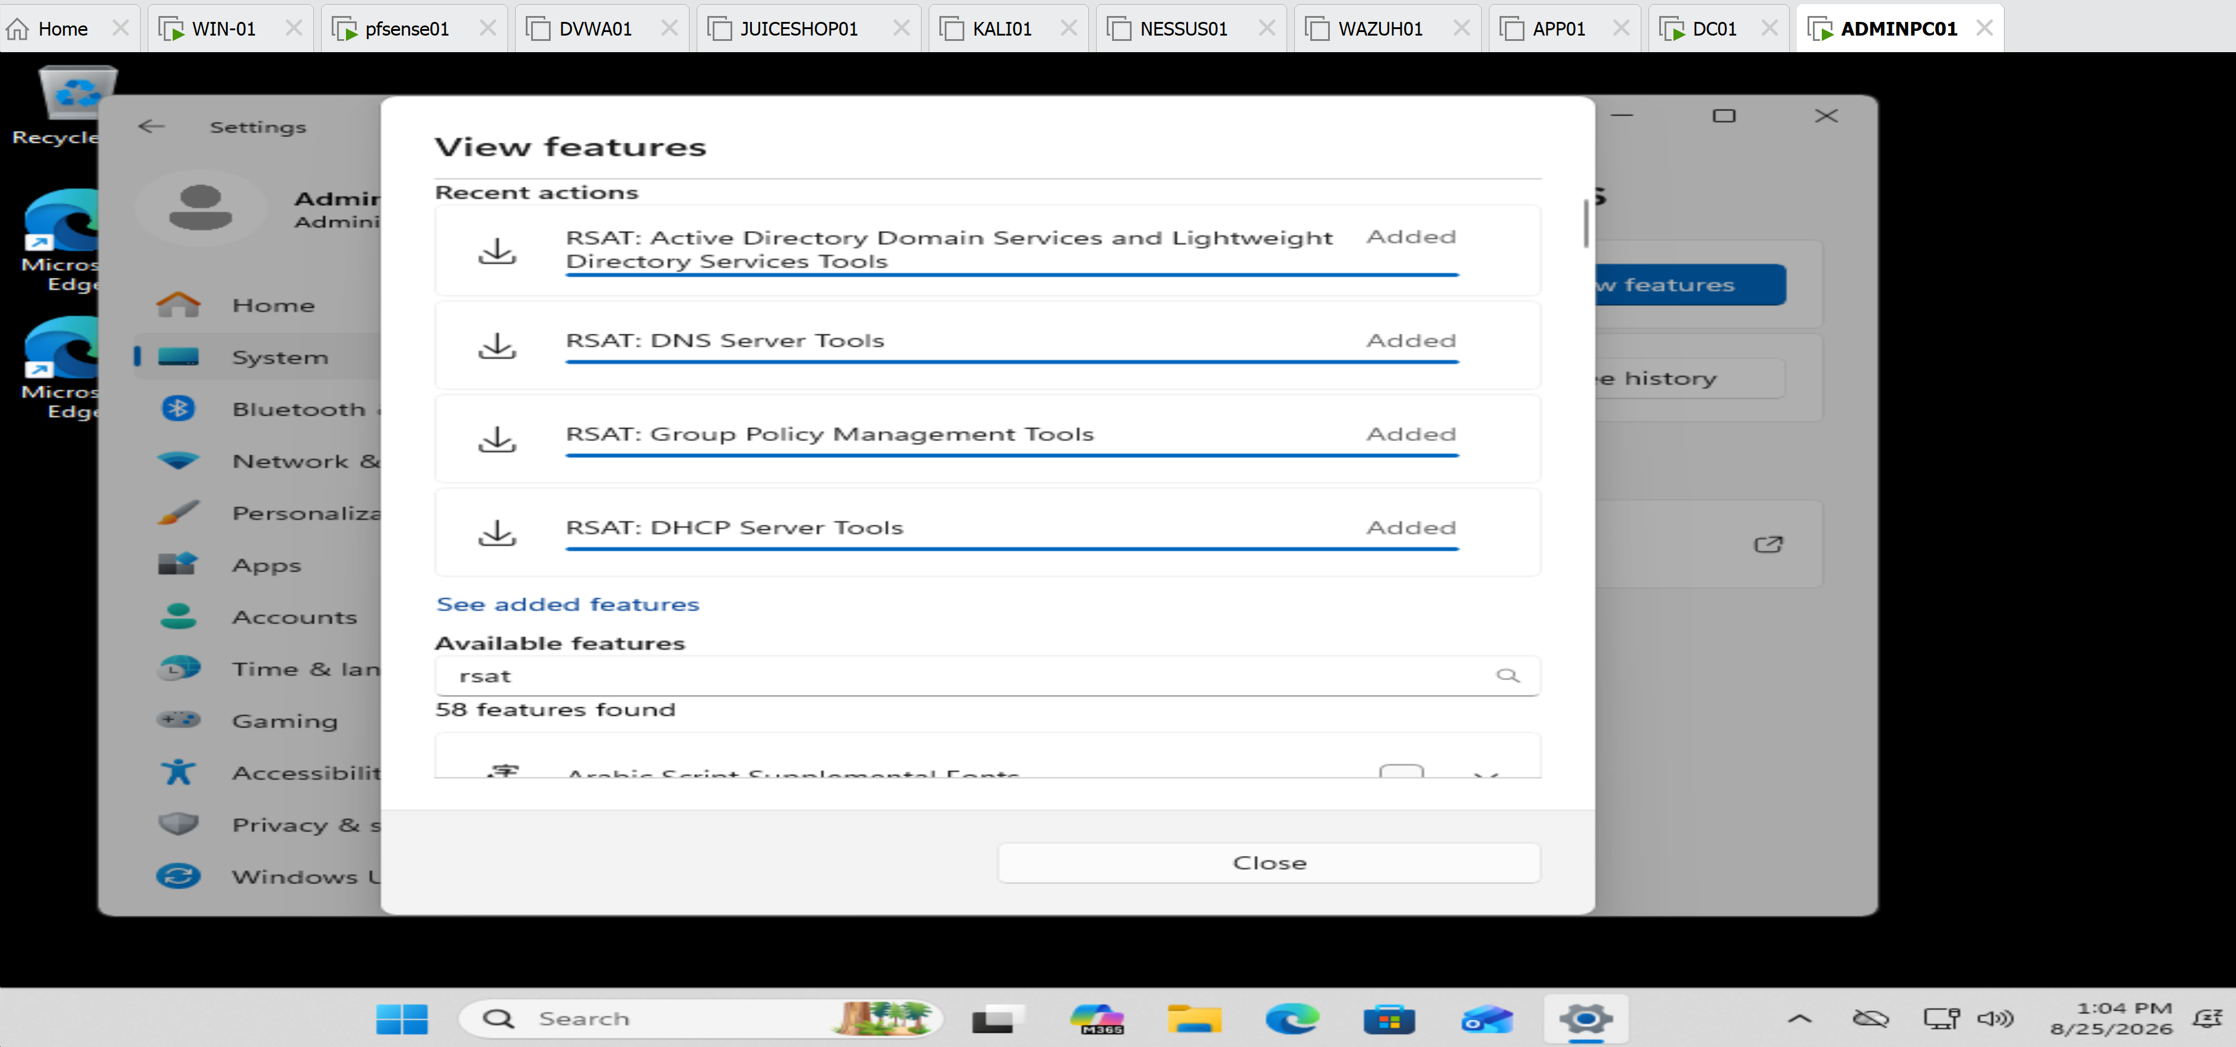
RSAT installation completed — showing the four components as Added.

Active Directory Users and Computers from ADMINPC01 — showing the BENLAB\Users objects.
Group Policy Management from ADMINPC01 — showing the existing benlab.local GPO infrastructure.
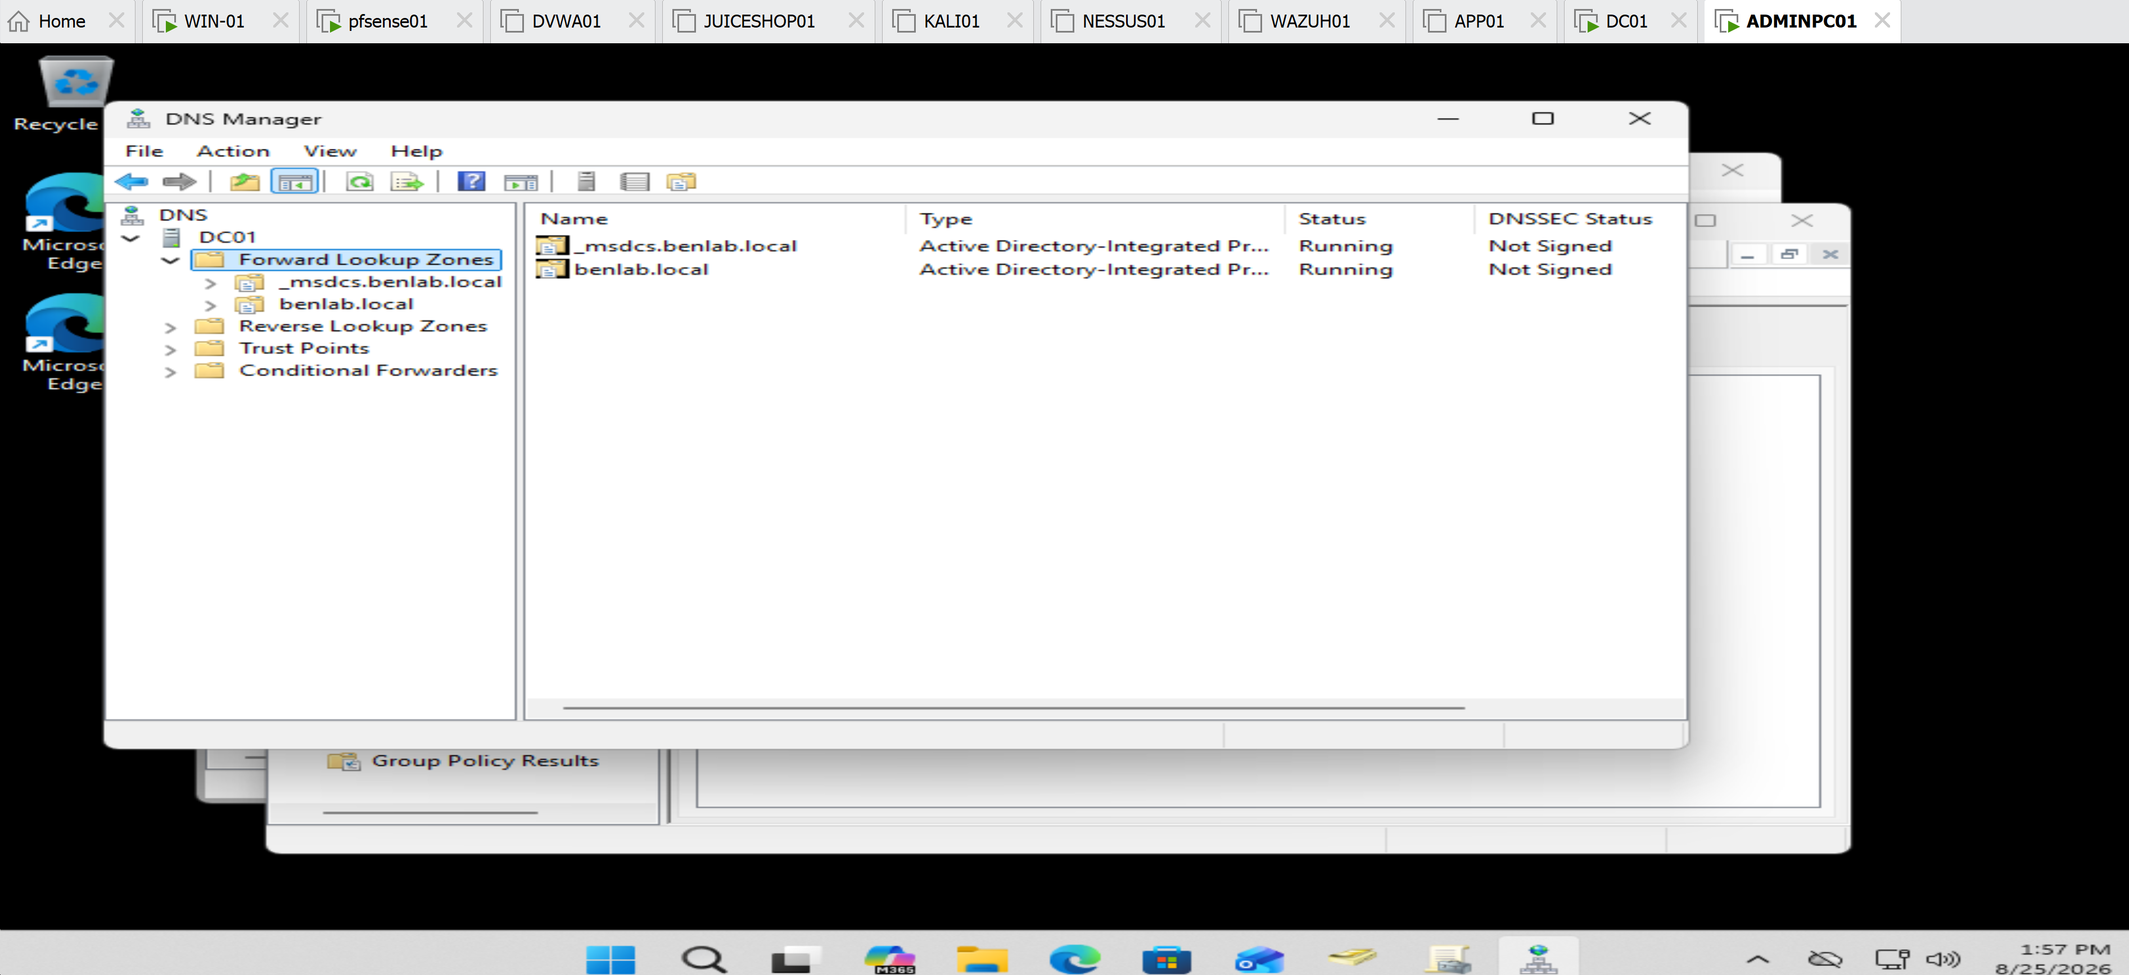
DNS Manager connected to DC01 — use the screenshot showing benlab.local, _msdcs.benlab.local, Reverse Lookup Zones, and Conditional Forwarders.

Task 3 — Configure and Validate a DHCP Reservation

Objective
Configure and validate a DHCP reservation for ADMINPC01 within the BENLAB environment.
The goal was to provide ADMINPC01 with a predictable IP address while allowing the workstation to remain configured as a DHCP client. The reservation was created on pfSense01, which provides DHCP services for the 10.20.20.0/24 network.

Environment
- Domain: benlab.local
- DHCP Server / Gateway: pfSense01 — 10.20.20.254
- DNS Server: DC01 — 10.20.20.10
- DHCP Pool: 10.20.20.100 – 10.20.20.200
- Client: ADMINPC01
- Original DHCP Address: 10.20.20.146
- Reserved Address: 10.20.20.90
- ADMINPC01 MAC Address: 00-0C-29-CF-0D-EB

Step 1 — Validate the Existing DHCP Configuration
On ADMINPC01, PowerShell was used to review the workstation's existing network configuration:
ipconfig /all
The output confirmed that ADMINPC01 was configured as a DHCP client and had received:
- IPv4 address: 10.20.20.146
- DHCP server: 10.20.20.254
- Default gateway: 10.20.20.254
- DNS server: 10.20.20.10
- MAC address: 00-0C-29-CF-0D-EB
This established the baseline before modifying DHCP configuration.

Step 2 — Verify the Existing DHCP Lease
The pfSense DHCP lease table was reviewed.
The active lease showed:
- Hostname: ADMINPC01
- IP address: 10.20.20.146
- MAC address: 00:0c:29:cf:0d:eb
The information matched the configuration reported by ipconfig /all on ADMINPC01.
This confirmed the DHCP client/server relationship before creating the reservation.

Step 3 — Create the Static DHCP Mapping
From the pfSense DHCP Server configuration, a Static DHCP Mapping was created for ADMINPC01.
The following values were configured:
MAC Address: 00:0c:29:cf:0d:eb
IP Address: 10.20.20.90
Hostname: ADMINPC01
The reserved address 10.20.20.90 was selected because it is within the BENLAB 10.20.20.0/24 subnet but outside the dynamic DHCP pool of 10.20.20.100–200.
The existing DHCP options were retained:
- DNS server: 10.20.20.10
- Gateway: 10.20.20.254
- Domain: benlab.local
Static ARP was not enabled because it was not required for the DHCP reservation.

Step 4 — Save and Apply the DHCP Configuration
The static mapping was saved in pfSense.
pfSense indicated that the DHCP configuration had changed and required the changes to be applied.
Apply Changes was selected, and pfSense reported:
The changes have been applied successfully.
This activated the new DHCP reservation.

Step 5 — Release the Existing DHCP Lease
On ADMINPC01, the existing 10.20.20.146 lease was released:
ipconfig /release
The workstation temporarily lost its DHCP-assigned IPv4 configuration, confirming that the existing lease had been released.

Step 6 — Request a New DHCP Lease
A new DHCP lease was requested:
ipconfig /renew
pfSense recognized ADMINPC01 by its MAC address and assigned the newly reserved address:
IPv4 Address: 10.20.20.90
Subnet Mask: 255.255.255.0
Default Gateway: 10.20.20.254
This demonstrated that the static DHCP mapping was functioning correctly.

Step 7 — Validate the DHCP Reservation
A final validation was performed:
ipconfig /all
The output confirmed:
DHCP Enabled: Yes
IPv4 Address: 10.20.20.90
DHCP Server: 10.20.20.254
DNS Server: 10.20.20.10
Default Gateway: 10.20.20.254
The most important validation was that DHCP Enabled remained set to Yes while ADMINPC01 received the predictable address 10.20.20.90.
This confirms that 10.20.20.90 was obtained through the DHCP reservation and was not manually configured as a static IP address in Windows.

Validation Result
Task 3 completed successfully. ✅
ADMINPC01 transitioned from the dynamically allocated address:
10.20.20.146
to the DHCP-reserved address:
10.20.20.90
The workstation remained a DHCP client and continued receiving the correct gateway, DNS server, and BENLAB domain configuration.

Key Learning Points
- A DHCP reservation associates a specific client identifier, commonly a MAC address, with a predictable IP address.
- A reserved address differs from a manually configured static IP because the client continues using DHCP.
- DHCP reservations provide centralized control while giving important devices predictable addressing.
- In this pfSense ISC DHCP configuration, the reserved address was placed outside the dynamic DHCP pool.
- ipconfig /release relinquishes the client's existing DHCP lease.
- ipconfig /renew requests a new lease from the DHCP server.
- ipconfig /all provides detailed evidence for validating the assigned address, DHCP server, DNS server, gateway, and whether DHCP remains enabled.
- Comparing the MAC address on the client with the static mapping on the DHCP server helps verify that the reservation targets the correct device.

Screenshots / evidence

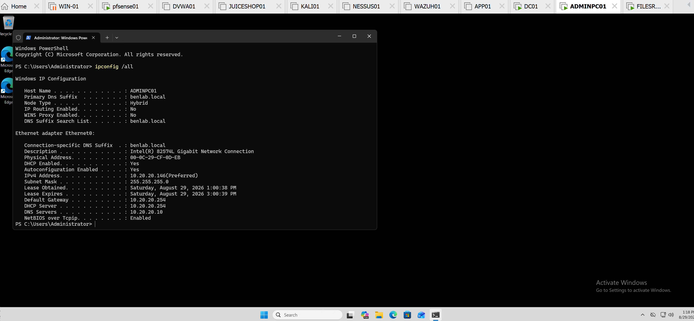
Initial ipconfig /all — ADMINPC01 at 10.20.20.146.

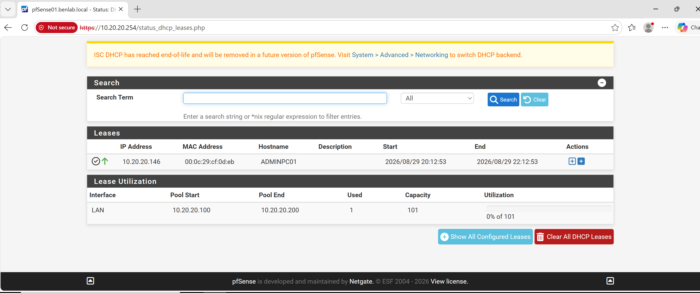
pfSense DHCP lease — showing .146 associated with ADMINPC01 and its MAC.

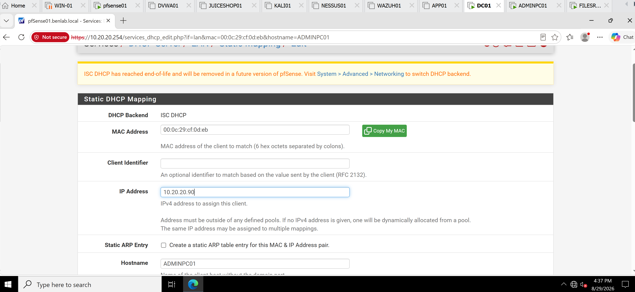
pfSense Static DHCP Mapping — MAC mapped to 10.20.20.90.

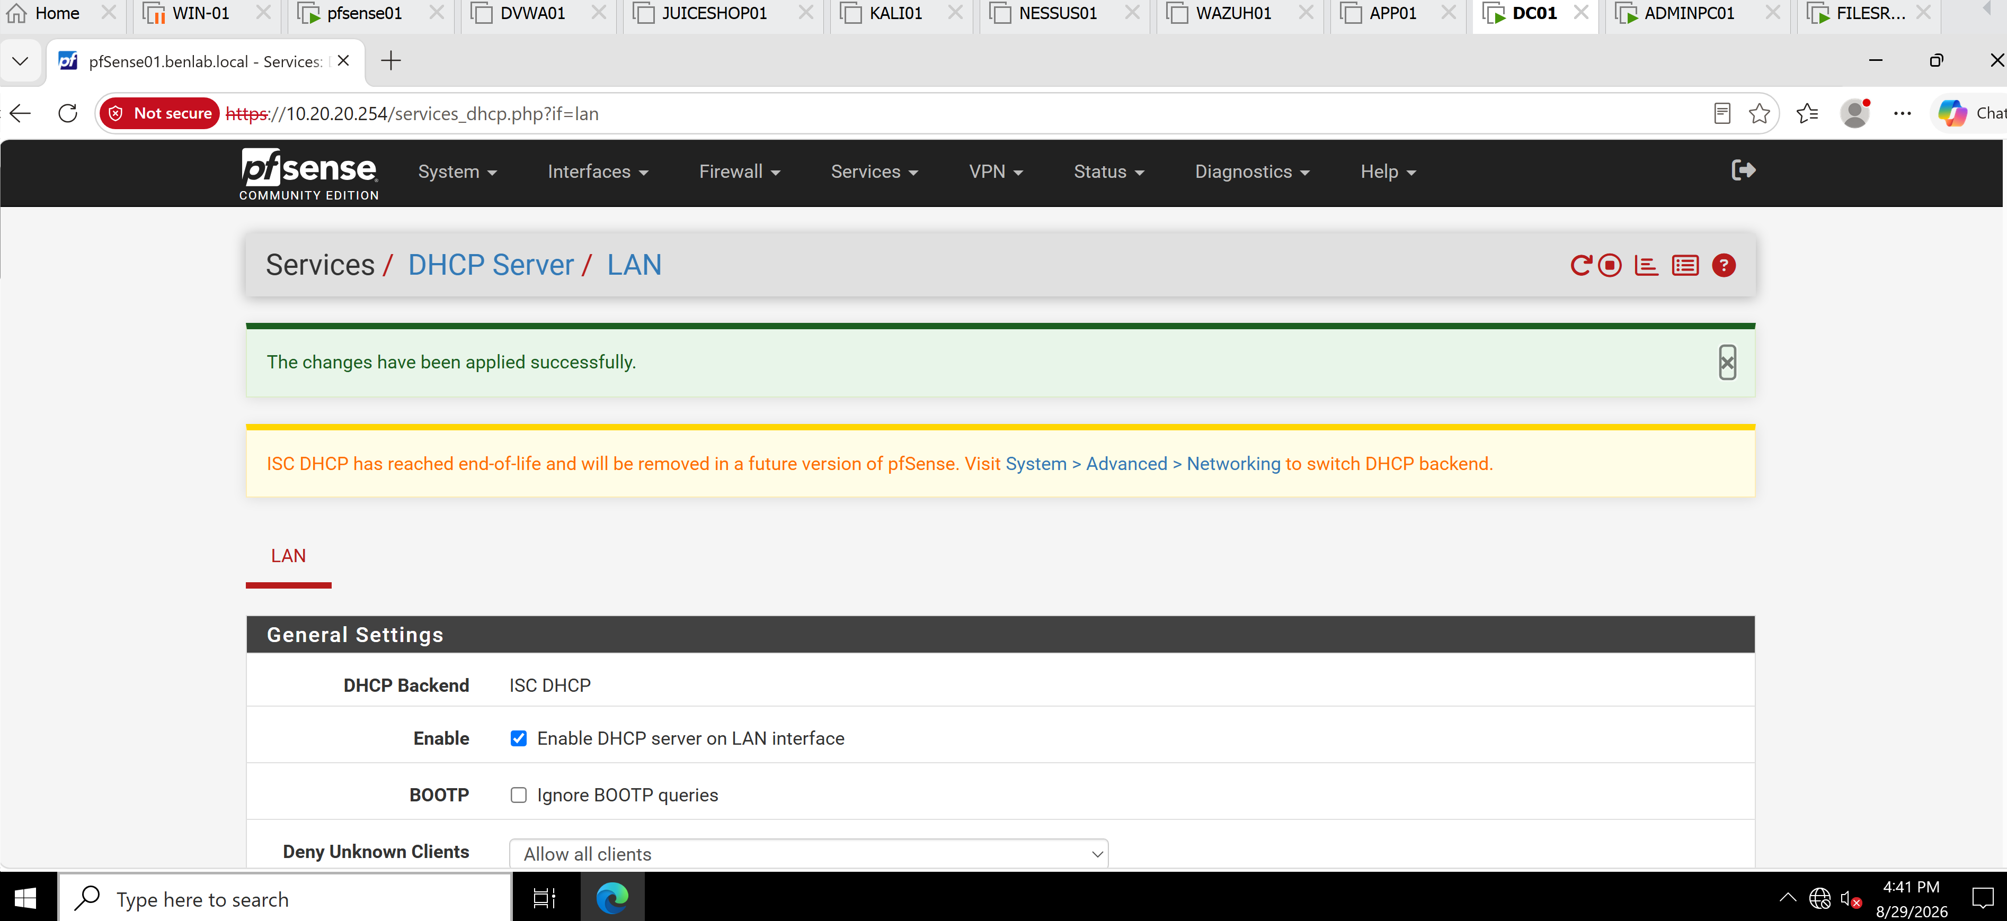
pfSense “changes have been applied successfully” confirmation.

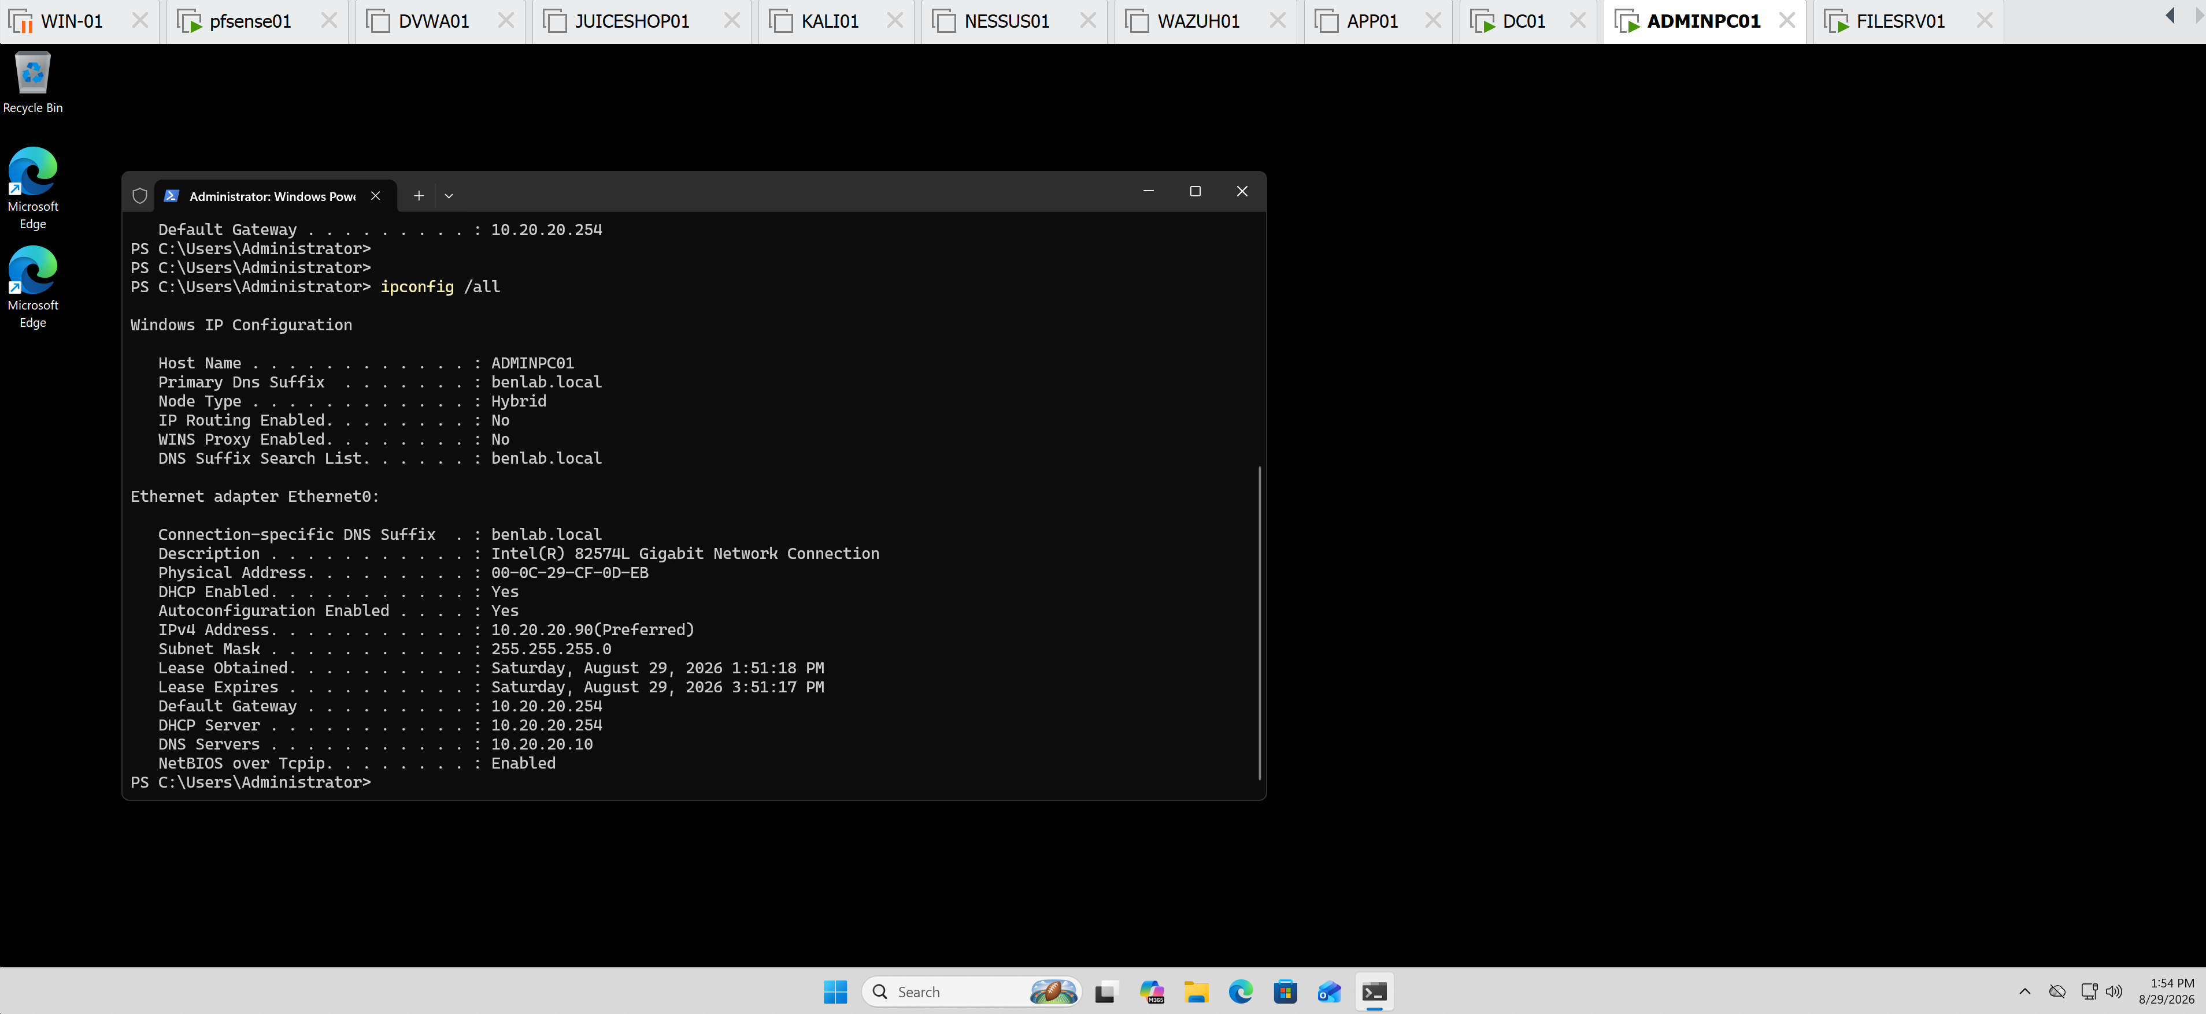
Final ipconfig /all — DHCP Enabled: Yes + IPv4 10.20.20.90.

Task 4 — Configure and Validate DHCP Exclusions

Objective
Configure an excluded address range within the BENLAB DHCP environment to prevent selected IP addresses from being dynamically assigned to DHCP clients.
Because pfSense01 provides DHCP services rather than Windows Server DHCP, the exclusion was implemented by dividing the dynamic address space into separate pools and intentionally leaving a protected gap between them.

Environment
- Subnet: 10.20.20.0/24
- DHCP Server / Gateway: pfSense01 — 10.20.20.254
- DNS Server: DC01 — 10.20.20.10
- Original DHCP Pool: 10.20.20.100 – 10.20.20.200
- Test Client: WIN01
- WIN01 Address: 10.20.20.140
- Reserved ADMINPC01 Address: 10.20.20.90

Step 1 — Review the Existing DHCP Scope
The LAN DHCP configuration was reviewed in pfSense.
The original dynamic allocation pool was:
10.20.20.100 – 10.20.20.200
Before modifying the pool, the active DHCP leases were inspected to ensure the proposed exclusion would not interfere with an actively leased address.
WIN01 was using 10.20.20.140, while ADMINPC01 used its previously configured DHCP reservation at 10.20.20.90.

Step 2 — Define the Excluded Address Range
The following addresses were selected for exclusion:
10.20.20.150 – 10.20.20.160
The purpose was to prevent DHCP from dynamically allocating these addresses while preserving them for potential infrastructure or manually addressed devices.

Step 3 — Reconfigure the DHCP Address Pools
Unlike Windows Server DHCP, the pfSense ISC DHCP interface used in the lab does not provide the same explicit Exclusion Range configuration.
The exclusion concept was therefore implemented by dividing the dynamic address space into two pools:
Primary DHCP Pool:
10.20.20.100 – 10.20.20.149

Excluded Gap:
10.20.20.150 – 10.20.20.160

Additional DHCP Pool:
10.20.20.161 – 10.20.20.200
This removed .150–.160 from all dynamic allocation pools.

Step 4 — Save and Apply the Configuration
The updated DHCP pool configuration was saved and the changes were applied in pfSense.
The DHCP lease information subsequently showed the updated primary pool:
Pool Start: 10.20.20.100
Pool End: 10.20.20.149
Capacity: 50
The additional pool remained configured for 10.20.20.161–200.

Step 5 — Validate DHCP Client Operation
WIN01 was used to verify that DHCP continued functioning after the pool modification.
The existing lease was released:
ipconfig /release
A new DHCP lease was then requested:
ipconfig /renew
WIN01 successfully received:
IPv4 Address: 10.20.20.140
Subnet Mask: 255.255.255.0
Default Gateway: 10.20.20.254
DNS Suffix: benlab.local
The assigned address .140 belongs to the permitted primary pool of .100–.149 and does not fall within the protected .150–.160 range.

Validation Result
Task 4 completed successfully. ✅
The DHCP allocation space was reorganized so that:
.100–.149 → Dynamic DHCP
.150–.160 → Excluded from dynamic allocation
.161–.200 → Dynamic DHCP
WIN01 successfully renewed its lease after the change, confirming that DHCP service remained operational.
The server-side pool configuration provides the primary evidence that .150–.160 is outside the dynamic allocation ranges.

Key Learning Points
- DHCP exclusions prevent selected IP addresses from being dynamically assigned.
- Excluded addresses can be useful for infrastructure, appliances, or other devices requiring separately managed addressing.
- Windows Server DHCP supports explicit exclusion ranges within a scope.
- In this pfSense ISC DHCP implementation, the same allocation-control objective was achieved by creating separate DHCP pools with an intentional address gap.
- Active leases should be inspected before modifying DHCP ranges to avoid disrupting clients.
- ipconfig /release and ipconfig /renew can be used to validate DHCP operation after configuration changes.
- DHCP concepts remain consistent even when different DHCP products implement them differently.

Screenshots / Evidence
Original pfSense pool showing 10.20.20.100–200.

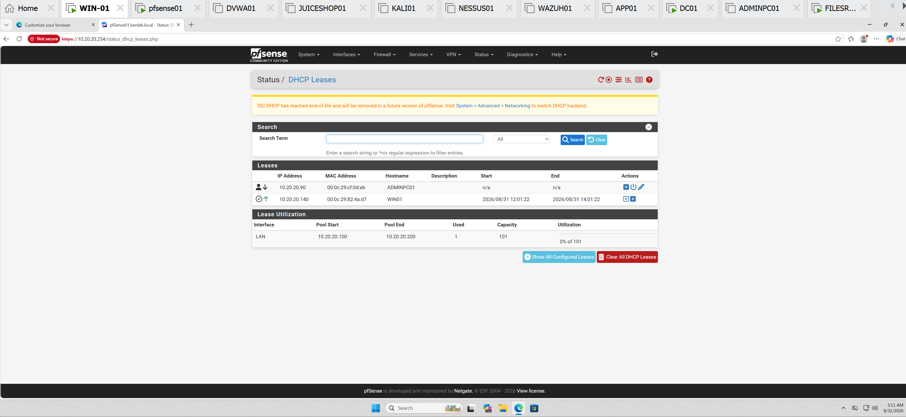
DHCP leases before the change showing WIN01 at .140.

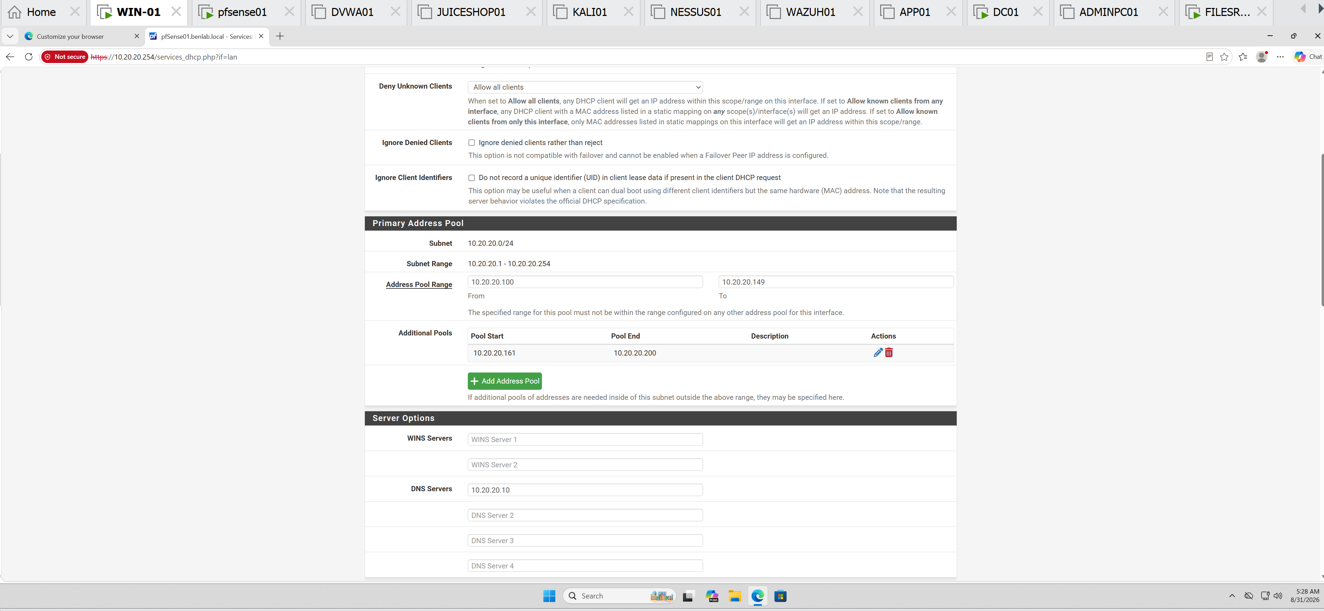
Final pfSense configuration showing Primary .100–149 and Additional .161–200.

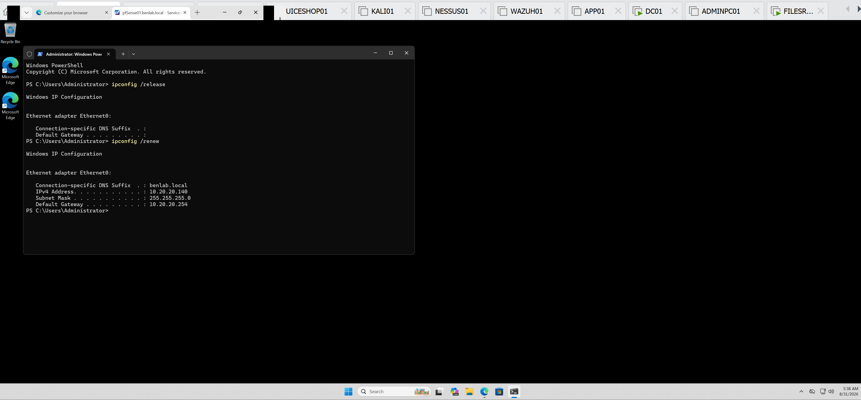
WIN01 /release + /renew showing successful reassignment of 10.20.20.140.

Task 5 – Configure and Validate DHCP Scope Options

Objective
Configure and validate DHCP scope options on pfSense01 to ensure DHCP clients receive the correct network configuration for the BENLAB environment.

Environment
DHCP Server: pfSense01
DHCP Server / Gateway IP: 10.20.20.254
DNS Server: DC01 — 10.20.20.10
Domain: benlab.local
Test Client: WIN01
Network: 10.20.20.0/24

DHCP Scope Options Reviewed
On pfSense01, navigated to:
Services → DHCP Server → LAN
The DHCP configuration was reviewed to verify the network options distributed to DHCP clients.
The following settings were confirmed:
DNS Server: 10.20.20.10
Default Gateway: 10.20.20.254
Domain Name: benlab.local
Default Lease Time: 7200 seconds
Maximum Lease Time: 86400 seconds
The configuration ensures that BENLAB DHCP clients use DC01 for internal DNS resolution while using pfSense01 as their default gateway.

Client-Side Validation
On WIN01, opened an elevated PowerShell session and executed:
ipconfig /all
The resulting configuration confirmed that WIN01 was using DHCP and had received the expected scope information.
Observed values included:
DHCP Enabled: Yes
IPv4 Address: 10.20.20.140
Subnet Mask: 255.255.255.0
Default Gateway: 10.20.20.254
DHCP Server: 10.20.20.254
DNS Servers: 10.20.20.10
Connection-specific DNS Suffix: benlab.local
WIN01 also received an approximately two-hour DHCP lease, consistent with the configured default lease time of 7200 seconds.

Validation Result
The DHCP scope options were successfully validated.
pfSense01 correctly provides DHCP configuration to WIN01, including the appropriate default gateway, DNS server, domain suffix, subnet configuration, and lease information.
This confirms that DHCP clients on the BENLAB network are receiving the required network settings automatically and that pfSense01 DHCP and DC01 DNS are operating together as designed.

Skills Demonstrated
DHCP scope option administration, DHCP client configuration validation, DNS and gateway assignment, lease configuration verification, Windows ipconfig troubleshooting, and integration of DHCP with Active Directory DNS.

Screenshots / Evidence
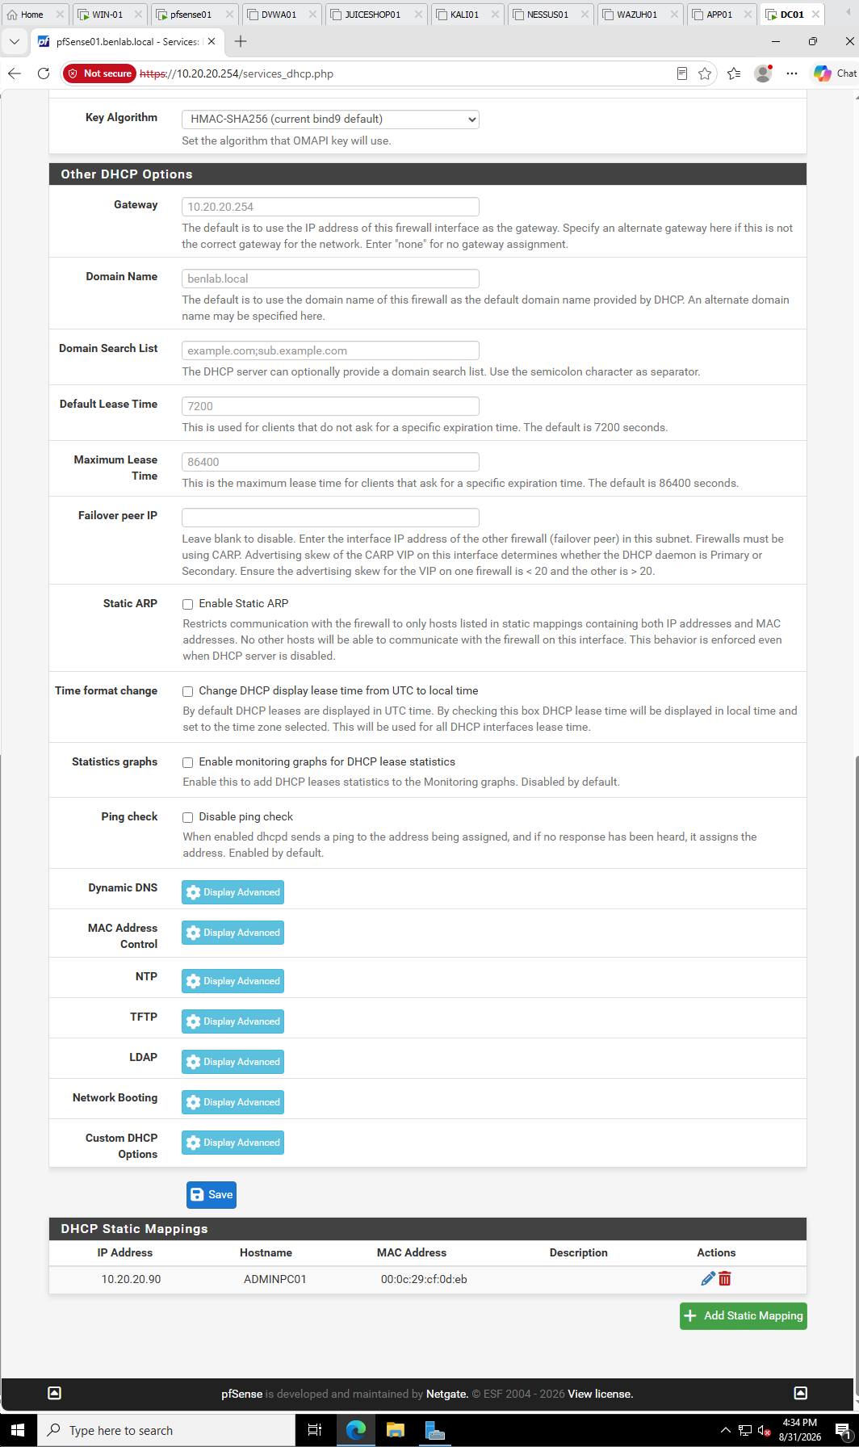
pfSense DHCP Scope Options
Show the pfSense section containing DNS Server: 10.20.20.10, Gateway: 10.20.20.254, and Domain Name: benlab.local.

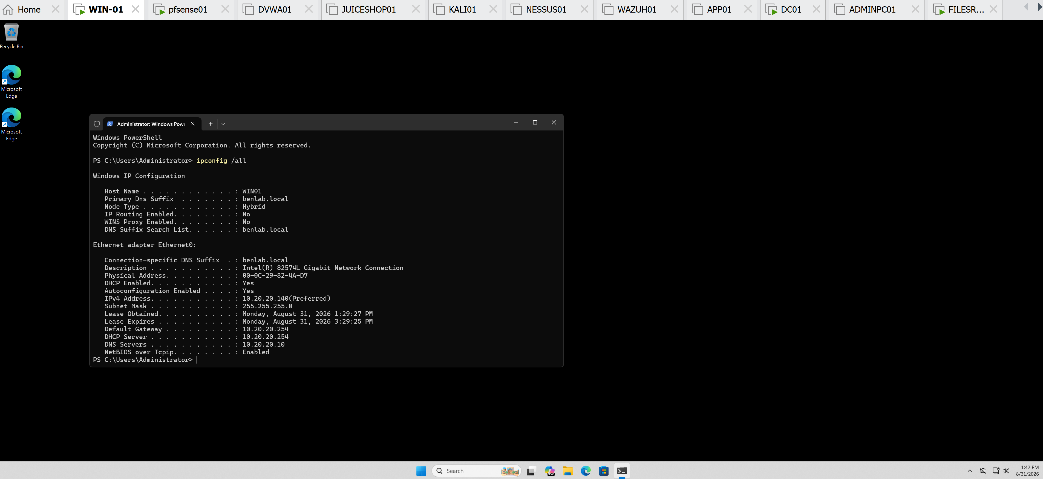
Screenshot 2 — WIN01 DHCP Validation
Showing 10.20.20.140, gateway 10.20.20.254, DHCP server 10.20.20.254, DNS 10.20.20.10, and benlab.local.

Task 6 — DHCP Troubleshooting & Client Validation
Objective:
Validate DHCP client operation on WIN01 and demonstrate a practical troubleshooting procedure by releasing and renewing its DHCP lease. Confirm that pfSense01 correctly provides IPv4 addressing and gateway information while DC01 provides DNS services.

Environment
- Client: WIN01
- Domain: benlab.local
- DHCP Server / Gateway: pfSense01 — 10.20.20.254
- DNS Server: DC01 — 10.20.20.10
- Network: 10.20.20.0/24
- DHCP Client Address: 10.20.20.140

Step 1 — Validate Existing DHCP Configuration
On WIN01, the current network configuration was reviewed using:
ipconfig /all
The workstation was confirmed to be configured as a DHCP client and had received a valid address from pfSense01.
Observed configuration:
IPv4 Address: 10.20.20.140
Subnet Mask: 255.255.255.0
Default Gateway: 10.20.20.254
DHCP Server: 10.20.20.254
DNS Server: 10.20.20.10
DNS Suffix: benlab.local
DHCP Enabled: Yes
Result: WIN01 had a valid DHCP configuration before troubleshooting began.

Step 2 — Release the DHCP Lease
The existing DHCP configuration was intentionally released:
ipconfig /release
After releasing the lease, WIN01 no longer had its assigned IPv4 address or default gateway.
Network connectivity temporarily disappeared as expected.
Purpose: This simulated a client without a usable DHCP lease and demonstrated the effect of removing the workstation's current DHCP configuration.

Step 3 — Renew the DHCP Lease
A new DHCP request was initiated:
ipconfig /renew
WIN01 successfully contacted the DHCP service on pfSense01 and obtained:
IPv4 Address: 10.20.20.140
Subnet Mask: 255.255.255.0
Default Gateway: 10.20.20.254
Network connectivity returned immediately after the successful renewal.
Result: DHCP communication between WIN01 and pfSense01 was successfully validated.

Step 4 — Final Client Validation
The complete configuration was checked again:
ipconfig /all
The final output confirmed:
- DHCP remained enabled.
- WIN01 received 10.20.20.140.
- pfSense01 (10.20.20.254) supplied DHCP and gateway services.
- DC01 (10.20.20.10) remained the configured DNS server.
- The benlab.local DNS suffix was correctly assigned.
- Valid DHCP lease information was present.
Result: WIN01 successfully recovered its complete network configuration through DHCP.

Troubleshooting Concept — APIPA
During the task, APIPA troubleshooting was also reviewed.
A Windows workstation receiving an address in:
169.254.0.0/16
typically indicates that the DHCP-enabled client was unable to successfully obtain an IPv4 lease.
The troubleshooting workflow established for the lab was:
Check network/NIC connectivity → verify DHCP is enabled → inspect ipconfig /all → release/renew the lease → verify the DHCP server and address pool → determine whether one or multiple clients are affected → validate gateway/IP connectivity → troubleshoot DNS after valid IP connectivity is established.
This helps distinguish a DHCP/addressing problem from a DNS resolution problem.

Task Result
Task 6 completed successfully. ✅
WIN01 demonstrated successful DHCP lease release and renewal. The client recovered its expected 10.20.20.140 address and received the correct gateway and DNS configuration.
The exercise also demonstrated a practical troubleshooting workflow for DHCP failures and APIPA addressing commonly encountered in enterprise workstation support.

Screenshots / Evidence

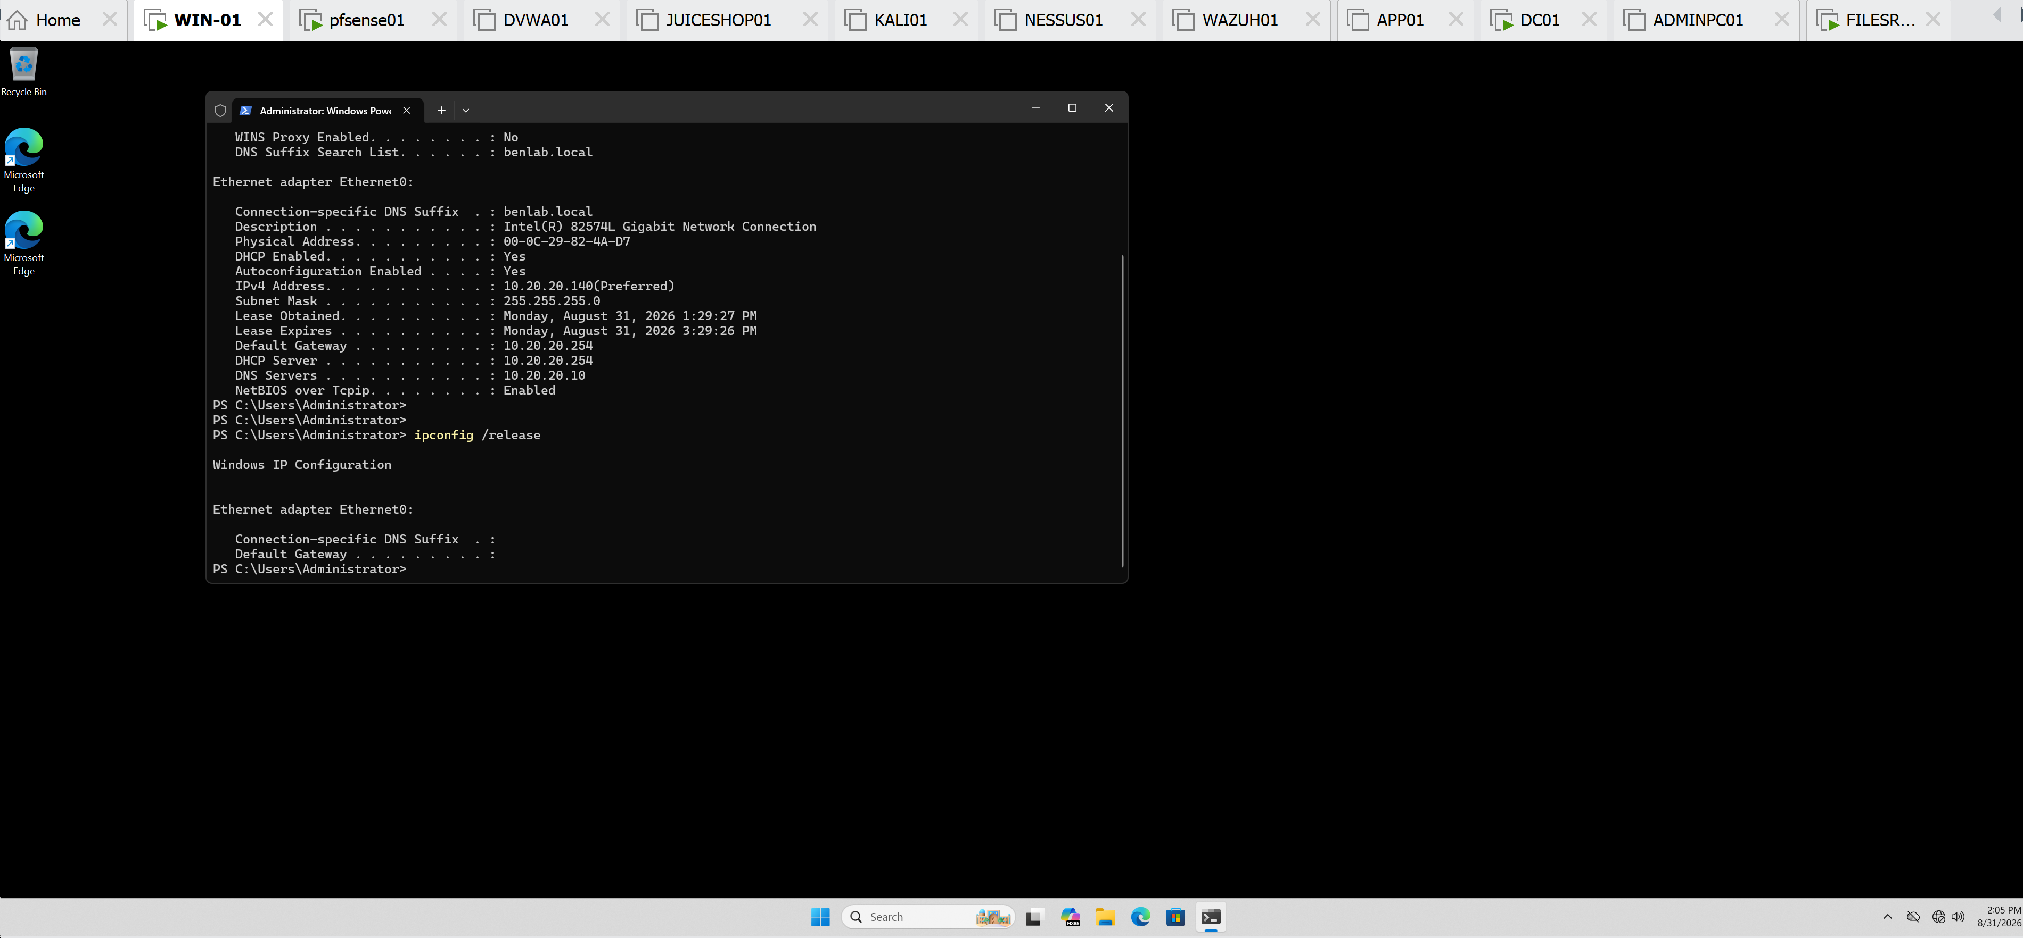
WIN01 after ipconfig /release — demonstrates loss of the DHCP configuration.

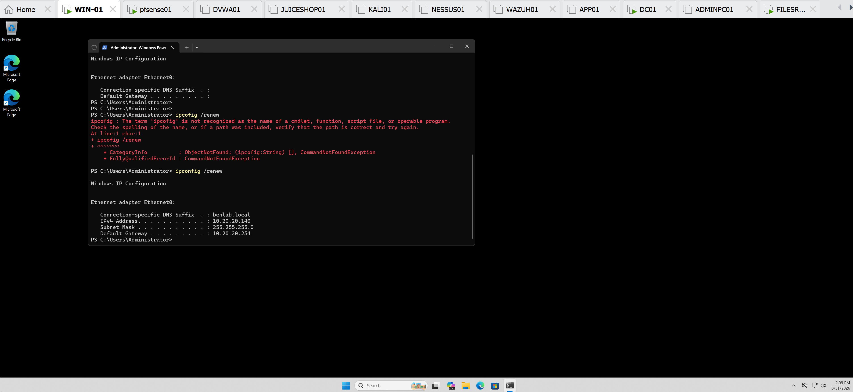
WIN01 after ipconfig /renew — demonstrates successful recovery of 10.20.20.140.

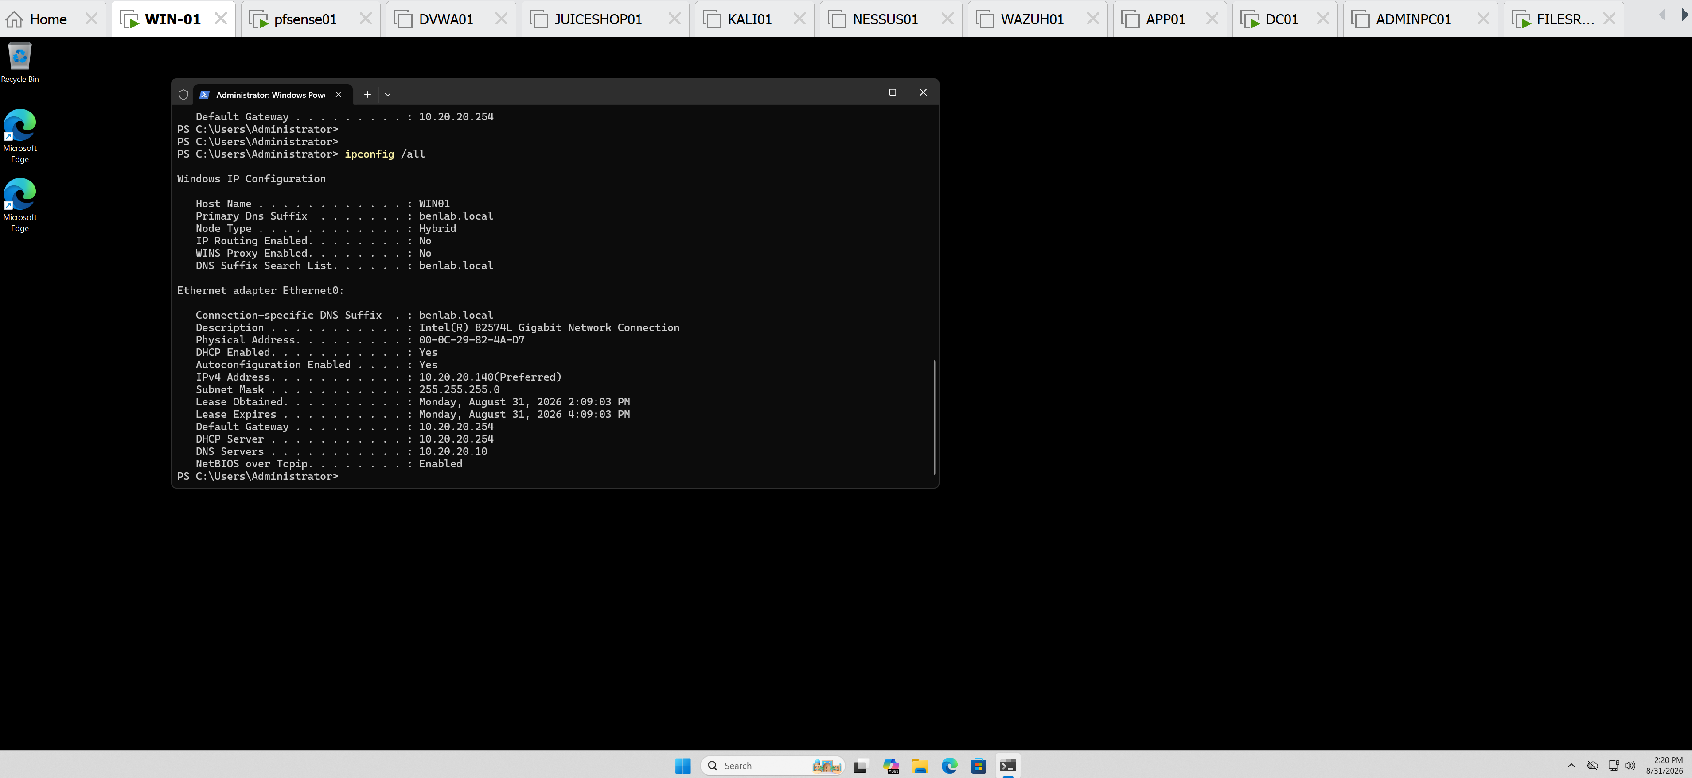
Final ipconfig /all — shows DHCP enabled, IPv4 address, gateway, DHCP server, DNS server, and domain suffix together.

Task 7 — DHCP Failure and APIPA Troubleshooting

Objective
Simulate and troubleshoot a DHCP service failure to understand how a Windows workstation behaves when it cannot obtain an IP configuration from the DHCP server.

Procedure
- Verified WIN01 initially had a valid DHCP configuration.
- Temporarily disabled the DHCP service on the pfSense LAN interface.
- Released WIN01's existing DHCP lease:
ipconfig /release
- Attempted to obtain a new DHCP lease:
ipconfig /renew
- Observed that WIN01 could not contact the DHCP server and the request timed out.
- Verified that Windows automatically assigned WIN01 an APIPA address:
169.254.89.221
Subnet Mask: 255.255.0.0
Default Gateway: None
- Re-enabled DHCP on the pfSense LAN interface.
- Renewed the DHCP lease again:
ipconfig /renew
- Verified that WIN01 successfully recovered its normal DHCP configuration:
IPv4 Address: 10.20.20.140
Subnet Mask: 255.255.255.0
Default Gateway: 10.20.20.254
- Tested connectivity to the pfSense gateway:
ping 10.20.20.254
The gateway responded successfully with 0% packet loss.

Result
The DHCP failure and recovery process was successfully demonstrated. When the DHCP server became unavailable, WIN01 was unable to renew its lease and automatically assigned itself an APIPA address from the 169.254.0.0/16 range.
After DHCP service was restored, WIN01 successfully obtained its normal 10.20.20.140/24 configuration and regained connectivity to the default gateway.

Key Learning
An APIPA (169.254.x.x) address is an important troubleshooting indicator on a DHCP-enabled Windows workstation. It indicates that the workstation was unable to obtain a valid IPv4 configuration from a DHCP server.
The troubleshooting process demonstrated the relationship:
DHCP unavailable → DHCP request fails → APIPA assigned → DHCP restored → lease renewed → connectivity restored.

Screenshots / Evidence

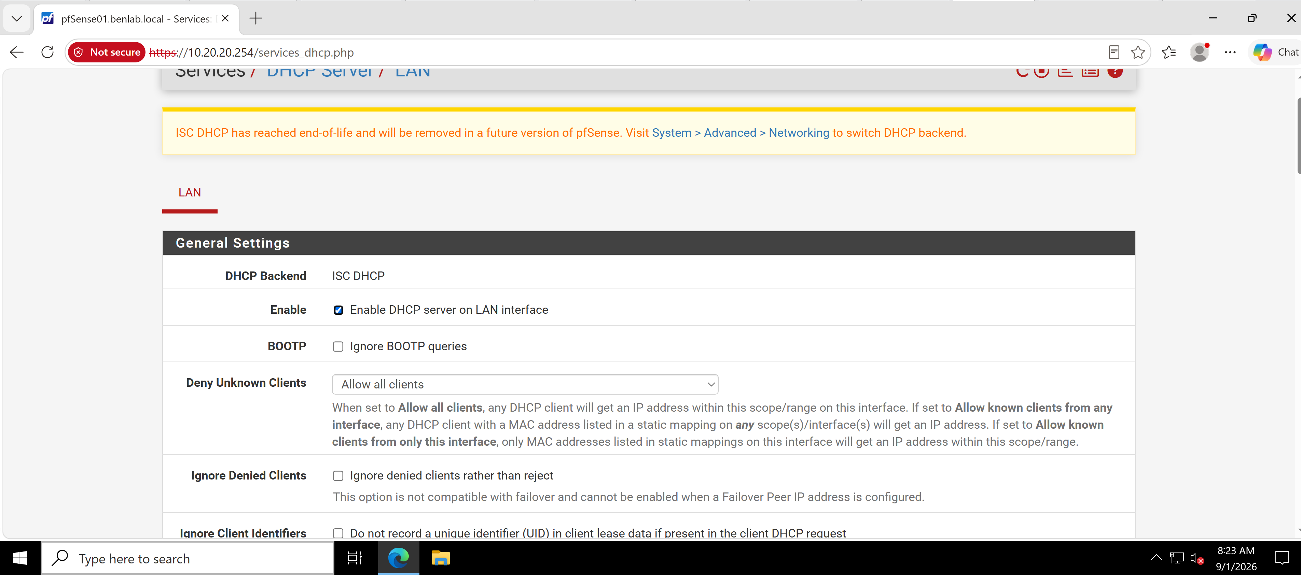
pfSense DHCP service enabled and normal DHCP configuration.

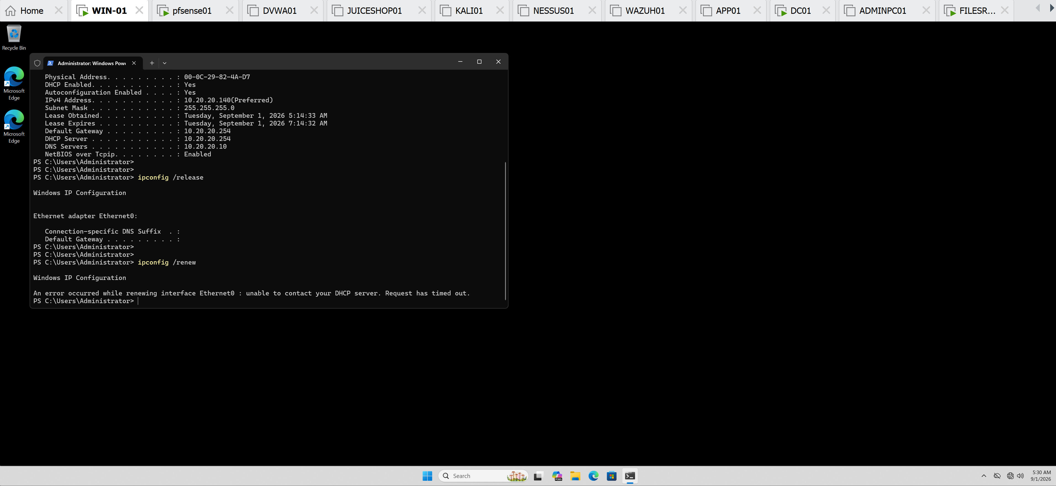
WIN01 DHCP renewal failure after DHCP service was disabled.

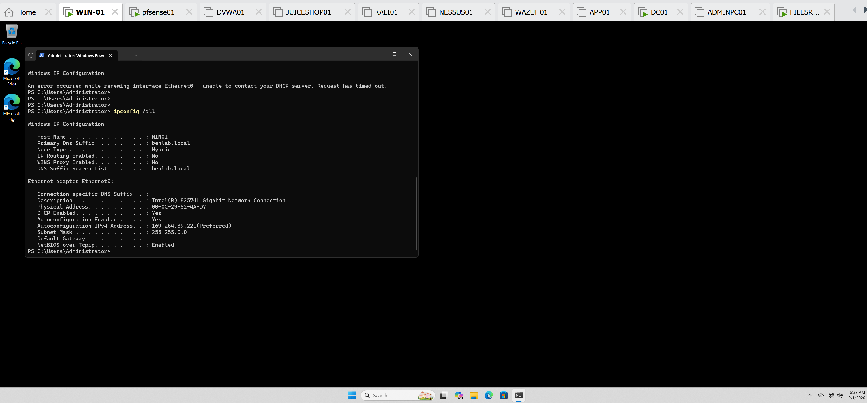
ipconfig /all showing WIN01 assigned APIPA address 169.254.89.221.

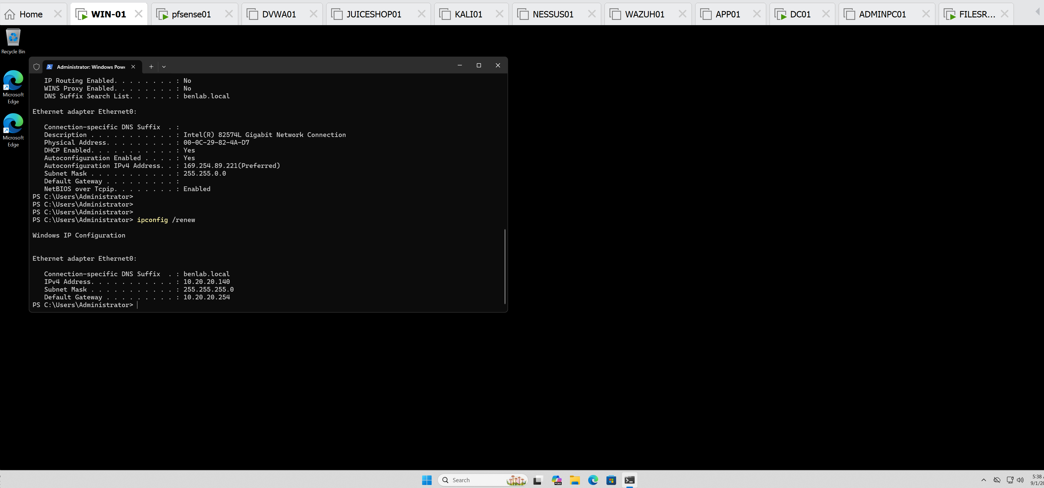
Screenshot 4: DHCP service restored and ipconfig /renew successfully returning WIN01 to 10.20.20.140.

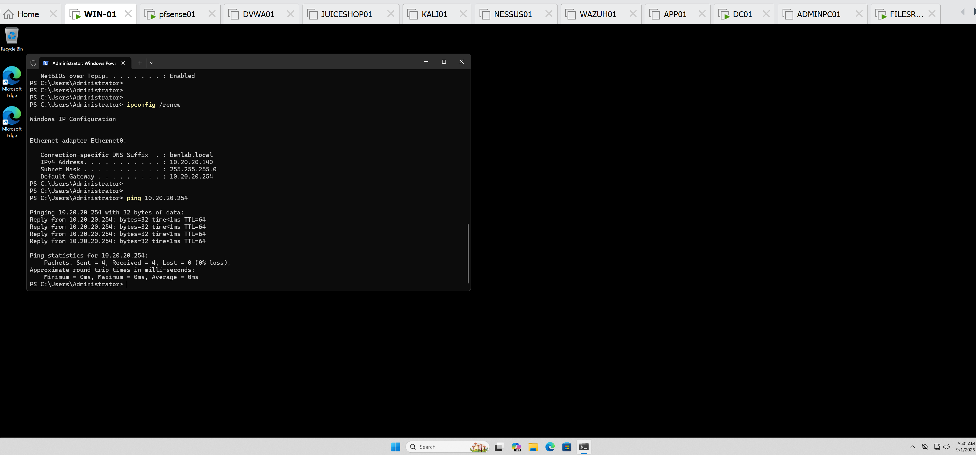
Screenshot 5: Successful ping 10.20.20.254 confirming connectivity to the pfSense default gateway after recovery.

Task 8 — DHCP Lease Management

Objective
Manage and validate DHCP client leases using pfSense and a Windows workstation. This task demonstrates the relationship between the DHCP server's lease database and the DHCP configuration maintained locally by a client.

Environment
DHCP Server: pfSense01
DHCP Server / Gateway: 10.20.20.254
DHCP Scope: 10.20.20.100 – 10.20.20.149
Client: WIN01
WIN01 MAC Address: 00-0C-29-82-4A-D7
WIN01 DHCP Address: 10.20.20.140
DNS Server: DC01 — 10.20.20.10

Procedure
1. Reviewed the DHCP lease table
Navigated to:
pfSense → Status → DHCP Leases
Verified that WIN01 had an active dynamic DHCP lease for 10.20.20.140.
The DHCP pool showed one dynamically assigned address in use.

2. Verified the client-side DHCP configuration
On WIN01, the following command was used:
ipconfig /all
The workstation showed:
DHCP Enabled: Yes
IPv4 Address: 10.20.20.140
Subnet Mask: 255.255.255.0
Default Gateway: 10.20.20.254
DHCP Server: 10.20.20.254
DNS Server: 10.20.20.10
This established the client's DHCP configuration before manipulating the lease.

3. Deleted the WIN01 lease from pfSense
The active 10.20.20.140 lease was manually deleted from the pfSense DHCP lease table.
After deletion, WIN01 disappeared from the active lease list and pfSense reported that no dynamic leases were in use.

4. Verified client behavior after server-side deletion
The following command was run again on WIN01:
ipconfig /all
WIN01 continued using 10.20.20.140 even though its corresponding lease entry had been removed from pfSense.
This demonstrated that removing a DHCP lease from the server does not immediately remove the IP configuration already held by the client.

5. Released the client's DHCP configuration
On WIN01:
ipconfig /release
The workstation relinquished its DHCP configuration. Its IPv4 address and default gateway were removed, temporarily interrupting network connectivity.

6. Requested a new DHCP lease
WIN01 was instructed to obtain DHCP configuration again:
ipconfig /renew
pfSense successfully responded to the DHCP request and assigned:
IPv4 Address: 10.20.20.140
Subnet Mask: 255.255.255.0
Default Gateway: 10.20.20.254
Receiving the same address was valid because 10.20.20.140 was available for assignment again.

7. Verified the newly created lease on pfSense
Returned to:
pfSense → Status → DHCP Leases
WIN01 appeared again with:
IP Address: 10.20.20.140
MAC Address: 00:0c:29:82:4a:d7
Hostname: WIN01
Start: 2026/09/01 13:55:42
End: 2026/09/01 15:55:42
The new Start and End timestamps confirmed that pfSense had recorded a new DHCP lease following the client renewal.

Validation
The following were successfully validated:
- DHCP leases can be viewed and managed through pfSense.
- WIN01 successfully obtained addressing from pfSense.
- A DHCP server-side lease entry can be manually removed.
- Removing the server's lease record does not immediately remove the client's current IP configuration.
- ipconfig /release relinquishes the Windows client's DHCP configuration.
- ipconfig /renew initiates a new DHCP lease request.
- pfSense successfully issued a new lease to WIN01.
- The newly issued lease was recorded in the pfSense DHCP lease table with updated timestamps.

Key Learning
A DHCP server lease and a client's locally held IP configuration are related but are not the same thing.
Deleting a lease from the DHCP server removes the server's lease record, but the client may continue using its existing address until it releases the configuration, the lease expires, or another DHCP event causes renegotiation.
The Windows commands:
ipconfig /release
ipconfig /renew
provide direct client-side control over that DHCP lease process.
This exercise demonstrated a fundamental DHCP administration workflow:
Inspect → Remove → Observe → Release → Renew → Verify

Screenshots / Evidence
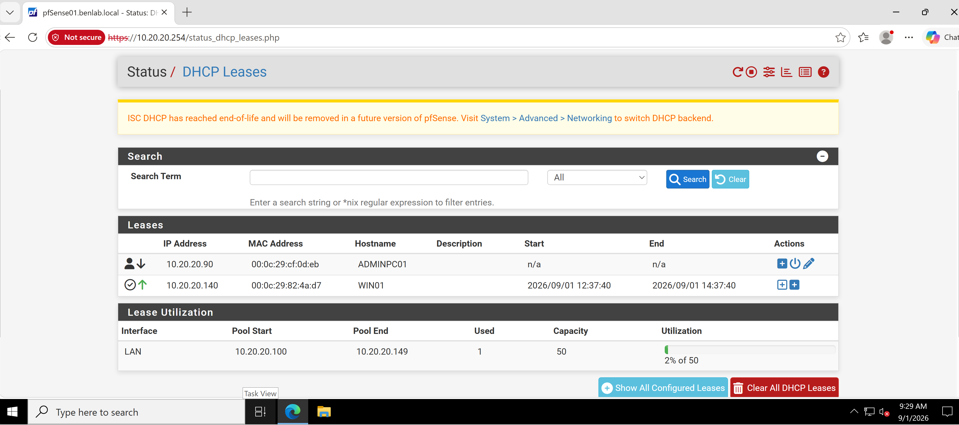
pfSense DHCP Leases showing WIN01 with active address 10.20.20.140.

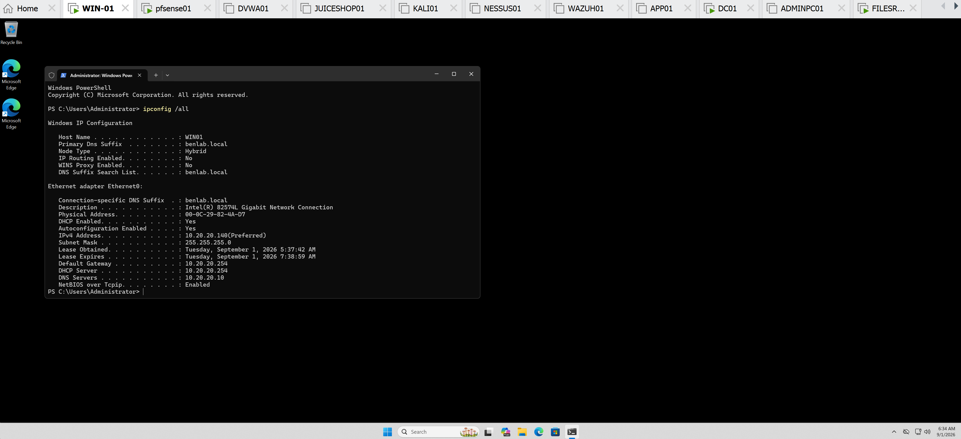
Initial WIN01 DHCP Configuration
ipconfig /all showing WIN01's DHCP-assigned address, gateway, DHCP server, DNS server, and lease information.

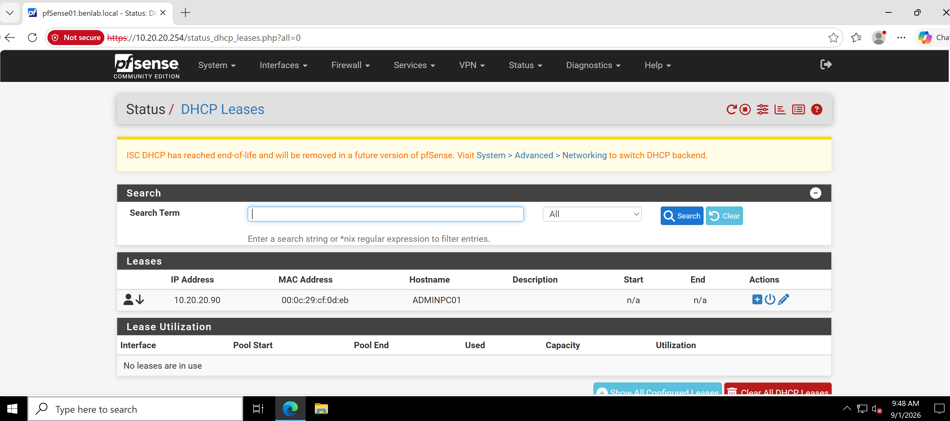
Lease Removed from pfSense
DHCP Leases showing the WIN01 dynamic lease removed and no dynamic leases in use.

Client Retains Address After Server-Side Deletion
WIN01 ipconfig /all showing that 10.20.20.140 remained locally configured after its server-side lease entry was deleted.

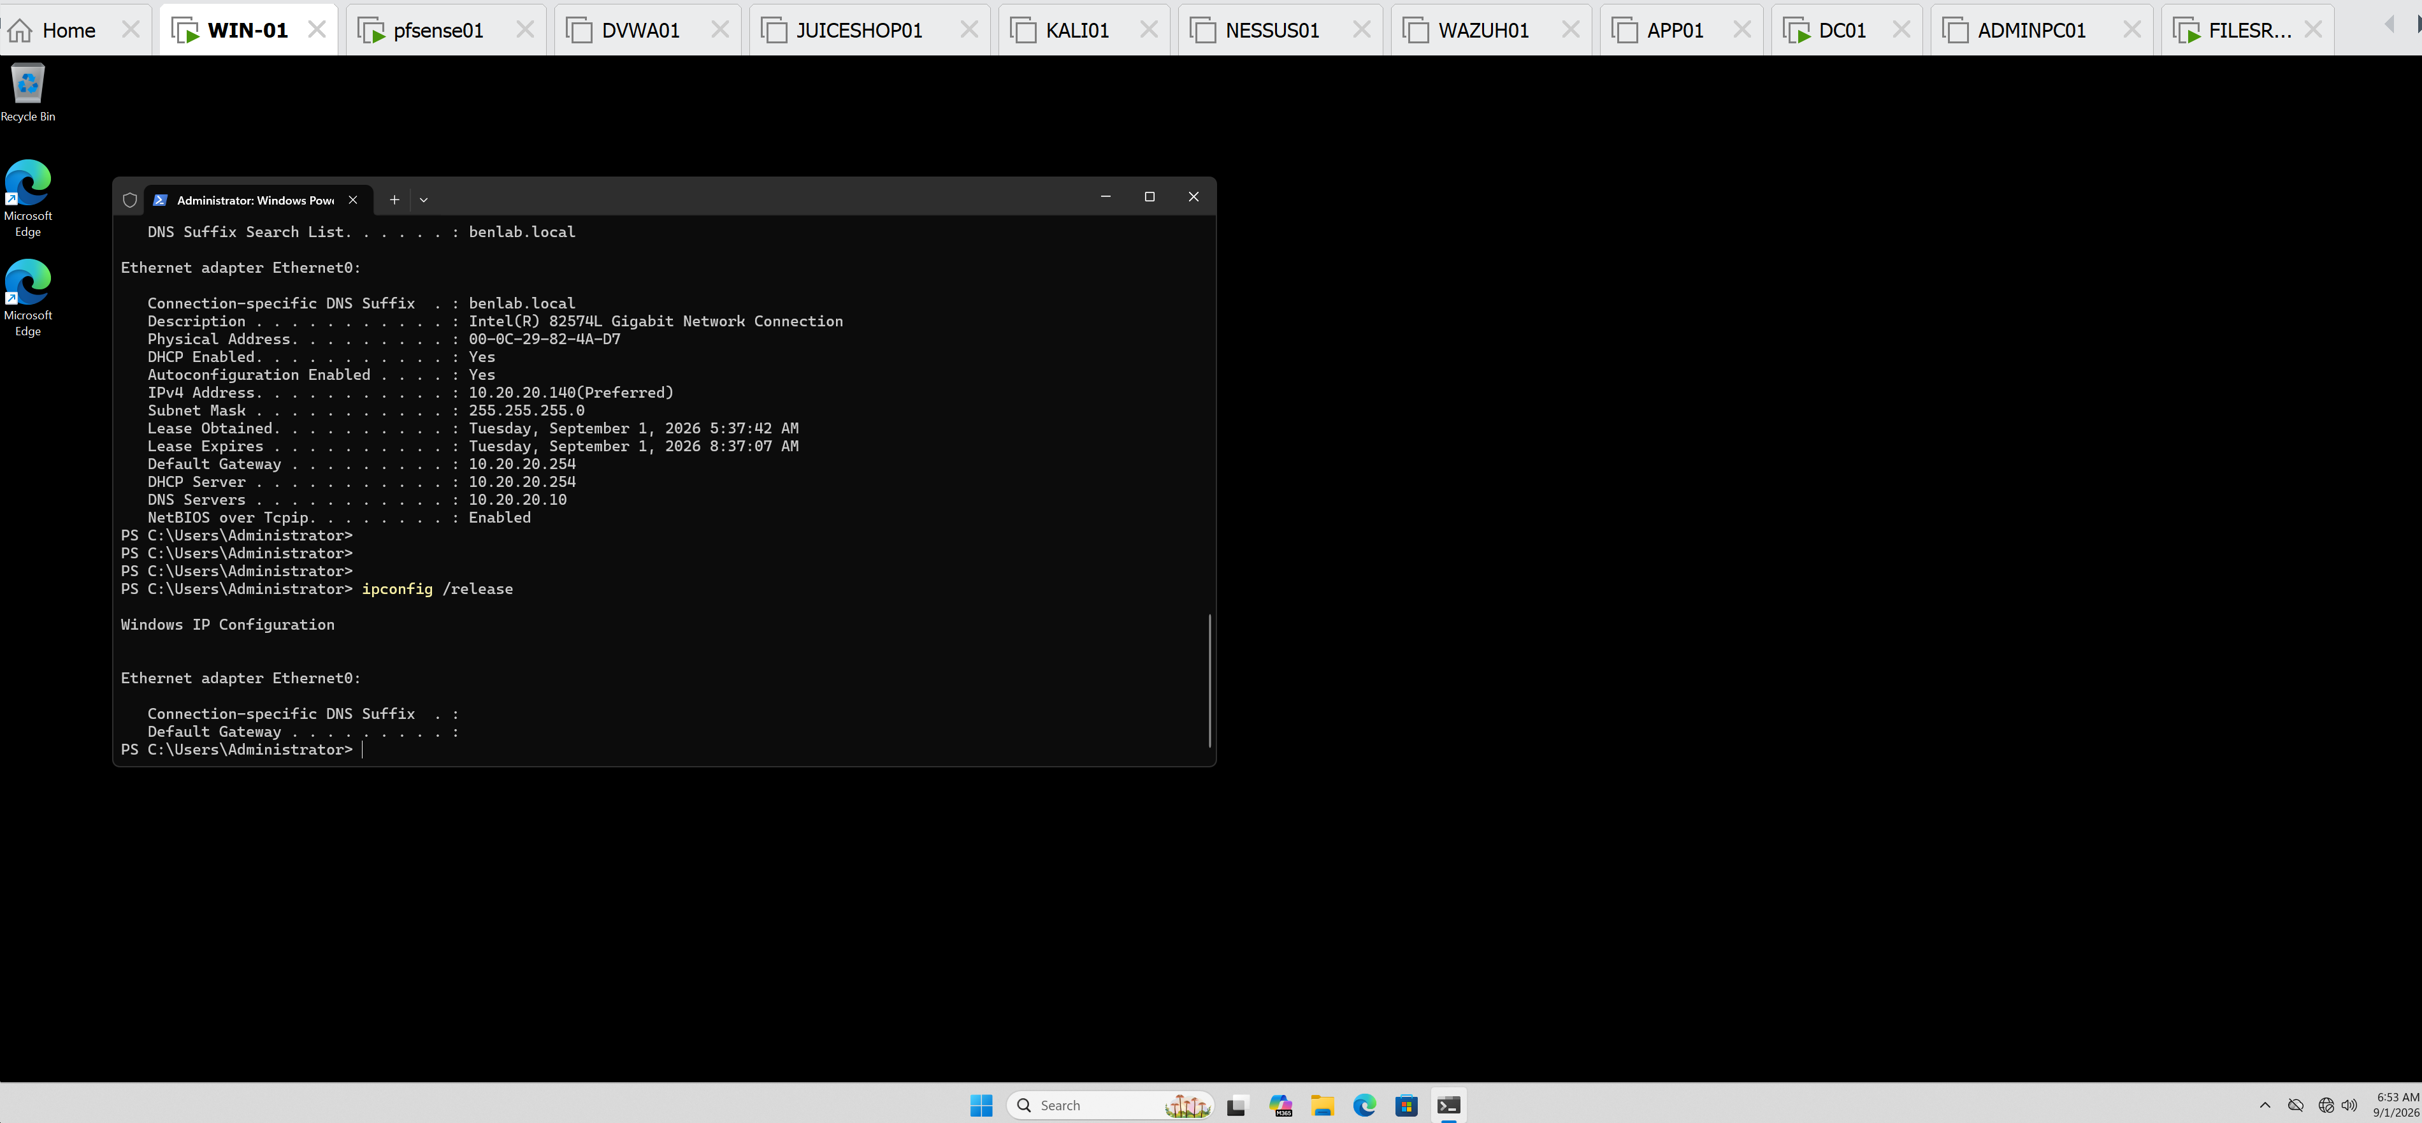
DHCP Release
ipconfig /release showing removal of WIN01's DHCP configuration.

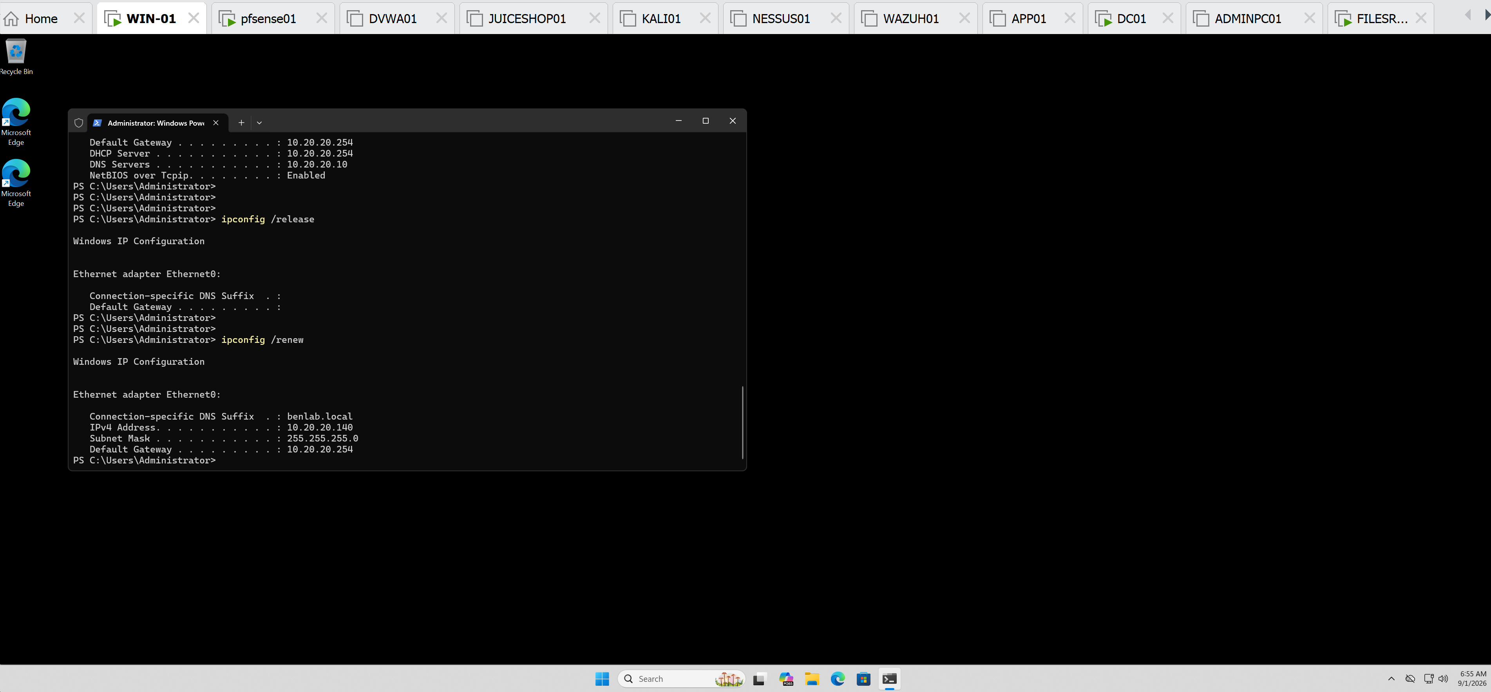
DHCP Renewal
ipconfig /renew showing WIN01 successfully receiving 10.20.20.140 again.

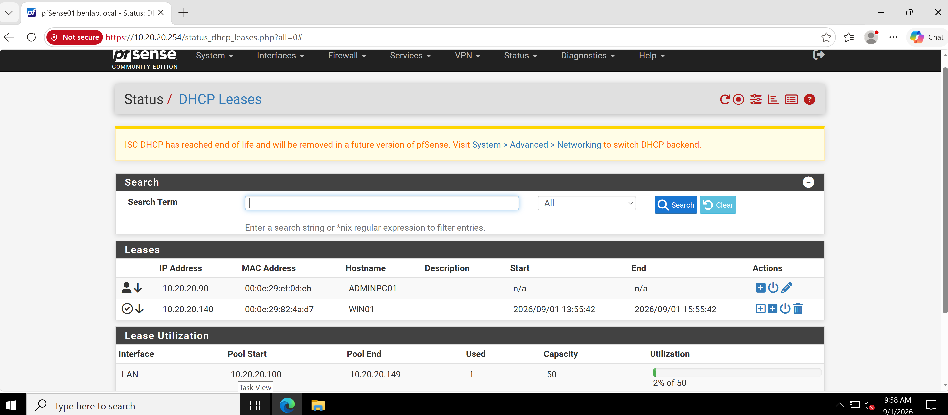
New Lease Verified in pfSense
pfSense DHCP Leases showing WIN01 at 10.20.20.140 with the new lease timestamps of 13:55:42 – 15:55:42.

Task 9 — DHCP Service Failure Troubleshooting

Objective
Simulate a DHCP service outage, identify the resulting client-side symptoms, restore DHCP service, and verify successful network recovery.

Environment
DHCP Server / Gateway: pfSense01
LAN Gateway: 10.20.20.254
DHCP Client: WIN01
Domain: benlab.local
Expected WIN01 Address: 10.20.20.140

Procedure
1. Established the working baseline
WIN01 was initially operating with a valid DHCP configuration:
- IPv4: 10.20.20.140
- Subnet Mask: 255.255.255.0
- Default Gateway: 10.20.20.254
- DNS Server: 10.20.20.10

2. Simulated a DHCP service outage
On pfSense01:
Services → DHCP Server → LAN
The Enable DHCP server on LAN interface option was disabled and the configuration was saved.
This intentionally prevented pfSense from responding to DHCP requests on the LAN.

3. Reproduced the client-side failure
On WIN01, the existing DHCP lease was released:
ipconfig /release
WIN01 then attempted to obtain a new DHCP lease:
ipconfig /renew
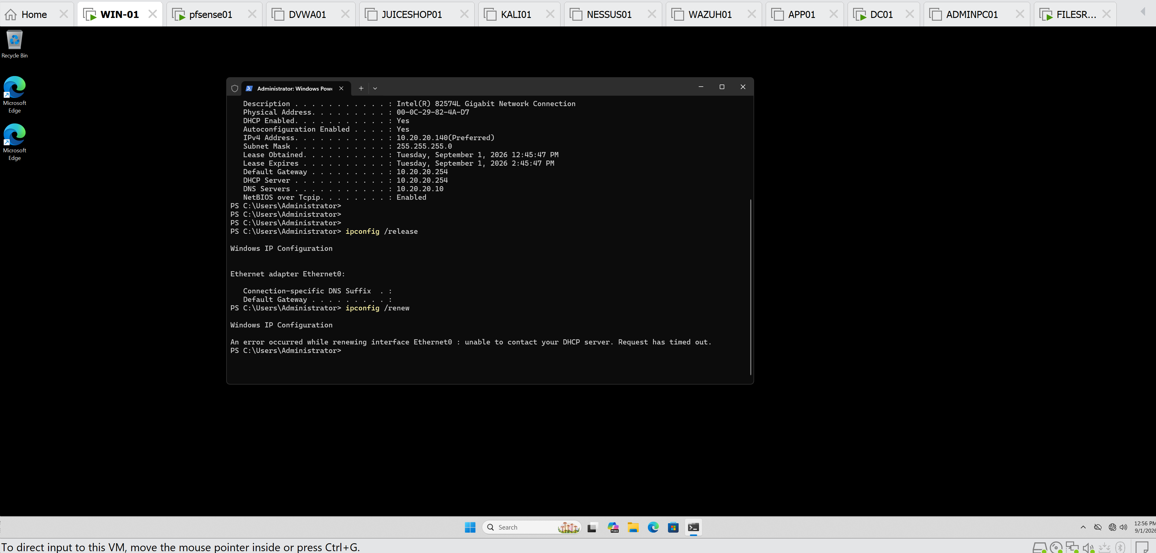
The request failed with:
unable to contact your DHCP server. Request has timed out.
This confirmed that the client could not obtain network configuration while the DHCP service was unavailable.

4. Restored DHCP service
On pfSense01:
Services → DHCP Server → LAN
The Enable DHCP server on LAN interface option was re-enabled and the configuration was saved.

5. Verified DHCP recovery
WIN01 requested a new lease:
ipconfig /renew
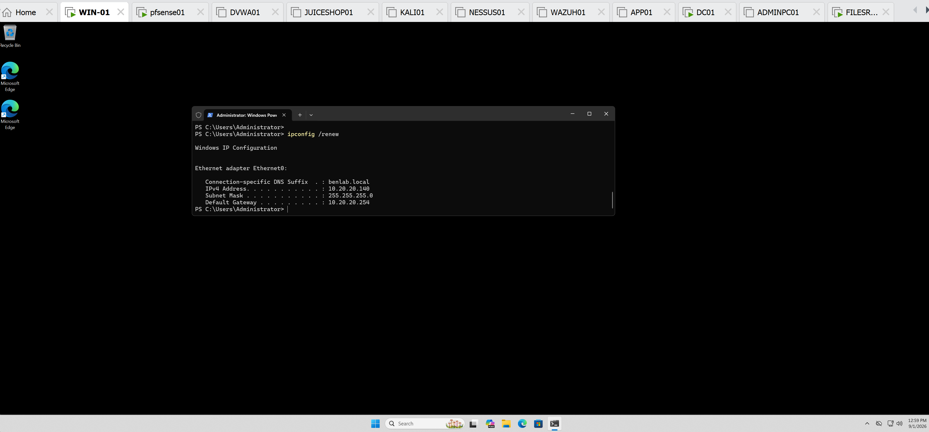
The request succeeded and WIN01 received:
IPv4 Address: 10.20.20.140
Subnet Mask: 255.255.255.0
Default Gateway: 10.20.20.254
This confirmed successful DHCP lease acquisition after service restoration.

6. Verified network connectivity
Connectivity to the default gateway was tested:
ping 10.20.20.254
Result:
Packets: Sent = 4, Received = 4, Lost = 0 (0% loss)
This verified that WIN01 had regained functional LAN connectivity after DHCP recovery.

Result
A controlled DHCP outage was created by disabling the pfSense LAN DHCP service. WIN01 subsequently failed to obtain a DHCP lease and returned a DHCP server timeout. After restoring the DHCP service, WIN01 successfully reacquired 10.20.20.140, and connectivity to the 10.20.20.254 gateway was verified with 0% packet loss.

Skills Demonstrated
DHCP Troubleshooting | pfSense Administration | DHCP Lease Management | ipconfig | TCP/IP Troubleshooting | Connectivity Validation | Root-Cause Isolation

Task 10 — DHCP End-to-End Validation & Troubleshooting
Objective:
Validate end-to-end DHCP client configuration, internal DNS resolution, gateway connectivity, external routing, and external DNS resolution from a domain-joined Windows workstation.
Environment:
- Client: WIN01
- DHCP Server/Gateway: pfSense01 — 10.20.20.254
- DNS Server/Domain Controller: DC01 — 10.20.20.10
- Domain: benlab.local
- WIN01 DHCP Address: 10.20.20.140
Validation Performed:
ipconfig /all was used to verify that WIN01 received the expected DHCP configuration:
- IPv4 Address: 10.20.20.140
- Subnet Mask: 255.255.255.0
- Default Gateway: 10.20.20.254
- DHCP Server: 10.20.20.254
- DNS Server: 10.20.20.10
- DNS Suffix: benlab.local
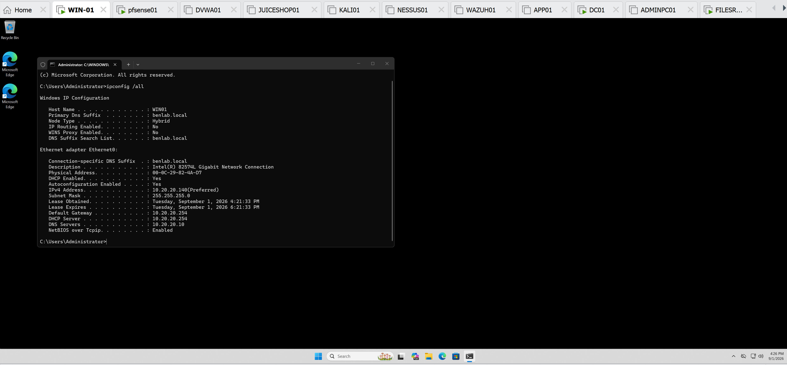
Internal DNS resolution was tested with:
nslookup dc01
DC01 successfully resolved to:
dc01.benlab.local
10.20.20.10
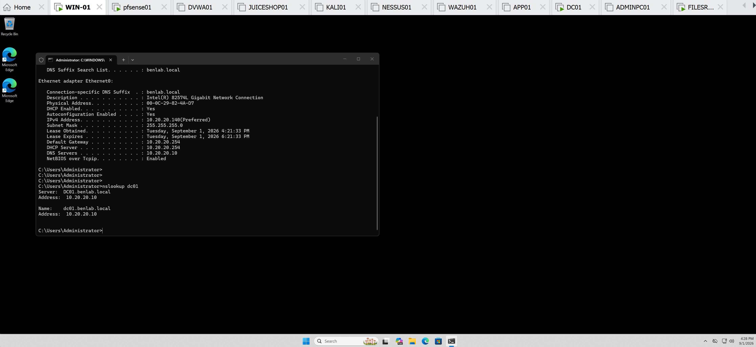
Internal connectivity was validated with:
ping dc01
The test returned 4/4 successful replies with 0% packet loss.
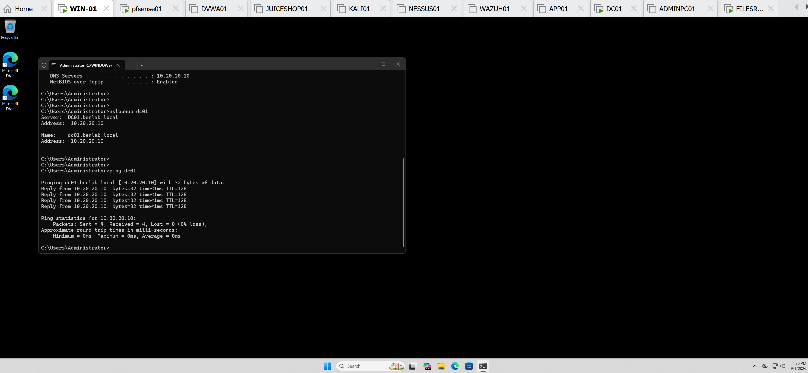
External IP connectivity was tested with:
ping 8.8.8.8
The test returned 4/4 successful replies with 0% packet loss, confirming external routing through pfSense independently of DNS.
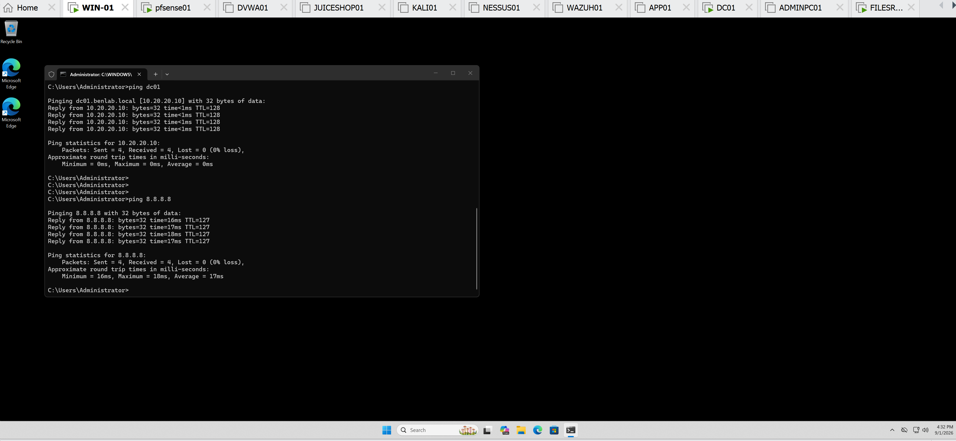
External DNS resolution was tested with:
nslookup google.com
WIN01 queried DC01 at 10.20.20.10, and google.com successfully resolved to a public IP address. A temporary two-second DNS timeout was observed before the successful response.

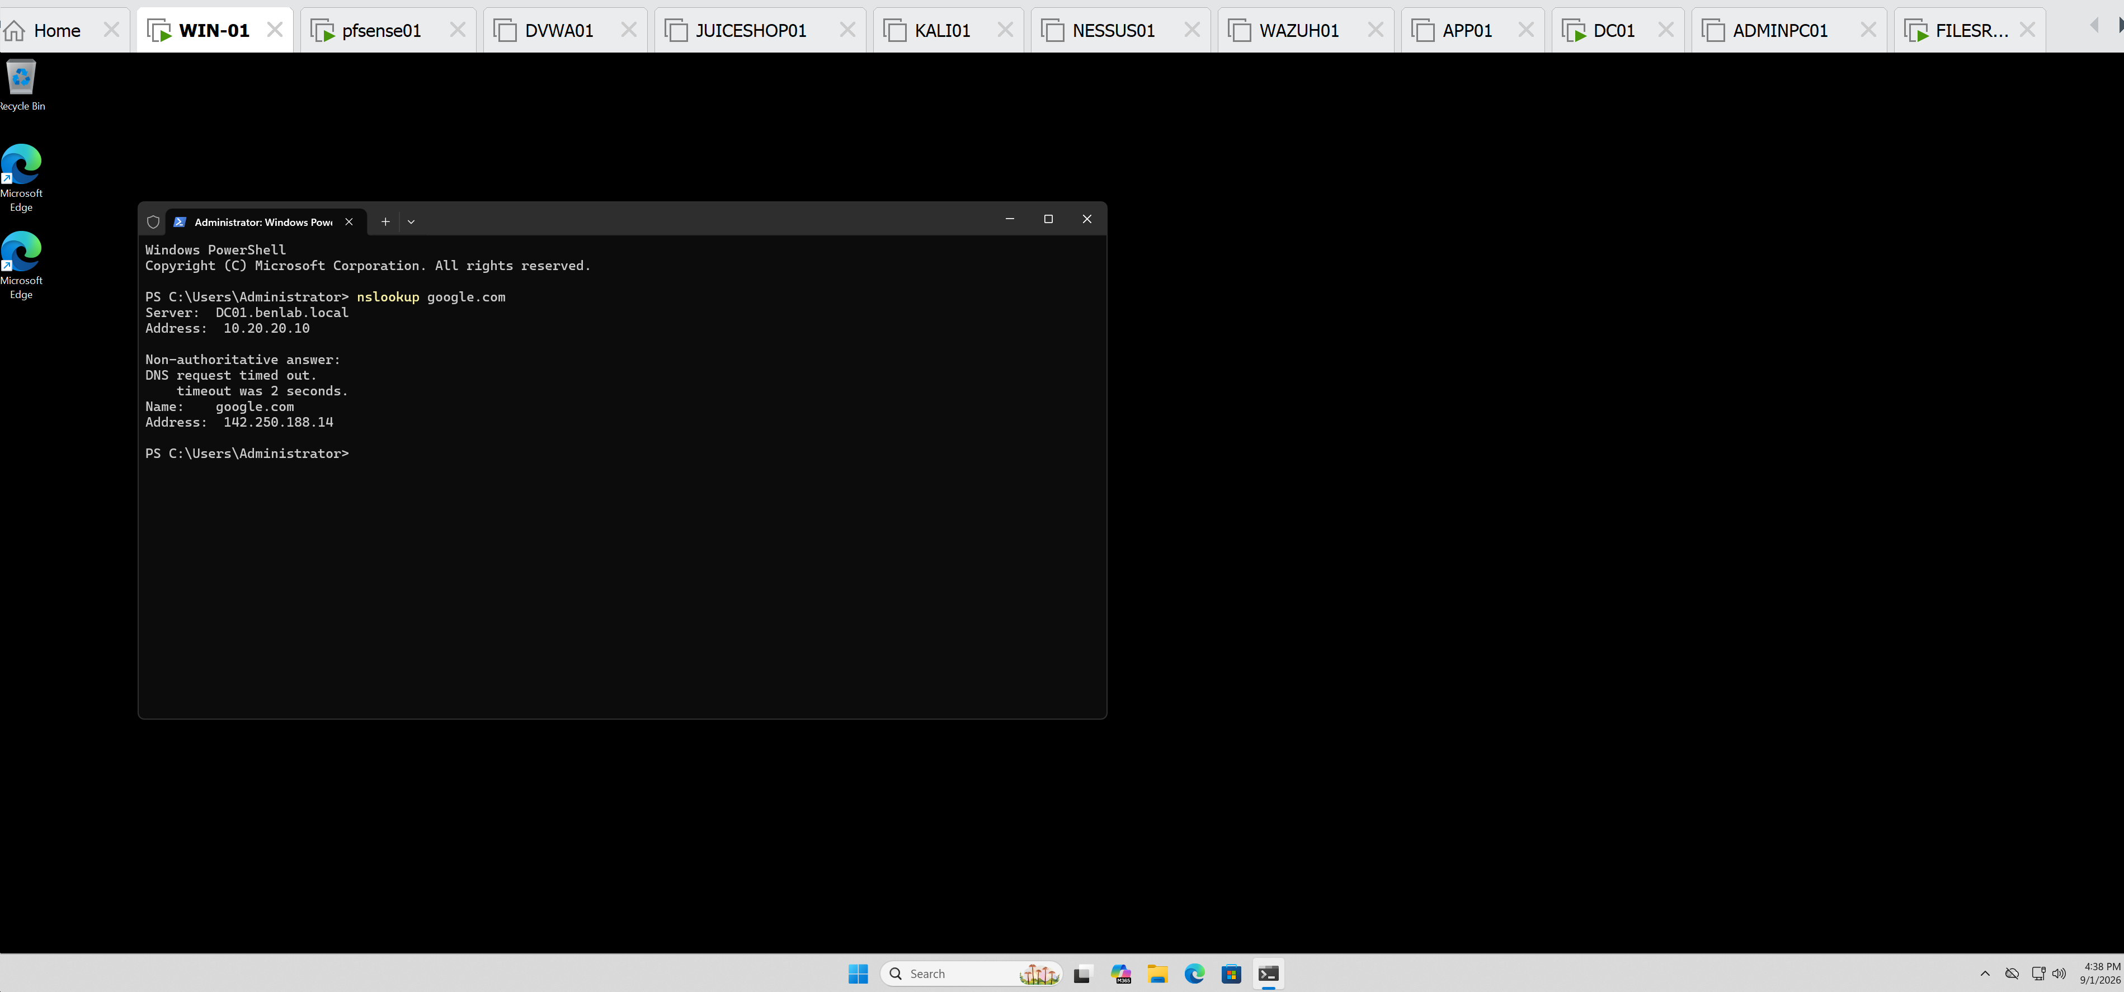
Finally:
ping google.com
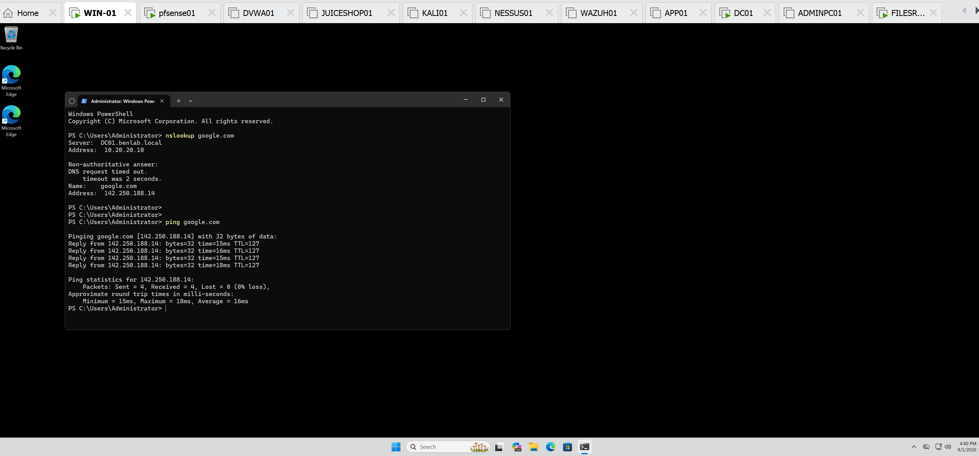
successfully resolved google.com to 142.250.188.14 and returned 4/4 replies with 0% packet loss.
Result:
Task completed successfully. End-to-end testing confirmed that WIN01 receives valid DHCP configuration from pfSense, uses DC01 for DNS resolution, communicates with internal domain resources, routes external traffic through pfSense, and successfully resolves and reaches Internet hosts.

