Module 1 – Active Directory Administration

Task 1 – Active Directory Environment Verification

Objective
Verify that the Active Directory domain, forest, and domain controller are operating correctly before performing any administrative changes.

Background
Before making changes to an Active Directory environment, administrators verify that the domain infrastructure is healthy. This ensures they are connected to the correct domain, confirms the functional levels of the domain and forest, and verifies the domain controller responsible for authentication and directory services.

Systems Used
Component | Value
Server | DC01
Operating System | Windows Server 2022
Domain | benlab.local
Domain Controller | DC01.benlab.local

Commands Used
whoami

Get-ADDomain | Select DNSRoot,DomainMode,PDCEmulator,RIDMaster,InfrastructureMaster

Get-ADForest | Select RootDomain,ForestMode,Domains

Get-ADDomainController | Select HostName,IPv4Address,Site,IsGlobalCatalog

Verification
The verification confirmed:
- The Active Directory domain is benlab.local.
- The domain functional level is Windows Server 2016.
- DC01 holds the PDC Emulator, RID Master, and Infrastructure Master FSMO roles.
- The forest root domain is benlab.local.
- DC01 is functioning as a Global Catalog server.
- The domain controller IP address is 10.20.20.10.

Screenshot
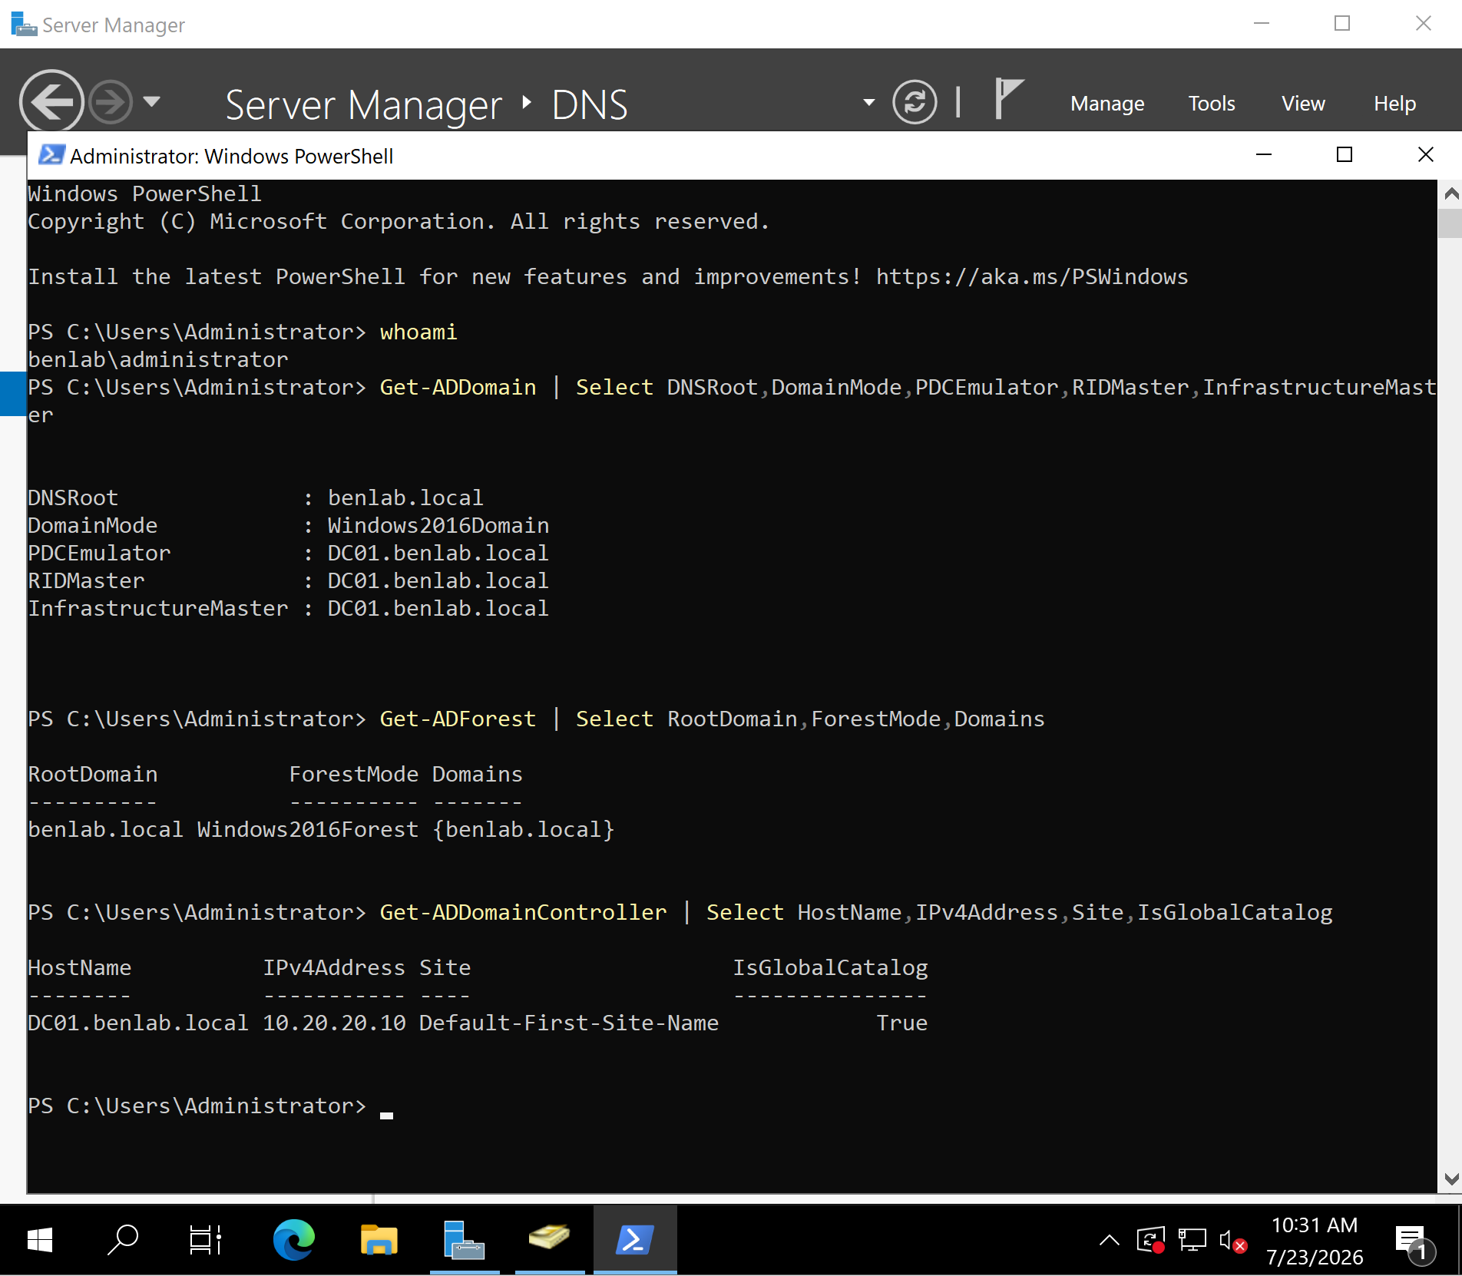
M1-T1-Environment-Verification.png

Lessons Learned
Active Directory should always be verified before making administrative changes. Confirming the domain configuration, forest information, FSMO roles, and domain controller health reduces the risk of making configuration changes in the wrong environment.

Task 2 – Enable Active Directory Recycle Bin

Objective
Enable the Active Directory Recycle Bin to provide rapid recovery of deleted Active Directory objects.

Background
The Active Directory Recycle Bin is a Microsoft feature that allows administrators to restore deleted users, groups, computers, and organizational units without performing an authoritative restore from backup. When enabled, deleted objects retain important attributes such as group memberships, security identifiers (SIDs), and permissions.
Unlike older recovery methods, the Recycle Bin significantly reduces recovery time and administrative effort.

Important Note
The Active Directory Recycle Bin is a one-way feature.
Once enabled, it cannot be disabled.
Because of this, administrators verify the Active Directory environment before activation.

Steps Performed
- Opened Active Directory Administrative Center.
- Selected the benlab.local domain.
- Located Enable Recycle Bin.
- Confirmed the warning dialog.
- Enabled the Active Directory Recycle Bin.
- Refreshed the Administrative Center.
- Verified successful activation.

Verification
The following confirms successful activation:
- The Deleted Objects container appeared.
- The Enable Recycle Bin option became unavailable.
- Active Directory accepted the forest-wide configuration change.

Screenshots
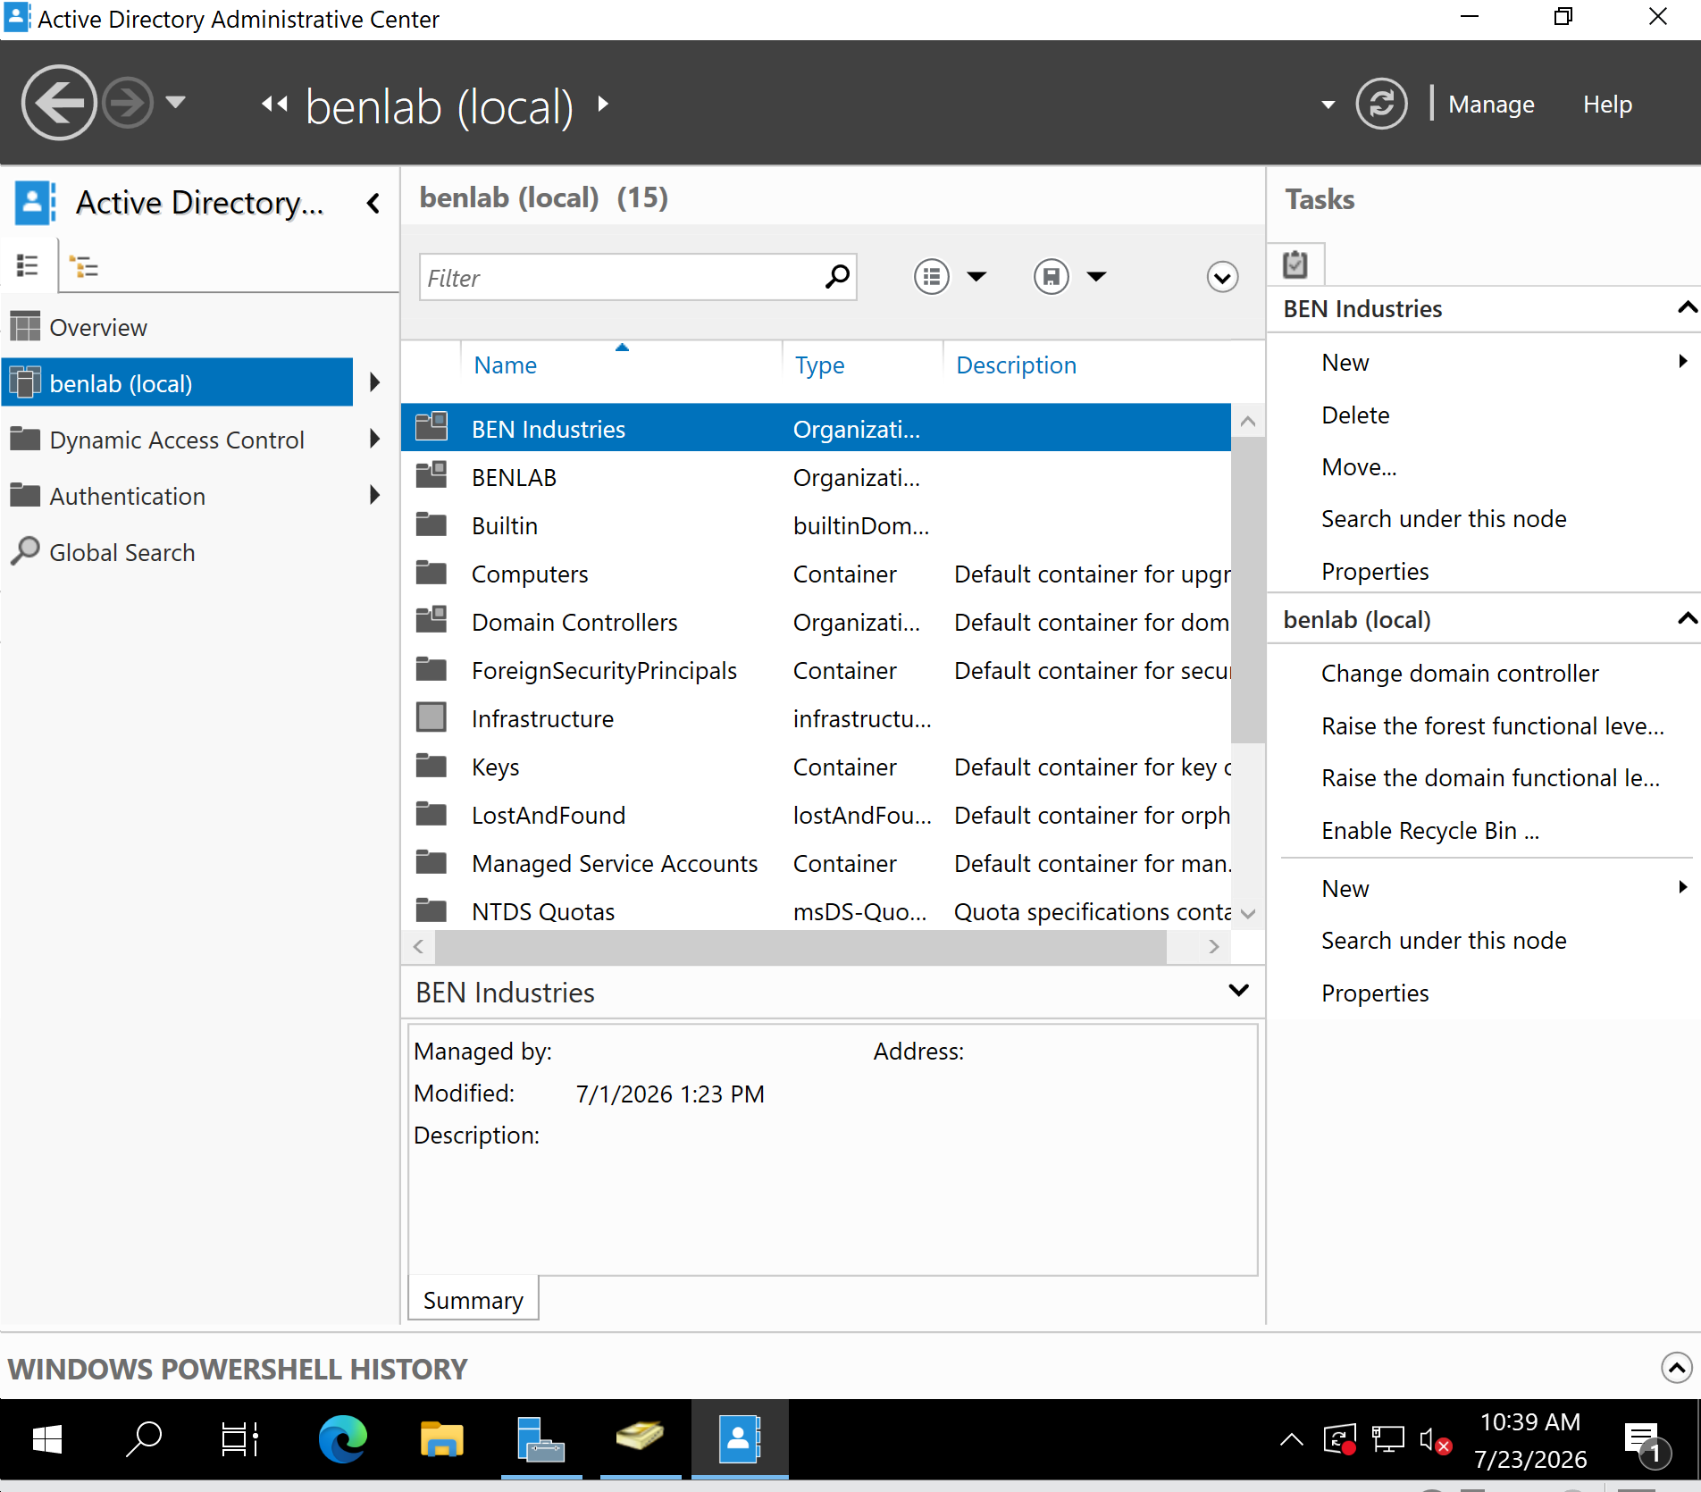
M1-T2-Before-Enable-RecycleBin.png
(Administrative Center showing the Enable Recycle Bin option.)

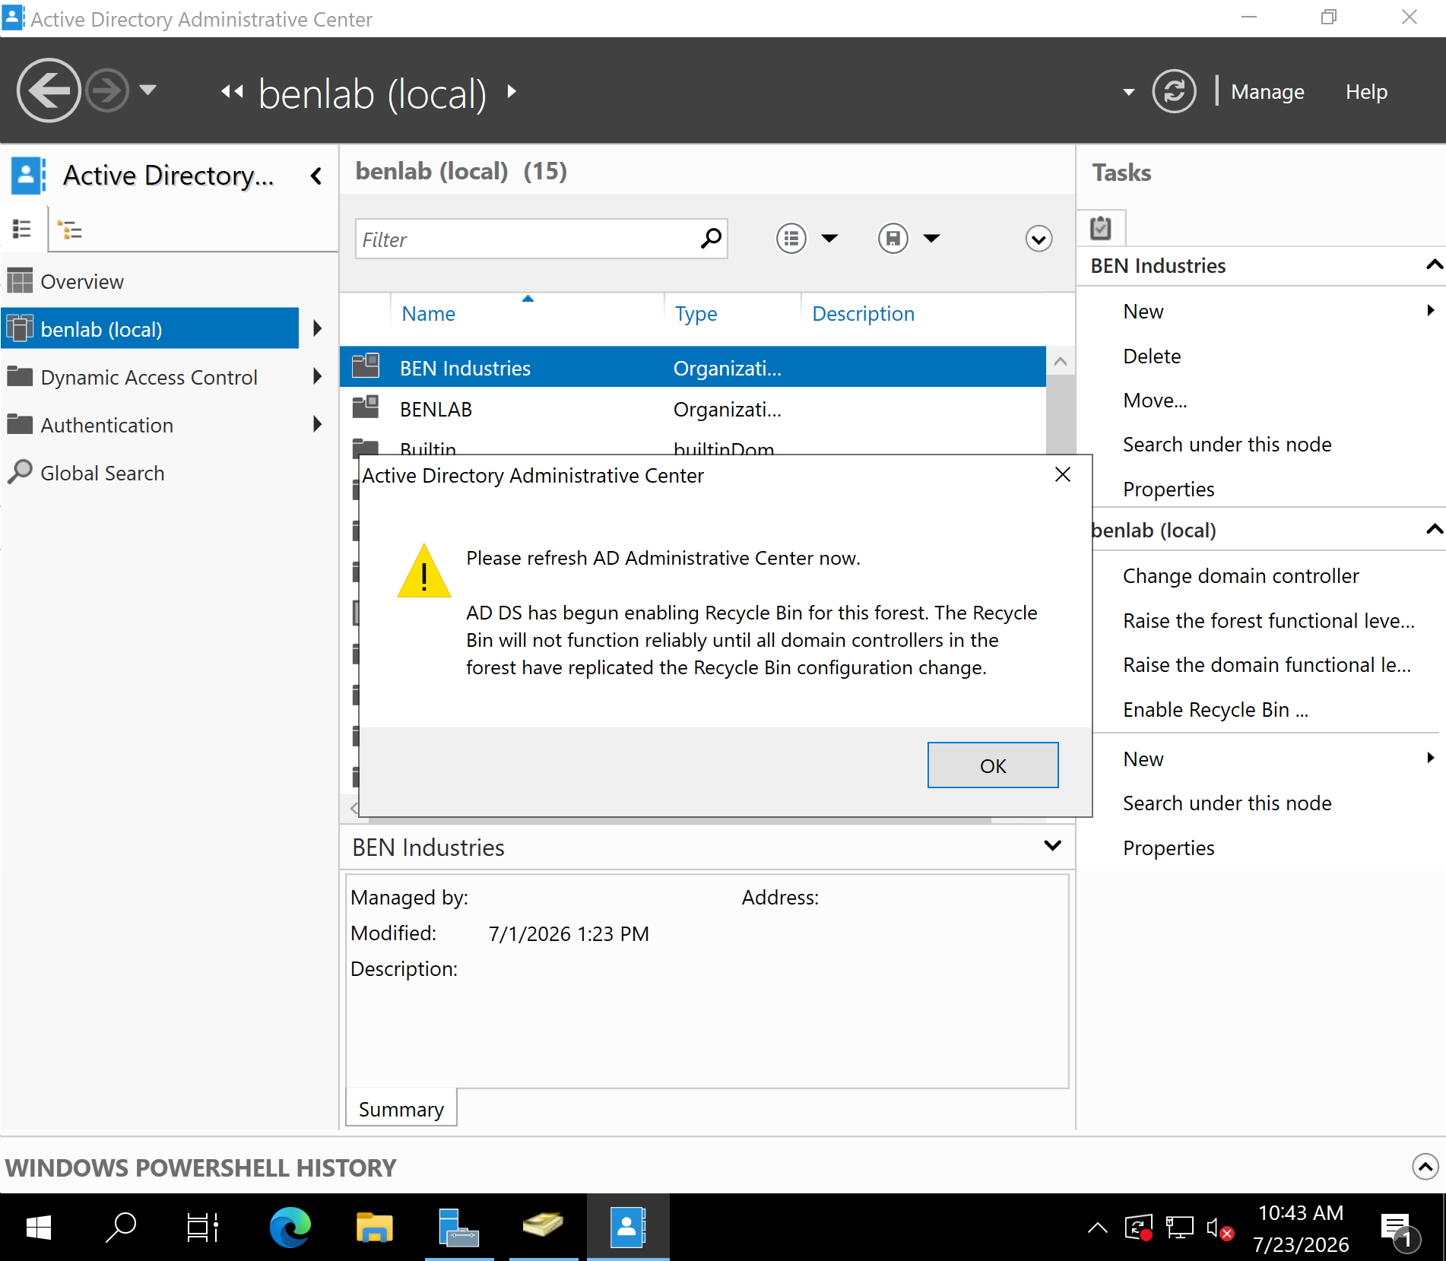
M1-T2-Enable-RecycleBin-Confirmation.png
(Confirmation dialog indicating the feature is being enabled.)

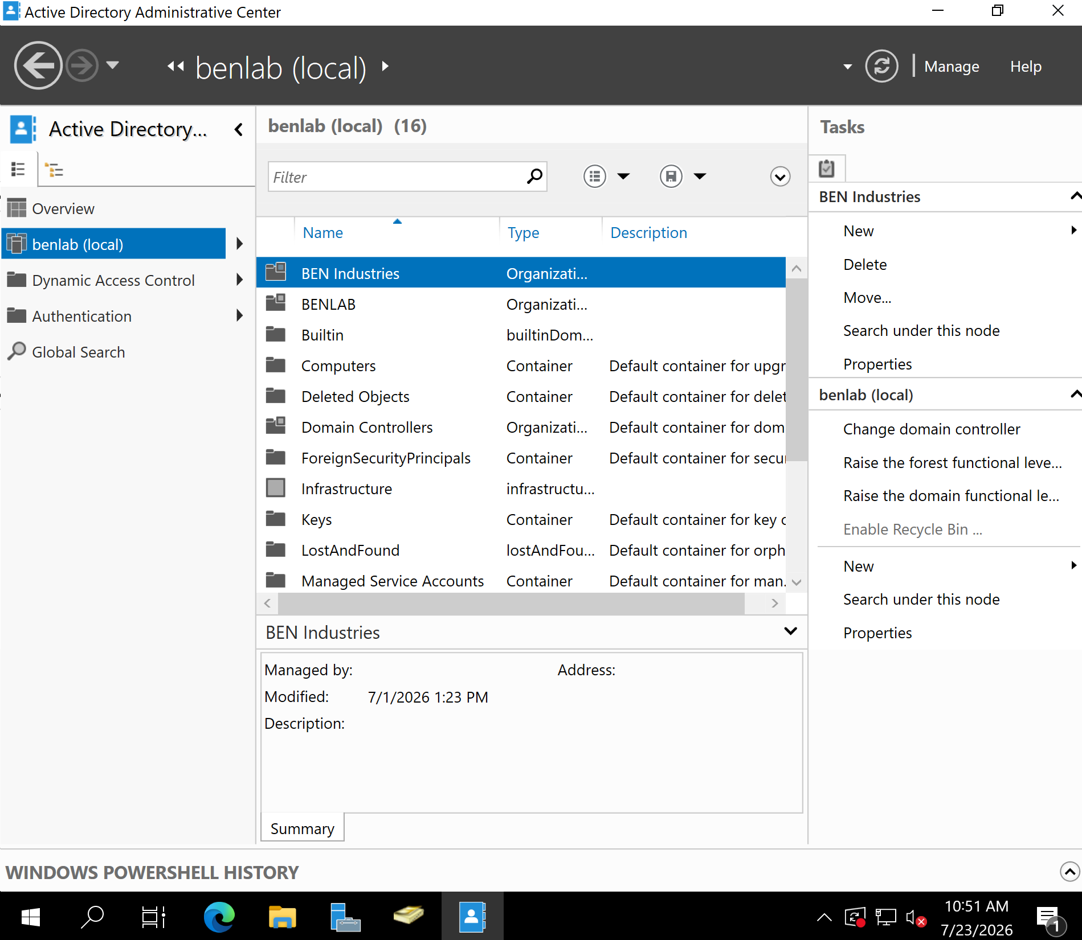
M1-T2-RecycleBin-Enabled.png
(Administrative Center showing the Deleted Objects container after activation.)

Lessons Learned
Enabling the Active Directory Recycle Bin is considered a best practice because it provides a fast and reliable method for recovering accidentally deleted Active Directory objects while preserving their attributes and security information. Understanding that this is a permanent forest-wide configuration reinforces the importance of validating the environment before making infrastructure changes.

Task 3 – Create a Fine-Grained Password Policy (FGPP)

Objective
Create a Fine-Grained Password Policy (FGPP) using a Password Settings Object (PSO) to enforce stronger password and account lockout requirements for members of the GG_IT security group.

Background
The Default Domain Password Policy applies the same password and account lockout requirements to every user in an Active Directory domain. However, enterprise environments often require different security standards for different types of accounts.
Fine-Grained Password Policies (FGPP) allow administrators to create multiple password policies within the same domain and apply them to specific users or security groups. This provides greater flexibility and improves security by allowing privileged accounts to follow stricter password requirements than standard user accounts.
In this task, a Password Settings Object (PSO) was created to strengthen password security for members of the GG_IT security group.

Systems Used
Component | Value
Server | DC01
Operating System | Windows Server 2022
Domain | benlab.local
Security Group | GG_IT
Policy Type | Password Settings Object (PSO)

Configuration Summary
Setting | Value
Policy Name | PSO-IT-Administrators
Precedence | 1
Minimum Password Length | 15 characters
Password History | 24 remembered passwords
Password Complexity | Enabled
Reversible Encryption | Disabled
Minimum Password Age | 1 day
Maximum Password Age | 30 days
Account Lockout | Enabled
Failed Logon Attempts | 3
Reset Failed Attempts | 30 minutes
Lockout Duration | 30 minutes
Applied To | GG_IT

Steps Performed
- Verified that the GG_IT security group already existed in Active Directory.
- Opened the Password Settings Container using the Active Directory Administrative Center.
- Created a new Password Settings Object named PSO-IT-Administrators.
- Configured stronger password complexity, password history, and password age requirements.
- Configured an account lockout policy to protect administrative accounts from brute-force attacks.
- Added the GG_IT security group under Directly Applies To.
- Saved the Password Settings Object.
- Verified that the policy was successfully created and stored in the Password Settings Container.

Verification
Verification confirmed that the Password Settings Object PSO-IT-Administrators was successfully created with a precedence value of 1 and was configured with stronger password and account lockout settings. The policy was linked to the GG_IT security group, ensuring that all current and future members of the group will automatically receive the enhanced password policy.

Screenshots
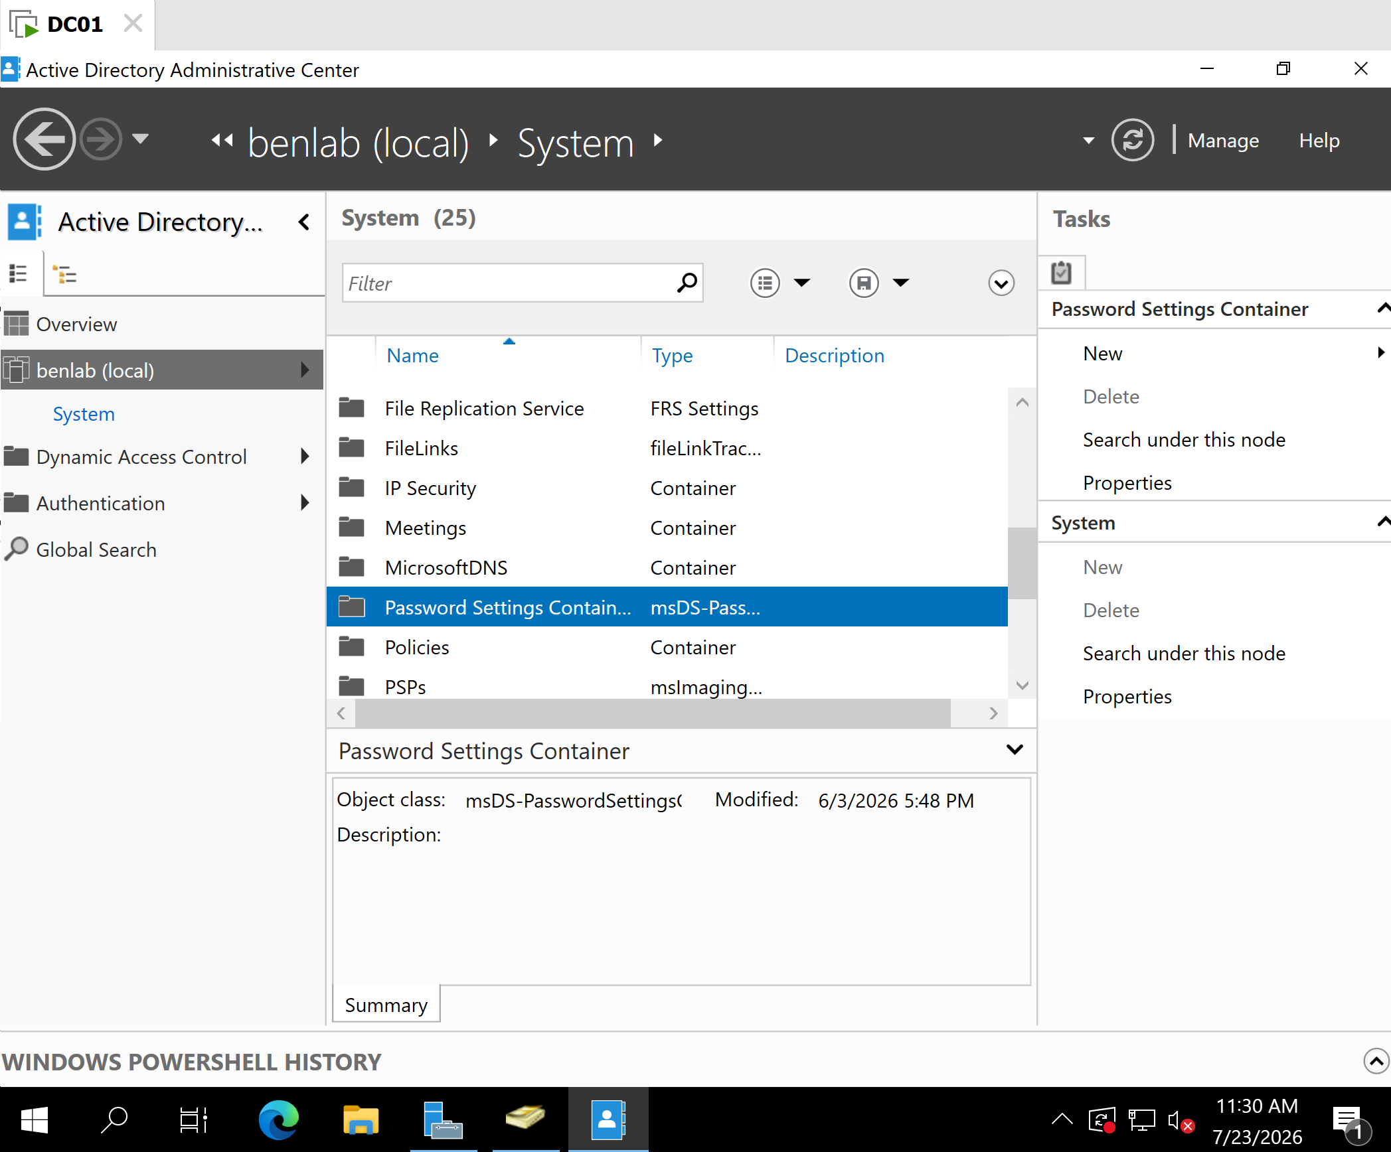
M1-T3-GG_IT-Verification.png
Verified that the GG_IT security group exists before creating the Password Settings Object.

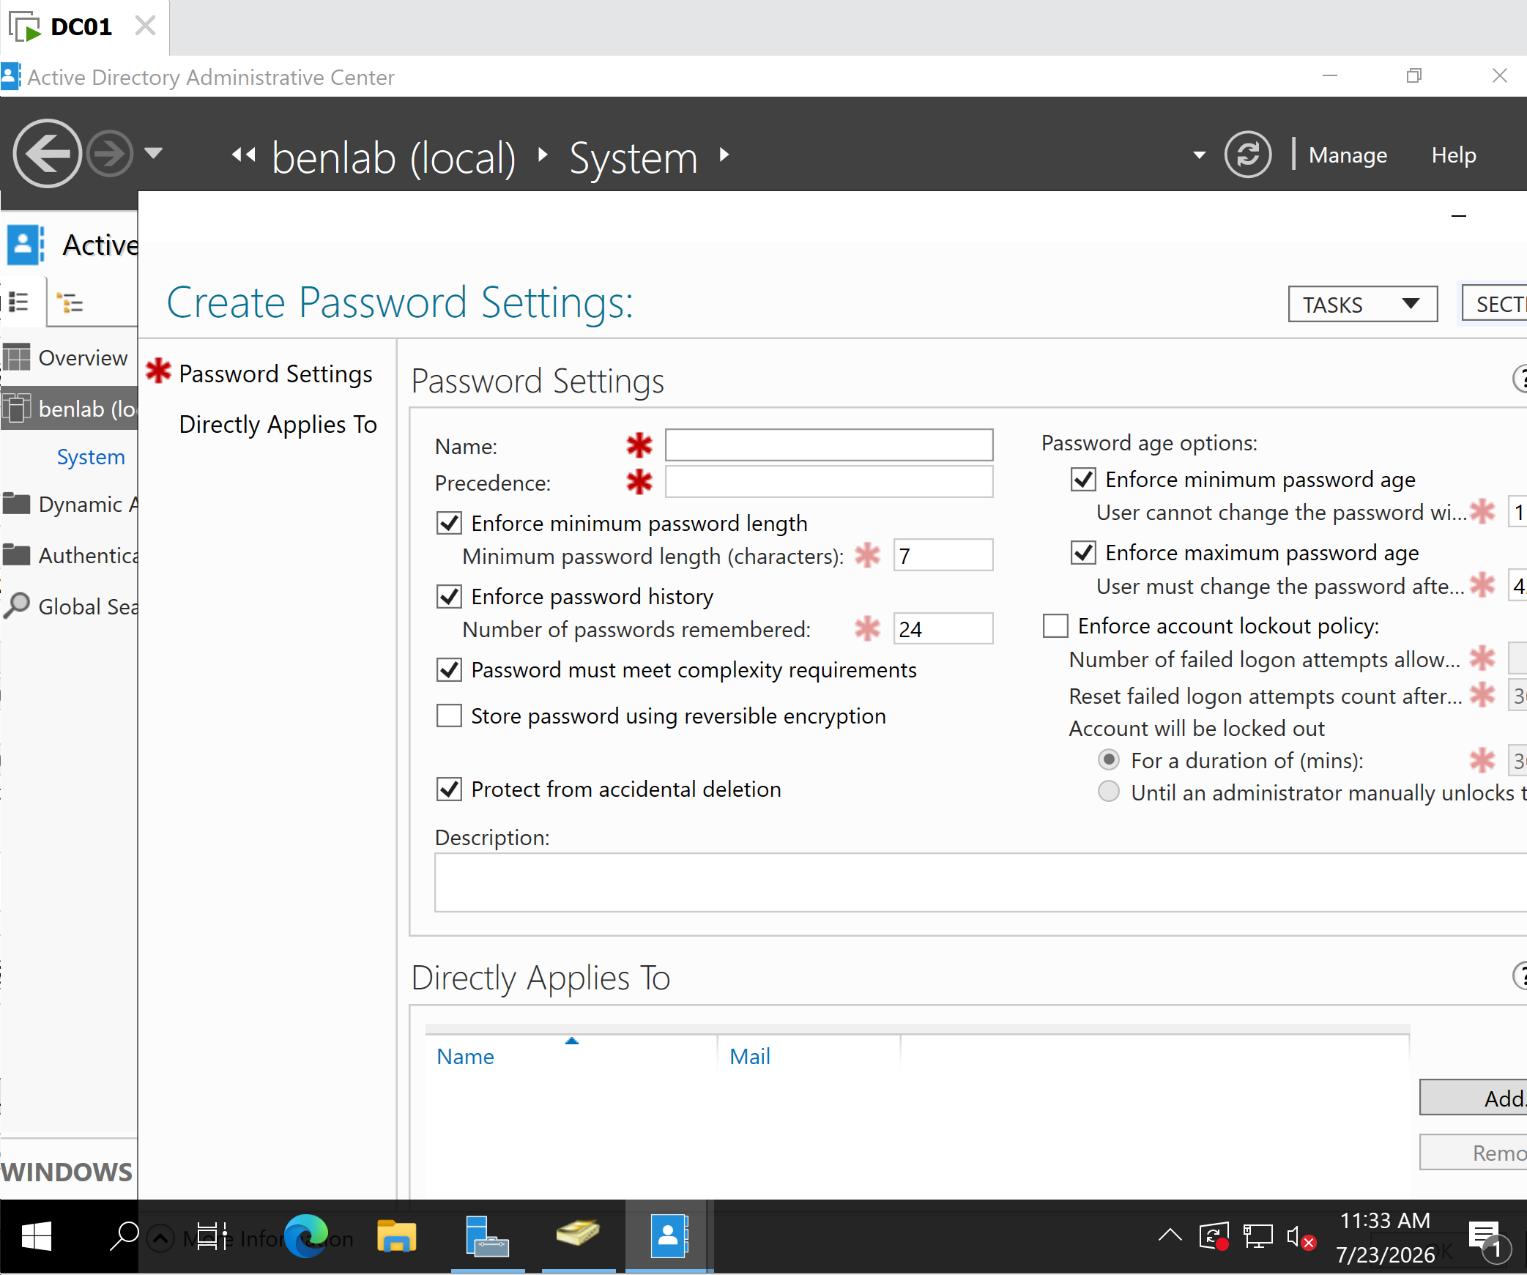
M1-T3-Password-Settings-Container.png
Verified the location of the Password Settings Container prior to creating the Fine-Grained Password Policy.
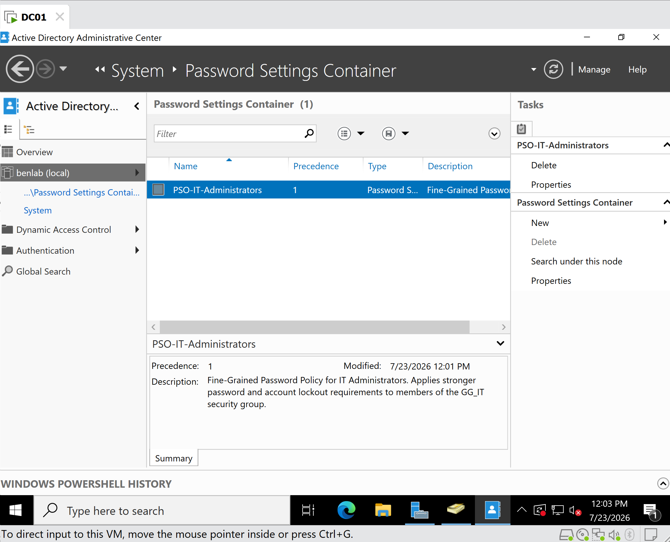
M1-T3-PSO-Created.png
Verified that the Password Settings Object was successfully created and stored in the Password Settings Container.

Key Concepts Learned
- A Password Settings Object (PSO) stores a Fine-Grained Password Policy in Active Directory.
- Fine-Grained Password Policies allow different password requirements for different users or security groups without modifying the Default Domain Policy.
- Precedence determines which Password Settings Object is applied when multiple policies affect the same user. The lowest numerical value has the highest priority.
- Applying a Password Settings Object to a security group is more scalable than assigning it to individual users because all current and future members automatically inherit the policy.
- Strong password policies and account lockout settings reduce the risk of brute-force attacks against privileged accounts.

Lessons Learned
This task demonstrated how Fine-Grained Password Policies provide flexibility and improve security in enterprise Active Directory environments. Rather than applying identical password requirements to every user, administrators can enforce stronger authentication standards for privileged accounts while maintaining separate policies for standard users. Applying the policy to a security group also simplifies ongoing administration and supports future growth without requiring additional configuration.

Task 4 – Delegate Control of an Organizational Unit (OU)

Objective
Delegate administrative control of the Finance Organizational Unit (OU) to a designated Help Desk technician without granting Domain Administrator privileges. This delegation enables the technician to perform common user account management tasks while maintaining the Principle of Least Privilege.

Background
In enterprise Active Directory environments, it is not considered a security best practice to grant Domain Administrator privileges to Help Desk personnel. Instead, administrators delegate only the permissions required for specific job responsibilities.
The Delegation of Control Wizard simplifies assigning administrative permissions to users or groups for a specific Organizational Unit (OU). This approach limits administrative access to only the required resources and reduces the risk of accidental or unauthorized changes elsewhere in the domain.
In this task, administrative control of the Finance OU was delegated to Daniel Scott, allowing him to manage Finance user accounts without becoming a Domain Administrator.

Systems Used
Component | Value
Server | DC01
Operating System | Windows Server 2022
Domain | benlab.local
Organizational Unit | Finance
Delegated User | Daniel Scott
Administrative Tool | Active Directory Users and Computers (ADUC)

Delegation Scenario
BEN Industries promoted Daniel Scott to a Help Desk Technician role. As part of his responsibilities, he must support users within the Finance department.
To follow Microsoft's Principle of Least Privilege, Daniel Scott was granted administrative permissions only for the Finance OU instead of being added to the Domain Admins group.
This delegation allows Daniel Scott to perform common Help Desk tasks while limiting administrative access to the Finance department.

Delegated Permissions
The following permissions were assigned using the Delegation of Control Wizard:
Permission | Purpose
Create, delete, and manage user accounts | Allows management of Finance department user accounts.
Reset user passwords and force password change at next logon | Enables password recovery and enforces secure password changes.
No additional administrative permissions were granted.

Steps Performed
- Opened Active Directory Users and Computers (ADUC).
- Navigated to BEN Industries → Departments → Finance.
- Right-clicked the Finance Organizational Unit.
- Launched the Delegation of Control Wizard.
- Added Daniel Scott as the delegated administrator.
- Selected the following delegated tasks:
  - Create, delete, and manage user accounts.
  - Reset user passwords and force password change at next logon.
- Completed the Delegation of Control Wizard.
- Opened the Finance OU Properties.
- Verified that Daniel Scott appeared on the Security tab, confirming that the delegated permissions had been successfully applied.

Verification
Verification confirmed that the delegation was successfully applied to the Finance Organizational Unit.
The Security properties of the Finance OU displayed Daniel Scott as a delegated security principal. This confirms that Daniel Scott now has the assigned administrative permissions for the Finance OU without receiving Domain Administrator privileges.

Screenshots
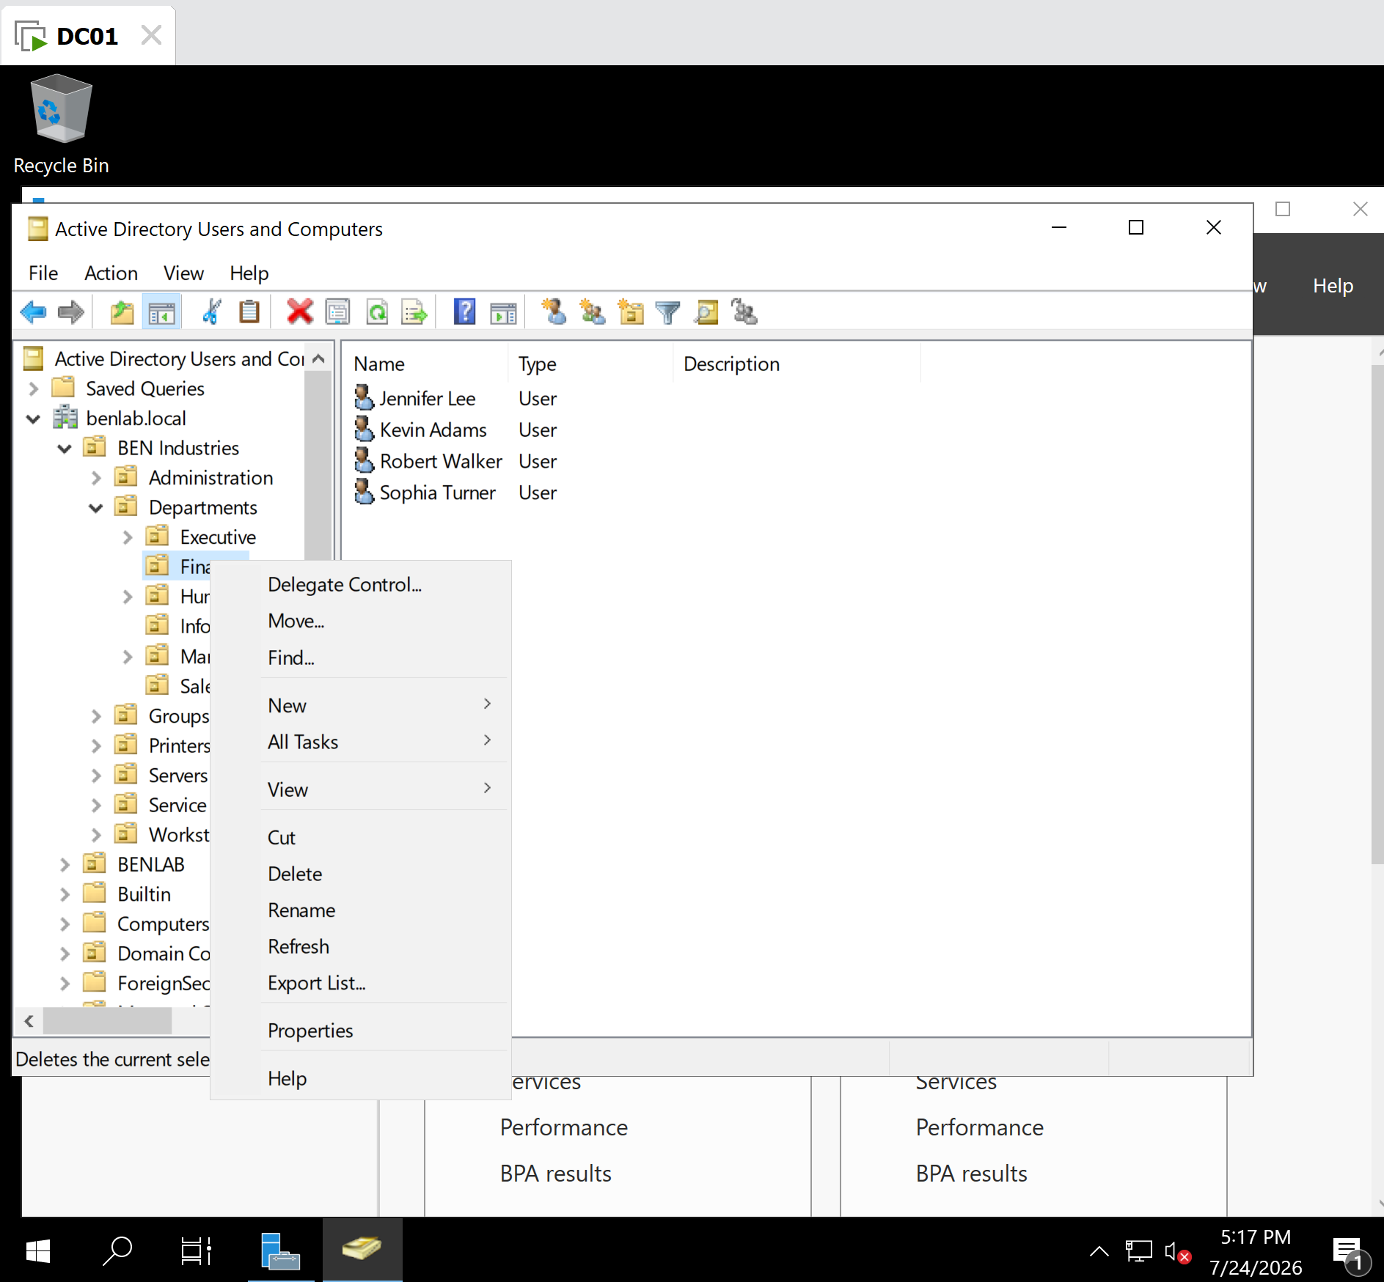
M1-T4-Delegate-Control-Start.png
Description
Opened the Finance Organizational Unit and launched the Delegation of Control Wizard.

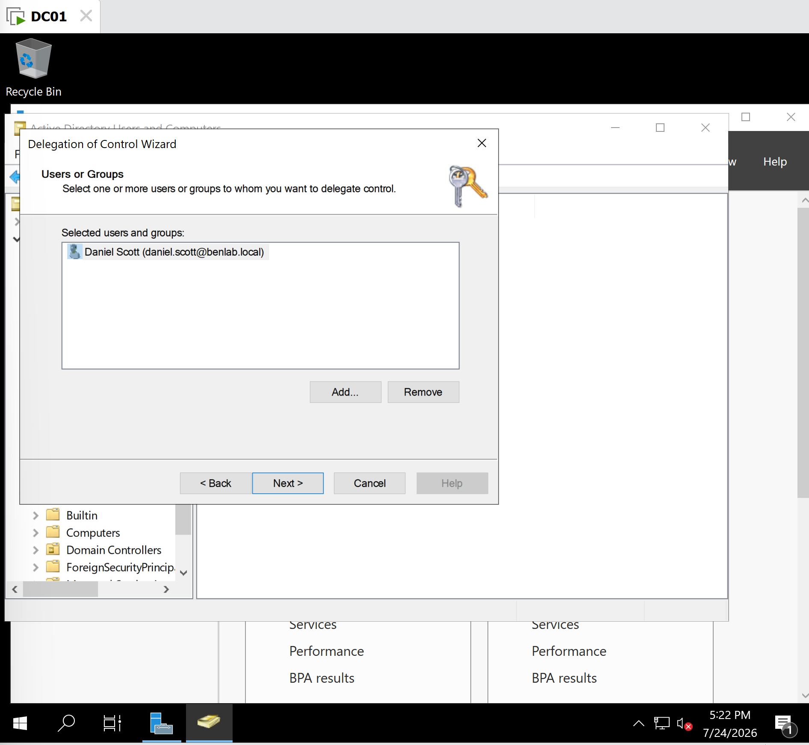
M1-T4-Delegate-User-Selected.png
Description
Selected Daniel Scott as the delegated administrator for the Finance Organizational Unit.

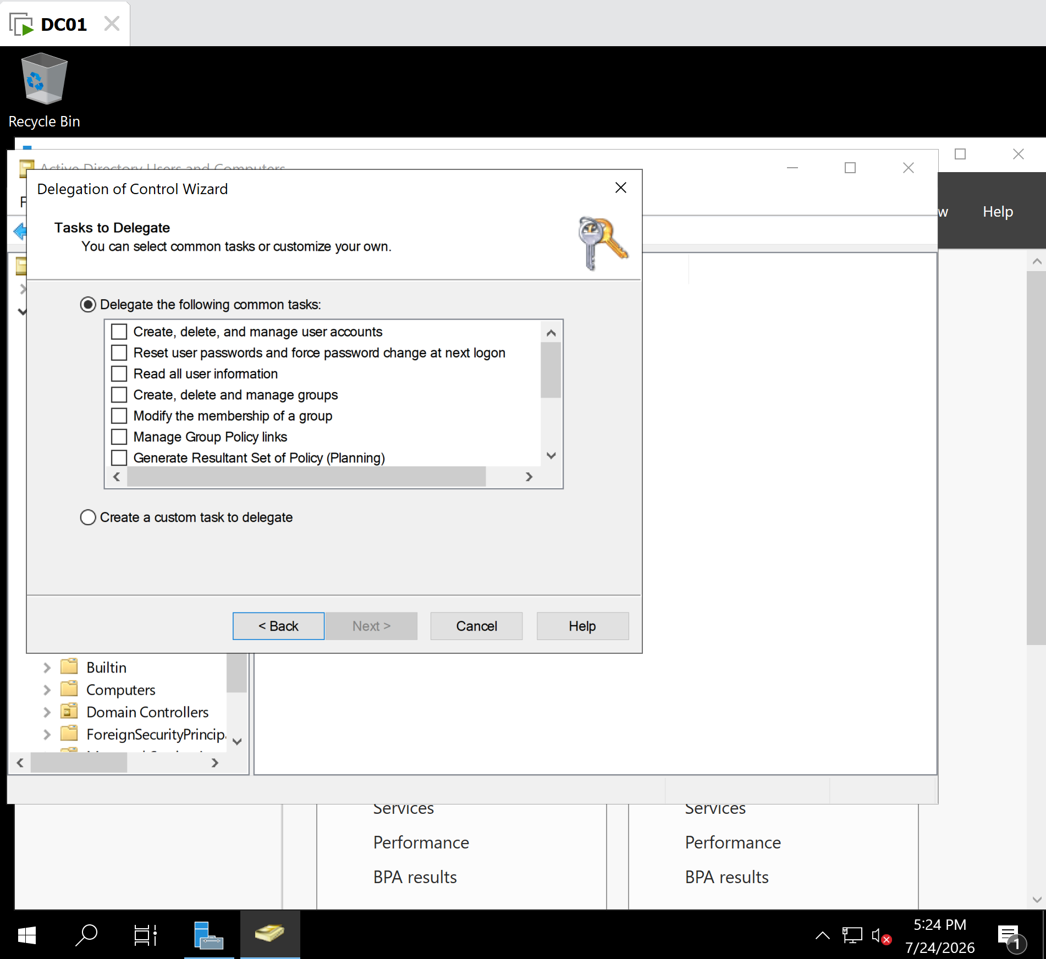
M1-T4-Delegation-Tasks.png
Description
Selected the delegated administrative tasks for Daniel Scott using the Delegation of Control Wizard.

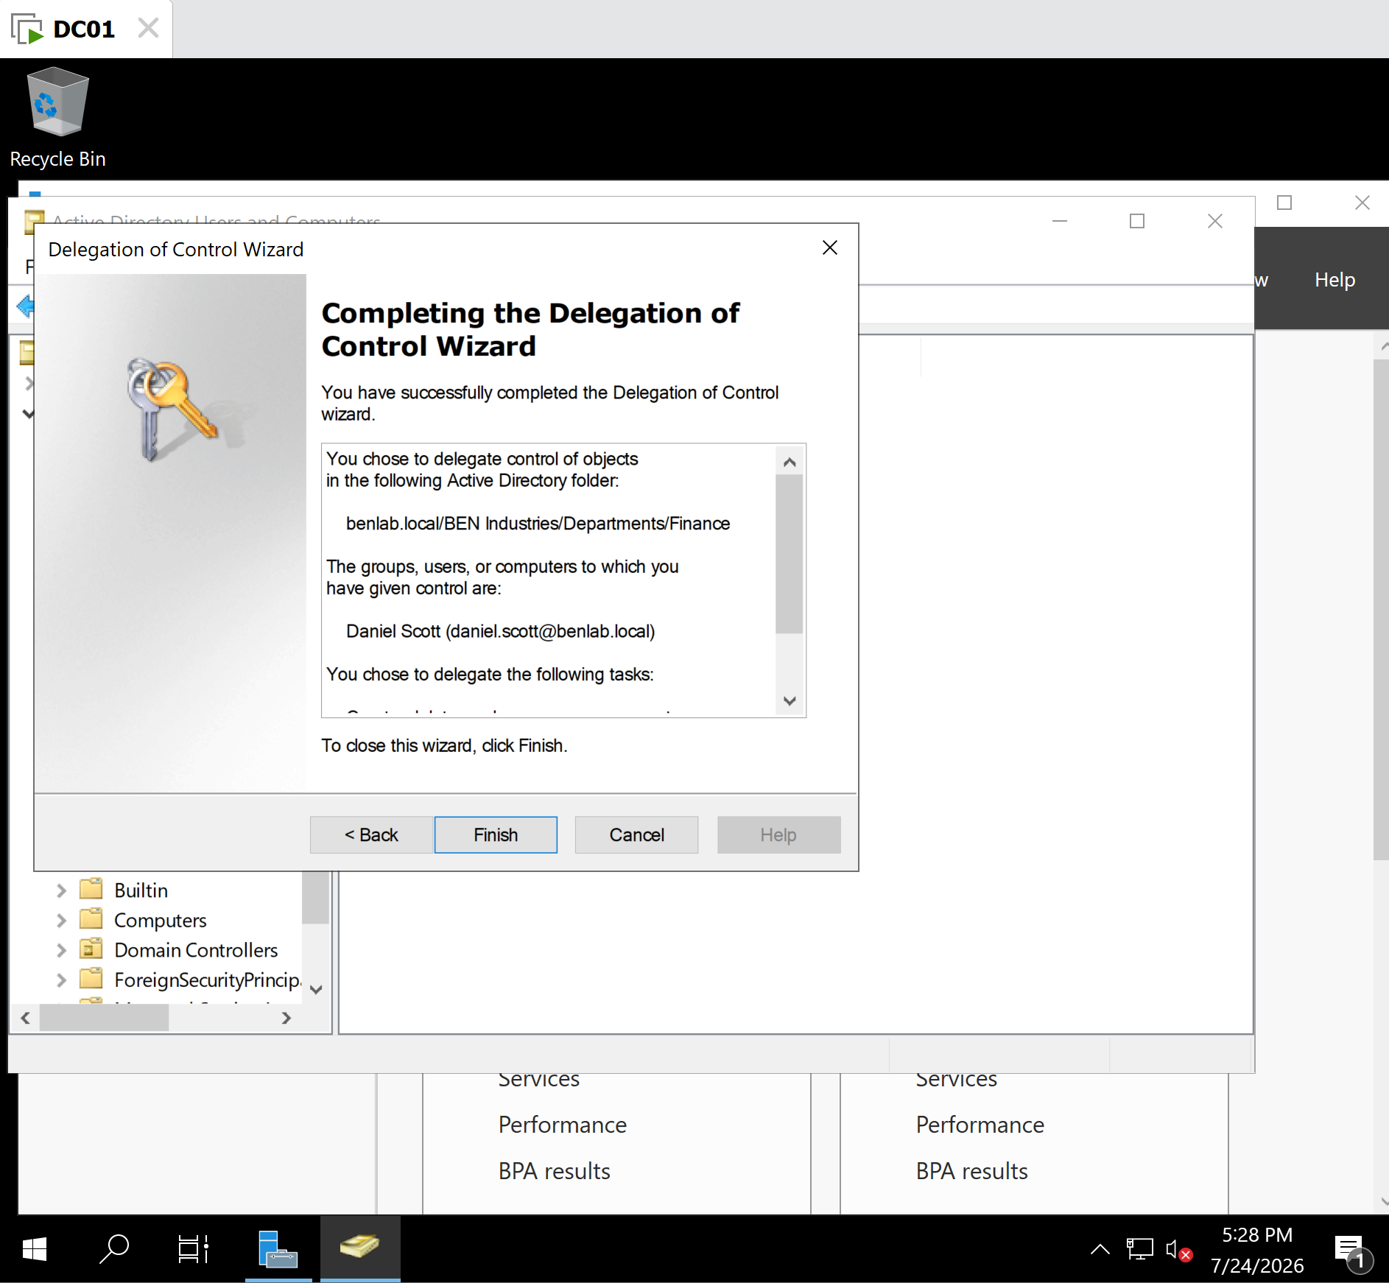
M1-T4-Delegation-Summary.png
Description
Reviewed the delegation summary before applying the configuration.

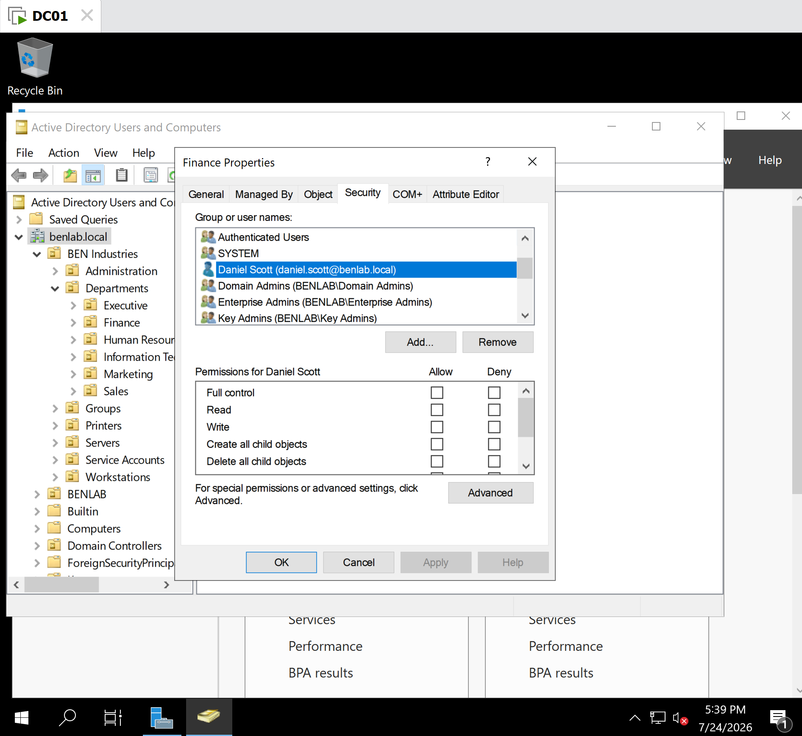
M1-T4-Delegation-Verification.png
Description
Verified that Daniel Scott appears in the Security permissions of the Finance Organizational Unit after the delegation was successfully applied.

Key Concepts Learned
- Delegation of Control allows administrators to assign specific administrative permissions without granting Domain Administrator rights.
- The Delegation of Control Wizard provides a secure method for assigning common administrative tasks.
- Organizational Units (OUs) enable administrators to delegate permissions at a departmental level.
- Following the Principle of Least Privilege reduces security risks by granting users only the permissions necessary to perform their assigned duties.
- Verifying delegated permissions after configuration ensures that the intended security settings have been successfully applied.

Lessons Learned
This task demonstrated how Active Directory delegation supports secure administrative practices in enterprise environments. Rather than assigning excessive privileges, administrators can delegate only the permissions required for specific responsibilities. By granting Daniel Scott limited administrative control over the Finance Organizational Unit, the environment remains secure while allowing Help Desk personnel to efficiently support end users. This approach improves security, accountability, and operational efficiency within the organization.

Administrator's Note
Enterprise Best Practice: Administrative permissions should be delegated to security groups whenever possible instead of individual user accounts. In this lab, Daniel Scott was delegated permissions directly to simplify the learning exercise. In a production environment, Microsoft recommends delegating permissions to a Help Desk security group (for example, GG_HelpDesk) so that administrators can manage access by adding or removing group members rather than modifying permissions on the OU itself.

Task 5 – Active Directory Administrative Center (ADAC) Administration

Objective
Explore and use the Active Directory Administrative Center (ADAC) to manage Active Directory objects, navigate Organizational Units (OUs), view user properties, and perform Global Search. The objective of this task is to become familiar with Microsoft's modern Active Directory management interface and understand its advantages over the traditional Active Directory Users and Computers (ADUC) console.

Background
The Active Directory Administrative Center (ADAC) is Microsoft's modern management interface for Active Directory Domain Services (AD DS). While Active Directory Users and Computers (ADUC) remains widely used for routine administration, ADAC introduces additional features that simplify management and improve administrator productivity.
ADAC integrates advanced capabilities such as Global Search, Fine-Grained Password Policy management, Active Directory Recycle Bin, and Windows PowerShell History. These features allow administrators to perform administrative tasks more efficiently while also learning the PowerShell commands associated with many graphical operations.

Systems Used
Component | Value
Server | DC01
Operating System | Windows Server 2022
Domain | benlab.local
Management Tool | Active Directory Administrative Center (ADAC)
Test User | Jennifer Lee

Features Explored
During this task, the following ADAC features were explored:
- Active Directory Overview
- Organizational Unit navigation
- Tasks pane
- Summary pane
- User Properties
- Global Search
- Windows PowerShell History
- Password Settings

Steps Performed
- Opened Active Directory Administrative Center (ADAC) from Server Manager → Tools.
- Reviewed the ADAC Overview page and its built-in administrative tools.
- Navigated to BEN Industries → Departments.
- Selected the Finance Organizational Unit.
- Reviewed the Tasks pane and Summary pane.
- Opened the Jennifer Lee user account.
- Examined the user property sections, including:
  - Account
  - Member Of
  - Password Settings
- Used Global Search to locate Jennifer Lee.
- Reviewed the available administrative actions and Windows PowerShell History panel.

Verification
Verification confirmed that Active Directory Administrative Center was functioning correctly.
The Global Search feature successfully located the Jennifer Lee user account within the domain. User properties displayed correctly, and administrative tasks such as password reset, group membership management, and password policy viewing were available directly from the Tasks pane. This demonstrated ADAC's ability to provide centralized and efficient Active Directory administration.

ADUC vs ADAC Comparison
Active Directory Users and Computers (ADUC) | Active Directory Administrative Center (ADAC)
Traditional MMC console | Modern Microsoft management interface
Fast and lightweight | Feature-rich and modern
Right-click context menus | Integrated Tasks pane
Basic object management | Advanced object management
Limited search capabilities | Domain-wide Global Search
No integrated PowerShell history | Built-in Windows PowerShell History
Limited Fine-Grained Password Policy management | Full Fine-Grained Password Policy support
No Recycle Bin management | Built-in Active Directory Recycle Bin support

Screenshots
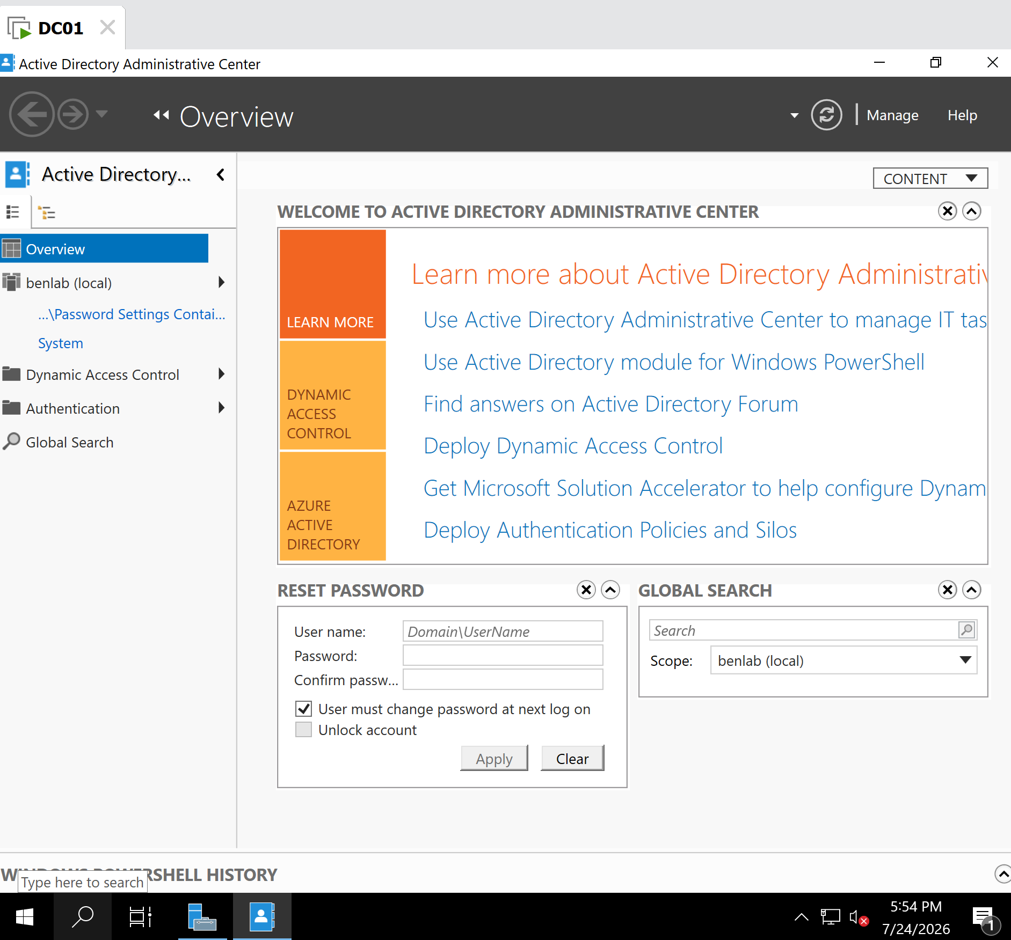
M1-T5-ADAC-Overview.png
Description
Opened the Active Directory Administrative Center and reviewed the Overview dashboard.

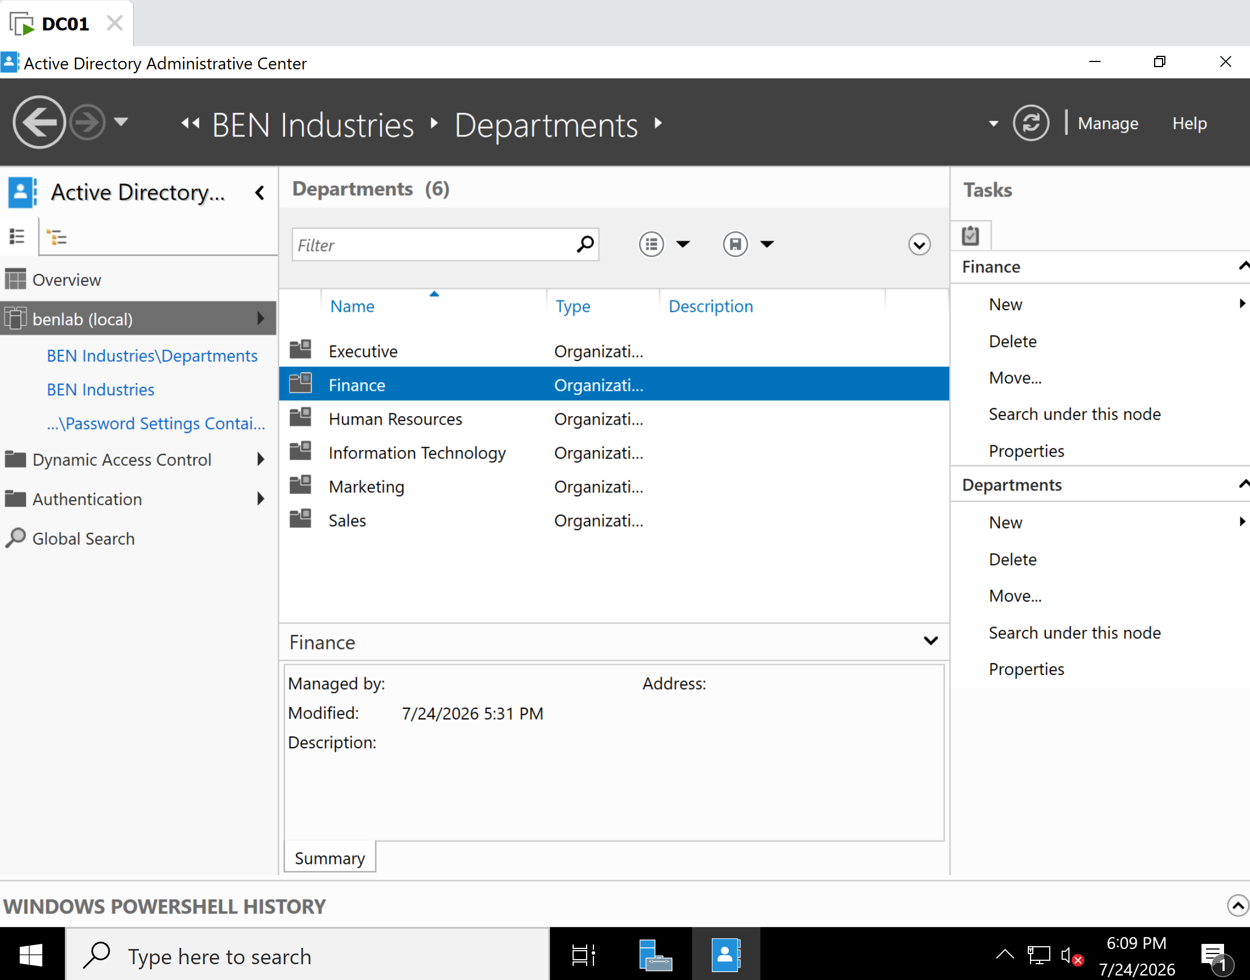
M1-T5-ADAC-Finance-OU.png
Description
Navigated to the Finance Organizational Unit and examined the Tasks pane and Summary pane.

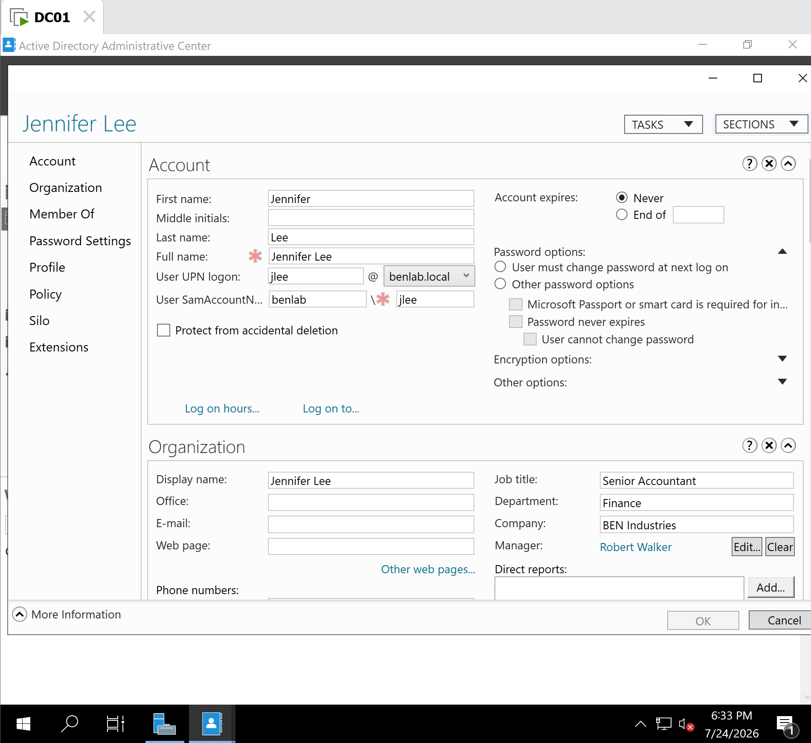
M1-T5-ADAC-User-Properties.png
DescriptionReviewed Jennifer Lee's user properties, including Account, Member Of, and Password Settings sections.

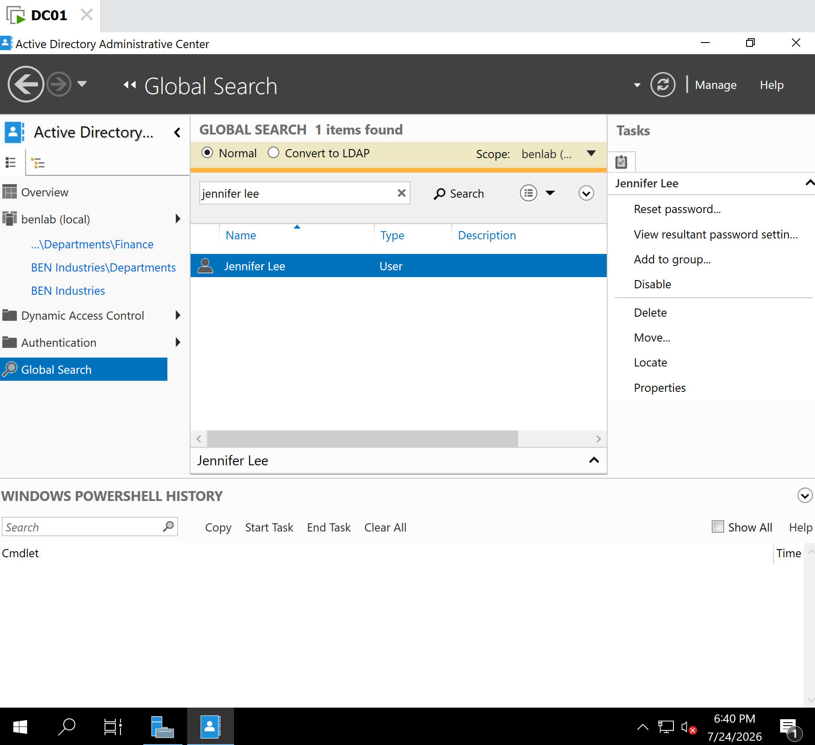
M1-T5-ADAC-Global-Search.png
Description
Used the Global Search feature to locate Jennifer Lee and reviewed the available administrative actions.

Key Concepts Learned
- Active Directory Administrative Center (ADAC) is Microsoft's modern interface for managing Active Directory.
- ADAC complements rather than replaces Active Directory Users and Computers (ADUC); experienced administrators often use both depending on the task.
- Global Search allows administrators to locate Active Directory objects across the domain without manually browsing Organizational Units.
- The Tasks pane provides quick access to common administrative actions, improving workflow efficiency.
- The Password Settings section simplifies viewing the effective password policy for a user, including Fine-Grained Password Policies.
- The Windows PowerShell History pane helps administrators learn and automate Active Directory management by exposing PowerShell commands generated through the GUI.

Lessons Learned
This task demonstrated the advantages of using Active Directory Administrative Center for modern Active Directory administration. Compared to the traditional ADUC console, ADAC offers a more organized interface, integrated search capabilities, advanced password policy management, and PowerShell integration. Understanding both management tools enables administrators to choose the most appropriate interface for each administrative task and prepares them for managing enterprise Windows Server environments efficiently.

Administrator's Notes
Enterprise Best Practice: Most Windows administrators use both ADUC and ADAC in their daily work. ADUC is typically preferred for quick, routine administrative tasks, while ADAC is used for advanced management features such as Fine-Grained Password Policies, Active Directory Recycle Bin operations, Global Search, and PowerShell-integrated administration. Becoming proficient with both tools provides greater flexibility and aligns with common enterprise administration practices.

Task 6 – Active Directory PowerShell Administration

Objective
Learn how to use Windows PowerShell to administer Active Directory by importing the Active Directory module, retrieving domain information, querying users and Organizational Units (OUs), viewing user properties, and inspecting group memberships. The objective of this task is to understand how PowerShell complements graphical administration tools by enabling faster, repeatable, and automated management of Active Directory.

Background
Windows PowerShell is Microsoft's command-line automation framework used extensively for Windows Server administration. The Active Directory PowerShell module provides administrators with cmdlets to manage users, groups, computers, Organizational Units, Group Policy, and other Active Directory objects.
Unlike graphical tools such as Active Directory Users and Computers (ADUC) and Active Directory Administrative Center (ADAC), PowerShell enables administrators to automate repetitive tasks, generate reports, and manage hundreds or thousands of objects efficiently.

Systems Used
Component | Value
Server | DC01
Operating System | Windows Server 2022
Domain | benlab.local
PowerShell Module | ActiveDirectory
Test User | Jennifer Lee (jlee)

PowerShell Cmdlets Used
Get-Module ActiveDirectory -ListAvailable
Verified that the Active Directory module was installed.

Import-Module ActiveDirectory
Imported the Active Directory module into the current PowerShell session.

Get-ADDomain | Select DNSRoot,NetBIOSName,DomainMode
Verified domain configuration.

Get-ADUser -Filter * | Select Name
Retrieved all Active Directory users.

Get-ADUser -Filter * -SearchBase "OU=Finance,OU=Departments,OU=BEN Industries,DC=benlab,DC=local" | Select Name
Retrieved users located only within the Finance Organizational Unit.

Get-ADUser -Filter 'Name -eq "Jennifer Lee"' | Select Name,SamAccountName
Identified Jennifer Lee's SamAccountName.

Get-ADUser jlee -Properties Department,Title,Enabled | Select Name,SamAccountName,Department,Title,Enabled
Retrieved additional user properties.

Get-ADPrincipalGroupMembership jlee | Select Name
Displayed Jennifer Lee's Active Directory group memberships.

Verification
PowerShell successfully communicated with Active Directory.
The following information was verified:
- Active Directory module installed
- Module imported successfully
- Domain configuration retrieved
- Active Directory users listed
- Finance OU queried successfully
- Jennifer Lee's account identified using SamAccountName
- Department and job title displayed
- Account status verified as enabled
- Group membership successfully retrieved

Screenshots
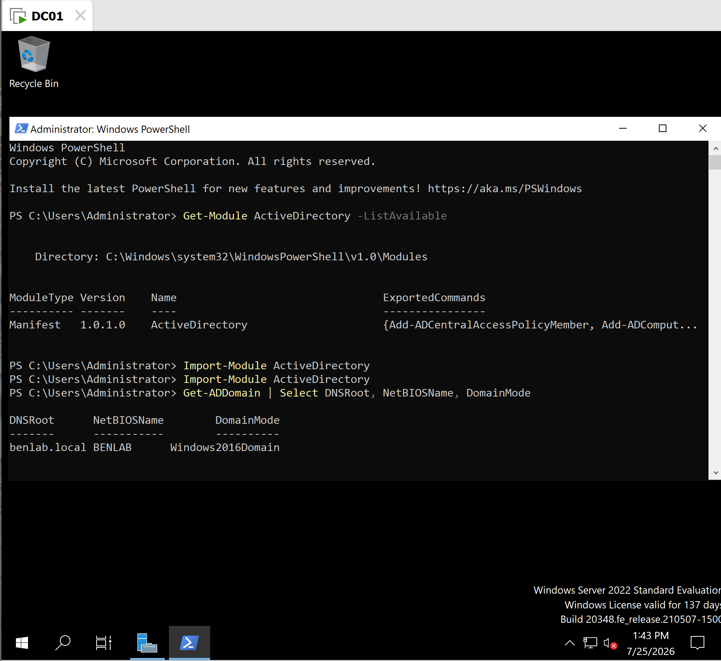
M1-T6-AD-PowerShell-Domain.png
Description
Verified the Active Directory module and confirmed communication with the Active Directory domain.

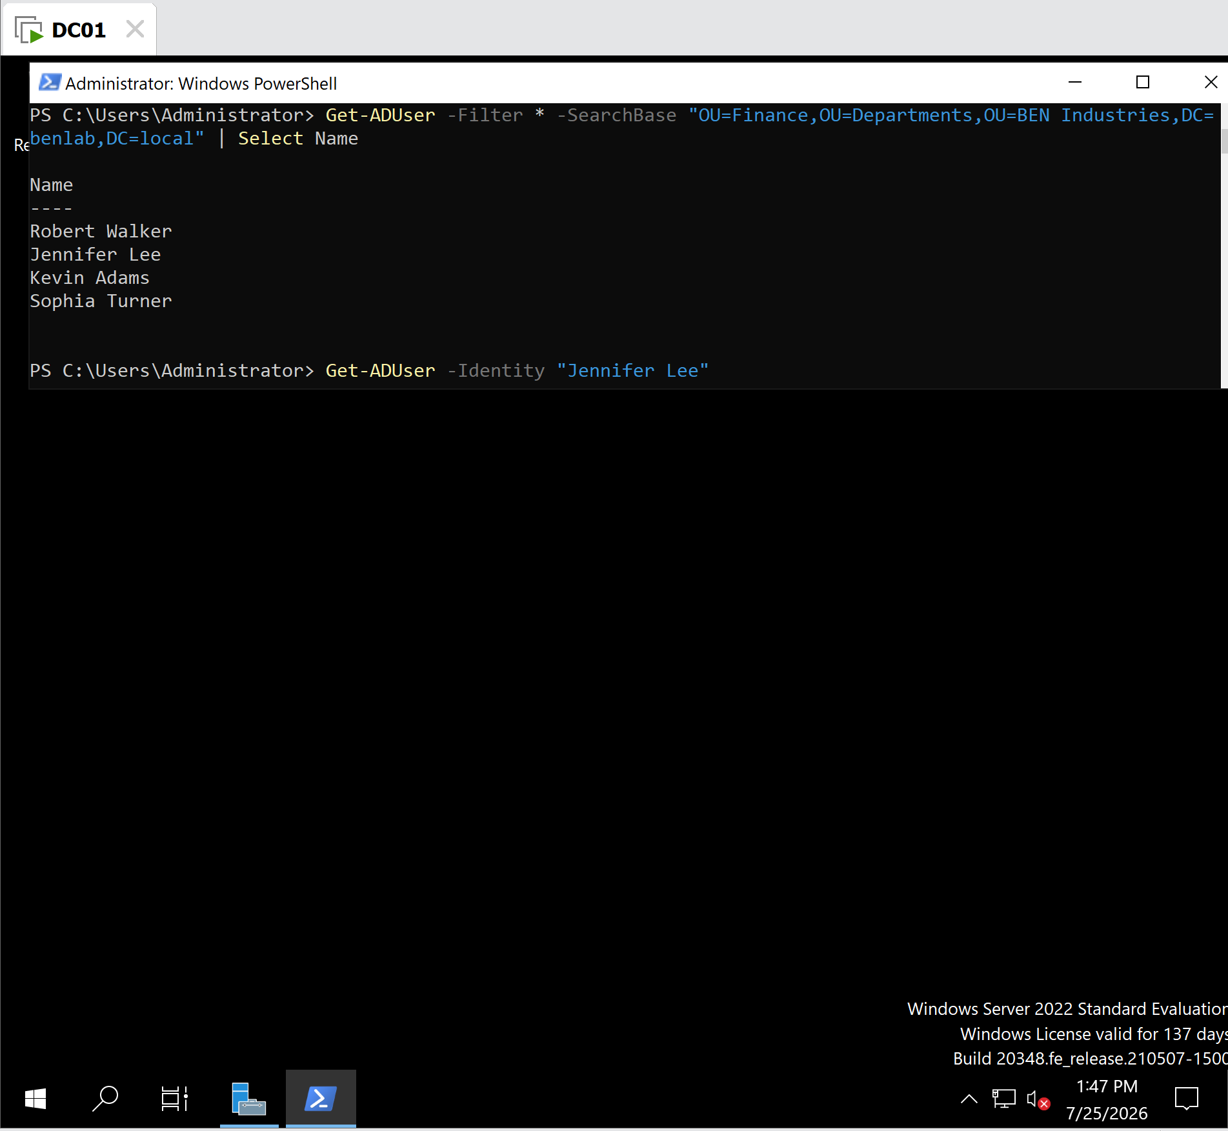
M1-T6-PowerShell-Finance-Users.png
Description
Retrieved all users located within the Finance Organizational Unit.

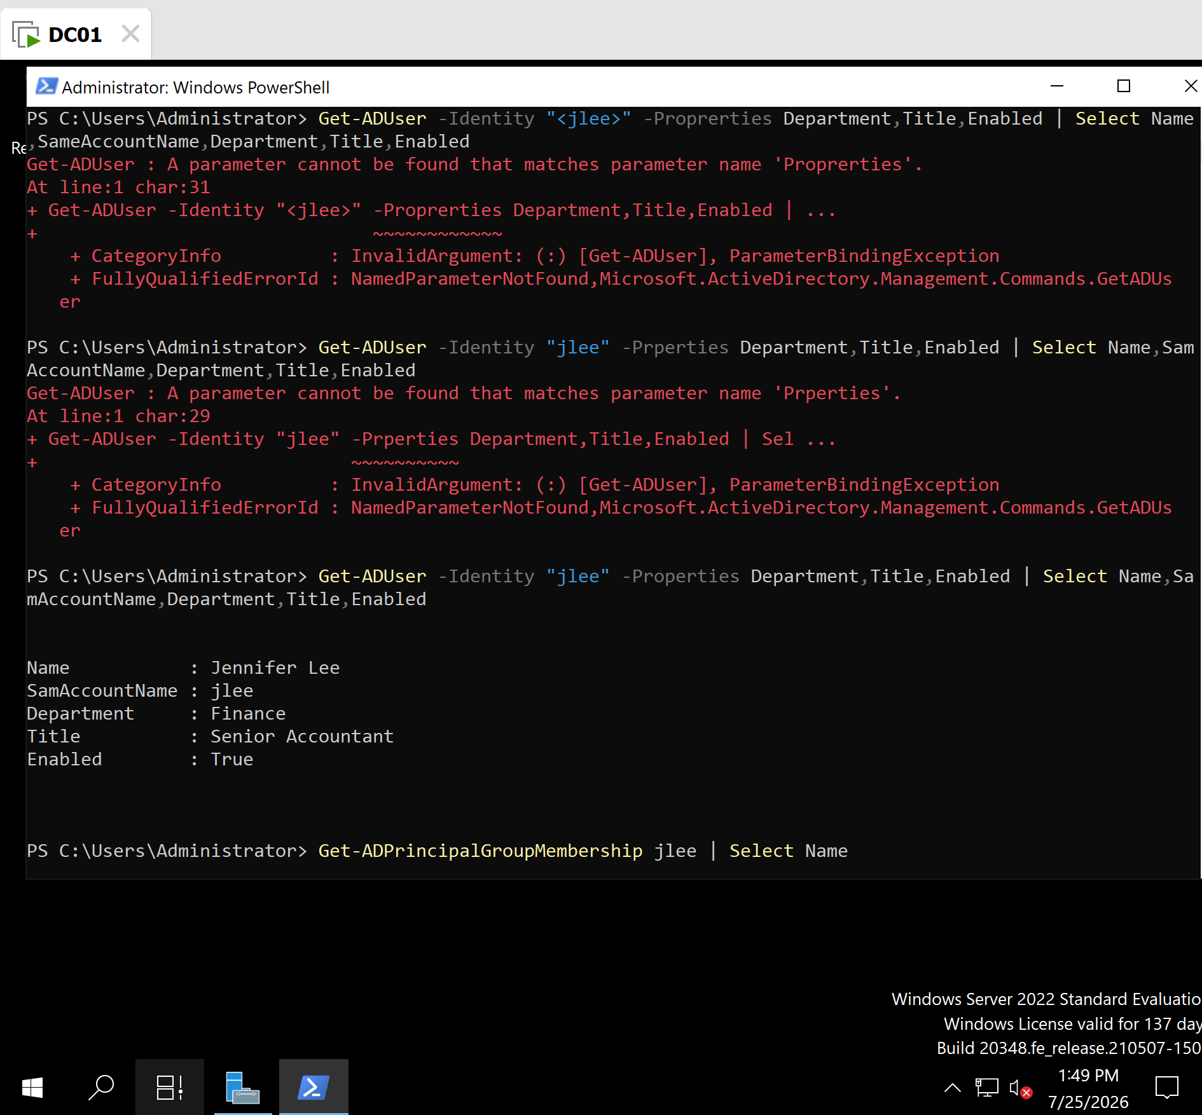
M1-T6-PowerShell-User-Properties.png
Description
Displayed Jennifer Lee's account information, including SamAccountName, department, job title, and account status.

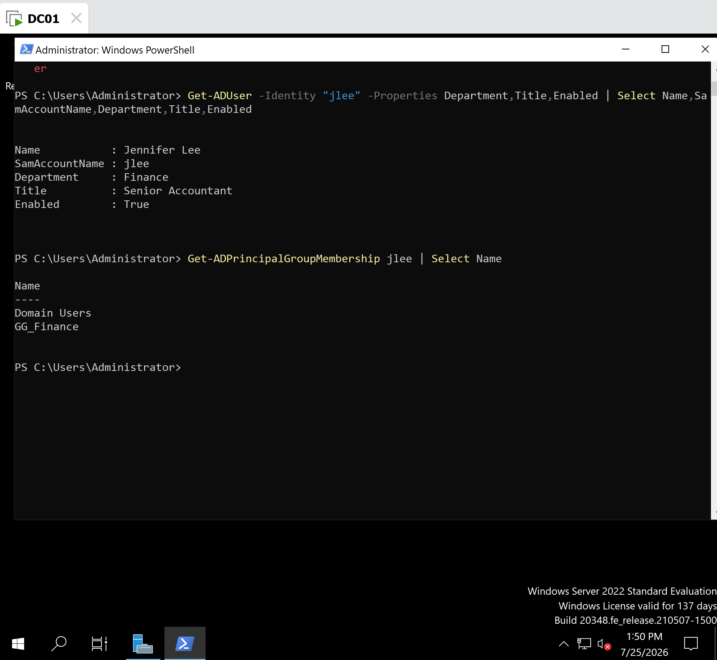
M1-T6-PowerShell-GroupMembership.png
Description
Retrieved Jennifer Lee's Active Directory group memberships using PowerShell.

Key Concepts Learned
- The Active Directory PowerShell module extends PowerShell with cmdlets for administering Active Directory.
- Import-Module ActiveDirectory loads the Active Directory cmdlets into the current session.
- Get-ADDomain verifies domain configuration.
- Get-ADUser retrieves Active Directory user objects.
- -Filter specifies which objects should be returned.
- -SearchBase limits the search to a specific Organizational Unit.
- SamAccountName is the unique legacy Windows logon name commonly used by administrators.
- -Identity works best with unique identifiers such as SamAccountName, Distinguished Name, GUID, or SID.
- Get-ADPrincipalGroupMembership quickly identifies the security groups a user belongs to.
- GG stands for Global Group, which is commonly used to group users by department or role.

Troubleshooting Performed
During this task, the following issues were encountered and resolved:

Issue 1
Get-ADUser -Identity "Jennifer Lee" returned an error because the Display Name is not the preferred identifier for the -Identity parameter.
Resolution
Identified the user's SamAccountName (jlee) and successfully queried the account.

Issue 2
PowerShell returned:
A parameter cannot be found that matches parameter name 'Prperties'
Cause
A typographical error in the parameter name.
Resolution
Corrected the spelling to:
-Properties
and the command executed successfully.

Lessons Learned
This task demonstrated how PowerShell complements graphical administration tools by providing faster, scriptable, and repeatable methods for managing Active Directory. Rather than manually navigating through administrative consoles, PowerShell enables administrators to retrieve user information, verify account status, inspect group memberships, and automate repetitive tasks using concise commands. Learning to use SamAccountName, understand Global Groups (GG), and troubleshoot common syntax errors are foundational skills for Windows Server administration.

Administrator's Notes
Enterprise Best Practice: PowerShell is the preferred tool for bulk administration, automation, and reporting in enterprise Windows environments. While GUI tools such as ADUC and ADAC are excellent for interactive management, PowerShell is commonly used to create users, reset passwords, unlock accounts, manage group memberships, generate reports, and automate repetitive administrative tasks. A Windows Systems Administrator should be comfortable using both GUI-based management and PowerShell depending on the situation.

Task 7 – Active Directory User Lifecycle Management

Objective
Learn how to manage the complete lifecycle of an Active Directory user account using Windows PowerShell. This task demonstrates how to create a user account, verify its creation, assign group membership, verify permissions, remove the account, and confirm its deletion.

Background
User account management is one of the most common responsibilities of Windows Systems Administrators. While Active Directory Users and Computers (ADUC) provides a graphical interface for managing users, PowerShell allows administrators to perform these tasks faster, more consistently, and at scale.
Organizations often use PowerShell to automate employee onboarding, department transfers, security group assignments, and account deprovisioning.

Systems Used
Component | Value
Server | DC01
Operating System | Windows Server 2022
Domain | benlab.local
Tool | Windows PowerShell
Active Directory Module | ActiveDirectory
Test User | Olivia Parker (Temporary Account)

Steps Performed

Step 1 – Create a New Active Directory User
Created a temporary Finance employee account using the New-ADUser cmdlet.
Key account information included:
- Display Name: Olivia Parker
- SamAccountName: oparker
- User Principal Name (UPN): oparker@benlab.local
- Department: Finance
- Title: Financial Analyst
- Organizational Unit: Finance OU
- Enabled account with an initial password

Step 2 – Verify User Creation
Verified that the account was successfully created using:
Get-ADUser oparker
Confirmed:
- Account enabled
- Correct SamAccountName
- Correct UPN
- Correct Organizational Unit
- User created successfully

Step 3 – Add User to Finance Security Group
Added Olivia Parker to the Finance Global Security Group using:
Add-ADGroupMember `
-Identity "GG_Finance" `
-Members oparker
The command completed successfully without returning any errors.

Step 4 – Verify Group Membership
Verified Olivia Parker's group memberships using:
Get-ADPrincipalGroupMembership oparker |
Select Name
Returned:
- Domain Users
- GG_Finance
This confirmed the account was successfully added to the Finance security group.

Step 5 – Remove Temporary User
Deleted the temporary lab account using:
Remove-ADUser oparker
PowerShell requested confirmation before deleting the account.
Confirmed the deletion by selecting:

Step 6 – Verify User Deletion
Verified that the account had been removed by running:
Get-ADUser oparker
PowerShell returned:
Cannot find an object with identity: 'oparker'
This confirmed that the account had been successfully removed from Active Directory.

Verification
The following administrative tasks were successfully completed:
- Created a new Active Directory user
- Verified user account creation
- Added the user to the Finance security group
- Verified group membership
- Deleted the temporary user account
- Confirmed the account no longer existed

Screenshots
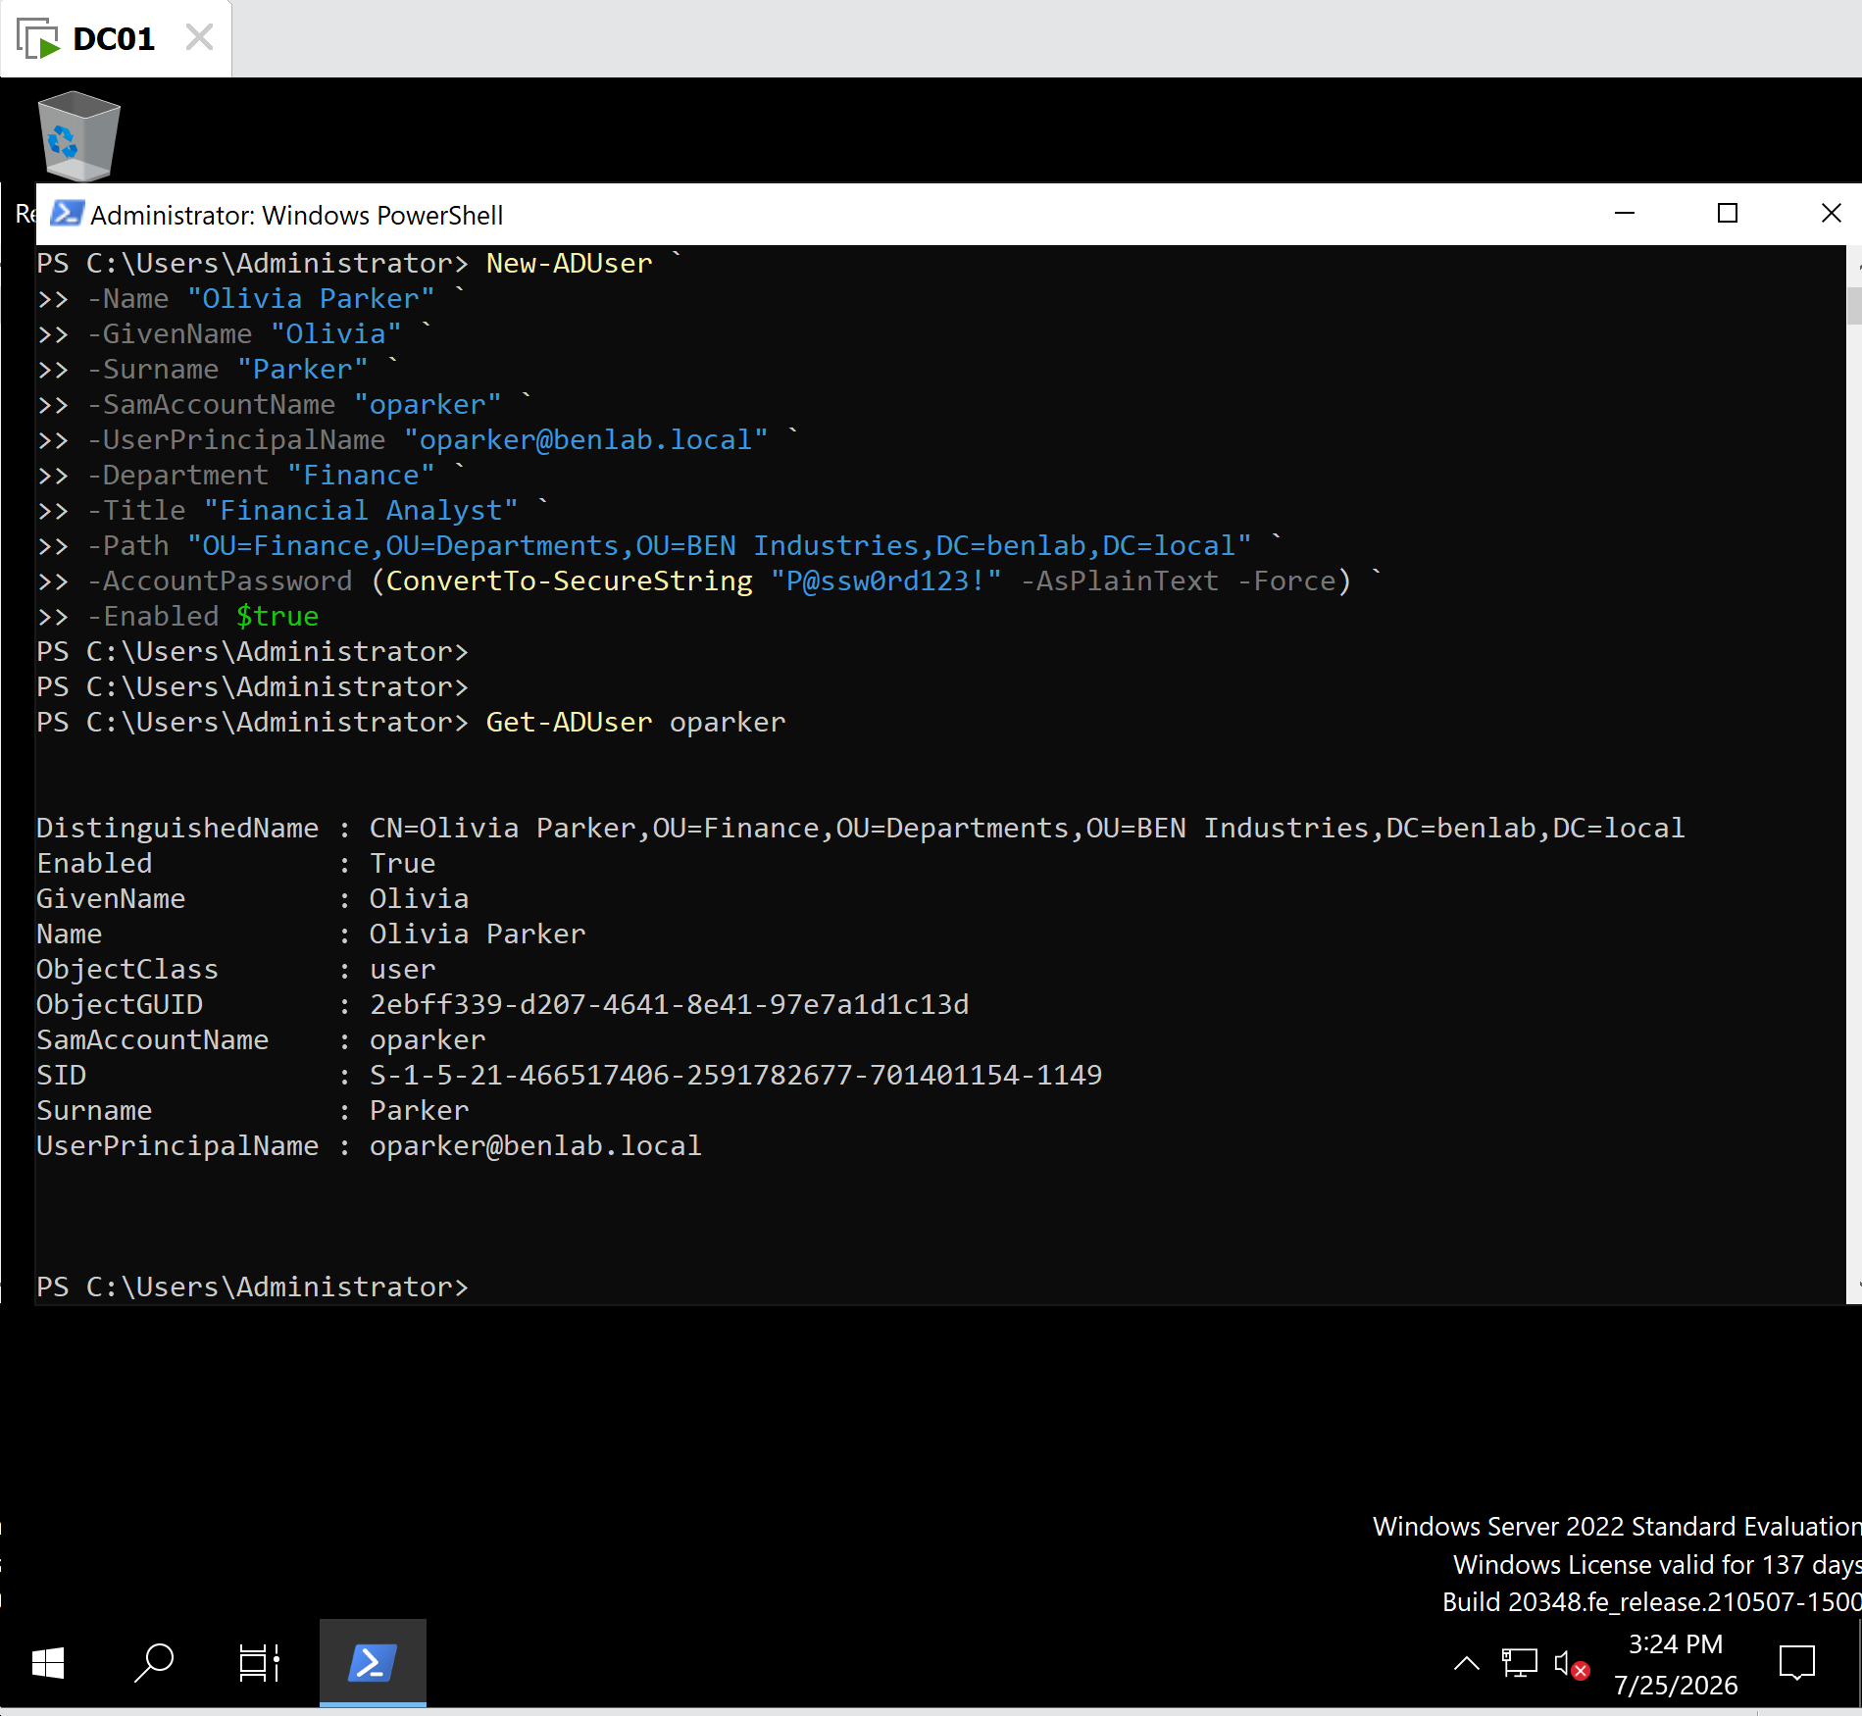
M1-T7-New-ADUser.png
Description
Created the temporary Active Directory user account using the New-ADUser PowerShell cmdlet.

M1-T7-Verify-User.png
Description
Verified the newly created user account using Get-ADUser.

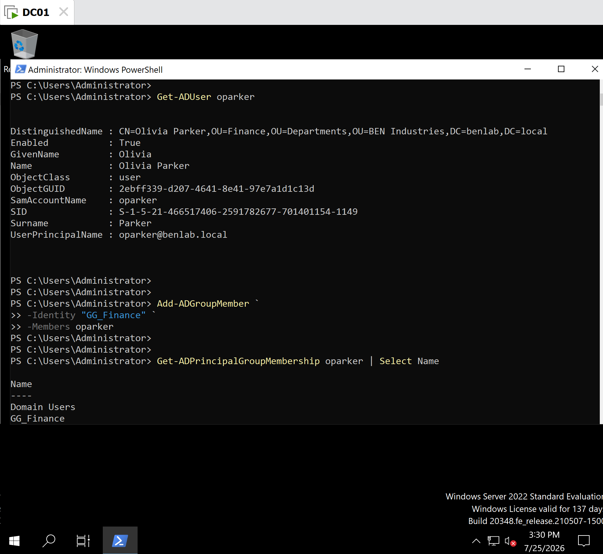
M1-T7-Add-GroupMembership.png
Description
Added Olivia Parker to the GG_Finance security group using Add-ADGroupMember.

M1-T7-Verify-GroupMembership.png
Description
Verified the user's membership in the GG_Finance security group using Get-ADPrincipalGroupMembership.

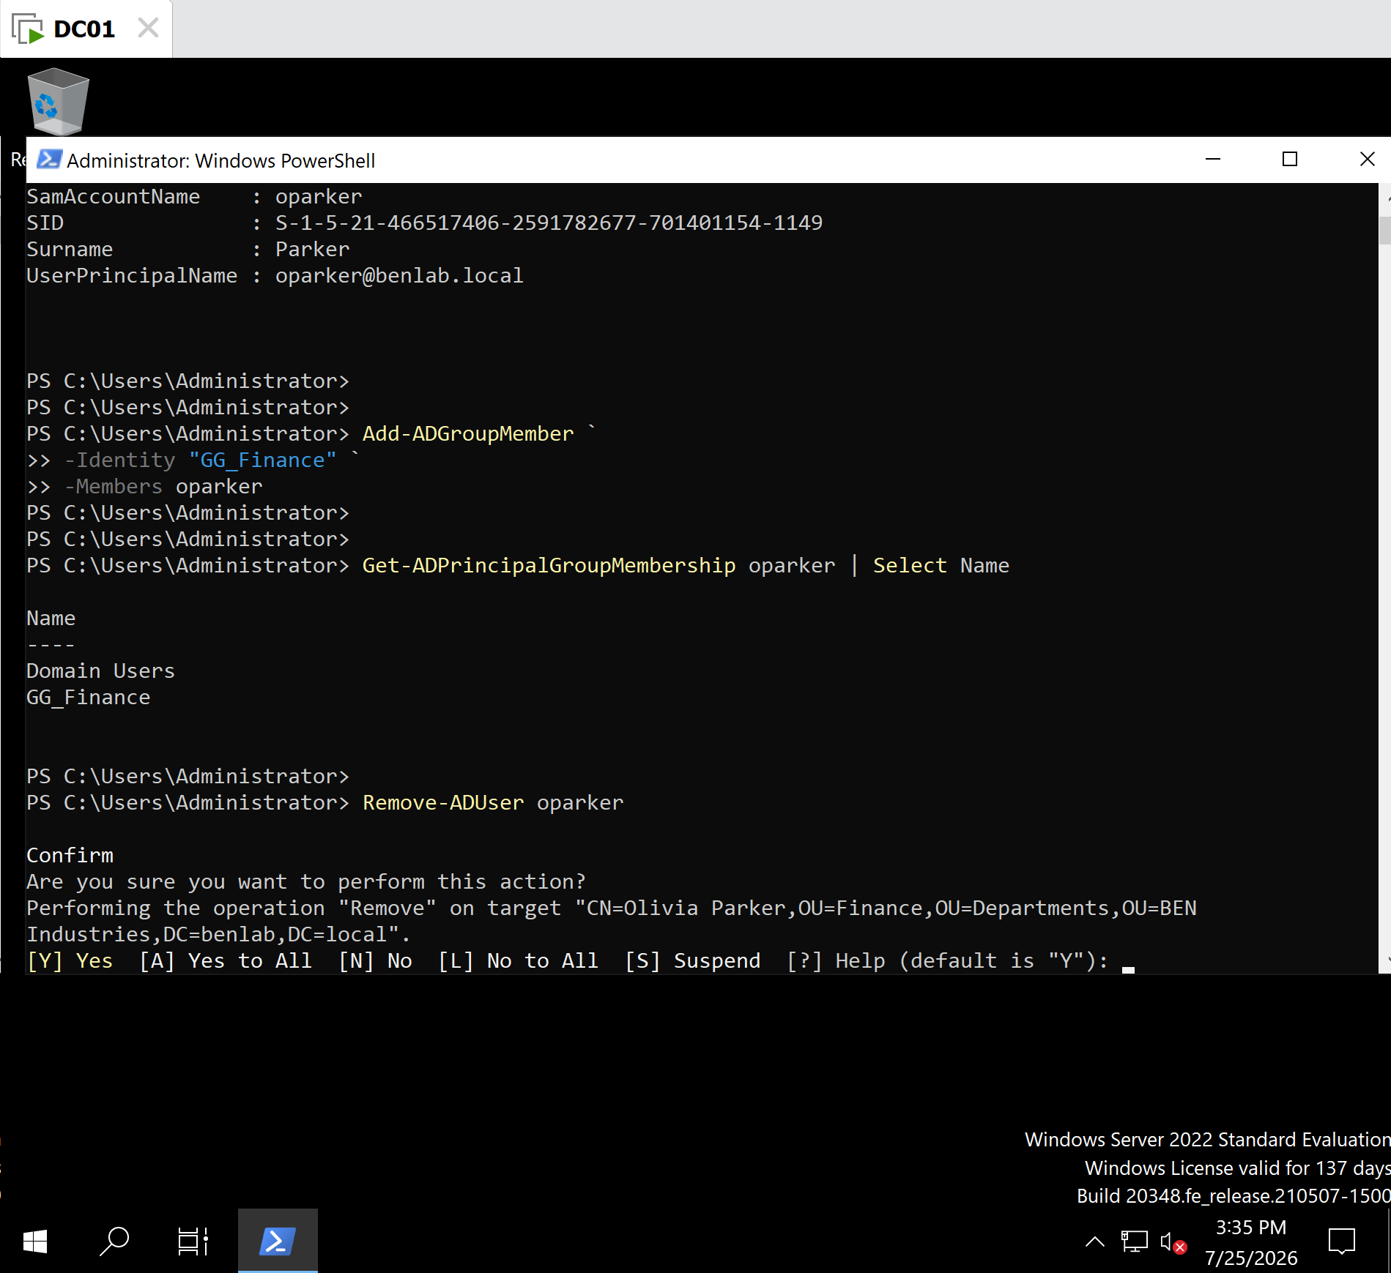
M1-T7-Remove-User.png
Description
Removed the temporary Active Directory user account using Remove-ADUser and confirmed the deletion.

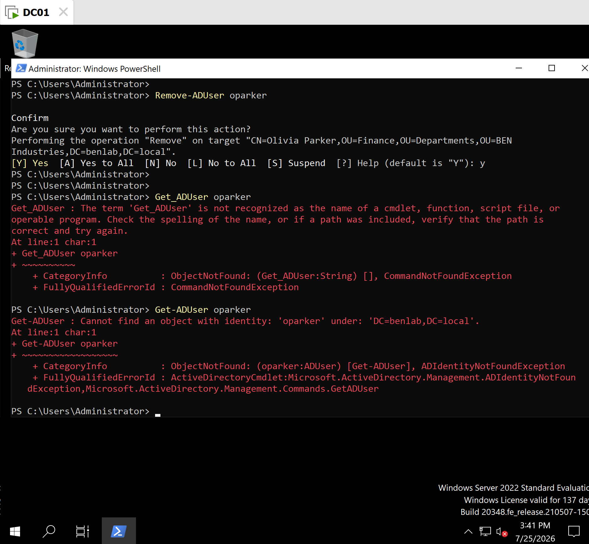
M1-T7-Verify-Deletion.png
Description
Verified the account no longer existed by running Get-ADUser, which returned the expected "Cannot find an object with identity" message.

Key Concepts Learned
- New-ADUser creates Active Directory user accounts.
- Get-ADUser retrieves and verifies user information.
- Add-ADGroupMember adds users to security groups.
- Get-ADPrincipalGroupMembership displays a user's group memberships.
- Remove-ADUser removes user accounts from Active Directory.
- SamAccountName is commonly used as the unique identifier in PowerShell.
- PowerShell prompts for confirmation before performing destructive actions such as deleting user accounts.
- Successful PowerShell commands often complete silently and return to the prompt without displaying a success message.

Troubleshooting Performed

Issue 1 – Missing Backticks
The command terminated early because a line continuation backtick (`) was omitted.
Resolution
Added the required backtick at the end of each line except the final line.

Issue 2 – Missing Parameter Hyphens
Some parameters were entered without the required leading hyphen (for example, Title instead of -Title).
Resolution
Corrected all parameter names to include the leading hyphen.

Issue 3 – Duplicate User Principal Name (UPN)
Attempting to create Emily Carter generated an error because the account already existed in Active Directory.
Resolution
Created a new temporary account named Olivia Parker using a unique SamAccountName and UPN.

Issue 4 – Cmdlet Typographical Error
Initially entered:
Get_ADUser
instead of:
Get-ADUser
Resolution
Corrected the cmdlet by replacing the underscore (_) with a hyphen (-).

Lessons Learned
This task demonstrated the complete lifecycle of an Active Directory user account using PowerShell. It reinforced the importance of accurate PowerShell syntax, including proper parameter formatting, line continuation characters, and command verification. It also highlighted the value of interpreting PowerShell error messages to troubleshoot syntax issues, duplicate objects, and verification tasks. Managing users through PowerShell provides a faster and more scalable approach than relying solely on graphical administration tools.

Administrator's Notes
Enterprise Best Practice: Many organizations automate user provisioning and deprovisioning with PowerShell. Administrators commonly use scripts to create user accounts, assign security groups, configure department attributes, and remove accounts during employee offboarding. Verifying each administrative action with cmdlets such as Get-ADUser and Get-ADPrincipalGroupMembership helps ensure changes were applied correctly before moving to production systems.

Task 8 – Active Directory Group Lifecycle Management

Objective
Learn how to manage Active Directory security groups using Windows PowerShell by creating a security group, verifying its configuration, adding users, verifying membership, removing users, deleting the group, and confirming its removal from Active Directory.

Background
Security groups are fundamental to access management in Active Directory. Rather than assigning permissions directly to individual users, administrators assign permissions to security groups and then add or remove users from those groups. This simplifies administration, improves security, and supports the Principle of Least Privilege.
PowerShell enables administrators to efficiently create, modify, and remove groups while automating repetitive administrative tasks.

Systems Used
Component | Value
Server | DC01
Operating System | Windows Server 2022
Domain | benlab.local
Tool | Windows PowerShell
Active Directory Module | ActiveDirectory
Temporary Group | GG_ProjectAlpha

Steps Performed

Step 1 – Create a Security Group
Created a temporary Global Security Group named GG_ProjectAlpha using the New-ADGroup cmdlet.
Configuration included:
- Group Name: GG_ProjectAlpha
- SamAccountName: GG_ProjectAlpha
- Group Scope: Global
- Group Category: Security
- Location: Groups OU

Step 2 – Verify Group Creation
Verified the group using:
Get-ADGroup GG_ProjectAlpha
Confirmed:
- Group exists
- Security group
- Global scope
- Correct Organizational Unit
- Correct SamAccountName

Step 3 – Add Users to the Group
Added existing Active Directory users to the temporary group:
- Jennifer Lee (jlee)
- Kevin Adams (kadams)
Command used:
Add-ADGroupMember `
-Identity "GG_ProjectAlpha" `
-Members jlee,kadams
The command completed successfully without errors.

Step 4 – Verify Group Membership
Verified the group membership using:
Get-ADGroupMember GG_ProjectAlpha |
Select Name,ObjectClass
Returned:
- Jennifer Lee
- Kevin Adams
Both objects were verified as Active Directory user accounts.

Step 5 – Remove a Group Member
Simulated a project change by removing Kevin Adams from the group.
Command used:
Remove-ADGroupMember `
-Identity "GG_ProjectAlpha" `
-Members kadams
PowerShell requested confirmation before removing the user.

Step 6 – Verify Updated Membership
Verified the updated membership using:
Get-ADGroupMember GG_ProjectAlpha |
Select Name
Confirmed only:
- Jennifer Lee
remained a member of the group.

Step 7 – Remove the Temporary Group
Deleted the temporary security group using:
Remove-ADGroup GG_ProjectAlpha
PowerShell requested confirmation before deleting the group.

Step 8 – Verify Group Deletion
Verified the deletion by running:
Get-ADGroup GG_ProjectAlpha
PowerShell returned:
Cannot find an object with identity: 'GG_ProjectAlpha'
This confirmed the group had been successfully removed from Active Directory.

Verification
The following administrative tasks were successfully completed:
- Created a Global Security Group
- Verified the group configuration
- Added users to the group
- Verified group membership
- Removed a user from the group
- Verified updated membership
- Deleted the temporary group
- Confirmed the group no longer existed

Screenshots
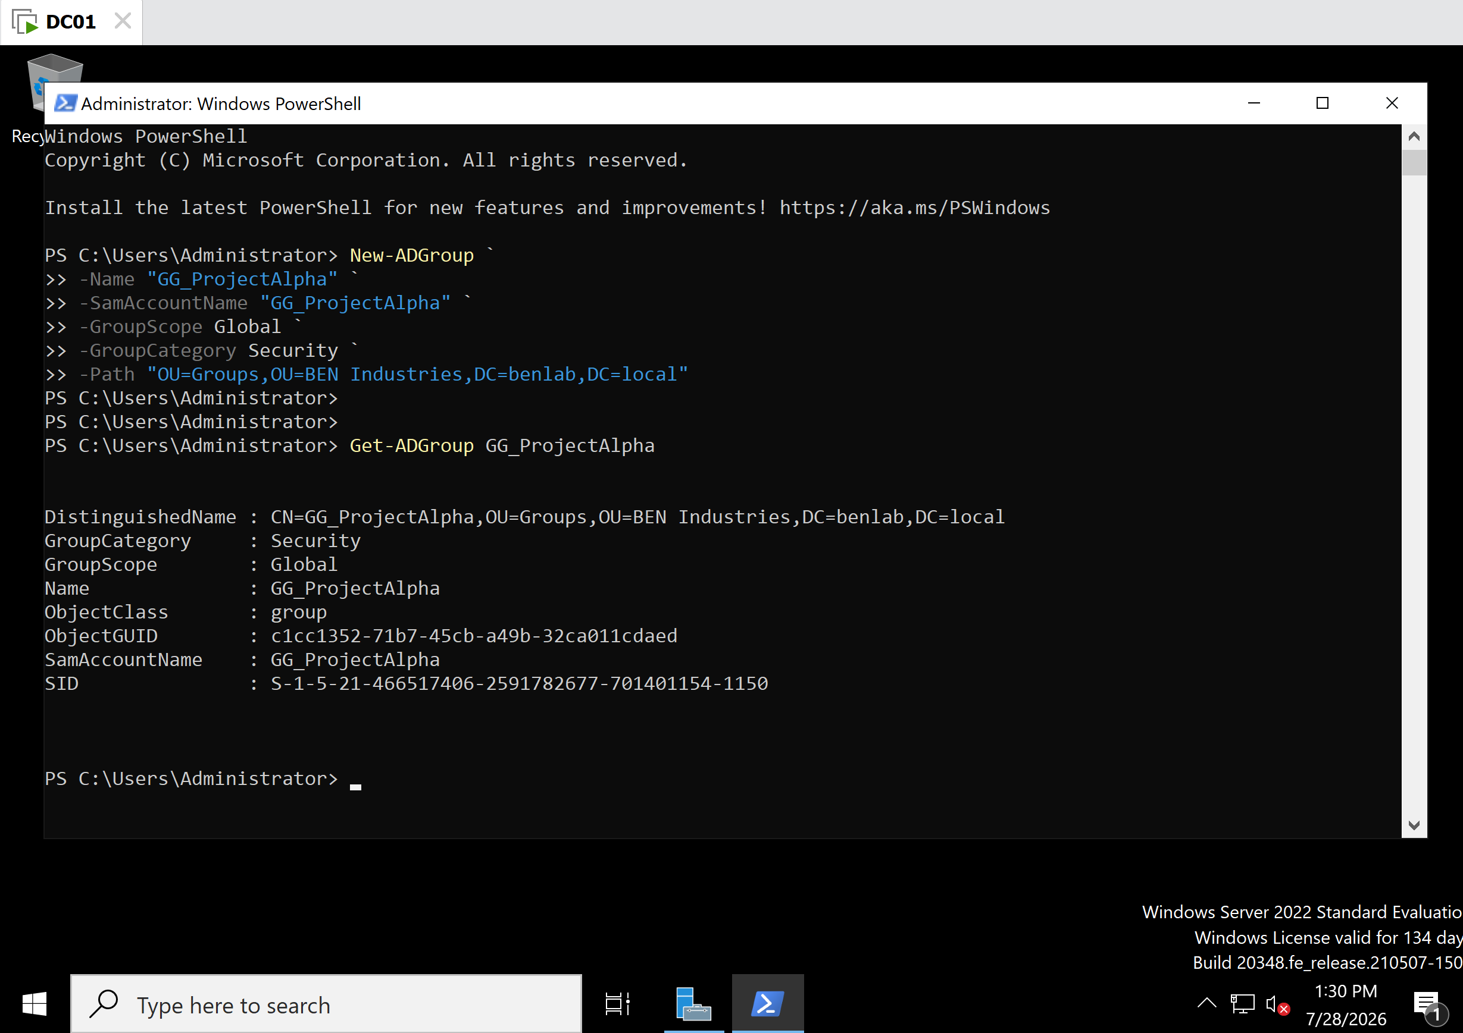
M1-T8-New-ADGroup.png
Description
Created the temporary security group GG_ProjectAlpha using the New-ADGroup PowerShell cmdlet.

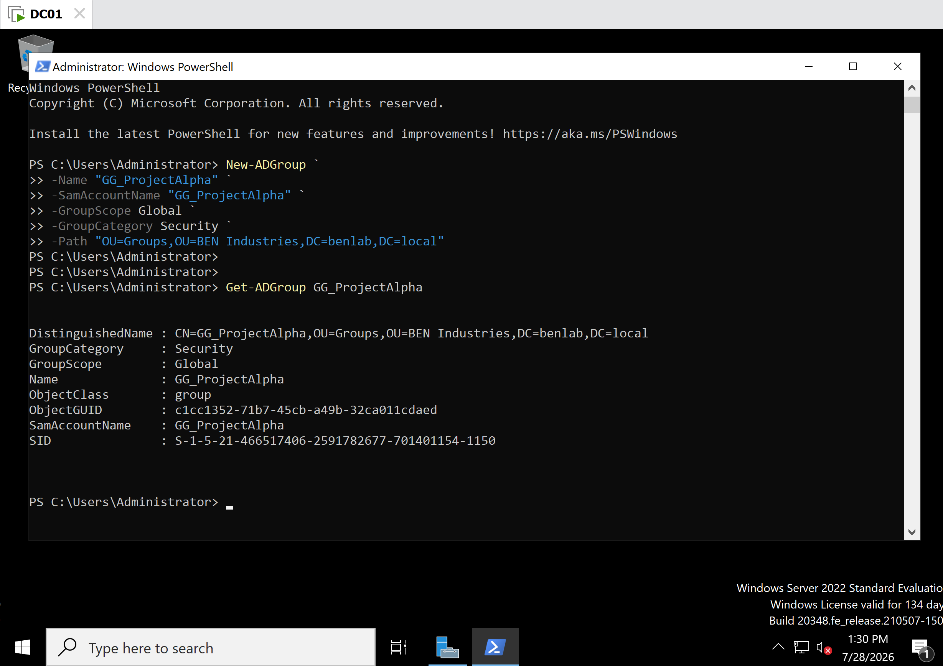
M1-T8-Verify-Group.png
Description
Verified the group configuration, including Group Scope, Group Category, and Organizational Unit.

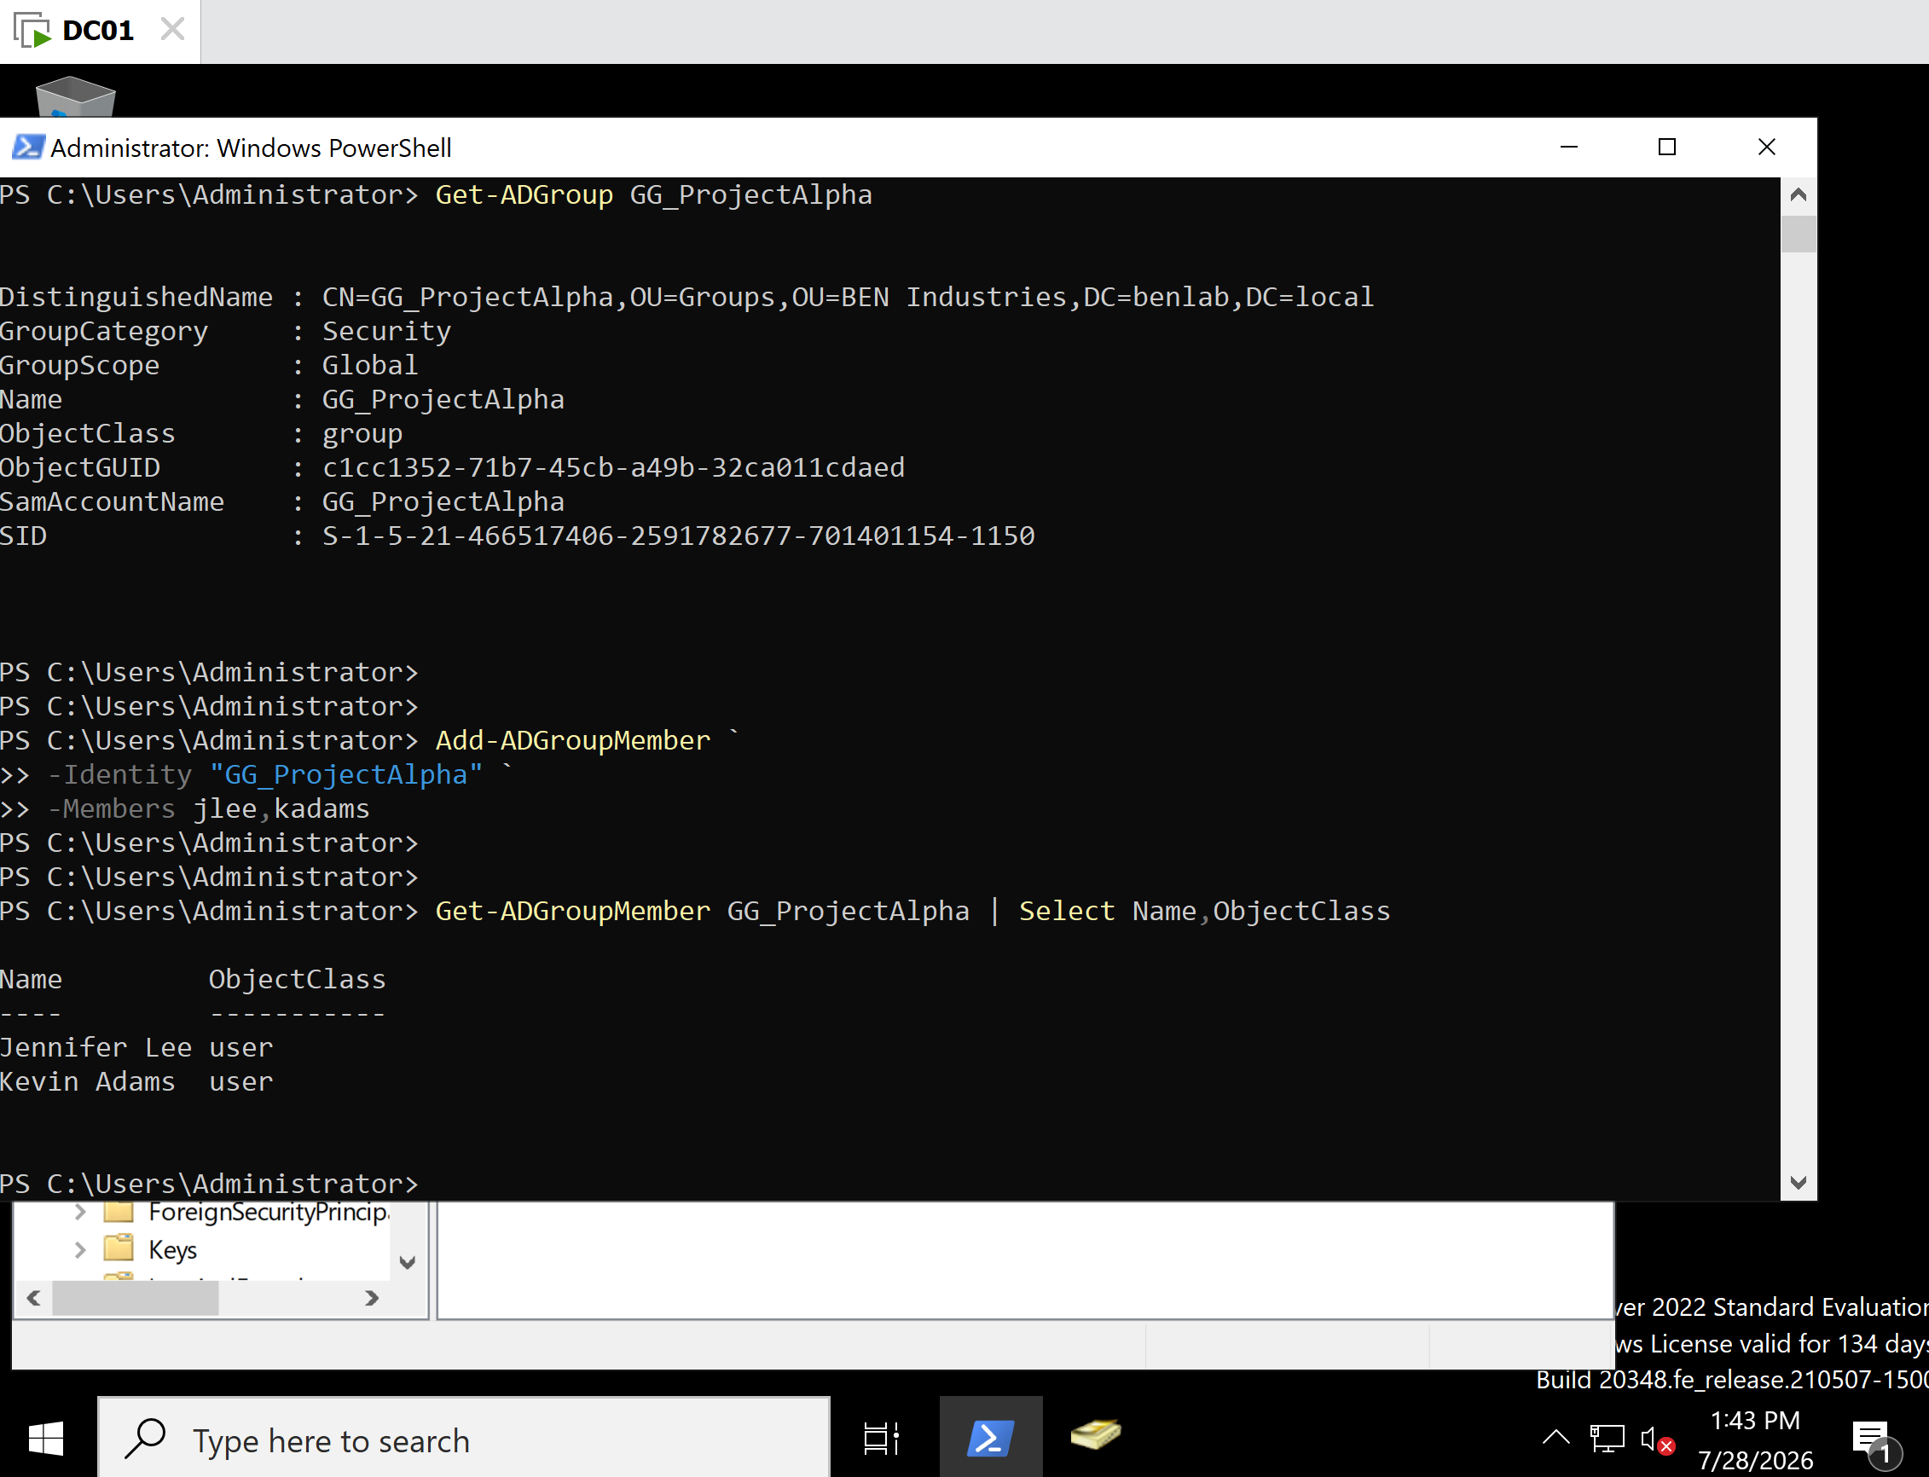
M1-T8-Add-GroupMembers.png
Description
Added Jennifer Lee and Kevin Adams to the GG_ProjectAlpha security group using Add-ADGroupMember.

M1-T8-Verify-GroupMembers.png
Description
Verified both users were members of GG_ProjectAlpha using Get-ADGroupMember.

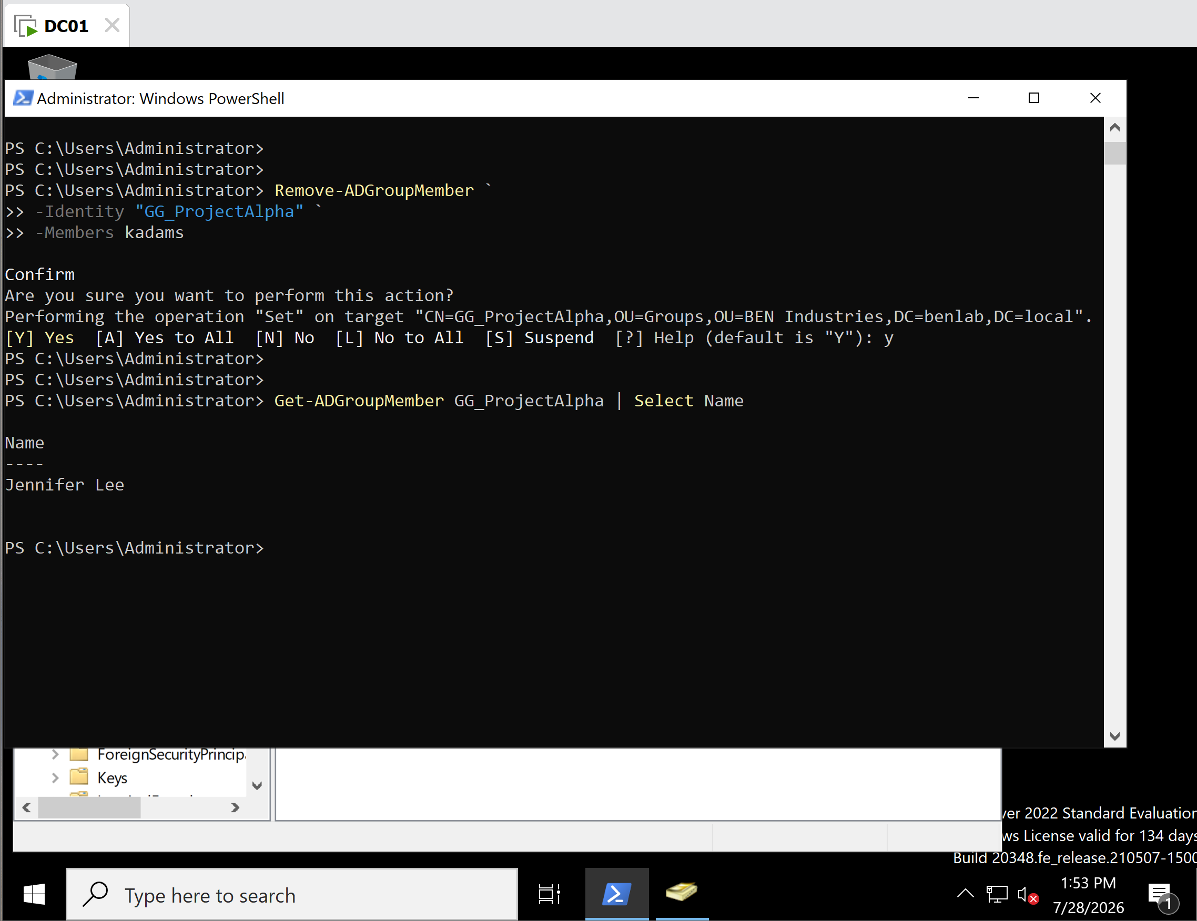
M1-T8-Remove-GroupMember.png
Description
Removed Kevin Adams from the security group using Remove-ADGroupMember.

M1-T8-Verify-RemainingMember.png
Description
Verified Jennifer Lee remained the only member of the group after Kevin Adams was removed.

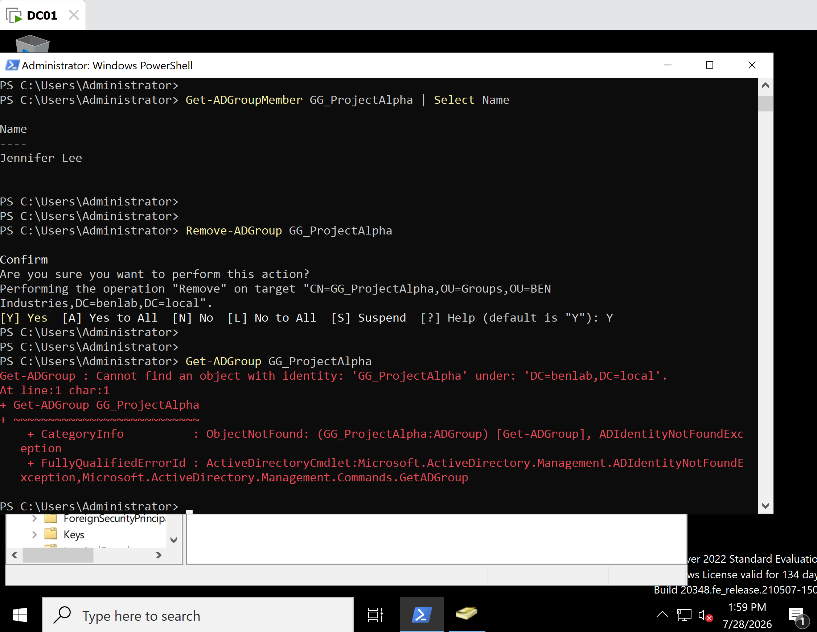
M1-T8-Remove-Group.png
Description
Deleted the temporary security group GG_ProjectAlpha using Remove-ADGroup.

M1-T8-Verify-GroupDeletion.png
Description
Verified the group no longer existed by running Get-ADGroup, which returned the expected "Cannot find an object with identity" message.

Key Concepts Learned
- New-ADGroup creates Active Directory security groups.
- Get-ADGroup retrieves and verifies group information.
- Add-ADGroupMember adds users to security groups.
- Get-ADGroupMember lists the members of a group.
- Remove-ADGroupMember removes users from security groups.
- Remove-ADGroup deletes security groups.
- Global Security Groups are commonly used to organize users for permission assignment.
- PowerShell requests confirmation before destructive actions such as deleting groups.

Troubleshooting Performed

Issue 1 – Multi-line PowerShell Syntax
While entering PowerShell commands, proper use of backticks () and parameter prefixes (-`) was reinforced to ensure successful execution.
Resolution
Verified that each line ended with a backtick except the final line and confirmed all parameters included the required leading hyphen.

Issue 2 – Verification of Group Membership
Confirmed that users were successfully added and removed by using:
Get-ADGroupMember
rather than relying solely on command completion.
Resolution
Verified membership after every administrative change to ensure the expected results.

Lessons Learned
This task demonstrated the complete lifecycle of an Active Directory security group using PowerShell. It reinforced the importance of managing permissions through security groups instead of assigning permissions directly to users. The task also highlighted the value of verifying every administrative change using PowerShell cmdlets and maintaining a clean Active Directory environment by removing temporary objects after testing.

Administrator's Notes
Enterprise Best Practice: Organizations commonly assign permissions to security groups rather than individual users. Administrators add or remove users from groups as employees join projects, change departments, or leave the organization. PowerShell enables these changes to be performed consistently, efficiently, and at scale while providing quick verification through cmdlets such as Get-ADGroup and Get-ADGroupMember.

Task 9 – Bulk Active Directory User Management with PowerShell

Objective
Learn how to perform bulk administration of Active Directory user accounts using Windows PowerShell by identifying users based on a common attribute, modifying multiple user accounts simultaneously, verifying the changes, restoring the original configuration, and confirming the restoration.

Background
Enterprise environments often require administrators to update dozens or hundreds of user accounts at once. Rather than modifying each account individually through Active Directory Users and Computers (ADUC), PowerShell allows administrators to automate repetitive administrative tasks using pipelines and cmdlets.
Bulk administration improves efficiency, reduces administrative effort, and minimizes the risk of inconsistent configuration across user accounts.

Systems Used
Component | Value
Server | DC01
Operating System | Windows Server 2022
Domain | benlab.local
Tool | Windows PowerShell
Active Directory Module | ActiveDirectory
Department | Finance

Steps Performed

Step 1 – Display Finance Department Users
Retrieved all Finance department users along with their department and current job titles.
Command used:
Get-ADUser `
-Filter "Department -eq 'Finance'" `
-Properties Department,Title |
Select Name,Department,Title
Verified the following users:
- Robert Walker
- Jennifer Lee
- Kevin Adams
- Sophia Turner
along with their original job titles.

Step 2 – Perform Bulk Job Title Update
Updated every user in the Finance department to the temporary title:
Senior Financial Analyst
Command used:
Get-ADUser `
-Filter "Department -eq 'Finance'" |
ForEach-Object {
Set-ADUser $_ `
-Title "Senior Financial Analyst"
}
PowerShell processed every matching user account through the pipeline and updated the Title attribute.

Step 3 – Verify Bulk Update
Verified the updated job titles by running:
Get-ADUser `
-Filter "Department -eq 'Finance'" `
-Properties Department,Title |
Select Name,Department,Title
Confirmed that every Finance user displayed:
- Senior Financial Analyst

Step 4 – Restore Original Job Titles
Returned each Finance user to their original job title using the Set-ADUser cmdlet.
Commands used:
Set-ADUser rwalker `
-Title "Finance Manager"

Set-ADUser jlee `
-Title "Senior Accountant"

Set-ADUser kadams `
-Title "Accountant"

Set-ADUser sturner `
-Title "Payroll Specialist"

Step 5 – Verify Restoration
Verified the original configuration using:
Get-ADUser `
-Filter "Department -eq 'Finance'" `
-Properties Department,Title |
Select Name,Department,Title
Confirmed the original titles had been successfully restored.

Verification
Successfully demonstrated:
- Retrieved users using the Department attribute.
- Used the -eq comparison operator to filter Active Directory objects.
- Performed a bulk modification using a PowerShell pipeline.
- Verified the updated user attributes.
- Restored the original configuration.
- Verified the restoration.

Screenshots
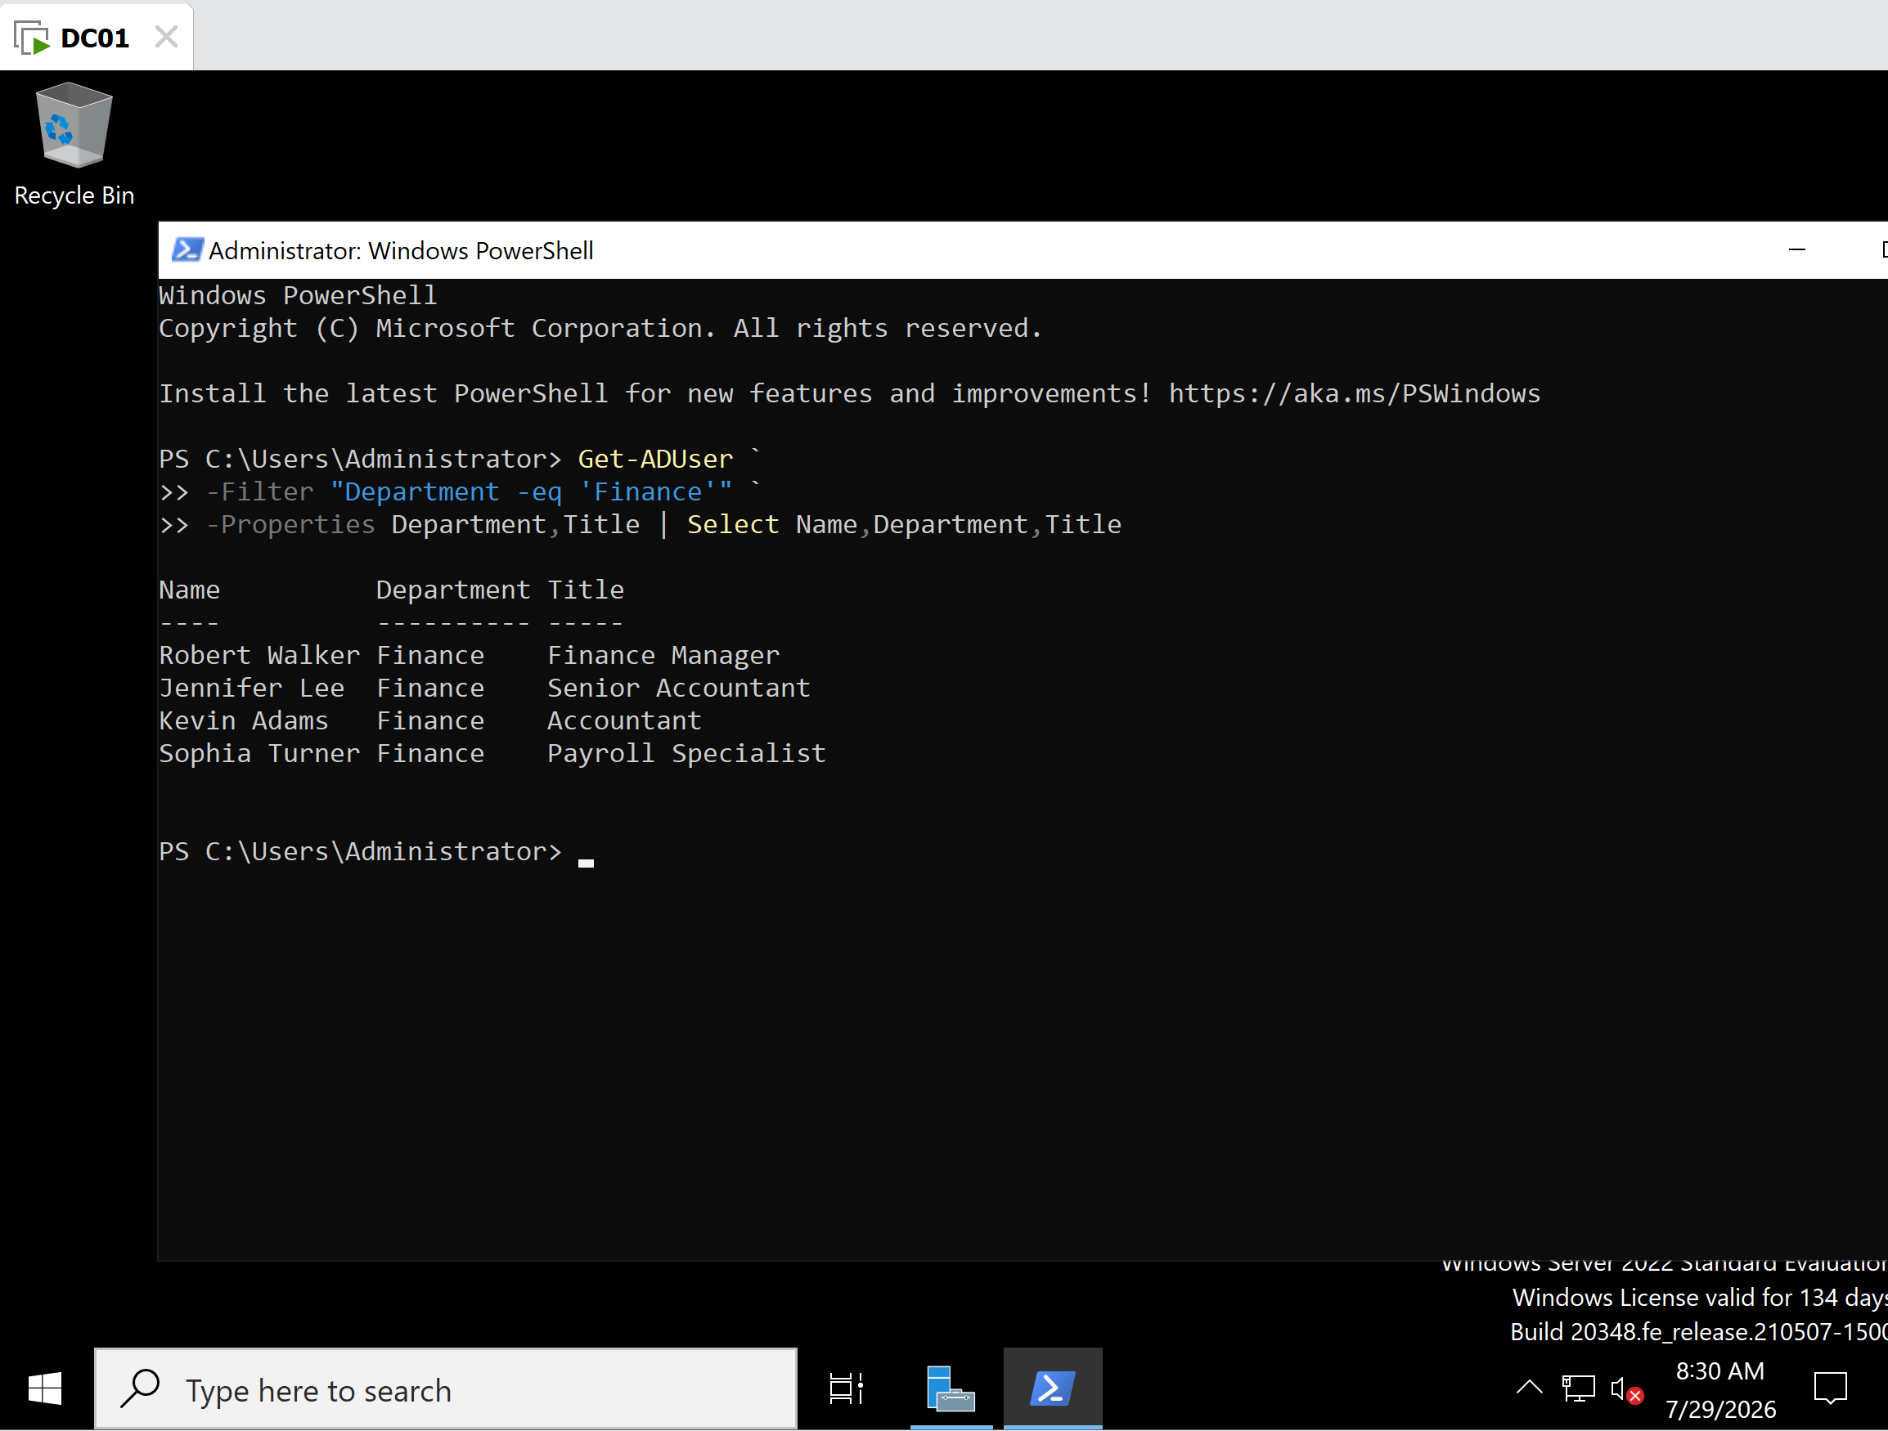
M1-T9-Current-Finance-Users.png
Description
Displayed all Finance department users and their original job titles before performing the bulk update.

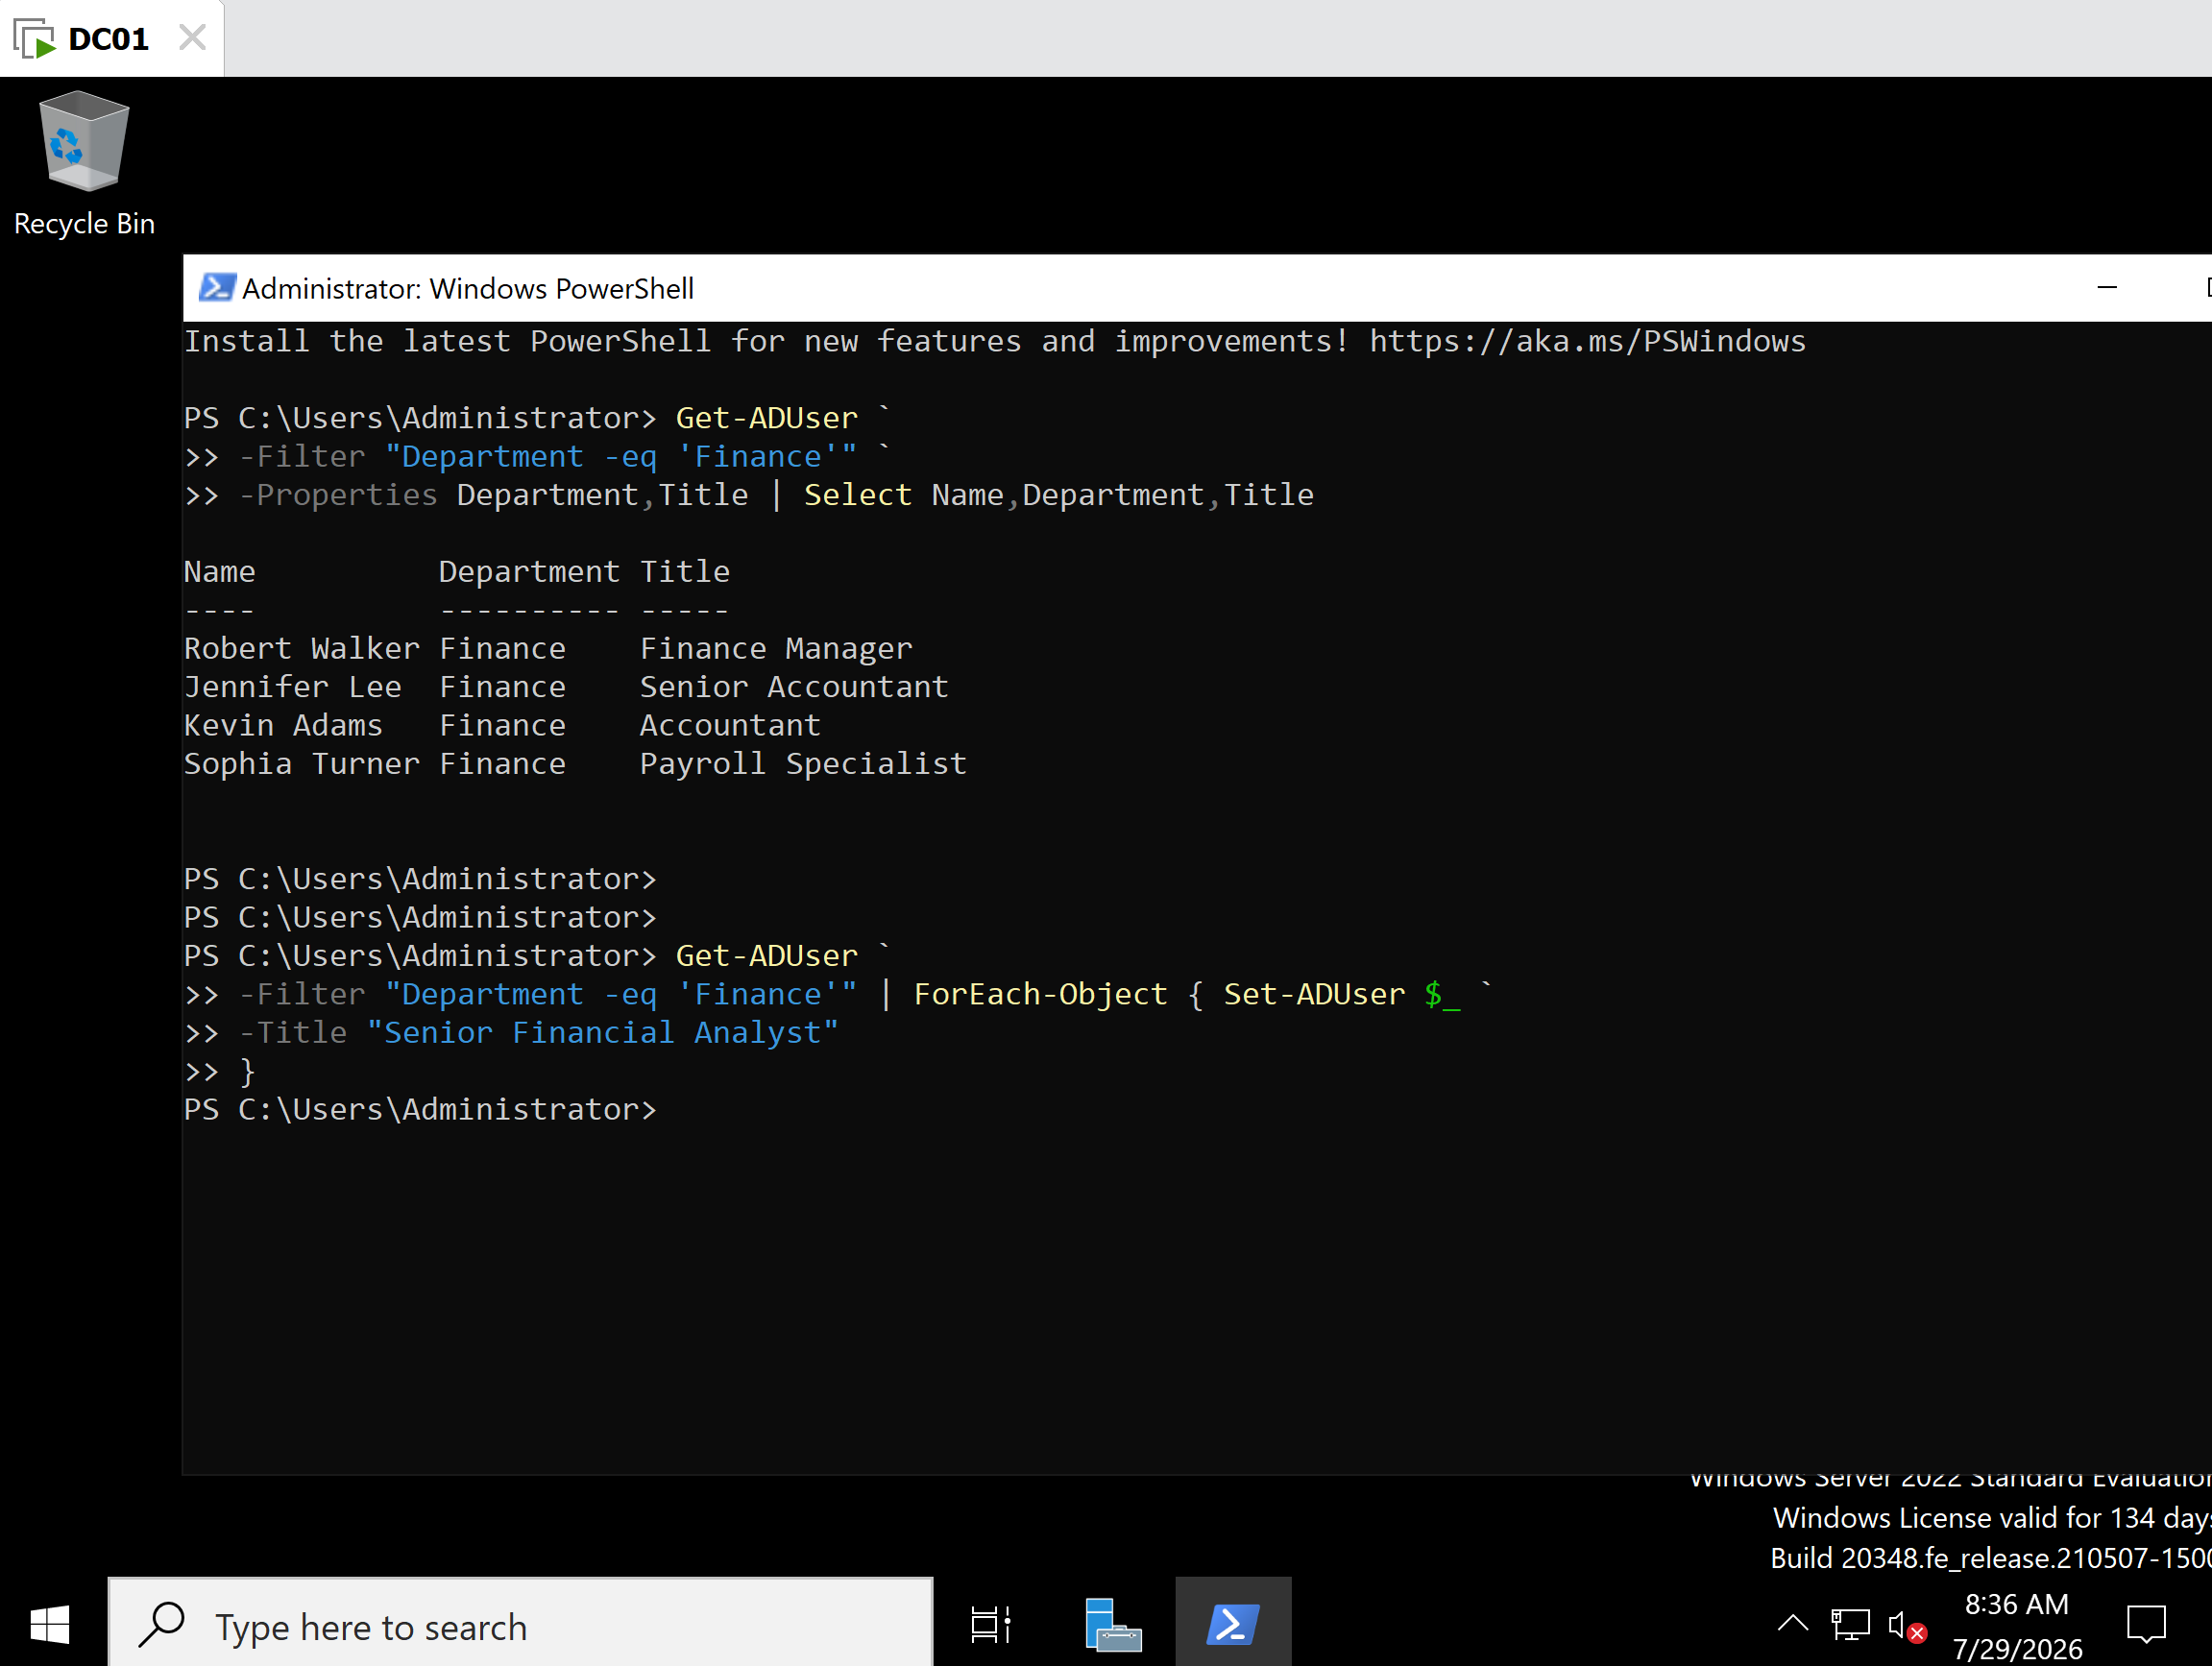
M1-T9-Bulk-Update.png
Description
Executed a PowerShell pipeline using Get-ADUser, ForEach-Object, and Set-ADUser to update the Title attribute for every Finance department user.

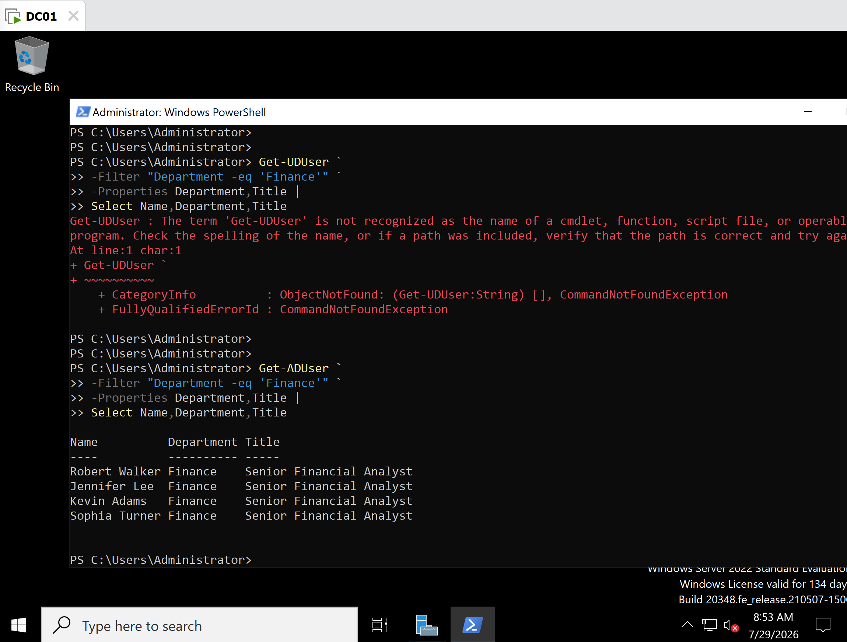
M1-T9-Verify-Bulk-Update.png
Description
Verified that every Finance department user had been updated to the temporary title Senior Financial Analyst.

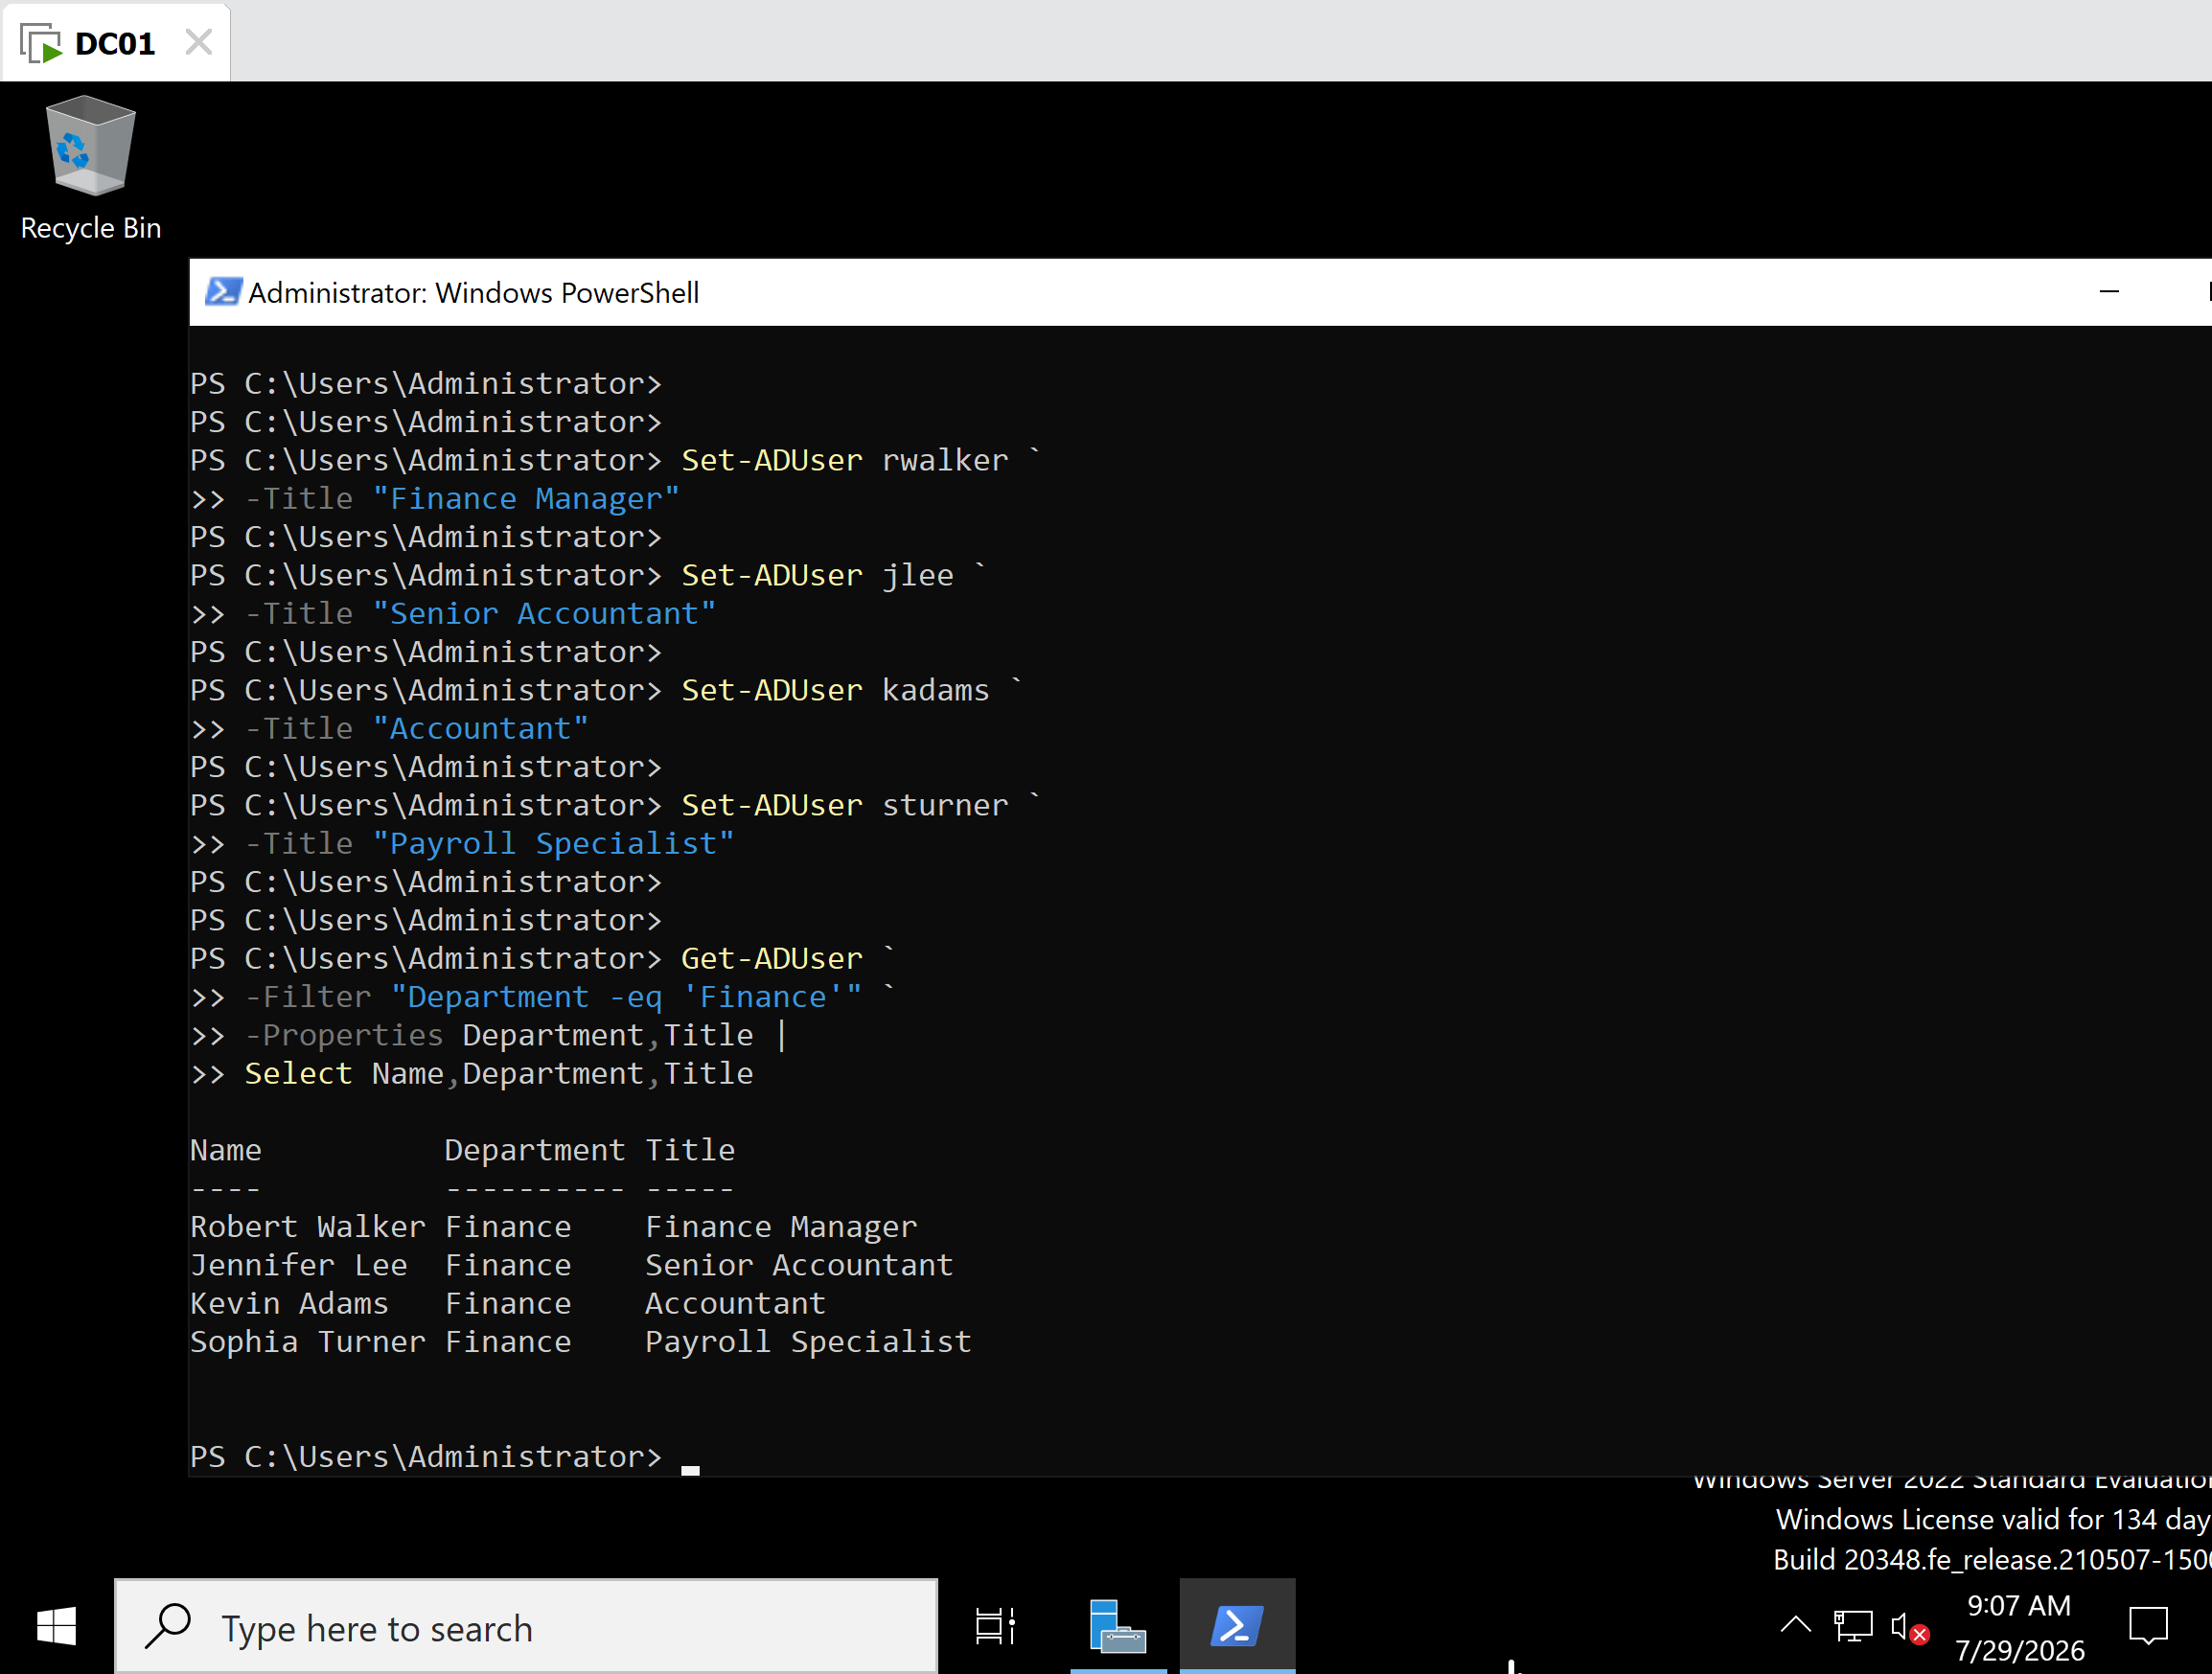
M1-T9-Restore-Titles.png
Description
Restored the original job titles for each Finance department user using individual Set-ADUser commands.

M1-T9-Verify-Restoration.png
Description
Verified that all Finance department users had been restored to their original job titles.

Key Concepts Learned
- Get-ADUser retrieves Active Directory user accounts.
- Set-ADUser modifies existing user attributes.
- ForEach-Object performs an action on every object passed through the pipeline.
- The PowerShell pipeline (|) passes output from one command directly to the next.
- The -eq operator compares two values for equality.
- Bulk administration is significantly faster than modifying users individually through the GUI.
- Administrative changes should always be verified after execution.
- Restoring a lab to its original state is a recommended practice after testing.

Troubleshooting Performed

Issue 1 – Incorrect Cmdlet Name
The command was initially entered as:
Get-UDUser
PowerShell returned a CommandNotFoundException because the cmdlet name was misspelled.
Resolution
Corrected the cmdlet to:
Get-ADUser
and successfully retrieved the Finance department users.

Issue 2 – Bulk Update Verification
After performing the bulk update, all Finance users displayed the temporary title:
Senior Financial Analyst
To preserve the integrity of the lab environment, the original job titles were restored and verified before concluding the task.

Lessons Learned
This task demonstrated the efficiency of PowerShell for bulk administration in Active Directory. Using filters, pipelines, and the Set-ADUser cmdlet allowed multiple user accounts to be updated simultaneously with minimal effort. The exercise also reinforced the importance of verifying administrative changes and restoring the lab environment to a known baseline after testing.

Administrator's Notes
Enterprise Best Practice: Large-scale user modifications should be performed using PowerShell rather than manually through graphical tools. Administrators should verify all changes immediately after execution and, when working in a lab or testing environment, restore the original configuration to maintain a consistent baseline for future exercises.

Task 10 – Enable and Disable Active Directory User Accounts Using PowerShell

Objective
Learn how to enable and disable Active Directory user accounts using PowerShell cmdlets while verifying account status before and after each administrative action.

Background
User accounts are frequently disabled in enterprise environments for security and administrative reasons, including employee leave, account compromise, temporary suspension, or offboarding. PowerShell allows administrators to perform these tasks quickly across one or many user accounts while maintaining consistency and automation.

Systems Used
- Windows Server 2022
- Active Directory Domain Services (AD DS)
- Windows PowerShell
- Domain Controller: DC01
- Domain: benlab.local

PowerShell Cmdlets Used

Verify Current Account Status
Get-ADUser kadams `
-Properties Enabled |
Select Name,Enabled

Disable the User Account
Disable-ADAccount kadams

Verify the Account is Disabled
Get-ADUser kadams `
-Properties Enabled |
Select Name,Enabled

Re-enable the User Account
Enable-ADAccount kadams

Verify the Account is Enabled Again
Get-ADUser kadams `
-Properties Enabled |
Select Name,Enabled

Verification
The PowerShell output confirmed the expected results:

Initial State
Kevin Adams
Enabled : True
↓

After Disabling
Kevin Adams
Enabled : False
↓

After Re-enabling
Kevin Adams
Enabled : True
This verified that the account status changed correctly after each administrative action.

Screenshots
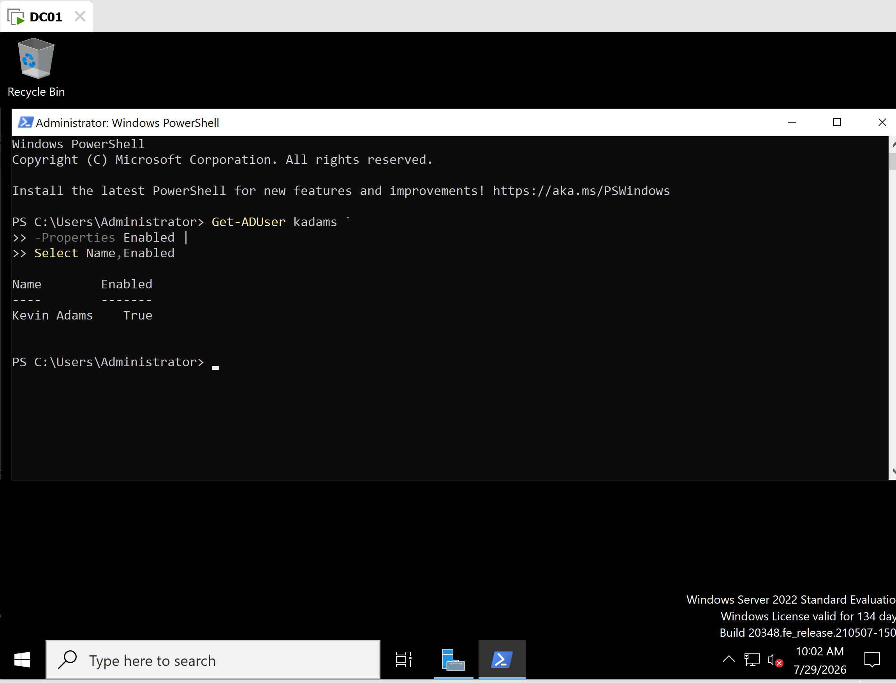
Initial account status (Enabled = True)

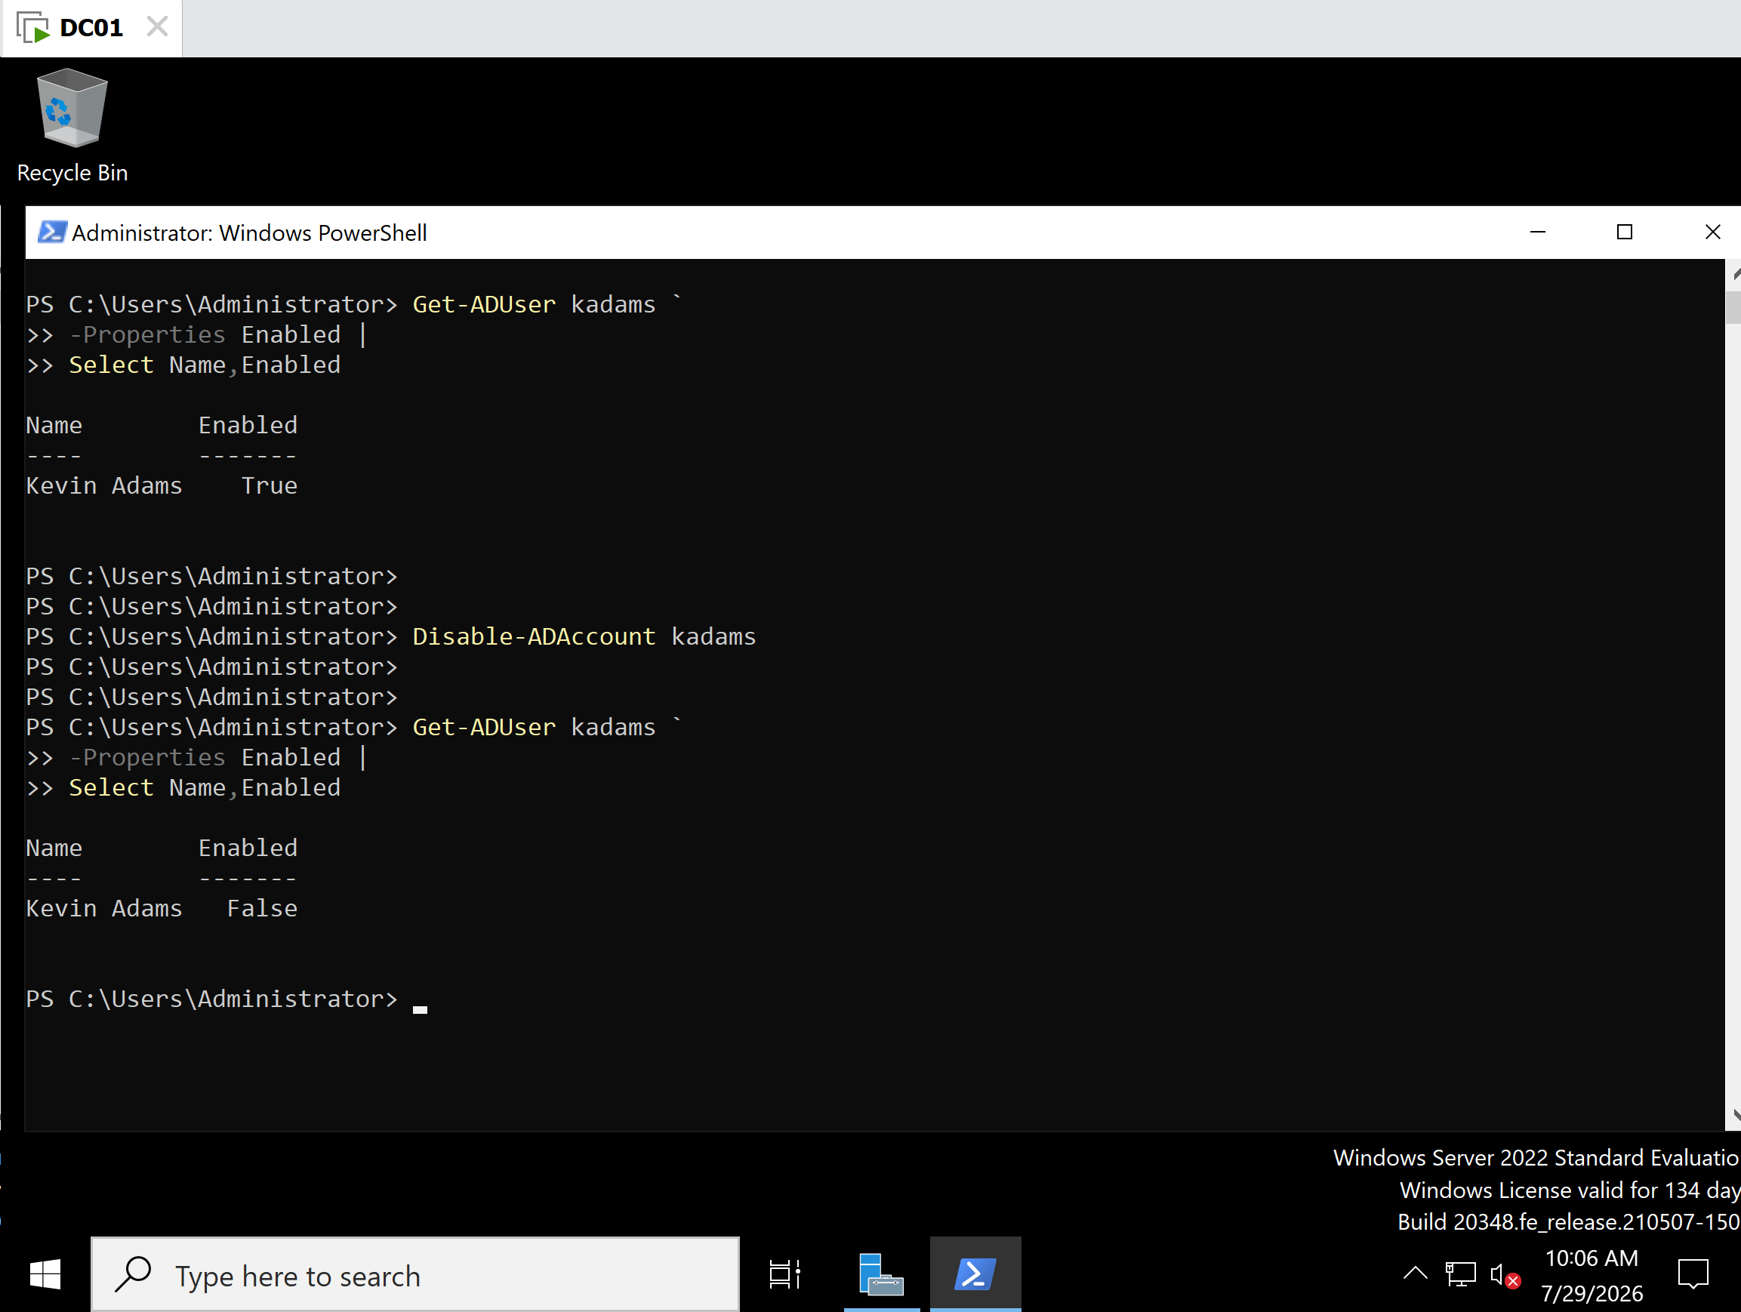
Account disabled (Enabled = False)
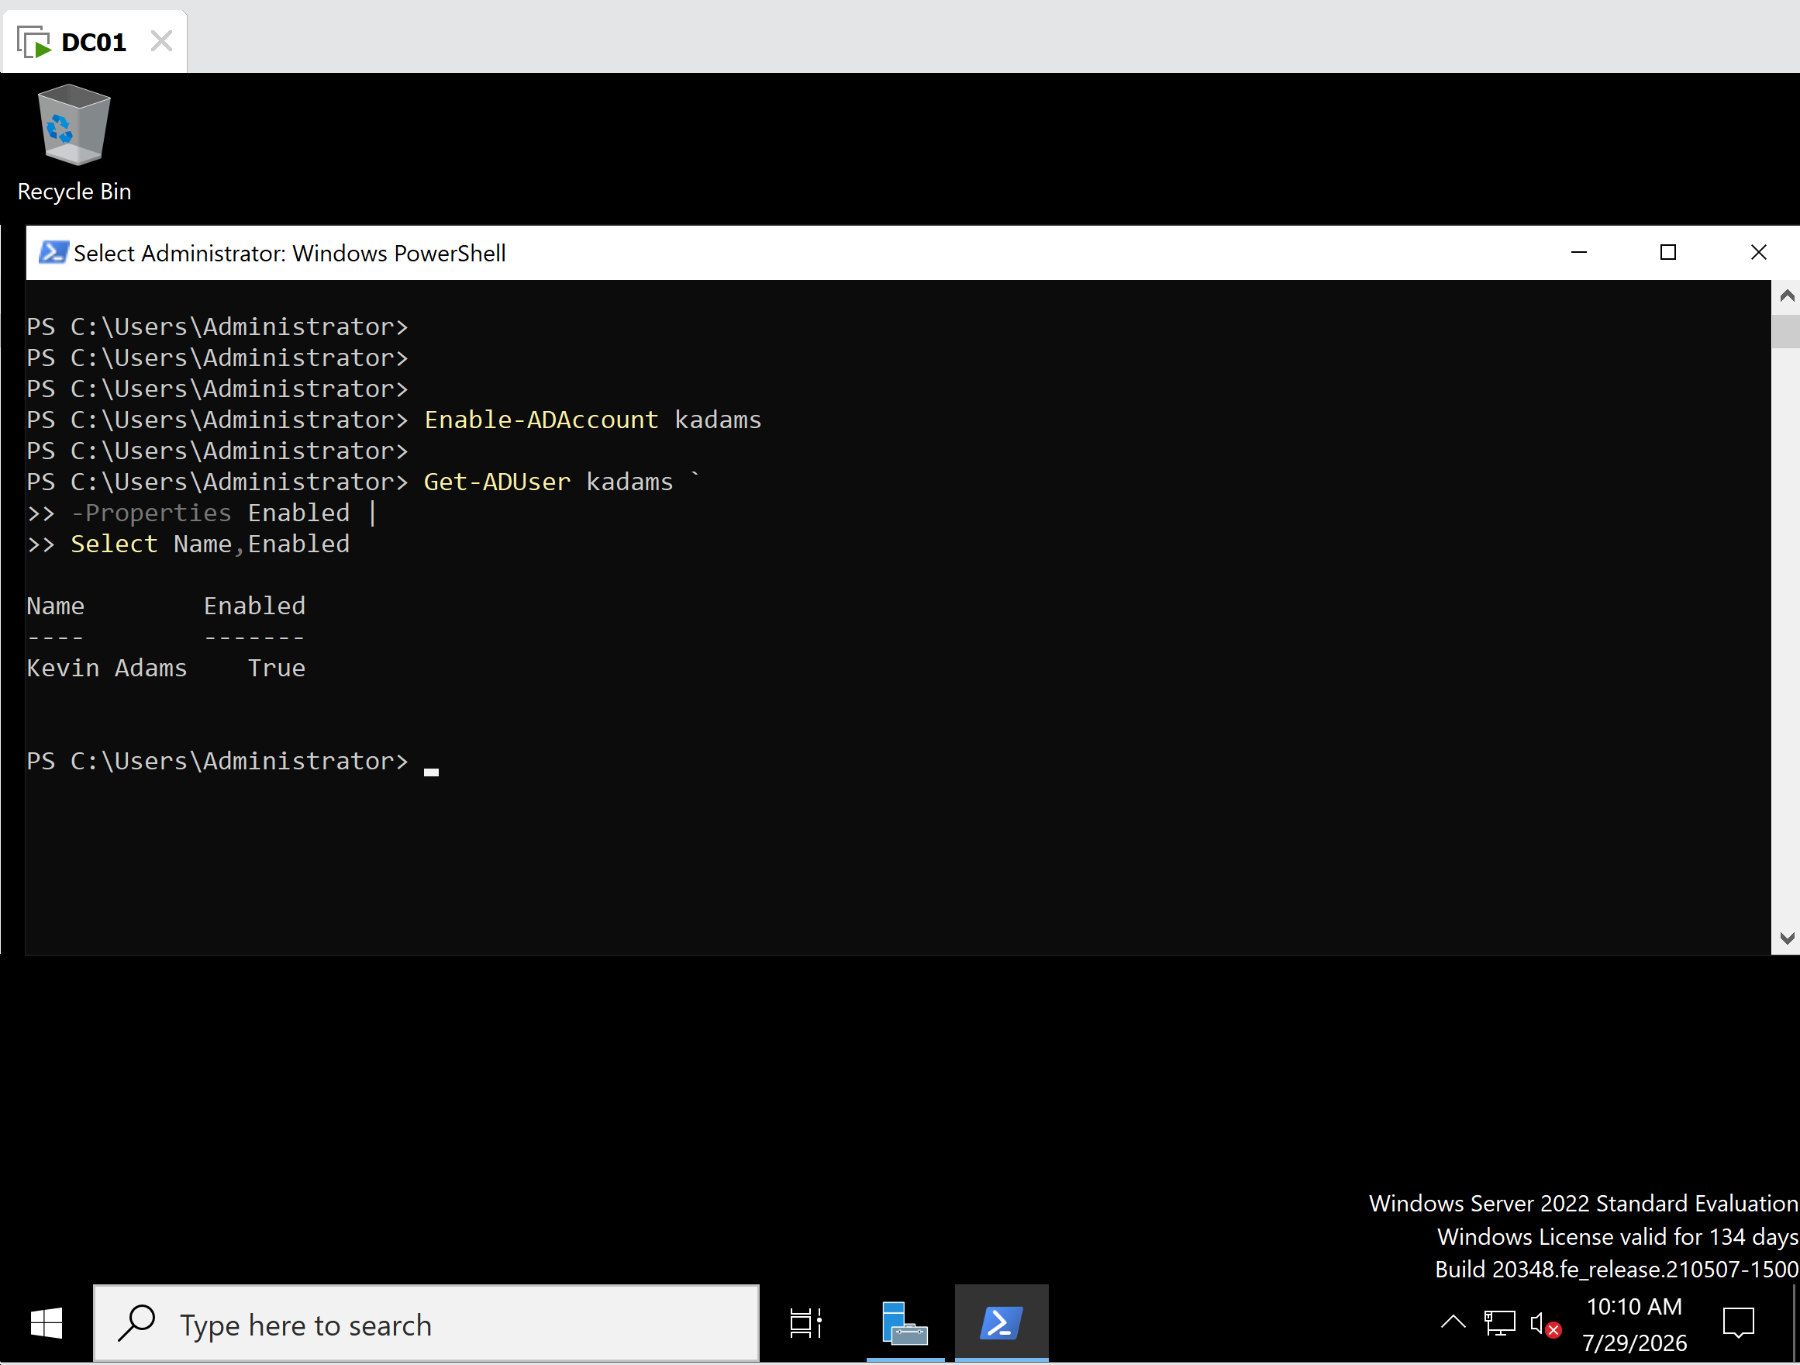
Account re-enabled (Enabled = True)

Key Concepts Learned
- Viewing account status with Get-ADUser
- Understanding the Enabled property
- Disabling accounts using Disable-ADAccount
- Re-enabling accounts using Enable-ADAccount
- Verifying administrative changes using PowerShell
- Performing common Active Directory administrative tasks without using the GUI

Lessons Learned
This exercise demonstrated how PowerShell simplifies routine Active Directory administration. Rather than navigating through Active Directory Users and Computers, administrators can enable or disable user accounts with a single cmdlet and immediately verify the results. These commands are especially valuable for automating administrative tasks involving multiple users and are commonly used in enterprise environments.

Administrator's Notes
This task reinforced the importance of verification after every administrative change. Instead of assuming a command completed successfully, the account status was checked before disabling, after disabling, and again after re-enabling. This verify-first approach helps administrators ensure that changes have been applied correctly and is considered a best practice in enterprise Windows Server administration.

