Module 2 – Advanced Group Policy Administration

Task 1 – Create and Link a Group Policy Object (GPO)

Objective
Create and link a new Group Policy Object (GPO) to the Workstations Organizational Unit (OU) to prepare for centralized management of workstation settings.

Background
Group Policy allows administrators to centrally configure and manage Windows computers and users within an Active Directory domain. By linking a GPO to an Organizational Unit, administrators can apply consistent security settings, desktop configurations, software deployments, and other policies to all objects contained within that OU.

Systems Used
Component | Value
Server | DC01
Operating System | Windows Server 2022
Domain | benlab.local
Management Tool | Group Policy Management Console (GPMC)
Target OU | Workstations

Procedure
- Opened Group Policy Management (gpmc.msc).
- Expanded the benlab.local domain.
- Navigated to BEN Industries → Workstations.
- Right-clicked the Workstations OU.
- Selected Create a GPO in this domain, and Link it here...
- Created a new GPO named Corporate Desktop.
- Verified that the GPO was successfully linked to the Workstations OU.

Result
A new Group Policy Object named Corporate Desktop was successfully created and linked to the Workstations Organizational Unit. The GPO is now ready to be configured with administrative policies for Windows client computers.

Verification
Verified in Group Policy Management Console that:
- The Corporate Desktop GPO exists.
- The GPO is linked to the Workstations OU.
- The link is enabled and available for future policy configuration.

Screenshot
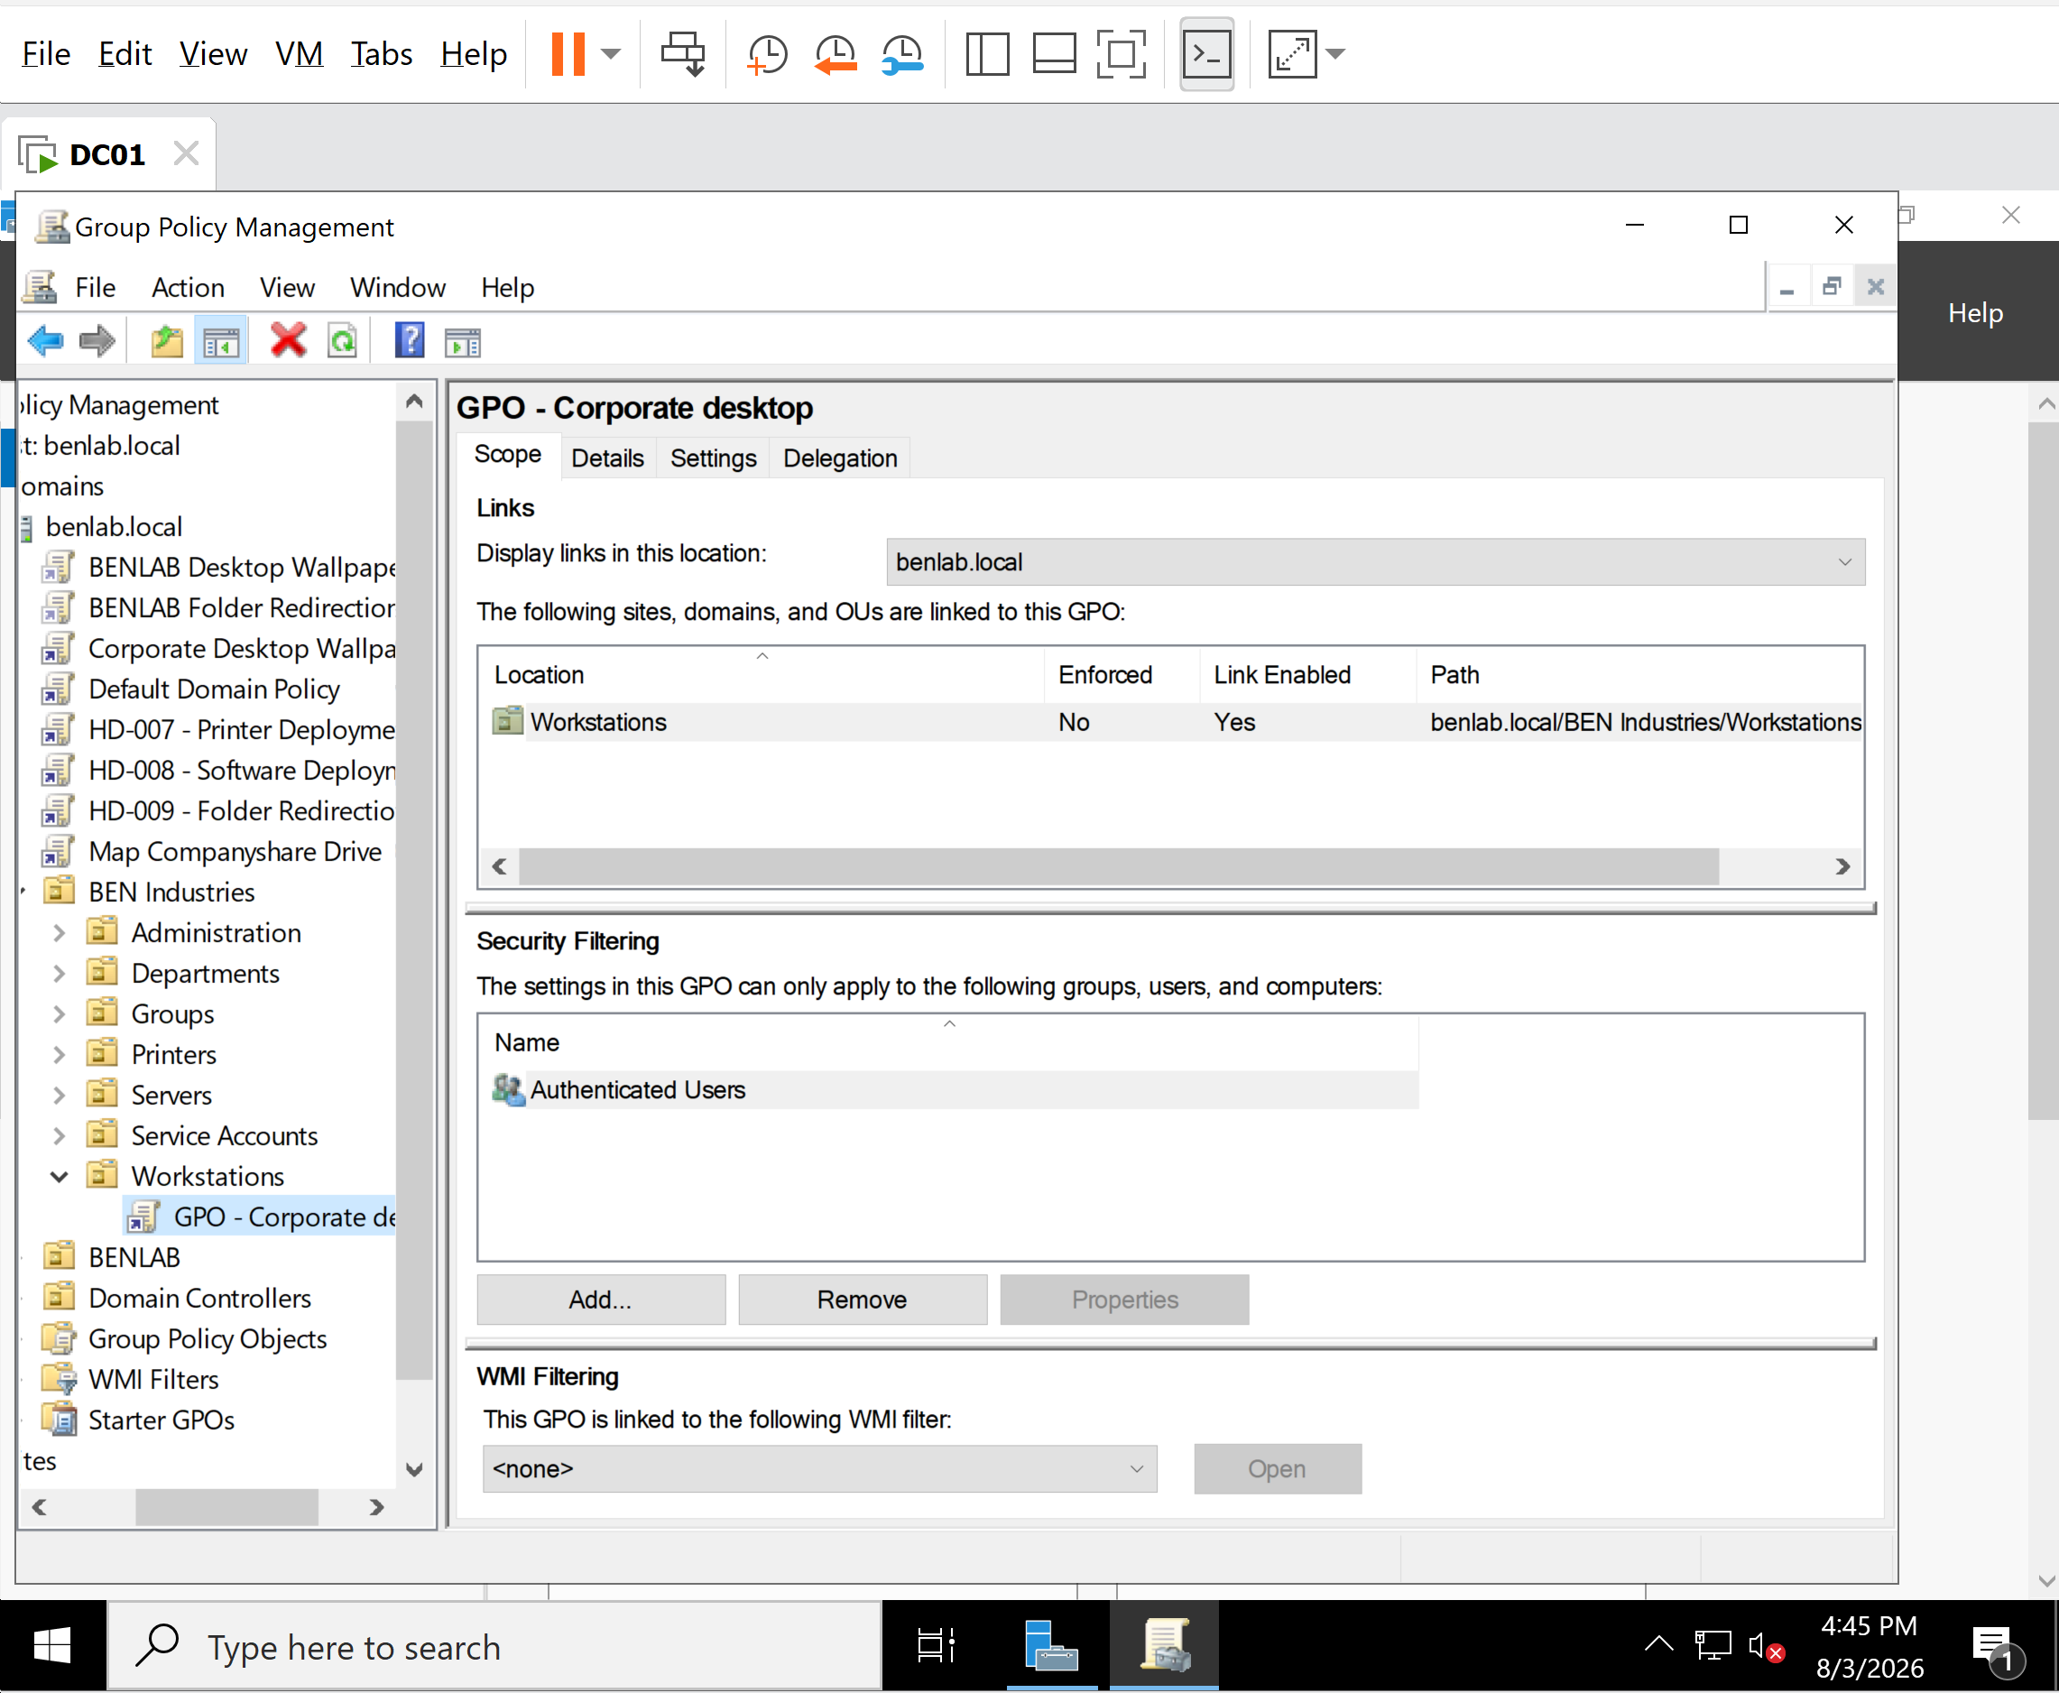
Corporate desktop GPO linked to the Workstation organization Unit

Skills Demonstrated
- Group Policy Management
- Organizational Unit Administration
- Active Directory Administration
- Enterprise Windows Infrastructure
- Centralized Policy Management

Task 2 - Documentation
- Objective
  - Create a dedicated Group Policy Object for enterprise security settings.
- Background
  - Explain why administrators create separate GPOs instead of modifying the Default Domain Policy. Mention that separating policies makes management, troubleshooting, and future expansion easier.
- Systems Used
  - DC01
  - Windows Server 2022
  - Domain: benlab.local
- Steps Performed
  - Opened Group Policy Management.
  - Expanded Forest → Domains → benlab.local → Group Policy Objects.
  - Right-clicked Group Policy Objects.
  - Selected New.
  - Named the GPO Corporate Security Settings.
  - Verified the GPO was created successfully.
- Result
  - Successfully created a new GPO that will later contain enterprise security policies.
Screenshot
Screenshots
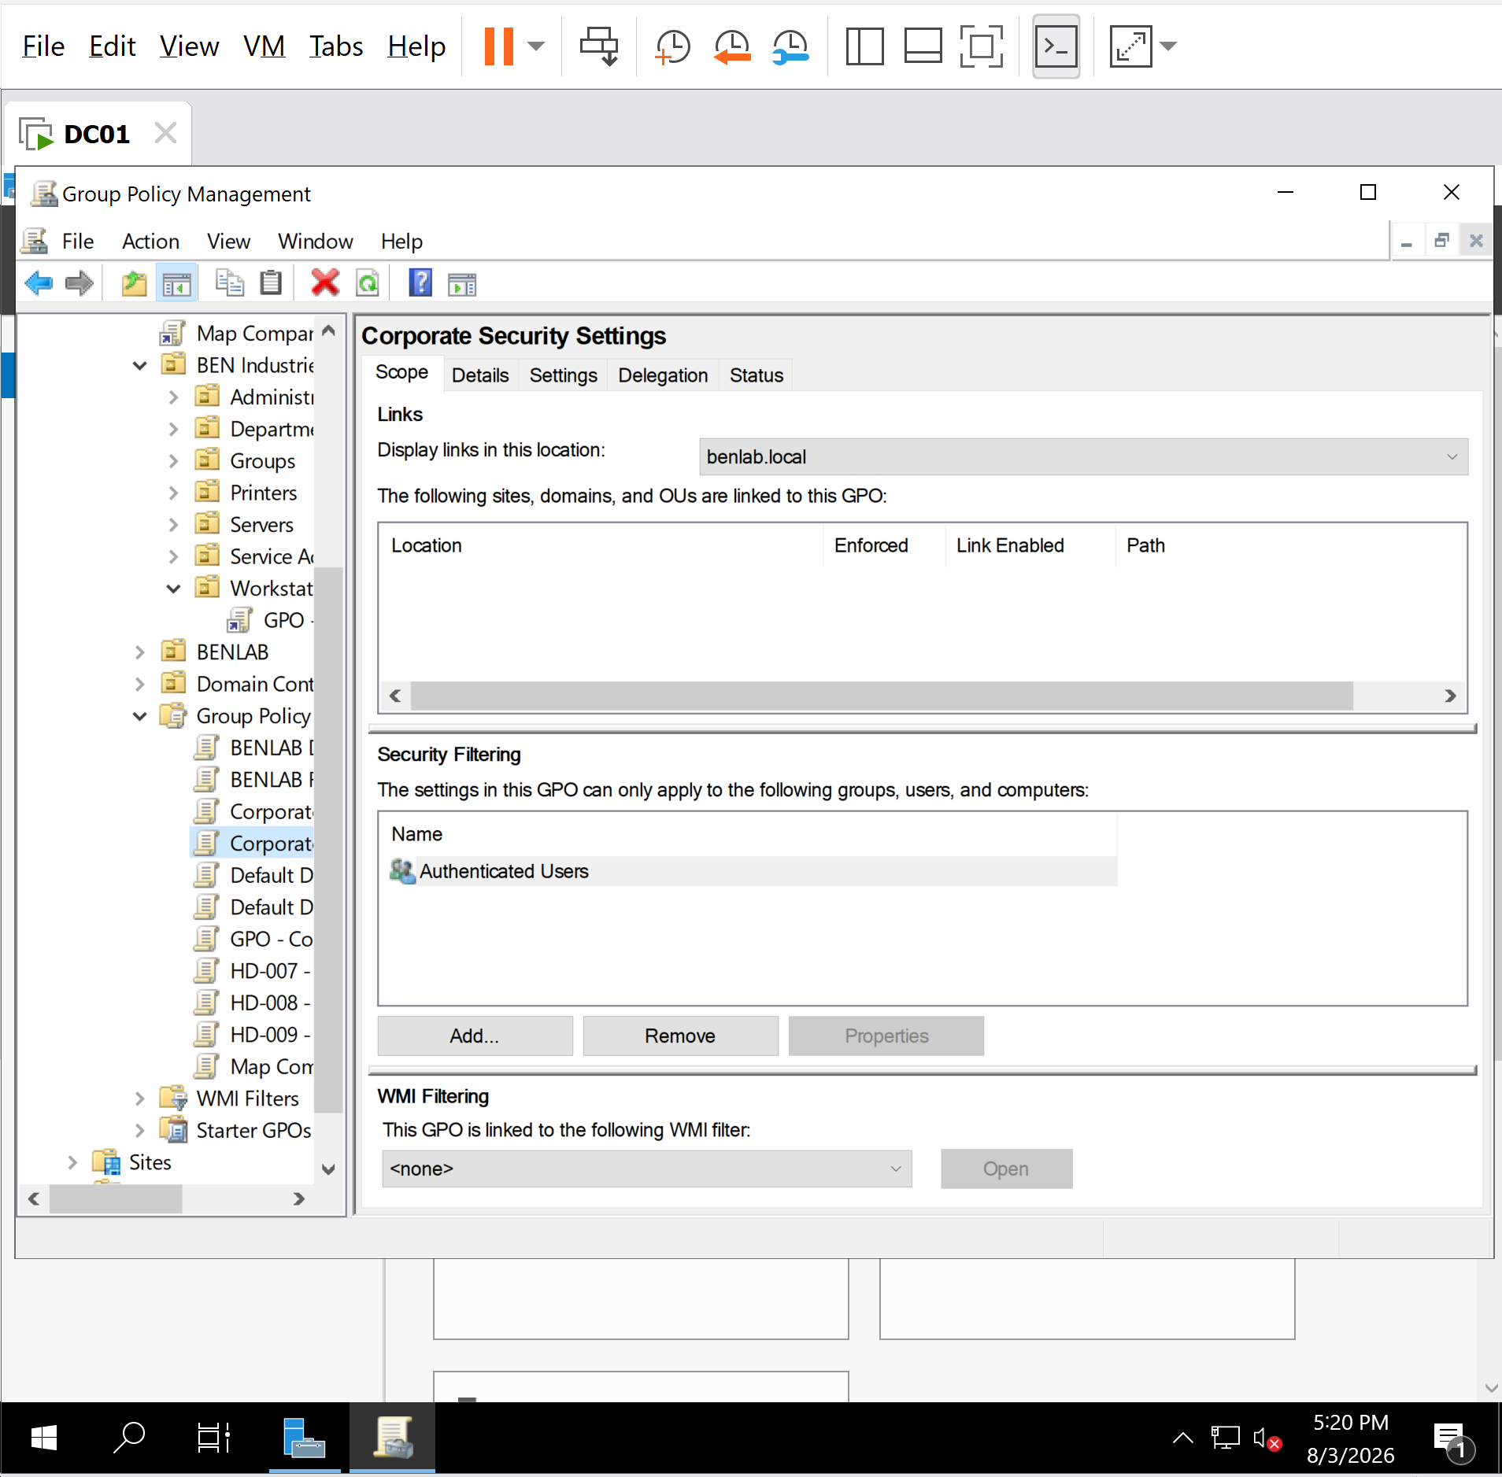

Task 3 - Configure Enterprise Password Policy Using Group Policy

Objective
Configure a centralized enterprise password policy using Group Policy to enforce strong password requirements for domain users. This task demonstrates how administrators implement organization-wide password policies to improve security and ensure compliance with enterprise security standards.

Background
Group Policy enables administrators to centrally manage password policies across an Active Directory domain. Strong password policies help protect user accounts from unauthorized access, password reuse, and brute-force attacks by enforcing consistent security requirements throughout the organization.
Unlike Fine-Grained Password Policies, which target specific users or security groups, Group Policy is commonly used to establish the organization's standard password policy.

Systems Used
Component | Value
Domain Controller | DC01
Operating System | Windows Server 2022
Domain | benlab.local
Management Tool | Group Policy Management Console (GPMC)
Group Policy Object | Corporate Security Settings

Procedure

Step 1
Opened Group Policy Management (gpmc.msc).
Expanded:
Forest: benlab.local
Domains
benlab.local
Group Policy Objects
Corporate Security Settings
Right-clicked Corporate Security Settings and selected Edit.

Step 2
Navigated to:
Computer Configuration
Policies
Windows Settings
Security Settings
Account Policies
Password Policy

Step 3
Configured the following enterprise password policy settings.
Policy | Configured Value
Enforce password history | 24 passwords remembered
Maximum password age | 90 days
Minimum password age | 1 day
Minimum password length | 12 characters
Password must meet complexity requirements | Enabled
Store passwords using reversible encryption | Disabled

Explanation of Each Policy

Enforce Password History
Configured to remember the previous 24 passwords.
This prevents users from immediately reusing previously used passwords and encourages stronger password rotation.

Maximum Password Age
Configured to 90 days.
Users are required to change their passwords every 90 days, reducing the likelihood of compromised passwords remaining active for extended periods.

Minimum Password Age
Configured to 1 day.
This prevents users from rapidly changing their password multiple times in succession to bypass the password history requirement while still allowing legitimate password changes the following day if necessary.

Minimum Password Length
Configured to 12 characters.
Longer passwords provide significantly stronger protection against password guessing and brute-force attacks than shorter passwords.

Password Must Meet Complexity Requirements
Configured as Enabled.
Passwords must include a combination of character types such as uppercase letters, lowercase letters, numbers, and special characters, reducing the risk of weak or easily guessed passwords.

Store Passwords Using Reversible Encryption
Configured as Disabled.
This setting remains disabled because storing passwords using reversible encryption significantly reduces password security and is generally unnecessary in modern enterprise environments.

Verification
Verified that all password policy settings were successfully configured within the Corporate Security Settings Group Policy Object.
Confirmed that the configured values appeared correctly in the Password Policy console.
Captured screenshots documenting each stage of the configuration.

Comparison with Fine-Grained Password Policies
This task demonstrates configuring an organization-wide password policy using Group Policy.
Earlier in Module 1, a Fine-Grained Password Policy (Password Settings Object - PSO) was created.

Group Policy
- Applies the organization's standard password policy.
- Used for broad password management across domain users.

Fine-Grained Password Policy
- Applies different password requirements to specific users or security groups.
- Commonly used for privileged accounts such as Domain Administrators, Finance Administrators, and IT Administrators.
Using both technologies together provides flexibility while maintaining a consistent enterprise security strategy.

Results
Successfully created and configured an enterprise password policy using Group Policy.
The Corporate Security Settings GPO now enforces standardized password security requirements that can be applied to domain-joined computers and users after the GPO is linked and deployed.

Skills Demonstrated
- Windows Server Administration
- Active Directory Administration
- Group Policy Management
- Enterprise Password Policy Configuration
- Security Hardening
- Enterprise Authentication Management
- Windows Security Administration

Lessons Learned
This exercise demonstrated how Group Policy provides centralized management of enterprise password policies. Understanding the relationship between Group Policy and Fine-Grained Password Policies is essential for Windows administrators because organizations often require a standard password policy for most users while applying stricter password requirements to privileged accounts through Password Settings Objects (PSOs). Configuring password policies through Group Policy ensures consistency, strengthens account security, and supports enterprise security best practices.

Screenshots
Corporate Security Settings GPO opened in Group Policy Management.

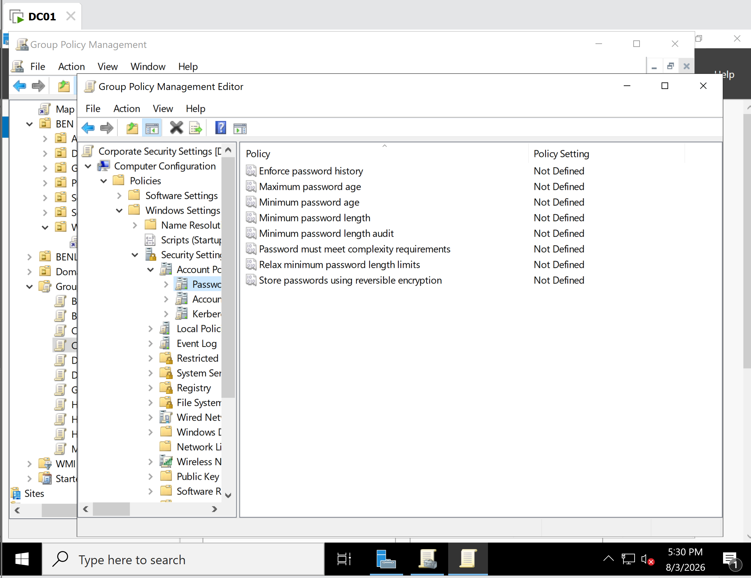
Password Policy node before configuration.

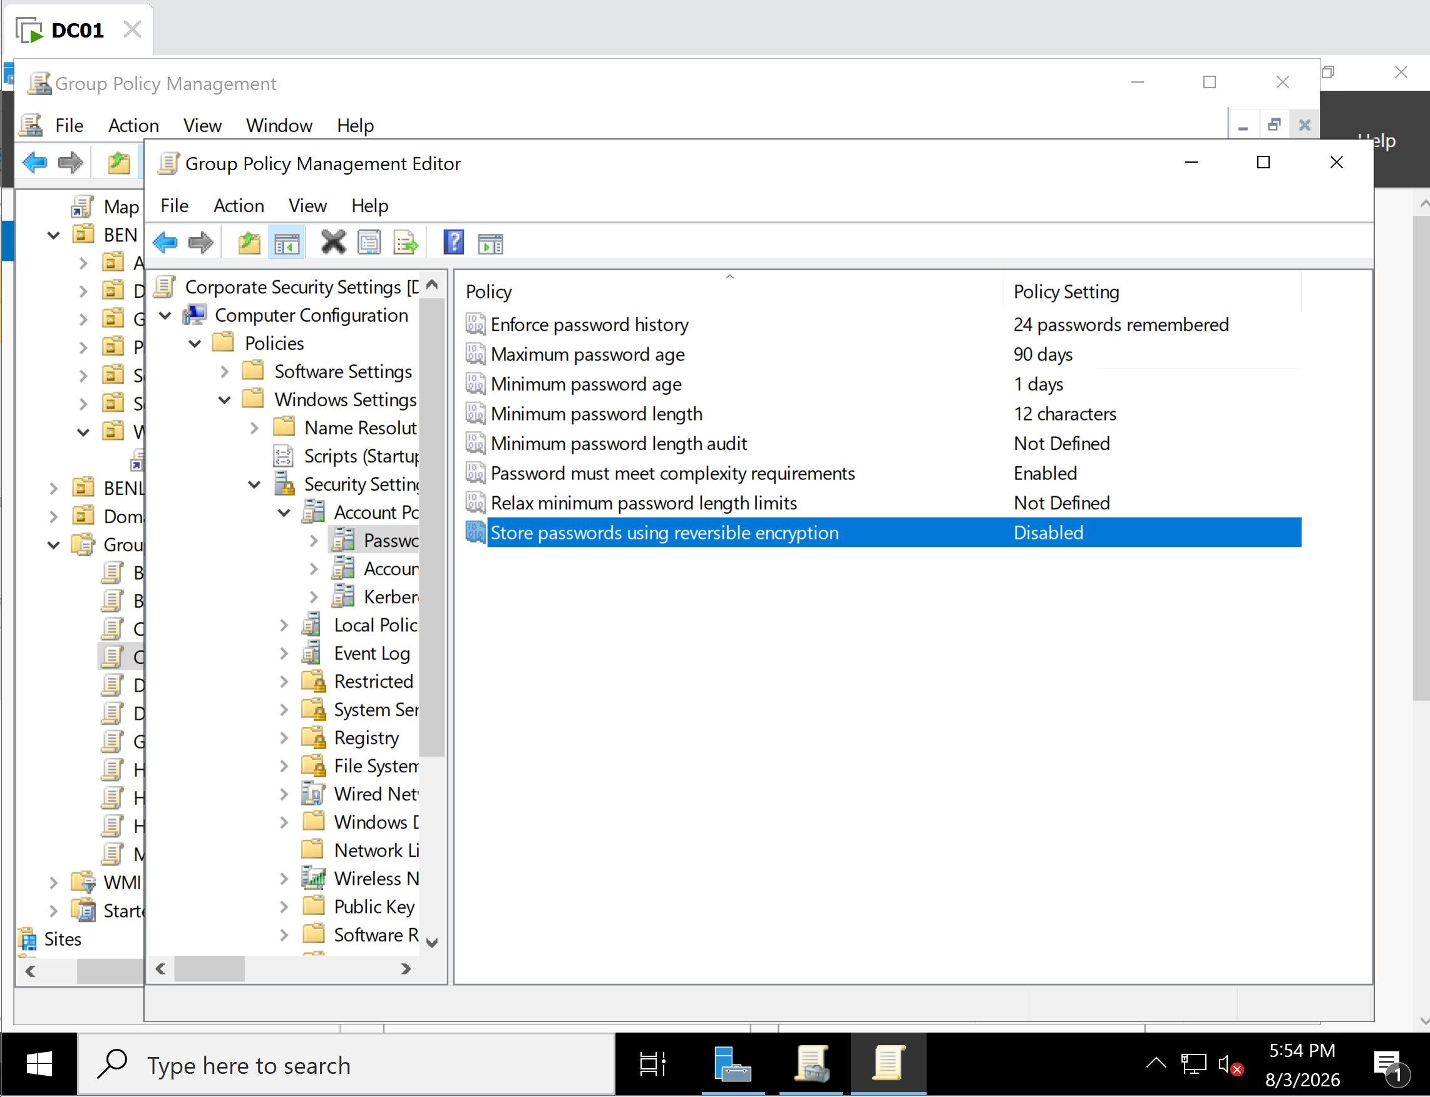
Enterprise password policy configured with organization security settings.

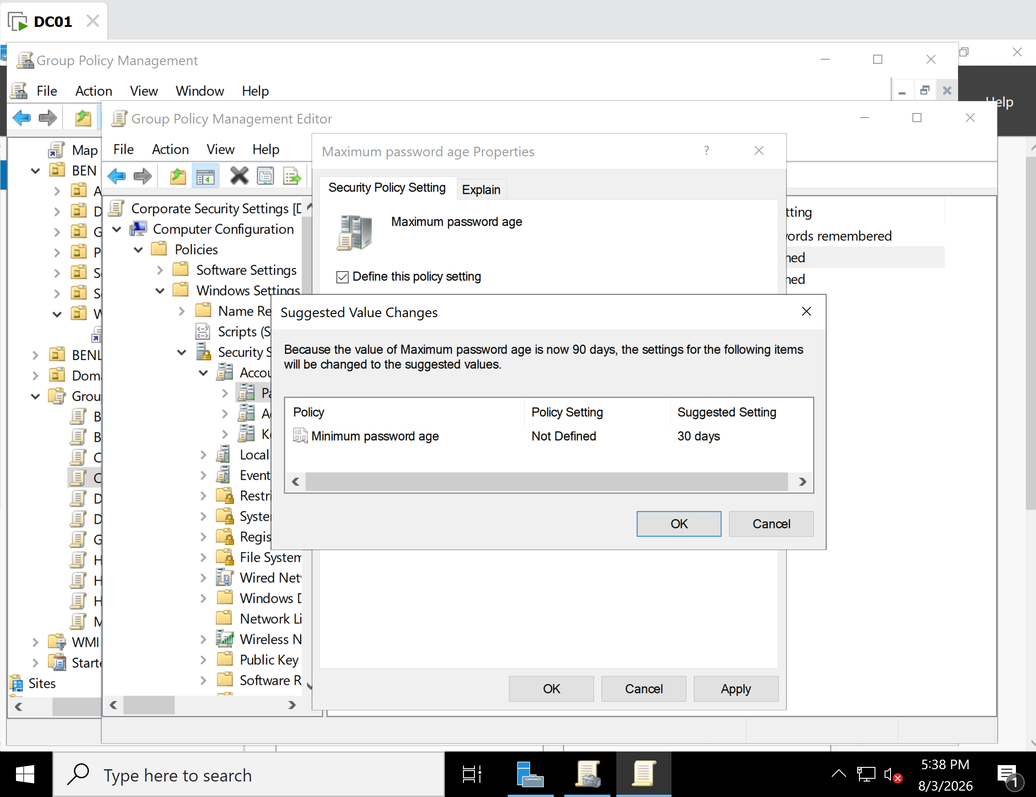
Example password policy configuration window (Maximum Password Age or Minimum Password Length).

Task 4 – Configure Account Lockout Policy

Objective
Configure an Account Lockout Policy using Group Policy to protect Active Directory user accounts against brute-force and password guessing attacks.

Background
Account Lockout Policies automatically lock user accounts after a specified number of failed logon attempts. This reduces the risk of unauthorized access by slowing automated password attacks while allowing administrators to balance security with user convenience.

Systems Used
Component | Value
Server | DC01
Operating System | Windows Server 2022
Domain | benlab.local
Tool | Group Policy Management Editor

Configuration Steps
- Opened Group Policy Management.
- Edited the Corporate Security Settings GPO.
- Navigated to:
Computer Configuration
└─ Policies
└─ Windows Settings
└─ Security Settings
└─ Account Policies
└─ Account Lockout Policy
- Configured:
  - Account Lockout Threshold
  - Account Lockout Duration
  - Reset Account Lockout Counter After
- Applied the changes.
- Updated Group Policy.
- Verified the effective account policy.

Commands Used
gpupdate /force
net accounts

Verification
The net accounts command confirmed the domain account policy, including the configured account lockout threshold and current lockout settings.

Result
Successfully configured and verified an Account Lockout Policy using Group Policy to strengthen Active Directory account security against repeated failed authentication attempts.

Task 5 - Configure Software Restriction Policies

Objective
Configure a Software Restriction Policy (SRP) through Group Policy to prevent users from running unauthorized applications from a specific folder. This demonstrates how Windows administrators can reduce security risks by restricting software execution.

Environment
- Domain Controller: DC01
- Client Computer: CLIENT02
- Domain: benlab.local
- GPO: Corporate Security Settings

Procedure

1. Open the Group Policy Management Console
On DC01:
Server Manager → Tools → Group Policy Management
Navigate to:
Forest: benlab.local
Domains
benlab.local
BEN Industries
Workstations
Right-click Corporate Security Settings and select:
Edit

2. Create Software Restriction Policies
Navigate to:
Computer Configuration
Policies
Windows Settings
Security Settings
Software Restriction Policies
If Software Restriction Policies do not exist:
Action
Create New Policies
Windows automatically creates:
- Security Levels
- Additional Rules
- Enforcement
- Designated File Types
- Trusted Publishers

3. Create a Path Rule
Open:
Additional Rules
Right-click:
New Path Rule
Configure:
Path
C:\Games\*
Security Level
Disallowed
Description
Block unauthorized games from executing.
Click:
OK

4. Update Group Policy
On CLIENT02, open Command Prompt as Administrator and run:
gpupdate /force

5. Verify GPO Application
Run:
gpresult /scope computer /r
Verification:
Applied Group Policy Objects

Corporate Security Settings
Default Domain Policy
HD-008 - Software Deployment
This confirmed that the Corporate Security Settings GPO was successfully applied to the workstation.

6. Test the Restriction
Create the folder:
mkdir C:\Games
Copy Command Prompt into the folder:
copy C:\Windows\System32\cmd.exe C:\Games\
Double-click:
C:\Games\cmd.exe
Windows displayed:
This app has been blocked by your system administrator.
This confirmed that the Software Restriction Policy successfully prevented executables from running from the restricted path.

Result
The Software Restriction Policy was successfully deployed through Group Policy and verified on CLIENT02. Executables located in the restricted folder (C:\Games) were blocked from running, demonstrating centralized application control using Windows Server Group Policy.

Screenshots
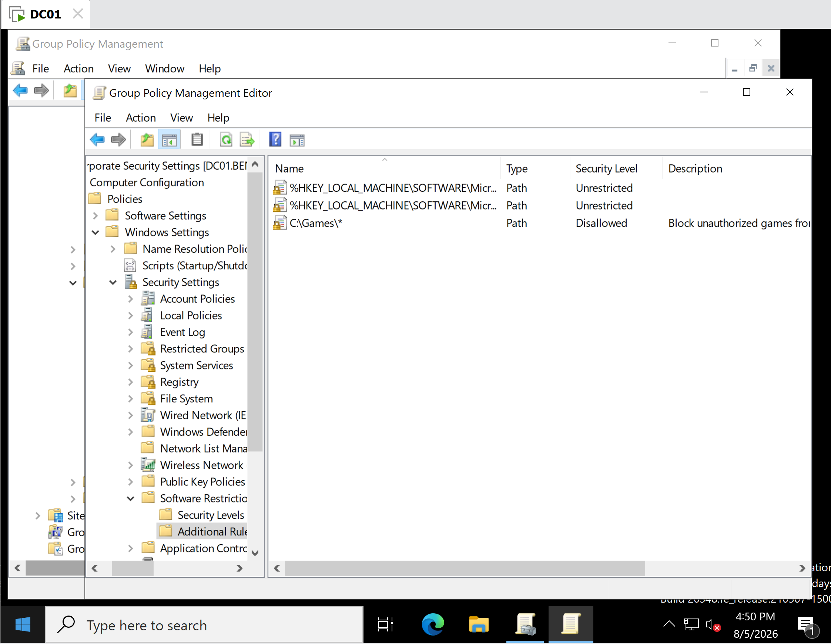
Software Restriction Policies → Additional Rules showing:
C:\Games\*
Security Level: Disallowed
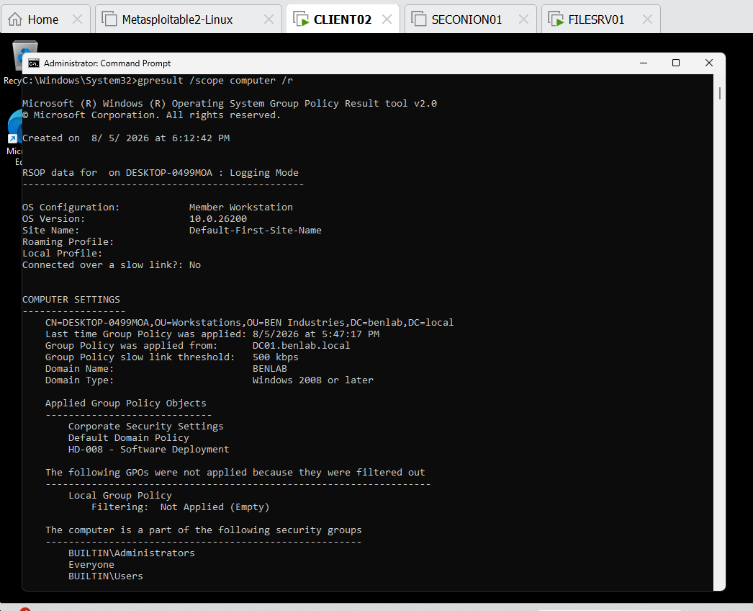
Output of:
gpresult /scope computer /r
showing:
Corporate Security Settings
under Applied Group Policy Objects.
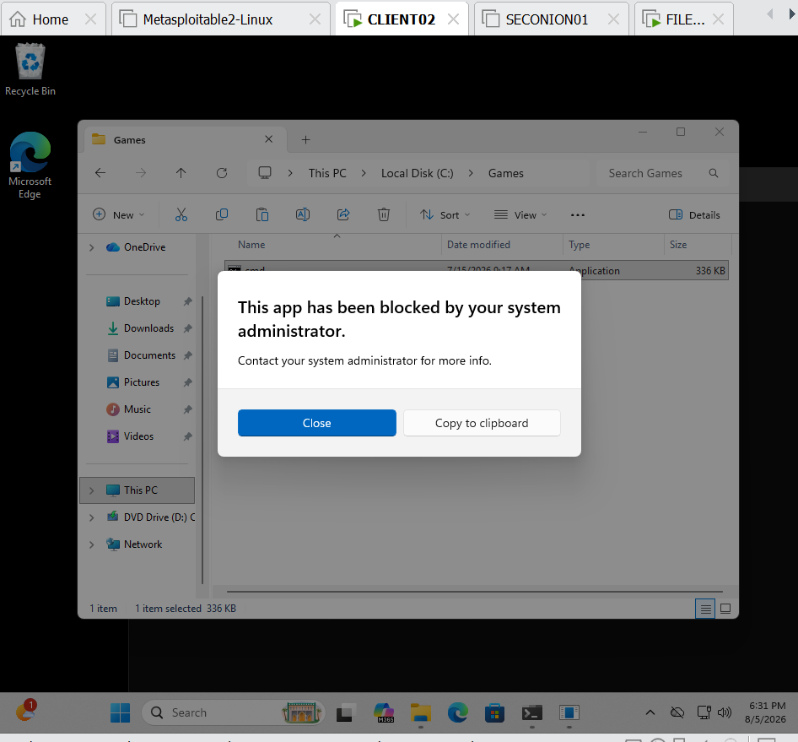
The Windows message:
This app has been blocked by your system administrator.

Skills Demonstrated
- Group Policy Management
- Software Restriction Policies (SRP)
- Path Rules
- Application Whitelisting/Blacklisting
- Enterprise Endpoint Security
- Windows Server Administration
- Group Policy Verification (gpresult)
- Windows Security Hardening

Task 5 - Administrative Templates

Objective
Configure and verify Administrative Template settings using Group Policy to manage user access to Windows features in an Active Directory environment.

Environment
- Domain Controller: DC01 (Windows Server 2022)
- Client Computer: CLIENT02 (Windows 11)
- Domain: benlab.local
- Test User: Brian Johnson
- Tool: Group Policy Management Console (GPMC)

Configuration Steps

Step 1 – Edit the Existing GPO
- Open Group Policy Management on DC01.
- Navigate to:
Forest → Domains → benlab.local → Group Policy Objects
- Right-click Workstation Configuration.
- Select Edit.

Step 2 – Configure the Administrative Template
Navigate to:
User Configuration
└── Policies
└── Administrative Templates
└── Control Panel
Enable the following policy:
- Prohibit access to Control Panel and PC settings → Enabled
Click Apply, then OK.

Step 3 – Link the GPO
Initially, the GPO was linked only to the Workstations Organizational Unit (OU). Because the configured setting was a User Configuration policy, it did not apply to users located in other OUs.
To ensure the policy applied to domain users, an additional link was created.
Steps performed:
- Right-click the Departments OU.
- Select Link an Existing GPO.
- Choose Workstation Configuration.
- Click OK.
The GPO was now linked to both:
- Workstations OU
- Departments OU

Step 4 – Update Group Policy
On CLIENT02, logged in as Brian Johnson, run:
gpupdate /force

Step 5 – Verify the Applied Policies
Run:
gpresult /scope user /r
Verification confirmed the following GPOs were applied:
- Workstation Configuration
- Map CompanyShare Drive
- HD-007 – Printer Deployment
- HD-009 – Folder Redirection
- Corporate Desktop Wallpaper

Step 6 – Test the Policy
Attempt to open Control Panel while logged in as Brian Johnson.
Expected Result:
This operation has been cancelled due to restrictions in effect on this computer.
Please contact your system administrator.
The restriction confirmed that the Administrative Template policy was successfully applied.

Commands Used
gpupdate /force
gpresult /scope user /r

Verification
✅ Workstation Configuration GPO edited successfully.
✅ Administrative Template policy configured.
✅ GPO linked to both the Workstations and Departments OUs.
✅ Group Policy successfully refreshed.
✅ gpresult confirmed the GPO was applied.
✅ Brian Johnson was unable to open Control Panel.

Troubleshooting Performed
During testing, the Administrative Template policy did not initially apply because the GPO was linked only to the Workstations OU. Since Administrative Template settings were configured under User Configuration, Windows evaluated the user's Organizational Unit instead of the computer's.
After linking the same GPO to the Departments OU, Group Policy was refreshed using gpupdate /force, and verification with gpresult confirmed that the policy was successfully applied to the user.

Skills Demonstrated
- Active Directory Group Policy Management
- Administrative Templates
- Group Policy Linking
- Organizational Unit (OU) Design
- User Configuration Policies
- Group Policy Troubleshooting
- gpupdate
- gpresult
- Enterprise Windows Administration

Screenshots
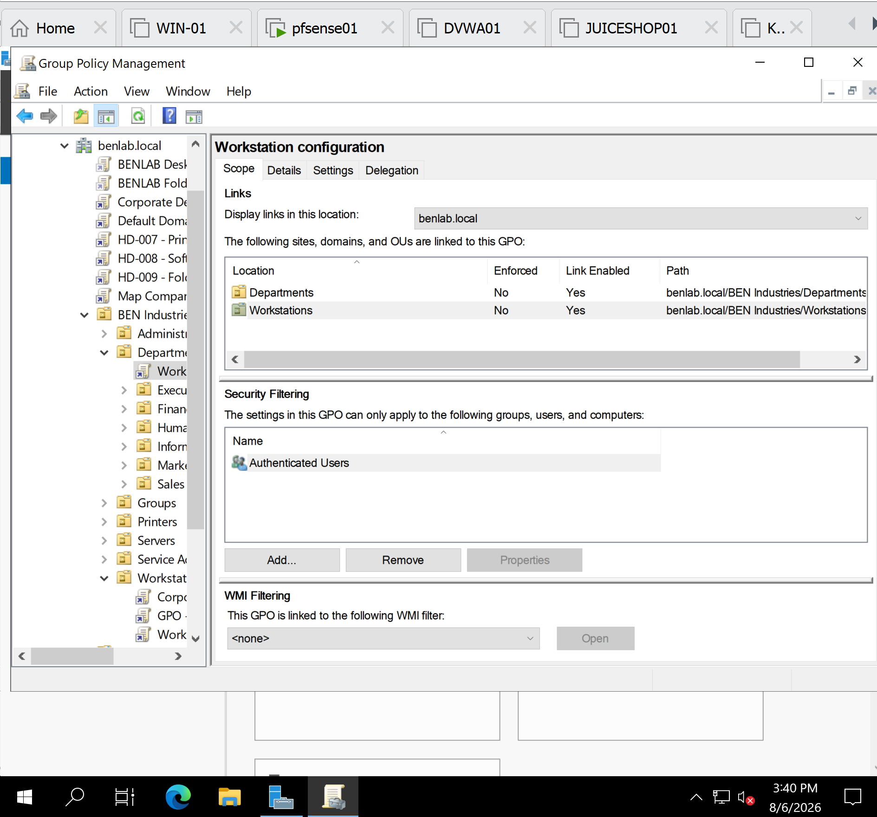
GPO linked to the Workstations OU.
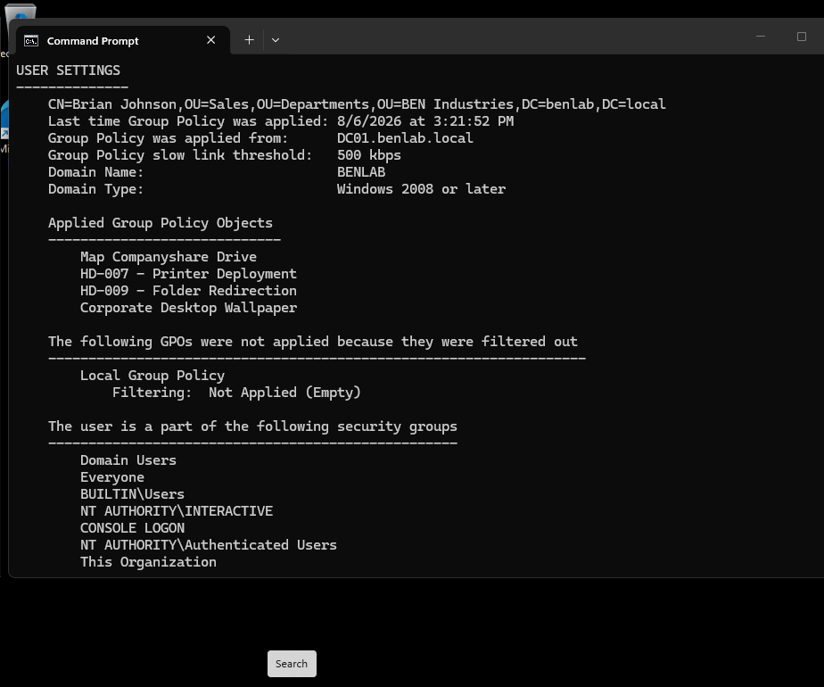
Additional GPO link to the Departments OU.
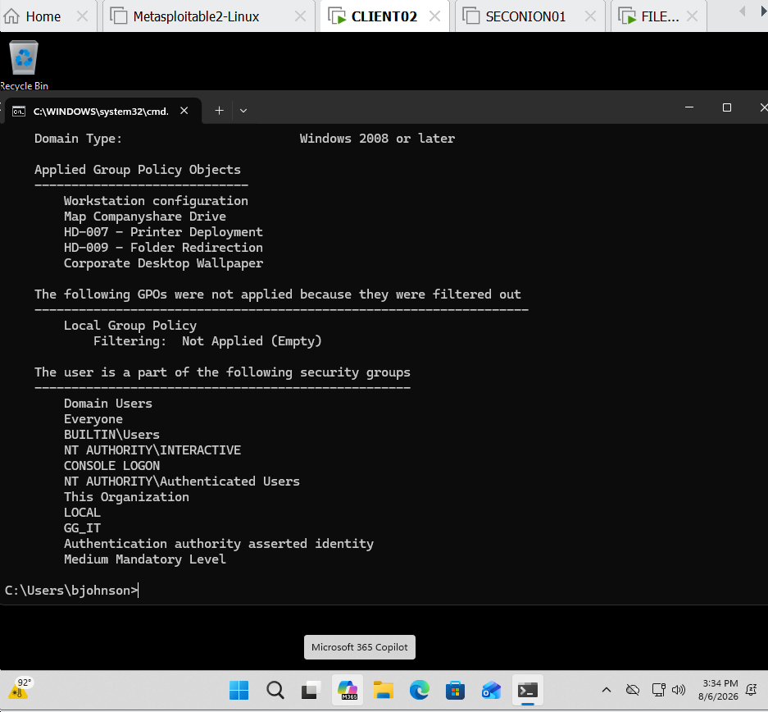
gpresult /scope user /r showing Workstation Configuration under Applied Group Policy Objects.
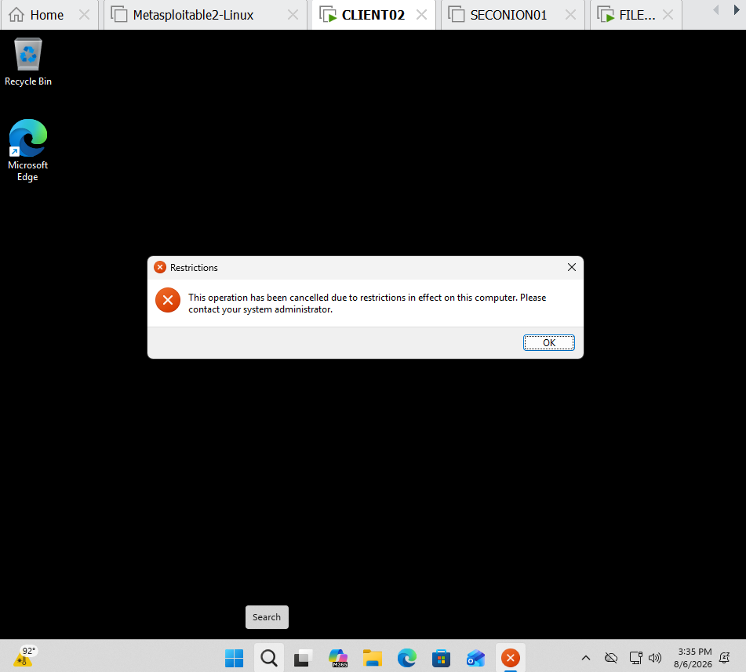
Restriction message:
"This operation has been cancelled due to restrictions in effect on this computer."

Task 6 - Configure Group Policy Loopback Processing

Objective
Configure and test Group Policy Loopback Processing to demonstrate how user configuration settings can be applied based on the computer a user logs into, rather than solely on the user's location within Active Directory.

Environment
- Domain: benlab.local
- Domain Controller: DC01
- Client workstation: CLIENT02
- Test user: Brian Johnson
- User location: Sales OU under Departments
- Computer location: Workstations OU
- GPO: Workstation configuration
- Loopback mode: Replace

Procedure
The existing Workstation configuration GPO was used for the loopback processing test. The GPO was linked to the Workstations OU, allowing policies to target computers located within that OU.
Within Group Policy Management Editor, the following location was opened:
Computer Configuration
→ Policies
→ Administrative Templates
→ System
→ Group Policy
The following policy was configured:
Configure user Group Policy loopback processing mode
The policy was set to:
Enabled
Mode: Replace
Replace mode was selected so that when a user logs onto a workstation affected by this GPO, the user configuration associated with the workstation's GPO context replaces the user's normal user-policy processing for that session.

Preparation for Testing
The temporary Workstation configuration GPO link previously created on the Departments OU during Task 5 was removed before testing loopback processing.
This was important because leaving that link in place would allow Brian Johnson to receive the GPO directly through his user OU hierarchy, making it difficult to prove that Loopback Processing was responsible for applying the policy.
After the link was removed, Control Panel access returned to normal, confirming that the previous policy application was no longer affecting Brian through the Departments OU.

Testing
Brian Johnson, whose Active Directory account resides within:
BEN Industries
→ Departments
→ Sales
logged onto CLIENT02, whose computer account resides within:
BEN Industries
→ Workstations
Group Policy was refreshed and the resulting user policy was examined using:
gpresult /scope user /r
The output showed:
Applied Group Policy Objects
-----------------------------
Workstation configuration
Map Companyshare Drive
HD-007 - Printer Deployment
HD-009 - Folder Redirection
Corporate Desktop Wallpaper
The presence of Workstation configuration under Brian Johnson's applied user GPOs confirmed that the workstation-linked GPO was affecting his user session through Group Policy Loopback Processing.

Functional Verification
Control Panel was then opened while logged in as Brian Johnson.
Windows displayed the following restriction:
This operation has been cancelled due to restrictions
in effect on this computer.
Please contact your system administrator.
This confirmed that the user restriction configured within the Workstation configuration GPO was successfully applied to Brian Johnson when he logged onto CLIENT02.

Additional Observation
The following command was also attempted while logged in as Brian Johnson:
gpresult /scope computer /r
The command returned:
ERROR: Access Denied.
This occurred because the command was being executed under the standard user's security context. Computer-scope Group Policy results can instead be queried from an elevated Command Prompt using administrative credentials.
This did not affect the validity of the loopback test because the user-scope gpresult output and the successful Control Panel restriction provided evidence that the policy was functioning.

Result
Task completed successfully.
Group Policy Loopback Processing was successfully configured using Replace mode. Brian Johnson normally receives policies according to his location in the Sales OU. However, when he logged onto CLIENT02 in the Workstations OU, the user settings associated with the workstation's GPO context were applied.
The Control Panel restriction provided functional confirmation that the loopback policy was operating as intended.

Key Learning Outcome
This task demonstrated the difference between normal Group Policy processing and loopback processing.
Normally:
User → User's OU → User policies
With Loopback Processing:
User
↓
Logs onto CLIENT02
↓
CLIENT02 is in Workstations OU
↓
Workstation configuration GPO
↓
Loopback Processing (Replace)
↓
Workstation-context user policies applied
This type of configuration is useful in enterprise environments where administrators need a consistent user experience on specific computers regardless of who logs onto them, such as kiosks, shared workstations, classrooms, training rooms, reception computers, and secured administrative systems.

Screenshots
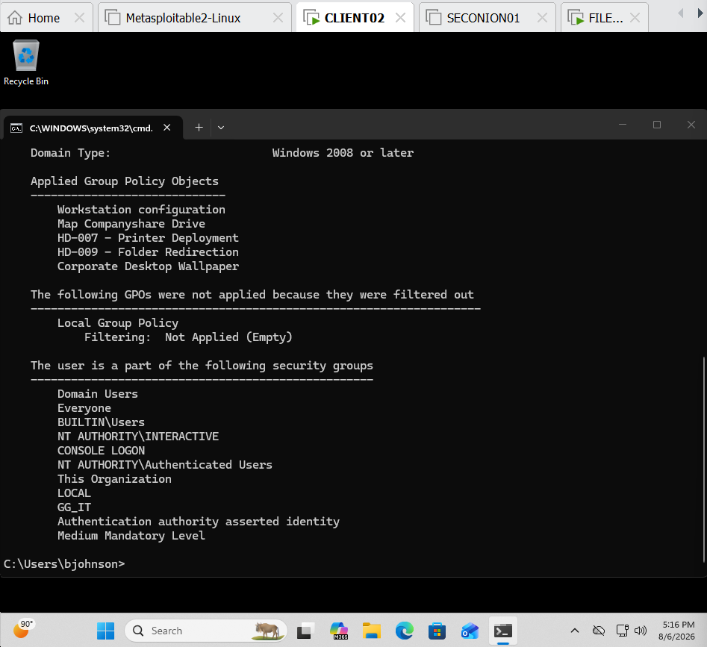
Screenshot 1 – Loopback Policy Verification
gpresult /scope user /r showing Workstation configuration under Applied Group Policy Objects while logged in as Brian Johnson.

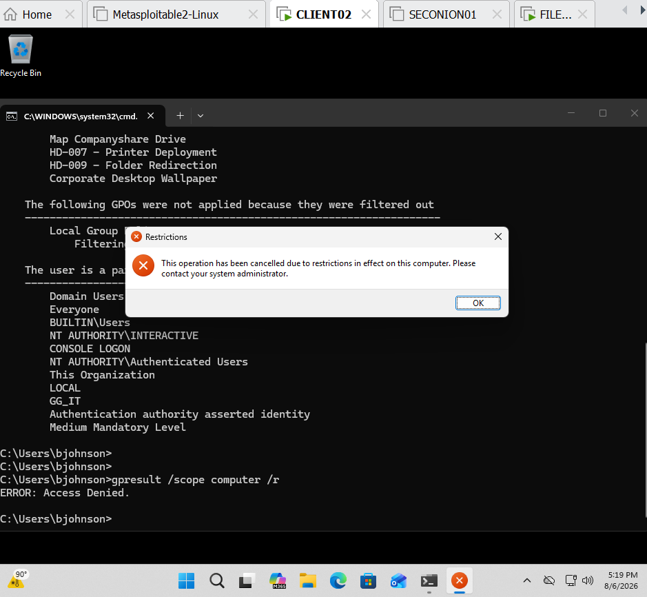
Screenshot 2 – Functional Restriction Test
Control Panel attempt showing “This operation has been cancelled due to restrictions in effect on this computer.”

Task 7 – Configure and Test WMI Filtering

Objective
Configure a Windows Management Instrumentation (WMI) filter to control Group Policy application based on the operating system of the target computer.
The goal was to configure the Corporate Security Settings GPO so that it applies to qualifying Windows 11 workstation computers, while preventing the same GPO from applying to Windows Server systems.

Environment
Domain: benlab.local
Domain Controller: DC01
Group Policy Object: Corporate Security Settings
Target OU: Workstations
WMI Filter: Windows 11 Workstations
Windows 11 test system: CLIENT02
Windows Server test system: FILESRV01

Step 1 – Create the WMI Filter
On DC01, opened:
Server Manager → Tools → Group Policy Management
Expanded:
Forest: benlab.local → Domains → benlab.local → WMI Filters
Right-clicked WMI Filters and selected:
New
Created the following WMI filter:
Name:
Windows 11 Workstations
Description:
Applies Group Policy only to Windows 11 workstation computers.

Step 2 – Configure the WMI Query
Selected Add to create a query.
The default WMI namespace was retained:
root\CIMv2
The following WMI query was entered:
SELECT * FROM Win32_OperatingSystem WHERE Version LIKE "10.%" AND ProductType = "1" AND BuildNumber >= "22000"
The query evaluates properties of the Win32_OperatingSystem class.
The important conditions are:
- Version LIKE "10.%" — matches the Windows NT 10.x version family used by Windows 10/11.
- ProductType = "1" — identifies Windows client/workstation operating systems rather than Windows Server.
- BuildNumber >= "22000" — identifies Windows 11-era builds.
The WMI filter was then saved.

Step 3 – Associate the WMI Filter with the GPO
Selected:
Group Policy Objects → Corporate Security Settings
On the Scope tab, located the WMI Filtering section.
Changed the WMI filter from:
<none>
to:
Windows 11 Workstations
Confirmed the association when prompted.
The Corporate Security Settings GPO was therefore configured to evaluate the WMI filter before being applied to a computer.

Step 4 – Verify the GPO on CLIENT02
On the Windows 11 client CLIENT02, Group Policy was refreshed.
The resulting computer policy was examined using:
gpresult /scope computer /r
The output showed:
Applied Group Policy Objects

Corporate Security Settings
Workstation configuration
Default Domain Policy
HD-008 - Software Deployment
This confirmed that Corporate Security Settings successfully applied to CLIENT02.
Because CLIENT02 satisfied the WMI query conditions, the WMI filter evaluated successfully and allowed the GPO to be processed.

Step 5 – Perform a Negative Test Using FILESRV01
To verify that the WMI filter actually controlled policy application rather than simply allowing the GPO everywhere, a temporary additional link for Corporate Security Settings was created on the Servers OU.
This allowed FILESRV01, running Windows Server 2022, to encounter the same GPO.
Group Policy was refreshed on FILESRV01 and the resulting computer policy was examined.
The applied GPOs included:
Default Domain Policy
HD-008 - Software Deployment
However:
Corporate Security Settings
was not applied.
This was the expected result.
FILESRV01 is a Windows Server system and therefore does not satisfy:
ProductType = "1"
Consequently, the WMI filter prevented the Corporate Security Settings GPO from applying to the server.

Step 6 – Generate Detailed Group Policy Results
For additional verification, a detailed HTML Group Policy report was generated on FILESRV01:
gpresult /h C:\gpresult.html
The report was opened with:
start C:\gpresult.html
The report confirmed successful Group Policy processing while showing that Corporate Security Settings was not among the applied GPOs on FILESRV01.
This provided additional evidence that the WMI filter was functioning as intended.

Step 7 – Remove the Temporary Server Link
After completing the negative test, the temporary Corporate Security Settings link was removed from the Servers OU.
Only the link was deleted; the actual GPO was not deleted.
The final configuration was verified under:
Group Policy Objects → Corporate Security Settings → Scope
The resulting configuration showed:
Link:
Workstations

Link Enabled:
Yes

Enforced:
No

Security Filtering:
Authenticated Users

WMI Filtering:
Windows 11 Workstations
This returned the environment to its intended production-style configuration.

Result
Status: Successful
The lab demonstrated that a GPO can be linked within the Active Directory hierarchy while a WMI filter provides an additional dynamic condition determining whether the GPO actually applies to a computer.
The test produced two different results:
System | Operating System | WMI Match | Corporate Security Settings
CLIENT02 | Windows 11 | Yes | Applied
FILESRV01 | Windows Server 2022 | No | Not Applied
This verified both the positive and negative behavior of the WMI filter.

Key Concepts Learned
A GPO link determines where a policy is available for processing, while a WMI filter determines whether a particular computer meets specified conditions before that GPO is applied.
This provides administrators with more granular targeting than OU placement alone. For example, administrators can target Group Policy according to operating-system version, workstation/server classification, hardware characteristics, or other information available through WMI.
The lab also demonstrated an important troubleshooting principle:
A GPO being linked to an OU does not necessarily mean that every computer within that scope will receive it. Administrators must also consider security filtering, WMI filtering, inheritance, and policy processing results.

Screenshots
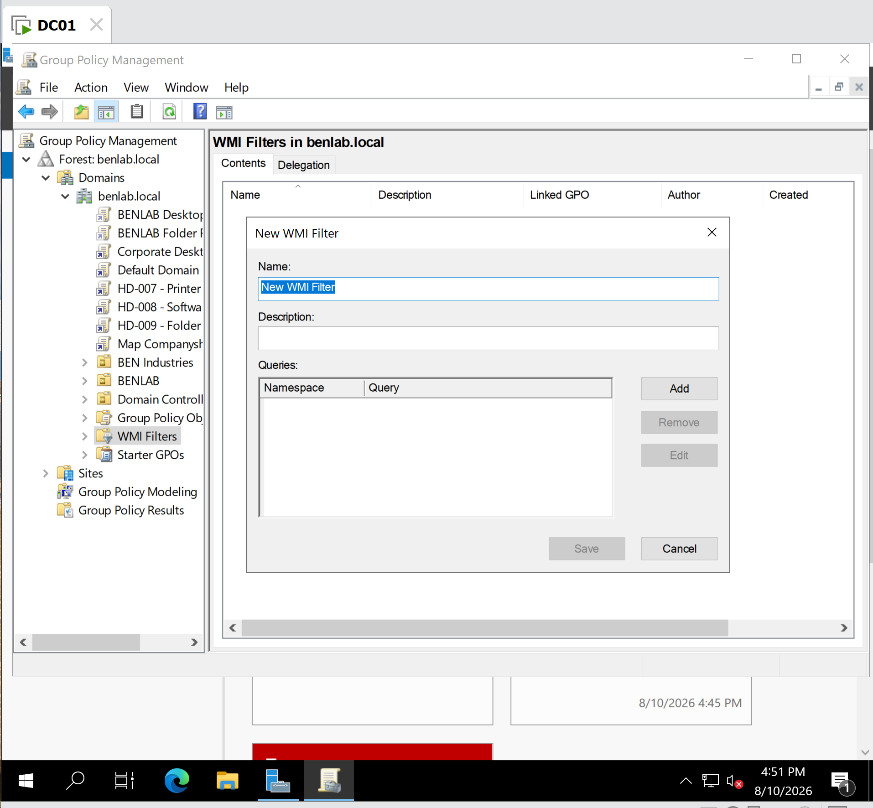
Creating Windows 11 Workstations WMI filter
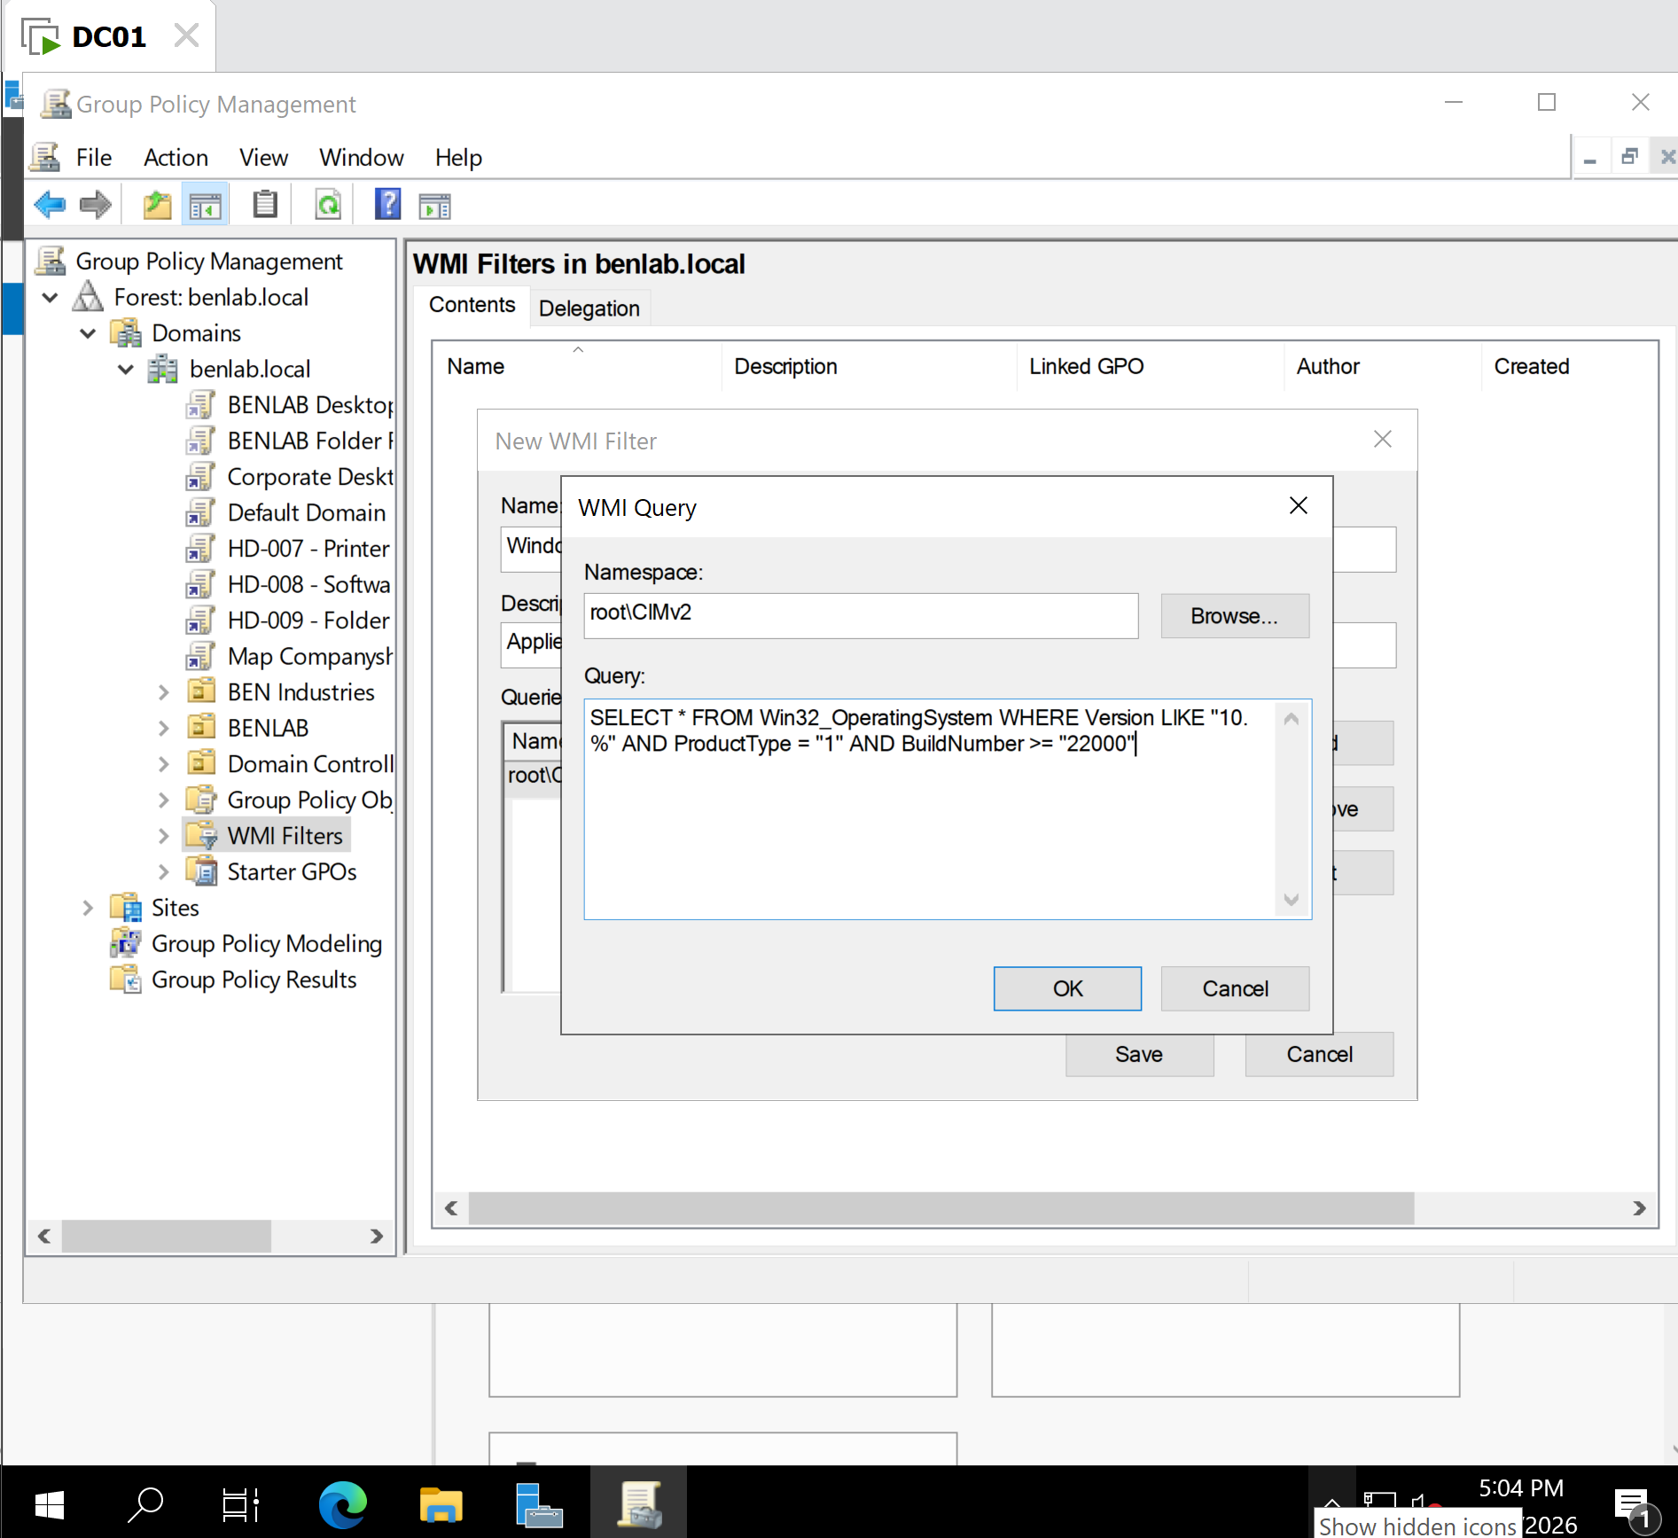
The WMI query showing Win32_OperatingSystem, ProductType, and BuildNumber
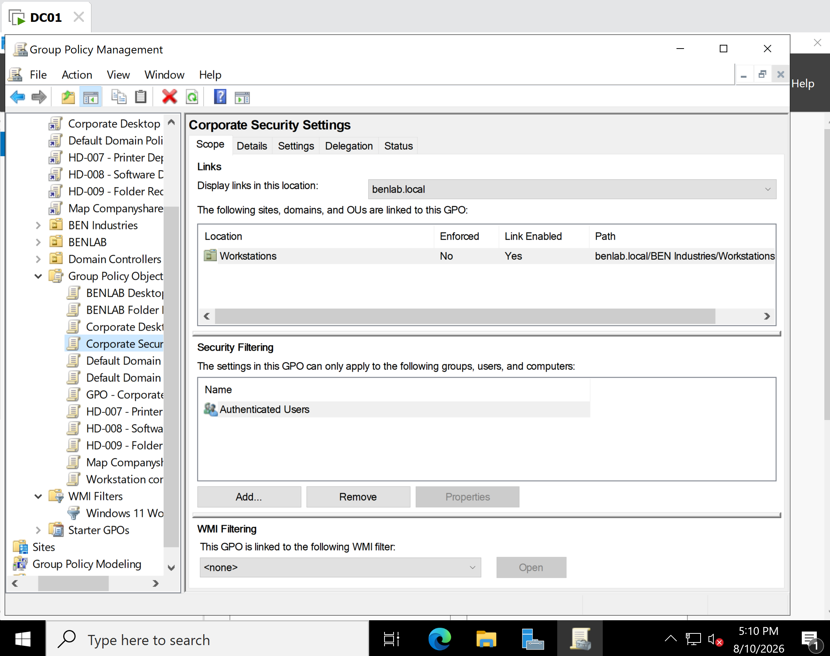
Corporate Security Settings → WMI Filtering: Windows 11 Workstations
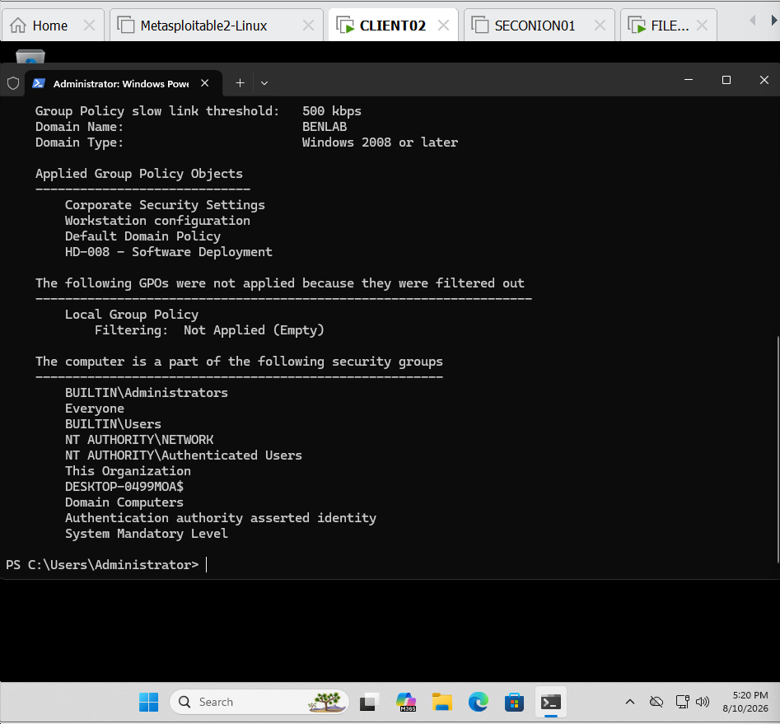
CLIENT02 gpresult showing Corporate Security Settings applied

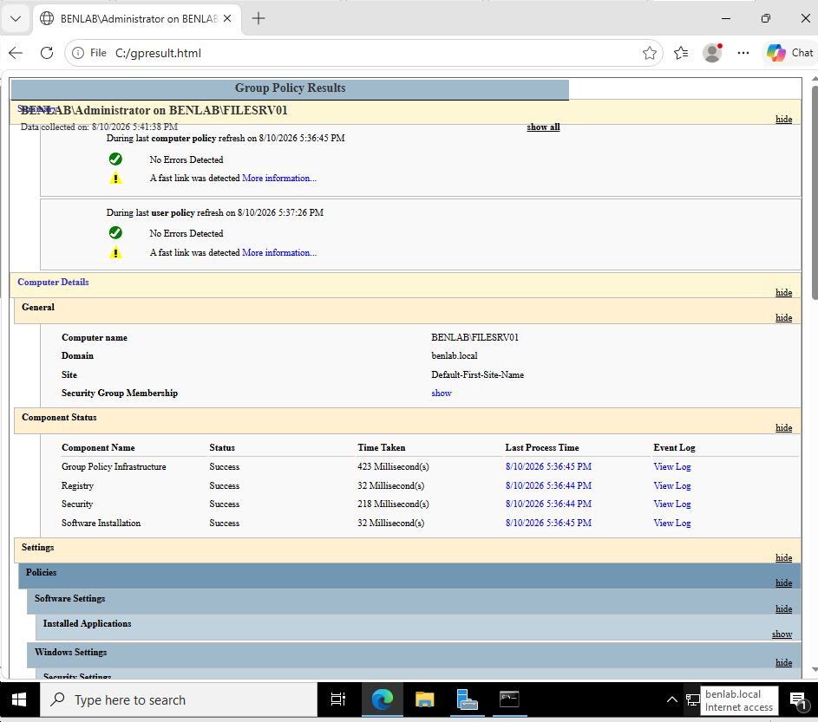
The FILESRV01 gpresult/HTML report

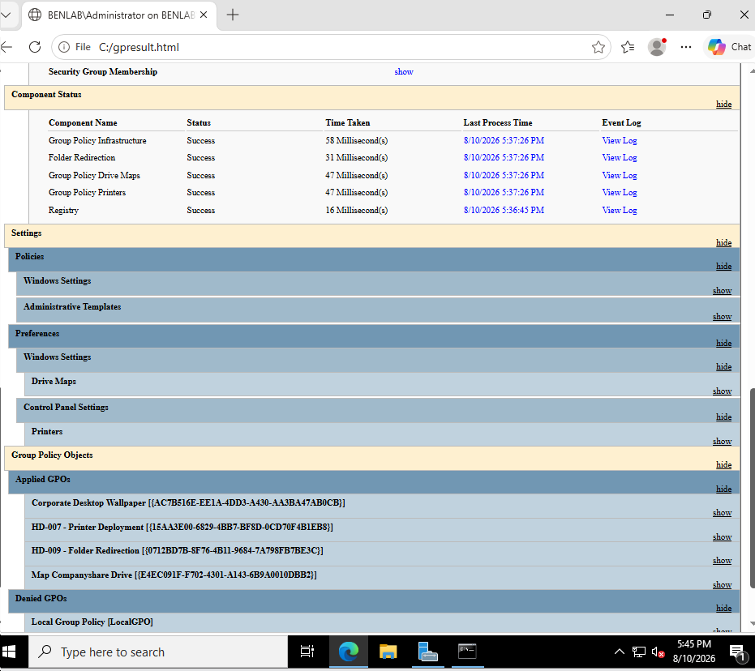

Task 8 – Configure Security Filtering for the IT Department

Objective
Configure Group Policy security filtering so that a specific user-based policy targets members of the GG_IT security group within the appropriate organizational unit structure.

Configuration Performed
Created and configured the GPO:
GPO Name: Security Filtering - IT Department
The GPO was linked to:
BEN Industries
└── Departments
└── Information Technology
Security Filtering was configured for:
GG_IT
The following user policy was configured:
User Configuration
└── Policies
└── Administrative Templates
└── Control Panel
└── Prohibit access to Control Panel and PC settings
→ Enabled

Security Filtering Verification
The GG_IT group was verified to have the required GPO permissions:
Read Allow
Apply group policy Allow
No explicit Deny permission was configured for GG_IT.

Test User
The policy was tested using the domain user:
Daniel Scott
Active Directory verification confirmed that Daniel Scott is located in:
CN=Daniel Scott,
OU=Information Technology,
OU=Departments,
OU=BEN Industries,
DC=benlab,
DC=local
Daniel Scott was also confirmed as a member of:
GG_IT

Troubleshooting and Verification
During client-side testing on CLIENT02, the targeted GPO did not appear in the applied GPO list returned by gpresult.
The following checks were performed:
gpupdate /force
gpresult /r
gpresult /scope user /z
SYSVOL connectivity was also verified from CLIENT02:
dir \\benlab.local\SYSVOL
On DC01, PowerShell was used to verify the GPO and its Active Directory link:
Get-GPO -Name "Security Filtering - IT Department"
The GPO's AD and SYSVOL version information was examined using:
Get-GPOReport -Name "Security Filtering - IT Department" -ReportType XML -Path "C:\GPOReport.xml"

Select-String -Path "C:\GPOReport.xml" -Pattern "VersionDirectory","VersionSysvol"
The Departments OU's gPLink was verified with:
Get-ADOrganizationalUnit -Identity "OU=Departments,OU=BEN Industries,DC=benlab,DC=local" -Properties gPLink |
Select-Object -ExpandProperty gPLink
The returned GUID matched the Security Filtering - IT Department GPO.
Daniel Scott's OU placement and group membership were additionally verified using:
Get-ADUser "daniel.scott" -Properties DistinguishedName,MemberOf |
Select-Object DistinguishedName,MemberOf

Result
The server-side GPO configuration, OU link, security filtering, user placement, group membership, permissions, GPO version information, and SYSVOL accessibility were successfully validated.
However, the targeted GPO was not enumerated by GPResult on CLIENT02 during final client-side testing. The behavior remained unresolved after systematic troubleshooting and was documented rather than making additional unnecessary configuration changes.

Skills Practiced
Group Policy Management • Security Filtering • Active Directory OU Structure • Security Groups • GPO Permissions • SYSVOL • GPResult • GPUpdate • PowerShell • GPO Troubleshooting

Screenshots
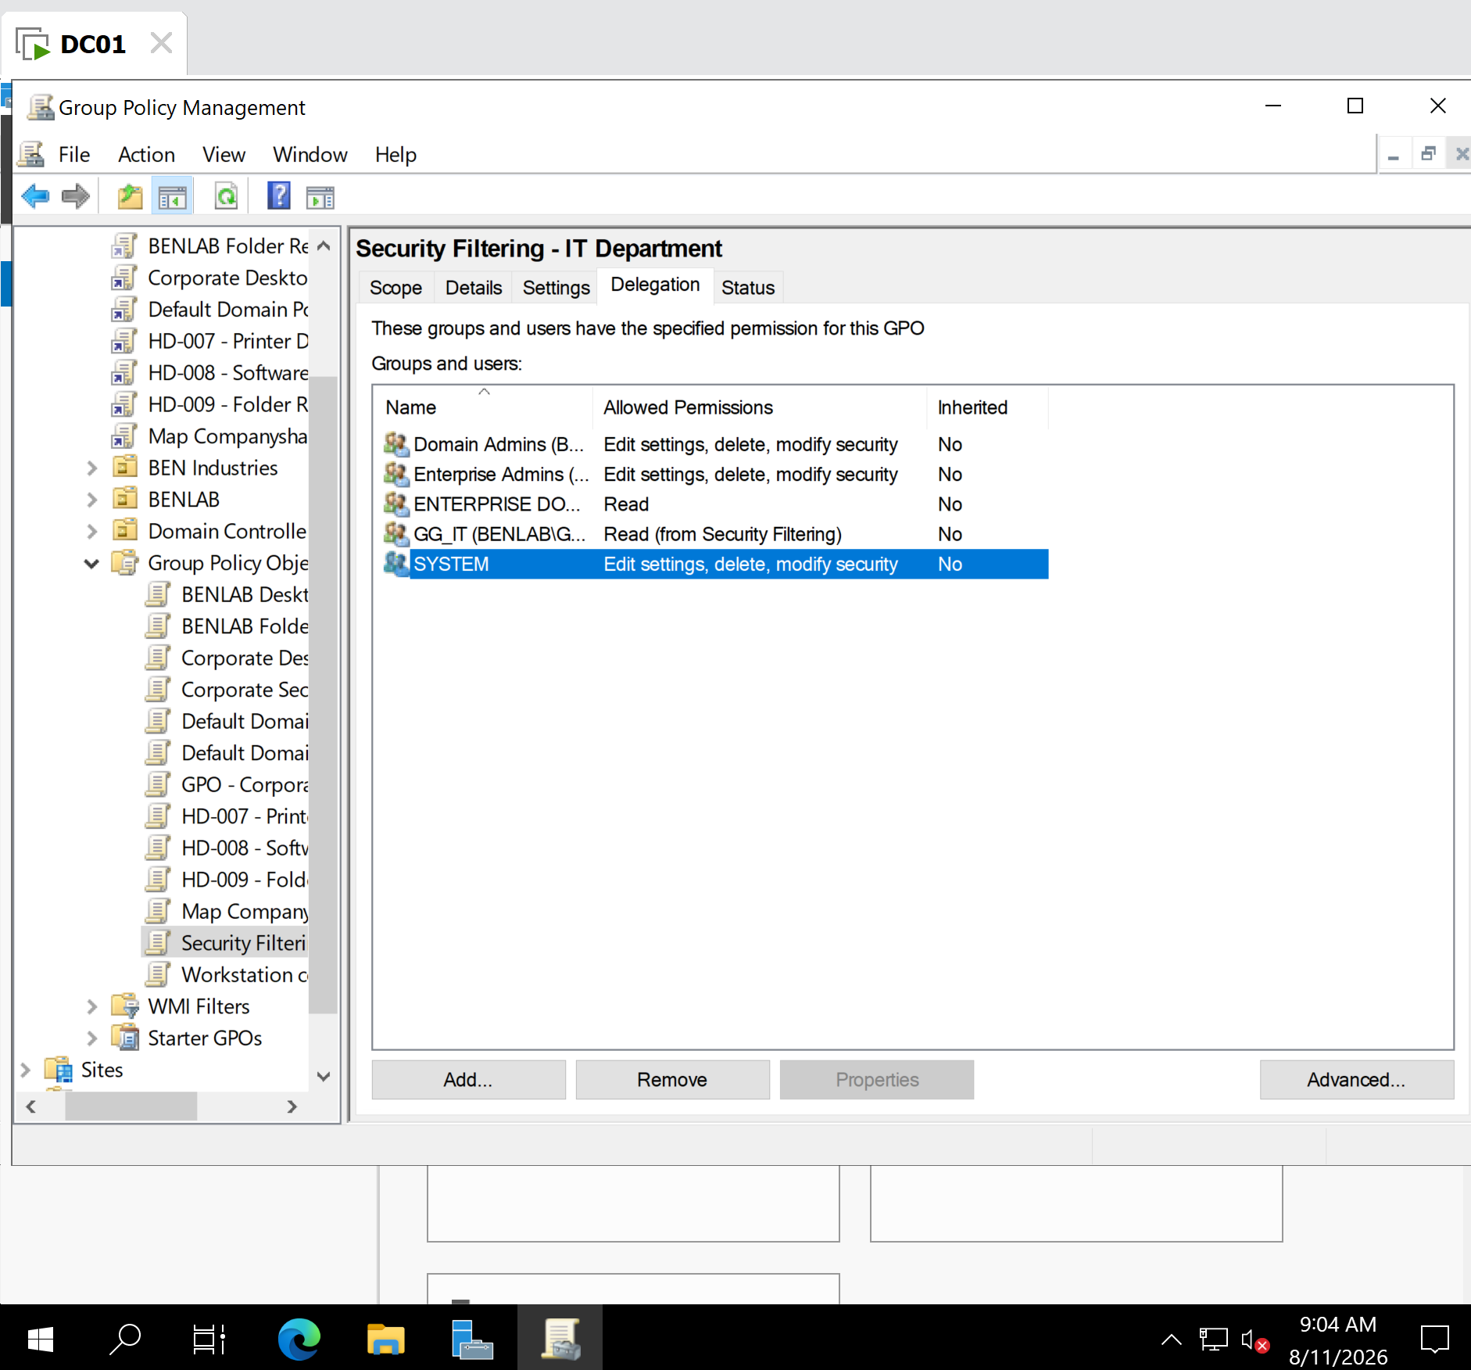
GPO Scope tab — showing GG_IT under Security Filtering.

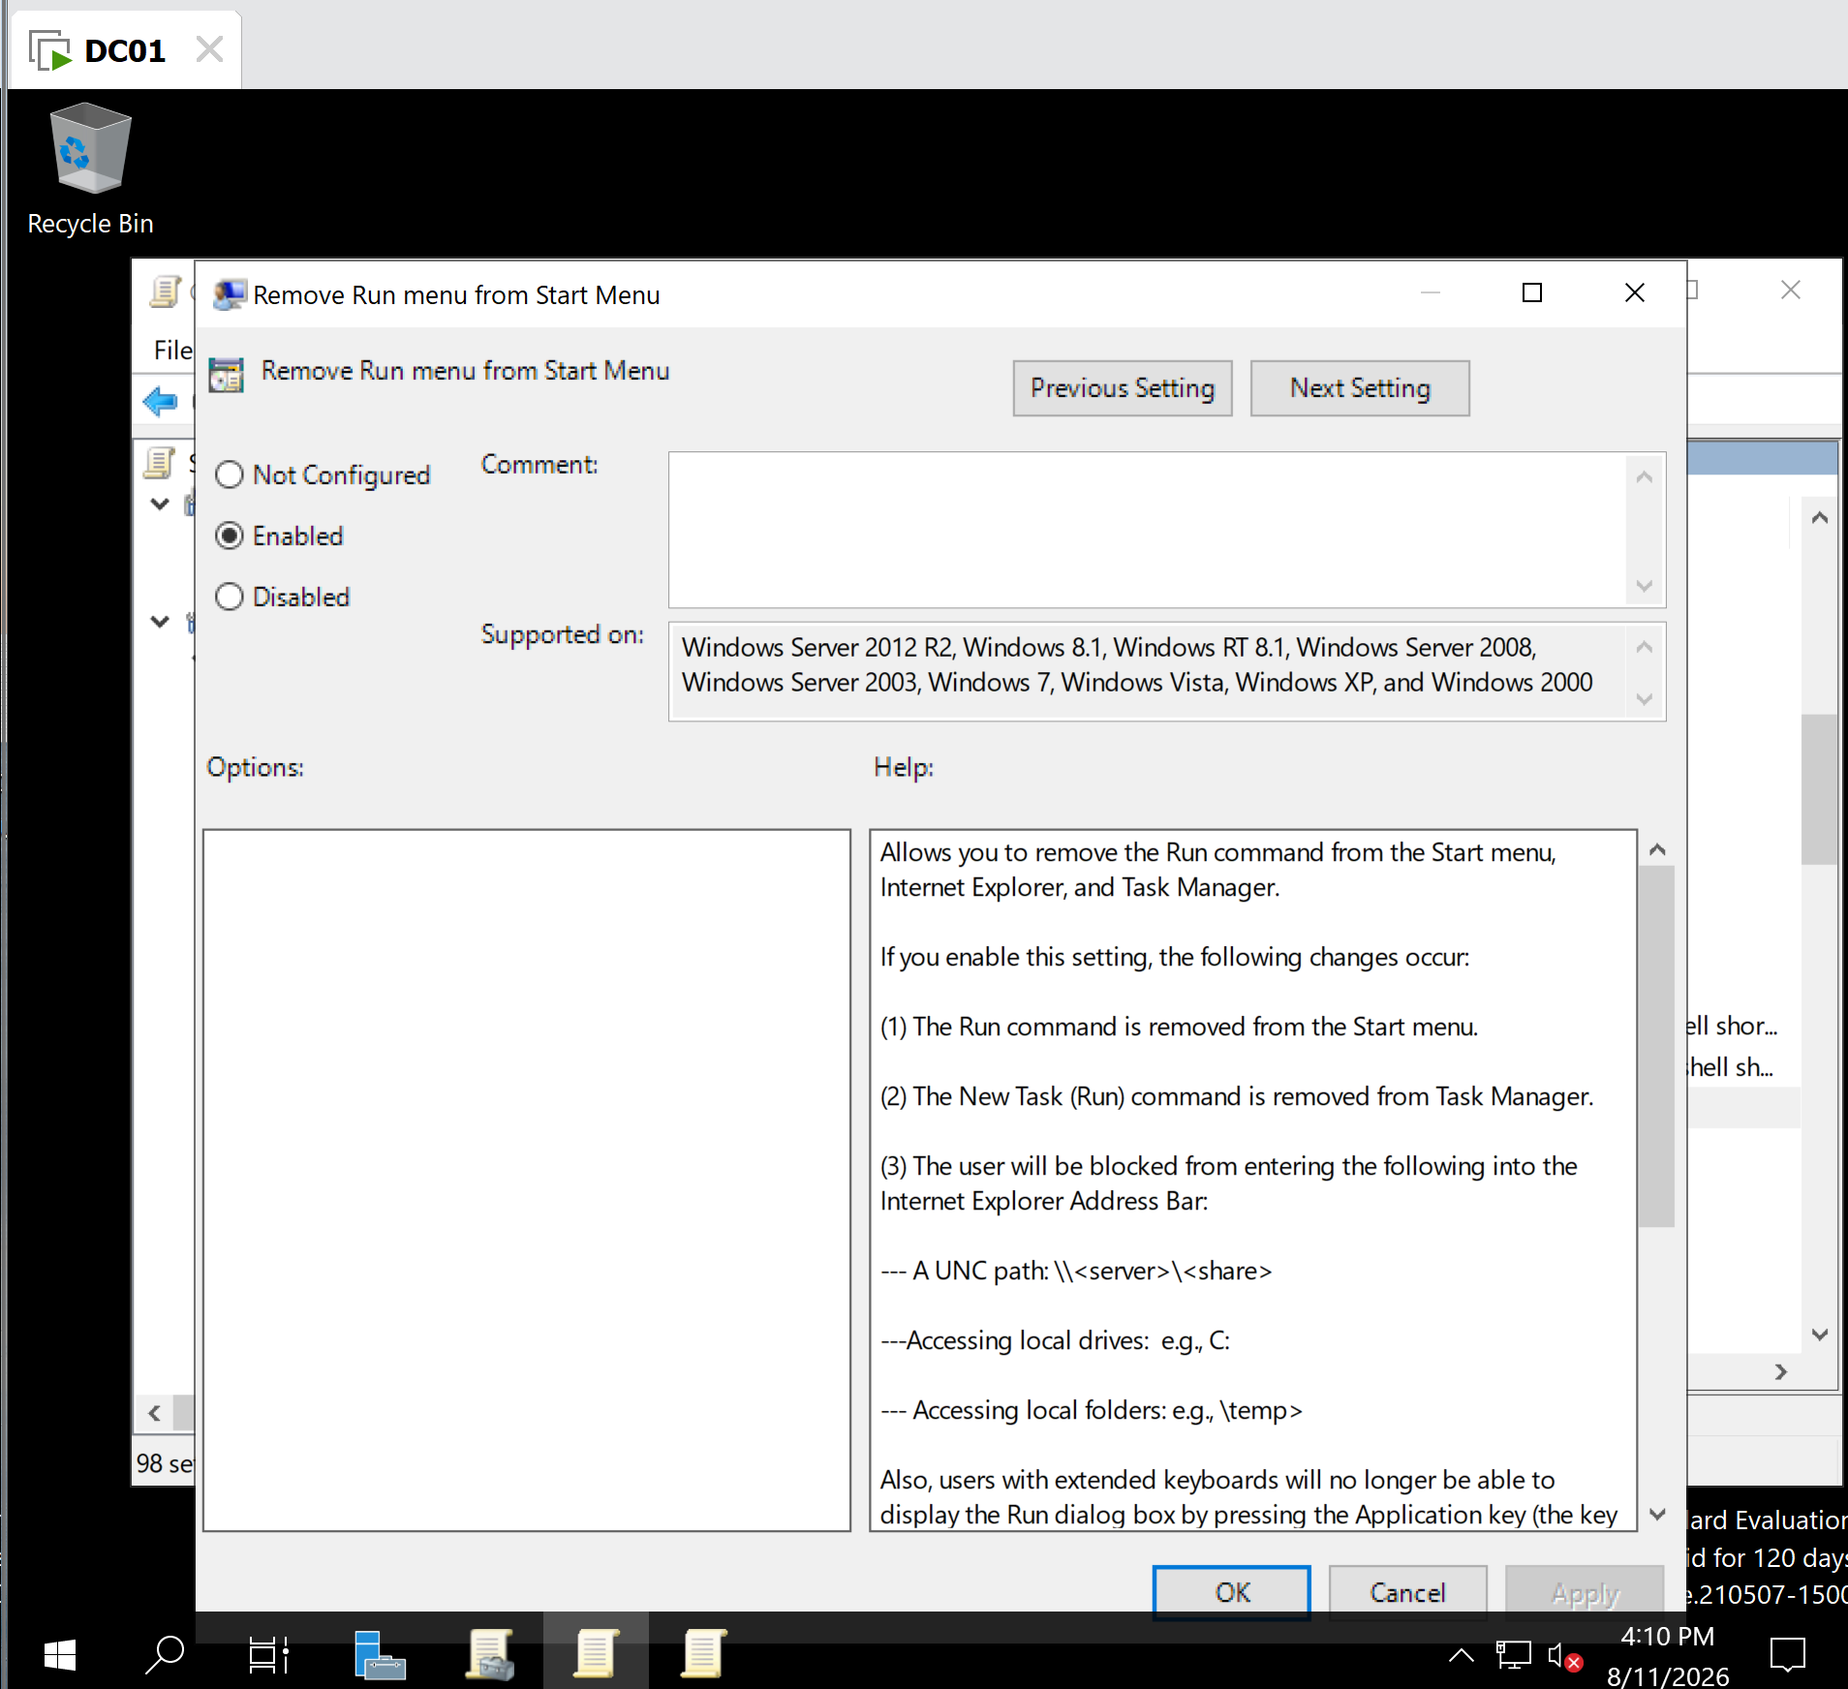
GPO Settings tab — showing Prohibit access to Control Panel and PC settings = Enabled.

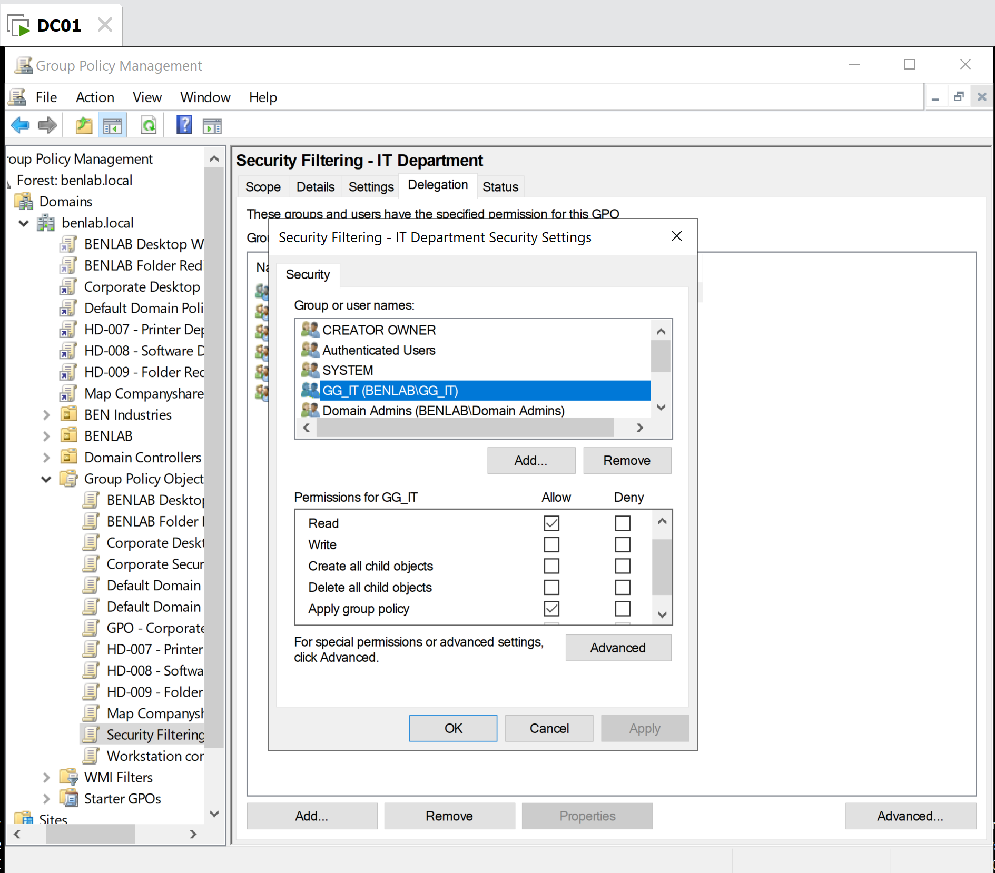
Advanced Security screenshot — the one you just took showing GG_IT with Read + Apply group policy

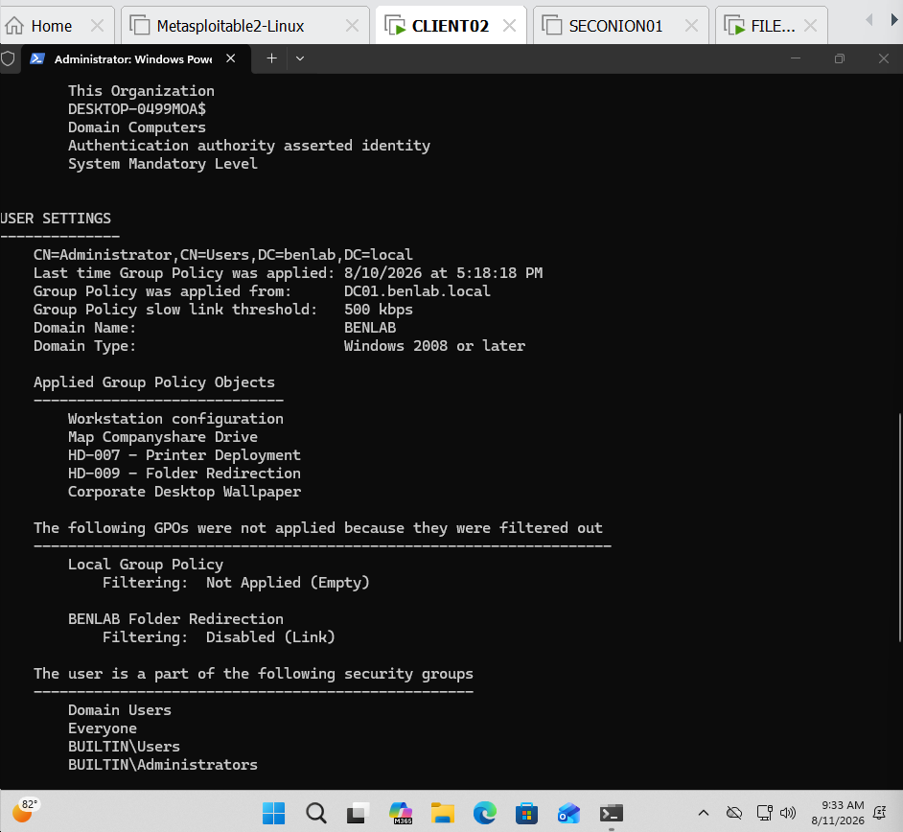
CLIENT02 gpresult screenshot — showing Daniel's GG_IT membership and the absence of the targeted GPO.

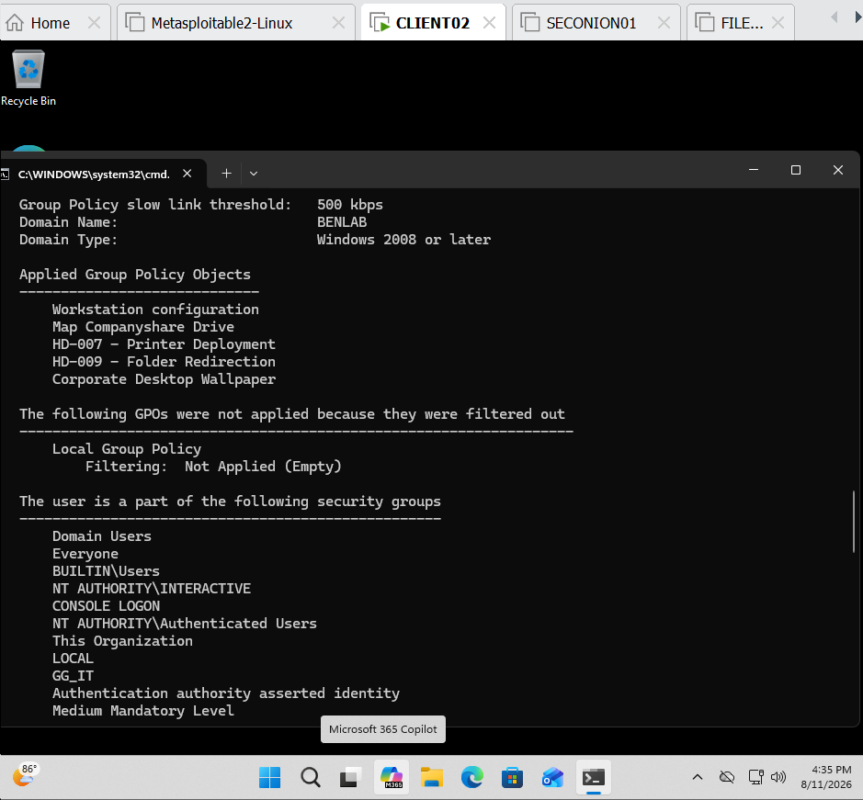
DC01 PowerShell screenshot — your final one showing Daniel Scott's correct DistinguishedName and GG_IT membership.

Task 9 & Task 10 – GPO Backup and Restore

Objective
Demonstrate how to back up and restore a Group Policy Object (GPO) to provide a recovery mechanism for accidental configuration changes, corruption, or administrative errors.

Environment
- Domain Controller: DC01
- Domain: benlab.local
- GPO: Corporate Security Settings
- Backup Location: C:\GPO-Backups\Corporate-Security-Settings
- Management Tool: Group Policy Management Console (GPMC)

Task 9 – Back Up the GPO
The Corporate Security Settings GPO was backed up before performing restore testing.
Procedure:
- Opened Group Policy Management on DC01.
- Expanded Domains → benlab.local → Group Policy Objects.
- Right-clicked Corporate Security Settings and selected Back Up.
- Specified the backup location:
C:\GPO-Backups\Corporate-Security-Settings
- Added the description:
Task 9 - Backup before GPO restore testing
- Started the backup.
- GPMC reported that the backup Succeeded.
- Verified the backup directory in File Explorer and confirmed that Windows created the corresponding backup folder.
Result:
The Corporate Security Settings GPO was successfully backed up and stored on DC01.

Task 10 – Restore the GPO
The previously created backup was then used to test the GPO recovery process.
Procedure:
- Returned to Group Policy Management.
- Right-clicked Corporate Security Settings and selected Restore from Backup.
- Selected:
C:\GPO-Backups\Corporate-Security-Settings
- Selected the backup created during Task 9.
- Verified the backup timestamp and description in the Restore Group Policy Object Wizard.
- Completed the restore operation.
- Returned to the Settings tab of Corporate Security Settings to verify the restored configuration.
Post-Restore Verification:
The GPO remained enabled and its configuration was successfully displayed after restoration. Verification included the GPO link, security filtering, WMI filtering, and configured computer security policies.
Result:
The Corporate Security Settings GPO was successfully recovered from its backup and its configuration was verified after restoration.

Key Learning
GPO backup and restore provides administrators with a recovery mechanism before making significant policy changes. A backup should be created before potentially disruptive modifications so that a known-good configuration can be restored if necessary.
One particularly important thing I learned is that backup is only half of the recovery process. An administrator should also know how to locate the correct backup, perform the restoration, and verify the GPO afterward.

Screenshots
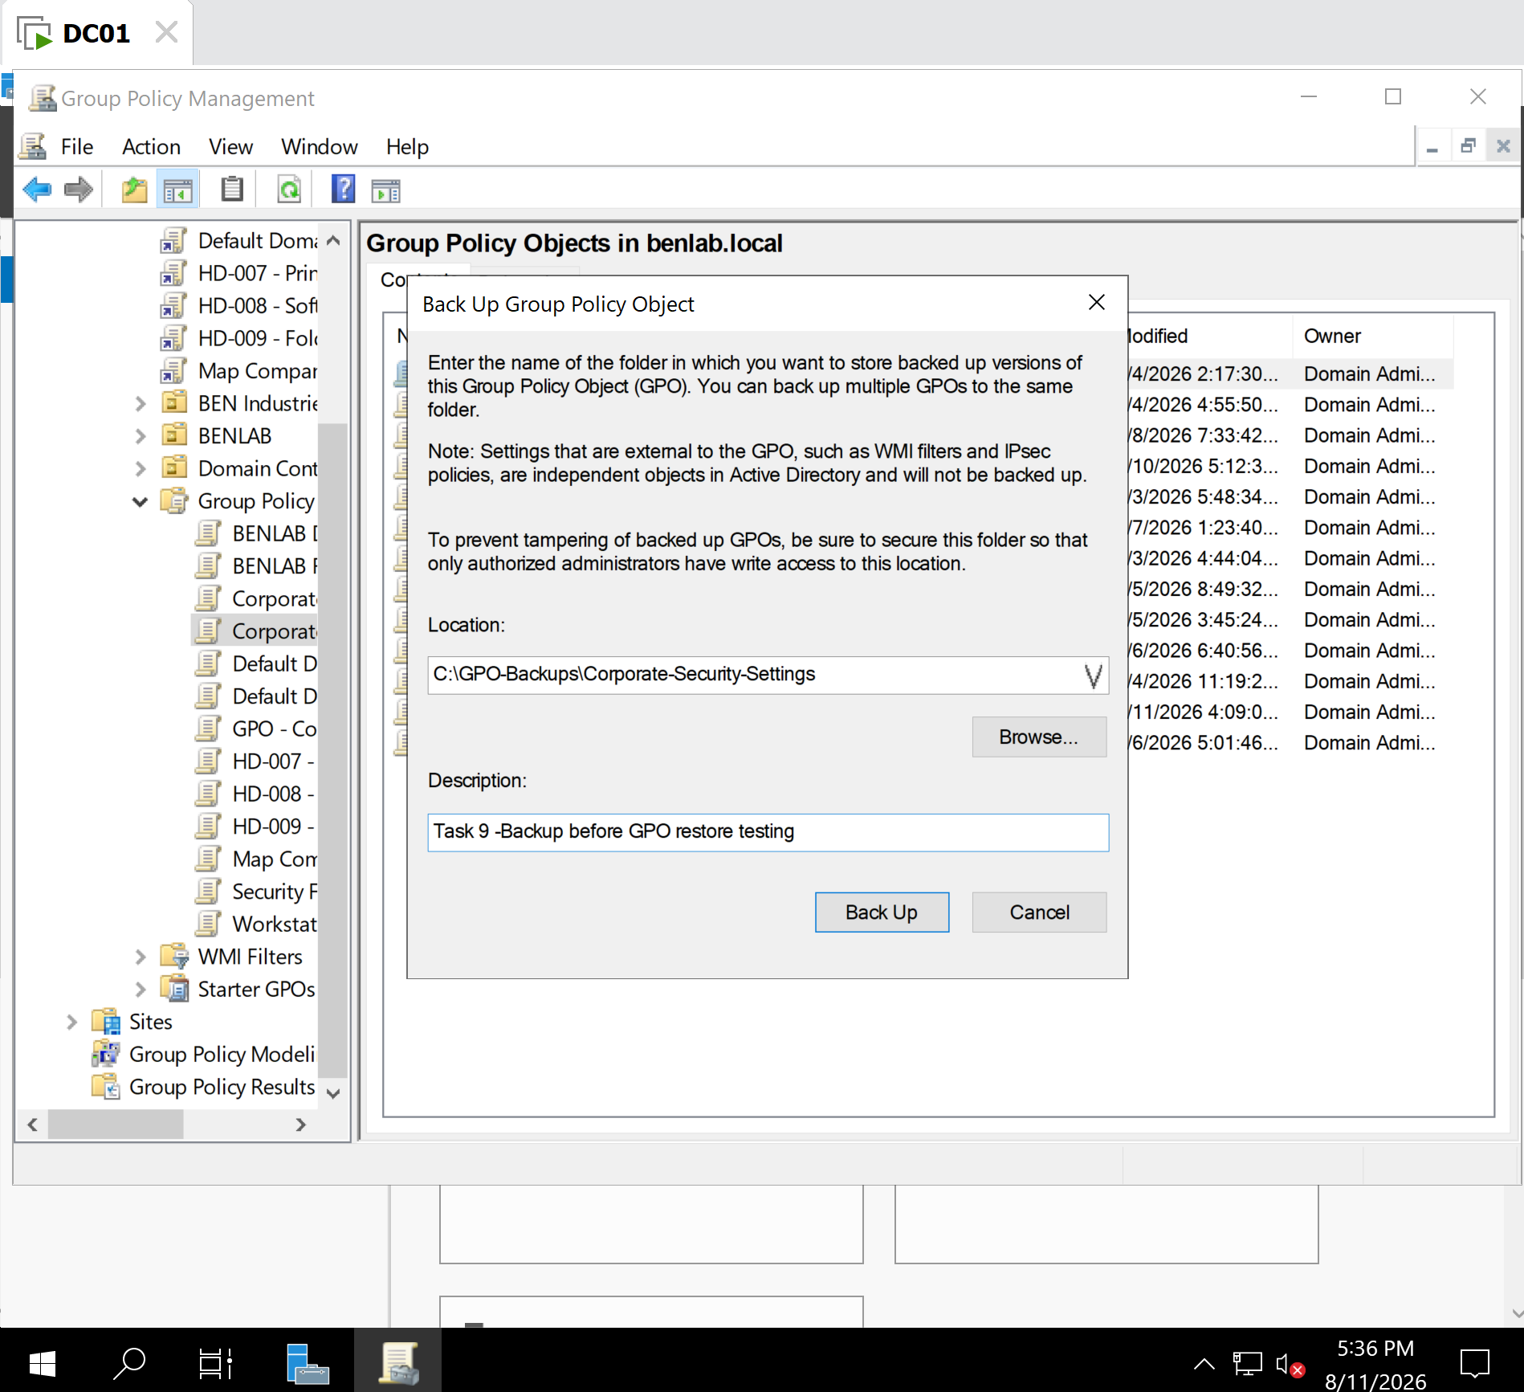
Backup configuration — showing the backup path and Task 9 description.
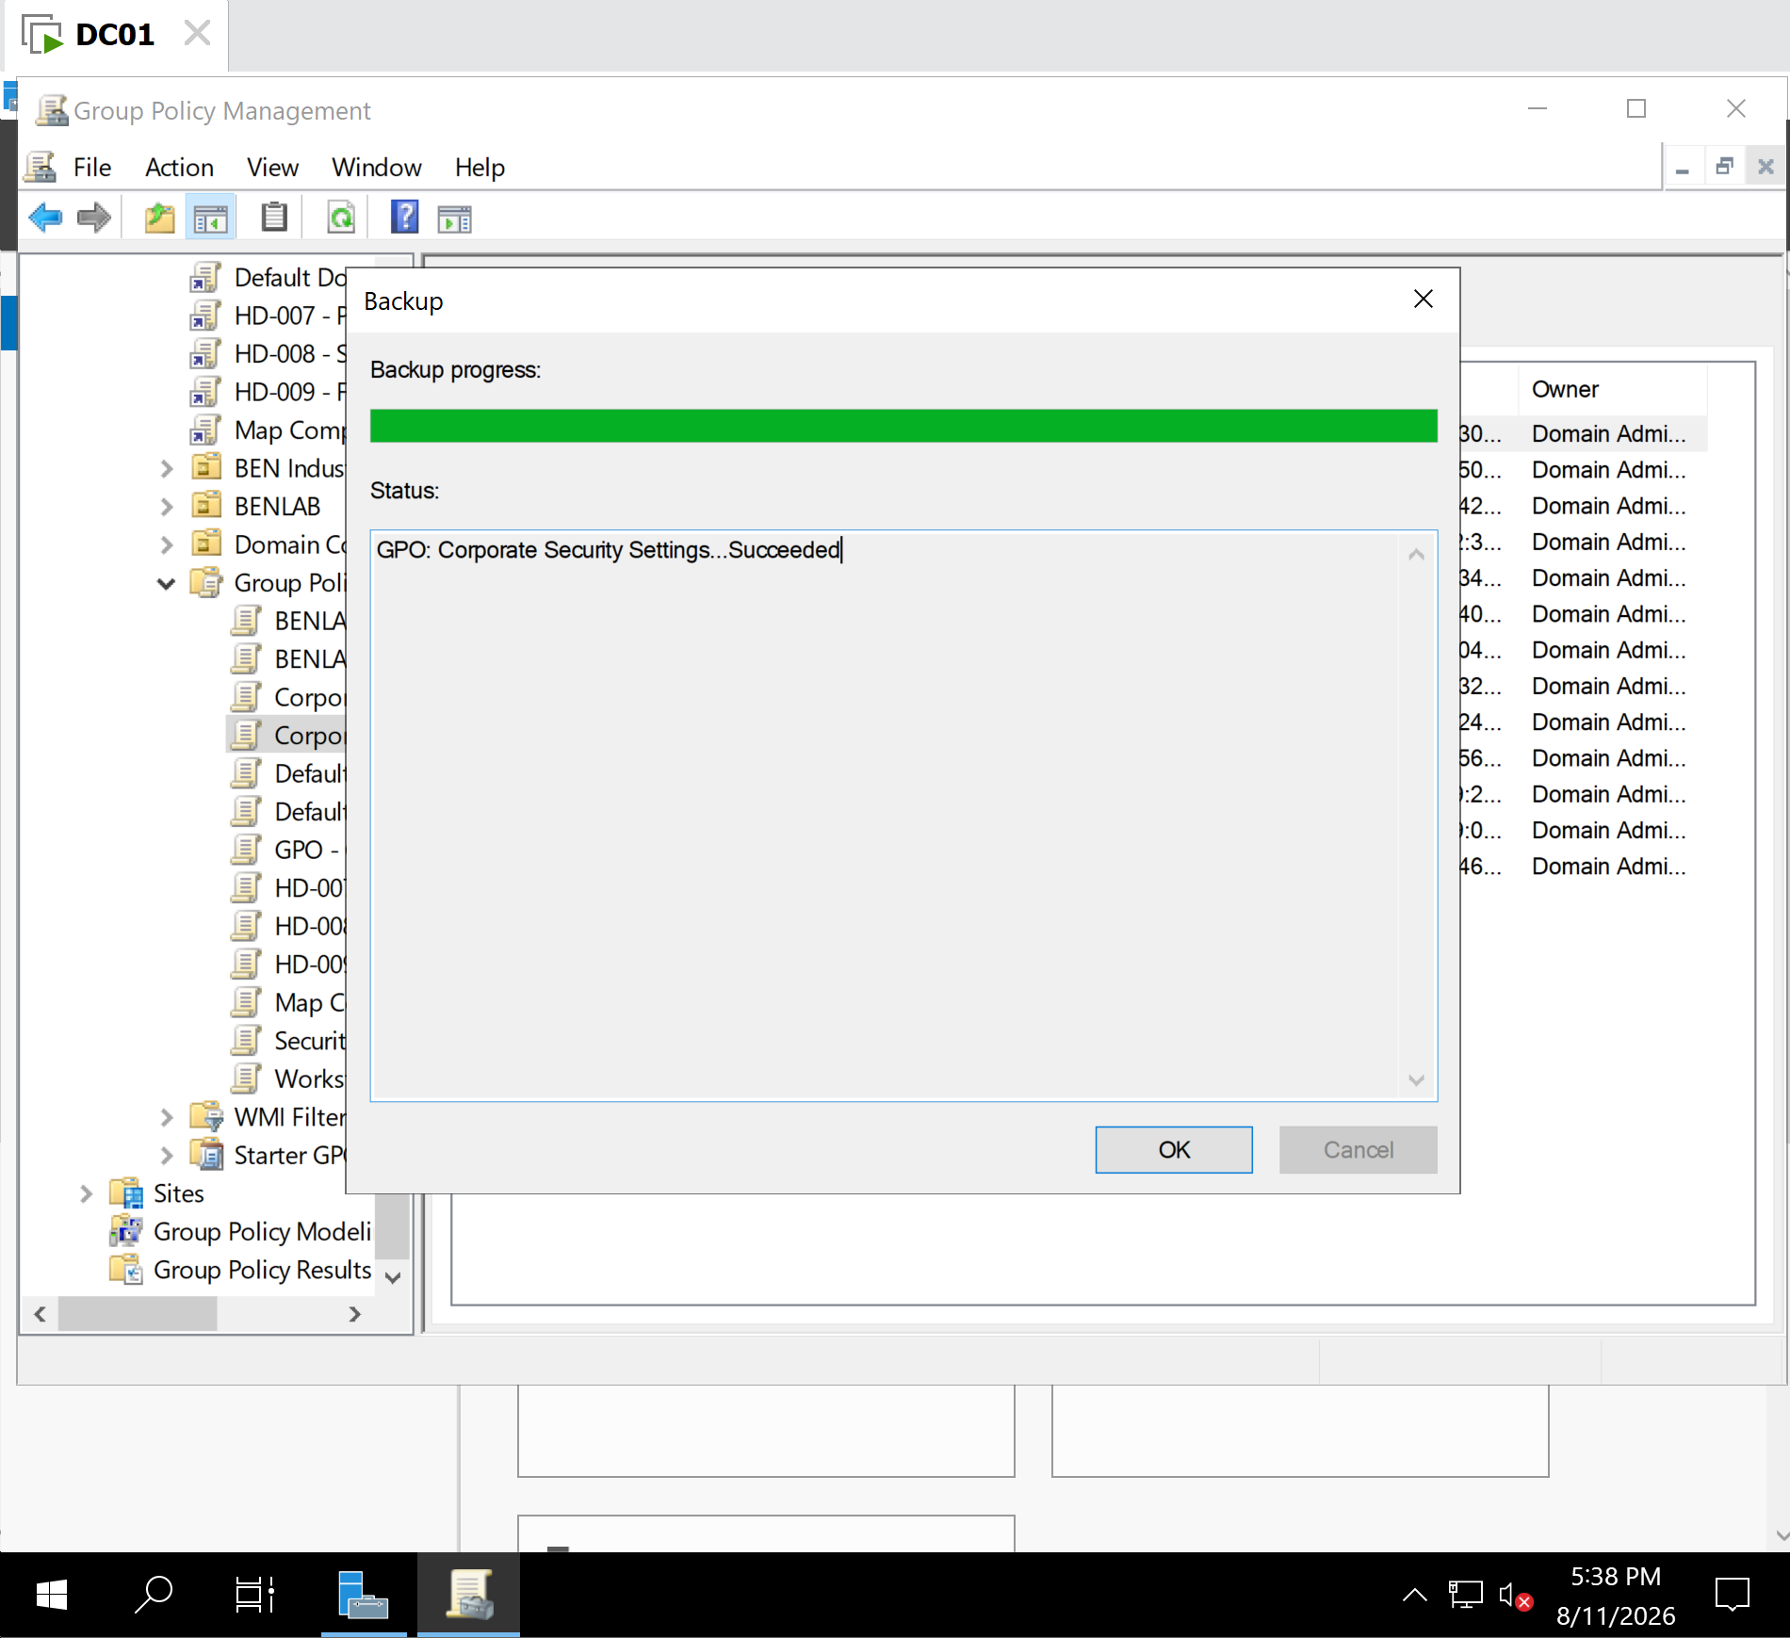
Backup succeeded — your 5:38 PM success screen.
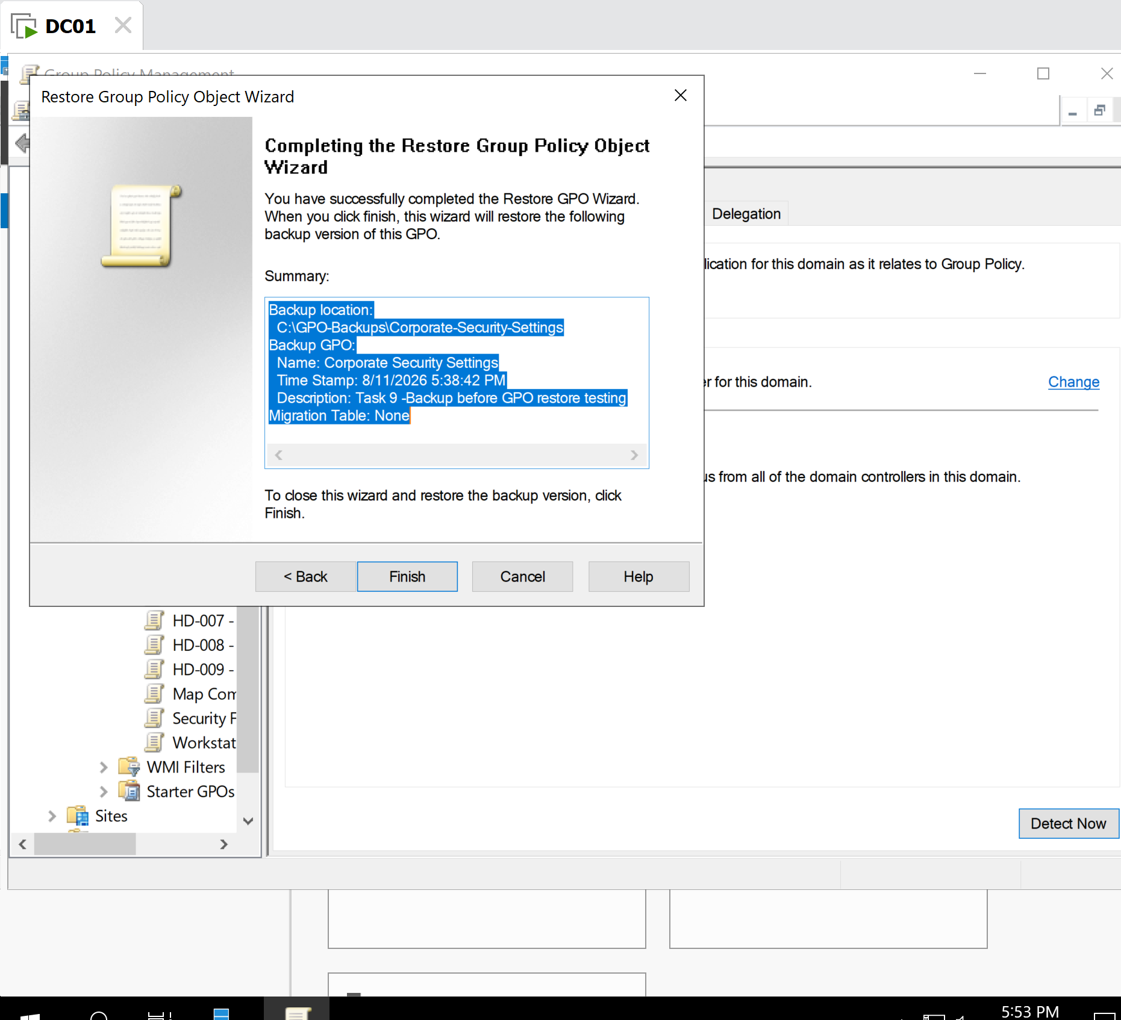
Restore confirmation — the screen showing the correct GPO, backup location, timestamp, and description before clicking Finish.

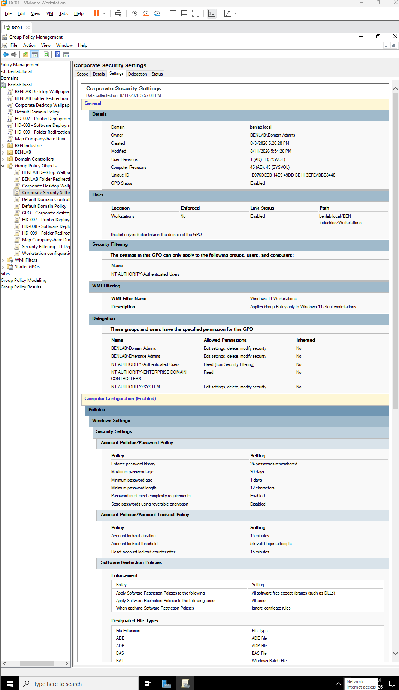
Post-restore verification — the latest Corporate Security Settings Settings report you just captured.

