Task 1 – DNS Server and Zone Validation

Objective
Validate the DNS configuration and DNS Server service on DC01, inspect the existing forward and reverse lookup zones, review DNS resource records, and test name resolution within the benlab.local domain.
The purpose of this task was to establish a baseline of the existing DNS infrastructure before making DNS configuration changes.

Environment Validation
The following DC01 configuration was verified:
- Server Name: DC01
- Domain: benlab.local
- IPv4 Address: 10.20.20.10
- Subnet Mask: 255.255.255.0
- Default Gateway: 10.20.20.254
- IPv4 DNS Server: 127.0.0.1
- DNS Server Role: Installed and operational
DC01 functions as both an Active Directory Domain Controller and DNS server for the BENLAB environment.

PowerShell Commands
DNS client configuration:
Get-DnsClientServerAddress -AddressFamily IPv4
Complete network configuration:
ipconfig /all
DNS Server service status:
Get-Service DNS
DNS zones hosted by DC01:
Get-DnsServerZone
Resource records contained in the benlab.local zone:
Get-DnsServerResourceRecord -ZoneName "benlab.local"

Forward and Reverse Zone Inspection
The DNS zones hosted by DC01 were inspected using PowerShell and DNS Manager.
Important forward lookup zones included:
- benlab.local
- _msdcs.benlab.local
The reverse lookup zone for the BENLAB 10.20.20.0/24 network was:
20.20.10.in-addr.arpa
The benlab.local zone contained several important DNS record types:
- A — Hostname to IPv4 address
- AAAA — Hostname to IPv6 address
- NS — Identifies authoritative DNS servers
- SOA — Contains authoritative zone information
- SRV — Identifies services such as LDAP, Kerberos, and Global Catalog
Existing A records included:
APP01 → 10.20.20.15
DC01 → 10.20.20.10
FILESRV01 → 10.20.20.50
WIN01 → 10.20.20.140

Resolution Testing
Forward DNS resolution was tested with:
Resolve-DnsName dc01.benlab.local
Resolve-DnsName FILESRV01.benlab.local
Resolve-DnsName WIN01.benlab.local
All three hostnames successfully resolved to their corresponding IPv4 addresses.
Reverse DNS resolution was then tested:
Resolve-DnsName 10.20.20.10
Resolve-DnsName 10.20.20.50
Resolve-DnsName 10.20.20.140
Successful results included:
10.20.20.10 → DC01.benlab.local
10.20.20.50 → FILESRV01.benlab.local

WIN01 Missing PTR Finding
The reverse lookup for WIN01 was tested using:
Resolve-DnsName 10.20.20.140
The query failed because no corresponding PTR record was found.
However, forward resolution was successful:
WIN01.benlab.local → 10.20.20.140
This demonstrated that WIN01 had a valid A record but did not have a corresponding PTR record.
Forward DNS
WIN01.benlab.local ── A ──► 10.20.20.140
SUCCESS

Reverse DNS
10.20.20.140 ── PTR ──► WIN01.benlab.local
MISSING
This demonstrated that forward and reverse DNS resolution are separate operations.

Screenshots
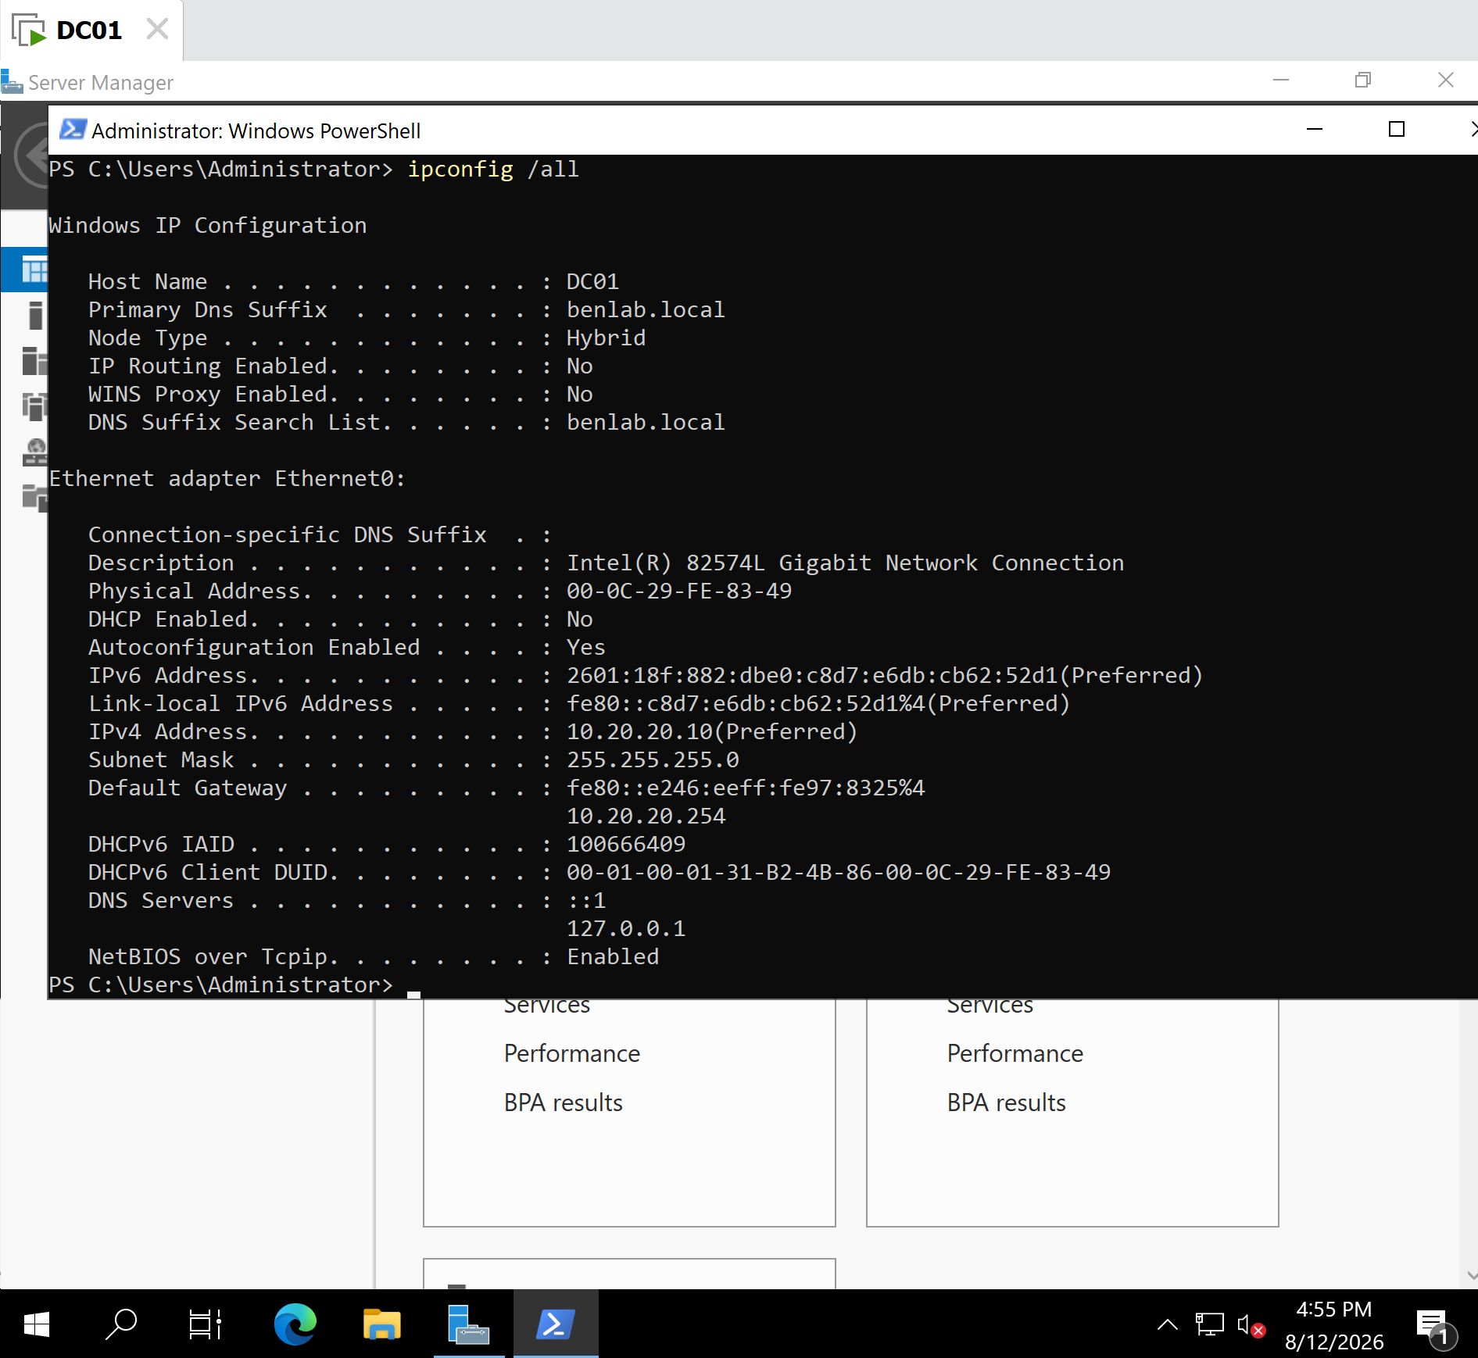
Screenshot 1 – DC01 DNS and Network Configuration
Shows the DC01 hostname, domain suffix, IPv4 address, default gateway, and configured DNS server.

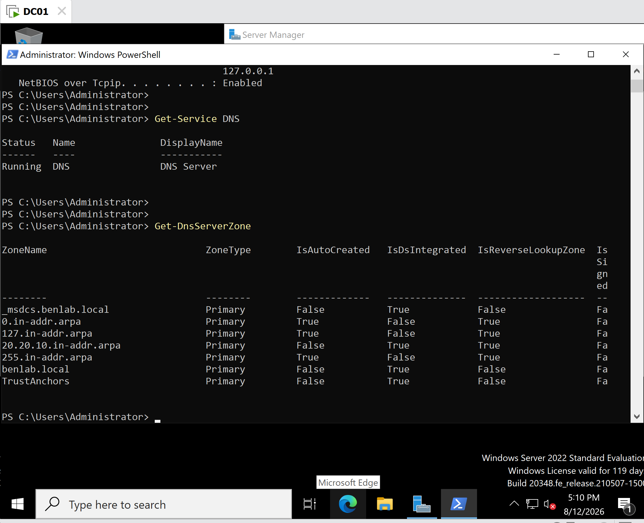
Screenshot 2 – DNS Service and Zone Validation
Shows the DNS Server service running and the DNS zones hosted by DC01.
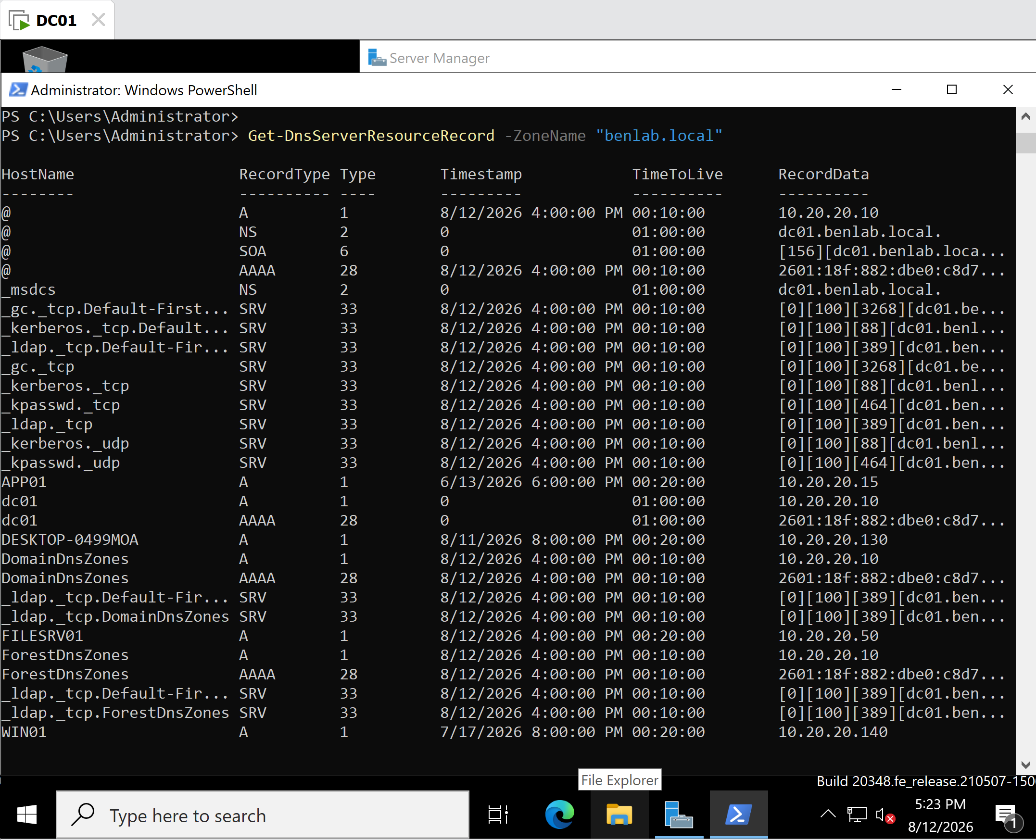
Screenshot 3 – DNS Resource Records
Shows records contained within the benlab.local forward lookup zone.

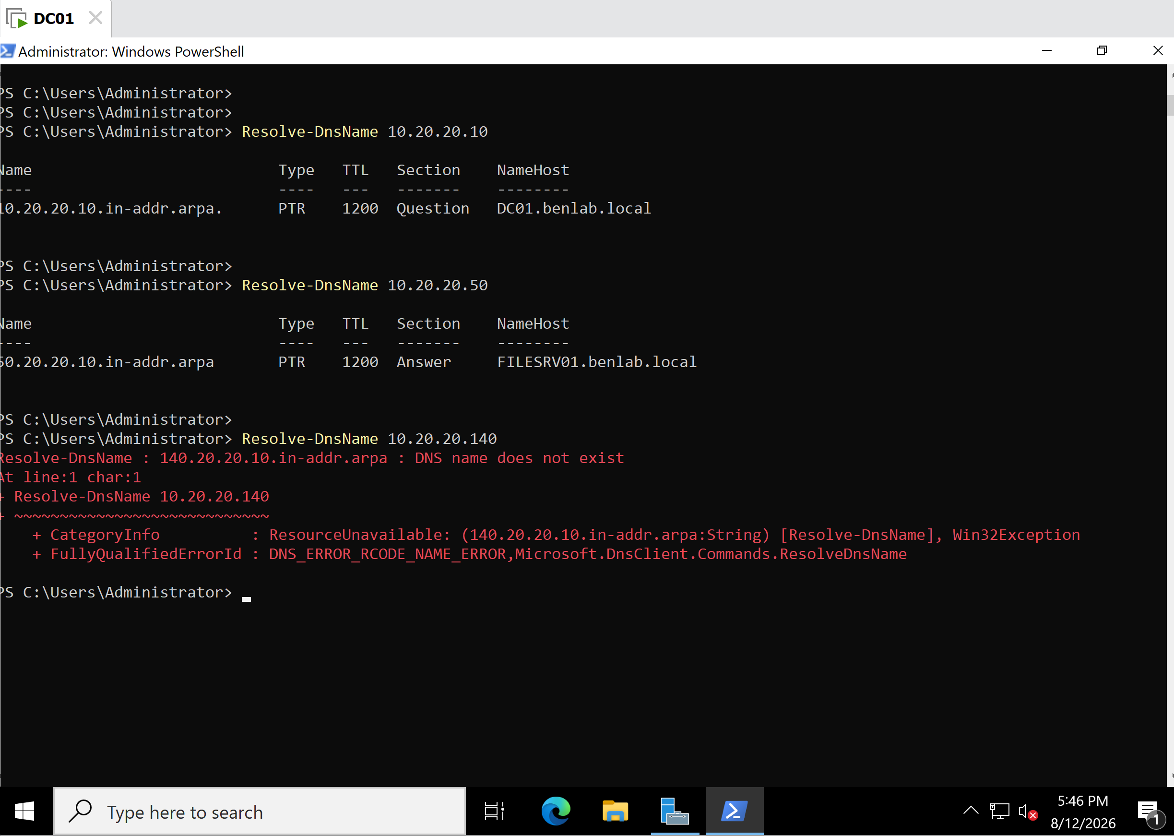
Screenshot 4 – Reverse DNS Resolution Testing
Shows successful reverse resolution for DC01 and FILESRV01 and the failed WIN01 reverse lookup caused by the missing PTR record.

Key Learning Points
- DNS provides hostname-to-IP and IP-to-hostname resolution.
- A records map hostnames to IPv4 addresses.
- PTR records map IPv4 addresses back to hostnames.
- Forward and reverse DNS resolution are independent.
- A valid A record does not guarantee that a PTR record exists.
- Resolve-DnsName can test both forward and reverse resolution.
- Get-DnsServerZone allows administrators to inspect DNS zones through PowerShell.
- Get-DnsServerResourceRecord allows DNS records to be inspected from PowerShell.
- Active Directory relies heavily on DNS and SRV records for service discovery.
- Successful DNS resolution does not prove that the destination computer is powered on or reachable.
- Establishing a DNS baseline before making changes is an important administration and troubleshooting practice.

Task 2 – Create and Verify A and PTR Records

Objective
Create and validate DNS A and PTR records in the benlab.local DNS infrastructure using DNS Manager and PowerShell.
The purpose of this task was to practice both forward and reverse DNS record administration and understand the relationship between A and PTR records.

Test DNS Record
A test hostname was created specifically for DNS administration practice.
The following information was used:
- Hostname: TESTSERVER01
- FQDN: TESTSERVER01.benlab.local
- IPv4 Address: 10.20.20.200
- Forward Lookup Zone: benlab.local
- Reverse Lookup Zone: 20.20.10.in-addr.arpa
TESTSERVER01 was used as a DNS test record and did not require an actual server to be running at the assigned IP address.

Create TESTSERVER01 A Record
DNS Manager was opened on DC01 and the following location was selected:
DC01
└── Forward Lookup Zones
└── benlab.local
The New Host (A or AAAA) option was used to create the record.
The following values were entered:
Name: TESTSERVER01
FQDN: TESTSERVER01.benlab.local
IP Address: 10.20.20.200
The host record was successfully created in the benlab.local forward lookup zone.
The resulting A record provides:
TESTSERVER01.benlab.local ──► 10.20.20.200

Create Associated PTR Record
While creating the TESTSERVER01 A record, the following option was enabled:
Create associated pointer (PTR) record
This instructed DNS Manager to create the corresponding PTR record in the existing reverse lookup zone.
The PTR record provides the opposite mapping:
10.20.20.200 ──► TESTSERVER01.benlab.local
This demonstrated that an A record and a PTR record perform complementary but separate DNS functions.

Forward Lookup Verification
The new A record was verified from PowerShell using:
Resolve-DnsName TESTSERVER01.benlab.local
The query successfully returned:
Name: TESTSERVER01.benlab.local
Type: A
IPAddress: 10.20.20.200
This confirmed successful forward DNS resolution:
Hostname ── A Record ──► IPv4 Address

TESTSERVER01.benlab.local
│
▼
10.20.20.200

Reverse Lookup Verification
Reverse DNS resolution was tested using:
Resolve-DnsName 10.20.20.200
The query successfully returned:
Type: PTR
NameHost: TESTSERVER01.benlab.local
This confirmed successful reverse DNS resolution:
IPv4 Address ── PTR Record ──► Hostname

10.20.20.200
│
▼
TESTSERVER01.benlab.local
Both the A and PTR records were therefore successfully created and verified.

DNS Resolution vs. Host Availability
TESTSERVER01 was only created as a DNS record for testing purposes. No physical or virtual server was actually operating at 10.20.20.200.
Despite this, both DNS queries succeeded.
This demonstrated an important troubleshooting concept:
Successful DNS resolution does not necessarily mean that the destination computer is online or reachable.
DNS confirms that a record exists associating a hostname and IP address. Additional network testing would be required to determine whether an actual host is available at that address.

Screenshots
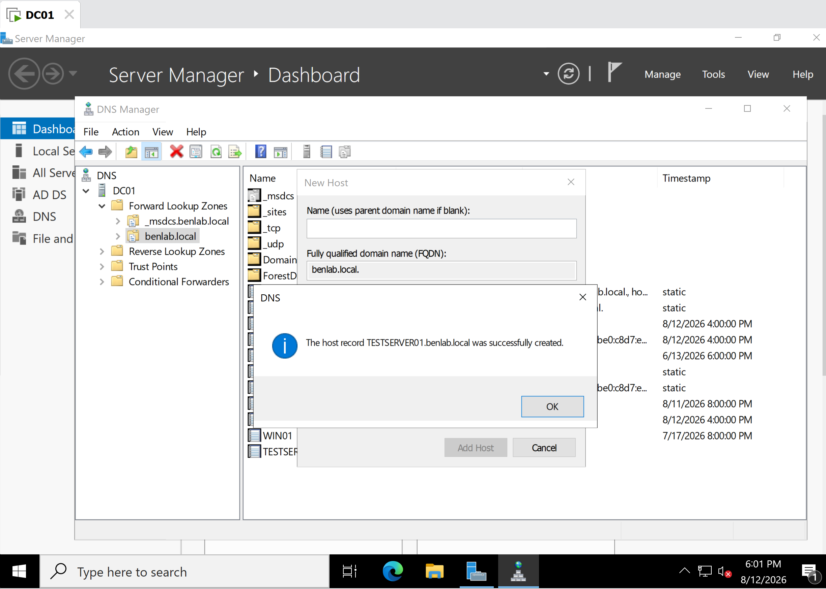
Screenshot 1 – TESTSERVER01 Host Record Creation
Shows confirmation that the TESTSERVER01.benlab.local host record was successfully created.

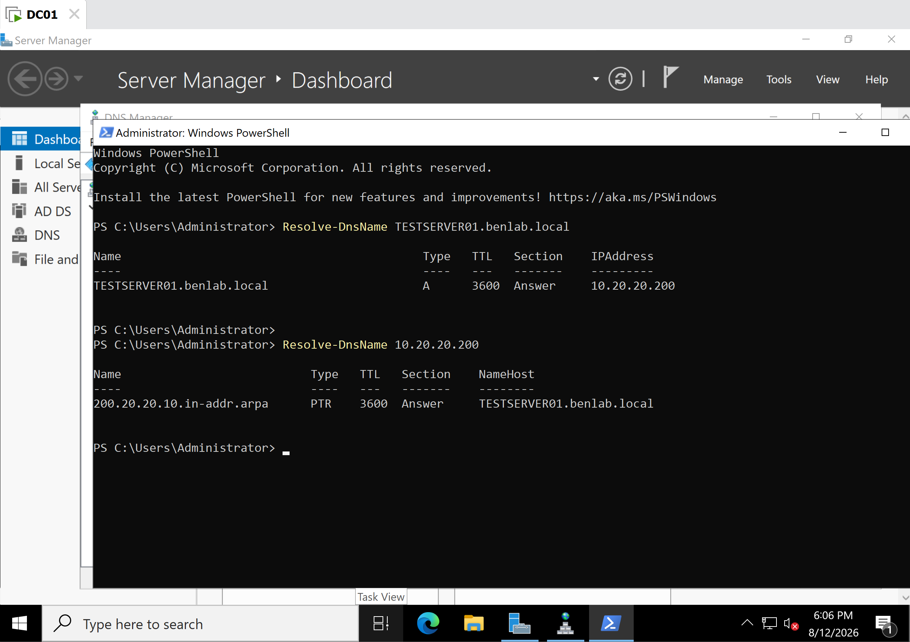
Screenshot 2 – Forward and Reverse DNS Verification
Shows successful PowerShell resolution of:
TESTSERVER01.benlab.local → 10.20.20.200
and:
10.20.20.200 → TESTSERVER01.benlab.local
This screenshot provides evidence that both the A and associated PTR records were functioning correctly.

Key Learning Points
- An A record maps a hostname to an IPv4 address.
- A PTR record maps an IPv4 address back to a hostname.
- DNS Manager can automatically create a corresponding PTR record when creating an A record.
- Forward and reverse DNS resolution should be tested independently.
- Resolve-DnsName can verify both A and PTR records.
- DNS records can exist even when no actual device is operating at the configured IP address.
- Successful name resolution does not prove network connectivity or host availability.
- Creating both A and PTR records provides more complete DNS name-resolution coverage.
- DNS changes should be verified after configuration rather than assuming successful creation means resolution is functioning.

Task 3 – Troubleshoot and Repair DNS Record Inconsistency

Objective
Troubleshoot a DNS resolution inconsistency involving the TESTSERVER01 host record.
The goal was to identify why forward name resolution worked while reverse name resolution failed, inspect the DNS records, correct the inconsistency, and verify successful resolution in both directions.

Initial DNS Configuration
TESTSERVER01 had the following DNS A record:
Hostname: TESTSERVER01
FQDN: TESTSERVER01.benlab.local
IP Address: 10.20.20.201
Forward resolution was tested using PowerShell:
Resolve-DnsName TESTSERVER01.benlab.local
The query successfully returned:
TESTSERVER01.benlab.local A 10.20.20.201
This confirmed that the A record was functioning correctly.

Reverse Lookup Failure
Reverse DNS resolution was then tested:
Resolve-DnsName 10.20.20.201
The query returned:
DNS name does not exist
This demonstrated that although the hostname could be translated to its IP address, DNS could not translate the IP address back to the hostname.
The problem therefore involved reverse DNS resolution rather than forward DNS resolution.

DNS Manager Investigation
DNS Manager was opened on DC01, and the following reverse lookup zone was inspected:
20.20.10.in-addr.arpa
Existing PTR records were present for several systems in the 10.20.20.0/24 network, but there was no PTR record for:
10.20.20.201
This identified the root cause of the failed reverse lookup.
Finding: The A record for TESTSERVER01 existed, but its corresponding PTR record was missing.

PTR Record Repair
A new PTR record was created in the reverse lookup zone.
The completed mapping was:
10.20.20.201 → TESTSERVER01.benlab.local
DNS Manager was then refreshed to verify that the new PTR record appeared successfully in the reverse lookup zone.

Forward and Reverse Resolution Verification
After repairing the PTR record, forward resolution was tested again:
Resolve-DnsName TESTSERVER01.benlab.local
Result:
TESTSERVER01.benlab.local → 10.20.20.201
Reverse resolution was then tested:
Resolve-DnsName 10.20.20.201
Result:
10.20.20.201 → TESTSERVER01.benlab.local
Both queries completed successfully.
This confirmed that the A and PTR records were now consistent.

Screenshots
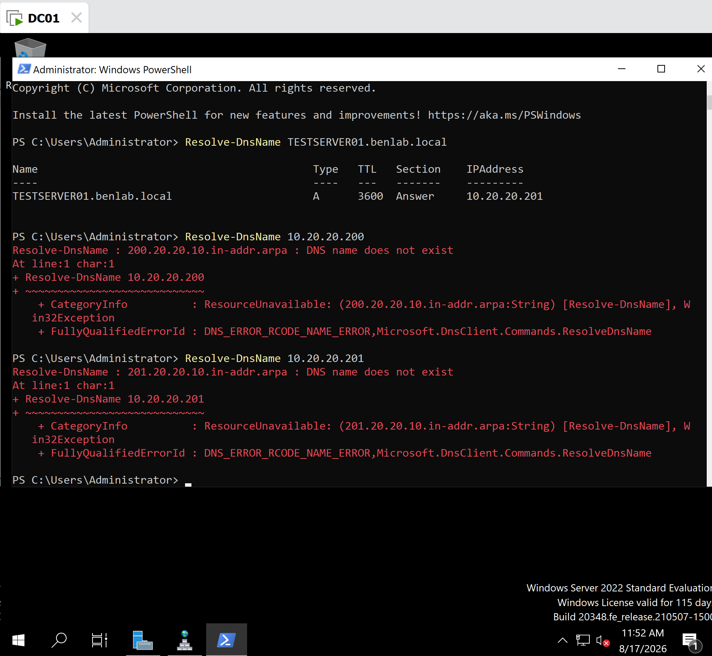
Screenshot 1 – Reverse DNS Failure
PowerShell showing that the forward lookup for TESTSERVER01.benlab.local succeeded while the reverse lookup failed because the PTR record was missing.

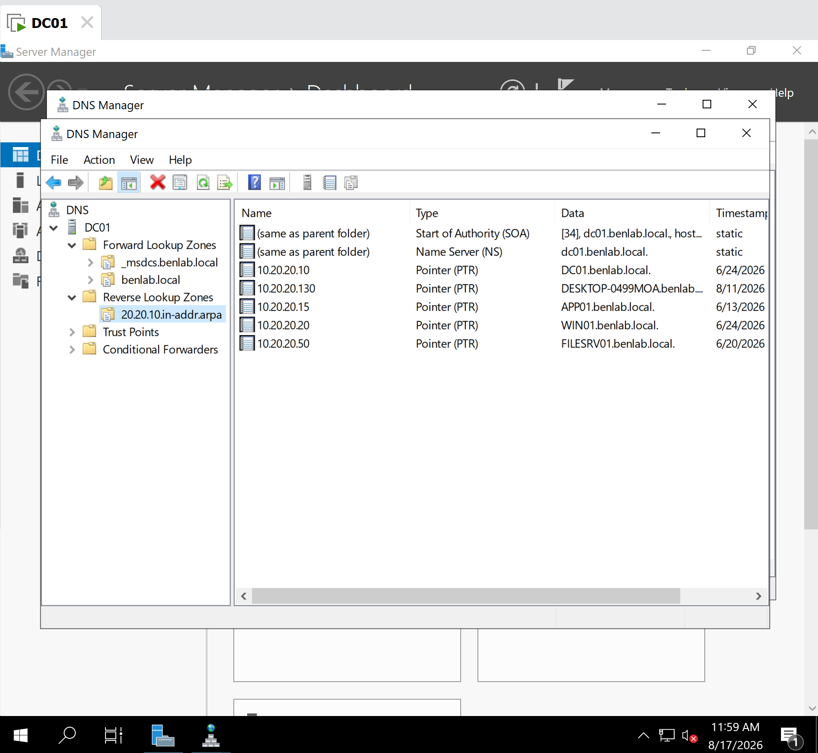
Screenshot 2 – Reverse Lookup Zone Investigation
DNS Manager showing the 20.20.10.in-addr.arpa reverse lookup zone without a PTR record for 10.20.20.201.

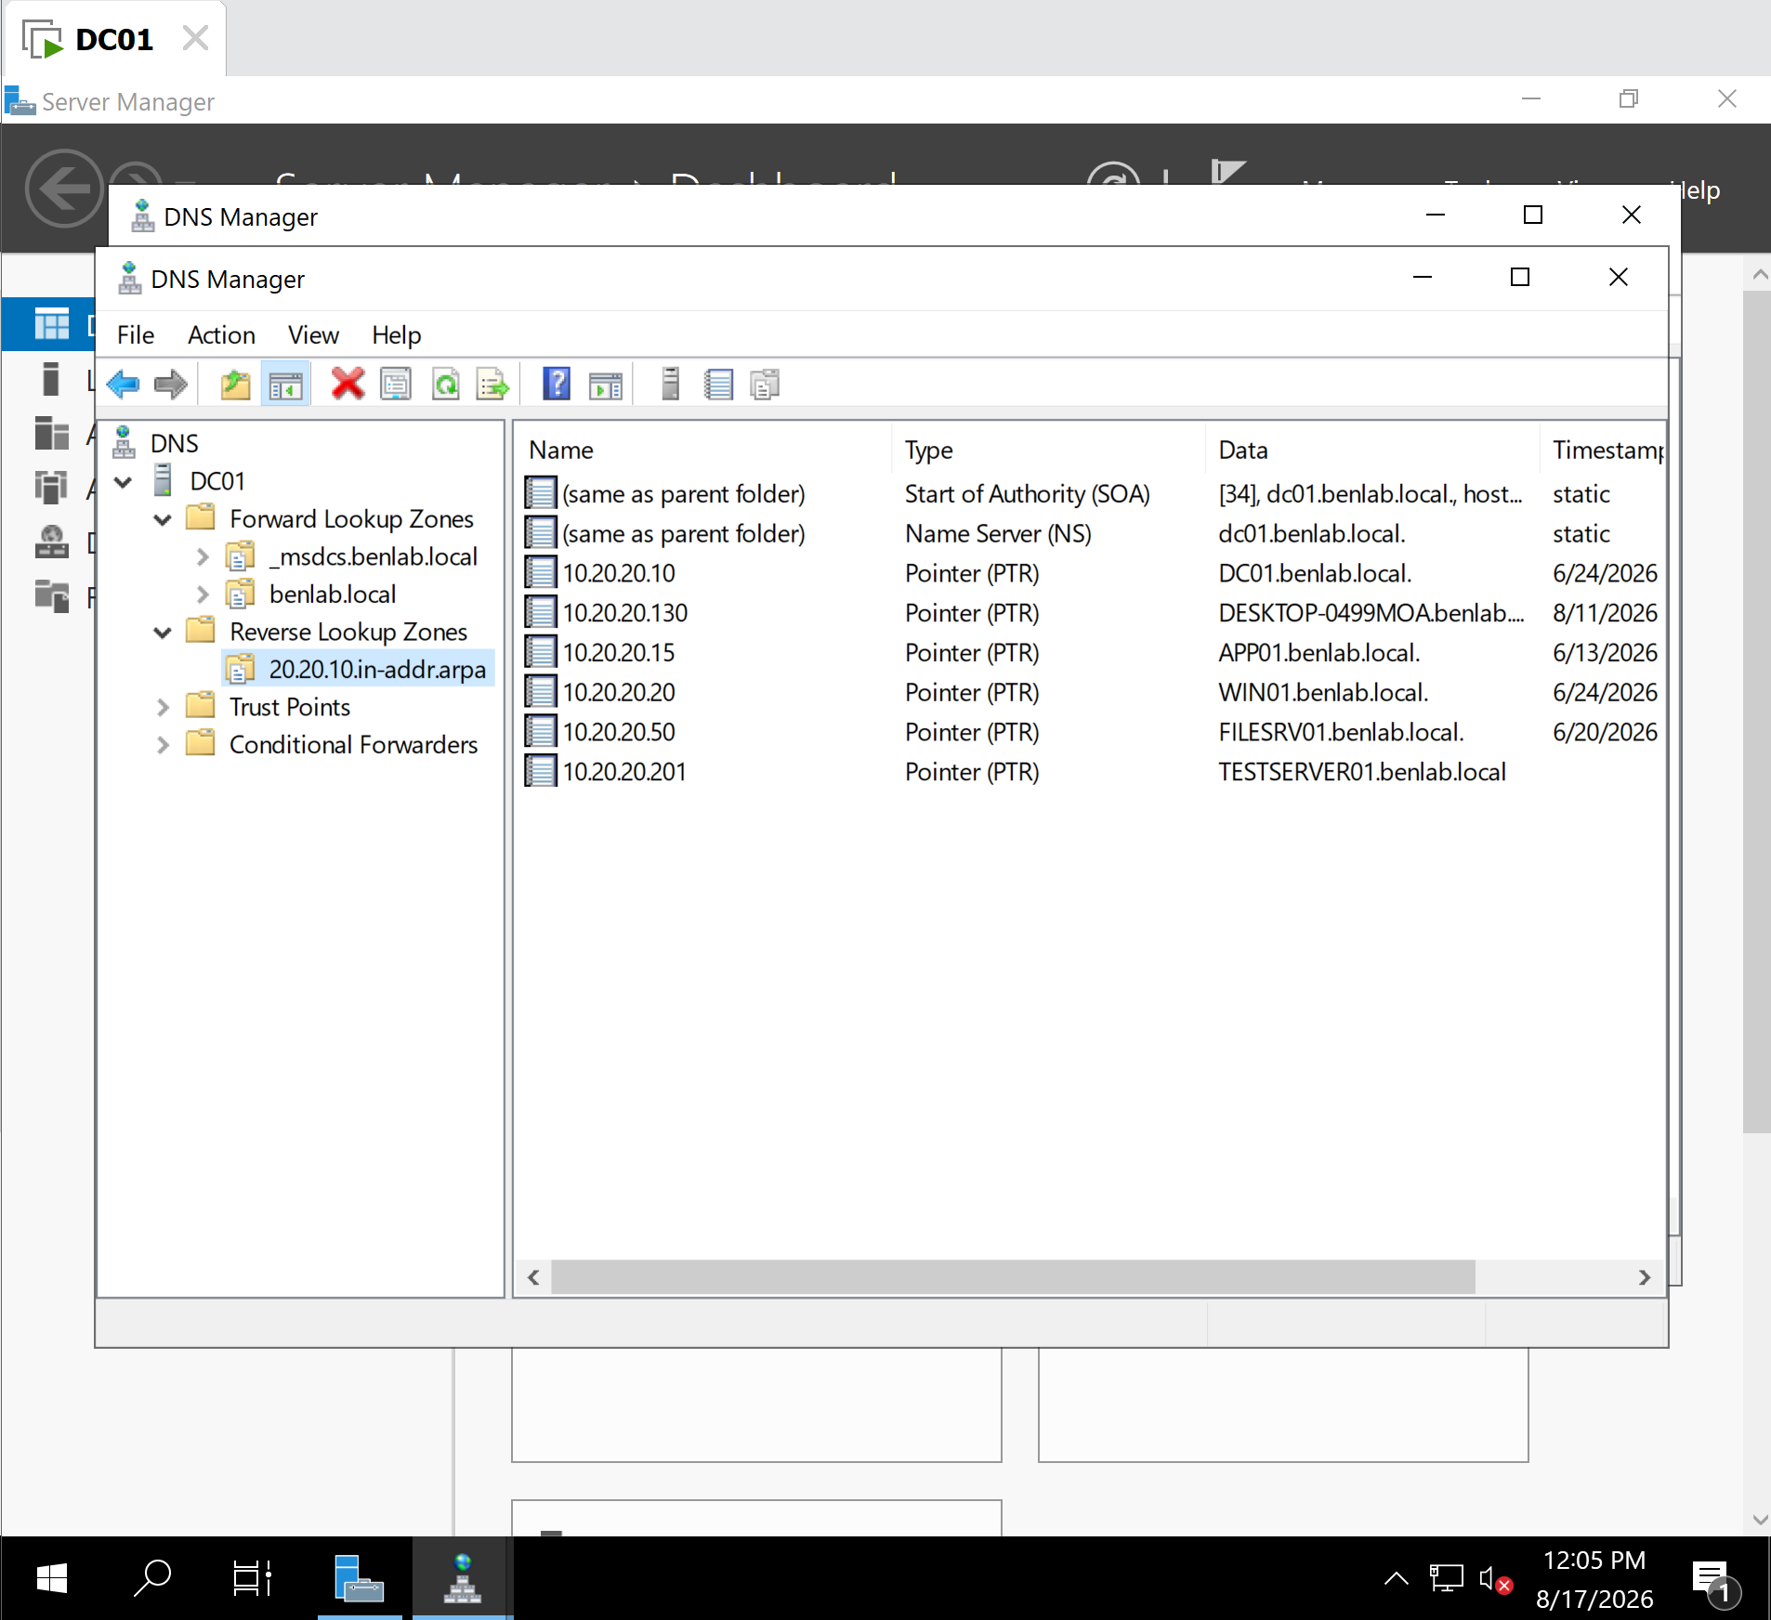
Screenshot 3 – PTR Record Created
DNS Manager showing the newly created PTR record:
10.20.20.201 → TESTSERVER01.benlab.local

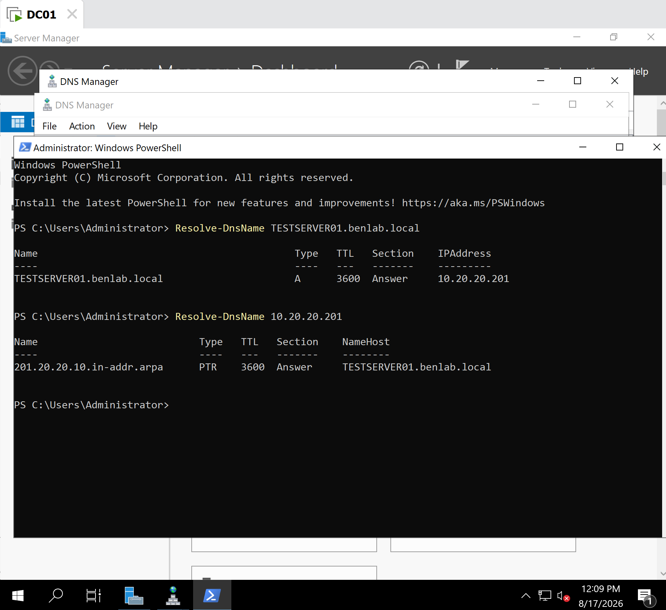
Screenshot 4 – Final DNS Verification
PowerShell showing successful forward and reverse resolution:
TESTSERVER01.benlab.local → 10.20.20.201
10.20.20.201 → TESTSERVER01.benlab.local

Key Learning Points
- An A record provides forward DNS resolution from a hostname to an IPv4 address.
- A PTR record provides reverse DNS resolution from an IP address to a hostname.
- Successful forward resolution does not guarantee successful reverse resolution.
- A missing PTR record does not necessarily mean the entire DNS service is broken.
- Resolve-DnsName can be used to test both forward and reverse DNS resolution.
- DNS Manager can be used to inspect and manually repair DNS resource records.
- Comparing forward and reverse lookup results is an effective DNS troubleshooting technique.
- After repairing DNS records, administrators should verify the solution rather than assuming the configuration change worked.

Result
Status: Completed Successfully
TESTSERVER01 now has consistent forward and reverse DNS resolution:
A record: TESTSERVER01.benlab.local → 10.20.20.201
PTR record: 10.20.20.201 → TESTSERVER01.benlab.local
This task demonstrated a realistic DNS troubleshooting workflow: identify the symptom → isolate forward vs. reverse resolution → inspect DNS records → identify the missing record → repair it → verify the result.

Task 4 – Forward Lookup Zone Administration and CNAME Records

Objective
The objective of this task was to perform additional administration within the benlab.local Forward Lookup Zone and understand how DNS aliases (CNAME records) work.
The task demonstrated the relationship between A records and CNAME records, how an alias continues functioning when the IP address of its target host changes, and the important distinction between successful DNS name resolution and actual network connectivity.

Environment
The task was performed on:
- DNS Server: DC01
- DNS Server IP: 10.20.20.10
- Domain: benlab.local
- Forward Lookup Zone: benlab.local
- Test host: TESTSERVER01.benlab.local
- Initial test IP: 10.20.20.201
- Updated test IP: 10.20.20.202
- DNS Alias: intranet.benlab.local
TESTSERVER01 was used as a DNS test record and does not represent an active server at the configured test IP address.

CNAME Record Creation
DNS Manager was opened on DC01 and the following location was selected:
DC01
└── Forward Lookup Zones
└── benlab.local
A new Alias (CNAME) resource record was created with the following configuration:
Alias name:
intranet

Fully Qualified Domain Name:
intranet.benlab.local

Target host:
TESTSERVER01.benlab.local
The resulting relationship was:
intranet.benlab.local
↓
CNAME
↓
TESTSERVER01.benlab.local
Unlike an A record, the CNAME does not directly contain the IPv4 address. Instead, it references another hostname.

CNAME Resolution Verification
PowerShell was used to verify the new alias:
Resolve-DnsName intranet.benlab.local
DNS returned the CNAME target:
intranet.benlab.local
↓
TESTSERVER01.benlab.local
DNS then resolved the A record associated with TESTSERVER01:
TESTSERVER01.benlab.local
↓
10.20.20.201
This confirmed the complete resolution process:
intranet.benlab.local
↓ CNAME
TESTSERVER01.benlab.local
↓ A
10.20.20.201

Testing a Change to the Target A Record
To demonstrate an important administrative benefit of CNAME records, the IP address associated with TESTSERVER01 was changed.
The A record was modified from:
10.20.20.201
to:
10.20.20.202
The intranet CNAME record itself was not modified.
The DNS client cache was then cleared:
Clear-DnsClientCache
The updated A record was verified:
Resolve-DnsName TESTSERVER01.benlab.local
The result showed:
TESTSERVER01.benlab.local → 10.20.20.202

CNAME Verification After the IP Change
The alias was queried again:
Resolve-DnsName intranet.benlab.local
The result showed:
intranet.benlab.local
↓ CNAME
TESTSERVER01.benlab.local
↓ A
10.20.20.202
The alias continued to function even though the underlying server IP address had changed.
This demonstrated an important advantage of CNAME records: a friendly or service-oriented DNS name can remain unchanged while administrators modify the host information behind it.

DNS Resolution vs. Network Connectivity
A final troubleshooting test was performed to distinguish DNS resolution from actual network connectivity.
First:
Resolve-DnsName TESTSERVER01.benlab.local
successfully returned:
10.20.20.202
This confirmed that the DNS Server running on DC01 was functioning correctly and could resolve the hostname.
Connectivity was then tested:
ping TESTSERVER01.benlab.local
Windows successfully resolved the hostname:
Pinging TESTSERVER01.benlab.local [10.20.20.202]
However, the result returned:
Reply from 10.20.20.10: Destination host unreachable.
This occurred because 10.20.20.202 was created as a DNS test record and no actual TESTSERVER01 device was operating at that IP address.
Therefore:
DNS Resolution → SUCCESS
Network Connectivity → FAILED
This demonstrated that successful DNS resolution does not guarantee that the destination system is online or reachable.

Troubleshooting Logic
The task established the following troubleshooting approach:
Can the hostname be resolved?
↓
YES
↓
DNS is resolving the name
↓
Can the destination be reached?
↓
NO
↓
Investigate:
• Host availability
• Network connectivity
• Routing
• Firewall
• Required service
A connectivity failure should therefore not automatically be diagnosed as a DNS problem.

Screenshots
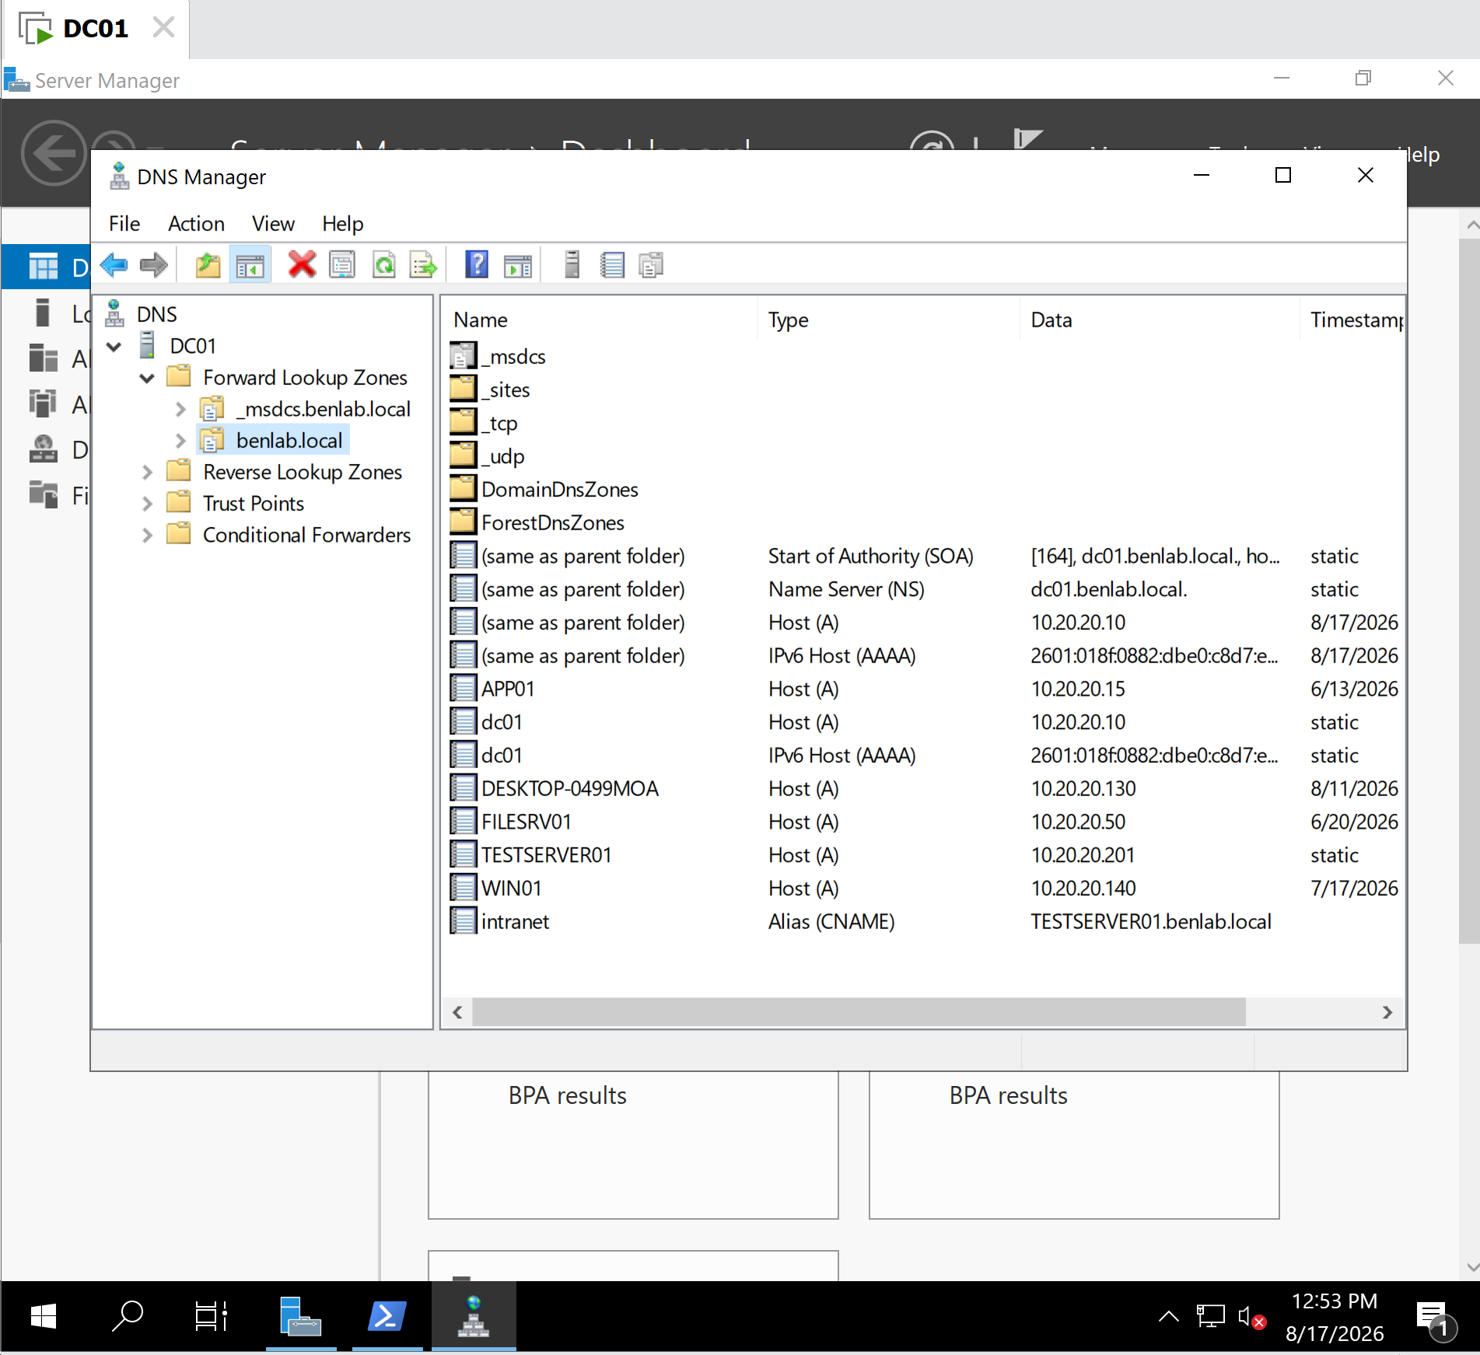
Screenshot 1 – CNAME Record in DNS Manager
Shows the intranet CNAME record configured in the benlab.local Forward Lookup Zone and pointing to:
TESTSERVER01.benlab.local

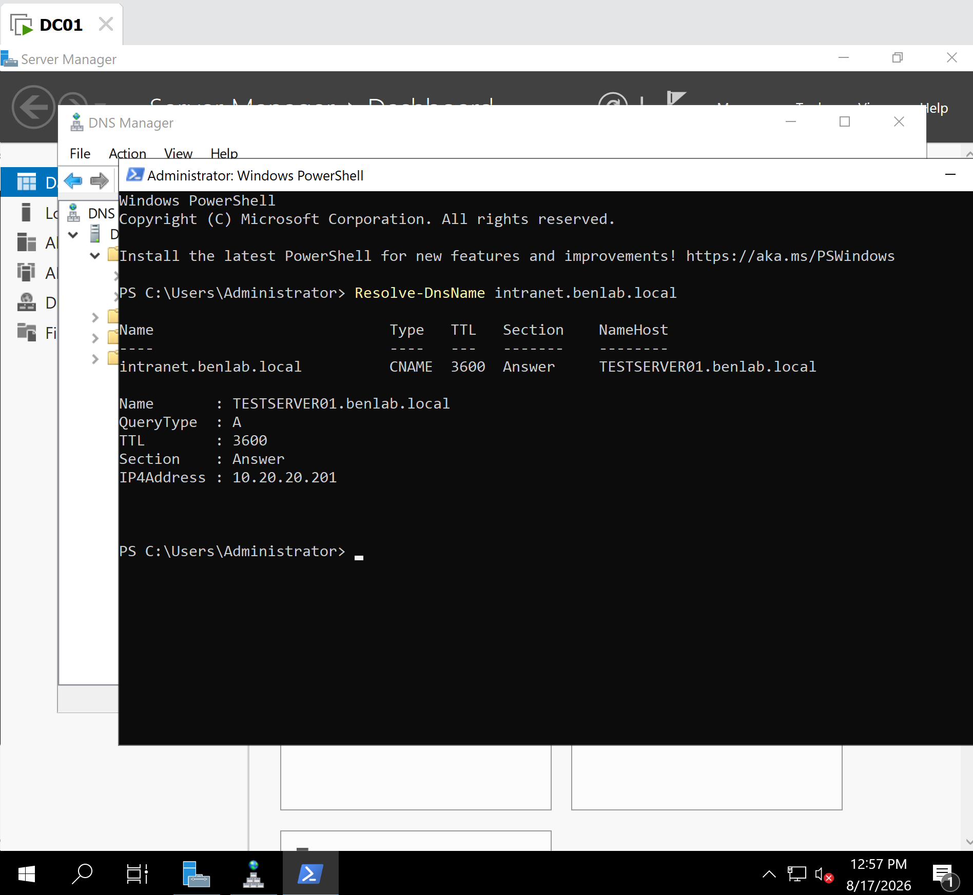
Screenshot 2 – Initial CNAME Resolution
Shows:
Resolve-DnsName intranet.benlab.local
resolving:
intranet.benlab.local
→ TESTSERVER01.benlab.local
→ 10.20.20.201

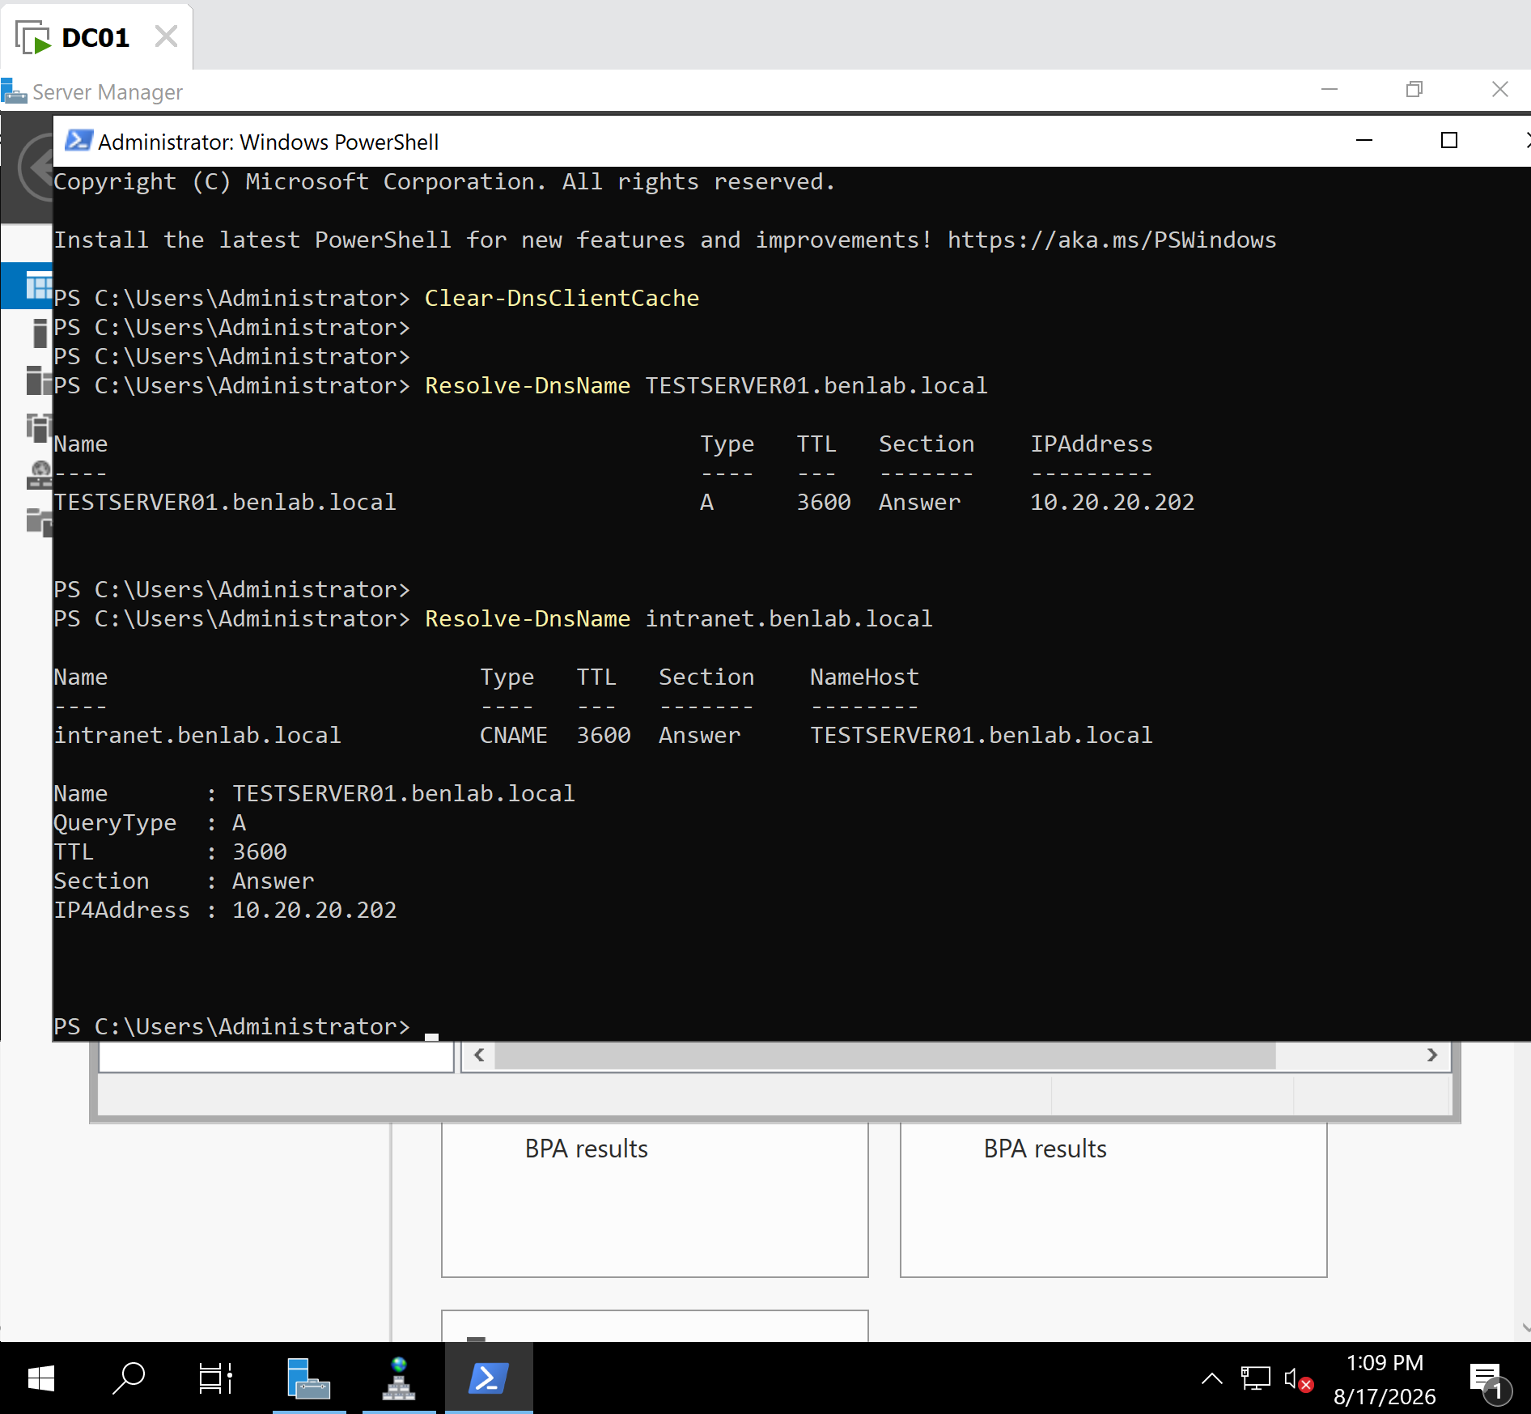
Screenshot 3 – CNAME Resolution After A Record Change
Shows the A record changed to 10.20.20.202 and demonstrates that the unchanged intranet CNAME automatically resolves through the updated target.

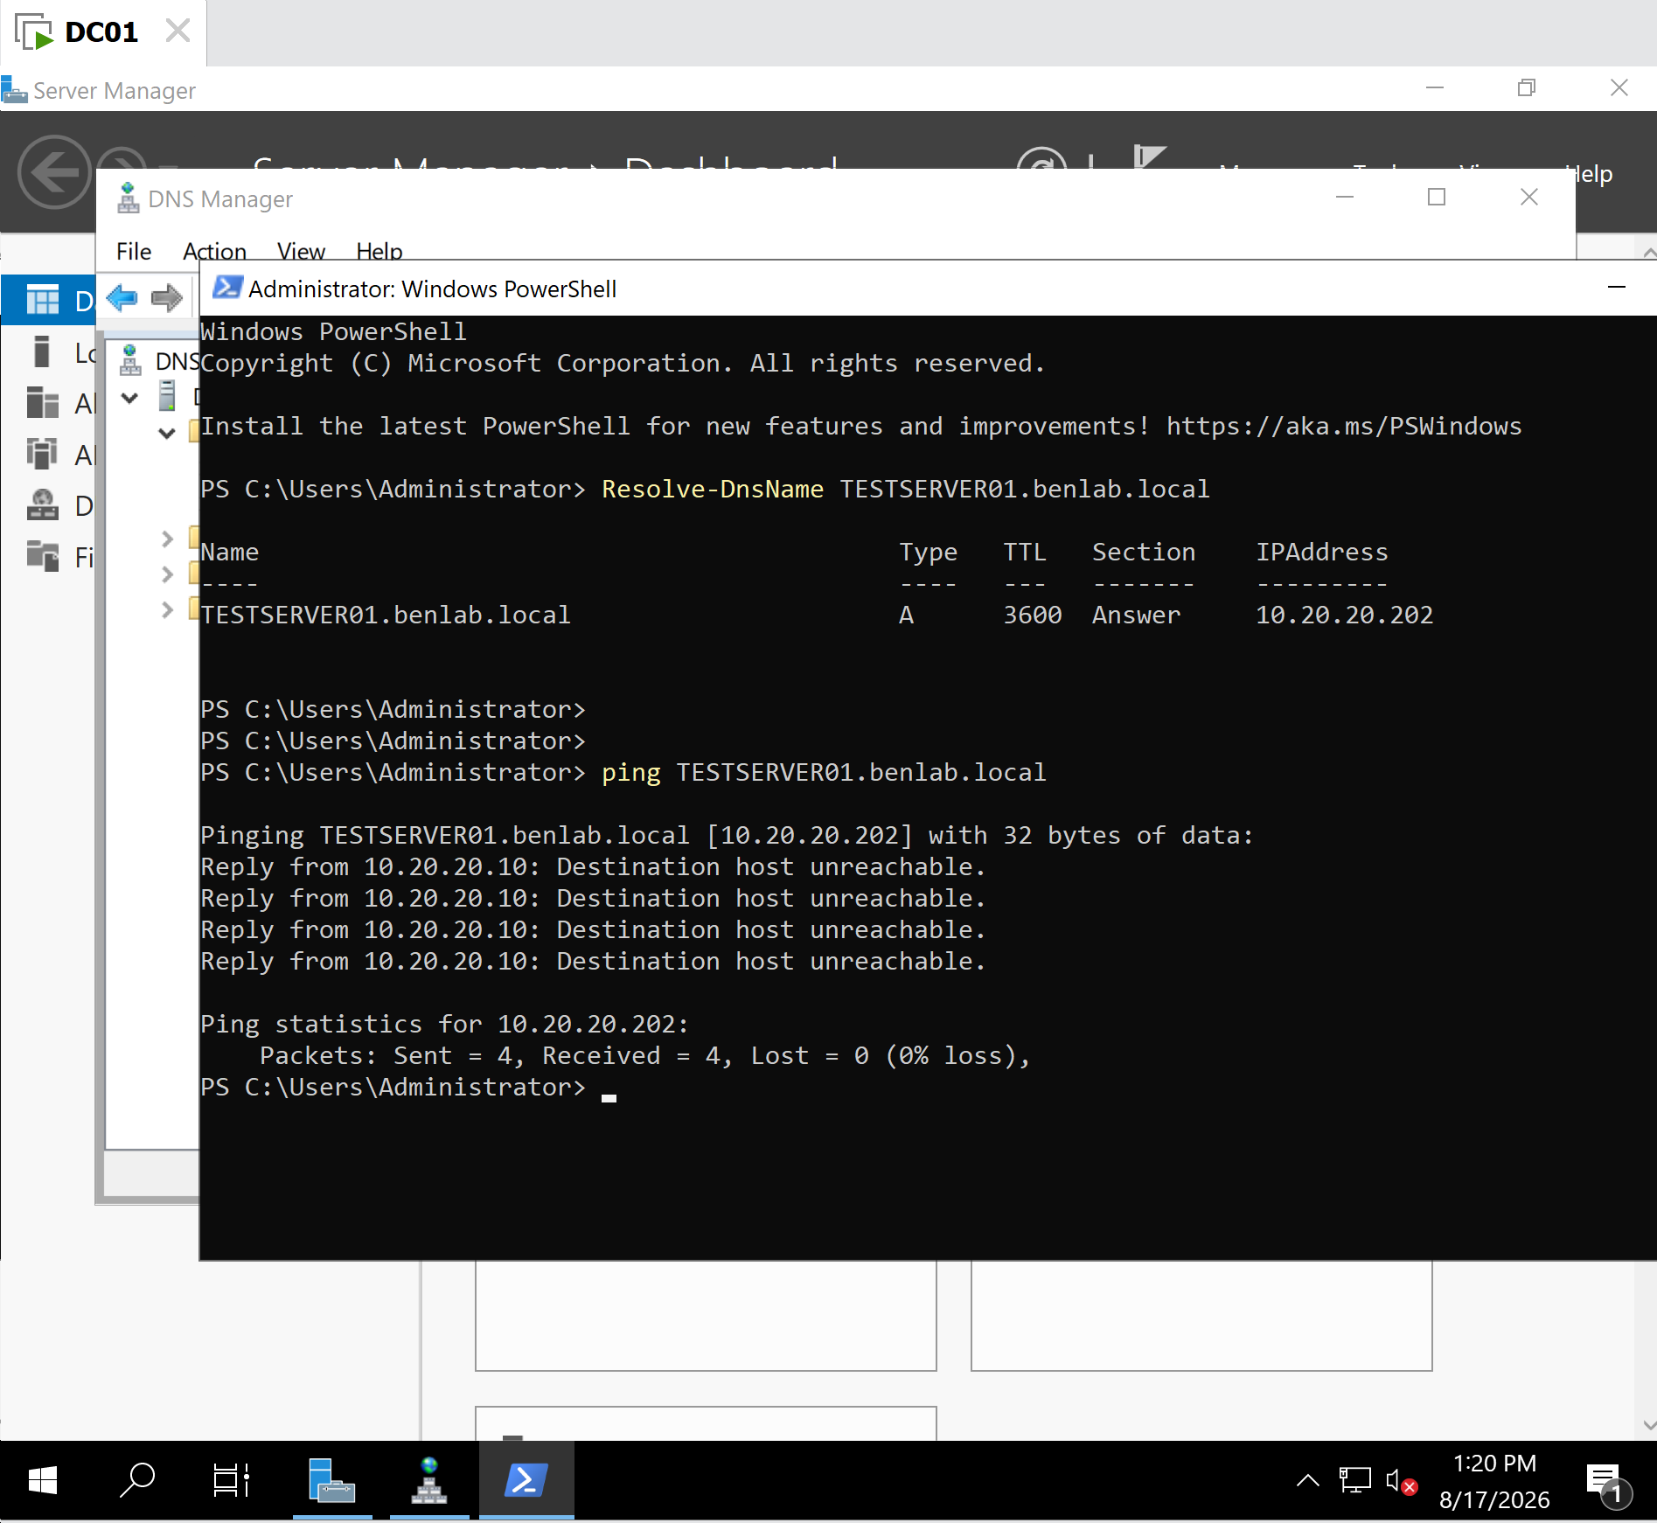
Screenshot 4 – DNS Resolution vs. Connectivity
Shows successful:
Resolve-DnsName TESTSERVER01.benlab.local
returning 10.20.20.202, followed by:
ping TESTSERVER01.benlab.local
successfully resolving the hostname but returning Destination host unreachable.
This provides evidence that DNS resolution and network connectivity are separate mechanisms.

Key Learning Points
- A Forward Lookup Zone translates hostnames into IP addresses.
- An A record maps a hostname directly to an IPv4 address.
- A CNAME record maps one hostname to another hostname.
- intranet.benlab.local can act as a friendly alias for TESTSERVER01.benlab.local.
- Changing the target host's A record does not require changing the CNAME.
- Clear-DnsClientCache removes locally cached DNS responses before retesting.
- Resolve-DnsName is useful for directly testing DNS name resolution.
- Successful DNS resolution does not prove that the destination host is online or reachable.
- ping may successfully resolve a hostname while communication with the resulting IP address still fails.
- DNS troubleshooting should separate name-resolution problems from network-connectivity problems.
- In this lab, DC01 at 10.20.20.10 is the actual DNS server; 10.20.20.202 is only the test IP stored in the TESTSERVER01 A record.

Result
The benlab.local Forward Lookup Zone was administered by creating and testing a CNAME alias, modifying the target A record, verifying automatic alias resolution to the updated address, and demonstrating the difference between DNS resolution and network connectivity.

Task 5 – DNS Troubleshooting

Objective
Troubleshoot a DNS name-resolution failure on a domain workstation, identify the root cause, restore the correct DNS client configuration, and verify successful internal DNS resolution.

Environment
- Domain: benlab.local
- DNS Server / Domain Controller: DC01
- DC01 IP Address: 10.20.20.10
- Client Workstation: CLIENT02
- Test DNS Record: TESTSERVER01.benlab.local
- TESTSERVER01 IP: 10.20.20.202
- Incorrect DNS Server used for troubleshooting: 8.8.8.8

Scenario
A DNS troubleshooting scenario was simulated by changing CLIENT02's configured DNS server from the internal DNS server, DC01 (10.20.20.10), to the external Google DNS server (8.8.8.8).
After the change, CLIENT02 maintained IP connectivity to DC01 but could no longer resolve resources within the internal benlab.local DNS namespace.
This simulated a common enterprise issue where network connectivity remains functional while DNS name resolution fails.

Troubleshooting Procedure

Step 1 – Verify IP Connectivity
Connectivity from CLIENT02 to DC01 was tested using:
ping 10.20.20.10
The ping succeeded with 0% packet loss, confirming that CLIENT02 could communicate with DC01 at the IP layer.
This established that the problem was not basic network connectivity.

Step 2 – Test Internal DNS Resolution
Internal DNS resolution was tested using:
Resolve-DnsName DC01.benlab.local
Resolve-DnsName TESTSERVER01.benlab.local
Both DNS queries failed with:
DNS name does not exist
Because IP connectivity was successful while hostname resolution failed, the investigation was narrowed to DNS.

Step 3 – Inspect DNS Client Configuration
The DNS server configured on CLIENT02 was examined using:
Get-DnsClientServerAddress -AddressFamily IPv4
The result showed:
Ethernet0 IPv4 {8.8.8.8}
This identified the source of the problem.
CLIENT02 was querying Google Public DNS instead of the internal DNS server on DC01.

Root Cause
CLIENT02 was incorrectly configured to use:
8.8.8.8
instead of the internal DNS server:
10.20.20.10
Google Public DNS can resolve public Internet domains but does not contain the private Active Directory DNS records maintained by DC01 for the benlab.local namespace.
As a result, CLIENT02 retained normal IP connectivity but lost the ability to resolve internal domain resources by hostname.

Resolution
The DNS client configuration on CLIENT02 was restored to DC01 using Administrator PowerShell:
Set-DnsClientServerAddress -InterfaceAlias "Ethernet0" -ServerAddresses 10.20.20.10
The DNS client cache was then cleared:
Clear-DnsClientCache
The corrected DNS configuration was verified:
Get-DnsClientServerAddress -AddressFamily IPv4
The result showed:
Ethernet0 IPv4 {10.20.20.10}
CLIENT02 was therefore restored to the correct internal DNS infrastructure.

Final Verification
Internal DNS resolution was tested again:
Resolve-DnsName DC01.benlab.local
The query successfully returned:
DC01.benlab.local A 10.20.20.10
The test server record was then queried:
Resolve-DnsName TESTSERVER01.benlab.local
The query successfully returned:
TESTSERVER01.benlab.local A 10.20.20.202
Both internal DNS records resolved successfully, confirming that DNS functionality had been restored.

Result
Task completed successfully.
The DNS failure was isolated from basic network connectivity. The incorrect DNS client configuration was identified as the root cause, CLIENT02 was restored to the internal DNS server, and successful internal name resolution was verified.

Screenshots / Evidence

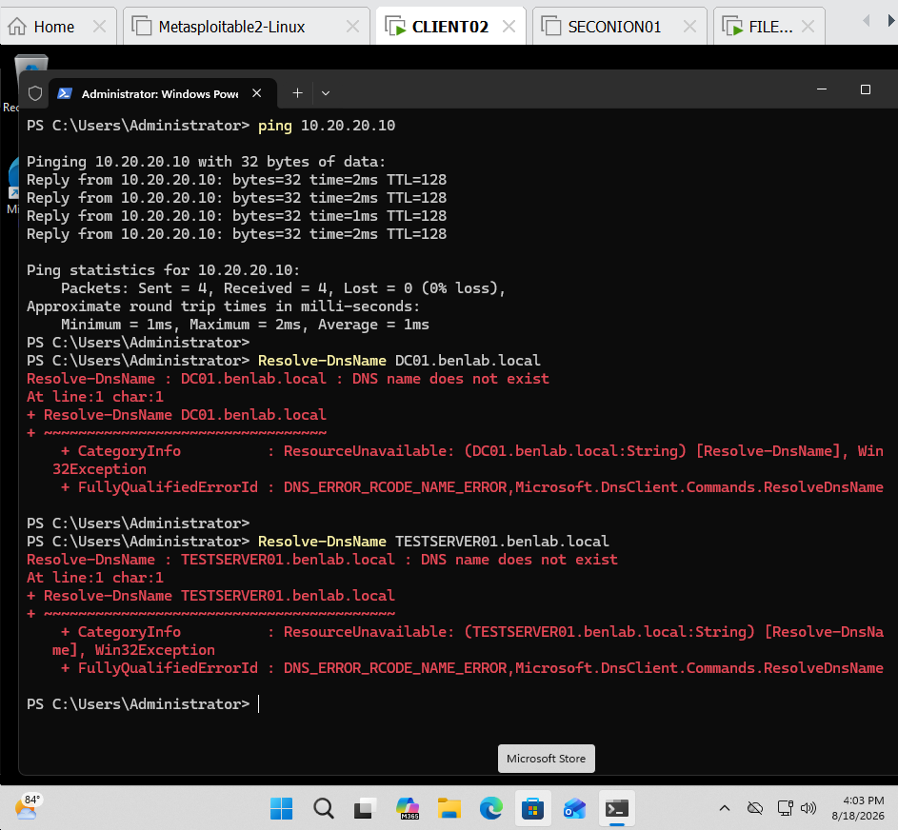
Screenshot 1 – DNS Resolution Failure
Shows CLIENT02 successfully pinging DC01 at 10.20.20.10 while DNS queries for DC01.benlab.local and TESTSERVER01.benlab.local fail.
Purpose: Demonstrates that IP connectivity was functional while DNS name resolution was failing.

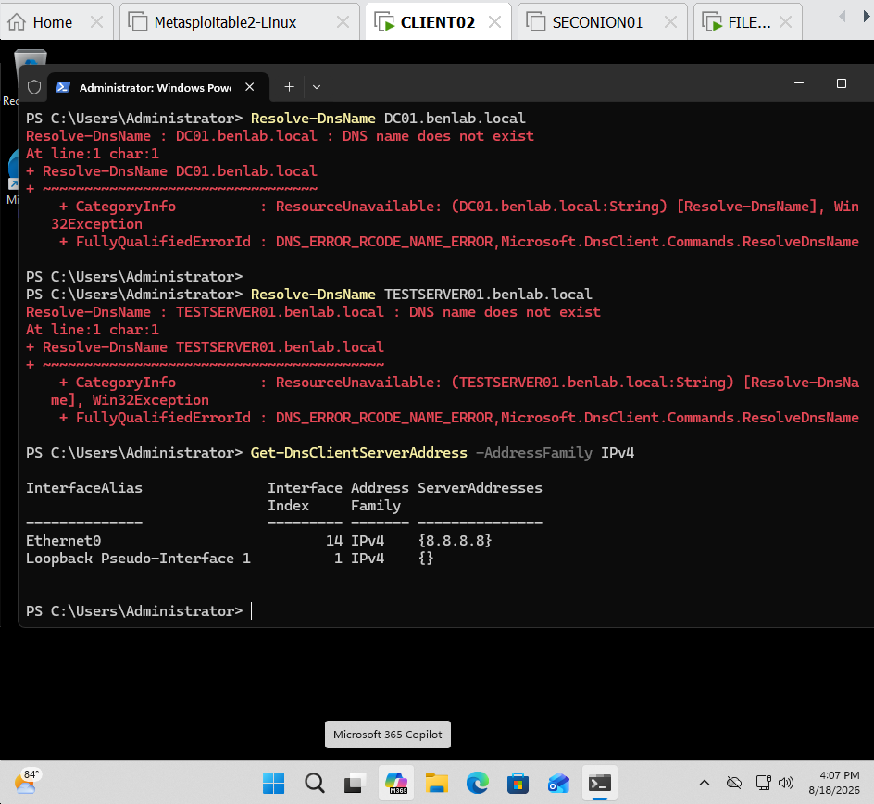
Screenshot 2 – Incorrect DNS Server Identified
Shows:
Get-DnsClientServerAddress -AddressFamily IPv4
returning:
Ethernet0 IPv4 {8.8.8.8}
Purpose: Documents the incorrect DNS client configuration and identifies the root cause of the name-resolution failure.

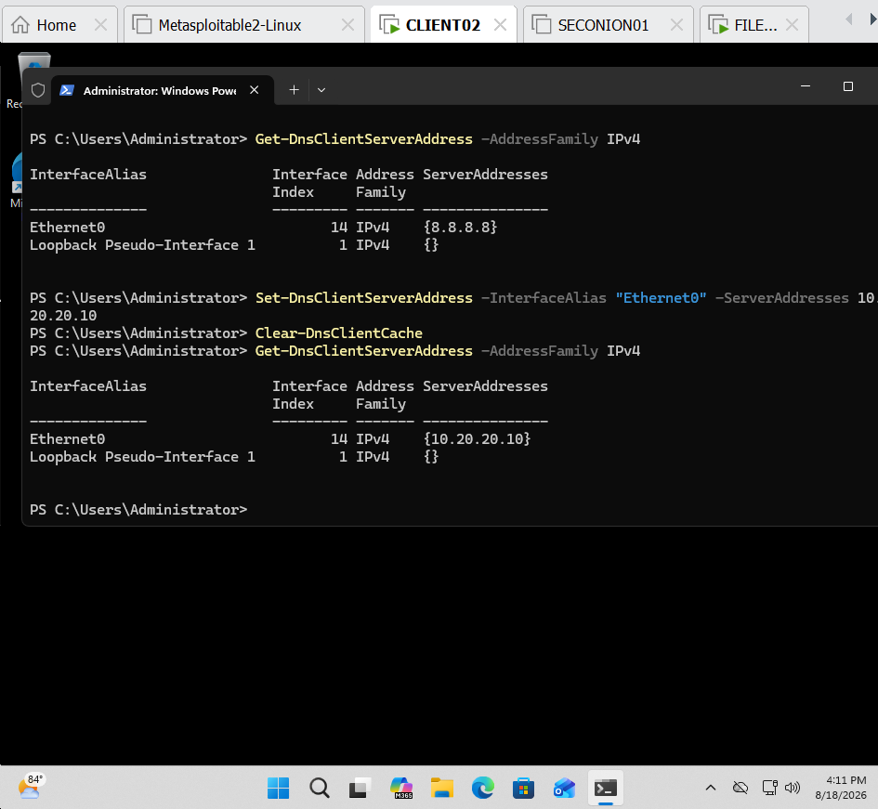
Screenshot 3 – DNS Configuration Restored
Shows the following corrective actions:
Set-DnsClientServerAddress -InterfaceAlias "Ethernet0" -ServerAddresses 10.20.20.10
Clear-DnsClientCache
Get-DnsClientServerAddress -AddressFamily IPv4
The final output confirms:
Ethernet0 IPv4 {10.20.20.10}
Purpose: Documents the administrative remediation and verifies that CLIENT02 was restored to the correct internal DNS server.

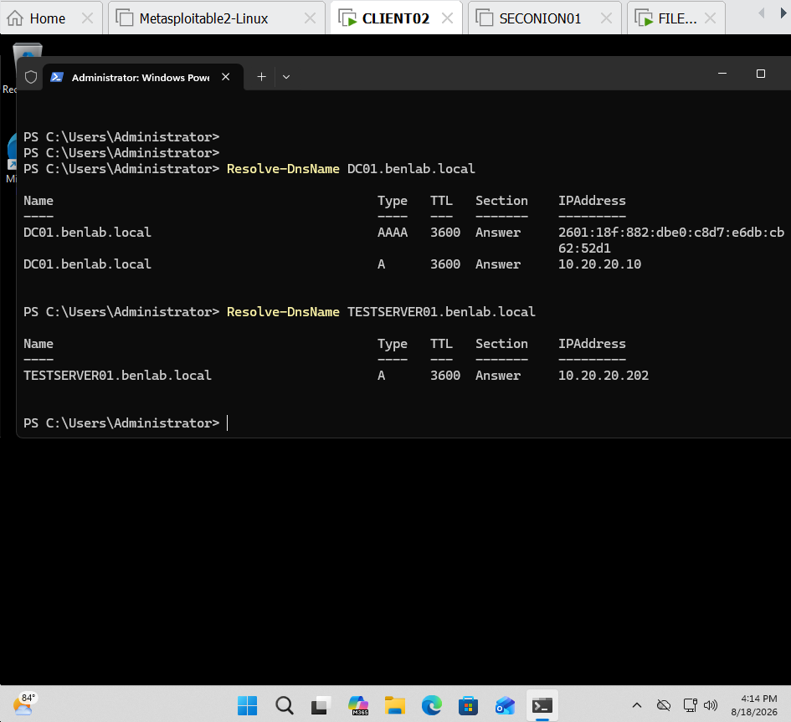
Screenshot 4 – Successful DNS Resolution
Shows successful execution of:
Resolve-DnsName DC01.benlab.local
Resolve-DnsName TESTSERVER01.benlab.local
with the results:
DC01.benlab.local → 10.20.20.10
TESTSERVER01.benlab.local → 10.20.20.202
Purpose: Provides final evidence that internal DNS name resolution was successfully restored after correcting the client DNS configuration.

Key Takeaways
- Successful IP connectivity does not necessarily mean DNS is functioning correctly.
- Testing connectivity by IP and hostname separately helps distinguish network problems from DNS problems.
- Active Directory domain clients should use the organization's internal DNS infrastructure for domain name resolution.
- Public DNS servers such as 8.8.8.8 cannot resolve private records in the benlab.local DNS zone.
- Get-DnsClientServerAddress can identify which DNS servers a Windows client is configured to use.
- Resolve-DnsName is useful for testing forward DNS resolution and diagnosing DNS failures.
- Clear-DnsClientCache can clear cached DNS information after DNS configuration changes.
- A structured troubleshooting process—connectivity → name resolution → DNS configuration → remediation → verification—helps isolate DNS problems efficiently.

Task 6 – Configure and Verify DNS Conditional Forwarding

Objective
Configure and test DNS conditional forwarding between two DNS servers in the lab. DC01 was configured to forward DNS queries for the branchlab.local namespace to APP01, which was configured as the authoritative DNS server for that namespace.

Environment
Primary DNS Server: DC01
DC01 IP Address: 10.20.20.10
Primary Domain: benlab.local
Branch DNS Server: APP01
APP01 IP Address: 10.20.20.15
Branch DNS Zone: branchlab.local
Test DNS Record: BRANCHSERV01.branchlab.local
Test IP Address: 10.20.20.100

Procedure

1. Verified DNS configuration on DC01
The existing DNS zones on DC01 were reviewed to verify that the new branch namespace did not already exist.
Get-DnsServerZone | Format-Table ZoneName,ZoneType,IsDsIntegrated -AutoSize
The results confirmed that DC01 was authoritative for benlab.local and did not already contain a branchlab.local zone.

2. Configured APP01 as a DNS server
The DNS Server role and management tools were installed on APP01.
Install-WindowsFeature DNS -IncludeManagementTools
The installation completed successfully without requiring a restart.

3. Created the branch DNS zone on APP01
A standalone primary DNS zone named branchlab.local was created on APP01.
Add-DnsServerPrimaryZone -Name "branchlab.local" -ZoneFile "branchlab.local.dns"

4. Created the branch server DNS record
An A record was created inside the branchlab.local zone:
Add-DnsServerResourceRecordA -Name "BRANCHSERV01" -ZoneName "branchlab.local" -IPv4Address "10.20.20.100"
The record represents:
BRANCHSERV01.branchlab.local → 10.20.20.100

5. Verified APP01 DNS resolution directly from DC01
Before configuring conditional forwarding, DC01 was instructed to query APP01 directly:
Resolve-DnsName BRANCHSERV01.branchlab.local -Server 10.20.20.15
The query successfully returned:
BRANCHSERV01.branchlab.local A 10.20.20.100
This confirmed that APP01 was correctly answering DNS queries for the branchlab.local namespace.

Troubleshooting Performed
The original design used:
branch.benlab.local
APP01 successfully hosted the zone and responded to direct DNS queries. However, attempts to configure DC01 with a conditional forwarder for this namespace failed.
PowerShell returned:
Failed to create zone branch.benlab.local on server DC01.
WIN32 9604
The DNS namespace design was reviewed. Because branch.benlab.local was a child namespace of the existing authoritative benlab.local zone, the lab design was changed to use a separate namespace:
branchlab.local
The original test zone was removed from APP01:
Remove-DnsServerZone -Name "branch.benlab.local" -Force
The new branchlab.local zone and BRANCHSERV01 A record were then created. This provided a clean environment for demonstrating conditional forwarding between separate DNS namespaces.

Conditional Forwarder Configuration
On DC01, DNS Manager was opened and a new conditional forwarder was configured with:
DNS Domain:
branchlab.local

Master DNS Server:
10.20.20.15
The configuration was successfully accepted, and branchlab.local appeared under Conditional Forwarders in DNS Manager.
The resulting DNS path was:
DC01 (10.20.20.10)
|
| Query for *.branchlab.local
v
Conditional Forwarder
|
v
APP01 (10.20.20.15)
|
| Authoritative for branchlab.local
v
BRANCHSERV01 → 10.20.20.100

Verification
The final DNS resolution test was performed on DC01:
Resolve-DnsName BRANCHSERV01.branchlab.local
Importantly, the -Server 10.20.20.15 parameter was not specified.
DC01 successfully returned:
Name Type TTL Section IPAddress
---- ---- --- ------- ---------
BRANCHSERV01.branchlab.local A 3600 Answer 10.20.20.100
This demonstrated that DC01 automatically matched the branchlab.local namespace to its conditional forwarder and sent the DNS query to APP01.

Result
Status: Successful
DC01 was successfully configured to conditionally forward DNS requests for branchlab.local to APP01 at 10.20.20.15.
APP01 successfully resolved BRANCHSERV01.branchlab.local to 10.20.20.100.
This task demonstrated practical administration and troubleshooting of:
- Windows Server DNS roles
- Primary DNS zones
- DNS A records
- Conditional forwarders
- Cross-DNS-server name resolution
- PowerShell DNS administration
- DNS namespace troubleshooting

Screenshot Evidence
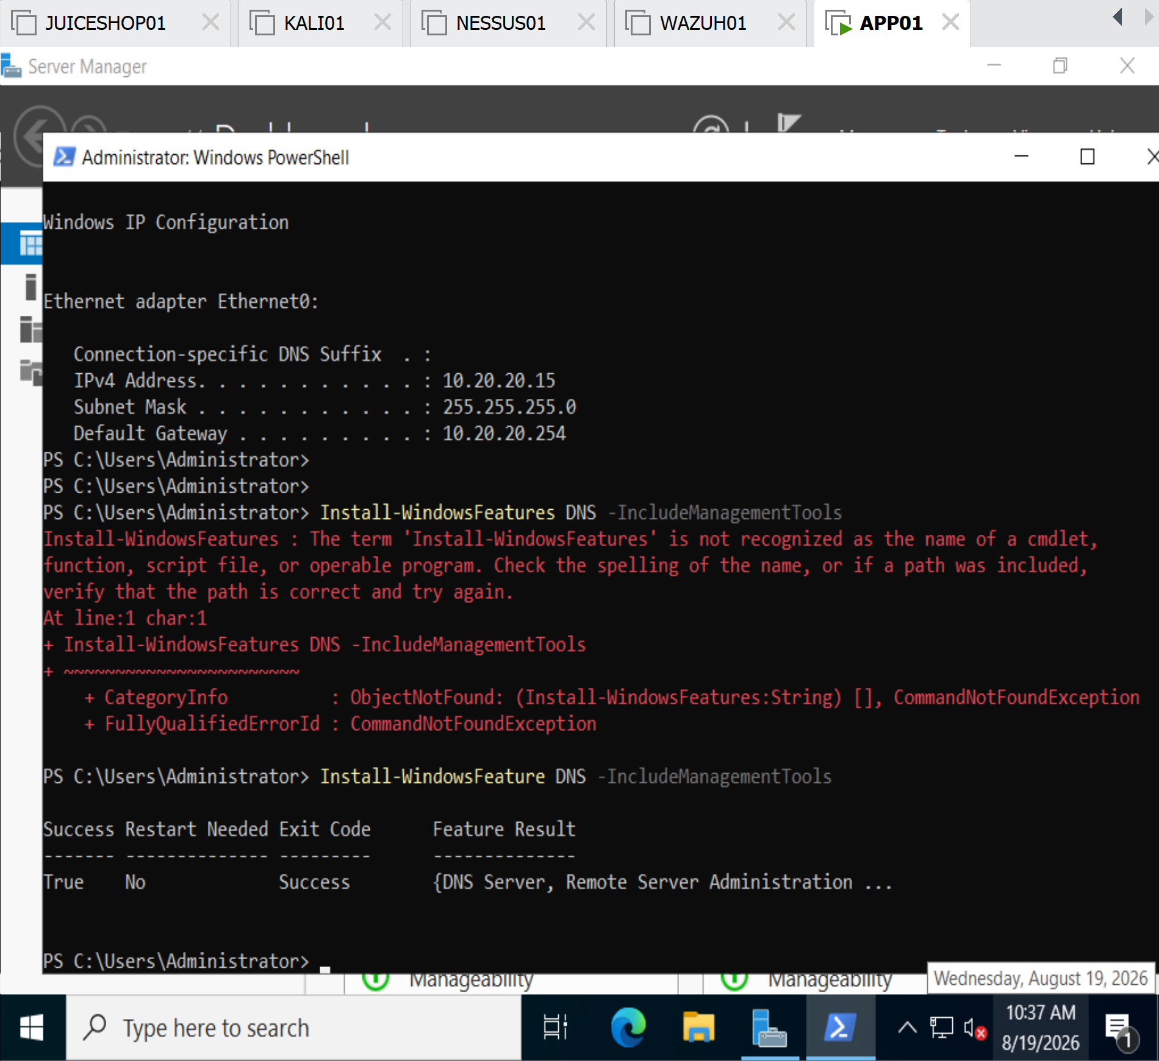
Screenshot 1 – DNS Server Role Installation on APP01
Shows successful installation of the DNS Server role and Remote Server Administration Tools using Install-WindowsFeature.
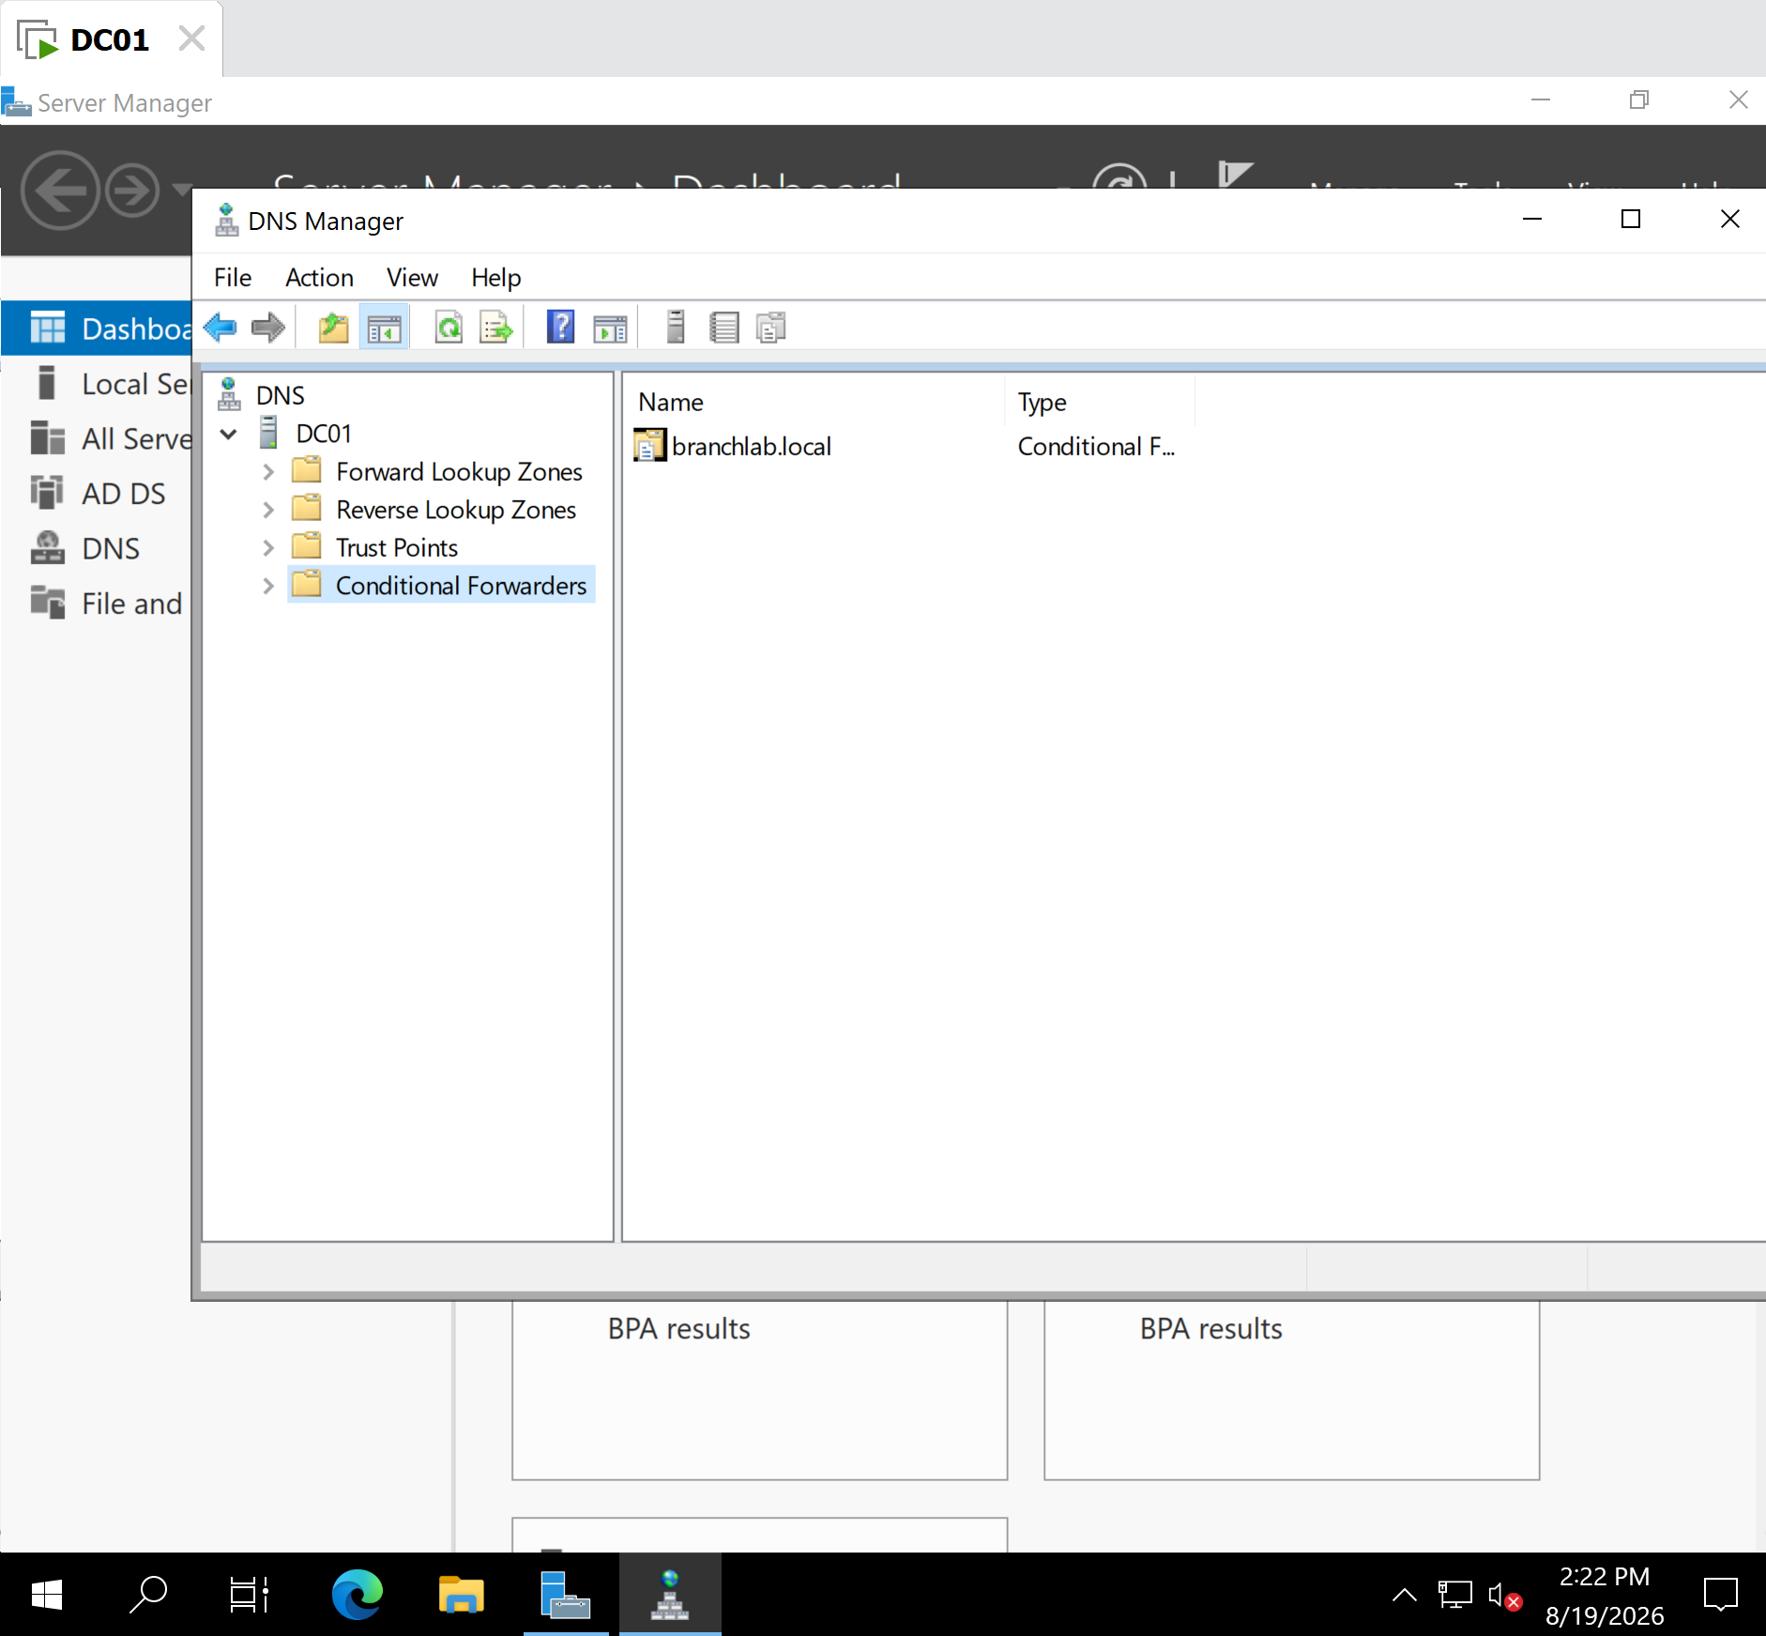
Screenshot 2 – Branch DNS Zone on APP01
Shows the creation and verification of the branchlab.local primary DNS zone.
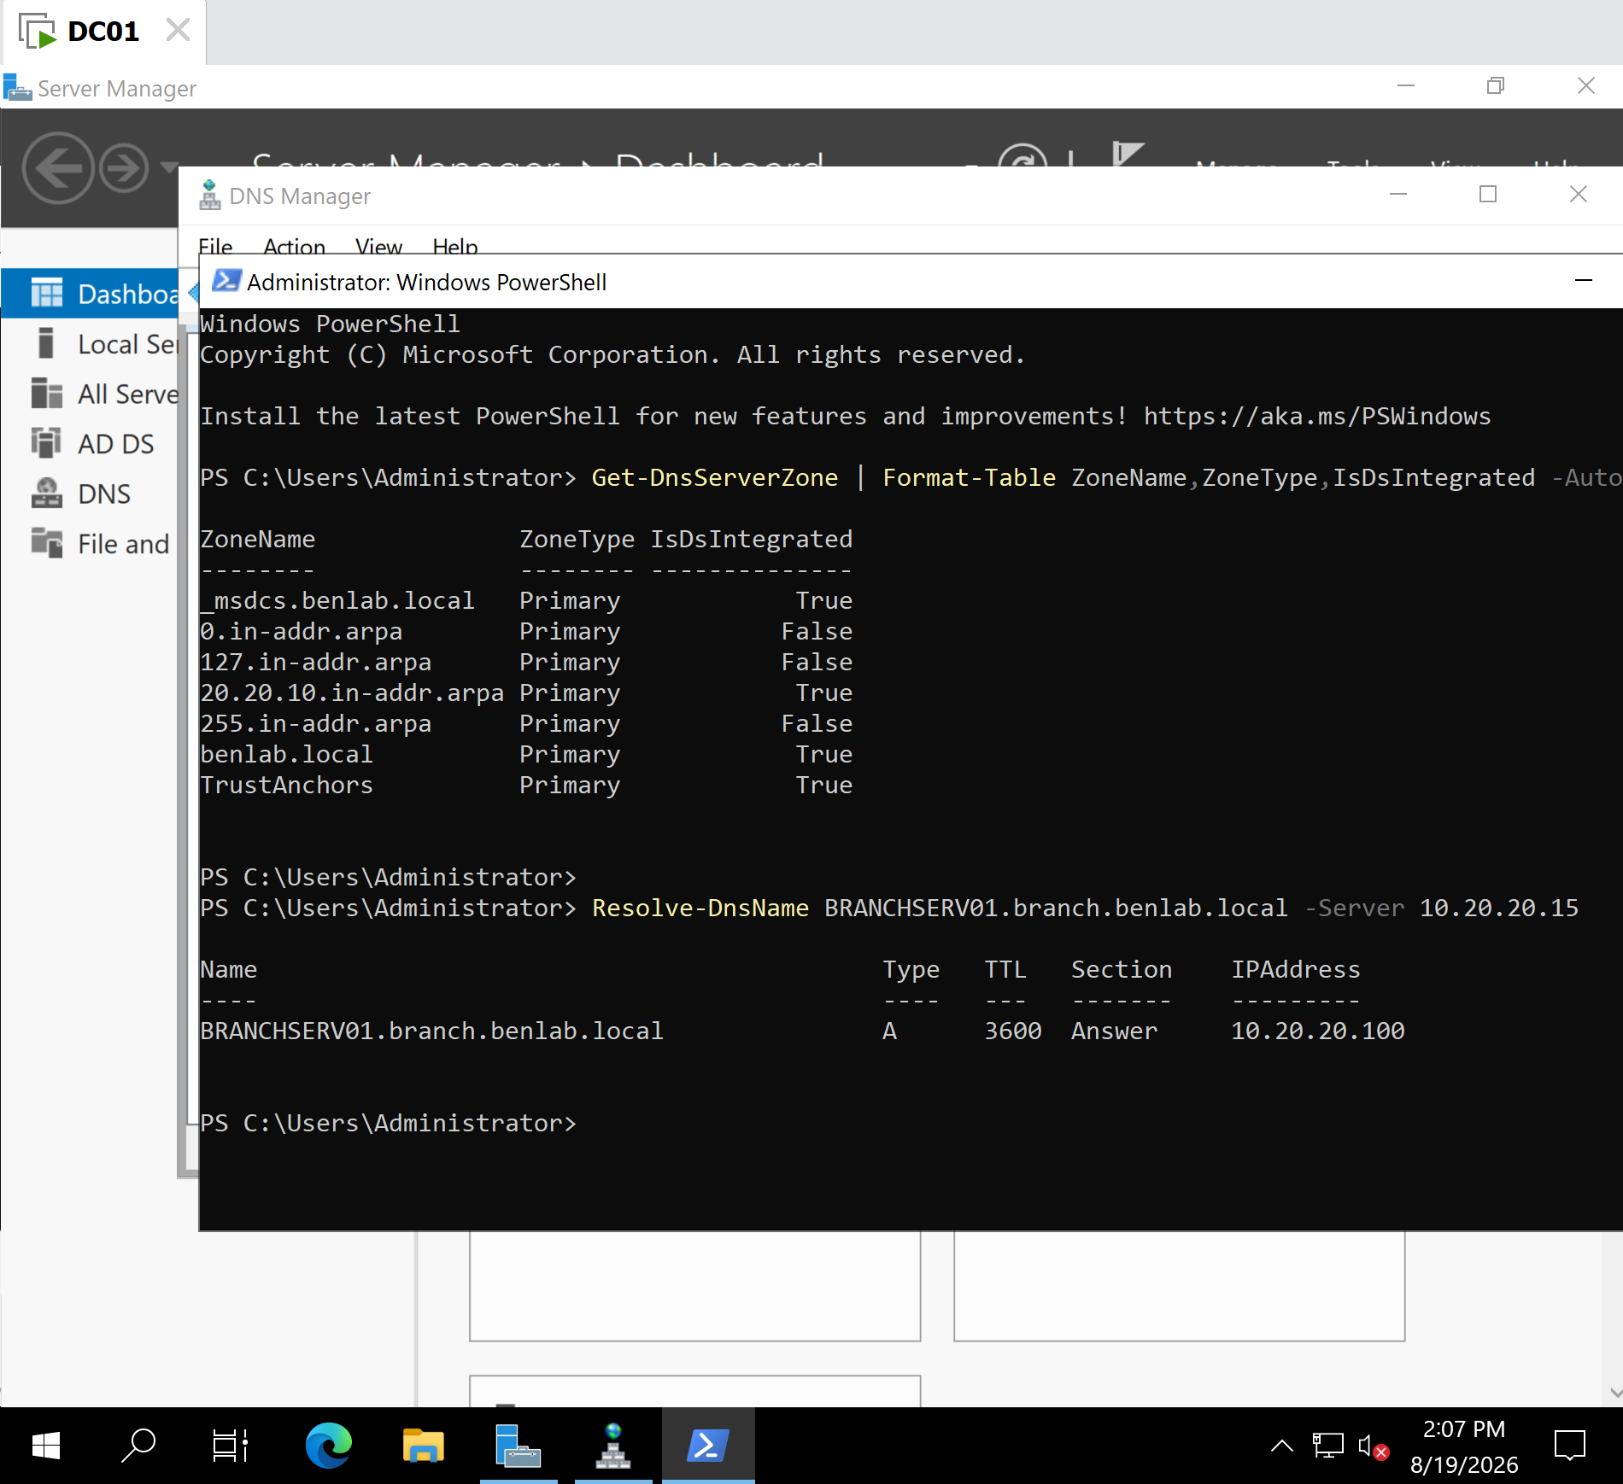
Screenshot 3 – Branch DNS A Record
Shows BRANCHSERV01 configured in the branchlab.local zone with IP address 10.20.20.100.
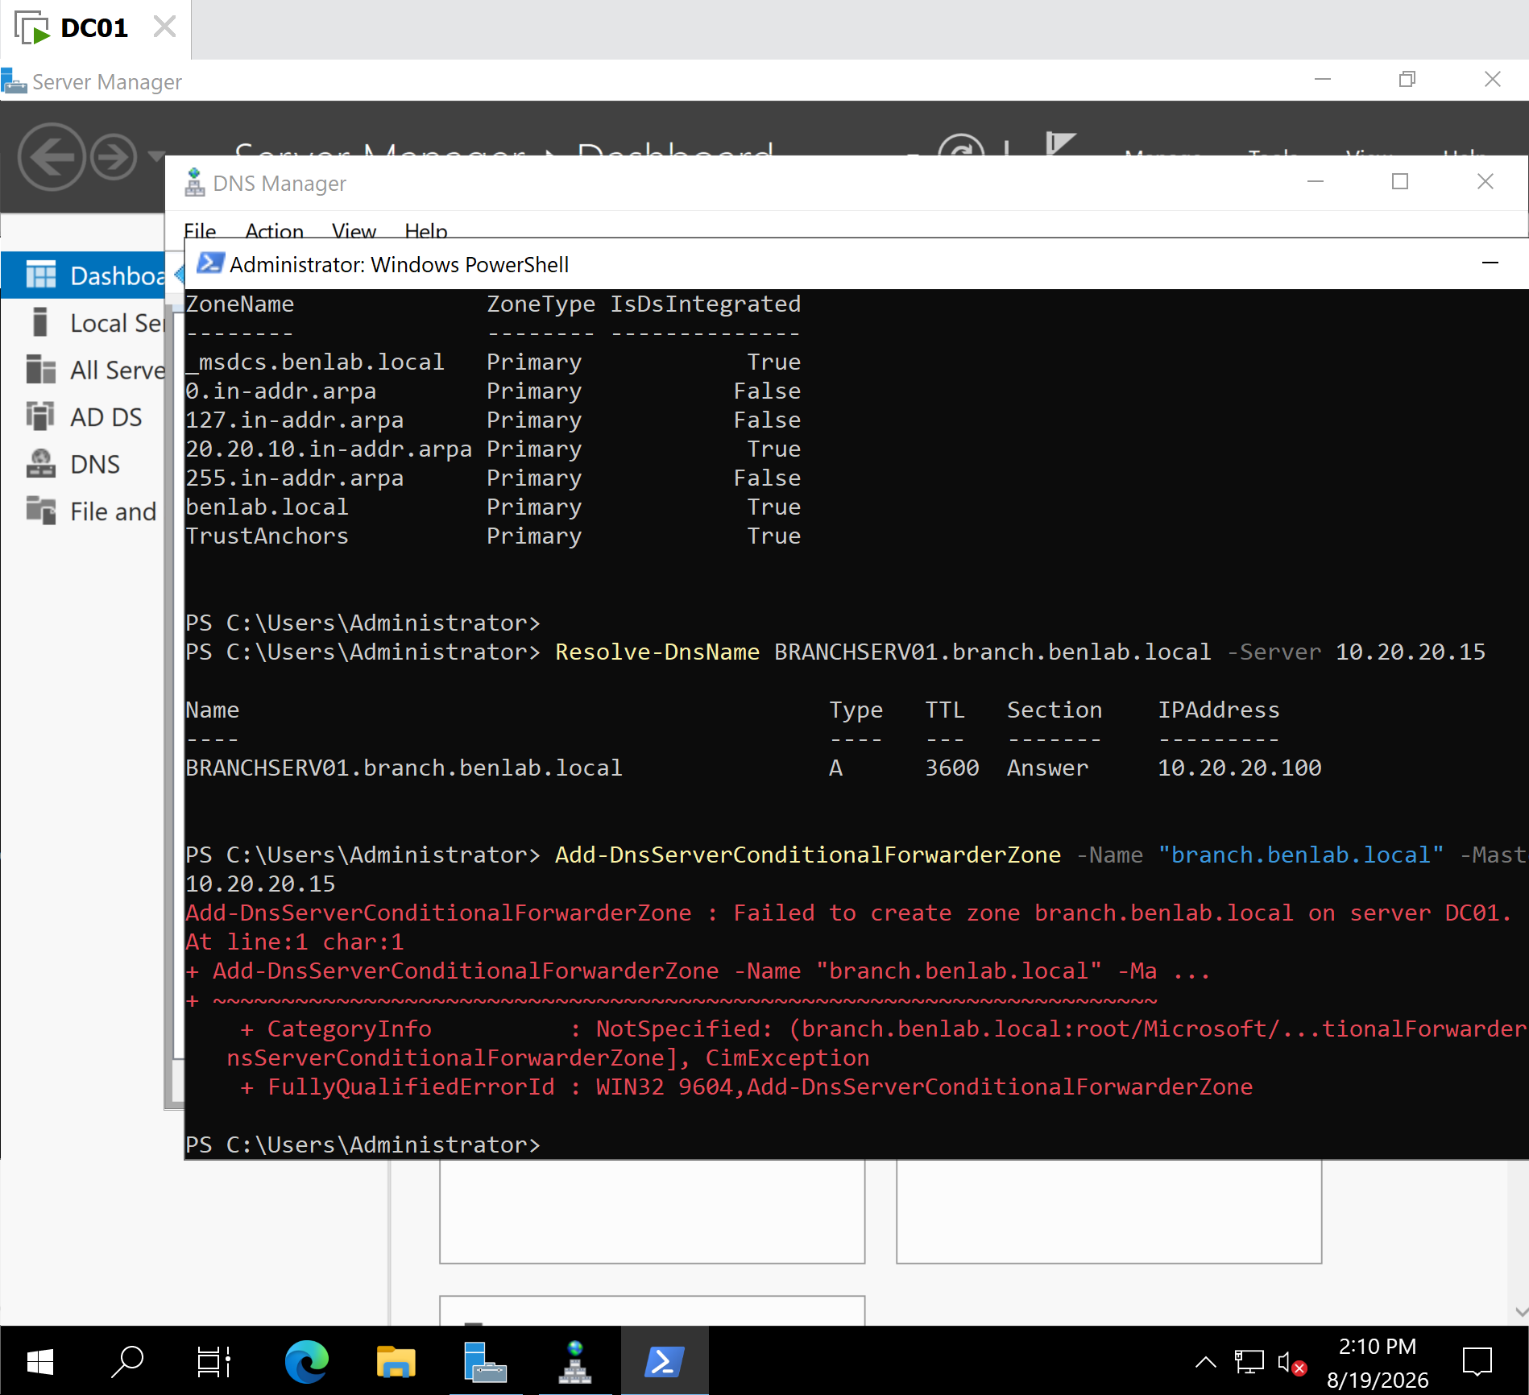
Screenshot 4 – Direct DNS Resolution Test
Shows DC01 successfully resolving BRANCHSERV01.branchlab.local directly through APP01 (10.20.20.15).
Screenshot 5 – Conditional Forwarder on DC01
Shows branchlab.local listed under Conditional Forwarders in DNS Manager on DC01.
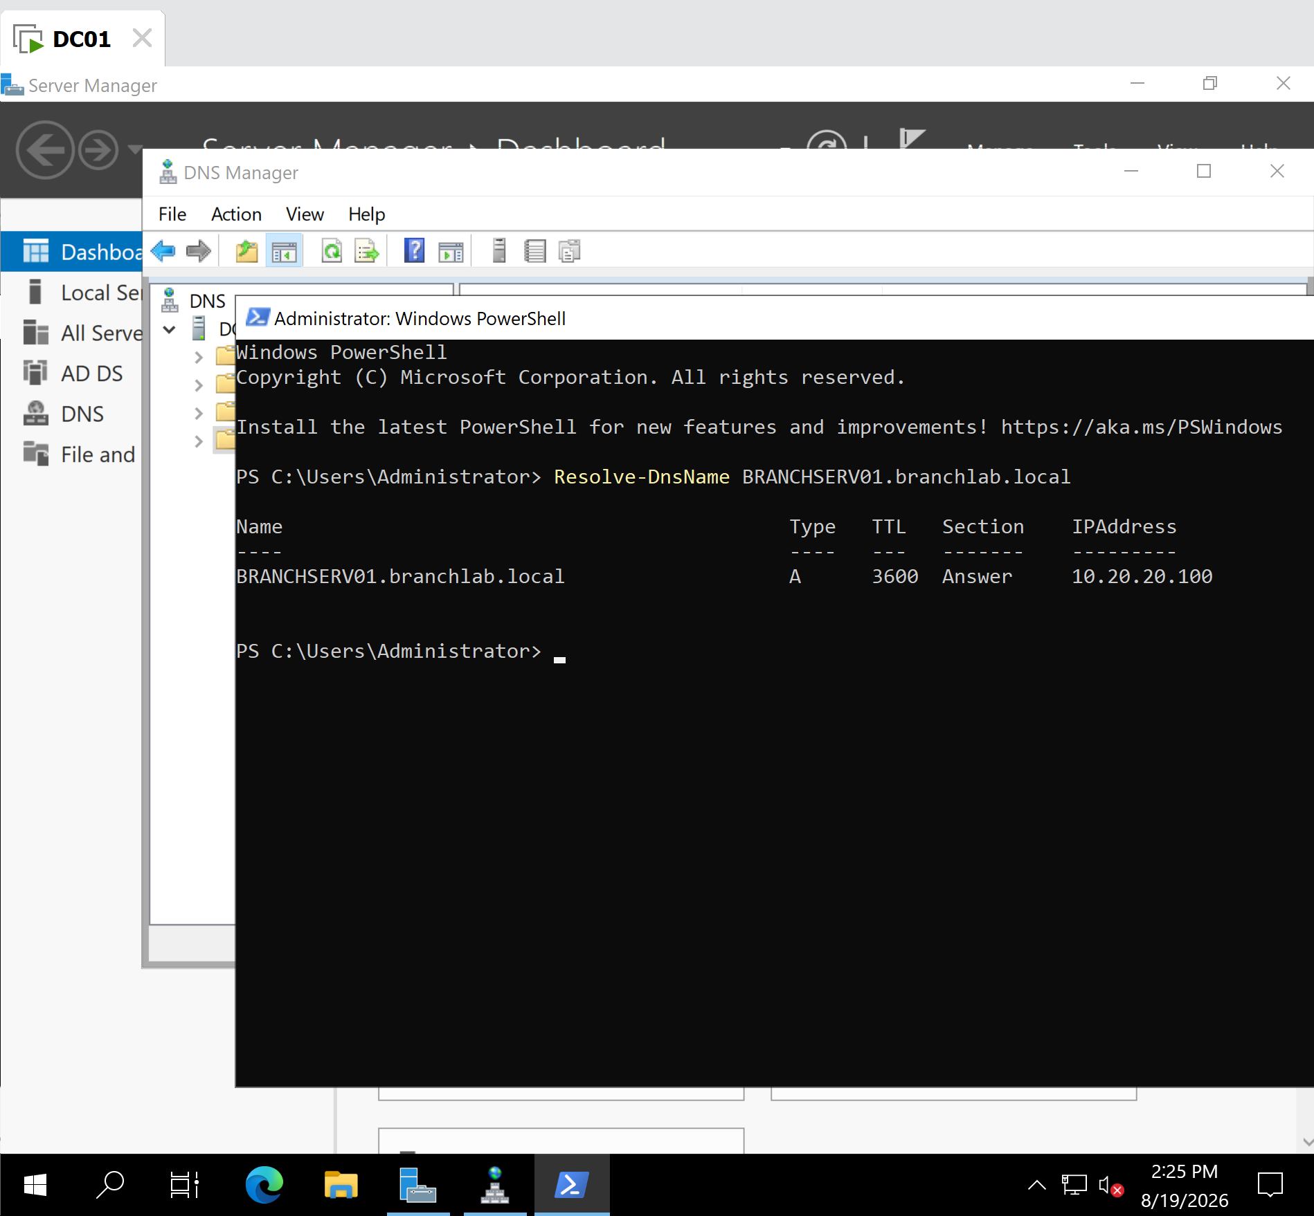
Screenshot 6 – Final Conditional Forwarding Verification
Shows:
Resolve-DnsName BRANCHSERV01.branchlab.local
successfully returning 10.20.20.100 without explicitly specifying APP01 as the DNS server, confirming that DC01's conditional forwarder is functioning correctly.

Key Learning Outcome
A conditional forwarder allows a DNS server to route queries for a specific DNS namespace to a designated DNS server instead of using its normal resolution path. In this lab, DC01 remained responsible for the benlab.local environment while forwarding requests for branchlab.local to APP01.
The troubleshooting also demonstrated an important administrative principle: when DNS commands and connectivity appear correct but zone creation fails, the DNS namespace and zone design should also be investigated, rather than assuming the problem is network connectivity.

Task 7 — DNS Aging and Scavenging

Objective
Configure and verify DNS Aging and Scavenging on DC01 to automatically manage stale dynamically registered DNS records in the benlab.local zone.
The goal was to understand how Windows DNS distinguishes between static records and dynamic timestamped records, how records become stale, and how scavenging can safely remove obsolete dynamic DNS records.

Environment
DNS Server: DC01
Domain: benlab.local
DNS Zone: benlab.local
Operating System: Windows Server 2022
Administration Tools: DNS Manager and Windows PowerShell

Step 1 — Check Existing Zone Aging Configuration
Before making changes, the existing configuration was inspected.

Command
Get-DnsServerZoneAging -Name "benlab.local"

Initial result
The important values were:
ZoneName : benlab.local
AgingEnabled : False
RefreshInterval : 7.00:00:00
NoRefreshInterval : 7.00:00:00

Observation
AgingEnabled : False showed that DNS aging was not enabled for the benlab.local zone.
Although the default No-Refresh and Refresh intervals existed, the aging mechanism itself was inactive.

Step 2 — Check Server-Level Scavenging
The DNS server's scavenging configuration was then inspected.

Command
Get-DnsServerScavenging

Initial result
NoRefreshInterval : 7.00:00:00
RefreshInterval : 7.00:00:00
ScavengingInterval : 00:00:00
ScavengingState : False
LastScavengeTime :

Observation
The important result was:
ScavengingState : False
Automatic scavenging was therefore disabled on DC01.

Step 3 — Enable Aging on the DNS Zone
Aging was enabled for benlab.local with a 7-day No-Refresh interval and a 7-day Refresh interval.

Command
Set-DnsServerZoneAging -Name "benlab.local" -Aging $true -RefreshInterval 7.00:00:00 -NoRefreshInterval 7.00:00:00
The configuration was verified with:
Get-DnsServerZoneAging -Name "benlab.local"

Result
ZoneName : benlab.local
AgingEnabled : True
AvailForScavengeTime : 8/27/2026 6:00:00 PM
RefreshInterval : 7.00:00:00
NoRefreshInterval : 7.00:00:00
AgingEnabled : True confirmed successful configuration.

Step 4 — Enable Server-Level Scavenging
Automatic scavenging was enabled on DC01 with a 7-day scavenging interval.

Command
Set-DnsServerScavenging -ScavengingState $true -ScavengingInterval 7.00:00:00
Verification:
Get-DnsServerScavenging

Result
NoRefreshInterval : 7.00:00:00
RefreshInterval : 7.00:00:00
ScavengingInterval : 7.00:00:00
ScavengingState : True
LastScavengeTime :
The important result was:
ScavengingState : True
Automatic DNS scavenging was successfully enabled.

Step 5 — Examine DNS Record Timestamps
The records inside benlab.local were inspected to determine which records were static and which contained aging timestamps.

Command
Get-DnsServerResourceRecord -ZoneName "benlab.local" |
Select-Object HostName, RecordType, Timestamp, RecordData |
Format-Table -AutoSize
Several records contained timestamps, including records associated with systems such as:
APP01
FILESRV01
WIN01
DESKTOP-0499MOA
Other records had no timestamp.
This demonstrated that not every DNS record is treated the same way by aging and scavenging.

Step 6 — Compare Dynamic and Static Records
Two records were examined individually.

FILESRV01
Get-DnsServerResourceRecord -ZoneName "benlab.local" -Name "FILESRV01" |
Format-List HostName,RecordType,Timestamp,RecordData
Result included:
HostName : FILESRV01
RecordType : A
Timestamp : 6/20/2026 1:00:00 PM
FILESRV01 therefore had a timestamp associated with the record.

TESTSERVER01
Get-DnsServerResourceRecord -ZoneName "benlab.local" -Name "TESTSERVER01" |
Format-List HostName,RecordType,Timestamp,RecordData
Result:
HostName : TESTSERVER01
RecordType : A
Timestamp :
The empty timestamp indicated that TESTSERVER01 was a static record.

Step 7 — Verify Records in DNS Manager
DNS Manager was opened and Advanced View was enabled so that the Timestamp column could be inspected.
The benlab.local zone showed examples such as:
Record | IP Address | Timestamp
dc01 | 10.20.20.10 | static
APP01 | 10.20.20.15 | timestamped
FILESRV01 | 10.20.20.50 | timestamped
TESTSERVER01 | 10.20.20.202 | static
WIN01 | 10.20.20.140 | timestamped
This provided GUI confirmation of the same information observed through PowerShell.

Final Verification
The complete configuration was verified one final time.

Zone Aging
Get-DnsServerZoneAging -Name "benlab.local"
Confirmed:
AgingEnabled : True
RefreshInterval : 7.00:00:00
NoRefreshInterval : 7.00:00:00

Server Scavenging
Get-DnsServerScavenging
Confirmed:
ScavengingInterval : 7.00:00:00
ScavengingState : True

Final Status
DNS Aging: Enabled ✅
No-Refresh Interval: 7 days ✅
Refresh Interval: 7 days ✅
DNS Scavenging: Enabled ✅
Scavenging Interval: 7 days ✅
No manual scavenging operation was forced during the task.

Key Concepts Learned

1. DNS Aging
Aging allows Windows DNS to track how old eligible dynamically registered records are by using timestamps.
It does not itself delete records.

2. No-Refresh Interval
For the first 7 days, Windows does not need to update the timestamp merely because the client refreshes the same record.
This helps reduce unnecessary DNS database updates and AD replication traffic for AD-integrated zones.

3. Refresh Interval
After the No-Refresh interval, the record enters the Refresh interval.
During this period, an eligible client can refresh its DNS registration and update the timestamp.
If the record continues to be refreshed appropriately, it remains active.

4. Scavenging
Scavenging is the cleanup mechanism.
It examines records that have become stale according to the aging configuration and can remove eligible stale dynamic records.
The conceptual process is:
Dynamic DNS Record
↓
Timestamp
↓
No-Refresh Interval
↓
Refresh Interval
↓
Record not refreshed
↓
Record becomes stale
↓
Scavenging
↓
Stale record removed

Static vs. Dynamic DNS Records
One of the most important lessons from this task was understanding that scavenging does not simply delete records because their IP addresses are old.
A static record such as:
dc01 → 10.20.20.10 → static
does not have the same aging timestamp behavior as a dynamically registered record such as:
WIN01 → 10.20.20.140 → timestamped
This is why enabling scavenging does not mean Windows will simply start deleting important manually configured server records such as the static A record for DC01.

Real-World Importance
Over time, client computers can receive different IP addresses, be renamed, be removed from the environment, or stop connecting altogether.
Without proper DNS maintenance, obsolete records can accumulate.
For example:
WIN01 → 10.20.20.140
If that dynamically registered system disappears permanently and its record is never refreshed, the DNS record can eventually become stale.
Aging and scavenging provide Windows administrators with an automated mechanism for cleaning up these eligible stale DNS records.
This helps maintain a cleaner and more accurate DNS database.

PowerShell Commands Used
Get-DnsServerZoneAging -Name "benlab.local"

Get-DnsServerScavenging

Set-DnsServerZoneAging -Name "benlab.local" -Aging $true -RefreshInterval 7.00:00:00 -NoRefreshInterval 7.00:00:00

Set-DnsServerScavenging -ScavengingState $true -ScavengingInterval 7.00:00:00

Get-DnsServerResourceRecord -ZoneName "benlab.local" |
Select-Object HostName, RecordType, Timestamp, RecordData |
Format-Table -AutoSize

Get-DnsServerResourceRecord -ZoneName "benlab.local" -Name "FILESRV01" |
Format-List HostName,RecordType,Timestamp,RecordData

Get-DnsServerResourceRecord -ZoneName "benlab.local" -Name "TESTSERVER01" |
Format-List HostName,RecordType,Timestamp,RecordData

Screenshots Evidence
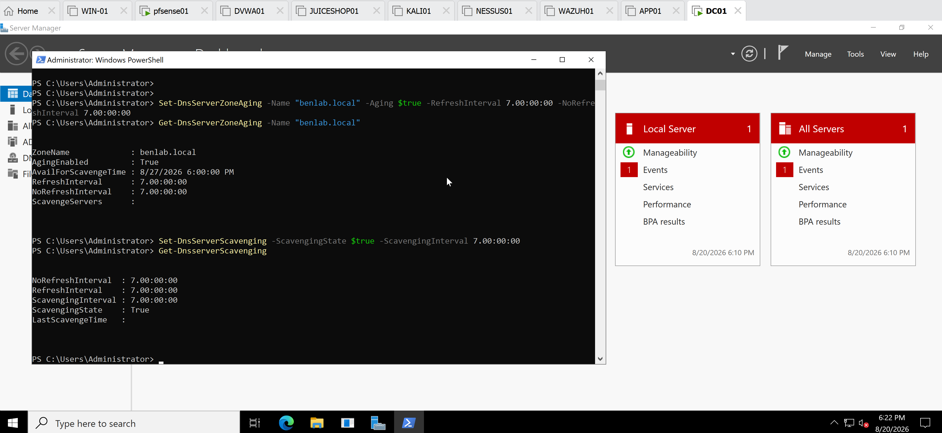
Screenshot 1 — Aging Configuration
PowerShell showing AgingEnabled : True, along with the 7-day Refresh and No-Refresh intervals.

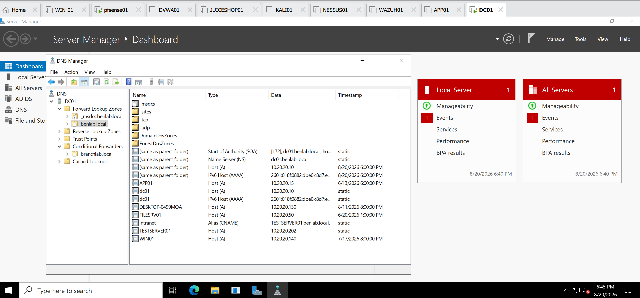
Screenshot 2 — Static vs. Timestamped Records
DNS Manager Advanced View showing dc01 and TESTSERVER01 as static, while APP01, FILESRV01, and WIN01 contain timestamps.

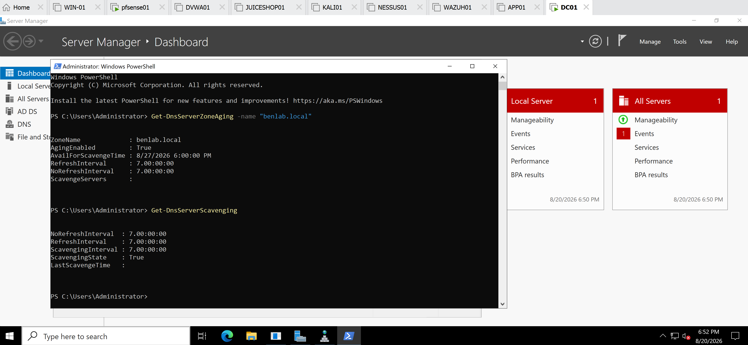
Screenshot 3 — Final Verification
AgingEnabled : True
ScavengingState : True

Module 3 – DNS Administration

Task 8 – DNS Cache Management and Client-Side DNS Validation

Objective
The objective of this task was to examine and manage DNS caching at both the DNS server and DNS client levels.
The task demonstrated how:
- DC01 maintains a DNS server cache.
- WIN01 maintains its own local DNS resolver cache.
- DNS queries for internal and external resources are resolved.
- Cached DNS entries can be viewed and cleared.
- DNS connectivity problems can affect name resolution.

Environment
System | Role | IP Address
DC01 | Domain Controller / DNS Server | 10.20.20.10
WIN01 | Domain-joined Windows 11 client | 10.20.20.140
pfSense01 | Gateway / DHCP | 10.20.20.254
Domain | Active Directory domain | benlab.local
WIN01 was configured to use:
10.20.20.10
as its IPv4 DNS server, meaning DNS queries from WIN01 are sent to DC01.

Part 1 – Examining the DNS Server Cache on DC01
On DC01, the DNS server cache configuration was examined using:
Get-DnsServerCache
The output displayed DNS server cache properties including:
MaxTTL
MaxNegativeTTL
EnablePollutionProtection
LockingPercent
This confirmed that the Microsoft DNS service on DC01 maintains a cache for previously resolved DNS information.

External DNS Resolution Test
An external DNS query was generated with:
Resolve-DnsName microsoft.com
The query successfully returned DNS records for microsoft.com, including IPv4 and IPv6 addresses.
This demonstrated that DC01 could resolve an external Internet domain.

Part 2 – Viewing Cached Records on DC01
The DNS server cache was inspected for Microsoft-related records using:
Get-DnsServerResourceRecord -ZoneName "." |
Where-Object {$_.Hostname -like "*microsoft*"} |
Format-Table Hostname,RecordType,Timestamp,RecordData -AutoSize
Multiple Microsoft-related records appeared in the DNS server cache, including record types such as:
A
AAAA
CNAME
NS
This demonstrated that external DNS information obtained during DNS resolution can be temporarily stored by the DNS server.

Part 3 – Clearing the DNS Server Cache
The DNS server cache on DC01 was cleared using:
Clear-DnsServerCache -Force
The Microsoft-related cache query was then executed again.
The previously cached records were no longer displayed.

Key concept
Clear-DnsServerCache clears temporary cached DNS information.
It does not delete authoritative DNS records from the benlab.local DNS zone, such as:
DC01 → 10.20.20.10
Therefore:
DNS cache records and DNS zone records are not the same thing.

Part 4 – Examining the WIN01 DNS Client Cache
On WIN01, the local Windows DNS resolver cache was examined using:
ipconfig /displaydns
The output showed cached DNS records from previous DNS queries.
Because the output can contain many records, this demonstrated how quickly a Windows workstation accumulates temporary DNS information during normal operation.

Part 5 – WIN01 Network Troubleshooting
During the task, WIN01 unexpectedly received an APIPA address:
169.254.x.x
Instead of receiving an address from the pfSense DHCP scope:
10.20.20.100 – 10.20.20.200
Connectivity to the pfSense gateway also failed:
ping 10.20.20.254
with:
PING: transmit failed. General failure.
The network adapter itself was checked with:
Get-NetAdapter
and appeared Up, indicating that Windows recognized the virtual NIC even though the TCP/IP configuration was malfunctioning.

Part 6 – DHCP and TCP/IP Troubleshooting
Attempts were made to obtain a new DHCP lease:
ipconfig /release
ipconfig /renew
The commands returned network endpoint/NCB errors rather than obtaining a valid lease.
The Windows networking stack was therefore reset using:
netsh winsock reset
followed by:
netsh int ip reset
Windows reported that a restart was required.
After restarting WIN01, DHCP communication was restored and WIN01 successfully obtained:
IPv4 Address : 10.20.20.140
Subnet Mask : 255.255.255.0
Gateway : 10.20.20.254
DHCP Server : 10.20.20.254
Connectivity tests to both the gateway and DC01 were successful.

Part 7 – Clearing the WIN01 DNS Client Cache
The workstation's local DNS cache was cleared using:
ipconfig /flushdns
Windows confirmed:
Successfully flushed the DNS Resolver Cache.
Running:
ipconfig /displaydns
immediately afterward showed that the previously accumulated cache entries had been removed.

Part 8 – Internal DNS Resolution
WIN01 was then used to query the domain controller:
Resolve-DnsName DC01.benlab.local
The query successfully returned the internal IPv4 record:
DC01.benlab.local
A
10.20.20.10
This verified that WIN01 could communicate with the internal DNS server and resolve resources in the benlab.local namespace.

Part 9 – External DNS Resolution and Client Caching
An external DNS lookup was performed from WIN01:
Resolve-DnsName microsoft.com
The query returned an IPv4 A record and IPv6 AAAA record for microsoft.com.
WIN01's DNS cache was then inspected again:
ipconfig /displaydns
The newly resolved microsoft.com information appeared in the local client cache.
This demonstrated the DNS resolution path:
WIN01
│
│ DNS query
▼
DC01 (10.20.20.10)
│
│ resolves external name
▼
External DNS infrastructure
│
▼
DC01
│
│ DNS response
▼
WIN01
│
▼
Stores result in local DNS cache
Once the IP address is known, normal application traffic can then travel from WIN01 through pfSense toward the destination. DC01 is providing DNS resolution, not acting as the router for the subsequent web connection.

Key Learning Points
1. DNS servers and DNS clients maintain separate caches.
DC01 maintains the server-side DNS cache, while WIN01 maintains its own local DNS resolver cache.
2. Clear-DnsServerCache and ipconfig /flushdns perform different jobs.
Clear-DnsServerCache clears DC01's DNS server cache, while ipconfig /flushdns clears WIN01's local resolver cache.
3. Clearing DNS cache does not delete authoritative DNS zone records.
Records belonging to the benlab.local zone remain intact.
4. DNS resolution depends on network connectivity.
WIN01's APIPA condition prevented normal communication with pfSense and DC01 even though the network adapter itself showed as Up.
5. An APIPA address (169.254.x.x) indicates that the client failed to obtain a usable IPv4 configuration from DHCP.
6. Resetting Winsock/TCP-IP and restarting WIN01 restored DHCP connectivity in this troubleshooting case.
7. Internal and external DNS resolution use the same client DNS infrastructure.
WIN01 can ask DC01 about both:
DC01.benlab.local
microsoft.com
but DC01 is authoritative for benlab.local while external names must be resolved through DNS outside that authoritative zone.
8. DNS resolution and actual application traffic are different processes.
DNS tells WIN01 the destination IP address; after resolution, WIN01 communicates with that destination through the network rather than sending all application traffic through DC01.

Screenshots Evidence
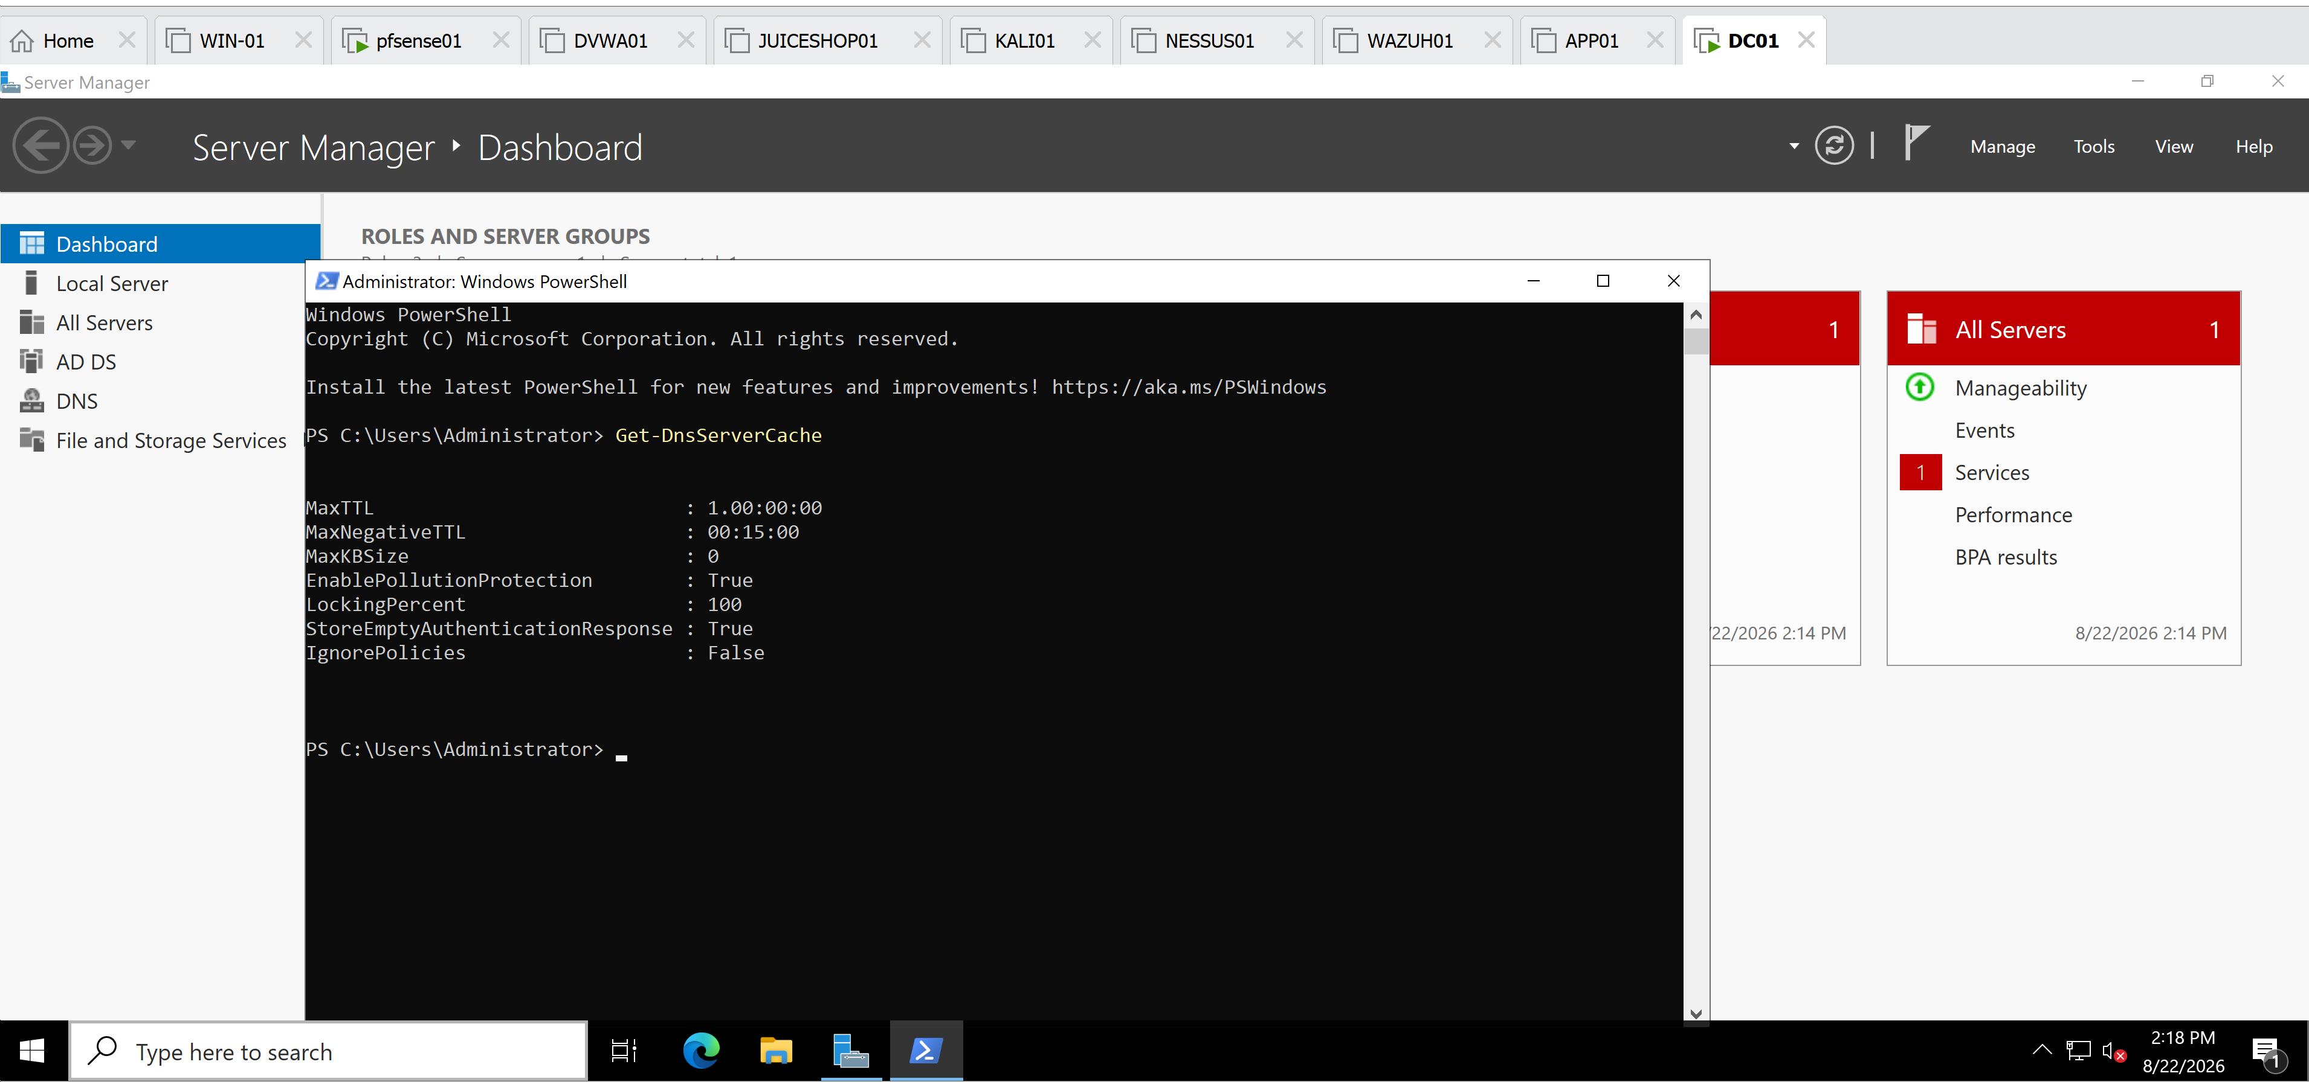
Screenshot 1: Get-DnsServerCache on DC01

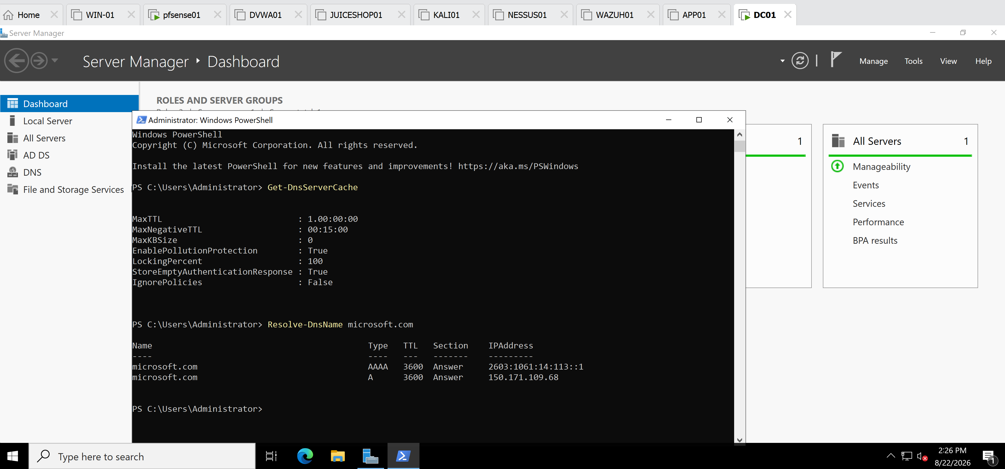
Screenshot 2: Microsoft records visible in DC01's DNS server cache

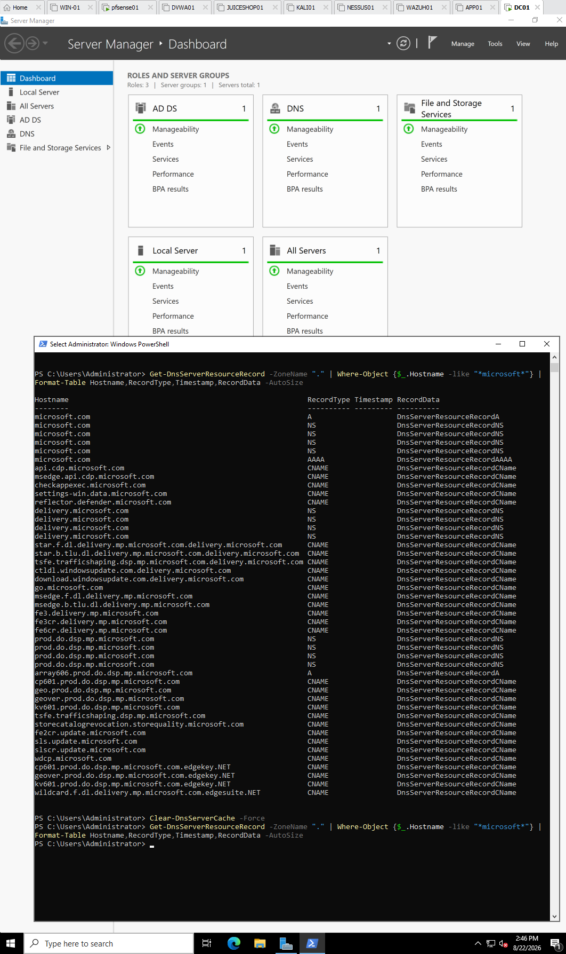
Screenshot 3: Cache cleared with Clear-DnsServerCache -Force and Microsoft records disappearing

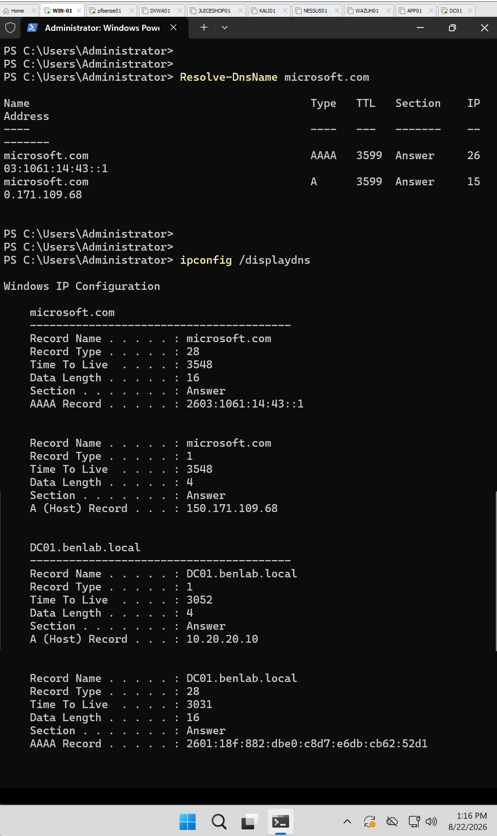
Screenshot 4: WIN01 showing Resolve-DnsName microsoft.com followed by ipconfig /displaydns

Task 9 — DNS Event Log Monitoring and Health Verification

Objective
Monitor the DNS Server event logs on DC01, identify DNS-related warnings or errors, determine whether the events indicate an active DNS problem, and verify the current operational health of the DNS service.

Environment
Server: DC01
Domain: benlab.local
DC01 IPv4: 10.20.20.10
Roles involved: Active Directory Domain Services (AD DS) and DNS Server

Step 1 — Open the DNS Server Event Log
On DC01, opened:
Server Manager → Tools → Event Viewer
Then navigated to:
Applications and Services Logs → DNS Server
The DNS Server log contained both informational events and warnings generated by the DNS Server service.

Step 2 — Filter Significant DNS Events
Used Filter Current Log and selected:
- Critical
- Error
- Warning
This reduced the DNS log to 62 significant events requiring investigation.
The events were then examined by Event ID.

Step 3 — Investigate Event ID 4013
The filtered log showed repeated:
Source: DNS-Server-Service
Event ID: 4013
Level: Warning
Event 4013 indicated that the DNS Server service was waiting for Active Directory Domain Services (AD DS) to complete its initial directory synchronization before DNS could fully initialize.
Because DC01 hosts both AD DS and DNS, DNS depends on Active Directory for its AD-integrated DNS data.

Step 4 — Verify the Event Count
The DNS Server log was filtered specifically for:
4013
The result remained:
Number of events: 62
Therefore:
All 62 Critical/Error/Warning events identified during the investigation were Event ID 4013 warnings.
No separate collection of DNS critical errors or other DNS failure event IDs was identified in this filtered set.

Step 5 — Verify DNS Server Service Status
Opened PowerShell as Administrator on DC01 and ran:
Get-Service DNS
Result:
Status Name DisplayName
------ ---- -----------
Running DNS DNS Server
This confirmed that the DNS Server service was currently running.

Step 6 — Run Domain Controller DNS Diagnostics
Ran:
dcdiag /test:dns
The diagnostic returned successful results including:
DC01 passed test Connectivity
DC01 passed test DNS
benlab.local passed test DNS
This verified that DC01 passed its Domain Controller connectivity and DNS diagnostic testing.

Results
The investigation determined that the DNS Server service on DC01 was operational and healthy at the time of testing.
Although Event Viewer contained 62 warning events, all 62 were Event ID 4013, associated with AD DS/DNS initialization and synchronization.
Current health verification showed:
DNS Server Service → Running
DC01 Connectivity Test → Passed
DC01 DNS Test → Passed
benlab.local DNS Test → Passed
The Event 4013 warnings therefore did not provide evidence of a current DNS outage. They were correlated with the server's AD DS/DNS startup synchronization behavior.

Key Learning Points
Event Viewer is historical. A warning recorded in Event Viewer does not necessarily mean that the problem is occurring right now.
Event IDs require investigation. Administrators should examine the Event ID, source, timestamp, description, frequency, and current server behavior before deciding that something needs to be repaired.
Service status alone is not enough. Get-Service DNS verified that DNS was running, while dcdiag /test:dns provided deeper validation that the Domain Controller's DNS functionality passed diagnostic testing.
AD DS and DNS are closely integrated. On DC01, DNS hosts Active Directory-integrated DNS information, which explains why DNS may wait for AD DS during initialization.
Warnings should be correlated with operational testing. In this task, Event Viewer showed Event ID 4013 warnings, while current DNS diagnostics passed successfully.

Screenshots
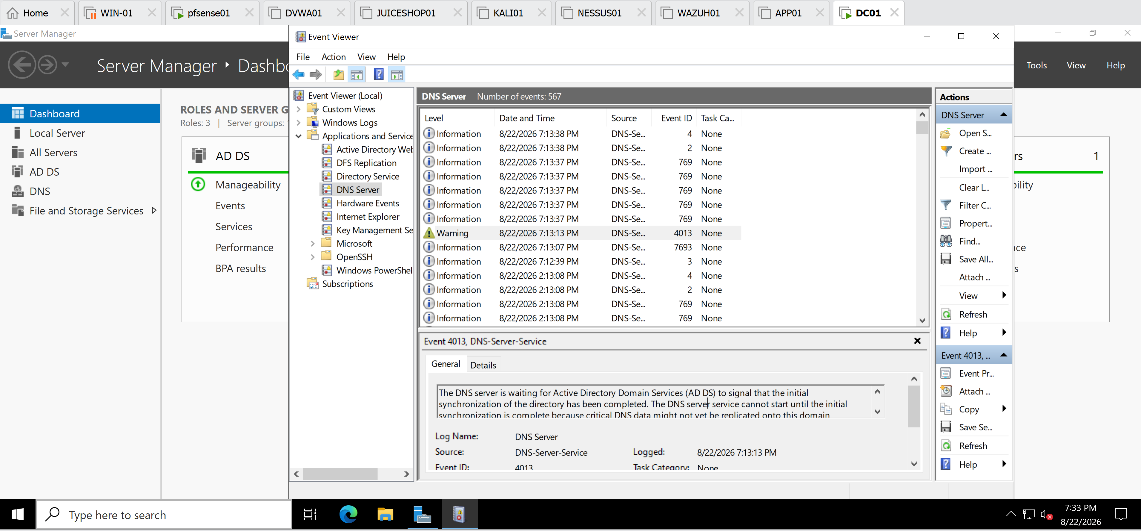
Event Viewer filtered to Critical/Error/Warning, showing Event ID 4013.

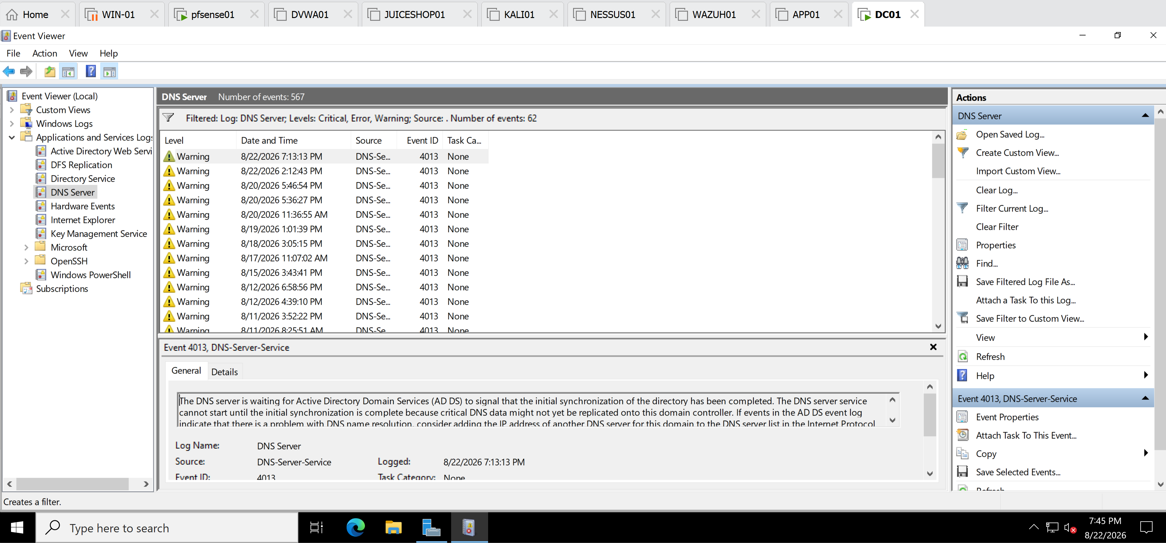
Event Viewer filtered specifically to 4013, showing Number of events: 62.

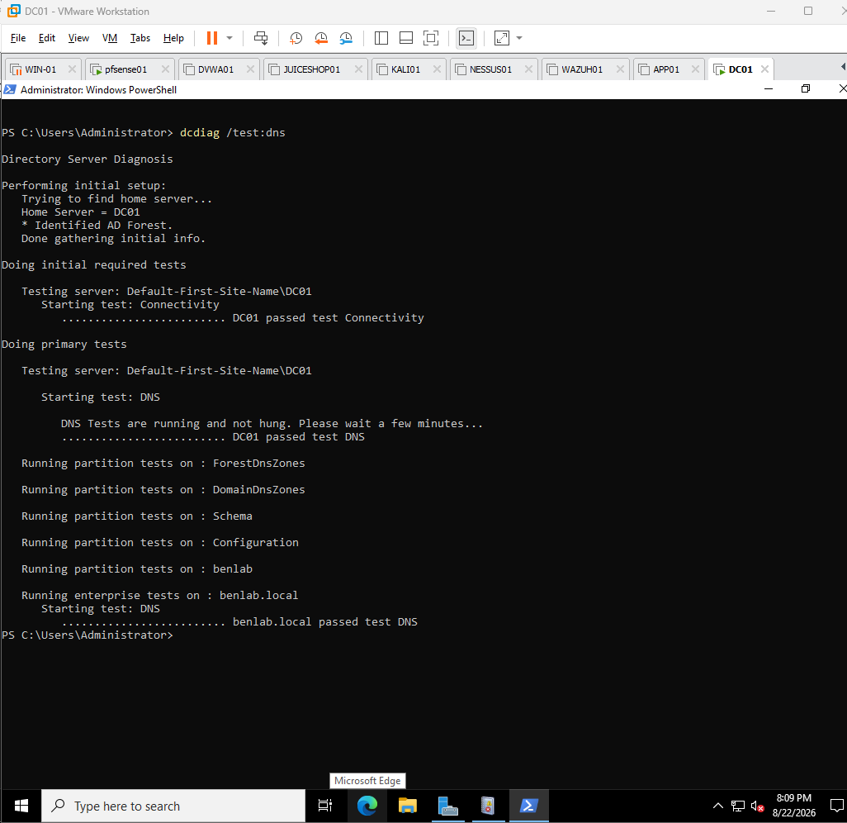
PowerShell DNS health verification, especially the screenshot showing:

DC01 passed test DNS
benlab.local passed test DNS

Module 3 – DNS Administration

Task 5 – DNS Troubleshooting and Validation

Objective
Perform systematic DNS troubleshooting and validation within the benlab.local Active Directory environment.
The purpose of this task was to verify DNS service health, DNS zones and resource records, forward and reverse name resolution, Active Directory service discovery, Kerberos and LDAP connectivity, Domain Controller discovery, external DNS resolution, DNS client caching, and overall DNS health.

Environment
System | Role | IP Address
DC01 | Domain Controller / AD DS / DNS Server | 10.20.20.10
WIN01 | Domain-joined Windows workstation | 10.20.20.140
FILESRV01 | Windows File Server | 10.20.20.50
pfSense01 | Gateway / DHCP Server | 10.20.20.254
Domain | Active Directory Domain | benlab.local
Troubleshooting was performed primarily from DC01 and WIN01 using Windows PowerShell and command-line administration tools.

Troubleshooting and Validation Steps

Step 1 – Verify the DNS Server Service
On DC01, verify that the Windows DNS Server service is running.

Command
Get-Service DNS

Expected/Observed Result
Status Name DisplayName
------ ---- -----------
Running DNS DNS Server

Explanation
This verifies that the DNS Server service itself is operational.
Checking the service is an important early troubleshooting step because DNS queries cannot be processed normally if the DNS service is stopped.

Result
Successful — DNS Server service was running on DC01.

Step 2 – Verify DNS Zones
List the DNS zones configured on DC01.

Command
Get-DnsServerZone
The output confirmed important zones including:
_msdcs.benlab.local
20.20.10.in-addr.arpa
benlab.local
branchlab.local

Explanation
This verifies that the DNS server contains the zones required by the environment.
benlab.local provides forward DNS resolution for the Active Directory domain.
20.20.10.in-addr.arpa provides reverse DNS resolution for the 10.20.20.0/24 network.
_msdcs.benlab.local contains DNS information used extensively by Active Directory for Domain Controller and service discovery.
branchlab.local is the conditional forwarder configured earlier in the DNS module.

Result
Successful — required DNS zones were present.

Step 3 – Inspect DNS Resource Records
Review the resource records stored inside the benlab.local DNS zone.

Command
Get-DnsServerResourceRecord -ZoneName "benlab.local"
The output displayed several DNS record types, including:
A
AAAA
CNAME
NS
SOA
SRV
Records for systems such as DC01, FILESRV01, APP01, and WIN01 were present.
Active Directory SRV records for LDAP, Kerberos, and other domain services were also visible.

Explanation
DNS contains more than simple hostname-to-IP mappings.
Active Directory relies heavily on SRV (Service) records to advertise the location of services such as LDAP and Kerberos.

Result
Successful — host and Active Directory service records were present.

Step 4 – Verify WIN01 DNS Client Configuration
On WIN01, inspect the workstation's TCP/IP and DNS configuration.

Command
ipconfig /all
Important values observed:
IPv4 Address : 10.20.20.140
Subnet Mask : 255.255.255.0
Default Gateway : 10.20.20.254
DHCP Server : 10.20.20.254
DNS Server : 10.20.20.10
DNS Suffix : benlab.local

Explanation
This was particularly important because an Active Directory client should use the internal DNS server that understands the AD domain.
WIN01 was correctly configured to use:
10.20.20.10 → DC01
rather than using a public DNS server directly.

Result
Successful — WIN01 was configured to use DC01 for DNS resolution.

Step 5 – Test Forward DNS Resolution
From WIN01, test whether the hostname of FILESRV01 resolves to its IP address.

Command
Resolve-DnsName FILESRV01.benlab.local

Result
FILESRV01.benlab.local → 10.20.20.50

Explanation
This tests a forward lookup:
Hostname
↓
DNS
↓
IP Address

Result
Successful — FILESRV01 resolved to 10.20.20.50.

Step 6 – Test Reverse DNS Resolution
Test whether the IP address of FILESRV01 resolves back to its hostname.

Command
Resolve-DnsName 10.20.20.50

Result
10.20.20.50 → FILESRV01.benlab.local
The response was provided by a PTR record in the reverse lookup zone.

Explanation
This tests a reverse lookup:
IP Address
↓
PTR Record
↓
Hostname

Result
Successful — forward and reverse resolution were both functioning.

Step 7 – Verify LDAP SRV Record Discovery
Test whether WIN01 can use DNS to locate the LDAP service for the Active Directory domain.

Command
Resolve-DnsName _ldap._tcp.dc._msdcs.benlab.local -Type SRV
Important result:
NameTarget : dc01.benlab.local
Port : 389

Explanation
This tells WIN01:
For an LDAP service associated with a Domain Controller in benlab.local, contact DC01 on port 389.
LDAP is used to access and query directory information such as users, groups, computers, and other Active Directory objects.

Result
Successful — LDAP service discovery through DNS worked.

Step 8 – Verify Kerberos SRV Record Discovery
Test Kerberos service discovery.

Command
Resolve-DnsName _kerberos._tcp.dc._msdcs.benlab.local -Type SRV
Important result:
NameTarget : dc01.benlab.local
Port : 88

Explanation
Kerberos is the primary authentication protocol used by Active Directory.
The SRV record tells domain clients which Domain Controller provides Kerberos authentication services.

Result
Successful — DC01 was discovered as a Kerberos service provider on port 88.

Step 9 – Test Kerberos and LDAP Port Connectivity
DNS service discovery proves that the appropriate SRV records exist, but it does not by itself prove that the client can establish TCP connections to those service ports.
Test Kerberos:
Test-NetConnection dc01.benlab.local -Port 88
Result:
TcpTestSucceeded : True
Test LDAP:
Test-NetConnection dc01.benlab.local -Port 389
Result:
TcpTestSucceeded : True

Explanation
This demonstrated an important troubleshooting distinction:
Resolve-DnsName
↓
Can I FIND the service?

Test-NetConnection
↓
Can I REACH the service's TCP port?

Result
Successful — WIN01 could reach both Kerberos and LDAP service ports on DC01.

Step 10 – Verify Domain Controller Discovery
Test whether WIN01 can locate a Domain Controller for the domain.

Command
nltest /dsgetdc:benlab.local
The output identified:
DC: \\DC01.benlab.local
Address: \\10.20.20.10
Dom Name: benlab.local
Forest Name: benlab.local
Our Site Name: Default-First-Site-Name

The command completed successfully

Explanation
This goes beyond simply resolving dc01.benlab.local.
It verifies that WIN01 can actually discover a Domain Controller for the Active Directory domain.

Result
Successful — WIN01 successfully discovered DC01.

Step 11 – Test External DNS Resolution
Test whether WIN01 can resolve an Internet hostname.

Command
Resolve-DnsName google.com
Public IPv4 and IPv6 addresses were successfully returned.

Explanation
WIN01 is configured to use DC01 as its DNS server.
Therefore, external resolution demonstrates the following path:
WIN01
│
│ DNS query
▼
DC01
│
│ Forwarding / recursion
▼
External DNS
│
▼
google.com resolved

Result
Successful — external DNS resolution worked.

Step 12 – Test External TCP Connectivity
Test HTTPS connectivity separately from DNS resolution.

Command
Test-NetConnection google.com -Port 443
Result:
RemotePort : 443
TcpTestSucceeded : True

Explanation
DNS resolution and network connectivity are related but separate troubleshooting layers.
A hostname can resolve successfully while the destination service remains unreachable.

Result
Successful — WIN01 had external HTTPS connectivity.

Step 13 – Inspect the DNS Client Cache
View locally cached DNS records on WIN01.

Command
Get-DnsClientCache
The output displayed DNS records previously resolved by WIN01.

Explanation
Windows caches DNS responses locally to avoid repeatedly querying the DNS server for the same records.
Each cached record remains available according to its TTL (Time To Live).

Result
DNS client cache successfully inspected.

Step 14 – Clear and Repopulate the DNS Client Cache
Clear WIN01's DNS client cache.

Command
Clear-DnsClientCache
Then perform a fresh lookup:
Resolve-DnsName dc01.benlab.local
Finally, inspect the cache again:
Get-DnsClientCache
DC01 appeared in the cache after the new lookup.

Explanation
This demonstrated the troubleshooting process:
Cached DNS information exists
↓
Clear-DnsClientCache
↓
Cached entries removed
↓
Resolve-DnsName
↓
Fresh DNS query
↓
Response cached again
This is particularly useful when troubleshooting stale or incorrect DNS information.

Result
Successful — DNS cache clearing and repopulation were demonstrated.

Step 15 – Perform Final DNS Health Diagnostic
Finally, run an Active Directory DNS diagnostic directly from DC01.

Command
dcdiag /test:dns
Important results:
DC01 passed test Connectivity
DC01 passed test DNS
benlab.local passed test DNS

Explanation
dcdiag is a Domain Controller diagnostic utility.
The DNS test examines DNS functionality required by Active Directory and provides a strong final server-side validation after client-side troubleshooting has been completed.

Result
Successful — DC01 and benlab.local passed the DNS diagnostic.

Screenshots
This section provides visual evidence of the DNS troubleshooting and validation performed during Task 5.

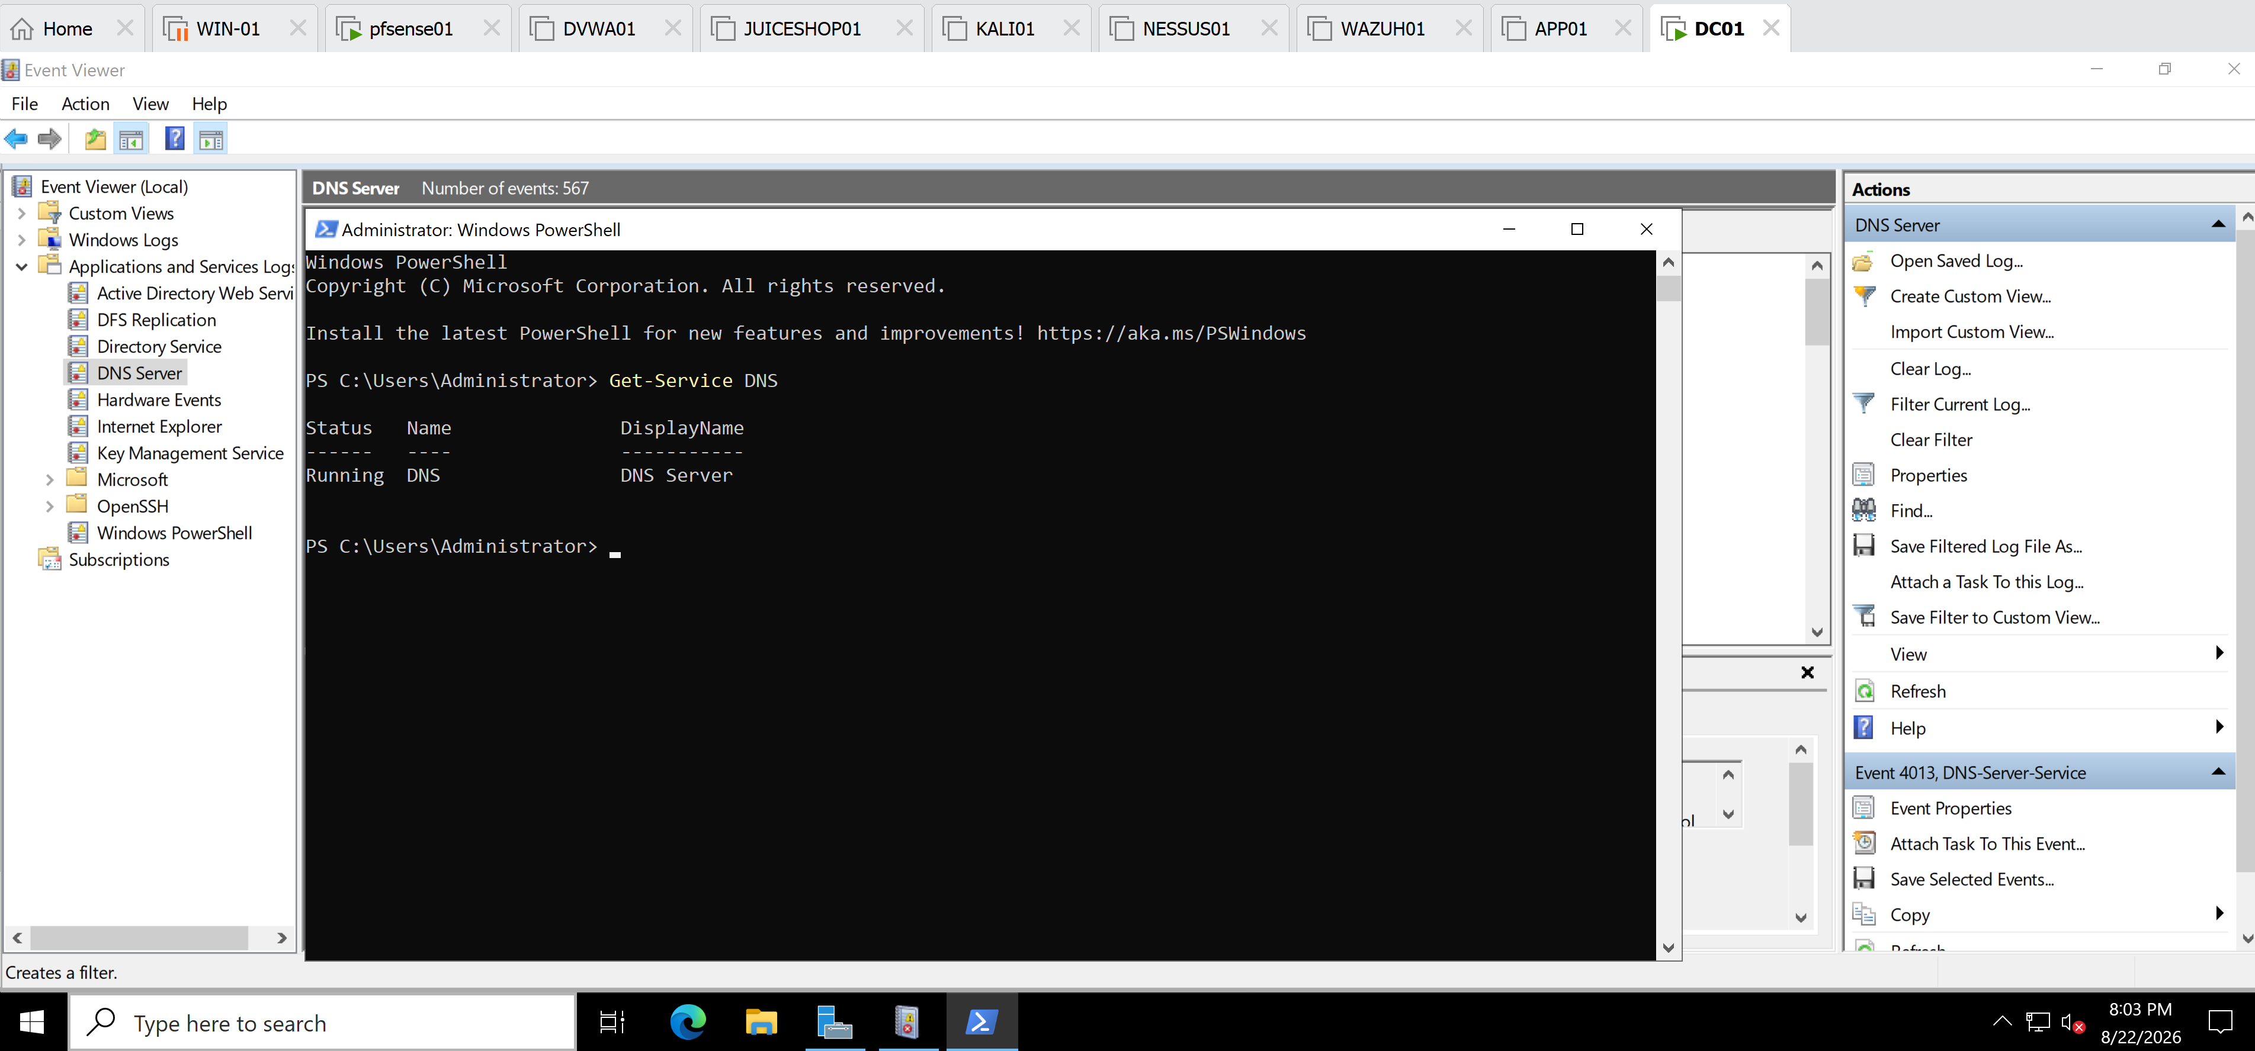
Screenshot 1 – DNS Service and Zone Validation
Caption:
DNS Server service and DNS zone validation on DC01, confirming that the DNS service is running and the required Active Directory DNS zones are available.

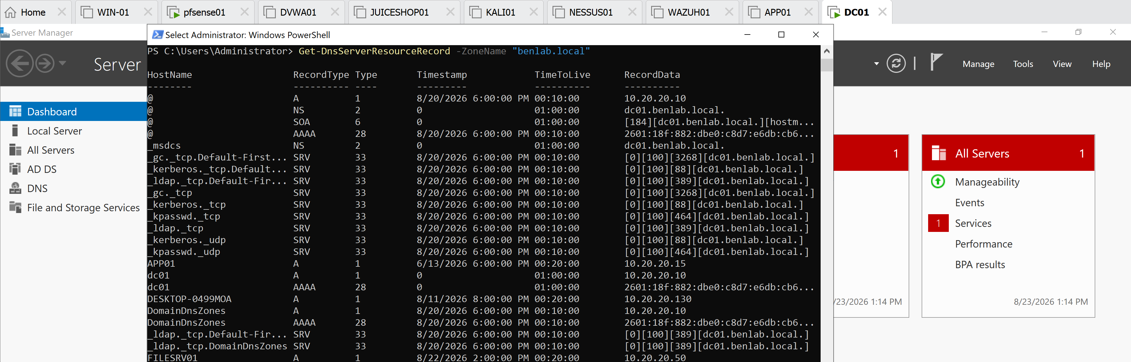
Screenshot 2 – DNS Resource Record
Caption:
DNS resource record inspection for benlab.local, showing host records and Active Directory SRV records used for service discovery.

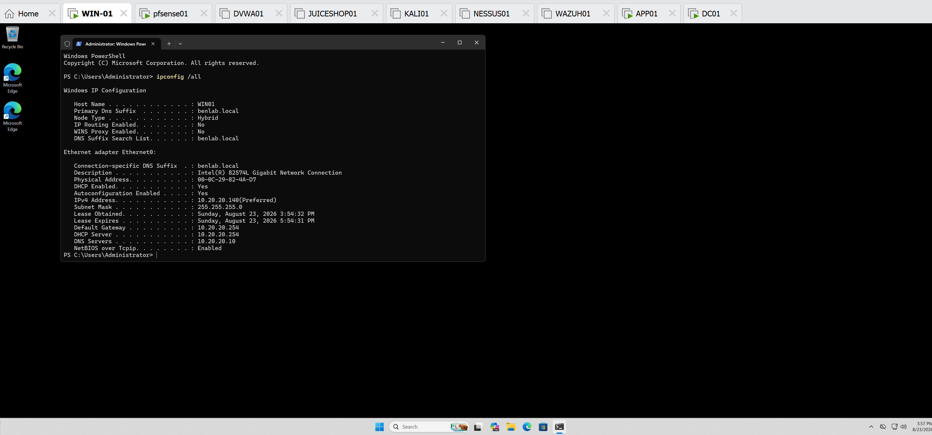
Screenshot 3 – WIN01 DNS Client Configuration
Caption:
WIN01 TCP/IP configuration confirming that the domain workstation receives network configuration from pfSense and uses DC01 (10.20.20.10) as its DNS server.

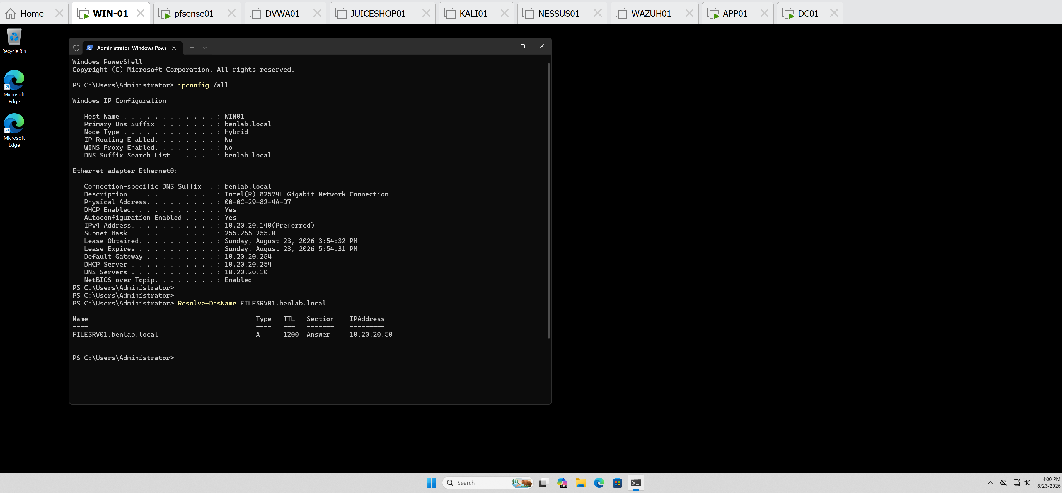
Screenshot 4 – Forward and Reverse DNS Resolution
Caption:
Successful forward and reverse DNS resolution for FILESRV01, validating both the A record and PTR record.

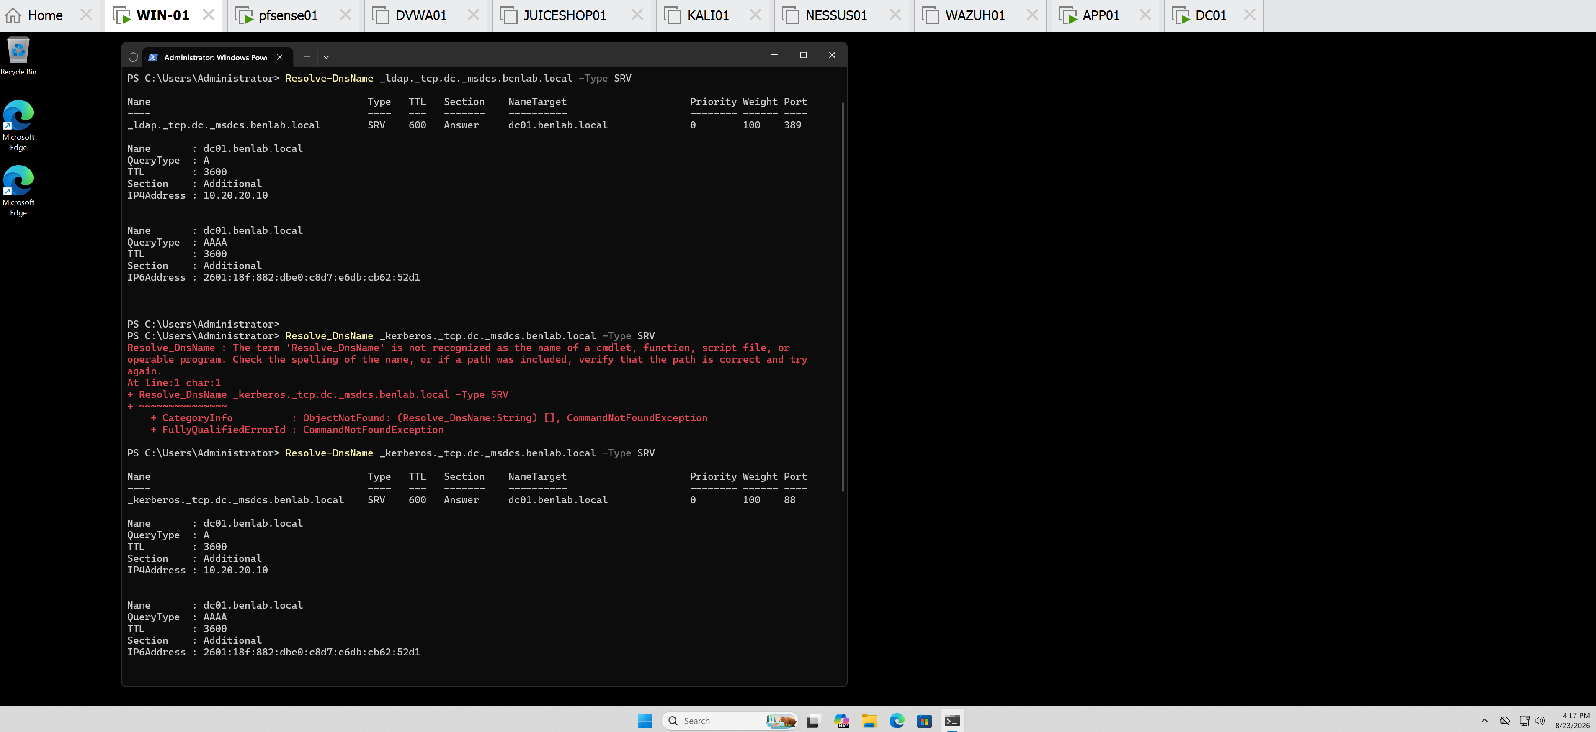
Screenshot 5 – LDAP and Kerberos SRV Discovery
Caption:
Active Directory SRV record validation demonstrating successful discovery of LDAP and Kerberos services hosted by DC01.

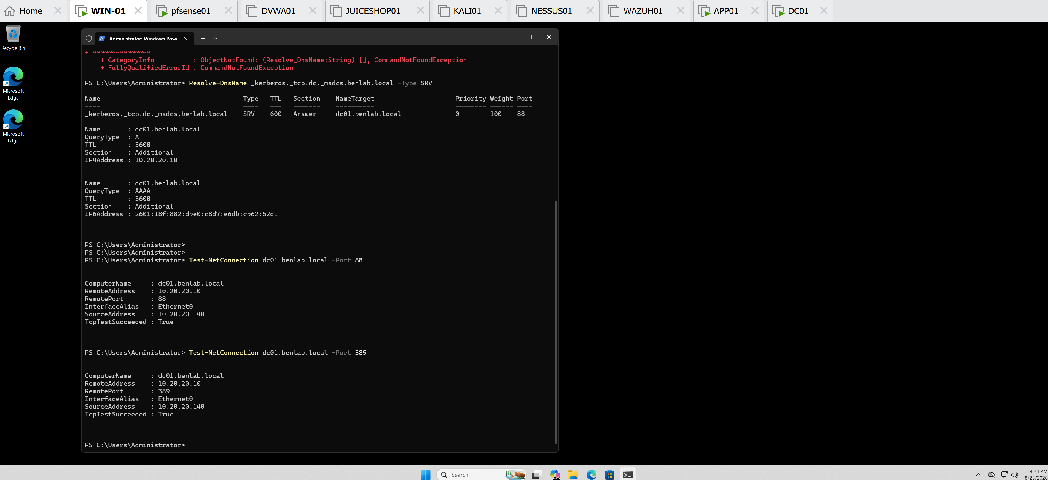
Screenshot 6 – Kerberos and LDAP Connectivity
Caption:
Successful TCP connectivity from WIN01 to DC01 over Kerberos port 88 and LDAP port 389.

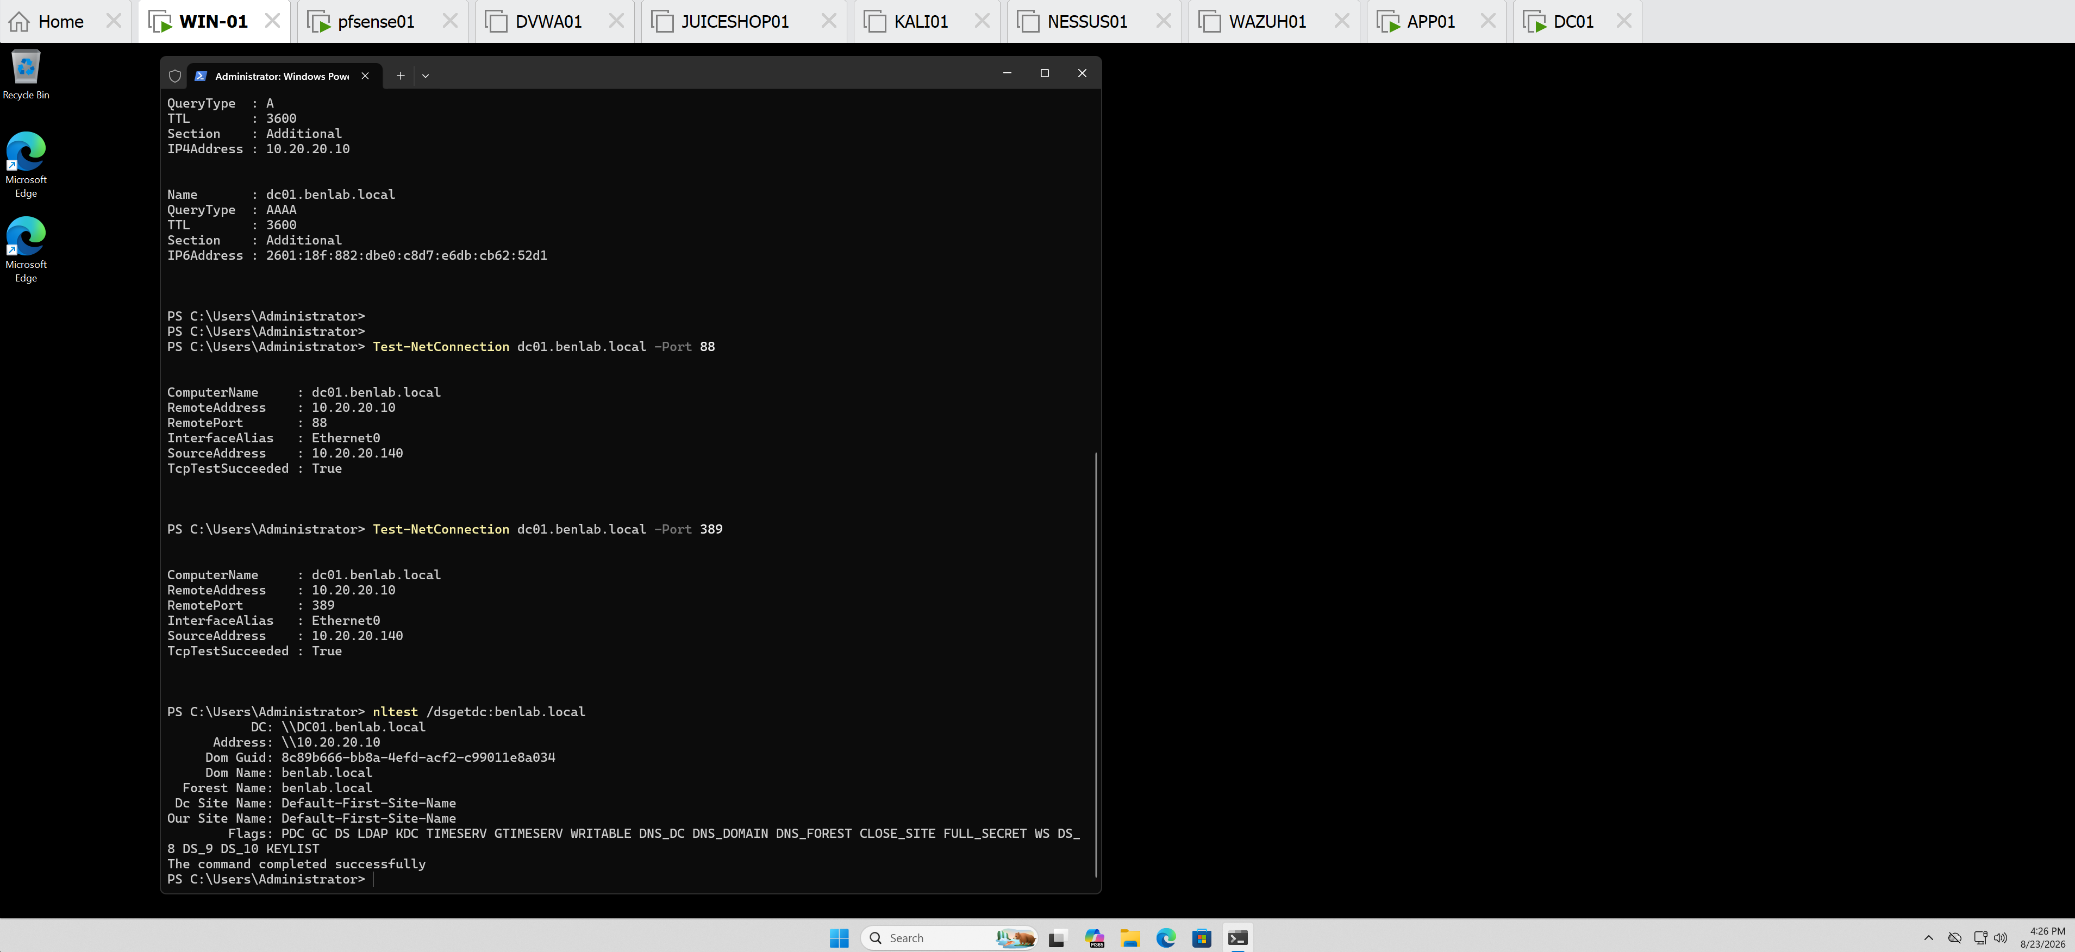
Screenshot 7 – Domain Controller Discovery
Caption:
Successful Active Directory Domain Controller discovery from WIN01, identifying DC01 (10.20.20.10) as a Domain Controller for benlab.local.

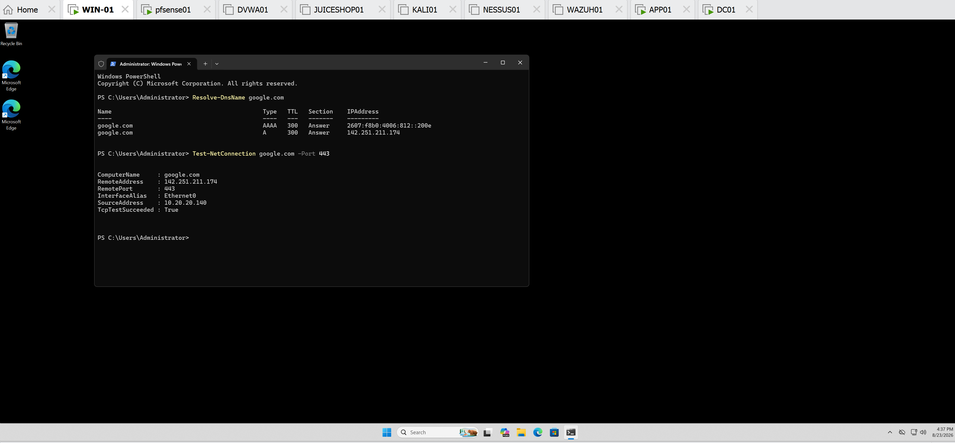
Screenshot 8 – External DNS and Connectivity
Caption:
Successful external DNS resolution and HTTPS connectivity from WIN01, validating external name resolution through the internal DNS infrastructure.

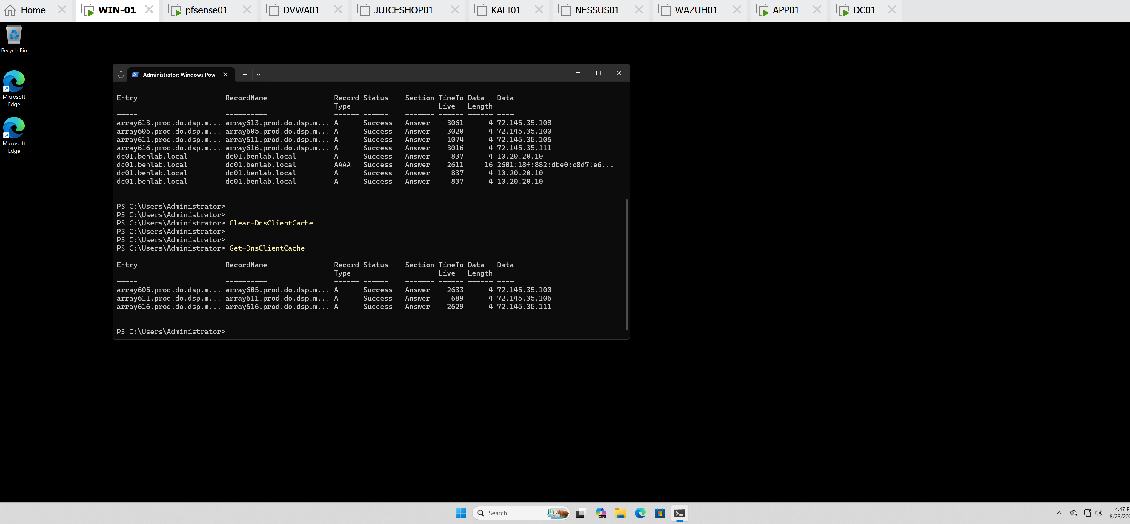
Screenshot 9 – DNS Client Cache
Caption:
DNS client cache troubleshooting on WIN01, demonstrating cache inspection, clearing, fresh name resolution, and cache repopulation.

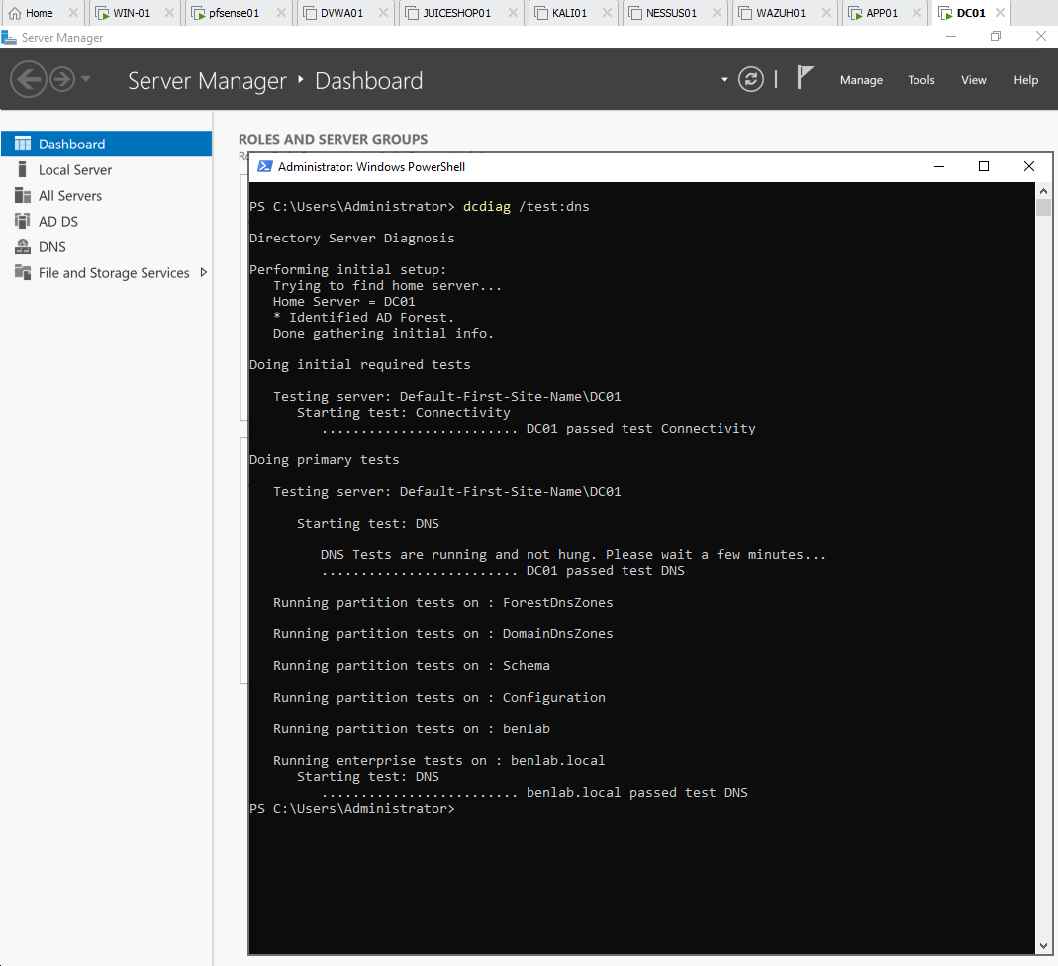

Screenshot 10 – Final DNS Diagnostic

Caption:
Final Active Directory DNS diagnostic on DC01 confirming successful connectivity and DNS health for the benlab.local domain.

Troubleshooting Sequence Learned
A systematic troubleshooting sequence was developed during this task:
1. Verify client IP configuration
↓
2. Verify configured DNS server
↓
3. Verify DNS Server service
↓
4. Verify DNS zones
↓
5. Inspect DNS records
↓
6. Test forward resolution
↓
7. Test reverse resolution
↓
8. Verify AD SRV records
↓
9. Test LDAP/Kerberos connectivity
↓
10. Verify Domain Controller discovery
↓
11. Test external DNS resolution
↓
12. Test external connectivity
↓
13. Inspect/clear DNS cache
↓
14. Run dcdiag /test:dns
The main lesson is to troubleshoot DNS layer by layer instead of immediately changing configurations.

Key Learning Points
- DNS is a critical component of Active Directory infrastructure.
- Domain clients should use the internal Active Directory DNS server for domain name resolution.
- A records map hostnames to IPv4 addresses.
- PTR records provide reverse IP-to-hostname resolution.
- SRV records advertise network services and allow Active Directory clients to locate Domain Controllers and services.
- LDAP, primarily using TCP port 389, provides access to Active Directory directory information.
- Kerberos, using port 88, provides Active Directory authentication.
- Successful DNS resolution does not automatically prove that the associated network service is reachable.
- Test-NetConnection can verify TCP connectivity to specific service ports.
- nltest /dsgetdc: can verify Domain Controller discovery from a domain workstation.
- Get-DnsClientCache allows administrators to inspect cached DNS responses.
- Clear-DnsClientCache is useful when troubleshooting stale DNS information.
- Resolve-DnsName can generate fresh DNS queries and test specific DNS record types.
- dcdiag /test:dns provides a comprehensive DNS diagnostic from the Domain Controller perspective.
- Effective troubleshooting should follow a logical sequence from network configuration → DNS infrastructure → name resolution → AD service discovery → connectivity → final validation.

Commands Used
Get-Service DNS

Get-DnsServerZone

Get-DnsServerResourceRecord -ZoneName "benlab.local"

ipconfig /all

Resolve-DnsName FILESRV01.benlab.local

Resolve-DnsName 10.20.20.50

Resolve-DnsName _ldap._tcp.dc._msdcs.benlab.local -Type SRV

Resolve-DnsName _kerberos._tcp.dc._msdcs.benlab.local -Type SRV

Test-NetConnection dc01.benlab.local -Port 88

Test-NetConnection dc01.benlab.local -Port 389

nltest /dsgetdc:benlab.local

Resolve-DnsName google.com

Test-NetConnection google.com -Port 443

Get-DnsClientCache

Clear-DnsClientCache

Resolve-DnsName dc01.benlab.local

dcdiag /test:dns

Final Result
Task 5 – DNS Troubleshooting and Validation: COMPLETED SUCCESSFULLY
The benlab.local DNS infrastructure was validated from both the client and server perspectives.
WIN01 successfully:
- Used DC01 as its DNS server.
- Resolved internal hostnames.
- Performed reverse DNS lookups.
- Discovered LDAP and Kerberos services through SRV records.
- Connected to LDAP TCP 389 and Kerberos TCP 88.
- Located the benlab.local Domain Controller.
- Resolved external Internet hostnames.
- Established external HTTPS connectivity.
- Cleared and repopulated its DNS client cache.
DC01 successfully passed:
dcdiag /test:dns
confirming healthy DNS functionality for the Active Directory environment.

