Task 1 – Enterprise File Share and NTFS Permission Administration

Objective
Configure and validate a centralized departmental file-sharing structure on FILESRV01 using SMB share permissions, NTFS permissions, Active Directory security groups, and end-user access testing.
The goal was to implement an enterprise-style access model in which domain users can connect to a common network share while NTFS permissions control access to individual departmental folders.

Environment
File Server: FILESRV01
Domain: BENLAB.LOCAL
Share Name: EnterpriseData
Local Path: C:\EnterpriseData
UNC Path: \\FILESRV01\EnterpriseData
Departmental folders:
- Finance
- Human Resources
- Information Technology
- Public

Step 1 – Create the Enterprise Data Share
The EnterpriseData SMB share was created on FILESRV01 using PowerShell.
New-SmbShare -Name "EnterpriseData" -Path "C:\EnterpriseData" -ChangeAccess "BENLAB\Domain Users" -FullAccess "BENLAB\Domain Admins"
The share configuration was verified with:
Get-SmbShare -Name "EnterpriseData"
Result: EnterpriseData successfully mapped to C:\EnterpriseData.

Step 2 – Configure and Verify Share Permissions
The SMB share was configured with the following permissions:
Security Principal | Share Permission
BENLAB\Domain Admins | Full
BENLAB\Domain Users | Change
Verification command:
Get-SmbShareAccess -Name "EnterpriseData"
This allows authenticated domain users to connect to the share while preserving full administrative control for Domain Admins.

Step 3 – Configure Departmental NTFS Permissions
NTFS permissions were used to provide more granular access within the EnterpriseData share.
The resulting departmental access model was:
Folder | Authorized Group | NTFS Permission
Finance | BENLAB\GG_Finance | Modify
Human Resources | BENLAB\GG_HR | Modify
Information Technology | BENLAB\GG_IT | Modify
Public | BENLAB\Domain Users | Modify
Administrative and system permissions were also preserved, including Full Control for SYSTEM and Administrators.

Step 4 – Verify NTFS Permissions with PowerShell
The departmental ACLs were validated using icacls.
Example:
icacls "C:\EnterpriseData\Finance"
A PowerShell loop was also used to inspect all departmental folders:
Get-ChildItem "C:\EnterpriseData" -Directory | ForEach-Object {
Write-Host "`n=== $($_.Name) ==="
icacls $_.FullName
}
The results confirmed that each department was assigned to its corresponding Active Directory security group with Modify permission.

Step 5 – Test SMB Connectivity from WIN01
Testing was performed from the domain-joined Windows 11 workstation WIN01.
Connectivity to FILESRV01 was verified:
ping FILESRV01
The server name successfully resolved to:
10.20.20.50
SMB connectivity was then tested on TCP port 445:
Test-NetConnection FILESRV01 -Port 445
Result:
TcpTestSucceeded : True
This confirmed that WIN01 could communicate with the SMB service running on FILESRV01.

Step 6 – Validate Access as a Finance User
Testing was performed while signed in as domain user jlee, a Finance employee.
The user successfully browsed:
\\FILESRV01\EnterpriseData
Because jlee is authorized through the Finance security group, the user successfully opened:
\\FILESRV01\EnterpriseData\Finance
A test file was successfully created:
JLee-Finance-Permission-Test.txt
This demonstrated that the Finance NTFS Modify permission was functioning correctly.
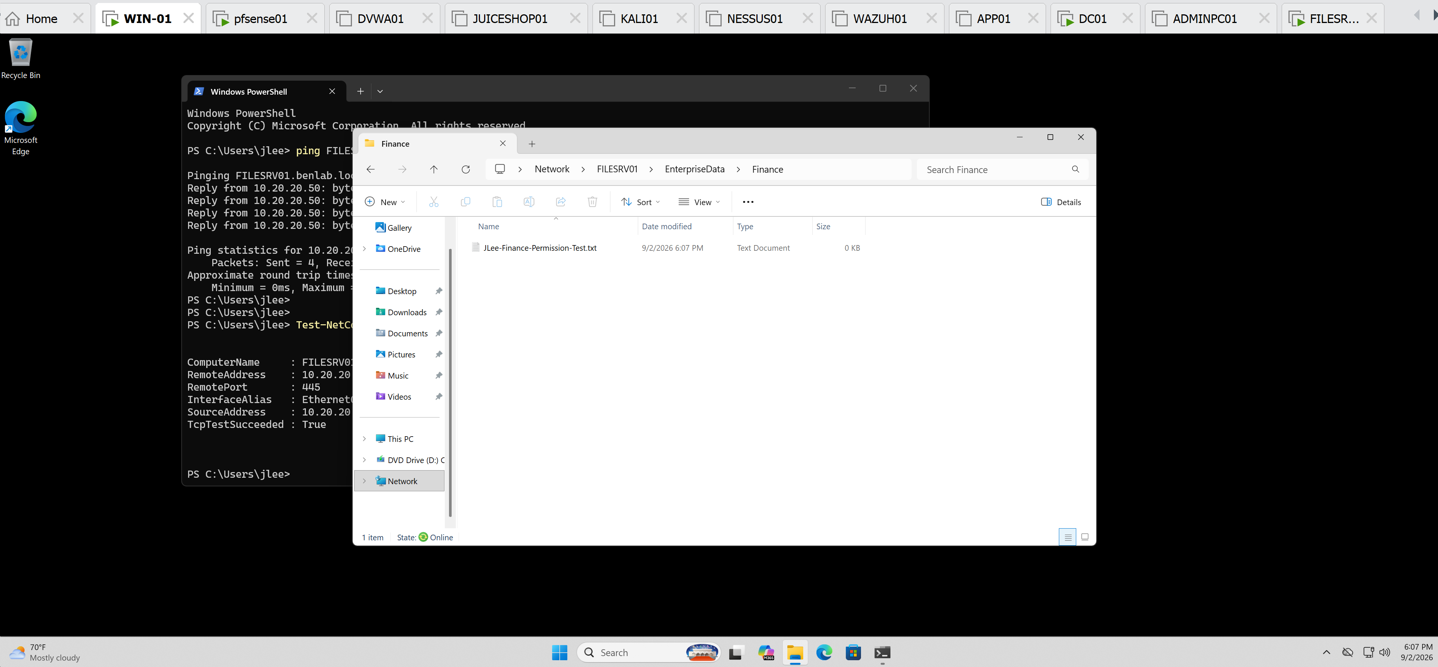
jlee successfully inside Finance showing Jlee-Finance-Permission-Test.txt.

Step 7 – Validate Unauthorized Department Access
The same Finance user attempted to access:
\\FILESRV01\EnterpriseData\Human Resources
Result: Access denied.
The user also attempted to access:
\\FILESRV01\EnterpriseData\Information Technology
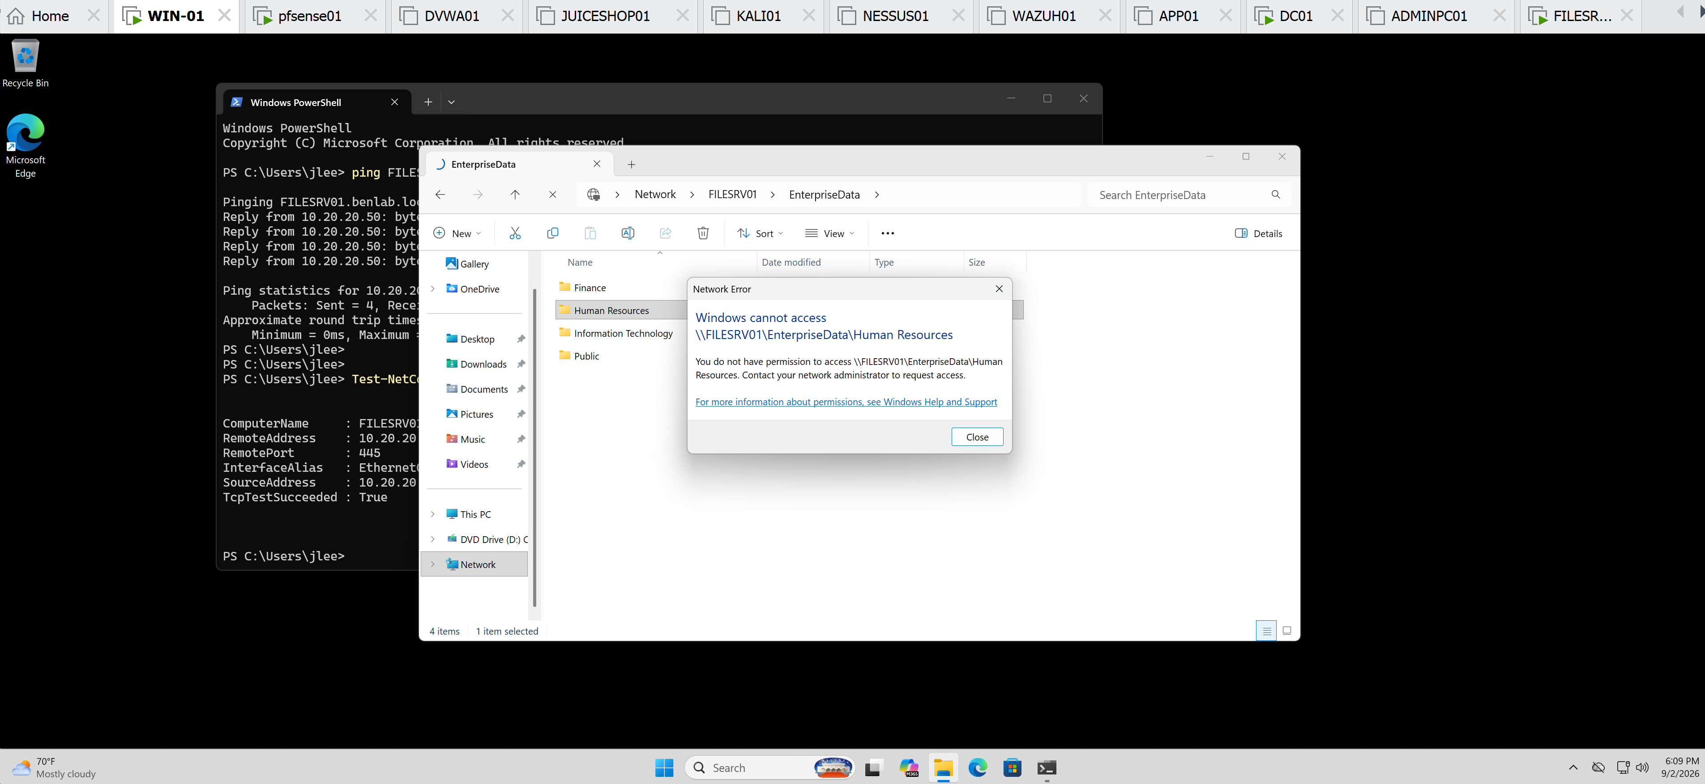
Result: Access denied.
These tests confirmed that having access to the EnterpriseData SMB share does not automatically provide access to every folder contained within it.
Departmental access remained controlled by NTFS permissions and Active Directory security-group membership.

Step 8 – Validate Public Folder Access
The Finance user successfully accessed:
\\FILESRV01\EnterpriseData\Public
A test file was successfully created:
JLee-Public-Permission-Test.txt
This was expected because the Public folder grants Modify permission to BENLAB\Domain Users.
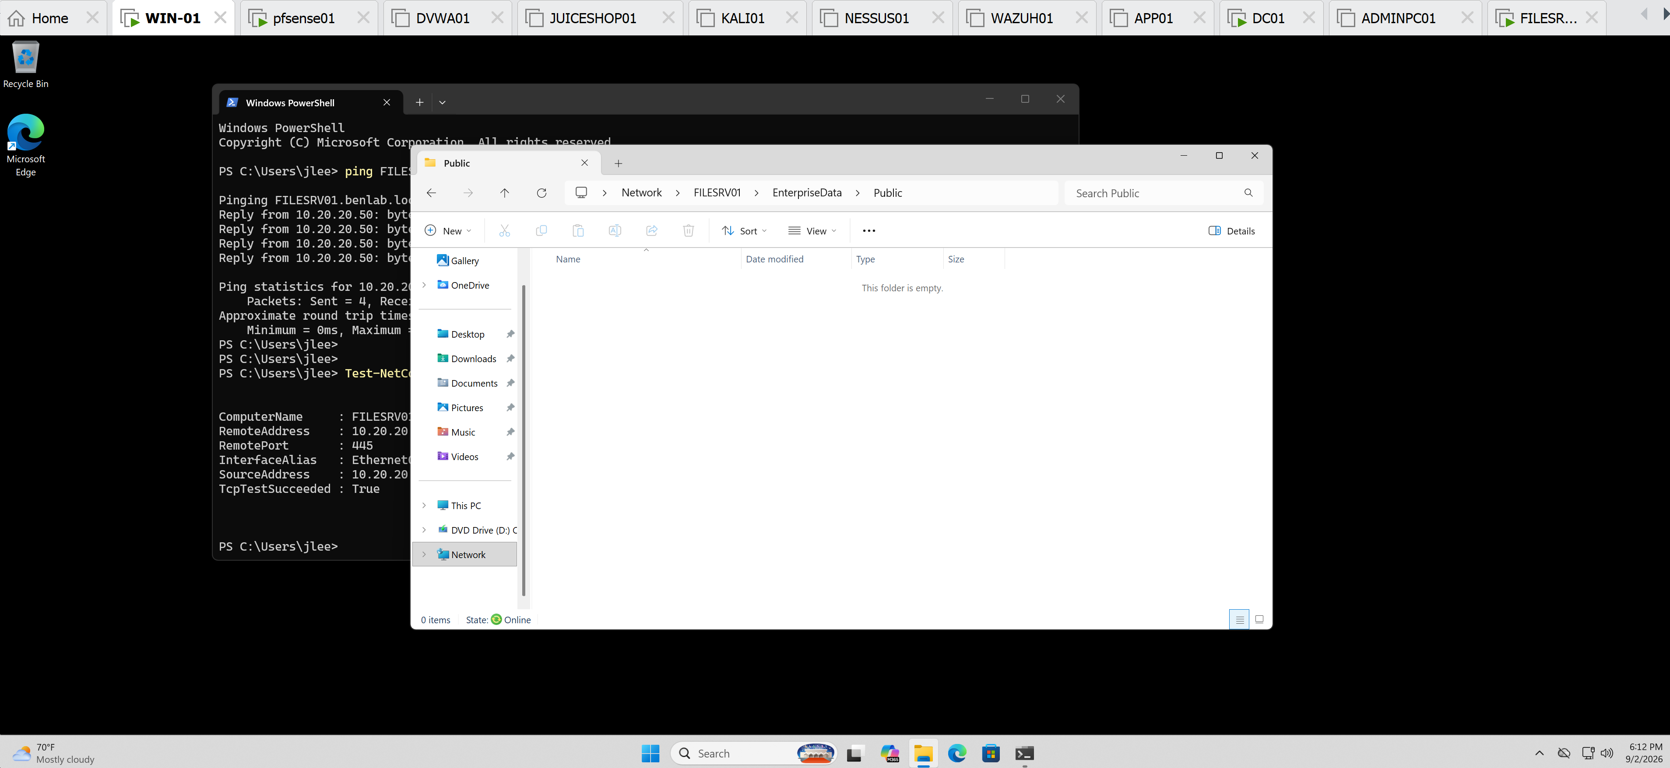

Final Validation
The completed configuration demonstrated the interaction between the two Windows file-access permission layers:
Share permissions
Control access when users connect to the resource across the network.
Domain Users → Change
NTFS permissions
Control what authenticated users can access within the underlying folder structure.
For example:
GG_Finance → Finance → Modify
Therefore, a Finance employee can reach the EnterpriseData share but cannot automatically access HR or IT data.
The effective access observed during testing matched the intended security design.

Key Learning Points
- SMB share permissions and NTFS permissions are separate authorization layers.
- Share permissions provide network-level access to a shared resource.
- NTFS permissions provide granular file and folder authorization.
- Active Directory security groups simplify departmental permission management.
- Users should normally receive access through security-group membership rather than individual user ACL entries.
- Get-SmbShare, Get-SmbShareAccess, and icacls provide useful administrative validation of file-server permissions.
- Test-NetConnection -Port 445 can verify SMB network connectivity before troubleshooting permissions.
- Successful network connectivity does not necessarily mean a user has authorization to a folder.
- Testing with a real standard domain user is important because administrative testing alone does not demonstrate the actual end-user permission experience.

Task Result
A centralized SMB share was successfully implemented on FILESRV01 with departmental NTFS authorization based on Active Directory security groups. Access was validated from WIN01 using a Finance domain user, including successful authorized access, successful file creation, and expected access-denied results for unauthorized departmental resources.

Screenshots / Evidence
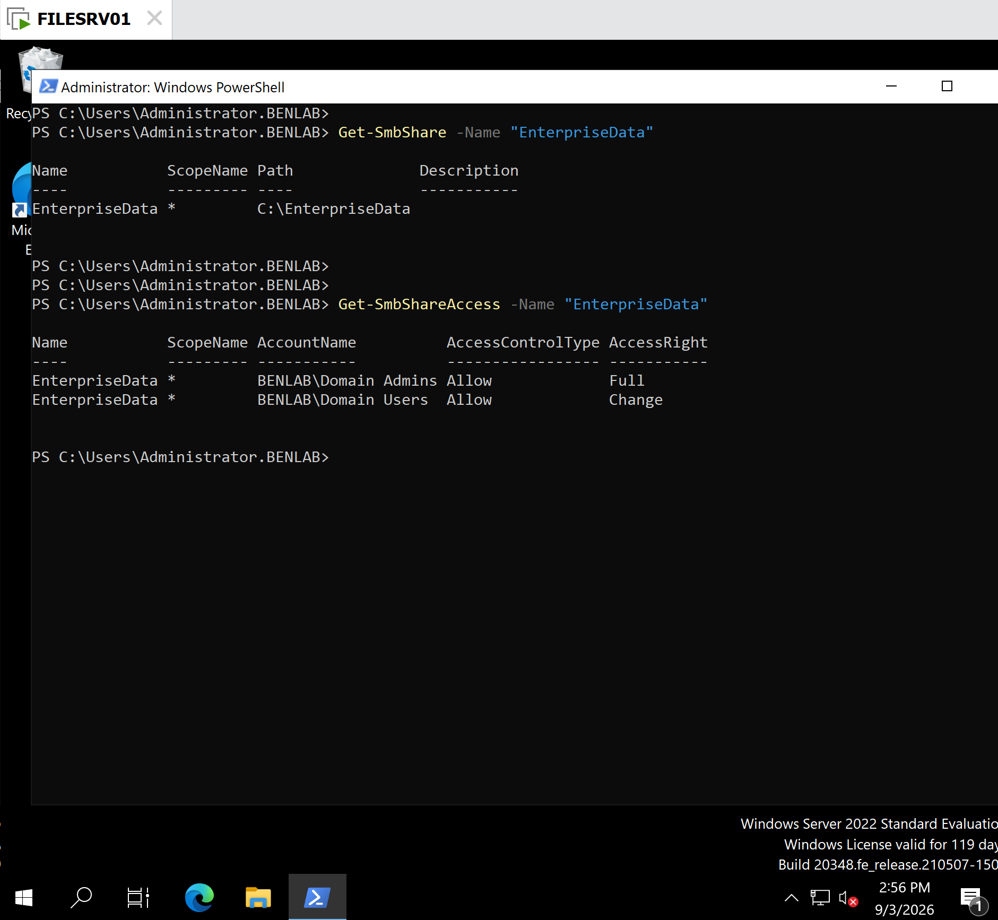
Get-SmbShare + Get-SmbShareAccess.

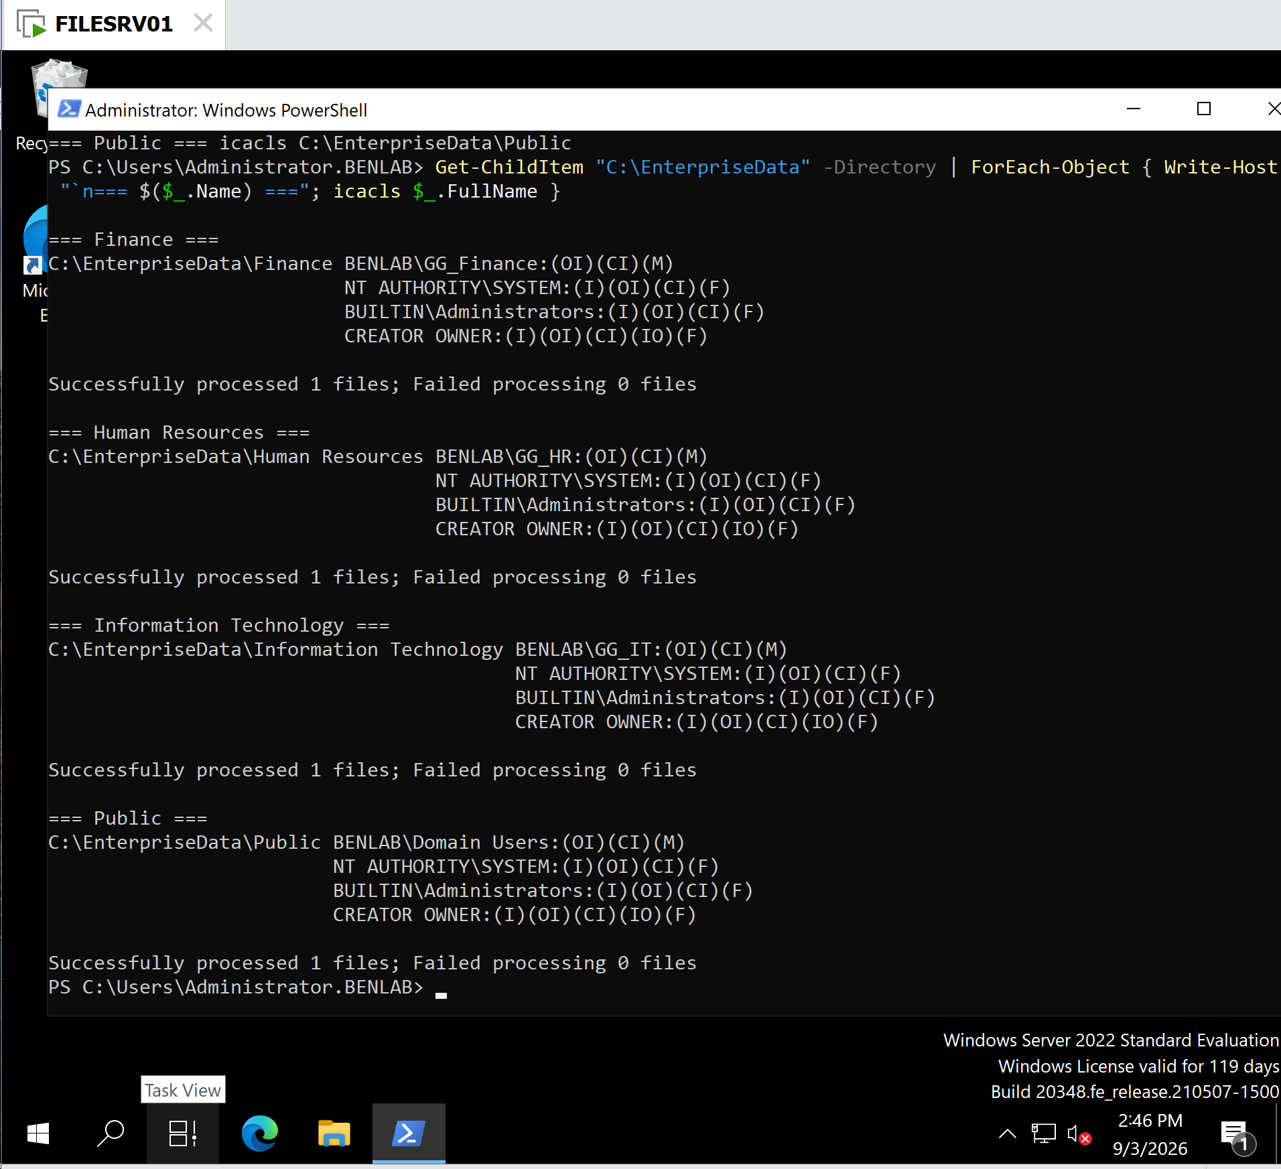
The combined icacls output showing Finance, HR, IT, and Public permissions.
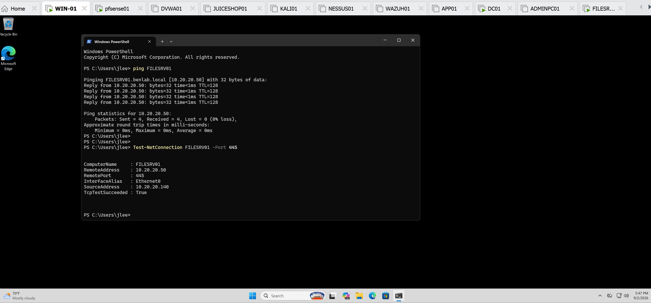
Test-NetConnection FILESRV01 -Port 445 showing TcpTestSucceeded : True.

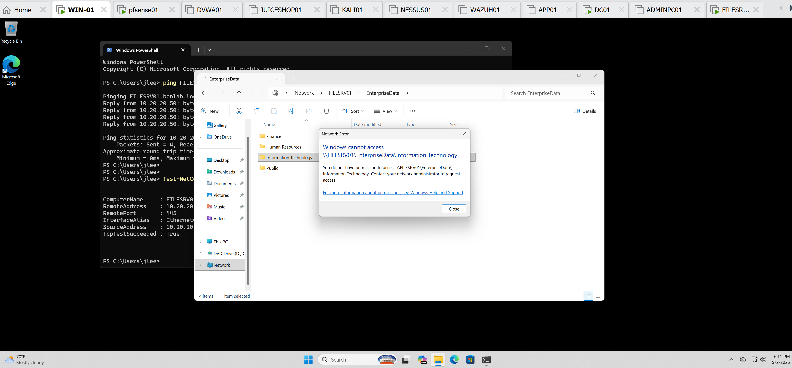
Jlee access denied onto Information Technology folder—Windows cannot access.

Task 2 – File Server Resource Manager (FSRM) and Storage Quota Management

Objective
Install and configure File Server Resource Manager (FSRM) on FILESRV01 to implement centralized storage quota management.
The task demonstrates how a Windows Server administrator can use quota templates to control departmental storage consumption, generate administrative warnings as storage approaches capacity, and enforce hard storage limits.
A custom 1 GB hard quota template was created and applied to the Finance departmental folder:
C:\EnterpriseData\Finance
The configuration was then validated through both the FSRM management console and PowerShell, followed by an enforcement test.

Environment
Server: FILESRV01
Domain: BENLAB.LOCAL
Operating System: Windows Server 2022
Role/Feature: File Server Resource Manager (FSRM)
Managed Folder: C:\EnterpriseData\Finance
Quota Limit: 1 GB
Quota Type: Hard Quota
Warning Threshold: 85%
Notification Method: Windows Event Log

Implementation Steps

Step 1 – Verify FSRM Installation Status
PowerShell was used to determine whether File Server Resource Manager was already installed:
Get-WindowsFeature FS-Resource-Manager
The initial result showed:
[ ] File Server Resource Manager
Install State: Available
This confirmed that FSRM was available on FILESRV01 but had not yet been installed.

Step 2 – Install File Server Resource Manager
FSRM and its management tools were installed using:
Install-WindowsFeature FS-Resource-Manager -IncludeManagementTools
The installation completed successfully with:
Success: True
Restart Needed: No
Exit Code: Success
The installation was then verified:
Get-WindowsFeature FS-Resource-Manager
The result showed:
[X] File Server Resource Manager
Install State: Installed
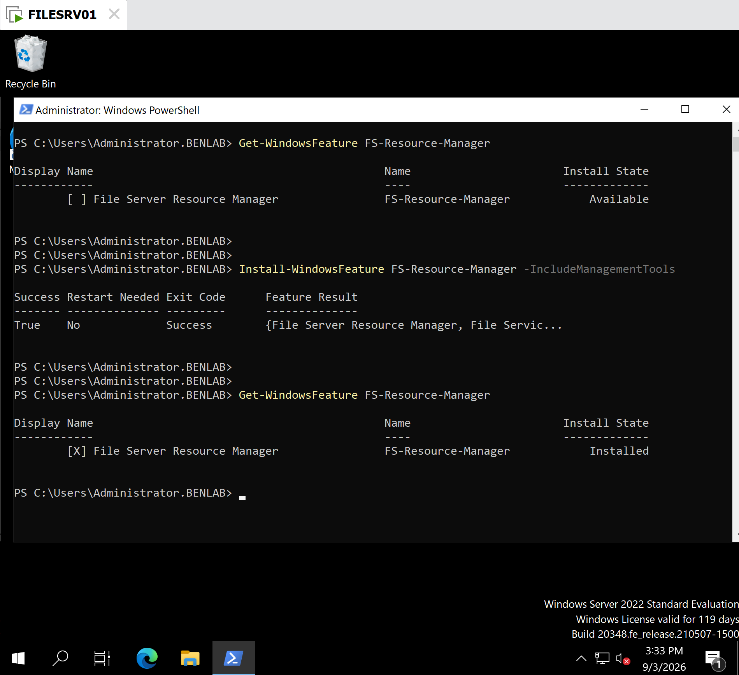
This confirmed that FSRM and its management interface were available for configuration.

Step 3 – Open and Review File Server Resource Manager
The File Server Resource Manager console was opened on FILESRV01.
The console provides several administrative capabilities, including:
Quota Management
File Screening Management
Storage Reports Management
Classification Management
File Management Tasks
For this task, Quota Management was used.

Step 4 – Create a Custom Departmental Quota Template
Under:
Quota Management
└── Quota Templates
a new custom quota template was created.
Template Name:
BENLAB Department 1 GB Hard Quota
Description:
Standard 1 GB storage quota for BENLAB departmental folders
Space Limit:
1 GB
Quota Type:
Hard quota: Do not allow users to exceed limit
A hard quota was intentionally selected because it provides actual enforcement rather than simply monitoring storage consumption.

Step 5 – Configure the Storage Warning Threshold
A notification threshold was configured at:
85%
The Event Log notification option was enabled.
This means that when storage consumption reaches 85% of the quota, FSRM can generate a warning in the Windows Event Log, providing administrators with an opportunity to investigate storage consumption before the hard limit is reached.
The completed template therefore provided:
1 GB Hard Limit
│
├── 85% → Event Log Warning
│
└── 100% → Additional writes exceeding quota blocked

Step 6 – Apply the Quota to the Finance Department
The custom template was applied to:
C:\EnterpriseData\Finance
The following option was selected:
Create quota on path
The quota properties were derived from:
BENLAB Department 1 GB Hard Quota
Before creation, FSRM displayed the configuration summary:
Quota: C:\EnterpriseData\Finance
Source template: BENLAB Department 1 GB Hard Quota
Limit: 1.00 GB (Hard)
Warning (85%): Event log
The quota was then created successfully.

PowerShell Validation
The resulting quota configuration was independently verified from PowerShell:
Get-FsrmQuota -Path "C:\EnterpriseData\Finance"
Important results included:
Disabled : False
MatchesTemplate : True
Path : C:\EnterpriseData\Finance
Size : 1073741824
SoftLimit : False
Template : BENLAB Department 1 GB Hard Quota
These values confirmed several important configuration details.
MatchesTemplate : True confirmed that the Finance quota remained associated with the custom FSRM template.
Size : 1073741824 represents exactly 1 GiB (1,073,741,824 bytes).
SoftLimit : False confirmed that this was an enforced hard quota, rather than a monitoring-only soft quota.

Quota Enforcement Test
To verify that the quota actually enforced the configured storage restriction, an oversized test file was attempted inside the Finance folder:
fsutil file createnew "C:\EnterpriseData\Finance\Quota-Test.bin" 1100000000
The requested test file was approximately 1.1 billion bytes, which exceeded the available space permitted by the 1 GB hard quota.
Windows returned:
Error: There is not enough space on the disk.
The operation was therefore rejected.
This demonstrated that the quota was not merely reporting storage usage—the hard quota was actively enforcing the configured storage limit.

Verify No Test File Remained
After the rejected operation, PowerShell was used to verify that the failed test had not left the intended file behind:
Test-Path "C:\EnterpriseData\Finance\Quota-Test.bin"
Result:
False
This confirmed that Quota-Test.bin did not exist after the failed creation attempt.

Validation / Results
Task 2 successfully demonstrated the complete FSRM quota-management lifecycle:
Install → Configure → Apply → Verify → Test → Validate
The final configuration was:
Configuration | Result
FSRM | Installed
Custom quota template | Created
Template | BENLAB Department 1 GB Hard Quota
Managed folder | C:\EnterpriseData\Finance
Storage limit | 1 GB
Quota type | Hard
Warning threshold | 85%
Warning action | Event Log
Template association | Verified
PowerShell validation | Successful
Oversized write | Blocked
Test-file cleanup check | File absent

Screenshots / Evidence
Shows Install-WindowsFeature succeeding and Get-WindowsFeature reporting FSRM as Installed.
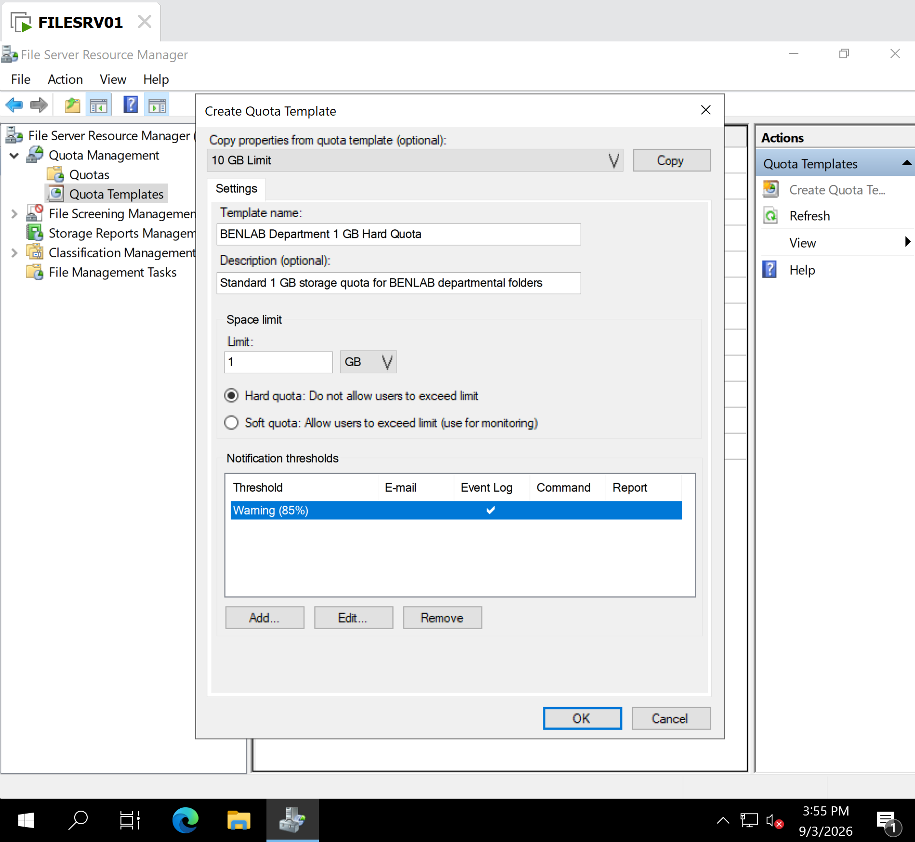
Shows BENLAB Department 1 GB Hard Quota, the 1 GB limit, Hard quota, and the configured 85% Event Log warning.

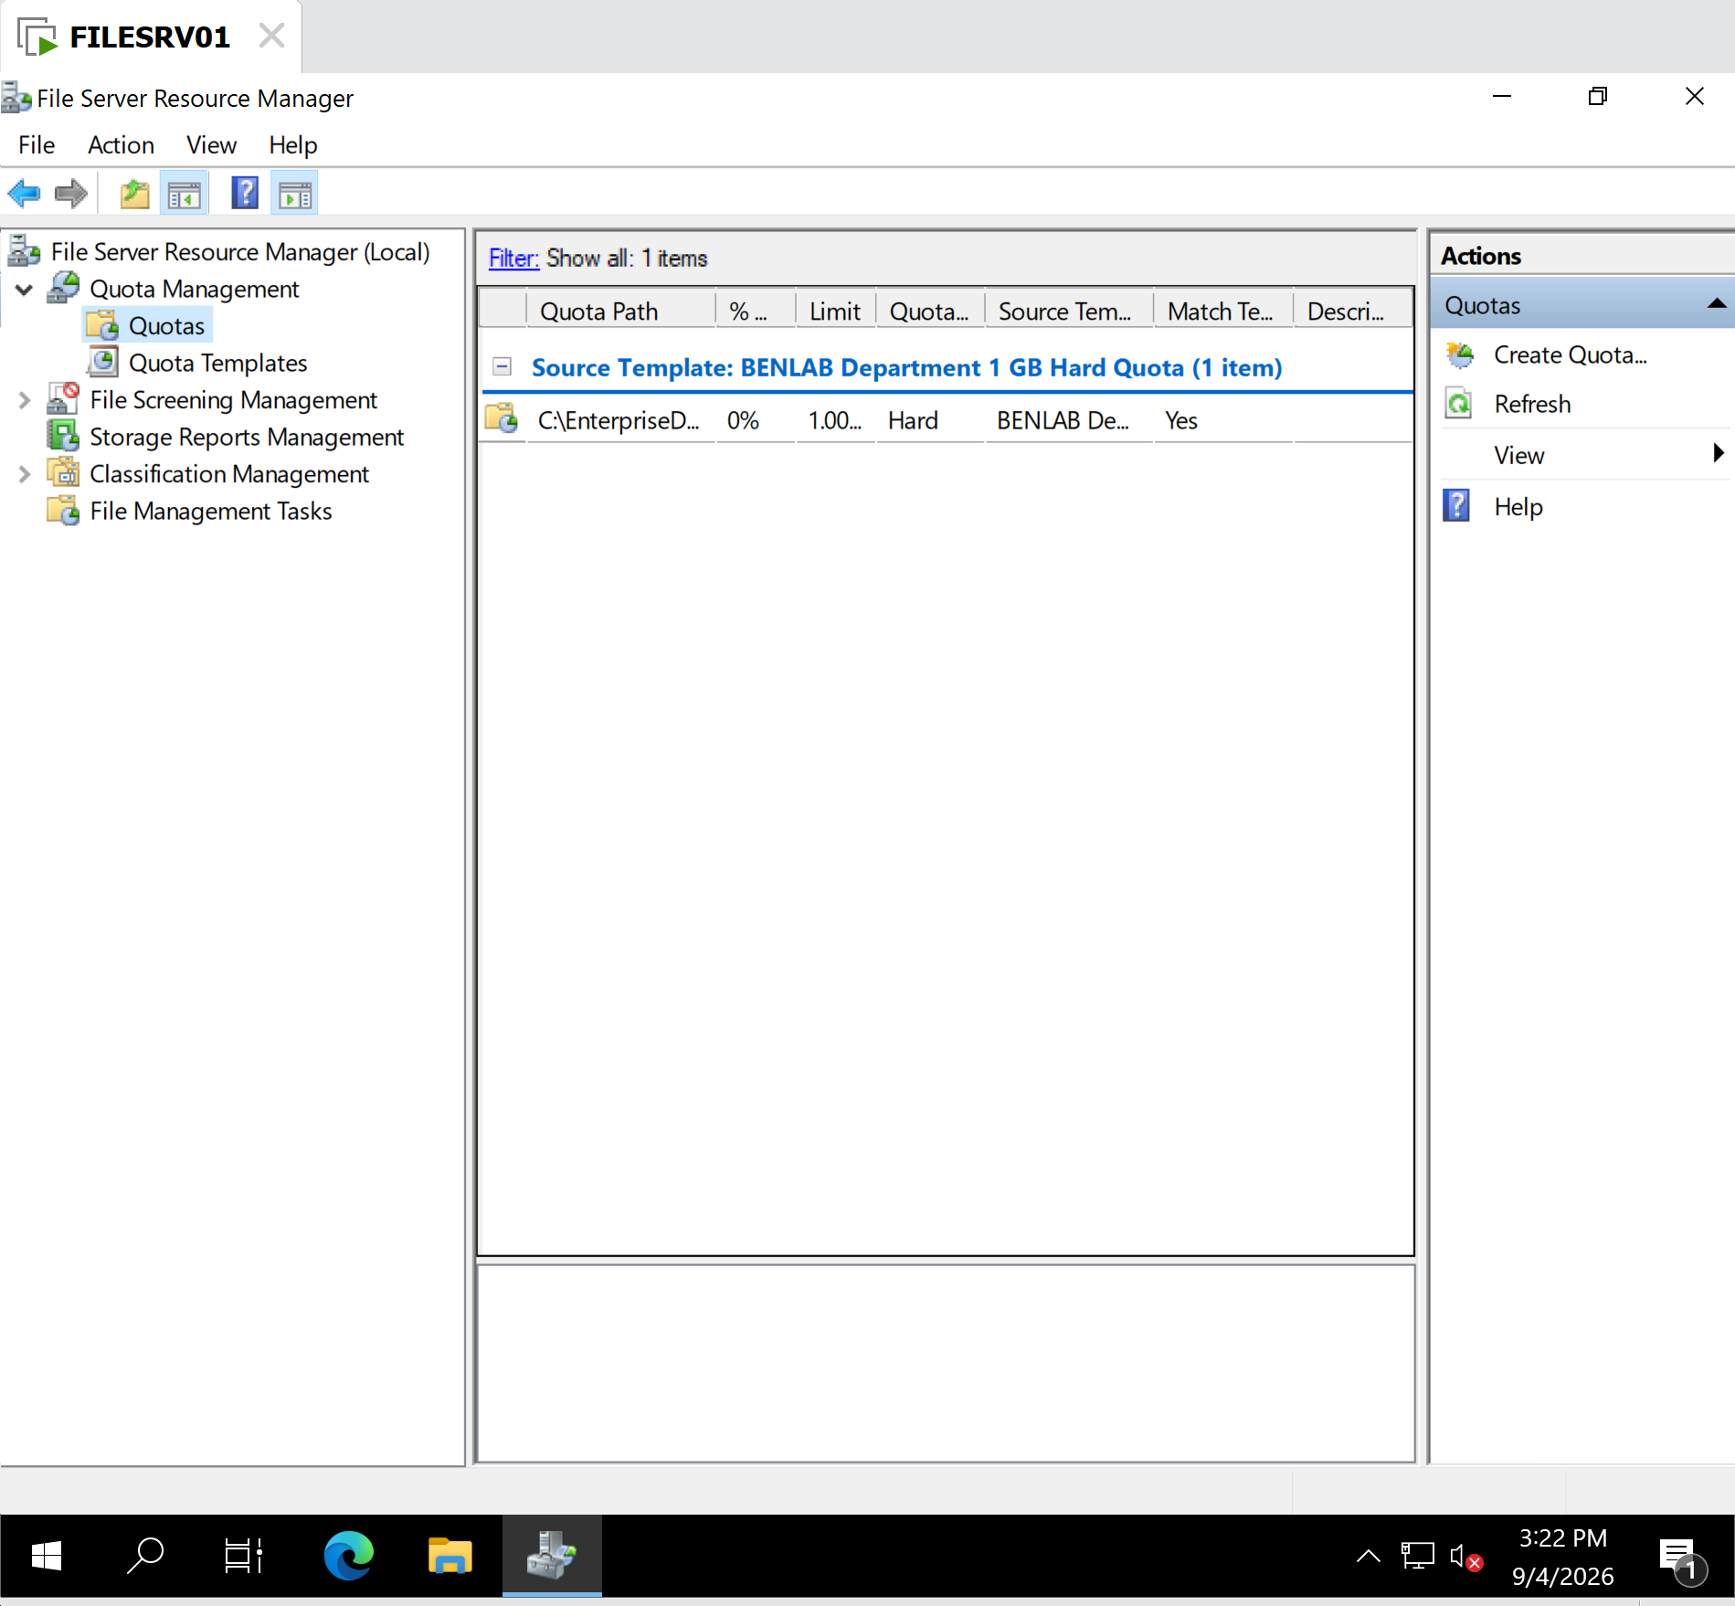
Shows the Finance quota listed under Quota Management → Quotas and associated with the BENLAB template.

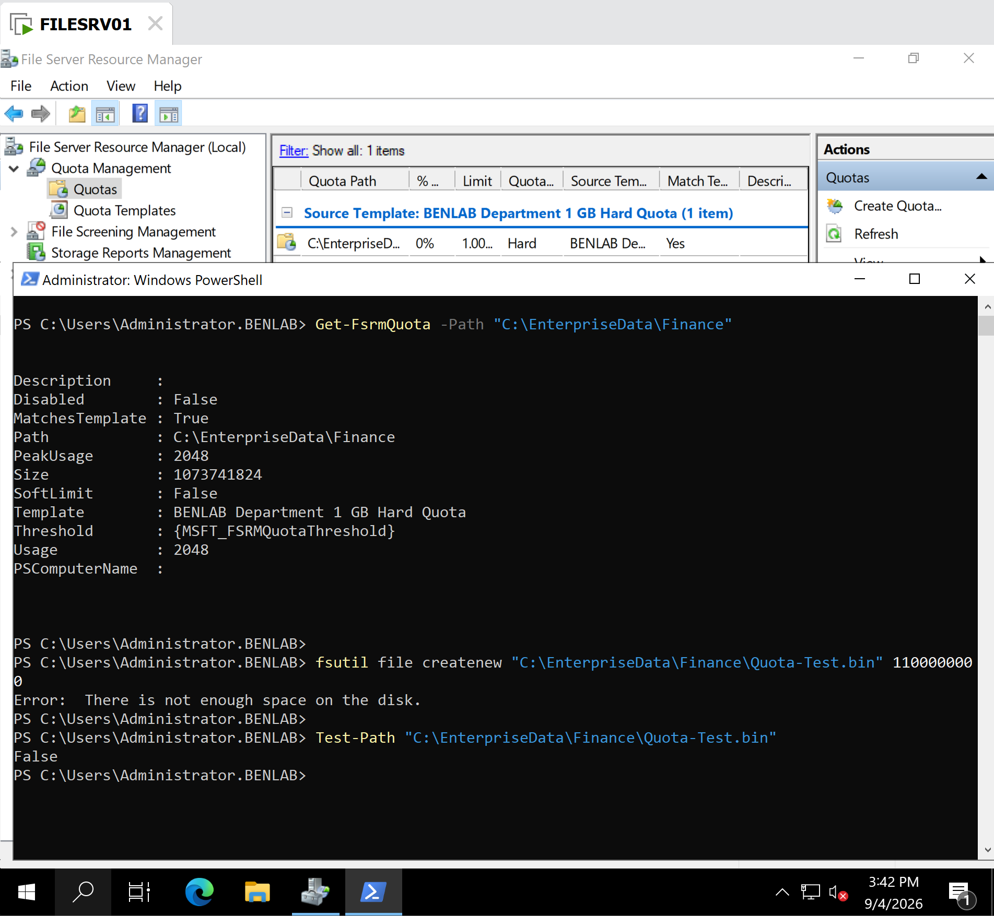
PowerShell Verification and Enforcement Test

Key Learning Points
- File Server Resource Manager (FSRM) provides centralized Windows Server storage-management capabilities beyond ordinary SMB sharing and NTFS permissions.
- A quota template allows administrators to standardize storage policies and reuse them across multiple folders.
- A hard quota actively prevents storage consumption beyond the configured limit.
- A soft quota monitors usage but does not prevent users from exceeding the configured threshold.
- Notification thresholds allow administrators to respond before storage reaches its maximum allocation.
- Windows Event Log integration provides an administrative monitoring mechanism without requiring an email infrastructure in the lab.
- Get-FsrmQuota provides a PowerShell method for independently verifying FSRM quota configuration.
- A configuration should not be considered fully validated merely because it appears correctly in the GUI. Testing the actual enforcement behavior provides stronger operational evidence.
- This task followed the administrative workflow:
Configure → Verify → Test → Validate

Task 3 – File Screening Management

Objective
Configure and validate File Server Resource Manager (FSRM) File Screening on FILESRV01 to prevent unauthorized executable files from being stored in a departmental data folder while continuing to permit normal business files.
The configuration demonstrates how Windows Server administrators can enforce file-type restrictions and audit policy violations on enterprise file servers.

Environment
Server: FILESRV01
Domain: BENLAB.LOCAL
Role/Feature: File Server Resource Manager (FSRM)
Protected folder:
C:\EnterpriseData\Finance
Screening mode: Active Screening
Blocked file group: Executable Files

Configuration

Step 1 – Review FSRM File Groups
Opened:
File Server Resource Manager → File Screening Management → File Groups
Reviewed the built-in file groups provided by FSRM, including:
- Executable Files
- Audio and Video Files
- Office Files
- Image Files
- Compressed Files
- System Files
- Text Files
The Executable Files group was selected for this task because executable content should not normally be stored in the Finance departmental data location.

Step 2 – Create a File Screen Template
Opened:
File Screening Management → File Screen Templates
Created a custom template named:
BENLAB Block Executable Files
Configured:
Screening Type:
Active Screening
Active Screening prevents users from saving files belonging to prohibited file groups rather than merely monitoring the activity.
Selected file group:
Executable Files

Step 3 – Configure Event Log Auditing
Under the template's Event Log configuration, enabled:
Send warning to event log
This allows FSRM to generate an administrative event whenever a user attempts to store a prohibited executable file.
The event can record information such as the user, attempted file path, protected location, server, and violated file group.

Step 4 – Apply the File Screen
Created a File Screen on:
C:\EnterpriseData\Finance
Applied the custom template:
BENLAB Block Executable Files
The resulting configuration showed:
Screening Type: Active
File Group: Executable Files
Template: BENLAB Block Executable Files
This established an actively enforced file-type policy on the Finance folder.

Validation

Test 1 – Verify an Allowed File Type
Created a normal text file:
"FSRM normal file test" | Out-File "C:\EnterpriseData\Finance\Allowed-Test.txt"
Verified its existence:
Test-Path "C:\EnterpriseData\Finance\Allowed-Test.txt"
Result:
True
Result: PASS ✅
The .txt file was successfully created, confirming that the file screen does not indiscriminately block all writes to the Finance folder.

Test 2 – Attempt to Store a Prohibited Executable
Attempted to copy Windows Notepad into the protected Finance folder:
Copy-Item "C:\Windows\System32\notepad.exe" "C:\EnterpriseData\Finance\Notepad-Test.exe"
PowerShell returned:
Copy-Item : Access to the path
'C:\EnterpriseData\Finance\Notepad-Test.exe' is denied.
Result: PASS ✅
The executable was prevented from being written to the folder, demonstrating successful enforcement of the Active File Screen.

Test 3 – Verify the FSRM Audit Event
Opened:
Event Viewer → Windows Logs → Application
Located the FSRM warning generated at the time of the blocked operation.
The event showed:
Source: SRMSVC
Event ID: 8215
Level: Warning
Computer: FILESRV01.benlab.local
The event reported that:
BENLAB\Administrator
attempted to save:
C:\EnterpriseData\Finance\Notepad-Test.exe
and identified the prohibited category as:
Executable Files
Result: PASS ✅
This confirmed that FSRM not only prevented the prohibited file operation but also recorded the policy violation for administrative review.

Final Validation
Task 3 successfully demonstrated the complete FSRM File Screening workflow:
Configure policy → Apply policy → Test allowed file → Test prohibited file → Verify enforcement → Review audit event
The Finance folder continued accepting permitted files while executable files were actively rejected and the attempted violation was recorded in the Windows Application event log.

Key Learning Points
Active vs. Passive Screening: Active Screening actually prevents prohibited files from being saved. Passive Screening allows the files but monitors and reports the activity.
File Groups: FSRM uses file groups to categorize files by filename patterns/extensions, allowing administrators to centrally control categories such as executables, multimedia files, compressed files, and others.
NTFS permissions vs. FSRM: NTFS permissions determine who can access and modify a folder, while FSRM File Screening can determine what types of files may be stored there. A user may therefore have NTFS write permission but still be prevented from storing a prohibited file type.
Auditing: FSRM can record policy violations in Event Viewer. In this lab, the blocked executable attempt generated SRMSVC Event ID 8215, providing evidence of the attempted operation.
Enterprise relevance: File Screening helps administrators enforce storage policies, reduce inappropriate file storage, and provide visibility into violations on centralized file servers.

Screenshots / Evidence

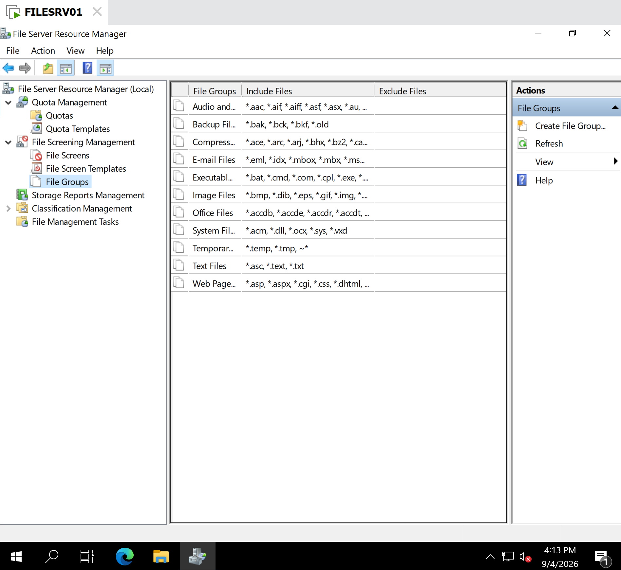
File Groups showing the built-in groups, especially Executable Files.

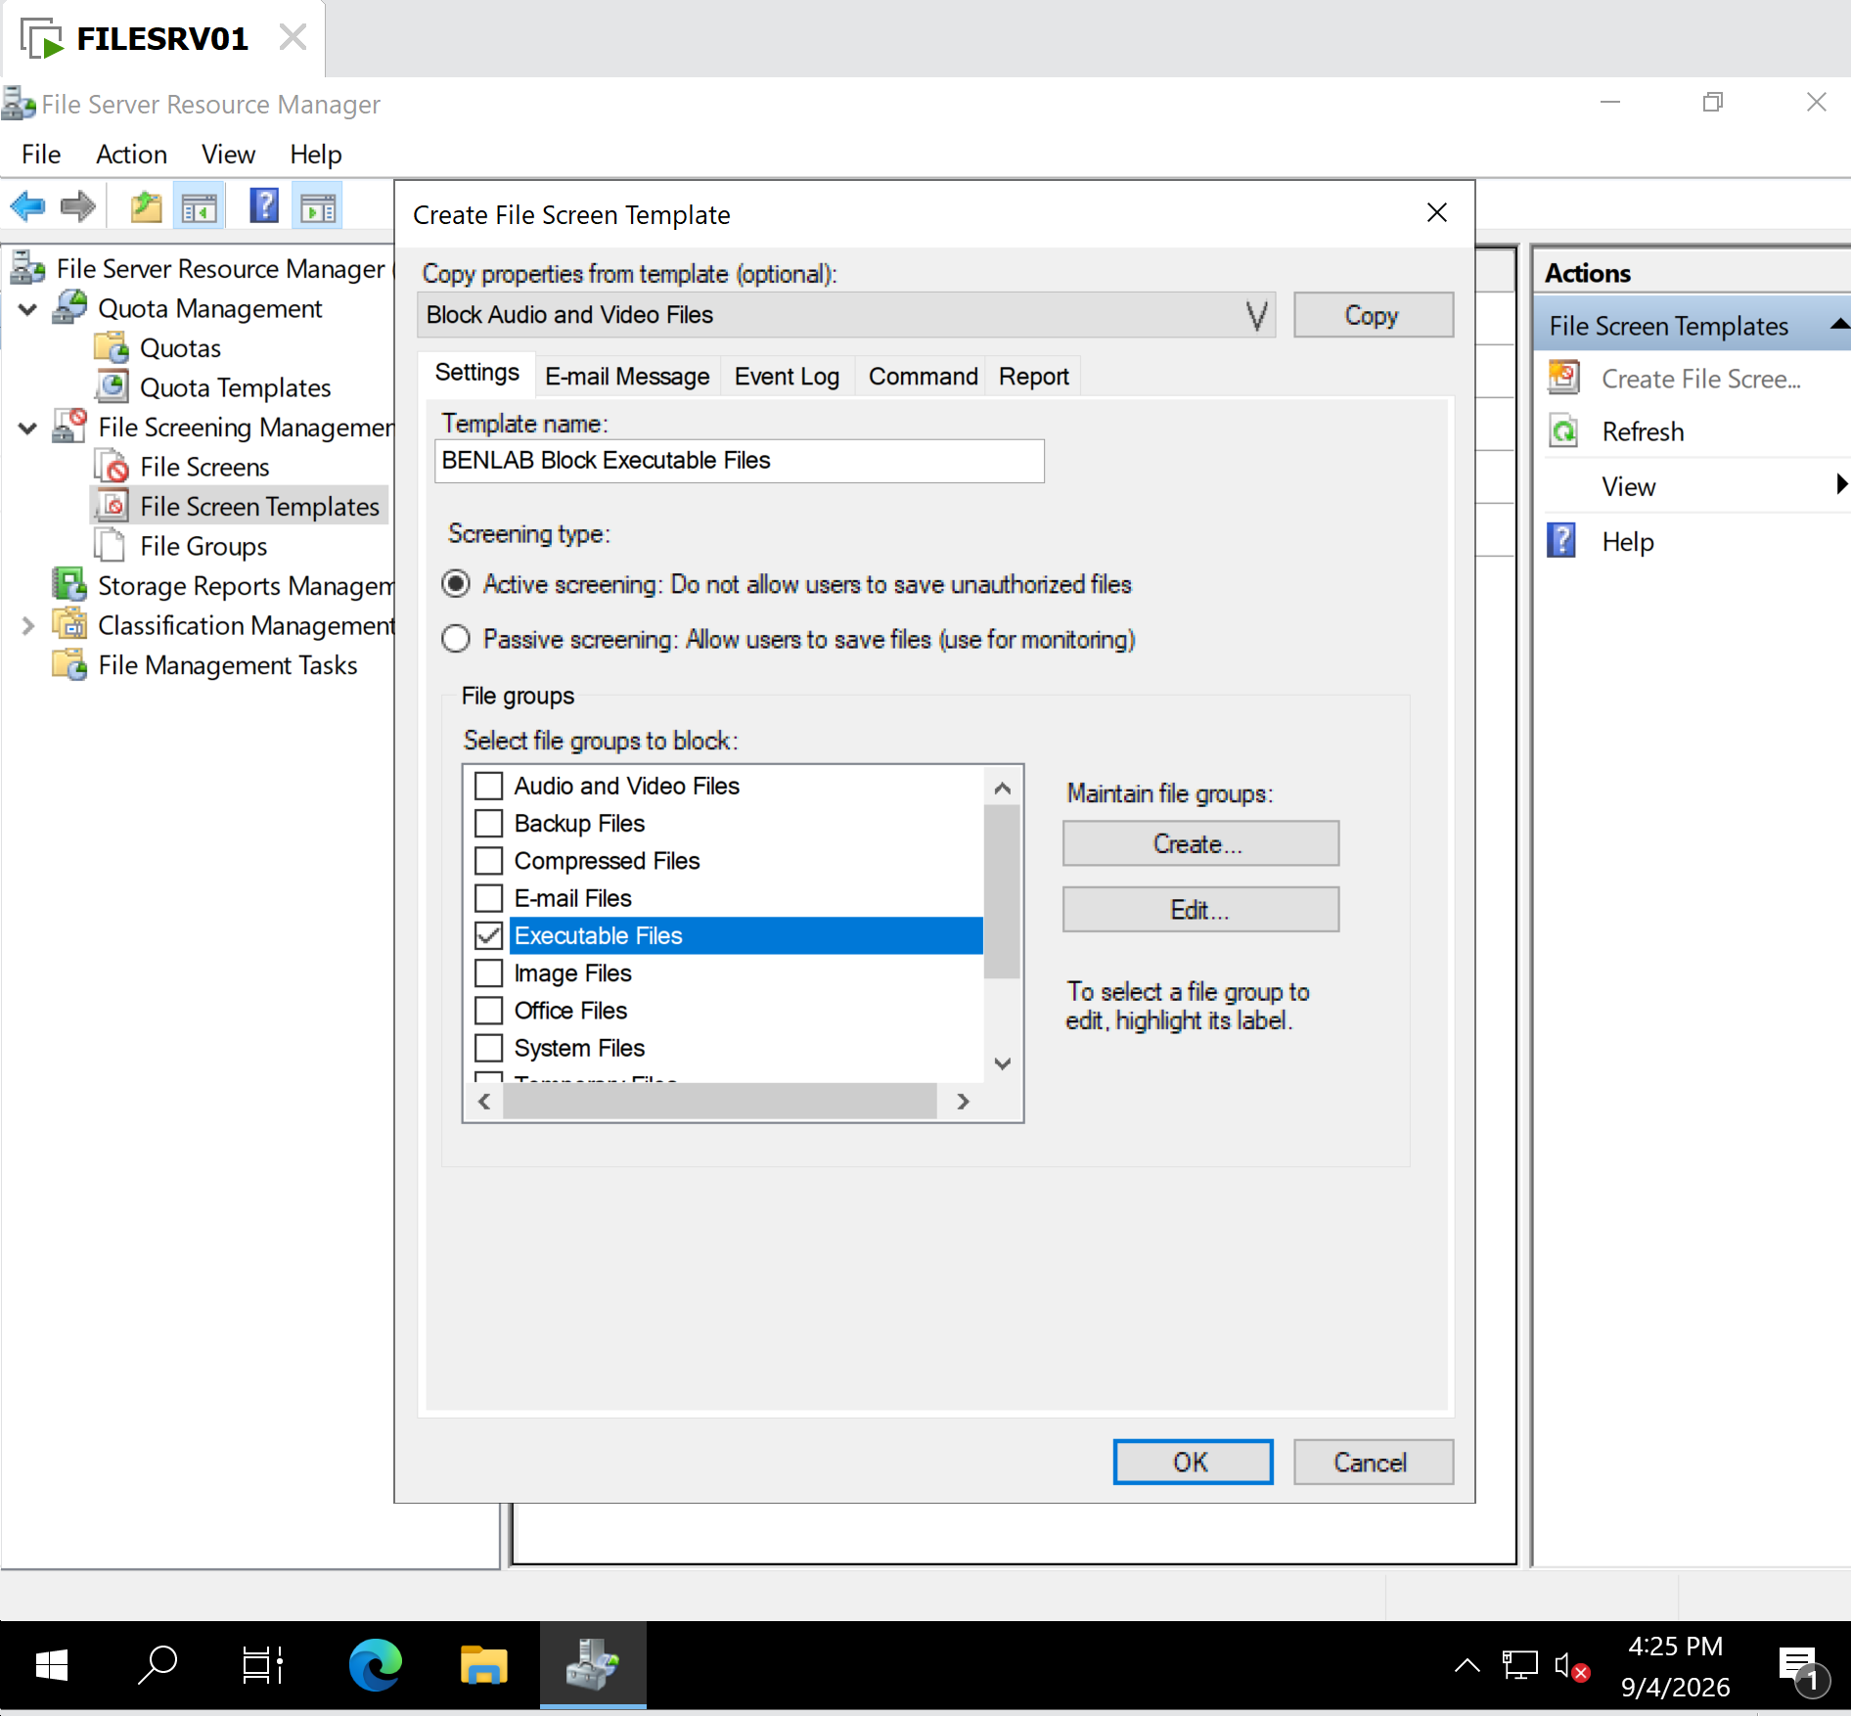
BENLAB Block Executable Files template showing Active Screening + Executable Files.

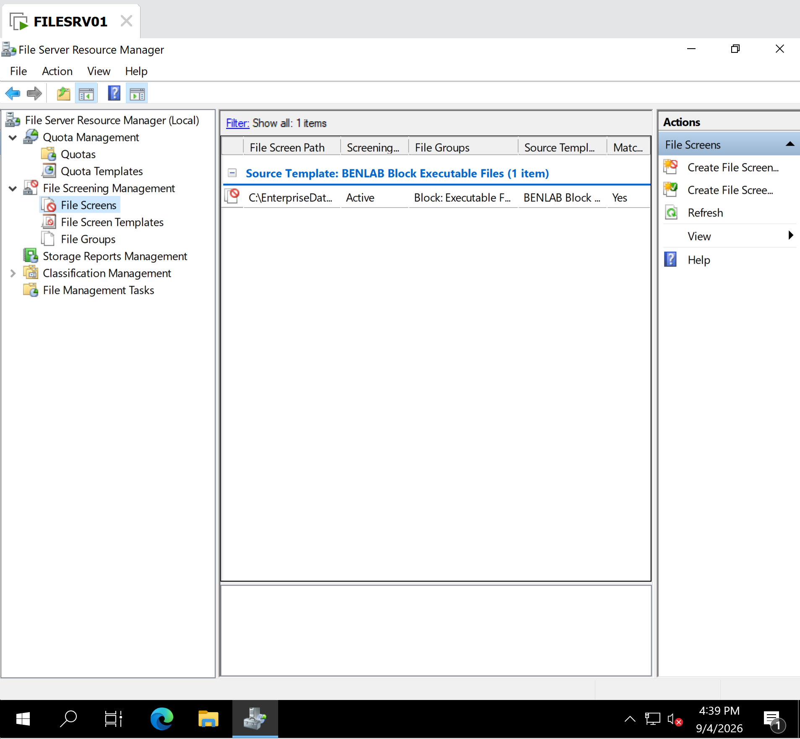
File Screen on C:\EnterpriseData\Finance showing the BENLAB template applied.

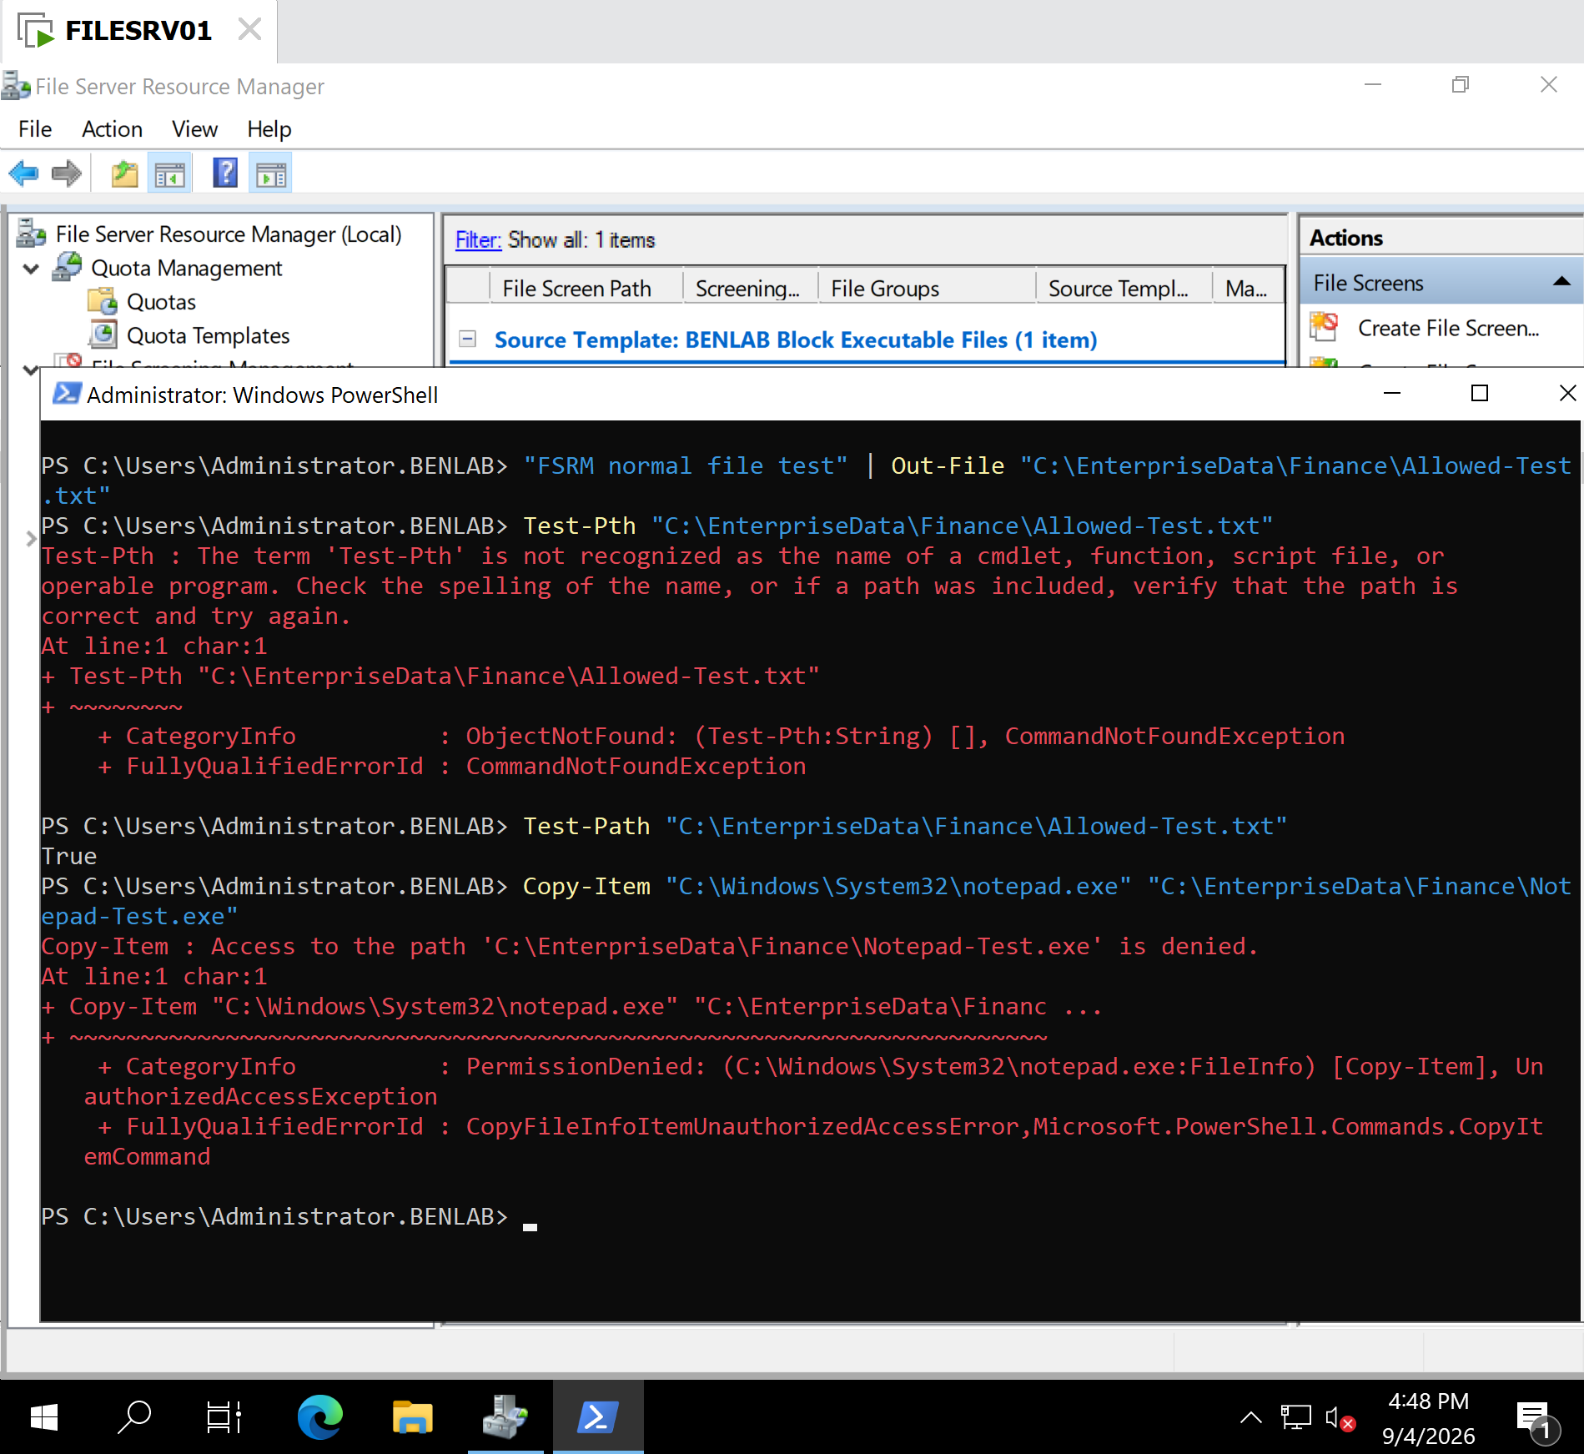
PowerShell validation showing Allowed-Test.txt = True and the attempted .exe returning Access denied.

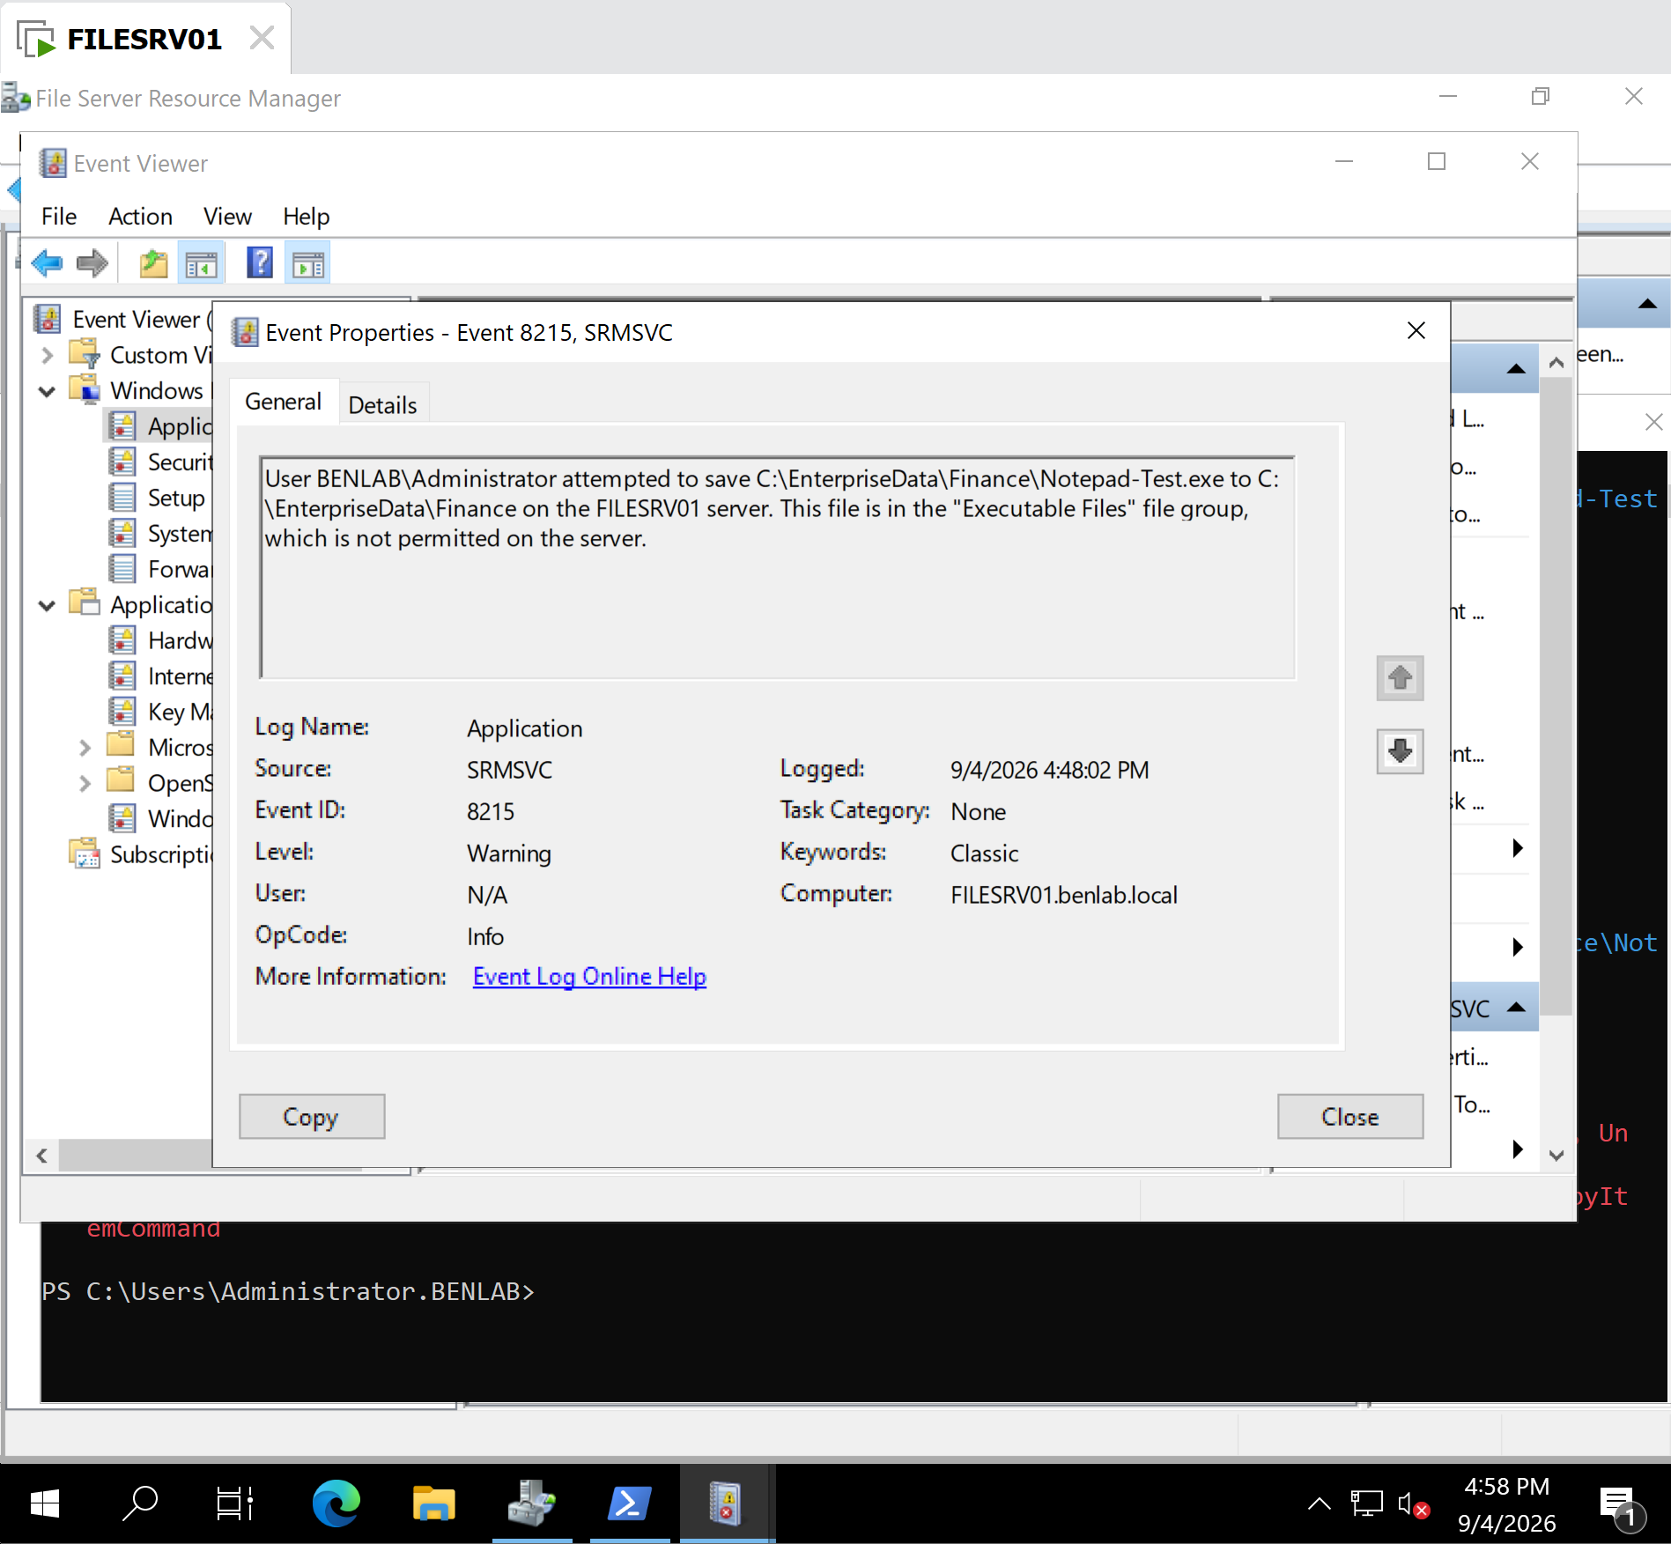
Event Properties – Event 8215, SRMSVC

Task 4 – Storage Reports Management

Objective
Configure and generate File Server Resource Manager (FSRM) Storage Reports on FILESRV01 to analyze data stored within the enterprise file structure.
The task demonstrates how Windows Server administrators can use FSRM reporting to identify file types, file ownership, storage consumption, and potentially large files for storage auditing and capacity management.

Environment
Server: FILESRV01
Domain: BENLAB.LOCAL
Role: File Server
Management Tool: File Server Resource Manager (FSRM)
Report Scope: C:\EnterpriseData

Configuration and Steps

Step 1 – Open Storage Reports Management
On FILESRV01, opened:
File Server Resource Manager → Storage Reports Management
Selected Generate Reports Now to create an interactive storage report.

Step 2 – Select Storage Reports
Configured the report to analyze the enterprise data structure.
Selected reports included:
- Large Files
- Files by File Group
The reports were generated in DHTML/HTML format for interactive viewing.

Step 3 – Configure Report Scope
Under the Scope tab, added:
C:\EnterpriseData
This allowed FSRM to analyze the enterprise department folders contained beneath this directory, including Finance, Human Resources, Information Technology, and Public.

Step 4 – Configure Report Delivery
Reviewed the Delivery configuration.
E-mail delivery was not required for this lab. FSRM was allowed to save the interactive reports locally under:
C:\StorageReports\Interactive
This demonstrated how reports can be retained locally for administrative review without requiring an SMTP configuration.

Validation

Test 1 – Large Files Report
Generated the Large Files Report against:
C:\EnterpriseData
The report was configured with a minimum file size of:
5.00 MB

Result
FSRM reported:
0 files meeting the report criteria
This was an expected and valid result because the current lab files within C:\EnterpriseData were smaller than 5 MB.
The result demonstrated that FSRM successfully scanned the specified directory and evaluated its contents against the configured file-size threshold.

Test 2 – Files by File Group Report
Generated the Files by File Group Report against the same enterprise data directory.
FSRM successfully detected:
File Groups: 1
Files: 3
Detected File Group: Text Files
The report further analyzed the files by ownership and location.

File Ownership Results
BENLAB\jlee owned 2 files (66.67%).
BUILTIN\Administrators owned 1 file (33.33%).

Detailed File Analysis
FSRM identified the following test files:
Allowed-Test.txt
Location: C:\EnterpriseData\Finance
Owner: BUILTIN\Administrators
JLee-Finance-Permission-Test.txt.txt
Location: C:\EnterpriseData\Finance
Owner: BENLAB\jlee
JLee-Public-Permission-Test.txt.txt
Location: C:\EnterpriseData\Public
Owner: BENLAB\jlee
All three files were correctly classified within the Text Files file group.
Because the files were very small, their reported storage consumption rounded to 0.00 MB.

Results
FSRM Storage Reports successfully:
- Scanned C:\EnterpriseData.
- Evaluated files against a 5 MB large-file threshold.
- Classified existing files according to file group.
- Identified file ownership.
- Identified the folders containing the files.
- Generated interactive HTML reports for administrator review.
- Stored generated reports under C:\StorageReports\Interactive.
The testing confirmed that FSRM can provide visibility into enterprise file-server storage without modifying or deleting user data.

Key Learning Points
Storage reporting is different from file screening. File screening controls what users are permitted to store, while storage reports provide administrators with visibility into what is already stored.
A report containing zero results can still represent a successful scan. The Large Files Report returned zero files because none of the current files met the configured 5 MB threshold.
FSRM can analyze ownership as well as storage consumption. The Files by File Group Report showed that two files belonged to the domain user BENLAB\jlee, while another belonged to the local Administrators group.
File groups have uses beyond blocking files. The same FSRM classification concepts used during File Screening Management can also help administrators analyze and report on existing data.
Storage reports support proactive administration. In a production environment, administrators can use these reports for capacity planning, storage audits, cleanup decisions, policy development, and identification of unusual storage patterns.

Screenshots / Evidence
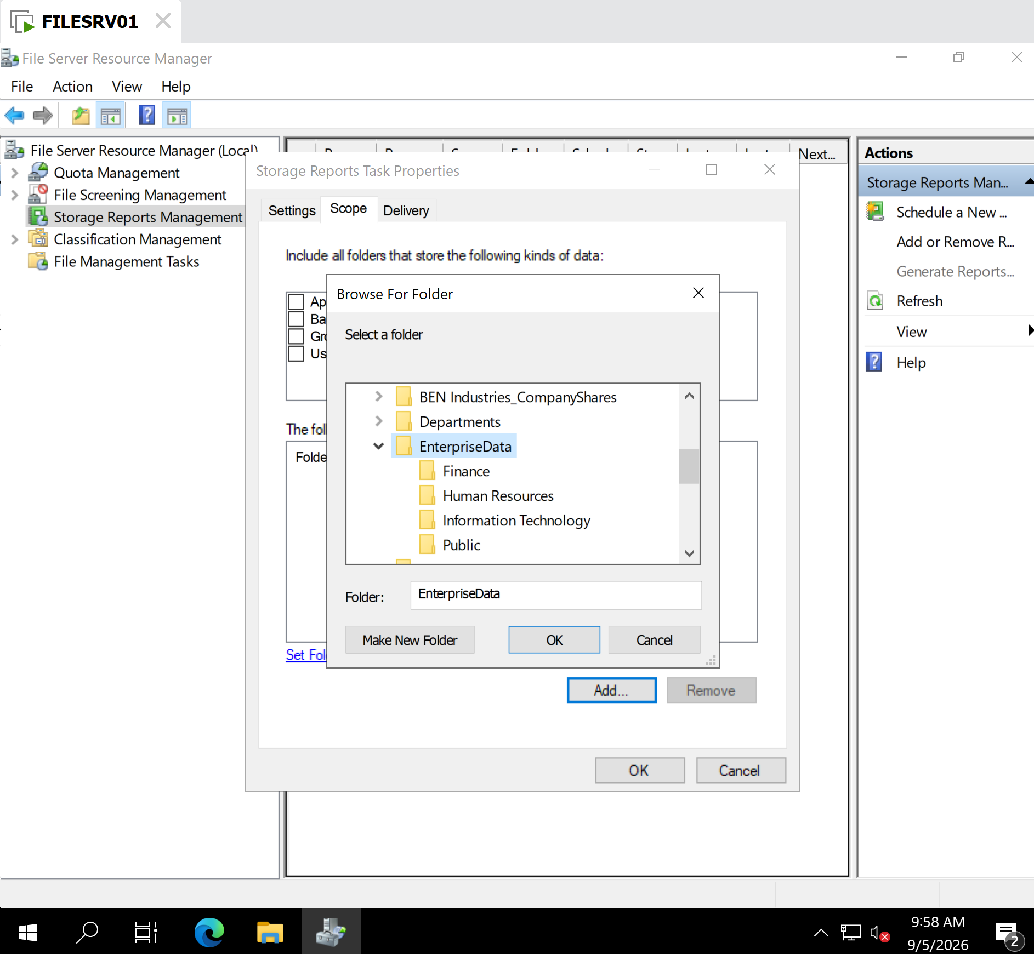
FSRM Storage Reports Management configured to generate storage-analysis reports.
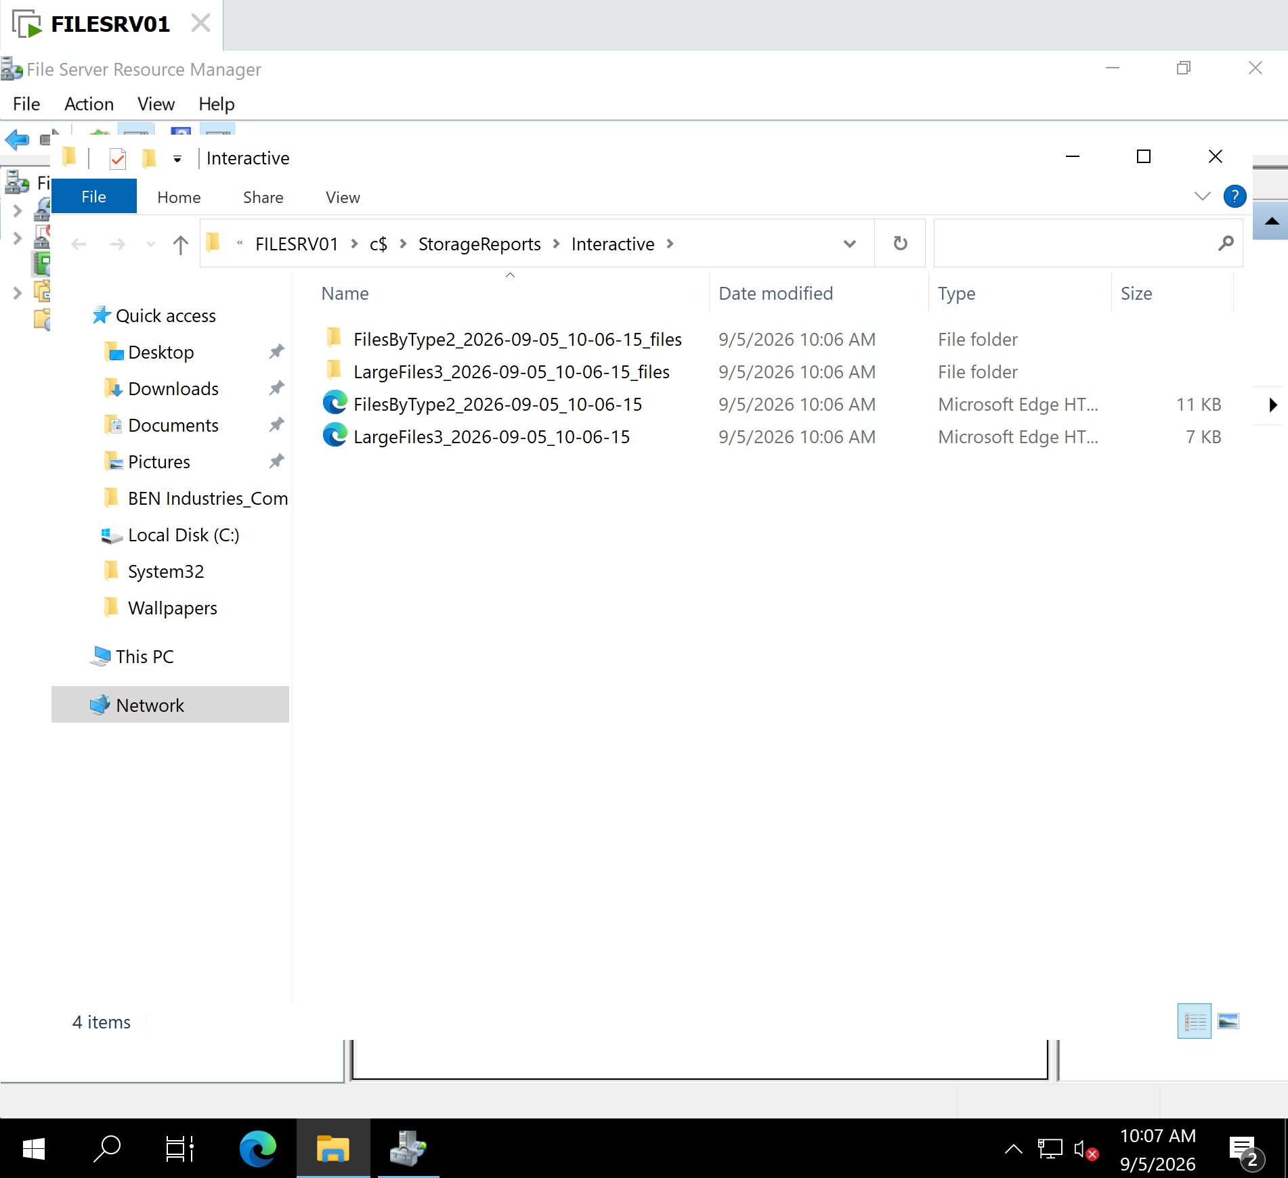
C:\EnterpriseData configured as the target directory for the storage report.

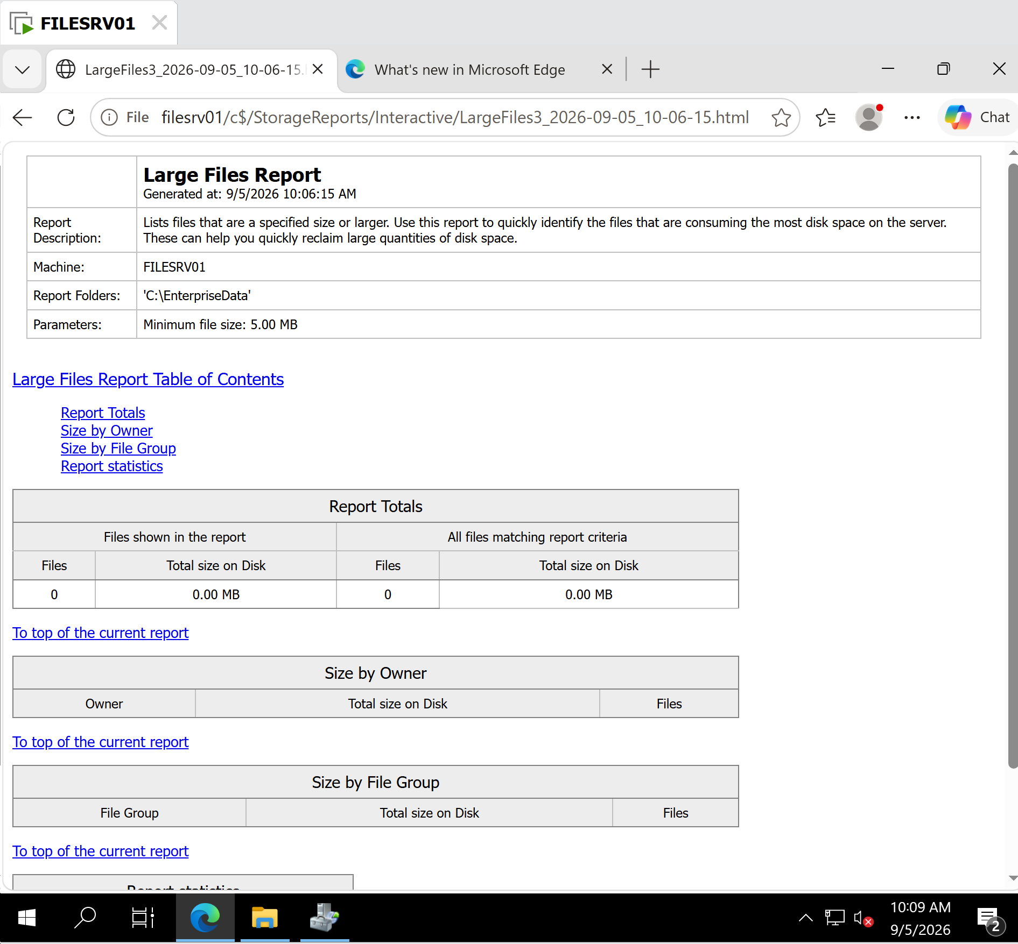
Large Files Report showing a 5.00 MB minimum file size and 0 files matching the criteria.

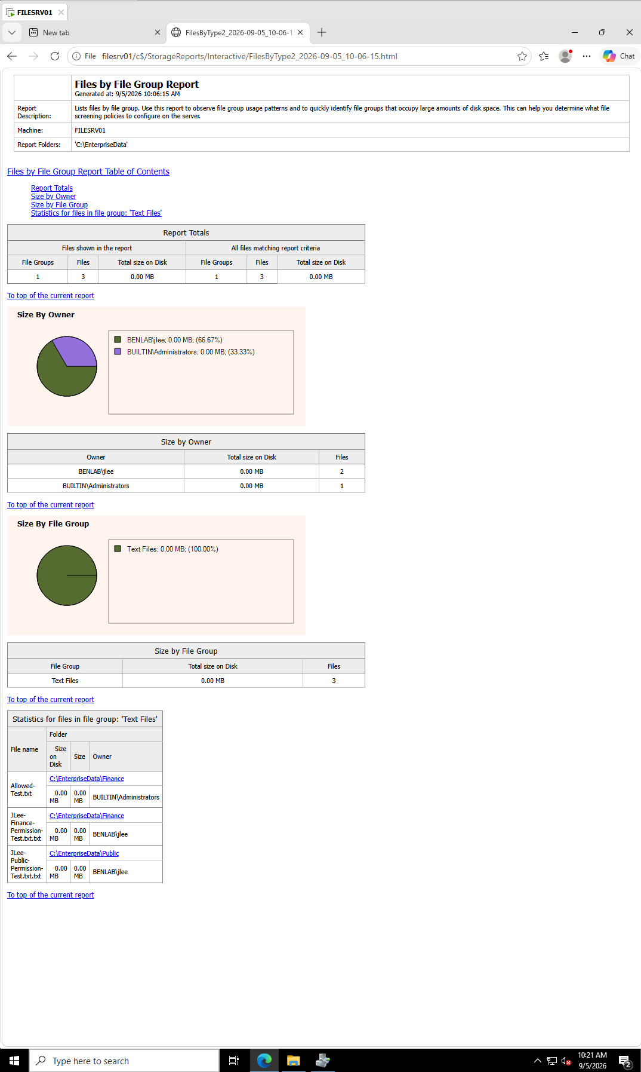

Report showing:
- C:\EnterpriseData as the report scope
- 3 detected files
- Text Files classification
- BENLAB\jlee ownership of two files
- BUILTIN\Administrators ownership of one file
- Individual filenames and folder locations

Task 5 – Configure and Validate FSRM File Management Tasks

Objective
Configure a File Server Resource Manager (FSRM) File Management Task on FILESRV01 to identify files that have not been modified for more than 30 days and automatically move qualifying files to a designated expiration directory. Validate the configuration using a controlled test file.

Configuration
Server: FILESRV01
File Management Task: BENLAB Stale File Management
Scope:
C:\EnterpriseData\FileManagementTest
Condition:
Days since file was last modified: 30
This condition identifies files whose last modification time exceeds the 30-day threshold.
Action:
File expiration
Expiration directory:
C:\EnterpriseData\ExpiredFiles
The task was configured with a weekly schedule and enabled for automatic execution.

Validation Procedure
A controlled test file was created in the File Management Task scope:
New-Item "C:\EnterpriseData\FileManagementTest\StaleFile-Test.text.txt" -ItemType File
Because a newly created file would not meet the 30-day condition, its LastWriteTime was modified to simulate a stale file:
(Get-Item "C:\EnterpriseData\FileManagementTest\StaleFile-Test.text.txt").LastWriteTime = (Get-Date).AddDays(-31)
The timestamp was then verified:
Get-Item "C:\EnterpriseData\FileManagementTest\StaleFile-Test.text.txt" |
Select-Object Name, LastWriteTime
Observed result:
StaleFile-Test.text.txt 8/6/2026 9:34:06 AM
This confirmed that the test file exceeded the configured 30-day stale-file threshold.

Manual Task Execution
Rather than waiting for the scheduled execution, the File Management Task was manually initiated through:
File Server Resource Manager
→ File Management Tasks
→ BENLAB Stale File Management
→ Run File Management Task Now
The option Wait for the task to complete was selected to observe the test execution directly.

FSRM Report Validation
After execution, FSRM generated a File Management Task Report.
The report confirmed:
- Task: BENLAB Stale File Management
- Machine: FILESRV01
- Action type: Expiration
- Scope: C:\EnterpriseData\FileManagementTest
- Files matching report criteria: 1
- Matching file: StaleFile-Test.text.txt
- Last modified: 8/6/2026 9:34:06 AM
- No file-processing error was reported.
This demonstrated that FSRM correctly evaluated the configured condition and identified the intentionally aged test file.

Expiration Verification
PowerShell was used to verify the contents of the expiration directory:
Get-ChildItem "C:\EnterpriseData\ExpiredFiles" -Recurse
The expired file was located under:
C:\EnterpriseData\ExpiredFiles
└── FILESRV01
└── 2026-09-06_09-44-06
└── C$
└── EnterpriseData
└── FileManagementTest
└── StaleFile-Test.text.txt
This confirmed that FSRM successfully moved the qualifying file from its original location into the configured expiration directory while preserving information about its original path.

Result
Task 5 completed successfully.
FSRM was configured and validated to automatically manage stale data based on file age. A controlled file was artificially aged beyond the 30-day threshold, detected by the File Management Task, processed through the configured expiration action, and successfully located in the expiration directory.
The validation demonstrated an end-to-end file lifecycle workflow:
Identify → Evaluate condition → Expire → Relocate → Verify

Key Learning Points
- File Management Tasks automate file lifecycle operations based on defined conditions.
- File age can be evaluated using attributes such as last modified time.
- File expiration does not necessarily mean immediate deletion; the configured action can relocate stale files to a controlled location.
- FSRM creates reports that provide evidence of which files matched the configured criteria.
- PowerShell provides an effective method for creating controlled test conditions and independently verifying FSRM results.
- Preserving the original directory hierarchy in the expiration location helps administrators determine where expired files originated.
- Production file-management policies should be tested against controlled data before being applied broadly to business shares.

Screenshots / Evidence

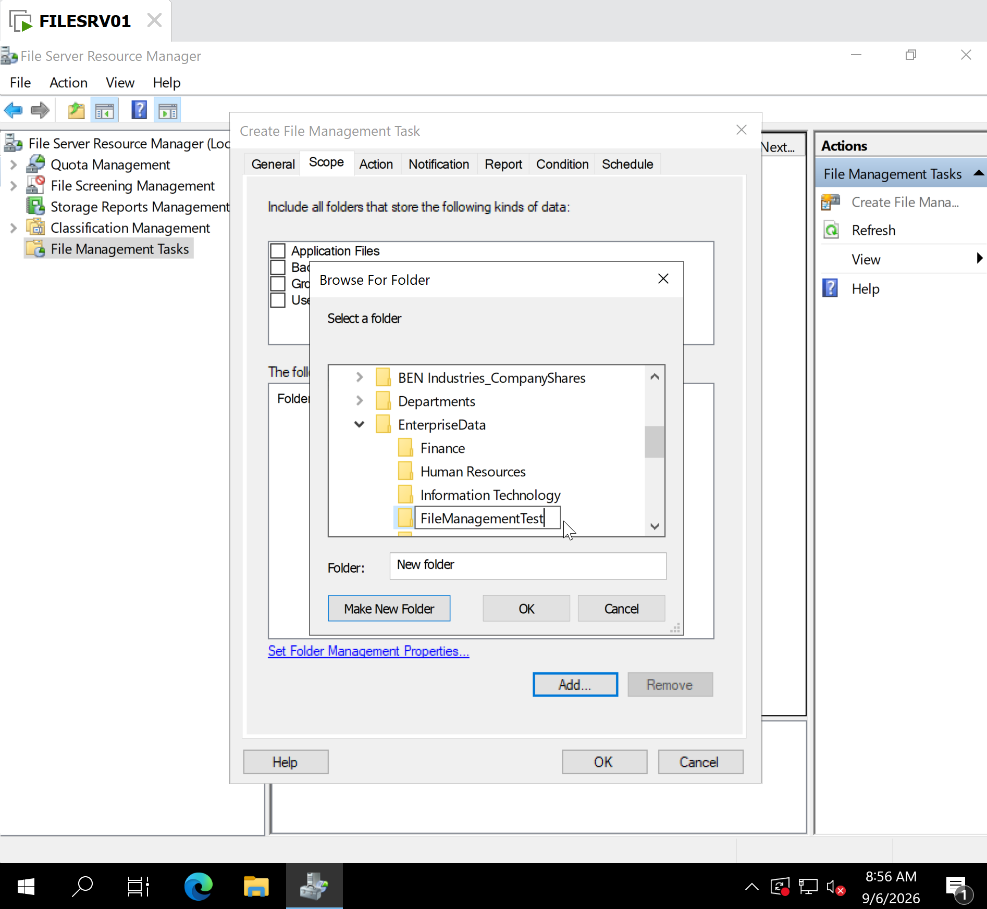
FSRM File Management Task configuration showing the scope/action.

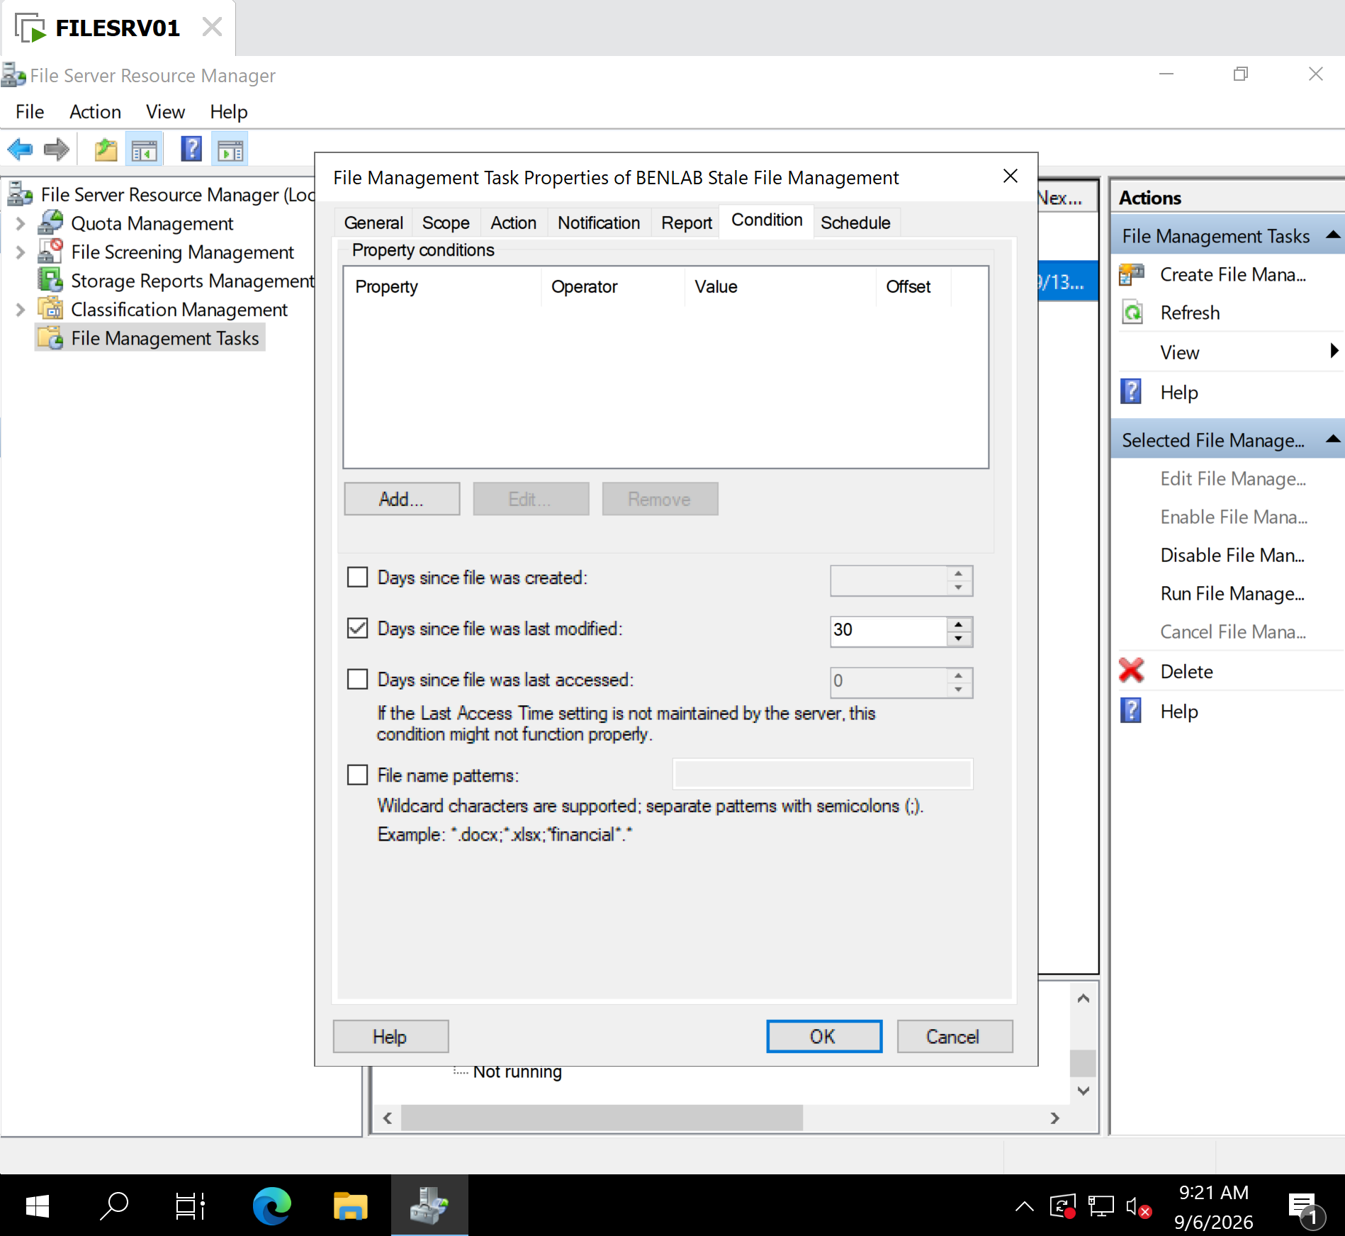
Condition tab showing Days since file was last modified: 30.

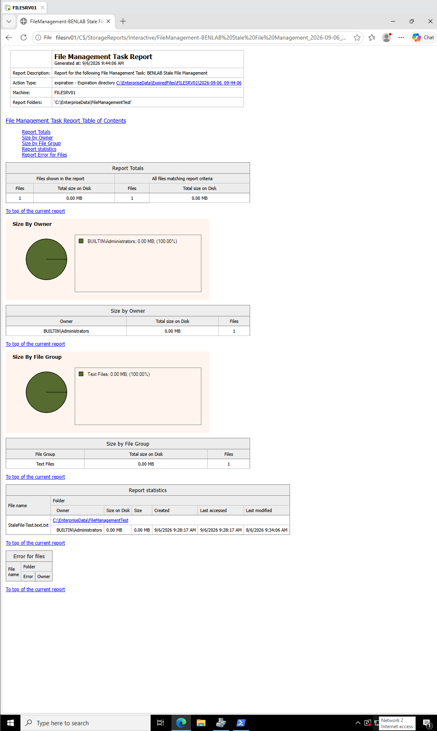

FSRM File Management Task Report showing the one matching file.

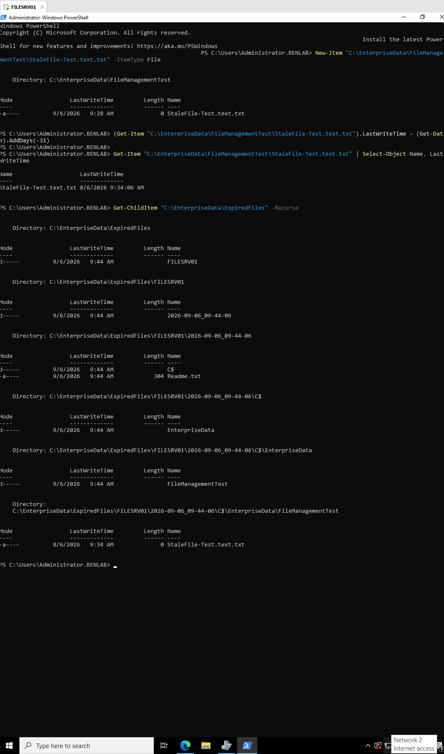
Final PowerShell verification showing StaleFile-Test.text.txt underneath\EnterpriseData\ExpiredFiles.

Task 6 – Configure and Validate Shadow Copies

Objective
Configure Volume Shadow Copy Service (VSS) on FILESRV01 to provide point-in-time recovery of files stored on the server.
The task also validates a realistic recovery scenario in which a file is accidentally overwritten and an administrator restores an earlier version without restoring the entire server from backup.

Environment
Server: FILESRV01
Domain: BENLAB.LOCAL
Operating System: Windows Server 2022
Volume: C:\
Test folder:
C:\EnterpriseData\FileManagementTest
Recovery test file:
ShadowCopy-Recovery-Test.txt

Step 1 – Verify the Server Volume
PowerShell was used to inspect the available volumes:
Get-Volume
The command confirmed that the C: volume uses NTFS, is healthy, and had sufficient free disk space for Shadow Copy storage.
Key learning point: Shadow Copies operate at the volume level. Enabling Shadow Copies on C: therefore protects eligible data stored on that volume rather than enabling the feature separately on each individual folder.

Step 2 – Configure Shadow Copy Storage
From the properties of the C: drive:
Properties → Shadow Copies → C: → Settings
Shadow Copy storage was configured on the C: volume with a storage limit of approximately:
8127 MB
This prevents VSS snapshots from consuming unlimited disk space.
Key learning point: Shadow Copies require disk space to maintain historical block changes. When the allocated storage becomes full, Windows can remove older shadow copies to make room for newer ones.

Step 3 – Configure the Shadow Copy Schedule
Two scheduled Shadow Copy creation times were configured:
7:00 AM – Monday through Friday
12:00 PM – Monday through Friday
This provides multiple recovery points during a normal business day.
For example:
7:00 AM Snapshot
↓
User modifies files
↓
12:00 PM Snapshot
↓
User modifies files
If a file is accidentally changed during the morning, the administrator may be able to recover the version captured by the 7:00 AM snapshot.
Important: Shadow Copies do not continuously save every change. Recovery is based on the versions available at the configured snapshot points.

Step 4 – Enable Shadow Copies
Shadow Copies were enabled for the C: volume.
The Shadow Copies interface subsequently displayed:
- Shadow Copies enabled
- Scheduled next run
- Storage consumption on C:
- Existing shadow-copy recovery points
This confirmed that VSS was operational.

Step 5 – Create a Manual Recovery Point
A manual Shadow Copy was created using:
Create Now
The interface displayed a new recovery point, providing a controlled snapshot for the recovery test.
A second recovery point was later visible as well, confirming that multiple point-in-time versions could be maintained.

Step 6 – Create the Recovery Test File
The following file was created inside the test directory:
C:\EnterpriseData\FileManagementTest\ShadowCopy-Recovery-Test.txt
The original contents were:
BENLAB Finance Report - ORIGINAL VERSION
A Shadow Copy was captured while this original version existed.

Step 7 – Simulate an Accidental File Overwrite
To reproduce a realistic end-user mistake, the contents of the file were changed to:
BENLAB Finance Report - ACCIDENTALLY OVERWRITTEN
The modified file was saved.
This simulated a situation in which an employee unintentionally replaces valid business information.

Step 8 – Locate the Previous Version
The file properties were opened:
Right-click file → Properties → Previous Versions
Windows displayed a previous version from the Shadow Copy.
The administrator selected the historical version and used Open first to inspect it.
The historical copy contained:
BENLAB Finance Report - ORIGINAL VERSION
This confirmed that the desired data existed inside the Shadow Copy before performing a restore.
Key learning point: When possible, inspecting a previous version before restoring it is safer than immediately replacing the production copy.

Step 9 – Restore the Previous Version
After verifying the historical copy, Restore was selected.
Windows displayed a warning explaining that restoring the previous version would replace the current version and that the operation could not simply be undone.
The restoration was then confirmed.

Step 10 – Verify Successful Recovery
The live file was reopened after restoration.
Its contents were successfully returned to:
BENLAB Finance Report - ORIGINAL VERSION
The file size also returned from approximately 48 bytes for the overwritten version to approximately 40 bytes after restoration.
This provided direct evidence that the historical version replaced the accidentally modified version.

Validation Results
Test | Result
NTFS volume verified | ✅ Passed
Shadow Copy storage configured | ✅ Passed
Shadow Copies enabled | ✅ Passed
7:00 AM schedule configured | ✅ Passed
12:00 PM schedule configured | ✅ Passed
Manual recovery point created | ✅ Passed
Original test file captured | ✅ Passed
Accidental overwrite simulated | ✅ Passed
Previous version located | ✅ Passed
Historical contents inspected | ✅ Passed
Previous version restored | ✅ Passed
Original contents recovered | ✅ Passed

Key Learning Points
Shadow Copies are point-in-time recovery, not traditional backups. They are extremely useful for quickly recovering files that users accidentally delete, overwrite, or modify, but they should complement—not replace—a proper backup strategy.
The administrator can use Previous Versions to recover individual files without restoring an entire server or volume.
The lab also demonstrated why snapshot frequency matters. With recovery points at 7:00 AM and 12:00 PM, the available recovery version depends on when the last Shadow Copy was created relative to the user's mistake.
Most importantly, this task demonstrated the complete administrative workflow:
Configure → Schedule → Capture → Simulate Failure → Locate Previous Version → Inspect → Restore → Verify

Screenshots /Evidence
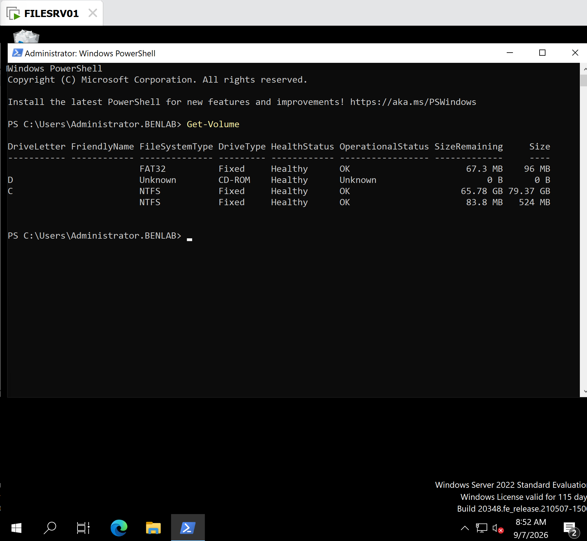
Evidence: Get-Volume output showing the C: volume as NTFS, healthy, and with sufficient free space.
Purpose: Confirms the storage volume being protected by Shadow Copies and validates available capacity before configuration.

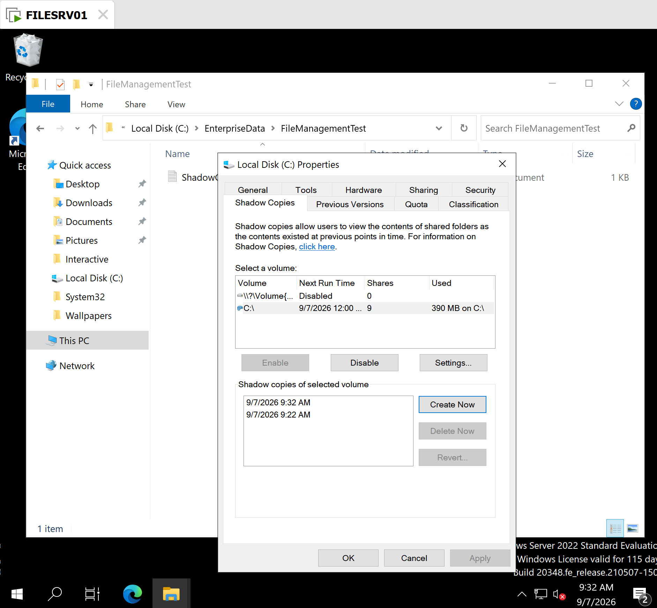
Evidence: Shadow Copies tab showing:
- Shadow Copies enabled
- 9/7/2026 9:22 AM
- 9/7/2026 9:32 AM
- VSS storage usage on C:
Purpose: Confirms that VSS is operational and that point-in-time recovery snapshots were successfully created.

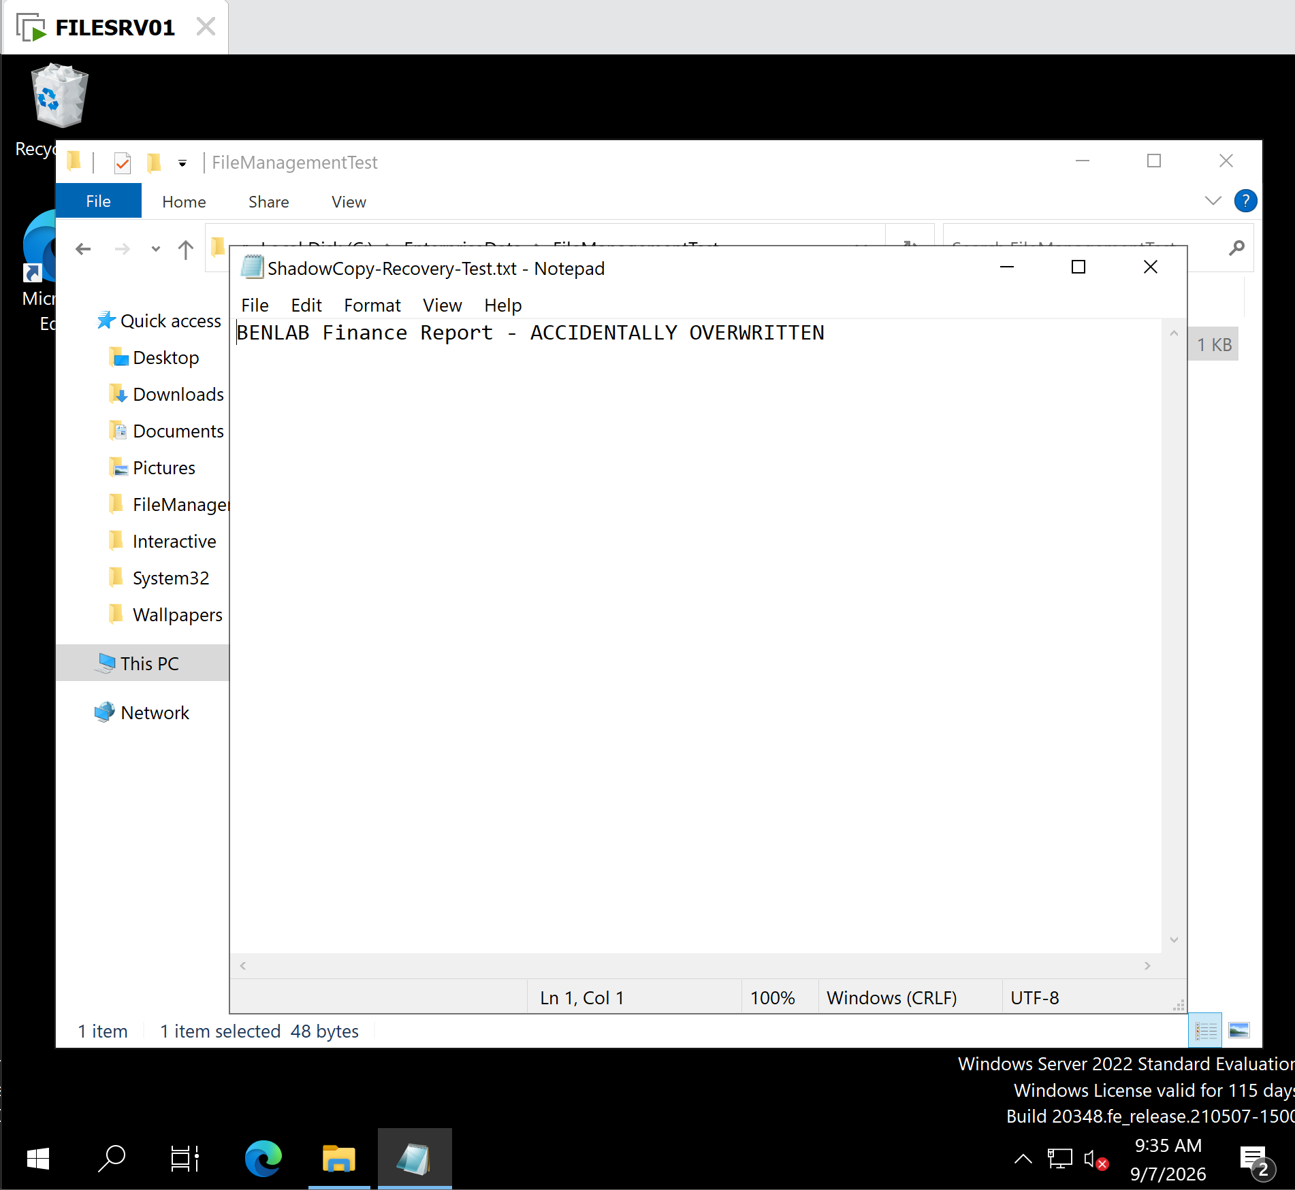
Simulated Accidental Overwrite
Evidence: Same file containing:
BENLAB Finance Report - ACCIDENTALLY OVERWRITTEN
Purpose: Documents the simulated end-user incident requiring recovery.

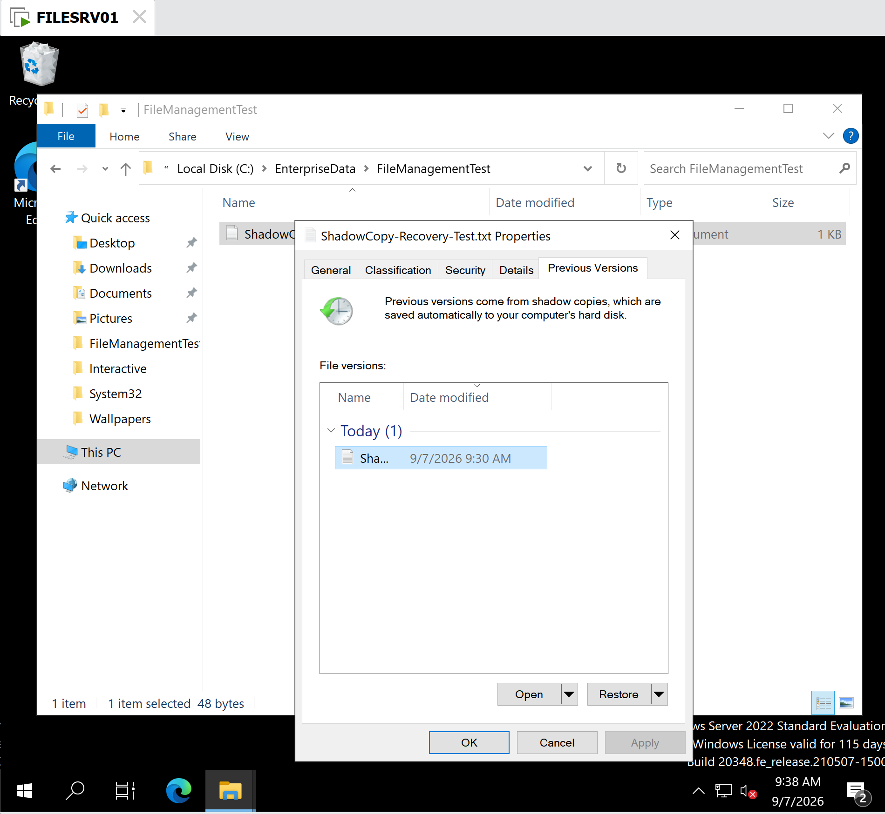
Evidence: Historical copy opened from Previous Versions, displaying:
BENLAB Finance Report - ORIGINAL VERSION
Purpose: Demonstrates the safer administrative practice of inspecting the historical version before restoring it.

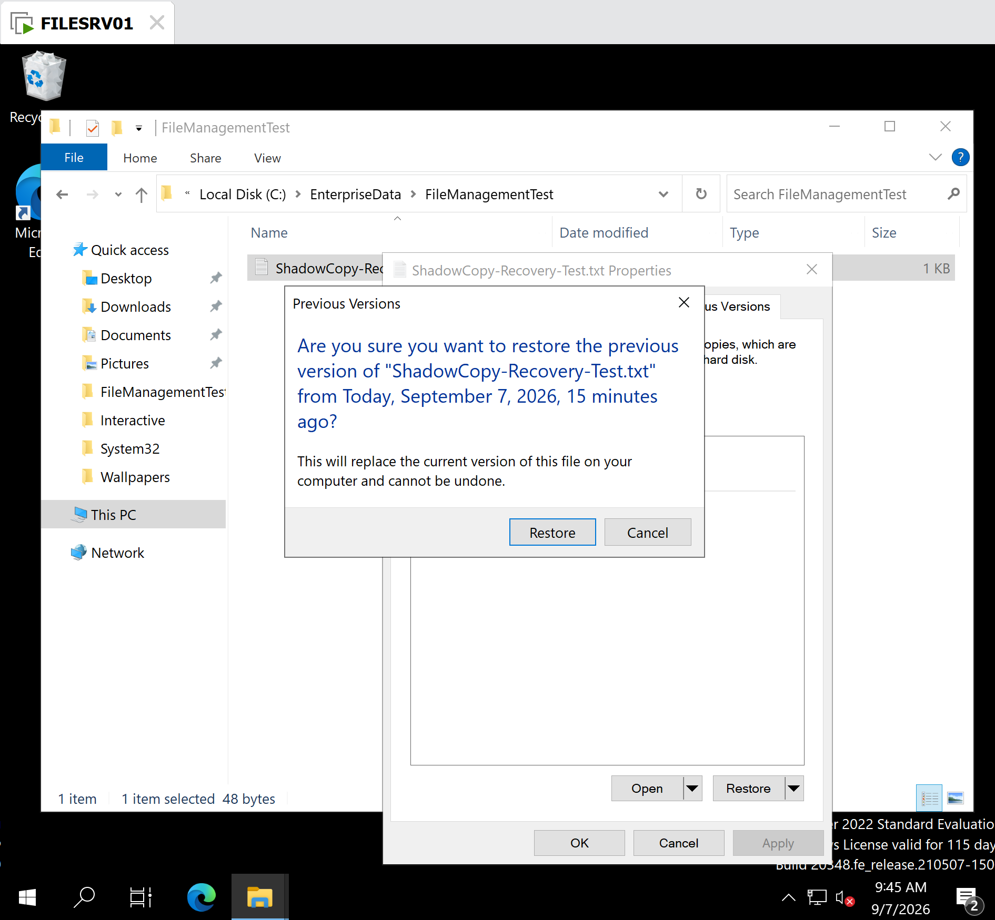
Evidence: Windows warning:
Restoring the previous version will replace the current version and cannot be undone.
Purpose: Documents the administrative confirmation step before overwriting the live file.

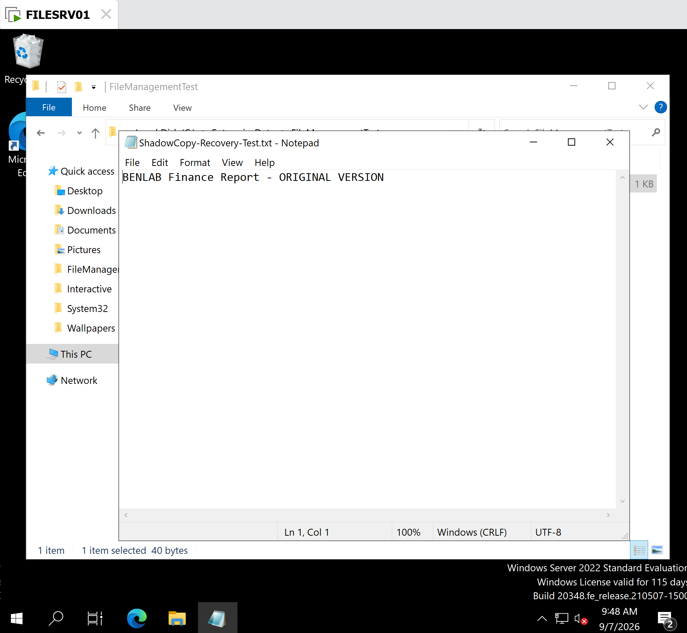
Evidence: Live ShadowCopy-Recovery-Test.txt reopened after restoration and displaying:
BENLAB Finance Report - ORIGINAL VERSION
Purpose: Final proof that the previous version was successfully restored.

Task 7 — Configure and Validate a Domain-Based DFS Namespace

Objective
Configure a domain-based Distributed File System (DFS) Namespace on FILESRV01 to provide users with a centralized, logical path for accessing departmental file shares without requiring users to know the physical file server hosting the data.
The namespace was designed to provide access through:
\\benlab.local\CorporateData
rather than requiring users to browse directly to:
\\FILESRV01\CompanyShares

Environment
Domain: benlab.local
Namespace Server: FILESRV01
DFS Namespace: \\benlab.local\CorporateData
Existing SMB Share: \\FILESRV01\CompanyShares
Validation Workstation: ADMINPC01

Step 1 — Open DFS Management
Opened DFS Management on FILESRV01 and selected:
Namespaces → New Namespace
FILESRV01 was selected as the namespace server.

Step 2 — Create the CorporateData Namespace
Created a new namespace named:
CorporateData
A domain-based namespace was selected, resulting in the UNC path:
\\benlab.local\CorporateData
Windows Server 2008 mode was enabled.
The namespace root was created locally under:
C:\DFSRoots\CorporateData
The New Namespace Wizard completed successfully.

Step 3 — Validate the Existing SMB Share
Before creating DFS folder targets, the existing departmental share was verified with PowerShell:
Get-SmbShare -Name CompanyShares | Select-Object Name, Path
The command confirmed:
Name Path
---- ----
CompanyShares C:\BEN Industries_CompanyShares
This established that the existing departmental data remained hosted on FILESRV01 and could be referenced by DFS.

Step 4 — Create DFS Namespace Folders
Created eight logical folders within the CorporateData namespace:
Executive
Finance
Human Resources
Information Technology
Marketing
Projects
Public
Sales
Each DFS folder was associated with its corresponding folder under the existing CompanyShares SMB share.
For example:
DFS Path:
\\benlab.local\CorporateData\Finance

Folder Target:
\\FILESRV01\CompanyShares\Finance
The same design was applied to the remaining departmental folders.

Step 5 — Verify the Namespace in DFS Management
DFS Management displayed all eight folders beneath:
\\benlab.local\CorporateData
This confirmed that the logical corporate namespace had been successfully constructed on FILESRV01.

Step 6 — Client-Side Validation from ADMINPC01
From the domain-joined ADMINPC01 workstation, File Explorer was used to access:
\\benlab.local\CorporateData
The workstation successfully displayed all eight DFS folders:
Executive
Finance
Human Resources
Information Technology
Marketing
Projects
Public
Sales
The Finance namespace had also previously been opened successfully and displayed the existing files stored in the underlying Finance folder.
This confirmed that DFS was correctly directing client access from the domain-based namespace to the physical folder target on FILESRV01.

Architecture
BENLAB.LOCAL
│
│
\\benlab.local\CorporateData
│
DFS Namespace
│
┌─────────────────┼─────────────────┐
│ │ │
Finance Human Resources IT
│ │ │
└─────────────────┼─────────────────┘
│
FILESRV01
│
\\FILESRV01\CompanyShares
│
┌─────────────────┼─────────────────┐
│ │ │
Finance Human Resources IT
The same structure applies to Executive, Marketing, Projects, Public, and Sales.

Result
DFS Namespace configuration and client-side validation were successful.
The BENLAB environment now provides a centralized domain-based path:
\\benlab.local\CorporateData
Users no longer need to know that the departmental data currently resides on FILESRV01.
This introduces an important abstraction layer between the user-facing file path and the physical server hosting the data.

Key Learning Points
- DFS Namespace (DFS-N) provides a logical, centralized structure for accessing network shares.
- A domain-based namespace uses the Active Directory domain name rather than exposing a particular server name to users.
- A DFS folder is the logical folder users see, while a folder target identifies the actual SMB location containing the data.
- Existing SMB shares can be incorporated into DFS without moving the underlying files.
- DFS Namespace does not automatically copy or synchronize data.
- DFS Replication (DFS-R) is a separate technology used when data needs to be synchronized between multiple servers.
- Separating the logical namespace from the physical server makes future file-server migrations and multi-server designs easier because the user-facing path can remain consistent.

Screenshots / Evidence

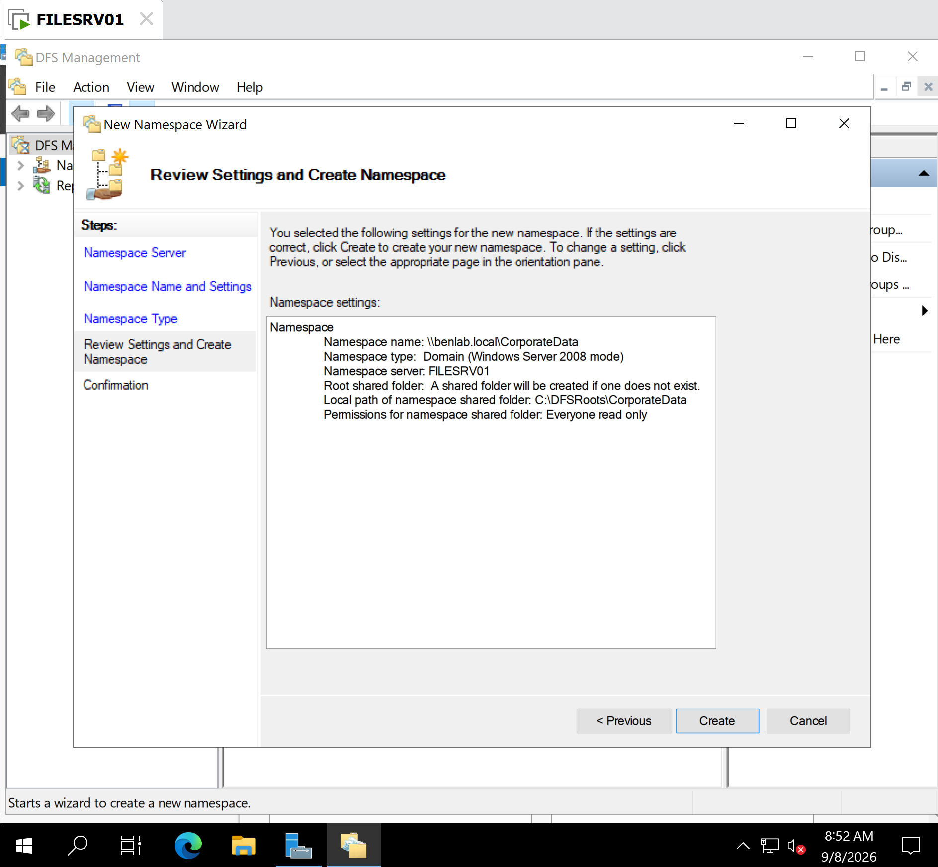
New Namespace Wizard — Namespace Type
Shows \\benlab.local\CorporateData configured as domain-based.

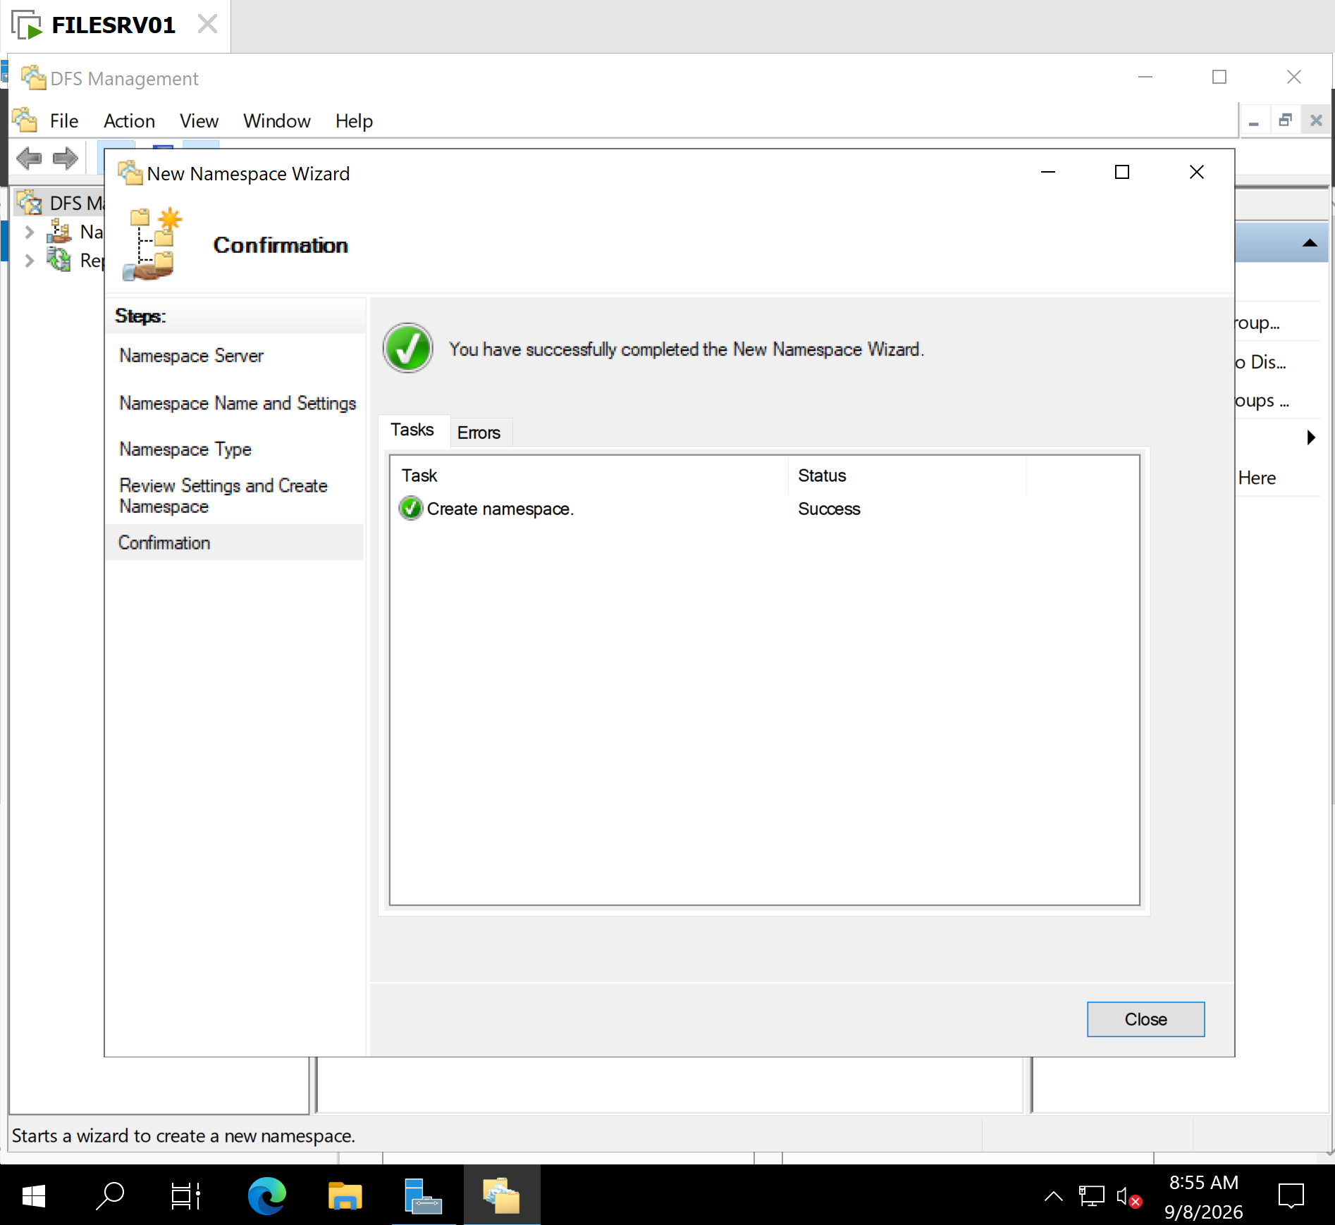
New Namespace Wizard — Successful Completion
Proves successful namespace creation.

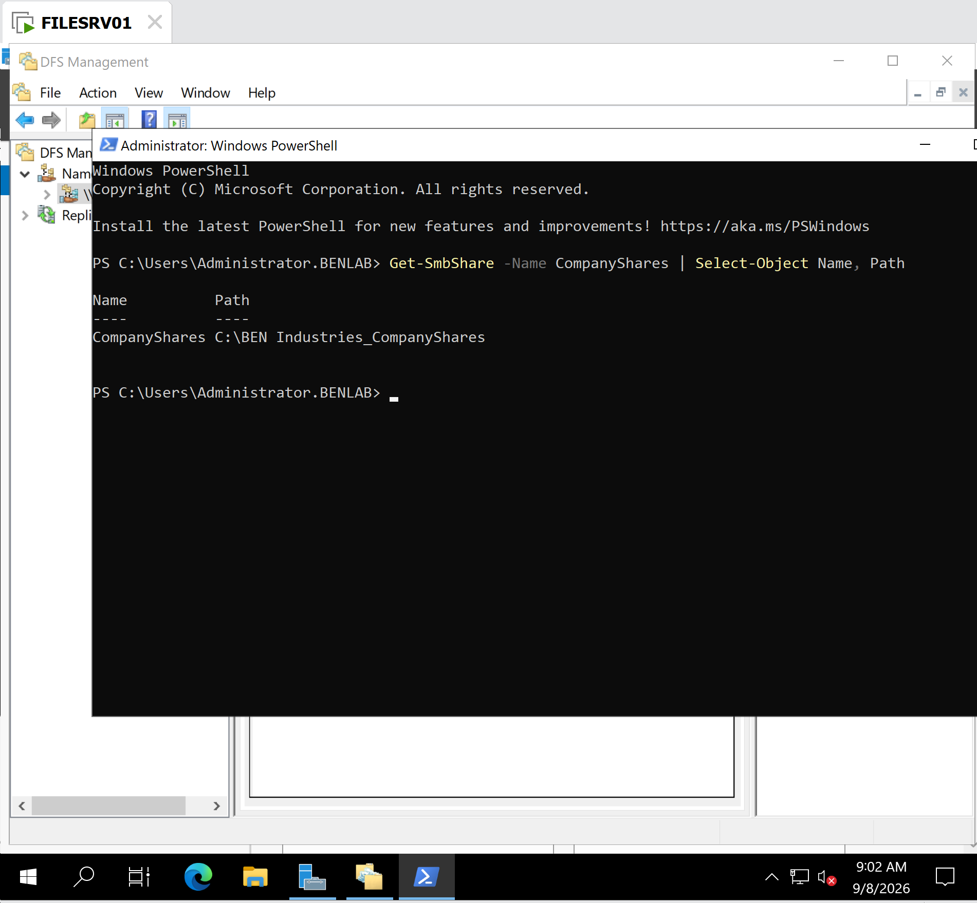
PowerShell — Existing CompanyShares Validation
Shows Get-SmbShare and the underlying C:\BEN Industries_CompanyShares path.

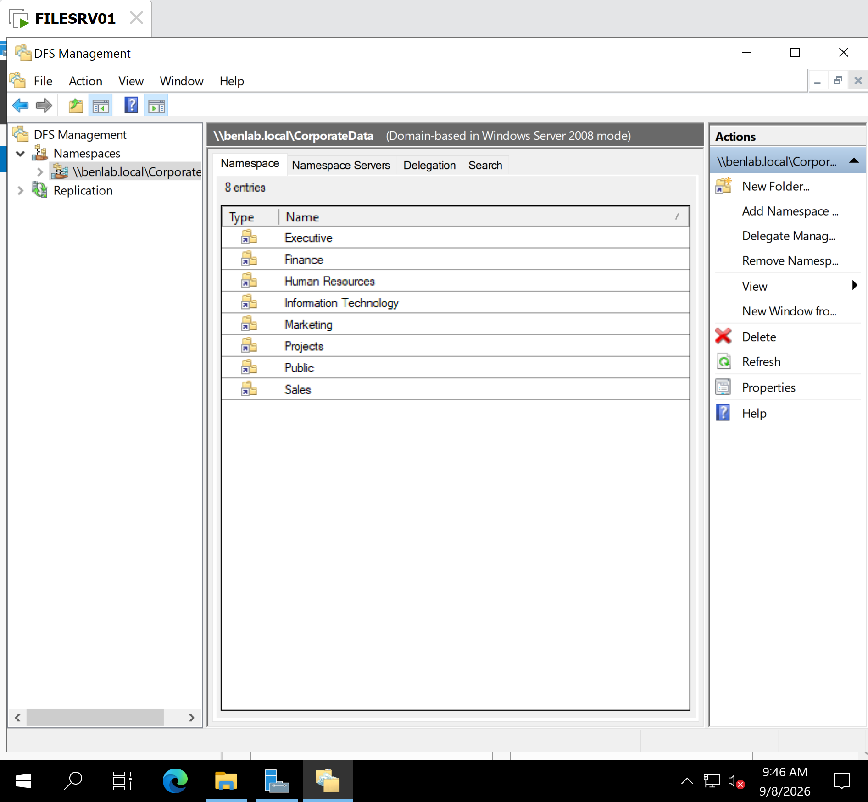
DFS Management — Eight Namespace Folders
Shows Executive through Sales under \\benlab.local\CorporateData.

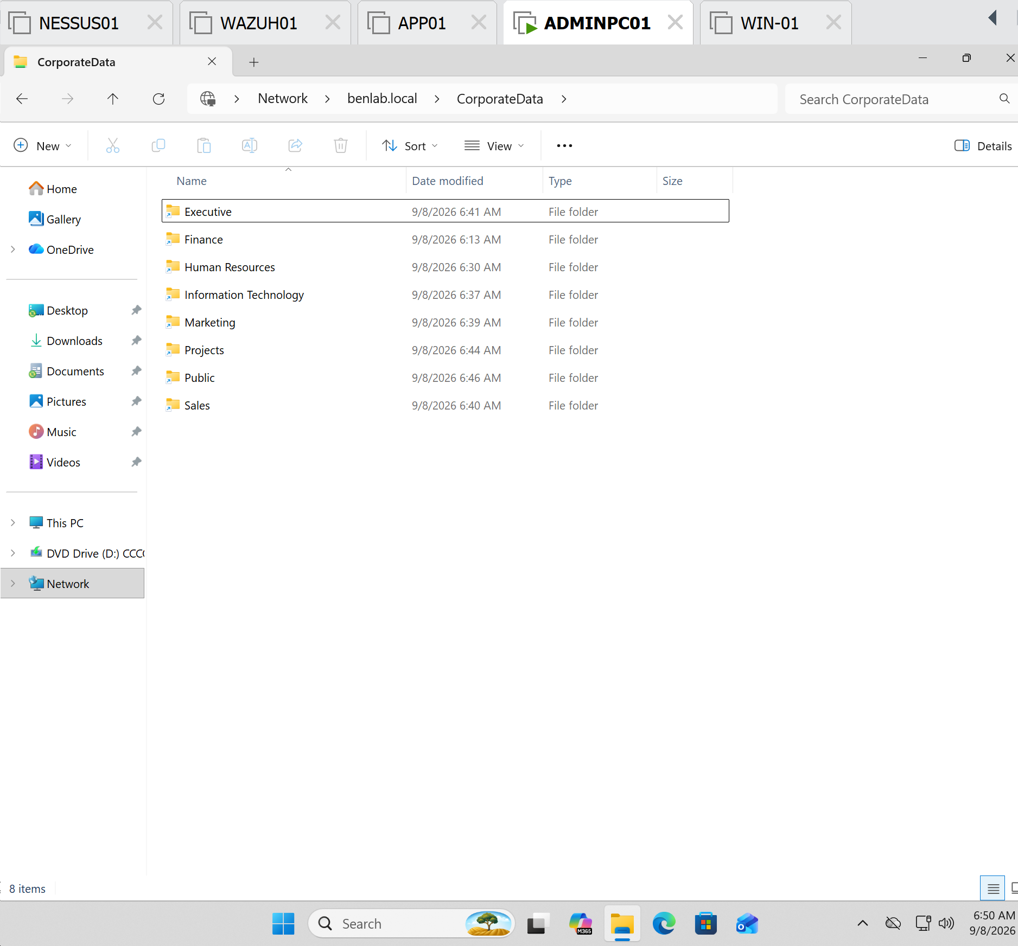
ADMINPC01 — Client-Side Namespace Validation ⭐
Showing all eight folders through Network > benlab.local > CorporateData.

Skills Demonstrated
Windows Server File Services • DFS Namespaces • Domain-Based DFS • SMB File Sharing • UNC Paths • Active Directory Integration • PowerShell Validation • Centralized File Access • Client-Side Testing

Task 8 – Configure and Validate DFS Replication

Objective
Configure Distributed File System Replication (DFSR) between the HQ file server FILESRV01 and Branch file server FILESRV02 to provide synchronized enterprise data between the two locations.
The task also demonstrates troubleshooting DFSR communication across routed networks protected by pfSense firewalls.

Lab Environment
HQ Site
- FILESRV01 — 10.20.20.50
- HQ network — 10.20.20.0/24
- Replicated folder — C:\EnterpriseData
Branch Site
- FILESRV02 — 10.30.30.101
- Branch network — 10.30.30.0/24
- Replicated folder — C:\EnterpriseData
Active Directory Domain
benlab.local
Replication Group
HQ-Branch-File-Replication
Replicated Folder
EnterpriseData

Step 1 – Validate DFS Replication Prerequisites
Verified that the DFS Namespace and DFS Replication role services were installed on both file servers.
PowerShell was used to validate the required Windows Server features.
The DFS Replication service was also confirmed to be running.

Step 2 – Configure the DFS Replication Group
A replication group named:
HQ-Branch-File-Replication
was configured with two members:
FILESRV01
FILESRV02
The replicated folder was configured as:
EnterpriseData
with the local path:
C:\EnterpriseData
on both servers.

Step 3 – Validate the Replication Configuration
PowerShell was used to verify the replication group:
Get-DfsReplicationGroup
The replication group returned:
GroupName : HQ-Branch-File-Replication
DomainName : benlab.local
State : Normal
Membership was then validated:
Get-DfsrMember -GroupName "HQ-Branch-File-Replication"
Both servers appeared as members:
FILESRV01
FILESRV02
with their DFSR state reported as:
Normal
The replicated folder configuration was also validated. Both servers showed:
FolderName : EnterpriseData
ContentPath : C:\EnterpriseData
Enabled : True
State : Normal

Step 4 – Troubleshoot DFSR Network Connectivity
Because FILESRV01 and FILESRV02 reside on different routed networks, firewall and network connectivity had to be validated.
Connectivity was tested with:
Test-NetConnection 10.30.30.101 -Port 5722
and in the opposite direction:
Test-NetConnection 10.20.20.50 -Port 5722
The final result was:
TcpTestSucceeded : True
This confirmed TCP communication for the configured DFSR service between the HQ and Branch file servers.
pfSense firewall rules were configured to permit the required inter-site communication.

Step 5 – Force DFSR Configuration Refresh
The servers were instructed to immediately retrieve updated DFSR configuration information from Active Directory:
dfsrdiag pollad
Result:
Operation Succeeded
Replication activity was also inspected using:
dfsrdiag replicationstate
This provided visibility into active DFSR inbound and outbound replication operations.

Step 6 – Validate HQ-to-Branch Replication
A test file was created on FILESRV01 inside:
C:\EnterpriseData
The contents of the replicated directory were checked using:
Get-ChildItem C:\EnterpriseData
The test file subsequently appeared on FILESRV02, demonstrating successful:
FILESRV01
↓
FILESRV02
HQ-to-Branch replication.

Step 7 – Validate Branch-to-HQ Replication
A second test file was created directly on FILESRV02:
"Created on FILESRV02 to validate Branch-to-HQ DFS Replication" |
Out-File C:\EnterpriseData\DFSR-Test-Branch.txt
The directory was checked:
Get-ChildItem C:\EnterpriseData
DFSR-Test-Branch.txt subsequently appeared on FILESRV01.
This demonstrated successful replication in the opposite direction:
FILESRV02
↓
FILESRV01
Therefore, bidirectional DFS Replication was successfully demonstrated.

Step 8 – Validate DFSR Backlog
The DFSR backlog was checked with:
dfsrdiag backlog /rgname:"HQ-Branch-File-Replication" /rfname:"EnterpriseData" /smem:FILESRV01 /rmem:FILESRV02
A successful test returned:
No Backlog - member <filesrv02> is in sync with partner <filesrv01>

Operation Succeeded
This demonstrated that the two DFSR members had reached synchronization during validation.

Troubleshooting – WMI/RPC Remote Management
Additional dfsrdiag backlog tests exposed a separate remote-management issue.
The command sometimes returned:
[ERROR] Failed to connect to WMI services on computer
Operation Failed
Testing showed that basic network connectivity remained available.
RPC Endpoint Mapper connectivity was tested using:
Test-NetConnection FILESRV02 -Port 135
and eventually returned:
TcpTestSucceeded : True
Windows Management Instrumentation firewall rules were examined using:
Get-NetFirewallRule -DisplayGroup "Windows Management Instrumentation (WMI)" |
Select-Object DisplayName, Enabled, Direction, Action
The WMI firewall rules were enabled where required:
Enable-NetFirewallRule -DisplayGroup "Windows Management Instrumentation (WMI)"
Further investigation showed that Windows was listening on dynamic RPC ports in the range:
49152–65535
using:
Get-NetTCPConnection -State Listen |
Where-Object {$_.LocalPort -ge 49152 -and $_.LocalPort -le 65535} |
Select-Object LocalAddress,LocalPort,OwningProcess
A direct IPv4 test to one of these ports demonstrated that additional RPC/WMI communication across the routed environment remained restricted:
Test-NetConnection 10.30.30.101 -Port 49664
Result:
PingSucceeded : True
TcpTestSucceeded : False
This issue affected some remote WMI/RPC-based diagnostic operations but did not invalidate the successfully demonstrated DFSR file replication.

Important Ports Encountered
Protocol/Service | Port | Purpose
SMB | TCP 445 | Windows file sharing and administrative communication
RPC Endpoint Mapper | TCP 135 | Initial RPC service discovery
Dynamic RPC | TCP 49152–65535 | Dynamic Windows RPC communication
DFS Replication | TCP 5722 | DFSR communication used in this lab
These ports should also be added to the Windows Administrator Field Reference.

Validation Results
Replication Group: HQ-Branch-File-Replication — Normal
FILESRV01 membership: Normal
FILESRV02 membership: Normal
EnterpriseData replicated folder: Enabled / Normal
HQ → Branch replication: Successful
Branch → HQ replication: Successful
DFSR backlog synchronization: Successfully demonstrated
TCP 5722 connectivity: Successful
Remote WMI/RPC diagnostics: Additional troubleshooting required

Key Learning Points
This task demonstrated that DFS Replication is more than simply creating a replication group. Successful deployment requires coordination between Active Directory, DFSR configuration, Windows services, routing, Windows Firewall, and network firewalls.
A particularly important troubleshooting lesson was the distinction between the data replication path and the management/diagnostic path. DFSR successfully synchronized files between FILESRV01 and FILESRV02 even though some later WMI-based diagnostic commands encountered RPC connectivity problems.
The troubleshooting process also reinforced a useful administrative methodology:
Verify IP connectivity
↓
Verify required service port
↓
Verify Windows service is listening
↓
Verify Windows Firewall
↓
Verify pfSense/firewall path
↓
Verify application/service operation

Screenshots / Evidence

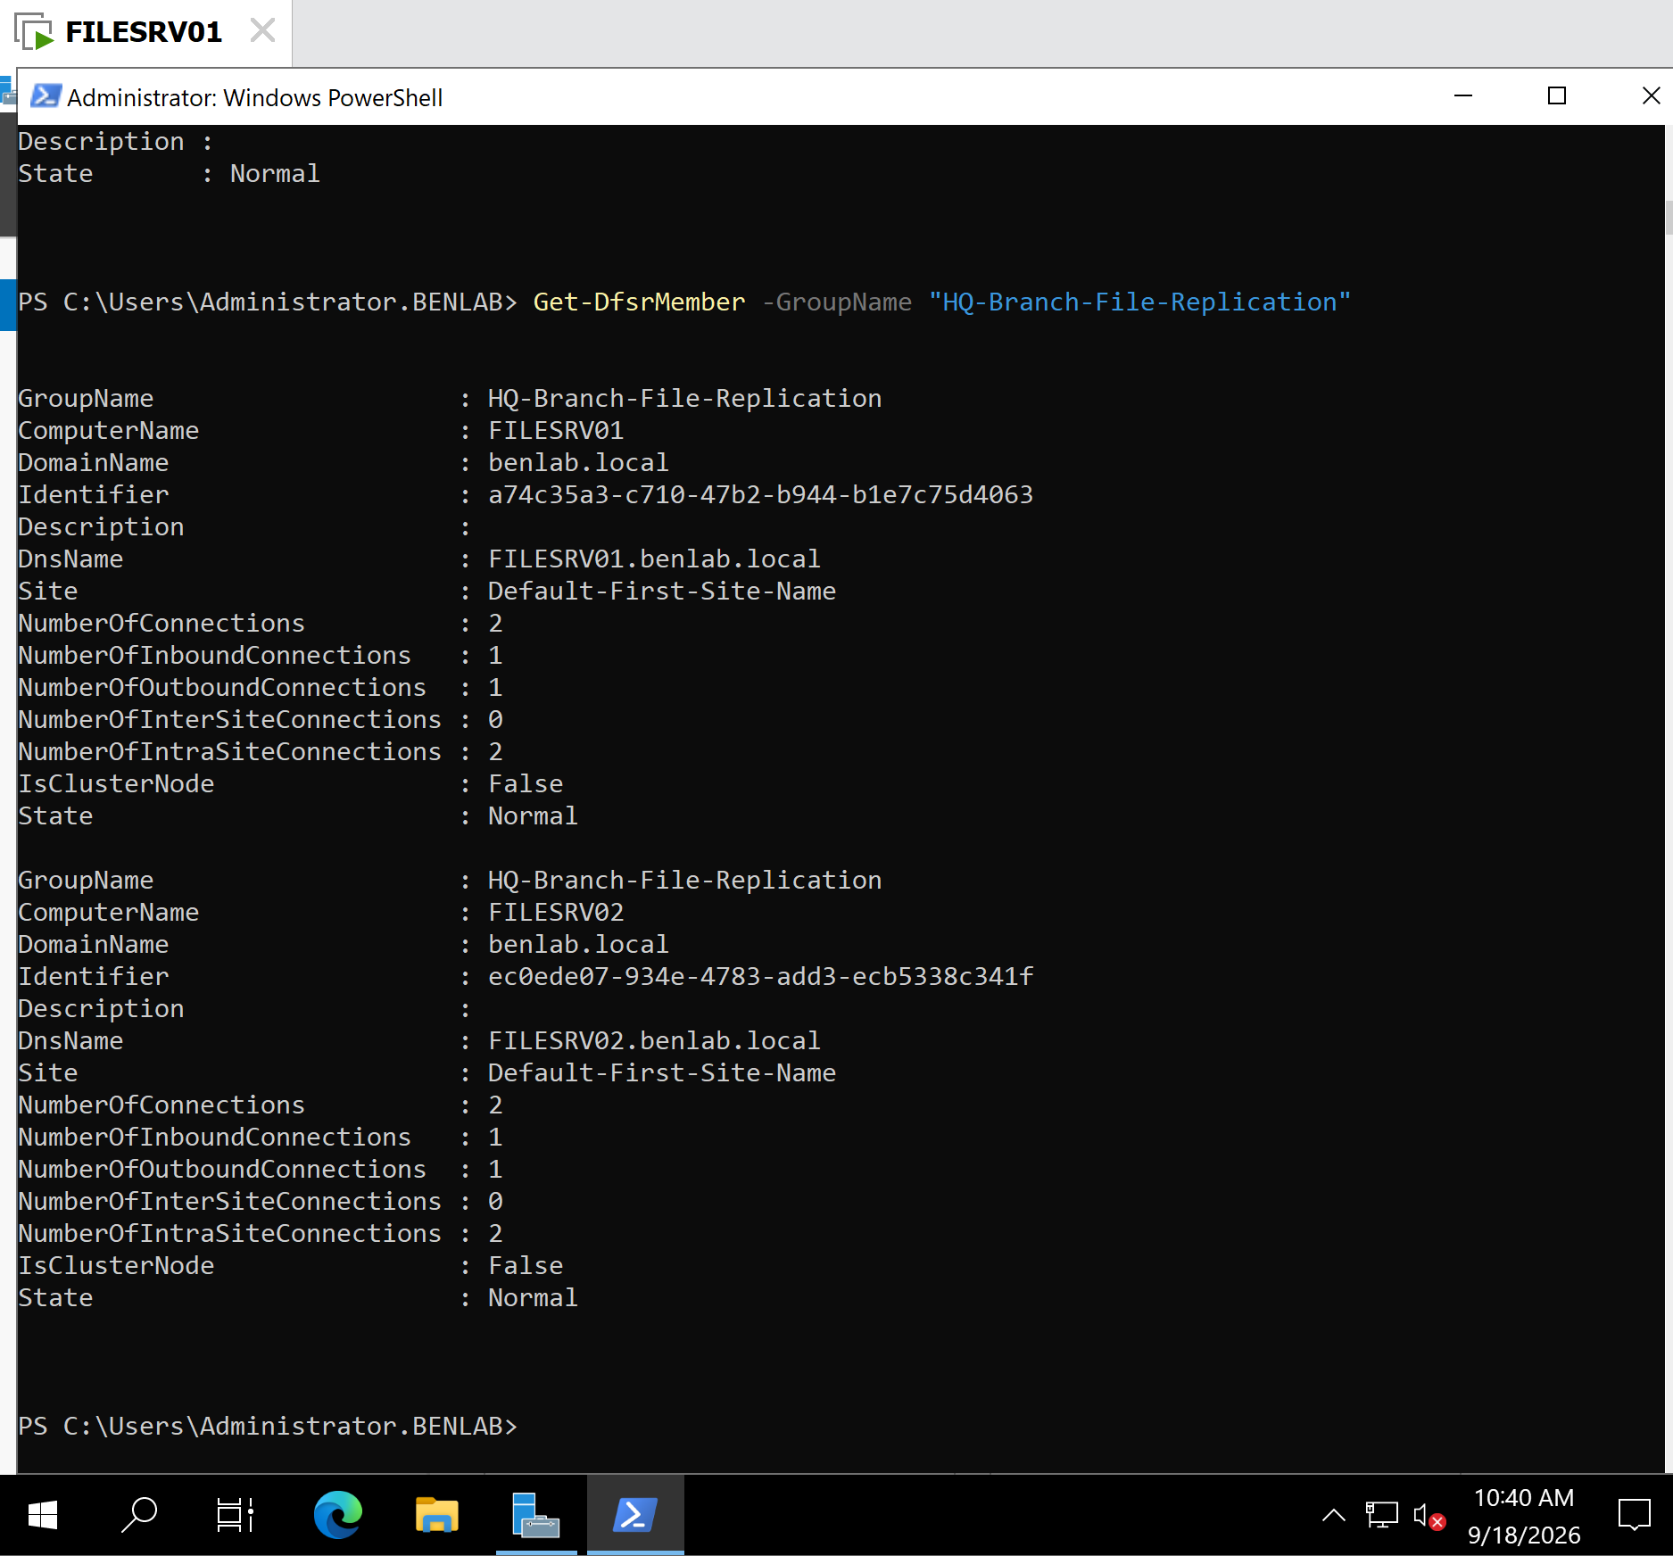
Screenshot 1 – DFS Replication Members Validated
Caption:
PowerShell validation showing FILESRV01 and FILESRV02 successfully configured as members of the HQ-Branch-File-Replication replication group with a Normal state.

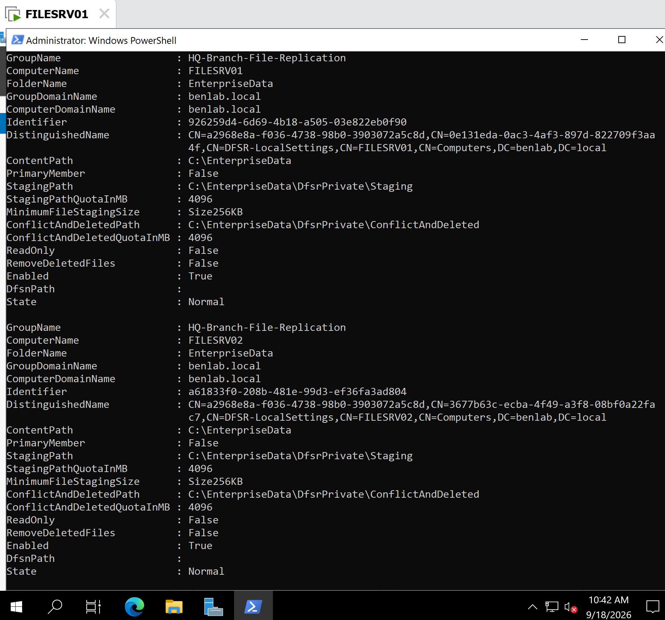
Screenshot 2 – DFS Replicated Folder Configuration
Caption:
DFSR configuration validation confirming that C:\EnterpriseData is enabled as the replicated folder on both FILESRV01 and FILESRV02.

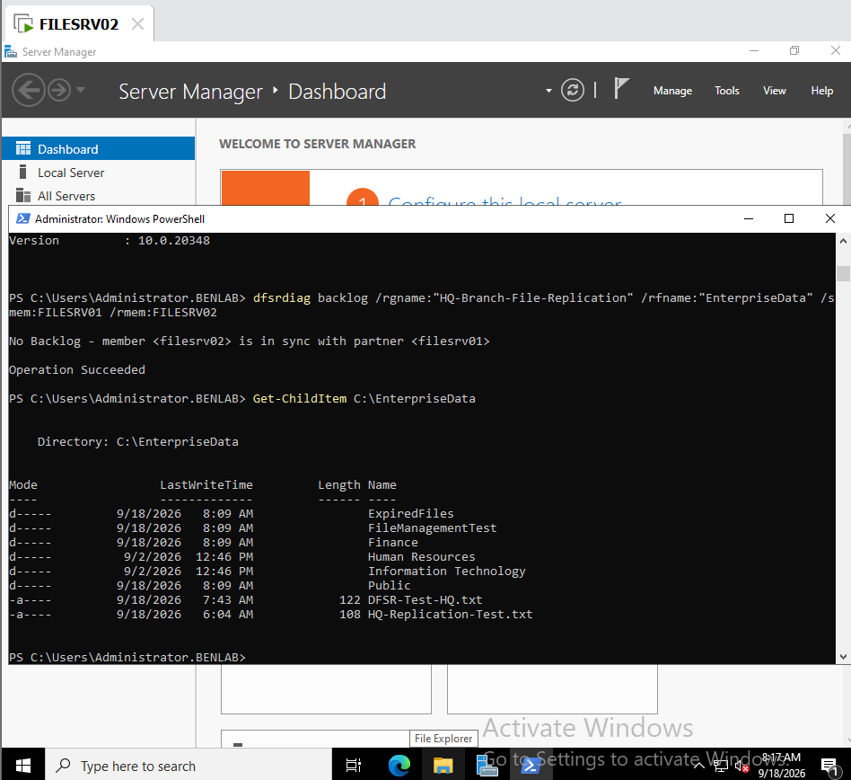

Screenshot 3 – DFSR Backlog Successfully Synchronized

Caption:
DFSR backlog validation confirming that FILESRV02 was synchronized with FILESRV01 with no pending replication backlog.

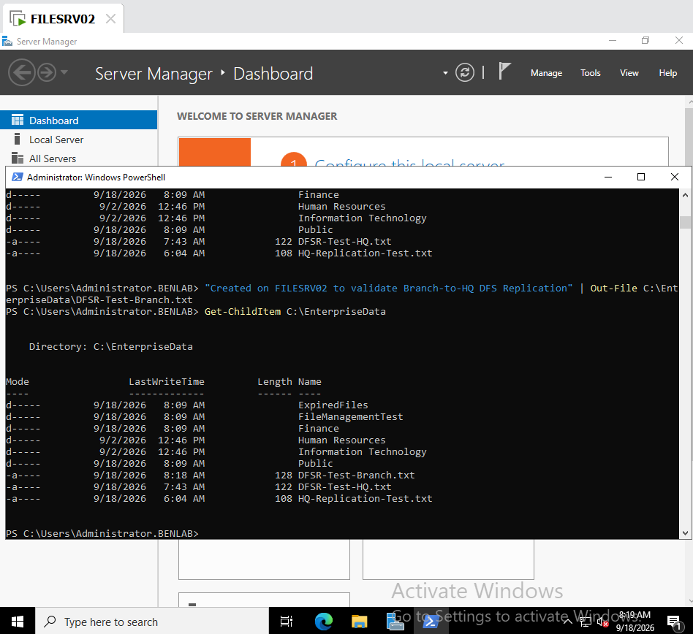

Screenshot 4 – Branch-to-HQ Test File Created on FILESRV02

Caption:
Test file created on FILESRV02 to validate Branch-to-HQ DFS Replication.

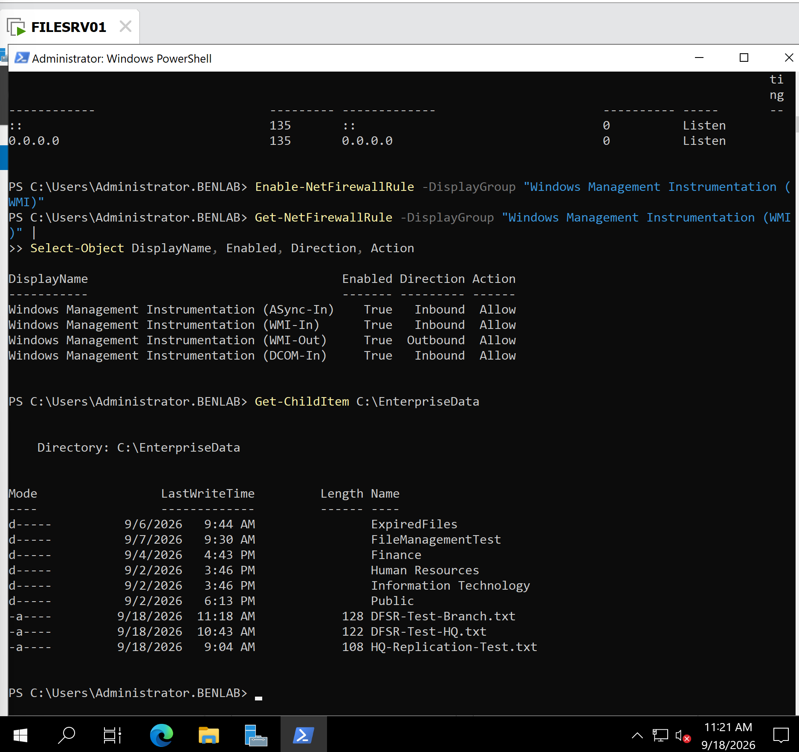
Screenshot 5 – Branch File Successfully Replicated to FILESRV01
Caption:
FILESRV01 showing DFSR-Test-Branch.txt, confirming successful replication of a file created at the Branch server back to the HQ server.

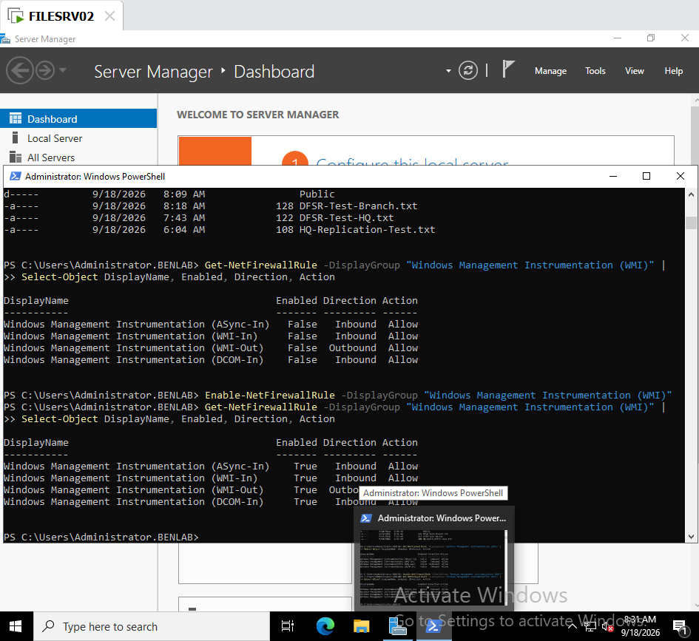

Screenshot 6 – WMI Firewall Rules Enabled

Caption:
Windows Firewall WMI rules enabled on FILESRV02 while troubleshooting remote DFSR backlog management.

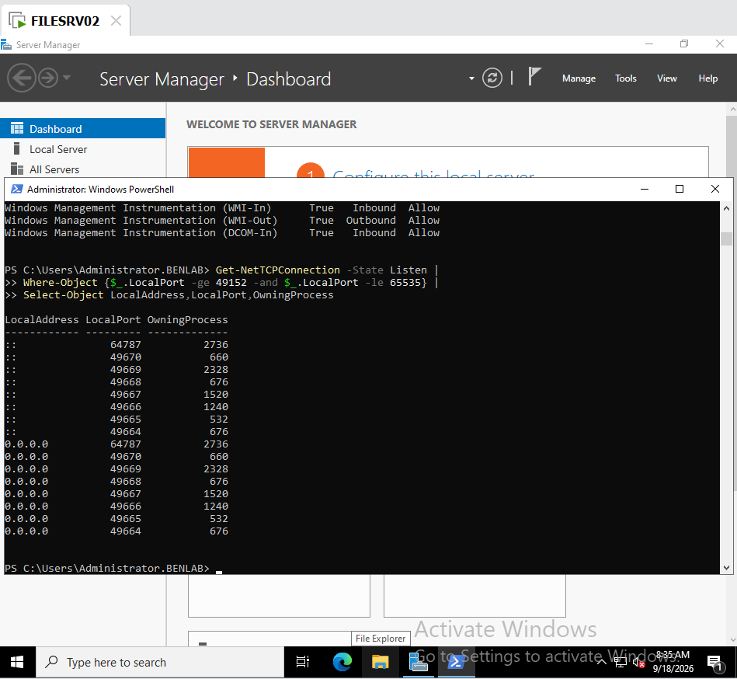

Screenshot 7 – Dynamic RPC Ports Identified

Caption:
Dynamic RPC listening ports identified on FILESRV02 while investigating WMI/RPC communication across the routed HQ-to-Branch network.

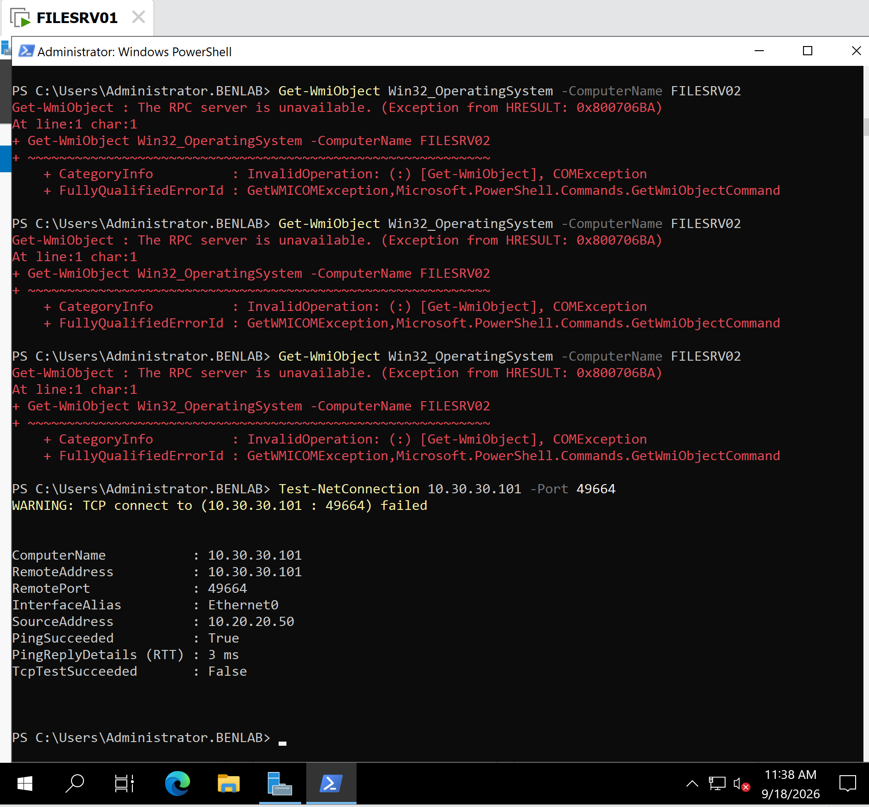
Screenshot 8 – RPC Dynamic Port Blocked Across Sites
Caption:
Network troubleshooting demonstrating successful IP connectivity between HQ and Branch while TCP 49664 remained inaccessible, isolating the remaining issue to RPC/firewall communication rather than basic routing.

Final Result
Task 8 – Configure and Validate DFS Replication: COMPLETED
A bidirectional DFS Replication environment was successfully configured between HQ FILESRV01 and Branch FILESRV02. Files created at either site were successfully replicated to the opposite server.
An additional WMI/RPC management limitation across the routed environment was identified and documented as part of the troubleshooting process rather than being treated as a failure of DFS Replication itself.

