IT 140 Design Document Template

Instructions
Fill out the sections below. Be sure to remove the bracketed text before submitting your Design Document.

Benvindo Kiazayamoko

Storyboard (Description and Map)
Theme: Sci-Fi Survival Escape on an Alien-Infested Research Station
Storyline: The player is stranded on planet March after a containment breach releases a hostile alien creature inside the research station Kizomba Alfa. To escape, the player must explore the interconnected rooms of the station, gather six essential components needed to power the escape shuttle, and avoid the alien until all items have been collected. Entering the alien’s room before gathering all components results in immediate failure, while collecting all items and reaching the shuttle allows the player to escape the planet.
Rooms: landing Bay (start room), engineering lab, Cryo chamber, control room, bio lab, storage bay, reactor room, communications hub, escape shuttle bay (villain room).
Items: circuit board, navigation module, access key cards, fuel canister toolkit, power cell oxygen regulator.
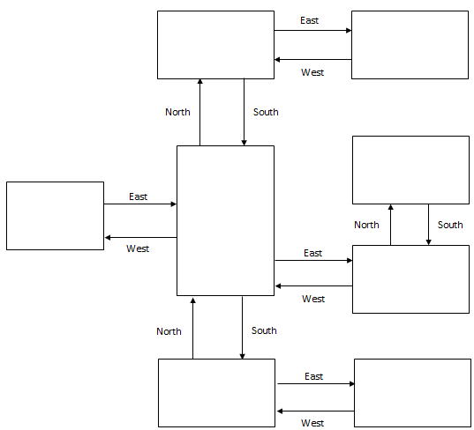
Bio lab
Item: circuit board
Communication hub
Item: navigation
module
Escape shuttle bay
VILLAIN
North
South
Control room
Item: access key card
Cryo chamber
Item: oxygen regulator
Engineering lab
Item: toolkit
Storage bay
Item: fuel canister
Reaction room
Item: power cell
Landing bay
START

Pseudocode or Flowchart for Code to “Move Between Rooms”
SET currentRoom = “Landing Bay”
SET inventory = empty list
SET gameOver = False

WHILE gameOver == False:
DISPLAY “You are in the “ + currentRoom
DISPLAY “Enter a direction (North, South, East, West):”
GET direction

IF currentRoom == “Landing Bay”:
IF direction == “North”:
currentRoom = “Storage Bay”
ELIF direction == “East”:
currentRoom = “Escape Shuttle Bay”
Else:
DISPLAY “You cannot go that way.”

ELIF currentRoom == “Storage Bay”:
IF direction == “North”:
currentRoom = “communication Hub”
ELIF direction == “East”:
currentRoom == “Reaction Room”
ELIF direction == “West”:
currentRoom = “Engineering Lab”
ELIF direction == “South”:
currentRoom = “Landing Bay”
Else:
DISPLAY “You cannot go that way.”

ELIF currentRoom == “Communication Hub”:
IF direction == “East”:
currentRoom = “Bio Lab”
ELIF direction == “South”:
currentRoom = “Storage Bay”
ELSE:
DISPLAY “You cannot go that way.”

ELIF currentRoom == “Bio Lab”:
IF direction == “West”:
currentRoom = Communication Hub”
ELSE:
DISPLAY “You cannot go that way.”

ELIF currentRoom == “Reaction Room”:
IF direction == “North”:
currentRoom = “Control Room”
ELIF direction == “West”:
currentRoom = “Storage Bay”
ELSE:
DISPLAY “You cannot go that way.”

ELIF currentRoom == “Control Room”:
IF direction == “South”:
currentRoom = “Reaction Room”
ELSE:
DISPLAY “You cannot go that way.”

ELIF currentRoom == “Engineering Lab”:

IF direction == “South”:
currentRoom = “Cryo Chamber”
ELIF direction == “East”:
currentRoom = “Storage Bay”
ELSE:
DISPLAY “You cannot go that way.”

ELIF currentRoom == “Cryo Chamber”:
IF direction == “North”:
currentRoom = “Engineering Lab”
ELSE:
DISPLAY “You cannot go that way.”

DISPLAY “You moved to the” + currentRoom

IF currentRoom == “Escape Shuttle Bay” AND inventory does not contain all 6 items:
DISPLAY “The alien attacks you! Game Over.”
SET gameOver = True
IF currrentRoom == “Escape Shuttle Bay” AND inventory contains all 6 items:
DISPLAY “You power the shuttle and escape! You win
SET gameOver = True
END WHILE

Pseudocode or Flowchart for Code to “Get an Item”
IF currentRoom contains an item:

DISPLAY “This room contains: “ + item
DISPLAY “Enter ‘get item’ to pick it up.”
GET command

IF command == “get item”:
ADD item to inventory
REMOVE item from currentRoom
DISPLAY “You picked up the “ + item
ELSE:
DISPLAY “Invalid command. Try again.”

ELSE:
DISPLAY “There is no item in this room.”

