NAME: Ben Puryear

FILE: hw1-writeup.pdf

DATE: Spring 2023

DESC: This pdf will provide a short description of any challenges and/or issues I faced and how I addressed them in this assignment.

Challenges faced:

The only challenge I faced during this assignment were figuring out how to stop reading command line input after Ctrl-d is pressed without stopping the execution of the entire program. I overcame this challenge by coming to the realization that I can use &cin as if it was a file and check if it has reached EOF().

Testing:

Basic From-File usage:

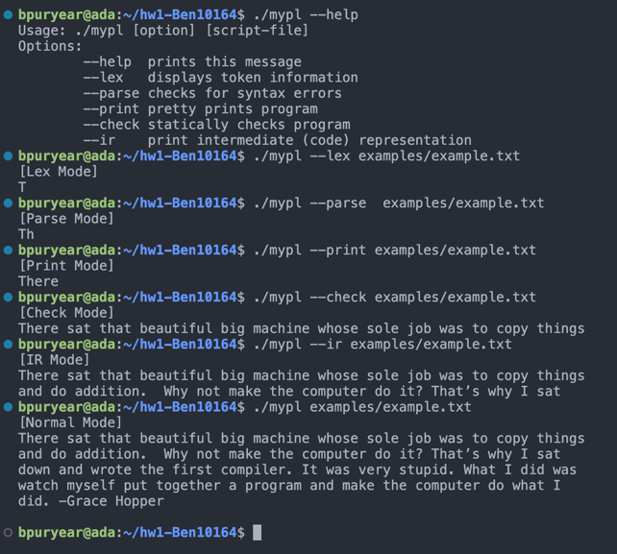

Invalid Usage:

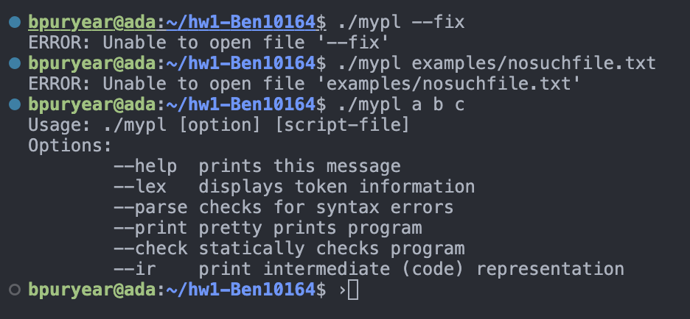

Basic From-CLI usage:

My own text example (Lorem Ispum Generator)

Valgrind output:

