NAME: Ben Puryear

FILE: hw2-writeup.pdf

DATE: Spring 2023

DESC: This pdf will provide a short description of any challenges and/or issues I faced and how I addressed them in this assignment.

**Challenges faced:**

The only challenge I faced was how to make sure new line, EOF, and space characters would be used to determine where to end the token. The solution was figuring out a way to use peek() to break loops while keeping curr_char the same value.

**Testing:**

Passing all Tests

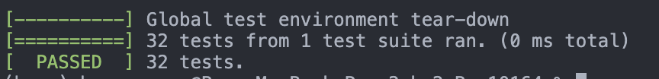

Valgrind of all Tests

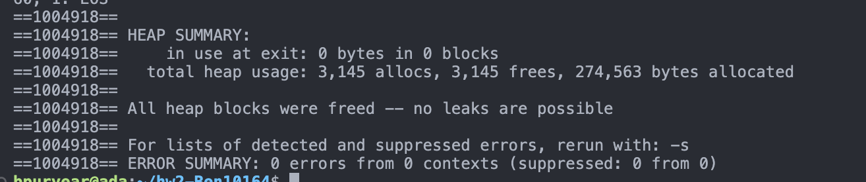

Tokens.mypl

Additional Test Text

Additional Test Output

Valgrind Additional Test

**Additional Test Text**

# Comment!

void main(){

# Comment 2?

int hello = 1

hello = hello + 1

for(int i = 0; i < 10; i = i + 1){

print(hello+i)

}

}