NAME: Ben Puryear

FILE: hw7-writeup.pdf

DATE: Spring 2023

DESC: This pdf will provide a short description of any challenges and/or issues I faced and how I addressed them in this assignment.

**Challenges faced:**

I faced many challenges in this assignment, the majority of which came from shadowing and how to handle variables. I was having difficulties figuring out what addresses to store variables in, especially when pushing and popping a new environment. The solution I came to was to store the current var_index before starting a new environment, then after popping the environment I set the new var_index to the old one.

The main portion of my time debugging was figuring out issues in the example files. I flew through the g-test tests fairly quickly but was then humbled by the example files. The most complicated one for me was exec-arrays.mypl and exec-sum-to-prime.mypl.

**Testing:**

All Tests Passing

Custom Programs

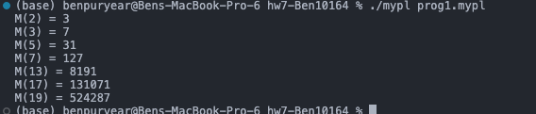

Example files output





