Project 3 Simulator: Process Scheduler (30 points)

1. Compute the response time and turnaround time when running three jobs of length 200 with the SJF and FIFO schedulers. (FIFO works the same way as FCFS.)
   1. Job 0:
      1. Response: 0.00, Turnaround: 9.00
   2. Job 1:
      1. Response: 9.00, Turnaround: 17.00
   3. Job 2:
      1. Response: 17.00, Turnaround: 22.00
   4. Text

      Description automatically generated
2. Now do the same but with jobs of different lengths: 100, 200, and 300.
   1. Job 0:
      1. Response: 0.00, Turnaround: 100.00
   2. Job 1:
      1. Response: 100.00, Turnaround: 300.00
   3. Job 2:
      1. Response: 300.00, Turnaround: 600.00
   4. Text

      Description automatically generated
3. Now do the same, but also with the RR scheduler and a time slice of 1.
   1. Job 0:
      1. Response: 0.00, Turnaround: 298.00
   2. Job 1:
      1. Response: 1.00, Turnaround: 499.00
   3. Job 2:
      1. Response: 2.00, Turnaround: 600.00
   4. 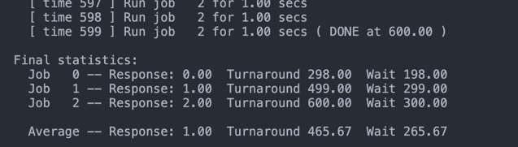
4. For what types of workloads does SJF deliver the same turnaround times as FIFO?
   1. FIFO will deliver the same turnaround time as SJF when the jobs all have the same length.
5. For what types of workloads and quantum lengths does SJF deliver the same response times as RR?
   1. RR will deliver the same response times as SJF whenever the time quantum is larger than the longest job.
6. What happens to response time with SJF as job lengths increase? Can you use the simulator to demonstrate the trend?
   1. The response time will increase linearly with the increase in job length. The two examples below will show how when the length of the jobs double, the average response time will also double.
   2. 5, 10, 20
      1. 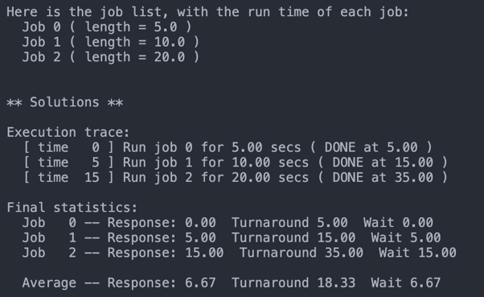
   3. Below is a SJF run with the job lengths being double of what they were before. 10, 20, 40
      1. 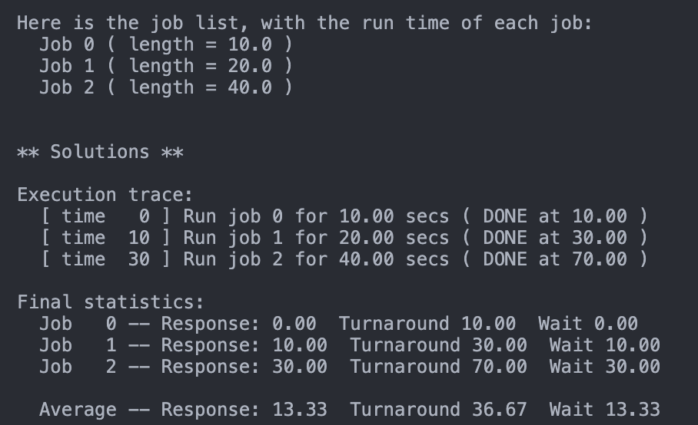
   4. The Average response time went from 6.67 to 13.33, meaning that when the job lengths all doubled, the average response time also doubled.
7. What happens to response time with RR as quantum lengths increase? Can you write an equation that gives the worst-case response time, given N jobs?
   1. R-Worst = (N-1)\*Q
   2. R-Avg = ((N-1)\*Q)/2 is my equation for the average
   3. N = 100, Q = 1
      1. R-Worst = 99.00, R-Predicted-Avg = 49.50, R-Actual = 49.50
      2. 
   4. N = 100, Q = 2
      1. R-Worst = 198, R-Predicted-Avg = 99.00, R-Actual-Avg = 94.04
      2. 
   5. N = 200, Q = 2
      1. R-Worst = 398, R-Predicted-Avg = 199.00, R-Actual-Avg = 192.72
      2. 