# 

# Library Management System – Hackathon Level 2 Submission

**Use Case Title:**

Library Management System

**Student Name:**

E. RUPBEN

Register Number:

C2S27522

Institution:

Theni Kammavar Sangam College of Arts and Science

Department:

BCA

Date of Submission:

19 - 04 - 2025

## 1. Problem Statement

Libraries require a robust system to manage book lending, track borrowed books, monitor due dates, and maintain accurate records. The challenge is to create an efficient Library Management System using SQLite 3 to streamline these operations.

## 2. Database Design & Implementation

### 2.1 Database Creation & Tables

The Library Management System will use the following SQL queries to create tables:

SQL Queries for Table Creation:

CREATE TABLE Books (  
 BookID INTEGER PRIMARY KEY AUTOINCREMENT,  
 Title TEXT NOT NULL,  
 Author TEXT NOT NULL,  
 Genre TEXT,  
 ISBN TEXT UNIQUE,  
 AvailabilityStatus TEXT CHECK(AvailabilityStatus IN ('Available', 'Issued'))  
);

CREATE TABLE Users (  
 UserID INTEGER PRIMARY KEY AUTOINCREMENT,  
 Name TEXT NOT NULL,  
 ContactInfo TEXT,  
 MembershipType TEXT CHECK(MembershipType IN ('Student', 'Faculty', 'Guest'))  
);

CREATE TABLE Transactions (  
 TransactionID INTEGER PRIMARY KEY AUTOINCREMENT,  
 BookID INTEGER,  
 UserID INTEGER,  
 IssueDate DATE,  
 ReturnDate DATE,  
 Status TEXT CHECK(Status IN ('Issued', 'Returned')),  
 FOREIGN KEY(BookID) REFERENCES Books(BookID),  
 FOREIGN KEY(UserID) REFERENCES Users(UserID)  
);

### 2.2 ER Diagram (Reverse Engineered)

The ER diagram for the Library Management System represents the relationships between books, users, and transactions. The diagram visually illustrates the structure of the database.

## 3. Queries for Data Management

### 3.1 Insert Sample Data

SQL Queries for Sample Data Insertion:

INSERT INTO Books (Title, Author, Genre, ISBN, AvailabilityStatus)   
VALUES   
('The Great Gatsby', 'F. Scott Fitzgerald', 'Fiction', '9780743273565', 'Available'),  
('1984', 'George Orwell', 'Dystopian', '9780451524935', 'Available');

INSERT INTO Users (Name, ContactInfo, MembershipType)   
VALUES   
('John Doe', 'johndoe@example.com', 'Student'),  
('Jane Smith', 'janesmith@example.com', 'Faculty');

INSERT INTO Transactions (BookID, UserID, IssueDate, ReturnDate, Status)   
VALUES   
(1, 1, '2025-04-01', '2025-04-15', 'Issued');

### 3.2 Retrieval Queries

SQL Queries for Data Retrieval:

SELECT * FROM Books WHERE AvailabilityStatus = 'Available';

SELECT Users.Name, Books.Title, Transactions.ReturnDate   
FROM Transactions   
JOIN Users ON Transactions.UserID = Users.UserID   
JOIN Books ON Transactions.BookID = Books.BookID   
WHERE Transactions.ReturnDate < DATE('now') AND Transactions.Status = 'Issued';

## 4. Implementation & Results

### 4.1 Execution Environment

The Library Management System was implemented using SQLite 3, and SQL queries were executed in SQLite Database Browser. Screenshots of query execution results have been attached.

### 4.2 Screenshots of Execution Results

Screenshots showing successful database creation, data insertion, and retrieval queries are attached in the GitHub repository.

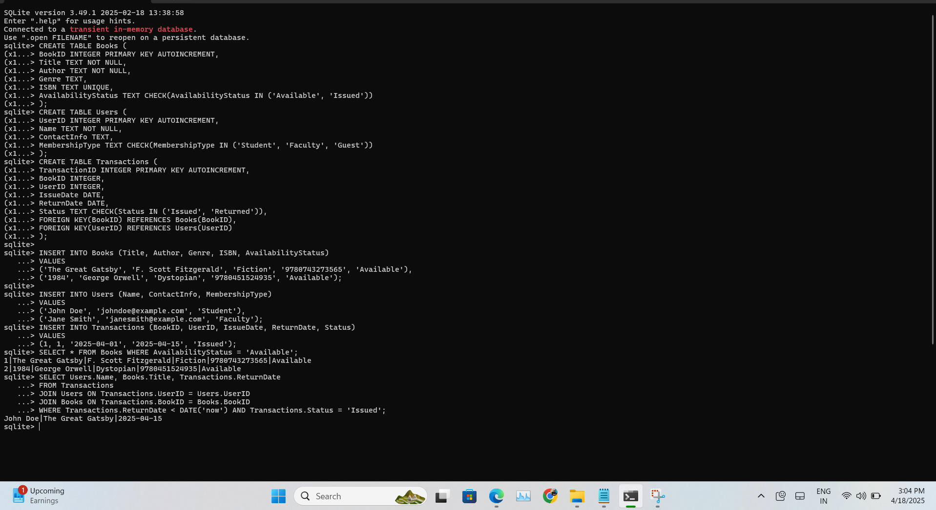

## 5. GitHub Repository

### 5.1 Repository Link

GitHub Repository: https://github.com/Ben1104/Hackathon-2.git

### 5.2 Uploaded Files in Repository

The following files are available in the repository:

- SQL scripts for table creation and sample data insertion

- ER diagram of the database structure

- Screenshots of execution results