**LIVE STREAMING EVENTS Documentation**

**Basic Features:**

**Note: we are providing cost for the Web Application only right now**

**1. User registration and login**. Via use of Email, Phone or social media login

**Comment by Letscms(23 June 2021):**

**Registration via Email** – Users can use their email ID for registration and Login. At the time of user registration email id will be verified and the user will be able to register and login.

**Registration via Phone** – Users can use their phone number for registration and login. Phone number will be verified by the OTP and the user will be able to register and login.

Question:

Which SMS gateway you need in this one?

To Be Confirmed (Namson)

**Registration via social media login** – Users can use their social media account like google, Facebook and LinkedIn.

**Cost(Letscms): Registration for all like by email, by phone OTP and by social media : 100 USD**

2. **User profile** should include some personal information so the app can offer tailored video suggestions in the future.

1. **Type of Profile:** Singer, Dancer, Musician, Producer, Event Manager...  (list of any type to be provided)

2. **Rate Profile** **:** Will have rating by other people.

**Comment by Letscms(23 June 2021):**

**User Profile:-** Information provided by users in their profile will be used and video suggestion will be shown ( Full Name, Nickname, DOB, Type of profile (Dancer, Singer…),Phone number, Email....

**Cost(Letscms): 50 USD**

**1. Type of profile –** There could be any type of user profile like singer, musician, producer, Event manager etc.

**Cost(Letscms): Need to discuss on it**

**Comment(Letscms): Only expecting to have the dropdown of profile types only there and include this one in profile. (if user type has different functionalities - Namson)**

2**. Rating for profile –** A rating system would be used to make every profile rated by their audience (Comment, rating ****).

**Cost(Letscms): 100 USD**

**3. Live video streaming** is the key feature. The quality of the streamed video should be our priority. It is the most important factor, according to 67% of the viewers who watch live stream broadcasts. Video compression algorithms can solve this problem.

**Comment by Letscms(23 June 2021):**

**Live Video Streaming :-** Live video streaming will be used with either third party streaming tool or open source streaming tool like nginx . Video quality would be depend on the speed of internet of the user if speed is low it reduce the quality pixels of video.

**Cost(Letscms): 1000 USD Approx**

4. **In-app video storage** allows users to download some of the video’s content  to their devices and watch/re-watch it later. Users can also store their past live  events on their profiles or share them personally with the users who weren’t  able to participate.

**Comment by Letscms(23 June 2021):**

**In app video storage:-** Users will have option to save video in local storage to watch/re-watch offline. Every users profile will have a past live event as a recorded video and share as well.

**Cost(Letscms): 400 USD Approx**

**5. Language setting (All)**

**Comment by Letscms(23 June 2021):**

How many language you need in this application , we need to manage the application according to that. If need mobile applications then it is also much important to have the functionality with multi language from starting of application.  
Kindly update the language list that need to manage.

ENG 1st.

**Cost(Letscms): 400 USD**

**Comment: Issue for cost with multilanaguge so we will come back for this one later - Letscms**

**Networking and Communication Features:-**

1. **live comments** during Live performance - enable direct dialog between the  streamer and the audience, which can increase their length and frequency of  engagement.

**Comment by Letscms(23 June 2021):**

**live comments:-**   
*It will be depend on you, basically if we need group chat then surly we need to use the node-js platform to perform group chat system for fast and real-time response. And you need to provide also the hosting so on that we can manage the chat system easily.*

**Cost(Letscms): 500 Approx**

**Comment: for the cost to live comment later will discuss, I have some thing to analyse again for costing on this. this seems some low but need to analyse- Letscms**

**2. Comments and discussions:-** provide a way to communicate within a small  group or provide feedback on the workout directly to the trainer after the  stream has ended.

**Comment by Letscms(23 June 2021):**

Comments and discussions:- As per my understanding this will be the normal comments on the video of the performer. If it is not like that, then you need to provide me some much information about it.

**Cost(Letscms): 300 USD approx -- DO not consider this one because this is only simple comments on video there no other functionality needed.**

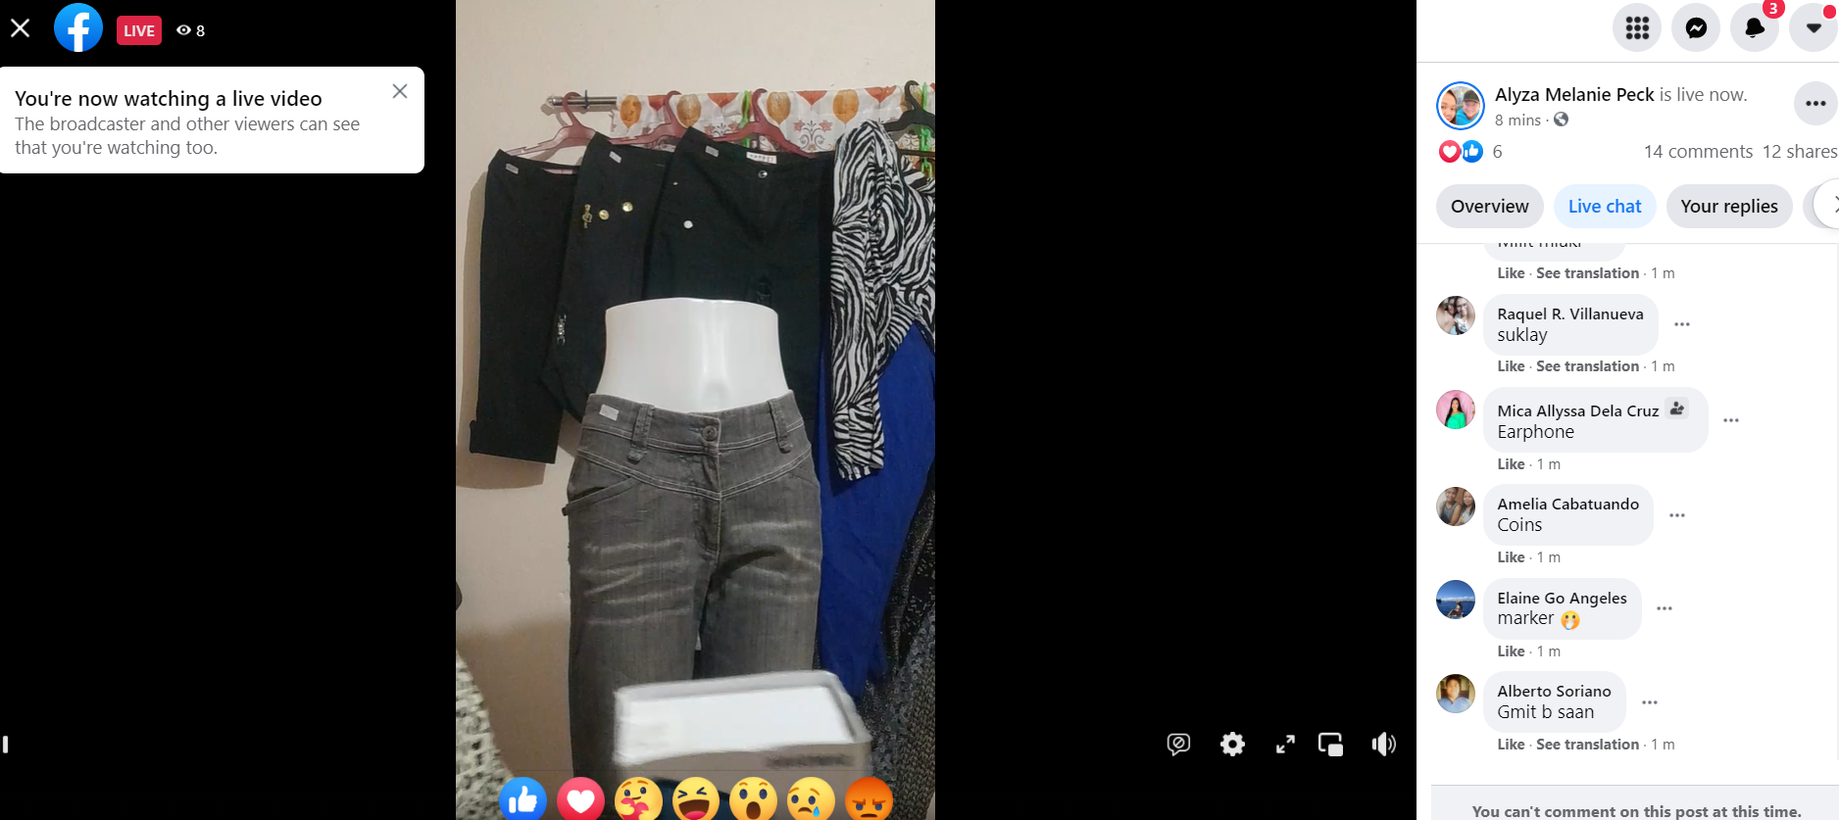

**Utilities**

**1. Search** feature could be really useful for users who want to explore more streams outside of their network. This can be search by city, type of events, type of profile / name etc.

**Comment by Letscms(23 June 2021):**

Normally search will be based on the parameters and information of the performers that is used in the system and type of events, and city etc.

**Depending on the chosen date,**

**if it is the future, the list of search will display Upcoming Events**

**if it is the past, the list of search will be Past InApp store saved videos**

**Cost(Letscms): 100 USD Aprox**

**2.** Performers should be able to **Schedule of their upcoming live events**. For example,  you can integrate it with their Google event calendar and add the classes they  booked.

**Comment by Letscms(23 June 2021):**

We will provide the events in calendar from where the events can be checked.  
if you need the google calendar integration then you need to provide the google calendar account information.

**Cost(Letscms): 400 USD Approx**

**No need for the Google Calendar implementation**

**3. Subscriptions and push notifications (browser/mobile app)** allow you to inform users about some recent news stories or updates. For example, users can subscribe to updates  and new events from their favourite events performer. Or the app can simply remind them of the upcoming events they have paid/scheduled.

**Comment by Letscms(23 June 2021):**

As per my understating , the normal user will subscribe for the notification and that will be based on the event and also that may be based on the performer.   
we will use firebase for the push notification. You need to provide the firebase information so can be tested properly.

**Cost(Letscms): 300 USD Aprox**

**4 - Packages ( Content to be confirmed)**

***we need only 3 subscriptions (standard, Pro, Business)***

| ***1 - Standard*** | *1st month free $40/Month* | *$480 /Yearly* | *Free storage & bandwidth* | *Sell on you own term* | *20 hours per month Live streaming* | *Free subscriber* | *Upgrade for own branding* |
| --- | --- | --- | --- | --- | --- | --- | --- |
| ***2 - Professional*** | *1st month free $99 /Monthly* | *$1188 /Yearly* | *Free storage & bandwidth* | *Sell on you own term* | *30 hours per month Live streaming* | *Free subscriber* | *Upgrade for own branding* |
| ***3 - Business*** | *1st month free $300/ Monthly* | *$3600/ Yearly* | *Free storage & bandwidth* | *Sell on you own term* | *Unlimited Live streaming* | *Free subscriber* | *Set you own branding* |

**4. Social Media Sharing:**

**Comment by Letscms(23 June 2021):**

Users can share the events and video on provided social accounts as you will provide the information about the social accounts so we can manage those properly.

**Cost(Letscms): 150 USD approx**

**Later will discuss on this for the price- By Namson**

**Role and Tasks :**

**Normal User Functions:**

As per my understanding,  
Normal user will be able to search the events and filter the events based on different parameters as you have provided like, city, event type, artist and date based

For the event ticket user needs to login and then need to make payment for that event so the virtual ticket can be send to the email of the user and if you need can be provided also the sms notification, email notification and push notification

**Cost(Letscms): 350 Approx**

**No Need**

For the group chat and comments , first of all normal user should be login in the system, if already not register then should be register first of all then can perform the operations like group chat and simple chat and also the comments on events and performers.

**Cost(Letscms): 200 USD Approx**

Live chat: here what do you mean by Live chat?  
do you mean by live chat as live video call system.

**Cost(Letscms): 200 USD Approx**

Can be provide the rating system for the performers by the user.

**Cost(Letscms): 100 USD**

**Payment Gateway**

You need to provide me the payment gateway which one you want to configure in your system

**Cost(Letscms): 300 USD Approx**

**Paypal and Stripe - By letscms**

**All payments transactions or any issues with the gateway.**

**Event Performers can**

* Schedule live Event (Rescheduling : Update to be confirmed)
* Perform Event
* Reply to comments
* Make Payment (Come back on it - Update to be confirmed)
* Contacts Customer Service (Email based / or Live Chat to Admin)

For all type of users the login and register will be same but the sections will be separate that will be managed by the role and permissions.

As you have provided me the list of the type users I will will manage those.

**Cost(Letscms): 500 USD**

Need to provide flowchart / details for every type of user

**Experienced performers:**

Experienced performers can hire also the beginners performers, but for the paying system etc. will be manage so if you need like payment functionality for the beginner performers please update me

Experience performers will have all devices that needs to perform the events as you have given in the document.

Doe you need to list also by the performers that which one equipment’s you have or not in the performers section

**Cost(Letscms): 200 USD**

**Beginner performers:**

They will be start up and will not have equipment’s for event

Packages:

All performers will subscribe for packages ( the list is above on table).

Please update me

Performers will select date for the events and will provide the information about the event.

Question: What mean of GO live Here?? (Start scheduled event)

Performers will also have the reply section in chat for the comments

Manage ticket: as we will use the manage ticket, we need to manage a simple ecommerce platform for this.

N**eed to specify the rules either for the chat section .. comment on performers profile and or during / after Live performance**

In case of the refund ticket , how the money will be transfer to end user or not.

And the ticket money will be transfer to the company or will transfer to the event manager.  
**Will need to deal separately by email / manual**

What will be the commission of the company if the performers of event is organising.  
  
how the payment system will work for the ticket amount/ money management.

This is the simple things that are considering but we need to discuss on this one some more so all hidden functionality can be discussed before final cost and timing.

**Will get back to you with this**

**Cost(Letscms): Need discussion on this**

**Administrator Panel :**

1. User Management (listing, view, change password, edit and update for those type of users.

**Cost(Letscms):100 USD approx**

**2. Event Management (Add new event, Update or delete Event for the performers, Only Admin can delete Event)**

**3. Payment Management (list of payment, Refund…)**

**For Customers**

**\*Refund Process (Customer send Email separately) -- cost is not consider for this one**

**For Performances**

**Cost(Letscms): 180 USD approx (2,3)**

2. If you need specific management for the users like

, location etc. please provide me here.

**Cost(Letscms): Need to discuss on this point**

3. events can me only view and if the empty slot is available then can be shift by the admin only not by any other user.

**Cost(Letscms): need discussion more sir on this**

4. for all events schedule also will be manage by the admin only.

**Cost(Letscms):50 USD approx**

5. there will be configuration for the sms gateway and you need to manage the listing , view sms by the sms gateway panel  
if you need in self application then you need to provide the gateway that have like this functionality so we can integrate in our system

**Cost(Letscms): 70 USD approx**

**Need to identify the elements to be included in the admin and performers and users panel**

6. Subscription package/plan will be manage in admin but you need to provide which sms gateway you will use for those because some functionality also depend on the payment gateways like stripe

**Cost(Letscms):200 USD**

7. In the admin area the transaction will be separate by the performers and normal users.  
total amount , report etc will be of the transactions in the admin area.

**Cost(Letscms):100 USD**

8. from the admin section also the chat will be happen with the normal users and with performers.

In admin chat will be list only with admin communication, not between of performers and normal users.

**Cost(Letscms):100 USD**

9. Push notifications can be send to the performers, event related users, and specific users. That will be depend on your requirements.

**Cost(Letscms):100 USD**

**Detail for technology used By letscms pvt ltd**

1. **For backend purpose we will user Laravel latest version**
2. **For front end we will use IONIC and Android.**
3. **For mobile application android/IOS, will be used IONIC and angular**

Create API

Implement API in Mobile

we did not discuss on Design part. Would you provide me the XD,Figma, PSD for web application and mobile application,

Namson - or the design part, please propose me 2 or 3 designs. Thanks