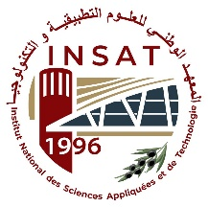 | TUNISIAN REUBLIC  Ministry of Higher Education and Scientific Research  University of Carthage  National Institute of Applied Sciences and Technology | 

End of Year Project

Second Year Engineering Cycle
Specialty: Computer Networks and Telecommunications

Intelligent Multimodal approach for Automatic Generation of High-Impact Short Formats (Shorts / Reels)

Prepared by
Ben Amor Hanine
Bhar Amira
Cheriaa Nermine

Defended on june 2026 in front of a jury composed of:
……………………….………… | President of the jury
Mliki Hazar | Supervisor at INSAT

Academin Year: 2025/2026

